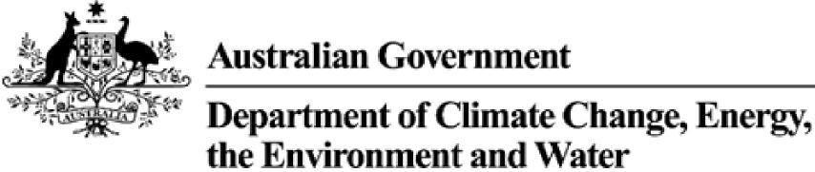
Product Emissions Standards Act 2017
Product Emissions Standards Rules 2017
Exemption Variation Notice
Variation to Exemption No: ECP-21-0006Ev
I, Tracy Gurnett, a Delegate of the Secretary of the Department of Climate Change, Energy, the Environment and Water (the Department) hereby vary the conditions of Exemption No. ECP-21-0006E under Section 35 of the Product Emissions Standards Rules 2017 by inserting an additional organisation ‘New South Wales Rural Fire Service’ in Conditions 1, 2 and 3 of Schedule 2, so that existing conditions 1, 2 and 3 are replaced with the following:
Condition 1. The engines must only be supplied by Lakeside Marine Pty Ltd through an authorized dealer for the ultimate use of New South Wales National Parks and Wildlife Service (NSW NPWS), New South Wales Rural Fire Service (NSW RFS), a member club of Surf Life Saving Australia (SLSA) or an SLSA affiliated state or territory-based entity to provide rescue or emergency services purposes.
Condition 2: The supply of engines as described in Condition 1 must only be undertaken upon receipt of an order form from NSW NPWS, NSW RFS, a member club of SLSA or an SLSA affiliated state or territory-based entity.
Condition 3: A copy of this exemption must be clearly displayed in the area(s) of the premises where the ECPs are stored before they are supplied to NSW NPWS, NSW RFS, a member club of SLSA or an SLSA affiliated state or territory-based entity.

Exemption No: ECP-21-0006Ev
In accordance with paragraph 35(1) of the Rules, notice of this variation will be published on the Department’s website and the variation will take effect on the day it is published on the website.
The exemption as varied is attached for reference.
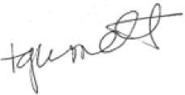 | Date: 27 /09/2022

Delegate of the Secretary
2

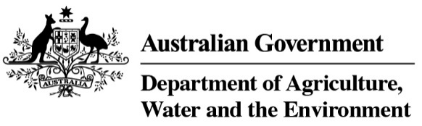

Product Emissions Standards Act 2017

Product Emissions Standards Rules 2017

Exemption Notice

(Issued 6 July 2021, Varied 27 September 2022)

Exemption No: ECP-21-0006E

I, David Jeffery, a Delegate of the Secretary of the Department of the Agriculture, Water and the Environment (the Department) grant this exemption from Part 3 of the Product Emissions Standards Act to Lakeside Marine Pty Ltd (ABN 29001930098).

This exemption is granted under Section 32 of the Product Emissions Standards Rules 2017 in accordance with exemption category 30 (1)(d) Emergency services organisation for the emissions-controlled products specified in Schedule 1 to this Notice, subject to the conditions specified in Schedule 2 to this Notice.

This exemption comes into force on the date that it is published on the Department’s Website.

This exemption expires on the date specified in Condition 7 of Schedule 2.

In accordance with paragraph 32(1)(a) of the Rules, notice of this exemption will be published on the Department’s website.

Date:

Delegate of the Secretary

Schedule 1

Emissions-Controlled Products (ECPs) Included in this Exemption

Only the ECPs specified in the table below are included in this exemption.

Make | Model Name | Equipment Type
Tohatsu | M25H | Propulsion Marine Engines
Tohatsu | MX25H | Propulsion Marine Engines
Tohatsu | M30H | Propulsion Marine Engines
Tohatsu | MX30H | Propulsion Marine Engines

Schedule 2

Exemption Conditions

In accordance with subsection 34(2) of the Product Emissions Standards Rules 2017, the exemption for the engines specified in Schedule 1 is granted subject to the following conditions:

- The engines must only be supplied by Lakeside Marine Pty Ltd through an authorized dealer for the ultimate use of New South Wales National Parks and Wildlife Service (NSW NPWS), New South Wales Rural Fire Service (NSW RFS), a member club of Surf Life Saving Australia (SLSA) or an SLSA affiliated state or territory-based entity to provide rescue or emergency services purposes.
- The supply of engines as described in Condition 1 must only be undertaken upon receipt of an order form from NSW NPWS, NSW RFS, a member club of SLSA or an SLSA affiliated state or territory-based entity.
- A copy of this exemption must be clearly displayed in the area(s) of the premises where the ECPs are stored before they are supplied to NSW NPWS, NSW RFS, a member club of SLSA or an SLSA affiliated state or territory-based entity.
- The engines are to be labelled upon arrival with the relevant supply limitation details outlined in this Exemption Notice.
- If requested by the Department, Lakeside Marine Pty Ltd must be able to submit a report relating to compliance with the conditions of this exemption including details of the recipient of each engine.
- The engines must not be displayed by any person for sale in a retail showroom or sales area accessible to the public.
- The import and supply of the ECPs for the purpose specified in this exemption must be completed prior to the expiry date of 30 June 2024.
- Exempted engines imported but not supplied by 30 June 2024 are not covered by this exemption.
- This exemption is for a total of six hundred (600) ECPs as described in Schedule 1.

