

Product Emissions Standards Act 2017 Product Emissions Standards Rules 2017 Exemption Notice

Exemption No: ECP-25-0008E

I, David Perry, a Delegate of the Secretary of the Department of Climate Change, Energy, the Environment and Water (the Department) grant this exemption from Part 3 of the Product Emissions Standards Act to Husqvarna Australia Pty Limited (ABN 45 115 475 619)

This exemption is granted under Section 32 of the Product Emissions Standards Rules 2017 in accordance with exemption category 30 (1)(b) for the testing, evaluation or display of the emissions-controlled products specified in Schedule 1 to this Notice, subject to the conditions specified in Schedule 2 to this Notice.

This exemption comes into force on the date that it is published on the Department’s website.

This exemption expires on the date specified in Condition 1 of Schedule 2.

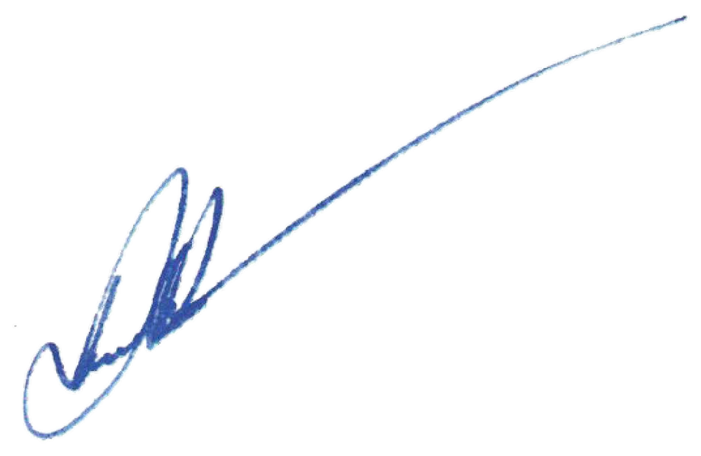
In accordance with paragraph 32(1)(a) of the Rules, notice of this exemption will be published on the Department’s website.
Date:
08 April 2025

Delegate of the Secretary

Schedule 1
Emissions-Controlled Products (ECPs) Included in this Exemption

Only the ECPs specified in the table below are included in this exemption.

Make | Model Name | Equipment Type
Husqvarna | 564XP | Non-Road Engines

Schedule 2 Exemption Conditions

In accordance with subsection 34(2) of the Product Emissions Standards Rules 2017, the exemption for the engines specified in Schedule 1 is granted subject to the following conditions:
- The import, testing and evaluation of the ECPs must be completed prior to the expiry date of 1 January 2027.

- Upon arrival, the ECPs must be securely stored on Husqvarna Australia Pty Limited’s premises and marked in such a manner that they are clearly identifiable as the ECPs imported under this exemption.

- A copy of this exemption must be clearly displayed in the area(s) of the premises where the ECPs are stored.

- When the ECPs have been utilised for the purpose of this exemption and are no longer required, before the expiry date of this exemption they must be either:
  - destroyed through a product destruction service and a certificate of destruction collected as evidence of the destruction; or
  - exported and a record of the export collected as evidence; or
  - if the ECPs become certified during the exemption period, a copy of the certification must be provided to the Department

- The ECPs must not be displayed by any person for sale in a retail showroom or sales area accessible to the public and must not be available for purchase in Australia to the public through Husqvarna Australia Pty Ltd’s dealer network or by any other means.

- Any staff or external testing agents engaged to undertake the required testing of the ECPs must be made aware of the requirements and limitations of this exemption.

- Husqvarna Australia Pty Limited must submit a comprehensive report demonstrating compliance with the conditions of this exemption prior to 1 January 2027.

- This exemption is for a total of four (4) ECPs, with the total to be made up of any combination of the ECPs as described in Schedule 1.

