

Product Emissions Standards Act 2017 Product Emissions Standards Rules 2017 Exemption Notice

Exemption No: ECP-26-0046E

I, David Perry, a Delegate of the Secretary of the Department of Climate Change, Energy, the Environment and Water (the Department) grant this exemption from Part 3 of the Product Emissions Standards Act to STIHL PTY. LTD. (ABN 76004881145)

This exemption is granted under Section 32 of the Product Emissions Standards Rules 2017 in accordance with exemption category 30 (1)(a) for the export of the emissions-controlled products specified in Schedule 1 to this Notice, subject to the conditions specified in Schedule 2 to this Notice.

This exemption comes into force on the date that it is published on the Department’s Website

This exemption expires on the date specified in Condition 1 of Schedule 2.
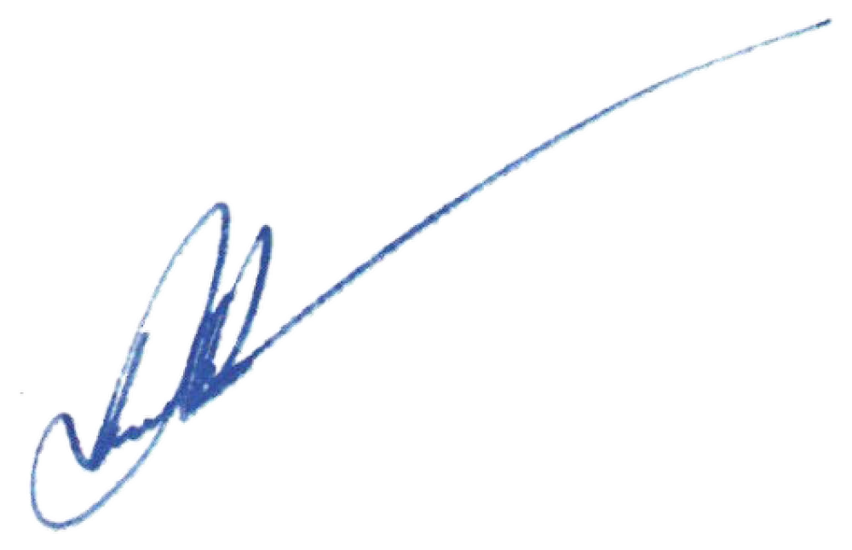
In accordance with paragraph 32(1)(a) of the Rules, notice of this exemption will be published on the Department’s website.
Date:
29/06/2026

Delegate of the Secretary

Schedule 1
Emissions-Controlled Products (ECPs) Included in this Exemption
Only the ECPs specified in the table below are included in this exemption.

Make | Model Name | Equipment Type
1119-011-3055 | 1119-200-0353 | Non-Road Engines

Schedule 2 Exemption Conditions
In accordance with subsection 34(2) of the Product Emissions Standards Rules 2017, the exemption for the engines specified in Schedule 1 is granted subject to the following conditions:

- The import of the ECPs must be completed prior to the expiry date of 30 June 2028

- Upon arrival, the ECPs must be securely stored on STIHL PTY.LTD premises and marked in such a manner that they are clearly identifiable as the ECPs imported under this exemption.

- A copy of this exemption must be clearly displayed in the area(s) of the premises where the ECPs are stored.

- The ECPs must not be displayed by any person for sale in a retail showroom or sales area accessible to the public and must not be available for purchase in Australia to the public through STIHL PTY. LTD. dealer network or by any other means.

- STIHL PTY. LTD. must submit a comprehensive report demonstrating compliance with the conditions of this exemption prior to 30 June 2028.

- This exemption is for a total of 900 ECPs, with the total to be made up of any combination of the ECPs as described in Schedule 1.

