Agriculture and the EPBC Act

Guide to the Environment Protection and Biodiversity Conservation Act 1999

  - Version 1 August 2026

© Commonwealth of Australia 2026
Ownership of intellectual property rights
Unless otherwise noted, copyright (and any other intellectual property rights) in this publication is owned by the Commonwealth of Australia (referred to as the Commonwealth).
Creative Commons licence
All material in this publication is licensed under a Creative Commons Attribution 4.0 International Licence except content supplied by third parties, logos and the Commonwealth Coat of Arms.
Inquiries about the licence and any use of this document should be submitted via our online contact form.

Cataloguing data
This publication (and any material sourced from it) should be attributed as: National EPA 2026, Agriculture and the EPBC Act, National Environmental Protection Agency, Canberra, August. CC BY 4.0.
This publication is available at nationalepa.gov.au
National Environmental Protection Agency
GPO Box 3090 Canberra ACT 2601
Telephone 1800 976 422
Web nationalepa.gov.au
This is an initial version of Agriculture and the EPBC Act. If you have comments or feedback, please contact the agency or pass feedback on to your peak organisation. Further versions of this guide will be available informed by user feedback.
Disclaimer
The Australian Government acting through the National Environmental Protection Agency has exercised due care and skill in preparing and compiling the information and data in this publication. Notwithstanding, the National Environmental Protection Agency, its employees and advisers disclaim all liability, including liability for negligence and for any loss, damage, injury, expense or cost incurred by any person as a result of accessing, using or relying on any of the information or data in this publication to the maximum extent permitted by law.
Acknowledgement of Country
We acknowledge the Traditional Owners of Country throughout Australia and recognise their continuing connection to land, waters and culture. We pay our respects to their Elders past and present.

Contents
Purpose of this document 5
Introduction to the EPBC Act 5
Which protected matters are affected by agricultural activities? 6
Navigating the EPBC Act 7
How do agricultural activities interact with the EPBC Act? 7
State regulations and national environment laws 7
EPBC exemptions under Section 43B: Actions which are lawful continuations of use of land 8
Landholder Decision flow chart 9
Table 1: Common farm activities and the EPBC Act 12
Self-assessment 13
Good record keeping 16
Tools to assist 17
How to check the time since the last clearing event 17
How to determine if land is 50 metres from a Great Barrier Reef watercourse, wetland or drainage line 17
How to determine if there are protected matters on your land 17
Reviewing the PMST results 20
Interpreting PMST results 22
I think I need an approval – what next? 24
Pre-referral meetings 25
Preparing for a pre-referral meeting 25
What happens during a pre-referral meeting? 25
What a pre-referral meeting will not do 26
Where you can get professional advice 26
Preparing and submitting a referral 27
How long it will take 28
Self-assessment timeframes 28
Referral timeframes 28
Assessment timeframes 28
Planning your project around a referral or assessment 29
Exemptions from EPBC fees 30
How we approach compliance – there is no such thing as a ‘blanket approach’ 30
Contact us 33
Glossary 34
Appendices 39
Appendix A: Helpful links 39
Appendix B: EPBC self-assessment template 42
Details of person doing the self-assessment 42
What are you planning to do? 43
When was the last self-assessment undertaken? 43
Existing environment 44
Identifying protected matters 45
Baseline and surveys (if existing or available - not required to be commissioned or undertaken at this stage) 46
Significant Impact Assessment (apply relevant guidelines) 46
Avoidance and mitigation 48
Should you consider an EPBC referral? 49
Pre-referral discussion (if required) 49
Recommended attachments 50
Appendix C: EPBC scenarios 51
Scenario: Erosion control and groundcover restoration 51
Scenario: Fodder harvesting for drought resilience 52
Scenario: Invasive weed control near a waterway 53
Appendix D: Frequent flyers – species and communities that most often occur on farms 54
Threatened species 54
Threatened ecological communities 57

Purpose of this document
This guide was developed in response to feedback from farmers, industry groups and other stakeholders seeking clearer guidance on how agricultural activities interact with the Environment Protection and Biodiversity Conservation Act 1999 (EPBC Act), particularly following the 2025 reforms. Prepared by the National Environmental Protection Agency in consultation with agricultural representatives, producers and environmental experts, it provides practical, plain-English advice for landholders.
By reading this guide you will learn:
- What the EPBC Act covers
- When exemptions may apply
- Key decisions that you may need to take on farm to meet your obligations (including a decision chart)
- How to do a self-assessment, including a template to assist you in completing this
- When you should consider referring clearing and other actions under the EPBC Act to the National Environmental Protection Agency (National EPA)
- How the National EPA approaches compliance and enforcement.

Introduction to the EPBC Act

The Environment Protection and Biodiversity Conservation Act 1999 (the EPBC Act) and the Environment Protection and Biodiversity Conservation Regulations 2025 (EPBC Regulations) are Australia's main national environmental legislation. They provide a way for Australia to protect and manage nationally and internationally important plants, animals, habitats and places. We call these matters of national environmental significance (MNES), or protected matters. The EPBC Act is administered by the National EPA.
The EPBC Act has 9 categories of protected matters:
- Threatened species and ecological communities
- Migratory species
- Ramsar wetlands
- National Heritage places
- World Heritage properties
- Commonwealth Marine Area
- Protection of the environment from nuclear actions
- Great Barrier Reef Marine Park
- Protection of Water Resources (CSG, large coal mines and all types of unconventional gas).
The EPBC Act also protects the environment when actions are taken:
- on Commonwealth land (or impact upon Commonwealth land)
- by an Australian Government agency anywhere in the world that impact Commonwealth Heritage places overseas.

Which protected matters are affected by agricultural activities?
The protected matters that are most likely to be relevant to agricultural actions are what are known as ‘listed threatened species’ and ‘ecological communities’. However, other EPBC protected matters may also be relevant. Examples of these additional matters include:
Additional matter | Description
Great Barrier Reef  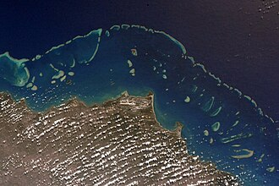  Image credit: NASA/Kjell Lindgren | Environmental reforms passed in late 2025 mean that an EPBC Act exemption for lawful continuous use is no longer available for land clearing within 50 metres of a watercourse, wetland or drainage line in Great Barrier Reef catchments. You can find more information on the exemption on page 8. This was done because greater protection of healthy riparian vegetation is one of the most effective ways to reduce sediment delivery to the reef.  The reform supports best-practice agricultural land management. However, landowners need to consider whether the proposed activities might release significant quantities of sediment or chemical pollutants and discuss with the National EPA if unsure.
Listed migratory species    Image credit: Jasmine Zeleny | For many farms, migratory species will only be flying over. Agricultural activities are generally low risk unless the activity may significantly impact a wetland or other area where migratory birds congregate.  Activities likely to impact wetlands directly (such as by clearing vegetation) or indirectly (such as by changing water flows) need to be considered and, if likely significant, referred to the National EPA.
Internationally listed wetlands  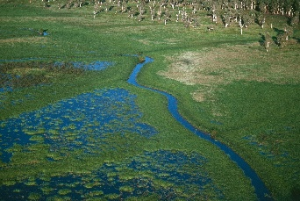  Image credit: Dr Warren Nicholls | Wetlands listed under the Ramsar Convention (known as Ramsar Wetlands) are given a high level of protection extending to the catchments feeding them with water and nutrients.  While best-practice agricultural land management is unlikely to significantly impact these areas, the EPBC Act may regulate activities that:  - occur within or close to Ramsar Wetlands, or  - involve clearing in their catchment.

Navigating the EPBC Act

How do agricultural activities interact with the EPBC Act?
This guide seeks to provide landholders with advice on what farming activities may interact with the EPBC Act, and how to ensure they are complying with obligations under the Act. It mainly focuses on listed threatened species and ecological communities as they are generally the protected matters most impacted by agricultural activities in Australia. This guide has been developed following the introduction of EPBC Act reforms on 1 December 2025, which included updates to an EPBC Act exemption for some lawful continuing uses of land (Section 43B). Learn more about updates to agricultural action exemptions under the EPBC Act.
The agriculture sector manages over half of Australia’s landmass, with estimates typically ranging between 51% and 58% (approximately 385-439 million hectares). This vast area is predominantly used for livestock grazing, particularly in the rangelands, with only a small fraction used for crops (about 5% of agricultural land), based on data from the Department of Agriculture Fisheries and Forestry (DAFF), Land Use Australia and the Department of Climate Change, Energy, Environment and Water (DCCEEW).
Landholders are subject to various land management and environmental regulations. While states and territories (and local governments) have primary responsibility for planning and environmental management, the Australian Government plays a role in protecting nationally significant plants, animals and places. Approval under local, state or territory laws doesn’t automatically provide approval from the Commonwealth government.
In managing these vast areas of land, the agriculture sector has the same legal responsibility under the EPBC Act as every other industry sector. In other words, EPBC Act regulation continues to apply to all sectors equally.
However, the National EPA recognises that the agricultural sector differs from other sectors such as mining, renewables and construction. In those sectors, interaction with the EPBC Act tends to be project-based, whereas agricultural activities usually occur on an ongoing basis. Landholders generally strive for sustainable outcomes, such as protecting soil health and water quality, retaining shelterbelts of trees and controlling weeds. Doing this promotes the long-term productivity of their land. Farming is also unique in that conserving the habitats protected under national environment law will often contribute to farm productivity by helping with pest control (by encouraging insect-eating birds and small reptiles), soil retention and water quality.

State regulations and national environment laws
The EPBC Act operates alongside state and territory legislation. Both may apply to farming operations. Just because an activity has state approval it doesn’t mean it’s compliant under the EPBC Act. Landholders must check both systems.
‘Category X’ mapped areas – in Queensland, mapping under Property Maps of Assessable Vegetation (PMAV) approvals do not provide an exemption or approval under national environment laws. It is important you check State/Territory and Commonwealth requirements before clearing land.

EPBC exemptions under Section 43B: Actions which are lawful continuations of use of land
To qualify for this category of exemption:
- The land use was occurring immediately before the EPBC Act commenced on 16 July 2000 and has continued until present time, with no breaks in continuity; AND
- the land use was and remains lawful (e.g. through state laws etc.) from immediately before 16 July 2000 to present; AND
- there has been no enlargement, expansion, or intensification* of the land use; AND
- there has been no change in the location of the land resulting in a substantial increase in impacts of the use on protected matters; AND
- there has been no change in the nature of the use of the land resulting in a substantial increase in impacts of the use on protected matters; AND
- an exemption under section 43A does not apply (see below Note).
- The exemption under section 43B DOES NOT apply to an area of land that has not been cleared for 15 years or more or if the land is within 50 metres of a Great Barrier Reef watercourse, wetland or drainage line.
*Intensification means changing land use in a way that increases impacts on native vegetation or the environment.
For example, changing from grazing to rotational cropping is generally an intensification because it involves greater disturbance to the land. This may mean the continuous use exemption no longer applies.
Improving productivity within an existing grazing or cropping system is generally not considered an intensification if the type of land use does not change.
Oversowing native grasslands with introduced pasture species is generally considered an intensification because it can harm native vegetation.
Actions that are exempt do not need a self-assessment or approval under the EPBC Act.

Landholder Decision flow chart
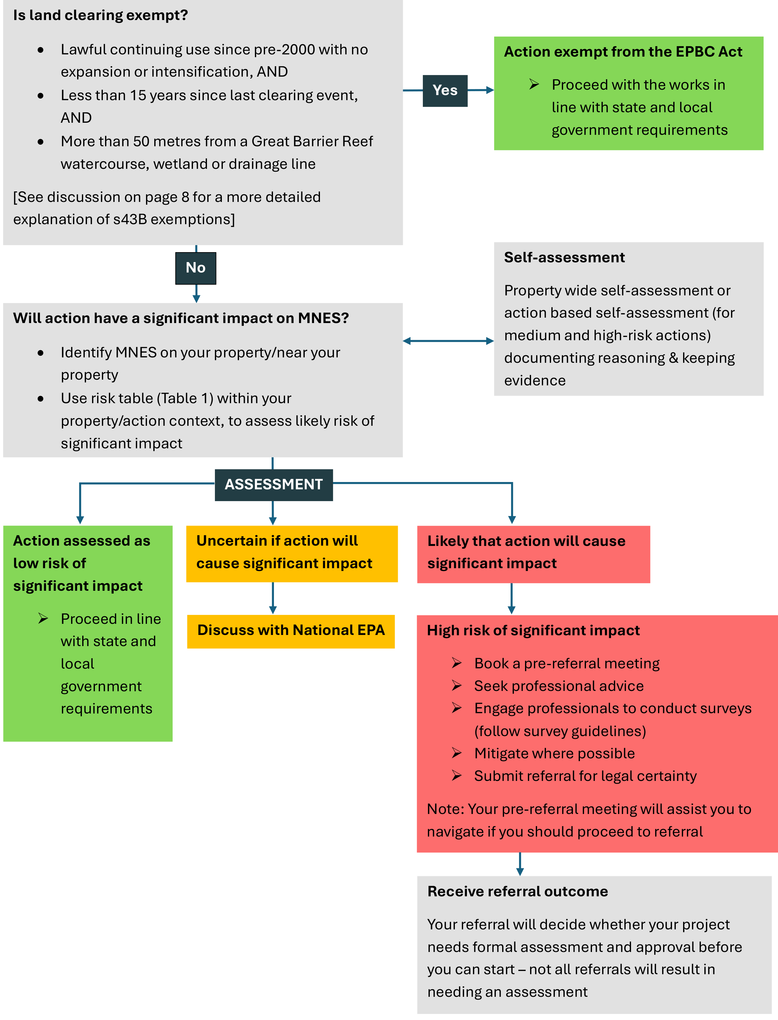
Text version of the flowchart
Question 1: Is the land clearing exempt?
- Lawful continuing use since pre-2000 with no expansion or intensification, AND
- Less than 15 years since the last clearing event, AND
- More than 50 metres from a Great Barrier Reef watercourse, wetland or drainage line
[See discussion on page 8 for a more detailed explanation of s43B exemptions]
If YES, Action is exempt from the EPBC Act. Proceed with the works in line with state and local government requirements.
If NO, continue to the next question.
Question 2: Will action have a significant impact on MNES?
- Identify MNES on your property/near your property
- Use risk table (Table 1) within your property/action context, to assess likely risk of significant impact
Move to:
Self-assessment – Property wide self-assessment or action based self-assessment (for medium and high-risk actions) documenting reasoning & keeping evidence
Move to: ASSESSMENT
Path 1: Action assessed as low risk of significant impact
- Proceed in line with state and local government requirements
Path 2: Uncertain if action will cause significant impact
Move to: Discuss with National EPA
Path 3: Likely that action will cause significant impact
Move to:
High risk of significant impact
- Book a pre-referral meeting
- Seek professional advice
- Engage professionals to conduct surveys (follow survey guidelines)
- Mitigate where possible
- Submit a referral for legal certainty
Note: Your pre-referral meeting will assist you to navigate if you should proceed to referral.
Move to:
Receive referral outcome – Your referral will decide whether your project needs formal assessment
This flow-chart shows landholders how to navigate their national environment obligations under the EPBC Act. Regardless of state or territory laws, there are three main questions for landholders to ask with regards to their obligations under the EPBC Act:
- Is the activity exempt under national environmental law?
- If it is not exempt under national law, is the activity routine, on existing cleared footprint, with no expansion or intensification (see activities listed as low risk and marked in green on Table 1) and thus low risk of significant impact to MNES?
- If it is not exempt nor low risk and protected matters (or their habitat) could be impacted, what is the potential scale of the impact and sensitivity of the environment to that potential impact?
IMPORTANT: State, territory and local exemptions (e.g. Category X in QLD and LLS Permits in NSW) do not apply nationally. They are not exemptions from the EPBC Act.
Note: Section 43A of the EPBC Act exempts actions covered by a pre-2000 authorisation granted in writing by a Commonwealth, state or territory environmental organisation, that continues to be in force. We are not aware of any authorisations being granted to farmers under section 43A. If, however, you believe you have one, please contact the National EPA.
If an activity is not eligible for an exemption, then use Table 1 to check your risk.
- Green means low risk in most cases. If you are intending to undertake these routine farming activities on an already cleared part of your farm, consider whether there is a chance of any native species, native vegetation, wetlands or waterways being significantly impacted. If not, then you do not need to undertake a more detailed self-assessment, and you can proceed with the activity (subject to compliance with State and local laws).
- Yellow means uncertain risk, you should undertake a more detailed self-assessment and contact us if unsure.
- Red means high risk, and we recommend that you contact us for assistance in preparing a referral under the EPBC Act.
This is general advice only and may not cover all situations. If you want to discuss your individual situation, please contact us.

Table 1: Common farm activities and the EPBC Act
Exempt from the EPBC Act under Section 43B (see page 8 for more detail): Lawful continuous land-use from before 2000 (if the activity involves land clearing and the area to be cleared has been previously cleared less than 15 years ago AND is more than 50 metres from a Great Barrier Reef watercourse, wetland, or drainage line).
For actions not covered by exemptions refer to the following three risk categories as a guide to what you need to do:
Risk level | Description
Low risk of significant impact on MNES: detailed self-assessment not required. Retain basic evidence such as diary notes. | In most cases the following routine farming activities will be low risk of having a significant impact on MNES. Things that are likely not to include significant impacts on MNES, are where activities are carried out on an existing cleared footprint and do not involve any native species, native vegetation, waterways, wetlands or protected heritage places:  - Existing cropping/crop rotation activities that will not impact watercourses, waterbodies or drainage lines (including by increased sediment, including pasture layovers as part of standard crop rotation).  - Grazing within a current grazing footprint.  - Maintaining existing firebreaks (Asset Protection Zones), fire trails and water points for bushfire protection – see Firebreak renewal for bushfire season cases study.  - Protecting people or property during a bushfire emergency  - Creating new fencelines (assuming a standard stock fence with 10 metre clearance) – see Fencing for grazing management case study.  - Weed management targeted at declared weeds in line with state and territory requirements, – see Invasive weed control near a waterway case study.  - Maintaining existing water infrastructure, fences and buildings – this would also include upgrading irrigation infrastructure inside the same footprint- see Minor repairs/ maintenance to farm infrastructure – case study.  - Gully repair and groundcover restoration to stabilise eroded areas – see Erosion control and groundcover restoration case study.  - Works to prevent sedimentation and/or erosion within a watercourse, wetland or drainage line – see Erosion control and groundcover restoration).  - Removing individual hazardous trees – see Minor repairs/ maintenance to farm infrastructure – case study.  - Small-scale clearance of previously disturbed areas e.g. for fence lines  - De-silting of existing farm dams.  - Fodder harvesting within previously harvested areas, and in accordance with State development codes.  - Installation of on farm water infrastructure where State/Territory planning requirements are not activated - see Installing polyethylene pipe for water security case study.
Medium risk of significant impact on MNES: self-assessment required, retaining evidence and notes, and potentially book a pre-referral meeting | - Smaller scale clearing of vegetation where this is close to areas that have been identified as habitat in guidance for listed species or ecological communities (e.g. hollow-bearing trees and vegetated gullies and riparian zones, clearing tree corridors between habitat areas)  - Clearing of regrowth meeting the criteria for a threatened ecological community, particularly if it could be habitat for a listed species  - Use of herbicide immediately adjacent to known or potential habitat areas, where the herbicide could have a significant impact on MNES  - Fodder harvesting in new areas, self-assess to confirm that there is no significant impact to nationally protected matters  - Ecological thinning, where this is consistent with state guidance, self-assess to ensure there is no significant impact to nationally protected matters  - Oversowing paddocks with exotic grass species, where this could affect EPBC listed native pastures  - Smaller scale land-use changes (e.g. changing from medium-density grazing to rotational cropping) where impact on habitats for protected species is uncertain/unknown  - Removal of hollow-bearing trees that aren’t hazardous
High-risk of significant impact on MNES: referral and booking a pre-referral meeting recommended | - Any clearing of vegetation that has not been cleared in the past, or is within 50 metres of a Great Barrier Reef wetland, watercourse or drainage line, and could potentially provide habitat for listed species or be part of an ecological community, especially where critical habitat for nationally protected matters will not be retained (e.g. large or hollow-bearing trees and vegetated gullies and vegetation near rivers, streams and watercourses, etc.)  - Clearing that creates isolated fragments of habitat  - Large-scale land-use changes resulting in significant impacts to MNES

Self-assessment
As a land manager, if you are not covered by an exemption you need to consider if clearing activities are likely to have a ‘significant impact’ on a nationally protected matter (e.g. a threatened species) under national environment laws. If a significant impact is likely, you’ll need approval before the action can proceed.
Undertaking a robust self-assessment helps you determine if you need to make a referral for potential significant impacts and also provides evidence that you have made management decisions in good faith.
We recommend that producers undertake a property wide self-assessment based on their farm management plan, but there is also the option of doing self-assessments for individual actions, based on personal preference. Once completed, this should only need to be reviewed if your management approach has changed (such as after a major flood, fire, or changing to a different commodity).
If you have worked through the steps above and found your action is not exempt nor low risk of significant impact (green section in Table 1), the next step is to decide whether your action is likely to have a significant impact on one or more protected matters.
You will need to understand what ‘significant impact’ means. The best guide is Significant Impact Guidelines 1.1 – Matters of National Environmental Significance.
Under the guidelines, it is an impact which is ‘important, notable, or of consequence’, having regard to its context or intensity. Whether or not an action is likely to have a significant impact depends upon the sensitivity, value and quality of the environment which is impacted; and upon the intensity, duration, magnitude and geographic extent of the impacts.
A significant impact, considers:
- how sensitive, valuable or high-quality the environment is
- how strong the impact is, how long it lasts, how big it is, and how wide an area it affects.
In simple terms, an impact is likely to be significant if the proposed action could, for example:
- reduce, change, damage, destroy or break up habitat, ecosystems, or places relied on by a protected species or community, to the point that it is likely to decline
- disrupt key parts of a species’ life cycle (such as feeding, breeding, nesting, resting or moving around), or cause a long-term drop in population size
- introduce diseases or invasive species that cause the protected matter to decline
- interfere with the recovery of a threatened species or ecological community.
To be ‘likely’, it is not necessary for a significant impact to have a greater than 50% chance of happening; it is sufficient if a significant impact on the environment is a real or not remote chance or possibility.
In practice, this means you need to consider both the nature of the environment being affected and the scale of the activity. For example, clearing vegetation in an area that provides critical habitat for a threatened species is more likely to be significant than clearing in an area without critical habitat.
If your action is not exempt or low risk of having a significant impact (activities listed under green section in Table 1) and you need to find out whether your activity could trigger the EPBC Act, follow these steps, which are explained in more detail in the Significant Impact Guidelines 1.1 – Matters of National Environmental Significance:
- Determine if MNES or their habitat are present. Use the Protected Matters Search Tool – see How to determine if there are protected matters on your land section below. Note that: The reality on the ground, verified through ground-truthing by land managers or environmental consultant, where appropriate, can refine what matters, if any, that came up in the PMST require further consideration. All actions should include some level of on-ground assessment or site knowledge. The level of investigation should be proportionate to the risk, with more detailed on-ground assessment generally required for medium and high-risk actions.
- Determine if there is the potential for significant impacts, including indirect impacts (see Significant Impact Guidelines 1.1 page 6) on protected matters. If the species or ecological community may be present, how does or might it use the site, and is that use likely to be affected by the works you are planning?
- Check whether your action is allowable under state or territory legislation. Exemption or approval under the EPBC Act does not override state rules, check if your action is allowable under state or territory legislation before continuing.
- Consider whether impacts can be avoided or reduced: For example, assess whether you really do need to clear higher-risk areas, such as critical habitat. Is there a way to change the clearing area, so it avoids critical habitat. Pay particular attention to:
  - vegetation that meets the description for any threatened ecological communities that came up in your search results (guidance on common Threatened ecological communities can be found at Appendix D: Frequent flyers – species and communities that most often occur on farms)
  - clearing that breaks connections between patches of vegetation, including creating fragments of vegetation, removing or narrowing wildlife corridors, or creating areas of open pasture that birds and other fauna are unwilling to cross
  - clearing where ‘indirect impacts’ such as erosion and/or weeds are likely to cause follow-on problems that are costly to fix (e.g. introduction of weeds into an area through contaminated soil on a dozer).
    - Weed management is unlikely to cause a significant impact on nationally protected matters, but they should still be kept in mind when undertaking treatment. An example of weed management can be found at Appendix C: EPBC scenarios.
- Record your findings. You don’t need to submit your self-assessment to the National EPA, but keeping a record of your notes, searches and photos of the site is an important part of the process. We may ask for copies of your self-assessment at a later date if we think you may have reached the wrong conclusion. The National EPA has developed a self-assessment template, which has been included in Appendix B: EPBC self-assessment template of this guide. For actions in the ‘uncertain’ or ‘high risk’ category, you should keep copies of your self-assessment for at least 5 years.
- Consider whether impacts are likely to be significant impacts and seek advice if unsure. If you conclude that your activity is likely to have a significant impact on a protected matter, we recommend that you book a free pre-referral meeting to discuss with the National EPA. The pre-referral discussion will assist you to work out what to do next, including if you need to submit a referral to the National EPA.
- Submitting a referral is the formal way to find out whether you need approval before starting an activity that could significantly impact MNES. If you are unsure whether your activity could have a significant impact, we recommend contacting the National EPA for advice or considering a referral. You can organise a chat with assessment teams through the contact centre or book a free pre-referral meeting in the first instance. See How long it will take and Fees, exemptions and waivers under the EPBC Act for more information on timeframes and costs, should you need to refer your action.
If you feel you are unable to properly complete the above steps, you may want to consider hiring an ecological consultant. If you want clarification prior to starting or planning an action, contact the National EPA on 1800 976 422.

Good record keeping
Keeping thorough, dated and well-organised records demonstrating you have considered potential impacts on nationally protected matters, is very important. It helps demonstrate that you understand your legal obligations and have acted in good faith.
Keep dated records as part of your self-assessment, for activities that fall under the ‘uncertain’ or ‘high risk’ categories in Table 1. We recommend using some (or all) of the following (as appropriate, depending on scenario and evidence level needed to satisfy that the self-assessment is sufficiently robust)
- aerial photos, ideally taken before and after work is completed
- periodic drone videos
- GIS maps
- copies of Protected Matter Search Tool (PMST) reports (for further information see section on How to determine if there are protected matters on your land)
- land management plans
- communication records
- diary notes
- ecologist reports.
These records show us the process you undertook to decide whether to refer your action for assessment under the EPBC Act. Keep records for at least 5 years after the project is completed.
A self-assessment is the first step of the EPBC Act process and helps you to understand your obligations under the EPBC Act. You can choose to undertake a property wide self-assessment as part of a farm management plan, but there is also the option of doing self-assessments for individual actions, depending on personal preference.
A well-prepared self-assessment is based on reliable information and helps you make an informed judgement on whether your activity needs to be referred under the EPBC Act. It is important for you to consider if you can avoid impacts on protected matters. Many landholders can undertake a robust self-assessment for low and medium-risk actions themselves. We recommend you engage an environmental consultant to provide assurance that your self-assessment for high-risk actions is sufficiently robust.
Landholders who apply this guidance, undertake robust self-assessments and can demonstrate that their activities are unlikely to have a significant impact should have a high degree of confidence that they are meeting their obligations under the EPBC Act.

Tools to assist

How to check the time since the last clearing event
From 1 December 2025, the lawful continuations of use of land exemption (section 43B of the EPBC Act) no longer applies to land clearing if the area has not been cleared in the past 15 years. Vegetation older than 15 years is more likely to provide habitat for nationally protected matters (e.g. for nesting, foraging and shelter).
If the time since last clearing is unknown, publicly available tools such as Digital Earth Australia (for anywhere in Australia) or the Queensland-specific QLD Globe, can be useful. These interactive, web-based platforms allow you to view and compare past and current satellite imagery.
To assist landholders, the National EPA has developed instructions for using Queensland Globe and Digital Earth Australia to determine the time of the last clearing event. Both instruction sets are included in Mapping tool guidance

How to determine if land is 50 metres from a Great Barrier Reef watercourse, wetland or drainage line
From 1 December 2025, any clearing of vegetation within 50 metres of a Great Barrier Reef watercourse, wetland or drainage line is not eligible for the lawful continuous-use exemption under section 43B of the EPBC Act. This is to protect the Great Barrier Reef from damage caused by land clearing, including direct habitat loss and reduced water quality. The Mapping tool guidance covers how to determine if your land is in this category.
Please note that the Queensland Globe instructions assist in identifying mapped GBR watercourses, wetlands and drainage lines; if the reality on the ground differs from the map, the reality on the ground takes precedence in determining your obligations under the EPBC Act.
If you identify issues with Queensland Globe mapping of watercourses or drainage lines, contact Queensland Veg Hub for assistance.
Existing cropping areas – there may be existing cropping areas located within 50 metres of GBR watercourse, wetland or drainage line. Routine management of an established cropping area will generally not involve clearing of native vegetation, and therefore fall outside of the land clearing provisions. As a result, these activities do not need to be self-assessed or referred. If listed species are known, likely or observed to occur within the area affected by the proposed activity, landholders should contact the National EPA for advice.

How to determine if there are protected matters on your land
Landholders typically know their land very well and may very well be aware of protected matters being present. Some protected matters may be hard to spot, however, because they are out of sight, or only occur at certain times of the year. This information may also not be readily available when a property has a new owner or manager.
To ensure that you consider all protected matters that could be on your land, first use the Protected Matter Search Tool (PMST) to identify which protected matters may occur within the selected area (e.g. your property). Use this search tool as part of a self-assessment. You can find a Appendix B: EPBC self-assessment template at Appendix B: EPBC self-assessment template. There are other helpful databases covering biodiversity matters, some of these are stated based, these have been included at Appendix A: Helpful links, for information only.
Be aware that the PMST is designed to be conservative and consider all potential protected matters - it does not confirm that a particular species or ecological community is present. It will help you focus your self-assessment on matters that are more likely to be present and therefore could be impacted by your proposed action. It is normal for the PMST to identify multiple protected matters, including some that may not be present on your specific piece of land.
The reality on the ground, verified through ground-truthing by land managers or environmental consultant, where appropriate, overrides what comes up on your PMST search results. Make sure to include indirect impacts too, such as runoff into the Great Barrier Reef.
To use the PMST, do the following:
- Go to the PMST
- Find your farm on the map by entering the address (you may need to find your address manually)
- Click the ‘Draw’ icon and select a shape to draw around your farm area (polygon or rectangle). Click on a corner of your property to start the shape, move the cursor and keep clicking to create each line until the shape is complete. You can draw more than one shape if you need to (Figure 1).
- To see which protected matters may be present, click on the shape/s you have drawn and select ‘Explore’ (Figure 2).
- When you click on a protected matter, the interactive map will show you how the range of that protected matter overlaps with your property. This will give you a good feel for how likely it is that your action may potentially impact that protected matter (Figure 3).
- Next, click on the ‘report’ icon, select the shape/s you want to include and click on ‘generate Excel report’.
- Go to your downloads and open the report. A summary page will show a count of potential protected matters affected, with drilldown (tabs) to the protected matters identified.
You do not need to carry out and record investigations for protected matters every year. Instead, this should be done when work is planned or a proposed action changes, particularly for activities listed as uncertain or high risk in Table 1.
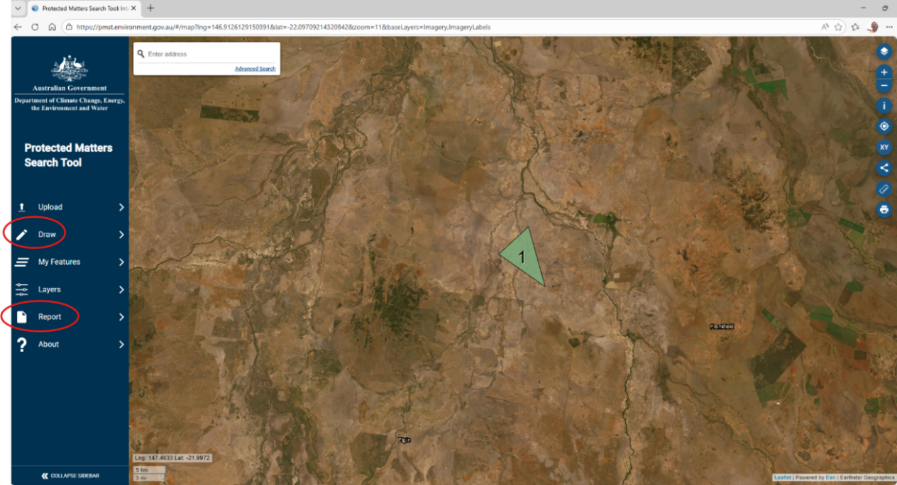
Figure 1: Setting the initial search zone
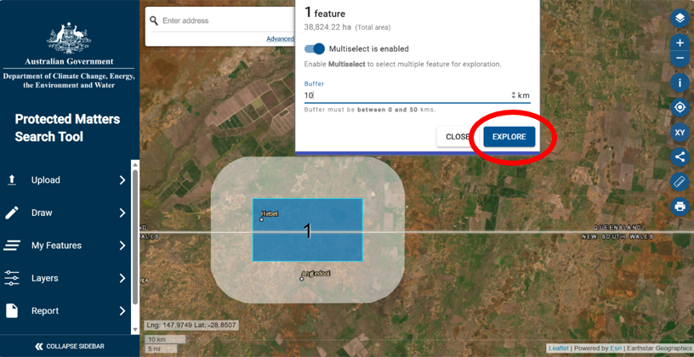
Figure 2: Creating a report of protected matters in the area
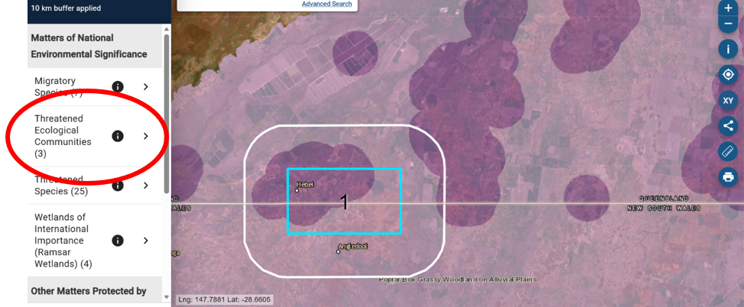
Figure 3: Viewing mapping of listed species and ecological communities

Reviewing the PMST results
- The likelihood of a protected matter occurring on your property is listed under ‘presence status’ as ‘known to occur’, ‘likely to occur’, ‘may occur’. Guidance has been provided on how to interpret these results here Interpreting PMST results
  - You may be able to easily rule out some protected matters without further research if it is clear that your activity could not impact them, or their habitat. For instance, if a threatened turtle is flagged but the area you want to clear is not near water (and runoff from clearing could not get into water), note that this protected matter has been ruled out, and why, as part of your self-assessment.
  - If you are uncertain if a protected matter, or its habitat is present, always assume they are present and conduct your self-assessment based on that assumption. If your self-assessment shows a significant impact could occur, that is when it is important to determine if the protected matter (or their habitat) is definitely present.
- See the Species Profile and Threats Database (SPRAT) for more information (including conservation advices, listing advices and recovery plans) about the protected matters.
- Prioritise which protected matters to consider further based on the likelihood of occurrence and whether the habitat present on the property may be suitable for the protected matter.
  - Check the interactive map to see whether the area you plan to clear overlaps with any protected matters.
  - Consider what protected matters within or near the clearing area may be affected by your activity, including through indirect impacts such as erosion, sedimentation, chemical use, or dust.
  - Compare what the protected matters need to survive using, for example, SPRAT conservation advice, with the actual conditions on your land, such as habitat type, vegetation quality, soil types and water features. State/territory or other national databases (See Appendix A: Helpful links for links) may also provide helpful information. The aim here is to determine how an action may impact protected matters on your property. If in doubt, contact National EPA for assistance.
- Document your findings (see Appendix B: EPBC self-assessment template), including any species you screen out and why.
  - If you think you could impact protected matters, you should seek advice from the National EPA.
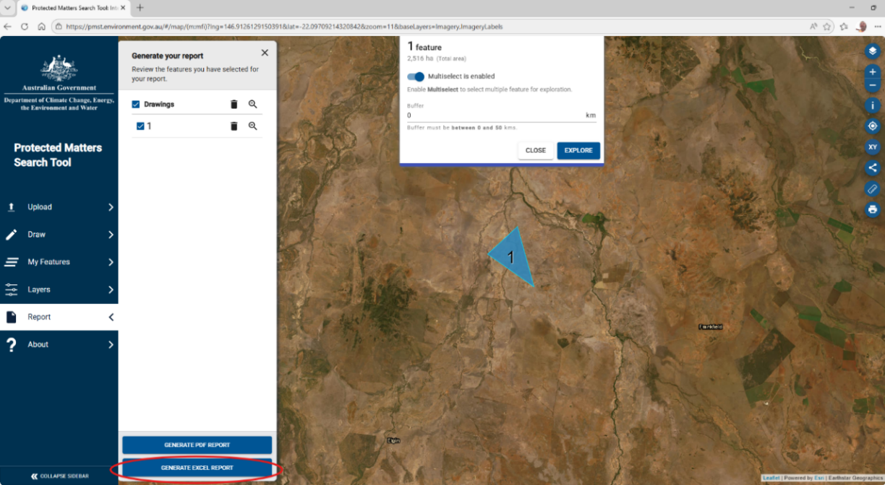
Figure 4: Creating a report
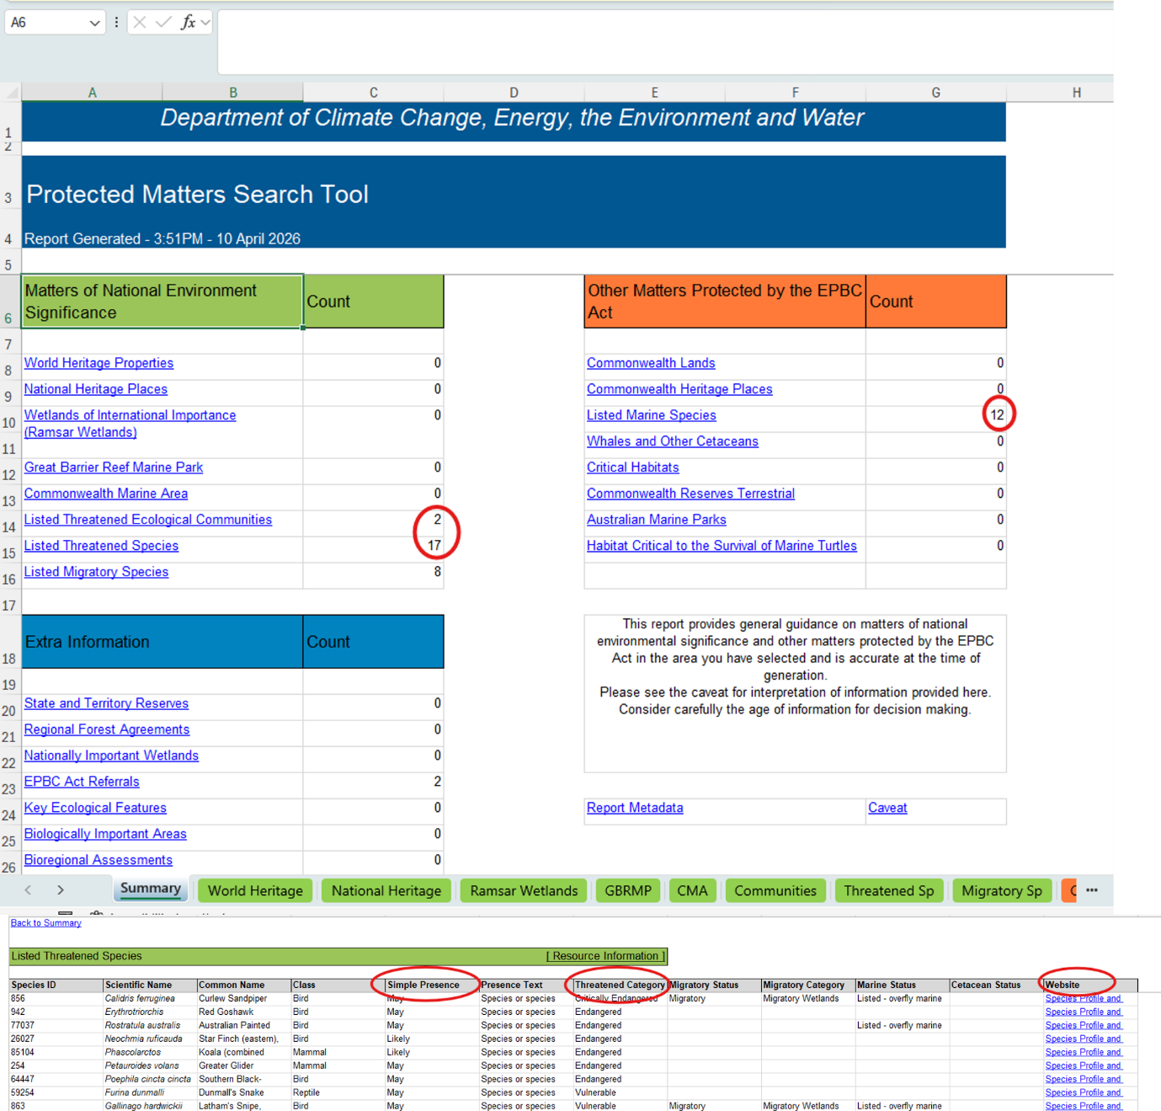
Figure 5: Reviewing the protected matters report

Interpreting PMST results
PMST results should help you with your self-assessment by showing you what to focus on. If for example, the search shows migratory or marine species, these can generally be excluded at the start of the analysis, unless there is a significant wetland nearby. When looking at species or ecological communities, you will see a rating of how likely it is that they are present: ‘known to occur’, ‘likely to occur’ or ‘may occur’. See below for guidance on how to interpret these results. A description of species and ecological communities that commonly appear in searches is at Appendix D: Frequent flyers – species and communities that most often occur on farms, which links to statutory documents describing general ecology, habitat requirements, key threats, conservation objectives (e.g. avoidance, mitigation and management measures) and other information.
To learn more about the threatened species or ecological communities that may be on your land, you can use the Species Profile and Threats Database (SPRAT). SPRAT includes statutory documents such as conservation advice, listing information and recovery plans, which include key threats. You can access SPRAT by following the web links provided in your Protected Matters Search Tool (PMST) report, and links to species and ecological communities that commonly appear in searches is at Appendix D: Frequent flyers – species and communities that most often occur on farms.

Known to occur
This category is for a species or ecological community that has confirmed records in the project area or has been detected in recent surveys.
- Treat it as present on site.
- Include it in your self-assessment.

Likely to occur
This category is for a species or ecological community with a high probability of occurrence. It means suitable habitat or conditions are present and there is a recent record of occurrence nearby.
- Include it in your self-assessment.
- Review habitat quality and potential impacts.

May occur
This category is for a species or ecological community that could occur because the broader habitat (or Condition thresholds for ecological communities - see Appendix D: Frequent flyers – species and communities that most often occur on farms) is modelled as potentially present (the project area lies within the known distribution range despite no recent records confirming its presence). The habitat may be of marginal quality.
- Consider habitat suitability, for a species.
- If suitable or high-quality habitat exists, include in your self-assessment.
- If suitable habitat is absent or highly degraded, you may justify screening the species out.

Self-assessment tips:
- If known to occur: include in self-assessment
- If likely to occur: evaluate habitat and any potential impacts of your activity
- If it may occur: assess habitat suitability:
  - if suitable: consider further.
  - if not suitable: Document and screen out

I think I need an approval – what next?
The self-assessment process helps you to identify if your proposed action is likely to have a significant impact on protected matters. If you believe your action is likely to have a significant impact, you must refer it for assessment under the EPBC Act.
There are several reasons why landowners submit a formal referral application. In the past, these have included:
- self-assessments showing that you may impact on habitat for listed species, ecological communities or protected wetlands
- cases where a higher level of legal certainty is needed, such as when preparing a property for sale, or during succession planning (properties with a referral decision have legal certainty with regard to the referral submission)
- concerns someone might complain or report the work, and the landholder wants to remove the risk of a future compliance action.
To ensure that the referral (and if necessary, approval) process is as efficient as possible, we recommend that you:
- talk to the National EPA early and often (see advice on pre-referral meetings below)
- hire a suitably qualified environmental consultant to provide you expert ecological advice
- prepare survey data, following survey guidelines, state survey guidelines and/or best practice survey guidelines
- design activities to avoid and mitigate environmental harm
- prepare an offset in accordance with Commonwealth requirements if you cannot avoid or mitigate adverse impacts to nationally protected matters
- submit the referral to the National EPA.
Once you have referred an action, you must not proceed with the activity until a decision under the EPBC Act has been reached. If in doubt, speak to the National EPA.
Going through the National EPA’s referral and assessment process will ensure you receive full legal certainty for the referred action under national environmental law. Legal certainty means you have certainty that your Commonwealth environmental obligations have been met and can be helpful when negotiating sale of properties, or during succession planning, particularly if you are looking to change how the property is managed.
For fast approvals, include all necessary information in your application. We recommend using an environmental consultant if you think your action is likely to have a significant impact on nationally protected matters.

Pre-referral meetings
We recommend booking a free pre-referral meeting with assessment staff from the National EPA early in the design of your action, particularly if you think that you might need to submit a referral. You may want to engage with the National EPA on multiple occasions prior to the submission of a referral, particularly if you redesign your action. If you want clarification prior to starting or planning an action, contact the National EPA on 1800 976 422.
Pre-referral meetings can help you:
- identify key information that should be considered
- get MNES-specific advice from the National EPA to provide to assist you to reduce the potential for significant impacts (e.g. project design, MNES to focus on, examples of avoidance and mitigation, etc)
- make sure you aren’t missing anything important from your self-assessment
- understand potential regulatory risks
- clarify what information would likely be required if you refer the action.
Pre-referral meetings are free and optional. They are an early engagement option that can help you better understand your obligations under the EPBC Act, reduce uncertainty and help you make informed decisions about farm activities before significant time or money is invested.

Preparing for a pre-referral meeting
Before the meeting, complete a basic self-assessment and check the Protected Matters Search Tool (PMST) for the property area (see How to determine if there are protected matters on your land). You do not need detailed technical studies at this stage, but you should be able to explain:
- where the activity will occur (a property map is helpful)
- what you propose to do (e.g. clearing, creating a new dam, undertaking irrigation works, building new infrastructure, or changing the land-use)
- the timing and scale of the activity
- any surveys, reports or previous approvals you have
- the types of vegetation on your property.
Providing this information in advance helps National EPA staff prepare for the discussion and ensures the meeting focuses on what is relevant to your action. Come with any questions or concerns you want to discuss.

What happens during a pre-referral meeting?
Pre-referral meetings are held with assessment staff member and can take place online, by phone or in person (depending on location). During the meeting, staff members will explain:
- how the EPBC referral and assessment process works
- typical timeframes and potential costs, should you need or want to do a referral
- the type of information usually required in a referral
- how potential impacts on protected matters are considered
- any extra information you should consider in your self-assessment.
You can talk through your proposed farming activity, any steps you have taken to avoid or minimise impacts, and any alternative options you are considering. The meeting is intended to be informative and practical. After the meeting, you will receive a written summary of what was discussed to help inform your next steps.

What a pre-referral meeting will not do
A pre-referral meeting is not designed to determine whether your activity must be referred or whether it would be approved. Staff members cannot give a legal ruling or guarantee an outcome. The decision about whether to refer an action remains with you as the landholder. If you proceed without a referral and your activity does significantly impact on a protected matter, there may be legal consequences under the EPBC Act.

Where you can get professional advice
Landholders can seek independent advice from ecologists or environmental consultants if they need help completing an EPBC Act self-assessment or preparing a referral. These professionals can assist with identifying protected matters on or near a property, advising on potential impacts of farm activities, and preparing supporting information if a referral is needed. The National EPA recommends that referral is prepared by a suitably qualified environmental consultant, where available, to ensure that all EPBC Act and EPBC Regulations requirements are identified, appropriately assessed and suitably documented. Early advice can help reduce uncertainty, avoid unnecessary costs, and support practical decisions about whether and how the EPBC Act applies to a proposed farm activity.
A good starting point is a recognised professional body:
- Environment Institute of Australia and New Zealand (EIANZ) is Australasia’s peak body for environmental practitioners, with a searchable directory of members, including EPBC-experienced consultants.
- Environmental Consultants Association (WA) represents commercial environmental consultants in Western Australia and has a ‘Find a Consultant’ tool.
- Ecological Consultants Association of NSW represents qualified ecological consultants in NSW and offers a consultant search, including certified practitioners.
Industry associations and farming organisations
Peak farming organisations and commodity groups can also be helpful. While they don’t tend to provide ecological assessments, they often:
- maintain lists of recommended consultants for members
- provide guidance notes or templates
- offer referrals to advisers familiar with agricultural settings.
Local grower groups, Landcare networks, and regional natural resource management organisations may also be able to recommend consultants who understand local environmental conditions.

Choosing an adviser
When engaging a consultant, ask whether they have experience with EPBC Act referrals, agricultural activities, and working in regional or farming contexts.

Preparing and submitting a referral
If, after your self-assessment you decide your action is likely to have a significant impact on protected matter(s), you need to refer your action to the National EPA. Your referral application is designed to help the Minister (or their delegate) decide if your action needs to be assessed. Before submitting your referral, you'll need to prepare supporting documents. Both your preparation and our process can take some time. Once you have prepared your information, complete the online referral form, make the relevant declarations and submit it through our business portal.
Provide as much clear, relevant information as possible to support your referral. The online referral form requires a written submission detailing:
- the nature of the action
- the location of the action (including maps and spatial data)
- the relevant environmental values (species, communities, water resources)
- expected impacts and ways you have sought to avoid or mitigate those impacts.
You should plan ahead if you think you’ll need to submit a referral as you may need to consider things such as:
- surveys that may need to be undertaken. This can only happen at certain times of the year, depending on the protected matter.
- you may realise you'll need to provide new information, such as considering additional protected matters, after having a pre-referral meeting.
We have resources to assist you including:
- a referral preparation guide
- an offline version of the referral form.
After you have submitted your referral, we'll ask you to pay the referral fee (where applicable), which applies Exemptions from EPBC fees or we grant you a waiver. Learn more about fees, exemptions and waivers.
Your referral won't appear immediately on the all referrals section of the EPBC Act Business Portal. We need to review it first to ensure it meets the requirements of the EPBC Act regulations (Schedule 2). We'll contact you if you need to make any changes. Then we'll tell you when it's been published on our EPBC Act Public Portal for public comments.
After receiving the referral, the Minister (or their delegate) will decide whether the action needs a Commonwealth approval. The three categories are:
- ‘not a controlled action’ which means you can proceed as planned in your referral and no Commonwealth approval is required
- ‘not a controlled action – particular manner’ which means you can proceed with no Commonwealth approval if you carry out the action in a specified particular manner
- ‘controlled action’ which means your action needs to be formally assessed and approved before you start work.

How long it will take

Self-assessment timeframes
The time taken to undertake a self-assessment will vary depending on the complexity of the work, and the number of protected matters that are likely to be present. To date, most of the landholders contacting us directly have been able to complete their self-assessment in a few days. They sometimes contact us for a follow-up discussion (which you are most welcome to do).
Self-assessments are for your records. They do not need to be submitted to the National EPA for review or approval. We may ask to see them, however, if we suspect you may have reached the wrong conclusion.

Referral timeframes
Under the EPBC Act, the statutory timeframe for the Minister (or delegate) to make a decision on the outcome of a referral is 20 business days from when the referral is published. This timeframe includes a 10 business day public comment period where any interested parties can submit a comment on your referral to the National EPA.
This 20-day timeframe is paused if the National EPA requests further information, and restarts once you provide the requested information. The more complete the information, the quicker we can consider your application.

Assessment timeframes
If the action is deemed ‘not a controlled action’ or ‘not a controlled action – particular manner’, the referral process ends and you can proceed to undertake that action (in accordance with any specified particular manner) without further EPBC Act assessment. If it is deemed a ‘controlled action’, however, the action moves into the assessment phase.
The National EPA determines the method by which the action is to be assessed based on:
- the complexity of the action
- the scale of the impacts
- the quality and completeness of the information submitted with the referral.
If you submit good quality information prepared by a suitably qualified expert (such as an environmental consultant), the National EPA is likely to proceed with a more streamlined assessment approach, which reduces time and cost.
Options include:
- assessment on referral information
- assessment on preliminary documentation
- bilateral (state/territory-accredited) assessment
- environmental impact statement (EIS)
- public inquiry
It is common for agricultural projects which require assessment and approval to run through preliminary documentation which is generally a faster approval pathway. You can find more information about assessment options on our website.
Assessment timeframes vary significantly and depend on the method:
- Simple or minor assessments can be relatively fast (months)
- EIS or major assessments can take 1 to 2+ years
- Public interest or complexity can add delays.
- The biggest delays to projects are generally when there are information gaps, which need to be addressed by landholders before the National EPA can progress an assessment.

Planning your project around a referral or assessment
Undertake a self-assessment:
- Avoiding significant impacts on nationally protected matters is the fastest way to get through the EPBC Act process. Consider designing the activity to avoid known or likely habitat areas entirely.
- Hire a suitably qualified environmental consultant to undertake vegetation assessments and surveys (if required, but especially for large-scale and high-risk actions).
Submit a referral:
- Build time in for your referral to be validated. There is no statutory timeline for a validation, but it is done on first-come-first-paid basis.
- All parts of the process, including validation, go quicker when you submit all required information and pay promptly (or demonstrate you are exempt from the fee).
Consider the referral timeframe:
- There is a 20-business day timeframe for a referral decision from the date that the referral is published. If the National EPA needs more information, it may be longer than 20 business days.
Consider the assessment timeframe:
- If your action is found to be a controlled action (i.e. likely to cause significant impacts to nationally protected matters) and therefore requires assessment, your action could take anywhere from 3 months (for a simpler action) to a couple of years (for large complex actions with large areas of habitat clearance) to be approved.
- This also depends on the quality and completeness of information you provide up front and how many protected matters are likely to be significantly impacted by your action.

Exemptions from EPBC fees
If you refer an action under the EPBC Act, you will need to pay fees unless you qualify for an exemption or waiver.
People who are not acting on behalf of a company are exempt from fees. To see if you're exempt, check Part 5 Subdivision M of the EPBC Regulations.
You may also be exempt if you meet the Australian Tax Office criteria for a small business.
Find out more about Fees, exemptions and waivers under the EPBC Act.
If you are an individual not acting on behalf of a company or qualify as a small business (under the ATO definition) with an annual turnover of less than $10 million per year, or you are exempt from all National EPA referral and assessment fees.

How we approach compliance – there is no such thing as a ‘blanket approach’
The National EPA’s approach to enforcing compliance and enforcement is outlined in its Compliance Policy. We focus on encouraging and verifying compliance with the EPBC Act, and approvals granted under it, while responding proportionately when non-compliance is identified.
The National EPA applies a proportionate response model that considers a range of factors, including the nature and seriousness of the contravention, the level of environmental harm or risk of harm, the conduct and cooperation, compliance history and whether the behaviour is deliberate, reckless or repeated.
We support and encourage compliant behaviour and work constructively with people acting in good faith. We expect land holders and proponents to take reasonable steps to understand their obligations under the EPBC Act and to consider whether their activities may significantly impact matters protected under national environmental law.
Undertaking an action without approval that has, will have or is likely to have a significant impact on a matter protected under the EPBC Act may contravene the EPBC Act. Where unlawful or unapproved clearing occurs, the National EPA will assess the circumstances of each case individually and determine an appropriate compliance response based on the available evidence and the level of environmental risk or harm.
Strong enforcement responses may be considered where non-compliance is serious, deliberate, reckless, repeated or results in significant environmental harm. Each matter is assessed on its individual facts and circumstances.
We work collaboratively with communities, regions, industry, states/ territories, First Nations people, other government departments and international partners to deliver this compliance approach.
There is no transition period for the amendments to the lawful continuations of use exemption in section 43B of the EPBC Act relating to 15-year growth and Great Barrier Reef catchment areas. The amendments commenced 1 December 2025. Activities undertaken from that date must comply with the amended legislation.
How does the National EPA approach compliance?
- Verifying continuous use. Where a land manager seeks to rely on the lawful continuous-use exemption, we will consider the available evidence as a whole. Relevant evidence may include historical records, local or state authorisations, farm management records, diary notes, invoices, aerial or satellite imagery, photographs, maps, and the land manager’s knowledge of the property and normal management cycle. The key issue is whether the activity is a genuine lawful continuation of a pre-2000 use, rather than an expansion, intensification or new use. Evidence of cyclical management will be important, particularly where clearing or treatment occurs periodically rather than every year.
- Level of evidence for self-assessment. We do not expect land managers to prove every issue with absolute certainty. We do expect them to make reasonable enquiries, use available tools, consider the condition of the land on the ground, and keep records showing how they reached their conclusion. A self-assessment should be able to show the steps taken, the information relied on, any assumptions made, and why the land manager considered the activity was unlikely to have a significant impact or did not require referral. If the conclusion is reasonable, evidence-based and consistent with the available information, that will be taken into account in any compliance assessment.
- Level of survey effort required. The level of survey effort depends on the nature, scale, location and risk of the proposed activity. Lower-risk activities may only require desktop checks, photos, maps and local knowledge. Activities in or near potential habitat, threatened ecological communities, waterways or other sensitive areas may require advice from a suitably qualified environmental consultant, targeted survey work, or sampling designed to test whether protected matters are present and likely to be affected. Where uncertainty remains, land managers should take a conservative approach, seek advice, redesign the activity to avoid significant impacts on MNES, or consider referral.
- How compliance considers regulatory risk. Compliance decisions are made case by case, based on the evidence available and the civil standard of proof. We will consider the environmental harm or risk of harm, the seriousness of any contravention, the quality of the land manager’s self-assessment and records, whether expert advice was sought where appropriate, the apparent intent of the person involved, and their compliance history. We will work constructively with people who have made genuine, reasonable and documented efforts to understand and comply with the EPBC Act. Stronger enforcement action is more likely where conduct is deliberate, reckless, repeated, unsupported by reasonable enquiries, or results in serious environmental harm.

Monitoring, verification, collection and analysis
We routinely monitor and verify compliance across our regulatory schemes. To collect and analyse data and information in accordance with relevant legislation, we may:
- ask questions
- inspect, authenticate, take extracts from or make copies of documents
- require the production of records
- inspect, examine, take measurements or conduct tests
- take photographs or make recordings
- examine or observe activity conducted on the premises
- access external information, intelligence and data sources – including from commercial business
- seek data sets and specialist sources of information, such as aerial or satellite imagery.
Where suspected non-compliance is identified, we undertake additional targeted collection and analysis to confirm or dismiss our concerns. Targeted collection can include:
- conducting additional compliance inspections or audits
- undertaking investigations to gather specific information
- conducting targeted operations such as multi-agency investigations, intelligence gathering, surveillance activities and a range of law enforcement actions
- external information, intelligence and data sources – including holdings from other law enforcement and regulatory agencies
- specialist examination and detection technologies operated by other law enforcement and regulatory agencies
- consulting experts
- searching premises under warrant.
Where the National EPA identifies non-compliance with the EPBC Act, it may use one or more of the following compliance and enforcement tools:¹²
- official warning letter
- conservation agreement with remediation provisions
- enforceable undertaking
- remediation determination
- remediation order
- injunction
- civil penalty proceedings
- criminal prosecution.
Taking an action without approval that has, will have or is likely to have a significant impact on a matter protected under the EPBC Act may constitute both a civil penalty provision and a criminal offence.

If you become aware of activity that you believe may not comply with the EPBC Act, please visit the National EPA website for more further information or to report your concern.¹³

Contact us
If you have questions about your obligations under the EPBC Act with respect to your land, contact us on 1800 976 422 between 9:00 am to 5:00 pm (AEST) Monday to Friday, except public holidays. You can also ask for a call back at a time that suits you, even if this is outside of 9am-5pm. Alternatively, email EPBC.Referrals@nationalepa.gov.au to book a free pre-referral meeting, ask for a callback at a time that suits you, or let us know your feedback. This is an advice service only and as per the DCCEEW/National EPA privacy policy, your details will only be stored for the purpose stated above.
This is an initial version of Agriculture and the EPBC Act, if you have comments or feedback, please contact the National EPA or pass feedback on to your peak organisation. Further versions of this guide will be available informed by user feedback.

Glossary
Term | Definition
Action | A project, development, undertaking, activity, or series of activities, including changes to any of these. Actions include construction, expansion, demolition, industrial processes, resource extraction (including pilots or exploration), water use, agriculture (including land-use change), clearing vegetation, and associated site preparation, operation, maintenance, and closure activities.
Actively occupying | Species or ecological community currently residing in, using, or taking physical control of a specific habitat
Activity | An action or set of actions, including constructing, operating, maintaining, or decommissioning works, that may cause environmental impacts. These can include construction, clearing land, or operating equipment.
Area of interest | A place you focus on for a project or study. The area you want to look at more closely. The area of interest may be broader than the final project footprint to ensure all relevant ecological, cultural, and environmental values are properly identified.
Assumptions | Statements or conditions accepted as true for the purposes of the assessment. These are often used where information is incomplete or to define the scope and limitations of the analysis.  In practice, this means things that are taken as true for the purpose of the assessment, even if they cannot be fully proven at the time.
Avoidance | Measures taken to prevent impacts from occurring in the first place by changing the location, design, timing, or nature of an activity.  In practice, this may mean avoiding areas of high-quality habitat such as areas of remnant vegetation, riparian areas and established shade lines.
Clearing event | Removing native or non-native vegetation from land that changes any of its use, structure or ecological function. This includes woody vegetation (trees and shrubs) and non-woody vegetation like groundcover like grasses.
Lawful continuous use | The exemption for lawful continuous use is provided by section 43B of the EPBC Act, which applies where:  - the action with a lawful continuation of land use that was occurring before the EPBC Act commenced in July 2000. The exemption applies where:  - there is no enlargement, expansion or intensification of the land use  - there has been no substantial increase in impact from the use of the land as result of:  - a change in where the land-use occurs  - a change in how the land is being used.  - If the land-use involves the clearing of vegetation:  - the land has been cleared within the last 15 years (unless the clearing is part of an established forestry operation)  - the clearing does not occur within 50m of a watercourse, wetland or drainage line in the Great Barrier Reef catchment area.
Controlled action | One of the possible decisions the environment minister can make about a referred action. A controlled action is one that the minister decides has, will have, or is likely to have, a significant impact on a protected matter.
Critical habitat | Habitat critical to the survival of a listed species or ecological community. Refers to areas that are necessary:  - for activities such as foraging, breeding, roosting, or dispersal  - for the long-term maintenance of the species or ecological community (including the maintenance of species essential to the survival of other species or the ecological community, such as pollinators)  - to maintain genetic diversity and long-term evolutionary development, or  - for the reintroduction of populations or recovery of the species or ecological community
Drainage feature (QLD Water Act 2000) | A natural landscape feature, including a gully, drain, drainage depression or other erosion feature that  - is formed by the concentration of, or operates to confine or concentrate, overland flow water  - during and immediately after rainfall events  - flows for only a short duration after a rainfall event, regardless of the frequency of flow events; and commonly, does not have enough continuing flow to create a riverine environment.
Ecological community | A group of native plants, animals and other organisms that naturally occur together and interact in a unique habitat. An ecological community’s (EC) structure, composition and distribution are determined by environmental factors such as soil type, position within the landscape/seascape (e.g. altitude/depth), climate, and water availability, chemistry and movement (e.g. oceanic currents). Species within each ecological community interact with and depend on each other— for example, for food or shelter.  Listed ecological communities include grasslands, woodlands, shrublands, forests, wetlands, marine, ground springs and cave communities.
Existing footprint | The physical or environmental space currently occupied, affected, or utilized by a landholder
Expert | An accredited person, with at least 5-years working in that field, can provide an expert report and be willing to stand behind it.
Great Barrier Reef Catchment | Catchment area of the Great Barrier Reef Marine Park means the area falling within the boundary described in the dataset that:  - is titled Great Barrier Reef catchment and river basins; and  - has a dataset scale of 1:100,000; and  - specifies the boundaries of all river basins draining to the Great Barrier Reef; and  - is dated 5 May 2018; and  - is held by the government of Queensland.  Note 1: An indicative map of this area is set out in Schedule 2.  Note 2: The dataset could in 2025 be viewed on the Queensland Spatial Catalogue’s website (https://qldspatial.information.qld.gov.au/catalogue/).  Find out if your property is part of the catchment: Reef regulatory requirements map | Environment, land and water | Queensland Government
Habitat | Means the physical environment:  - occupied (continuously, periodically or occasionally) by a species or ecological community; or  - once occupied (continuously, periodically or occasionally) by a species or ecological community, and into which the same species have the potential to be reintroduced.
Hazardous trees | Hazardous trees and/or tree hazards are defined as a tree, limb or branch that is expected to fall within the timeframe of the current operation and has the potential to impact personnel, infrastructure, or appliances.
High risk areas | Habitats often characterized by a high probability of loss, degradation, or fragmentation, which places the species relying on them at a high-to extreme-risk of extinction
Hydrology | The study of the movement, distribution, and quality of water on and below the Earth’s surface, including surface water, groundwater, drainage patterns and flows.  In practice, this means looking at how water moves and behaves in an area, including rivers, creeks, rainfall, drainage and groundwater.
Indirect impacts | Significant impacts on MNES that are indirect or offsite. Indirect and offsite impacts include:  - ‘downstream’ or ‘downwind’ impacts, such as impacts on wetlands or ocean reefs from sediment, fertilisers or chemicals which are washed or discharged into river systems;  - ‘upstream impacts’ such as impacts associated with the extraction of raw materials and other inputs which are used to undertake the action; and  - ‘facilitated impacts’ which result from further actions (including actions by third parties) which are made possible or facilitated by the action. For example, the construction of a dam for irrigation water facilitates the use of that water by irrigators with associated impacts. Likewise, the construction of basic infrastructure in a previously undeveloped area may, in certain circumstances, facilitate the urban or commercial development of that area.
Intensification (in context of continuous use) | Changing land use in a way that makes the environmental impact stronger or more acute.  As an example, changing from grazing to rotational cropping is an intensification as the level of ground disturbance is typically much greater.  Oversowing listed native grass with exotic pasture grasses is an intensification as it has a detrimental impact on native vegetation. Moving from one broad production system to another (grazing to cropping) is an intensification.
Land clearing | Removing native or non-native vegetation from land that changes any of its use, structure or ecological function. This includes woody vegetation (trees and shrubs) and non-woody vegetation like groundcover like grasses.
Matters of National Environmental Significance | The matters of national environmental significance (MNES) are:  - world heritage properties  - national heritage places  - wetlands of international importance (often called ‘Ramsar’ wetlands after the international treaty under which such wetlands are listed)  - nationally threatened species and ecological communities  - migratory species  - Commonwealth marine areas  - the Great Barrier Reef Marine Park  - nuclear actions (including uranium mining)  - water resources, in relation to coal-seam gas development and large coal-mining development
Mitigation | Actions or strategies implemented to reduce, manage, or offset adverse environmental impacts after avoidance and minimisation measures have been applied.  In practice, this means changes such as undertaking activities when birds and other species are not breeding or leaving vegetated corridors of movement between remnant patches.
MNES habitat | Areas where nationally protected matters are known to occur
Potential habitat | Areas where nationally protected matters are likely or may occur
Presence | The confirmed, or potential, occurrence of a species, ecological community, or environmental value in a defined area, based on survey data, records, or habitat suitability.  In practice, this is whether a plant, animal or environmental feature is known or likely to exist in an area.
Protected matters | Most relevant for agriculture on private land are listed threatened plants, animals, and the ecological communities that sustain them, which can also be listed in their own right.  The full list of protected matters also includes world and national heritage places, wetlands of international importance, migratory species, nuclear actions, and Commonwealth areas. The EPBC Act also protects water resources from unconventional gas development and large mining developments, as well as controlling the environmental impacts of Commonwealth actions.
Referral | The process of formally submitting information about a proposed action to the National EPA for a decision by the environment minister on whether assessment and approval under the EPBC Act are required.  This is essentially a screening test that gives a formal decision on whether the proposed clearing is ‘in’ or ‘out’ of the assessment/approval process.
Remnant vegetation | Native vegetation that has not been cleared or significantly modified and retains its original structure and ecological characteristics, often providing habitat values.
Sensitive habitat | Habitat critical to the survival of a species or ecological community’ refers to areas that are necessary:  - for activities such as foraging, breeding, roosting, or dispersal  - for the long-term maintenance of the species or ecological community (including the maintenance of species essential to the survival of other species or the ecological community, such as pollinators)  - to maintain genetic diversity and long-term evolutionary development, or  - for the reintroduction of populations or recovery of the species or ecological community
Significant impact | An impact that is important, notable, or of consequence, because of its context, intensity, duration, and scale, particularly in relation to protected matters. For more information see “Determining if there is a significant impact” and Significant Impact Guidelines (links)
Suitably qualified environmental consultant | A professional with relevant tertiary qualifications, demonstrated experience, and technical expertise in ecology or a related field, competent to undertake ecological surveys and impact assessments.
Watercourse (CTH Water Act 2007) | - Means a river, creek or other natural watercourse (whether modified or not) in which water is contained or flows (whether permanent or from time to time); and  - Includes:  - a dam or reservoir that collects water flower in a watercourse  - a lake or wetland through which water flows  - a channel into which the water of a watercourse has been diverted  - part of a watercourse  - an estuary through which water flows
Wetland (Ramsar Convention) | Areas of marsh, fen, peatland or water, whether natural or artificial, permanent or temporary, with water that is static or flowing, fresh, brackish or salt, including areas of marine water the depth of which at low tide does not exceed six metres.
Wildlife corridors | Wildlife corridors are connections across the landscape that link up areas of habitat. They support natural processes that occur in a healthy environment, including the movement of species to find resources.

Appendices

Appendix A: Helpful links
Updates to continuing-use exemptions under the EPBC Act
A step-by-step guide to referrals and environmental assessments under the EPBC Act
This webpage also includes simplified videos about:
- navigating the EPBC Act
- self-assessment before making a referral under the EPBC Act
- EPBC matters of national environmental significance (MNES)
- avoidance and mitigation
Self-assessment under the EPBC Act
You may need to submit a referral if your project potentially impacts any matters protected under the EPBC Act. Self-Assessment is the first stage of the EPBC Act process and will help you understand if you need to refer your project to the National EPA.
The Protected Matters Search Tool (PMST)
When planning a project, you need to know if your actions might impact the local environment. You can search the PMST to see what is protected under the EPBC Act. Use it as a guide to help work out what protected matters might be on your property. If there are likely protected matters on your property, you should undertake a self-assessment to determine if you need to lodge a referral or avoid impacts in the project area.
Significant Impact Guidelines
These guidelines provide overarching guidance to help determine whether your planned action is likely to have a significant impact on a matter protected under the EPBC Act.
Queensland Globe mapping
This mapping tool provides a comprehensive digital map of Queensland’s vegetation. It can assist you to investigate the time since the last clearing event on the property or location of your interest.
Digital Earth Australia mapping
This mapping tool provides satellite imagery across Australia. It can assist you to investigate the time since the last clearing event on the property or location of your interest. Type in your address and select ‘show historical imagery.’
EPBC Act Business Portal
The EPBC Act Business Portal is where you submit referrals of an action that may impact protected matters.
EPBC Act Public Portal
All projects referred to us are available to view on the EPBC Act Public Portal. This is also where the public can comment on referred proposals.
Public comments
Guidance on public comments and decisions on actions referred under the EPBC Act.
Referral Guidelines for the Great Barrier Reef
Guidance on when a project should be approved in the Great Barrier Reef catchment area.
Brigalow regrowth guidance
Information on Brigalow regrowth and when it interacts with the EPBC Act.
Species Profile and Threats Database (SPRAT)
For information regarding listed species and communities, including their ecology, recommended survey guidelines and key diagnostic criteria, conservation advices, recovery plans, and threat abatement plans (statutory documents).
Atlas of Living Australia (ALA)
Provides access to comprehensive biodiversity occurrence and species information drawn from museums, herbaria, government agencies, and citizen science. The ALA supports species distribution analysis, ecological research, conservation planning, and environmental assessment through records, maps, taxonomy, images, and links to relevant ecological and conservation information across Australia.
NSW BioNet
The NSW Government’s biodiversity data repository providing access to information on flora, fauna, and ecosystems across The state. BioNet supports biodiversity assessment and conservation planning by providing species records, distribution maps, threatened species profiles, habitat information, and links to relevant legislation, conservation actions, and recovery instruments.
Queensland WildNet
Queensland’s biodiversity information system providing access to flora and fauna records, species distribution data, and conservation status information. WildNet supports environmental assessment, land-use planning, and conservation management by supplying species records and associated ecological information relevant to Queensland legislation and decision-making processes.
Victorian Biodiversity Atlas (VBA)
The Victorian Government’s repository for flora and fauna records, including threatened species and communities. The VBA supports environmental assessment, conservation planning, and reporting with species occurrence data, distribution information, and links to conservation status and management frameworks within Victoria.

NatureMaps – South Australia
An online spatial biodiversity information system providing access to species records, vegetation mapping, and ecological data across South Australia. NatureMaps supports land-use planning, conservation management and ecological assessment through mapping and downloadable datasets.
Natural Values Atlas (NVA) - Tasmania
Tasmania’s central repository for natural values data, including threatened species, ecological communities and geodiversity. The NVA supports planning, development assessment and conservation decision-making with mapped records and associated environmental information.
Dandjoo – Western Australia
The Danjoo platform facilitates access to information relevant to biodiversity, land and sea management. Information from Dandjoo may be used to inform impact identification, risk assessment, and mitigation measures, in conjunction with scientific datasets and regulatory biodiversity information systems.
Referral preparation guidance
If you decide to submit a referral to the National EPA, we have resources that can assist you in preparing your referral including:
- a referral preparation guide
- an offline version of the referral form

Appendix B: EPBC self-assessment template
The Environment Protection and Biodiversity Conservation Act 1999 (EPBC Act) is Australia’s national environment law. It protects Australia’s nationally significant animals, plants, habitats and places. Understanding your responsibilities means you can plan early and check which, if any, approvals you need. Self-assessment is the first stage of the EPBC Act process. It will help you understand if you need to refer your project to the National EPA.
This form is an optional checklist to help land managers complete a self-assessment. It’s a basic guide only.
If you have questions about completing this template, contact the National EPA on 1800 976 422 between 9:00 am to 5:00 pm (AEST) Monday to Friday, except public holidays. You can request a callback at a time that suits you.
If for any reason, you feel you are unable to undertake the self-assessment, it is important that you employee a suitably qualified environmental consultant to do so.
We recommend that you store a copy of the assessment and any attachments for at least 5 years.
You will need:
- this self-assessment template
- a Protected Matters Search Tool (PMST) report (or another means of determining which protected matters might be in the vicinity of the relevant property/properties)
- a copy of the relevant Significant Impact Guidelines
- any relevant ecological and land surveys undertaken on your property or adjacent lands in the last 5 years (where available)
- photos of the area where you plan to undertake the action.

Details of person doing the self-assessment
Field | Response
Full name
Name of company/partnership/trust if applicable
Authorised representative (if different)
Property name
Property address
Lot and title details
Phone / email
Postal address
State/Territory approvals (environmental development, etc) relevant to this self-assessment (include date of approval).
Commonwealth approvals relevant to this self-assessment (include date).
Consultants/experts engaged (if any).
Date self-assessment undertaken.

What are you planning to do?
Field | Response (type here) | Notes / attachments
Describe the activity including any reasoning for undertaking the action.
Location on property (e.g. GPS coordinates, references to property landmarks, paddock number).
Purpose/objectives
Key inputs (machinery, workforce, materials).
Timing/seasonality considerations (what time of year might you take the action? Would it be wet/dry season? Would it be repeated or one off?).
Will there be a change in land use?
Are you enlarging, expanding or intensifying the land use?

When was the last self-assessment undertaken?
Field | Response (Select one) | Outcome
First time the activity has been undertaken. | ☐ | Self-assessment required
You are expanding previously assessed impacts into a new area. | ☐ | Self-assessment required
It has been longer than 15 years since you conducted a self-assessment. | ☐ | New self-assessment required
You have been taking this action on a regular or cyclic basis without major change (i.e. on a < 15-year cycle). | ☐ | Depending on level of regrowth, likely no self-assessment required

Existing environment
Field | Response | Notes / attachments
Describe current land tenure and zoning.
What is the land currently used for?
Describe current topography and soils.
Describe current vegetation.
Describe existing ground cover.
Describe climate/seasonality relevant to the action.
Describe current hydrology (surface water, groundwater).
Describe any important characteristics of the vegetation. Does it:
- contain hollows
- support complex understorey
- provide stable habitat for threatened species
- Comprise a threatened ecological community?

Identifying protected matters
Field | Response
Protected Matters Search Tool (PMST) report date
Area of interest (AOI) extent/size and buffer applied.
Summary of PMST results
Number of protected matters identified e.g.
X threatened species known/likely to occur
- Species A, B, C do not occur because… (anything you can easily rule out can be briefly explained here)
- Species D is likely to occur
- Species E may occur
Y threatened ecological communities
z migratory species

*note – we recommend you focus on results that return a known or likely to be present
Other datasets checked for protected matters if required (Queensland Globe, Biologically Important Areas, Australian Heritage Database, Atlas of Living Australia)
Photographs of the areas to be affected by the works  Photographs demonstrating the condition of vegetation before treatments are applied are helpful, and would ideally cover variances across the areas being managed. | (We recommend that you retain these in a separate dated folder on your computer with this checklist)

Baseline and surveys (if existing or available - not required to be commissioned or undertaken at this stage)
Field survey methods and dates. | Enter methods & dates
Surveyor qualifications | Enter qualifications
Key baseline findings | Enter findings
Limitations/assumptions | Enter limitations

Significant Impact Assessment (apply relevant guidelines)
For each protected matter potentially affected, assess against EPBC Act Significant Impact Guidelines and any matter-specific guidance. Duplicate the tables below for each protected matter that may be affected. If you think the answer is ‘yes’ to any of the following and you cannot avoid the habitat areas, please contact the National EPA to discuss.
Listed species Significant impact criteria: An action is likely to have a significant impact on a listed critically endangered or endangered species if there is a real chance or possibility that it will:

Critically endangered and endangered species - Significant impact criteria: An action is likely to have a significant impact on a listed critically endangered or endangered species if there is a real chance or possibility that it will: | Known or likely on Protected Matters Search Tool report
lead to a long-term decrease in the size of a population | Yes ☐  No ☐
reduce the area of occupancy of the species | Yes ☐  No ☐
fragment an existing population into 2 or more populations | Yes ☐  No ☐
adversely affect habitat critical to the survival of a species | Yes ☐  No ☐
disrupt the breeding cycle of a population | Yes ☐  No ☐
modify, destroy, remove, isolate or decrease the availability or quality of habitat to the extent that the species is likely to decline | Yes ☐  No ☐
result in invasive species that are harmful to a critically endangered or endangered species becoming established in the endangered or critically endangered species’ habitat | Yes ☐  No ☐
introduce disease that may cause the species to decline, or | Yes ☐  No ☐
interfere with the recovery of the species. | Yes ☐  No ☐

Critically endangered and endangered ecological communities
Duplicate the table above for each protected matter that may be affected.
Protected Critically endangered or endangered Ecological Species - significant impact criteria an action is likely to have a significant impact on a critically endangered or endangered ecological community if there is a real chance or possibility that it will: | Known or likely on Protected Matters Search Tool report
reduce the extent of an ecological community. | Yes ☐  No ☐
fragment or increase fragmentation of an ecological community, for example by clearing vegetation for roads or transmission lines | Yes ☐  No ☐
adversely affect habitat critical to the survival of an ecological community | Yes ☐  No ☐
modify or destroy abiotic (non-living) factors (such as water, nutrients, or soil) necessary for an ecological community’s survival, including reduction of groundwater levels, or substantial alteration of surface water drainage patterns | Yes ☐  No ☐
cause a substantial change in the species composition of an occurrence of an ecological community, including causing a decline or loss of functionally important species, for example through regular burning or flora or fauna harvesting | Yes ☐  No ☐
cause a substantial reduction in the quality or integrity of an occurrence of an ecological community, including, but not limited to: – assisting invasive species, that are harmful to the listed ecological community, to become established,  or causing regular mobilisation of fertilisers, herbicides or other chemicals or pollutants into the ecological community which kill or inhibit the growth of species in the ecological community,  or interfere with the recovery of an ecological community. | Yes ☐  No ☐

Avoidance and mitigation
Outline the design alternatives you have considered to avoid remnant vegetation and other sensitive values and/or outline the ways you have changed the plan to avoid sensitive areas
Outline any commitments you can make to mitigate impacts or steps you can take to reduce impacts
Outline how you will monitor and adaptively manage the property? How you’ll keep an eye on things and fix issues?

Should you consider an EPBC referral?
Based on the information you have provided in this form so far, and using the knowledge you have available to you: | Action
Is the activity unlikely to significantly affect protected matters? | Referral required/not required
Are you unsure whether your activity is likely to significantly affect protected matters? | Seek advice from the National EPA
Do you consider it possible that your activity may have a significant impact on protected matters? | Consider booking a pre-referral meeting and submitting a referral

Pre-referral discussion (if required)
Pre-referral meeting requested? | Yes ☐  No ☐
Questions you want to ask.
Outcome of pre-referral discussion
To book a pre-referral meeting:
Email: epbc.referrals@nationalepa.gov.au
Phone: 1800 976 422 between 9:00 am and 5:00 pm Canberra time Monday to Friday

Recommended attachments
Attachment | What you should do with the document
PMST report and map | Attach
Baseline survey reports and shapefiles | Attach
Figures (footprint, buffers, habitat maps, QLD Globe reports) | Attach
Photos | Attach
Pre-referral meeting agenda/notes | Attach
Guidance referenced | List documents
Relevant state or territory approvals | Attach

Appendix C: EPBC scenarios

Scenario: Erosion control and groundcover restoration

The situation
A landholder needs to repair gullies and restore groundcover after heavy rainfall. The aim is to stabilise eroded areas, reduce soil loss and limit sediment runoff.
All work will take place within the existing farmed area.

Proposed activity
The landholder will:
- repair gullies using low-impact methods
- restore groundcover through seeding or natural regrowth
- put in place erosion and sediment controls
- maintain buffers near waterways
- use appropriate non-invasive species for revegetation
- keep records and monitor the work.

Key considerations
- The work improves land condition and supports state soil conservation rules.
- The activity stays within the existing farmed area.
- If the gully flows to a Ramsar wetland, river system, including watercourses and drainage lines in the Great Barrier Reef catchment zone or habitat for migratory or threatened species, care is needed to protect water quality.
- Work near threatened ecological communities or species habitat may require a referral if disturbance occurs.
- Low-impact methods, such as contouring or vegetation, should be used.
- Clearing vegetation, changing water flows or using chemicals near sensitive areas may still require assessment.
- When determining whether an action is ‘in’ or ‘out’ of the EPBC Act, the focus is on potential impact, not the beneficial intent of the activity. If protected matters (including habitat for a threatened or migratory species) were present and could be significantly impacted, a self-assessment would need to be undertaken and a referral may still be required.

Outcome
An EPBC Act referral was not required in this case.
Erosion control and groundcover restoration are usually low risk when:
- done within existing farmed areas
- significant impacts on Matters of National Environmental Significance (MNES) are avoided.
This would change if MNES are present and may be significantly impacted, and in this case a self-assessment is needed and a referral may be required.
If no MNES are present, or significant impacts on MNES are avoided, the work can proceed without a referral in line with state and local government requirements.

Scenario: Fodder harvesting for drought resilience

The situation
A medium-sized, family-owned grazing business operates in a semi-arid region during a dry period. Mulga and other fodder trees are an important feed source.
With limited pasture, the business needs to access fodder to maintain animal welfare.

Proposed activity
The business will:
- carry out strip harvesting of mulga in line with the Queensland Managing Fodder Harvesting Vegetation Code
- knock down trees in a way that allows regrowth
- leave unharvested areas between strips, with retained fodder species at least 4 metres high
- limit harvesting to previously disturbed areas, and to no more than 50% of the total area over 10 years
- avoid damaging non-fodder tree species taller than 4 metres
- avoid remnant vegetation and retain refuge areas.

Key considerations
- Fodder harvesting is an established practice.
- The activity is limited to previously disturbed areas and does not expand the agricultural footprint.
- Vegetation is managed to allow regrowth, not permanent clearing.
- A self-assessment confirms no Matters of National Environmental Significance (MNES) are likely to be present.
- Evidence is kept, including:
  - protected matters search tool results
  - satellite imagery of past harvesting
  - georeferenced photos before works begin
- Remnant vegetation and higher-value habitat areas are avoided.

Outcome
An EPBC Act referral was not required in this case.

Scenario: Invasive weed control near a waterway
The situation
A landholder plans to control invasive weeds along a narrow area next to a waterway in the Great Barrier Reef catchment.
These weeds are declared under state biosecurity laws, which means landholders must manage them. The surrounding area contains native vegetation that can benefit when weeds are removed.
Proposed activity
The landholder will:
- use targeted chemical spraying to control invasive weeds
- limit spraying to the affected area
- use selective herbicides and low-drift methods to avoid off-target impacts
- set up buffer zones and avoid spraying in poor weather
- take steps to prevent runoff into the waterway.

Key considerations
- The landholder is required under state law to manage declared weeds.
- Weed control is a routine activity, but EPBC Act rules still apply if Matters of National Environmental Significance (MNES) are present.
- Impacts may occur if spraying affects nearby native vegetation, species habitat, or the waterway.
- Risks include spray drift, chemical runoff, and damage to riparian vegetation.
- Careful use of herbicides, buffer zones and timing can reduce these risks.
Outcome
An EPBC Act referral was not required in this case, particularly due to:
- the self-assessment showed no MNES are present in or near the treatment area
- spraying avoids runoff, spray drift and impacts on the waterway.
This would change if habitat for protected species or ecological communities were present in the treatment area, and spraying could affect them through drift, runoff or habitat damage. In this case a referral may be required.

Appendix D: Frequent flyers – species and communities that most often occur on farms
There are a variety of nationally protected matters that can occur on farms throughout Australia. The most relevant nationally protected matters for agriculture are listed threatened species and listed ecological communities. It is important to check the statutory documents linked below (as well as other documents flagged in your Protected Matters search) as these will describe the potential habitat, threats and any thresholds for significant impact that have been established.

Threatened species
Threatened species are listed individually, and protection is provided against the significant loss, degradation and fragmentation of habitat. This could include the direct clearance of habitat, opening up intact patches of vegetation that would allow the introduction of invasive species and altered fire regimes.
The National EPA has published a range of guidance and other support materials for many of these species and ecological communities, including recovery plans and conservation advice. Some of the species that are most commonly encountered in agricultural areas are able to co-exist with many forms of farming, but clearing of habitat always carries a high risk of loss. Some of these may be well known, like koalas; others are more obscure, such as the ornamental snake. Here are some of the native species that might occur on your farm:
Table D1: EPBC species commonly appearing in search results
Region | Species commonly appearing in searches There are many species that are not listed in this table you may find on your farm, these are species that we see commonly occur. You must still do a full search of your property via the Protected Matters Search Tool as part of your self-assessment.
Eastern QLD | - Koala (Phascolarctos cinereus) – across eastern QLD in eucalypt woodlands, often overlapping cleared or semi‑cleared pastoral land.  - Greater glider (Petauroides volans) – woodland and forest edges; these often border agricultural strips.  - Red goshawk (Erythrotriorchis radiatus) – widespread raptor, with nesting trees particularly important as habitat to retain in the landscape.  - Wallum sedge frog (Litoria olongburensis) – coastal QLD, sometimes near modified drainage or wetlands.  - Black‑throated finch (Poephila cincta cincta) - eastern QLD grazing lands  - Squatter pigeon (southern) (Geophaps scripta scripta) – inhabits arid and semi-arid grassy woodlands and open forests dominated by eucalypts  - Yakka skink (Egernia rugosa) – inhabits pasture edges and woodland patches.  - Grey‑headed flying‑fox (Pteropus poliocephalus) – uses farmland fruit trees, riparian strips.
Northern QLD | - Red goshawk (Erythrotriorchis radiatus)  - Yakka skink (Egernia rugosa) – pasture edges and woodland patches.
Brigalow Belt | - Ornamental snake (Denisonia maculata) - Brigalow Belt North and parts of the Brigalow Belt South bioregions.  - Dunmall’s snake (Furina dunmalli) –Brigalow landscapes, much of which is used for grazing and cropping.
Central-Southern QLD | - Superb parrot (Polytelis swainsonii) – woodland in far southern QLD fringe.  - Giant barred frog (Mixophyes iteratus) – riparian areas in SEQ used for grazing.  - Box gum woodland species – part of the critically endangered ecological community often preserved on farms.  - Regent honeyeater (Anthochaera phrygia) – farms with flowering eucalypts or planted shelterbelts.  - Yakka Skink (Egernia rugosa) – pasture edges and woodland patches.  - Grey‑headed flying‑fox (Pteropus poliocephalus) – farmland fruit trees, riparian strips.
Eastern NSW | - Koala (Phascolarctos cinereus) - Widespread across coastal and inland NSW where eucalypt patches remain.  - Greater glider (Petauroides volans) – woodland and forest edges; these often border agricultural strips  - Regent honeyeater (Anthochaera phrygia) – farms with flowering eucalypts or planted shelterbelts.  - Grey‑headed flying‑fox (Pteropus poliocephalus) – farmland fruit trees, riparian strips.  - Pink‑tailed worm‑lizard (Aprasia parapulchella) – stony areas often surrounded by grazing land.  - Striped legless lizard (Delma impar) – native grassland remnants within farming regions.  - Superb parrot (Polytelis swainsonii) – woodland in southern and central NSW  - Swift parrot (Lathamus discolor) – areas where eucalypts are flowering profusely or where there are abundant lerp. Favoured feed trees include wamp mahogany, spotted gum, red bloodwood, forest red gum, mugga ironbark and white box.  - Diamond fire tail (Stagonopleura guttata) – found in grassy woodlands, including box-gum and snow gum qoodlands, and open forest, mallee, natural temperate grassland.  - Latham’s snipe (Gallinago hardwickii) – shelter in small wetlands including urban water bodies saltmarshes, creek edges, and crops and pasture.
Inland NSW | - Koala (Phascolarctos cinereus) - Widespread across coastal and inland NSW where eucalypt patches remain.  - Greater glider (Petauroides volans) – found in woodland and forest edges; these often border agricultural strips.  - Superb parrot (Polytelis swainsonii) - Woodland in southern and central NSW  - Plains‑wanderer (Pedionomus torquatus) – inland NSW native grasslands used for grazing.  - Box gum woodland species – part of the critically endangered ecological community often preserved on farms.  - Regent honeyeater (Anthochaera phrygia) – farms with flowering eucalypts or planted shelterbelts.  - Pink‑tailed worm‑lizard (Aprasia parapulchella) – stony areas often surrounded by grazing land.  - Grey‑headed flying‑fox (Pteropus poliocephalus) – uses farmland fruit trees, riparian strips.  - Corbens long-eared bat (Nyctophilus corbeni) – mallee woodland and cypress pine habitat, relying on tree hollow, crevices, loose bark and bark fissures for food, breeding and roosting  - Major Mitchell's cockatoo (eastern) (Lophochroa leadbeateri leadbeateri) – arid/semi-arid woodlands dominated by mulga, mallee and box eucaplypts, slender cypress pine or belah, relies on old eucalypts or cypress pines for nesting.
Western NSW | - Mallee bird community of the Murray Darling depression bioregion - assemblage of 20 bird species reliant on the mallee vegetation that characterises the Murray Darling depression bioregion.  - Painted honeyeater (Grantiella picta) - eucalypt forests/woodlands, riparian woodlands of black box and river red gum, box-ironbark-yellow gum woodlands, acacia-dominated woodlands, paperbarks, casuarinas, callitris, and trees on farmland or gardens often used for grazing or cleared for agriculture.  - Thick-billed grasswren ((Amytornis modestus) – chenapod shrublands, especially those dominated by saltbush and bluebush. In NW NSW they have been recorded on low ridgelines covered in gibber and scattered with blackbush and thorny saltbush.  - Blue-winged parrot (Neophema chrysostoma) – range of habitats from coastal, sub-coastal and inland areas through to semi-arid zones, favouring grasslands and grassy woodlands used for grazing.  - Major Mitchell's cockatoo (eastern) (Lophochroa leadbeateri leadbeateri) – arid/semi-arid woodlands dominated by mulga, mallee and box eucaplypts, slender cypress pine or belah, relies on old eucalypts or cypress pines for nesting.  - Regent parrot (eastern) (Polytelis anthopeplus monarchoides) – forages in mallee woodlands (close to nesting habitat critical), and in riverine forests and woodlands. Nests in River Red Gums forests with large, mature healthy trees usually near water.  - Plains‑wanderer (Pedionomus torquatus) – inland NSW native grasslands used for grazing.  - Southern whiteface (Aphelocephala leucopsis) – small bird favouring open woodlands and shrublands with grass/shrub understorey, dominated by acacias or eucalypts  - Corbens long-eared bat (Nyctophilus corbeni) – mallee woodland and cypress pine habitat, relying on tree hollow, crevices, loose bark and bark fissures for food, breeding and roosting  - South-eastern hooded robin (Melanodryas cucullata cucullata) – dry eucalypt and acacia woodlands and shrublands with open understorey, some grassy areas and complex ground layer.

Threatened ecological communities
Threatened ecological communities are also protected under national environmental laws. An ecological community is a naturally occurring group of native plants, animals and other organisms that are interacting in a unique habitat. Its structure, composition and distribution are determined by environmental factors such as soil type, position in the landscape, altitude, climate and water availability.
Types of ecological communities listed under national environmental law include woodlands, grasslands, shrublands, forests, wetlands, ground springs and cave communities.
Protecting ecological communities supports the species associated with them, and these are commonly also listed threatened species. Many of these ecological communities also provide valuable ecosystem services such as pest control, and clean water. Some ecological communities are also compatible with agriculture, particularly carefully managed grazing. In some cases, landholders are paid to provide ongoing management services for these areas, integrated into their farm business. The Nature Repair Market provides opportunities for landholders to be paid for their biodiversity services.

Condition thresholds for ecological communities
To qualify as an EPBC ecological community, a patch of vegetation must meet a series of condition thresholds. These commonly include factors such as minimum patch size, species, and the structure of the vegetation (forest, woodland, grassland).
Many listed ecological communities are named after their dominant species and may also have other species of plants that must be present before the area can be part of the listed community.
Areas of degraded ecological community should not be ignored – in many cases these still provide habitat for listed threatened species, and these habitats are still protected.
Ecological community | Condition thresholds (not exhaustive, be sure to check the linked information)
White box - yellow box - Blakely's red gum grassy woodlands and derived native grasslands – critically endangered ecological community, with remnant patches spread throughout Queensland, NSW, Victoria and the ACT | - Overstorey dominated by White Box (Eucalyptus albens), Yellow Box (Eucalyptus melliodora) or Blakely’s Red Gum (Eucalyptus blakelyii)  - Predominantly native understorey  - Patches greater than 0.1Ha in size  - Some additional criteria linked to understorey diversity
Brigalow (Acacia harpophylla) dominant and co-dominant) ecological community – endangered woodland community occurring throughout Queensland and NSW, providing habitat for a range of bird and reptile species. | - Located in several bioregions in NSW and Queensland  - Brigalow (Acacia harpophylla) is dominant or co-dominant tree species, either as mature trees or as regrowth from root suckers (sometimes known as ‘whipstick’) Overstorey may also include eucalyptus or casuarina, often as large emergent trees  - Woodland or open forest structure, or clearly regenerating towards that structure  - Understorey predominantly native species, and often has little to no grass, in favour of leaf litter that provides habitat for small reptiles.  - Can persist in small patches as small as 0.5 hectares
Poplar box grassy woodland on alluvial plains – endangered community typically occurring on ancient and recent depositional soils in flat terrain and occasionally along watercourses in undulating country west of the Great Dividing Range. | - Remnant patches are broadly distributed across Queensland and NSW, including the Brigalow belt.  - Dominant tree species is poplar box (Eucalyptus populnea)  - Open woodland with a grassy understorey dominated by native species, mostly grasses but may also contain native herbs and chenopods  - Shrub layer and/or small trees generally less than 30% of the crown cover  - Can persist in small remnant patches (1-5 hectares in size)
Coolibah - Black box woodlands of the Darling riverine plains and the Brigalow Belt south bioregions – endangered community occurring in the upper reaches of the Murray-Darling Basin and southern part of the Fitzroy River system. | - Coolibah (Eucaluptus colibah) and black box (Eucalyptus largiflorens) are the dominant tree species, and may include dense thickets of regenerating tree saplings.  - Occurs around waterlogged floodplains, wetlands and swarm margins, including ephemeral wetlands  - Grassy native understorey with scattered logs  - Habitat for a wide range of animal species, including nesting sites for waterbirds.
Natural grasslands of the Queensland Central Highlands and northern Fitzroy Basin – native grasslands occurring on fine textured (often cracking) clays on flat to gentle slopes in Queensland | - Found on the Darling Downs in Queensland, through to the Liverpool and Moree Plains of NSW  - Grassland with less than 10% tree cover  - Dominated by native grass tussocks, with a diverse range of component species  - Can persist in patches as small as 0.5 hectares.
More information on threatened ecological communities can be found under Threatened ecological communities.

What's protected under the EPBC Act
Environment protection reforms
Protected Matters Search Tool
Environmental offsets under the EPBC Act
Environmental offsets under the EPBC Act
Referral applications and proposals
Referrals and environmental assessments under the EPBC Act
Referrals and environmental assessments under the EPBC Act - DCCEEW
Referrals and environmental assessments under the EPBC Act - DCCEEW
Referrals and environmental assessments under the EPBC Act
Fees, exemptions and waivers under the EPBC Act
Compliance and enforcement
Report a breach of the EPBC Act
Hazardous Trees - NSW Rural Fire Service
What are wildlife corridors?

