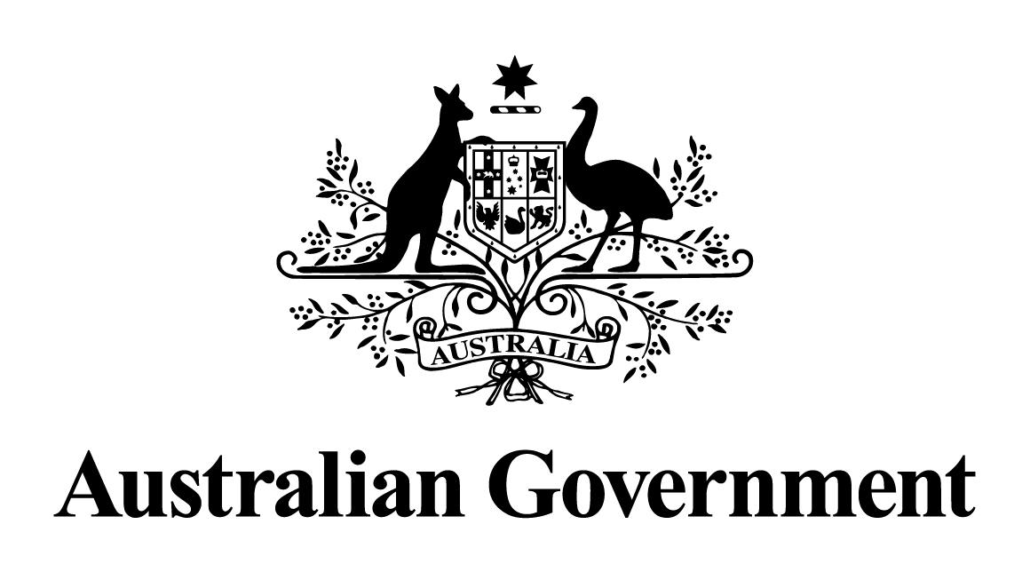

NOTICE OF DECISION TO GRANT A PERMIT VARIATION UNDER THE
HAZARDOUS WASTE (REGULATION OF EXPORTS AND IMPORTS) ACT 1989
Pursuant to section 33 of the Hazardous Waste (Regulation of Exports and Imports) Act 1989, notice is given that a variation to special export permit AUH16-030 was granted to Hydromet Corporation Pty Limited (ACN 002 802 646), 201 Five Islands Road, Unanderra, NSW, 2526 (Telephone: +64 9 914 8594; Facsimile: +64 9 309 9264).
The particulars of the varied permit are as follows:
- the proposed recipient of the waste is Kook Jea Metallic Co Ltd, 34-3 Ogup, Yeongcheon-Si, Gyeongsangbuk-Do, the Republic of Korea (Telephone: +82 31 499 4011;
Facsimile: +82 31 499 4016);
- the type of waste is lead waste and scrap derived from used lead acid batteries
(Basel Code A1020);
- the maximum quantity of the waste that may be exported is 6000 tonnes;
- the waste is to be contained during export in bulk bags in sealed shipping containers;
- the waste is to be transported during export by road to the port of export, shipped by sea, and then by road from the port of destination to the recovery facility;
- the waste may only be exported during the permit period;
- the waste is to be exported from the Port of Melbourne, Port Botany and the Port of Brisbane, Australia;
- the waste is to be exported to Port Busan, the Republic of Korea;
- the waste may not transit any countries;
- the waste is to undergo a recovery operation at the Kook Jea Metallic Co Ltd in
Gyeongsangbuk-Do, the Republic of Korea;
- the waste is to undergo recovery operation R4 – Recycling/reclamation of metals and metal compounds; and
- a financial guarantee of at least AUD $155,000 is to be in place prior to any movement of the waste and is to be valid until 30 June 2018.

The permit period is from the date below until the permit expiry date of 31 December 2017. All transboundary movements must be completed by the permit expiry date.
The permit includes and is subject to conditions.
Andrew McNee
Delegate of the Minister
Assistant Secretary
Chemicals and Waste Branch
Department of the Environment and Energy
5 June 2017

Subject to the Administrative Appeals Tribunal Act 1975, a person or persons whose interests are affected by this decision may, within 28 days, make an application in writing to the Department of the Environment and Energy requesting the reasons for the decision.
An application for independent merits review of the decision may be made to the Administrative Appeals Tribunal on payment of the relevant fee by the applicant within 28 days of receipt of the reasons for the decision, or within 28 days of this notice if the reasons for the decision are not sought. Applications should be made to the Principal Registry or the Deputy Registrar, Administrative Appeals Tribunal in your capital city or Territory, as listed under Commonwealth Government Section in the White Pages. For further information, particularly about how to apply for review, visit www.aat.gov.au.
Further information or enquiries relating to the decision should be directed to:
Director, Hazardous Waste Section
Department of the Environment and Energy
GPO Box 787
CANBERRA ACT 2601
Telephone 1800 803 772, Facsimile (02) 6274 1164, or by email at hwa@environment.gov.au.

