
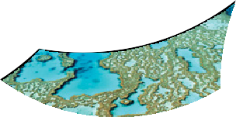
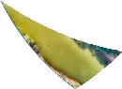
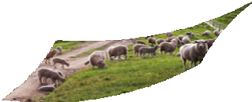

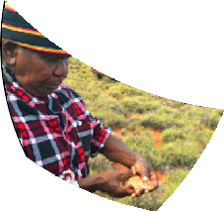



The Australian Government Department of Agriculture, Water and the Environment has published a revised referral guideline for 3 WA black cockatoos – Carnaby’s Cockatoo (Zanda latirostris), Baudin’s Cockatoo (Zanda baudinii) and the Forest Red-tailed Black-cockatoo (Calyptorhynchus banksii naso). This fact sheet explains the referral guideline, the government’s regulatory objectives for these birds and the rationale for the approach.

Black cockatoos and development in South-West Western Australia

Why a referral guideline for these birds?
Of the 1,915 species currently listed under the EPBC Act, a large number are either endemic to protected areas or are threatened by invasive species, predation, climate change or knowledge gaps on species’ biology or ecology. Australian Government funding enables the National Landcare Program, National Reserve System and National Environmental Science Program to address these threats.

Species such as the 3 black cockatoos in South-West Western Australia are most threatened from habitat loss due to residential, agricultural or industrial development.

One of our tools to address these threats is the regulatory provisions of the EPBC Act. Through case- by-case assessment of actions, better project planning and design outcomes can help avoid or minimise habitat loss.

Where this is not achievable the EPBC Act ensures compensation for the loss of habitat through offsetting, to assist species recovery afforded through other non-regulatory initiatives. It also allows us to minimise interference with the recovery of these species.

The purpose of the referral guideline
The referral guideline clarifies whether or not you need to refer your action to us for approval. This
creates a more consistent approach to decision making to help improve the recovery of these birds.

The referral guideline captures the actions posing most risk of interfering with the recovery of one or more of the cockatoos. It uses impacts to individual trees with known or suitable nest hollows and high quality habitat as key defining measures.

Determining high quality foraging habitat is underpinned by important ecological and contextual attributes including proximity to known or suitable nesting hollows. The approach is intended to be as straightforward as possible.

Site attributes indicative of high-quality foraging habitat – as outlined in the referral guideline

Black cockatoos and development in South-West Western Australia
Is > 1 ha in size

Contains suitable feed species

Shows clear evidence of feeding

Is within 12km of a known or suitable nesting site

Is within 2km of a watering point

Is within 6km of other foraging habitat

Is within 20km of known roosting habitat

Is not suffering significantly from dieback
The importance of tree hollows – as outlined in the referral guideline
- They are the foundation of life for future generations of black cockatoos.
- Recovery plans for each of the cockatoos clearly identify trees with suitable and known nesting hollows as limiting resources.
- Trees are likely to take up to 200 years or longer to develop suitable nest hollows.
- Habitat loss, habitat degradation, lack of recruitment, fire and competition are causing the scarcity of nesting resources.

What is the Australian Government wanting to achieve for these birds?
The Australian Government wants to work with anyone carrying out actions that may affect these birds to help avoid, minimise or compensate for the loss of important habitat areas. We are committed to working with you on the finer details and contextual considerations of any proposals to reach the best possible outcomes.

This approach aims to minimise any interference with the recovery of these species as well as provide support for other non-regulatory initiatives.

The rationale behind the regulatory approach
Evidence in scientific literature and expert knowledge
suggests a negative outlook for the 3 black cockatoos.
A key driver behind our regulatory approach is the significant historical and ongoing loss of habitat which is impacting the long term survival of these cockatoos in the wild.

There has been a significant loss of breeding and foraging habitat in eucalypt woodlands of the Western Australian Wheatbelt, as well as a loss of banksia woodland foraging resources and a reduction in the size of woodland patches on the Swan Coastal Plain. This has led to the listing of these important bird habitats as threatened ecological communities under the EPBC Act.

Woodlands in the Wheatbelt have declined by around 85 percent, from an estimated 6.2 million ha prior to European settlement to about 939,000 ha today. Banksia woodlands have declined by 50 to 60 percent from an estimated 708,000 ha prior to European settlement
to 337,000 ha today. The median patch size of this community has also reduced significantly from 146 ha to 1.6 ha.

The regulatory approach is also supported by declining population counts undertaken by Birdlife Australia and recent modelling for Carnaby’s Cockatoo. Under
a continuing habitat loss scenario, this modelling predicts extinction in parts of this species range in the very near future and emphasises the significance of adult mortality on the viability of the species. This information demands thorough assessments, robust decisions and stringent conditions on development
applications where these birds are known to occur and
where a significant impact is likely.

Lawful responsibilities
It is our responsibility under the EPBC Act to not let scientific uncertainty stand in the way of regulatory decision-making as defined as the ‘precautionary principle’.

National recovery plans for these species define recovery objectives and priority actions. It is our responsibility under the EPBC Act to not act inconsistently with these recovery plans.

The referral guideline and conservation

planning documents
You can access the referral guideline on the department’s EPBC Act policy statements page.

You can access the conservation planning documents
for these species on the
Species Profile and Threats (SPRAT) Database

