

Significant impact guidelines for the endangered
southern cassowary (Casuarius casuarius johnsonii)
Wet tropics population
Nationally threatened species and ecological communities
EPBC Act policy statement 3.15

Copyright
© Commonwealth of Australia 2010
This work is copyright. You may download, display, print and reproduce this material in unaltered form only (retaining this notice) for your personal, non-commercial use or use within your organisation. Apart from any use as permitted under the Copyright Act 1968, all other rights are reserved. Requests and inquiries concerning reproduction and rights should be addressed to Commonwealth Copyright Administration, Attorney General’s Department, Robert Garran Offices, National Circuit, Barton ACT 2600 or posted at www.ag.gov.au/cca.

Disclaimer
The contents of this document have been compiled using a range of source materials and is valid as at January 2010. The Australian Government is not liable for any loss or damage that may be occasioned directly or indirectly through the use of or reliance on the contents of the document.

Introduction 4
Map 1: Distribution of the southern cassowary 5
How to interpret and apply these guidelines 6
What other laws protect the cassowary? 7
The cassowary in Australia 8
The species 8
Distribution 8
Map 2: Potential southern cassowary habitat 9
Life history and ecology 10
Habitat 10
Key landscape values for the cassowary 10
Benefits to other species or ecological communities 11
Figure 1: Cassowary habitat and movement 12
Principal threats to the cassowary 13
Areas under threat 13
Survey guidelines for the cassowary 14
Survey recommendations 14
Presence/absence 14
Estimating abundance 14
Habitat assessment 15
What types of actions are likely to have a significant impact on the cassowary? 17
Table 1: Significant impact thresholds for the cassowary 18
Figure 2: Barriers to cassowary movement 20
What does this mean for actions that may significantly impact on the cassowary? 21
How can my actions avoid having a significant impact on the cassowary? 21
Table 2: Suggested mitigation measures for the cassowary 22
Figure 3: Large lot sub-division 25
Where can I get more information? 26

Introduction
This policy statement builds on the information and explanations in EPBC Act policy statement 1.1 Significant impact guidelines – Matters of national environmental significance.
The southern cassowary, Casuarius casuarius johnsonii, is listed as endangered under national environment law, the Environment Protection and Biodiversity Conservation Act 1999 (EPBC Act). The southern cassowary is also a listed value of the Wet Tropics of Queensland World Heritage Area and National Heritage Place.
Listed threatened species and ecological communities, world heritage areas and national heritage places are matters of national environmental significance. Under the EPBC Act, an action will require approval from the federal environment minister if the action has, will have, or is likely to have a ‘significant impact’ on a matter of national environmental significance.
A ‘significant impact’ is an impact which is important, notable, or of consequence, having regard to its context or intensity. Whether or not an ‘action’ is likely to have a significant impact depends upon the sensitivity, value, and quality of the environment which is impacted, and upon the intensity, duration, magnitude and geographic extent of the impact. You should consider all of these factors when determining whether your action is likely to have a significant impact on matters of national environmental significance.
This document will from now on refer to Casuarius casuarius johnsonii as ‘cassowary’ for ease of reference.
This policy statement:
- identifies key characteristics of landscape used by the cassowary
- provides guidance on activities which may have a significant impact, and
- identifies a range of actions that can be taken to mitigate or offset impacts on the cassowary.
The cassowary occurs in two broad areas, the Wet Tropics (Townsville to Cooktown) and Cape York (see Map 1).
This policy statement applies only to the Wet Tropics population as the intensity and magnitude of impacts is not applicable in the same way to the Cape York population.
This policy statement is based on the best available information, including:
- EPBC Act listing and conservation advice
- the Recovery plan for the Southern Cassowary, Casuarius casuarius johnsonii Environment Protection Agency 2007
- scientific literature
- consultation with species experts, and
- application of the EPBC Act.

Map 1: Distribution of the southern cassowary
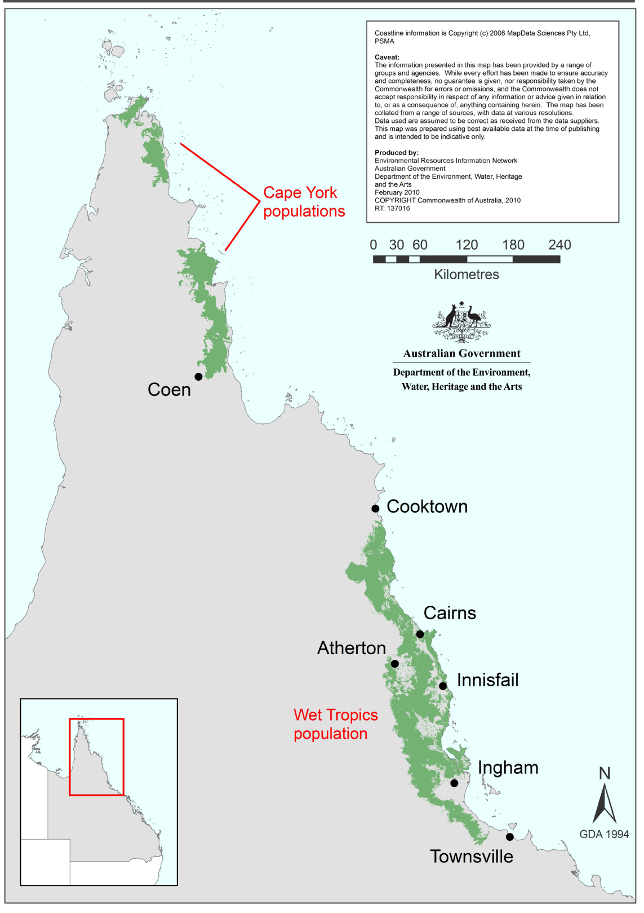

How to interpret and apply these guidelines
The thresholds outlined in this policy statement are not designed to be prescriptive, but rather to clarify the level and types of impact likely to be significant for the Wet Tropics cassowary population, having regard for the biology, ecology and threats to the species.
If you are planning an action within the area defined as the Wet Tropics cassowary population (see Maps 1 & 2) you should consider the following:
- Does my site support the cassowary and/or is it defined as potential cassowary habitat?
  - Consider vegetation, habitat, records and surveys on and near the site (see page 8-13).
  - Is my site within foraging range of cassowary habitat?
  - Does my site contain a water source or provide access to a water source?
  - Does my site contain a known cassowary corridor?
- What impacts, both direct and indirect, could result from my action?
- Could any of these impacts exceed the thresholds outlined in pages 18-19?
- What measures could be taken to reduce the level of impact (see pages 21-24)?
If you think that your action may have a significant impact on the cassowary or any other matter of national environmental significance, or if you are unsure, you should refer the action to the federal environment minister. The minister will make a decision within 20 business days on whether approval is required under the EPBC Act. Substantial penalties apply for taking an action that has, will have or is likely to have a significant impact without approval.
Further information on the EPBC Act, including guidance on the referral, assessment and compliance processes is available at: www.environment.gov.au
Additional details of listed threatened species and ecological communities as well as listed migratory species can be obtained from the department’s website.

What other laws protect the cassowary?
In addition to its listing as endangered under the EPBC Act, the cassowary is listed under state legislation. The Queensland Nature Conservation Act 1992 lists the Wet Tropics population of the cassowary as endangered, whereas the Cape York populations are listed as vulnerable.
The listing of a species, subspecies or ecological community under the EPBC Act recognises the importance of the matter from a national perspective, and does not replace listing under state, regional or local legislation or regulations.
You should consider the need to refer the action under the EPBC Act prior to any clearing taking place.
Judgements may differ between Australian Government, state and local decision-making processes due to the different scales of consideration. If your activity could affect the species or individual animals, in addition to contacting the Australian Government, you should contact the relevant state and local authorities regarding your obligations in that jurisdiction.

The cassowary in Australia

The species
Cassowaries belong to the Struthioniformes order of large flightless land birds distributed across New Guinea, Australia, New Zealand, South America and Africa. The cassowary is the largest native vertebrate in Australian rainforests with adults growing up to two metres tall with males weighing up to 55kg and females, usually larger, up to approximately 75kg.
Adult cassowaries have shiny black plumage and a distinctive neck and head. The tall helmet or casque on maturing cassowaries grows with age. Newly hatched chicks are striped dark brown and creamy white. After three to six months the stripes fade and the plumage changes to brown. As the young mature the plumage darkens, the wattles and casque develop and the skin colour on the neck and wattles brightens.

Distribution
The cassowary is the only member of the cassowary family in Australia and occurs in two populations in north Queensland. In the Wet Tropics it is distributed from Cooktown to just north of Townsville (see Map 2). Its habitat includes rainforests and associated vegetation types from the coast to the uplands and highlands as well as across to the western rainforest margin.
A ‘population’ is an occurrence of the species in a particular area, and includes but is not limited to:
- a geographically distinct regional population, or
- a collection of local populations.
A ‘fragmented population’ is a population that is distributed across disconnected isolated areas of habitat.
Clearing of natural vegetation has greatly reduced and fragmented the habitat of the cassowary. There appear to be at least ten subpopulations whose habitat has become isolated by clearing in the Wet Tropics.
‘Fragmented habitat’ is an area of habitat that has become discontinuous through clearing but which still supports all, or part, of the ecological function of this species. The ecological function (for example dispersal) may be limited by biophysical and land use constraints.
For the purposes of this policy statement, all subpopulations, metapopulations and populations are referred to as ‘populations’.
Map 2 shows current distribution of potential cassowary habitat. Local validation of some mapped habitat may be necessary where patches are small, isolated and fragmented (see page 14 for survey methods). Map 2 includes areas of key ecological function, broad movement corridors and appropriate rehabilitating habitat. Data provided by the Queensland Department of Environment and Resource Management (formerly the Queensland Environmental Protection Agency) was used in developing Map 2. It will be updated as new distribution information arises. The map can be accessed in more detail on the department’s website at: www.environment.gov.au/epbc/guidelines-policies.html#threatened
Map 2: Potential southern cassowary habitat
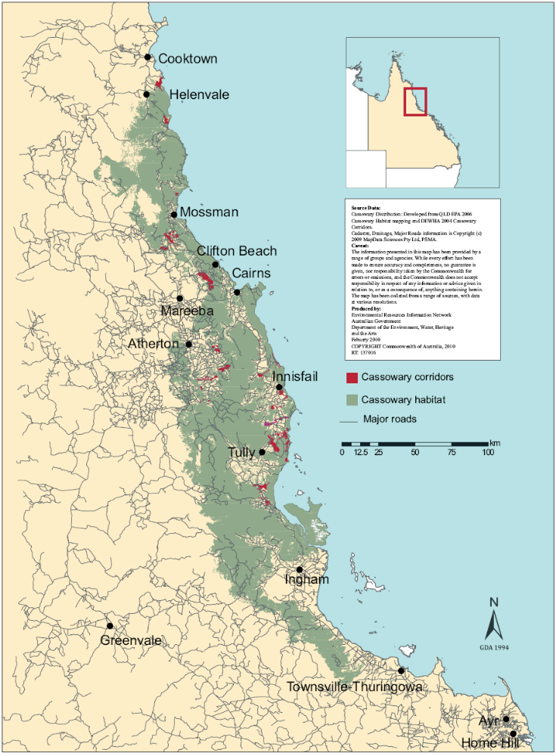

Life history and ecology
The cassowary is a keystone species in tropical rainforest (that is, one whose loss would impact upon other species within the system, potentially causing their decline or disappearance). It plays a key ecological role in the dispersal of many rainforest plant seeds and is the only long distance disperser of some fleshy-fruited plants with large seeds.
Adult cassowaries appear to be territorial, with females holding larger territories than males. Adults do not migrate once they have established a home territory. Though individuals remain attached to core areas (territories) throughout most of the year, home range size may vary with seasonal fruit production and cassowaries may travel over 4 km a day to access resources. Home territories may be 0.52 to 5.76 km² in coastal lowland habitat, possibly even larger (12 km²) in upland regions.

Habitat
While cassowaries live in and depend on tropical rainforest they will also utilise a mosaic of associated habitats when these are available. Associated habitats utilised include mangroves, melaleuca, eucalypt woodlands, swamps and swamp forests. Cassowaries rely upon a year round supply of fleshy fruit and these associated habitats can provide crucial food resources at certain times of year (for example following tropical cyclones). A range of non-rainforest habitats may also be used as corridors.

Key landscape values for the cassowary
Feeding habitat: Cassowaries feed primarily on the fleshy fruits of rainforest trees and shrubs, taking most fruit from the ground. The species will also feed on exotic fruit plantations and some weed species such as pond apple (Annona glabra). Feeding areas change with fruiting seasons and if traditional food supplies fail (for example due to cyclones), alternative sources of food may be sought in areas not usually used (for example more isolated fragments of feeding habitat).
Breeding habitat: Cassowaries can nest in a variety of habitats such as primary and regrowth rainforest and woodland. All recorded nests have been in rainforest or woodland mosaics with rainforest elements, usually near the base of large trees or stumps and often with a closed understorey of vines, regrowth or dense grass thickets. Sites are apparently used only once. Cassowaries typically breed in winter and spring, but sometimes in summer.
Water: Cassowaries depend on access to fresh water for drinking and bathing many times a day.
Resting habitat: The cassowary requires quiet and dark habitat during the night. Noise and light pollution has the potential to disrupt and stress cassowaries.
Corridors for movement: A cassowary habitat corridor provides a continuous, or near continuous link of suitable habitat across a modified landscape that may otherwise impede movement of the species. A habitat corridor may comprise remnant habitat, regenerated habitat or artificially created habitat. Corridors for movement may include open areas as well as vegetated areas. The fact that a corridor contains open areas or barriers (such as roads) does not mean that it is not important for cassowary movement; this is particularly the case in fragmented habitat.
Corridors for cassowaries operate at a number of levels in the landscape, the two most relevant being:
- corridors that allow populations to remain connected in the landscape, particularly in an east-west direction, and
- corridors that are used by individuals at the local scale.
Juvenile and displaced adult cassowaries use corridors to disperse away from occupied territories, and adults with established home ranges will use corridors to move through the local landscape. Cassowaries, including dispersing young, often use riparian corridors to move between habitat patches, moving up to two to three kilometres along them (Figure 1). Riparian areas are considered to be the most beneficial areas for restoration work.
Note: Corridors of movement are not solely limited to those shown on Map 2.

Benefits to other species or ecological communities
The habitat of the cassowary supports at least 106 plant species and 37 animal species identified as threatened under state and Australian Government legislation.

Protection of cassowary habitat may help secure the habitat of many other species and ecological communities. Threatened ecological communities listed under the EPBC Act such as the Mabi Forest (Complex Notophyll Vine Forest 5b), Littoral Rainforest and Coastal Vine Thickets of Eastern Australia, and the Semi-evergreen vine thickets of the Brigalow Belt (North and South) and Nandewar Bioregions are also closely linked with the cassowary. Therefore, these ecological communities can benefit from protection of the cassowary and vice versa.
More information about the cassowary can be found in the recovery plan for the southern cassowary and the species profile and threats database (SPRAT) on the department’s website: www.environment.gov.au/biodiversity/threatened/publications/recovery/southern-cassowary/pubs/sth-cassowary.pdf
www.environment.gov.au/cgi-bin/sprat/public/sprat.pl

Figure 1: Cassowary habitat and movement
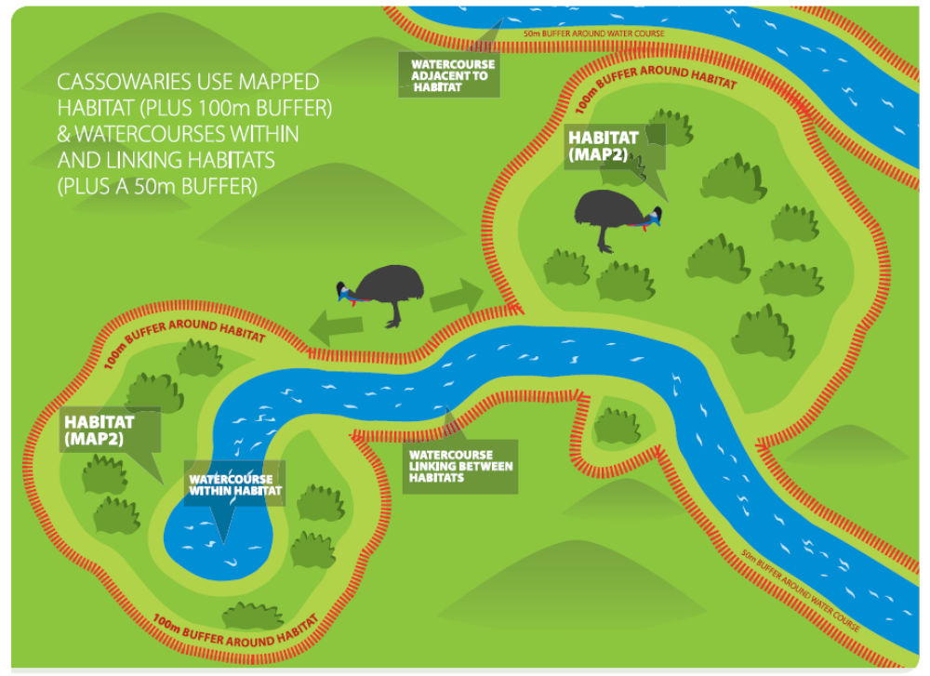

Principal threats to the cassowary
The cassowary is sensitive to certain development activities because of the following traits:
- increasingly isolated and fragmented distribution
- seasonal habitat requirements
- limited ability to disperse through altered landscapes
- large home range (up to 12 km² in suboptimal habitats)
- need for large (> five hectares) connected patches of foraging habitat
- territorial and rely on sound to detect the presence of other cassowaries
- shy nature, and
- daily access to fresh water.
The principal threats to the cassowary (as listed in the recovery plan for the southern cassowary) include:
- habitat loss from clearing: more than 80 per cent of its coastal lowland habitat has gone
- habitat fragmentation: much of its remaining habitat is fragmented, isolating groups and disrupting movement
- habitat degradation: through invasion of weeds such as pond apple, and changed fire regimes
- roads and traffic: cassowaries are killed by vehicles on roads and traffic may intimidate cassowaries preventing them from crossing a road to access resources
- dog attack: urban development brings more domestic dogs (dog presence may intimidate cassowaries resulting in decreased use of an area – even if the dog does not attack)
- hand feeding: brings cassowaries closer to vehicle traffic and dogs and increases the risk of aggressive interactions with humans
- diseases: aspergillosis, avian tuberculosis and parasites, and
- natural catastrophic events such as cyclones.
Many threats are localised and do not apply across the extent of cassowary distribution. For example, road mortality is a major issue in those areas where substantial urban/peri-urban development encroaches into cassowary habitat. Increased exposure of cassowaries to humans and their activities may eventually result in hostile interactions between cassowaries and humans.
Some cassowary age groups are more susceptible to particular threats. For example, chicks and sub-adults are the most vulnerable to dog attack. Other factors, for example habitat fragmentation, may cause cassowaries to travel further to access food and new habitat and therefore expose them to threats such as road crossings.

Areas under threat
The recovery plan for the southern cassowary identifies eight key areas in the Wet Tropics which are seriously threatened by development activities:
- Mission Beach
- Daintree/Mossman lowlands
- Kuranda/Black Mountain corridor
- Cairns hill slopes
- Mulgrave Valley/Malbon-Thompson Range
- southern Atherton Tablelands
- Graham/Palmerston/Moresby Range, and
- Kennedy Valley/Murray River floodplain.

Survey guidelines for the cassowary
A guide to conducting surveys for the presence of cassowaries is outlined below. Surveys should:
- maximise the chance of detecting the species
- determine the context of the site within the broader landscape
- be conducted by a suitably qualified person, and
- account for uncertainty, seasonality and error.

Consideration should be given to the timing, effort, methods and area to be covered in the context of the proposed action. If surveys are conducted outside recommended periods or conditions, survey methods and effort should be adjusted to compensate for the decreased likelihood of detecting the species.

Survey recommendations

Presence/absence
Presence or absence of the cassowary in an area can be determined by investigation targeting scats (dung), footprints, sightings and community knowledge. The following recommendations relate to the effort generally required to confirm the likely absence of the cassowary in areas of 50 hectares or less.
Recommended survey methods include area searches or transect surveys in suitable habitat. The recommended minimum search effort is 20 person hours conducted over 10 days, as the likelihood of detection is usually greater when surveys are conducted over different days. Short term surveys may not detect areas used by cassowaries seasonally or during times of food or resource shortages, but this can be investigated by seeking local information or by sampling across seasons. It is also important to note that longer survey efforts may be required and that failure to detect the cassowary does not mean that they are not present.
In larger areas, different methods and/or effort would be required to determine cassowary abundance (see below).

Estimating abundance
Surveying for the abundance of cassowaries is difficult and requires intensive and extensive effort. Currently, methods for estimating abundance are limited.
Individual cassowaries can be distinguished by variation in their neck, wattle, facial and other morphological features but surveys based on identifying individual cassowaries are labour intensive and slow.
Assessing abundance by the density of scats as a surrogate for the density of cassowaries has been attempted. This approach however was demonstrated to be problematic, because a single scat does not necessarily indicate a constant number of cassowaries. A further uncertainty with this method is that it relies on assumptions about cassowary movements which, in general, are poorly known and which are unlikely to be true over all survey areas.
An experimental method currently being developed through the CSIRO and the Queensland Department of Environment and Resource Management is a field survey methodology and technique to identify individual cassowaries based on DNA extracted from scats. Once fully developed this method is likely to become the best tool for determining cassowary presence and abundance.
It should be noted that:
- Abundance can be determined in small areas by individual identification.
- Short term surveys may not detect seasonal use of areas by cassowaries, but this can be investigated by reviewing local information sources and by spreading survey efforts across the seasons.
- Local and state government agencies are an essential source of information on the cassowary and its distribution including:
  - Wet Tropics Management Authority (WTMA)
  - James Cook University
  - local CSIRO
  - Queensland Department of Environment and Resource Management (formerly the Queensland Environmental Protection Agency)
  - local government councils, and
  - local community groups such as the Community for Coastal and Cassowary Conservation Inc (C4) hold information on cassowary sightings. Terrain NRM can provide further information on habitat linkages.

Habitat assessment
Up to one kilometre beyond the edge of cassowary habitat (Map 2) the following features are considered important:
- riparian corridors
- water bodies, and
- food resources, that is, native and other fruiting plants.
Where these features are present they should be assessed to determine if they are used by cassowaries (see presence/absence survey). If cassowaries are present, these features should be considered as cassowary habitat. Actions should then be assessed in accordance with page 12.
Where it is not possible to conduct surveys in the manner recommended (methods, timing and effort), the precautionary principle should be used (that is, failure to detect the cassowary should not be considered indicative of its absence).
Survey results enhance but do not over-ride cassowary habitat mapping. It should be noted that significant cassowary habitat may be unoccupied at the time of survey due to current threats that may be treatable, for example offsite unmanaged dogs, inappropriate fencing or road traffic currently blocking access to the surveyed areas.

What types of actions are likely to have a significant impact on the cassowary?
Significant impact judgements must be made on a case by case basis and with consideration for the situation of the action. The potential for a significant impact on a listed threatened species will depend on the:
- intensity, duration, magnitude and geographic extent of the impact
- sensitivity, value and quality of the environment on and around the site
- cumulative effects of on-site, off-site, direct and indirect impacts, and
- presence of this species and other matters of national environmental significance.
For the cassowary, there is a real chance or possibility of a significant impact if the action will result in any one of the following impacts (see Table 1). The statements provided in Table 1 give an indication of ‘significance’ and build upon more general guidance for endangered species as provided in the EPBC Act policy statement 1.1 Significant impact guidelines – Matters of national environmental significance.
Actions are less likely to be significant in habitat patches which are very small, highly isolated, and greatly fragmented. See the online copy of Map 2 which shows patch sizes and isolation in more detail at: www.environment.gov.au/epbc/guidelines-policies.html#threatened
It is also unlikely that there will be significant impact on cassowaries in areas where there is significant evidence that cassowaries are not present and have not been present for a long period of time (such as the Cairns Botanical Gardens).

Table 1: Significant impact thresholds for the cassowary
Threat | For actions within potential cassowary habitat defined in Map 2 (plus a 100 m buffer). See Figures 1 & 2. | Watercourses within, adjacent or linking between areas of potential cassowary habitat defined in Map 2 (plus a 50 m buffer from the bank). See Figures 1 & 2. | Potential cassowary corridors defined in Map 2.*
Clearing habitat#  - Habitat removal. | - Clearing more than 1500m² for any purpose other than a single dwelling on an existing lot.  - Forestry operations (including selective logging) that:  - open the canopy by >10 per cent, or  - remove cassowary food trees.  - Subdivision of land that results in clearing and/or intensification of use. | - Any clearing | - Clearing that reduces:  - corridor width  - number of corridor links, or  - any corridor patch area to below five ha.
Habitat degradation caused by:  - exotic plants or animals  - increased accessibility  - fire behaviour change  - microclimate change. | - Any action that reduces habitat quality. | - Any action that changes water quality or flow. | - Any action that reduces cassowary movement.
Fragmentation and isolation of habitat and populations caused by:  - roads  - fencing^  - drainage channels  - powerlines  - service infrastructure, and  - subdivision of land. | - Any action that :  - reduces patch area to less than five ha, or  - separates patches by more than 100 m  - reduces patch quality or,  - separates or perforates existing patches. | - Any action that reduces access to water for example:  - Fencing that reduces connectivity between or within riparian corridors.  - Roads that reduce connectivity between or within riparian corridors.  - Any action that reduces movement along waterways. | - Any action that reduces:  - corridor width  - number of corridor links  - any corridor patch area below five ha.  See Figure 2.
Roads and traffic  - Traffic conflict points  - Traffic volume such as road upgrades or traffic-producing development.  - Any increase in vehicle speed limits.  - Proliferation of roadside weeds.  - Any road or vehicle track developments with proposed speeds >60 km/hr (without adequate and proven traffic calming measures) in the following areas:  - Places where cassowary road deaths have occurred.  - Through known cassowary crossing points.  - Within local or regional movement corridors.  - In the eight key areas where the cassowary is seriously threatened (see Areas under threat, page 13).  - Through National Parks or conservation areas. | - Any action that increases:  - traffic conflict  - traffic volume  - traffic speed to more than 60km/hr. | - Any road, trail, or other access point, construction or upgrade. | - Any road, trail, or other access point construction or upgrade with a design speed greater than 60 km/hr.
Notes:
The examples in the above table give guidance to the level of impact that is likely to be significant for the cassowary at a site. They are not intended to be exhaustive or prescriptive, but rather to highlight the need to maintain the ecological function of the habitat area.
#Clearing includes any canopy, mid storey or understorey removal that reduces habitat quality.

Habitat and/or populations may, and often will, extend beyond Map 2 boundaries and may include (but are not limited to) areas used for: foraging, breeding, roosting, dispersal.

*Corridors not shown on Map 2 may also be important to the cassowary. Cassowaries will use a variety of local movement corridors which can be riparian corridors, water bodies, strategic open spaces and areas where food resources are available. Whilst not shown on Map 2 these corridors may be important and will depend on species presence and likelihood of use. See Figures 2 and 3. Alternative corridors also decrease the risk of antagonistic encounters between territorial cassowaries.
^Fencing- For development in the Cairns urban footprint area that abuts cassowary habitat but does not fragment habitat or a movement corridor, exclusion fencing may be appropriate. Fencing should be considered on a case by case basis, see Table 2.

Figure 2: Barriers to cassowary movement
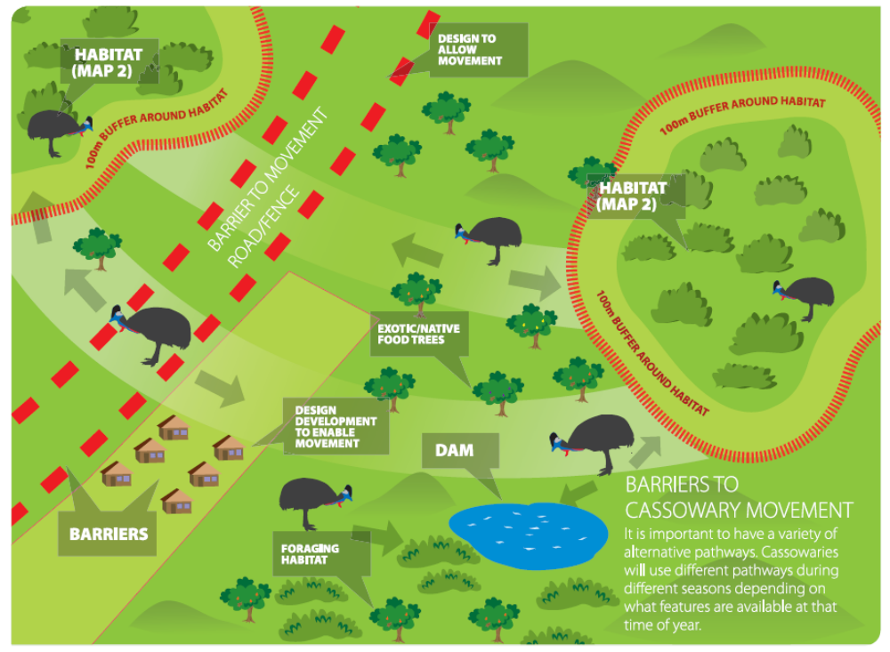

What to do if you think your activity may impact on the cassowary or cassowary habitat.

Ask yourself the following questions and take appropriate actions:
- Are there cassowaries present OR is there cassowary habitat present?
- Will there be cassowary habitat loss from the activity?
- Is there water present possibly used by cassowaries?
- Will the activity interrupt or prevent access by cassowaries to their habitat or water?
- Will the activity increase exposure of cassowaries to cars, dogs and humans (can also apply to areas adjacent to and beyond mapped cassowary habitat)?
YES to any of the above
▼
- Check the area against Map 2, this will give you a general idea of where cassowaries are found.
- If you are unsure ask local agencies such as state or local government (as detailed in page 11) to determine where cassowaries are.
- Survey local knowledge about cassowary presence.
- Undertake a site survey in accordance with guidelines on page 10.
- Assess your activity against Table 1 “Significant impact thresholds for the cassowary”.
- If unsure, you will need to consider a referral under the EPBC Act - see page 21 below.

What does this mean for actions that may significantly impact on the cassowary?
If you plan an action that may have a significant impact on the cassowary then you should refer the proposal to the federal environment minister before commencing the action. The minister will decide within 20 business days whether assessment and approval is required under the EPBC Act. More information on referral and assessment is available at: www.environment.gov.au/epbc/assessments/process.html.

How can my actions avoid having a significant impact on the cassowary?
Mitigation includes all measures undertaken on the site of the action to avoid or reduce its impacts. Measures should be incorporated into the design of the action at the conceptual and planning stage(s) to:
- reduce the level of the impact to below the significant impact thresholds outlined in this policy statement
- monitor the performance of the mitigation measures (specify the timeframe and use performance indicators for example measured seasonally/annually), and
- incorporate findings into an adaptive management plan, to quickly address any changes in performance.

Mitigation and management actions must:
- ensure avoidance of impacts is the first priority, followed by other impact reduction measures
- avoid negative impacts on any other matters of national environmental significance, and
- be consistent with relevant recovery, conservation or action plans.

The following mitigation measures may assist in minimising impacts on the cassowary. In many cases, a combination of mitigation measures may give the highest benefit. Removing or mitigating a threat may return suitable habitat to regular cassowary use.
An adaptive management approach should be taken when considering actions to ensure mitigation measures are flexible enough to adjust to changing conditions.

Table 2: Suggested mitigation measures for the cassowary
Avoiding impacts | - Retain cassowary habitat, corridors and manage for the species.  - Site roads or easements to avoid habitat disturbance and identify and introduce traffic calming measures at know seasonal cassowary crossing points.  - Discourage traffic/cassowary interactions.  - Ensure existing cassowary movement corridors are maintained.  - Avoid interaction of people and cassowaries through design of new consolidated developments#. Best practice approaches may include (See Figure 3):  - limit the extent of urban encroachment by leaving larger areas of cassowary habitat land unimpeded by fences (such as around buildings) to enable cassowary use of the development site  - minimise motor vehicle use by design that encourages walking and cycling within developments and enables easy access to links, such as bus stops  - distance housing lots, vehicles and people from cassowary habitat through appropriate design  - distance water bodies in development design to avoid contact with people and domestic dogs, and  - assess rural residential developments on a case by case basis.  - Logging activities to have a cassowary management plan.  - Exclude dogs from cassowary habitat.  - Implement a policy where dogs and cats are controlled and fenced/secured. Dogs to be under leash and supervision when outside the property.  - Design dog free developments and include buffer zones.  - Construct fencing only when it is appropriate. Fencing must demonstrate a benefit for cassowaries and not negatively impact on other listed fauna. (See Figure 3)  - Each situation is different and should be approached as such. Consider potential impacts and determine possible solutions.  - Wide ranging consultation should be conducted.
Minimising impacts | - Maintain distance between cassowaries and humans and implement effective public awareness programs. Education programs should be ongoing and regularly updated to maintain effectiveness. Awareness programs and educational content should be consistent with the recovery plan for the southern cassowary. The Queensland Department of Environment and Resource Management can be contacted for further information.  - Minimise interactions between cassowaries and humans and dogs. Follow local council regulation, construct appropriate fencing and enhance awareness by those using the area.  - Avoid planting known cassowary food trees within urban areas where human interactions may occur.  - Avoid undertaking actions that would introduce weeds or non-Indigenous plants into a site.  Roads (See Figure 3)  - Implement adequate measures proven over the long term to minimise the impacts of roads such as:  - effective speed limits  - extensive signage – signage is recommended to be of a temporary or variable nature to increase effectiveness  - effective traffic calming measures  - proven fauna sensitive road design  - reduce traffic volume  - fauna underpasses (not culverts)  - fauna overpasses, and  - public education.  - The above should be tailored to specific road circumstances and should be planned based on a whole of road approach.  Fencing  - Consider fencing on a case by case basis (See Figure 3). Appropriate fencing will depend on the situation, size, location and area where the activity will occur. Fencing will not be appropriate if it:  - fragments habitat  - reduces connectivity  - isolates cassowaries and their access to habitat  - leads to entrapment of cassowaries (including on the outside of the fence)  - prevents movement during critical periods (such as extreme events and cyclones)  - funnels cassowaries towards roads, leading to mortality, and  - blocks escape routes.  - Reduction of these impacts may be achieved by a buffer around fencing in some circumstances.  - Fencing can be used near roads to direct cassowaries to safe road crossing points (such as fauna over and underpasses).  - Use fencing where there is a major expansion of urban development (such as the Cairns urban footprint area), where it abuts cassowary habitat but does not fragment habitat or a movement corridor. The ongoing costs of fence maintenance should also be included in planning.  - Design mitigation measures, where development abuts habitat, based on local habitat conditions, other fauna present and habitat availability. In areas where habitat is of poorer quality, cassowaries may need access to habitat around dwellings, in which case, fencing is not an option and dog free developments would be appropriate.  - Ensure fencing complies with current best practice standards and guidelines*.  - A cattle fence with three to four strand plain wire is suitable in an agricultural context only.  - Use of electric fencing should only be used in agricultural context.  - Barbed wire and chain link fencing is not acceptable.
Managing habitat | - Consider design of habitat corridors:  - Avoid creating corridors that lead cassowaries into high risk areas such as roads or residential areas.  - Corridors should be at a 5:1 ratio (length: width), wider if possible, with a minimum width of 200 metres if development abuts either side (See Figure 2). This width is required to minimise habitat degradation by light and wind penetration as well as weed invasions. It also provides for resilience over time allowing corridors to naturally regenerate after cyclone damage.  - Humans must be excluded or controlled within corridors; dogs must be excluded from corridors, fencing may be appropriate to achieve this.  - Recognition of riparian areas as corridors (See Figures 1 and 3).  - Extend current corridors and areas with the potential to support appropriate vegetation including cassowary food plants.  - Evaluate the location of roads and cassowary road crossing points relative to corridors. Road crossings through corridors need to be designed to minimise impacts. If unavoidable and necessary, proven measures should be put in place and maintained to ensure safe crossing.  - Retain, enhance and restore habitat and manage for the cassowary. Retaining habitat should be the first option. Note: revegetation can be both intensive and expensive.  - All areas of occupied cassowary habitat could be considered for rehabilitation to expand existing habitat.  - Restored areas should be established prior to clearing and be of equivalent ecological value or function.  Useful information in relation to restoring and enhancing habitat includes:  - Map 2 (cassowary habitat map) – some of these habitat areas may be suitable for restoration or rehabilitation, and  - When undertaking rehabilitation it is important to use appropriate plant species. A list of restoration plant species can be obtained from Biotropica Australia. Species should be selected based on the site’s ecosystems characteristics (that is, species naturally associated with the landscape area).  - Place residential pathways (if necessary) outside of habitat and install interpretive/educational signage to highlight conservation significance.  - Construct appropriate fencing (if necessary) to manage habitat, note fencing guidance in above section, minimising impacts.
# Building envelope is grouped together to minimise clearing and other impacts
*Fencing – Information on best practice guidelines can be sourced from recent decisions approving projects from local, state, and Australian government websites.

Figure 3: Large lot sub-division
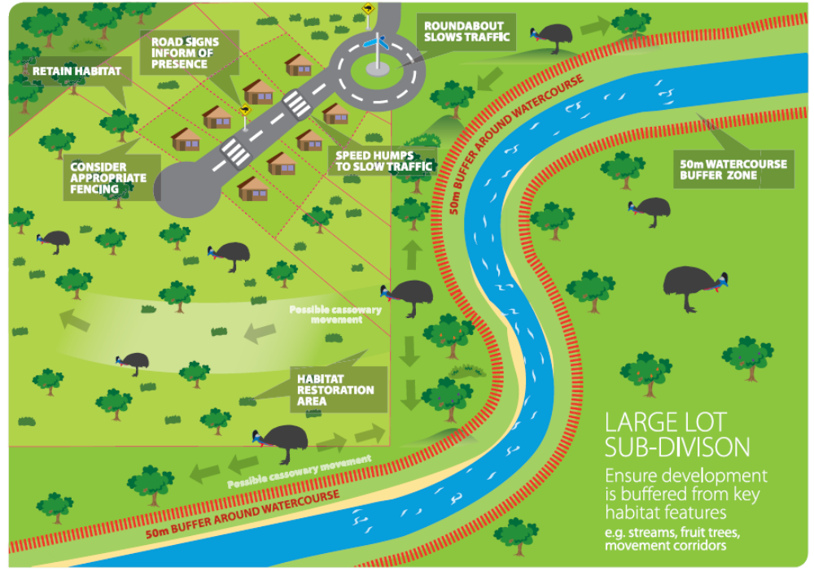

Where can I get more information?
The Recovery Plan for the Southern Cassowary Casuarius casuarius johnsonii (Environment Protection Agency, 2007) provides detailed biological information, recovery objectives, performance criteria and actions. It is available from the department’s website at: www.environment.gov.au/biodiversity/threatened/publications/recovery/southern-Cassowary/pubs/sth-Cassowary.pdf

Other EPBC Act policy statements will help you to understand the Act and your obligations. They are available from the department’s website at: www.environment.gov.au/epbc/guidelines-policies.html, or by contacting the community information unit by email: ciu@environment.gov.au or phone: 1800 803 772.

The protected matters search tool can provide a good starting point for determining the likelihood of having matters of national environmental significance in your area at: www.environment.gov.au/erin/ert/epbc/index.html.

Farmers can contact the environment liaison officer at the National Farmers' Federation (NFF), Canberra, ACT.
phone: 1800 704 520
email: environment@nff.org.au.

Local community groups, state, territory and local government agencies may hold relevant information including habitat and species distribution information.

Search recent decisions made under the EPBC Act for information on similar proposals:
www.environment.gov.au/cgi-bin/epbc/epbc_ap.pl?name=public_notifications

Further information including details on other listed threatened species and ecological communities is at the department’s species profiles and threats database (SPRAT) at:
www.environment.gov.au/cgi-bin/sprat/public/sprat.pl

