

Environment Protection and Biodiversity Conservation Act 1999
(Parts 7, 9 & 10)
Environment Protection (Sea Dumping) Act 1981
Fuel Quality Standards Act 2000
Ozone Protection and Synthetic Greenhouse Gas Management Act 1989
Compliance Monitoring Program
2016 - 2017

© Commonwealth of Australia, 2016.
Environment Protection and Biodiversity Conservation Act 1999 (Parts 7, 9 & 10), Environment Protection (Sea Dumping) Act 1981, Fuel Quality Standards Act 2000 and Ozone Protection and Synthetic Greenhouse Gas Management Act 1989 Compliance Monitoring Program 2016–2017 is licensed by the Commonwealth of Australia for use under a Creative Commons By Attribution 4.0 Australia licence with the exception of the Coat of Arms of the Commonwealth of Australia, the logo of the agency responsible for publishing the report, content supplied by third parties, and any images depicting people. For licence conditions see: http://creativecommons.org/licenses/by/4.0/
This report should be attributed as ‘Environment Protection and Biodiversity Conservation Act 1999 (Parts 7, 9 & 10), Environment Protection (Sea Dumping) Act 1981, Fuel Quality Standards Act 2000 and Ozone Protection and Synthetic Greenhouse Gas Management Act 1989 Compliance Monitoring Program 2016–2017, Commonwealth of Australia 2016’.
The Commonwealth of Australia has made all reasonable efforts to identify content supplied by third parties using the following format ‘© Copyright, [name of third party] ’.
Disclaimer The views and opinions expressed in this publication are those of the authors and do not necessarily reflect those of the Australian Government or the Minister for the Environment and Energy.
Table of Contents
1 Compliance Monitoring Overview
2 Scope of this Compliance Monitoring Program
3 Compliance Monitoring Risk Prioritisation
3.1 EPBC Act Risk Prioritisation
3.2 Sea Dumping Act Risk Prioritisation
3.3 Fuel Act Risk Prioritisation
3.4 OPSGG Act Risk Prioritisation
4 Approach to Compliance Monitoring
5 Compliance Monitoring Achievements in 2015–16
5.1 EPBC Act and SD Act
5.2 Fuel Act
5.3 OPSGG Act
6 Compliance Monitoring Focus for 2016–17
6.1 EPBC Act
6.2 Sea Dumping Act
6.3 Fuel Act
6.4 OPSGG Act
7 What we expect from the Regulated Community
8 Further Information or Questions

1. Compliance Monitoring Overview

The Department of the Environment and Energy (the Department) is responsible for a range of regulatory functions under legislation. Although each piece of legislation seeks to achieve specific objectives, such as protection of the environment or minimising the potential for impacts to human health, at its core each has a requirement for a regulated community to comply with specific rules or standards. These are often articulated in the form of conditions attached to approvals, permits or licences.
The function through which the Department ensures that the regulated community meets its obligations outlined in conditions of approvals, permits and licences is known as Compliance Monitoring.
Compliance monitoring ensures that the regulated community undertakes actions that are in accordance with the respective legislation. By ensuring that the regulated community does this, impacts to the environment and human health can be managed and minimised.
Compliance monitoring:
- Begins at different stages, depending on the respective legislation, however it generally commences when an action or activity starts, or when approval is given for that action or activity to start.
- Takes the form of desktop assessment and audits of approval, permit or licence conditions, review of reports, and inspections of sites where an action or activities are being undertaken.
- Involves working with co-regulators to achieve regulatory consistency and to reduce the compliance burden on the regulated community.
- Uses education and outreach, through the production of information materials and presentations to the regulated community.
- Aims to identify any non-compliance at an early stage, and to implement measures to address issues before it has the potential to escalate to more significant or systematic non-compliance.
- Is informed through risk prioritisation; monitoring information is then incorporated back into the risk profile.

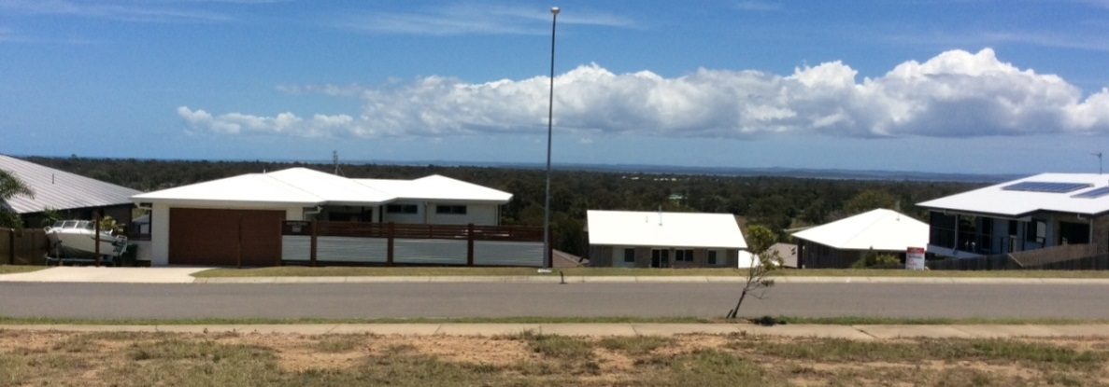

The compliance monitoring function is illustrated through the following figure.

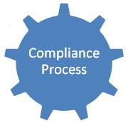

In the figure, authorisation for an activity is given under legislation (whether this is an approval, permit, licence, or some other authorisation). Through the compliance monitoring function, these authorisations are reviewed in the context of risk; which may include, depending on the particular legislation, risk to the environment or human health. Those activities identified to be the highest risk are subject to the greatest levels of compliance monitoring focus. How we use risk to prioritise our compliance monitoring efforts is detailed in Section 3 of this Program.
Through the monitoring process, we may find that particular activities require a re-assessment of their risk consideration. For example:
- Where monitoring identifies an activity to represent a lower potential risk than was originally determined, this information is fed back through the risk prioritisation process to determine a new potentially lower risk rating for that activity.
- Where monitoring identifies an activity to represent a greater potential risk that was originally determined (which can occur in situations such as non-compliance), this information is fed-back through the risk prioritisation process to determine a new, potentially higher, risk rating for that activity.
The risk rating of individual activities is continually reassessed and reviewed, in order to ensure we focus our compliance monitoring resources appropriately.

2. Scope of this Compliance Monitoring Program

This Annual Compliance Monitoring Program informs the regulated community, co-regulators and other stakeholders of our achievements in 2015–16, and objectives in 2016–17, for our Compliance monitoring activities. This program focuses on compliance monitoring activities under four pieces of legislation. These include:
Environment Protection and Biodiversity Conservation Act 1999 (Parts 7, 9, and 10)
The Environment Protection and Biodiversity Conservation Act 1999 (EPBC Act) is Australia’s national environmental law. The EPBC Act provides a strong legal framework to protect and manage Australia’s land and marine biodiversity, threatened species, ecosystems, environment and heritage—‘matters of national environmental significance’.
Provisions of the EPBC Act underpin Australia’s responsibilities under a number of international treaties; including the World Heritage Convention, the Ramsar Convention, the Convention on Biological Diversity (1992), JAMBA and CAMBA (Japan/China – Australia migratory bird agreements), the Bonn Convention, and CITES (convention on wildlife trade).
Under the EPBC Act, actions that are likely to have a significant impact on matters of national environmental significance must be approved before they can proceed.
Once a project has been referred and assessed, outcomes to which compliance monitoring resources are focussed include:
- A ‘Controlled Action’ (CA), typically where conditions are applied to offset, mitigate or compensate for the impacts to matters of national environmental significance of an action;
- A ‘Not a Controlled Action if Undertaken in a Particular Manner’ (NCAPM) decision, where an action will be taken in a certain way to ensure there are no impacts on matters of national environmental significance;
- A ‘Not a Controlled Action’ decision, where the action has been determined to have no potential for impacts on matters of national environmental significance.
Approvals can also be granted to enable actions to be under a ‘Strategic Assessment’, where impacts can be considered at a landscape scale, and holistic management measures put in place to avoid or offset any impacts to the matters of national environmental significance.
Environment Protection (Sea Dumping) Act 1981
The Environment Protection (Sea Dumping) Act 1981 (SD Act) provides a legal framework to regulate the dumping of waste at sea, incineration at sea, and the placement of artificial reefs. The SD Act fulfils Australia’s international obligations under the London Protocol (1972) to prevent marine pollution by controlling dumping of wastes and other matter.
Under the SD Act, the Commonwealth aims to minimise pollution threats by prohibiting ocean disposal of waste considered too harmful to be released into the marine environment and regulating permitted waste disposal to ensure environmental impacts are minimised.
Fuel Quality Standards Act 2000
The quality of fuel in Australia is regulated under the Fuel Quality Standard Act 2000 (Fuel Act) that places obligations on the fuel industry to ensure that supplied fuel meets strict environmental and human health requirements. The Act is in place to:
1) Regulate the quality of fuel supplied in Australia to:
- reduce the level of pollutants and emissions arising from the use of fuel that may cause environmental and health problems;
- facilitate the adoption of better engine technology and emission control technology; and
- allow the more effective operation of engines.
2) Ensure that, where appropriate, information about fuel is provided when the fuel is supplied.
Compliance monitoring activities under the Fuel Act involve a nationwide screening program to test fuel at various points in the supply chain, including at service stations, with samples subject to additional laboratory analysis to determine compliance against a range of parameters.
Ozone Protection and Synthetic Greenhouse Gas Management Act (1989)
The Ozone Protection and Synthetic Greenhouse Gas Management Act 1989 (OPSGG Act) helps to ensure that Australia meets its legal obligations under the Montreal Protocol (1989) and the United Nations Framework Convention on Climate Change. The OPSGG program aims to control the use of, and phase out over time, substances that have the potential to deplete the ozone layer, or man-made gases that contribute towards climate change.
Activities regulated under the OPSGG Act typically include those related to refrigeration, air-conditioning and fire protection. Compliance monitoring activities involve desktop audit and review, as well as site inspections to ensure that users of gases covered by the OPSGG Act are acting in accordance with conditions of their licences.

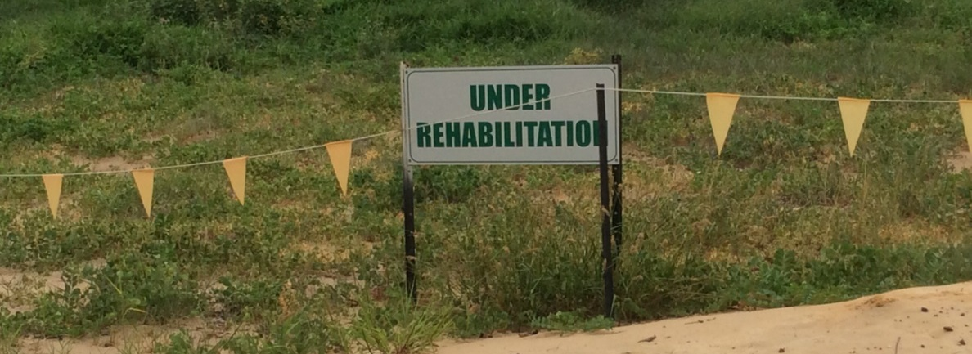
3. Compliance Monitoring Risk Prioritisation
An important aspect of best practice regulation is that it must be risk-based (ANAO, 2014; OECD, 2014).
The Department has made progressive improvements in relation to risk prioritisation under the other three pieces of legislation subject to this program.
3.1 EPBC Act Risk Prioritisation
In July 2014, a risk based prioritisation tool, developed in collaboration with the Commonwealth Scientific and Industrial Research Organisation (CSIRO). The National Environmental Significance Threat Risk Assessment (NESTRA) tool provides a relative risk rating for each project, based on the likelihood and consequence of non-compliance causing impacts to matters of national environmental significance.
The risk focus determined through NESTRA is informed through a variety of factors; such as compliance history, the nature of conditions of approval and management plans, and the types and number of matters of national environmental significance requiring protection under that approval. Data used in the NESTRA process is continually updated and revised based on new information.
The NESTRA assessment informs the identification of priority sectors for compliance monitoring activities.
3.2 Sea Dumping Risk Prioritisation
There are around 30 Sea Dumping permits active at any one time. Activities under these permits may relate to one-off capital or maintenance activities or a program over an extended period of time. It is also not uncommon for a permit to be issued for a sea dumping activity that relates to dredging conducted under an EPBC Act approval.
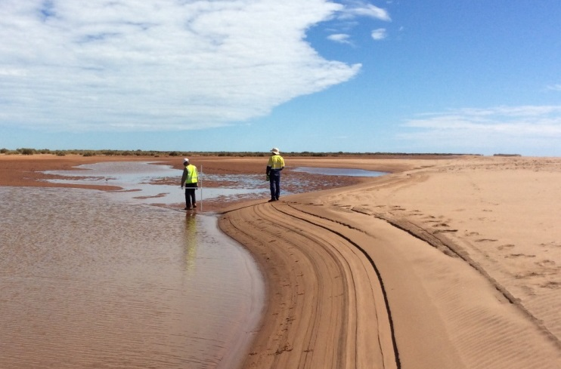
We prioritise our compliance monitoring resources towards:
- projects with an EPBC approval corresponding to a Sea Dumping permit.
- projects where the permit holder has a history of non-compliance with the SD Act.
- projects being conducted in areas of particular environmental sensitivity (such as projects conducted in proximity to the Great Barrier Reef).
During 2016-17, we will continue to make improvements to how we manage risk and undertake our compliance monitoring activities in relation to Sea Dumping permits. Proposed activities in support of this objective include changes to IT systems and improvements to intelligence capabilities, as well as enhancing information sharing arrangements with co-regulators.
3.3 Fuel Act Risk Prioritisation
Our inspection program of fuel supply sites is informed through intelligence collected from a variety of sources. These include:
- Referrals from other agencies and regulators (such as State Government Consumer Affairs Agencies);
- Complaints or concerns raised by members of the public (via telephone or our online form), typically concerning damage to vehicles which potentially occurred through the use of non-specification fuels; and
- Our own analysis based on intelligence and thorough consideration of compliance history.
We target our compliance monitoring resources towards those sites and areas where there appears to be the greatest potential for impacts to the environment and human health. To achieve this we have made significant improvements to our databases and systems, with further changes to be made in the current year to enhance our analytical capability by enabling greater data matching and spatial visualisation of information.
Our analysis shows that this year we need to focus our compliance monitoring resources on suppliers of diesel, particularly in Queensland, Victoria and Tasmania.
3.4 OPSGG Risk Act Prioritisation
Our compliance monitoring OPSGG program focuses on ensuring that the users and suppliers of these gases and substances are meeting the requirements of the legislation; including to ensure that business activities are being conducted in accordance with licensing requirements. We have in place mechanisms to monitor the importation of these substances and arrangements with industry co-regulators (the Australian Refrigeration Council and the Fire Protection Association Australia) to ensure that any potential breach of a licence condition, or legislation, is reported to us for further investigation.
Our compliance monitoring program involves desktop audits and review, as well as onsite inspection. Our program targets those licence holders who have been reported to not be complying with their licence conditions.
We also focus our compliance monitoring resources towards those licence holders who have been the subject of previous non-compliance. We undertake follow up inspections of these licence holders to ensure that they have implemented the necessary measures to mitigate against a reoccurrence of the non-compliance.
During 2016-17 enhancements will be made to a number of our databases that store information concerning the OPSGG program. These enhancements will enable more effective data matching, analysis and reporting, which will facilitate improvements to the compliance monitoring activities of the OPSGG program.

If you think there may be potential non-compliance with any activity subject to the above legislation, or have any questions, please contact the Department using the information in Section 8 of this Program.

4. Approach to Compliance Monitoring
Our Program is consistent with international and national standards provided in the Organization for Economic Cooperation and Development’s Best Practice Principles for Regulatory Policy Regulatory Enforcement (OECD, 2014) and the Australian National Audit Office Better Practice Guide for Administering Regulation (ANAO, 2014)
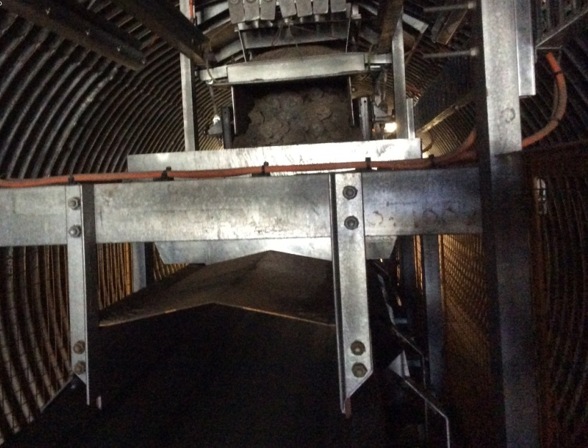
We undertake our compliance monitoring activities in accordance with the EPBC Act Compliance and Enforcement Policy (2013) and the Department’s overarching Regulatory Policy (2013). These policies describe our approach to, and the principles that guide, compliance and enforcement activities, including compliance monitoring. The policies promote a consistent, transparent and fair approach to compliance and enforcement activities, and provide guidance for stakeholders and the wider community about how we detect and address potential contraventions of the legislation we administer.
Among other things, the policies state our commitment to promote and support responsible self-regulation. Our compliance monitoring activities are a key mechanism for delivering on this commitment. Compliance monitoring activities include engaging with approval holders who are generally compliant (or willing to be) and providing education, information and advice.

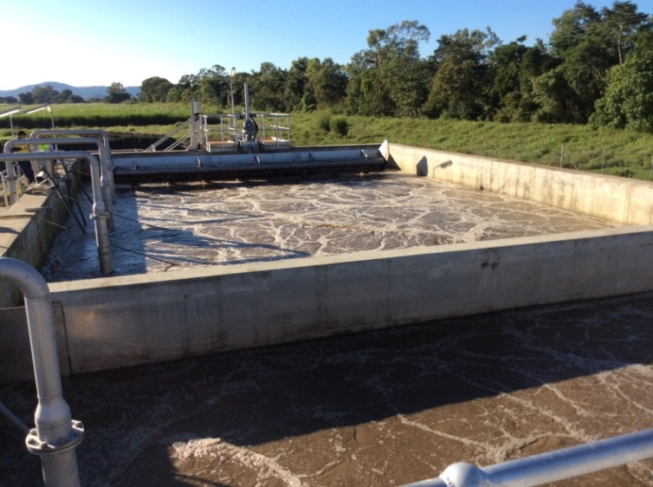
This helps to:
- Remove barriers to compliance and overcome factors that may otherwise lead to breaches of conditions (e.g. lack of awareness about how to meet requirements or confusion with other regulators).
- Identify and address potential breaches before they occur.
- Detect breaches when they do occur.

In cases where breaches of approval conditions are detected, we have a range of enforcement options available to enable a proportionate and appropriate response to the non-compliance. In accordance with our Compliance and Enforcement Policies, where there is an identified breach, we are able to use a range of compliance and enforcement responses proportionate to the nature of the breach.
Copies of the EPBC Act Compliance and Enforcement Policy (2013) and the Department’s (overarching) Compliance and Enforcement Policy (2009) are available on the Department’s website at www.environment.gov.au
5. Compliance Monitoring Achievements in 2015–16
In 2015–16 we undertook targeted stakeholder engagement particularly with identified high risk industries; we worked with co-regulators in the State and Territory Governments; and we improved our tools to enable more effective analysis of the information we receive. Our strategic objectives were achieved for the four pieces of legislation described in this program. A detail of achievements and performance is outlined in the following:
5.1 EPBC Act and SD Act:

- Our regulatory environment included 1,840 EPBC Act approved projects (817 Controlled Action Approvals and 1,023 Not a Controlled Action Particular Manner Decisions),
10 Strategic Assessments and 30 Sea Dumping Permits.
- Compliance plans were developed for 286 projects through desktop review to identify potential non-compliance, to inform the inspection program, and to inform the risk prioritisation process.
- 104 projects were subject to a Compliance monitoring inspection to verify compliance with conditions of approval (4 inspections were conducted with State Government co-regulators).
- 190 annual compliance reports and monitoring reports were reviewed.
- 7 Sea Dumping permits were subject to intensive desktop review to assess compliance.
- 13 audits were completed or initiated, including those for three major coal seam gas projects in southeast Queensland (Santos, APLNG and QGC).
- 97 projects were found to be non-compliant with approval conditions.
- We responded to non-compliance by:
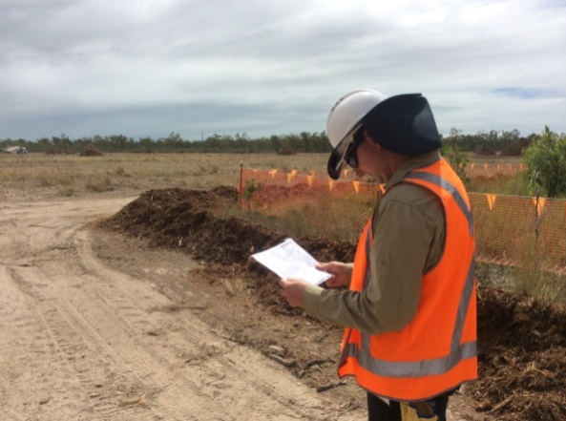
  - Issuing warnings and formal cautions;
  - Directing variations to management plans and conditions of approval; and
  - Negotiating new outcomes required to be met by approval holders to mitigate impacts caused through non-compliance.
- Industry outreach and education was undertaken with representatives of priority sectors.
- We undertook a review of a large number of projects subject to environmental offsetting requirements to ensure that offsets required by conditions of approval had been met.
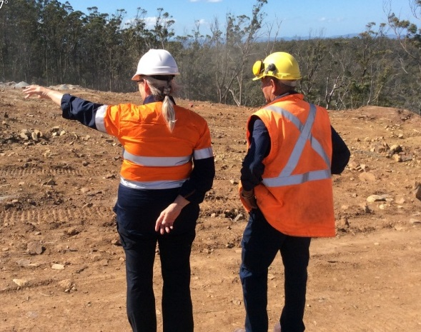

.

5.2 Fuel Act:
- 455 fuel supply sites around Australia were subject to a monitoring inspection.
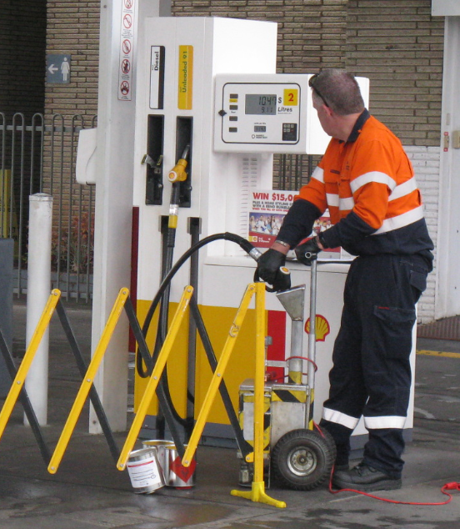
- 1,577 samples were screened on site against those fuel quality standards that can be tested for in the field. Screening is conducted using on-vehicle equipment, or can be undertaken using mobile equipment (enabling screening in remote areas where inspectors can fly in and fly out to a supply site).
- 326 of the screened samples were sent for further laboratory tests to verify compliance against all parameters under the Fuel Act.
- 77 non-compliances were identified (29 relating to documentation, 21 labelling, and 27 concerning samples not meeting parameters specified in the Fuel Act).
- We responded to non-compliance by:
  - Issuing warnings and formal cautions;
  - Directing that the supply of fuel cease; and
  - Initiating action to bring penalties against suppliers of fuels that did not meet the standards.
5.3 OPSSG Act:
- 248 referrals of potential non-compliance with licence conditions were made to the Department by industry co-regulators. Through desktop review, correspondence and telephone calls, we have brought the bulk of these into compliance.
- 102 licence holder sites were subject to a compliance monitoring inspection. Non-compliance was established with 25 of the sites that were inspected; these sites were subject to follow up monitoring, with the bulk being brought into compliance through those processes.
- A small number of matters are currently undergoing compliance processes. Under our policies and procedures, we have a range of enforcement options to address these including:
  - Issuing warnings and form cautions;
  - Revocation of licences; and
  - Infringement notices
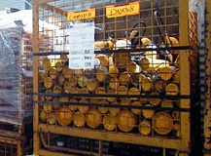

6. Compliance Monitoring Focus for 2016–17
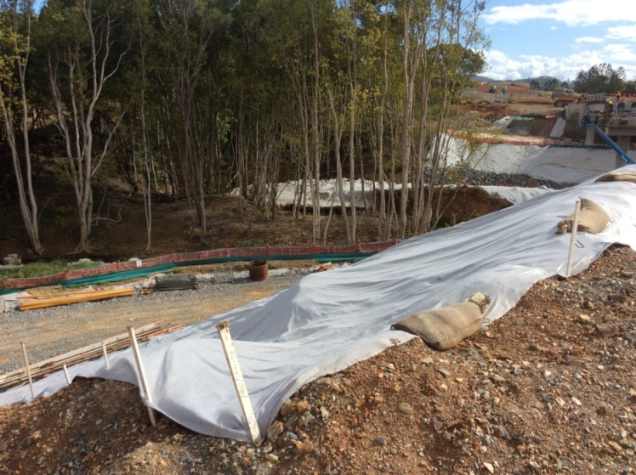
Our compliance monitoring focus for 2016-17 is informed through our risk prioritisation process. While this section outlines priority sectors and regions, the Department will remain responsive to emerging risks and reports of serious non-compliance.
6.1 EPBC Act
At the start of 2016-17 our regulatory environment includes:
- 773 active controlled action approvals;
- 1,039 active not a controlled action particular manner decisions;
- 2,663 not a controlled action decisions; and
- 10 approved Strategic Assessments.

Our risk modelling has identified the priority sectors to be Mining (coal, iron ore and mineral sands), Energy (oil and gas, including coal seam gas), Construction (residential development) and Transport (road); and priority regions to be central QLD, northern NSW and the Hunter Valley, Perth/Peel and the Pilbara region of WA. We will target our compliance monitoring resources towards projects from these sectors and regions.
Our EPBC key performance indicators are:


- Compliance Plans – will be developed for all projects identified as high risk, all projects approved in 2016-17 and for all projects subject to inspection. Compliance Plans enable us to review the status of the project as well as provide us with the opportunity to reassess the relative risk rating of that project.

- Inspections – At least 30% of high risk projects will be subject to an onsite inspection to verify compliance with approval conditions. At least 70 other risk rated projects will be subject to an onsite inspection. We will increase the number of inspections we undertake jointly with co-regulators (such as State or Local Government authorities).
- Monitoring and Compliance Reports – All reports submitted as required by conditions of approval for high risk projects will be subject to detailed review.
- Audit – At least 5% of projects identified as high risk will be subject to directed independent audit under the strategic audit program. We will audit other risk rated projects under our random audit program.
- Compliance Monitoring Assurance Plans – will be developed for all Strategic Assessments. These plans enable us to review the status of each Strategic Assessment to effectively monitor for compliance with approval conditions and management plans. We will review all submitted Strategic Assessment reports submitted.
- Potential Non-Compliance – All allegations of potential non-compliance will be assessed and managed in accordance with our standard operating procedures and our EPBC Act Compliance and Enforcement Policy

In addition to the above, we will target industry outreach towards the priority sectors and regions with a focus on industry outreach. This will include educational activities, such as presentations at industry events and forums and one-on-one engagement with individual approval holders; particularly those subject to a number of approvals in a high priority sector or region.
Our analysis shows we need to direct our compliance monitoring efforts towards:

- Ensuring that holders of approvals notify us of commencement of the action, and that actions do not commence without Ministerial approval where conditions have been imposed to require commencement within a specified time period.
- Ensuring management plans are fully implemented, including when changes to economic conditions may result in delay or cessation of the project, and that any revisions to management plans are undertaken in accordance with the process outlined in the conditions of approval.
- Producing annual compliance and monitoring reports as required by the conditions of approval.
Securing offsets on time and through robust long-term mechanisms, as well as providing for effective and ongoing management of these sites.
- Managing projects to ensure that rehabilitation and revegetation requirements are fully realised.
- Ensuring adequate records are maintained to demonstrate compliance with disturbance limits for fauna habitat and threatened ecological communities.
- Helping approval holders to understand the difference between our role and that of co-regulators (e.g. state government environment or planning agencies), particularly where the approval holders also have to meet requirements under approvals administered by a co-regulator.

6.2 Sea Dumping Act
Activities subject to the Sea Dumping Act typically include capital or maintenance dredging programs, or the scuttling of vessels or other objects for the purpose of developing artificial reefs or recreational dive sites. Sea Dumping permits may vary in terms of the time that they remain in effect; a permit may apply to a short term once off action, or a program that runs over several years.
There are approximately 30 Sea Dumping permits which are in effect at any one time. We will focus our compliance monitoring resources on Sea Dumping permits which have a corresponding EPBC Act approval.
Our Sea Dumping key performance indicators are:

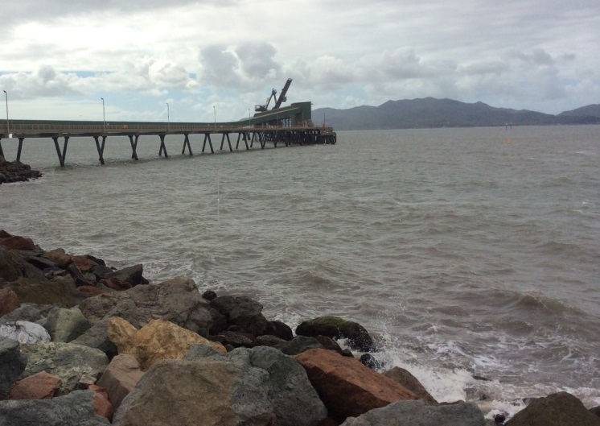
- Review – At least 30% of all active Sea Dumping permits will be subject to a desktop review to verify compliance with permit conditions.
- Audit – At least 2 Sea Dumping permits will be subject to an audit.
- Inspection – At least 20% of active Sea Dumping permits will be subject to an inspection.
- Potential Non-Compliance – All allegations of potential non-compliance will be assessed and managed in accordance with our standard operating procedures and our Compliance and Enforcement Policy.

6.3 Fuel Act
Compliance monitoring under the Fuel Act involves ensuring that fuel supplied in Australia satisfies the standards specified in the legislation. This includes ensuring that the quality of the fuel meets environmental and human health requirements, as well as that documentation is appropriately maintained and correct signage displayed. The fuel compliance monitoring program incorporates supply sites across Australia.
While we will be undertaking compliance monitoring activities across Australia, our analysis has identified the need for increased focus in Tasmania, Victoria and QLD during 2016-17.
Our Fuel Quality key performance indicators are:

- Inspection – At least 450 fuel supply sites will be subject to a monitoring inspection. Inspections will be conducted in all States and Territories.
- Screens – At least 1,500 on site fuel samples will be subject to onsite initial screening.
- Samples – At least 350 samples will be subject to comprehensive laboratory analysis.
- Potential Non-Compliance – All allegations of potential non-compliance will be assessed and managed in accordance with our standard operating procedures and our Compliance and Enforcement Policy.

Our intelligence suggests that we need to focus our testing program towards diesel fuel; in particular, to test that diesel fuel meets the specification in regards to flash point (the temperature at which diesel fuel combusts). Our inspectors will conduct follow up testing at those sites that have had prior non-compliant results.

6.4 OPSGG Act
Regulation under the OPSGG is undertaken in collaboration with industry; these industry co-regulators can only operate within the parameters of legal arrangements detailed in contractual agreements we manage. Most compliance monitoring of the regulated community is undertaken by these industry co-regulators; specifically to conduct desktop audits of licence holders, and to undertake education and outreach activities. Our compliance monitoring function comes into effect to enable assurance of co-regulator activities, as well as to provide a point of escalation where there is potential non-compliance.
We will broaden our focus across the regulated community and revisit those with prior non-compliance.
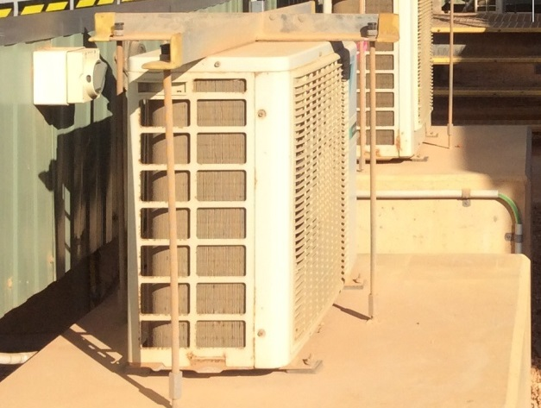
Our OPSGG key performance indicators are:

- Alleged Non-compliance – All allegations of
non-compliance referred to us by industry co-regulators will be assessed, and prioritised, and acted upon with either desktop review or onsite inspection.
- Inspection:
  - At least 70 onsite inspections will be conducted each year of sites in the refrigeration and air-conditioning industry where potential non-compliance is referred from a co-regulator.
  - At least 10 onsite inspections will be conducted each year of sites in the fire protection industry where potential non-compliance is referred from a co-regulator.
  - At least 20 onsite inspections will be conducted of licensees in any industry irrespective of whether there are allegations of potential non-compliance in order to provide assurance of co-regulator processes.
- Non-Compliance – All non-compliance will managed in accordance with our standard operating procedures and the our Compliance and Enforcement Policy
7. What we expect from the Regulated Community
Our regulated community is diverse, including a range of industries and organisations of varying size. We expect all who we regulate to comply with the respective legislation. To do this, we encourage the regulated community to:

Know your responsibilities:
- Make sure that you know what is required of you under the legislation; ensure you do only what is permitted in your approval, permit or licence.
- Read relevant guidance material available on our website.
- Beware of assumptions. If you are looking to make changes to your project or operation, do not assume that your permit or approval will automatically cover that change.

Did you know?
EPBC approvals can only be transferred with the agreement of the Minister.
Sale of a project or site does not automatically transfer the approval. Failing to transfer an approval can result in the risk of unexpected liability or could invalidate an EPBC approval (requiring the project to be re-referred for assessment).
Put in place systems and processes:
- Make sure you identify all due dates and put in place systems and processes to ensure that you meet deliverables on time.
- Ensure that you keep full records of all activities to demonstrate compliance with conditions of approvals, permits or licences.
Remember, we work and share information with
co-regulators.
Expect an inspection or audit
- Every year we inspect and conduct audits of hundreds of projects and sites including:
  - Projects involving the extraction and processing of minerals and gas, transport (such as roads, rail, shipping and airports), construction of residential and commercial developments (small subdivisions to master planned communities), and management of natural resources (such as land clearing and scientific research).
  - Projects involved with dredging and the construction or installation of artificial reefs.
  - Retail and wholesale fuel suppliers (such as service stations), and at special events (such as racetracks).
  - Businesses involved in air-conditioning and refrigeration (such as motor vehicle repairers and equipment installers and servicers), and fire protection (such as installation, maintenance and decommissioning of fire protection equipment and infrastructure).
Ensure you can demonstrate to an inspector or auditor that you are complying with the applicable legislative requirements.
Remember, we have a range of compliance monitoring tools; even if you are not inspected or audited, it does not mean you are not being monitored.
Ensure long term compliance
- Compliance with legislation does not finish when your approval, permit or licence expires, or when your project finishes. All necessary steps must be undertaken to ensure that any activity is conducted in accordance with legislation.
Seek help or guidance
- We want you to comply with the requirements of legislation, and will happily assist with any questions or concerns you may have. If you are unsure of anything, please do not hesitate to contact the relevant team using the details provided in Section 8 of this program.

8. Further Information or Questions
For further information about compliance monitoring, to ask any questions, or to discuss any concerns you may have regarding the activities outlined in this program, please contact:
Monitoring and Assurance Section
Compliance and Enforcement Branch
Department of the Environment and Energy
GPO Box 787
Canberra ACT 2601
EPBC and Sea Dumping
Telephone: 1800 803 772 (and ask for the EPBC and Sea Dumping Compliance Monitoring Team)
Email: EPBCmonitoring@environmnt.gov.au
Website: https://www.environment.gov.au/epbc/compliance-and-enforcement

Fuel Quality
Telephone: 1800 803 772 (and ask for the Fuel Quality Monitoring Team)
Email: fuel.quality@environment.gov.au
Website: https://www.environment.gov.au/webform/make-fuel-quality-complaint

OPSGG
Telephone: 1800 803 772 (and ask for the Ozone Compliance Monitoring Team)
Email: ozone.monitoring@environment.gov.au
Website: https://www.environment.gov.au/protection/ozone

The documents specifically referred to in this document include:
- Compliance and Enforcement Policy (2009)
- EPBC Act Compliance and Enforcement Policy (2013)
- ANAO (2014) Australian National Audit Office Better Practice Guide—Administering Regulation
- OECD (2014), OECD Best Practice Principles for Regulatory Policy—Regulatory Enforcement and Inspections

The above documents can be downloaded from the Department’s website – www.environment.gov.au

