CONSERVATION AGREEMENT
Conservation Agreement for the protection and conservation of the Central Hunter Valley Eucalypt Forest and woodland ecological community, and the Regent
Honeyeater Mitchelhill Biodiversity Offset Area
Minister for the Environment and Water on behalf of the Commonwealth of Australia

HV Operations Pty Ltd
Coal & Allied Operations Pty Ltd Anotero Pty Ltd

Conservation Agreement for the protection and conservation of the Central Hunter Valley Eucalypt Forest and woodland ecological community, the Regent Honeyeater, page i
[8699614:33026560_1]

Table of contents

Table of contents Details

Agreed terms

Definitions and interpretation

Agreement Period

Priority of documents

Acknowledgement

Registration of this Agreement

Conservation Activity

Review and monitoring of the Agreement

Dispute Resolution

Termination or variation

Notices

Representations and warranties

Change in ownership or control of the Offset Area or the authorisations

General clauses

Schedule 1 – Agreement Details

Schedule 2 – Biodiversity Offset Management Plan Execution page

Annexure 1 – Approval

Conservation Agreement for the protection and conservation of the Central Hunter Valley Eucalypt Forest and woodland ecological community, the Regent Honeyeater, page ii
[8699614:33026560_1]

Details

Parties
- Minister for the Environment and Water (Minister) on behalf of the Commonwealth (Commonwealth)
- HV Operations Pty Ltd (ACN 606 478 399) (HVO), Coal & Allied Operations Pty Ltd (ACN 000 023 656) (CAO) and Anotero Pty Ltd (ACN 618 503 674) (Anotero) (together, the Interest Holder)

Recitals
  - Section 305(1)(a) of the EPBC Act provides that the Minister may, on behalf of the Commonwealth, enter into a conservation agreement for the protection and conservation of biodiversity in the Australian jurisdiction.
  - Condition 4 of the Approval requires the person taking the action to enter into and comply with a conservation agreement under section 305 of the EPBC Act for each of the following offset areas as shown in Schedule 3 to the Approval:
    - Figure 1. The Wandewoi Biodiversity Area;
    - Figure 2. The Hook Biodiversity Area;
    - Figure 3A and 3B. The Mitchelhill Biodiversity Area;
    - Figure 4. The Condon View Biodiversity Area;
    - Figure 5A and 5B. The Crescent Head Biodiversity Area.
  - Pursuant to section 305(1A)(a) of the EPBC Act, the purpose of this Agreement is to provide for the protection and conservation of listed species and ecological communities, and their habitat by:
- protecting and conserving the Protected Matter within the Offset Area; and
- satisfying condition 4 and 12 of the Approval in respect of the Offset Area.
  - The Minister, on behalf of the Commonwealth, has agreed to enter into this Agreement with the Interest Holder under section 305(1)(a) of the EPBC Act to give effect to the purpose described in Recital C in respect of the Offset Area.
  - For the purposes of section 305(2) of the EPBC Act, the Minister is satisfied that:
- the implementation of this Agreement will result in a net benefit to the conservation of biodiversity; and
- this Agreement is not inconsistent with any recovery plan, threat abatement plan or wildlife conservation plan.
  - Pursuant to section 307 of the EPBC Act, this Agreement is binding on the Commonwealth and the Interest Holder, and anyone else who is a successor to the whole or any part of the Interest Holder’s respective Interests in the Offset Area.

Conservation Agreement for the protection and conservation of the Central Hunter Valley Eucalypt Forest and woodland ecological community, the Regent Honeyeater,
[8699614:33026560_1]

Agreed terms

Definitions and interpretation

Definitions
In this Agreement, except where the contrary intention is expressed, terms have the meaning they are given in the EPBC Act or Approval and otherwise the following definitions are used:

Agreement | this agreement between the Minister and the Interest Holder, including its Schedules, as amended from time to time in accordance with section 308 of the EPBC Act or clause 9.2 of this Agreement.
Agreement Details | Schedule 1 of this Agreement.
Anotero | Anotero Pty Ltd (ACN 618 503 674)
Approval | the approval granted on 10 October 2016 under sections 130 and 133 of the EPBC Act in respect of EPBC 2016/7640 (a copy of which is included in Annexure 1 to this Agreement), and subject to the conditions of approval as varied from time to time.
Approval Period | means the period from the commencement of this Agreement until the earlier of:  - the expiry date of the Approval (as may be extended by the Minister from time to time);  - the date that the Approval is surrendered; and  - the date that is 20 Business Days after the Approval is revoked, or if a request for reinstatement is made during that period and the Minister decides not to reinstate the Approval, the date that the Minister provides written notice of that decision.
BOMP | the Hunter Valley Operations Biodiversity Offset Management Plan – Mitchelhill Biodiversity Area, version 5, dated 3 June 2025, which is included as Schedule 2 to this Agreement, or any subsequent version of that plan approved by the Minister from time to time.
Business Day | in relation to the doing of any action in a place, any day other than a Saturday, Sunday or public holiday in that place.
CAO | Coal & Allied Operations Pty Ltd (ACN 000 023 656)
Change in Control | a situation or occurrence where a party comes under the Control of a person who did not Control that party at the date of this Agreement.
CHVEF | Central Hunter Valley Eucalypt Forest and woodland.
Commonwealth | the Commonwealth of Australia.

Conservation Activity | the actions specified in clause 6.3.
Conservation Activity Objective | the objective specified in clause 6.2.
Control | has the meaning in section 50AA(1) of the Corporations Act 2001 (Cth).
Department | the Commonwealth agency responsible for administering the EPBC Act, currently the Department of Climate Change, Energy, the Environment and Water.
Electronic Communication | has the same meaning as in the Electronic Transactions Act 1999 (Cth).
EPBC Act | the Environment Protection and Biodiversity Conservation Act 1999 (Cth).
EPBC 2016/7640 | the action described as “the continuation of open cut coal mining operations in areas that were previously approved by the State after the commencement of the Environmental Protection and Biodiversity Conservation Act 1999 within the Hunter Valley Operations (HVO) mine complex, located 24 km north west of Singleton, NSW [See EPBC Act referral 2016/7640]” that was approved in accordance with the Approval.
HVO | HV Operations Pty Ltd (ACN 606 478 399).
HVO Joint Venture | the joint venture arrangement entered into between CAO and Anotero and, as at the date of this Agreement, managed by HVO.
Interest | each Interest Holder’s respective interest in the Offset Area at the date of this Agreement, being:  - with respect to CAO and Anotero, as the registered proprietors of the Offset Area in fee simple; and  - with respect to HVO, as the holder of the Approval and the manager of the HVO Joint Venture.
Interest Holder | each of HVO, CAO and Anotero, jointly and severally.
Interest Holder Invitee | any lessee, licensee or other invitee of the Interest Holder, including any contractor (of any tier) or consultant engaged by or on behalf of the Interest Holder, who accesses the Offset Area.
Law | any applicable statute, regulation, by-law, ordinance or subordinate legislation in force from time to time in Australia, whether made by a State, Territory, the Commonwealth, or a local government.
Minister | the Minister administering the EPBC Act or a delegate of the Minister pursuant to section 515(1) of the EPBC Act.
Offset Area | the land described in Item 1 of the Agreement Details.

Protected Matter | each of the species and ecological communities identified in Item 2 of the Agreement Details.
Security Interest | - any mortgage, pledge, lien, charge or other preferential right, trust arrangement, agreement or arrangement of any kind given or created by way of security, including a security interest (as defined in the Personal Property Securities Act 2009 (Cth)); and  - any agreement to create or grant any arrangement described in paragraph (a) of this definition.

Interpretation
In this Agreement, except where the contrary intention is expressed:
    - the singular includes the plural and vice versa, and a gender includes other genders;
    - another grammatical form of a defined word or expression has a corresponding meaning;
    - the meaning of general words is not limited by specific examples introduced by meaning of, for example or similar expressions;
    - a reference to a clause, paragraph, Schedule or Annexure is to a clause or paragraph of, or Schedule or Annexure to, this Agreement;
    - a reference to a document or instrument includes the document or instrument as novated, altered, supplemented or replaced from time to time;
    - a reference to time is to the time in the place where the obligation is to be performed;
    - a reference to a party is to a party to this Agreement and:
      - if the party consists of 2 or more persons, is a reference to each of those persons jointly and severally; and
      - includes the party's executors, administrators, successors and permitted assignees, delegates and substitutes;
    - a reference to a person includes a natural person, partnership, body corporate, association, governmental or local authority or agency or other entity;
    - a government agency or department includes any successor or replacement of that government agency or department;
    - a reference to a statute, ordinance, code or other law includes regulations and other instruments under it and consolidations, amendments, re-enactments or replacements of any of them;
    - a rule of construction does not apply to the disadvantage of a party because the party was responsible for the preparation of this Agreement or any part of it; and
    - the word 'includes' in any form is not a word of limitation.

Agreement Period
- This Agreement commences on the date of execution by the last party.
- This Agreement operates in perpetuity, unless:
  - the parties agree in writing that this Agreement should end, or
  - the Agreement is terminated under clause 9, or
  - this Agreement is terminated under the EPBC Act.

Priority of documents
If there is any inconsistency between any of the documents forming part of this Agreement those documents will be interpreted in the following order of priority to the extent of the inconsistency:
- the ‘Agreed terms’ of this Agreement (being clauses 1 through to 13) and Schedule 1 - Agreement Details;
- Schedule 2 – BOMP;
- any Annexure(s) in their order of appearance; and
- documents incorporated by reference in this Agreement.

Acknowledgement
- The parties acknowledge and agree that:
  - this is a conservation agreement entered into under section 305(1)(a) of the EPBC Act for the protection and conservation of biodiversity in the Australian jurisdiction; and
  - the purpose of this Agreement is:
    - the enduring protection of the Protected Matter within the Offset Area; and
    - to satisfy condition 4 and 12 of the Approval in respect of the Offset Area.
- The Minister acknowledges and agrees that:
  - for the purposes of section 305(2)(a) of the EPBC Act, the Minister is satisfied that:
    - this Agreement will result in a net benefit to the conservation of biodiversity; and
    - this Agreement is not inconsistent with any recovery plan, threat abatement plan or wildlife conservation plan.
  - as required by section 305(3A) of the EPBC Act, in deciding whether to enter into this Agreement, the Minister has had regard to all approved conservation advices for the Protected Matter.

Registration of this Agreement
- The Interest Holder must do all things reasonably necessary to have this Agreement registered or noted on each certificate of title for the land comprising the Offset Area as soon as practicable after commencement of this Agreement.
- Without limiting clause 5(a), within 10 Business Days of the commencement of this Agreement, the Interest Holder must submit an application to the NSW Land Registry Services to have this agreement registered or noted on the relevant certificates of title using the form entitled ‘Form 11R’ or such other form as required by the NSW Land Registry Services.

Conservation Activity

Obligation to carry out the Conservation Activity
The Interest Holder must carry out the Conservation Activity:
    - as described in clause 6.3 of this Agreement;
    - to protect and conserve each Protected Matter within the Offset Area in accordance with the BOMP;
    - in accordance with all applicable Laws;
    - so as to deliver the Conservation Activity Objective and meet all reporting requirements, in accordance with the requirements of this Agreement; and
    - otherwise in accordance with the provisions of this Agreement.

Conservation Activity Objective
The Conservation Activity Objective is to:
    - protect and conserve each Protected Matter within the Offset Area; and
    - by the deadlines specified in the BOMP, ensure that the Offset Area meets the condition thresholds specified in the BOMP.

Conservation Activity particulars
During the term of this Agreement, the Interest Holder must:
    - comply with and implement, in full, the BOMP, including implementing all actions and requirements of the BOMP by the relevant timeframes specified therein;
    - comply with its monitoring and reporting obligations under clause 7.2; and
    - not take any action that would prevent or otherwise impede the implementation of the BOMP or this Agreement.

Review and monitoring of the Agreement

Review
    - The Minister may undertake, or direct the Interest Holder to undertake, a review of the operation of this Agreement, including the Schedules, at any time during the term of this Agreement, including if:
      - in the opinion of the Minister:
        - monitoring conducted in accordance with clause 7.2 indicates that any of the actions, requirements or outcomes of the BOMP are not likely to be achieved by the relevant timeframes therein; or
        - any breach of the BOMP or this Agreement, is detected or is likely to occur; or
      - any of the conditions of the Approval are varied in accordance with section 143 of the EPBC Act.

    - Prior to a review being undertaken, the Minister will consult with the Interest Holder regarding:
      - the terms of the review;
      - the scope of the review; and
      - the date by which the review will be completed.
    - A review may be linked to a report, document or audit prepared under clauses 7.2 or 7.3.
    - Failure to undertake the review contemplated by clause 7.1(a) does not invalidate this Agreement.
    - The Interest Holder must comply with any direction given by the Minister under clause 7.1(a) and provide all reasonable assistance to the Minister to enable a review contemplated by clause 7.1(a), including by promptly providing all requested information and data.
    - This clause does not limit the Minister’s powers to terminate or vary this Agreement under section 308 of the EPBC Act.

Reporting
    - The Interest Holder must, unless otherwise agreed in writing by the parties:
      - monitor and provide to the Minister on an annual basis, a report on compliance with, and the implementation and effectiveness of, this Agreement and the BOMP;
      - notify the Minister in writing of any non-compliance with this Agreement and the BOMP, promptly after becoming aware of the non-compliance; and
      - maintain accurate and complete records in relation to compliance with, and the implementation and effectiveness of this Agreement and the BOMP, and provide these to the Minister upon request.
    - To the extent that any of the Interest Holder’s obligations under clause 7.2(a) may be satisfied through the provision of documents or reports in compliance with HVO’s reporting requirements under conditions 21, 21A, 22, 22A and 22B of the Approval, the provision of such documents or reports in compliance with conditions 21, 21A, 22, 22A and 22B of the Approval will be taken to satisfy the Interest Holder’s obligations under clause 7.2(a).

Independent audit of Agreement
    - At any time during the term of this Agreement, the Minister may, commission, or direct the Interest Holder to commission, an independent audit of this Agreement, its implementation and the Interest Holder’s compliance with the Agreement.
    - If the Minister directs the Interest Holder to commission the audit in accordance with clause 7.3(a), the direction may specify:
      - the terms of the audit;
      - the scope of the audit;

      - the date by which the audit will be completed; and
      - the independent auditor who will carry out the audit and prepare the audit report, or that the Interest Holder is to propose an independent auditor for the Minister’s approval by a nominated date.
    - The Minister or their representative, and the person conducting the audit, may at any time upon first giving reasonable notice to the Interest Holder, enter onto the Offset Area to inspect the condition of the Offset Area and carry out the audit.
    - The Interest Holder must:
      - comply with any direction given by the Minister under clause 7.3(a); and
      - fully cooperate with any audit conducted under this clause 7.3, including by:
        - providing any reasonable assistance requested by the Minister or the person conducting the audit;
        - making sure that a representative of the Interest Holder is available to discuss compliance and other relevant matters during the audit with the person conducting the audit; and
        - promptly complying with any requests for documents or other information by the auditor and ensuring that all Interest Holder Invitees promptly comply with such requests.
    - The Minister may cause the results of an audit to be published on the internet or through the general media, provided that the Interest Holder has been provided with an opportunity to respond to any adverse audit findings.

No restraint on powers in this Act
Nothing in this Agreement limits or constrains any inspection, entry or audit power any person may have under the EPBC Act.

Remedying non-compliance
    - If any non-compliance with this Agreement is identified in:
      - a review carried out under clause 7;
      - any documents or reports submitted under clause 7.2; or
      - any audit carried out under clause 7.3,
or is otherwise identified by the Minister acting reasonably, the Minister may, without limiting or affecting its other rights under this Agreement or the EPBC Act, issue a written notice to the Interest Holder requiring the Interest Holder to remedy the non-compliance within a specified period requested by the Minister (Default Notice).
    - If the Minister issues a Default Notice then the Interest Holder must comply with that notice.
    - If the Interest Holder fails to remedy the non-compliance identified in a Default Notice within the period specified in that notice (or such other period agreed

by the parties in writing), the Minister may take all reasonable action to remedy the non-compliance, and may recover the costs of doing so as a debt due from the Interest Holder.
    - Nothing in this Agreement, including this clause 7.5 affects or limits the Minister’s ability to exercise powers and make any decisions authorised under the EPBC Act in relation to the Interest Holder’s failure to comply with this Agreement.

Access to Offset Area
    - The Minister or their representatives may, at any time upon first giving reasonable notice to the Interest Holder, enter onto the Offset Area for the purpose of inspecting the condition of the Offset Area or to monitor compliance with this Agreement.
    - The Interest Holder must not, and must ensure that each Interest Holder Invitee does not, obstruct access by the Minister or their representatives to the Offset Area in accordance with clause 7.6(a).

Dispute Resolution

Dispute Notice
    - Unless otherwise expressly provided in this Agreement, the parties agree that any dispute between the parties in relation to this Agreement (Dispute) must be resolved in accordance with this clause 8.
    - If a Dispute arises then either party may give notice to the other party (Dispute Notice), which must:
      - be in writing;
      - state that it is a notice under this clause 8.1; and
      - include or be accompanied by full details of the Dispute.

Meeting to discuss
Senior representatives of the Minister and the Interest Holder (Dispute Parties) must meet within 10 Business Days of the service of a Dispute Notice in accordance with clause 8.1 for the purpose of resolving the Dispute.

Expert determination
If a Dispute is not resolved within 20 Business Days after the service of the Dispute Notice, either party may give a written notice to the other party to refer the Dispute for expert determination (Notice of Referral).
  - Appointment of Expert
    - Only an expert (as defined in clause 8.4(b)) may conduct an expert determination under clause 8.3.
    - An expert is:
      - a person agreed between the parties; or

      - where the parties are unable to reach agreement within 10 Business Days of a Notice of Referral, a person appointed by the Chair of the Resolution Institute.
  - Not arbitration
An expert determination conducted under this clause 8 is not arbitration and the expert is not an arbitrator. The expert may reach a decision from his or her own knowledge and expertise.

Procedure for determination
The parties agree that the expert must give effect to this Agreement and must:
    - act as an expert and not as an arbitrator;
    - act fairly, impartially and independently of each party;
    - apply the expert's own knowledge and expertise;
    - determine and notify the parties of the procedure for conducting the expert determination as the expert thinks fit, and is not bound by the rules of evidence;
    - make any directions for conducting the expert determination as the expert thinks fit;
    - conduct investigations and enquiries, examine documents and interview persons to the extent the expert considers necessary or desirable to resolve the Dispute;
    - determine the Dispute as expeditiously as possible; and
    - give the parties a written determination with reasons, within 20 Business Days after the date of the engagement, or any later date the parties may agree in writing.
  - Legal representation
Each party is entitled to legal representation during the expert determination process set out in clauses 8.4 and 8.6.

Disclosure of interest
The expert must:
    - immediately disclose to the parties any interest he or she has in the outcome of the determination; and
    - not communicate with one party to the determination without the knowledge of the other.

Expert’s determination
The determination of the expert:
    - shall be in writing;
    - will be final and binding, unless a party gives notice of appeal to the other party within 21 days of the determination; and

    - subject to clause 8.9(b), is to be given effect to by the parties unless and until it is reversed, overturned or otherwise changed under the procedure in clause 8.13.

Correction
Any party may make a written request to the expert to correct the determination for:
    - a minor mistake arising from an accident or omission; or
    - a defect in form.

Cooperation
Each party must:
    - cooperate in good faith with the expert and the other party in the conduct of the expert determination; and
    - use reasonable endeavours to comply with all requests and directions reasonably given by the expert.

Costs
Each party must:
    - bear its own costs in respect of any expert determination; and
    - unless determined otherwise by the expert, pay one-half of the expert’s costs.

Condition precedent to litigation
    - If a Notice of Referral has been given under clause 8.3 in respect of a Dispute, then a party may not litigate the issues the subject of the Dispute unless the Dispute is not resolved within 30 Business Days of receipt of the Notice of Referral (or such later date as the parties may agree in writing).
    - Nothing in this clause 8 prejudices the right of a party to seek urgent injunctive or declaratory relief for any matter in connection with this Agreement, or to seek an order or injunction under section 476 of the EPBC Act.

Confidentiality
    - Subject to clause 8.14(b), the parties must, and must ensure that the Expert must, keep confidential and not disclose to any other person:
      - all proceedings and submissions relating to an expert determination under clause 8.3, including the fact that any step in the expert determination is occurring; and
      - all documents and any other information (in any form) relating to the expert determination, including the Expert’s determination.
    - A party may disclose confidential information referred to in clause 8.14(a):
      - to an officer, employee, agent, contractor, or legal, financial or other professional advisor, if the disclosure is necessary to enable the party to perform its obligations or to exercise its rights under this Agreement, including to enable the party to receive advice in respect of and participate in an expert determination;
      - if that party obtains the prior written consent of the other party;

      - as required by Law or any recognised stock exchange; or
      - to the extent necessary to give effect to or to enforce a determination.

Obligations continue
    - Despite the existence of a Dispute, the Interest Holder must continue to perform its obligations under this Agreement, unless a direction is issued in accordance with clause 8.15(b).
    - If directed and notified in writing by the Minister to do so, the Interest Holder must cease performing the obligations under this Agreement which are specified in the Minister’s notice until the Minister issues a further written notice to the Interest Holder directing it to resume performance of those obligations.

Subsequent proceedings
A party must not appoint the Expert as arbitrator, advocate or adviser in any arbitral, judicial or adjudication proceedings relating to the Dispute or any part of it, except with the other party’s written consent.

Termination or variation

Termination and variation under section 308 of the EPBC Act
The parties acknowledge and agree that:
    - under section 308(3)(a) of the EPBC Act, the parties may agree to terminate this Agreement;
    - under section 308(4) of the EPBC Act, if the Minister is satisfied that this Agreement is not capable of achieving its purpose, the Minister may, by order published in the Gazette, terminate the Agreement or vary it in any way the Minister thinks necessary to ensure it becomes capable of achieving its purpose;
    - the Minister may make an order under section 308(4) of the EPBC Act without the agreement of the Interest Holder;
    - if this Agreement is varied by an order under section 308(4) of the EPBC Act, the Interest Holder may terminate the Agreement by written notice given to the Minister, under section 308(7) of the EPBC Act; and
    - if this Agreement is terminated or varied by the Minister by an order under section 308(4) of the EPBC Act or terminated by the Interest Holder under section 308(7) of the EPBC Act, the Interest Holder is not entitled to any compensation or damages in respect of the termination or variation, and the Interest Holder releases the Commonwealth and the Minister accordingly.

Variation by agreement
    - Without limiting clause 9.1, the parties may vary this Agreement by agreement.
    - No agreement or understanding varying or extending this Agreement is legally binding upon a party to this Agreement unless the agreement or understanding is in writing and signed by the parties.

Notices

Service of notices
    - A party giving notice or notifying under this Agreement must do so in English.
    - The notice must be given in writing or by Electronic Communication:
      - directed to the other party’s address for notices (as set out in Item 3 of the Agreement Details and as varied by any notice); and
      - hand delivered or sent by prepaid post or Electronic Communication to that address.
    - A party to this Agreement must ensure it provides current and correct contact details to the other party.

Effective on receipt
A notice given in accordance with clause 10.1 takes effect when it is taken to be received (or at a later time specified in it), and is taken to be received:
    - if hand delivered, on delivery;
    - if sent by prepaid post, on the sixth Business Day after the date of posting (or on the seventh Business Day after the date of posting if posted to or from a place outside Australia); or
    - if sent by Electronic Communication, at the time that would be the time of receipt under the Electronic Transactions Act 1999 (Cth),
but if the delivery, receipt or transmission is not on a Business Day or is after 5.00pm on a Business Day, the notice is taken to be received at 9.00am on the next Business Day.

Representations and warranties
The Interest Holder represents and warrants to the Minister that:
- CAO and Anotero are the registered proprietors of the Offset Area;
- CAO and Anotero are paticipants in the HVO Joint Venture;
- HVO is the manager of the HVO Joint Venture;
- HVO is the holder of the Approval;
- the Interest Holder has full power and authority to enter into, perform and observe its obligations under this Agreement;
- the execution, delivery and performance of this Agreement has been duly and validly authorised by the Interest Holder; and
- no litigation, arbitration, mediation, conciliation or administrative proceedings are taking place, pending, or to the knowledge of any of its officers after due inquiry, are threatened which if adversely decided, could have an adverse effect on the Interest Holder’s ability to perform its obligations under this Agreement.

Change in ownership or control of the Offset Area or the authorisations
- The parties acknowledge the effect of section 307(c) of the EPBC Act.
- Except as permitted under clause 12(c), the Interest Holder must not sell, assign, novate, transfer, delegate, otherwise deal with, encumber or create a Security Interest over:
  - the Offset Area;
  - the Approval; or
  - any of its rights or obligations under this Agreement,
without the prior written consent of the Minister (which consent may be withheld in its absolute discretion).
- Without limiting the Minister’s discretion under clause 12(b), the Minister agrees to use its best endeavours to make a decision under clause 12(b), and notify the Interest Holder of that decision, within 20 Business Days of receipt of a written request for consent under that clause.
- After the Approval Period, the Interest Holder may sell or transfer to another person (an Incoming Party) the Offset Area, provided that it first:
  - notifies the Minister of the details of the proposed Incoming Party;
  - provides a copy of this Agreement to the Incoming Party; and
  - procures that the Incoming Party:
    - execute a deed of novation whereby it agrees to assume the obligations, duties and liabilities of the Interest Holder under or in connection with this Agreement, on terms acceptable to the Minister (acting reasonably); and
    - delivers a copy of that executed deed to the Minister.
- For the purpose of clauses 12(b) and 12(d), a Change in Control of an Interest Holder will be deemed to be an assignment by that Interest Holder. Where a Change in Control occurs, clause 12(d)(iii) does not apply.

General clauses

Rights and powers of the Minister
The rights and powers of the Minister under this Agreement are in addition to any rights and powers the Minister has under the EPBC Act.

Ownership of Agreement
All copyright and other intellectual property rights that subsist in this Agreement remain the property of the Commonwealth.

Approvals and consents
Except where this Agreement expressly states otherwise, a party may, in its discretion, give conditionally or unconditionally or withhold any approval or consent under this Agreement.

Costs
    - Each party must pay its own costs of negotiating, preparing and executing this Agreement.
    - A party which is obliged or permitted to do anything under this Agreement must perform that obligation or exercise that power at its cost unless expressly stated otherwise.
    - In particular, except as expressly provided in this Agreement, HVO is responsible for all costs and expenses of complying with its obligations, duties and responsibilities (express or implied) under this Agreement.

Counterparts
This Agreement may be executed in counterparts. All executed counterparts constitute one document.

Electronic execution
Each party consents to the signing of this Agreement by electronic means. The parties agree to be legally bound by this Agreement signed in this way.
The Minister may provide the Interest Holder with the ability to sign this Agreement by electronic means, including by giving access to software or to an online service for this purpose.

Entire agreement
This Agreement constitutes the entire agreement between the parties in connection with its subject matter and supersedes all previous agreements or understandings between the parties in connection with its subject matter.

Further action
Each party must do, at its own expense, everything reasonably necessary (including executing documents) to give full effect to this Agreement and any transaction contemplated by it.

Severability
    - If a provision in this Agreement is held to be illegal, invalid, void, voidable or unenforceable, that provision must be read down to the extent necessary to ensure that it is not illegal, invalid, void, voidable or unenforceable.
    - If it is not possible to read down a provision as required in this clause, that provision is severable without affecting the validity or enforceability of the remaining part of that provision or the other provisions in this Agreement.

Waiver
Waiver of any provision of or right under this Agreement:
    - must be in writing signed by the party entitled to the benefit of that provision or right; and
    - is effective only to the extent set out in any written waiver.

Relationship
    - The parties must not represent themselves, and must ensure that their officers, employees, agents and subcontractors do not represent themselves as being an officer, employee, partner or agent of the other party, or as otherwise able to bind or represent the other party.
    - This Agreement does not create a relationship of employment, agency or partnership between the parties.

Governing law and jurisdiction
This Agreement is governed by the law of New South Wales and each party irrevocably and unconditionally submits to the non-exclusive jurisdiction of the courts of New South Wales, including for the avoidance of doubt, the Federal Court of Australia sitting in New South Wales.

No fetter
Nothing in this Agreement fetters or limits the ability, right, or discretion of the Minister or Department to use any power or make any decision under the EPBC Act or any other statute.

Publication
The parties note that the Minister will:
    - publish a notice of this Agreement in the Gazette and on its website; and
    - take reasonable steps to ensure that copies of this Agreement are available for purchase by the general public in accordance with s 309 of the EPBC Act.

No merger
The rights and obligations of the parties under this Agreement do not merge on completion of any transaction contemplated by this Agreement.

Operation of certain clauses
All clauses which are by their nature intended to operate or continue to operate after the termination of this Agreement will survive the termination or expiration of this Agreement including clauses 8, 9, 10 and 13.

Joint and several liability
If the Interest Holder consists of 2 or more persons, this Agreement binds them jointly and each of them severally.

Schedule 1 – Agreement Details

Item No. | Description | Clause reference | Details
1. | Offset area | 1.1 | the Mitchelhill Biodiversity Area comprising: Lot 125 in DP627406;  Lot 128 in DP708716; Lot 138 in DP752486; Lot 146 in DP752444; Lot 146 in DP752486; Lot 208 in DP752444; Lot 215 in DP752486;  Lot 5 in DP1115243; and Lot 89 in DP752486,  as represented in Figures 3A and 3B of Schedule 3 of the Approval
2. | Protected Matter | 1.1 | - CHVEF ecological community  - Regent Honeyeater
3. | Address for notices | 10.1 | Minister:  Assessment Officer, Post Approval Section Environment Approvals Division  Department of Climate Change, Energy, the Environment and Water.  Postal address: GPO Box 787, Canberra, ACT, 2601 Email: PostApproval@dcceew.gov.au  The Interest Holder:  Name: Michael Lloyd  Position: Environment and Community Coordinator Postal address: PO Box 315 Singleton NSW 2330  Email: Michael.lloyd@hvo.com.au

Schedule 2 – Biodiversity Offset Management
Plan

MITCHELHILL BIODIVERSITY AREA MANAGEMENT PLAN
DOCUMENT NUMBER
Mitchelhill Biodiversity Area MP V5 2024
STATUS
Final
VERSION
5
EFFECTIVE
18/12/2024
REVIEW
18/12/2027
OWNER
Hunter Valley Operations

Uncontrolled when printed

Page 1 of 146
Number: | Mitchelhill BAMP V5 2024 Status: Final | Effective: 18/12/2024
Owner: | Hunter Valley Operations Version: 5 | Review: 18/12/2027

Declaration of accuracy I declare that:
- To the best of my knowledge, all the information contained in, or accompanying this Biodiversity Area Management Plan is complete, current and correct.
- I am duly authorised to sign this declaration on behalf of the approval holder.
- I am aware that:
  - Section 490 of the Environment Protection and Biodiversity Conservation Act 1999 (Cth) (EPBC Act) makes it an offence for an approval holder to provide information in response to an approval condition where the person is reckless as to whether the information is false or misleading.
  - Section 491 of the EPBC Act makes it an offence for a person to provide information or documents to specified persons who are known by the person to be performing a duty or carrying out a function under the EPBC Act or the Environment Protection and Biodiversity Conservation Regulations 2000 (Cth) where the person knows the information or document is false or misleading.
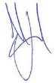
  - The above offences are punishable on conviction by imprisonment, a fine or both. Signed

MICHAEL LLOYD
(Environment and Community Co-ordinator) Full name (please print)
HUNTER VALLEY OPERATIONS
Organisation (please print)

03/06/2025
Date

Number: | Mitchelhill BAMP V5 2024 Status: | Final | Effective: 18/12/2024 Page 2 of 146
Owner: | Hunter Valley Operations Version: | 5 | Review: 18/12/2027

Document Title | Version | Date effective | Comment
DRAFT Biodiversity Areas – Management Plan | 1 | October 2017 | Submitted for approval to DoEE on 10 October 2017.
FINAL Biodiversity Areas – Management Plan | 1.1 | October 2019 | Separate Management Plans for HVO Biodiversity Areas merged to create this document.
FINAL Biodiversity Areas – Management Plan | 2 | December 2020 | Update to include reference to Intensive Weed Management Plan at Hook Biodiversity Area and Figure updates
FINAL Biodiversity Areas – Management Plan | 3 | May 2021 | Update offset areas at Wandewoi and Mitchelhill Biodiversity Areas. Update revegetation area at Hook Biodiversity Area
FINAL Biodiversity Areas – Management Plan | 3.1 | October 2021 | Updated to following consultation with the DAWE
Mitchelhill Biodiversity Area – Management Plan | 4 | May 2023 | A separate plan for Mitchelhill Biodiversity Area extracted from the HVO Biodiversity Areas – Management Plan V3.1
Mitchelhill Biodiversity Area – Management Plan | 5 | December 2024 | Update to Section 2.2 – Information management

Number: | Mitchelhill BAMP V5 2024 Status: Final | Effective: 18/12/2024 Page 3 of 146
Owner: | Hunter Valley Operations Version: 5 | Review: 18/12/2027

Table of Contents
  - Background 7
  - Approval history 9
    - State 9
    - Commonwealth 9
  - Offsets at the Hunter Valley Operations Biodiversity Areas 17
  - Intent of the Plan 18
  - Structure of the Plan 19
  - Information management 19
  - Key project stakeholders and roles 20
  - Review and reporting 20
  - Location and description 22
  - Cultural heritage 24
  - Vegetation communities 24
    - Vegetation condition 25
  - Conservation objectives 30
  - Key performance indicators 30
  - Completion criteria 31
  - Controlled activities 32
    - Prohibited actions 32
    - Access 32
    - Cultural heritage 33
    - Waste 33
  - Management of grazing for conservation 33
    - Situations when grazing will be considered 33
    - Limitations of grazing 33
  - Weed control 34
    - Control areas 35
    - Control methods and target weed species 35
    - Weed control methods 36
  - Management of fire for conservation 47
  - Infrastructure maintenance and improvement 48

Number: | Mitchelhill BAMP V5 2024 Status: Final | Effective: 18/12/2024 Page 4 of 146
Owner: | Hunter Valley Operations Version: 5 | Review: 18/12/2027

  - Retention of regrowth and remnant native vegetation 48
  - Re-establishment 49
    - Re-establishment and linkage/patch size enhancement at Mitchelhill Biodiversity Area 49
    - Seed collection 49
    - Species list 52
    - Planting method 55
    - Survival assessments 55
  - Erosion control 56
  - Vertebrate pest and overabundant native animal control 56
    - Local control 59
    - Regional control 59
  - Pre-clearing surveys 60
  - Summary of performance and completion criteria and trigger action response plan 60
  - Consistency with recovery actions 80
  - Overview 84
  - Monitoring objectives 84
  - Landscape monitoring 85
  - Ecological monitoring 86
    - Condition assessment monitoring 86
    - Bird assemblage monitoring 87
    - Photo reference points 88
  - Management monitoring 91
    - Rapid Condition Assessment 91
    - Property inspections 91
    - Survival assessment 92
    - Grazing monitoring 92
  - Data analysis, interpretation and reporting 92
  - Risk ratings 94

Number: | Mitchelhill BAMP V5 2024 Status: Final | Effective: 18/12/2024 Page 5 of 146
Owner: | Hunter Valley Operations Version: 5 | Review: 18/12/2027

Abbreviations and Definitions

Acronym | Description
asl | Above sea level
BA | Biodiversity Area includes the Offset Area, infrastructure and other land.
BBAM | BioBanking Assessment Methodology
BC Act | NSW Biodiversity Conservation Act 2016
CEEC | Critically Endangered Ecological Community
CHVEFW | Central Hunter Valley eucalypt forest and woodland
Coal & Allied | Coal & Allied Operations Limited
COPs | Model Code of Practice
DBH | Diameter at Breast Height
DAWE | Australian Government Department of Agriculture, Water and the Environment (replaced by DCCEEW in July 2022)
DCCEEW | Australian Government Department of Climate Change, Energy, the Environment and Water
DoEE | Australian Government Department of the Environment and Energy (replaced by the DAWE in February 2020)
DP | Deposited Plan
EP&A Act | NSW Environmental Planning and Assessment Act 1979
EPBC Act | Commonwealth Environment Protection and Biodiversity Conservation Act 1999
GDP | Ground Disturbance Permit
ha | Hectare
HLLS | Hunter Local Land Services
HVO | Hunter Valley Operations
IBRA | Interim Biogeographic Regionalisation of Australia
km | Kilometre
LLS Act | NSW Local Land Services Act 2013
MNES | Matters of National Environmental Significance
NPWS | NSW National Parks and Wildlife Service
NSW | New South Wales
OEH | NSW Office of Environment and Heritage
Offset Area | Area of vegetation and habitat to be secured by legally binding mechanism.
RCA | Rapid Condition Assessment
SOPs | Standard Operating Procedures
TEC | Threatened Ecological Community
WONS | Weeds of National Significance

Number: | Mitchelhill BAMP V5 2024 Status: Final | Effective: 18/12/2024 Page 6 of 146
Owner: | Hunter Valley Operations Version: 5 | Review: 18/12/2027

Introduction

Background
The action is referred to as Hunter Valley Operations (HVO) – State-approved mining project (EPBC 2016/7640). It comprises the continuation of mining in areas approved by the New South Wales (NSW) State Government after the commencement of the Commonwealth Environment Protection and Biodiversity Conservation Act 1999 (EPBC Act) on 16 July 2000 and prior to commencement of the EPBC Amendment Bill 2013 (also known as the water trigger) on 22 June 2013. HVO is a joint venture operation located 24km north of Singleton. The action and required Biodiversity Areas (BAs) are shown on Figure 1.
The action was submitted for determination under the EPBC Act to the former Department of the Environment (DoE) (now the Department of Climate Change, Energy, the Environment and Water (DCCEEW)) on 29 January 2016. On 3 March 2016, the Minister determined that the action was a controlled action under Section 75 of the EPBC Act and was required to be assessed by preliminary documentation under Section 87 of the EPBC Act.
The preliminary documentation report was submitted to DoE on 5 May 2016. The preliminary documentation report concluded that the action was likely to result in significant impacts on the following protected matters:
- Central Hunter Valley eucalypt forest and woodland ecological community (CHVEFW);
- Regent Honeyeater (Anthochaera phrygia);
- Swift Parrot (Lathamus discolor); and
- Green and Golden Bell Frog (Litoria aurea).
The preliminary documentation report included a preliminary strategy to provide offsets for the above protected matters, in accordance with the EPBC Act Environmental Offsets Policy (SEWPaC 2012a).
The action was approved by the Acting Assistant Secretary on 10 October 2016, subject to conditions. The action commenced on 1 November 2016.
Due to the ongoing drought conditions that were experienced in NSW, the requirement to regenerate up to 230 ha of grassland at the Wandewoi BA presented a compliance risk and there are community concerns in relation to the loss of the agricultural landscape of Jerrys Plains. HVO proposed to vary the conditions of approval to substitute the majority of the grassland areas of the Wandewoi BA with equivalent habitats within the Hook BA in Belford, NSW.
It was determined by the Department that in order to facilitate an adequate offset swap for the CHVEFW, it must be demonstrated that the revised offset package meets the approved quantum of impact as calculated by the EPBC Offset Assessment Guide tool. It was also agreed that the calculations that have been accepted by the Department would not be altered, and only those calculations that are impacted by the proposed variation would be contemporised.
An assessment of the Hook BA using the Commonwealth-accredited BioBanking Assessment Methodology (BBAM) and the EPBC Offset Assessment Guide tool was undertaken to demonstrate that the offset swap provides the same or greater offset quantum outcome to the offset required.
In accordance with the approval, the Wandewoi and Hook BAs offset the majority of the action’s impacts on CHVEFW and 100% of the action’s offset requirements for the Swift Parrot. The Mitchelhill BA offsets 100% of the residual impacts on CHVEFW and 53.9% of the residual Regent Honeyeater impacts. Condon View BA will offset the remaining 46.6% of the residual Regent Honeyeater impacts. Crescent Head BA will offset 100% of the residual significant impact on the Green and Golden Bell Frog when combined with the other compensatory measures.

Number: | Mitchelhill BAMP V5 2024 Status: Final | Effective: 18/12/2024 Page 7 of 146
Owner: | Hunter Valley Operations Version: 5 | Review: 18/12/2027

Plan | Mitchelhill Biodiversity Area Management Plan

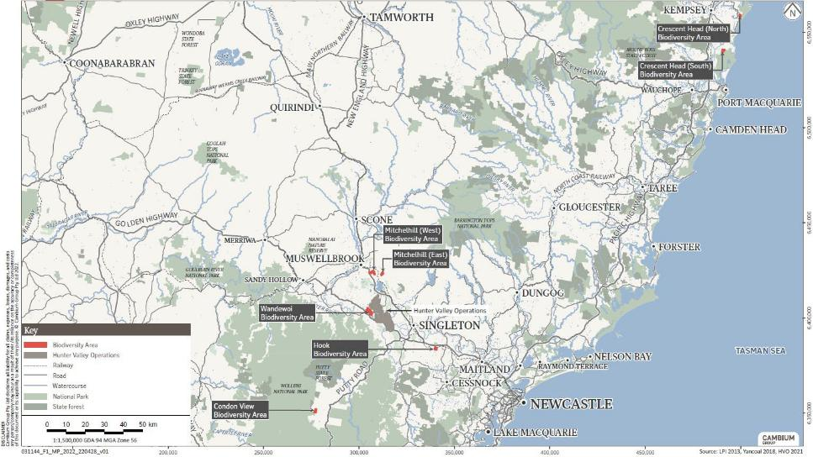
Figure 1 Location of the Hunter Valley Operations Biodiversity Areas

Uncontrolled when printed
Number: Mitchelhill BAMP V5 2024 Status: Final Effective: 18/12/2024 Page 8 of 146 Owner: Hunter Valley Operations Version: 5 Review: 18/12/2027

Approval history

State
While HVO is managed as one operation, HVO North and HVO South have separate NSW planning approvals. Coal & Allied was granted Project Approval by the NSW Minister for Planning for HVO South on 24 March 2009. The approval was granted under the provisions of the Environmental Planning and Assessment Act 1979 (EP&A Act), reference NSW PA 06_0261. The approval granted permission to clear 48 ha of remnant native vegetation and 92 ha of regrowth.
To offset this impact, 140 ha of Narrow-leaved Ironbark Woodland is to be protected in perpetuity. The offset area to satisfy this condition is located within the Goulburn River BA.

Commonwealth

Referral
A review was undertaken as part of the referral process for EPBC 2016/7640 to identify any new or modified development consents granted under the NSW EP&A Act after the commencement of the EPBC Act where the approved mining disturbance footprint had increased. The outcomes of the review identified the disturbance areas for the action, namely the West Pit, Carrington Pit, Riverview Pit and Cheshunt Pit extension areas. In May 2015, the Commonwealth Government listed the CHVEFW as a critically endangered ecological community (CEEC) under the EPBC Act. An area of approximately 61 hectares (ha) of CHVEFW was identified within the footprint of the action. Clearing of approximately 61 ha of CHVEFW equates to approximately 0.2% of the total occurrence of the CHVEFW as mapped by the listing and is likely to have a significant impact on the community.
The action will also result in the clearing of potential habitat for the Green and Golden Bell Frog, a vulnerable species under the EPBC Act. An area of approximately 105.3 ha of potential Green and Golden Bell Frog habitat was identified within the footprint of the action. Clearing of approximately 105.3 ha of potential Green and Golden Bell Frog habitat has the potential for a significant impact on this species. Approximately 68.4 ha of Regent Honeyeater and 68.1 ha of Swift Parrot habitat was also identified within the footprint of the action and was deemed likely to result in a significant impact for these species.

Approval pathway
The action was assessed by preliminary documentation. The Commonwealth Minister for the Environment (Minister), under provisions of the EPBC Act, granted approval for HVO on the 10 October 2016 to disturb 61 ha of CHVEFW, 68.4 ha of Regent Honeyeater habitat, 68.1 ha of Swift Parrot habitat and 105.3 ha of Green and Golden Bell Frog habitat. The Commencement of the Action occurred on 1 November 2016.
To compensate for the significant residual impacts from this disturbance on Matters of National Environmental Significance (MNES), a Biodiversity Offset Strategy (EMM 2017a) was submitted and approved by the Minister. Following extensive ecological investigations and discussions with the then Department of Environment and Energy (DoEE) (now DCCEEW), the Biodiversity Offset Strategy has been revised (HVO 2021) to allow for the substitution of the majority of the grassland offset areas at Wandewoi BA for habitats within the Hook and Mitchelhill BAs that will meet the approval requirements.
This Management Plan (Plan) meets the offset requirements for the Mitchelhill BA in accordance with Biodiversity Offset Strategy (HVO 2024) and EPBC 2016/7640.

Uncontrolled when printed

Page 9 of 146
Number: | Mitchelhill BAMP V5 2024 Status: Final | Effective: 18/12/2024
Owner: | Hunter Valley Operations Version: 5 | Review: 18/12/2027

HVO enforceable undertaking
Between May and December 2015, Coal & Allied inadvertently cleared vegetation that was later identified as CHVEFW at HVO. The action was undertaken as part of the pre-stripping operations in advance of the mine, within areas approved for mining by the State.
On 24 December 2015, Coal & Allied notified the DoEE of the action. Based on an initial desktop analysis of regional vegetation mapping (Peake 2006), the notification reported that 16.5 ha of CHVEFW was cleared. Following ecological field investigations, the area of CHVEFW cleared was revised to 31.5 ha.
An investigation report was prepared (EMM 2016) to document the extent of CHVEFW clearing and was provided with an updated notification to DoEE on 29 January 2016. The Minister's delegate determined that Coal & Allied undertook the action without approval, and that the action resulted or was likely to have resulted in a significant impact on CHVEFW.
Compensation for the action is provided in the form of an enforceable undertaking. An enforceable undertaking is a written undertaking provided by a person to the Minister that specifies that the person will pay an amount within a given period to the Commonwealth or to another party for the purpose of protection and conservation of a protected matter.
In relation to the HVO enforceable undertaking (the enforceable undertaking) Coal & Allied committed to the following:
- provision of an offset to compensate for the clearing of 31.5 ha of CHVEFW in accordance with the EPBC Act Environmental Offsets Policy (SEWPaC 2012a) within 12 months of the undertaking;
- securing the offset in perpetuity within a reasonable timeframe;
- provision of additional funds for ongoing management of the offset; and
- re-establishment of species consistent with CHVEFW on 31.5 ha of Derived Native Grassland at Mitchelhill.
The Minister will not pursue further action against Coal & Allied in relation to the action on the basis that the requirements of the enforceable undertaking are fulfilled.
A Biodiversity Offset and Rehabilitation Strategy has been prepared (EMM 2017b) to describe the offset and rehabilitation for the HVO enforceable undertaking. It is proposed that the Mitchelhill BA will offset 100% of the enforceable undertaking’s impacts in addition to the offsets provided for EPBC 2016/7640, namely the clearing of 31.5 ha of CHVEFW, Regent Honeyeater and Swift Parrot habitat. Disturbed land (31.5 ha) at Mitchelhill BA will also be rehabilitated to CHVEFW, in accordance with the HVO enforceable undertaking.

Transfer of ownership
On 8 May 2018, Coal & Allied sought approval from the DoEE to transfer the EPBC approval from Coal & Allied Operations Pty Ltd to HV Operations Pty Ltd. This was required due to HVO becoming a joint venture operation. The Department accepted the request on 3 September 2018.

Conditions of approval
This Plan has been prepared in accordance with Condition 11 of the final approval decision notice for EPBC 2016/7640, the enforceable undertaking and addresses all recommendations in the offset management plan. Compliance with Condition 11 and the offset management plan checklist is demonstrated in Table 1 and Table 2, respectively. The conditions of approval are provided at Appendix A of the Plan.
This Plan has been prepared for the Mitchelhill BA and specifically addresses the offsets that will be provided at the Mitchelhill BA to compensate for the action’s impacts on CHVEFW, Swift Parrot and the Regent Honeyeater.

Number: | Mitchelhill BAMP V5 2024 Status: Final | Effective: 18/12/2024 Page 10 of 146
Owner: | Hunter Valley Operations Version: 5 | Review: 18/12/2027

Table 1 Compliance with Condition 11

Condition | Page/section addressed in the Plan
11. To compensate for residual impacts to the protected matters, the person taking the action must submit to the Department, for the Minister’s approval, a Biodiversity Offset Management Plan (BOMP) for each of the offset areas. Relevant offset attributes and shapefiles, must be provided to the Department at the time each BOMP is submitted. Each BOMP must:
a. Detail the location, nature and boundaries of the relevant offset area, including textual descriptions and maps; | Section 3 , Figure 2 (Mitchelhill West) and Figure 3 (Mitchelhill East)describe the direct offsets for CHVEFW, Swift Parrot and Regent Honeyeater at the Mitchelhill BA relevant to Conditions 4 and 9 of the approval
b. Include a survey and description of the current condition (prior to management activities commencing) of each offset site; | Section 3.3.1 describes the current condition of the CHVEFW, Swift Parrot and Regent Honeyeater habitat at the Mitchelhill BA.
c. Detail management actions to be undertaken at each offset site to protect and improve the habitat quality for the relevant protected matters. This must include but not be limited to weed management, feral animal management, erosion and sediment control, and fire management, as necessary; | Section 5 describes the detailed management actions, timing, performance criteria and completion criteria relevant to each offset site for the CHVEFW, Swift Parrot and Regent Honeyeater.
d. Include timeframes, interim performance targets and completion criteria for implementing all management measures and for achieving and demonstrating achievement of all required improvements in the condition of the offsets. These must include criteria for triggering corrective actions if interim performance targets and/or completion criteria are not met by the relevant timeframes; | Section 5 describes the detailed management actions, timing, performance criteria and completion criteria relevant to each offset site for the CHVEFW, Swift Parrot and Regent Honeyeater.
e. Include a program to monitor and report on the effectiveness of the management measures, and to assess and demonstrate progress against the interim performance targets and the completion criteria; | Section 6 describes the monitoring program.
f. Identify the potential risks to the successful implementation of the BOMP; and | Section 7 provides a description of potential risks and corrective actions.
g. Include measures that will be implemented to mitigate identified risks to successful BOMP implementation, monitoring to detect the likely realisation of those risks, and corrective measures that will be implemented if those risks are realised. | Section 7 provides a description of potential risks and corrective actions.

Number: | Mitchelhill BAMP V5 2024 Status: | Final | Effective: 18/12/2024 Page 11 of 146
Owner: | Hunter Valley Operations Version: | 5 | Review: 18/12/2027

Table 2 Compliance of the Plan with the offset management plan checklist

Requirements for OMPs | Page/section addressed in the Plan
1. The plan includes an executive summary which states the relevant approval conditions, expands upon the purpose of the plan, and outlines the primary measures to manage key risks and achieve the plan’s objectives. | N/A
- The plan is required under EPBC Act approval conditions, and includes a table containing:  - approval condition requirements;  - section and page numbers which address the approval conditions; and  - key commitments for meeting each condition requirement. | Table 1 provides the approval conditions and where they are addressed in the Plan. The key commitments are provided in Chapter 5.
- The plan is supported by an offset strategy. User inputs to the EPBC Offset Guide are the basis to management planning, specifically:  - completion criteria and interim performance targets are demonstrably based on start quality, future quality with offset and time until ecological benefit; and  - management measures are specifically related to attainment of completion criteria and interim performance targets. | This Plan is supported by the Biodiversity Offset Strategy for EPBC 2016/7640 (HVO 2021)  that describes the user inputs to the EPBC Offset Guide.
4. The plan states the environmental outcomes to be achieved by implementing the plan. The plan defines environmental outcomes as measurable extent and condition targets, or circumstances of, the protected matter (e.g. water quality environmental values, ecological attributes/function). | Section 4
5. The plan includes performance targets. For the purpose of the plan, performance targets are time-bound short and medium term targets, for management interventions and environmental condition that are used to monitor, evaluate, review and improve the effectiveness of the plan. | Section 4 describes the objectives, time-bound performance criteria and completion criteria. A trigger, response and action plan is provided for each management action in Chapter 5.
- The plan includes management measures that will be implemented to offset environmental impacts. Each management measure:  - has timeframes for implementation;  - is described sufficiently to avoid ambiguity and to inform plan implementation;  - is related to performance targets; and  - is derived from recognised principles, practice, or guidelines, and is justified - technically, scientifically and/or legally – as an effective and appropriate measure to attain and/or maintain the plan’s performance targets. | Section 5 describes the management actions, their timeframes and performance targets.
7. The plan describes the purpose of monitoring and its functional relationship to operational decisions. | Section 6.2

Number: | Mitchelhill BAMP V5 2024 Status: Final | Effective: 18/12/2024 Page 12 of 146
Owner: | Hunter Valley Operations Version: 5 | Review: 18/12/2027

- The plan states monitoring objectives to meet operational decision-making. To this end:  - for each objective, the monitoring plan specifies the variables to be measured, the state and/or rate of change, the precision and confidence, the spatial resolution and time scales required to inform operational decision-making; and  - the monitoring objectives provide for ‘early-control’ (that management actions are effective) and ‘early warning’ (corrective actions are required) functions, so as inform timely decisions on corrective actions to ensure performance and completion criteria are achieved. | Section 6.2
9. The plan includes a monitoring program comprised of monitoring methods, a data handling strategy, arrangements for the periodic technical review and evaluation of the monitoring program and timeframes for implementing program components. | Section 6 describes the monitoring methods. Section 2.2 describes the  data handling strategy.  Section 2.4 describes review of the monitoring program.  Table 17 provides the implementation timeframes for the monitoring program.
- The plan describes the monitoring methods that will be implemented, and:  - includes quantitative (e.g. on-ground survey results) and qualitative baseline data (e.g. photos from photo-point monitoring sites) that establish the start quality/condition of the environment;  - describes the sampling strategy (including monitoring area, site selection and sampling intensity over space and time) and statistical analyses to be employed;  - justifies the sampling strategy/monitoring methods, including through the likely statistical power delivered by the strategy/method;  - justifies the monitoring methods to be used, including:  - an assessment of effectiveness and constraints to use;  - capacity to detect change in environmental condition due to management interventions;  - capacity to demonstrate attainment of performance targets and completion criteria;  - commits to engage appropriately qualified experts to design and conduct monitoring and survey activities, and analyse monitoring results; and  - the location, nature and number of monitoring sites, including benchmark/reference sites to evaluate management performance (c.f. seasonal variation) and that for offset management plans verify future condition without offset values used to determine offset requirements. | Section 6 describes the monitoring methods that will be implemented.  Requirements (a.) to (i.) are addressed for each action.

Number: | Mitchelhill BAMP V5 2024 Status: Final | Effective: 18/12/2024 Page 13 of 146
Owner: | Hunter Valley Operations Version: 5 | Review: 18/12/2027

11. The plan includes a data handling program for data storage and protection, data extraction, quality control, analysis, interpretation, reporting and presentation. Data ownership, and distribution, availability and licensing to the Department for compliance and recovery planning purposes, must be specified. Timelines for the data handling, analyses and delivery should be specified. | Section 2.2
12. The plan outlines a periodic technical review and evaluation of the plan and the likely composition of the review committee(s). | Section 2.4
- The plan assesses the risk of failure to achieve the plan’s performance targets. To this end the plan:  - states the plan’s performance targets;  - identifies events or circumstances that prejudice attainment/maintenance of performance targets. The events or circumstances must address scientific/ecological uncertainty, stochastic events and legal/land use planning factors that may represent risks;  - includes a qualitative assessment of the likelihood and consequence of those events or circumstances, and the residual risk of failure to achieve those criteria due to identified events or circumstances (assuming management measures will be implemented);  - characterises risk as low, medium, high or severe, and derived from likelihood (highly likely, likely, possible, unlikely, rare) and consequence (minor, moderate, high, major and critical); and  - explains how consequence, likelihood and risk level for each risk have been determined. | Section 4 provides performance targets for the Plan.  Section 7 provides a risk assessment for these performance targets.
- The plan manages the risk of failure by:  - detailing management measures that will be implemented to achieve the performance targets;  - enhancing management measures for high risk events or circumstances, thereby providing a ‘margin of safety’ to avoid or mitigate the likelihood and/or impacts of the event or circumstance;  - specifying management triggers (measurable events or circumstances) that detect actual or potential issues in a timely manner to avoid, minimise or mitigate adverse impacts;  - ensuring the monitoring program includes activities to detect management triggers, and explaining how monitoring activities may inform the selection and implementation of corrective actions; and  - detailing effective contingency responses and corrective actions that may be implemented if a management trigger is realised. | Section 5 details the management measures. Each management measure has its own trigger, response and action plan that details contingency measures.

Number: | Mitchelhill BAMP V5 2024 Status: Final | Effective: 18/12/2024 Page 14 of 146
Owner: | Hunter Valley Operations Version: 5 | Review: 18/12/2027

- The plan identifies and manages uncertainty. To this end the plan specifies:  - key data/information used to formulate the plan;  - the limitations and/or uncertainty associated with the use of that data/information; and  - how limitations and/or uncertainty, and associated risks, are mitigated during plan implementation. For example, where a margin of safety is applied to management measures until uncertainty is reduced to an acceptable level or performance criteria are attained/maintained. | Section 7 provides a risk assessment that identifies and provides management for uncertainty.
16. The plan includes a schedule and triggers for auditing the implementation and effectiveness of the plan, and outlines auditable systems for recording plan implementation and the environmental outcomes achieved. | Section 2.4 describes the annual reporting and auditing measures.
- The plan includes an adaptive implementation program to ensure uncertainty is reduced over time, and that performance targets and completion criteria are achieved. The plan therefore includes arrangements for:  - ensuring new data/information is collected and incorporated into the plan, as a result of implementing the plan and from new information derived from external sources (e.g. academic literature, EPBC policy statements);  - effectively coordinating, scheduling and/or triggering monitoring, risk management, auditing and reporting activities;  - periodically reviewing risks, including in response to the risk level, changing circumstances or the results from implementing contingency responses;  - frequent review of the effectiveness of management measures with significant levels of uncertainty, relatively long implementation timeframes, and upon which the plan is highly dependent;  - addressing the consequences of significant environmental incidents (pre-determined and unanticipated); and  - reviewing the plan under the following circumstances:  - performance reports indicate performance targets/completion criteria may not be achieved;  - according to approved timeframes; and  - the impacts of significant environmental incidents. | Section 5 details the management measures. Each management measure has its own trigger, response and action plan that details contingency measures. The Plan is reviewed annually and monitoring is undertaken to test the efficacy of management measures against performance targets.
- The plan specifies reporting commitments, including:  - reporting required under EPBC conditions of approval;  - an outline of the standard report content; and  - a schedule and triggers for reporting. | Section 2.4
19. The plan specifies accountabilities for implementing the plan, including management measures, risk management, monitoring, reporting, review, auditing and contingency responses. | Section 2.3 provides responsibilities for the Plan.

Number: | Mitchelhill BAMP V5 2024 Status: Final | Effective: 18/12/2024 Page 15 of 146
Owner: | Hunter Valley Operations Version: 5 | Review: 18/12/2027

- Maps, plans, figures, images and sections used in the plan:  - are scaled to enable the reader to clearly identify, based on local landmarks (trees, fences, structures) the location of features shown on the map etc;  - shows the offset area in a regional context;  - environmentally sensitive areas on or near the project site, vegetation/habitats that require protection, are buffer or ‘no-go’ zones  - monitoring locations and/or where random monitoring/survey activities will be undertaken  - shows areas with differing environmental condition or quality;  - include appropriate standard metric scales to represent the information (for example 1:25 000, 1:10 000 and 1:5000). Datum – plans and cross sections refer to AHD;  - have metric measurements, graphic bar scales, local grid lines and standards and north point or orientation of sections (include a key) are used throughout; and  - include title blocks in the lower right hand corner with the following information: EPBC number and project name, title and number of the plan, author, scale, date, source and date of data. | All figures have been prepared in accordance with these mapping requirements.
21. The plan references scientific, legal or other claims or statements that support the effectiveness of the plan, e.g. references to scientific literature, published guidelines, legislation, conservation advice, recovery plans, threat abatement plans. | Section 5.10 describes the consistency of the Plan with statements that support its effectiveness. References for cited literature are provided in Section 8
22. The plan uses the terms ‘will’ and ‘must’ when committing to actions, instead of ‘where possible’, ‘as required’, ‘to the greatest extent possible’, ‘should’ or ‘may’. | Applied throughout the Plan
23. The footer or header of each page of the plan states the name of the project, the date of the plan and sequential page numbering. | On each page of the Plan
24. The plan includes a glossary of terms comprised of acronyms, terms open to different interpretations, not in common use, technical or defined in the approval conditions. | Page 7
25. The plan includes as appropriate implementation, risk assessment and management, monitoring and reporting schedules prepared in accordance with Appendix A. | Section 7 provides risk assessment in accordance with Appendix A.  Section 6 provides monitoring in accordance with Appendix A.  Section 2.1 provides an outline of report contents.
26. The plan submitted for approval includes an Approval Holder Declaration signed by the approval holder. | Page 2

Number: | Mitchelhill BAMP V5 2024 Status: Final | Effective: 18/12/2024 Page 16 of 146
Owner: | Hunter Valley Operations Version: 5 | Review: 18/12/2027

Offsets at the Hunter Valley Operations Biodiversity Areas
The Biodiversity Offsets Strategy (HVO 2021) has been prepared in accordance with the approval conditions and the Offset Strategy Checklist.
The Biodiversity Offset Strategy has five objectives:
- To compensate for residual significant impacts to 54.4 ha of Class A condition CHVEFW from the Riverview Pit extension area;
- To compensate for residual significant impacts to 6.6 ha of Class B condition CHVEFW from the West Pit extension area
- To compensate for residual significant impacts to 68.4 ha of breeding and foraging habitat for the Regent Honeyeater;
- To compensate for residual significant impacts to 2.6 ha of breeding habitat and 102.7 ha of foraging habitat for the Green and Golden Bell Frog; and
- To compensate for residual significant impacts to 68.1 ha of winter foraging habitat for the Swift Parrot.
A staged process was originally implemented to identify offset sites that achieve the objectives of the BOS. The first stage comprised a detailed desktop analysis of previous local studies and GIS datasets to identify multiple potential offset sites that contain CHVEFW, Swift Parrot, Regent Honeyeater and/or Green and Golden Bell Frog habitat. A large number of potential offset sites were identified as part of the desktop analysis. The list of these sites was refined to landowners willing to enter into a contract and/or provide access for site assessment purposes.
Preliminary surveys were conducted to determine if the properties identified contained the required biodiversity values. HVO then selected suitable offset sites, namely Mitchelhill BA (comprising Mitchelhill East and Mitchelhill West), Condon View BA and Crescent Head BA (comprising Crescent Head (north) and Crescent Head (south)). Following proposed revisions to the Wandewoi BA boundaries, the Hook BA was surveyed and assessed using the NSW BioBanking Assessment Methodology (BBAM) for inclusion in the BOS. These offset sites were selected based on the results of the preliminary surveys, an assessment of land values and the practicality of ongoing management that would be required. Detailed surveys were completed at these sites to determine the extent of CHVEFW, Swift Parrot and Regent Honeyeater habitat, and targeted surveys and habitat assessment for the Green and Golden Bell Frog.
Following the completion of surveys, the Offset Assessment Guide (DSEWPaC 2012b) was completed for each of properties to determine the percentage of direct offset provided for CHVEFW, Swift Parrot, Regent Honeyeater and Green and Golden Bell Frog. The sites provide a 100% (or higher) direct offset for CHVEFW and Regent Honeyeater, and a 99.29% direct offset for the Green and Golden Bell Frog. The residual 0.71% offset for the Green and Golden Bell Frog has been provided through a contribution to a research program.
Mitchelhill BA will also compensate for the direct impacts of the HVO enforceable undertaking (Section 1.2.2 iii), relating to 31.5 ha of CHVEFW, Swift Parrot and Regent Honeyeater habitat inadvertently cleared prior to the listing of CHVEFW under the EPBC Act. Direct impacts for the HVO enforceable undertaking will be compensated through the provision and maintenance of
180.7 ha of CHVEFW and the rehabilitation of 31.5 ha of disturbed land to CHVEFW at Mitchelhill.

Number: | Mitchelhill BAMP V5 2024 Status: Final | Effective: 18/12/2024 Page 17 of 146
Owner: | Hunter Valley Operations Version: 5 | Review: 18/12/2027

Intent of the Plan
The Plan provides the management framework for the Mitchelhill BA with the aim to protect and enhance conservation values through the implementation of conservation management actions.
The intent of the Plan is to:
- comply with the EPBC 2016/7640 environmental approval;
- comply with the offset obligations of the HVO enforceable undertaking at Mitchelhill BA;
- support the legally binding conservation mechanism by implementing the conservation management actions in Section 5 and monitoring in Section 6;
- achieve the conservation objectives set out in Section 4.
The legally binding conservation mechanism must remain on the land title in perpetuity, for the land parcels listed in Section 3.

Number: | Mitchelhill BAMP V5 2024 Status: | Final | Effective: 18/12/2024 Page 18 of 146
Owner: | Hunter Valley Operations Version: | 5 | Review: 18/12/2027

Management Plan framework

Structure of the Plan
The Plan provides clear conservation objectives, details the conservation management actions and measures to monitor success at the Mitchelhill BA.
This Plan addresses the following:
    - Mitchelhill Biodiversity Area: describes the BA and baseline ecological condition of the vegetation communities and habitats;
    - Conservation Objectives, Key Performance Indicators and Completion Criteria: outlines the conservation objectives for the Plan, conservation values and key performance indicators that have guided the development of conservation management actions and the monitoring program;
    - Conservation Management Actions: details the management actions to be implemented to achieve and maintain Key Performance Indicators and Completion Criteria;
    - Monitoring: details the approach to data collection, analysis and interpretation to measure the efficacy of the conservation management strategies, guide adaptive management, identify positive trends in conservation values and assess attainment and maintenance of Key Performance Indicators and Completion Criteria; and
    - Risk Assessment: provides a matrix of key risks in the implementation of the Plan and attainment of the objectives.

Information management
To secure monitoring data and assist in the management of the BA, records are maintained in accordance with HVO’s Environmental Management Strategy.

Number: | Mitchelhill BAMP V5 2024 Status: Final | Effective: | 18/12/2024 Page 19 of 146
Owner: | Hunter Valley Operations Version: 5 | Review: | 18/12/2027

Key project stakeholders and roles
The key project stakeholders are identified by their roles in Table 3.
Table 3 Key project stakeholders and roles

Roles | Responsible entity | Details
Commonwealth Regulator: Administers approvals granted under the EPBC 2016/7640. | Australian Government Department of Climate Change, Energy, the Environment and Water (DCCEEW) | postapproval@environment.gov.au (for submission of Plan and matters related to the EPBC approval)  EPBCMonitoring@environment.gov.au (for submission of Annual Report and EPBC Annual Compliance reports)
Land owner:  Holds the title for the land. | HVO Resources Pty Ltd whose operations are managed by Hunter Valley Operations. | Manager – Environment and Community
Project Proponent:  Prepare and implement the Plan and complete reporting. | Hunter Valley Operations | Manager - Environment and Community
Biodiversity Auditor: Monitor improvement in condition of the biodiversity values and completes  ecological monitoring. | Hunter Valley Operations | HVO to engage suitably qualified person/s.

Review and reporting
The Plan will be reviewed every four years from the date the Plan is approved by the Commonwealth approval authority. The review will incorporate suggestions from the Biodiversity Auditor after completing the threatened species and habitat monitoring, update information on the ecological condition and extent of the plant community types and habitats across the BA and refine conservation management actions. The review will incorporate any updated National Recovery Plans and other literature to ensure that the management actions in the Plan are aligned and consistent with current science and conservation management practice.
Revisions of the Plan that reduce the management requirements will require approval from DCCEEW. Any other changes will require notification and a copy (electronic with marked up changes, an explanation and the reasons for the changes, as well as the date of the proposed implementation of the revised Plan) to be provided to DCCEEW. Plan updates that will not require approval will be those not likely to have a new or increased impact on the Swift Parrot, Regent Honeyeater or CHVEFW (as per Section 143A of the EPBC Act).
Annual Reports will include a summary and analysis of monitoring data and notable management outcomes.
The Annual Report will be submitted to DCCEEW for the period the EPBC Act approval has effect, and will report on the activities undertaken during the previous calendar year. The report will be prepared with input from a suitably qualified ecologist or environmental scientist, and will include the following information as a minimum:
    - the name and contact details of the Landholder and/or Leaseholder;

Number: | Mitchelhill BAMP V5 2024 Status: Final | Effective: 18/12/2024 Page 20 of 146
Owner: | Hunter Valley Operations Version: 5 | Review: 18/12/2027

    - identification of any required vegetation clearing that was undertaken;
    - a list of conservation management actions undertaken, describing scope of works and performance;
    - monitoring results, with all relevant data correctly labelled with date, location and GPS points;
    - an analysis of monitoring results with recommendations for modifications, if any, to the management or monitoring activities;
    - an assessment of any new risks or potential threats to the BA and actions to be undertaken to manage these threats and/or risks; and
    - an assessment of the progress in attainment of the conservation objectives and key performance indicators.

Number: | Mitchelhill BAMP V5 2024 Status: Final | Effective: 18/12/2024 Page 21 of 146
Owner: | Hunter Valley Operations Version: 5 | Review: 18/12/2027

Mitchelhill Biodiversity Area
This chapter provides details on the location, cultural heritage values and vegetation communities at the Mitchelhill BA. This BA is required to offset the Matters of National Environmental MNES of CHVEFW, Swift Parrot winter foraging habitat and Regent Honeyeater breeding and foraging habitat. Profiles of the CHVEFW, Swift Parrot and Regent Honeyeater are provided in Appendix B.

Location and description
Mitchelhill BA comprises two sites, namely Mitchelhill (West) and Mitchelhill (East). The total area of the BA is 378.8 ha, 316.1 ha of which contains native vegetation and comprises the offset area. The offset area includes the following (noting that there is overlap in the CHVEFW and habitats for the Swift Parrot and Regent Honeyeater):
- CHVEFW - 213.3 ha in Mitchelhill (West)
- Grassland proposed to be rehabilitated to treed CHVEFW – 24.1 ha in Mitchelhill (West)
- CHVEFW - 102.8 ha in Mitchelhill (East)
- Grassland proposed to be rehabilitated to treed CHVEFW – 7.4 ha in Mitchelhill (East)
- Swift Parrot and Regent Honeyeater Habitat – 142.2 ha in Mitchelhill (West)
- Swift Parrot and Regent Honeyeater Habitat – 102.8 ha in Mitchelhill (East).

Mitchelhill (West) is approximately 5.6 km south-east of Muswellbrook. Mitchelhill (East) is approximately 11.4 km south-east of Muswellbrook. Mitchelhill (West) is accessible from the New England Highway and Muscle Creek Road. Mitchelhill (East) is accessible from Muscle Creek Road and a number of private properties over which HVO have an access agreement. Access to the BA is restricted and all entry gates are locked.
Mitchelhill BA comprises nine separate cadastral blocks owned by Coal & Allied Pty Ltd and Anotero Pty Limited. A full list is shown in Table 4. Figure 2 and Figure 3 show the location of the BA and cadastral boundaries, and the offset areas are shown in Figure 4 and Figure 5.
Table 4 Mitchelhill Biodiversity Area lot and deposited plan (DP)

Lot | DP | Area within BA (ha) | Offset area within lot (ha)
125 | 627406 | 95.6 | 62.5
128 | 708716 | 168.5 | 150.8
138 | 752486 | 16.8 | 15.5
146 | 752444 | 18.7 | 17.3
146 | 752486 | 24.2 | 24.2
208 | 752444 | 9.4 | 9.4
215 | 752486 | 20.6 | 19.2
5 | 1115243 | 8.9 | 8.9
89 | 752486 | 16.1 | 8.3
Total | - | 378.8 | 316.1

Number: | Mitchelhill BAMP V5 2024 | Status: Final | Effective: 18/12/2024 Page 22 of 146
Owner: | Hunter Valley Operations | Version: 5 | Review: 18/12/2027

Mitchelhill (West) is located within the Sydney Basin Bioregion, while Mitchelhill (East) is on the border of the Sydney Basin and NSW North Coast Bioregions. The BA contributes to a south to north biodiversity corridor, extending south to Lake Liddell, Plashett Reservoir and Wandewoi BA. Biodiversity corridors are connected or stepping stones of existing native vegetation that provide connectivity at a landscape scale for flora and fauna. They are important in the ongoing conservation and protection of flora and fauna, as they enable migration, improve resilience to environmental and climatic variability and support genetic diversity. The BA is situated in the Muswellbrook local government area.
Table 5 provides the regional biophysical context for the BA.
Parts of the BA have been previously cleared and disturbed for agriculture and cattle grazing. Small ephemeral drainage lines are located throughout both Mitchelhill (West) and Mitchelhill (East), and there are numerous small dams scattered throughout the area. Eroded areas can be found in locations across the BA.

Number: | Mitchelhill BAMP V5 2024 Status: | Final | Effective: 18/12/2024 Page 23 of 146
Owner: | Hunter Valley Operations Version: | 5 | Review: 18/12/2027

Table 5 Regional biophysical context

Geographical Feature | Description
Bioregion | Sydney Basin (Mitchelhill (West))  Border of Sydney Basin and NSW North Coast (Mitchelhill (East))
Local Land Services Region | Hunter
IBRA subregion | Hunter (Mitchelhill (West))  Border of Hunter and Ellerston (Mitchelhill (East))
Mitchell Landscape | Central Hunter Foothills (Mitchelhill (West))  Border of Central Hunter Foothills and Scone – Gloucester Foothills (Mitchelhill (East))
Watercourses | Hunter River (part of the Hunter River catchment)
Elevation | 230- 250 asl
Geology | Permian
Nearby conservation areas | Mount Royal National Park (approximately 25 km north-east of Mitchelhill (East))  Wollemi National Park (approximately 25 km south-east of Mitchelhill (West))

Cultural heritage
A cultural heritage assessment was undertaken within the DNG areas nominated to be rehabilitated (Figure 8 and Figure 9). Artefacts were identified in the Mitchelhill (West) BA below the dam located adjacent to the New England Highway. Within Mitchelhill (East), an isolated artefact was found at the southern boundary of the nominated rehabilitation area. These artefacts will not be disturbed during the rehabilitation activities and HVO’s GDP process will be implemented prior to the commencement of any ground disturbing management actions taking into account the provisions of this Plan. Any identified cultural heritage sites or values will be managed to ensure their protection.

Vegetation communities
The vegetation across Mitchelhill BA is CHVEFW, as described below. Figure 4 and Figure 5 show the distribution of CHVEFW at Mitchelhill BA. Further details on the baseline condition of vegetation communities, habitats and bird assemblages can be found in the initial monitoring report (EcoPlanning 2019a).
Mitchelhill BA comprises 316.1 ha of CHVEFW, 135.4 ha dedicated to EPBC 2016/7640 (132 ha plus 3.4 ha) and 180.5 ha dedicated to the HVO enforceable undertaking (Figure 4 and Figure 5). The site is located in the Hunter River catchment of the Hunter Valley. The vegetation is located on low hillslopes and not alluvial plains and has a woodland structure with a projected canopy cover of greater than 10%.
The vegetation is dominated by key diagnostic species including Narrow-leaved Ironbark (Eucalyptus crebra), Grey Box (E. moluccana) and/or Spotted Gum (Corymbia maculata). The CHVEFW in Mitchelhill (West) is dominated by Narrow-leaved Ironbark and Grey Box, while Mitchelhill (East) is more dominated by Spotted Gum. These three tree species are important foraging resources for the Swift Parrot and Regent Honeyeater.

Number: | Mitchelhill BAMP V5 2024 Status: Final | Effective: 18/12/2024 Page 24 of 146
Owner: | Hunter Valley Operations Version: 5 | Review: 18/12/2027

The community has a sparse shrub layer comprising Broad-leaved Hickory (Acacia falciformis), Blackthorn (Bursaria spinosa) and Mock Olive (Notelaea microcarpa var. microcarpa), and an understorey comprising a variety of native grasses and forbs, comprising Barbed Wire Grass (Cymbopogon refractus), Purple Wiregrass (Aristida ramosa), Yellow Buttons (Chrysocephalum apiculatum), Rock Fern (Cheilanthes sieberi), Kidney Weed (Dichondra repens) and Native Wandering Jew (Commelina cyanea). CHVEFW is in good condition at the site, with few weeds observed during surveys.
In consideration of the above, vegetation at the site satisfies the key diagnostic characteristics in Section 1.5.1 of the Approved Conservation Advice (including listing advice) for Central Hunter Valley Eucalypt Forest and Woodland ecological community (TSSC 2015).

Vegetation condition
The starting condition of the CHVEFW vegetation in the Mitchelhill BA was assessed as being an 8 out of possible 10.
This determination of condition was assessed where conditions can potentially range between 1 and 10 (with a condition of 1 comprising a poor condition grassland and 10 comprising an almost pristine unmodified remnant fragment). The starting condition score of 8 was based upon the following:
- Vegetation assessed as varying between Class A to Class B in accordance with the Approved Conservation Advice for CHVEFW (TSSC 2015).
      - Class A (patch size ≥ 5ha) and with ≥ 50% of perennial understorey vegetation cover native and with at least 12 native understorey species
      - Class B (patch size ≤ 5ha) and with ≥ 70% of perennial vegetative cover in each layer present native, and containing at least 12 native understorey species.
- Low diversity and abundance of weeds (particularly Weeds of National Significance (WONS) and weeds listed under the Biosecurity Act 2015).
- Low levels of historic clearing.
- Low levels of grazing.
- High native forb and grass diversity.
- A diversity of age ranges of canopy vegetation (saplings through to old growth).
- Low edge effects due to the vegetation largely comprising a contiguous remnant fragment.
- Good coverage of logs and hollow-bearing trees,
The condition of this vegetation is anticipated to improve to a condition of 9 with the implementation of the actions of this plan, and this benefit is anticipated to be achieved by Year 10 of the implementation of this plan. This condition improvement will be achieved via:
- Strategic removal and management of weeds.
- Reduced grazing, subsequently reducing soil compaction and increasing capacity for regeneration.
- Canopy gap-filling via natural regeneration.
- Rehabilitation of current grassland areas to a standard consistent with CHVEFW.
For the Regent Honeyeater and Swift Parrot, this increase in condition will be achieved through increasing the presence of appropriate foraging species and thus increasing the potential presence by these species. This will be achieved by planting target canopy species as well as encouraging natural regeneration.

Number: | Mitchelhill BAMP V5 2024 Status: Final | Effective: 18/12/2024 Page 25 of 146
Owner: | Hunter Valley Operations Version: 5 | Review: 18/12/2027

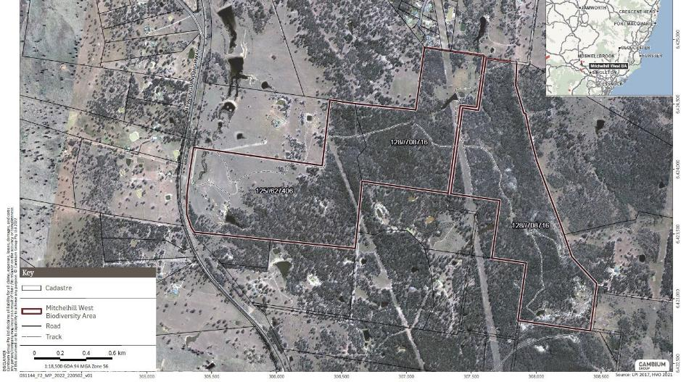

Figure 2 Cadastral boundaries at the Mitchelhill (West) Biodiversity Area

Uncontrolled when printed
Number: Mitchelhill BAMP V5 2024 Status: Final Effective: 18/12/2024 Page 26 of 146 Owner: Hunter Valley Operations Version: 5 Review: 18/12/2027

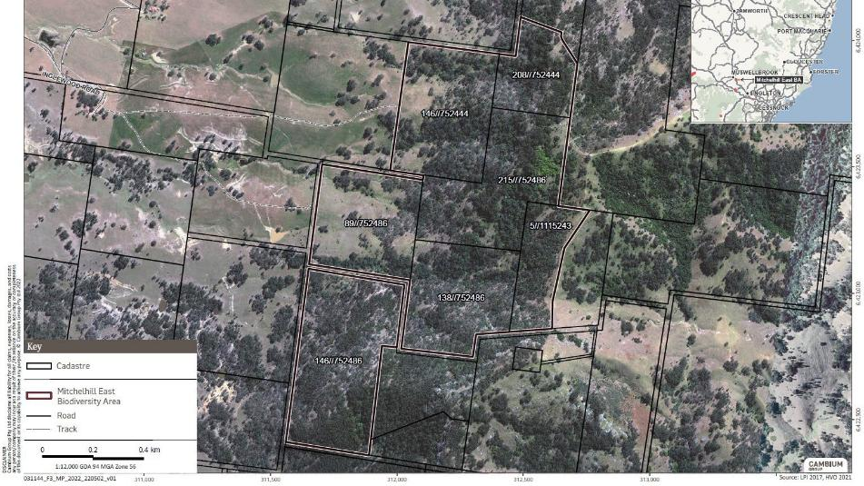
Figure 3 Cadastral boundaries at the Mitchelhill (East) Biodiversity Area

Uncontrolled when printed
Number: Mitchelhill BAMP V5 2024 Status: Final Effective: 18/12/2024 Page 27 of 146 Owner: Hunter Valley Operations Version: 5 Review: 18/12/2027

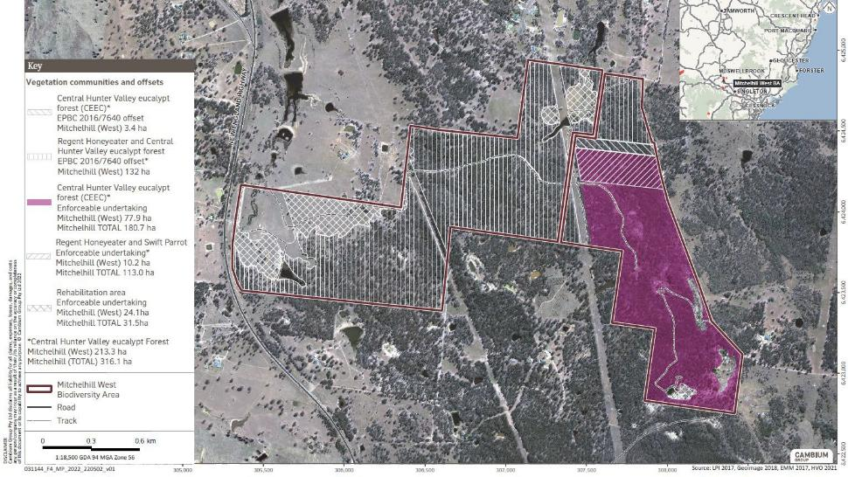
Figure 4 Vegetation communities and offsets at the Mitchelhill (West) biodiversity Area

Number: | Mitchelhill BAMP V5 2024 Status: Final | Effective: 18/12/2024 Page 28 of 146
Owner: | Hunter Valley Operations Version: 5 | Review: 18/12/2027

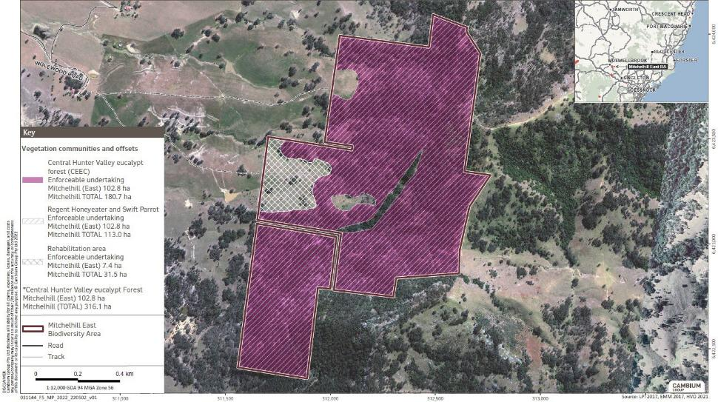
Figure 5 Vegetation communities and offsets at the Mitchelhill (East) biodiversity Area

Number: | Mitchelhill BAMP V5 2024 Status: Final | Effective: 18/12/2024 Page 29 of 146
Owner: | Hunter Valley Operations Version: 5 | Review: 18/12/2027

Objectives, key performance measures and completion criteria

Conservation objectives
The conservation objective for this Plan is to protect and improve the ecological quality and extent of the conservation values of the BA progressively over 10 years.
The conservation management actions described in Chapter 5 outline activities to achieve the conservation objectives. The methods to monitor the attainment of these objectives are described in Chapter 6. The monitoring data will be annually reviewed to adapt conservation management actions through continual improvement.
The key conservation outcomes from the long-term management and protection of the offset areas include:
    - protection of the BA under a legally binding conservation covenant;
    - protect and improve the ecological quality of 316.1 ha CHVEFW at the Mitchelhill BA;
    - improve the 31.5 ha of CHVEFW derived grassland areas at Mitchelhill so they attain the key characteristics of CHVEFW, shown in Appendix B;
    - increased condition and extent of suitable habitats for the Regent Honeyeater and Swift Parrot within protected reserves at Mitchelhill BA;
    - enhanced landscape connectivity within the surrounding landscape;
    - improved fauna movement and flora dispersal opportunities within the surrounding landscape; and
    - enhanced network of protected vegetation within the Hunter Valley.

Key performance indicators
The key performance indicators will measure:
    - improved condition and extent of CHVEFW and woodland habitats;
    - transition of CHVEFW derived grassland to woodland;
    - increased targeted habitat for the Regent Honeyeater and Swift Parrot; and
    - improved or maintained species richness of woodland birds.
Table 6 lists the key conservation values within the BA, key performance indicators and completion criteria. The monitoring program, outlined in Section 6, details the attributes to be measured to provide evidence and demonstrate achievement of the key performance indicators from the implementation of the conservation management actions detailed in Section 5.

Uncontrolled when printed

Page 30 of 146
Number: | Mitchelhill BAMP V5 2024 Status: Final | Effective: 18/12/2024
Owner: | Hunter Valley Operations Version: 5 | Review: 18/12/2027

Table 6 Key performance indicators and completion criteria

Conservation value | Key performance indicator | Completion criteria
- CHVEFW | Improved condition of 316.1 ha over 10 years. | Observed and measured increase in condition through monitoring over 10 years in woodland from a score of 8 to a score of 9.
- DNG (to be regenerated to CHVEFW) | Transition 31.5 ha of grassland to woodland over 10 years. | Observed and measured trajectory towards and / or attainment of the key characteristics of CHVEFW over 10 years (measured biennially).
Bird Habitat | Bird usage over 10 years | Observed increase or maintained species richness and usage by woodland birds over 10 years (measured biennially).
- Swift Parrot Habitat | Improved condition of 113 ha of woodland habitats over 10 years. | Observed and measured increase in or maintained condition (from a score to 8 to a score of 9) through monitoring over 10 years in woodland.  Observed and measured trajectory towards and / or attainment of the key characteristics of CHVEFW over 10 years (measured biennially).
- Regent Honeyeater | Mitchelhill: Improved condition of 245 ha of woodland habitats over 10 years. | Observed and measured increase in or maintained condition (from a score to 8 to a score of 9) in winter flowing canopy species through monitoring over 10 years in woodland.  Observed and measured trajectory towards and / or attainment of the key characteristics of CHVEFW over 10 years (measured biennially).

Completion criteria
The objectives will be deemed to be attained when the completion criteria defined in Table 6 have been met. To ensure the objectives are maintained, monitoring and management will continue following attainment of the completion criteria as necessary until confirmation to cease is obtained from the Minister or delegate.
The monitoring schedule (Section 6.5.2) includes minimum monitoring frequencies post objective attainment.

Number: | Mitchelhill BAMP V5 2024 Status: Final | Effective: 18/12/2024 Page 31 of 146
Owner: | Hunter Valley Operations Version: 5 | Review: 18/12/2027

Conservation management strategies
This chapter outlines the management actions to protect and increase the extent and improve the condition of the conservation values in the BA. The conservation management strategies focus on addressing the key threats to the conservation values, such as unauthorised activity, clearing, altered fire regimes, weeds, feral animals, and overgrazing.
The following sections detail the purpose, scope and method for the actions. Each action has been assigned performance and completion criteria, triggers for management intervention and corrective actions.
HVO is accountable for the implementation of the conservation management actions detailed in the following sections. This key responsibility rests with the Manager, Environment and Community. Qualified consultants and contractors will be engaged to carry out the monitoring, weed and pest animal control, supplementary planting, construction and maintenance of infrastructure and other works as described in the following sections.

Controlled activities

Prohibited actions
The BA will have legal protection. HVO will ensure that all employees or representatives, contractors, consultants and visitors are aware of these legal protections and penalties through a site induction prior to entering the BA.
All actions are prohibited in the BA other than:
      - the activities detailed in this Plan to manage and monitor the BA for conservation;
      - emergency activities conducted by state authorities; and
      - vegetation clearing for the maintenance of:
        - access tracks (Figure 6 and Figure 7);
        - a cleared area along permanent boundary fences with neighbouring properties to a width of 3m; and
        - the powerlines and associated easements that have been excluded from the BA.

Access
Access to the BA will be controlled through locked gates, maintenance of existing boundary fences and signs at main access points to inform all visitors they are entering a protected area. Routine inspections (see Section 6.5.2) and maintenance of infrastructure (access/fire tracks, fence lines and gates) will be undertaken to ensure they are to standard and fit for purpose.
Routine vehicle access will be restricted to authorised personnel only and vehicle speed will be restricted to a maximum of 40km/h. This will be indicated via legible signage (i.e. not faded) posted at entrance points.
Where issues are identified with the integrity of locks, gates, fences and signage, they are to be rectified within 30 days.
The above will minimise the potential for unintentional damage to existing values present.

Number: | Mitchelhill BAMP V5 2024 Status: Final | Effective: 18/12/2024 Page 32 of 146
Owner: | Hunter Valley Operations Version: 5 | Review: 18/12/2027

Cultural heritage
A number of cultural heritage sites have been identified within the Mitchelhill BA during cultural heritage surveys. No cultural heritage sites will be disturbed by any management actions implemented through the provisions of this Plan. All identified cultural heritage sites or values have been recorded and will be managed to ensure their protection. Consideration of the known and unknown sites will be given through the implementation of the Ground Disturbance Permit (GDP) process prior to ground disturbing works commencing within the BA.
Protective barricading will be erected and maintained around cultural heritage sites to prevent unintentional disturbance.

Waste
Any waste that has been identified at the BA (Figure 6 and Figure 7) will be removed, this will include progressive removal of redundant internal fences. Biannual Property Inspections will be undertaken which will include waste inspections (see Section 6.5.2 ) and removal will be undertaken if necessary for new waste identified.

Management of grazing for conservation
Generally, grazing activities will not be undertaken within the Mitchelhill BA.

Situations when grazing will be considered
Strategic grazing may be used as a management tool to promote regeneration, control weeds, and reduce excessive fire fuel loads.
Grazing will be excluded from the BA, except to reduce fire risk or improve conservation values (namely excessive exotic grass or exotic forb coverage), and entirely from sensitive environments including:
- riparian areas; and
- areas of natural regeneration with key CHVEFW species and feed species for Swift Parrot and Regent Honeyeater.
Grazing will only be implemented in areas where alternative management activities (such as herbicide treatment or slashing activities) cannot be undertaken e.g. due to terrain or landscape features.
Strategic grazing may be utilised in such areas if it is deemed that the fire risk is excessive, and/or these difficult to access areas have been identified during condition monitoring as a source of weeds that have a detrimental impact on the condition category of the adjacent vegetation community. The fire risk will be determined following appraisal by a qualified person during the winter biannual property inspection (Section 6.5.2) of each year by assessing fuel load.
Should it be implemented, temporary watering points and fencing will be used to protect sensitive areas and restrict the grazing area.

Limitations of grazing
The trigger point to cease grazing will be less than 70% ground cover (i.e. no greater than 30% bare ground) and average height of ground cover of less than 12 cm (approximately 2500 kg dry matter per/ha). The trigger point will be measured using the following quadrat sampling method for ground cover and herbage mass (Lang and McDonald 2005) or another appropriate method.
Using a wooden or metal square (quadrat) of at least 0.5m x 0.5m internal dimensions, undertake the following steps:

Number: | Mitchelhill BAMP V5 2024 Status: Final | Effective: 18/12/2024 Page 33 of 146
Owner: | Hunter Valley Operations Version: 5 | Review: 18/12/2027

- Walk at random path within each area to be assessed and throw the quadrat a short distance.
- For each throw look only at the area within the quadrat and assess and record the following:
A = the percentage of total pasture cover (living and dead);
B = the percentage cover of live native plants;
C = the percentage cover of live non-native plants; and
D = measure height of pasture cover using Meat and Livestock Australia Pasture Ruler to estimate herbage mass.

- Take at least 10 random samples for each assessment area (the number of sample will be increased by 1 for each addition 5ha for areas greater than 50ha).
- Calculate the percentage of the assessment area covered by vegetation (living or dead): Sum of A / Number of samples.
- Calculate the percentage of the living vegetation that is live native groundcover by: (Sum of B x 100) / (Sum of B + Sum of C).
- Calculate average mass by: Sum of D / Number of samples.
Monitoring events for ground cover and herbage mass will occur pre and post grazing. Grazing areas will be examined weekly to determine the timing of the formal monitoring of ground cover and herbage mass.
The quadrat data for the commencement and at the completion of grazing will be provided in the annual reports along with the following information:
- livestock movement including dates of entry and removal from the grazing area;
- a map of the grazed offset area;
- number of livestock and type;
- quantity of supplement (if any);
- any livestock health or other management issues; and
- rainfall data during the grazing period.
Grazing periods will not exceed four weeks in a given area and there will be a minimum of four weeks between grazing events. Grazing will take place outside of the dominant growth periods for native groundcover plants (allowing native groundcover time to actively grow, set and disperse seed), and as such should preferentially occur in autumn or winter.

Weed control
Weed control will be utilised to keep un-infested areas clear of weeds and control the spread of existing weed infestations in the BA. Weed control will focus on species that exclude or have the potential to exclude native species, disrupt recruitment of native species, impede ecological processes, or impact native animals.
Weed control will prioritise manual and targeted control methods as far as practicable and where they are effective to do so. The use of herbicides in sensitive areas will be minimised and only utilised where alternative weed eradication processes are considered impractical to achieve the intended conservation outcome.

Number: | Mitchelhill BAMP V5 2024 Status: Final | Effective: 18/12/2024 Page 34 of 146
Owner: | Hunter Valley Operations Version: 5 | Review: 18/12/2027

Control areas
Weed management containment zones of 50m from the tracks and BA boundaries will be maintained. Any weeds outside of these areas will be controlled based on the observations from the monitoring program and following five yearly weed mapping survey.

Control methods and target weed species
An integrated weed management approach will be implemented utilising a range of suitable control methods, the preferred control methods are described in Table 7.
Areas identified during the monitoring and mapping surveys as containing weeds that pose a risk to native species management will receive a focus during the subsequent year. Areas that require attention will be ranked according to those containing the noxious and priority weeds over other environmental weeds and/or exotic plants recorded during the surveys and inspections.
The noxious weeds given priority for weed control are those declared under the Biosecurity Act 2015. The full list of priority weeds for the Hunter Region are provided at Appendix D.
Table 8 lists the priority and environmental weed species detected at the site to date, their nomination as a Weed of National Significance (WONS), control methods, timing and intensity required to manage these weeds, based on the NSW Department of Primary Industries Noxious and Environmental Weed Control Handbook (NSW DPI 2014). The photos have been sourced from http://weeds.dpi.nsw.gov.au/.
The use of chemicals in the BA will be undertaken by qualified personnel (bush regenerators) with suitable experience in native plant and weed identification and management. All chemical weed control will be in accordance with the registered label or current minor use permit, Safety Data Sheets and appropriate safety standards. Chemical use in the vicinity of waterways will be restricted to herbicides and adjuvants registered for use in or near aquatic environments.
Broadscale spraying of herbicides within sensitive environments will not be undertaken. In these areas, an integrated weed management approach will be implemented utilising a range of suitable control methods such as manual removal and targeted herbicide application.
Chemical weed control operations pose a substantial risk to successful natural regeneration processes unless carefully planned, implemented and monitored. Planning considerations relevant to weed control operations in natural or assisted revegetation areas include:
- selection of personnel based on demonstrated experience and skill in selective weed control methods in regeneration areas; and
- timing of proposed application in relation to recent or planned revegetation works.

Number: | Mitchelhill BAMP V5 2024 Status: Final | Effective: 18/12/2024 Page 35 of 146
Owner: | Hunter Valley Operations Version: 5 | Review: 18/12/2027

Weed control methods
Table 7 Weed control methods

Control method | Potential use in control regime
Chemical control – is the application of chemicals to kill the weed by interfering in the plants growth processes. | Spot application of herbicide is the preferred method of application. Boom spray application is permissible as part of ground preparation for re-establishment activities. Areas that cannot be accessed safely by ground-based methods the use of Unmanned Aerial Vehicles (UAV) may be used.  Herbicides:  Only registered herbicides will be used for the control of the weed species and used in accordance with the directions on the label. Users have a legal obligation to read and follow the instructions on the label. Where appropriate, selective herbicides will be used to minimise impacts on native vegetation.  Handling and application:  Herbicide is to be applied to actively growing plants. Herbicides must be handled and applied with consideration of their toxic nature and potentially harmful effects on human  health, livestock and the environment. Only accredited and  trained in the identification of native plant operators are permitted to apply herbicides.  During application weather condition, nozzles, equipment and operator are to be closely monitored throughout application to reduce the risk of drift and subsequent off- target damage.  Coarse to very coarse nozzles should be used to increase droplets size.  Suitable weather conditions for spraying are extremely important.  Weather guidelines  - Read the product label and follow all label instructions.  - Spray when wind is steady and ideally 3–15 km/h.  - Avoid variable or gusty wind conditions.  - Avoid calm conditions - small droplets remain suspended for long periods.  - Spray when wind blows away from sensitive areas.  - Avoid spraying in temperatures above 28 °C.  - Aim to spray when Delta T is between 2 and 8 and not greater than 10.  - Do not spray when inversion conditions exist.  - Aim to spray when the atmosphere is neutrally stable.  - Most chemicals require a rain free period – check

Number: | Mitchelhill BAMP V5 2024 Status: Final | Effective: 18/12/2024 Page 36 of 146
Owner: | Hunter Valley Operations Version: 5 | Review: 18/12/2027

the label.
- Be aware of local topographic and convective influences on wind speed and direction.
- Record on-site weather conditions at spray time.
For more detail please refer to www.bom.gov.au/info/leaflets/Pesticide-Spraying.pdf. Reporting:
The Pesticides Regulation 2017 requires all commercial pesticide users (that includes farmers, leaseholders and spray contractors) to keep records on their pesticide application.
Grazing management | Grazing may be used to control weeds subject to not meeting or exceeding ground cover trigger values (Section 5.2) and there is evidence the weed species are preferentially grazed by stock.  Livestock being introduced to a BA will be quarantined for several days, so any potential weed seeds can pass through their digestive system in a known area and be controlled.  Spray graze - applying a hormone herbicide and grazing 7-10 days later. Other grazing management practices that are recommended by the Biodiversity Auditor or the Hunter Local Land Services (HLLS) may be implemented.
Biological control – is a long-term control technique. | This is a complementary strategy and alone it may not eradicate the weed. Any use of biological controls will be undertaken in conjunction with appropriate advice.
Slashing – mechanical cutting of weeds to prevent seed production | Areas heavily infested with exotic grasses can be treated with slashing equipment mounted on a tractor prior to flowering (likely to be late spring/ early summer).
Manual removal – removal of the weed plant and roots from the site. | Physical removal of new weeds, unearthing of root systems and containment and removal of seed.

The impact of weeds and the frequency of control methods implemented will be assessed and determined through the ecological monitoring program in addition to observations gathered during the monthly and biannual property inspections. This information will be used to monitor the success of the weed control activities.

Number: | Mitchelhill BAMP V5 2024 Status: Final | Effective: 18/12/2024 Page 37 of 146
Owner: | Hunter Valley Operations Version: 5 | Review: 18/12/2027

Table 8 Priority and environmental weed species, treatment method, control period and intensity

Species | Photo | Duty under Biosecurity Act 2015 | WONS | Control method/s | Control period and intensity
WOODY WEEDS
African Olive (Olea europaea) | 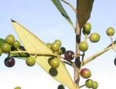 | General Biosecurity Duty Regional  recommended  measures (Hunter) |  | Chemical - Spot spray, basal bark or cut stump application with registered herbicide | Actively growing  From Year 1 to Year 4, at least one control event per year with additional events as required.  Ongoing maintenance, minimum of one control event per year if identified through monitoring events.
Willow (Salix sp.) | 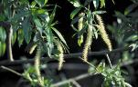 | General Biosecurity Duty Prohibition on dealings |  | Chemical – Stem injection and cut stump application. Spot spray for small plants. Manual removal – seedlings  <0.5 m tall | Summer to early Autumn  From Year 1 to Year 4, at least one control event per year with additional events as required.  Ongoing maintenance, minimum of one control event per year if identified through monitoring events.

Number: Mitchelhill BAMP V5 2024 Status: Final Effective: 18/12/2024 Page 38 of 146 Owner: Hunter Valley Operations Version: 5 Review: 18/12/2027

PRICKLY PEARS
Prickly Pear (Opuntia stricta) | 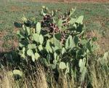 | General Biosecurity Duty Prohibition on dealings | ✓ | Chemical - Spot spray with registered herbicide.  Biological control - (Cactoblastis (Cactoblastis cactorum) and Cochineal (Dactylopius spp.) – better suited to large infestations or inaccessible areas. | All year – control period.  From Year 1 to Year 4, at least one control event per year with additional events as required.  Ongoing maintenance, minimum of one control event per year if identified through monitoring events.
Tiger Pear (Opuntia aurantiaca) | 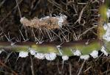 | General Biosecurity Duty Prohibition on dealings Regional recommended measures | ✓ | Chemical - Spot spray with registered herbicide.  Biological control - (Cactoblastis (Cactoblastis cactorum) and Cochineal (Dactylopius spp.) – better suited to large infestations or inaccessible areas. | All year – control period.  From Year 1 to Year 4, at least one control event per year with additional events as required.  Ongoing maintenance, minimum of one control event per year if identified through monitoring events.

Number: Mitchelhill BAMP V5 2024 Status: Final Effective: 18/12/2024 Page 39 of 146 Owner: Hunter Valley Operations Version: 5 Review: 18/12/2027

PASTURE / ANNUALS
Fireweed (Senecio madagascariensis) | 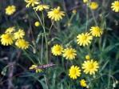 | General Biosecurity Duty Prohibition on dealings | ✓ | Chemical - Spot spray with registered herbicide whilst the plant is actively growing and not under stress.  Manual removal - by hand pulling individual plants. | Autumn to Spring - control period.  From Year 1 to Year 4, at least one control event per year with additional events as required.  Ongoing maintenance, minimum of one control event per year if identified through monitoring events.
St John's Wort (Hypericum perforatum) | 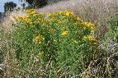 | General Biosecurity Duty |  | Chemical – Spot spray with registered herbicide.  Biological control – eleven biological control agents have been released in Australia with six established. | Spring to Summer - control period.  From Year 1 to Year 4, at least one control event per year with additional events as required.  Ongoing maintenance, minimum of one control event per year if identified through monitoring events.
Narrow-leaf Cotton Bush (Gomphocarpus fruticosus) | 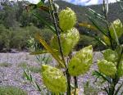 | Not listed |  | Chemical – Spot spray with registered herbicide.  Manual removal - by chipping to remove small infestations. | Spring to December.  From Year 1 to Year 4, at least one control event per year with additional events as required.  Ongoing maintenance, minimum of one control event per year if identified through monitoring events.

Number: Mitchelhill BAMP V5 2024 Status: Final Effective: 18/12/2024 Page 40 of 146 Owner: Hunter Valley Operations Version: 5 Review: 18/12/2027

Cobblers Pegs (Bidens pilosa) | 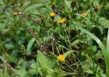 | Not listed |  | Chemical – Spot spray with registered herbicide.  Manual removal - by chipping to remove small infestations. | Spring to December.  From Year 1 to Year 4, at least one control event per year with additional events as required.  Ongoing maintenance, minimum of one control event per year if identified through monitoring events.
Catsear (Hypochaeris radicata) | 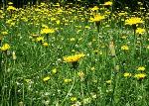 | Not listed |  | Chemical – Spot spray with registered herbicide.  Manual removal of vegetative components and taproot for small infestations. | Spring to December.  From Year 1 to Year 4 at least one control event per year with additional events as required.  Ongoing maintenance, minimum of one control event per year if identified through monitoring events.
Scarlet Pimpernel (Lysimachia arvensis) | 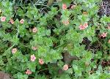 | Not listed |  | Manual removal of vegetative components for small infestations. | Spring to December.  From Year 1 to Year 4, at least one control event per year with additional events as required.  Ongoing maintenance, minimum of one control event per year if identified through monitoring events.
Dandelion (Taraxacum officinale) | 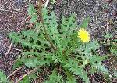 | Not listed |  | Manual removal of vegetative components and taproot for small infestations. | Spring to December.  From Year 1 to Year 4, at least one control event per year with additional events as required.  Ongoing maintenance, minimum of one control event per year if identified through monitoring events.

Number: Mitchelhill BAMP V5 2024 Status: Final Effective: 18/12/2024 Page 41 of 146 Owner: Hunter Valley Operations Version: 5 Review: 18/12/2027

Plantain (Plantago lanceolata) | 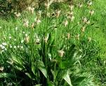 | Not listed |  | Manual removal of vegetative components and taproot for small infestations. | Spring to December.  From Year 1 to Year 4, at least one control event per year with additional events as required.  Ongoing maintenance, minimum of one control event per year if identified through monitoring events.
Red Natal Grass (Melinis repens) | 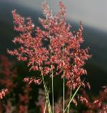 | Not listed |  | Chemical – Spot spray with registered herbicide. | Year round.  From Year 1 to Year 4, at least one control event per year with additional events as required.  Ongoing maintenance, minimum of one control event per year if identified through monitoring events.
Paddy’s Lucerne (Sida rhombifolia) | 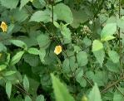 | Not listed |  | Chemical – Spot spray with registered herbicide.  Manual removal by chipping to remove small infestations. | Spring to December.  From Year 1 to Year 4, at least one control event per year with additional events as required.  Ongoing maintenance, minimum of one control event per year if identified through monitoring events.
Sheep Sorrel (Acetosella vulgaris) | 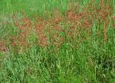 | Not listed |  | Chemical – Spot spray with registered herbicide.  Manual removal - by chipping to remove small infestations. | Spring.  From Year 1 to Year 4, at least one control event per year with additional events as required.  Ongoing maintenance, minimum of one control event per year if identified through monitoring events.

Number: Mitchelhill BAMP V5 2024 Status: Final Effective: 18/12/2024 Page 42 of 146 Owner: Hunter Valley Operations Version: 5 Review: 18/12/2027

THISTLES
Spearthistle (Onopordum acanthium) | 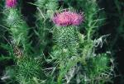 | General Biosecurity Duty |  | Chemical – Spot spray with registered herbicide.  Manual removal - by chipping to remove small infestations. | All year (actively growing rosettes to flowering stage) – control period.  From Year 1 to Year 4, at least one control event per year with additional events as required.  Ongoing maintenance, minimum of one control event per year if identified through monitoring events.
RUSHES
Sharp Rush (Juncus acutus)  image sourced from https://weeds.brisb ane.qld.gov.au | 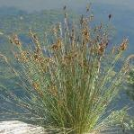 | Not listed |  | Chemical – Spot spray with registered herbicide | Summer and autumn.  From Year 1 to Year 4, at least one control event per year with additional events as required.  Ongoing maintenance, minimum of one control event per year if identified through monitoring events

Number: Mitchelhill BAMP V5 2024 Status: Final Effective: 18/12/2024 Page 43 of 146 Owner: Hunter Valley Operations Version: 5 Review: 18/12/2027

Duty under Biosecurity Act 2015 | Measures
General biosecurity duty | All plants are regulated with a general biosecurity duty to prevent, eliminate or minimise any biosecurity risk they may pose. Any person who deals with any plant, who knows (or ought to know) of any biosecurity risk, has a duty to ensure the risk is prevented, eliminated or minimised, so far as is reasonably practicable.
Prohibition on dealings | Must not be imported into the State or sold.
Regional recommended measure | African Olive (Hunter region): Land managers mitigate the risk of the plant being introduced to their land. Land managers  reduce impacts from the plant on priority assets. Land managers prevent spread from their land where feasible. The plant or parts of the plant are not traded, carried, grown or released into the environment.

Number: Mitchelhill BAMP V5 2024 Status: Final Effective: 18/12/2024 Page 44 of 146 Owner: Hunter Valley Operations Version: 5 Review: 18/12/2027

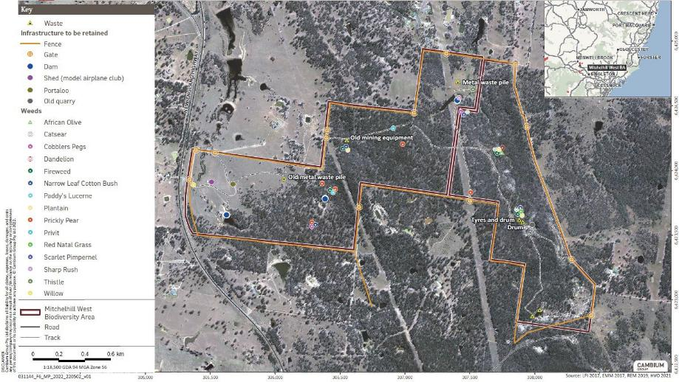
Figure 6 Key infrastructure to be retained, waste and weeds at the Mitchelhill (West) Biodiversity Area

Number: Mitchelhill BAMP V5 2024 Status: Final Effective: 18/12/2024 Page 45 of 146 Owner: Hunter Valley Operations Version: 5 Review: 18/12/2027

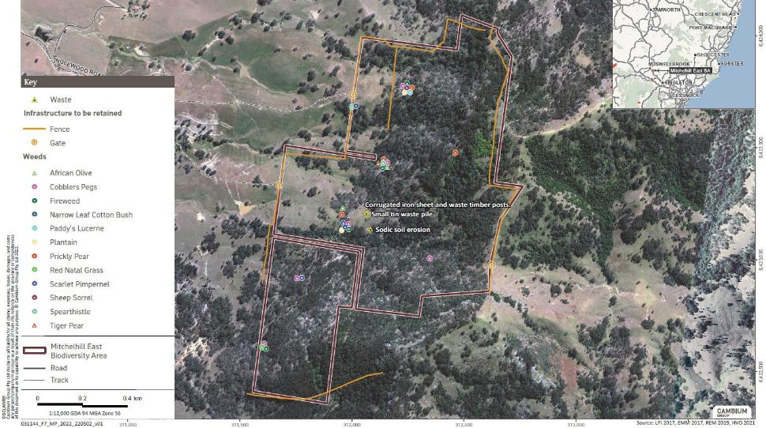
Figure 7 Key infrastructure to be retained, waste and weeds at the Mitchelhill (East) Biodiversity Area

Number: Mitchelhill BAMP V5 2024 Status: Final Effective: 18/12/2024 Page 46 of 146 Owner: Hunter Valley Operations Version: 5 Review: 18/12/2027

Management of fire for conservation
Bushfire prevention is required under the Rural Fires Act 1997 and a fire regime is required to maintain ecological condition and reduce the risk of damage from wildfire. The absence of fire and the reduction of livestock grazing may lead to a build-up of fire fuel and risk of high intensity bushfire. The land manager is required to take practicable steps to prevent the occurrence of bush fires on the land and minimise the spread of bushfire.
HVO has prepared a Bushfire Management Plan (BFMP) for the Mitchelhill BA in consultation with the Rural Fire Service (RFS). It identifies fire risks, control measures and communication procedures. The BFMP is subject to review by the RFS and is updated internally by HVO and reissued if significant change is undertaken.
The quick identification of a threatening bushfire, notification of the Rural Fire Service and suppression is the primary goal.
Key control measures comprise:
- documentation of access and water supply points for suppression activities;
- maintain safe and clear access tracks that also form fire breaks;
- a reduction of fuel build-up along potential ignition sources, such as public roads, prior to the fire season;
- use of ecological burns in non-sensitive environments (with any required approvals and/or permits from Rural Fire Service) to reduce fuel build-up to protect the conservation values;
- establishment of asset protection zones around priority infrastructure;
- investment in water and other fire suppression assets; and
- communication of the Bushfire Management Plan and response procedures with key stakeholders, including Leaseholders, neighbours, consultants, contractors and employees.
Key management and safety restrictions for total fire ban and very high fire danger rating days include:
- communication of travel plans to HVO personnel, so personnel can be located in the case of an emergency; and
- no undertaking ‘hot works’, unless these activities are required for firefighting purposes.
Any fuel hazard reduction burns will be planned in accordance with the Bush Fire Environmental Assessment Code for New South Wales (Rural Fire Service, February 2006) and the guidelines contained in the Threatened Species Hazard Reduction Lists for the Bush Fire Environmental Assessment Code.
Recommendations under the Code are:
- in woodland vegetation, fire should not occur within 5 years of a previous fire and consideration should be given to burning within 40 years of any previous fire; and
- in grassland vegetation derived from the woodland vegetation, the recommended fire intervals are the same as woodland vegetation.
All ecological burns are dependent upon suitable climatic conditions and appropriate level of risk. The advice of a suitably qualified person experienced in ecological fire management will be required to plan and implement the ecological fire management plan, including a post-fire monitoring program to specifically assess the impact of the ecological burn. Any burns are to be scheduled to occur when conditions are suitable for a low intensity burn. Typically, this is winter or early spring. Where possible, burning should be scheduled prior to a significant rain event to
assist in extinguishing the fire.

Page 47 of 146
Number: | Mitchelhill BAMP V5 2024 Status: Final | Effective: 18/12/2024
Owner: | Hunter Valley Operations Version: 5 | Review: 18/12/2027

Data is to be recorded for all ecological burns including the date and intensity of the fire, the area burnt (shown on a map) during fire, any canopy scorch, percentage of leaf litter remaining and any interactions with stakeholders. Any additional damage, including fire breaks or new tracks, must also be recorded.
No burning is recommended for grassland areas post planting until plantings are sustainable.

Infrastructure maintenance and improvement
Improvements to existing infrastructure (such as access tracks/fire breaks, fences and dam structures) may be required to maintain safe access to undertake management and monitoring activities.
Relevant environmental approvals will be sought where areas of native vegetation supporting habitat for matters of national environmental significance must be cleared to implement infrastructure improvements.
Grading activities will be limited to existing tracks.
Any ground disturbance will be carried out under the Ground Disturbance Permit (GDP) process and will include appropriate pre-clearing assessment to identify resident fauna, threatened flora or habitat features. Should these be identified, HVO will implement measures to minimise impacts on conservation values.
Any clearing required to be undertaken will be quantified and reported within the Annual Report (AR).

Retention of regrowth and remnant native vegetation
Remnant native vegetation and regrowth is important as it is the key component of the BA. The retention of this native vegetation and its regrowth is important to maintain and enhance the conservation value of the offset area.
Natural regrowth of remnant vegetation will be preferentially retained to promote recovery of native vegetation. Exceptions to this rule include maintenance of fence lines and management tracks associated with the BA (Section 5.1).
Very dense stands can occur after significant site or soil disturbance. These stands may prevent the recruitment of other species and inhibit the potential to achieve the biodiversity and conservation objectives. Regrowth control or thinning of these stands will ensure that a diverse and sustainable woodland community is established with a similar structure, function and composition to the medium to high quality woodlands occurring within the BA.
Thinning of regrowth will be undertaken according to techniques specified in “A Guide to Managing Box Gum Grassy Woodlands” (Rawlings, 2010). Permits under the Local Land Services Act 2013 will be required for thinning activities and will be obtained prior to the works occurring.
In portions of the Mitchelhill BA, the woodlands have been impacted by agriculture and the native plant diversity, community structure and habitat values have been degraded. Consequently, reinstating/restoring these components will aim to:
- increase native mid-storey cover;
- increase native ground cover (herbs, ferns, lilies, rushes, sedges); and
- maintain woodland canopy cover.

Number: | Mitchelhill BAMP V5 2024 Status: Final | Effective: 18/12/2024 Page 48 of 146
Owner: | Hunter Valley Operations Version: 5 | Review: 18/12/2027

The regenerative potential is substantial and natural regeneration is already evident in many areas, particularly where grazing pressure has been removed/substantially reduced. In the absence of disturbance, these areas are likely to regenerate with minimal assistance. Low to moderate management intervention is required in these regions and will be implemented in accordance with the management actions outlined in this section.

Re-establishment

Re-establishment and linkage/patch size enhancement at Mitchelhill Biodiversity Area
Existing CHVEFW will be enhanced through the revegetation of derived native grasslands at Mitchelhill BA with representative CHVEFW species and Regent Honeyeater and Swift Parrot foraging habitat. This will include the 31.5 ha re-establishment area in accordance with the HVO enforceable undertaking and the linkage and patch size enhancement area shown in Figure 8 and Figure 9. This will increase the extent and resilience of existing CHVEFW patches.
The re-establishment process will use a ‘stepping-stone’ approach, whereby appropriate species will be planted or direct seeded in patches. Patches will be spaced no more than 30 m apart, so that the patches represent CHVEFW as described in the Approved Conservation Advice for CHVEFW (TSSC 2015). This approach aims to create microclimates that will encourage and support natural regeneration between the patches.
Figure 8 and Figure 9 indicate the proposed locations where linkages and patch size will be enhanced. All planting and direct seeding will occur when suitable climatic conditions prevail.

Seed collection
It will be permissible to collect seed from remnant patches of ecological communities across the Mitchelhill BA. However seed collection must be for non-commercial purposes and meet the standards of the “Guidelines and Codes of Practice” developed by Florabank (www.florabank.org.au), or subsequent equivalent, and the following limitations and permissions apply:
- collect seed in the BA only if seed of the particular species and genotype is not available elsewhere or if the seed collected is intended for seedlings that will be planted within the BA;
- seeds may not be collected from species individually listed on schedules 1, 2, 3 or 6 of the NSW Biodiversity Conservation Act 2016 (BC Act) without prior written approval from the Environment Agency Head, or under a licence granted under S2.11 of the BC Act; and
- seeds may be collected from any other native species.
Species for seed collection will be based on the description provided in the following species list. These seeds are from a critically endangered ecological community, and therefore a biodiversity conservation license must be sought under the BC Act prior to seed collection.

Number: | Mitchelhill BAMP V5 2024 Status: Final | Effective: 18/12/2024 Page 49 of 146
Owner: | Hunter Valley Operations Version: 5 | Review: 18/12/2027

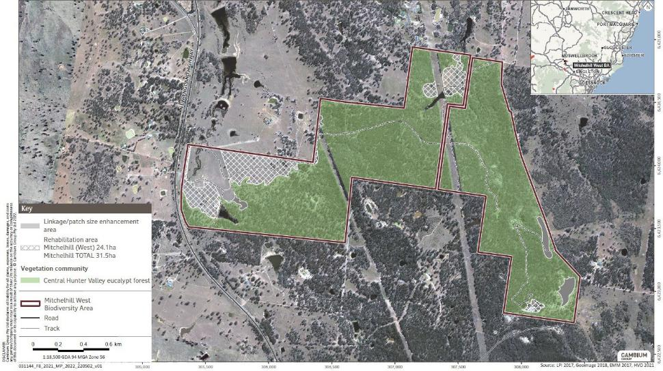
Figure 8 Re-establishment and linkage/patch size enhancement areas at the Mitchelhill (West) Biodiversity Area

Number: Mitchelhill BAMP V5 2024 Status: Final Effective: 18/12/2024 Page 50 of 146 Owner: Hunter Valley Operations Version: 5 Review: 18/12/2027

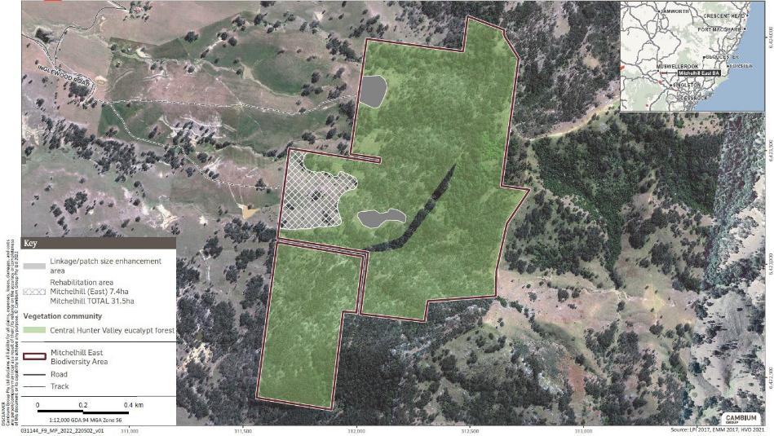
Figure 9 Re-establishment and linkage/patch size enhancement areas at the Mitchelhill (East) Biodiversity Area

Number: Mitchelhill BAMP V5 2024 Status: Final Effective: 18/12/2024 Page 51 of 146 Owner: Hunter Valley Operations Version: 5 Review: 18/12/2027

Plan | Mitchelhill Biodiversity Area Management Plan

Species list
Table 9 lists the CHVEFW species for planting in re-establishment areas at Mitchelhill BA. The quantity and diversity of tubestock for planting/direct seeding will target canopy and mid canopy stratum with at least three different species within in each stratum, i.e., a minimum of six species. The seed for the direct seeding works will be selected from the species in Table 9 and/or Appendix B.

Number: | Mitchelhill BAMP V5 2024 | Status: Final | Effective: 18/12/2024 Page 52 of 146
Owner: | Hunter Valley Operations | Version: 5 | Review: 18/12/2027

Table 9 CHVEFW species planting list

 | Scientific Name | Common Name | Present at Mitchelhill BA | Collection times and notes
 | Canopy
 | Eucalyptus moluccana | Grey Box | Yes | Late summer
 | Eucalyptus crebra | Narrow-leaved Ironbark | Yes | Late spring
 | Eucalyptus dawsonii | Slaty gum
 | Corymbia maculata (syn. E. maculata) | Spotted gum | Yes
 | Mid storey
 | Acacia salicina | Cooba | Yes
 | Allocasuarina luehmannii | Buloke | Yes
 | Myoporum montanum | Western Boobialla | Yes
 | Notelaea microcarpa var. microcarpa | Mock Olive | Yes
 | Breynia oblongifolia | Coffee Bush | Yes | Spring - autumn
 | Bursaria spinosa subsp. spinosa | Blackthorn | Yes | Late summer –autumn
 | Cassinia quinquefaria | Cough Bush |  | Autumn – winter
 | Dodonaea viscosa | Hop Bush | Yes | Spring – summer
 | Solanum cinereum | Narrawa Burr | Yes | All year
 | Groundcover
 | Aristida ramosa | Purple Wiregrass | Yes | Autumn – early winter
 | Austrostipa scabra | Corkscrew Grass | Yes | Summer
 | Bothriochloa decipiens | Red Grass |  | Summer
 | Brunoniella australis | Blue Trumpet | Yes | Summer
 | Calotis cuneifolia | Purple Burr-daisy |  | Summer
 | Cheilanthes distans | Bristly Cloak Fern |  | All year
 | Cheilanthes sieberi | Poison Rock Fern | Yes | All year
Number: Mitchelhill BAMP V5 2024 Status: Final Effective: 18/12/2024 Page 53 of 146 Owner: Hunter Valley Operations Version: 5 Review: 18/12/2027

Chloris ventricosa | Tall Chloris | Yes | Summer – autumn
Chrysocephalum apiculatum | Common Everlasting | Yes | Summer
Cymbopogon refractus | Barbed Wire Grass | Yes | Summer
Desmodium brachypodum | Large Tick-trefoil | Yes
Desmodium varians | Slender Tick-trefoil | Yes | Spring – autumn
Dichondra repens | Kidney Weed | Yes
Echinopogon caespitosus | Bushy Hedgehog-grass | Yes | Late summer to autumn
Einadia nutans | Climbing Saltbush |  | Summer
Eragrostis leptostachya | Paddock Lovegrass | Yes | Late summer
Eremophila debilis | Winter Apple | Yes | Late summer – autumn
Glycine clandestina | Twining glycine | Yes
Lomandra multiflora | Many-flowered Mat-rush | Yes | Summer
Melichrus urceolatus | Urn-heath | Yes | Winter – late spring
Microlaena stipoides | Weeping Grass | Yes | Summer
Paspalidium distans |  | Yes
Pomax umbellata | - |  | Summer
Sida corrugata | - | Yes
Solanum prinophyllum | Forest Nightshade |  | All year
Sporobolus creber | Slender Rat’s Tail Grass | Yes | Spring – autumn
Vittadinia cuneata | Fuzzweed | Yes | Late spring - summer
Wahlenbergia communis | tufted bluebell | Yes

Number: Mitchelhill BAMP V5 2024 Status: Final Effective: 18/12/2024 Page 54 of 146 Owner: Hunter Valley Operations Version: 5 Review: 18/12/2027

Planting method
Table 10 lists the key planting criteria to increase the likelihood of planting success. This information is to be used as a guide for the re-establishment works within the BA.
Table 10 Key planting criteria

Activity | Comment
Species selection | Species selected are species listed on the description of the vegetation communities issued by the NSW Scientific Committee or NSW government description. Seed can be collected from site or regionally from equivalent vegetation communities.
Cultivation | As a guide, cultivation for tube stock planting should be to a depth of 500-600mm at least 6 months prior to planting and when soil moisture is low to improve sub surface soil shatter, this is not required on sand sites. Cultivation for direct seeding may include light soil scarification.
Pre-plant weed control | As a guide, chemical control of weeds at least 1 week prior to planting or seeding. An area of at least 1m diameter around each tree or seeding patch is to be sprayed to remove all competition for site resources.
Tube stock planting | As a guide, planting will only occur when there is suitable soil moisture, typically in spring or autumn. Tube stock is to be at least 25mm in height, with a well-established root system and in good condition. The tube stock root plug is to be saturated at the time of planting.  Soil conditioner is to be applied into the planting hole and all plants should be planted deep, with their root plug at least 50mm below ground and gently firmed in to remove any air pockets in the soil.  The spacing of tube stock planting will occur in rows or clusters to create appropriate shelter effects.
Direct seeding | Seed is to be free of weed seed. Seeding must only occur when there is suitable soil moisture in spring or autumn.
Watering | As a guide, watering is to occur at the time of planting or seeding.
Maintenance | Maintenance period will apply for at least 18 months, including post plant weed control.
Replanting | Where the survival of tubestock is less than 60% the area will be supplementary replanted.
All planting activities are dependent upon suitable climatic conditions and may be postponed. If this occurs, weather records will be reported to support any delay in activities.

Survival assessments
Survival assessments are to be completed at approximately 6 and 12 months post planting to assess the success of tubestock planting and direct seeding. Details of the monitoring program are provided in Section 6.5.3. If the results of the 6-month assessment determine that

Number: | Mitchelhill BAMP V5 2024 Status: Final | Effective: 18/12/2024 Page 55 of 146
Owner: | Hunter Valley Operations Version: 5 | Review: 18/12/2027

supplementary planting is required, the 12 month assessment will not occur if supplementary plantings are scheduled and yet to be completed.

Erosion control
There is moderate potential for erosion to occur within the BA (Figure 7). Management options for erosion control include excluding grazing, controlling vehicle access, maintenance of tracks and rehabilitation of drainage lines, watercourses and riparian areas where erosion impacts are identified.
Erosion within the BA will be monitored during the site inspections along with other observations recorded during the ecological monitoring program. Should it be required, appropriate erosion remediation measures will be implemented.

Vertebrate pest and overabundant native animal control
Vertebrate pest species and overabundant native herbivores can pose a threat to native flora and fauna through degradation of habitat, competition for habitat resources, and direct predation.
The National Recovery Plan for the Swift Parrot (Birds Australia 2011) and the National Recovery Plan for the Regent Honeyeater (DoE 2016), list the following key threatening processes, which are relevant to the vertebrate pest and overabundant native animal control across the BA:
- competition from Noisy Miners.
- environmental degradation caused by the feral European rabbit;
- predation by the feral cat; and
- competition from feral honey bees;
There is no specific recovery plan for CHVEFW, however the Conservation Advice for CHVEFW (TSSC 2015) lists the following threats relevant to this community:
  - novel biota and their impact on biodiversity
  - competition and land degradation by rabbits;
  - competition from feral honey bees;
  - aggressive exclusion by Noisy Miners;
  - predation by the European Fox; and
  - predation by the feral cat.
The Noisy Miner has been identified throughout Mitchelhill BA and is known for its aggressive exclusion of other bird species. However, this species shows a preference for degraded and fringing habitats and becomes less common with increasing density of trees (correlation with decreasing density of trees and increasing penetration by Noisy Miners (Clarke and Oldland 2007)). Therefore, the best means of reducing impacts from this species is in the reduction of edge effects an increasing the size of remnant fragments via habitat re-establishment. Although not specifically mentioned under the relevant recovery plans, feral goats and feral deer both have potential to degrade habitats for the Swift Parrot, Regent Honeyeater and degrade native vegetation of the CHVEFW via grazing on planted revegetation and natural recruitment. Feral pigs can additionally cause degradation via pugging and wallows thus reducing potential success of revegetation programs.

Number: | Mitchelhill BAMP V5 2024 Status: Final | Effective: 18/12/2024 Page 56 of 146
Owner: | Hunter Valley Operations Version: 5 | Review: 18/12/2027

This Plan will target the control of declared vertebrate pests and those causing environmental degradation at a regional and local level, and the opportunistic control of the species listed in Table 11. Other vertebrate pests, overabundant native herbivores, or noisy miners will be managed as required following approval from relevant authorities prior to their control. All vertebrate pest control activities will be reported in the Annual Report. If a control event is required but conditions are unsuitable, justification will be presented in the Annual Report.
Under the LLS Act, species that are currently declared pests in NSW include rabbits, feral pigs and wild dogs. Pest Control Orders can be issued by the regulator to legally enforce land managers to control the species on their land. Land managers are defined as either owners or occupiers of the land. Occupiers of land in NSW are not obliged to control other vertebrate pest animals. However, these species may have significant negative impacts on the environment and agricultural production in many areas. The NSW Game and Feral Animal Control Act 2002 requires the control of feral deer.
This Plan acknowledges that populations of vertebrate pests are determined by several factors such as topography, shelter, behaviour and food availability. Property fences do not restrict pests, and control actions will not therefore be limited to artificial boundaries. Most vertebrate pests are highly mobile and can readily replace those that are controlled on individual properties. A variety of control methods can be utilised provided they are:
- species specific (wherever possible);
- cause no or little damage to the natural environment;
- are humane;
- meet relevant Work, Health, Safety and Environment regulatory requirements; and
- are regularly monitored.
Control programs are likely to be far more effective when coordinated with multiple landholdings. HVO will endeavour to work with the HLLS on regional control programs and supported by local on ground control actions. Neighbours are to be notified on local on-ground actions to facilitate coordination of efforts and deliver more effective control.
Design and implementation of local controls will be guided by the Model Codes of Practice (COPs) and Standard Operating Procedures (SOPs) produced by the Commonwealth Department of the Environment (available online http://www.pestsmart.org.au/animal-welfare/humane-codes/). The COPs for each of the key pest animal species provides general information on best practice management, control strategies, species biology and impact, and the humaneness of current control methods. The SOPs describe management techniques and their application for these pest animal species, including a discussion of animal welfare impacts for target and non-target species. They also cover the health and safety aspects of management techniques.
The vertebrate pests identified in Table 11 have been recorded or have the potential to occur at the Mitchelhill BA. Control methods, timing and intensity are also provided for these species.
Where the species has not been identified as residing or traversing through the BA, control methods for that species will not be implemented. The frequency of the control methods will be determined from the monitoring results and may be repeated within a suitable timeframe if required.

Number: | Mitchelhill BAMP V5 2024 Status: Final | Effective: 18/12/2024 Page 57 of 146
Owner: | Hunter Valley Operations Version: 5 | Review: 18/12/2027

Table 11 Identified vertebrate pests control methods, timing and intensity

Pest* | Declared | Control methods | Control timing and intensity
European rabbit (Oryctolagus  cuniculus) | Yes | Baiting: 1080 / Pindone Trapping: cage trap Shooting: ground based Biological: Myxomatosis  and / or Rabbit Haemorrhagic Disease(RHD)  Other: Exclusion fencing / Warren fumigation / Warren ripping | Control event in Autumn and /or Spring.  From Year 1 to Year 4, at least one control event per year with additional events as required.  Ongoing maintenance, minimum of one control event per year if required.
Feral Deer (Cervus timorensis) (Dama dama) (Cervus elaphus) | Yes | Shooting: ground based | Control event in Autumn and /or Spring.  From Year 1 to Year 4, at least one control event per year with additional events as required.  Ongoing maintenance, minimum of one control event per year if required.
Feral cat (Felis catus) | No | Trapping: Wire mesh cage trap / Soft net trap/  Padded-jaw trap Shooting – ground based | Control event in Autumn and /or Spring  From Year 1 to Year 4, at least one control event per year with additional events as required.  Ongoing maintenance, minimum of one control event per year if required.
Feral cattle (Bos taurus) | No | Other - Exclusion fencing / Mustering | As required.
Feral Goat (Capra hircus) | No | Shooting – ground / aerial based  Other - Exclusion fencing / Mustering | Control event in Autumn and /or Spring.  From Year 1 to Year 4, at least one control event per year with additional events as required.  Ongoing maintenance, minimum of one control event per year if required.
Feral pig (Sus scrofa) | Yes | Baiting – 1080  Trapping - Silo, panel or box traps  Shooting – ground / aerial based  Other - Exclusion fencing | Control event in Autumn and /or Spring.  From Year 1 to Year 4, at least one control event per year with additional events as required.  Ongoing maintenance, minimum of one control event per year if required.

Number: | Mitchelhill BAMP V5 2024 Status: Final | Effective: 18/12/2024 Page 58 of 146
Owner: | Hunter Valley Operations Version: 5 | Review: 18/12/2027

Hares (Lepus europaeus) | No | Trapping – cage trap Shooting – ground based Other - Exclusion fencing / Habitat modification /  Repellents | Control event in Autumn and /or Spring.  From Year 1 to Year 4, at least one control event per year with additional events as required.
Ongoing maintenance, minimum of
one control event per year if required.
Red fox (Vulpes vulpes) | No | Baiting – 1080  Trapping - Wire mesh cage trap  / Soft jaw leg hold trap Shooting – ground based Other - Den fumigation / Exclusion fencing / Ejectors / Habitat modification | Control event in Autumn and /or Spring.  From Year 1 to Year 4, at least one control event per year with additional events as required.  Ongoing maintenance, minimum of one control event per year if required.
Wild dog (Canis lupus spp.) | Yes | Baiting – 1080 / PAPP  Trapping - Soft jaw leg hold trap Shooting – ground based  Other - Exclusion fencing | Control event in Autumn and /or Spring.  From Year 1 to Year 4, at least one control event per year with additional events as required.
 |  |  | Ongoing maintenance, minimum of one control event per year if required.
Noisy Miner | No | Shooting – ground based | Implemented only if bird assemblage monitoring (Section 6.4.2) results indicate that the population is having a detrimental impact on bird diversity.
* Note, the control methods stated would only be implemented should the species be identified as utilising or occurring within the BA, or in the case with the Noisy Miner, monitoring results indicate that the population is having a detrimental impact on bird diversity.

Local control
Unless indicated otherwise, local on ground control measures including trapping, baiting and shooting (as appropriate) are to occur across the BA in Autumn and Spring, to coincide with breeding seasons of many of the vertebrate pest species. Reactive control may be undertaken at other times in response to reports of threatened species and/or livestock predation.
All control actions will be undertaken by appropriately qualified personnel and are required to complete a comprehensive job safety assessment prior to commencement of actions. Control actions must follow the COPs and SOPs for the humane control of pest animals.

Regional control
At the Mitchelhill BA, participation will continue in regional aerial and ground control programs for feral pigs and wild dogs, managed and coordinated by the HLLS and/or National Parks and Wildlife Service (NPWS). These programs will be permitted to apply across the BA.

Number: | Mitchelhill BAMP V5 2024 Status: Final | Effective: 18/12/2024 Page 59 of 146
Owner: | Hunter Valley Operations Version: 5 | Review: 18/12/2027

Regional control programs are managed and co-ordinated by the HLLS. The HLLS will be responsible for advising the community of the control action, while HVO will notify any adjacent Leaseholders of the proposed action.

Pre-clearing surveys
Pre-clearing surveys will be undertaken for any shrubby or treed vegetation clearing prior to installing firebreaks or any ground disturbance or significant tree vegetation removal. These will be undertaken to identify any resident fauna, threatened flora or habitat features that need to be avoided or relocated. Clearance protocol and pre-clearance survey requirements are outlined in the HVO Vegetation Clearance Plan.
To ensure only approved areas are disturbed, clearance limits will be clearly identified on plans and on the ground (using durable markers, and / or signage and exclusion fencing). Habitat trees and appropriate micro-habitats such as fallen logs will be surveyed and marked to determine if fauna are using them. Any marked trees that show signs of current or recent use are reserved for latest possible removal to encourage fauna to abandon the area of their own accord or undertake possible physical relocation.
In accordance with the HVO Vegetation Clearance Plan (HVO 2024), if the Regent Honeyeater and/or Swift Parrot are recorded during pre-clearance surveys, a two-stage clearance protocol must be implemented. The two-stage clearance protocol requires targeted searches for habitat trees for the two species, and targeted nest searches for the Regent Honeyeater. All habitat trees and/or nests are required to be marked in the field and recorded using a GPS for management during clearance and reporting purposes.

Summary of performance and completion criteria and trigger action response plan
A summary of all performance and completion criteria, accompanied by the Trigger, Action Response Plan is provided in Table 12 and Table 13 respectively.

Number: | Mitchelhill BAMP V5 2024 Status: Final | Effective: | 18/12/2024 Page 60 of 146
Owner: | Hunter Valley Operations Version: 5 | Review: | 18/12/2027

Table 12 Summary of performance and completion criteria

Activity | Annual criteria Year 1 | Annual criteria Year 2 | Annual criteria Year 3 | Annual criteria Year 4 | Annual criteria Year 5 | Annual criteria from Year 6 to Year 10 | Completion Criteria
Overall | Overall condition | Overall condition | Overall condition | Overall condition | Overall condition | Overall condition | Overall condition
condition of | (based on | (based on | (based on | (based on | (based on | (based on | (based on
the 316.1 ha | vegetation | vegetation | vegetation | vegetation | vegetation | vegetation | vegetation
of CHVEFW | integrity scores | integrity scores | integrity scores | integrity scores | integrity scores | integrity scores | integrity scores
is managed | for composition, | for composition, | for composition, | for composition, | for composition, | for composition, | for composition,
 | structure and | structure and | structure and | structure and | structure and | structure and | structure and
 | function) of the | function) of the | function) of the | function) of the | function) of the | function) of the | function) of the
 | 316.1 ha of | 316.1 ha of | 316.1 ha of | 316.1 ha of | 316.1 ha of | 316.1 ha of | 316.1 ha of
 | CHVEFW is on | CHVEFW is on | CHVEFW is on | CHVEFW is on | CHVEFW is on | CHVEFW is | CHVEFW is now
 | an improving | an improving | an improving | an improving | an improving | improving. | at a score of 9.
 | trajectory. | trajectory. | trajectory. | trajectory. | trajectory.
 | Trees are | Trees are | Trees are | Trees are | Trees are | Trees are | Trees are
 | generally in a | generally in a | generally in a | generally in a | generally in a | generally in a | generally in a
 | good state of | good state of | good state of | good state of | good state of | good state of | good state of
 | health, with no | health, with no | health, with no | health, with no | health, with no | health, with no | health, with no
 | signs of | signs of | signs of | signs of | signs of | signs of | signs of
 | substantive | substantive | substantive | substantive | substantive | substantive | substantive
 | depreciation (or | depreciation (or | depreciation (or | depreciation (or | depreciation (or | depreciation (or | depreciation (or
 | negative trend as | negative trend as | negative trend as | negative trend as | negative trend as | negative trend as | negative trend as
 | identified through | identified through | identified through | identified through | identified through | identified through | identified through
 | three | three | three | three | three | three | three
 | consecutive | consecutive | consecutive | consecutive | consecutive | consecutive | consecutive
 | years of | years of | years of | years of | years of | years of | years of
 | monitoring). | monitoring). | monitoring). | monitoring). | monitoring). | monitoring). | monitoring).

Number: Mitchelhill BAMP V5 2024 Status: Final Effective: 18/12/2024 Page 61 of 146 Owner: Hunter Valley Operations Version: 5 Review: 18/12/2027

Activity | Annual criteria Year 1 | Annual criteria Year 2 | Annual criteria Year 3 | Annual criteria Year 4 | Annual criteria Year 5 | Annual criteria from Year 6 to Year 10 | Completion Criteria
Prohibited actions | HVO personnel, contractors, consultants or other agents of HVO are made aware of prohibited actions through the induction process. | HVO personnel, contractors, consultants or other agents of HVO are made aware of prohibited actions through the induction process. | HVO personnel, contractors, consultants or other agents of HVO are made aware of prohibited actions through the induction process. | HVO personnel, contractors, consultants or other agents of HVO are made aware of prohibited actions through the induction process. | HVO personnel, contractors, consultants or other agents of HVO are made aware of prohibited actions through the induction process. | HVO personnel, contractors, consultants or other agents of HVO are made aware of prohibited actions through the induction process. | No reported occurrences of prohibited actions undertaken by HVO,  contractors, consultants or other agents of HVO.
Exemption of clearing vegetation | Any clearing required is subject to appropriate approvals (including pre-clearing survey for habitat value), and notification is obtained and given.  Any clearing of vegetation reported in the Annual Report (AR). | Any clearing required is subject to appropriate approvals (including pre-clearing survey for habitat value), and notification is obtained and given.  Any clearing of vegetation reported in the AR. | Any clearing required is subject to appropriate approvals (including pre-clearing survey for habitat value), and notification is obtained and given.  Any clearing of vegetation reported in the AR. | Any clearing required is subject to appropriate approvals (including pre-clearing survey for habitat value), and notification is obtained and given.  Any clearing of vegetation reported in the AR. | Any clearing required is subject to appropriate approvals (including pre-clearing survey for habitat value), and notification is obtained and given.  Any clearing of vegetation reported in the AR. | Any clearing required is subject to appropriate approvals (including pre-clearing survey for habitat value), and notification is obtained and given.  Any clearing of vegetation reported in the AR. | Vegetation clearing is only undertaken when necessary to do so.  Necessary vegetation clearing was subject to appropriate approvals and reported on in the AR.

Number: Mitchelhill BAMP V5 2024 Status: Final Effective: 18/12/2024 Page 62 of 146 Owner: Hunter Valley Operations Version: 5 Review: 18/12/2027

Activity | Annual criteria Year 1 | Annual criteria Year 2 | Annual criteria Year 3 | Annual criteria Year 4 | Annual criteria Year 5 | Annual criteria from Year 6 to Year 10 | Completion Criteria
Access | Biannual Property Inspections completed and include assessment of physical condition of:  - existing fencing, gates, signage and locks.  - signs of disturbance such as fire and unauthorised access (including hunting firewood collections, new waste) | Biannual Property Inspections completed and include assessment of physical condition of:  - existing fencing, gates, signage and locks.  - signs of disturbance such as fire and unauthorised access (including hunting firewood collections, new waste) | Biannual Property Inspections completed and include assessment of physical condition of:  - existing fencing, gates, signage and locks.  - signs of disturbance such as fire and unauthorised access (including hunting firewood collections, new waste) | Biannual Property Inspections completed and include assessment of physical condition of:  - existing fencing, gates, signage and locks.  - signs of disturbance such as fire and unauthorised access (including hunting firewood collections, new waste) | Biannual Property Inspections completed and include assessment of physical condition of:  - existing fencing, gates, signage and locks.  - signs of disturbance such as fire and unauthorised access (including hunting firewood collections, new waste) | Biannual Property Inspections completed and include assessment of physical condition of:  - existing fencing, gates, signage and locks.  - signs of disturbance such as fire and unauthorised access (including hunting firewood collections, new waste) | Fences, gates, locks and signage were regularly assessed to ensure potential breaches were promptly identified and rectified.

Number: Mitchelhill BAMP V5 2024 Status: Final Effective: 18/12/2024 Page 63 of 146 Owner: Hunter Valley Operations Version: 5 Review: 18/12/2027

Activity | Annual criteria Year 1 | Annual criteria Year 2 | Annual criteria Year 3 | Annual criteria Year 4 | Annual criteria Year 5 | Annual criteria from Year 6 to Year 10 | Completion Criteria
 | Any issues with fences, gates, signage and locks are rectified within 30 days of identification. | Any issues with fences, gates, signage and locks are rectified within 30 days of identification. | Any issues with fences, gates, signage and locks are rectified within 30 days of identification. | Any issues with fences, gates, signage and locks are rectified within 30 days of identification. | Any issues with fences, gates, signage and locks are rectified within 30 days of identification. | Any issues with fences, gates, signage and locks are rectified within 30 days of identification. | All required boundary fences, gates, signage and locks are present and regularly monitored and maintained in appropriate condition
 | Offset signage includes information of the Conservation status of the area as well as speed limit signage. | Offset signage is replaced if necessary to do so do that necessary information is clearly displayed. | Offset signage is replaced if necessary to do so do that necessary information is clearly displayed. | Offset signage is replaced if necessary to do so do that necessary information is clearly displayed. | Offset signage is replaced if necessary to do so do that necessary information is clearly displayed. | Offset signage is replaced if necessary to do so do that necessary information is clearly displayed. | Offset signage is maintained and clearly legible.
 | New waste identified will be subject to removal from the BA within 30 days of its identification. | New waste identified will be subject to removal from the BA within 30 days of its identification. | New waste identified will be subject to removal from the BA within 30 days of its identification. | New waste identified will be subject to removal from the BA within 30 days of its identification. | New waste identified will be subject to removal from the BA within 30 days of its identification. | New waste identified will be subject to removal from the BA within 30 days of its identification. | If relevant, newly identified waste was promptly removed.

Number: Mitchelhill BAMP V5 2024 Status: Final Effective: 18/12/2024 Page 64 of 146 Owner: Hunter Valley Operations Version: 5 Review: 18/12/2027

Activity | Annual criteria Year 1 | Annual criteria Year 2 | Annual criteria Year 3 | Annual criteria Year 4 | Annual criteria Year 5 | Annual criteria from Year 6 to Year 10 | Completion Criteria
 | The induction process in order to access or undertake work in Mitchelhill BA includes briefing on the legal protections associated with the CHVEFW, Swift Parrot and Regent Honeyeater as well as the penalties associated with interference with these values. | Induction components in order to access or undertake work in Mitchelhill BA are maintained. | Induction components in order to access or undertake work in Mitchelhill BA are maintained. | Induction components in order to access or undertake work in Mitchelhill BA are maintained. | Induction components in order to access or undertake work in Mitchelhill BA are maintained. | Induction components in order to access or undertake work in Mitchelhill BA are maintained. | No un-inducted personnel accessed or completed works within Mitchelhill BA.

Number: Mitchelhill BAMP V5 2024 Status: Final Effective: 18/12/2024 Page 65 of 146 Owner: Hunter Valley Operations Version: 5 Review: 18/12/2027

Activity | Annual criteria Year 1 | Annual criteria Year 2 | Annual criteria Year 3 | Annual criteria Year 4 | Annual criteria Year 5 | Annual criteria from Year 6 to Year 10 | Completion Criteria
Protection of Cultural heritage | Areas of proposed ground disturbance subject to due diligence prior to commencing work.  No Cultural heritage sites disturbed and any protective barricading erected and maintained. | Areas of proposed ground disturbance subject to due diligence prior to commencing work.  No Cultural heritage sites disturbed and any protective barricading erected and maintained. | Areas of proposed ground disturbance subject to due diligence prior to commencing work.  No Cultural heritage sites disturbed and any protective barricading erected and maintained. | Areas of proposed ground disturbance subject to due diligence prior to commencing work.  No Cultural heritage sites disturbed and any protective barricading erected and maintained. | Areas of proposed ground disturbance subject to due diligence prior to commencing work.  No Cultural heritage sites disturbed and any protective barricading erected and maintained. | Areas of proposed ground disturbance subject to due diligence prior to commencing work.  No Cultural heritage sites disturbed and any protective barricading erected and maintained. | Cultural heritage sites were protected through barricading for the duration of this plan.
Waste Removal | Waste identified in Figure 6 and Figure 7 progressively removed until none remains present. | Waste identified in Figure 6 and Figure 7 progressively removed until none remains present. | Waste identified in Figure 6 and Figure 7 progressively removed until none remains present. | Waste identified in Figure 6 and Figure 7 progressively removed until none remains present. | Waste identified in Figure 6 and Figure 7 progressively removed until none remains present. | None of the waste identified in Figure 6 and Figure 7 remains present. | All originally identified waste from baseline surveys is removed.
Waste Removal | Internal redundant fences in Mitchelhill are progressively removed and disposed of off-site. | Internal redundant fences in Mitchelhill are progressively removed and disposed of off-site. | Internal redundant fences in Mitchelhill are progressively removed and disposed of off-site. | Internal redundant fences in Mitchelhill are progressively removed and disposed of off-site. | No redundant internal fences remain. | No redundant internal fences remain. | No redundant internal fences remain.

Number: Mitchelhill BAMP V5 2024 Status: Final Effective: 18/12/2024 Page 66 of 146 Owner: Hunter Valley Operations Version: 5 Review: 18/12/2027

Activity | Annual criteria Year 1 | Annual criteria Year 2 | Annual criteria Year 3 | Annual criteria Year 4 | Annual criteria Year 5 | Annual criteria from Year 6 to Year 10 | Completion Criteria
 | Waste identified during biannual Property inspections removed within the calendar year unless the waste presents a potential biodiversity issue (then 30 days of identification). | Waste identified during biannual Property inspections removed within the calendar year unless the waste presents a potential biodiversity issue (then 30 days of identification). | Waste identified during biannual Property inspections removed within the calendar year unless the waste presents a potential biodiversity issue (then 30 days of identification). | Waste identified during biannual Property inspections removed within the calendar year unless the waste presents a potential biodiversity issue (then 30 days of identification). | Waste identified during biannual Property inspections removed within the calendar year unless the waste presents a potential biodiversity issue (then 30 days of identification). | Waste identified during biannual Property inspections removed within the calendar year unless the waste presents a potential biodiversity issue (then 30 days of identification). | No new waste is negatively impacting the condition of the vegetation present.
Monitoring | Two property inspections are undertaken that include recording details required in Section 6.5.2. | Two property inspections are undertaken that include recording details required in Section 6.5.2. | Two property inspections are undertaken that include recording details required in Section 6.5.2. | Two property inspections are undertaken that include recording details required in Section 6.5.2. | Two property inspections are undertaken that include recording details required in Section 6.5.2. | Two property inspections are undertaken that include recording details required in Section 6.5.2. | All Property Inspections (Section 6.5.2) completed.
Grazing | Grazing does not take place, unless as a last resort for the purposes of reducing fuel load and weed infestation. | Grazing does not take place, unless as a last resort for the purposes of reducing fuel load and weed infestation. | Grazing does not take place, unless as a last resort for the purposes of reducing fuel load and weed infestation. | Grazing does not take place, unless as a last resort for the purposes of reducing fuel load and weed infestation. | Grazing does not take place, unless as a last resort for the purposes of reducing fuel load and weed infestation. | Grazing does not take place, unless as a last resort for the purposes of reducing fuel load and weed infestation. | Grazing was only undertaken if determined as necessary to do so in order to minimise fuel load or manage weeds.

Number: Mitchelhill BAMP V5 2024 Status: Final Effective: 18/12/2024 Page 67 of 146 Owner: Hunter Valley Operations Version: 5 Review: 18/12/2027

Activity | Annual criteria Year 1 | Annual criteria Year 2 | Annual criteria Year 3 | Annual criteria Year 4 | Annual criteria Year 5 | Annual criteria from Year 6 to Year 10 | Completion Criteria
Weed management | At least one control event per year with additional events as required for species listed in Table 8 or Appendix D that are identified as needing control, and any other weeds needing control recorded from monitoring activities.  All actions recorded in the Annual Report. | At least one control event per year with additional events as required for species listed in Table 8 or Appendix D that are identified as needing control, and any other weeds needing control recorded from monitoring activities.  All actions recorded in the Annual Report. | At least one control event per year with additional events as required for species listed in Table 8 or Appendix D that are identified as needing control, and any other weeds needing control recorded from monitoring activities.  All actions recorded in the Annual Report. | At least one control event per year with additional events as required for species listed in Table 8 or Appendix D that are identified as needing control, and any other weeds needing control recorded from monitoring activities.  All actions recorded in the Annual Report. | At least one control event per year with additional events as required for species listed in Table 8 or Appendix D that are identified as needing control, and any other weeds needing control recorded from monitoring activities.  All actions recorded in the Annual Report. | At least one control event per year with additional events as required for species listed in Table 8 or Appendix D that are identified as needing control, and any other weeds needing control recorded from monitoring activities.  All actions recorded in the Annual Report. | Ecological monitoring data indicates a trajectory for reduction in weed plant cover over three consecutive monitoring events.
Weed monitoring | Complete condition assessment monitoring (Section 6.4.1), rapid condition assessment (Section 6.5.1) and property inspections (Section 6.5.2). | Complete condition assessment monitoring (Section 6.4.1), rapid condition assessment (Section 6.5.1) and property inspections (Section 6.5.2). | Complete condition assessment monitoring (Section 6.4.1), rapid condition assessment (Section 6.5.1) and property inspections (Section 6.5.2). | Complete condition assessment monitoring (Section 6.4.1), rapid condition assessment (Section 6.5.1) and property inspections (Section 6.5.2). | Complete condition assessment monitoring (Section 6.4.1), rapid condition assessment (Section 6.5.1) and property inspections (Section 6.5.2). | Complete condition assessment monitoring (Section 6.4.1), rapid condition assessment (Section 6.5.1) and property inspections (Section 6.5.2). | Weed monitoring is completed

Number: Mitchelhill BAMP V5 2024 Status: Final Effective: 18/12/2024 Page 68 of 146 Owner: Hunter Valley Operations Version: 5 Review: 18/12/2027

Activity | Annual criteria Year 1 | Annual criteria Year 2 | Annual criteria Year 3 | Annual criteria Year 4 | Annual criteria Year 5 | Annual criteria from Year 6 to Year 10 | Completion Criteria
Bushfire Management Plan (BFMP) | Actions of BFMP implemented.  BFMP reviewed and revised by HVO if required. | Actions of BFMP implemented.  BFMP reviewed and revised by HVO if required. | Actions of BFMP implemented.  BFMP reviewed and revised by HVO if required. | Actions of BFMP implemented.  BFMP reviewed and revised by HVO if required. | Actions of BFMP implemented.  BFMP reviewed and revised by HVO if required. | Actions of BFMP implemented.  BFMP reviewed and revised by HVO if required. | All required actions of BFMP have been implemented  BFMP has been reviewed annually and revised if required.
Ecological burns | None required | None required | None required | None required | Review woodland area for  suitability for ecological burn. | None required | The site’s suitability for an ecological burn is reviewed.
Bushfire monitoring | Complete condition assessment monitoring (Section 6.4.1) and property inspections (Section 6.5.2). | Complete condition assessment monitoring (Section 6.4.1) and property inspections (Section 6.5.2). | Complete condition assessment monitoring (Section 6.4.1) and property inspections (Section 6.5.2). | Complete condition assessment monitoring (Section 6.4.1) and property inspections (Section 6.5.2). | Complete condition assessment monitoring (Section 6.4.1) and property inspections (Section 6.5.2). | Complete condition assessment monitoring (Section 6.4.1) and property inspections (Section 6.5.2). | Monitoring has been completed as per the schedule.
Infrastructure improvements | If infrastructure improvement requiring ground disturbance is | If infrastructure improvement requiring ground disturbance is | If infrastructure improvement requiring ground disturbance is | If infrastructure improvement requiring ground disturbance is | If infrastructure improvement requiring ground disturbance is | If infrastructure improvement requiring ground disturbance is | All required infrastructure improvements were completed.

Number: Mitchelhill BAMP V5 2024 Status: Final Effective: 18/12/2024 Page 69 of 146 Owner: Hunter Valley Operations Version: 5 Review: 18/12/2027

Activity | Annual criteria Year 1 | Annual criteria Year 2 | Annual criteria Year 3 | Annual criteria Year 4 | Annual criteria Year 5 | Annual criteria from Year 6 to Year 10 | Completion Criteria
 | necessary, GDP process is completed. | necessary, GDP process is completed. | necessary, GDP process is completed. | necessary, GDP process is completed. | necessary, GDP process is completed. | necessary, GDP process is completed. | All infrastructure improvements requiring ground disturbance were subject to the GDP process.
Monitoring of infrastructure | Infrastructure monitoring undertaken during biannual property inspections (Section 6.5.2).  Any repairs undertaken as required. | Infrastructure monitoring undertaken during biannual property inspections (Section 6.5.2).  Any repairs undertaken as required. | Infrastructure monitoring undertaken during biannual property inspections (Section 6.5.2).  Any repairs undertaken as required. | Infrastructure monitoring undertaken during biannual property inspections (Section 6.5.2).  Any repairs undertaken as required. | Infrastructure monitoring undertaken during biannual property inspections (Section 6.5.2).  Any repairs undertaken as required. | Infrastructure monitoring undertaken during biannual property inspections (Section 6.5.2).  Any repairs undertaken as required. | Monitoring has been completed as per the schedule.

Number: Mitchelhill BAMP V5 2024 Status: Final Effective: 18/12/2024 Page 70 of 146 Owner: Hunter Valley Operations Version: 5 Review: 18/12/2027

Activity | Annual criteria Year 1 | Annual criteria Year 2 | Annual criteria Year 3 | Annual criteria Year 4 | Annual criteria Year 5 | Annual criteria from Year 6 to Year 10 | Completion Criteria
Natural regeneration | Annual management activities include weed control, vertebrate pest and fire management actions as specified in this plan. | Annual management activities include weed control, vertebrate pest and fire management actions as specified in this plan. | Annual management activities include weed control, vertebrate pest and fire management actions as specified in this plan. | Annual management activities include weed control, vertebrate pest and fire management actions as specified in this plan. | Annual management activities include weed control, vertebrate pest and fire management actions as specified in this plan. | Annual management activities include weed control, vertebrate pest and fire management actions as specified in this plan. | Ecological monitoring demonstrates a trajectory to benchmark values for relevant attributes measured over three consecutive monitoring events (the average of all plots).  Linkage and patch size enhancement areas identified in Figure 8 and Figure 9 have been achieved.
Natural regeneration | As indicated by monitoring result, natural regeneration of canopy species is occurring. | As indicated by monitoring result, natural regeneration of canopy species is occurring. | As indicated by monitoring result, natural regeneration of canopy species is occurring. | As indicated by monitoring result, natural regeneration of canopy species is occurring. | As indicated by monitoring result, natural regeneration of canopy species is occurring. | As indicated by monitoring result, natural regeneration of canopy species is occurring.
 | Monitoring indicates that native mid-storey cover and native ground cover (herbs, ferns, lilies, rushes and sedges) are on a positive trajectory. | Monitoring indicates that native mid-storey cover and native ground cover (herbs, ferns, lilies, rushes and sedges) are on a positive trajectory. | Monitoring indicates that native mid-storey cover and native ground cover (herbs, ferns, lilies, rushes and sedges) are on a positive trajectory. | Monitoring indicates that native mid-storey cover and native ground cover (herbs, ferns, lilies, rushes and sedges) are on a positive trajectory. | Monitoring indicates that native mid-storey cover and native ground cover (herbs, ferns, lilies, rushes and sedges) are on a positive trajectory. | Monitoring indicates that native mid-storey cover and native ground cover (herbs, ferns, lilies, rushes and sedges) are on a positive trajectory.

Number: Mitchelhill BAMP V5 2024 Status: Final Effective: 18/12/2024 Page 71 of 146 Owner: Hunter Valley Operations Version: 5 Review: 18/12/2027

Activity | Annual criteria Year 1 | Annual criteria Year 2 | Annual criteria Year 3 | Annual criteria Year 4 | Annual criteria Year 5 | Annual criteria from Year 6 to Year 10 | Completion Criteria
Re-establishment | Collection of seeds, including those of feed tree specific resources for the Regent Honeyeater and Swift Parrot and those specific to the CHEFW. Plant propagation. | Collection of seed as required, including those of feed tree specific resources for the Regent Honeyeater and Swift Parrot and those specific to the CHEFW Plant propagation.  Tubestock planted and/or area direct seeded.  Completed survival assessment. | Ecological monitoring completed.  Completed survival assessment as required. | Ecological monitoring completed.  Completed survival assessment as required. | Ecological monitoring completed.  Completed survival assessment as required. | Ecological monitoring completed.  Completed survival assessment as required. | Ecological monitoring demonstrates a trajectory to benchmark values for relevant attributes measured over three consecutive monitoring events (the average of all plots).  Management monitoring demonstrates a minimum 60% survival rate of planted tubestock in the re-establishment area
Re-establishment | NA | Failed plantings subject to supplementary planting to bring numbers to at least 60% of initial planting density. | Failed plantings subject to supplementary planting to bring numbers to at least 60% of initial planting density. | Failed plantings subject to supplementary planting to bring numbers to at least 60% of initial planting density. | Failed plantings subject to supplementary planting to bring numbers to at least 60% of initial planting density. | Failed plantings subject to supplementary planting to bring numbers to at least 60% of initial planting density.

Number: Mitchelhill BAMP V5 2024 Status: Final Effective: 18/12/2024 Page 72 of 146 Owner: Hunter Valley Operations Version: 5 Review: 18/12/2027

Activity | Annual criteria Year 1 | Annual criteria Year 2 | Annual criteria Year 3 | Annual criteria Year 4 | Annual criteria Year 5 | Annual criteria from Year 6 to Year 10 | Completion Criteria
 | 31.5ha of CHVEFW DNG is  progressively being re-established. | 31.5ha of CHVEFW DNG is  progressively being re-established. | 31.5ha of CHVEFW DNG is  progressively being re-established. | 31.5ha of CHVEFW DNG is  progressively being re-established. | 31.5ha of CHVEFW DNG is  progressively being re-established. | 31.5ha of CHVEFW DNG is  progressively being re-established. | 31.5 ha of treed CHVEFW has been achieved
 | Areas of former DNG have canopy stem density, and shrub stem density on a trajectory of that of the CHVEFW Conservation Advice (TSSC 2015) and vegetation is consistent with either open forest or woodland. | Areas of former DNG have canopy stem density, and shrub stem density on a trajectory of that of the CHVEFW Conservation Advice (TSSC 2015) and vegetation is consistent with either open forest or woodland. | Areas of former DNG have canopy stem density, and shrub stem density on a trajectory of that of the CHVEFW Conservation Advice (TSSC 2015) and vegetation is consistent with either open forest or woodland. | Areas of former DNG have canopy stem density, and shrub stem density on a trajectory of that of the CHVEFW Conservation Advice (TSSC 2015) and vegetation is consistent with either open forest or woodland. | Areas of former DNG have canopy stem density, and shrub stem density on a trajectory of that of the CHVEFW Conservation Advice (TSSC 2015) and vegetation is consistent with either open forest or woodland. | Areas of former DNG have canopy stem density, consistent with that of the CHVEFW  Conservation Advice (TSSC 2015) and vegetation is consistent with either open forest or woodland. | Areas of former DNG have canopy stem density, consistent with that of the CHVEFW  Conservation Advice (TSSC 2015) and vegetation is consistent with either open forest or woodland.

Number: Mitchelhill BAMP V5 2024 Status: Final Effective: 18/12/2024 Page 73 of 146 Owner: Hunter Valley Operations Version: 5 Review: 18/12/2027

Activity | Annual criteria Year 1 | Annual criteria Year 2 | Annual criteria Year 3 | Annual criteria Year 4 | Annual criteria Year 5 | Annual criteria from Year 6 to Year 10 | Completion Criteria
Erosion control | Biannual property inspections include erosion assessment.  Areas of erosion remediation completed as required and all actions recorded in Annual Report. | Biannual property inspections include erosion assessment.  Areas of erosion remediation completed as required and all actions recorded in Annual Report. | Biannual property inspections include erosion assessment.  Areas of erosion remediation completed as required and all actions recorded in Annual Report. | Biannual property inspections include erosion assessment.  Areas of erosion remediation completed as required and all actions recorded in Annual Report. | Biannual property inspections include erosion assessment.  Areas of erosion remediation completed as required and all actions recorded in Annual Report. | Biannual property inspections include erosion assessment.  Areas of erosion remediation completed as required and all actions recorded in Annual Report. | No significant erosion that is detrimental to conservation objectives identified in Section 4.1 recorded during final property inspection.
Vertebrate pest – local control | At least one control event per year with additional events as required for species listed in Table 11, and any other species recorded from monitoring activities.  All actions recorded in the Annual Report. | At least one control event per year with additional events as required for species listed in Table 11, and any other species recorded from monitoring activities.  All actions recorded in the Annual Report. | At least one control event per year with additional events as required for species listed in Table 11, and any other species recorded from monitoring activities.  All actions recorded in the Annual Report. | At least one control event per year with additional events as required for species listed in Table 11, and any other species recorded from monitoring activities.  All actions recorded in the Annual Report. | At least one control events each year for species listed in Table 11, and any other species recorded from monitoring activities.  All actions recorded in the Annual Report. | At least one control events each year for species listed in Table 11, and any other species recorded from monitoring activities.  All actions recorded in the Annual Report. | Vertebrate pests not having a significant detrimental impact on conservation objectives.

Number: Mitchelhill BAMP V5 2024 Status: Final Effective: 18/12/2024 Page 74 of 146 Owner: Hunter Valley Operations Version: 5 Review: 18/12/2027

Activity | Annual criteria Year 1 | Annual criteria Year 2 | Annual criteria Year 3 | Annual criteria Year 4 | Annual criteria Year 5 | Annual criteria from Year 6 to Year 10 | Completion Criteria
Vertebrate pest – regional control | Active participation in program coordinated by HLLS This may include local control actions. | Active participation in program coordinated by HLLS This may include local control actions. | Active participation in program coordinated by HLLS This may include local control actions. | Active participation in program coordinated by HLLS This may include local control actions. | Active participation in program coordinated by HLLS This may include local control actions. | Active participation in program coordinated by HLLS This may include local control actions. | Active participation in control programs.
Vertebrate pest monitoring | Management monitoring program completed. | Management monitoring program completed. | Management monitoring program completed. | Management monitoring program completed. | Management monitoring program completed. | Management monitoring program completed. | Management monitoring program completed.

Number: Mitchelhill BAMP V5 2024 Status: Final Effective: 18/12/2024 Page 75 of 146 Owner: Hunter Valley Operations Version: 5 Review: 18/12/2027

Table 13 Summary of trigger, action response plan

Management aspect | Key Element | Trigger | Corrective action
Controlled Activities. | Protection of remnant vegetation | Damage to conservation values by persons undertaking controlled activities – reported through Management Monitoring (Section 6.5) or other visitors to the BA | Occurrences recorded by HVO personnel within 30 days of identification.  Include occurrence in the Annual Report. Complete self-assessment of the significant residual impact from the damage. In situations where there is assessed to be a significant residual impact, active and or passive restoration works are to be implemented.  Review security measures and offset induction procedure.
Access control | Protection of remnant vegetation | Unauthorised stock or personnel access | Identify access points and repair fences appropriately within 15 days.  Communicate with agricultural managers and adjacent landholders to emphasise areas where stock are not permitted.
Access control | Protection of remnant vegetation | Clearing outside of areas approved | Undertake supplementary planting to compensate for vegetation lost.
Grazing | Grazing only utilised as a last resort management tool for fuel load management and weed management purposes. | Fuel load is identified as excessive during annual Bushfire Assessments.  High fuel load of weeds is reducing condition of grasslands (understorey species diversity is less than 12 and perennial understorey vegetation cover is less than 50% native) | Grazing considered as per Section 5.2.
Grazing |  | Over grazing – groundcover less than 70 % and average height of ground cover of less than 12cm. | Grazing ceased

Number: Mitchelhill BAMP V5 2024 Status: Final Effective: 18/12/2024 Page 76 of 146 Owner: Hunter Valley Operations Version: 5 Review: 18/12/2027

 |  | Fence damaged and not excluding stock from neighbouring property – impact reported through Management Monitoring (Section 6.5) or visitor to BA. | Fence damaged and not excluding stock from neighbouring property – impact reported through Management Monitoring (Section 6.5) or visitor to BA.
 |  | Neighbour raises concerns over high biomass increasing fire risk - observed high levels of biomass/grass prior to fire season. | Review property inspection and monitoring reports and Bushfire Management Plan.  Discuss appropriate course of action with neighbour. Update Bushfire Management Plan if required.
 |  | Biodiversity assessment recommends strategic grazing is required to reduce weed competition and / or encourage regeneration of native plants when completing Ecological Monitoring. | Qualified person to prepare plan to implement strategic grazing to control weeds, manage fire hazard and/or encourage regeneration.  Record and report all strategic grazing activities and outcomes.
Weeds | Weed management | Weed identified in Table 8 are identified as increasing in abundance or cover during monitoring events.  New weeds species specified under the Biosecurity Act 2015 identified | Target the weed management actions to reduce the identified weed species.  Suitably qualified and experienced person to review weed control action.
Fire management | Wildfire event | Unplanned wildfire event occurs. | Assess risks to conservation objectives from the fire. Update BFMP if necessary.
Fire management | Wildfire event | Post fire monitoring results indicate a reduction in native plant cover and increase in weed cover. | Evaluate active regeneration, increase in weed control if required and implement supplementary planting if necessary.

Number: Mitchelhill BAMP V5 2024 Status: Final Effective: 18/12/2024 Page 77 of 146 Owner: Hunter Valley Operations Version: 5 Review: 18/12/2027

 | Emergency vehicle access | Tracks are in a poor condition for emergency vehicle access. | Slash vegetation on existing tracks. Undertake track remediation works.
Infrastructure maintenance and improvements | Unauthorised clearing | Unauthorised clearing of vegetation for the purpose of infrastructure improvements | Document unauthorised clearing, undertake MNES due diligence assessment, report event if necessary.  Implement remedial action (active regeneration) and reporting as necessary.
Infrastructure maintenance and improvements | Fence replacement | Fencing continually damaged by flood waters (as determined by monitoring). | Replace fence with floating fences or re-align fence.
Natural regeneration | Natural regeneration and plant recruitment is occurring | No active regeneration and native plant recruitment by year 5 in grassland recorded through the ecological monitoring, indicated by no trajectory towards benchmark ranges. | Consider planting actions. Planting actions to be considered include direct seeding and tube stock planting of species selected from the description of the plant community type. Details of the methodology and maintenance to be included in the Annual Report.
Re-establishment | Survival of plantings | Average survival assessment less than 60% during monitoring undertaken (Section 6.5.3). | Review planting activities, determine if poor survival due to climatic conditions or operational matters.  Complete further site assessment (including soil and pathogen testing) if cause cannot be identified.  Review Plan in light of finding if required and replant the area to replace failed planting numbers to minimum of 60% following favourable conditions and recommence survival assessment monitoring for replanted areas.
Re-establishment | Survival of plantings | Ecological monitoring does not show trajectory toward reference site or the NSW Biometric benchmark. | Review adequacy of management actions, assess if performance can be attributed to factors that cannot be controlled. Consider review of completion criteria.  Revise Plan to include suggested remediation actions.

Number: Mitchelhill BAMP V5 2024 Status: Final Effective: 18/12/2024 Page 78 of 146 Owner: Hunter Valley Operations Version: 5 Review: 18/12/2027

Erosion control | Active erosion | Active erosion observed through monitoring. | Install erosion control measures, undertake monitoring of the area over 12 months post event to ensure the site is stabilised. Stability will be monitored during the annual inspection regime.  All actions and observations will be reported in the Annual Report.
Vertebrate Pests | Vertebrate pest management | Management monitoring identifies vertebrate pest having detrimental impact on conservation values (e.g. grazing on regeneration and revegetation or damaging trees via rubbing, soil pugging, deceased bird presence etc.). | Increase the number of control events per year. Suitably qualified and experienced person to review control action.  Revise the Plan if necessary.
Vertebrate Pests | Vertebrate pest management | New vertebrate pest identified within the BA. | Targeted vertebrate pest control updated to include newly identified species.  Notify Government Agency and neighbors, if required. Revise the Plan
Bird Assemblage Monitoring | Aggressive exclusion by Noisy Miners | Bird assemblage monitoring indicates a correlation between Noisy Miner presence and declining native bird diversity over three consecutive monitoring events. | Increase re-establishment activities in open habitats to decrease appeal of habitats present to this species.  Investigate potential control mechanisms for the Noisy Miner.  Implement control activities following approval from  relevant control authorities

Number: Mitchelhill BAMP V5 2024 Status: Final Effective: 18/12/2024 Page 79 of 146 Owner: Hunter Valley Operations Version: 5 Review: 18/12/2027

Consistency with recovery actions
Table 14, Table 15 and Table 16 describe the consistency of conservation management strategies with recovery actions for CHVEFW, Swift Parrot and Regent Honeyeater respectively.
Table 14 Consistency of conservation management strategies with CHVEFW conservation advice

Actions | Conservation Advice – Central Hunter Valley eucalypt forest and woodland ecological community - threats | Alignment / Contribution
Controlled activities (Section 5.1) | Vegetation clearing. Removal of fallen timber and trees. | The prohibited activities restrict the clearing of vegetation and removal of fallen timber and trees.
Management of grazing for conservation (Section 5.2) | Detrimental grazing, mowing and slashing regimes. | Grazing excluded, with the exception of circumstances where it can promote regeneration, control exotic plants or reduce fire fuel loads.
Weed control (Section 5.3) | Invasive flora species | Control of weeds to reduce regeneration suppression; encourage regeneration; and habitat loss.
Management of fire for conservation (Section 5.4) | Altered fire regimes | Control of fuel loads and ecological burns to address key threatening process such as: frequent fire; and high intensity fires.
Infrastructure improvement (Section 5.5) | Detrimental grazing, mowing and slashing regimes.  Invasive flora species. Altered fire regimes | Infrastructure to protect offset areas such as: fencing to exclude persons and grazing; safe access to implement management activities; and fire protection infrastructure.
Retention of regrowth and remnant native vegetation  (Section 5.6) | Vegetation clearing | Protection of the BA as an offset will prevent future vegetation clearing.
Re-establishment, linkage and patch size enhancement (Section 5.7) | Landscape fragmentation Climate change. | Active restoration of areas within the offset areas that have limited regenerative capacity and require introduction of plants to trigger regeneration to establish more and enhanced habitat. Increasing the connectivity value and overall patch size of the CHVEFW.
Erosion control (Section 5.8) | Rural, residential and industrial developments | Rural developments have altered flow regimes and water quality, causing erosion and aiding the spread of weeds. Remediation of eroded areas impacting CHVEFW.

Number: | Mitchelhill BAMP V5 2024 Status: Final | Effective: 18/12/2024 Page 80 of 146
Owner: | Hunter Valley Operations Version: 5 | Review: 18/12/2027

Vertebrate pest and overabundant native animal control (Section 5.9) | Introduced animals and aggressive native species | Control of pests, such as pigs, rabbits and wild dogs that destroy vegetation, suppress native regeneration and diminish habitat value.
Ecological monitoring – condition assessment (Section 6.4.1) | To monitor regeneration of grassland and the improvement in ecological condition. | Biennial monitoring measuring attributes to track positive changes in ecological quality.

Table 15 Consistency of conservation management strategies with National Recovery Plan for the Swift Parrot

Actions | National Recovery Plan for the Swift Parrot (2011) | Alignment / Contribution
Controlled activities (Section 5.1) | Manage and protect foraging habitat | Protection of habitat in Hunter Valley identified as Priority habitat for conservation for the species.  The prohibited activities address key threatening processes such as: habitat loss and alteration; forestry and firewood collection; and competition from honey bees.
Management of grazing for conservation (Section 5.2) | Manage and protect foraging habitat | The grazing controls addresses key threatening processes such as habitat loss and fragmentation, habitat degradation and regeneration suppression.
Weed control (Section 5.3) | Manage and protect foraging habitat | Control of weeds addressed key threatening process such as regeneration suppression, encourage regeneration and habitat loss.
Management of fire for conservation (Section 5.4) | Manage and protect foraging habitat | Control of fuel loads to address key threatening process such as: frequent fire; and high intensity fires.
Infrastructure improvement (Section 5.5) | Manage and protect foraging habitat | Infrastructure to protect offset areas such as: fencing to exclude persons and grazing; safe access to implement management activities; and fire protection infrastructure.
Retention of regrowth and remnant native vegetation  (Section 5.6) | Manage and protect foraging habitat | Protection, improvement and expansion of Swift Parrot foraging habitat.
Re-establishment, linkage and patch size enhancement (Section 5.7) | Manage and protect foraging habitat | Active restoration of areas within the offset areas that have limited regenerative capacity and require introduction of plants to trigger regeneration to establish more and enhanced habitat.

Number: | Mitchelhill BAMP V5 2024 Status: Final | Effective: | 18/12/2024 Page 81 of 146
Owner: | Hunter Valley Operations Version: 5 | Review: | 18/12/2027

Erosion control (Section 5.8) | Manage and protect foraging habitat | Controlling erosion for the improvement of Swift Parrot foraging habitat condition
Vertebrate pest and overabundant native animal control. (Section 5.9) | Manage and protect foraging habitat | Pest control to address key threatening process such as:  Predation– cats. Competition – noisy miners.

Number: | Mitchelhill BAMP V5 2024 Status: Final | Effective: 18/12/2024 Page 82 of 146
Owner: | Hunter Valley Operations Version: 5 | Review: 18/12/2027

Table 16 Consistency of conservation management strategies with National Recovery Plan for the Regent Honeyeater

Actions | National Recovery Plan for the Regent Honeyeater (DoE 2016) | Alignment / Contribution
Controlled activities (Section 5.1) | Protect intact areas of Regent Honeyeater breeding and foraging habitat | Protection of habitat in Hunter Valley identified as Priority habitat for conservation for the species.  The prohibited activities address threatening processes including habitat loss and fragmentation and habitat degradation.
Management of grazing for conservation (Section 5.2) | Protect intact areas of Regent Honeyeater breeding and foraging habitat | The grazing controls address threatening processes including habitat loss and fragmentation and habitat degradation.
Weed control (Section 5.3) | Protect intact areas of Regent Honeyeater breeding and foraging habitat | Control of weeds addresses habitat degradation, a threatening process to the Regent Honeyeater.
Management of fire for conservation (Section 5.4) | Protect intact areas of Regent Honeyeater breeding and foraging habitat | Management of fire for conservation prevents too frequent fires that would lead to threatening processes comprising habitat loss and fragmentation and habitat degradation.
Infrastructure improvement (Section 5.5) | Protect intact areas of Regent Honeyeater breeding and foraging habitat | Infrastructure to protect offset areas such as: fencing to exclude persons and grazing; safe access to implement management activities; and fire protection infrastructure.
Retention of regrowth and remnant native vegetation  (Section 5.6) | Protect intact areas of Regent Honeyeater breeding and foraging habitat | Protection, improvement and expansion of Regent Honeyeater foraging habitat.
Re-establishment, linkage and patch size enhancement (Section 5.7) | Habitat patches or corridors are enhanced in order to facilitate landscape scale movements | Revegetation of ‘stepping stone’ corridors through grasslands to increase habitat extent and resilience.
Erosion control (Section 5.8) | Protect intact areas of Regent Honeyeater breeding and foraging habitat | Controlling erosion for the improvement of Regent Honeyeater foraging habitat condition.
Vertebrate pest and overabundant native animal control. (Section 5.9) | Noisy Miner control actions undertaken | Investigation of the need for Noisy Miner management to reduce competition.

Number: | Mitchelhill BAMP V5 2024 Status: Final | Effective: | 18/12/2024 Page 83 of 146
Owner: | Hunter Valley Operations Version: 5 | Review: | 18/12/2027

Monitoring program

Overview
This Section outlines the monitoring program designed to assess changes in the habitats of the offset areas at three different scales:
- landscape monitoring (long-term):
  - to assess vegetation changes and habitat connectivity at the landscape scale in the long-term;
- ecological monitoring (short to medium-term):
  - condition assessment monitoring to assess habitat condition by quantifying changes in vegetation structure and key fauna habitat features;
  - bird assemblages monitoring to assess changes in bird assemblages
- management monitoring (short-term):
  - rapid condition assessments and property inspections to assess woodland and habitat condition and identify emerging threats;
  - survival assessment to assess the success of re-establishment actions

Monitoring objectives
The objectives of this monitoring program are to confirm (or otherwise) that the Plan is being effectively implemented and conservation objectives are being achieved.
Accordingly, the variables to be monitored are:
- the key performance and completion criteria, as described in Section 4;
- the performance criteria and the trigger events, as described in Section 5; and
- scenarios that represent risk to the attainment of the Plan’s objectives, as assessed in Section 7.
Monitoring activities will have a clear relationship to operational decision-making such that:
- if the landscape (Section 6.3), ecological (Section 6.4), and management (Section 6.5) monitoring demonstrate an increase in habitat extent and enhanced habitat condition then the Plan is achieving the desired outcomes and should proceed without modification;
- if the monitoring indicates no increase in the extent of woodland or enhancement of ecological condition, then the corrective actions listed in the risk assessment in Section 7 should be implemented; and
- if the monitoring indicates that the performance criteria for the conservation management actions are not achieved then the relevant Trigger, Action and Response plan should be enacted.
The Annual Reports will provide ongoing review of the monitoring results. This includes the annual management monitoring and the biennial ecological monitoring reports. These reports may include recommendations to amend the monitoring program and any recommendations will be considered and incorporated as part of the review of the Plan or immediately provided it does not diminish the monitoring effort.
The frequency of monitoring activities will vary according to the monitoring schedule provided in Table 17.

Number: | Mitchelhill BAMP V5 2024 Status: Final | Effective: 18/12/2024 Page 84 of 146
Owner: | Hunter Valley Operations Version: 5 | Review: 18/12/2027

Note that offset monitoring has been ongoing according to the schedule in Table 17 since the EPBC approval in 2016, variation in 2017 and subsequent consultation and acceptance of the draft Biodiversity Areas Management Plan with the then DoEE. Compliance reporting with the commitments made in the Plan has been submitted annually. Additional monitoring events in response to environmental opportunities have been undertaken and reported.
Table 17 Monitoring schedule

Monitoring method | Year 1 | Year 2 | Year 3 | Year 4 | Year 5 | Year 6 | Year 7 | On
Landscape
Aerial photo interpretation | X |  |  |  | X |  |  | Repeat every 5 years
Ecological
Condition Assessment | Spring | Spring |  | Spring |  | Spring |  | Repeat from Year 2
Bird Assemblage | Winter | Winter |  | Winter |  | Winter |  | Repeat from Year 2
Management
Rapid Condition Assessment - CHVEFW |  | Spring | Spring | Spring | Spring | Spring | Spring | Spring
Rapid Condition Assessment – Swift Parrot and Regent Honeyeater |  | Spring | Spring | Spring | Spring | Spring | Spring | Spring
Property inspection | Biannual

Landscape monitoring
Aerial photographic imagery for the entire Mitchelhill BA will be taken every 5 years to assess the extent of canopy regeneration within the BA.
The analysis of tree canopy cover will be used to map changes in the distribution and condition of woodland habitats and the connectivity of vegetation remnants. An increase in the extent and condition of woodland habitats will be indicative of successful management of the offset areas towards the Key Performance Indicators.

Number: | Mitchelhill BAMP V5 2024 Status: Final | Effective: 18/12/2024 Page 85 of 146
Owner: | Hunter Valley Operations Version: 5 | Review: 18/12/2027

Ecological monitoring

Condition assessment monitoring
Condition assessment monitoring aims to assess changes in the condition and extent of the woodland habitats within the Mitchelhill BA.
The objectives of the condition assessment monitoring are to demonstrate:
      - changes in vegetation community composition, structure and habitat features in the Grassland sites towards the Woodland sites;
      - changes in vegetation composition, structure and habitat features towards the plant community type benchmarks and CHVEFW key diagnostic characteristics; and
      - recruitment of canopy species by transitioning to older age classes (measured as diameter at breast height).
Permanent monitoring plots have been established across the Mitchelhill BA to monitor the condition of woodland reference sites and grassland transition sites. The locations of the plots are shown on Figure 10 and Figure 11 . Monitoring results will be included in the Annual Report.
The condition assessment monitoring program assesses key vegetation attributes within the BA. Monitoring data is assessed relative to the benchmark values presented in the Bionet Vegetation Type Database (OEH 2017b). These benchmark values relate to species richness and percent cover of native plants in the various vegetation layers. Additional habitat features are also included in this monitoring program to track canopy regeneration and health.
The first survey of all plots was completed in 2018. Subsequent surveys were undertaken in 2019, 2021, and then biennially (every two years) during Spring.
Field methods
The monitoring plots established across the Mitchelhill BA are located within woodland and grassland. The field methods follow the Biodiversity Assessment Method (OEH 2017c). Detailed data is collected on species composition, structure and function. Any updates or alternative methods to the Biodiversity Assessment Method will be considered and implemented if it allows for consistency with the data collected to date.
The plots are 50m x 20m and established such that the plot runs downslope. A 20 m x 20 m quadrat is positioned within this larger plot and one 50m transects runs along its length. Marker pegs are positioned at the top-middle of the plot to establish a permanent plot position. GPS coordinates have been taken to ensure monitoring plots can be relocated over time.
The 20m x 20m quadrat is used to assess the composition (i.e. species richness) for each growth form and if the species is native or exotic. The 20m x 20m quadrat also enables an assessment of the structure (i.e. percentage foliage cover) for each growth form and each native and exotic species within the quadrat.
The 50m x 20m plot is used to assess vegetation function. Specific habitat features, such as the abundance of large trees, tree hollows, litter cover, regeneration, tree stem size classes, fallen logs are also recorded at this scale. Five 1m x 1m quadrats are nested within the 50m x 20m plot to record litter cover.

Number: | Mitchelhill BAMP V5 2024 Status: Final | Effective: 18/12/2024 Page 86 of 146
Owner: | Hunter Valley Operations Version: 5 | Review: 18/12/2027

Bird assemblage monitoring
Bird assemblage monitoring focuses on areas of existing woodland habitat. The objectives of the bird assemblage monitoring are to:
      - demonstrate ongoing habitat usage by woodland birds and a decrease in the relative abundance of bird species typical of forest margins and grasslands (i.e., being gradually replaced with typical woodland bird species); and
      - assess the presence of Swift Parrot and Regent Honeyeater within the offset areas and collect information regarding their movements and habitat usage.
Birds are typically abundant and widespread taxa whose populations are easily surveyed. Although they are relatively mobile, many species can show specialisation in their habitat requirements. Patterns in the distribution and abundance of bird assemblages can be indicative of biodiversity as a whole and of environmental change. Accordingly, bird assemblages are being monitored as indicators of general ecosystem condition.
A desktop study has been undertaken to predict the timing and distribution of the Swift Parrot and Regent Honeyeater in the region so that habitat and bird assemblage surveys are designed to maximise the likelihood of detecting these species. Swift Parrots are likely to occur in the region occasionally and in very low numbers between July and October to feed on winter-flowering eucalypts (Swift Parrot Recovery Team 2000; Saunders and Tzaros 2011; OEH 2012b). The Regent Honeyeater is historically known to breed around the Upper Hunter Valley and Mudgee regions. The species moves with seasonal patterns of abundance and breeding related to regional patterns in flowering of key forage species (Franklin, Menkhorst et al. 1989; Menkhorst, Schedvin et al. 1999; OEH 2012c; SEWPaC 2012b).
Accordingly, bird assemblage monitoring started in winter/spring 2018 to collect baseline data and subsequent monitoring occurred in winter/spring 2019 and 2021, then will be undertaken biennially (every 2 years). Birds Australia may be consulted prior to the commencement of these surveys to coordinate survey effort and increase the likelihood of observations, therefore the timing of survey maybe adjusted.
Field Methods
The bird assemblage monitoring locations are shown in Figure 10 and Figure 11.
Habitat area searches are conducted in accordance with Birds Australia Atlas search methodology and EPBC Act bird survey guidelines (DEWHA 2010a). This method involves searching a set area and recording data only from within the pre-defined search zone. A 2ha area is surveyed for 20 minutes by two observers. Broadcast surveys for the Regent Honeyeater are also undertaken at the same location as the monitoring plots. During this time, all bird species heard or observed will be recorded, along with counts and whether the type of observation (i.e., visual confirmation or audible only and whether the species was observed inside or outside of the survey area).
Incidental and opportunistic surveys are also conducted where suitable habitat areas for the Swift Parrot or Regent Honeyeater are observed when travelling to and between monitoring sites. All opportunistic sightings of these species and their locations are recorded. General notes and important habitat resources such as tree hollows, flowering trees and nests are recorded incidentally and photographed, as well as any notable bird activities such as specific forage behaviour or signs of breeding activity.

Number: | Mitchelhill BAMP V5 2024 Status: Final | Effective: 18/12/2024 Page 87 of 146
Owner: | Hunter Valley Operations Version: 5 | Review: 18/12/2027

Photo reference points
Photo reference points have been established and permanently marked within each habitat monitoring plot at the top of the middle 50m transect. During each monitoring event, a series of photos is taken from this point to provide a visual record of any changes in vegetation and habitat condition. Depending on the location of the monitoring plot, this might include:
      - changes in vegetation structure (e.g. presence/absence of canopy species, shrubs, tussock grasses);
      - the presence/condition of special habitat features (e.g. rock outcrops, flowering/fruiting species); and
      - changes in identified threatening processes (e.g. weed infestations, erosion).
At each photo reference point, a minimum of five photos are taken, in the following directions:
      - downslope;
      - upslope;
      - across the slope – left (when facing downslope);
      - across the slope – right (when facing downslope); and
      - directly down.
The photo records are displayed on the online data management system such that monitoring photos can be viewed against the baseline photo. This will provide an ongoing and gradual visual record of changes in habitats as the management strategies are implemented as well as changes in existing threats and early warning of emerging threats at monitoring sites.

Number: | Mitchelhill BAMP V5 2024 Status: Final | Effective: 18/12/2024 Page 88 of 146
Owner: | Hunter Valley Operations Version: 5 | Review: 18/12/2027

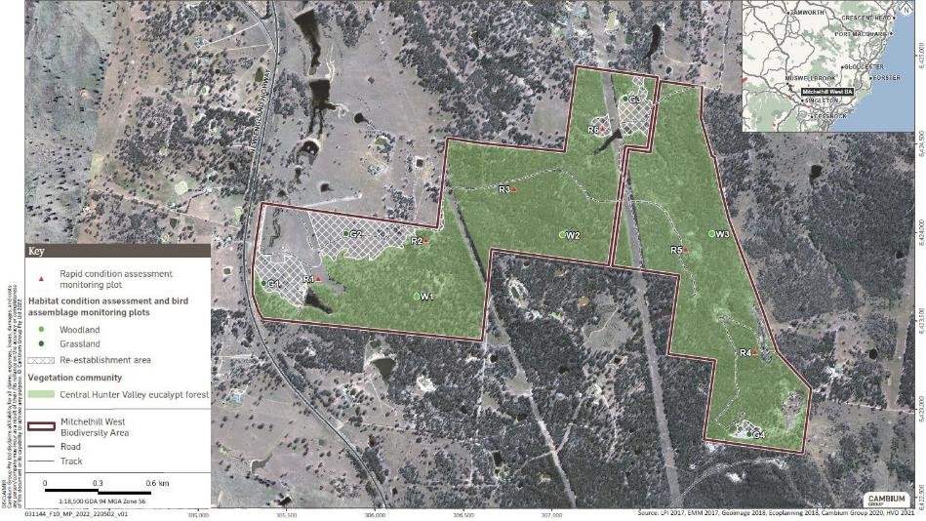
Figure 10 Rapid condition assessment, habitat condition assessment and bird assemblage monitoring locations at the Mitchelhill (West) Biodiversity Area

Number: Mitchelhill BAMP V5 2024 Status: Final Effective: 18/12/2024 Page 89 of 146 Owner: Hunter Valley Operations Version: 5 Review: 18/12/2027

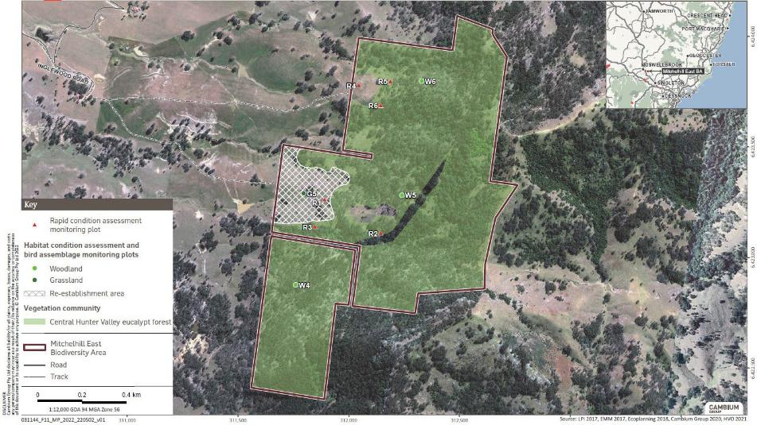
Figure 11 Rapid condition assessment, habitat condition assessment and bird assemblage monitoring locations at the Mitchelhill (East) Biodiversity Area

Number: Mitchelhill BAMP V5 2024 Status: Final Effective: 18/12/2024 Page 90 of 146 Owner: Hunter Valley Operations Version: 5 Review: 18/12/2027

Management monitoring

Rapid Condition Assessment
Each year, Rapid Condition Assessment (RCA) monitoring is conducted to record the presence or absence of key habitat components and threatening processes at fixed designated locations (six located in Mitchelhill (West) and a further six in Mitchelhill (East)). Appendix E provides the RCA report template for assessment of condition of existing and proposed areas of CHVEFW, as well as an assessment of vegetation coverage of key tree species utilised by the Regent Honeyeater and Swift Parrot.
The results of the RCA, together with property inspections and photo reference points will be used to monitor habitat condition and identify emerging threats.

Property inspections
Regular property inspections will be undertaken to ensure that there is a systematic monitoring of the BA, to ensure its protection and to ensure early detection of potential threats or failures.
These will involve a combination of vehicle based and on-foot observation of the following:
      - physical condition of fencing (such as downed sections from fallen trees, broken fence lines), and at each access point, gates, signage (non-sun damaged and present) and locks (non-tampered with and operational);
      - disturbance factors including fire and unauthorised access e.g. hunting, fire wood collection;
      - condition of erosion (with a focus on tributaries particularly after heavy rainfall and any measures previously put in place to assist with erosion);
      - evidence of waste dumping (including blown in from outside or intentional);
        - for minor blown-in waste removal should be undertaken immediately and documented
      - presence/activity of vertebrate pest species (particularly if observation is made of the feral pest species impacting habitat condition, such as ring-barking of trees, grazing on regeneration or pugging causing erosion);
      - grazing pressure from over-abundant native herbivores;
      - observation of grazing cattle (escapees from adjacent landholdings);
      - presence of weed species (with a focus on known infestations of WONS and species listed under the Biosecurity Act 2015 as well as observation of success of any recent weed management programs undertaken);
      - assessment of fire fuel loads in winter; and
      - any other observations of note that may have an impact on condition.
Where observations of the above are made, their respective locations will be documented for management purposes.

Number: | Mitchelhill BAMP V5 2024 Status: Final | Effective: 18/12/2024 Page 91 of 146
Owner: | Hunter Valley Operations Version: 5 | Review: 18/12/2027

Survival assessment
To assess the survival of planted tubestock in re-establishment, linkage and patch size enhancement areas, monitoring will be undertaken at 6- and 12-months post planting (including supplementary plantings).
If the results of the 6-month assessment determine that supplementary planting is required, the 12-month assessment will not occur if supplementary plantings are scheduled and yet to be completed.
The assessment will be undertaken via an on-foot meander within the entire planting area, with a sub-set assessment also undertaken to consider the survival of 100 tubestock plantings within each location.

Grazing monitoring
If grazing is implemented, grazing monitoring will be undertaken utilising the methodology specified in Section 5.2.2.

Data analysis, interpretation and reporting
To assess the success of the management actions in meeting the Key Performance Indicators, data on vegetation, fauna habitats and bird assemblages will be analysed against the predicted changes in these groups associated with implementation of the actions.
The ecological data will be analysed to assess the nature and extent of change through time, relative to the benchmark values. It is expected that in subsequent years, with the progressive improvement in habitat condition, the ecological data analysis will eventually show a convergence of ecological variables to that of the benchmark condition. This is expected to be a medium to long-term upward trend that will reflect the enhancement of woodland and the development and availability of critical fauna habitat features such as hollows, ground debris and forage resources. By demonstrating this convergence through time, it will be inferred that the proposed conservation management actions have been successful in restoring the lower quality vegetation and fauna habitats (in particular for Regent Honeyeater and Swift Parrot) towards the benchmark condition.
Annual (except for Landscape monitoring which will be every 5 years) reporting will therefore include (but not be limited to):
- comparison of extent of CHVEFW vegetation to baseline levels, and identification of how this compares to required hectare requirements;
- identification of where re-establishment works have been unsuccessful and require supplementary planting;
- for each Condition assessment monitoring site:
- whether the trajectory of native floristic composition and structure are improving or declining in comparison to baseline values
- whether habitat features are improving, declining or remain stable in comparison to baseline
- progress of natural recruitment (if natural success (i.e. saplings are present), is regeneration growing (as shown by increases in DBH))
- if re-establishment areas contain assemblages with key diagnostic features of CHVEFW, and if not where do the deficits occur

Number: | Mitchelhill BAMP V5 2024 Status: Final | Effective: 18/12/2024 Page 92 of 146
Owner: | Hunter Valley Operations Version: 5 | Review: 18/12/2027

- bird species diversity, including notes of any observations of the Regent Honeyeater or Swift Parrot. As well as notes on the presence of bird species prone to aggressive exclusion, with a focus on but not limited to the Noisy Miner. This will include correlations of Noisy Miner presence with overall bird species diversity;
- comparison of photo monitoring for progress;
- indication of the health of tree species that provide a foraging resource to the Swift Parrot and Regent Honeyeater;
- indication of whether targeted planting activities that have been undertaken are relevant as foraging resources for the Swift Parrot and Regent Honeyeater;
- indication of whether targeted planting activities have adequately survived to replicate required tree densities of a CHVEFW;
- if grazing is undertaken, notes on why grazing was initiated, duration of the grazing undertaken and any before and after monitoring results on fuel load decreases, exotic species changes and native species diversity and abundance changes;
- key threats observed that either are or could potentially limit the successful improvement of ecological condition (including factors assessed during property inspections (Section 6.5.2)); and
- recommendations for improvement of current management actions (if required).

Number: | Mitchelhill BAMP V5 2024 Status: Final | Effective: 18/12/2024 Page 93 of 146
Owner: | Hunter Valley Operations Version: 5 | Review: 18/12/2027

Risk assessment

7.1 Risk ratings
The risk assessment is undertaken in accordance with the following risk framework, having regard for the likelihood and consequence definitions used below. A risk assessment and corrective actions are provided in Table 18. Most risks will be mitigated using regular monitoring and therefore early identification of any issues.

 |  | Consequence
Likelihood |  | Minor | Moderate | High | Major | Critical
Likelihood | Highly Likely | Medium | High | High | Severe | Severe
Likelihood | Likely | Low | Medium | High | High | Severe
Likelihood | Possible | Low | Medium | Medium | High | Severe
Likelihood | Unlikely | Low | Low | Medium | High | High
Likelihood | Rare | Low | Low | Low | Medium | High

Qualitative measure of likelihood (how likely is it that this event/circumstances will occur after management actions have been put in place/are being implemented)
Highly likely | Is expected to occur in most circumstances
Likely | Will probably occur during the life of the project
Possible | Might occur during the life of the project
Unlikely | Could occur but considered unlikely or doubtful
Rare | May occur in exceptional circumstances
Qualitative measure of consequences (what will be the consequence/result if the issue does occur)
Minor | Minor risk of failure to achieve the Plan’s objectives. Results in short term  delays to achieving Plan objectives, implementing low cost, well characterised corrective actions.
Moderate | Moderate risk of failure to achieve the Plan’s objectives. Results in short term delays to achieving Plan objectives, implementing well characterised, high cost/effort corrective actions.
High | High risk of failure to achieve the Plan’s objectives. Results in medium-long term delays to achieving Plan objectives, implementing uncertain, high  cost/effort corrective actions.
Major | The Plan’s objectives are unable to be achieved, with significant legislative,  technical, ecological and/or administrative barriers to attainment that have no evidenced mitigation strategies.
Critical | The Plan’s objectives are unable to be achieved, may include widespread and severe environmental harm, with no evidenced mitigation strategies.

Number: | Mitchelhill BAMP V5 2024 Status: Final | Effective: 18/12/2024 Page 94 of 146
Owner: | Hunter Valley Operations Version: 5 | Review: 18/12/2027

Table 18 Risk assessment and corrective action matrix

Objective | Scenario | Likelihood | Consequence | Risk level | Trigger | Corrective Action
To protect the conservation values of the offset area within 10 years at the BA. | Delay in securing the offset area under a legally binding mechanism | Likely | Minor | Low | NSW biodiversity reforms not providing a fit for purpose mechanism to practically and legally secure EPBC offset areas. | Additional consultation with DCCEEW
 | Unable to attach the Plan to the land title. | Likely | Minor | Low | NSW government requires different plan to be attached to the land title. | Ensure that a new plan is equivalent to this Plan.
 | Illegal access to offset area causing significant residual impact. | Unlikely | Moderate | Low | Failure in access control (Section 5.1.2) captured in management monitoring (Section 6.5) and reported in the Annual Report. | Review access control and improve security measures.  Increase monitoring effort.  Undertake supplementary planting to compensate for any native vegetation loss.
 | Improper contractor vehicle use resulting in impacts such as soil compaction, weed dispersal or vegetation disturbance, on habitats | Possible | Moderate | Medium | Failure in access control (Section 5.1.2) captured in management monitoring (Section 6.5) and reported in the Annual Report. | Review access control and improve security measures.  Increase monitoring effort.

Number: Mitchelhill BAMP V5 2024 Status: Final Effective: 18/12/2024 Page 95 of 146 Owner: Hunter Valley Operations Version: 5 Review: 18/12/2027

 | Uncontrolled bushfire impacts BA. | Possible | High | Medium | Bushfire on extreme or catastrophic fire danger day impacts offset area. | Implement Post Fire Event recovery with NSW Rural Fire Service.  Complete post fire survey, map fire damaged areas, and revise the Plan.
To enhance the condition of conservation values of the offset area within 10 years at the BA. | No improvement in condition of the conservation values measured by the Ecological Monitoring (Section 6.4). | Possible | Moderate | Medium | Review of Annual Reports and Monitoring data. | Increase monitoring effort.  Review management actions.  Assess influence on success from other factors such as extreme climatic conditions.
 | No increase in extent of woodland or in habitat connectivity from the active restoration of grassland as measured by the landscape monitoring (Section 6.3) and Ecological Monitoring (Section 6.4). | Possible | Moderate | Medium | Review of Annual Reports and Monitoring data. | Increase monitoring effort.  Review management actions.  Assess influence on success from other factors such as extreme climatic conditions.

Number: Mitchelhill BAMP V5 2024 Status: Final Effective: 18/12/2024 Page 96 of 146 Owner: Hunter Valley Operations Version: 5 Review: 18/12/2027

References
Birds Australia (2011) National Recovery Plan for the Swift Parrot, Swift Parrot Recovery Team, Victoria
Clarke MF, and Oldland JM, July 2007. Penetration of remnant edges by Noisy Miners Manorina melanocephala and implications for habitat restoration Wildlife Research, 34 (4): 253-261
Department of the Environment (DoE) (2016) National Recovery Plan for the Regent Honeyeater,
Commonwealth of Australia
Department of the Environment, Water, Heritage and the Arts (DEWHA) (2010a) Survey guidelines for Australia's threatened birds. Canberra, ACT, Commonwealth Department of Environment, Water, Heritage and the Arts.
Department of Sustainability, Environment, Water, Population and Communities (SEWPaC) (2012a), EPBC Act Environmental Offsets Policy, Department of Sustainability, Environment, Water, Population and Communities, Canberra
Department of Sustainability, Environment, Water, Population and SEWPaC (2012b) Regent Honeyeater in Species Profile and Threats Database. Canberra, ACT, Commonwealth Department of Sustainability, Environment, Water, Population and Communities
Ecoplanning (2019a) Ecological Offsets – Condition Assessment Monitoring (Wandewoi, Mitchelhill and Hook Biodiversity Areas). Report prepared for Hunter Valley Operations.
EMM (2016) HVO State-approved mining Investigation report, report to Rio Tinto Coal Australia EMM (2017a) HVO State-approved mining (EPBC 2016/7640) Biodiversity Offset Strategy.
Report to Rio Tinto Coal Australia
EMM (2017b) HVO enforceable undertaking biodiversity offset and rehabilitation strategy. Report to Rio Tinto Coal Australia
Franklin, D. C., Menkhorst, P. W. et al. (1989) Ecology of the Regent Honeyeater Xanthomyza phrygia. EMU: 141-154.
Lang, D. and McDonald, W. (2005), Maintaining groundcover to reduce erosion and sustain production. NSW Department of Primary Industries, Agfact P2.1.14
NSW Department of Primary Industries (NSW DPI) (2014) Noxious and Environmental Weed Control Handbook.
Menkhorst, P., Schedvin, N. and Geering, D. (1999) Regent Honeyeater (Xanthomyza phrygia) Recovery Plan 1999-2003 Department of Natural Resources and Environment, Canberra, ACT. (http://www.environment.gov.au/biodiversity/threatened/publications/recovery/regent-h-eater/)
Mitchell, P. B. (unpub.) NSW ecosystems study: background and methodology. Unpublished report to the NSW National Parks and Wildlife Service, Hurstville
NSW Rural Fire Service (2006) Bush Fire Environmental Assessment Code for New South Wales.
Office of Environment and Heritage (OEH) (2012a) OEH guidelines Erosion and sediment control on unsealed roads
Office of Environment and Heritage (OEH) (2012b) Swift Parrot - profile. Hurstville, Office of Environment and Heritage.
Office of Environment and Heritage (OEH) (2012c) Regent Honeyeater - profile. Hurstville, Office of Environment and Heritage.

Number: | Mitchelhill BAMP V5 2024 Status: Final | Effective: 18/12/2024 Page 97 of 146
Owner: | Hunter Valley Operations Version: 5 | Review: 18/12/2027

Office of Environment and Heritage (OEH) (2017b) Bionet Vegetation Type Database http://www.environment.nsw.gov.au/
Office of Environment and Heritage (OEH) (2017c) Biodiversity Assessment Method, Office of Environment and Heritage, Sydney
Peake, T (2006) The vegetation of the central Hunter Valley NSW, Hunter-Central Rivers Catchment Management Authority, Paterson
Rawlings, K (2010) A guide to managing box gum grassy woodlands DEWHA, Canberra.
Saunders, D. L. and Tzaros, C. L. (2011) National Recovery Plan for the Swift Parrot (Lathamus discolor). Melbourne, Birds Australia. (http://www.environment.gov.au/biodiversity/threatened/publications/recovery/pubs/lathamus-discolor-swift-parrot.pdf)
Swift Parrot Recovery Team (2000) Swift Parrot Recovery Plan 2001-2005. Hobart, Department of Primary Industries, Water and Environment.
Threatened Species Scientific Committee (TSSC) (2015) Approved Conservation Advice for the Central Hunter Valley eucalypt forest and woodland ecological community, Threatened Species Scientific Committee, 7 May 2015.
Wakefield, S. and Goldney, D.C. (1997) Save the Bush Toolkit. Charles Sturt University, Bathurst

Number: | Mitchelhill BAMP V5 2024 Status: Final | Effective: 18/12/2024 Page 98 of 146
Owner: | Hunter Valley Operations Version: 5 | Review: 18/12/2027

Appendix A Condition of approval EPBC 2016/7640

Number: | Mitchelhill BAMP V5 2024 Status: Final | Effective: 18/12/2024 Page 99 of 146
Owner: | Hunter Valley Operations Version: 5 | Review: 18/12/2027

Appendix B Profiles of the Central Hunter Valley eucalypt forest, Swift Parrot and Regent Honeyeater

Central Hunter Valley eucalypt forest
Table 19 describes the key diagnostic characteristics of CHVEFW as described in the Approved Conservation Advice for the Central Hunter Valley eucalypt forest and woodland ecological community (TSSC 2015).
Table 19 Key diagnostic characteristics of CHVEFW

Characteristics | Mitchelhill BA
 | Present in CHVEFW?
It occurs in the Hunter River catchment (typically called the Hunter Valley region); | Yes
AND
It typically occurs on lower hillslopes and low ridges, or valley floors in undulating country; on soils derived from Permian sedimentary rocks; | Yes
AND
It does not occur on alluvial flats, river terraces, aeolian sands, Triassic sediments, or escarpments; | Yes
AND
It is woodland or forest, with a projected canopy cover of trees of 10% or more; or with a native tree density of at least 10 native tree stems per 0.5 ha (at least 20 native tree stems/ha) that are at least one metre in height; | No
AND
The canopy of the ecological community is dominated by one or more of the following four eucalypt species: Eucalyptus crebra (narrow-leaved ironbark), Corymbia maculata (syn. E. maculata) (spotted gum), E. dawsonii (slaty gum) and E. moluccana (grey box);  OR  a fifth species, Allocasuarina luehmannii (bulloak, buloke) dominates in combination with one or more of the above four eucalypt species, in sites previously dominated by one or more of the above four eucalypt species; | No
AND
Allocasuarina torulosa (forest oak/ she-oak, rose she-oak/oak), Eucalyptus acmenoides (white mahogany) and E. fibrosa (red/broad-leaved ironbark) are largely absent from the canopy of a patch; | Yes
AND
A ground layer is present (although it may vary in development and composition), as a sparse to thick layer of native grasses and other native herbs and/or native shrubs. | Partial
Does the community represent CHVEFW? | Yes

Number: Mitchelhill BAMP V5 2024 Status: Final Effective: 18/12/2024 Page 100 of

Owner: Hunter Valley Operations Version: 5 Review: 18/12/2027
146

Table 20 provides a full species list (Peake 2006) for CHVEFW.
Table 20 Species list for CHVEFW

Scientific name | Common name
Acacia amblygona | fan wattle
Acacia bulgaensis | Bulga wattle
Acacia cultriformis | knife-leaf wattle, dog-tooth wattle
Acacia decora | western silver/golden / showy wattle
Acacia falcata | burra, hickory wattle, silver-leaved wattle
Acacia implexa | lightwood
Acacia parvipinnula | silver-stemmed wattle
Acacia pendula | weeping myall
Acacia salicina | cooba, coobar, willow wattle
Ajuga australis | Australian bugle
Allocasuarina luehmannii | buloke, bull oak, bulloak, bull sheoak
Angophora floribunda | rough-barked apple
Aristida ramosa | wire-grass, purple wire-grass
Aristida vagans | three-awn spear-grass
Austrostipa scabra | rough needle-grass, spear-grass
Brachychiton populneus subsp. populneus | kurrajong
Brachyscome multifida | cut-leaved daisy
Bothriochloa decipiens | pitted blue-grass, red grass
Breynia oblongifolia | breynia, coffee bush
Brunoniella australis | blue trumpet
Bursaria spinosa subsp. spinosa | blackthorn
Calotis cuneifolia | purple burr-daisy
Calotis lappulacea | yellow burr-daisy, yellow daisy-burr
Callitris endlicheri | black Cypress-pine, black/red Cypress
Cassinia quinquefaria | cassinia
Cheilanthes sieberi subsp. seiberi | mulga fern, narrow rock-fern
Cheilanthes distans | bristly cloak-fern, bristly rock-fern
Chloris ventricosa | tall chloris, plump windmill-grass
Chrysocephalum apiculatum | yellow buttons, common everlasting
Corymbia maculata (syn. Eucalyptus maculata) | spotted gum
Cymbopogon refractus | barbed-wire grass
Cyperus gracilis | slender sedge
Daviesia genistifolia | broom bitter pea
Daviesia ulicifolia | gorse bitter-pea
Desmodium brachypodum | large tick-trefoil

Number: Mitchelhill BAMP V5 2024 Status: Final Effective: 18/12/2024 Page 101 of

Owner: Hunter Valley Operations Version: 5 Review: 18/12/2027
146

Desmodium varians | slender tick-trefoil
Dichondra repens | kidney weed, kidney grass
Dianella revoluta | blueberry lily, blue flax-lily
Dodonaea viscosa | sticky hop-bush, giant hop-bush
Dodonaea viscosa subsp. cuneata | wedge-leaf hop-bush
Echinopogon caespitosus var. caespitosus | tufted hedgehog-grass
Einadia nutans | climbing saltbush, nodding saltbush
Entolasia stricta | wiry panic
Eragrostis leptostachya | paddock lovegrass
Eremophila debilis | winter apple, creeping boobialla, amulla
Eucalyptus albens | white box
Eucalyptus blakelyi | Blakely’s red gum
Eucalyptus crebra | narrow-leaved ironbark
Eucalyptus dawsonii | slaty gum
Eucalyptus glaucina | slaty red gum
Eucalyptus moluccana | grey box
Eucalyptus punctata | grey gum
Eucalyptus tereticornis | forest red gum
Fimbristylis dichotoma | common fringe-rush
Geijera salicifolia | scrub/brush wilga, greenheart, green satinheart
Glycine clandestina | twining glycine
Glycine latifolia | glycine pea, variable glycine
Hakea sericea | silky hakea, bushy needlewood
Hypericum gramineum | small St John's wort
Laxmannia gracilis | slender wire lily
Lissanthe strigosa | peach heath
Lobelia purpurascens (syn. Pratia purpurascens) | whiteroot
Lomandra multiflora | many-flowered matrush
Melichrus urceolatus | urn heath
Microlaena stipoides var. stipoides | weeping grass, meadow rice-grass
Myoporum montanum | western boobialla, water-bush
Notelaea microcarpa var. microcarpa | native olive
Olearia elliptica | sticky daisy-bush
Opercularia diphylla | stinkweed
Paspalidium distans | spreading panicgrass
Phyllanthus virgatus | creeping phyllanthus
Pomax umbellata | pomax
Psydrax odorata | shiny-leaved canthium, inland native coffee

Number: Mitchelhill BAMP V5 2024 Status: Final Effective: 18/12/2024 Page 102 of

Owner: Hunter Valley Operations Version: 5 Review: 18/12/2027
146

Pultenaea spinosa | spiny /grey bush-pea
Sida corrugata | corrugated sida
Solanum brownii | violet nightshade
Solanum cinereum | Narrawa burr
Solanum prinophyllum | forest nightshade
Sporobolus creber | slender rat's-tail grass
Stackhousia viminea | slender stackhousia
Themeda triandra (syn. T. australis) | kangaroo grass
Vernonia cinerea | vernonia
Vittadinia cuneata | fuzzweed
Wahlenbergia communis | tufted bluebell
Wahlenbergia gracilis | Australian / sprawling bluebell

Number: Mitchelhill BAMP V5 2024 Status: Final Effective: 18/12/2024 Page 103 of

Owner: Hunter Valley Operations Version: 5 Review: 18/12/2027
146

Swift Parrot
The Swift Parrot is small parrot about 25cm long. It is bright green with red around the bill, throat and forehead. It has a long (12 cm), thin tail, which is dark red. The Swift Parrot is listed as a critically endangered species under the EPBC Act.
The Swift Parrot is a migratory bird species that occurs in south-east Australia, between Tasmania and NSW. In NSW, this species occurs mainly on and to the east of the Great Dividing Range, in the Central and Southern Tableland regions and in coastal regions south of the Hunter Valley. Some rarer scattered occurrences have been recorded further north and further to the west.
On the mainland they occur in areas where eucalypts are flowering profusely or where there are abundant lerp infestations. Favoured feed trees include winter flowering species such as Swamp Mahogany, Spotted Gum, Red Bloodwood, Mugga Ironbark and White Box. Also, the swift parrot commonly forages on lerp infested trees which include Western Grey Box, Coastal Grey Box and Blackbutt. The swift parrot returns to some foraging sites on a cyclical basis depending on food availability.
The National Recovery Plan for the Swift Parrot (Birds Australia 2011) provides direction on the management actions for the long-term protection and conservation of the species. The Swift Parrot is likely to frequent the BA during the winter months. The mature Grey Box trees provide foraging opportunities for the Swift Parrot.
Key management strategies for their protection and conservation include:
- no clearing of vegetation;
- revegetation to reconnect fragmented remnant vegetation;
- protection from high frequency fire events;
- control of predators, such as feral cats; and
- reduced competition from European bees.
http://www.environment.gov.au/system/files/resources/c3e20a20-8122-4a9c-bd06-455ea7620380/files/lathamus-discolor-swift-parrot.pdf
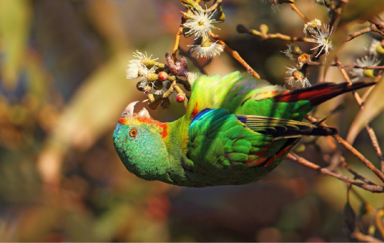
Photograph 1 Swift Parrot (source: Chris Tzaros)

Number: Mitchelhill BAMP V5 2024 Status: Final Effective: 18/12/2024 Page 104 of

Owner: Hunter Valley Operations Version: 5 Review: 18/12/2027
146

Regent Honeyeater
The Regent Honeyeater is a winter migrant endemic to southeastern Australia where it is widespread but sparsely scattered, and strongly associated with the western slopes of the Great Dividing Range (Garnett and Crowley 2000) and is listed as Critically Endangered under the Biodiversity Conservation Act 2016 (BC Act) and EPBC Act. The species is also known to forage and breed in Box-Ironbark woodland in the Hunter Valley region. It is found in temperate eucalypt forests and woodlands but prefers Box-Ironbark associations and River Oak riparian forest in wet, fertile sites along creek lines and river valleys.
The Regent Honeyeater is strongly nomadic and follows blossoming trees and mistletoe (Franklin, Menkhorst and Robinson 1989). Numbers fluctuate greatly between years and sites, and movement outside of breeding season is poorly understood. Only 1,500 individuals are thought to make up the single subpopulation of this species. Regent Honeyeaters forage in the canopy tops of mature feed trees, but roost in saplings (Oliver 1998). This suggests that the species requires a more extensive area of habitat than other similar nectarivorous species.
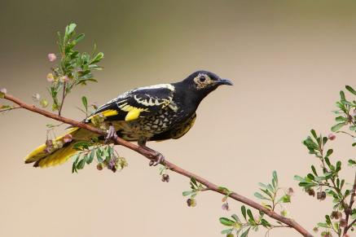
Photograph 1 Regent Honeyeater (source: birdlifemelbourne.wordpress.com)
Section 1.4 of the Approved Conservation Advice (including listing advice) for Central Hunter Valley Eucalypt Forest and Woodland ecological community (TSSC 2015) recognises the community as containing an important source of winter-flowering eucalypts for the Regent Honeyeater. In addition, the National Recovery Plan for the Regent Honeyeater recognises areas containing Ironbark in the Hunter Valley as important foraging habitat for the species, and identifies Spotted Gum as a key nectar-producing tree for the Regent Honeyeater. The survey confirmed the presence of important foraging habitats for the Regent Honeyeater, comprising CHVEFW, Ironbark and Spotted Gum trees.
The site is within approximately 30 km of the Hunter Valley key breeding area, as identified in the National Recovery Plan for the Regent Honeyeater (DoE 2016). The site also contains mature trees with rough bark (Ironbarks) that are identified in the National Recovery Plan for the Regent Honeyeater (DoE 2016) as a species in which Regent Honeyeaters can build their nests. Given the above, it is possible that breeding may occur within the site.

Number: Mitchelhill BAMP V5 2024 Status: Final Effective: 18/12/2024 Page 105 of

Owner: Hunter Valley Operations Version: 5 Review: 18/12/2027
146

Appendix C Land classification and zoning

Mitchelhill land classification and zoning
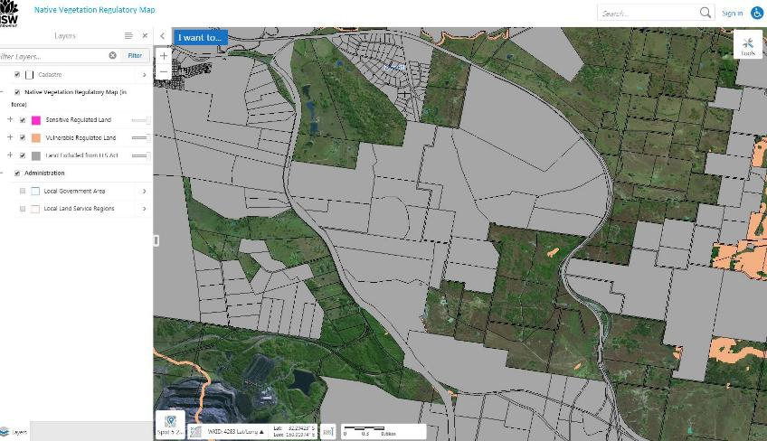
Plate 1 Native vegetation regulatory map output for Mitchelhill (West)

Number: Mitchelhill BAMP V5 2024 Status: Final Effective: 18/12/2024 Page 106 of 146 Owner: Hunter Valley Operations Version: 5 Review: 18/12/2027

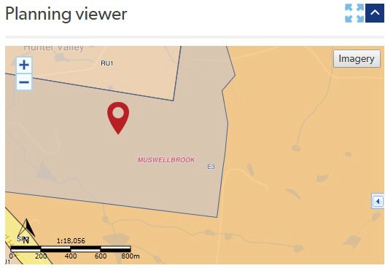
Plate 2 Environmental (E3) and rural (RU1) zonings at Mitchelhill (West)

Number: Mitchelhill BAMP V5 2024 Status: Final Effective: 18/12/2024 Page 107 of 146 Owner: Hunter Valley Operations Version: 5 Review: 18/12/2027

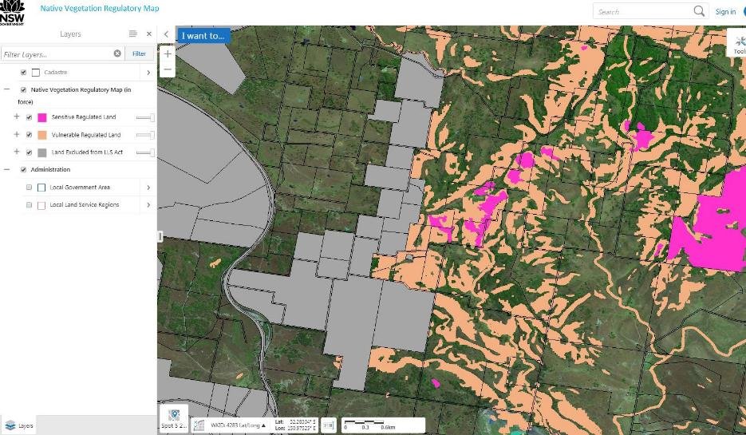
Plate 3 Native vegetation regulatory map output for Mitchelhill (East)

Number: Mitchelhill BAMP V5 2024 Status: Final Effective: 18/12/2024 Page 108 of 146 Owner: Hunter Valley Operations Version: 5 Review: 18/12/2027

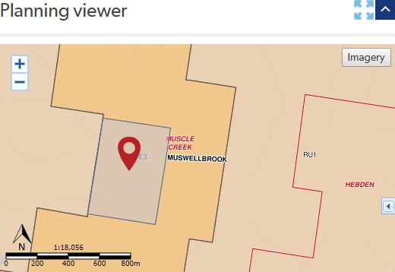

Plate 4 Environmental (E3) and rural (RU1) zoning at Mitchelhill (East)

Number: Mitchelhill BAMP V5 2024 Status: Final Effective: 18/12/2024 Page 109 of 146 Owner: Hunter Valley Operations Version: 5 Review: 18/12/2027

Appendix D Priority weeds for the Hunter region
Priority Weeds for the Hunter – as of 19 May 2023
Note: This region includes the local council areas of Cessnock, Dugong, Lake Macquarie, Maitland, Mid-Coast, Muswellbrook, Newcastle, Port Stephens, Singleton and Upper Hunter

Weed | Duty
All plants | General Biosecurity Duty  All pest plants are regulated with a general biosecurity duty to prevent, eliminate or minimise any biosecurity risk they may pose. Any person who deals with any plant, who knows (or ought to know) of any biosecurity risk, has a duty to ensure the risk is prevented, eliminated or minimised, so far as is reasonably practicable.
Aaron's beard prickly pear  Opuntia leucotricha | Prohibition on certain dealings  Must not be imported into the state, sold, bartered, exchanged or offered for sale.
Aaron's beard prickly pear  Opuntia leucotricha | Regional Recommended Measure  Land managers should mitigate the risk of the plant being introduced to their land. Land managers should mitigate spread of the plant from their land. A person should not buy, sell, move, carry or release the plant into the environment. Land managers should reduce the impact of the plant on assets of high economic, environmental and/or social value.
African boxthorn  Lycium ferocissimum | Prohibition on certain dealings  Must not be imported into the state, sold, bartered, exchanged or offered for sale.

Number: Mitchelhill BAMP V5 2024 Status: Final Effective: 18/12/2024 Page 110 of

Owner: Hunter Valley Operations Version: 5 Review: 18/12/2027
146

African boxthorn  Lycium ferocissimum | Regional Recommended Measure  An exclusion zone is established for all land in the region, except the core infestation which includes parts of: Muswellbrook Local Government Area, Upper Hunter Local Government Area.  Entire Hunter Local Land Services region: Land managers should mitigate the risk of the plant being introduced to their land. Exclusion zone: Notify local control authority if found.  Land managers should eradicate the plant from the land and keep the land free of the plant. A person should not deal with the plant, where dealings include but are not limited to buying, selling, growing, moving, carrying or releasing the plant. Core infestation: Land managers should mitigate spread of the plant from their land. A person should not buy, sell, move, carry or release the plant into the environment. Land managers should reduce the impact of the plant on assets of high economic, environmental and/or social value.
African lovegrass  Eragrostis curvula | Regional Recommended Measure  Land managers should mitigate the risk of the plant being introduced to their land. Land managers should mitigate spread of the plant from their land. A person should not buy, sell, move, carry or release the plant into the environment. Land managers should reduce the impact of the plant on assets of high economic, environmental and/or social value.

Number: Mitchelhill BAMP V5 2024 Status: Final Effective: 18/12/2024 Page 111 of

Owner: Hunter Valley Operations Version: 5 Review: 18/12/2027
146

African olive  Olea europaea subsp. cuspidata | Regional Recommended Measure  An exclusion zone is established for all land in the region, except the core infestation which includes parts of: Dungog Local Government Area, Lake Macquarie Local Government Area Maitland Local Government Area, MidCoast Local Government Area, Port Stephens Local Government Area, Singleton Local Government Area.  Entire Hunter Local Land Services region: Land managers should mitigate the risk of the plant being introduced to their land. Exclusion zone: Notify local control authority if found.  Land managers should eradicate the plant from the land and keep the land free of the plant. A person should not deal with the plant, where dealings include but are not limited to buying, selling, growing, moving, carrying or releasing the plant. Core infestation: Land managers should mitigate spread of the plant from their land. A person should not buy, sell, move, carry or release the plant into the environment. Land managers should reduce the impact of the plant on assets of high economic, environmental and/or social value.
Alligator weed  Alternanthera philoxeroides | Prohibition on certain dealings  Must not be imported into the state, sold, bartered, exchanged or offered for sale.
Alligator weed  Alternanthera philoxeroides | Biosecurity Zone  The Alligator Weed Biosecurity Zone is established for all land within the state except land in the following regions: Greater Sydney; Hunter (but only in the local government areas of City of Lake Macquarie, City of Maitland, City of Newcastle or Port Stephens).  Within the Biosecurity Zone this weed must be eradicated where practicable, or as much of the weed destroyed as practicable, and any remaining weed suppressed. The local control authority must be notified of any new infestations of this weed within the Biosecurity Zone

Number: Mitchelhill BAMP V5 2024 Status: Final Effective: 18/12/2024 Page 112 of

Owner: Hunter Valley Operations Version: 5 Review: 18/12/2027
146

Alligator weed  Alternanthera philoxeroides | Regional Recommended Measure  An Alligator Weed Biosecurity Zone is established for all land within the Hunter Local Land Services region except land in the following local government areas: Lake Macquarie Local Government Area, Maitland Local Government Area, Newcastle Local Government Area, Port Stephens Local Government Area.  Entire Hunter Local Land Services region: A person must not, import into the State or sell. Within the biosecurity zone: If the weed is part of a new infestation of the weed on the land, notify the local control authority for the land as soon as practicable. Eradicate the weed or, if that is not practicable, destroy as much of the weed as is practicable and suppress the spread of any remaining weed. Outside the biosecurity zone: Land managers should mitigate spread of the plant from their land.  Land managers should reduce the impact of the plant on assets of high economic, environmental and/or social value.
Anchored water hyacinth  Eichhornia azurea | Prohibited Matter  A person who deals with prohibited matter or a carrier of prohibited matter is guilty of an offence. A person who becomes aware of or suspects the presence of prohibited matter must immediately notify the Department of Primary Industries
Arrowhead  Sagittaria calycina var. calycina | Regional Recommended Measure  Land managers should mitigate the risk of the plant being introduced to their land. Land managers should eradicate the plant from the land and keep the land free of the plant. A person should not deal with the plant, where dealings include but are not limited to buying, selling, growing, moving, carrying or releasing the plant. Notify local control authority if found.

Number: Mitchelhill BAMP V5 2024 Status: Final Effective: 18/12/2024 Page 113 of

Owner: Hunter Valley Operations Version: 5 Review: 18/12/2027
146

Asparagus fern  Asparagus virgatus | Regional Recommended Measure  An exclusion zone is established for all land in the region, except the core infestation which includes parts of: MidCoast Local Government Area.  Entire Hunter Local Land Services region: Land managers should mitigate the risk of the plant being introduced to their land. Exclusion zone: Notify local control authority if found.  Land managers should eradicate the plant from the land and keep the land free of the plant. A person should not deal with the plant, where dealings include but are not limited to buying, selling, growing, moving, carrying or releasing the plant. Core infestation: Land managers should mitigate spread of the plant from their land. A person should not buy, sell, move, carry or release the plant into the environment. Land managers should reduce the impact of the plant on assets of high economic, environmental and/or social value.
Athel pine  Tamarix aphylla | Prohibition on certain dealings  Must not be imported into the state, sold, bartered, exchanged or offered for sale.
Bellyache bush  Jatropha gossypiifolia | Prohibition on certain dealings  Must not be imported into the state, sold, bartered, exchanged or offered for sale.
Bitou bush  Chrysanthemoides monilifera subsp. rotund ata | Prohibition on certain dealings  Must not be imported into the state, sold, bartered, exchanged or offered for sale.
Bitou bush  Chrysanthemoides monilifera subsp. rotund ata | Biosecurity Zone  The Bitou Bush Biosecurity Zone is established for all land within the State except land within 10 kilometres of the mean high water mark of the Pacific Ocean between Cape Byron in the north and Point Perpendicular in the south.  Within the Biosecurity Zone this weed must be eradicated where practicable, or as much of the weed destroyed as practicable, and any remaining weed suppressed. The local control authority must be notified of any new infestations of this weed within the Biosecurity Zone

Number: Mitchelhill BAMP V5 2024 Status: Final Effective: 18/12/2024 Page 114 of

Owner: Hunter Valley Operations Version: 5 Review: 18/12/2027
146

Bitou bush  Chrysanthemoides monilifera subsp. rotund ata | Regional Recommended Measure  A Bitou Bush Biosecurity Zone is established for all land within the Hunter Local Land Services Region except land within 10 kilometres of the mean high water mark of the Pacific Ocean, which includes parts of: Lake Macquarie Local Government Area, MidCoast Local Government Area, Newcastle Local Government Area, Port Stephens Local Government Area.  Entire Hunter Local Land Services region: A person must not, import into the State or sell. Within the biosecurity zone: If the weed is part of a new infestation of the weed on the land, notify the local control authority for the land as soon as practicable. Eradicate the weed or, if that is not practicable, destroy as much of the weed as is practicable and suppress the spread of any remaining weed. Outside the biosecurity zone: Land managers should mitigate spread of the plant from their land.  Land managers should reduce the impact of the plant on assets of high economic, environmental and/or social value.
Black knapweed  Centaurea x moncktonii | Prohibited Matter  A person who deals with prohibited matter or a carrier of prohibited matter is guilty of an offence. A person who becomes aware of or suspects the presence of prohibited matter must immediately notify the Department of Primary Industries
Black locust  Robinia pseudoacacia | Regional Recommended Measure  An exclusion zone is established for all land in the region, except the core infestation which includes all urban centres of the Hunter region. Entire Hunter Local Land Services region: Land managers should mitigate the risk of the plant being introduced to their land. Exclusion zone: Notify local control authority if found.  Land managers should eradicate the plant from the land and keep the land free of the plant. A person should not deal with the plant, where dealings include but are not limited to buying, selling, growing, moving, carrying or releasing the plant. Core infestation: Land managers should mitigate spread of the plant from their land. A person should not buy, sell, move, carry or release the plant into the environment. Land managers should reduce the impact of the plant on assets of high economic, environmental and/or social value.

Number: Mitchelhill BAMP V5 2024 Status: Final Effective: 18/12/2024 Page 115 of

Owner: Hunter Valley Operations Version: 5 Review: 18/12/2027
146

Black willow  Salix nigra | Prohibition on certain dealings  Must not be imported into the state, sold, bartered, exchanged or offered for sale.
Blackberry  Rubus fruticosus species aggregate | Prohibition on certain dealings  Must not be imported into the state, sold, bartered, exchanged or offered for sale.  All species in the Rubus fruiticosus species aggregate have this requirement, except for the varietals Black Satin, Chehalem, Chester Thornless, Dirksen Thornless, Loch Ness, Murrindindi, Silvan, Smooth Stem, and Thornfree
Blackberry  Rubus fruticosus species aggregate | Regional Recommended Measure  Land managers should mitigate the risk of the plant being introduced to their land. Land managers should mitigate spread of the plant from their land. A person should not buy, sell, move, carry or release the plant into the environment. Land managers should reduce the impact of the plant on assets of high economic, environmental and/or social value.
Blind cactus  Opuntia rufida | Prohibition on certain dealings  Must not be imported into the state, sold, bartered, exchanged or offered for sale.
Blind cactus  Opuntia rufida | Regional Recommended Measure  Land managers should mitigate the risk of the plant being introduced to their land. Land managers should mitigate spread of the plant from their land. A person should not buy, sell, move, carry or release the plant into the environment. Land managers should reduce the impact of the plant on assets of high economic, environmental and/or social value.
Blue heliotrope  Heliotropium amplexicaule | Regional Recommended Measure  Land managers should mitigate the risk of the plant being introduced to their land. Land managers should mitigate spread of the plant from their land. A person should not buy, sell, move, carry or release the plant into the environment. Land managers should reduce the impact of the plant on assets of high economic, environmental and/or social value.
Blue periwinkle  Vinca major | Regional Recommended Measure  Land managers should mitigate the risk of the plant being introduced to their land. Land managers should mitigate spread of the plant from their land. A person should not buy, sell, move, carry or release the plant into the environment. Land managers should reduce the impact of the plant on assets of high economic, environmental and/or social value.

Number: Mitchelhill BAMP V5 2024 Status: Final Effective: 18/12/2024 Page 116 of

Owner: Hunter Valley Operations Version: 5 Review: 18/12/2027
146

Boneseed  Chrysanthemoides monilifera subsp. monilif era | Prohibition on certain dealings  Must not be imported into the state, sold, bartered, exchanged or offered for sale.
Boneseed  Chrysanthemoides monilifera subsp. monilif era | Control Order  Boneseed Control Zone: Whole of NSW Boneseed Control Zone (Whole of NSW): Owners and occupiers of land on which there is boneseed must notify the local control authority of new infestations; immediately destroy the plants; ensure subsequent generations are destroyed; and ensure the land is kept free of the plant. A person who deals with a carrier of boneseed must ensure the plant (and any seed and propagules) is not moved from the land; and immediately notify the local control authority of the presence of the plant.
Boxing glove cactus  Cylindropuntia fulgida var. mamillata | Prohibition on certain dealings  Must not be imported into the state, sold, bartered, exchanged or offered for sale.
Boxing glove cactus  Cylindropuntia fulgida var. mamillata | Regional Recommended Measure  Notify local control authority if found. Land managers should eradicate the plant from the land and keep the land free of the plant. A person should not deal with the plant, where dealings include but are not limited to buying, selling, growing, moving, carrying or releasing the plant.
Bridal creeper  Asparagus asparagoides | Prohibition on certain dealings  Must not be imported into the state, sold, bartered, exchanged or offered for sale.  *this requirement also applies to the Western Cape form of bridal creeper

Number: Mitchelhill BAMP V5 2024 Status: Final Effective: 18/12/2024 Page 117 of

Owner: Hunter Valley Operations Version: 5 Review: 18/12/2027
146

Bridal creeper  Asparagus asparagoides | Regional Recommended Measure  An exclusion zone is established for all land in the region, except the core infestation which includes: Dungog Local Government Area, Lake Macquarie Local Government Area, Cessnock Local Government Area, MidCoast Local Government Area.  Entire Hunter Local Land Services region: Land managers should mitigate the risk of the plant being introduced to their land. Exclusion zone: Notify local control authority if found.  Land managers should eradicate the plant from the land and keep the land free of the plant. A person should not deal with the plant, where dealings include but are not limited to buying, selling, growing, moving, carrying or releasing the plant. Core infestation: Land managers should mitigate spread of the plant from their land. A person should not buy, sell, move, carry or release the plant into the environment. Land managers should reduce the impact of the plant on assets of high economic, environmental and/or social value.
Bridal veil creeper  Asparagus declinatus | Prohibited Matter  A person who deals with prohibited matter or a carrier of prohibited matter is guilty of an offence. A person who becomes aware of or suspects the presence of prohibited matter must immediately notify the Department of Primary Industries
Broad-leaf pepper tree  Schinus terebinthifolius | Regional Recommended Measure  Notify local control authority if found. Land managers should eradicate the plant from the land and keep the land free of the plant. A person should not deal with the plant, where dealings include but are not limited to buying, selling, growing, moving, carrying or releasing the plant.
Broomrapes  Orobanche species | Prohibited Matter  A person who deals with prohibited matter or a carrier of prohibited matter is guilty of an offence. A person who becomes aware of or suspects the presence of prohibited matter must immediately notify the Department of Primary Industries  All species of Orobanche are Prohibited Matter in NSW, except Clover broomrape, Orobanche minor and Australian broomrape, Orobanche cernua var. australiana.

Number: Mitchelhill BAMP V5 2024 Status: Final Effective: 18/12/2024 Page 118 of

Owner: Hunter Valley Operations Version: 5 Review: 18/12/2027
146

Brown-spined Hudson pear  Cylindropuntia tunicata | Regional Recommended Measure  Notify local control authority if found. Land managers should eradicate the plant from the land and keep the land free of the plant. A person should not deal with the plant, where dealings include but are not limited to buying, selling, growing, moving, carrying or releasing the plant.
Bunny ears cactus  Opuntia microdasys | Prohibition on certain dealings  Must not be imported into the state, sold, bartered, exchanged or offered for sale.
Bunny ears cactus  Opuntia microdasys | Regional Recommended Measure  Land managers should mitigate the risk of the plant being introduced to their land. Land managers should mitigate spread of the plant from their land. A person should not buy, sell, move, carry or release the plant into the environment. Land managers should reduce the impact of the plant on assets of high economic, environmental and/or social value.
Cabomba  Cabomba caroliniana | Prohibition on certain dealings  Must not be imported into the state, sold, bartered, exchanged or offered for sale.
Cabomba  Cabomba caroliniana | Regional Recommended Measure  Notify local control authority if found. Land managers should eradicate the plant from the land and keep the land free of the plant. A person should not deal with the plant, where dealings include but are not limited to buying, selling, growing, moving, carrying or releasing the plant.
Camphor laurel  Cinnamomum camphora | Regional Recommended Measure  Land managers should mitigate the risk of the plant being introduced to their land. Land managers should mitigate spread of the plant from their land. A person should not buy, sell, move, carry or release the plant into the environment. Land managers should reduce the impact of the plant on assets of high economic, environmental and/or social value.
Cane cactus  Austrocylindropuntia cylindrica | Prohibition on certain dealings  Must not be imported into the state, sold, bartered, exchanged or offered for sale. All species in the Austrocylindropuntia genus have this requirement

Number: Mitchelhill BAMP V5 2024 Status: Final Effective: 18/12/2024 Page 119 of

Owner: Hunter Valley Operations Version: 5 Review: 18/12/2027
146

Cane cactus  Austrocylindropuntia cylindrica | Regional Recommended Measure  Land managers should mitigate the risk of the plant being introduced to their land. Land managers should eradicate the plant from the land and keep the land free of the plant. A person should not deal with the plant, where dealings include but are not limited to buying, selling, growing, moving, carrying or releasing the plant. Notify local control authority if found.
Cape broom  Genista monspessulana | Prohibition on certain dealings  Must not be imported into the state, sold, bartered, exchanged or offered for sale.
Cape broom  Genista monspessulana | Regional Recommended Measure  Notify local control authority if found. Land managers should eradicate the plant from the land and keep the land free of the plant. A person should not deal with the plant, where dealings include but are not limited to buying, selling, growing, moving, carrying or releasing the plant.
Cat's claw creeper  Dolichandra unguis-cati | Prohibition on certain dealings  Must not be imported into the state, sold, bartered, exchanged or offered for sale.
Cat's claw creeper  Dolichandra unguis-cati | Regional Recommended Measure  Land managers should mitigate the risk of the plant being introduced to their land. Land managers should mitigate spread of the plant from their land. A person should not buy, sell, move, carry or release the plant into the environment. Land managers should reduce the impact of the plant on assets of high economic, environmental and/or social value.
Chicken dance cactus  Opuntia schickendantzii | Prohibition on certain dealings  Must not be imported into the state, sold, bartered, exchanged or offered for sale.
Chicken dance cactus  Opuntia schickendantzii | Regional Recommended Measure  Land managers should mitigate the risk of the plant being introduced to their land. Land managers should mitigate spread of the plant from their land. A person should not buy, sell, move, carry or release the plant into the environment. Land managers should reduce the impact of the plant on assets of high economic, environmental and/or social value.
Chilean needle grass  Nassella neesiana | Prohibition on certain dealings  Must not be imported into the state, sold, bartered, exchanged or offered for sale.

Number: Mitchelhill BAMP V5 2024 Status: Final Effective: 18/12/2024 Page 120 of

Owner: Hunter Valley Operations Version: 5 Review: 18/12/2027
146

Chilean needle grass  Nassella neesiana | Regional Recommended Measure  Notify local control authority if found. Land managers should eradicate the plant from the land and keep the land free of the plant. A person should not deal with the plant, where dealings include but are not limited to buying, selling, growing, moving, carrying or releasing the plant.
Chinese celtis  Celtis sinensis | Regional Recommended Measure  Notify local control authority if found. Land managers should eradicate the plant from the land and keep the land free of the plant. A person should not deal with the plant, where dealings include but are not limited to buying, selling, growing, moving, carrying or releasing the plant.
Chinese knotweed  Persicaria chinensis | Regional Recommended Measure  Notify local control authority if found. Land managers should eradicate the plant from the land and keep the land free of the plant. A person should not deal with the plant, where dealings include but are not limited to buying, selling, growing, moving, carrying or releasing the plant.
Chinese tallow tree  Triadica sebifera | Regional Recommended Measure  An exclusion zone is established for all land in the region, except the core infestation which includes all urban centres of the Hunter region. Entire Hunter Local Land Services region: Land managers should mitigate the risk of the plant being introduced to their land. Exclusion zone: Notify local control authority if found.  Land managers should eradicate the plant from the land and keep the land free of the plant. A person should not deal with the plant, where dealings include but are not limited to buying, selling, growing, moving, carrying or releasing the plant. Core infestation: Land managers should mitigate spread of the plant from their land. A person should not buy, sell, move, carry or release the plant into the environment. Land managers should reduce the impact of the plant on assets of high economic, environmental and/or social value.

Number: Mitchelhill BAMP V5 2024 Status: Final Effective: 18/12/2024 Page 121 of

Owner: Hunter Valley Operations Version: 5 Review: 18/12/2027
146

Chinese violet  Asystasia gangetica subsp. micrantha | Control Order  Owners and occupiers of land on which there is Chinese violet must notify the local control authority for the area if the Chinese violet is part of a new infestation on the land, destroy all Chinese violet on the land ensuring that subsequent generations of Chinese violet are destroyed; and keep the land free of Chinese violet. A person who deals with a carrier of Chinese violet must ensure the plant (and any seed and propagules) is not moved from the land; and immediately notify the local control authority of the presence of the plant on the land, or on or in a carrier.
Climbing asparagus  Asparagus africanus | Prohibition on certain dealings  Must not be imported into the state, sold, bartered, exchanged or offered for sale.
Climbing asparagus  Asparagus africanus | Regional Recommended Measure  Notify local control authority if found. Land managers should eradicate the plant from the land and keep the land free of the plant. A person should not deal with the plant, where dealings include but are not limited to buying, selling, growing, moving, carrying or releasing the plant.
Climbing asparagus fern  Asparagus plumosus | Prohibition on certain dealings  Must not be imported into the state, sold, bartered, exchanged or offered for sale.
Cockspur coral tree  Erythrina crista-galli | Regional Recommended Measure  Land managers should mitigate the risk of the plant being introduced to their land. Land managers should mitigate spread of the plant from their land. A person should not buy, sell, move, carry or release the plant into the environment. Land managers should reduce the impact of the plant on assets of high economic, environmental and/or social value.
Common pear  Opuntia stricta | Prohibition on certain dealings  Must not be imported into the state, sold, bartered, exchanged or offered for sale.
Common pear  Opuntia stricta | Regional Recommended Measure  Land managers should mitigate the risk of the plant being introduced to their land. Land managers should mitigate spread of the plant from their land. A person should not buy, sell, move, carry or release the plant into the environment. Land managers should reduce the impact of the plant on assets of high economic, environmental and/or social value.

Number: Mitchelhill BAMP V5 2024 Status: Final Effective: 18/12/2024 Page 122 of

Owner: Hunter Valley Operations Version: 5 Review: 18/12/2027
146

Coolatai grass  Hyparrhenia hirta | Regional Recommended Measure  Land managers should mitigate the risk of the plant being introduced to their land. Land managers should mitigate spread of the plant from their land. A person should not buy, sell, move, carry or release the plant into the environment. Land managers should reduce the impact of the plant on assets of high economic, environmental and/or social value.
Coral creeper  Barleria repens | Regional Recommended Measure  Notify local control authority if found. Land managers should eradicate the plant from the land and keep the land free of the plant. A person should not deal with the plant, where dealings include but are not limited to buying, selling, growing, moving, carrying or releasing the plant.
Cotoneaster  Cotoneaster glaucophyllus | Regional Recommended Measure  Land managers should mitigate the risk of the plant being introduced to their land. Land managers should mitigate spread of the plant from their land. A person should not buy, sell, move, carry or release the plant into the environment. Land managers should reduce the impact of the plant on assets of high economic, environmental and/or social value.
Crofton weed  Ageratina adenophora | Regional Recommended Measure  Land managers should mitigate the risk of the plant being introduced to their land. Land managers should mitigate spread of the plant from their land. A person should not buy, sell, move, carry or release the plant into the environment. Land managers should reduce the impact of the plant on assets of high economic, environmental and/or social value.
East Indian hygrophila  Hygrophila polysperma | Regional Recommended Measure  Land managers should mitigate the risk of the plant being introduced to their land. Land managers should eradicate the plant from the land and keep the land free of the plant. A person should not deal with the plant, where dealings include but are not limited to buying, selling, growing, moving, carrying or releasing the plant. Notify local control authority if found.

Number: Mitchelhill BAMP V5 2024 Status: Final Effective: 18/12/2024 Page 123 of

Owner: Hunter Valley Operations Version: 5 Review: 18/12/2027
146

Espartillo - broad kernel  Amelichloa caudata | Regional Recommended Measure  Land managers should mitigate the risk of the plant being introduced to their land. Land managers should eradicate the plant from the land and keep the land free of the plant. A person should not deal with the plant, where dealings include but are not limited to buying, selling, growing, moving, carrying or releasing the plant. Notify local control authority if found.
Espartillo - narrow kernel  Amelichloa brachychaeta | Regional Recommended Measure  Land managers should mitigate the risk of the plant being introduced to their land. Land managers should eradicate the plant from the land and keep the land free of the plant. A person should not deal with the plant, where dealings include but are not limited to buying, selling, growing, moving, carrying or releasing the plant. Notify local control authority if found.
Eurasian water milfoil  Myriophyllum spicatum | Prohibited Matter  A person who deals with prohibited matter or a carrier of prohibited matter is guilty of an offence. A person who becomes aware of or suspects the presence of prohibited matter must immediately notify the Department of Primary Industries
Eve's needle cactus  Austrocylindropuntia subulata | Prohibition on certain dealings  Must not be imported into the state, sold, bartered, exchanged or offered for sale. All species in the Austrocylindropuntia genus have this requirement
Eve's needle cactus  Austrocylindropuntia subulata | Regional Recommended Measure  Land managers should mitigate the risk of the plant being introduced to their land. Land managers should eradicate the plant from the land and keep the land free of the plant. A person should not deal with the plant, where dealings include but are not limited to buying, selling, growing, moving, carrying or releasing the plant. Notify local control authority if found.
Fireweed  Senecio madagascariensis | Prohibition on certain dealings  Must not be imported into the state, sold, bartered, exchanged or offered for sale.
Flax-leaf broom  Genista linifolia | Prohibition on certain dealings  Must not be imported into the state, sold, bartered, exchanged or offered for sale.
Foxtail fern  Asparagus densiflorus | Prohibition on certain dealings  Must not be imported into the state, sold, bartered, exchanged or offered for sale.

Number: Mitchelhill BAMP V5 2024 Status: Final Effective: 18/12/2024 Page 124 of

Owner: Hunter Valley Operations Version: 5 Review: 18/12/2027
146

Frogbit  Limnobium laevigatum | Prohibited Matter  A person who deals with prohibited matter or a carrier of prohibited matter is guilty of an offence. A person who becomes aware of or suspects the presence of prohibited matter must immediately notify the Department of Primary Industries  All species of Limnobium are Prohibited Matter
Galenia  Galenia pubescens | Regional Recommended Measure  An exclusion zone is established for all land in the region, except the core infestation which includes parts of: Lake Macquarie Local Government Area, Maitland Local Government Area, Muswellbrook Local Government Area, Newcastle Local Government Area, Singleton Local Government Area, Upper Hunter Local Government Area.  Entire Hunter Local Land Services region: Land managers should mitigate the risk of the plant being introduced to their land. Exclusion zone: Notify local control authority if found.  Land managers should eradicate the plant from the land and keep the land free of the plant. A person should not deal with the plant, where dealings include but are not limited to buying, selling, growing, moving, carrying or releasing the plant. Core infestation: Land managers should mitigate spread of the plant from their land. A person should not buy, sell, move, carry or release the plant into the environment. Land managers should reduce the impact of the plant on assets of high economic, environmental and/or social value.
Gamba grass  Andropogon gayanus | Prohibited Matter  A person who deals with prohibited matter or a carrier of prohibited matter is guilty of an offence. A person who becomes aware of or suspects the presence of prohibited matter must immediately notify the Department of Primary Industries
Giant devil's fig  Solanum chrysotrichum | Regional Recommended Measure  Land managers should mitigate the risk of the plant being introduced to their land. Land managers should eradicate the plant from the land and keep the land free of the plant. A person should not deal with the plant, where dealings include but are not limited to buying, selling, growing, moving, carrying or releasing the plant. Notify local control authority if found.

Number: Mitchelhill BAMP V5 2024 Status: Final Effective: 18/12/2024 Page 125 of

Owner: Hunter Valley Operations Version: 5 Review: 18/12/2027
146

Giant Parramatta grass  Sporobolus fertilis | Regional Recommended Measure  Land managers should mitigate the risk of the plant being introduced to their land. Land managers should mitigate spread of the plant from their land. A person should not buy, sell, move, carry or release the plant into the environment. Land managers should reduce the impact of the plant on assets of high economic, environmental and/or social value.
Giant rat's tail grass  Sporobolus pyramidalis | Regional Recommended Measure  Land managers should mitigate the risk of the plant being introduced to their land. Land managers should mitigate spread of the plant from their land. A person should not buy, sell, move, carry or release the plant into the environment. Land managers should reduce the impact of the plant on assets of high economic, environmental and/or social value.
Giant reed  Arundo donax | Regional Recommended Measure  Land managers should mitigate the risk of the plant being introduced to their land. Land managers should mitigate spread of the plant from their land. A person should not buy, sell, move, carry or release the plant into the environment. Land managers should reduce the impact of the plant on assets of high economic, environmental and/or social value.
Glory lily  Gloriosa superba | Regional Recommended Measure  Notify local control authority if found. Land managers should eradicate the plant from the land and keep the land free of the plant. A person should not deal with the plant, where dealings include but are not limited to buying, selling, growing, moving, carrying or releasing the plant.
Gorse  Ulex europaeus | Prohibition on certain dealings  Must not be imported into the state, sold, bartered, exchanged or offered for sale.
Gorse  Ulex europaeus | Regional Recommended Measure  Notify local control authority if found. Land managers should eradicate the plant from the land and keep the land free of the plant. A person should not deal with the plant, where dealings include but are not limited to buying, selling, growing, moving, carrying or releasing the plant.

Number: Mitchelhill BAMP V5 2024 Status: Final Effective: 18/12/2024 Page 126 of

Owner: Hunter Valley Operations Version: 5 Review: 18/12/2027
146

Green cestrum  Cestrum parqui | Regional Recommended Measure  Land managers should mitigate the risk of the plant being introduced to their land. Land managers should mitigate spread of the plant from their land. A person should not buy, sell, move, carry or release the plant into the environment. Land managers should reduce the impact of the plant on assets of high economic, environmental and/or social value.
Grey sallow  Salix cinerea | Prohibition on certain dealings  Must not be imported into the state, sold, bartered, exchanged or offered for sale.
Ground asparagus  Asparagus aethiopicus | Prohibition on certain dealings  Must not be imported into the state, sold, bartered, exchanged or offered for sale.
Ground asparagus  Asparagus aethiopicus | Regional Recommended Measure  Land managers should mitigate the risk of the plant being introduced to their land. Land managers should mitigate spread of the plant from their land. A person should not buy, sell, move, carry or release the plant into the environment. Land managers should reduce the impact of the plant on assets of high economic, environmental and/or social value.
Groundsel bush  Baccharis halimifolia | Regional Recommended Measure  Notify local control authority if found. Land managers should eradicate the plant from the land and keep the land free of the plant. A person should not deal with the plant, where dealings include but are not limited to buying, selling, growing, moving, carrying or releasing the plant.
Harrisia cactus  Harrisia species | Regional Recommended Measure  Notify local control authority if found. Land managers should eradicate the plant from the land and keep the land free of the plant. A person should not deal with the plant, where dealings include but are not limited to buying, selling, growing, moving, carrying or releasing the plant.
Hawkweeds  Pilosella species | Prohibited Matter  A person who deals with prohibited matter or a carrier of prohibited matter is guilty of an offence. A person who becomes aware of or suspects the presence of prohibited matter must immediately notify the Department of Primary Industries  All species in the  genera Pilosella and Hieracium are Prohibited Matter except for Hieracium murorum.

Number: Mitchelhill BAMP V5 2024 Status: Final Effective: 18/12/2024 Page 127 of

Owner: Hunter Valley Operations Version: 5 Review: 18/12/2027
146

Honey locust  Gleditsia triacanthos | Regional Recommended Measure  An exclusion zone is established for all land in the region, except the core infestation which includes: Lake Macquarie Local Government Area, Newcastle Local Government Area.  Entire Hunter Local Land Services region: Land managers should mitigate the risk of the plant being introduced to their land. Exclusion zone: Notify local control authority if found.  Land managers should eradicate the plant from the land and keep the land free of the plant. A person should not deal with the plant, where dealings include but are not limited to buying, selling, growing, moving, carrying or releasing the plant. Core infestation: Land managers should mitigate spread of the plant from their land. A person should not buy, sell, move, carry or release the plant into the environment. Land managers should reduce the impact of the plant on assets of high economic, environmental and/or social value.
Horsetails  Equisetum species | Regional Recommended Measure  Land managers should mitigate the risk of the plant being introduced to their land. Land managers should eradicate the plant from the land and keep the land free of the plant. A person should not deal with the plant, where dealings include but are not limited to buying, selling, growing, moving, carrying or releasing the plant. Notify local control authority if found. This Regional Recommended Measure applies to Equisetum arvense
Hudson pear  Cylindropuntia pallida | Prohibition on certain dealings  Must not be imported into the state, sold, bartered, exchanged or offered for sale.
Hudson pear  Cylindropuntia pallida | Regional Recommended Measure  Notify local control authority if found. Land managers should eradicate the plant from the land and keep the land free of the plant. A person should not deal with the plant, where dealings include but are not limited to buying, selling, growing, moving, carrying or releasing the plant.
Hydrocotyl  Hydrocotyle ranunculoides | Prohibited Matter  A person who deals with prohibited matter or a carrier of prohibited matter is guilty of an offence. A person who becomes aware of or suspects the presence of prohibited matter must immediately notify the Department of Primary Industries

Number: Mitchelhill BAMP V5 2024 Status: Final Effective: 18/12/2024 Page 128 of

Owner: Hunter Valley Operations Version: 5 Review: 18/12/2027
146

Hygrophila  Hygrophila costata | Regional Recommended Measure  Notify local control authority if found. Land managers should eradicate the plant from the land and keep the land free of the plant. A person should not deal with the plant, where dealings include but are not limited to buying, selling, growing, moving, carrying or releasing the plant.
Hymenachne  Hymenachne amplexicaulis and hybrids | Prohibition on certain dealings  Must not be imported into the state, sold, bartered, exchanged or offered for sale.
Hymenachne  Hymenachne amplexicaulis and hybrids | Regional Recommended Measure  Land managers should mitigate the risk of the plant being introduced to their land. Land managers should eradicate the plant from the land and keep the land free of the plant. A person should not deal with the plant, where dealings include but are not limited to buying, selling, growing, moving, carrying or releasing the plant. Notify local control authority if found.
Karoo acacia  Vachellia karroo | Prohibited Matter  A person who deals with prohibited matter or a carrier of prohibited matter is guilty of an offence. A person who becomes aware of or suspects the presence of prohibited matter must immediately notify the Department of Primary Industries
Kidney-leaf mud plantain  Heteranthera reniformis | Regional Recommended Measure  Notify local control authority if found. Land managers should eradicate the plant from the land and keep the land free of the plant. A person should not deal with the plant, where dealings include but are not limited to buying, selling, growing, moving, carrying or releasing the plant.
Kochia  Bassia scoparia | Prohibited Matter  A person who deals with prohibited matter or a carrier of prohibited matter is guilty of an offence. A person who becomes aware of or suspects the presence of prohibited matter must immediately notify the Department of Primary Industries  Excluding the subspecies trichophylla
Koster's curse  Clidemia hirta | Prohibited Matter  A person who deals with prohibited matter or a carrier of prohibited matter is guilty of an offence. A person who becomes aware of or suspects the presence of prohibited matter must immediately notify the Department of Primary Industries

Number: Mitchelhill BAMP V5 2024 Status: Final Effective: 18/12/2024 Page 129 of

Owner: Hunter Valley Operations Version: 5 Review: 18/12/2027
146

Kudzu  Pueraria lobata | Regional Recommended Measure  Land managers should mitigate the risk of the plant being introduced to their land. Land managers should eradicate the plant from the land and keep the land free of the plant. A person should not deal with the plant, where dealings include but are not limited to buying, selling, growing, moving, carrying or releasing the plant. Notify local control authority if found.
Lagarosiphon  Lagarosiphon major | Prohibited Matter  A person who deals with prohibited matter or a carrier of prohibited matter is guilty of an offence. A person who becomes aware of or suspects the presence of prohibited matter must immediately notify the Department of Primary Industries
Lantana  Lantana camara | Prohibition on certain dealings  Must not be imported into the state, sold, bartered, exchanged or offered for sale.
Lantana  Lantana camara | Regional Recommended Measure  Land managers should mitigate the risk of the plant being introduced to their land. Land managers should mitigate spread of the plant from their land. A person should not buy, sell, move, carry or release the plant into the environment. Land managers should reduce the impact of the plant on assets of high economic, environmental and/or social value.
Leaf cactus  Pereskia aculeata | Regional Recommended Measure  Land managers should mitigate the risk of the plant being introduced to their land. Land managers should eradicate the plant from the land and keep the land free of the plant. A person should not deal with the plant, where dealings include but are not limited to buying, selling, growing, moving, carrying or releasing the plant. Notify local control authority if found.
Long-leaf willow primrose  Ludwigia longifolia | Regional Recommended Measure  Land managers should mitigate the risk of the plant being introduced to their land. Land managers should mitigate spread of the plant from their land. A person should not buy, sell, move, carry or release the plant into the environment. Land managers should reduce the impact of the plant on assets of high economic, environmental and/or social value.

Number: Mitchelhill BAMP V5 2024 Status: Final Effective: 18/12/2024 Page 130 of

Owner: Hunter Valley Operations Version: 5 Review: 18/12/2027
146

Ludwigia  Ludwigia peruviana | Regional Recommended Measure  Notify local control authority if found. Land managers should eradicate the plant from the land and keep the land free of the plant. A person should not deal with the plant, where dealings include but are not limited to buying, selling, growing, moving, carrying or releasing the plant.
Madeira vine  Anredera cordifolia | Prohibition on certain dealings  Must not be imported into the state, sold, bartered, exchanged or offered for sale.
Mahonia  Berberis lomariifolia | Regional Recommended Measure  Land managers should mitigate the risk of the plant being introduced to their land. Land managers should eradicate the plant from the land and keep the land free of the plant. A person should not deal with the plant, where dealings include but are not limited to buying, selling, growing, moving, carrying or releasing the plant. Notify local control authority if found.
Mesquite  Prosopis species | Prohibition on certain dealings  Must not be imported into the state, sold, bartered, exchanged or offered for sale.  All species in the genus Prosopis have this requirement
Mexican feather grass  Nassella tenuissima | Prohibited Matter  A person who deals with prohibited matter or a carrier of prohibited matter is guilty of an offence. A person who becomes aware of or suspects the presence of prohibited matter must immediately notify the Department of Primary Industries
Miconia  Miconia species | Prohibited Matter  A person who deals with prohibited matter or a carrier of prohibited matter is guilty of an offence. A person who becomes aware of or suspects the presence of prohibited matter must immediately notify the Department of Primary Industries  All species of Miconia are Prohibited Matter in NSW
Mikania vine  Mikania micrantha | Prohibited Matter  A person who deals with prohibited matter or a carrier of prohibited matter is guilty of an offence. A person who becomes aware of or suspects the presence of prohibited matter must immediately notify the Department of Primary Industries  *all species in the genus Mikania are Prohibited Matter in NSW

Number: Mitchelhill BAMP V5 2024 Status: Final Effective: 18/12/2024 Page 131 of

Owner: Hunter Valley Operations Version: 5 Review: 18/12/2027
146

Mimosa  Mimosa pigra | Prohibited Matter  A person who deals with prohibited matter or a carrier of prohibited matter is guilty of an offence. A person who becomes aware of or suspects the presence of prohibited matter must immediately notify the Department of Primary Industries
Ming asparagus fern  Asparagus macowanii | Regional Recommended Measure  Land managers should mitigate the risk of the plant being introduced to their land. Land managers should mitigate spread of the plant from their land. A person should not buy, sell, move, carry or release the plant into the environment. Land managers should reduce the impact of the plant on assets of high economic, environmental and/or social value.
Mistflower  Ageratina riparia | Regional Recommended Measure  Land managers should mitigate the risk of the plant being introduced to their land. Land managers should mitigate spread of the plant from their land. A person should not buy, sell, move, carry or release the plant into the environment. Land managers should reduce the impact of the plant on assets of high economic, environmental and/or social value.
Mother-of-millions  Bryophyllum species | Regional Recommended Measure  Land managers should mitigate the risk of the plant being introduced to their land. Land managers should mitigate spread of the plant from their land. A person should not buy, sell, move, carry or release the plant into the environment. Land managers should reduce the impact of the plant on assets of high economic, environmental and/or social value.
Mysore thorn  Caesalpinia decapetala | Regional Recommended Measure  Notify local control authority if found. Land managers should eradicate the plant from the land and keep the land free of the plant. A person should not deal with the plant, where dealings include but are not limited to buying, selling, growing, moving, carrying or releasing the plant.
Nodding thistle  Carduus nutans subsp. nutans | Regional Recommended Measure  Land managers should mitigate the risk of the plant being introduced to their land. Land managers should mitigate spread of the plant from their land. A person should not buy, sell, move, carry or release the plant into the environment. Land managers should reduce the impact of the plant on assets of high economic, environmental and/or social value.

Number: Mitchelhill BAMP V5 2024 Status: Final Effective: 18/12/2024 Page 132 of

Owner: Hunter Valley Operations Version: 5 Review: 18/12/2027
146

Ox-eye daisy  Leucanthemum vulgare | Regional Recommended Measure  Notify local control authority if found. Land managers should eradicate the plant from the land and keep the land free of the plant. A person should not deal with the plant, where dealings include but are not limited to buying, selling, growing, moving, carrying or releasing the plant.
Pampas grass  Cortaderia species | Regional Recommended Measure  An exclusion zone is established for all land in the region, except the core infestation which includes parts of: Lake Macquarie Local Government Area.  Entire Hunter Local Land Services region: Land managers should mitigate the risk of the plant being introduced to their land. Exclusion zone: Notify local control authority if found.  Land managers should eradicate the plant from the land and keep the land free of the plant. A person should not deal with the plant, where dealings include but are not limited to buying, selling, growing, moving, carrying or releasing the plant. Core infestation: Land managers should mitigate spread of the plant from their land. A person should not buy, sell, move, carry or release the plant into the environment. Land managers should reduce the impact of the plant on assets of high economic, environmental and/or social value.
Parkinsonia  Parkinsonia aculeata | Prohibition on certain dealings  Must not be imported into the state, sold, bartered, exchanged or offered for sale.
Parkinsonia  Parkinsonia aculeata | Control Order  Parkinsonia Control Zone: Whole of NSW Parkinsonia Control Zone (Whole of NSW): Owners and occupiers of land on which there is parkinsonia must notify the local control authority of new infestations; immediately destroy the plants; ensure subsequent generations are destroyed; and ensure the land is kept free of the plant. A person who deals with a carrier of parkinsonia must ensure the plant (and any seed and propagules) is not moved from the land; and immediately notify the local control authority of the presence of the plant.

Number: Mitchelhill BAMP V5 2024 Status: Final Effective: 18/12/2024 Page 133 of

Owner: Hunter Valley Operations Version: 5 Review: 18/12/2027
146

Parthenium weed  Parthenium hysterophorus | Prohibited Matter  A person who deals with prohibited matter or a carrier of prohibited matter is guilty of an offence. A person who becomes aware of or suspects the presence of prohibited matter must immediately notify the Department of Primary Industries
Parthenium weed  Parthenium hysterophorus | Prohibition on certain dealings  The following equipment must not be imported into NSW from Queensland: grain harvesters (including the comb or front), comb trailers (including the comb or front), bins used for holding grain during harvest operations, augers or similar for moving grain, vehicles used to transport grain harvesters, support vehicles driven in paddocks during harvest operations, mineral exploration drilling rigs and vehicles used to transport those rigs, unless set out as an exception in Division 5, Part 2 of the Biosecurity Order (Permitted Activities) 2017
Paterson's curse  Echium plantagineum | Regional Recommended Measure  An exclusion zone is established for all land in the region, except the core infestation which includes parts of: Dungog Local Government Area, Maitland Local Government Area, Muswellbrook Local Government Area, Singleton Local Government Area, Upper Hunter Local Government Area.  Entire Hunter Local Land Services region: Land managers should mitigate the risk of the plant being introduced to their land. Exclusion zone: Notify local control authority if found.  Land managers should eradicate the plant from the land and keep the land free of the plant. A person should not deal with the plant, where dealings include but are not limited to buying, selling, growing, moving, carrying or releasing the plant. Core infestation: Land managers should mitigate spread of the plant from their land. A person should not buy, sell, move, carry or release the plant into the environment. Land managers should reduce the impact of the plant on assets of high economic, environmental and/or social value.

Number: Mitchelhill BAMP V5 2024 Status: Final Effective: 18/12/2024 Page 134 of

Owner: Hunter Valley Operations Version: 5 Review: 18/12/2027
146

Plume poppy  Bocconia frutescens | Regional Recommended Measure  Land managers should mitigate the risk of the plant being introduced to their land. Land managers should eradicate the plant from the land and keep the land free of the plant. A person should not deal with the plant, where dealings include but are not limited to buying, selling, growing, moving, carrying or releasing the plant. Notify local control authority if found.
Pond apple  Annona glabra | Prohibited Matter  A person who deals with prohibited matter or a carrier of prohibited matter is guilty of an offence. A person who becomes aware of or suspects the presence of prohibited matter must immediately notify the Department of Primary Industries
Prickly acacia  Vachellia nilotica | Prohibited Matter  A person who deals with prohibited matter or a carrier of prohibited matter is guilty of an offence. A person who becomes aware of or suspects the presence of prohibited matter must immediately notify the Department of Primary Industries
Prickly pears - Austrocylindropuntias  Austrocylindropuntia species | Prohibition on certain dealings  Must not be imported into the state, sold, bartered, exchanged or offered for sale. All species in the Austrocylindropuntia genus have this requirement
Prickly pears - Austrocylindropuntias  Austrocylindropuntia species | Regional Recommended Measure  Land managers should mitigate the risk of the plant being introduced to their land. Land managers should eradicate the plant from the land and keep the land free of the plant. A person should not deal with the plant, where dealings include but are not limited to buying, selling, growing, moving, carrying or releasing the plant. Notify local control authority if found.
Prickly pears - Cylindropuntias  Cylindropuntia species | Prohibition on certain dealings  Must not be imported into the state, sold, bartered, exchanged or offered for sale. All species in the Cylindropuntia genus have this requirement
Prickly pears - Cylindropuntias  Cylindropuntia species | Regional Recommended Measure  Notify local control authority if found. Land managers should eradicate the plant from the land and keep the land free of the plant. A person should not deal with the plant, where dealings include but are not limited to buying, selling, growing, moving, carrying or releasing the plant.

Number: Mitchelhill BAMP V5 2024 Status: Final Effective: 18/12/2024 Page 135 of

Owner: Hunter Valley Operations Version: 5 Review: 18/12/2027
146

Prickly pears - Opuntias  Opuntia species | Prohibition on certain dealings  Must not be imported into the state, sold, bartered, exchanged or offered for sale.  For all Opuntia species except for Opuntia ficus-indica (Indian fig).
Prickly pears - Opuntias  Opuntia species | Regional Recommended Measure  Land managers should mitigate the risk of the plant being introduced to their land. Land managers should mitigate spread of the plant from their land. A person should not buy, sell, move, carry or release the plant into the environment. Land managers should reduce the impact of the plant on assets of high economic, environmental and/or social value. This Regional Recommended Measure applies to all species of Opuntia except for Opuntia ficus-indica. (Indian fig).
Rattlepod  Crotalaria beddomeana | Regional Recommended Measure  Notify local control authority if found. Land managers should eradicate the plant from the land and keep the land free of the plant. A person should not deal with the plant, where dealings include but are not limited to buying, selling, growing, moving, carrying or releasing the plant.
Rhus tree  Toxicodendron succedaneum | Regional Recommended Measure  Notify local control authority if found. Land managers should eradicate the plant from the land and keep the land free of the plant. A person should not deal with the plant, where dealings include but are not limited to buying, selling, growing, moving, carrying or releasing the plant.
Riverina pear  Opuntia elata | Prohibition on certain dealings  Must not be imported into the state, sold, bartered, exchanged or offered for sale.
Riverina pear  Opuntia elata | Regional Recommended Measure  Land managers should mitigate the risk of the plant being introduced to their land. Land managers should mitigate spread of the plant from their land. A person should not buy, sell, move, carry or release the plant into the environment. Land managers should reduce the impact of the plant on assets of high economic, environmental and/or social value.
Rope pear  Cylindropuntia imbricata | Prohibition on certain dealings  Must not be imported into the state, sold, bartered, exchanged or offered for sale. All species in the Cylindropuntia genus have this requirement

Number: Mitchelhill BAMP V5 2024 Status: Final Effective: 18/12/2024 Page 136 of

Owner: Hunter Valley Operations Version: 5 Review: 18/12/2027
146

Rope pear  Cylindropuntia imbricata | Regional Recommended Measure  Notify local control authority if found. Land managers should eradicate the plant from the land and keep the land free of the plant. A person should not deal with the plant, where dealings include but are not limited to buying, selling, growing, moving, carrying or releasing the plant.
Rubber vine  Cryptostegia grandiflora | Prohibited Matter  A person who deals with prohibited matter or a carrier of prohibited matter is guilty of an offence. A person who becomes aware of or suspects the presence of prohibited matter must immediately notify the Department of Primary Industries
Sagittaria  Sagittaria platyphylla | Prohibition on certain dealings  Must not be imported into the state, sold, bartered, exchanged or offered for sale.
Sagittaria  Sagittaria platyphylla | Regional Recommended Measure  Land managers should mitigate the risk of the plant being introduced to their land. Land managers should mitigate spread of the plant from their land. A person should not buy, sell, move, carry or release the plant into the environment. Land managers should reduce the impact of the plant on assets of high economic, environmental and/or social value.
Salvinia  Salvinia molesta | Prohibition on certain dealings  Must not be imported into the state, sold, bartered, exchanged or offered for sale.

Number: Mitchelhill BAMP V5 2024 Status: Final Effective: 18/12/2024 Page 137 of

Owner: Hunter Valley Operations Version: 5 Review: 18/12/2027
146

Salvinia  Salvinia molesta | Regional Recommended Measure  An exclusion zone is established for all land in the region, except the core infestation which includes parts of: Lake Macquarie Local Government Area, MidCoast Local Government Area, Port Stephens Local Government Area.  Entire Hunter Local Land Services region: Land managers should mitigate the risk of the plant being introduced to their land. Exclusion zone: Notify local control authority if found.  Land managers should eradicate the plant from the land and keep the land free of the plant. A person should not deal with the plant, where dealings include but are not limited to buying, selling, growing, moving, carrying or releasing the plant. Core infestation: Land managers should mitigate spread of the plant from their land. A person should not buy, sell, move, carry or release the plant into the environment. Land managers should reduce the impact of the plant on assets of high economic, environmental and/or social value. This Regional Recommended Measure applies to Salvinia molesta and Salvinia minima
Scotch broom  Cytisus scoparius subsp. scoparius | Prohibition on certain dealings  Must not be imported into the state, sold, bartered, exchanged or offered for sale.
Scotch broom  Cytisus scoparius subsp. scoparius | Regional Recommended Measure  An exclusion zone is established for all land in the region, except the core infestation which includes parts of: MidCoast Local Government Area, Upper Hunter Local Government Area. Entire Hunter Local Land Services region: Land managers should mitigate the risk of the plant being introduced to their land. Exclusion zone: Notify local control authority if found.  Land managers should eradicate the plant from the land and keep the land free of the plant. A person should not deal with the plant, where dealings include but are not limited to buying, selling, growing, moving, carrying or releasing the plant. Core infestation: Land managers should mitigate spread of the plant from their land. A person should not buy, sell, move, carry or release the plant into the environment. Land managers should reduce the impact of the plant on assets of high economic, environmental and/or social value.

Number: Mitchelhill BAMP V5 2024 Status: Final Effective: 18/12/2024 Page 138 of

Owner: Hunter Valley Operations Version: 5 Review: 18/12/2027
146

Sea spurge  Euphorbia paralias | Regional Recommended Measure  Notify local control authority if found. Land managers should eradicate the plant from the land and keep the land free of the plant. A person should not deal with the plant, where dealings include but are not limited to buying, selling, growing, moving, carrying or releasing the plant.
Senegal tea plant  Gymnocoronis spilanthoides | Regional Recommended Measure  Notify local control authority if found. Land managers should eradicate the plant from the land and keep the land free of the plant. A person should not deal with the plant, where dealings include but are not limited to buying, selling, growing, moving, carrying or releasing the plant.
Serrated tussock  Nassella trichotoma | Prohibition on certain dealings  Must not be imported into the state, sold, bartered, exchanged or offered for sale.
Serrated tussock  Nassella trichotoma | Regional Recommended Measure  Land managers should mitigate the risk of the plant being introduced to their land. Land managers should eradicate the plant from the land and keep the land free of the plant. A person should not deal with the plant, where dealings include but are not limited to buying, selling, growing, moving, carrying or releasing the plant. Notify local control authority if found.
Siam weed  Chromolaena odorata | Prohibited Matter  A person who deals with prohibited matter or a carrier of prohibited matter is guilty of an offence. A person who becomes aware of or suspects the presence of prohibited matter must immediately notify the Department of Primary Industries
Sicilian sea lavender  Limonium hyblaeum | Regional Recommended Measure  Land managers should mitigate the risk of the plant being introduced to their land. Land managers should eradicate the plant from the land and keep the land free of the plant. A person should not deal with the plant, where dealings include but are not limited to buying, selling, growing, moving, carrying or releasing the plant. Notify local control authority if found.

Number: Mitchelhill BAMP V5 2024 Status: Final Effective: 18/12/2024 Page 139 of

Owner: Hunter Valley Operations Version: 5 Review: 18/12/2027
146

Sicklethorn  Asparagus falcatus | Regional Recommended Measure  Land managers should mitigate the risk of the plant being introduced to their land. Land managers should eradicate the plant from the land and keep the land free of the plant. A person should not deal with the plant, where dealings include but are not limited to buying, selling, growing, moving, carrying or releasing the plant. Notify local control authority if found.
Silverleaf nightshade  Solanum elaeagnifolium | Prohibition on certain dealings  Must not be imported into the state, sold, bartered, exchanged or offered for sale.
Silverleaf nightshade  Solanum elaeagnifolium | Regional Recommended Measure  Notify local control authority if found. Land managers should eradicate the plant from the land and keep the land free of the plant. A person should not deal with the plant, where dealings include but are not limited to buying, selling, growing, moving, carrying or releasing the plant.
Smooth tree pear  Opuntia monacantha | Prohibition on certain dealings  Must not be imported into the state, sold, bartered, exchanged or offered for sale.
Smooth tree pear  Opuntia monacantha | Regional Recommended Measure  Land managers should mitigate the risk of the plant being introduced to their land. Land managers should mitigate spread of the plant from their land. A person should not buy, sell, move, carry or release the plant into the environment. Land managers should reduce the impact of the plant on assets of high economic, environmental and/or social value.
Snakefeather  Asparagus scandens | Prohibition on certain dealings  Must not be imported into the state, sold, bartered, exchanged or offered for sale.
Snakefeather  Asparagus scandens | Regional Recommended Measure  Notify local control authority if found. Land managers should eradicate the plant from the land and keep the land free of the plant. A person should not deal with the plant, where dealings include but are not limited to buying, selling, growing, moving, carrying or releasing the plant.

Number: Mitchelhill BAMP V5 2024 Status: Final Effective: 18/12/2024 Page 140 of

Owner: Hunter Valley Operations Version: 5 Review: 18/12/2027
146

Spiny rush  Juncus acutus | Regional Recommended Measure  Land managers should mitigate the risk of the plant being introduced to their land. Land managers should mitigate spread of the plant from their land. A person should not buy, sell, move, carry or release the plant into the environment. Land managers should reduce the impact of the plant on assets of high economic, environmental and/or social value.
Spongeplant  Limnobium spongia | Prohibited Matter  A person who deals with prohibited matter or a carrier of prohibited matter is guilty of an offence. A person who becomes aware of or suspects the presence of prohibited matter must immediately notify the Department of Primary Industries  All species of Limnobium are Prohibited Matter
Spotted knapweed  Centaurea stoebe subsp. micranthos | Prohibited Matter  A person who deals with prohibited matter or a carrier of prohibited matter is guilty of an offence. A person who becomes aware of or suspects the presence of prohibited matter must immediately notify the Department of Primary Industries
St. John's wort  Hypericum perforatum | Regional Recommended Measure  An exclusion zone is established for all land in the region, except parts of: MidCoast Local Government Area, Muswellbrook Local Government Area, Upper Hunter Local Government Area.  Entire Hunter Local Land Services region: Land managers should mitigate the risk of the plant being introduced to their land. Exclusion zone: Notify local control authority if found.  Land managers should eradicate the plant from the land and keep the land free of the plant. A person should not deal with the plant, where dealings include but are not limited to buying, selling, growing, moving, carrying or releasing the plant. Core infestation: Land managers should mitigate spread of the plant from their land. A person should not buy, sell, move, carry or release the plant into the environment. Land managers should reduce the impact of the plant on assets of high economic, environmental and/or social value.

Number: Mitchelhill BAMP V5 2024 Status: Final Effective: 18/12/2024 Page 141 of

Owner: Hunter Valley Operations Version: 5 Review: 18/12/2027
146

Sticky nightshade  Solanum sisymbriifolium  Regional recommended measure for Central Tablelands from February 2020 | Regional Recommended Measure  Notify local control authority if found. Land managers should eradicate the plant from the land and keep the land free of the plant. A person should not deal with the plant, where dealings include but are not limited to buying, selling, growing, moving, carrying or releasing the plant.
Tiger pear  Opuntia aurantiaca | Prohibition on certain dealings  Must not be imported into the state, sold, bartered, exchanged or offered for sale.
Tiger pear  Opuntia aurantiaca | Regional Recommended Measure  Land managers should mitigate the risk of the plant being introduced to their land. Land managers should mitigate spread of the plant from their land. A person should not buy, sell, move, carry or release the plant into the environment. Land managers should reduce the impact of the plant on assets of high economic, environmental and/or social value.
Tree-of-heaven  Ailanthus altissima | Regional Recommended Measure  Notify local control authority if found. Land managers should eradicate the plant from the land and keep the land free of the plant. A person should not deal with the plant, where dealings include but are not limited to buying, selling, growing, moving, carrying or releasing the plant.
Tropical soda apple  Solanum viarum | Control Order  Tropical Soda Apple Control Zone: Whole of NSW  Tropical Soda Apple Control Zone (Whole of NSW): Owners and occupiers of land on which there is tropical soda apple must notify the local control authority of new infestations; destroy the plants including the fruit; ensure subsequent generations are destroyed; and ensure the land is kept free of the plant. A person who deals with a carrier of tropical soda apple must ensure the plant (and any seed and propagules) is not moved from the land; and immediately notify the local control authority of the presence of the plant on the land, or on or in a carrier.
Velvety tree pear  Opuntia tomentosa | Prohibition on certain dealings  Must not be imported into the state, sold, bartered, exchanged or offered for sale.

Number: Mitchelhill BAMP V5 2024 Status: Final Effective: 18/12/2024 Page 142 of

Owner: Hunter Valley Operations Version: 5 Review: 18/12/2027
146

Velvety tree pear  Opuntia tomentosa | Regional Recommended Measure  Land managers should mitigate the risk of the plant being introduced to their land. Land managers should mitigate spread of the plant from their land. A person should not buy, sell, move, carry or release the plant into the environment. Land managers should reduce the impact of the plant on assets of high economic, environmental and/or social value.
Water caltrop  Trapa species | Prohibited Matter  A person who deals with prohibited matter or a carrier of prohibited matter is guilty of an offence. A person who becomes aware of or suspects the presence of prohibited matter must immediately notify the Department of Primary Industries  All species in the Trapa genus are Prohibited Matter in NSW
Water hyacinth  Eichhornia crassipes | Prohibition on certain dealings  Must not be imported into the state, sold, bartered, exchanged or offered for sale.
Water hyacinth  Eichhornia crassipes | Biosecurity Zone  The Water Hyacinth Biosecurity Zone applies to all land within the State, except for the following regions: Greater Sydney or North Coast, North West (but only the local government area of Moree Plains), Hunter (but only in the local government areas of City of Cessnock, City of Lake Macquarie, MidCoast, City of Maitland, City of Newcastle or Port Stephens), South East (but only in the local government areas of Eurobodalla, Kiama, City of Shellharbour, City of Shoalhaven or City of Wollongong).  Within the Biosecurity Zone this weed must be eradicated where practicable, or as much of the weed destroyed as practicable, and any remaining weed suppressed. The local control authority must be notified of any new infestations of this weed within the Biosecurity Zone

Number: Mitchelhill BAMP V5 2024 Status: Final Effective: 18/12/2024 Page 143 of

Owner: Hunter Valley Operations Version: 5 Review: 18/12/2027
146

Water hyacinth  Eichhornia crassipes | Regional Recommended Measure  A Water Hyacinth Biosecurity Zone, is established for all land within the Hunter Local Land Services region except land in the following local government areas: Cessnock Local Government Area, Lake Macquarie Local Government Area, MidCoast Local Government Area, Maitland Local Government Area, Newcastle Local Government Area, Port Stephens Local Government Area.  Entire Hunter Local Land Services region: A person must not, import into the State or sell. Within the biosecurity zone: If the weed is part of a new infestation of the weed on the land, notify the local control authority for the land as soon as practicable. Eradicate the weed or, if that is not practicable, destroy as much of the weed as is practicable and suppress the spread of any remaining weed. Outside the biosecurity zone: Land managers should mitigate spread of the plant from their land.  Land managers should reduce the impact of the plant on assets of high economic, environmental and/or social value.
Water lettuce  Pistia stratiotes | Regional Recommended Measure  Notify local control authority if found. Land managers should eradicate the plant from the land and keep the land free of the plant. A person should not deal with the plant, where dealings include but are not limited to buying, selling, growing, moving, carrying or releasing the plant.
Water soldier  Stratiotes aloides | Prohibited Matter  A person who deals with prohibited matter or a carrier of prohibited matter is guilty of an offence. A person who becomes aware of or suspects the presence of prohibited matter must immediately notify the Department of Primary Industries
Water star grass  Heteranthera zosterifolia | Regional Recommended Measure  Land managers should mitigate the risk of the plant being introduced to their land. Land managers should eradicate the plant from the land and keep the land free of the plant. A person should not deal with the plant, where dealings include but are not limited to buying, selling, growing, moving, carrying or releasing the plant. Notify local control authority if found.
Wheel cactus  Opuntia robusta | Prohibition on certain dealings  Must not be imported into the state, sold, bartered, exchanged or offered for sale.

Number: Mitchelhill BAMP V5 2024 Status: Final Effective: 18/12/2024 Page 144 of

Owner: Hunter Valley Operations Version: 5 Review: 18/12/2027
146

Wheel cactus  Opuntia robusta | Regional Recommended Measure  Land managers should mitigate the risk of the plant being introduced to their land. Land managers should mitigate spread of the plant from their land. A person should not buy, sell, move, carry or release the plant into the environment. Land managers should reduce the impact of the plant on assets of high economic, environmental and/or social value.
White blackberry  Rubus niveus | Regional Recommended Measure  Notify local control authority if found. Land managers should eradicate the plant from the land and keep the land free of the plant. A person should not deal with the plant, where dealings include but are not limited to buying, selling, growing, moving, carrying or releasing the plant.
Willows  Salix species | Prohibition on certain dealings  Must not be imported into the state, sold, bartered, exchanged or offered for sale. All species in the Salix genus have this requirement, except Salix  babylonica (weeping willows ), Salix x calodendron (pussy willow) and Salix x reichardtii (sterile pussy willow)
Witchweeds  Striga species | Prohibited Matter  A person who deals with prohibited matter or a carrier of prohibited matter is guilty of an offence. A person who becomes aware of or suspects the presence of prohibited matter must immediately notify the Department of Primary Industries  All species in the Striga genus are Prohibited Matter in NSW, except the native Striga parviflora
Yellow bells  Tecoma stans | Regional Recommended Measure  Land managers should mitigate the risk of the plant being introduced to their land. Land managers should mitigate spread of the plant from their land. A person should not buy, sell, move, carry or release the plant into the environment. Land managers should reduce the impact of the plant on assets of high economic, environmental and/or social value.
Yellow burrhead  Limnocharis flava | Prohibited Matter  A person who deals with prohibited matter or a carrier of prohibited matter is guilty of an offence. A person who becomes aware of or suspects the presence of prohibited matter must immediately notify the Department of Primary Industries

Number: Mitchelhill BAMP V5 2024 Status: Final Effective: 18/12/2024 Page 145 of

Owner: Hunter Valley Operations Version: 5 Review: 18/12/2027
146

Appendix E Rapid condition assessment – report template
The Rapid Condition Assessment (RCA) is derived from the ‘Save the Bush Toolkit’ technique (Wakefield and Goldney, 1997), which identifies the presence or absence of key habitat components and threatening processes. This technique is not applicable to all types of native vegetation (e.g. native grasslands, wetlands or pastures) but is a quick and reliable way to assess the condition of woodland communities.
The RCA requires answering true or false to a series of questions, with a tally of the “True” scores indicating woodland health. Where answers are false, improved management in these areas may be required. Sites scoring 16 - 20 “trues” are generally considered to be areas of healthy vegetation that are sustainable under current management. Sites scoring 10 - 15 “trues” are generally considered to be areas of moderately disturbed bushland that have key elements missing and need improved management. Scores lower than 10 are highly disturbed, have many key elements missing, and are generally unsustainable under the current management regime.
These RCA attributes are listed in with an example score for relatively undisturbed woodland.
Table 21 Rapid Condition Assessment attributes

Remnant attribute | Site
Low grazing intensity - never farmed | True
Tree and shrub regeneration present (<2m) | True
Infrequent fire regime (<5year intervals) | True
Healthy mature trees (no dieback) | False
Little to no evidence of rabbits | True
Little to no evidence of foxes/cats | True
Low abundance of weeds (most remnants contain some weeds) | True
No evidence of firewood collection | False
No obvious signs of erosion or salinity | True
Not susceptible to fertiliser application, herbicide or pesticide drift | True
Less than 20% trees with Mistletoe (NB some mistletoe is healthy) | True
Few tracks, trails or fence lines | True
Presence of native shrubs | True
Presence of large, old growth trees with hollows | True
Dead timber is left standing | True
Fallen timber and logs are left on the ground | True
Abundance of native ground flora | True
Presence of litter, cryptogams, cracks and rocks | True
Remnant is large (> 5ha is optimum) | True
Connected to or in close proximity to other remnant vegetation | True
Total No. True answers | 18/20
Health Rating
% cover of canopy species | Cm 1%, Ec 1%, Et 1%
Stem class maximum (cm) | >80 cm
Stem class minimum (cm) | <5 cm
Stem class average (cm) | 20-30 cm
Note: Af=Angophora floribunda, Ec=Eucalyptus crebra, Cm=Corymbia maculata, Et=Eucalyptus teretecornis

Number: Mitchelhill BAMP V5 2024 Status: Final Effective: 18/12/2024 Page 146 of

Owner: Hunter Valley Operations Version: 5 Review: 18/12/2027
146

or / Company
Execution page

EXECUTED as a Conservation Agreement under the Environment Protection and Biodiversity Conservation Act 1999 (Cth)

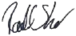
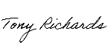
s)
SIGNED for and on behalf of the Commonwealth of Australia as represented by the delegate of the Minister for the Environment and Water

Rachel Short Tony Richards
Name  Branch Head - EAVTPAS |  | Name of witness (print)  Acting Director - PAS (NSW, ACT, Vic, Ta
Position
Signature  2.12.2025 |  | Signature of witness  27.01.2026
Date |  | Date

2

SIGNED by HV Operations Pty Ltd (ACN 606 478 399) in accordance with section 127 of the Corporations Act 2001 (Cth) by

David Foster Michael Pajkovic
Name of Director (print) |  | 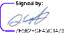  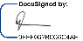  Name of Director / Company Secretary (print)
Signature of Director  03-Dec-25 | 06:08 AEDT |  | Signature of Direct Secretary  29-Nov-25 | 11:28 AEDT
Date |  | Date

SIGNED by Coal & Allied Operations Pty Ltd (ACN 000 023 656) in accordance with section 127 of the Corporations Act 2001 (Cth) by
Ning Su Sharif Burra
Name of Director (print) |  | Name of Director / Company Secretary (print)
Signature of Director  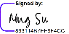  01 December 2025 |  | Signature of Director / Company Secretary  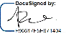  01 December 2025
Date |  | Date

SIGNED by Anotero Pty Ltd (ACN 618 503 674) in accordance with section 127 of the Corporations Act 2001 (Cth) by
Name of Director (print) |  | Name of Director / Company Secretary (print)
Signature of Director |  | Signature of Director / Company Secretary
Date |  | Date

Director / Company S

SIGNED by Coal & Allied Operations Pty Ltd (ACN 000 023 656) in accordance with section 127 of the Corporations Act 2001 (Cth) by
Name of Director (print) |  | Name of Director / Company Secretary (print)
Signature of Director |  | Signature of Director / Company Secretary
Date |  | Date

SIGNED by Anotero Pty Ltd (ACN 618 503 674) in accordance with section 127 of the Corporations Act 2001 (Cth) by
Michael Pajkovic Nicholas Talintyre
Name of Director (print) |  | 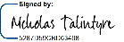  Name of Director / Company Secretary (print)
Signature of Director  29-Nov-25 | 11:28 AEDT |  | Signature of ecretary  28-Nov-25 | 20:04 AEDT
Date |  | Date

Annexure 1 – Approval


Australian Government
Department of the Environment and Energy

Approval

Hunter Valley Operations - State approved mining, Hunter Valley, NSW (EPBC 2016/7640)
This decision is made under sections 130(1) and 133 of the Environment Protection and Biodiversity Conservation Act 1999.

Proposed action

person to whom the Coal & Allied Operations Pty Ltd

approval is granted

proponent's ACN (if ACN 000 023 656

applicable)

proposed action
The continuation of open cut coal mining operations in areas that were previously approved by the State after the commencement of the Environment Protection and Biodiversity Conservation Act, 1999 within the Hunter Valley Operations (HVO) mine complex, located
24 km north west of Singleton, NSW [See EPBC Act referral 2016/7640].

Approval decision

Controlling Provision | Decision
Listed threatened species and communities (sections 18 & 18A) | Approved

conditions of approval
This approval is subject to the conditions specified below.

expiry date of approval

This approval has effect until 31 December 2030.

Decision-maker

name and position

signature

date of decision
Mike Smith
Acting Assistant Secretary

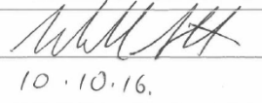

GPO Box 787 Canberra ACT 2601 • Telephone 02 6274 1111 •www.environment.gov.au
NOT 401 v3.0 Last updated: 21 July 2016
Page 1 of 8

Conditions attached to the approval

- The person taking the action must not clear more than 54.4 hectares of the Central Hunter Valley Eucalypt Forest and woodland (CHVEF) ecological community from the Riverview Pit and 6.6 ha of the CHVEF ecological community from within the West Pit and must limit all vegetation clearing to within the project disturbance boundaries defined at Schedule 1, Figures 1 - 4.
- The person taking the action must prepare and submit a Vegetation Clearance Plan (VCP) for the Minister's approval to mitigate impacts of the action on the CHVEF ecological community, the Regent Honeyeater (Anthochaera phrygia), Swift Parrot (Lathamus discolor) and the Green and Golden Bell Frog (Litoria aurea). The VCP must include:
  - Clear delineation of vegetation to be cleared, as per the disturbance boundary shown in Schedule 1 Figures 1 - 4, and vegetation that is to be retained.
  - Pre-clearance survey methods, which must include but not be limited to the following requirements:
    - A qualified ecologist must undertake a pre-clearance survey within 24 hours prior to the removal of potential foraging, nesting or breeding habitat for the Regent Honeyeater or foraging habitat for the Swift Parrot in areas identified in Schedule 2, Figures 1 - 5.
    - If during pre-clearance surveys, Regent Honeyeater or Swift Parrot individuals are identified within the clearance area the VCP must specify the use of a two stage clearing protocol where non-habitat trees are cleared 24 hours prior to any habitat trees being cleared, to encourage fauna to move out of a habitat area.
    - In the event an active Regent Honeyeater nest is identified during
pre-clearance surveys, vegetation clearing and overburden removal within 100 m of the active nest should be delayed up until the Regent Honeyeater nest is no longer actively being used.
    - A qualified ecologist must undertake pre-clearance surveys within a 2 week period prior to the removal of potential breeding habitat for the Green and Golden Bell Frog. Surveys are to be undertaken·within all potential breeding habitat areas identified in Schedule 2, Figure 2 as well as a 200m buffer around each potential breeding habitat area.
    - Pre-clearance survey methods for the Green and Golden Bell Frog must meet the survey effort requirements for the Green and Golden Bell Frog stipulated in the Survey Guidelines for Australia's threatened frog (2010) Commonwealth of Australia.
    - In the event Green and Golden Bell Frog individuals, metamorphs or tadpoles are located during pre-clearance surveys, they are to be handled and translocated in accordance with the Hygiene protocols for the control of diseases in frogs (2008) Department of Environment and Climate Change (NSW).

Page 2 of 8

  - Include measures to avoid, suppress and control the spread of plant pathogens (such as Phytophthora cinnamom1) and chytrid fungus that may degrade habitat for protected matters.
The action must not commence until the Vegetation Clearance Plan, required by Condition 2, has been approved by the Minister.
- The approved Vegetation Clearance Plan must be implemented.

- To compensate for residual impacts to protected matters the person taking the action must, under a legally binding agreement, secure in perpetuity 405.8 ha at the Wandewoi Biodiversity Area, described in 4(a)(b) and (c) within three (3) years from the date of this approval. The Wandewoi Biodiversity Area must include:
  - 405.8 hectares of the CHVEF ecological community;

  - 175.8 hectares of foraging habitat for the Swift Parrot; and

  - 40 ha of regenerating foraging habitat for the Swift Parrot.

- To compensate for residual significant impacts to 22.7 ha of Class A condition CHVEF from the Riverview Pit extension area the person taking the action must identify a direct offset site that meets requirements of the EPBC Act Offset Policy and secure the offset in perpetuity under a legally binding agreement within 12 months from the date of this approval.
- To compensate for residual significant impacts to 68.4 ha of breeding and foraging habitat for the Regent Honeyeater the person taking the action must identify a direct offset site that meets requirements of the EPBC Act Offset Policy and secure the offset in perpetuity under a legally binding agreement within 12 months from the date of this approval.
- To compensate for residual significant impacts to 2.6 ha of breeding habitat and 102.7 ha of foraging habitat for the Green and Golden Bell Frog the person taking the action must identify an offset package that meets requirements of the EPBC Act Offset Policy and secure a direct offset site in perpetuity under a legally binding agreement within
12 months from the date of this approval.

- Prior to securing the direct offsets required by Conditions 4, 5, 6 and 7 the direct offset sites and legally binding agreements must be agreed to by the Minister.
- The action cannot continue for more than 12 months from the date of the commencement of the action unless the direct offset sites required by Conditions 5, 6 and 7 have been secured in perpetuity under a legally binding agreement by the person taking the action.
- Within six (6) months from the commencement of the action the person taking the action must prepare and submit an Offset Strategy for the Minister's approval. The Offset Strategy must specify the development of the offset package and how direct offset sites required by Conditions 5, 6 and 7 will be identified, secured and managed in perpetuity. The Offset Strategy must:
  - Describe the development of the offset package and identify the proposed direct offset sites required by Conditions 5, 6 and 7, include a detailed description of the direct offset sites and demonstrate how the direct offset sites meet the EPBC Act Offset Policy and provide an adequate offset for the residual significant impacts to protected matters.
Page 3 of 8

  - Include proposed timeframes in which the direct offset sites will be secured by a legal binding agreement and a detailed description of how the legally binding agreement will secure the direct offset sites in perpetuity.
  - Proposed measures for the long term management of the direct offset sites.

The Offset Strategy..approved by the Minister must be implemented. _

- For the protection of the CHVEF as well as habitat for the Regent Honeyeater, Swift Parrot and Green and Golden Bell Frog the person taking the action must prepare and submit a Biodiversity Offset Management Plan (BOMP) for the Minister's approval within 12 months from the date of this approval. At a minimum, the BOMP must:
  - Clearly identify the direct offset sites described in Conditions 4, 5, 6 and 7. This must include offset attributes, shapefiles, textual descriptions and maps to clearly define the location and boundaries of the direct offset sites.
  - Provide a description of the offset attributes for each protected matter and h0w the offset site meets the offset requirements under Conditions 4, 5, 6 and 7.
  - Provide a survey and description of the current condition (prior to any management activities) of the direct offset sites identified in Conditions 4, 5, 6 and 7.
  - Include detailed management actions, including regeneration and revegetation strategies to be undertaken at the direct offset sites to improve the ecological quality of these areas. The BOMP must also include:
- Management actions relating to improving habitat quali�y for protected matters including but not limited to: weed management, feral animal management, erosion and sediment control and fire management.
- A description and timeframes that management measures would be implemented to improve the condition of CHVEF and habitat for the Regent Honeyeater, Swift Parrot and the Green and Golden Bell Frogs on the direct offset sites.
- Performance and completion criteria for evaluating the management of the
direct offset sites, and criteria for triggering remedial action.
- A program to monitor and report on the effectiveness of these measures, and progress against the performance and completion criteria.
- A description of potential risks to the successful implementation of the plan, a description of the measures that will be implemented to mitigate against these risks and a description of the contingency measures that will be implemented if defined triggers arise.
- Details of who would be responsible for monitoring, reviewing, and implementing the plan.
- The BOMP approved by the Minister must be implemented at the direct offset sites required to meet the requirements of Conditions 5, 6 and 7 within three (3) months from the date the offsets are secured under a legally binding agreement.
- To ensure timely compensation for significant impacts to protected matters, the approved BOMP must be implemented at the Wandewoi Biodiversity Area within one (1) month from the date the BOMP is approved, regardless if the Wandewoi Biodiversity Area has been secured under a legally binding agreement.
Page 4 of 8

- The person taking the action may choose to revise a management plan approved by
the Minister without submitting it for approval under Section 143A of the EPBC Act, if the taking of the action in accordance with the revised management plan would not be likely to have a new or increased impact on a protected matter under the conditions of this approval. If the person taking the action makes this choice, they must:
  - notify the Department in writing that the approved management plan has been revised and provide the Department with an electronic copy of the revised management plan;
  - implement the revised management plan from the date that it is submitted to the Department; and
  - for the life of this approval, maintain a record of the reasons the person taking the action considers that taking the action in accordance with the revised management plan would not be likely to have a new or increased impact on a protected matter under the conditions of this approval.
- The person taking the action may revoke its choice under Condition 14 at any time by notice to the Department. If the person taking the action revokes the choice to implement a revised management plan, without approval under Section 143A of the EPBC Act, the management plan approved by the Minister must be implemented.
- Condition 14 does not apply if the revisions to the approved management plan include changes to offsets provided under the management plan in relation to a matter protected by a controlling provision for the action, unless otherwise agreed in writing by the Minister. This does not otherwise limit the circumstances in which the taking of the action in accordance with a revised management plan would, or would not, be likely to have new or increased impacts.
- If the Minister gives a notice to the person taking the action that the Minister is satisfied that the taking of the action in accordance with the revised management plan would be likely to have a new or increased impact on a protected matter by the conditions of this approval, then:
  - Condition 14 does not apply, or ceases to apply, in relation to the revised management plan; and
  - The person taking the action must implement the previous management plan most recently approved by the Minister.
To avoid any doubt, this condition does not affect any operation of conditions 14, 15 and 16 in the period before the day the notice is given.
At the time of giving the notice the Minister may also notify that for a specified period of time that Condition 14 does not apply for one or more specified plans required under the approval.
- If, at any time after 5 years from the date of this approval, the person taking the action has not substantially commenced the action, then the person taking the action must not substantially commence the action without the written agreement of the Minister.
- Within 30 days after the commencement of the action, the person taking the action must advise the Department in writing of the actual date of commencement.
- Unless otherwise agreed to in writing by the Minister, the person taking the action must publish all management plans, referred to in these conditions of approval on their website.
Page 5 of 8

Each management plan must be published on the website within 1 month of being approved by the Minister or being submitted under Condition 14.a.
- The person taking the action must maintain accurate records substantiating all activities associated with or relevant to the conditions of approval, including measures taken to implement the VCP, Offset Strategy and Biodiversity Offset Management Plan required by tnis approvai, anctmaktrtliem avattaule---upon reqrresti�en .&rctrrercord ay be subject to audit by the Department or an independent auditor in accordance with section 458 of the EPBC Act, or used to verify compliance with the conditions of approval. Summaries of audits will be posted on the Department's website. The results of audits may also be publicised through the general media.
- Within three months of every 12 month anniversary of the commencement of the action, the person taking the action must publish a report on their website addressing compliance with each of the conditions of this approval, including implementation of any management plans as specified in the conditions. Documentary evidence providing proof of the date of publication and non-compliance with any of the conditions of this approval must be provided to the Department at the same time as the compliance report is published. Reports must remain on the website for the period this approval has effect. The approval holder may cease preparing and publishing compliance reports required by this condition with written agreement of the Minister to do so.
- Upon the direction of the Minister, the person taking the action must ensure that an independent audit of compliance with the conditions of approval is conducted and a report submitted to the Minister. The independent auditor must be approved by the Minister prior to the commencement of the audit. Audit criteria must be agreed to by the Minister and the audit report must address the criteria to the satisfaction of the Minister.

Page 6 of 8

Definitions

Active Regent Honeyeater nest is present when adult Regent Honeyeater birds are observed flying to and from, or sitting on a nest.
Commencement of the action means earthworks, vegetation removal or construction of any infrastructure, excluding fences and signage, associated with the proposed action.
Commencement does not include:

- physical disturbance necessary to undertake pre-clearance surveys or establish monitoring programs; or
- activities that are associated with mobilisation of plant and equipment, materials, machinery and personnel prior to the start of development only if such activities will have no adverse impact on matters of national environmental significance.
The Department means the Australian Government Department or any other agency that is responsible for administering the Environment Protection and Biodiversity Conservation Act 1999 (Cth).
Direct offset site means an offset site that is required by Conditions 4, 5, 6, and 7 that will protect and improve habitat for the relevant protected matter.

EPBC Act means the Environment Protection and Biodiversity Conservation Act 1999.

EPBC Act offset Policy means the Australian Government Department of Sustainability, Environment, Water Population and Communities (2012) Environment Protection and Biodiversity Conservation Act 1999 Environmental Offsets Policy. Commonwealth of Australia, Canberra.

Habitat trees are to be determined by qualified fauna spotter catcher or ecologist prior to vegetation clearance works.

Legally binding agreement means a legal mechanism that has been agreed by the Minister to secure and protect an offset site in perpetuity under NSW State legislation.

The Minister is the Commonwealth minister responsible for administering the Environment Protection and Biodiversity Conservation Act 1999 and includes a delegate of the Minister.
New or increased impact means a new or increased impact on any matter protected by the controlling provisions for the action, when compared to the plan that has been approved by the Minister.
Non-habitat trees are to be determined by qualified fauna spotter catcher or ecologist prior to vegetation clearance works.
Offset attributes means an '.xis' file capturing relevant attributes of the Offset site, including the EPBC reference ID number, the physical address of the offset site, coordinates of the boundary points in decimal degrees, the EPBC protected matters that the offset compensates for, any additional EPBC protected matters that are benefiting from the offset, and the size of the offset in hectares.
Offset package means a combination of direct and indirect offsets that has been approved by the Minister.

Page 7 of 8

Person taking the action is the person to whom the approval is granted as identified on the approval notice for EPBC 2016/7640.
Protected matter/s means any matter protected under the provisions of the Environment Protection and Biodiversity Conservation Act 1999 for which this approval applies. These are: Central Hunter Valley eucalypt forest and woodland ecological community, Regent Honeyeafer (:Antnocffaera Phrygta), wift Parrot (Lalhamus cfiscoror) andlh-e -c'.3reen and Golden Bell Frog (Litoria aurea).
Regent Honeyeater nest is no longer actively being used is present when the young have left the nest and Regent Honeyeaters are no longer seen coming or going from the nest for 2 days.
Shapefiles means an ESRI Shapefile containing '.shp', '.shx' and '.dbf' files and other files capturing attributes of the Offset sites, including the shape, EPBC reference ID number and EPBC protected matters present at the relevant site. Attributes should also be captured in '.xis' format.
Substantially commence(d) the action means commencement of vegetation clearing.

Qualified ecologist means a person who has a minimum of 5 years experience in locating, capturing, handling, caring for and the safe release of native animals.
Wandewoi Biodiversity Area means the direct offset site identified in Schedule 3.

Page 8 of 8

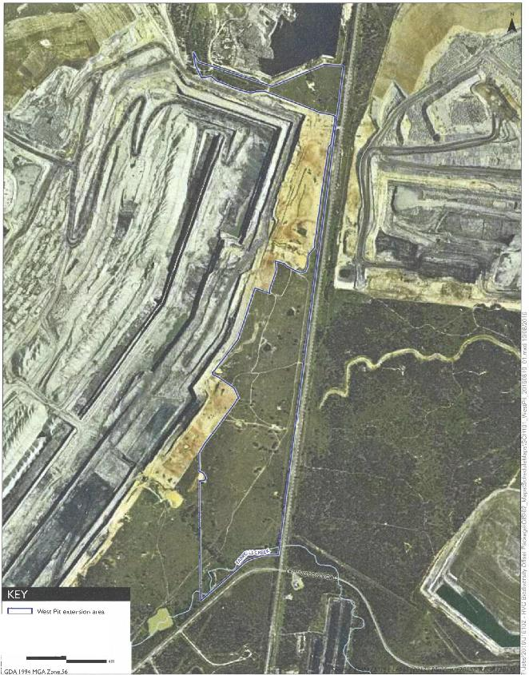
Local road
Major waterways

0.25 0.5

West Pit extension area
Hunter Valley Operations - State-approved mining
Schedule I Figure I

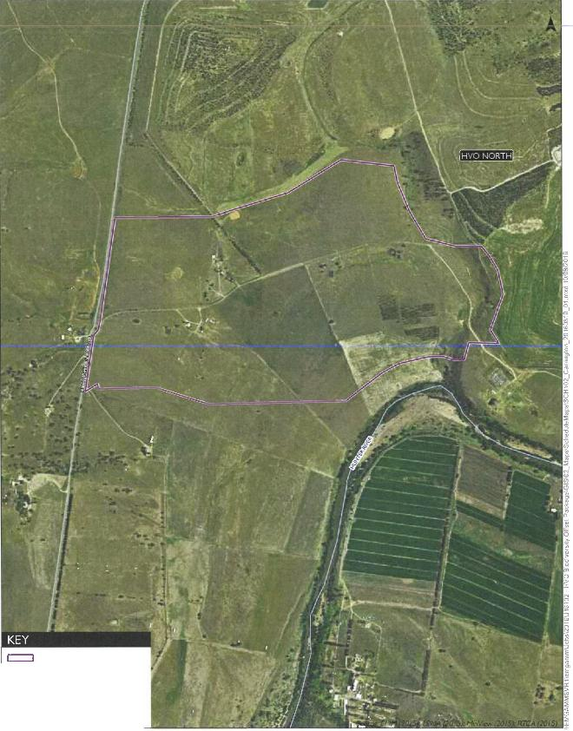
Carrington Pit extension area Local road
Major waterways

0.25 0.5

km
GOA 199◄ MGA Zone 56

Carrington Pit extension area
Hunter Valley Operations - State-approved mining
Schedule I Figure 2

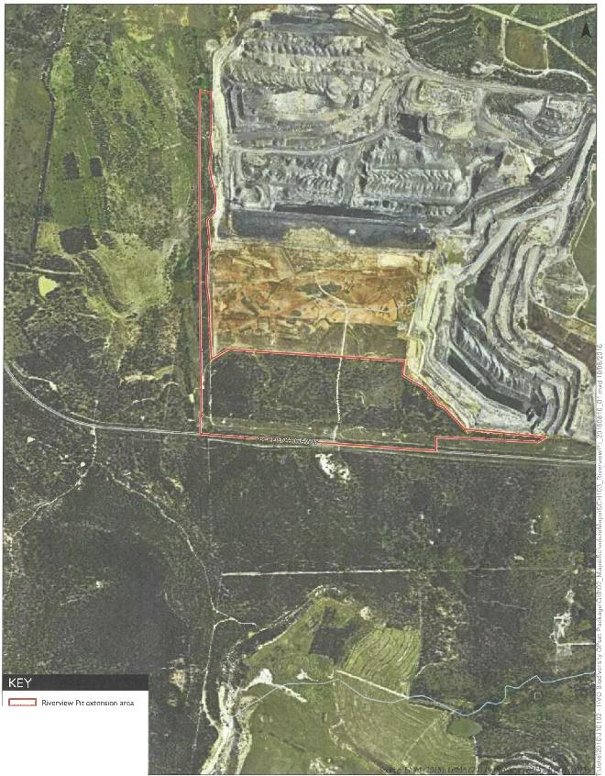
Major road Major waterways

0.25 0.5
km
GDA 1994 MGA Zone 56

Riverview Pit extension area
Hunter Valley Operations - State-approved mining
Schedule I Figure 3

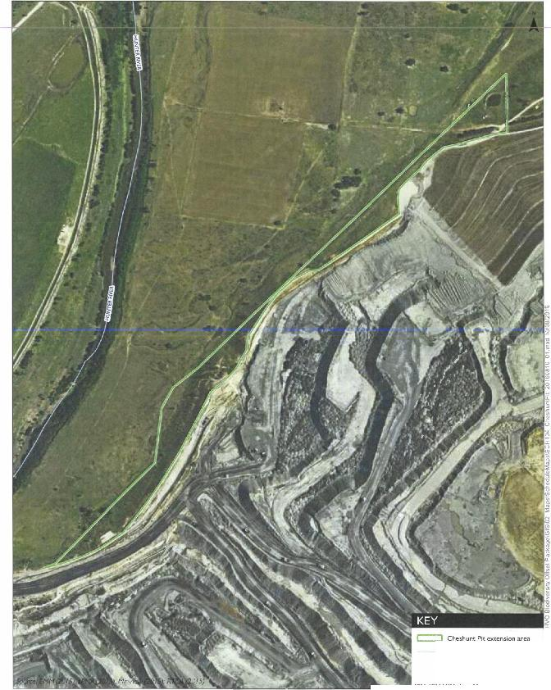
N
0
<D
Major waterways 7
"'
0.1 0.2,m
�
0
_..... -""....,,======= �e::,-
Cheshunt Pit extension area
Hunter Valley Operations - State-approved mining
Schedule I Figure 4

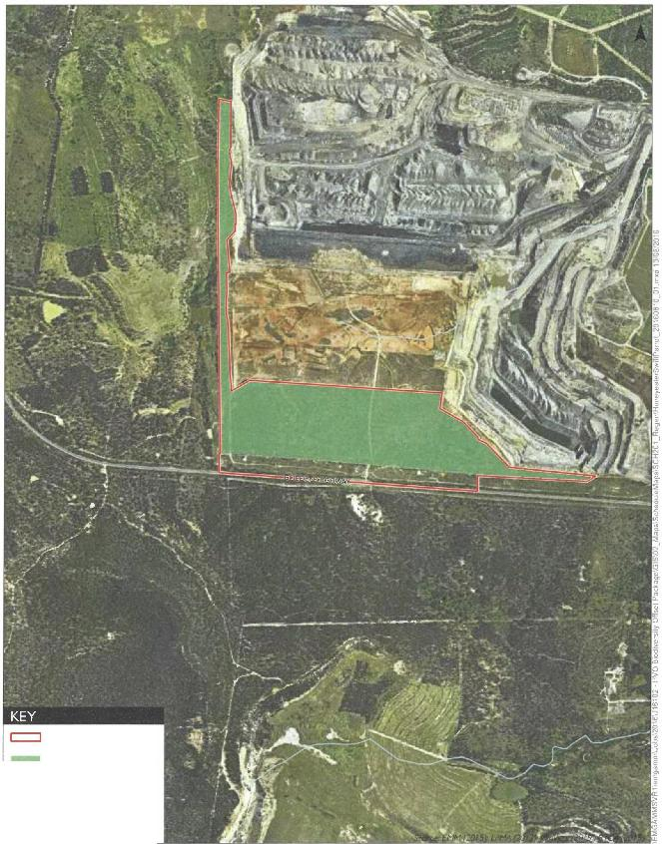
Riverview Pit extension area
Potential habitat for the Swift
Parrot and Regent Honeyeater Major road
Major waterways

0.25 0.5
km
GOA 1994 MGA Zone 56

Potential Regent Honeyeater and Swift Parrot habitat in the
Riverview Pit extension area
Hunter Valley Operations - State-approved mining
Schedule 2 Figure I

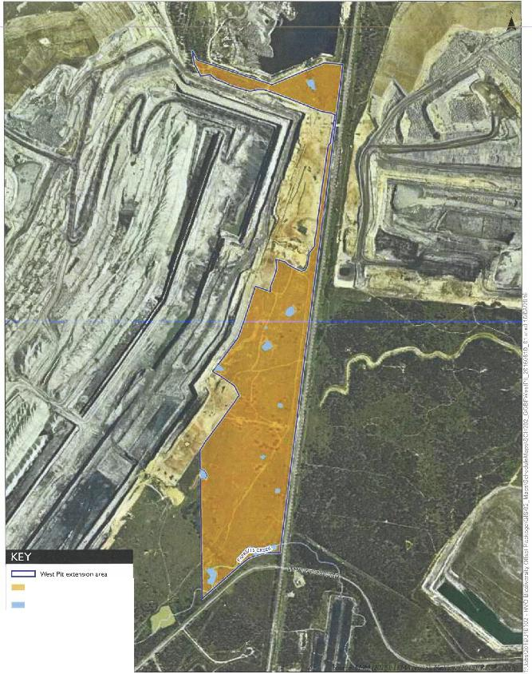
Potential GGBF foraging habitat
Potential GGBF breeding habitat
Local road
Major waterways

0.25 0.5
•m

GOA 1994 MGA Zone 56

Potential Green and Golden Bell Frog in the
West Pit extension area
Hunter Valley Operations - State-approved mining
Schedule 2
Figure 2

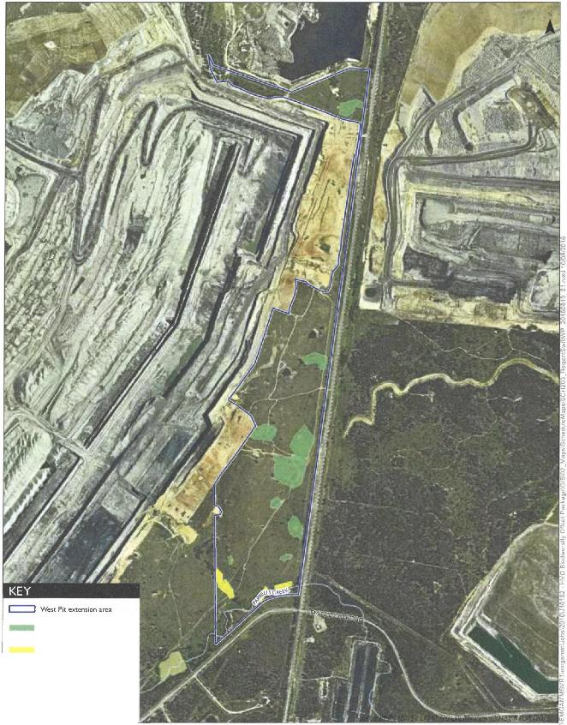
Potential Regent Honeyeater
and Swift Parrot habitat
Potential Regent Honeyeater
habitat Local road
Major waterways

0.25 0 5
•km
GOA 1994 MGA Zone 56

Potential Regent Honeyeater and Swift Parrot habitat in the West Pit extension area
Hunter Valley Operations - State-approved mining
Schedule 2
Figure 3

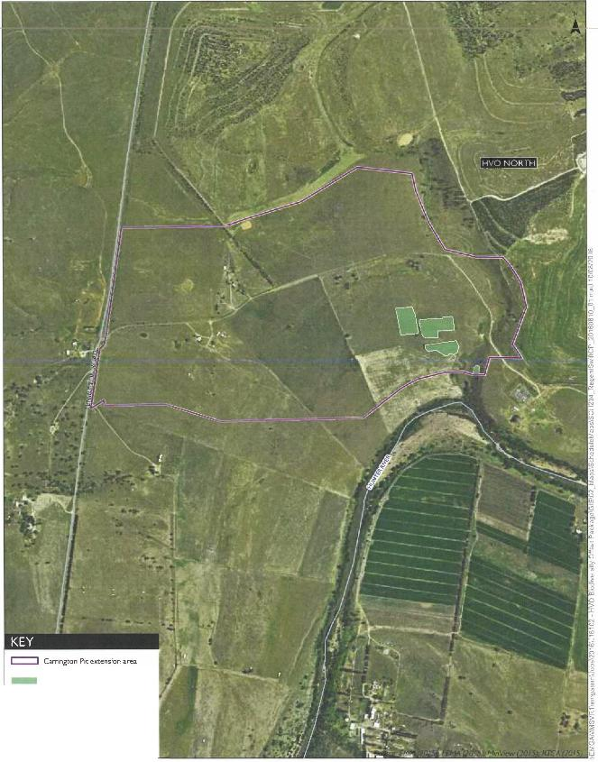
Potential Regent Honeyeater
and Swift Parrot habitat Local road
Major waterways
0.25 0.5,m

GOA 199◄MGA Zone 56

Potential Regent Honeyeater and Swift Parrot habitat in the Carrington Pit extension area
Hunter Valley Operations - State-approved mining
Schedule 2
Figure 4

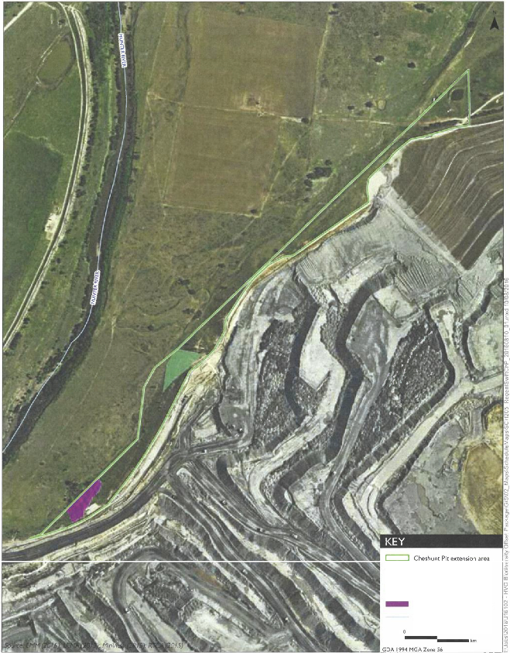
Vegetation to be cleared
Potential Regent Honeyeater
and Swift Parrot habitat Potential Swift Parrot habitat
Major waterways

0.1 0.2

Potential Regent Honeyeater and Swift Parrot habitat in the Cheshunt Pit extension area
Hunter Valley Operations - State-approved mining
Schedule 2
Figure 5

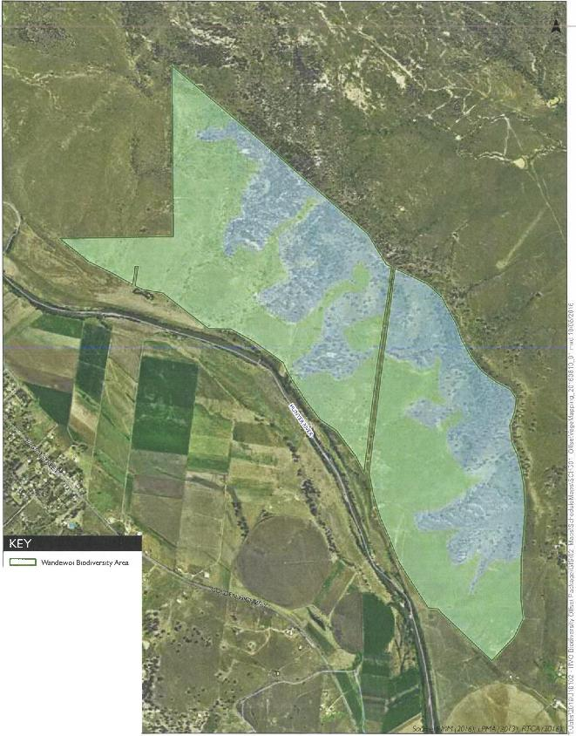
Vegetation community
Central Hunter Valley eucalypt forest and woodland CEEC (175.8 ha)
Derived Native Grassland to be regenerated to Central Hunter Valley eucalypt forest and woodland CEEC (230 ha)
Major road Local road
Major waterways
0.25 0.5,m

GOA 1994 MGA Zone 56

I••

