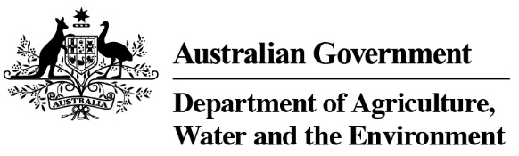

Product Emissions Standards Act 2017
Product Emissions Standards Rules 2017
Exemption Variation Notice

Variation to Exemption No: ECP-18-0005E

I, David Jeffery, a Delegate of the Secretary of the Department of Agriculture, Water and the Environment (the Department) hereby vary Exemption No ECP-18-0005E under Section 35 of the Product Emissions Standards Rules 2017 to remove conditions 2 and 3 of Schedule 2 Exemption Conditions.
This variation takes effect on 3/09/2020
The exemption as varied is attached for reference.

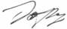
 | Date: | 3 / 09 / 2020
Delegate of the Secretary

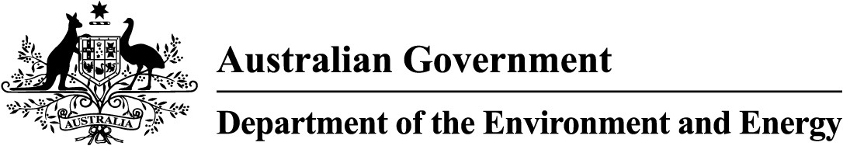

Product Emissions Standards Act 2017
Product Emissions Standards Rules 2017
Exemption
(Issued 22 June 2018, varied 29 November 2018 and 3 September 2020)

Exemption No: ECP-18-0005E

I, David Jeffery, a Delegate of the Secretary of the Department of the Environment and Energy (the Department) grant this exemption from Part 3 of the Product Emissions Standards Act to Lakeside Marine Pty Ltd (ABN 29 001 930 098).
This exemption is granted under Section 32 of the Product Emissions Standards Rules 2017 (The Rules) and in accordance with exemption category 30(1)(d) of the Rules for the import and supply of the emissions-controlled products specified in Schedule 1 to this Notice, subject to the conditions specified in Schedule 2 to this Notice.
In accordance with paragraph 32(1)(a) of the Rules this exemption comes into force on the date that it is published on the Department’s website and expires on 30 June 2021.

Date:
Delegate of the Secretary

Schedule 1
Emissions-Controlled Products (ECPs) Included in this Exemption
Only the ECPs specified in the table below are included in this exemption.
Unless varied in accordance with section 35 of the Rules, the total number of ECPs imported and supplied by the expiry date of this exemption must not exceed the maximum number specified in the last column of the table below.

ECP Category | Make | Model Name | Model Number | Equipment Type | Maximum Number
Propulsion Marine Engine | Tohatsu | - 25hp  - 30hp | - M25H S  - M30H S | Outboard engine | 580

Schedule 2
Exemption Conditions
In accordance with subsection 34(2) of the Product Emissions Standards Rules 2017, the exemption for the outboard engines specified in Schedule 1 is granted subject to the following conditions:
- The engines must only be supplied to a member club (club) of Surf Life Saving Australia (SLSA) or an SLSA affiliated State or Territory based entity (hereinafter included in the term “club”).
- [condition removed]
- [condition removed]
- Lakeside Marine Pty Ltd may only supply engines on receipt of a written purchase order from a club presented on the club’s letterhead.
- Consistent with the requirements of paragraph 34(1)(b) of the Rules, the engines must be accompanied throughout the supply chain by a copy of this exemption notice or by information regarding how the exemption can be accessed online.
- The engines must not be displayed by any person for sale in a retail showroom or sales area accessible to the public.
- Exempted engines imported but not supplied by 30 June 2021 will not be able to be supplied under this exemption.
- Lakeside Marine Pty Ltd shall provide an annual written report to the Department by 31 August in 2019, 2020 and 2021 documenting the number of each of the two engine models in Schedule 1 that have been supplied under this exemption in the 12 months to 30 June of that year.

