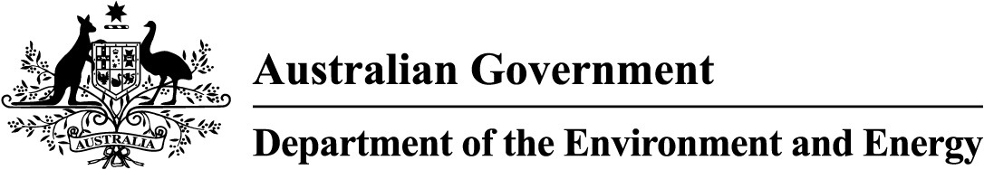

Product Emissions Standards Act 2017
Product Emissions Standards Rules 2017
Certificate of Conformity

Certificate No: ECP-18-0009C

I, Bruce Rose, a delegate of the Secretary of the Department of the Environment and Energy (the Department) issue this certificate of conformity (certificate) to Marine Power International Pty Ltd (ABN 25 003 100 007) for the engine family specified in Schedule 1 to this certificate.
This certificate is issued in accordance with paragraph 20(1)(a) of the Product Emissions Standards Rules 2017 (the Rules) on the basis of the test results provided for the tested engine in accordance with paragraph 20(2)(a), including the emissions results specified in Schedule 2 to this certificate.
Consistent with the requirements of paragraph 20(2)(b) of the Rules, all engines of the engine family specified in Schedule 1 must comply with the Australian emissions standard for propulsion marine engines set out in section 11 of the Rules.
This certificate comes into force on the date that it is published on the website.
In accordance with paragraph 20(1)(a) of the Rules, notice of this Australian certification will be published on the Department’s website.

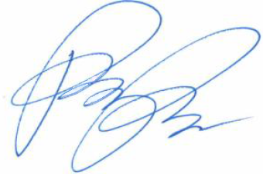
 | Date: | 13 / 7 / 2018
Delegate of the Secretary

Schedule 1
Engines Included in this Certificate of Conformity

Only the test engine model in Schedule 2 and the engine models specified in the table below are covered by this certificate.

Category: | Propulsion Marine Engine
Equipment Type: | Outboard Engine
Engine Family Name: | GM9XM.2092GO
Models Included in this Engine Family:
Make | Model Name | Model Number
Mercury | MA8MH 4S | 7F08201ZA
Mercury | MA8MLH 4S - | 7F08211ZA
Mercury | MA9.9MH 4S - | 7F10201ZA
Mercury | MA9.9MLH 4S - | 7F10211ZA
Mercury | ME8ELH 4S - | 1F08311KA
Mercury | ME8MH 4S - | 1F08201EA
Mercury | ME8MLH 4S - | 1F08211EA
Mercury | ME9.9EL 4S - | 1F10312KA
Mercury | ME9.9EL CT 4S - | 1F10352KL
Mercury | ME9.9ELH CT 4S - | 1F10351KL
Mercury | ME9.9ELPT CT 4S - | 1F10452KL
Mercury | ME9.9MH 4S - | 1F10201EA
Mercury | ME9.9MLH 4S - | 1F10211EA
Mercury | ME9.9MLH CT 4S - | 1F10251KL

Schedule 2
Summary of Emissions Results for Tested Engine

Test Engine Details:

Make | Model Name | Model Number
Mercury | ME 8MLH 4S | 1F08211EK

Emissions Results for Test Engine:

CO (g/kW-hr) | HC+NOx (g/kW-hr)
312 | 19

