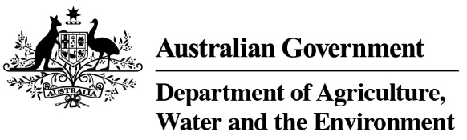

Product Emissions Standards Act 2017
Product Emissions Standards Rules 2017
Exemption Variation Notice

Variation to Exemption No: ECP-18-0015E

I, David Jeffery, a Delegate of the Secretary of the Department of Agriculture, Water and the Environment (the Department) hereby vary Exemption No ECP-18-0015E under Section 35 of the Product Emissions Standards Rules 2017 to remove conditions 4 and 6 of Schedule 2 Exemption Conditions.
This variation takes effect on 10/11/2020
The exemption as varied is attached for reference.

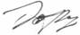
 | Date: | 10 / 11 / 2020
Delegate of the Secretary

Product Emissions Standards Act 2017
Product Emissions Standards Rules 2017
Exemption Notice
(Issued 27 Aug 2018, varied 27 November 2018 and 10 November 2020)

Exemption No: ECP-18-0015E

I, Bruce Rose, a Delegate of the Secretary of the Department of the Environment and Energy (the Department) grant this exemption from Part 3 of the Product Emissions Standards Act 2017 (the Act) to Marine Power International Pty Ltd (ABN 25 003 100 007).
This exemption is granted under Section 32 and in accordance with exemption category 30 (1) (d) of the Product Emissions Standards Rules 2017 (The Rules) for the import and supply of the emissions-controlled products specified in Schedule 1 to this Notice, subject to the conditions specified in Schedule 2 to this Notice.
This exemption comes into force on the date that it is published on the Department’s website.
This exemption expires on 31 August 2021.

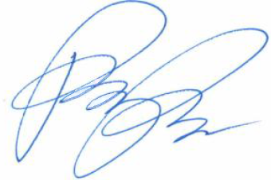
 | Date: | 27 / 8 / 2018
Delegate of the Secretary

Schedule 1
Emissions-Controlled Products (ECPs) Included in this Exemption
Only the ECPs specified in the table below are included in this exemption.
Unless varied in accordance with section 35 of the Rules, the total number of ECPs imported and supplied by the expiry date of this exemption must not exceed the maximum number specified in the last column of the table below.

ECP Category | Make | Model Name | Equipment Type
Propulsion Marine Engine | Mercury | 25 M  30 M  25 M SLS | Outboard engine

Schedule 2
Exemption Conditions
In accordance with subsection 34(2) of the Product Emissions Standards Rules 2017, the exemption for the outboard engines specified in Schedule 1 is granted subject to the following conditions:
- The engines must be stored in a designated area in Marine Power International Pty Ltd’s secure warehouse facility.
- The engines are to be labelled upon arrival with the relevant supply limitation details outlined in this Exemption Notice.
- The engines must only be supplied to a member club (club) of Surf Life Saving Australia (SLSA) or an SLSA affiliated state or territory based entity (hereinafter included in the term “club”).
- (Condition removed)
- The engines are only to be offered for sale through Marine Power International Pty Ltd’s authorised dealer network and Dealers will be required to complete a manual order form which will outline the conditions of the sale of these engines (refer also to the requirements of Condition 6 below).
- Condition removed)
- Marine Power International Pty Ltd may only supply engines on receipt of a written purchase order from a club presented on the club’s letterhead.
- Consistent with the requirements of paragraph 34(1)(b) of the Rules, the engines must be accompanied throughout the supply chain by a copy of this exemption notice or by information regarding how the exemption can be accessed online.
- The engines must not be displayed by any person for sale in a retail showroom or sales area accessible to the public, or be sold directly to the public.
- Exempted engines imported but not supplied by 31 August 2021 will not be able to be supplied under this exemption.
- Marine Power International Pty Ltd shall provide an annual written report to the Department by 30 September in 2019, 2020 and 2021 documenting the number of each of the three engine models in Schedule 1 that have been supplied under this exemption in the 12 months to 31 August of that year.
- This exemption is for a total of 500 engines.

