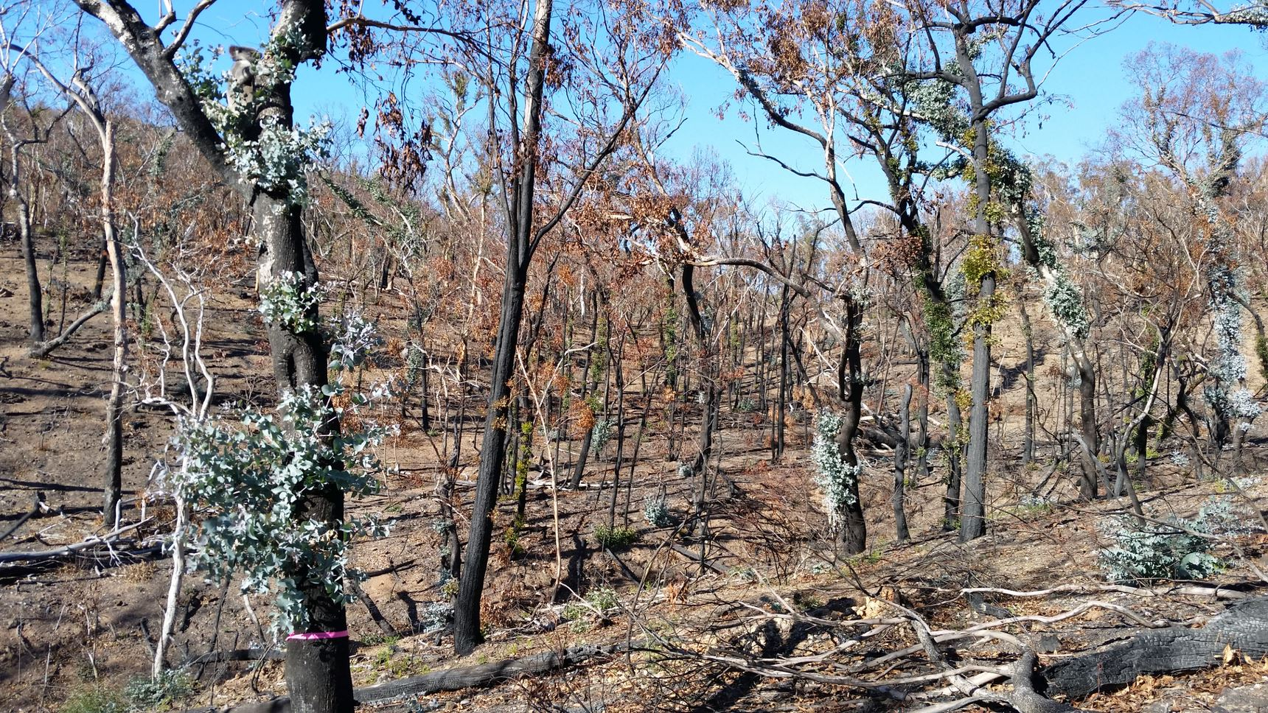

Effects of fire on koalas and their habitat

Phillipa Beale, Kara Youngentob and Karen Marsh
The Australian National University

© Commonwealth of Australia 2022
Ownership of intellectual property rights
Unless otherwise noted, copyright (and any other intellectual property rights) in this publication is owned by the Commonwealth of Australia (referred to as the Commonwealth).
Creative Commons licence
All material in this publication is licensed under a Creative Commons Attribution 4.0 International Licence except content supplied by third parties, logos and the Commonwealth Coat of Arms.
Inquiries about the licence and any use of this document should be emailed to copyright@dcceew.gov.au

Cataloguing data
This publication (and any material sourced from it) should be attributed as: Beale, P., Youngentob, K.N., Marsh, K.J., 2022, Effects of fire on koalas and their habitat, report prepared for the Department of Climate Change, Energy, the Environment and Water, Canberra, CC BY 4.0.

This publication is available at https://www.dcceew.gov.au/environment/epbc/publications
Department of Climate Change, Energy, the Environment and Water
GPO Box 858 Canberra ACT 2601
Telephone 1800 900 090
Web: dcceew.gov.au
Disclaimer
The Australian Government acting through the Department of Climate Change, Energy, the Environment and Water has exercised due care and skill in preparing and compiling the information and data in this publication. Notwithstanding, the Department of Climate Change, Energy, the Environment and Water, its employees and advisers disclaim all liability, including liability for negligence and for any loss, damage, injury, expense or cost incurred by any person as a result of accessing, using or relying on any of the information or data in this publication to the maximum extent permitted by law.
Acknowledgements
This report was funded by the Department of Climate Change, Energy, the Environment and Water. The authors thank researchers who provided feedback on earlier drafts and who allowed the inclusion of information from unpublished work.
Acknowledgement of Country
We acknowledge the Traditional Custodians of Australia and their continuing connection to land and sea, waters, environment and community. We pay our respects to the Traditional Custodians of the lands we live and work on, their culture, and their Elders past and present.
Cover photo by ANU Media
Phillipa Beale, Kara Youngentob and Karen Marsh
Youngentob, K.N, Marsh, K.F., Skewes, J., A review of koala habitat assessment criteria and methods, report prepared for the Department of Agriculture, Water and the Environment, Canberra, November. CC BY 4.0.

Contents
Purpose statement v
Introduction 1
1 Effects of fire on koalas 4
1.1 Injury and mortality 4
1.2 Physiological stress 7
1.3 Health and Disease 8
1.4 Koala movements 10
1.5 Predation 11
2 Effects of fire on koala habitat 13
2.1 Food availability 14
2.2 Food quality 16
2.3 Shelter and microclimate 17
2.4 Forest structure and age 18
2.5 Soil composition 19
2.6 Time scale of habitat recovery 20
3 Landscape context 22
4 Management implications 25
4.1 Habitat composition and connectivity 26
4.2 Prescribed burns 26
4.3 Threat control 28
4.4 Koala rescue and rehabilitation 28
4.5 Provision of water 30
4.6 Tree removal or replanting 31
Glossary 32
References 35

Figures
Figure 1. Veterinary assessment of a rescued koala and joey by Dr Arianne Lowe (left), and a burnt koala food pad (right). Photos by Karen Marsh. 6
Figure 2. A female koala and joey in burnt habitat in the NSW Monaro region. Photo by Murraya Lane. 10
Figure 3. Severe fire can remove all of the canopy in koala habitat until epicormic regrowth begins. Photo by Karen Marsh. 14
Figure 4. A koala in a eucalypt that is resprouting epicormically after fire. Photo by Michael Weinhardt. 15
Figure 5. A koala exposed to full solar radiation in a burnt tree. Photo by Michael Weinhardt. 18
Figure 6. A rehabilitated koala being released. The koala is fitted with a GPS tracking collar to allow monitoring post-release. Photo by James Walsh. 30

Maps
Map 1. The extent and severity of the 2019-2020 bushfires in south-eastern Australia relative to the distribution of the koala. 3

Purpose statement
The purpose of this document is to provide a review of the latest information on the effects of fire on koalas and their habitat and to identify knowledge gaps in currently available peer-reviewed literature. The document aims to provide contemporary information on how fire affects habitat values for koalas at different time scales, how fire regime, size and severity affect koalas, and the implications for post-fire management.

Introduction
The koala (Phascolarctos cinereus) is a specialist folivore with a diet that consists primarily of eucalypt foliage. Koalas can be found in a diverse range of forest types from open woodland in semi-arid regions in western NSW and Queensland to subtropical and temperate closed forests on the east coast of Australia (Department of Agriculture Water and the Environment, 2022). Many of these landscapes are fire prone. For example, between August 2019 and March 2020, 12.6 million hectares burnt on the eastern side of Australia, severely damaging ecosystems and placing further stress on native species that were already vulnerable (DPIE, 2020b, Wintle et al., 2020). This included an estimated 25% of suitable koala habitat in NSW (DPIE, 2020b) and around 10% across their distribution (Map 1).
Fire is a key threatening process for koalas (Department of Agriculture Water and the Environment, 2022). The potential immediate effects of fire on koalas (for example injury and mortality) are well reported in both the media and scientific literature (Lunney et al., 2022a, Matthews et al., 2007, Matthews et al., 2016, Parrott et al., 2021, Phillips et al., 2021). Fire can also affect habitat use by animals, their foraging behaviour, growth rates, reproductive capacity, risk of predation and more (Weiss and Brower, 2021, Brisson et al., 2003, Herzog et al., 2016, Herzog et al., 2014, James and M'Closkey, 2003, Wild and Gienger, 2018, Howey et al., 2016). Despite their iconic status and the significance of fire in the Australian landscape, there is limited information about how fire ultimately impacts koalas and koala habitat. In part, this is because the magnitude of effects and the final outcomes depend on a complex set of interactions between pre-fire conditions, fire severity, fire history, fire frequency, environmental conditions, habitat type, koala abundance, population health, other threats, and post-fire conditions.
Fires are often patchy in their distribution across the landscape and vary in severity from cooler understorey fires to high severity fires resulting in complete canopy consumption (Map 1). Fire can be incredibly damaging in the short term, but it also plays an essential role in shaping vegetation composition and biodiversity in the Australian landscape (Burrows, 2008). A plant’s response to fire can be classified in one of two ways; ‘seeders’ perish after fire and new individuals emerge via seed, while ‘resprouters’ regenerate from existing buds (Burrows, 2013). Resprouters can be further divided into ‘basal’ (regeneration from buds at or below ground level and through structures such as lignotubers) or ‘epicormic’ (regeneration above ground on branches and stems) (Burrows, 2013). Epicormic resprouting allows quicker recovery in fire-prone landscapes, which in turn assists in the recovery of ecosystem function (Pausas and Keeley, 2017).
As a group, eucalypts are considered to be the most proficient and successful epicormic resprouters (Burrows, 2013), potentially resulting in only short-term loss of food for koalas (Matthews et al., 2007). However, the recovery of eucalypts post-fire is dependent on a number of factors, including forest composition, seasonal conditions before and after the fire, and the patchiness and intensity of fire (Martin and Handasyde, 1999). The frequency and severity of extreme weather conditions including drought, heat waves and fires are expected to rise as the climate changes (Bowman et al., 2021). The changing fire regime may hinder the ability of forests to survive and recover (Nolan et al., 2021).
The nutritional composition of epicormic regrowth (for example digestible protein and deterrent or toxic plant secondary metabolites) may differ from mature canopy foliage due to differences in the way in which resources are allocated to epicormic leaves. There is surprisingly little information about the magnitude of these differences or the capacity of koalas, or any marsupial folivores, to eat epicormic regrowth from eucalypts recovering from fire, although recent unpublished research suggests that these relationships are likely to differ across eucalypt species (K. Marsh and K. Youngentob unpublished data). This knowledge gap creates uncertainty about whether human intervention is needed to support uninjured koalas in heavily burnt landscapes, and in determining the timing of release for rehabilitated koalas into fire-affected areas.
There have been relatively few studies examining the longer-term capacity of koalas to survive in habitat recovering from fire. The only series of published studies to intensively monitor a population of koalas after fire found that survival, reproductive rates and home range sizes were similar between rehabilitated koalas who were later released and uninjured koalas from the same fire-affected area in Port Stephens, NSW, although mortality was high in both groups (Lunney et al., 2004, Matthews et al., 2007, Matthews et al., 2016). Despite a mosaic of fire intensity across the study site, 70 % of trees in which koalas were observed during the day were burnt, and koalas used burnt areas extensively (Matthews et al., 2007). This demonstrated, for the first time, that koalas in Port Stephens did not need to be moved to unburnt habitat post fire to ensure their survival.
Several other published studies, as well as unpublished research from the 2019-2020 bushfires provide additional data to support the idea that koalas can persist in burnt landscapes. These include observations of koalas or their scats in burnt habitat (Curtin et al., 2001, Lunney et al., 2020, Phillips et al., 2021) and acoustic data and GPS-tracking that demonstrate that koalas utilise burnt areas (Law et al., 2022b; M. Lane and K. Marsh unpublished data). One key element to the post-fire survival of koalas or the recolonisation of severely burnt areas may be the proximity and connectivity to fire refuge areas or to habitat that burnt at lower severity (Law et al., 2022b). Overall, the scientific literature suggests that the scale and severity of fire influences effects on both koalas and their habitat, but that even high severity fire does not necessarily render a landscape uninhabitable to koalas.
This document reviews the current state of knowledge about the direct effects of fire on koalas, such as death and injury, and indirect effects such as increased risk of exposure to other threatening processes. It also describes fire impacts on koala habitat, including potential changes in foliage availability and quality, forest structure, the timeframe of habitat recovery, and how this affects the koala. Finally, the document discusses a variety of management actions and post-fire interventions that are aimed at minimising the risks or effects of fire on koalas. Throughout the document, we point out key knowledge gaps, and highlight where the current data are too limited to make broad conclusions under alternative scenarios.

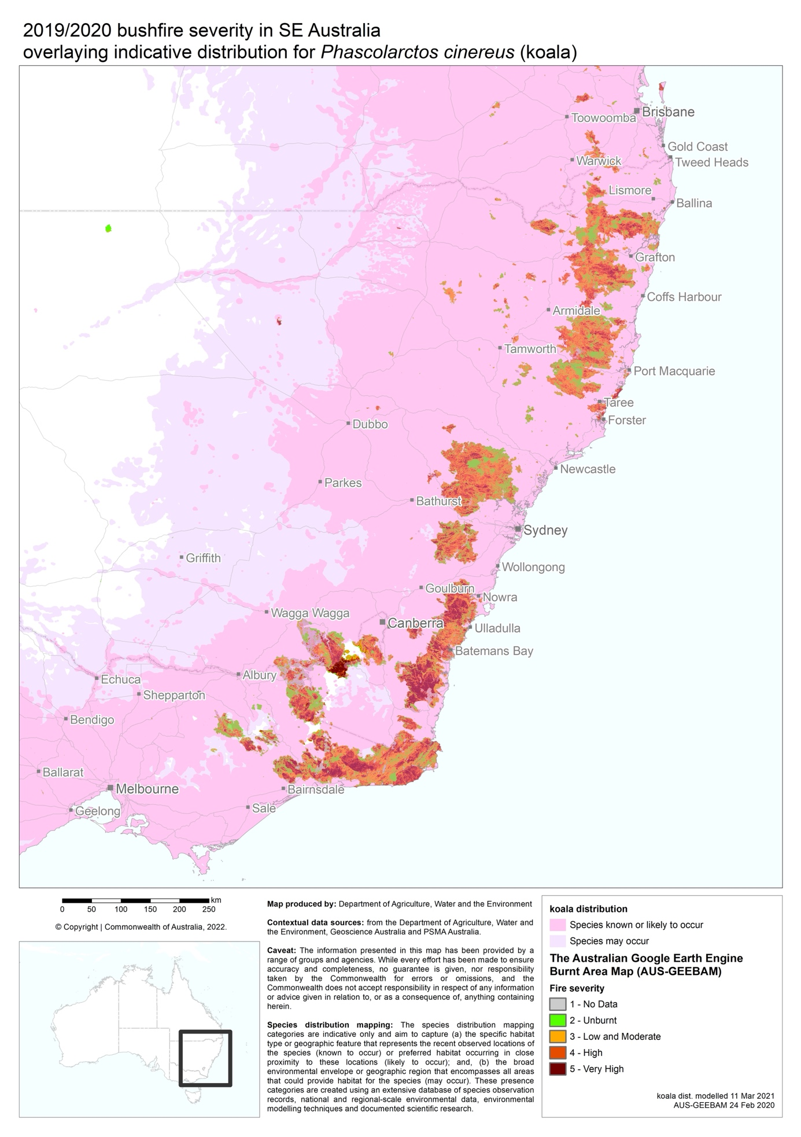
Map 1. The extent and severity of the 2019-2020 bushfires in south-eastern Australia relative to the distribution of the koala.

Effects of fire on koalas
The full impacts of fire on koalas are relatively poorly understood, firstly because there are limited pre-fire data on koala health, movements, and abundance in most areas across their range. Without these pre-fire data, it can be difficult to assess whether some findings are a response to fire or due to natural variation in koala ecology and abundance (Cristescu et al., 2021). Thus, caution should be used when interpreting post-fire data without the equivalent measurements pre fire. Secondly, the consequences of fire are likely to be influenced by complex interactions between a range of factors including pre-fire conditions, fire extent and severity, connectivity to unburnt refuges, and the rate of landscape recovery. This means that not all findings will apply to all locations and situations.
Where the effects of fire on koalas have been estimated, it is clear that they can be substantial. For example, it has been estimated that up to 80% of koalas were lost from some areas during the 2019-2020 “Black Summer” bushfires (Dunstan et al., 2021, Cristescu et al., 2021, Phillips et al., 2021). Theoretically, fire may also have more subtle effects on the resilience and recovery of koala populations by influencing the distances traversed by koalas, their risk of predation, and disease incidence and transmission, but these factors have been poorly studied in koalas to date.

Injury and mortality
- Koalas are killed and injured by fire
- Mortality rates are higher in areas in which the canopy has been scorched or consumed
- Some koalas rescued from fire grounds can be rehabilitated and later released
The most conspicuous and immediate impacts of fire on koalas are death and injuries. However, it can be surprisingly difficult to estimate fire-induced mortality rates in wild koalas because there is limited information on pre-fire population densities across much of the koala’s range. Even after fire, the cryptic nature of koalas, and the limitations of the various methods used for determining koala presence and abundance makes it difficult to assess the number of survivors (Youngentob et al., 2021b, Dunstan et al., 2021, Cristescu et al., 2021, Phillips et al., 2021). Furthermore, it can be difficult to extrapolate any specific findings to other locations due to differences in fire severity, population health, habitat condition, and predation, which are also likely to influence outcomes. Nevertheless, multiple studies suggest that the impacts of fire on koala mortality can be substantial.
On Kangaroo Island, South Australia, it has been estimated that up to 80% of koalas perished in the Black Summer fires (Department for Environment and Water South Australia, 2020). In NSW and Queensland, Cristescu et al. (2021) used thermal drone surveys and genetic fingerprinting to estimate that koala densities were 24-71% lower in burnt sites compared to three out of four paired unburnt controls. Likewise, Phillips et al. (2021) used the spot assessment technique (SAT) and rapid-SAT to search for koala scats after the Black Summer bushfires, and estimated that mean habitat occupancy was reduced by 71% at sites between Foster and Ballina on the north coast of New South Wales. However, koala scats were five times more likely to be found in areas where canopies were unburnt or only partially burnt compared to areas that were fully burnt (Phillips et al., 2021). Law et al. (2022b) also found a relationship between the severity of fire and changes in the density of koalas using acoustic arrays on the NSW north coast. Specifically, at sites which did not burn or burnt with low severity, koala densities were similar before and one year after fire, whereas koala densities were 50-60% lower one year post fire at sites that burnt with moderate to high severity (Law et al., 2022b). Koalas appeared to be absent when sites were sampled immediately after the high severity fire, so their presence one year later likely points to recolonisation of that habitat (Law et al., 2022b). Together, these findings demonstrate that the effects of fire on koala mortality are variable, and that the availability and size of habitat patches that burn with lower severity is likely to be critical to the survival of individuals along with connectivity with less affected populations to allow recolonisation.
Information about fire-related injuries and subsequent outcomes for koalas predominantly come from wildlife rescue organisations, who routinely rescue fire-affected animals following bushfires (Figure 1). It has been estimated that less than 1% of the affected koala population within a region is rescued after fire, but this likely reflects that rescue operations are often haphazard and tend to be concentrated in accessible areas where fire severity is lower rather than that few koalas are injured (Lunney et al., 2022a, Dunstan et al., 2021). Reports from the Black Summer bushfires suggest that about half of the koalas rescued from firegrounds were able to be treated and later released (Dunstan et al., 2021, Lunney et al., 2022a, Parrott et al., 2021).
Common injuries for koalas include burns to the foot pads, claws and face, smoke inhalation, and dehydration (Dunstan et al., 2021, Lunney et al., 2022a, Parrott et al., 2021). The location and severity of burns influences the likelihood of recovery in care. For example, burns to the face are a poor prognostic indicator as they can interfere with feeding, seeing, and smelling (Dunstan et al., 2021). Burns to the foot pads are also of particular concern for koalas as they can prevent the animals from climbing trees to access shelter and food (Dunstan et al., 2021). Damage to the nail beds from burns can also result in permanent loss of the claws which are required for tree climbing (Dunstan et al., 2021, Lunney et al., 2004). Although these individuals may otherwise recover in care, they may be unsuitable for release if enough claws are impacted. Koalas with minor burns are sometimes rescued many weeks post-fire (Dunstan et al., 2021, Wallis, 2013), and in some cases their burns heal without intervention (K. Marsh personal observation).
Koalas rescued from fire grounds are also often dehydrated, and those suffering from burns are even more likely to be dehydrated (Dunstan et al., 2021, Parrott et al., 2021) because significant fluid losses can occur due to the disruption of the skin’s barrier. It is not known whether there is a relationship between dehydration pre fire (for example from high temperatures and/or drought that may precede extreme fire conditions) and either the likelihood or severity of burns or of successful rehabilitation outcomes, but any pre-fire dehydration is likely to compound any further dehydrating impacts of fire. Koalas with burns are also often in poor body condition at presentation, but it is not clear whether this is a direct result of fire or whether individuals or populations in worse body condition leading up to fire (for example due to disease or drought) are less likely to escape injury from fire and are more likely to succumb when injured (Dunstan et al., 2021).
Post-fire surveys and data from rescue organisations clearly show that, at a landscape scale, many koalas survive in burnt habitat, depending on fire severity (DPIE, 2021, Law et al., 2022b, Cristescu et al., 2021, Phillips et al., 2021). However, the impact of fire on koala numbers is likely to be region and local population specific, and to depend on the severity and extent of fire, which is non-uniform. This makes extrapolation from the limited number of studies difficult. Nevertheless, Law et al., (Law et al., 2022b) suggested that the Black Summer fires may have reduced the density of koalas in the north-east region of NSW by approximately 13% based on the observation that 9.8% of landscape samples (2 km × 2 km) in koala habitat were dominated by high fire severity, while a further 6.1% were dominated by moderate fire severity. However, at the population level, the impacts may not be directly related to absolute mortality metrics because sparsely populated areas or areas with low levels of connectivity may become non-viable following a relatively small loss in numbers (Lunney et al., 2002, Lunney et al., 2020).

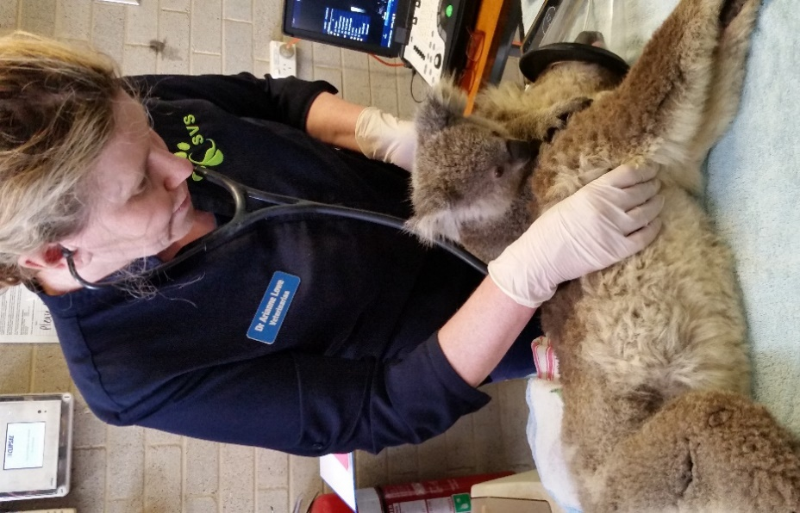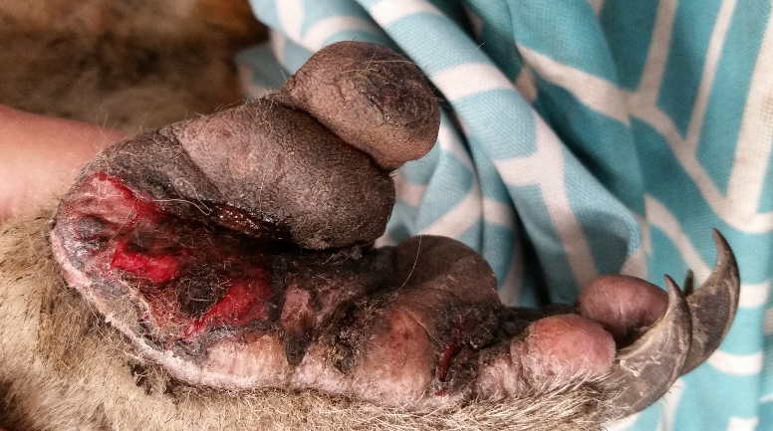
Figure 1. Veterinary assessment of a rescued koala and joey by Dr Arianne Lowe (left), and a burnt koala food pad (right). Photos by Karen Marsh.

Physiological stress
- Limited data suggest that koalas affected by bushfire are more stressed than healthy wild koalas
- Chronic stress can reduce animal and population fitness
- Hot, dry environmental conditions prior to or following fire could also affect animal physiology and resilience to fire effects
Physiological stress describes a state of disturbance to the normal internal functioning of an organism, triggering internal or external mechanisms that seek to restore the internal milieu. In the short term this response is beneficial, but in the long term it can be detrimental. Chronic stress can affect a variety of factors that are associated with individual and population resilience, including body condition, reproduction and susceptibility to disease (Davies et al., 2014, Bonier et al., 2009, Hing et al., 2016). Food deprivation, dehydration, hot temperatures, injury and bringing wild animals into captivity can all cause stress responses in a variety of studied animals (Narayan and Williams, 2016). Koalas often experience several of these conditions in conjunction with a fire event. In response to stress, animals may allocate energy resources away from specific physiological functions, such as reproduction and growth, to prioritise short-term survival (Narayan and Williams, 2016, Weiss and Brower, 2021). The effects can persist for months after the stressor event. For example, in the year after fire, female lizards were smaller in burnt areas than unburnt areas despite being in better body condition, and they also displayed less ornamentation, a signal of female quality and readiness for mating (Weiss and Bower 2021).
Physiological stress has been poorly studied in koalas, but limited data suggest that koalas impacted by bushfires have higher stress levels than healthy wild koalas (Narayan, 2019), and koalas that are brought into captivity show varied stress levels depending on source, cause and treatment (Charalambous et al., 2021, Narayan and Vanderneut, 2019, Santamaria et al., 2021). The potential consequences of this deserve consideration given that they could affect the fitness of individuals and the capacity of populations to recover after fire (Weiss and Bower 2021; Narayan and Williams 2016). Certainly, hot, dry conditions, which often precede and/or follow fire, can cause physiological stress to koalas, resulting in loss of condition and a decline in numbers (Davies et al., 2014, Gordon et al., 1988). Heat-stressed animals decrease their food intake to avoid contributing additional heat burden from foraging and the digestion process (Youngentob et al., 2021a, Beale et al., 2018). Animals which eat toxic diets, such as the koala, may also become less tolerant to those toxins in hotter conditions, meaning food intake is reduced even more than expected in the heat (Beale, 2020). Koalas that eat less will also dehydrate more quickly since they obtain most of their water from their food (Beale et al., 2018).
Female koalas living in burnt habitat have been observed with joeys within a year following fire (Lunney et al. 2004; K. Marsh personal observation), demonstrating that reproduction is not completely suppressed by potential stress experienced by populations in fire-affected areas. However, reproductive rates have not been specifically compared before and after fire in any population, and some individuals may be more impacted than others. Likewise, several months after the 2019-20 fires, koalas in burnt habitat in the NSW Monaro region were no more likely to be exhibiting symptoms of chlamydia, an important disease in koalas, than koalas in unburnt habitat (M. Lane and K. Marsh unpublished data), suggesting that their immune system was not compromised. However, there is no way to determine whether immune suppression played a more important role and contributed to elevated mortality from disease earlier post fire. With growing recognition of the effects of physiological stress on wildlife resilience in the literature, it is likely that more researchers will investigate how stress shapes the post-fire responses of koalas in the future. This also highlights the importance of monitoring and documenting population recovery after fire.

Health and Disease
- Several key diseases, including chlamydia and koala retrovirus, can affect koala health and survival
- There has been no research to determine whether changes in koala density after fire affect disease transmission
- In some populations, reduced fertility due to chlamydia could slow population recovery after fire
- Koalas can breed and reproduce in burnt habitat
Disease, in particular infection with Chlamydia spp or koala retrovirus (KoRV), is a major threat to koala survival in some areas across its range (Reckless et al., 2017, Polkinghorne et al., 2013, Rhodes et al., 2011). While there has been significant research into both chlamydia and KoRV (see Quigley and Timms, 2020), no published studies have directly examined the relationship between disease status and the impact of fire. One possibility is that physiological stress from the conditions preceding or following fire could exacerbate the effects of disease (Hing et al., 2016). Another is that the effects of disease may make koalas more vulnerable to death or injury from fire, and/or compound the effects of reduced food availability or dehydration following fire. For example, dehydration is both a symptom of chlamydial infection (Phillips et al., 2019) and a concern for koalas in recently burnt habitat (Dunstan et al., 2021, Parrott et al., 2021). These types of effects are difficult to untangle without data from known individuals both before and after fire. However, Speight et al. (unpublished data) found no association between burn status and KoRV or chlamydia status in two populations of koalas in South Australia.
One issue that is beginning to be investigated is whether the presence of antimicrobial resistant bacteria in koala microbiota reduces the efficacy of antibiotics in koalas treated for fire-related infection or chlamydial disease. Preliminary research at Macquarie University has found that the prevalence of resistance genes to key anti-chlamydial antibiotics (chloramphenicol and doxycycline) in urogenital tract and conjunctival microbiota was higher in fire-affected than non-fire-affected koalas (McDougall et al., unpublished data). Fire-affected koalas also had a higher diversity of resistance genes, suggesting that they had acquired the bacteria carrying resistance genes multiple times in care (McDougall et al., unpublished data). In addition, an antibiotic resistance determinant associated with bacteria in the gut was not detected in free-ranging koalas on Kangaroo Island pre fire, but it was present in almost half of fire-affected koalas entering care (McDougall et al., unpublished data). The increased prevalence and diversity of antimicrobial resistance in fire-affected koalas entering care may exacerbate the already significant threat of bushfires and chlamydial disease on Australia’s declining koala population.
In some koalas, infection with chlamydia reduces fertility (Polkinghorne et al., 2013, Burach et al., 2014, Pagliarani et al., 2020). This has important implications for the time frame and capacity for population recovery after fire as a lower number of fertile individuals will limit reproductive rates. However, population viability analyses conducted at several locations suggest that high rates of mortality (for example due to fire or predation) can have a greater influence on whether populations decline or increase than low rates of fertility, even though both play a role (Lunney et al., 2002, Lunney et al., 2007). Thus, integrated management of all major threats to koalas may be needed for building populations (Beyer et al., 2018).
There is currently no information on how fire interacts with disease transmission in koalas. Theoretically, effects could be either positive or negative. It may be possible that reduced koala densities following fire slows disease transmission, or that congregation of animals into unburnt patches speeds disease transmission, or that stress from fire enhances disease transmission by increasing bacterial or viral loads, or that the compounding effects of disease and fire remove the most diseased individuals resulting in slowed overall transmission. Given the significance of both fire and disease as threatening processes to koalas, filling this knowledge gap would be of significant value.
Ignoring the immediate effects of fire on injury and mortality, koalas that survived in burnt habitat in the NSW Monaro region were in similar body condition to those living in nearby unburnt habitat at both 3-6 months and 12 months after the Black Summer fires (M. Lane and K. Marsh unpublished data). Furthermore, koalas living in both habitats were able to successfully breed and reproduce (M. Lane and K. Marsh unpublished data), a finding similar to earlier studies on the NSW mid-north coast (Matthews et al., 2016, Lunney et al., 2007). This highlights that burnt forests can continue to be breeding habitat for koalas (Figure 2).

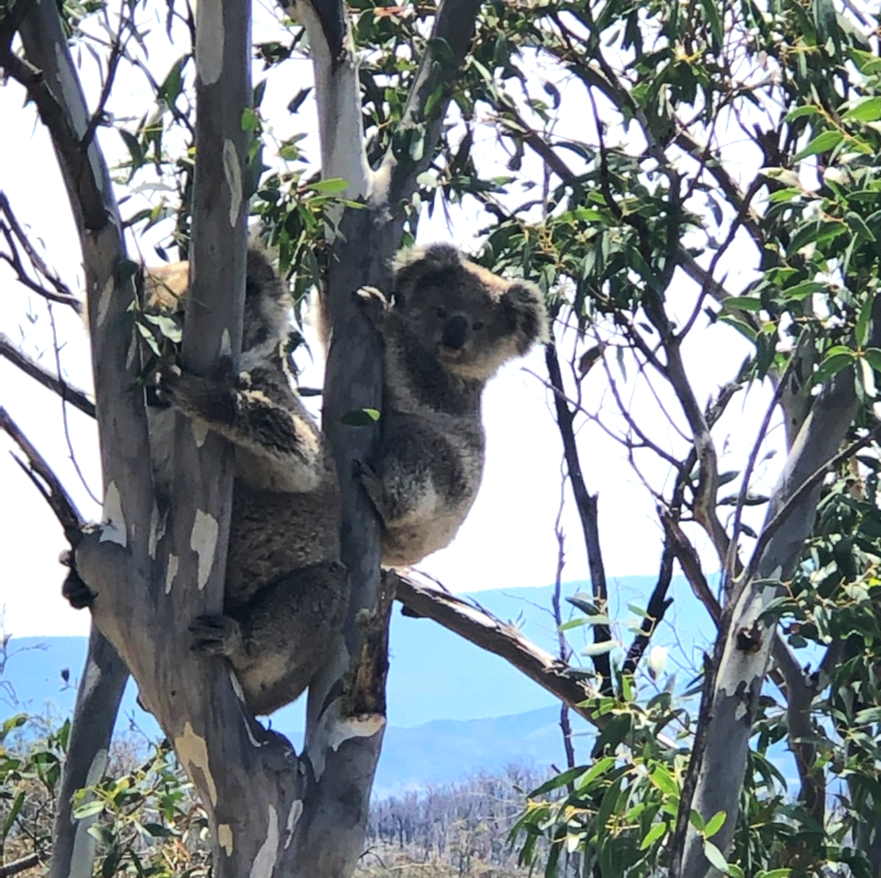
Figure 2. A female koala and joey in burnt habitat in the NSW Monaro region. Photo by Murraya Lane.

Koala movements
- Koalas move along the ground between trees
- It is not known whether koalas flee fire or remain in situ
- It is not known whether koalas alter their movements in response to changes in cover and food availability
- Koalas can live wholly within burnt habitat if adequate food is available
- Some individuals from nearby areas move into burnt habitat
Koalas are often viewed as sedentary, likely owing to their nocturnal nature; however, during the night they regularly move between trees. Koalas readily traverse a few hundred metres along the ground between and within habitat patches, and can move more than 500 m across cleared land (Davies et al., 2013). Young male koalas, but also females will also disperse between populations and some tracked koalas have walked several kilometres cross-country (Lunney et al., 2012). Although covering these distances is possible, they come at the cost of energy and risk to the koala.
There are several ways in which fire could conceivably affect the movement patterns of koalas. Examples include fleeing an approaching fire front, increasing the distances travelled after fire to utilise remaining or regrowing patches of food and/or shelter, avoiding areas that have been intensively burnt, exiting or recolonising fire affected areas, and adjusting home range boundaries in response to changes in population structure. Currently, there is little evidence to either support or refute most of these scenarios, although anecdotal observations from Kangaroo Island suggest that some koalas at least attempt to flee the fire (C. Moore personal communication).
The best information on the effects of fire on koala movements comes from studies that have radio- or GPS-tracked groups of koalas after wildfire. They show that, within three months of fire (the timing of study commencement), koalas can live wholly within burnt habitat and can use and traverse areas that have been severely impacted by fire (Matthews et al., 2007, M. Lane and K. Marsh unpublished data). In addition, some individuals move into burnt areas from neighbouring habitat within 12 months of fire (Law et al., 2022b). Daily and seasonal distances travelled by koalas living in burnt habitat can also be similar to those of koalas living in nearby unburnt habitat (Matthews et al., 2007, M. Lane and K. Marsh unpublished data). Together, these findings demonstrate that koalas are not excluded from burnt habitat, and that they do not necessarily need to restrict or alter their movements in fire-affected landscapes.

Predation
- Globally, changes in predator-prey dynamics after fire depend on the ecosystem context
- Predation by dogs is a key threat to koalas in some areas of Australia
- Invasive predator abundance can increase after fire, but it is not known whether this affects predation rates on koalas
Predation by dogs is one of the primary threats to koalas in some areas of Australia (Lunney et al., 2004, Beyer et al., 2018, Allen et al., 2016, Lunney et al., 2022b), but it is not clear whether predation or predation risk to koalas increases after fire. For some prey species, fire can increase the risk of predation as animals move away from advancing fire fronts, and as vegetation that provides shelter is removed (Geary et al., 2020). For example, in a before-after, control-impact study in forest in south-eastern Australia, the removal of understory by prescribed burning disadvantaged small to medium sized native prey in the short term (Hradsky et al., 2017). In the northern savannas of Australia, predation on small mammals by cats and dingoes increased in burnt habitat and was a key driver of a decline in their numbers after fire, while the fire itself had a relatively small impact on numbers (Leahy et al., 2016). For other species, however, removal of undergrowth can make predators easier to detect and evade (Geary et al., 2020). Thus, there is no clear global trend for how fire influences predator-prey dynamics, with responses most likely determined by ecosystem context (Geary et al., 2020).
For koalas, there is no published data comparing koala mortality from predation before and after fire. However, on the NSW mid-north coast, predation by dogs was the most common reason koalas died following release into burnt habitat after rehabilitation from burns (Lunney et al., 2004), although it is not clear whether predation rates differed between burnt and unburnt patches of habitat or before and after fire. Nevertheless, a population viability analysis showed that, when combined, the rates of mortality from fire and from predation by dogs could lead to extinction of the population (Lunney et al., 2007). Thus, the effects of dog predation can be significant, and the potential for increased predation after fire could further increase the risks to koalas.
Under some circumstances, foxes could also potentially pose a greater risk to koalas after fire. Red foxes and cats were five times more common after the undergrowth was removed by fire in a forest in south-eastern Australia (Hradsky et al., 2017). Anecdotally, foxes may attack young koalas or mothers with joeys (Cristescu et al., 2013), and have sometimes also been observed climbing trees (Mella et al., 2019).

Effects of fire on koala habitat
Fire has some well-documented effects on eucalypt trees, such as the removal of canopy foliage and the regrowth of new leaves from dormant epicormic buds. While these effects are immediately relevant to koalas via changes in food quality, food availability, and shelter availability, the consequences of fire burning koala habitat are still poorly understood. Any effects are likely to be mediated by fire severity, the scale of the area impacted, and the post-fire environmental conditions during forest recovery.
Fire has been part of the Australian landscape since the end of the Cretaceous period (Crisp et al., 2011). During this time eucalypts have experienced a long history of adaptation to fire, a clear example of which is the ability of many species to survive being burnt and to resprout from epicormic buds under the bark within days to weeks of fire (Crisp et al., 2011, Burrows, 2002, Gill, 1978, McCaw et al., 1994, Wardell-Johnson, 2000). Nevertheless, high severity fire that removes the canopy foliage can have immediate impacts on shelter, microclimate and the quality and availability of food for koalas (Figure 3). Fire may also affect koala habitat quality in the longer term through changes in the age structure of stands and eucalypt species composition.
The effects of fire on eucalypts depend on fire severity, frequency and characteristics of the trees, including size, bark, and regeneration strategy (Vivian et al., 2008, Zylstra et al., 2016). Habitat recovery can also occur over different time scales. In the short term, many eucalypts produce epicormic leaves which persist for months to years. In the medium term, seedlings are recruited, often creating a dense understorey. In the long term, the habitat matures to its pre-fire structural state. These stages may have different value for koalas, and high fire frequency has a negative effect on modelled habitat suitability (Law et al., 2017). Importantly, however, koalas do not appear to be excluded from habitat at any stage.
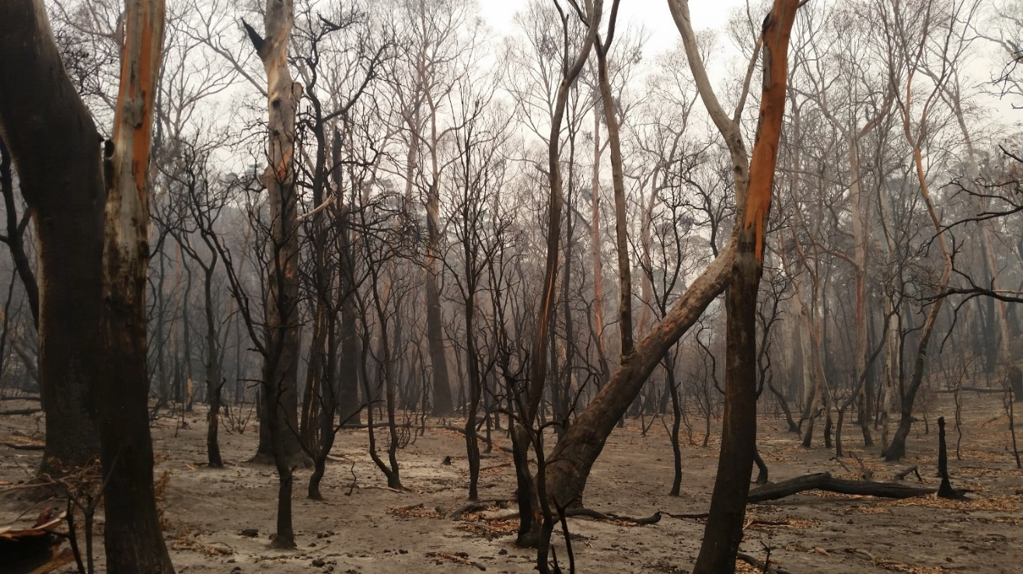
Figure 3. Severe fire can remove all of the canopy in koala habitat until epicormic regrowth begins. Photo by Karen Marsh.

Food availability
- High severity fire can reduce the immediate availability of food for koalas
- Low severity fire is unlikely to affect food availability
- Many eucalypt species produce epicormic regrowth soon after fire
- Eucalypts that regrow from basal buds or from seed may be slower to provide food for koalas
- Koalas can eat epicormic regrowth from a variety of species, so food shortages after fire are likely to be temporary in a multi-species forest
As obligate folivores, the availability of eucalypt leaves for food is critical to the survival of koalas. Intense fire can scorch or consume the canopy, reducing immediate food availability and potentially creating a nutritional “crunch point” (Figure 3). However, the effects of fire on landscapes are not uniform, with some areas being burnt more severely than others (Law et al., 2022b). The immediate effects of fire on food availability for koalas may therefore range from almost nothing under conditions of low-severity fire, to patchy across the home range of a koala in which fire severity varies, to the complete temporary loss of all food resources (Law et al., 2022b).
Due to the difficulty in observing koalas immediately after fire, and the complexity of interactions between a) fire severity mosaics, b) the capacity of koalas to move between food patches, and c) variation in the rate of epicormic resprouting, there is little direct information about how changes in food availability immediately after fire affect koalas. For example, in some regions, koalas move several hundred metres to kilometres each night (Davies et al., 2013, Lunney et al., 2012) and may therefore be able to find food in small patches that burned with lower severity by moving through more severely burnt areas. This is a key knowledge gap that creates uncertainty about whether human intervention, such as temporarily capturing koalas until regrowth appears or providing in situ feeding stations in the first few weeks after fire, provides any benefit or indeed adds any stress. Indirectly, koalas rescued within weeks of fire are often in poor body condition (Dunstan et al., 2021), but it is not clear whether this is due to the loss of food resources, or to the effects of fire on the koalas themselves (for example stress, injury and dehydration), or an indication of pre-fire conditions (for example heat or drought).
Even after severe fire, many Eucalyptus species survive and resprout from epicormic buds under the bark (Burrows, 2002, Gill, 1978, McCaw et al., 1994, Wardell-Johnson, 2000). This resprouting can begin almost immediately after fire, which provides koalas with a new potential source of food within weeks to months. Koalas have been observed in resprouting burnt trees as soon as three months after fire (Figure 4) (Matthews et al., 2007, Lunney et al., 2007, Curtin et al., 2001), and koalas in care are known to feed on the epicormic regrowth from some eucalypt species (M. Lane and K. Marsh unpublished data). Furthermore, koalas can gain body weight and condition and reproduce in areas that have been impacted by intense fire once leaves are regrowing (Lunney et al., 2004, M. Lane and K. Marsh unpublished data, Matthews et al., 2007, Lunney et al., 2020). This suggests that any food shortages for koalas after fire are likely to be temporary, despite being an important initial impact.

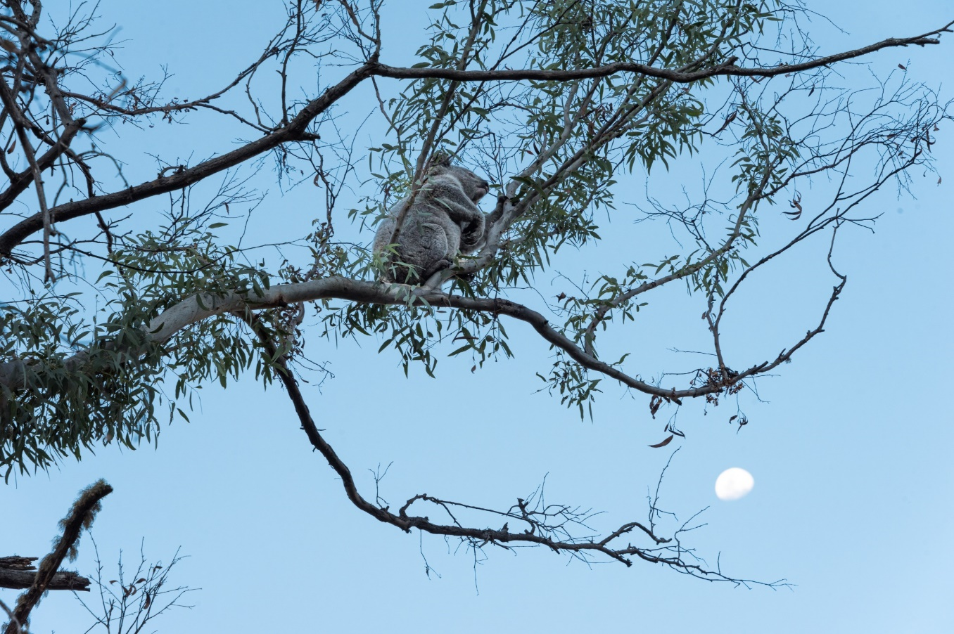
Figure 4. A koala in a eucalypt that is resprouting epicormically after fire. Photo by Michael Weinhardt.

Food quality
- The nutritional composition of epicormic regrowth differs from mature canopy
- Epicormic foliage from some eucalypt species may be more nutritious to koalas while others may be more toxic
- Koalas can eat epicormic foliage from at least some eucalypt species, but more research is needed to understand variation across their range
- In areas that have been studied, habitat that has been severely impacted by fire and is producing epicormic foliage can support koalas
- The community composition of eucalypts could influence the rate of koala population recovery via changes in nutritional quality in epicormic leaves
Eucalypt leaves contain a variety of chemical constituents, including nitrogen (a proxy for protein) and plant secondary metabolites (PSMs) such as tannins, formylated phloroglucinol compounds (FPCs), and unsubstituted B-ring flavanones (UBFs), which drive the foraging decisions and population densities of koalas (Moore et al., 2005, Moore et al., 2010, Marsh et al., 2014, Au, 2018, Au et al., 2019, Marsh et al., 2019, Marsh et al., 2021). High concentrations of FPCs and UBFs limit food intake by the koala, and koalas tend to favour trees that have lower concentrations of these compounds and higher digestible nitrogen concentrations (an integrated measure which incorporates the effects of tannin binding on foliar nitrogen available to the animal for digestion; Moore et al., 2005, Marsh et al., 2021, Degabriel et al., 2008). Foliar chemistry that dictates browse preference can vary both within and between eucalypt species (Moore et al., 2005, Au et al., 2019) and between different leaf phases (for example juvenile or adult; Gras et al., 2005) and ages (for example young or old; Marsh et al., 2018). Although some foliar constituents can be influenced by environmental factors, digestible nitrogen, FPCs and UBFs are largely determined by the genetics of the tree, and no links to soil type, fertility, or geologic substrate have been consistently identified (Andrew et al., 2010, Andrew et al., 2007).
Preliminary data suggests that, where the eucalypt canopy remains intact, fire may have minimal effects on the nutritional composition of mature leaves (K. Marsh and K. Youngentob unpublished data). Thus, both food availability and food quality likely remain stable for koalas in habitat that has been subjected to low severity fire. In contrast, the nutritional composition of juvenile phase epicormic regrowth can differ from that of adult phase mature leaves from the same eucalypt species (K. Marsh and K. Youngentob unpublished data). Interestingly, the effects are not consistent between eucalypt species. In a recent study on the NSW north coast, digestible nitrogen concentrations were higher in epicormic leaves compared to mature leaves from some eucalypt species but were lower in others (K. Marsh and K. Youngentob unpublished data). Likewise, concentrations of PSMs in epicormic leaves were higher, similar, or lower than in mature leaves from the canopy depending on the species (K. Marsh and K. Youngentob unpublished data). Initial data suggests that epicormic leaves from eucalypt species of the Symphyomyrtus subgenus are more likely to be higher in quality for koalas than mature leaves, while species of the Monocalyptus (also called Eucalyptus) subgenus may be lower (K. Marsh and K. Youngentob unpublished data). However, this requires further investigation across a larger number of eucalypt species to confirm. It is also worth noting that the epicormic leaves were collected at a single point in time more than 12 months post fire, and it is not known whether quality differs in much younger or much older leaves. Nevertheless, there are two main points to note. First, when epicormic leaves are present, the nutritional landscape available to koalas differs from pre-fire values. And second, the eucalypt species available could have a profound effect on whether the quality of food for koalas increases or decreases after fire.
The change in nutritional quality of available food when epicormic leaves are produced has implications for the effects of fire on koalas. In other wild mammalian herbivore species, individuals with access to higher quality food are in better condition and have higher rates of reproduction (DeGabriel et al., 2009, McArt et al., 2009), and the effects are probably similar in koalas. Certainly, landscapes with more preferred koala browse species of high nutritional quality (that is higher concentrations of digestible nitrogen and lower concentrations of PSMs) have a higher carrying capacity and higher habitat value (Au et al., 2019, Au, 2018, Law et al., 2017). Given these strong relationships, more research is needed to determine whether an upward or downward shift in food quality after fire influences the rate at which koalas and koala populations can recover, and to understand which eucalypt species or communities are most beneficial to them under post-fire conditions.

Shelter and microclimate
- Shelter is important to koalas for thermoregulation
- Fire can alter the microclimate and the level of exposure to radiant heat
- It is not known whether koalas in burnt habitat are more likely to suffer from heat stress
Aside from food, koalas may seek out certain trees, including non-eucalypts, for specific thermal properties that provide shade or offer cooler or warmer surface temperatures to help with thermoregulation (Ellis et al., 2010, Briscoe et al., 2014, Crowther et al., 2014). It is likely that these properties are determined by the type of bark (for example smooth or rough), tree size and/or density of canopy foliage, and that any tree or shrub that possesses the appropriate properties might be favoured for resting, even if it is not favoured as food. For example, koalas have been observed “hugging” cooler smooth barked tree species during hot conditions (Briscoe et al., 2014), or sitting in midstorey species with dense canopies (Ellis et al., 2010). Koalas may also use landscape features to assist with thermoregulation and have been observed selecting trees in sunny sheltered positions during cold weather and sheltering in dense epicormic regrowth in hot conditions (Lunney et al., 2020).
Following high severity fire, canopy cover provided by foliage is reduced, exposing koalas to more radiant heat from the sun (Figure 5). There is little information on how long the canopy cover is reduced after fire, but in one instance the canopy had recovered 5-7 years after fire (Heath et al., 2016). Prolonged exposure to heat can cause physiological stress in koalas (Degabriele and Dawson, 1979). However, there has been no specific investigation of whether fire, or the change in microclimate induced by fire, affects the shelter preferences of koalas. Nevertheless, the availability of habitat elements that provide refuge from high temperatures may be particularly important following fire given the additional risk of dehydration. These elements could include cooler, wetter areas, such as mesic areas along creek lines, or trees or shrubs with intact canopy.
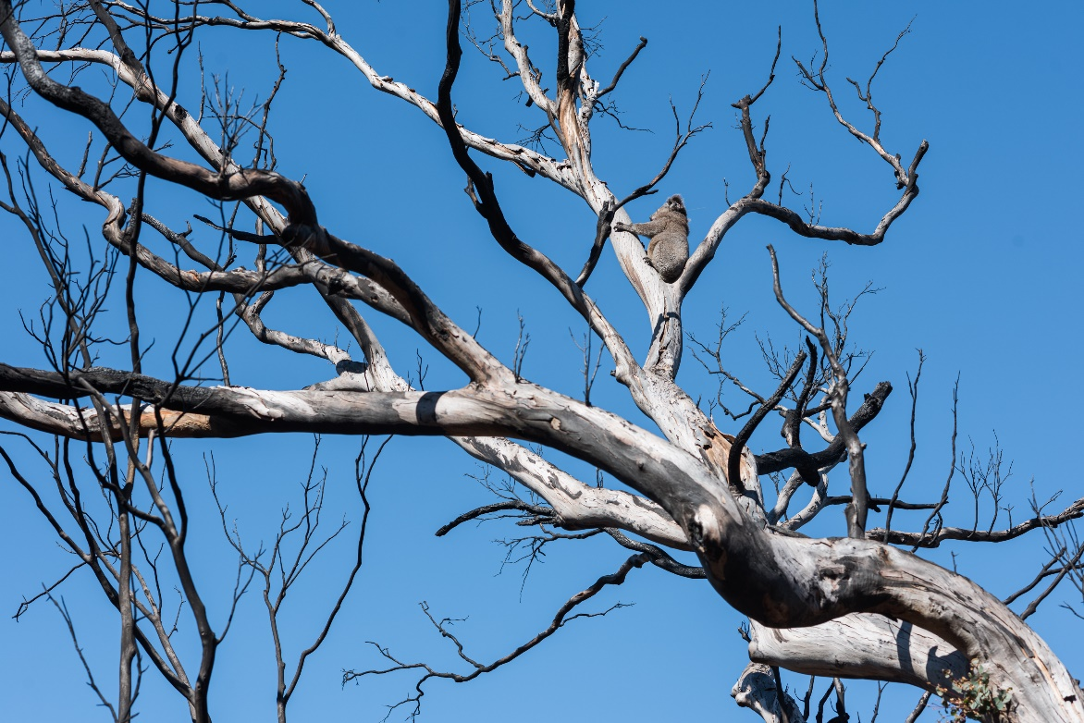
Figure 5. A koala exposed to full solar radiation in a burnt tree. Photo by Michael Weinhardt.

Forest structure and age
- Fire can remove ground cover, midstorey and/or canopy depending on severity, initially making forests more open
- Understorey vegetation can grow back in dense stands after fire
- Forests dominated by species that regrow from seed may form uniform stands with a more variable microclimate
- Koalas can use young trees for feeding within their habitat, but often rest in larger trees
Fire can have an immediate impact on landscape vegetation structure by removing the ground layer and midstorey, and at high severity, the canopy. In the short term, the area may be more open, but disturbed areas generally regrow with densely packed stands of vegetation within the first few years after fire (Heath et al., 2016). Little is known about whether these changes affect koalas, but there is the potential to both facilitate (when undergrowth is removed) or impede (when dense regrowth occurs) ground-based movement, and/or to increase or reduce predation risk. These are discussed further in sections 1.4 and 1.5, respectively.
The removal of canopy and resprouting of epicormic leaves can also change the structure of individual trees for several years. This could affect the availability of shelter and the microclimate for koalas, as discussed in section 2.3. The resprouting of leaves from the trunk rather than on the ends of branches could also potentially make it physically more difficult for koalas to feed. However, there is no evidence that this limits their capacity to obtain sufficient food.
For plant species that are sensitive to fire and must regrow from seed, intense fires can lead to the regeneration of single age stands, and for eucalypts this is most apparent in southern Australia (Nolan et al., 2021). Younger age stands are subjected to greater daily variation in temperature than older forests and are hotter during the day (Lindenmayer et al., 2022, Lindenmayer et al., 2011). Koalas are often seen sheltering in older, larger trees (Matthews et al., 2007) and survival of these larger trees will depend greatly on the eucalypt species and fire severity. However, they do not exclusively need access to these trees; they frequently use younger smaller trees for feeding and shelter and revegetated areas or areas with younger trees can be viable koala habitat (Law et al., 2018, Kavanagh and Stanton, 2012). For example, one study of revegetated farmland found that koalas used trees as young as 2-4 years old for feeding, but they would rest in nearby remnant older trees. By the time trees were 7 years old they were large enough that koalas were observed sheltering in them during the day (Kavanagh and Stanton, 2012).

Soil composition
- Fire can alter soil nutrients available to plants, but the relationship is complex and depends on many factors
- Fire can alter soil moisture, but it is not clear whether this affects water uptake by trees in a mature forest
- Since nutritional chemistry is largely determined by genetics it is possible that changes to soil have no effect on palatability to koalas.
Fire can alter the physical, chemical and biological properties of soil and the ecosystem nutrient status (Toberman et al., 2014, Shakesby et al., 2015, Bodí et al., 2014, Wang and Fu, 2020). The effects, however, can be complex and depend on, for example, vegetation type, combustion temperature, post-fire dispersion of ash, and soil erosion (Bodí et al., 2014, Neary et al., 1999). There is therefore little information about how changes in soil composition may affect the quality and availability of eucalypt leaves for koalas. For example, in some studies, fire can increase the availability of phosphorous, and since phosphorous is a limiting nutrient for plants, increased availability can increase plant productivity (Raison et al., 2009). However, Santín et al. (2018) found a decrease in soil phosphorous bioavailability after fire in a eucalypt forest near Sydney. Furthermore, only a portion of the nutrients incorporated into soil are present in forms that are available for plant uptake (Bodí et al., 2014). Glasshouse studies suggest that nutrients in ash can have positive effects on plant growth (Kutiel and Naveh, 1987, Bodí et al., 2014) because ash beds can make fertilisation last longer (Raison, 1979, Chambers and Attiwill, 1994, Humphreys and Lambert, 1965), but little is known about how these effects translate to established forest ecosystems.
In some systems, soil composition can influence the nutritional value of various plant parts (Braithwaite et al., 1984, McArthur et al., 2003). However, there are limited data on the role of soil properties in influencing the concentrations of nutritional constituents known to be important to koalas (Gleadow et al., 2002, Moore et al., 2004), and even less on how these constituents may be affected by changes in soil composition after fire. Research suggests that tree genetics play an important role in the production of key koala deterrent PSMs in eucalypt foliage (Andrew et al., 2010, Andrew et al., 2007), so there may be limited scope for changes in soil quality to affect foliar concentrations of these constituents. This may explain why concentrations of these compounds in mature canopy leaves were not affected by fire on the NSW north coast (K. Marsh and K. Youngentob unpublished data). Likewise, foliar concentrations of nitrogen did not differ consistently between overstorey trees or planted seedlings at burnt and long unburnt sites (for example Close et al., 2011a, Close et al., 2011b). Although more research is needed, there is currently no data to suggest that changes in soil chemistry after fire affect the nutritional quality of mature (that is canopy intact) eucalypt leaves for koalas.
There are complex hydrological effects of fire on soil moisture, which change over time, and it is unclear the impact this has on koalas or the leaves on which they feed. Suites of interacting factors may result in either decreased or increased soil moisture. For instance, changes in the structure of forests after fire (for example reduced shading) and the interaction of fire with other factors like pre-fire fuel load, burn severity and duration can initially reduce soil moisture content (Neary et al., 1999). Furthermore, decreased absorbency due to loss of leaf litter may result in lower soil moisture and increased runoff (Tulau, 2015), while reduced evapotranspiration due to defoliation may increase soil moisture initially, but then as evapotranspiration rapidly increases when regrowth begins soil moisture is reduced again (Tulau, 2015).
Some studies report that water deficit in eucalypt seedlings can influence the concentration of specific PSMs (Leicach et al., 2010, Doran and Bell, 1994), but adult eucalypts often use deep tap roots rather than surface moisture and may be less affected (Hamer et al., 2016). Another possible effect of reduced water availability to trees after fire is a reduction in leaf moisture content, although this has not been specifically investigated. Koalas are dependent on leaf moisture for most of their water requirements, especially in areas where there is little standing water, and reduced water availability in leaves has been hypothesised to contribute to declines in koala numbers during drought (Davies et al., 2014, Clifton, 2010, Clifton et al., 2007, Gordon et al., 1988). Despite this, young eucalypt leaves, including epicormic regrowth, are generally higher in moisture than mature leaves (Marsh et al., 2018; K. Marsh and K. Youngentob unpublished data), which may assist with meeting water requirements. In summary the effects of fire on soil moisture are dependent on complex suites of factors, vary enormously, and it remains unknown how this affects the value of eucalypt leaves for koalas.

Time scale of habitat recovery
- Rate of recovery of vegetation after fires depends on many factors, but forests that resprout epicormically can recover quickly
- Koalas may be more vulnerable to nutritional stress in the short to medium-term in landscapes that mainly regrow from seedlings
- Demographic shifts in eucalypt species community can occur after fire, which may change the ability of the area to support koalas long-term
The rate of recovery of vegetation from fire depends on the confluence of many factors including fire severity, climate, light, nutrient availability, species composition, topography, and fuel load before the fire (Williams, 1995, Ooi et al., 2004, Wright and Clarke, 2007, Keeley, 2009). Different eucalypt species respond to fire in different ways and over different time scales. While many species produce epicormic regrowth relatively quickly after fire, and therefore provide a rapid food source for koalas, some species, mostly in southern Australia, are killed and must regrow from seed (Nolan et al., 2021). These latter species may take years before they contribute substantially to the available food for koalas. Although it has not been specifically investigated, koalas may be more vulnerable to post-fire nutritional stress in landscapes where they depend on eucalypt species that are obligate seeders, which do not resprout.
Forests resprouting from epicormic regrowth recover faster than those that need to resprout from seed (Morrison et al., 1995, Clarke et al., 2009, Gill, 2012, Enright et al., 2012), however there has not been a great deal of analysis at the landscape scale to document this recovery period (Bradstock et al., 2002, Enright et al., 2012). Of the four studies looking at post fire recovery of vegetative communities at the landscape scale in Australia, only two examine eucalypt forests within the distribution of the koala. Both studies examined forest communities in the Sydney Basin, dominated by eucalypt species which resprout epicormically. In one, the canopy appeared to fully recover based on canopy spectral characteristics within five to seven years post severe bushfire (Heath et al., 2016) and in the other the recovery period was three to six years after fire (Caccamo et al., 2015). This timeframe may be different for different severity fires, and different forest types, however areas not yet fully recovered to a mature canopy state can still support koalas in the meantime.
As trees transition from the initial stage of soft, juvenile epicormic regrowth to fully expanded juvenile leaves, to intermediate leaves, and finally, after many years, to adult phase leaves, the nutritional value of the leaves likely also changes. Currently, the nutritional quality of epicormic leaves for koalas has only been examined at a single point in time, more than 12 months post fire. These leaves differed in nutritional composition from mature leaves sampled from the same trees pre fire (K. Marsh and K. Youngentob unpublished data), demonstrating that changes in nutritional quality for koalas after fire can be long-lasting. However, there is a need to investigate how food quality and availability change over time from the first appearance of epicormic regrowth through to the return of mature canopy, and of mature and epicormic regrowth in the same season after fire, to better understand habitat quality for koalas during this crucial period of recovery.
In the longer term, fire can also alter the species composition of koala habitat via selective mortality of fire-sensitive species and/or an increase in recruitment from seedlings, some of which can outcompete others (Bennett et al., 2016). Long unburnt forests (30-50 years) play a minor role in maintenance of floristic diversity in dry forests (more so in wet), and a diversity of fire ages within community types helps to maintain this diversity (Penman et al., 2011). The likelihood of demographic shifts in forest communities following fire depend on interactions between fire severity, the response strategy of trees, and competition dynamics. The consequences for koalas are difficult to predict without a specific understanding of the value of each species to koalas, but the effects could be either positive or negative depending on the degree and direction of change. As one example, silvertop ash (Eucalyptus sieberi), which is of low nutritional quality and is not a major component of the diets of koalas (DPIE, 2018, Youngentob et al., 2021b), may be particularly fast to regrow from seed after disturbance events and can come to dominate forests in almost monoculture stands after repeated disturbance (Au et al., 2019, DPIE, 2020a). Some areas on the south coast of NSW and East Gippsland in Victoria that have seen repeated fire and logging have experienced shifts in vegetation communities that favour silvertop ash (DPIE, 2020a, Au et al., 2019). Forests in that region that are monocultures or near-monocultures of silvertop ash are unlikely to support koala populations (DPIE, 2020a, Au et al., 2019).

Landscape context
- The severity of fire and its effects varies across the landscape
- It is important to protect potential fire refugia
- Koalas can recolonise burnt areas from fire refugia and nearby unburnt habitat if it is connected
- Habitat that burns more frequently may be less suitable for koalas
- Fire may interact with other threats to koalas to exacerbate rates of decline
- Climate may influence habitat recovery
- Fire can have long-term impacts on koala abundance
The consequences of fire for koalas and their habitat must be considered within the context of the broader landscape. For example, fire extent, fire frequency, connectivity to unaffected habitat, plant community composition, climate, and the density and health of the wider regional koala population could all influence the rate and capacity for habitat and population recovery, as shown by historical analyses (for example Lunney et al., 2016). In addition to this, the effects of fire on koalas and their habitat are not uniform across the landscape (Law et al., 2022b, Phillips et al., 2021). Variation in topography, weather conditions, microclimate, vegetation composition and vegetation structure all influence fire behaviour (Godfree et al., 2021, Bradstock et al., 2002, Taylor et al., 2021, Taylor et al., 2014, Zald and Dunn, 2018, Zylstra, 2018, Estes et al., 2017). This generates a landscape-scale mosaic, whereby some pockets of vegetation burn at a lower severity than others (Map 1). These fire refugia, which often include cooler, wetter areas along creek lines or in gullies (Collins et al., 2019), may be critical for the survival of individuals during extreme fire events, and likely act as a base from which koalas can recolonise more intensively burnt areas as the vegetation recovers (Chia et al., 2015, DPIE, 2021). Post-fire surveys following the 2019-2020 bushfires clearly show that, at a landscape scale, some koalas survive in burnt habitat (Law et al., 2022b, Cristescu et al., 2021, Phillips et al., 2021). There are currently no clear guidelines about how to identify potential fire (and/or drought) refugia for koalas, but as this information becomes available, it may be particularly important to ensure that such areas are protected.
Even after severe fire, koalas can recolonise burnt habitat within 12 months. For example, koalas were not detected one to two months after high-severity fire on the NSW north coast, but they were present 12 months later (Law et al., 2022b). In the NSW Monaro region, two GPS-tracked koalas moved several kilometres from unburnt habitat into habitat that had burnt less than six months previously. In both instances, intensively burnt habitat was continuous with habitat that did not burn or had burnt at lower severity. Landscape connectivity is likely to be critical in facilitating natural recolonisation (Chia et al. 2015), and fire could have greater negative long-term consequences for the viability of populations at the local scale in fragmented habitat where immigration rates are low (Lunney et al., 2007). Furthermore, habitat fragmentation can increase the flammability of the landscape because of edge effects in the remaining fragments, such as higher light, wind, heat, and desiccation as well as shifts from mesic to drier vegetation types (Armenteras et al., 2013).
In a case study of the 2013 fire in Warrumbungle National Park, Lunney et al. (2020) described how landscape context and multiple factors interacting with fire can produce devastating effects on koala populations. The koala population in Warrumbungle National Park was considered a healthy, thriving population and following the inception of the park and regrowth of koala habitat within, the koala population had been growing (Lunney et al., 2020). However, a decade of drought culminating in a fire in 2013 resulted in a massive crash from which the population has not yet recovered (Lunney et al., 2020). The population had already been in steep decline due to the drought (estimated 80% decline) and when a fire burnt 90% of the park with 75% of the fire burning at high severity, the results were devastating. Immediately following the fire, seven koalas were found either within the park or in the close surrounds, however none were seen in six months of searching after that, nor in the following seven years (Lunney et al., 2020). Preceding these events, the park was considered a source population for the surrounding areas, and following the fire, koala sightings on private property around the park have also been far lower (Lunney et al., 2020). Unlike some other populations that have bounced back relatively quickly after fire (Lunney et al., 2007, Lunney et al., 2004, Matthews et al., 2007, Matthews et al., 2016), the koala population in Warrumbungle National Park was vulnerable through isolation from unburnt source populations, and clearing of surrounding areas for farming since European colonisation (Lunney et al., 2020). This highlights that protection of koala habitat on private land should be enacted to complement protected reserves (Law et al., 2022a), but also that small protected areas are vulnerable, in particular in a changing climate, to the compounding effects of multiple threats. Koala populations can survive and recover after fire, however their ability to do so is impeded by the existence of other interacting factors, in this case extended drought, habitat fragmentation and habitat loss in the surrounding area.
The spatial extent of habitat affected by fire is also likely to be an important factor influencing outcomes for koalas. This is highlighted by concerns over the scale of the 2019-2020 bushfires (Map 1) and the potential cumulative effects on koala declines across their listed range. For example, in NSW, approximately 22% of modelled high or very high suitability koala habitat was affected by fire (DPIE, 2021). In north-east NSW, 9.8% of landscape samples (2 km x 2 km) in koala habitat were dominated by high fire severity, while a further 6.1% were dominated by moderate fire severity (Law et al., 2022b). In fire-affected areas, arboreal marsupials are more abundant where more of the surrounding landscape is unburnt or burnt with low severity (Chia et al. 2015). Annual monitoring of koala occupancy at the regional scale in north-east NSW since 2015 is showing a stable trend, likely because most habitat was unburnt or burnt with low severity fire (DPI, 2022). Thus, broad-scale patterns of fire and its severity can influence local-scale outcomes.
Forest type and plant species composition may affect both fire severity and rate of recovery. For example, some eucalypts must regrow from basal epicormic shoots or from seed (Nolan et al., 2021). These may be less suitable for koalas in the short term than fast-growing epicormic regrowth due to a dearth of available food immediately after fire. Communities which resprout epicormically are highly resilient to fire and more resilient to shifts in fire regime, however they may still experience shifts in community composition following repeated canopy scorch (Nolan et al., 2021), or in situations where epicormic resprouting fails and recruitment is mainly from seed (Bennett et al., 2016).
While, globally, the presence of fire in a landscape is associated with greater biodiversity (He et al., 2019), a variety of studies have shown that when landscapes experience more frequent fire they support a lower diversity and/or abundance of mammal fauna (Griffiths et al., 2015, Chia et al., 2015) and that the impact of fire on biodiversity is influenced by fire type (Pastro et al., 2011). In addition, while in the brief period immediately following fire the flammability of a disturbed forest may be lower, research shows that there can be a positive feedback loop such that disturbed forests become more flammable when regenerating after fire (Zylstra, 2018). There are few studies that address this issue specifically with koalas, although species distribution modelling predicted that sites with lower fire frequency (between 1975 and 2015) and lower fire severity were more likely to be highly suitable koala habitat (Law et al., 2017). Repeated fires that resulted in koala mortality also reduced the modelled viability of a koala population (Lunney et al. 2007) while studies with infrequent fire (one in a 10yr period) had only a small negative effect on occupancy (Law et al., 2018). Another study on forested land indicated no effect of recent fire on occupancy, although only a small number of sites had been recently burnt (Law et al., 2022a). More research is needed to disentangle the effects of fire frequency from other threats facing koalas to better understand factors affecting habitat suitability in fire-prone landscapes (Nolan et al., 2021).
Many koala populations are exposed to a variety of other threats in addition to fire (Beyer et al., 2018, McAlpine et al., 2015, Rhodes et al., 2011, Ashman et al., 2019). The effects of fire on population persistence and recovery may therefore be magnified in some populations relative to others. For example, Lunney et al. (2007) showed that the combined effects of dog predation and fire had a greater impact on the likelihood of population extinction than either scenario alone. Similarly, low rates of fertility and a lack of recruitment of new individuals into populations, such as can occur in highly fragmented landscapes, can reduce the potential for populations to recover from fire events (Lunney et al., 2007, Lunney et al., 2002).
Local and regional climatic conditions are well known to influence koala distributions (Briscoe et al., 2016). Climate likely also plays an important role in both habitat and koala population recovery from fire. For example, drought and/or heat stress coupled with fire can increase the rate of mortality in eucalypts (Nolan et al., 2021). Koalas are also susceptible to heat stress (Gordon et al., 1988) and drought, which could compound the effects of fire (Lunney et al., 2020). The amount of rainfall can influence recruitment success for seedlings (Nolan et al., 2021), which could have long-term implications for forest recovery and vegetation community composition. Ultimately, different landscapes and populations will recover from fire at different rates.
Fire is likely to have important long-term consequences for koalas at both local and regional scales, and these effects may be exacerbated under climate change. For example, in a variety of simulation scenarios, the predicted abundance of adult koalas in a model population was always lower 100 years into the future when the effects of the Black Summer fires were included (Spence, 2020). Furthermore, the focal population was predicted to switch from increasing abundance under the current climate to stable under a future climate scenario, or from stable to declining depending on the climate model used (Spence, 2020). This suggests that koalas in some areas may become even less resilient to fire and altered fire regimes in the future.

Management implications
Strategic management actions or responses may reduce the risk or consequences of wildfire to koalas. For example, areas that are revegetated could incorporate eucalypt species that are likely to provide nutritionally adequate epicormic regrowth after fire. Likewise, in the event of severe fire, koalas are more likely to be able to survive and/or recolonise areas that are appropriately connected to potential fire refuges such as creek lines. Any proposed actions, however, should be considered in the appropriate context because there may also be unintended consequences.
Hazard reduction burns are commonly used to reduce the risk of high intensity wildfire. However, there is a lack of information in the scientific literature about the short-term effects of these practices on koalas and their habitat. Their effectiveness in protecting koala habitat in the longer term has also been questioned. Some before and after experiments are currently underway assessing prescribed burning impacts on koalas (B. Law and M. Drury personal communication), and the results of these will likely inform future recommendations.
Following fire, management interventions may or may not be required for fire-affected koalas or fire-affected habitat. Wildlife organisations typically rescue koalas from fire grounds and rehabilitate fire-affected koalas in captivity before release. While these efforts only reach a small number of affected animals, they can be quite successful at the individual animal level (Lunney et al., 2022a, Dunstan et al., 2021). Furthermore, while there is information available on the treatment and care of burnt koalas once captured, there is a lack for information on survival of fire affected koalas left in situ. The provision of drinking water for wildlife on fire grounds has also become more common in recent years (for example DPIE, 2021). This has clear benefits in terms of hydration, but there is a need to investigate potential risks further.
Whether management actions are required to improve or restore koala habitat after fire is likely to be context dependent. For example, there is no clear evidence about whether the removal of dead trees or dense understorey and revegetation provide any benefit over natural recovery processes. In some cases, the removal of timber (for example salvage logging) can impede the recovery of vegetation and reduce biodiversity (Lindenmayer and Noss, 2006). However, there are other situations where repeated disturbance can alter the forest vegetation community and reduce habitat value for koalas (Au et al., 2019), which may require intervention such as thinning and revegetation to restore plant diversity. Importantly, programs that integrate the control of multiple threats including fire, dogs, and disease control are likely to be the most successful for koalas. Any management interventions that are undertaken should involve a well-designed monitoring program.

Habitat composition and connectivity
- Potential fire refugia should be conserved to enhance the likelihood that koalas will survive a fire event
- Connections should be maintained between fire refugia and habitat patches to facilitate recolonisation after severe fire
- Revegetation programs that plant a variety of local eucalypt species provide options for koalas to shift their diet to the most nutritious species in the event of a fire
Koalas are more likely to survive a fire event in areas that burn with lower severity (Law et al., 2022b, Phillips et al., 2021). Current research suggests that cooler, wetter areas along creek lines or in gullies can act as fire refugia for wildlife (Collins et al., 2019). The strategic protection of such areas may therefore reduce the risk that fire will decimate a koala population. Other landscape characteristics or habitat elements may also reduce the likelihood of high severity fire, but more work is needed to evaluate these.
If koalas survive in the surrounding area, they can recolonise severely burnt habitat within 12 months (Law et al., 2022b). Although koalas can move several hundred metres across open ground in some circumstances, there is intrinsic value in pre-emptively creating or maintaining continuous connectivity or habitat corridors between habitat patches and potential fire refugia to facilitate these types of movements.
Revegetation activities that are undertaken to restore or improve koala habitat or to create movement corridors may have additional risk mitigation and benefits if the tree species used provide adequate food for koalas after fire as well as under normal conditions. One way to achieve this is to ensure that most species are epicormic resprouters rather than seeders. Another is to incorporate a variety of species from different eucalypt subgenera in similar proportions to those encountered naturally locally so that koalas can select the most nutritious food available in different situations. Preliminary research suggests that epicormic leaves on some eucalypt species are higher in nutritional quality than mature leaves, while others are lower, and this may be partly influenced by the subgenus to which a species belongs (see section 2.2). The availability of a mixture of species should allow koalas to shift their diet preferences to accommodate changes in leaf quality when epicormic leaves are present after fire.

Prescribed burns
- Prescribed burns can reduce fuel loads in the short term, but may also rapidly increase fire risk through the regeneration of dense understorey
- Little is known about how prescribed burns impact koalas directly
Prescribed burns are a management tool for reducing fuel loads to decrease the risk of uncontrolled, high severity fire. However, the effectiveness of prescribed burning differs between vegetation communities and is influenced by a variety of other factors including topography and climate (Bradstock et al., 2009, Penman et al., 2020). Furthermore, prescribed burning can increase subsequent fire risk and/or fire severity if undertaken at inappropriate intervals. This is because, after a period of low flammability immediately after prescribed burning (Hislop et al., 2020), some landscapes regrow with a dense understorey with higher flammability (Zylstra, 2018). In these landscapes, high-severity bushfires are less likely in older, mature forests than in those that have been subjected to recent prescribed burns (Zylstra, 2018, Zylstra et al., 2022). Thus, the success of prescribed burning depends on the timing and intensity of management regimes.
Koalas occupy a variety of land tenures. Often prescribed burning, fuel reduction activities, and fighting of wildfires take place to protect human assets from fire. Koalas living on private property may therefore at times benefit from these activities and be more protected from fire than neighbouring koalas in national parks (Gallahar et al., 2021). Simulation of fire behaviour showed that koalas are most protected with a wider area being treated for fuel load, however fires can still spread through areas with low fuel loads if fire weather is severe, and in these conditions the fuel load is less important (Bentley and Penman, 2017). Population viability analyses also suggest that prescribed burns may have little impact on the long-term (for example 100 years) outcomes for koalas, because climate change increases the likelihood of severe fire weather (Spence, 2020). Likewise, modelling work by Lunney et al. (2007) suggested that small frequent fires did not reduce the risk of koala population decline any more than less frequent intense fires, however this population was already suffering from high rates of mortality due to dog predation in Port Stephens.
Prescribed burns are generally intended to be cooler than unmanaged wildfire and the majority of the canopy ideally remains undisturbed (Price et al., 2022). Indigenous cultural burning practices are lowest severity and consume less fuel than either wildfire or prescribed burns, pose the least risk for positive flammability loops, and may encourage regeneration by heating the seed bank (Zylstra et al., 2022, Price et al., 2022). Currently, there is no information in the peer-reviewed literature about the responses of koalas to prescribed fire or cultural burns, but the effects are likely to be similar to low severity wildfire if the canopy remains intact. Specific concerns have been raised when prescribed burning is used in areas with low tree height (for example <15m), as koalas may not be able to avoid the heat of the fire and low tree canopies can be scorched, resulting in a removal of both food and shelter (Melzer and Ellis, 2009). There is research underway on the impact of cultural burns on koala density and habitat on North Stradbroke Island, and preliminary results suggest that koala densities were not significantly lower 6-11 months after these burns (Samarawickrama, Unpublished Research).
Prescribed burning is sometimes used to remove weeds and rainforest plants that may be overgrowing koala habitat (Bowman, 2000, Lee et al., 2013). Although there has been no specific research on the impact of weeds on koala habitat, there are hypotheses that the fire practices of Aboriginal peoples resulted in a reduction in rainforest area and an expansion of dry forest resulting in expansion of koala occupancy in north-eastern NSW (Bowman, 2000, Lee et al., 2013). Another hypothesis is that prescribed burns may improve the health of eucalypt trees by reducing the palatability of leaves for folivores via fire-induced changes in soil moisture and chemistry (Jurskis, 2017, Turner et al., 2008). Under this scenario, Jurskis (2017) proposed that frequent, low severity burning, like that carried out by traditional owners, would prevent irruptions of koalas. Jurskis (2017) argued that koala populations in many cases are not in decline, but rather populations are crashing following irruptions due to mismanagement of vegetation resulting in flushes of young nutritious leaf followed by intense folivory, although there is no supporting data and both the mechanisms and predictions have been challenged by other authors (for example Lunney et al., 2017). Currently, there is no evidence to support relationships between fire frequency, soil composition and subsequent changes in leaf chemistry and herbivory (for example Close et al., 2011a, Close et al., 2011b, Turner et al., 2008).
Management practices such as prescribed burns would benefit from more information on the relationship between fire extent, frequency, and severity and the rates and severity of injury to koalas, as well as impacts on koala habitat. The authors are aware that there are currently studies underway using before after comparisons to look more closely at the effects of prescribed burns on koalas and their habitat (B. Law, and M. Drury personal communication) and these results will be useful to fill an important knowledge gap.

Threat control
- Integrated threat management programs may help to reduce additional indirect impacts of fire on koalas
A variety of threats, including predation by dogs, vehicle strike and disease, can have significant impacts on the abundance of koalas and the viability of koala populations (Lunney et al., 2007, Reckless et al., 2017, Rhodes et al., 2011). This, in turn, may exacerbate the consequences of fire and the likelihood of population recovery. While the impacts of fire are dramatic, rehabilitation records show that other threats can outweigh fire in their apparent impact on koalas in some regions. For example, in a 31-year study of koala rehabilitation in north-east NSW, the number of koalas rescued from fire was fewer than 100 of the 5,051 koalas admitted to rehabilitation (Lunney et al., 2022b).
As discussed in Section 1.5, since koalas typically moves between trees on the ground, removal of undergrowth by fire may expose them to higher levels of predation, particularly by feral dogs, but maybe also foxes (Leahy et al., 2016, Hradsky et al., 2017). Integrated and ongoing programs that focus on all major koala threats, including predator control, disease, habitat loss, and fire management, may help to reduce the indirect impacts of fire on koala numbers (Beyer et al., 2018) and give better outcomes than separate efforts. For example, Lunney et al. (2007) showed that reducing mortality rates from both fire and predation by dogs had better predicted outcomes for population viability than either strategy alone.

Koala rescue and rehabilitation
- Human rescuers save a small proportion of the impacted population
- Rehabilitation can be successful at the level of individual animals
- Rehabilitated koalas can be successfully released into burnt habitat
The number of koalas rescued after fire has been estimated to be less than 1% of the affected population within a region (Dunstan et al., 2021). Of the koalas rescued on Kangaroo Island after the Black Summer fires, relatively few had high severity burns, possibly because they were more likely to perish before rescue, or because the majority of rescue efforts took place in lower fire severity areas that are accessible to rescue teams (Dunstan et al., 2021). At a population scale, it is not clear whether rescue efforts significantly improve the outcomes for local koalas. Furthermore, rescue efforts can be costly, labour intensive and time consuming, but these factors are currently poorly documented (R. Ploeg personal communication; C. Moore personal communication). There is also little information about the length of time over which rescue operations should be conducted. Preliminary observations suggest that, after severe fire, injured animals are encountered for at least 6-8 weeks (C. Moore personal communication; Dunstan et al. 2021). Despite the limitations and unknowns, the smaller the remaining population following fire, the larger the likely impact of successful rehabilitation on population recovery (Lunney et al., 2022a).
Work is currently underway to characterise clinical features of rescued fire-affected koalas for use as prognostic indicators of outcomes (R. Ploeg personal communication; C. Moore personal communication; Dunstan et al. 2021). This would allow the development of more objective guidelines that facilitate early decisions about the likelihood of recovery of individuals, which would in turn allow resources to be appropriately prioritised. However, at the individual animal level, rescue efforts have been reported to be reasonably successful. For example, about 50% of the koalas rescued from the 2019-2020 bushfires were later released (Figure 5) (Lunney et al., 2022a, Dunstan et al., 2021).
It is not always possible to collect reliable information on the movements and survival of rehabilitated koalas after release without access to radio- or GPS-tracking equipment, especially because koalas can be difficult to observe in dense epicormic regrowth (C. Moore personal communication). However, post-release data on rehabilitated koalas, while limited, indicates that rates of survival and reproduction are similar to koalas who never came into care (Matthews et al., 2016, M. Lane and K. Marsh unpublished data, Lunney et al., 2004, Lunney et al., 2022c). Thus, if rehabilitation is successful, these individuals can reintegrate into the wild population. Importantly, the data also demonstrates that, at least when epicormic regrowth is present, rehabilitated koalas can be released into burnt habitat and do not need to be translocated to unburnt areas to facilitate survival.
Currently, there are no criteria to guide decisions about when koalas should be rescued from fire-affected areas relative to when they should be left in situ. There may be situations in which it is more harmful to bring a stressed koala into captivity than to allow it to recover from minor burns on its own. In contrast, there may be other situations where an uninjured koala could die if left in the wild because it does not have access to sufficient food or water. More research is needed to guide rescue efforts, but the ethics around testing whether some burnt koalas are better left in the wild is complicated. Animal rescue organisations filled with passionate volunteers will attempt to rescue and rehabilitate animals regardless of whether their efforts are fruitful at the population level. Effort should be put towards guiding these organisations in the most useful direction from a solid evidence base.
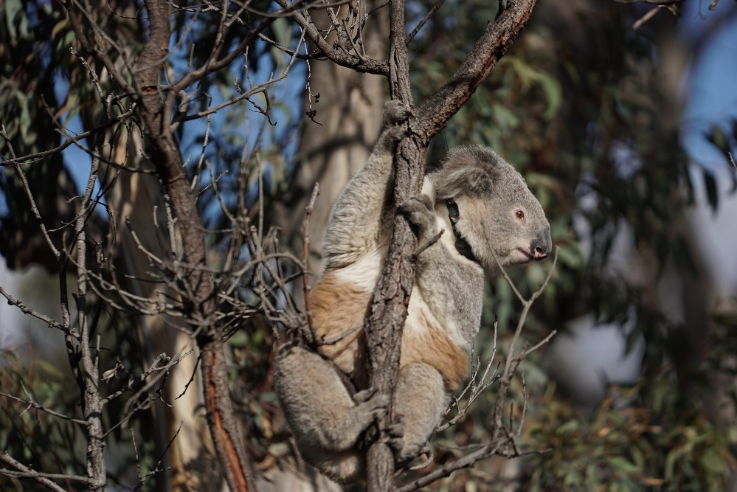
Figure 6. A rehabilitated koala being released. The koala is fitted with a GPS tracking collar to allow monitoring post-release. Photo by James Walsh.

Provision of water
- Provision of water after fire has both benefits in terms of hydration, and risks in terms of predators and disease
A common post-fire intervention aimed at supporting remaining wildlife in situ is the provision of artificial watering stations (for example DPIE, 2021). Although koalas normally obtain most of their water requirements from the moisture in leaves, they will also use automatic refilling water stations in low rainfall landscapes, in particular following periods without rain and on hotter days (Mella et al., 2019). This type of intervention is sometimes also used following fire to supply koalas with supplementary water when trees are defoliated. While providing immediate positive impacts, there are also risks associated, which may be enhanced by aggregation of animals. Artificial watering stations used by koalas have been shown to be contaminated with Chlamydia pathogens, particularly in summer when use is also highest, making them a potential source of disease transmission (Kutiel and Naveh, 1987). Furthermore, they are also frequented by invasive predators such as foxes, which may foster their persistence and may increase rates of predation (Mella et al., 2018, Webb et al., 2022, Roshier et al., 2021).

Tree removal or replanting
- Salvage logging after fire can be detrimental to forest recovery and biodiversity
- Replanting can assist with maintaining eucalypt species diversity under some circumstances
Given the relatively quick resprouting of most eucalypt species from epicormic buds, and that fire does not necessarily render a landscape uninhabitable to koalas, in many landscapes the most appropriate management practice after fire may be hands off. Practices such as salvage logging can impede the recovery of a forest after fire and, where studied, it has a negative impact on biodiversity. Salvage logging has been shown to remove structural complexity such as large trees and tree hollows and this has a detrimental effect on recovery of biodiversity (Lindenmayer and Noss, 2006). It can also impede ecosystem processes such as hydrological regimes and soil erosion and soil nutrient cycling (Lindenmayer and Noss, 2006). Further, while Australian biotas are adapted to fire, the removal of large numbers of trees following fire compounds disturbance and can alter floral and faunal communities towards disturbance adapted species (Au et al., 2019, Lindenmayer and Noss, 2006), although there are exceptions (for example Penman et al., 2009).
Under some circumstances, areas that have been heavily impacted by fire, resulting in extensive loss of mature trees, may benefit from replanting to maintain tree species diversity. The seedlings of some disturbance adapted eucalypt species can outcompete others when left to regenerate without intervention. In extreme situations, usually after repeated disturbance, this can lead to dominance by a single eucalypt species, altering the long-term carrying capacity of habitat for koalas (Au et al., 2019). Replanting to increase or restore eucalypt species diversity may also improve the likelihood that koalas will be able to find adequate food after fire, given that epicormic leaves from some eucalypt species are of poor nutritional quality (K. Marsh and K. Youngentob unpublished data). The best way to undertake revegetation efforts to support koalas is a topic of ongoing research and is covered in more detail in Beale et al. (2022).

Glossary
Term | Definition
Acoustic Array | Sound receiving system with recorders arranged to passively capture certain directional characteristics. For example, used to listen for koala bellows in a particular area to determine presence or absence
Adaptations | Traits in an individual or population that have evolved through natural selection
Ancillary habitat element | Landscape elements such as commonly used shelter vegetation species and the ground that contribute to koala habitat when they co-occur with locally important koala trees
BACI | Before-after-control-impact study design that evaluates the impact of perturbations on an ecological system where treatment sites cannot be randomly chosen
Biota | The animal and plant life of a particular area
Browse | Leaves or foliage for consumption by an animal
Canopy scorch | Burning of the highest levels of the tree
Chlamydia | Sexually transmitted disease of koalas found in many populations which causes infertility, blindness, and urogenital issues.
Connectivity | The connectedness of habitat patches, which is determined by whether a koala is able to move from one habitat patch to another without a barrier.
Cryptic | Relatively difficult to discern or see. Hidden.
Defoliation | Complete removal of the foliage
Digestible Nitrogen | An integrated measure of foliar nutritional quality that considers the influence of tannin-binding on the amount of nitrogen available for digestion by some herbivores.
Disturbance | An event or force that results in a change in the structure of an ecosystem, a loss or organisms, or altered distributions of organisms. For example fire, flood, logging
DPIE | Department of Planning, Industry and Environment (NSW)
Epicormic Regrowth | Juvenile leaves growing from a previously dormant bud on the trunk or branches of a tree
Fire Regime | The frequency, severity, and pattern of fires that prevail in an area over a long period of time
Fitness | Contribution of an individual to the gene pool of the next generation. Reproductive success.
Foliage | The leaves on a tree or shrub
Foliar Chemistry | Chemical composition of leaves in terms of PSMs and nutrients
FPC | Formylated phloroglucinol compounds
Formylated Phloroglucinol Compounds (FPCs) | A specific group of plant secondary metabolites found in some Eucalyptus species from the Symphyomyrtus subgenus known to influence the nutritional quality of browse and feeding by the koala
Fragmentation | The subdivision of a large area of habitat into multiple smaller areas of habitat
Genetic Fingerprint | A set of characteristics in the DNA that are unique to an individual and can be used to identify that individual from a sample
Habitat | the natural home or environment in which a species lives, and which contains the resources, physical and biotic factors that support the survival and reproduction of that species
Habitat Loss | Loss of suitable conditions required for a species to be present in a landscape.
High Severity Fire | Very hot fire that results in scorch of the canopy
Home Range | The area occupied by an individual animal
In situ | Situated in the original place
Invasive | Introduced, not native
Koala Habitat | The biophysical environment required by a koala to survive and reproduce.
KMB | Koala Management Bioregion
Koala Management Bioregion (KMB) | A management unit designated for the purpose of this document, consisting of delineated land areas within New South Wales and Queensland derived from Koala Modelling Regions and Queensland Bioregions in New South Wales (NSW) and Queensland (QLD), respectively
KoRV | Koala Retrovirus
LIKT | Locally Important Koala Trees
Locally Important Koala Trees (LIKT) | Trees from species that are regularly browsed by koalas in a particular KMB, such that it could be considered a substantial portion of the koalas’ diet. Where data from feeding observations or nutritional quality is lacking, then the tree species must be associated with medium or high use by koalas from observations of animals in a tree or scat associations with trees in published literature or from direct feedback from local koala researchers and/or koala carers in the region. See section 3.2 for a more detailed definition
Metapopulation | The set of biological populations within a larger area, where movement or gene flow from one biological population to at least some other patches is possible, even if irregular.
Monocalypt | Common name for eucalypt species from the Eucalyptus (formerly Monocalyptus) subgenus. This is the second largest eucalypt subgenus. Many trees from this subgenus produce a group of plant secondary metabolites called unsubstituted B-ring flavanones (UBFs), which are known to deter feeding by the koala if present in sufficient quantities
Nutritional Quality | A value judgement of the food for the consumer of the food based on the totally composition of the food in terms of nutrients and non-nutrients including PSMs
Palatability | How much leaf an animal will eat (that is total intake of browse)
Physiology | The normal internal functioning of an organism or part of an organism
Plant Secondary Metabolites (PSMs) | Chemical compounds produced by a plant through metabolic pathways, which are not used for primary processes (that is growth and reproduction)
Population | A set of individuals that live in the same habitat patch and interact with one another, commonly forming a breeding unit within which the exchange of genetic material is more or less unrestricted. (synonyms: local population, subpopulation)
Population Density | Number of animals in a given area
Prescribed Burn | A prescribed burn, also known as a controlled burn or a hazard reduction burn, is a fire intentionally created for the purposes of land management
Prognostic Indicator | A characteristic used to estimate the likelihood of recovery from a disease or condition
PSM | Plant secondary metabolite
Refugia | A habitat that provides spatial and/or temporal protection from one or more threats
Rehabilitation | Koalas taken from the natural environment into a care setting to be treated for injury or disease with the goal of rereleasing once healthy
Revegetation | Replanting vegetation
Specialist Folivore | An animal whose diet is restricted and made up only of leaves
Species | Following the EPBC Act (s528), a species is a group of biological entities that (a) interbreed to produce fertile offspring; or (b) possess common characteristics derived from a common gene pool; and includes (c) a sub-species
Spot Assessment | A common method for estimating koala abundance by searching for scats at a tree for a period of time
Symphyomyrtle | The common name for eucalypt species from the Symphyomyrtus subgenus. This is the largest eucalypt subgenus. Many trees from this subgenus make a group of plant secondary metabolites called formylated phloroglucinol compounds (FPCs), which are known to deter feeding by the koala if present in sufficient quantities
Surveys | Observation by a variety of methods of the presence, absence or numbers of an organism in a given area at a given time
Tannin | A common class of plant secondary metabolites found in many plants that can bind to foliar protein and make it unavailable for digestion
UBF | Unsubstituted B-ring flavanones
Unsubstituted B-ring Flavanones (UBFs) | A specific group of plant secondary metabolites found in some Eucalyptus species from the Eucalyptus (formerly Monocalyptus) subgenus and known to influence the nutritional quality of browse and feeding by the koala

References
ALLEN, B. L., CARMELITO, E., AMOS, M., GOULLET, M. S., ALLEN, L. R., SPEED, J., GENTLE, M. & LEUNG, L. K. P. 2016. Diet of dingoes and other wild dogs in peri-urban areas of north-eastern Australia. Scientific Reports, 6, 23028.
ANDREW, R. L., WALLIS, I. R., HARWOOD, C. E. & FOLEY, W. J. 2010. Genetic and environmental contributions to variation and population divergence in a broad-spectrum foliar defence of Eucalyptus tricarpa. Annals of Botany, 105, 707-717.
ANDREW, R. L., WALLIS, I. R., HARWOOD, C. E., HENSON, M. & FOLEY, W. J. 2007. Heritable variation in the foliar secondary metabolite sideroxylonal in Eucalyptus confers cross-resistance to herbivores. Oecologia, 153, 891-901.
ARMENTERAS, D., GONZÁLEZ, T. M. & RETANA, J. 2013. Forest fragmentation and edge influence on fire occurrence and intensity under different management types in Amazon forests. Biological Conservation, 159, 73-79.
ASHMAN, K. R., WATCHORN, D. J. & WHISSON, D. A. 2019. Prioritising research efforts for effective species conservation: a review of 145 years of koala research. Mammal Review, 49, 189-200.
AU, J. 2018. Multi-scale effects of nutrition on an arboreal folivore. PhD Thesis, Australian National University.
AU, J., CLARK, R. G., ALLEN, C., MARSH, K. J., FOLEY, W. J. & YOUNGENTOB, K. N. 2019. A nutritional mechanism underpinning folivore occurrence in disturbed forests. Forest Ecology and Management, 453, 117585.
BEALE, P. 2020. Effects of ambient temperature on feeding by herbivorous marsupials. Doctor of Philosophy, Australian National University.
BEALE, P. K., MARSH, K. J., FOLEY, W. J. & MOORE, B. D. 2018. A hot lunch for herbivores: physiological effects of elevated temperatures on mammalian feeding ecology. Biol Rev Camb Philos Soc, 93, 674-692.
BEALE, P. K., MARSH, K. J. & YOUNGENTOB, K. N. 2022. Revegetating Koala Habitat: Report prepared for DAWE. ANU.
BENNETT, L. T., BRUCE, M. J., MACHUNTER, J., KOHOUT, M., TANASE, M. A. & APONTE, C. 2016. Mortality and recruitment of fire-tolerant eucalypts as influenced by wildfire severity and recent prescribed fire. Forest Ecology and Management, 380, 107-117.
BENTLEY, P. D. & PENMAN, T. D. 2017. Is there an inherent conflict in managing fire for people and conservation? International Journal of Wildland Fire, 26, 455-468.
BEYER, H. L., DE VILLIERS, D., LOADER, J., ROBBINS, A., STIGNER, M., FORBES, N. & HANGER, J. 2018. Management of multiple threats achieves meaningful koala conservation outcomes. Journal of Applied Ecology, 55, 1966-1975.
BODÍ, M. B., MARTIN, D. A., BALFOUR, V. N., SANTÍN, C., DOERR, S. H., PEREIRA, P., CERDÀ, A. & MATAIX-SOLERA, J. 2014. Wildland fire ash: Production, composition and eco-hydro-geomorphic effects. Earth-Science Reviews, 130, 103-127.
BONIER, F., MARTIN, P. R., MOORE, I. T. & WINGFIELD, J. C. 2009. Do baseline glucocorticoids predict fitness? Trends in Ecology & Evolution, 24, 634-642.
BOWMAN, D., WILLIAMSON, G. J., GIBSON, R. K., BRADSTOCK, R. A. & KEENAN, R. J. 2021. The severity and extent of the Australia 2019-20 Eucalyptus forest fires are not the legacy of forest management. Nat Ecol Evol, 5, 1003-1010.
BOWMAN, D. M. J. S. 2000. The fire theory IV. Aboriginal landscape burning. Australian Rainforests: Islands of Green in a Land of Fire. Cambridge: Cambridge University Press.
BRADSTOCK, R. A., HAMMILL, K. A., COLLINS, L. & PRICE, O. 2009. Effects of weather, fuel and terrein on fire severity in topographically diverse landscapes of south-eastern Australia. Landscape Ecology, 25, 607-619.
BRADSTOCK, R. A., WILLIAMS, J. E. & GILL, M. A. 2002. Flammable Australia: the fire regimes and biodiversity of a continent, Cambridge University Press.
BRAITHWAITE, L. W., TURNER, J. & KELLY, J. 1984. Studies on the Arboreal Marsupial Fauna of Eucalypt Forests Being Harvested for Wood Pulp at Eden, N.s.w. Iii. Relationships Between Faunal Densities, Eucalypt Occurrence and Foliage Nutrients, and Soil Parent Materials. Wildlife Research, 11, 41-48.
BRISCOE, N. J., HANDASYDE, K. A., GRIFFITHS, S. R., PORTER, W. P., KROCKENBERGER, A. & KEARNEY, M. R. 2014. Tree-hugging koalas demonstrate a novel thermoregulatory mechanism for arboreal mammals. Biology Letters, 10.
BRISCOE, N. J., KEARNEY, M. R., TAYLOR, C. A. & WINTLE, B. A. 2016. Unpacking the mechanisms captured by a correlative species distribution model to improve predictions of climate refugia. Global Change Biology, 22, 2425-2439.
BRISSON, J. A., STRASBURG, J. L. & TEMPLETON, A. R. 2003. Impact of fire management on the ecology of collared lizard (Crotaphytus collaris) populations living on the Ozark Plateau. Animal Conservation, 6, 247-254.
BURACH, F., POSPISCHIL, A., HANGER, J., LOADER, J., PILLONEL, T., GREUB, G. & BOREL, N. 2014. Chlamydiaceae and Chlamydia-like organisms in the koala (Phascolarctos cinereus)—Organ distribution and histopathological findings. Veterinary Microbiology, 172, 230-240.
BURROWS, G. E. 2002. Epicormic strand structure in Angophora, Eucalyptus and Lophostemon (Myrtaceae) – implications for fire resistance and recovery. New Phytologist, 153, 111-131.
BURROWS, G. E. 2013. Buds, bushfires and resprouting in the eucalypts. Australian Journal of Botany, 61, 331.
BURROWS, N. D. 2008. Linking fire ecology and fire management in south-west Australian forest landscapes. Forest Ecology and Management, 255, 2394-2406.
CACCAMO, G., BRADSTOCK, R., COLLINS, L., PENMAN, T. & WATSON, P. 2015. Using MODIS data to analyse post-fire vegetation recovery in Australian eucalypt forests. Journal of Spatial Science, 60, 341-352.
CHAMBERS, D. P. & ATTIWILL, P. M. 1994. The Ash-Bed Effect in Eucalyptus regnans Forest: Chemical, Physical and Microbiological Changes in Soil After Heating or Partial Sterilisation. Australian Journal of Botany, 42, 739-749.
CHARALAMBOUS, R., SIMONATO, T., PEEL, M. & NARAYAN, E. J. 2021. Physiological Stress in Rescued Wild Koalas (Phascolarctos cinereus) Being Held in a Rehabilitation Sanctuary: A Pilot Study. Animals, 11, 2864.
CHIA, E. K., BASSETT, M., NIMMO, D. G., LEONARD, S. W. J., RITCHIE, E. G., CLARKE, M. F. & BENNETT, A. F. 2015. Fire severity and fire-induced landscape heterogeneity affect arboreal mammals in fire-prone forests. Ecosphere, 6, art190.
CLARKE, P. J., KNOX, K. J., CAMPBELL, M. L. & COPELAND, L. M. 2009. Post-fire recovery of woody plants in the New England Tableland Bioregion. Cunninghamia, 11, 221-239.
CLIFTON, I. D. 2010. High koala mortality associated with low browse moisture in tropical environments. Australian Mammalogy, 32, 157-159.
CLIFTON, I. D., ELLIS, W. A. H., MELZER, A. & TUCKER, G. 2007. Water turnover and the northern range of the koala (Phascolarctos cinereus). Australian Mammalogy, 29, 85-88.
CLOSE, D. C., DAVIDSON, N. J. & SWANBOROUGH, P. W. 2011a. Fire history and understorey vegetation: Water and nutrient relations of Eucalyptus gomphocephala and E. delegatensis overstorey trees. Forest Ecology and Management, 262, 208-214.
CLOSE, D. C., DAVIDSON, N. J., SWANBOROUGH, P. W. & CORKREY, R. 2011b. Does low-intensity surface fire increase water-and nutrient-availability to overstorey Eucalyptus gomphocephala? Plant and Soil, 349, 203-214.
COLLINS, L., BENNETT, A. F., LEONARD, S. W. J. & PENMAN, T. D. 2019. Wildfire refugia in forests: Severe fire weather and drought mute the influence of topography and fuel age. Glob Chang Biol, 25, 3829-3843.
CRISP, M. D., BURROWS, G. E., COOK, L. G., THORNHILL, A. H. & BOWMAN, D. M. J. S. 2011. Flammable biomes dominated by eucalypts originated at the Cretaceous–Palaeogene boundary. Nature Communications, 2, 193.
CRISTESCU, R. H., BANKS, P. B., CARRICK, F. N. & FRÈRE, C. 2013. Potential ‘Ecological Traps’ of Restored Landscapes: Koalas Phascolarctos cinereus Re-Occupy a Rehabilitated Mine Site. PLOS ONE, 8, e80469.
CRISTESCU, R. H., GARDINER, R., TERRAUBE, J., MCDONALD, K., POWELL, D., LEVENGOOD, A. L. & FRÈRE, C. H. 2021. Difficulties of assessing the impacts of the 2019–2020 bushfires on koalas. Austral ecology.
CROWTHER, M. S., LUNNEY, D., LEMON, J., STALENBERG, E., WHEELER, R., MADANI, G., ROSS, K. A. & ELLIS, M. 2014. Climate‐mediated habitat selection in an arboreal folivore. Ecography, 37, 336-343.
CURTIN, A., LUNNEY, D. & MATTHEWS, A. 2001. A survey of a low-density koala population in a major reserve system, near Sydney, New South Wales. Australian Mammalogy, 23, 135-144.
DAVIES, N., GRAMOTNEV, G., SEABROOK, L., BRADLEY, A., BAXTER, G., RHODES, J., LUNNEY, D. & MCALPINE, C. 2013. Movement patterns of an arboreal marsupial at the edge of its range: a case study of the koala. Movement Ecology, 1, 8.
DAVIES, N., GRAMOTNEV, G., SEABROOK, L., MCALPINE, C., BAXTER, G., LUNNEY, D. & BRADLEY, A. 2014. Climate-driven changes in diet composition and physiological stress in an arboreal folivore at the semi-arid edge of its distribution. Biological Conservation, 172, 80-88.
DEGABRIEL, J. L., MOORE, B. D., FOLEY, W. J. & JOHNSON, C. N. 2009. The effects of plant defensive chemistry on nutrient availability predict reproductive success in a mammal. Ecology, 90, 711-719.
DEGABRIEL, J. L., WALLIS, I. R., MOORE, B. D. & FOLEY, W. J. 2008. A simple, integrative assay to quantify nutritional quality of browses for herbivores. Oecologia, 156, 107-16.
DEGABRIELE, R. & DAWSON, T. J. 1979. Metabolism and heat balance in an arboreal marsupial, the koala (Phascolarctos cinereus). Journal of Comparative Physiology, 134, 293-301.
DEPARTMENT FOR ENVIRONMENT AND WATER SOUTH AUSTRALIA. 2020. Kangaroo Island Bushfires, 2019-2020 [Online]. Available: www.arcgis.com/apps/Cascade/index.html?appid=ef29c850d8e34e98a8307dbdfe0aaaab [Accessed 28 June 2022].
DEPARTMENT OF AGRICULTURE WATER AND THE ENVIRONMENT 2022. Conservation Advice for Phascolarctos cinereus (Koala) combined populations of Queensland, New South Wales and the Australian Capital Territory.
DORAN, J. C. & BELL, R. E. 1994. Influence of non-genetic factors on yield of monoterpenes in leaf oils of Eucalyptus camaldulensis. New Forests, 8, 363-379.
DPI. 2022. Monitoring Koalas in Hinterland Forests of Northeast NSW and the effect of 2019 fires on the meta-population. Available: https://www.dpi.nsw.gov.au/forestry/science/forest-ecology/koala-research-in-nsw-forests [Accessed 15 June 2022].
DPIE 2018. A review of koala tree use across New South Wales.
DPIE 2020a. Framework for the spatial prioritisation of koala conservation actions in NSW. Sydney, NSW: Department of Planning, Industry and Environment, NSW Government.
DPIE 2020b. NSW Fire and the Environment 2019–20 Summary: Biodiversity and landscape data and analyses to understand the effects of the fire events. Department of Planning, Industry and Environment.
DPIE 2021. NSW Wildlife and Conservation Bushfire Recovery: Medium-term response plan.
DUNSTAN, E., FUNNELL, O., MCLELLAND, J., STOECKELER, F., NISHIMOTO, E., MITCHELL, D., MITCHELL, S., MCLELLAND, D. J., KALVAS, J., JOHNSON, L., MOORE, C., EYRE, L. J. M., MCLUNE, A., HOUGH, I., VALENZA, L., BOARDMAN, W. S. J., SMITH, I. & SPEIGHT, N. 2021. An analysis of demographic and triage assessment findings in bushfire-affected koalas (Phascolarctos cinereus) on kangaroo island, south australia, 2019–2020. Animals (Basel), 11, 3237.
ELLIS, W., MELZER, A., CLIFTON, I. & CARRICK, F. 2010. Climate change and the koala Phascolarctos cinereus: water and energy. Australian Zoologist, 35, 369-377.
ENRIGHT, N., KEITH, D. A., CLARKE, M. F. & MILLER, B. P. 2012. Fire regimes in Australian sclerophyllous shrubby ecosystems: heathlands, heathy woodlands and mallee woodlands. Flammable Australia: Fire Regimes and Biodiversity in a Changing World. Melbourne: CSIRO Publishing, 215-235.
ESTES, B. L., KNAPP, E. E., SKINNER, C. N., MILLER, J. D. & PREISLER, H. K. 2017. Factors influencing fire severity under moderate burning conditions in the Klamath Mountains, northern California, USA. Ecosphere, 8, e01794.
GALLAHAR, N., LEIGH, K. & PHALEN, D. 2021. Koala tree selection in a mixed-tenure landscape and post-fire implications. Wildlife Research, 48, 737-755.
GEARY, W. L., DOHERTY, T. S., NIMMO, D. G., TULLOCH, A. I. T. & RITCHIE, E. G. 2020. Predator responses to fire: A global systematic review and meta-analysis. Journal of Animal Ecology, 89, 955-971.
GILL, A. M. 1978. Crown Recovery of Eucalyptus dives Following Wildfire. Australian Forestry, 41, 207-214.
GILL, A. M. 2012. Bushfires and biodiversity in southern Australian forests, CSIRO Publishing: Melbourne, Australia.
GLEADOW, R. M., FOLEY, W. J. & WOODROW, I. E. 2002. Enhanced CO2 alters the relationship between photosynthesis and defence in cyanogenic Eucalyptus cladocalyx F. Muell. Plant, Cell & Environment, 21, 12-22.
GODFREE, R. C., KNERR, N., ENCINAS-VISO, F., ALBRECHT, D., BUSH, D., CHRISTINE CARGILL, D., CLEMENTS, M., GUEIDAN, C., GUJA, L. K., HARWOOD, T., JOSEPH, L., LEPSCHI, B., NARGAR, K., SCHMIDT-LEBUHN, A. & BROADHURST, L. M. 2021. Implications of the 2019–2020 megafires for the biogeography and conservation of Australian vegetation. Nature Communications, 12, 1023.
GORDON, G., BROWN, A. S. & PULSFORD, T. 1988. A koala (Phascolarctos cinereus Goldfuss) population crash during drought and heatwave conditions in south-western Queensland. Australian Journal of Ecology, 13, 451-461.
GRAS, E. K., READ, J., MACH, C. T., SANSON, G. D. & CLISSOLD, F. J. 2005. Herbivore damage, resource richness and putative defences in juvenile versus adult Eucalyptus leaves. Australian Journal of Botany, 53, 33-44.
GRIFFITHS, A. D., GARNETT, S. T. & BROOK, B. W. 2015. Fire frequency matters more than fire size: Testing the pyrodiversity–biodiversity paradigm for at-risk small mammals in an Australian tropical savanna. Biological Conservation, 186, 337-346.
HAMER, J. J., VENEKLAAS, E. J., RENTON, M. & POOT, P. 2016. Links between soil texture and root architecture of Eucalyptus species may limit distribution ranges under future climates. Plant and soil, 403, 217-229.
HE, T., LAMONT, B. B. & PAUSAS, J. G. 2019. Fire as a key driver of Earth's biodiversity. Biological Reviews, 94, 1983-2010.
HEATH, J. T., CHAFER, C. J., BISHOP, T. F. A. & VAN OGTROP, F. F. 2016. Post-Fire Recovery of Eucalypt-Dominated Vegetation Communities in the Sydney Basin, Australia. Fire Ecology, 12, 53-79.
HERZOG, N. M., KEEFE, E. R., PARKER, C. H. & HAWKES, K. 2016. What's burning got to do with it? Primate foraging opportunities in fire-modified landscapes. American Journal of Physical Anthropology, 159, 432-441.
HERZOG, N. M., PARKER, C. H., KEEFE, E. R., COXWORTH, J., BARRETT, A. & HAWKES, K. 2014. Fire and home range expansion: A behavioral response to burning among savanna dwelling vervet monkeys (Chlorocebus aethiops). American Journal of Physical Anthropology, 154, 554-560.
HING, S., NARAYAN, E. J., THOMPSON, R. C. A. & GODFREY, S. S. 2016. The relationship between physiological stress and wildlife disease: consequences for health and conservation. Wildlife Research, 43, 51-60.
HISLOP, S., STONE, C., HAYWOOD, A. & SKIDMORE, A. 2020. The effectiveness of fuel reduction burning for wildfire mitigation in sclerophyll forests. Australian Forestry, 83, 255-264.
HOWEY, C. A. F., DICKINSON, M. B. & ROOSENBURG, W. M. 2016. Effects of a Landscape Disturbance on the Habitat Use and Behavior of the Black Racer. Copeia, 104, 853-863.
HRADSKY, B. A., MILDWATERS, C., RITCHIE, E. G., CHRISTIE, F. & DI STEFANO, J. 2017. Responses of invasive predators and native prey to a prescribed forest fire. Journal of Mammalogy, 98, 835-847.
HUMPHREYS, F. R. & LAMBERT, M. J. 1965. An examination of a forest site which has exhibited the ash-bed effect. Soil Research, 3, 81-94.
JAMES, S. E. & M'CLOSKEY, R. T. 2003. Lizard microhabitat and fire fuel management. Biological Conservation, 114, 293-297.
JURSKIS, V. 2017. Ecological history of the koala and implications for management. Wildlife Research, 44, 471-483.
KAVANAGH, R. P. & STANTON, M. A. 2012. Koalas use young Eucalyptus plantations in an agricultural landscape on the Liverpool Plains, New South Wales. Ecological Management & Restoration, 13, 297-305.
KEELEY, J. E. 2009. Fire intensity, fire severity and burn severity: a brief review and suggested usage. International Journal of Wildland Fire, 18, 116-126.
KUTIEL, P. & NAVEH, Z. 1987. Soil properties beneath Pinus halepensis and Quercus calliprinos trees on burned and unburned mixed forest on Mt. Carmel, Israel. Forest Ecology and Management, 20, 11-24.
LAW, B., CACCAMO, G., ROE, P., TRUSKINGER, A., BRASSIL, T., GONSALVES, L., MCCONVILLE, A. & STANTON, M. 2017. Development and field validation of a regional, management-scale habitat model: A koala Phascolarctos cinereus case study. Ecology and Evolution, 7, 7475-7489.
LAW, B., KERR, I., GONSALVES, L., BRASSIL, T., EICHINSKI, P., TRUSKINGER, A. & ROE, P. 2022a. Mini-acoustic sensors reveal occupancy and threats to koalas Phascolarctos cinereus in private native forests. Journal of Applied Ecology, 59, 835-846.
LAW, B. S., BRASSIL, T., GONSALVES, L., ROE, P., TRUSKINGER, A. & MCCONVILLE, A. 2018. Passive acoustics and sound recognition provide new insights on status and resilience of an iconic endangered marsupial (koala Phascolarctos cinereus) to timber harvesting. PLOS ONE, 13, e0205075.
LAW, B. S., GONSALVES, L., BURGAR, J., BRASSIL, T., KERR, I. & O’LOUGHLIN, C. 2022b. Fire severity and its local extent are key to assessing impacts of Australian mega-fires on koala (Phascolarctos cinereus) density. Global Ecology and Biogeography, 31, 714-726.
LEAHY, L., LEGGE, S. M., TUFT, K., MCGREGOR, H. W., BARMUTA, L. A., JONES, M. E. & JOHNSON, C. N. 2016. Amplified predation after fire suppresses rodent populations in Australia’s tropical savannas. Wildlife Research, 42, 705-716.
LEE, K. E., ELLIS, W. A. H., CARRICK, F. N., CORLEY, S. W., JOHNSTON, S. D., BAVERSTOCK, P. R., NOCK, C. J., ROWE, K. C. & SEDDON, J. M. 2013. Anthropogenic changes to the landscape resulted in colonization of koalas in north-east New South Wales, Australia. Austral Ecology, 38, 355-363.
LEICACH, S. R., GARAU, A. M., GUARNASCHELLI, A. B., YABER GRASS, M. A., SZTARKER, N. D. & DATO, A. 2010. Changes in Eucalyptus camaldulensis essential oil composition as response to drought preconditioning. Journal of Plant Interactions, 5, 205-210.
LINDENMAYER, D., BLANCHARD, W., MCBURNEY, L., BOWD, E., YOUNGENTOB, K., MARSH, K. & TAYLOR, C. 2022. Stand age related differences in forest microclimate. Forest Ecology and Management, 510, 120101.
LINDENMAYER, D. B., HOBBS, R. J., LIKENS, G. E., KREBS, C. J. & BANKS, S. C. 2011. Newly discovered landscape traps produce regime shifts in wet forests. Proceedings of the National Academy of Sciences, 108, 15887-15891.
LINDENMAYER, D. B. & NOSS, R. F. 2006. Salvage Logging, Ecosystem Processes, and Biodiversity Conservation. Conservation Biology, 20, 949-958.
LUNNEY, D., COPE, H., SONAWANE, I. & HAERING, R. 2022a. A state-wide picture of koala rescue and rehabilitation in New South Wales during the 2019–2020 bushfires. Australian Zoologist.
LUNNEY, D., COPE, H., SONAWANE, I., STALENBERG, E. & HAERING, R. 2022b. An analysis of the long-term trends in the records of Friends of the Koala in north-east New South Wales: I. Cause and fate of koalas admitted for rehabilitation (1989–2020). Pacific Conservation Biology, -.
LUNNEY, D., COPE, H., SONAWANE, I., STALENBERG, E. & HAERING, R. 2022c. An analysis of the long-term trends in the records of Friends of the Koala in north-east New South Wales: II. Post-release survival. Pacific Conservation Biology, -.
LUNNEY, D., CROWTHER, M. S., WALLIS, I. R., FOLEY, W. J., LEMON, J., WHEELER, R., MADANI, G., ORSCHEG, C., GRIFFITH, J. E., KROCKENBERGER, M. & RETAMALES, M. 2012. Koalas and climate change: a case study on the Liverpool Plains, north-west New South Wales. In: LUNNEY, D. & HUTCHINGS, P. (eds.) Wildlife and Climate Change: Towards Robust Conservation Strategies for Australian Fauna. Mosman, NSW, Australia: Royal Zoological Society of NSW.
LUNNEY, D., GRESSER, S., E. O'NEILL, L., MATTHEWS, A. & RHODES, J. 2007. The impact of fire and dogs on Koalas at Port Stephens, New South Wales, using population viability analysis. Pacific Conservation Biology, 13, 189-201.
LUNNEY, D., GRESSER, S. M., MAHON, P. S. & MATTHEWS, A. 2004. Post-fire survival and reproduction of rehabilitated and unburnt koalas. Biological Conservation, 120, 567-575.
LUNNEY, D., O'NEILL, L., MATTHEWS, A. & SHERWIN, W. B. 2002. Modelling mammalian extinction and forecasting recovery: koalas at Iluka (NSW, Australia). Biological Conservation, 106, 101-113.
LUNNEY, D., SONAWANE, I., WHEELER, R., TASKER, E., ELLIS, M., PREDAVEC, M. & FLEMING, M. 2020. An ecological reading of the history of the koala population of the Warrumbungle National Park. Open Journals.
LUNNEY, D., STALENBERG, E., SANTIKA, T. & RHODES, J. R. 2017. A rebuttal to ‘Mooted extinction of koalas at Eden: improving the information base’. Wildlife Research, 44, 453-457.
LUNNEY, D., WELLS, A. & MILLER, I. An ecological history of the koala'Phascolarctos cinereus' in coffs harbour and its environs, on the mid-north coast of New South Wales, c1861-2000. Proceedings of the Linnean Society of New South Wales, 2016. 1-48.
MARSH, K. J., BLYTON, M. D. J., FOLEY, W. J. & MOORE, B. D. 2021. Fundamental dietary specialisation explains differential use of resources within a koala population. Oecologia, 196, 795-803.
MARSH, K. J., MOORE, B. D., WALLIS, I. R. & FOLEY, W. J. 2014. Feeding rates of a mammalian browser confirm the predictions of a 'foodscape' model of its habitat. Oecologia, 174, 873-82.
MARSH, K. J., SARAF, I., HOCART, C. H., YOUNGENTOB, K., SINGH, I.-P. & FOLEY, W. J. 2019. Occurrence and distribution of unsubstituted B-ring flavanones in Eucalyptus foliage. Phytochemistry, 160, 31-39.
MARSH, K. J., WARD, J., WALLIS, I. R. & FOLEY, W. J. 2018. Intraspecific variation in nutritional composition affects the leaf age preferences of a mammalian herbivore. Journal of Chemical Ecology, 44, 62-71.
MARTIN, R. & HANDASYDE, K. 1999. The koala: natural history, conservation and management, UNSW Press.
MATTHEWS, A., LUNNEY, D., GRESSER, S. & MAITZ, W. 2007. Tree use by koalas (Phascolarctos cinereus) after fire in remnant coastal forest. Wildlife Research, 34, 84-93.
MATTHEWS, A., LUNNEY, D., GRESSER, S. & MAITZ, W. 2016. Movement patterns of koalas in remnant forest after fire. Australian Mammalogy, 38, 91-104.
MCALPINE, C., LUNNEY, D., MELZER, A., MENKHORST, P., PHILLIPS, S., PHALEN, D., ELLIS, W., FOLEY, W., BAXTER, G., DE VILLIERS, D., KAVANAGH, R., ADAMS-HOSKING, C., TODD, C., WHISSON, D., MOLSHER, R., WALTER, M., LAWLER, I. & CLOSE, R. 2015. Conserving koalas: A review of the contrasting regional trends, outlooks and policy challenges. Biological Conservation, 192, 226-236.
MCART, S. H., SPALINGER, D. E., COLLINS, W. B., SCHOEN, E. R., STEVENSON, T. & BUCHO, M. 2009. Summer dietary nitrogen availability as a potential bottom-up constraint on moose in south-central Alaska. Ecology, 90, 1400-11.
MCARTHUR, C., MARSH, N. R., CLOSE, D. C., WALSH, A., PATERSON, S., FITZGERALD, H. & DAVIES, N. W. 2003. Nursery conditions affect seedling chemistry, morphology and herbivore preferences for Eucalyptus nitens. Forest Ecology and Management, 176, 585-594.
MCCAW, W. L., SMITH, R. H. & NEAL, J. E. 1994. Stem damage and crown recovery following high intensity fire in a 16-year-old stand of Eucalyptus diversicolor and Eucalyptus muellerana. Australian Forestry, 57, 76-81.
MELLA, V. S. A., MCARTHUR, C., FREND, R. & CROWTHER, M. S. 2018. Foxes in trees: a threat for Australian arboreal fauna? Australian Mammalogy, 40, 103-105.
MELLA, V. S. A., MCARTHUR, C., KROCKENBERGER, M. B., FREND, R. & CROWTHER, M. S. 2019. Needing a drink: Rainfall and temperature drive the use of free water by a threatened arboreal folivore. PLOS ONE, 14, e0216964.
MELZER, A. & ELLIS, W. 2009. Integrating Research and Conservation Land Management - a Case Study from Koala Research in St Bees Island National Park, Environment Institute of Australia and New Zealand.
MOORE, B. D., FOLEY, W. J., WALLIS, I. R., COWLING, A. & HANDASYDE, K. A. 2005. Eucalyptus foliar chemistry explains selective feeding by koalas. Biology letters, 1, 64-67.
MOORE, B. D., LAWLER, I. R., WALLIS, I. R., BEALE, C. M. & FOLEY, W. J. 2010. Palatability mapping: a koala's eye view of spatial variation in habitat quality. Ecology, 91, 3165-3176.
MOORE, B. D., WALLIS, I. R., WOOD, J. T. & FOLEY, W. J. 2004. Foliar nutrition, site quality, and temperature influence foliar chemistry of tallowwood (Eucalyptus microcorys). Ecological Monographs, 74, 553-568.
MORRISON, D. A., CARY, G. J., PENGELLY, S. M., ROSS, D. G., MULLINS, B. J., THOMAS, C. R. & ANDERSON, T. S. 1995. Effects of fire frequency on plant species composition of sandstone communities in the Sydney region: Inter-fire interval and time-since-fire. Australian Journal of Ecology, 20, 239-247.
NARAYAN, E. 2019. Physiological stress levels in wild koala sub-populations facing anthropogenic induced environmental trauma and disease. Scientific Reports, 9, 6031.
NARAYAN, E. & VANDERNEUT, T. 2019. Physiological Stress in Rescued Wild Koalas Are Influenced by Habitat Demographics, Environmental Stressors, and Clinical Intervention. Frontiers in Endocrinology, 10.
NARAYAN, E. J. & WILLIAMS, M. 2016. Understanding the dynamics of physiological impacts of environmental stressors on Australian marsupials, focus on the koala (Phascolarctos cinereus). BMC Zoology, 1, 2.
NEARY, D. G., KLOPATEK, C. C., DEBANO, L. F. & FFOLLIOTT, P. F. 1999. Fire effects on belowground sustainability: a review and synthesis. FOREST ECOLOGY AND MANAGEMENT, 122, 51-71.
NOLAN, R. H., COLLINS, L., LEIGH, A., OOI, M. K. J., CURRAN, T. J., FAIRMAN, T. A., RESCO DE DIOS, V. & BRADSTOCK, R. 2021. Limits to post-fire vegetation recovery under climate change. Plant, Cell & Environment, 44, 3471-3489.
OOI, M. K. J., AULD, T. D. & WHELAN, R. J. 2004. Delayed post-fire seedling emergence linked to season: a case study with Leucopogon species (Epacridaceae). Plant Ecology, 174, 183-196.
PAGLIARANI, S., JOHNSTON, S., PYNE, M., BOOTH, R., HULSE, L., BEAGLEY, K. & PALMIERI, C. 2020. Chlamydia pecorum Infection in the Reproductive Tract of Female Koalas (Phascolarctos cinereus). Journal of Comparative Pathology, 174, 189.
PARROTT, M. L., WICKER, L. V., LAMONT, A., BANKS, C., LANG, M., LYNCH, M., MCMEEKIN, B., MILLER, K. A., RYAN, F., SELWOOD, K. E., SHERWEN, S. L. & WHITEFORD, C. 2021. Emergency Response to Australia’s Black Summer 2019–2020: The Role of a Zoo-Based Conservation Organisation in Wildlife Triage, Rescue, and Resilience for the Future. Animals, 11.
PASTRO, L. A., DICKMAN, C. R. & LETNIC, M. 2011. Burning for biodiversity or burning biodiversity? Prescribed burn vs. wildfire impacts on plants, lizards, and mammals. Ecological Applications, 21, 3238-3253.
PAUSAS, J. G. & KEELEY, J. E. 2017. Epicormic Resprouting in Fire-Prone Ecosystems. Trends in Plant Science, 22, 1008-1015.
PENMAN, T. D., BEUKERS, M., KAVANAGH, R. P. & DOHERTY, M. 2011. Are long-unburnt eucalypt forest patches important for the conservation of plant species diversity? Applied Vegetation Science, 14, 172-180.
PENMAN, T. D., BINNS, D. L. & KAVANAGH, R. P. 2009. Patch-Occupancy Modeling as a Method for Monitoring Changes in Forest Floristics: A Case Study in Southeastern Australia. Conservation Biology, 23, 740-749.
PENMAN, T. D., COLLINS, L., DUFF, T., PRINCE, O. & CARY, G. J. 2020. Scientific evidence regarding effectiveness of prescribed burning. In: LEAVESLEY, A., WOUTERS, M. & THORNTON, R. (eds.) Prescribed Burning in Australasia: The Science, Practice and Politics of Burning the Bush. AFAC Ltd.
PHILLIPS, S., QUIGLEY, B. L., AZIZ, A., BERGEN, W., BOOTH, R., PYNE, M. & TIMMS, P. 2019. Antibiotic treatment of Chlamydia-induced cystitis in the koala is linked to expression of key inflammatory genes in reactive oxygen pathways. PLOS ONE, 14, e0221109.
PHILLIPS, S., WALLIS, K. & LANE, A. 2021. Quantifying the impacts of bushfire on populations of wild koalas (Phascolarctos cinereus): Insights from the 2019/20 fire season. Ecological management & restoration, 22, 80-88.
POLKINGHORNE, A., HANGER, J. & TIMMS, P. 2013. Recent advances in understanding the biology, epidemiology and control of chlamydial infections in koalas. Veterinary Microbiology, 165, 214-223.
PRICE, O. H., NOLAN, R. H. & SAMSON, S. A. 2022. Fuel consumption rates in resprouting eucalypt forest during hazard reduction burns, cultural burns and wildfires. Forest Ecology and Management, 505, 119894.
QUIGLEY, B. L. & TIMMS, P. 2020. Helping koalas battle disease – Recent advances in Chlamydia and koala retrovirus (KoRV) disease understanding and treatment in koalas. FEMS Microbiology Reviews, 44, 583-605.
RAISON, R. J. 1979. Modification of the soil environment by vegetation fires, with particular reference to nitrogen transformations: A review. Plant and Soil, 51, 73-108.
RAISON, R. J., KHANNA, P. K., JACOBSEN, K. L., ROMANYA, J. & SERRASOLSES, I. 2009. Effect of fire on forest nutrient cycles. Fire effects on soils and restoration strategies. Science Publishers, 225-256.
RECKLESS, H. J., MURRAY, M. & CROWTHER, M. S. 2017. A review of climatic change as a determinant of the viability of koala populations. Wildlife Research 44, 458-470.
RHODES, J. R., NG, C. F., DE VILLIERS, D. L., PREECE, H. J., MCALPINE, C. A. & POSSINGHAM, H. P. 2011. Using integrated population modelling to quantify the implications of multiple threatening processes for a rapidly declining population. Biological Conservation, 144, 1081-1088.
ROSHIER, D. A., SIGNER, J. & CARTER, A. 2021. Visitation of artificial watering points by the red fox (Vulpes vulpes) in semiarid Australia. Ecology and Evolution, 11, 9815-9826.
SAMARAWICKRAMA, A. Unpublished Research. The effect of cultural burns on koala density, habitat characteristics and stress levels on Minjerribah, North Stradbroke Island. Master of Science (Research), University of the Sunshine Coast.
SANTAMARIA, F., PALME, R., SCHLAGLOTH, R., KLOBETZ-RASSAM, E. & HENNING, J. 2021. Seasonal Variations of Faecal Cortisol Metabolites in Koalas in South East Queensland. Animals, 11, 1622.
SANTÍN, C., OTERO, X. L., DOERR, S. H. & CHAFER, C. J. 2018. Impact of a moderate/high-severity prescribed eucalypt forest fire on soil phosphorous stocks and partitioning. Science of The Total Environment, 621, 1103-1114.
SHAKESBY, R. A., BENTO, C. P. M., FERREIRA, C. S. S., FERREIRA, A. J. D., STOOF, C. R., URBANEK, E. & WALSH, R. P. D. 2015. Impacts of prescribed fire on soil loss and soil quality: An assessment based on an experimentally-burned catchment in central Portugal. CATENA, 128, 278-293.
SPENCE, R. 2020. Long-term implications to koala populations in New South Wales follwing the 2019-2020 wildfires: Consequences of a climate-driven shift in the fire regime. Honours thesis, University of Melbourne.
TAYLOR, C., BLANCHARD, W. & LINDENMAYER, D. B. 2021. Does forest thinning reduce fire severity in Australian eucalypt forests? Conservation Letters, 14, e12766.
TAYLOR, C., MCCARTHY, M. A. & LINDENMAYER, D. B. 2014. Nonlinear Effects of Stand Age on Fire Severity. Conservation Letters, 7, 355-370.
TOBERMAN, H., CHEN, C., LEWIS, T. & ELSER, J. J. 2014. High-frequency fire alters C : N : P stoichiometry in forest litter. Global Change Biology, 20, 2321-2331.
TULAU, M. J. 2015. Fire and Soils. A review of the potential impacts of different fire regimes on soil erosion and sedimentation, nutrient and carbon cycling, and impacts on water quantity and quality. . OEH.
TURNER, J., LAMBERT, M., JURSKIS, V. & BI, H. 2008. Long term accumulation of nitrogen in soils of dry mixed eucalypt forest in the absence of fire. Forest Ecology and Management, 256, 1133-1142.
VIVIAN, L., CARY, G., BRADSTOCK, R. & GILL, A. 2008. Influence of fire severity on the regeneration, recruitment and distribution of eucalypts in the Cotter River Catchment, Australian Capital Territory. Austral Ecology, 33, 55-67.
WALLIS, R. 2013. Koalas Phascolarctos cinereus in Framlingham Forest, south-west Victoria : Introduction, translocation and the effects of a bushfire.
WANG, L. & FU, Q. 2020. Soil quality assessment of vegetation restoration after a large forest fire in Daxing’anling, northeast China. Canadian Journal of Soil Science, 100, 162-174.
WARDELL-JOHNSON, G. W. 2000. Responses of forest eucalypts to moderate and high intensity fire in the Tingle Mosaic, south-western Australia: comparisons between locally endemic and regionally distributed species. Austral Ecology, 25, 409-421.
WEBB, E. B., MCARTHUR, C., WOOLFENDEN, L., HIGGINS, D. P., KROCKENBERGER, M. B. & MELLA, V. S. A. 2022. Risk of predation and disease transmission at artificial water stations. Wildlife Research, -.
WEISS, S. L. & BROWER, R. M. 2021. Wildfire as a natural stressor and its effect on female phenotype and ornament development. Ecology and Evolution, 11, 6223-6232.
WILD, K. H. & GIENGER, C. M. 2018. Fire-disturbed landscapes induce phenotypic plasticity in lizard locomotor performance. Journal of Zoology, 305, 96-105.
WILLIAMS, R. J. 1995. Tree mortality in relation to fire intensity in a tropical savanna of the Kakadu region, Northern Territory, Australia. . CALMscience Supplement. 4, 4, 77-82.
WINTLE, B. A., LEGGE, S. & WOINARSKI, J. C. Z. 2020. After the Megafires: What Next for Australian Wildlife? Trends in Ecology & Evolution, 35, 753-757.
WRIGHT, B. R. & CLARKE, P. J. 2007. Resprouting responses of Acacia shrubs in the Western Desert of Australia fire severity, interval and season influence survival. International Journal of Wildland Fire, 16, 317-323.
YOUNGENTOB, K. N., LINDENMAYER, D. B., MARSH, K. J., KROCKENBERGER, A. K. & FOLEY, W. J. 2021a. Food intake: an overlooked driver of climate change casualties? Trends in Ecology & Evolution, 36, 676-678.
YOUNGENTOB, K. N., MARSH, K. J. & SKEWES, J. 2021b. A review of koala habitat assessment criteria and methods, report prepared for the Department of Agriculture, Water and the Environment, Canberra, November. CC BY 4.0.
ZALD, H. S. J. & DUNN, C. J. 2018. Severe fire weather and intensive forest management increase fire severity in a multi-ownership landscape. Ecological Applications, 28, 1068-1080.
ZYLSTRA, P., BRADSTOCK, R. A., BEDWARD, M., PENMAN, T. D., DOHERTY, M. D., WEBER, R. O., GILL, A. M. & CARY, G. J. 2016. Biophysical Mechanistic Modelling Quantifies the Effects of Plant Traits on Fire Severity: Species, Not Surface Fuel Loads, Determine Flame Dimensions in Eucalypt Forests. PLOS ONE, 11, e0160715.
ZYLSTRA, P. J. 2018. Flammability dynamics in the Australian Alps. Austral Ecology, 43, 578-591.
ZYLSTRA, P. J., BRADSHAW, S. D. & LINDENMAYER, D. B. 2022. Self-thinning forest understoreys reduce wildfire risk, even in a warming climate. Environmental Research Letters, 17, 044022.

