Environment Protection and Biodiversity Conservation Act 1999

Environment Assessment Manual

Implementing Chapter 4, EPBC Act

This manual is intended for use by staff of the Department of Sustainability, Environment, Water, Population & Communities. It should not be relied upon by any other person. This manual does not represent legal or professional advice. The policies and procedures included in this manual are intended to serve as guidance only and should be applied in conjunction with the requirements of the Environment Protection and Biodiversity Conservation Act 1999 (EPBC Act) and the Environment Protection and Biodiversity Conservation Regulations 2000 (EPBC Regulations), which must always prevail.
Amendments to the EPBC Act were introduced in February 2007. Projects that were determined to be controlled actions before 19 February 2007 will be assessed under pre – amendment processes and related legal requirements unless the minister has approved their transition.
On 25 November 2009, the Great Barrier Reef Marine Park became the eighth matter of national environmental significance under the EPBC Act. Any project that was the subject of an active referral before 25 November 2009 will be assessed under pre – amendments processes and legal requirements unless the person chooses to withdraw and resubmit their referral.

Contents
Process outline
Overview
Managing the project through the assessment process
Principles of effective environmental assessment
General operating principles
Glossary
1 Receive
1A Initiate processing
1B Is the referral valid?
1C Is the proposed action part of a larger project?
1D Is the proposed action related to another action?
1E Is the proposed action in, or partly within, the Great Barrier Reef Marine Park?
1F Establish administrative records
1G Invite comments from external stakeholders
1H Handover to Assessment Section
2 Determine
2A Who should provide advice from within the Portfolio?
2B Is there a likelihood of significant impact on matters protected under the EPBC Act?
2C Have the public, ministers or internal advice areas suggested possible impacts on protected matters?
2D Is more information needed to make a decision?
2E Could the action have a significant impact on anything protected by the Act?
2F Is the action clearly unacceptable?
2G Has the proponent provided an effective way of avoiding or reducing the impact?
2H How should the controlled action be assessed?
2I Finalise recommendation for decision maker
2J Communicate the decision and pass on information
2K Requests for ‘statement of reasons’
2L Requests for reconsideration of referral decision
2M Variations to a referral
2N Changes of a person proposing to take the action
2O Lapsed proposals
2P Withdrawn proposals
3 Assess & Recommend
An overview of the assessment process
(i) Understand the proposed action
(ii) Investigate the likely impact to the environment
(iii) Decide what impacts might be acceptable
(iv) Consider options
(v) Recommend conditions
(vi) Finalise the recommendation
(vii) How to check environmental history
(viii) The ‘no’ case
(ix)What to do if you do not have enough information
3A Assessment on referral information
3B Assessment on preliminary documentation
3C Assessment by Public Environment Report (PER) or Environmental Impact Statement (EIS)
3D Assessment by bilateral or accredited process
3E Assessment by Public Inquiry
3F Administrative procedures
3G Variations to a proposal
3H Changes of a person proposing to take the action
3I Lapsed proposals
3J Withdrawn proposals

4 Monitor
4A Handover to Monitoring and Audit Section
4B Transfer of an approval
4C Variations to conditions of approval
4D Suspend or revoke approval
4E Extending timeframe of approval for action
5 Evaluate
6 Flowcharts
Assessment Methods
Reconsiderations

Process outline
1 Receive | 2 Determine | 3 Assess & Recommend |  | 4 Monitor | 5 Evaluate
 |  |  |  |  | 
Undertake preliminary checks to ensure the referral is valid, find any links with other proposals, invite external comments, and enter into the database. | Determine whether or not the referral should be recommended as a controlled action. If yes, determine whether there is a bilateral agreement, or what assessment method should be recommended. | Assess the likely impact of the proposal. Investigate possible ways of avoiding, mitigating and/or offsetting impact. | Given the likely impact, recommend whether the proposal should be approved, approved subject to conditions, or rejected. | Monitor compliance with the conditions. Monitor predicted impact against actual impact. | Evaluate the effectiveness of conditions, approaches to avoidance mitigation and compensatory arrangements
Is the referral valid?  Is the proposed action part of a larger project?  Is the proposed action related to another action?  Is the proposed action in, or partly within, the Great Barrier Reef Marine Park?  Are there any exclusions or exemptions?  Who should be consulted outside the department? | Who should be asked to provide advice? Have stakeholders or other parties invited to comment suggested possible impacts on protected matters?  Is further information required to make a decision?  Is there a likelihood of significant impact on listed species or communities or anything else protected by the Act?  Is the action likely to be clearly unacceptable?  Has the proponent provided an effective way of avoiding or reducing the impact?  How should the action be assessed? | What is the proposed action?  What are the controlling provisions?  What would the minister/delegate be likely to consider acceptable environmental outcomes?  What options are there – approval with or without conditions, alternatives approaches, mitigation or compensatory actions?  How can the action be controlled so that it is performed in a manner that does not have an unacceptable impact on matters protected by the Act?  What is our final recommendation? |  | Are the conditions being met?  Do reports and other documents comply with conditions of approval? | Scoping for this section is underway and will be included in a later version of this manual.

Overview
The Australian Government seeks to protect the Australian environment and to promote ecologically sustainable development. One of the ways it does this is through the Environment Protection and Biodiversity Conservation Act 1999 (EPBC Act/the Act).
This manual provides advice and direction for the staff of the Environment Assessment Branches (EAB), who are responsible for implementing Chapter 4 of the Act.
The manual does not detail every procedural step, although it does provide sufficient information for staff to do their work. It also includes references to a range of more detailed guidelines and tools that will be of assistance.
The Act and Regulations takes precedence over this manual and guidance tools. Staff must ensure they are familiar with the Act and meet all of the statutory requirements.
The key questions for staff to consider are provided throughout. Discussion and seeking advice from other departmental officers (including your supervisors) as needed is critical.
The Government’s objective
In implementing Chapter 4 of the Act, the Australian Government seeks to meet the objectives of the Act through impact assessment and regulation of actions that will have, or are likely to have, a significant impact on matters protected by the EPBC Act. This includes matters of national environmental significance (NES), actions involving the Commonwealth and actions taken on, or impacting on, Commonwealth land.
Any person who proposes to take an action that he or she thinks may be a controlled action (i.e. will have or is likely to have a significant impact on a matter protected by the EPBC Act must refer the action to the Minister for Sustainability, Environment, Water, Population and Communities (the minister). This includes any actions in, or partly within, the Great Barrier Reef Marine Park that are not ‘as of right’ activities under the GBRMP Zoning Plan. If the minister or minister’s delegate decides that the proposed action is likely to have a significant impact on a protected matter then further assessment is required.
Following the assessment, the minister/delegate determines whether or not to approve the action.
The role of EAB
EAB is responsible for providing support to the implementation of Chapter 4 of the Act – that is, developing recommendations to the minister/delegate on referrals and assessments; and developing recommendations to the minister/delegate on whether or not to approve proposed controlled actions. In doing this we must ensure that we meet legislative requirements under the EPBC Act and administrative law requirements and that the decision maker is provided with the best possible advice.
Part of the objectives of the Act is to ensure that development is ecologically sustainable and that approval of actions results in the best environmental outcome in the circumstances.
Good outcomes rely on EAB ensuring that:
- we meet our obligations under the law
- we understand the issues and identify early possible outcomes that achieve the objectives of the Act
- decisions we recommend are fully informed, based on the best available information (recognising that the best information will often be incomplete)
- we work cooperatively with proponents and all other stakeholders, including other parts of the department and other Commonwealth, State and local government agencies
- we develop creative solutions focussed on outcomes
- alternative approaches, avoidance, mitigation and compensatory measures are all evaluated and applied appropriately and effectively
- we recommend acceptable environmental outcomes which take into account relevant economic and social considerations
Great Barrier Reef Marine Park administrative amendments
On 25 November 2009, the Great Barrier Reef Marine Park (the GBRMP) became the eighth matter of national environmental significance under the EPBC Act. Any project that was the subject of an active referral before 25 November 2009 will be assessed under the pre – amendment processes and legal requirements unless the person chooses to withdraw and resubmit their referral.
Where EPBC Act assessment and approval is required in relation to an action in the GBRMP, the EPBC Act assessment will also support decision-making by the Great Barrier Marine Park Authority on the granting of necessary permissions under the GBRMP Act – that is, a single integrated assessment will be employed. Under the integrated approach, the process established under the EPBC Act will provide the basis for public consultation / comment, and collecting information to inform decision making under both the EPBC Act and the GBRMP Act.
The Authority may not issue a GBRMP Act permission for an activity that is a controlled action under the EPBC Act unless it has been approved under the EPBC Act.
Under the MOU between the department and the Authority, where the GBRMP matter of NES is the only controlling provision for a controlled action, the department and the Authority may agree that the Authority will lead administration of EPBC Act assessment and approval requirements. Any such agreement should be made at the time the action is determined to be a controlled action and an assessment approach determined. As part of the agreement, the department and Authority will identify the arrangements for consultation, record keeping and other administrative matters that will apply to the assessment and approval.
Amendments to the EPBC Regulations
On 22 October 2011 a new regulation came into effect on the grazing of domestic stock in the Australian Alps National Parks and Reserves National Heritage Place. Regulation 2.10 provides that grazing of domestic stock within the Australian Alps National Parks and Reserves is a controlled action for the purposes of sections 15B(5), 15C(9) and 15C(10). These sections prohibit taking an action which has a significant impact on the heritage values of a listed national heritage place in an area for which Australia has obligations under Article 8 of the Biodiversity Convention.
Where a person refers grazing of domestic stock within the Australian Alps National Parks and Reserves, the action must be either a controlled action or a clearly unacceptable action for the purpose of sections 15B and 15C. It is not possible for grazing of domestic stock within those areas to be either a not-controlled action or a not controlled action – particular manner.
The ordinary process of assessment should still apply, and consideration of impacts on other protected matters is still required. The regulation does not affect the assessment of the impacts of the action under Part 8 of the Act or the minister’s decision about whether the impacts are acceptable.
Managing the project through the assessment process
It is important that Assessment Officers identify and manage the broader issues that may arise as a result of the referral, assessment and approval process. Some of the issues are identified below.
Stakeholder management
Projects will sometimes have a high degree of interest from stakeholders. To manage this and ensure transparency, assessment officers should:
- track emerging issues or controversial matters and keep the decision maker informed
- support appropriate stakeholder involvement in the process
- talk with stakeholders, and explain the process and progress of the proposal
Legislative risk
This is the risk that the department doesn’t comply fully with relevant legislation.
The risk is realised if a decision is overturned in the courts.
Legislative risk is best managed by being aware of and adhering to statutory requirements. Strategies to help achieve this include but are not limited to:
- recording due dates
- updating the appropriate database after each step in the assessment process
- documenting all dealings with proponents and as appropriate providing all copies to the proponent
- adhering to administrative law principles
- ensuring adequate information is available before making a recommendation
- documenting the basis of all decisions (at this time this means printing all relevant material, including web based material, and including in the paper file)
Time and efficiency risk
Timeliness and efficiency benefits the EAB in carrying out its work, and also benefits the proponent in achieving a final decision as rapidly as possible and with least impost, while still achieving the objectives of the Act.
Under section 518(2) of the Act, if any decisions are not made within the timeframes specified within the Act or the regulations, the minister is required to prepare a statement giving reasons and provide the statement to each House of Parliament at the end of each financial year.
Risks to timeliness and efficiency include but are not limited to:
- resources are not well matched to the task
- state and Commonwealth process are not well aligned
- differing views of stakeholders which are difficult to reconcile
- lack of understanding of the process and/or information required

The best way to manage these risks is to:
- use a project management approach to assessments
- communicate often with the proponent and other stakeholders, about the minister’s and the department’s responsibilities and objectives, and the various stages in the process

Principles of effective environmental assessment
Effective environmental assessment requires:
- efficient and transparent administration of the statutory process
- actively engaging with the proponent, government(s) and all other stakeholders
- good understanding of environmental science
- an ability to make judgements, critically analyse information, develop hypotheses, test arguments, propose creative solutions
- good written and communication skills

Outcome focussed
Early identification and analysis of the potential impacts to the environment and what environmental outcomes might be acceptable to the minister will allow the most efficient and effective finalisation of projects. In doing this we should consider:
- the potential to achieve acceptable outcomes for the matters protected by the Act
- the sensitivities and potential concerns surrounding a proposal
- the costs to both the proponent and the Government, including the department
- economic and social outcomes for the community

Due process
Decisions made under Chapter 4 of the EPBC Act are able to be challenged in court if the statutory process has not been correctly administered. The statutory process serves to ensure that all actions are assessed to the same standard and that decisions are based on the right information. EAB staff must ensure proper statutory and administrative procedures are followed. This includes accurate record keeping, the proper use of databases and accurate administration of delegations.

Informed, quality assessments and decision-making
The Act and the Regulations prescribes the type of information that must be included in assessment documentation. This information is developed throughout the assessment process and the project officer should communicate effectively with the proponent about the information needs of the minister/delegate, to ensure the quality of that information and the quality of decision-making.
EAB has a number of best-practice tools (i.e. SPRAT, spatial systems, guidelines) that, if used appropriately, can greatly inform the assessment process. EAB staff need to understand these tools and consider how best to use them.
EAB staff also must critically analyse the information provided by proponents and other stakeholders. Where there is doubt about the quality of information, we need to fill knowledge gaps by seeking further clarification from the proponent. Consideration can also be given to engaging an external consultant or seeking advice from a specialist agency, however where the department is relying on information which affects the legitimate right, interests or expectations of proponents and other stakeholders, those proponents and stakeholders must be given an opportunity to comment on that information before any decision is made.

Effective Communication and Liaison
The EPBC Act contains provisions which require consultation at particular stages, with government (state/territory and Commonwealth), proponents and the Australian public. In addition to providing a transparent assessment process, this consultation can introduce local and specialist knowledge, highlight relevant issues to be addressed as part of the assessment, and identify stakeholder positions. Understanding the position of various stakeholders helps identify common ground and points of difference.
General operating principles
The referral and assessment processes require two types of work:
- analysing and making judgements
- processing and administrative activities
In the steps where you need to make a judgement, this manual poses a question for you to answer. In the administrative steps, the manual gives an instruction.

Document processes and when you communicate with a stakeholder – make a record
Records of process steps, conversations etc should be kept and placed on file. Databases should be updated when needed. This allows the officer dealing with the proposal, and other people in EAB, to understand the current status of any proposal.
Record every action you take with a proposal – sending a letter, making a phone call, asking for comment etc.
Whenever you receive or generate a document, save it in the appropriate folder on the T: drive.
Print everything you use to make your decision and file it in the official TRIM file. Print web pages used – these can change over time and the record of the information used to make a decision will be lost. File all documents and correspondence – emails, supporting information, copies of letters, etc.

Timeframes under the EPBC Act
Timeframes are an important part of the legislated process – many steps must be completed within a set number of days. Section 156 of the Act sets out the general rules about timeframes which are calculated based on what is a business day in the place where the action is to be taken. Unless the Act specifically states so, they are not calculated on Canberra business days.
For a day not to be counted, it must be Saturday or Sunday, a public holiday or a bank holiday in the place in which the action is being undertaken. If the action occurs in two or more states or territories, it must be Saturday or Sunday, a public holiday or a bank holiday in one of the places in which the action is being undertaken for the day not to be counted.
There are some timeframes which are calculated in Canberra business days but the Act is clear on when this applies. For example, section 74(3) states that the minister must publish a referral on the department’s website when it is received and invite anyone to give the minister ‘comments within 10 business days (measured in Canberra) on whether the action is a controlled action'.
If further or clarifying information is requested under section 76 to assist the decision-maker decide whether the action is a controlled action and which controlling provisions apply, or under section 132 to assist the decision-maker to decide whether or not to approve action for a controlling provision, the clock stops automatically while the information is being provided (otherwise it must be by agreement with the person proposing to take the action). This extends the legislated timeframe by the number of days it takes to get the required information.
If additional information is requested, but not in accordance with a provision of the Act (e.g. section 76) then the decision-maker cannot stop the clock.
The decision maker may stop the clock at key steps in the process, but only when the additional information is genuinely necessary to complete the step. (It is best to use stop the clock provisions sparingly. Request all the information that is likely to be needed in a single request rather than stopping the clock multiple times.)
Make sure the proponent is aware that you have stopped the clock and knows when it will restart.

The minister and the department
The Act requires the minister to make decisions about the assessment of proposed actions and to publish various notifications regarding these decisions.
It is important to ensure that each decision is made by the appropriate delegate. The current delegations can be found in the EPBC Act resources page on the intranet.

Glossary

Accredited Assessment Process
A one off approval by the minister to use a state or territory statutory assessment process. This cannot be used where a Bilateral Agreement applies to that process.

Action
A project, development, undertaking, activity, or series of activities, and includes an alteration of any of these things. Refer to definition under section 523 of the EPBC Act and to ‘Guidance Note 3 - Definition of 'action': Section 523, section 524, and section 524A of the EPBC Act’

ADJR Act - Administrative Decisions (Judicial Review) Act 1977
A person who is aggrieved by a decision made by the decision maker may request a legal review of that decision under this Act.

Assessment
A consideration of the likely impacts of a controlled action and possible mitigation or offset arrangements to reduce the impact, along with a risk assessment.

Assessment approach
A method of gathering information about, and assessing the likely impact of, a controlled action. The choice of approach depends on such things as the extent of the likely impacts, the complexity of the action and the degree of public concern.

BEP
Business Entry Point - a unit within the EABs which processes all referrals.

Bilateral agreement
Agreements between the Australian Government and a state or territory government regarding the assessment, and in some cases approval (e.g. Sydney Opera House). If a bilateral is in place, it means the minister has agreed that in certain circumstances, the process used by the state or territory will meet the requirements of the Commonwealth for assessing controlled actions.

Chapter 4 Resources
Replacement for PINK. Contains referral, assessment and approval information including, protected items and approval conditions.

Controlled Action (CA)
A proposed action that has been determined by the minister/delegate as having, or likely to have, a significant impact on a protected matter.
Controlling Provisions
Sections of the EPBC Act that prohibit significant impacts on protected matters without an approval. They are summarised in the table at section 34 of the EPBC Act. These provisions must be referenced in recommendations and decisions under Chapter 4 of the Act.
Assessment and approval phases can only consider the impacts on those protected matters which were identified and recorded when the delegate made the CA decision.
Protected Matter
The item or value protected under the EPBC Act.
This is made up of:
- a matter of national environmental significance
- the environment, if the action is on or outside Commonwealth land, and will have likely significant impacts on that land
- the environment anywhere in the world (if the action is undertaken by the Commonwealth), and will have likely significant impacts on that land
Protected matters will sometimes be particular values of a matter. For example, the Act protects the world heritage values of world heritage places (not the geographic footprint). It is important to focus on the specific protected matter when considering the significance and acceptability of impacts.

DaIMS
Database and Information Management Section.

Decision Maker
The minister or an officer of the department who has legal authority (based on an instrument of delegation under the EPBC Act) to make decisions on behalf of the minister.

Decisions
Decision on referral (section 75)
A decision that the proposed action is
- a controlled action; or
- not a controlled action; or
- not a controlled action as long as it is performed in a Particular Manner; or
- clearly unacceptable.
Decision on Assessment Approach (section 87)
For a controlled action, a decision on the assessment approach to be used. This decision has a 20 day statutory timeframe that runs simultaneously with the must be made on the same day as the decision on referral, unless the clock has been stopped on the assessment approach decision.
Approval Decision (section 136)
After a controlled action has been assessed, a decision that the proposed action should be:
- approved,
- approved with conditions; or
- refused.

Delegate
A person who is legally authorised to make particular decisions on behalf of the minister. The delegations under the EPBC Act can be found at: http://intranet.environment.gov.au/Themes/epbc/Pages/delegations.aspx

EASy
Environment Assessments System. A database- used to record the status of referrals, assessments and approvals.

EIS
Environmental Impact Statement. A statement of the likely impacts of an action on the environment and how they may be mitigated or offset. Similar to a PER but broader in scope.

EPBC Act
Environment Protection and Biodiversity Conservation Act 1999. Also referred to as ‘the Act’.

GBRMPA
The Great Barrier Reef Marine Park Authority. Also referred to as ‘the Authority’.

GBRMP Act
Great Barrier Reef Marine Park Act 1975.
The GBRMP Act, regulations and zoning plan, provide a framework for protection and management of the Marine Park, including a requirement that certain activities can only be carried out in the Marine Park with the permission of the Great Barrier Reef Marine Park Authority (the Authority).
Actions in, or partly within, the Great Barrier Reef Marine Park may require permission under the GBRMP Act in addition to approval under the EPBC Act.
A referral under the EPBC Act relating to an action in the Marine Park is deemed to also be an application for all necessary GBRMP Act permissions.

Guidance Notes
Guidance Notes provide policy guidance on a range of EPBC Act issues. Guidance Notes can be found at: http://www.environment.gov.au/epbc/publications/index.html#notes

Impacts
Direct Impacts = direct consequences
Where an event or circumstance is a direct consequence of the action. For example, where construction of the referred action requires clearance of habitat.
Indirect Impacts = substantial cause
Where a primary action is a substantial cause of a secondary event or circumstance which has an impact on a protected matter. For example, residential development increases traffic, traffic impacts on threatened species. See ‘Guidance Note 5 –Indirect consequences of an action: section 527E of the EPBC Act’ for more information.

Invalid referral
A referral that is incomplete or that does not meet the requirements set out in the regulations.

Lapsed referral
If additional information is requested from a proponent and it is not provided within a time specified by the minister/delegate, the referral may be lapsed and processing stopped. If the proponent wishes to continue with the action they will need to make a new referral with complete information. (See section 155 for particular processes to lapse a referral).

Not a Controlled Action (NCA)

A proposed action that is not likely to have a significant impact on a protected matter.
Not a Controlled Action – Particular Manner (NCA-PM)
A proposed action that is not likely to have a significant impact on a protected matter provided it is undertaken in a Particular Manner, as proposed by the person proposing to take the action.
See ‘Guidance Note 10 – Not a Controlled Action – Particular Manner: sections 75 and 77A of the EPBC Act’ for more information.

PER
Public Environment Report. A statement of the likely impacts on the environment and how they may be mitigated or offset. Similar to an EIS but narrower in scope.

Person proposing to take the action/Responsible Party
This is the individual, government agency or company that will be principally responsible for, or who will carry out the proposed action.
If the proposed action is to be taken under a contract or other arrangement, this is:
- the person for whose benefit the action will be taken, or
- the person who procured the contract or other arrangement and who will have principal control and responsibility for the taking of the proposed action.
If further assessment and approval for the action is required, any approval which may be granted may be issued to the person proposing to take the action and/or another person. This person will be responsible for complying with any conditions attached to the approval.
Proponent
This person will be designated by the decision maker when a project is determined a ‘controlled action’ and is legally responsible for a number of other legislative steps in the assessment and approval process. The proponent will generally be the person proposing to take the action.

Proposed Action
A project, development, undertaking, activity, or series of activities that is the subject of a referral.

Reconsideration
A request to reconsider a referral decision or a clearly unacceptable decision for proposed action.

Reference Number
A unique identifier attached to each valid referral.

Referral
The written application from the person proposing to take an action, or from a regulator, or from some other person, containing information about the proposed action in accordance with the Act and the Regulations.
A referral acts as an application for a decision on the significance of the impact that the proposed action will have on protected matters.

Referral Decision Brief
The brief from the department to the decision maker containing recommendations on whether the action is a controlled action AND, if the recommendation is for a controlled action, a recommendation on the assessment approach.

SPRAT
Species Profile and Threats database. The SPRAT database provides information about species and ecological communities listed under the EPBC Act.

TRIM
The department’s record management system.

TRIM file
A file of all documents related to a referral, including copies of electronic documents or scanned images.

Statement of reasons
An explanation of the information used and the reasoning applied in making a decision. Can be applied for within 28 days of a decision notice. This timeframe to provide a statement of reasons is 28 calendar days from the date of the request.

Withdrawn referral
A referral that has been partly processed by the department, but the proponent advises that the proposed action will not proceed or requests to be removed from the process.

- Receive
Ensure the referral is valid, find any links with other proposals, invite external comment, and enter into the database.

1A Initiate processing
1B Is the referral valid?
1C Is the proposed action part of a larger project?
1D Is the proposed action related to another action?
1E Is the proposed action in, or partly within, the Great Barrier Reef Marine Park?
1F Establish administrative records
1G Invite comments from external stakeholders
1H Handover to Assessment Section

1A Initiate processing
who | Business Entry Point (BEP)
refs | EPBC Act Part 4, s33, s72, s158, s160  EPBC Regulations Schedule 2  Guidance Note 11 - Prior authorisation and continuing use exemptions: sections 43A and of the EPBC Act  DOC 001 Referral Form  EPBC Act Environment Assessment Process – Referral Flowchart  EPBC Act Decision on Referral Flowchart
Referrals may be received by the department electronically, by fax or in hard copy
Referrals, or suspected referrals, received by other areas of the department should be immediately delivered to the BEP. This includes all information provided with the referral e.g. maps, attachment and discs.
Who should handle the referral?
The BEP is the initial contact point for referrals and is responsible for:
- managing the referrals email account
- determining the validity of the referral
- checking any prior contact/compliance action relating to the referral
- entering the referral into EASy
- acknowledging receipt of the referral
- loading the documents onto the website
- inviting comments from external stakeholders on the referral
- liaising with the Great Barrier Reef Marine Park Authority if the proposed action is in, or partly within, the Great Barrier Reef Marine Park
Minister’s Advice on Authorising Actions
There is also a category of actions that are not controlled actions but which require the minister’s advice and which are assessed in the same way as other referrals (including providing advice on foreign aid, managing aircraft operations in airspace and major development plans for airports (section 159-164)).
Are there any exclusions and exemptions?
Exclusions and exemptions are rare.
An exclusion or exemption may apply to:
- actions taken under a management plan accredited under a bilateral agreement
- actions taken under a management plan accredited for a section 33 declaration that an approval is not needed
- forestry operations undertaken under a Regional Forest Agreement (RFA)
- an action that is an ‘as of right’ activity’ under the GBRMP zoning plan
- actions where advice has been obtained from the environment minister under s160
- other actions for which approval is not required (e.g. section 43A and section 43B). See ‘Guidance Note 11 - Prior authorisation and continuing use exemptions: sections 43A and of the EPBC Act’. for more information.
- actions taken consistently with a strategic assessment

If you suspect an exemption or exclusion may apply
- Discuss with your supervisor.
- Consult with your director.
- RFA queries should be directed to the Forest Policy Section, AGLC.
- Great Barrier Reef Marine Park queries should be directed to GBRMPA.
1B Is the referral valid?
who | BEP
refs | EPBC Act s72  EPBC Regulations Schedule 2  DOC 001 Referral Form  LET 102 Notify invalid referral  LET 209 Follow up  EPBC Act Environment Assessment Process – Referral Flowchart  EPBC Act Decision on Referral Flowchart
How to check
The Act and Regulations set out the content a referral must contain to be valid. The referral form on the department’s website includes sections asking for each of these pieces of information. A referral is valid if it includes:
- the name, signature, postal address and telephone number of the person proposing to take the action, the person making the referral and the nominated proponent (if different)
- whether the person proposing to take the action believes it is a controlled action, including reasons, and the controlling provisions of the Act that may apply
- adequate information to precisely locate the project area (latitude/longitude)
- description of the location, including tenure, current or proposed land uses
- important features of the project area (e.g. soil and vegetation characteristics, water flows, gradients, marine areas)
- a clear description of the proposed action (activities proposed, timeframe, relationship to other actions, proposals and planning frameworks, nature and extent of likely impacts on nationally protected matters)
- clearly legible maps suitable for publication that mark the location of the action, the boundary of the area and habitat, and where relevant, the tenure of the project area
- the source, currency and reliability of the information provided
Check the business ACN/ABN
If the person proposing to take the action is a company or business, the ABN and ACN of the company or business needs to be verified. Check the Australian Company Number (ACN) and the Australian Business Number (ABN) supplied in section 8 of the Referral Form.
Go to:
http://www.search.asic.gov.au/gns001.html
http://www.abr.business.gov.au/Index.aspx
Enter either the ACN/ABN number or the company/business name into the websites listed. Check the company is registered and the company/business name matches that supplied in the Referral Form. If the details supplied are not consistent with the Referral Form, please contact the person proposing to take the action to verify the details.
Note, if only a business name or number is provided in the referral form, check whether it is also a company by searching for an ACN on ASIC register (a business name alone is not a ‘person’ for the purposes of the EPBC Act). If you cannot find an ACN, contact the proponent to confirm the name of the individual who is the person proposing to take the action.
If the referral is valid
Go to 1C Is the proposed action part of a larger action for next steps.
If the referral is missing information
Liaise with the person making the referral. Call them if, for example, the referral:
- is not clearly legible (e.g. if faxed)
- cannot be opened in the departmental desktop environment
- has minor formatting issues that would make its publication on the web difficult
- is missing some minor content, though it is substantially complete
Describe the issue and ask for it to be remedied. Ensure you keep a record of your conversation by making a file note on the BEP Process Checklist.
If the referral is invalid in substance
If the referral is missing the content required, do not enter it into EASy. Contact the person making the referral; if possible, assist them to complete a valid referral. Ask the person making the referral to resubmit it with the necessary information. Ensure you keep a record of your conversation by making a file note on the BEP Process Checklist.
If the information is not provided within 10 business days, prepare an invalid Referral Form letter (LET 102 Notify invalid referral) that clearly specifies the reasons for the referral’s invalidity, and the information needed.
If no further referral is received:
- place the invalid referral and correspondence on the project file
- place any electronic files in the project folder on the T Drive
If the referral is received again and is valid, place the original invalid referral on the project file with the new referral.

1C Is the proposed action part of a larger project?
who | BEP and Assessment Officer
timing | within 10 days of receipt
refs | EPBC Act s72, s74A  EPBC Regulations Schedule 2  Guidance Note 12 - Staged developments - split referrals: section 74A of the EPBC Act  EPBC Act Environment Assessment Process – Referral Flowchart  EPBC Act Decision on Referral Flowchart
How to check
Does the Referral Form state that a larger action is planned?
Is there anything else to suggest that the proposed action is part (a component) of a larger action, that is, a ‘staged’ or ‘split’ action?
Consider:
- the interdependency of this action with other actions
- the viability of the proposed action in its own right, that is, whether it is a ‘stand-alone’ action
- the temporal and spatial relationship with other actions
- the person proposing to take the action and their involvement with other actions
- whether a separate but related action is being assessed by the state/territory
The referral may be invalid if the proponent has not indicated that the project is related to other actions or proposals in the region. Use the process in 1B for invalid referrals.
If not part of a larger action
Go to 1D Is the proposed action related to another action for next steps.
If part of a larger action
Discuss with your supervisor.
Discuss the project with the relevant Assessment Section, as they may need to consider this when preparing their advice for the decision maker.
BEP may seek additional information from the person making the referral and provide advice on potential delays that may arise if the decision maker decides that the action is part of a larger action which should be assessed as a whole.
If you speak with the person making the referral, make a note of your conversations on the BEP Process Checklist.
Additional information may be requested from internal or external stakeholders to help determine whether or not the proposed action is part of a larger project. Where this information is requested under section 76, the clock automatically stops while information is being provided.
The decision on whether to call in a larger action is discretionary. The decision maker is able to accept referrals for actions that are part of a larger project. The key considerations are whether separate assessment of the referred action risks important impacts being overlooked or being unable to be controlled through approval conditions; and whether if undertaken separately, the impact would be reduced below significant. For further information, including the steps for making a split referral decision and examples, see ‘Guidance Note 12 – Staged developments – split referrals: section 74A of the EPBC Act’.
The final decision is made by the decision maker and can be made at any time up until the decision whether the action is a controlled action (section 75 decision) is made.

1D Is the proposed action related to another action?
who | BEP
refs | EPBC Act s72  EPBC Regulations Schedule 2  Guidance Note 12 - Staged developments - split referrals: section 74A of the EPBC Act  EPBC Act Environment Assessment Process – Referral Flowchart  EPBC Act Decision on Referral Flowchart
‘Related’ generally means that:
- the same person is proposing both actions or
- the proposed actions are affecting the same location or
- the actions are similar and in the same region or
- the proposed actions are components of staged actions
These relationships may affect the requirement for approval or otherwise be relevant to the decision. There may also be third parties attached to those related referrals who should be entered as external contacts for your referral.
How to check
Use the “List of related actions/proposals” search in Chapter 4 Resources to search by keyword. Select any of the search results that relate to a similar action. Make a note of the related proposal on the BEP Process Checklist.
If not related
Go to 1F Establish administrative records for next steps.
If the proposed action has already been referred
Discuss with your supervisor. A proposed action which has already been referred by one party may be referred by another party – there is nothing in the Act which would preclude two different parties referring the same action.
Alternatively, the same person could re refer the same project again if they have already withdrawn their previous referral. It may be necessary to clarify if the original referral is being withdrawn. However, withdrawals are only available up until the time of a decision on a referral – see 2P for further information on withdrawals.
It may also be appropriate to consider a variation – see 2M for further information for variations.

1E Is the proposed action in, or partly within, the Great Barrier Reef Marine Park?
who | BEP
timing | within 2 days of receipt (Assessment Section), within 5 days of receipt (GBRMPA)
refs | EPBC Act Environment Assessment Process – Referral Flowchart  EPBC Act Decision on Referral Flowchart
A referral under the EPBC Act relating to an action in the Great Barrier Reef Marine Park is deemed to also be an application for all necessary GBRMP Act permissions. The MOU between the department and the Great Barrier Reef Marine Park Authority states that the Authority must be informed of all such deemed applications, and provided with a copy of the referral within five days.
The Authority may not issue a GBRMP Act permission in relation to an activity that is a controlled action under the EPBC Act unless it has been approved under the EPBC Act.
Submission of EPBC Act referrals
EPBC Act referrals relating to proposed actions in, or partly within, the Great Barrier Reef Marine Park must be submitted to the department. Referrals submitted directly to the Authority may be forwarded directly to the department by agreement between the proponent and the Authority.
Lead agency for referral
Where the department has received a referral in relation to a proposed action in the Great Barrier Reef Marine Park, the department will provide a copy of the referral to the Authority within five days.
The department will in most cases be responsible for administering the EPBC Act referral, assessment and approval processes as they apply to actions in and impacting on the Marine Park.
Where the Marine Park is the only controlling provision for a controlled action, the department and the Authority may agree that the Authority will lead administration of the EPBC Act assessment and approval requirements.
Any such agreement should be made at the time the action is determined to be a controlled action and an assessment approach determined.
GBRMP Act permissions
The GBRMP Act, regulations and zoning plan provide a framework for protection and management of the Marine Park, including a requirement that certain activities can only be carried out in the Marine Park with the permission of the Great Barrier Reef Marine Park Authority (the Authority).
Application fees
Fees are not payable in relation to the EPBC Act environmental impact assessment and approval. The collection of assessment fees under the GBRMP Act is a matter for the Authority.

Exemptions
Section 43 of the EPBC Act (as amended) provides that actions that are allowed ‘as of right’ under the zoning plan for the Great Barrier Reef Marine Park without a permission under the GBRMP Act and Regulations do not require approval under the EPBC Act.

1F Establish administrative records
who | BEP
timing | within 2 days of receipt
refs | Departmental Record Management Policy  LET 103 Acknowledge receipt of referral  EPBC Act Environment Assessment Process – Referral Flowchart  EPBC Act Decision on Referral Flowchart
There are three administrative records of the referral:
1. EASy
2. Electronic files on the T: Drive
3. Hard copies in the departmental File System (TRIM files)
Add the referral to EASy
Once a referral is determined to be valid, the environment assessment process is tracked by the EASy database. A unique ‘Reference Number’ is created for use in website notifications and for all correspondence.
For assistance with EASy, contact the DaIMS helpdesk.
What is the due date?
On the BEP Process Checklist for the new referral, make a record of:
- the date of receipt of a valid referral
- the decision on referral date – 20 business days from the date of receipt of a valid referral by the department, measured in the place in which the action is to be taken
- the due date for public/ministerial comments
Electronic files on the T: drive
A unique electronic folder needs to be created for every project. This should be saved in the folder for the relevant year on the ‘T: Drive’. The following link and naming conventions MUST be applied:
T:\AWD\BranchFolders\EAB\Projects\[year of referral receipt-EPBC no.\.....]
e.g. 2007-3216 Riverstone Integrated Water Services Proposal, NSW
Electronic records of documents created or received must be kept in this folder – they should not be kept in individual Section or personal folders.
Within the unique project folder, create a folder titled ‘Referral’. Within the ‘Referral’ folder create three sub-folders titled:
- '1. screening' (the referral, related attachments and notification letters to the state/Cwlth go here)
- ‘2. comments' (all internal advice areas and third party comments go here)
- '3. determination' (the determination brief, decision notice and final notification letters go here)
Save the referral and its attachments
- Scan the signed hardcopy of the Referral and all attachments that haven’t been provided electronically. Split attachments to less than 2MB.
- Save PDF versions of all documents in the ‘screening’ sub-folder on the T drive for the project.
- Save any figure or explanatory report as separate documents in the same folder.
Request a TRIM file
TRIM files are ordered in the name of the relevant Assessment Section director and are sent directly to the Assessment Sections.
The referral, copies of all correspondence and all relevant records generated or received must be placed on the file. These are Commonwealth records and must be handled in accordance with the departmental Records Management Policy.
BEP creates an interim file pending receipt of the official TRIM file. File all documents and correspondence on this interim file – emails, supporting information, copies of letters, etc.
Send receipt of the referral
Send an acknowledgment letter to the person making the referral and the person proposing to take the action (LET 103 Acknowledge receipt of referral).
Where possible, also send the letter by email (preferably), fax (next best).

1G Invite comments from external stakeholders
who | BEP
timing | within 2 days of receipt
refs | EPBC Act s74  DOC 101 Inviting comment – State Cwlth Contacts  LET 104 Invite comment –State minister  LET 105 Invite comment – person proposing  LET 106 Invite comment – Cwlth ministers  EPBC Act Environment Assessment Process – Referral Flowchart  EPBC Act Decision on Referral Flowchart
Comments from the public
All referrals are published on the department’s website. The public has 10 Canberra (ACT) business days from the date of publishing to make comment on the referral.
Post referral on the website
The referral and all attachments must be loaded on the website as PDF documents through Chapter 4 Resources, except commercial-in-confidence documents (subject to a separate application process as per section 74 (3A & 3B)). Flora or fauna surveys which identify the location of species at risk from human interference should also be identified and the extent of the risk assessed prior to a decision being made about publication.

Check the website and print a copy of the notice web page
Go to the department’s website ‘Invitations to Comment’ page to check that the proposal appears accurately.
If any errors are found, contact DaIMS to correct urgently. For example, check that the deadline date for comment is correct and that all intended documents are attached and can be viewed.
Print the Public Notices page for the referral record from the public access web page and place on the interim file.
Comments from state/territory ministers
The relevant minister in the state/territory in which the action is proposed should be invited to comment. They have 10 business days to comment.
- Find and select the correct contact (DOC 101 Inviting Comment – State Cwlth Contacts).
- Prepare a letter inviting comments on the proposed action and possible level of assessment, should it become a controlled action (LET 104 Invite comment – State ministers). Include a link to the Public Notices section of the department’s website.
- Delegate signs the letter, send and file a signed and dated copy.
- Send an email copy to relevant contacts within the minister’s office, including a link to the Public Notices section of the department’s website.

Comments from Commonwealth ministers
Any Commonwealth minister who the delegate believes has administrative responsibility relating to the proposed action must be invited to comment and provide information relevant to deciding whether the action is a controlled action. They have 10 business days to comment (LET 106 Invite comment – Cwlth ministers).
Use the process as for state/territory ministers.
Check with your supervisor that letters have been prepared for the relevant ministers.
Comments from the person proposing to take the action
If the referral is from a state/territory or Commonwealth agency and nominates a third party as the person proposing to take the action, invite comment from that person (LET 105 Invite comment – person proposing).
Record comments in EASy
Add all comment period in EASy (general public, Commonwealth ministers etc.)

1H Handover to Assessment Section
who | BEP/Assessment Officer
timing | within 2 days of receipt
refs | BEP Process Checklist  BEP - Referral Tracking Sheet

Following the registration of a valid referral and the invitation of comments from external stakeholders, the project is transferred to the director of the appropriate Assessment Section.
In the case of proposed actions in, or partly within the Great Barrier Reef Marine Park, a copy of the referral must also be provided to the Great Barrier Reef Marine Park Authority (within five days of receipt of the referral) as directed in the MOU between the department and the Authority.
BEP Administrative Steps
Before transferring a project to the director of the appropriate Assessment Section, you will need to:
- complete the BEP Process Checklist
- notify the director, the nominated contact in the appropriate Assessment Section, via email
- In EASy, change action officer and section as appropriate
- update the BEP - Referral Tracking Sheet

Assessment Officer Administrative Steps
On receipt of the project the Assessment Officer will need to check the temporary file to ensure all paperwork has been transferred.
On receipt of the TRIM file, the assessment officer should transfer the file into their name and move paperwork from the temporary file to the official TRIM file.

User’s notes page
This page is to record any additional notes, or processes to assist you. You may want to use these notes as a basis for providing feedback on the manual.
Feedback can be sent to the Branch Improvement and Coordination team.

2 Determine
Determine whether or not the referral should be recommended as a controlled action. If yes, make a recommendation on how it should be assessed.
Key questions:
Is the proposed action likely to have a significant impact on a matter of National Environmental Significance (NES) or other protected matter?
Is the proposed action a ‘non-controlled action’, a ‘non-controlled action - particular manner’, a ‘controlled action’ or a ‘clearly unacceptable’?
If the recommendation is for a controlled action, how should it be assessed?
Constructing the referral decision brief
As you work through the process, document your thinking in the referral decision brief. As you progress you will gradually build this document to completion.
The outcome of this phase of the process is a well constructed document that provides a well reasoned and solid basis for your recommendation to the decision maker.
Process
2A Who should provide advice from within the Portfolio?
2B Is there a likelihood of significant impact on
matters protected under the EPBC Act?
2C Have the public, ministers or internal advice areas suggested possible impacts on protected matters?
2D Is more information needed to make a decision?
2E Could the action have a significant impact on anything protected by the Act?
2F Is the action clearly unacceptable?
2G Has the proponent provided an effective way of avoiding or reducing the impact?
2H How should the controlled action be assessed?
2I Finalise recommendation for decision maker
2J Communicate the decision and pass on information
2K Manage requests for ‘statement of reasons’
2L Manage requests for reconsideration of referral decision
2M Manage variations to a referral
2N Manage changes of a person proposing to take the action
2O Manage lapsed proposals
2P Manage withdrawn proposals

Transitional arrangements
On 19 February 2007 a number of amendments to the EPBC Act came into operation. Most of these amendments did not apply retrospectively but only from the date they were enacted. This means that, generally speaking, if a referral was:
- made before 19 February 2007; and
- had not yet been approved or refused under section 133 by that date
then it is dealt with under the EPBC Act as it was before the amendments were made. It follows that if the referral was made after 19 February 2007 then it is dealt with under the EPBC Act as it is currently. These arrangements are generally known as the transitional arrangements.
You should always consider whether or not a referral might need to be dealt with under the transitional arrangements. If the referral you are dealing with was made prior to 19 February 2007 then you should consult with your supervisor to ensure you apply the correct provisions of the EPBC Act.
You should be aware that the minister can make a determination that a referral made before 19 February 2007 will be assessed under some or all of the provisions in the current EPBC Act.
This can only be done if:
- a decision on the assessment approach has not yet been made; and
- the minister has notified the proponent, the designated proponent and the appropriate state or territory minister about the proposed determination.
On 25 November 2009, the Great Barrier Reef Marine Park became the eighth matter of national environmental significance under the EPBC Act. Any project that was the subject of an active referral before 25 November 2009 will be assessed under pre – amendments processes and legal requirements unless the person chooses to withdraw and resubmit their referral.

2A Who should provide advice from within the Portfolio?
who | Assessment Officer
timing | within 20 days of receipt  Advice areas have 10 days to provide advice
refs | DOC 101 Inviting Comment – State Commonwealth Contacts  DOC 201 Controlling Provisions and Internal Advice Worksheet  Significant Impact Guidelines  SPRAT  EPBC Act Environment Assessment Process – Referral Flowchart  EPBC Act Decision on Referral Flowchart
Identify controlling provisions and internal advice areas
The controlling provisions which may potentially apply to a proposal are identified from information in the Referral Form and the report generated from the EPBC Act Environment Reporting Tool (ERT).
- Review the referral, particularly sections 3.1, 3.2 and 5.1, and identify whether the referral states or implies that the proposed action will impact a protected matter.
- Generate an ERT report.
- Complete the worksheet to identify the internal advice areas to be notified (see DOC 201 Controlling Provisions and Internal Advice Worksheet).

Notification and advice rules
Depending on the nature of the proposed action, one or more of the following internal advice areas may need to provide advice:
- Relevant Section of the Environment Assessment and Compliance Division (EACD) e.g. Ports & Marine Section, Commonwealth & Territories Section
- Heritage North Branch, Heritage and Wildlife Division
- Aquatic Systems Health Branch, Water Group
- Water Quality Policy Section, Water Group
- Great Barrier Reef Marine Park Authority (GBRMPA)
- Parks Australia
- Marine Division
- Supervising Scientist Division
Request internal advice
If internal advice is required, follow the process outlined on the Line Area Advice intranet page:
http://intranet.environment.gov.au/Themes/epbc/assessments/Pages/LineAreaAdvice.aspx
Attach a copy of the ERT report and the completed worksheet to the TRIM file. Save an electronic copy in the project ‘screening’ folder on the ‘T: Drive’.

2B Is there a likelihood of significant impact on matters protected under the EPBC Act?
who | Assessment Officer
timing | within 10 days of receipt
refs | Significant Impact Guidelines 1.1  Significant Impact Guidelines 1.2  Guidance Note 5- Indirect consequences of an action: section 527E of the EPBC Act;  Guidance Note 7 - Definition of the environment under section 528 of the EPBC Act  BRIEF 201 Referral decision brief  DOC 202 Impacts on species worksheet  Checklist of Possible Environmental Impacts by Development Type  EPBC Act Environment Assessment Process – Referral Flowchart  EPBC Act Decision on Referral Flowchart
The Assessment Officer, through their supervisor, is responsible for providing advice to the decision maker on the likely impact of the proposed action on matters of NES and other protected matters.
This is a matter of judgement based on scientific data, guidelines, the information contained in the referral, policy documents, public comments received, advice from line areas and other information sources. This requires consideration of the individual circumstances. This section provides general guidance, however if in doubt, discuss the requirements of the specific case with your supervisor and the decision maker (if necessary). Objectively determining whether or not a matter of NES is likely to be significantly impacted by a proposed action is done by identifying the likely adverse impacts of the action and the risk to that matter. A significant impact is one that is important, notable or of consequence having regard to its context and intensity. More information is available from the Significant Impact Guidelines, available for download at http://www.environment.gov.au/epbc/publications/nes-guidelines.html
If you have different views to those outlined in the advice received from internal line areas, discuss these with your supervisor and the line area prior to finalising your advice for the decision maker.
Impacts
Direct Impacts = direct consequences
Where an event or circumstance is a direct consequence of the action. For example, where construction of the referred action requires clearance of habitat.
Indirect Impacts = substantial cause
Where a primary action is a substantial cause of a secondary event or circumstance which has an impact on a protected matter. For example, residential development increases traffic, traffic impacts on threatened species.
For more guidance on direct and indirect impacts refer to the Significant Impact Guidelines.
Match your investigations to likely impact
If you are unsure about the extent of research required for a matter of NES or other protected matter, or the key issues that should be examined, discuss with your supervisor. Experience provides insight into the task.
DOC 201 Controlling Provisions and Internal Advice Worksheet (See 2A) will also guide you in determining what protected matters need further investigation.
The level of investigation required depends on the nature and location of the proposed action. For example, some referrals will not require detailed species advice, because it will be clear from an initial analysis of the referral that listed species are unlikely to occur or be significantly impacted by the proposal. Actions in a built-up environment, or where there is little natural vegetation, may not need detailed species advice. In some cases, the site may have been subject to adequate flora and fauna investigations and it may be reasonable to rely on the information contained in the referral. This is a matter of judgement based on individual circumstances and a range of factors – if in doubt, discuss with your supervisor.
As you consider these matters, document your thinking in the Referral Decision Brief template (BRIEF 201 Referral decision brief).
The key question to keep in mind is:
Is there a credible likelihood of significant impact to a protected matter if the proposed action occurs as described?
1 - Is there a likelihood of significant impact on listed threatened species and communities, or listed migratory species?
What is the scale and nature of the development and the existing state of the ecosystem in the project area?
Consider:
- the nature of the project
- the size of the project and size of the study/development area
- the level of physical disturbance to the environment (e.g removal of native vegetation, soil excavation, spoil disposal, stream diversion etc)
What is the impact at the ecosystem level?
Consider:
- proximity or relationship to biodiversity hotspots/conservation areas (e.g. breeding grounds, important foraging habitat, wetlands, salt marshes, migratory routes etc)
- conservation priority of the study area (remnant ecosystems, fragile ecosystems, undisturbed old growth forest etc)
- existing adverse effects of human activities
Which species need to be considered?
- Review the ERT Report to identify the species that are likely or known to occur in the project area or that have a suitable habitat:
- http://apps.internal.environment.gov.au/arcgis-framework/apps/ert/ert-home.jsf
- Analyse the likely presence of each species listed at the site location. Base your analysis on:
- The information contained in the referral (may include flora and fauna surveys indicating presence/absence of listed species or a desktop analysis of the likelihood of occurrence)
- Species profiles in SPRAT database – provides detail descriptions of individual species http://intranet.environment.gov.au/business/databasesandtools/sprat-internal/Pages/default.aspx
- Individual species significant thresholds and guidelines
http://www.environment.gov.au/epbc/guidelines-policies.html#species
- Identify the site’s ecological attributes that may provide suitable habitat for a listed species – including nesting, breeding, foraging or resting. Consider the individual circumstances of the case at hand – for example, the risk of removing known or potential nesting or foraging habitat (which may also have a limited distribution) for an endangered species may be high in comparison to removing some potential nesting habitat for a vulnerable species.
- Example 1: if the ERT list includes the Green and Golden Bell Frog, and the action site contains dams or waterways, the impact on the species is likely to require further examination
- Example 2: Peppermint trees on a site in the south west of Western Australia may indicate potential suitable habitat for the western ringtail possum
- Example 3: The presence of Wandoo or Salmon Gum trees may indicate the potential presence of Carnaby’s Black Cockatoo
- Example 4: Removing a mature nesting tree from an action site in the Wimmera-Mallee could have a significant impact on the endangered Red-tailed Black Cockatoo
- Consider any listed species that have been raised in any public submissions. Check against the referral documentation, the ERT list and SPRAT profiles. All listed species/communities raised in public submissions must be considered in the decision brief.
- If the referral information and SPRAT indicate that the species/ecological community is not present and there is no further evidence available to suggest the species/ecological community is present and there is no suitable habitat on site, then no further consideration of the species/community is likely to be needed. Note this in the Referral Decision Brief.
- For species identified as being of concern refer to any other available information such as recovery plans, SPRAT profile, listing information sheets, Action Plans, scientific papers, expert publications etc that may be available for the species (some links are in SPRAT).
- Any new information on species should be forwarded to the Species Information Section for inclusion into the database. To do this, go into SPRAT http://intranet.environment.gov.au/business/databasesandtools/sprat-internal/Pages/default.aspx and follow the Report new information link, or email any relevant reports or information to sprat@environment.gov.au
What are the potential adverse impacts on each species or community of concern?
Consider factors such as:
- What is the extent of native vegetation/habitat clearance and soil movement?
- Does the site contain important (nesting, breeding, foraging, roosting) habitat?
- Is the site located at the limit of a species distribution range?
- Does the project involve diversion of existing waterways?
- How will the project affect ecosystem processes – is the proposal likely to make the ecosystem more vulnerable or susceptible to change?
- What effects to the physical and chemical elements of the environment will result – change in seasonal flows, soil loss, nutrients, turbidity etc?
- Does the project result in the introduction of pest species?
- Does the project increase unauthorised access?
- What is the likely impact if the action doesn’t proceed in the manner described?
- Is the proposed action of sufficient distance from important populations or habitat such that the likely consequence is low?
The Checklist of Possible Environmental Impacts by Development Type can provide further guidance on what issues to consider http://intranet.environment.gov.au/Themes/epbc/products/Pages/default.aspx
How significant are the impacts?
The key policy framework for understanding significant impacts on listed threatened species and communities, and listed migratory species, is set out in the Significant Impact Guidelines 1.1. Use all available information resources during analysis – SPRAT species profiles, Threatened Species Scientific Committee listing advices, guidelines, recovery plans, policy documents, advice from other areas of the department and other relevant publications. Local council and state environmental officers may have useful local knowledge.
In general, the level of risk to a species is dependent on several factors such as the species’ status (critically endangered, endangered, or vulnerable), species distribution, feeding habits, reproductive capacity and other factors.

Impacts on threatened species
Consider factors including:
- species listing status – critically endangered, endangered, vulnerable or conservation dependent
- species distribution (sparsely distributed over larger areas vs. restricted to a particular location – endemic) and movement (e.g. sedentary vs. mobile)
- population size and the proportion of the population that uses the project site (regional context)
- the species’ lifecycle requirements
- the species’ reproduction, regenerative and recruitment capacity
- whether the species can persist in a disturbed habitat
- proportion of the extent of occurrence or area of occupancy represented by the study area within the species range
- whether the action will fragment an existing population
- whether the action will decrease the availability of quality habitat
- adaptability of the species
- recovery capacity of the species

Impacts on threatened ecological communities
Consider:
- the size and quality of the ecological community to be impacted
- area to be impacted in a local/regional and national context
- importance of habitat to any listed species
- connectivity to other similar ecological community patches and fauna corridor values
- weed invasion
- edge effects
- buffering of important habitats

Impacts on migratory species
Consider similar issues to those for threatened species and communities in the context of “ecologically significant proportion of a population” and “important habitat” as outlined in the Significant Impact Guidelines 1.1.
Consider whether the area affected provides important habitat (including habitat critical to survival of the species) supporting large aggregations of listed migratory species during part of their life-cycle (e.g. feeding mudflats for migratory waterbirds or summer feeding waters for the Blue Whale). Also consider the timing of impacts (migratory species are only present at certain times of the year – actions avoiding these times that have no permanent impacts, may be less likely to be significant).
Consider grouping migratory species, for example in the following categories:
- Terrestrial birds
Terrestrial birds typically found in woodlands or grasslands. Impacts that affect terrestrial listed threatened species may also affect these species, if present.
- Seabirds
Albatross, boobies, penguins, etc, that typically live at sea and only return to land to breed. These may be affected by actions that impact important breeding areas on offshore islands, isolated coastal areas or the Antarctic territories.
- Waterbirds
Typical waders and shorebirds that migrate between the northern Hemisphere and Australia (present during the warmer months) in large numbers. Important locations for these species are generally well known. Potential actions affecting such areas may be significant for these species.
- Marine non-avian
These include whales, turtles and dugongs. Marine-based proposals, such as offshore oil and gas development, may potentially affect this category.
In general, many species of terrestrial birds which range widely and rarely land in Australia may be less likely to be impacted significantly and trigger the Act. However, shorebirds (e.g. Sandpipers, Snipes, and Curlews) that seasonally aggregate are more likely to be impacted by certain proposed activities and trigger the Act.
When a species is listed as both threatened and migratory you do not need to apply both the threatened and migratory criteria - only the threatened species criteria. If the action is likely to have a significant impact on the species, both controlling provisions (threatened species & migratory species) should be triggered.
For example – the Regent Honeyeater is listed as endangered and as migratory. Therefore you should use the endangered species significant impact criteria in considering whether the action will have a significant impact on the species. If a significant impact on the Regent Honeyeater is likely, then both controlling provisions (threatened species & migratory) should be triggered. If a significant impact on the Regent Honeyeater is not likely, then neither controlling provision should be triggered. [Note: this example just relates to the impacts of the action on the Regent Honeyeater. In determining whether the action is a controlled action (and the relevant controlling provisions), you’ll need to consider if there are any other species that may trigger either controlling provision.]
2 - Is there a likelihood of significant impact on a World Heritage property?
Approval under the EPBC Act is required for any action occurring within or outside a declared World Heritage property that has, will have, or is likely to have a significant impact on the values of the World Heritage property.
To be included in the World Heritage List, properties must be of outstanding universal value and meet at least one of the following ten selection criteria:
- represent a masterpiece of human creative genius;
- exhibit an important interchange of human values, over a span of time or within a cultural area of the world, on developments in architecture or technology, monumental arts, town-planning or landscape design;
- bear a unique or at least exceptional testimony to a cultural tradition or to a civilization which is living or which has disappeared;
- be an outstanding example of a type of building, architectural or technological ensemble or landscape which illustrates (a) significant stage(s) in human history;
- be an outstanding example of a traditional human settlement, land-use, or sea-use which is representative of a culture (or cultures), or human interaction with the environment especially when it has become vulnerable under the impact of irreversible change;
- be directly or tangibly associated with events or living traditions, with ideas, or with beliefs, with artistic and literary works of outstanding universal significance);
- contain superlative natural phenomena or areas of exceptional natural beauty and aesthetic importance;
- be outstanding examples representing major stages of earth's history, including the record of life, significant on-going geological processes in the development of landforms, or significant geomorphic or physiographic features;
- be outstanding examples representing significant on-going ecological and biological processes in the evolution and development of terrestrial, fresh water, coastal and marine ecosystems and communities of plants and animals;
- contain the most important and significant natural habitats for in-situ conservation of biological diversity, including those containing threatened species of outstanding universal value from the point of view of science or conservation.
Sites are listed as World Heritage properties on the basis of cultural values, natural values or a combination of both.
Cultural heritage is considered as:
- monuments: architectural works, works of monumental sculpture and painting, elements or structures of an archaeological nature, inscriptions, cave dwellings and combinations of features, which are of outstanding universal value from the point of view of history, art or science;
- groups of buildings: groups of separate or connected buildings which, because of their architecture, their homogeneity or their place in the landscape, are of outstanding universal value from the point of view of history, art or science;
- sites: works of man or the combined works of nature and of man, and areas including archaeological sites which are of outstanding universal value from the historical, aesthetic, ethnological or anthropological points of view.
Natural heritage is considered as:
- natural features consisting of physical and biological formations or groups of such formations, which are of outstanding universal value from the aesthetic or scientific point of view;
- geological and physiographical formations and precisely delineated areas which constitute the habitat of threatened species of animals and plants of outstanding universal value from the point of view of science or conservation;
- natural sites or precisely delineated natural areas of outstanding universal value from the point of view of science, conservation or natural beauty.
What are the potential adverse impacts on listed World Heritage values of the World Heritage property?
Consider:
- whether the action is located in a declared World Heritage property;
- if the action is outside of a World Heritage property, the nature of the action and whether the values of the property could be impacted directly or indirectly;
- the nature of the action and the frequency and duration of the impacts;
- the world heritage values likely to be relevant to the proposal in question; and
- whether or not the values are likely to be lost, degraded or damaged.
For example, a subdivision near the Great Barrier Reef World Heritage Area (GBRWHA) involving earthworks may discharge acid sulphate soils. If the discharge is buffered and diluted by creeks and rivers before it reaches the GBRWHA, the risks may be limited and a ‘not significant’ judgment may be reasonable. But, if the site was directly adjacent to the GBRWHA the risk of serious or irreversible damage may be higher, so a ‘controlled action’ recommendation may be appropriate.
Examples of actions that could potentially impact World Heritage values of World Heritage properties include:
- major industrial plant (smelters, power stations, ports etc) with effluent discharge (e.g. in upstream catchments, into the marine environment, or into the air shed of a World Heritage property);
- substantial dam or proposals involving intensive agriculture or irrigation, and/or water extraction such that river flows and water quality into a World Heritage property are potentially affected;
- intensive agriculture causing spray drift from pesticide application into a World Heritage property;
- substantial clearing involving potential leaching of acid sulphate soils or erosion runoff into a World Heritage property;
- sewage treatment plant and/or outfall such that discharges could reach a World Heritage property;
- large scale mining near a World Heritage property, or in an upstream catchment;
- action could result in changes in access, land use or visitations affecting the world heritage values of the property (e.g. road, airport, tourist facility or other infrastructure that could result in changed visitation patterns, or other uses of the property).
How significant are the impacts?
In accordance with the Significant Impact Guidelines 1.1, an action is likely to have a significant impact on the World Heritage values of a declared World Heritage property if it is likely that:
- One or more World Heritage values will be lost
- One or more World Heritage values will be degraded or damaged
- One or more of the World Heritage values will be notably altered, modified, obscured or diminished.
The significance of impacts will depend on the individual impacts on each World Heritage property. Alteration or disturbance which is small in scale may have a significant impact if a feature or component of a World Heritage property embodies values that area particularly sensitive or important.
To have a significant impact on World Heritage values, it is not necessary for an action to impact upon the whole of a World Heritage property, all of the values of a World Heritage property, or a whole value of a World Heritage property. It is sufficient if an action is likely to have a significant impact on a part, element, or feature of a World Heritage property, which embodies, manifests, shows, or contributes to the values of that property.
Use all available information resources during analysis – Australian Heritage Database, World Heritage Committee information, World Heritage List nomination, Gazette notice, advice from the Heritage and Wildlife Division, other areas of the department and other relevant publications.
Provide detailed reasoning on why significant impacts are likely or not likely. This must relate to the specific world heritage values potentially affected and the nature and type of impacts identified.
Further information on World Heritage properties is available on the department’s web site: www.environment.gov.au/heritage/about/world/index.html
3 - Is there a likelihood of significant impact on a National Heritage place?
Approval under the EPBC Act is required for any action occurring within, or outside, a National Heritage place that has, will have, or is likely to have a significant impact on the National Heritage values of the National Heritage place.
The National Heritage List contains places or groups of places with outstanding heritage value to Australia – whether natural, Indigenous or historic or a combination of these.
For a place to be included in the National Heritage List the minister must be satisfied that the place meets one or more of the following National Heritage criteria:
- the place has outstanding heritage value to the nation because of the place’s importance in the course, or pattern, of Australia’s natural or cultural history;
- the place has outstanding heritage value to the nation because of the place’s possession of uncommon, rare or endangered aspects of Australia’s natural or cultural history;
- the place has outstanding heritage value to the nation because of the place’s potential to yield information that will contribute to an understanding of Australia’s natural or cultural history;
- the place has outstanding heritage value to the nation because of the place’s importance in demonstrating the principal characteristics of:
- a class of Australia’s natural or cultural places; or
- a class of Australia’s natural or cultural environments;
- the place has outstanding heritage value to the nation because of the place’s importance in exhibiting particular aesthetic characteristics valued by a community or cultural group;
- the place has outstanding heritage value to the nation because of the place’s importance in demonstrating a high degree of creative or technical achievement at a particular period;
- the place has outstanding heritage value to the nation because of the place’s strong or special association with a particular community or cultural group for social, cultural or spiritual reasons;
- the place has outstanding heritage value to the nation because of the place’s special association with the life or works of a person, or group of persons, of importance in Australia’s natural or cultural history.
- the place has outstanding heritage value to the nation because of the place’s importance as part of Indigenous tradition.
A place can only satisfy a National Heritage criterion if it has ‘outstanding heritage value to the nation’ for the reason set out in that criterion.
What are the potential adverse impacts on listed National Heritage values of the National Heritage place?
Refer to information on potential adverse impacts of World Heritage properties above, for guidance on identifying potential adverse impacts on National Heritage places.
How significant are the impacts?
In accordance with the Significant Impact Guidelines 1.1, an action is likely to have a significant impact on the National Heritage values of a National Heritage place if it is likely that:
- One or more National Heritage values will be lost
- One or more National Heritage values will be degraded or damaged
- One or more of the National Heritage values will be notably altered, modified, obscured or diminished.
To have a significant impact on National Heritage values, it is not necessary for an action to impact upon the whole of a National Heritage place, all of the values of a National Heritage place, or a whole value of a National Heritage place. It is sufficient if an action is likely to have a significant impact on a part, element, or feature of a National Heritage place which embodies, manifests, shows, or contributes to the values of that place.
Alteration or disturbance which is small in scale may have a significant impact if a feature or component of a National Heritage place embodies values that are particularly sensitive or important.
If the action is likely to have a significant impact on historic built National Heritage places, but the entity proposing to take the action is not a constitutional corporation, the Commonwealth or a Commonwealth or a Commonwealth agency, National Heritage places cannot be a controlling provision. If this situation is relevant to the project you are assessing, contact the Legal Section for more information.
Regulation 2.10 provides that grazing of domestic stock within the Australian Alps National Parks and Reserves (which is a listed national heritage place) is a controlled action for the purposes of sections 15B(5), 15C(9) and 15C(10). These sections prohibit taking an action which has a significant impact on the heritage values of a listed national heritage place in an area for which Australia has obligations under Article 8 of the Biodiversity Convention. Where a person refers grazing of domestic stock within the Australian Alps National Parks and Reserves the action must be either a controlled action or a clearly unacceptable action for the purpose of sections 15B and 15C. It is not possible for grazing of domestic stock within those areas to be either a non-controlled action or a non controlled action – particular manner. The ordinary process of assessment should still apply, and consideration of impacts on other protected matters is still required. The regulation does not affect the assessment of the impacts of the action under Part 8 of the Act or the minister’s decision about whether the impacts are acceptable.
Further information relevant to National Heritage places is available on the department’s
web site:
www.environment.gov.au/epbc/protect/heritage.html and www.heritage.gov.au/ahpi
4 - Is there a likelihood of significant impact on Wetlands of international importance?
Under the EPBC Act, approval is required for an action occurring within or outside of a declared Ramsar wetland that will have or is likely to have a significant impact on the ecological character of the Ramsar wetland (section 16(1)).
A ‘declared Ramsar wetland’ is an area that has been designated under Article 2 of the Ramsar
Convention or declared by the minister to be a declared Ramsar wetland under section 16 of the
EPBC Act.
A Ramsar wetland could include a wide variety of natural and human-made habitat types, including swamps, marshes, billabongs, lakes, salt marshes, mudflats, mangroves, coral reefs, fens, peat bogs, or bodies of water. Water within these areas can be static or flowing; fresh, brackish or saline; and can include inland rivers and coastal or marine water to a depth of six metres at low tide. There are even underground wetlands.
Wetlands are generally selected for the Ramsar List on account of their international significance in terms of biodiversity and uniqueness of their ecology, botany, zoology, limnology or hydrology. There are two categories of listing under the Ramsar criteria: Sites containing representative, rare or unique wetland types, and Sites of international importance for conserving biological diversity. Within these 9 listing criteria exist:
Group A of the Criteria. Sites containing representative, rare or unique wetland types
- A wetland should be considered internationally important if it contains a representative, rare, or unique example of a natural or near-natural wetland type found within the appropriate biogeographic region.
Group B of the Criteria. Sites of international importance for conserving biological diversity
Criteria based on species and ecological communities
- A wetland should be considered internationally important if it supports vulnerable, endangered, or critically endangered species or threatened ecological communities.
- A wetland should be considered internationally important if it supports populations of plant and/or animal species important for maintaining the biological diversity of a particular biogeographic region.
- A wetland should be considered internationally important if it supports plant and/or animal species at a critical stage in their life cycles, or provides refuge during adverse conditions.
Specific criteria based on waterbirds
- A wetland should be considered internationally important if it regularly supports 20,000 or more waterbirds.
- A wetland should be considered internationally important if it regularly supports 1% of the individuals in a population of one species or subspecies of waterbird.
Specific criteria based on fish
- A wetland should be considered internationally important if it supports a significant proportion of indigenous fish subspecies, species or families, life-history stages, species interactions and/or populations that are representative of wetland benefits and/or values and thereby contributes to global biological diversity.
- A wetland should be considered internationally important if it is an important source of food for fishes, spawning ground, nursery and/or migration path on which fish stocks, either within the wetland or elsewhere, depend.
Specific criteria based on other taxa
- A wetland should be considered internationally important if it regularly supports 1% of the individuals in a population of one species or subspecies of wetland-dependent non-avian animal species.
An Ecological Character description of each wetland is undertaken at the time the wetland is listed as Wetland of International Importance. The ‘ecological character’ is the combination of the ecosystem components, processes and benefits/services that characterise the wetland at a given point in time. Descriptions of the ecological character of listed Ramsar wetlands can be obtained from the Australian wetlands database at:
www.environment.gov.au/water/wetlands/database/index.html
How significant are the impacts?
The key policy framework for understanding significant impacts on Ramsar wetlands is set out in the Significant Impact Guidelines 1.1. An action is likely to have a significant impact on the ecological character of a declared Ramsar wetland if there is a real chance or possibility that it will result in:
- areas of the wetland being destroyed or substantially modified
- a substantial and measurable change in the hydrological regime of the wetland, for example, a substantial change to the volume, timing, duration and frequency of ground and surface water
- the habitat or lifecycle of native species, including invertebrate fauna and fish species, dependent upon the wetland being seriously affected
- a substantial and measurable change in the water quality of the wetland – for example, a substantial change in the level of salinity, pollutants, or nutrients in the wetland, or water temperature which may adversely impact on biodiversity, ecological integrity, social amenity or human health, or
- an invasive species that is harmful to the ecological character of the wetland being established (or an existing invasive species being spread) in the wetland.
Use the following information sources to assist your analysis: Ecological Character description, advice from the Wetlands area, advice from other areas of the department and other relevant publications.
5 - Is the action a Nuclear action?
All nuclear actions should be referred to the department for a decisions on whether it will have or is likely to have a significant impact on the environment.
Under section 22 of the Act, nuclear actions are considered to be:
- establishing or significantly modifying a nuclear installation or a facility for storing spent nuclear fuel;
- transporting spent nuclear fuel or radioactive waste products arising from reprocessing;
- establishing or significantly modifying a facility for storing radioactive waste products arising from reprocessing;
- mining or milling uranium ore;
- establishing or significantly modifying a large-scale disposal facility for radioactive waste;
- de-commissioning or rehabilitating any facility or areas in which an activity described above has been taken; or
- establishing, significantly modifying, decommissioning or rehabilitating a facility where radioactive materials at or above the activity level specified in regulation 2.02 of EPBC Regulations are, were, or are proposed to be stored.
How significant are the impacts?
Once you have determined that the action is a nuclear action, you will need to determine whether it will have or is likely to have a significant impact on the “environment”.
The “environment” includes all aspects of the environment, for example species and communities of conservation importance, air, water and land pollution, impacts from traffic, noise etc. Significant Impact Guidelines 1.2 may assist you in considering the significance of impacts on the “environment”.
6 - Is there a likelihood of significant impact on Commonwealth land or waters, the Great Barrier Reef Marine Park, or arising from action taken by the Commonwealth?

Under the EPBC Act approval is required for:
1. An action taken by any person on Commonwealth land that is likely to have a significant impact on the environment (section 26(1) of the EPBC Act).
2. An action taken by any person outside of Commonwealth land that is likely to have a significant impact on the environment on Commonwealth land (section 26(2) of the EPBC Act).
- An action taken by a Commonwealth agency anywhere in the world that is likely to have a significant impact on the environment (section 28 of the EPBC Act).
- An action taken by any person in a Commonwealth marine area that is likely to have a significant impact on the environment.
- An action taken by any person outside a Commonwealth marine area that is likely to have a significant impact on the environment in a Commonwealth marine area.
- An action taken by any person in the Great Barrier Reef Marine Park that is likely to have a significant impact on the environment.
- An action taken by any person outside the Great Barrier Reef Marine Park that is likely to have a significant impact on the environment in the Great Barrier Reef Marine Park.
The matter protected in these cases is the “environment”. This includes all aspects of the environment, for example species and communities of conservation importance, air, water and land pollution, impacts from traffic, noise etc. There are guidelines to assess significance for actions on, or impacting upon, Commonwealth land, and for actions by Commonwealth Agencies (see Significant Impact Guidelines 1.2). See Significant Impact Guidelines 1.1 for information relating to Commonwealth marine matters and the Great Barrier Reef Marine Park.
See ‘Guidance Note 7 – Definition of the environment under section 528 o the EPBC Act’ for more information.
Advice from GBRMPA
For all referrals where the Great Barrier Reef Marine Park matter of NES is potentially applicable, the department should seek advice from the Authority on:
- Whether or not the action is permitted under a zoning plan without a permission under the GBRMP Act (and therefore does not require an EPBC Act approval).
- Whether they have any comments on a proposed action and it’s likely impacts to the Marine Park matter of NES,
- If so, the form of assessment that they consider should be applied (including, where relevant, whether the bilateral agreement with the Queensland Government should apply).
- If a bilateral does not apply and there are terms of reference for the assessment, GBRMPA should be consulted before any terms of reference are published for public comment.
Document your advice
The documented advice will be included in the recommendation brief provided to the decision maker. You must demonstrate that the potential impacts on all matters protected under the EPBC Act have been considered in reaching your recommendation. Clearly state why you are recommending that a significant impact on a particular protected matter is likely or not.
Provide a detailed assessment for each protected matter of concern. Where the “environment” is the protected matter provide a detailed assessment for aspects of the “environment” which are of concern.
Wherever possible, ensure that you quantify the level of impact, e.g. how many hectares of habitat is being lost, what number of individual species are being lost?
This information allows the decision maker to make an informed decision. It must also be recorded as a record of the decision, and to respond to future inquires.
Your analysis may identify a large number of protected matters, for example species or aspects of the “environment” which may not be impacted by the proposal either because of the nature of the proposal or because the particular matter is not likely to occur within the area. This should be noted in the brief.
Prepare advice discussing the impacts on protected matter. The extent of written advice depends on the potential impact and other sensitivities (including previous decisions on similar proposals, etc) associated with the proposal.
It may be a simple summary or an extensive discussion of each matter concerned, depending on the level of impact and the extent of public concern.
If the risk of significant impact is negligible (e.g. the referral and SPRAT indicate that no species are likely to be present or the potential impacts are trivial), it may be appropriate just to provide this advice in the brief. If the risk requires more discussion, summarise internal views and include in appropriate attachment to the Referral Decision Brief. Also include copies of all internal advice as an attachment to the Referral Decision Brief.
2C Have the public, ministers or internal advice areas suggested possible impacts on protected matters?
who | Assessment Officer
timing | within 12 days of receipt
refs | BRIEF 201 Referral decision brief  EPBC Act Environment Assessment Process – Referral Flowchart  EPBC Act Decision on Referral Flowchart

Comments from the public
The BEP will save an electronic version of any public comment in the T: drive. You will need to place a hard copy in the TRIM file.
Give consideration to whether information submitted by external parties should be provided to the internal advice areas for consideration.
If the document is hard to scan, email relevant internal advices areas to invite inspection.

Document the external comments
Record the number of external comments received and summarise their content in the Referral Decision Brief.
Include copies of all external comments as an attachment to the Referral Decision Brief.

Comments from internal advice areas
Once the requested advice is finalised, the line area will notify the assessment officer via email and provide a copy of the advice (by saving it into the shared resources section of the T: drive or via email).
If the advice is not received by the due date, send a reminder by email or phone, asking for a response within 24 hours.

Close the comment period
Check that all comments have been saved in the T: drive and that internal advice areas have provided a response.
Update EASy to close the comment period.
Consolidate advice
Review the advice received on the protected matters (if requested) to ensure consistency.

Do the comments made by internal advice areas accord with the views of the assessment area?
If no, discuss the matter with the internal advice areas and your supervisor to attempt to reach a consensus.
If you still cannot reach a consensus then:
- discuss the matter with the decision maker – the aim is to develop ‘whole of department’ advice
- document the issues in the Referral Decision Brief
- give a copy of the final brief to the internal advice areas.

2D Is more information needed to make a decision?
who | Assessment Officer
timing | within 12 days of receipt
refs | EPBC Act s.75(6) and (7); and 76(1) and (2) [referral decisions]  EPBC Act 88(4)and (5); and 89(1) and (2) [assessment approach decisions]  LET 201 Request additional info  LET 302 Notify intention to lapse referral  LET 303 Notify referral has lapsed  EPBC Act Environment Assessment Process – Referral Flowchart  EPBC Act Decision on Referral Flowchart
Sometimes further information is needed to determine whether significant impacts are likely, or to determine what the most appropriate assessment method may be. Often further or clarifying information may be obtained by informal telephone conversation or email with the person proposing to take the action, or the person making the referral, particularly if the information required is readily available.
Formal requests for further information must be signed by the decision maker and should only be used where informal requests have not been successful or are impractical.
Further information can be requested:
- for making the decision on whether the action requires approval. This information can only be requested from the person proposing to take the action (section 76(1)).
- for making a decision on assessment approach. This information can only be requested from the person proposing to take the action or the designated proponent. In this case, the clock does not stop for the decision on whether the action requires approval (section 76(3) or section 89(1)).
- about whether or not the action is a component of a larger action (see 1C for further details) (section 76(2)).
- about the relevant state/territory assessment process (section 76(4)).
Formally requesting further information ‘stops the clock’. That is, it extends the decision timeframe until the new information is received.
There are two separate clocks which run concurrently during this timeframe, one for the referral decision and the other for the assessment approach decision. If the decision on assessment approach is not able to be made at the same time as the decision on whether the action requires approval because there is not enough information, the assessment approach clock must be formally stopped.
Referral decision
A request for further information in relation to a controlled action decision stops the clock if it is made to enable the decision maker to decide:
- whether the action requires further assessment and approval (i.e. is a controlled action) (section 76(1)(a)); or
- which controlling provisions will apply (section 76(1)(b)); or whether the action is a component of a larger action (split referral/staged development) (section 76(2)).
Assessment approach decision
A request for further information from the person proposing to take the action and/or the proponent, in relation to an assessment approach decision, stops the clock if it enables the decision maker to make an informed decision on:
- the assessment approach to be used for assessing the relevant impacts of the action (section 76(3) or section 89(1)); or
- whether it will be assessed by the state or territory and the method of assessment or whether it has been assessed by the state or territory and the method of assessment that was used (section 76(4) or section 89(2)).
Is a request for more information necessary?
A need to request further information may be identified by internal advice areas or other Commonwealth or state ministers. It is also possible that EAB officers will identify information that may be missing.
Making a request is only necessary if the information can be clearly identified and:
- is essential to making a decision; or
- is directly relevant to identified protected matters (or impacts on those matters); or
is directly relevant to clarifying whether or not an action is part of a larger action (split referral/staged development).
A request may be justified where, for example, it is required:
- to obtain reports and information that are referenced in the referral and which have not already been delivered;
- to assist in determining whether the action is likely to have a significant impact on a protected matter;
- to clarify a particular issue that is not clearly stated in the referral;
- to clarify whether or not the referral is part of a larger action
- to obtain information needed for making a decision on an assessment approach; or
- to obtain information on whether the action is being or has been assessed by a state or territory assessment process and, if so, the method of assessment that was or will be used.
A request may not be justified where, for example:
- the request relates to detailed information that would normally be prepared much later in the process, such as designs or Environment Management Plans; and/or
- the request would require the person proposing to take the action to undertake major new work (this avoids a request leading to a substantial change in the nature of a proposed action; if this happened, it could be argued that the altered proposal and its supporting documentation had avoided proper scrutiny or assessment).
Actions in the Great Barrier Reef Marine Park
For actions in the Great Barrier Reef Marine Park, the process established under the EPBC Act (described above) will provide the basis for collecting information to inform decision-making under both the EPBC Act and GBRMP Act. (There may be limitations on the minister’s delegate’s ability to request information about Great Barrier Reef Marine Park permissions).
If no further information is needed
Go to 2E Could the action have a significant impact on anything protected by the Act for next steps.
If a formal request for more information is needed

Confer with internal advice areas
Ask internal advice areas if they need further information (this avoids seeking further information more than once).

Wait for the comment period to expire
Waiting for the comment period to expire allows you to include requests for information to address issues that may have been raised by third party comments.

Compose the formal request for more information
- draft the appropriate letter (LET 201 Request additional information);
- state the information needed and how it relates to the action, protected matter or decision in question;
- submit the letter to the decision maker for decision and signature; and
- add copy of signed and dated letter to TRIM file.

Contact the person making the referral
Telephone the person who referred the action or the proponent to discuss the nature of the information required before sending the letter. Send a copy of the letter to each relevant internal advice area.

Send the letter and update the action in EASy
This will stop the appropriate clock or clocks in EASy.

Follow up request
If the information requested has not been received, call the person making the referral or the proponent after two weeks and again after four weeks.
See 2O Manage lapsed proposals for more information.
If further information is received
Within two days save the new information (or scan) to the project folder in the T: Drive, and file the hard copy on the TRIM file.

Consider whether the new information is adequate
Consult with the internal advice area(s) if they required the information about whether or not the information received is adequate. If it is not, the clock remains stopped (you may need to send another letter clarifying the request).
- Request a response from the relevant internal advice areas
If an area has already provided comment, ask whether they wish to amend or change their advice in response to the new information.
- Restart the Clock
If the information received is adequate, the clock restarts from the next business day after the information was received (section 75(6)(b), section 88(4)(b)). You will need to update EASy to reflect whether one or both clocks are restarting. In EASy, enter the date the information was received – the clock will automatically restart from the next business day. Where the information is provided in a number of instalments, the date is the date on which the last piece of information was received.

2E Could the action have a significant impact on anything protected by the Act?
who | Assessment Officer recommending to the decision maker
timing | within 20 days of receipt
refs | Guidance Note 5 - Indirect consequences of an action: section 527E of the EPBC Act;  BRIEF 201 Referral Decision Brief  BRIEF ATT 201 - Table of impacts on listed threatened and migratory species  Significant Impact Guidelines 1.1, 1.2  EPBC Act Environment Assessment Process – Referral Flowchart  EPBC Act Decision on Referral Flowchart
How to check

Consider all the comments and advice received.
Review all comments. Compare comments from the public, internal advice areas and ministers against statements made by the person proposing to take the action in the referral and supporting material.

What are the potential impacts of the action?
If the information indicates that important species or ecological communities may be present, decide whether or not the proposed action is likely to have a significant impact. Consider the level of threat to the species or community as reflected in the listing, e.g. critically endangered vs. vulnerable.
Review the expected impacts and any mitigation measures proposed in the referral documentation. Note that offsets cannot be considered at this point.
Whether impacts are likely to be significant is a judgement, however policy documents such as Significant Impact Guidelines 1.1 provide guidance.
Consider:
- Is there a credible likelihood of serious or irreversible damage to a protected matter if the proposed action occurs as described?
- Is there a credible likelihood of indirect/consequential impacts to a protected matter if the proposed action occurs as described? See ‘Guidance Note 5 – Indirect consequences of an action: section 527E of the EPBC Act’ for more information.
Compare the likely impacts of the proposed action against the Significant Impact Guidelines.
Document your thinking
Discuss and explain the key issues in the Referral Decision Brief. The extent of discussion should be consistent with the significance of the impact.

If the action is unlikely to have an impact on a protected matter
You should recommend to the decision maker that the action is not a controlled action.
Go to 2I Finalise recommendation for decision maker for next steps.

If the action could have a significant impact on a protected matter
You should consider whether the proponent has provided an effective way of avoiding or reducing the impacts of the action such that they will not be significant (see 2G). This will assist you in determining whether to recommend to the decision maker that the action may be a controlled action or not a controlled action if taken in a particular manner.
Go to 2F Is the action clearly unacceptable for next steps.

2F Is the action clearly unacceptable?
who | Assessment Officer recommending to the decision maker
timing | within 20 days of receipt
refs | EPBC Act s74B – 74D  Guidance Note 9 - A Clearly Unacceptable referral decision: Division 1A of Part 7 of the EPBC Act  BRIEF 201 Referral Decision Brief  BRIEF ATT 701 SoR template clearly unacceptable  LET 205 SoR covering letter clearly unacceptable  EPBC Act Environment Assessment Process – Referral Flowchart  EPBC Act Decision on Referral Flowchart
How to check
The minister may decide, if it is clear on the information in the referral, that a referred action would be clearly unacceptable. Such decisions will be rare and you must always discuss with your director/branch head early in the process if you think this approach may apply. The process for clearly unacceptable decisions is different from the process for other referral decisions.
Section 74B states that a ‘clearly unacceptable’ decision can be made ‘if the minister considers, on the basis of the information in the referral, that it is clear that the action would have unacceptable impacts on a [protected matter]’ (section 74B (1)(a)). This means that, in making the decision, the decision maker is only allowed to consider:
- the information in the referral
- pre-existing information on matters protected by Part 3 of the EPBC Act (such as habitat distribution, recovery activities and species behaviour).
The decision maker must not consider:
- New information that has been gathered only as a result of the referral (e.g. information obtained during a site visit to the relevant development);
- Information that has been gathered under section 76 or 89 of the EPBC Act as a consequence of the referral (e.g. public submissions);
- Comments obtained from Commonwealth or State / Territory Ministers under section 74 of the EPBC Act.
- Information received by the department after the referral, but before a clearly unacceptable decision is made.
- These types of information go beyond the information in the referral itself, and would require additional steps to obtain. They therefore cannot be considered under paragraph 74B (1) (b) in making a ‘clearly unacceptable’ decision.
If you are relying on information not contained in the referral, you should consult your supervisor to ensure it is able to be considered as part of a ‘clearly unacceptable’ decision.
The test for a decision under section 74B is ‘would be’ unacceptable rather than ‘is likely’ to be unacceptable. A high degree of certainty is needed before taking this approach.
Unacceptable proposals will generally have a serious or irreversible impact on a protected matter that cannot be mitigated or adequately compensated.
Examples of proposed actions that are likely to be clearly unacceptable may include:
- a project that will destroy a breeding population of a listed species such that the species is likely to become extinct
- a project that will cause irreversible loss of a key ecological character of a Ramsar wetland
- a project that will cause a loss of the values for which a National Heritage Place was listed
If clearly unacceptable

Decide the action is unacceptable
A formal decision must be made.
The decision maker must be able to conclude that the action will have serious or irreversible impacts on a protected matter that cannot be mitigated or adequately compensated.
The Referral Decision Brief should be prepared and contain information which clearly demonstrates why unacceptable impacts will occur, and a recommendation that the decision maker therefore decide that the action is clearly unacceptable. However, a decision about other controlling provisions does not need to be made.
See 2I Finalise recommendation for decision maker for more information.
A statement of reasons for the decision must be prepared and attached to the brief (BRIEF ATT 701 SoR template clearly unacceptable).
See 2K Manage requests for statement of reasons for more information.

Inform the person proposing the action
Send a letter to the person proposing the action (LET 205 SoR covering letter clearly unacceptable) advising of the decision that the action is clearly unacceptable and attach the Statement of Reasons.
The person proposing to take the action may:
- withdraw the referral (no further action is necessary)
- withdraw the referral and submit a modified proposal (the current referral is withdrawn and the modified proposal is treated as a new referral)
- request a reconsideration
Letters and briefs, particularly the statement of reasons, must always be cleared through the Legal Section.

If requested, reconsider the decision
If the person requests the decision be reconsidered, the minister must publish a notice on the department’s website stating that the minister has decided not to approve the action and seeking comments within 10 business days.
The reasons for the decision must also be published.
The department must prepare a report to the decision maker, considering any comments received. The decision maker will decide whether the action is ‘not approved’ or can proceed through the normal assessment process (e.g. is a controlled action).
2G Has the proponent provided an effective way of avoiding or reducing the impact?
who | Assessment Officer recommending to the decision maker
timing | within 20 days of receipt
refs | EPBC Act s275, s77A  Guidance Note 10 - Not a Controlled Action – Particular Manner: sections 75 and 77A of the EPBC Act  DOC 202 Impacts on species worksheet  EPBC Act Environment Assessment Process – Referral Flowchart  Controlled  Action  Probability  Consequence  significant impact  not significant impact  likely  unlikely  EPBC Act Decision on Referral Flowchart

The proponent may have recognised the potential for impact on a protected matter and planned measures to mitigate the impacts. They may be proposing to perform the action in a ‘Particular Manner’ (section 77A).
The Referral Form includes a section where any specific measures aimed at avoiding or reducing significant impacts can be described. The specific measures must clearly and demonstrably form part of the action that has been referred.
The measures proposed must actually eliminate or lessen the relevant impact to a level below the threshold of significance.
If you need more information from the proponent to understand their mitigation measures, see 2D Is more information needed to make a decision to ‘stop the clock’.

Will the proposed Particular Manner eliminate or reduce the impact?
The Particular Manner must:
- reduce the probability of the impact to ‘unlikely’, and/or
- reduce the consequence of the impact to ‘not significant’

How confident are you that the Particular Manner will actually reduce the likelihood or severity of the impact?

The Particular Manner must be clear, unambiguous, and provide a high degree of certainty that the impacts on the matters protected will be avoided or satisfactorily reduced. The proponent must have indicated that the action will be taken in accordance with the Particular Manner. If you think that the decision maker is likely to feel the need to impose conditions to further control the action, (discuss this with your supervisor) a Particular Manner decision is not appropriate. An Assessment on Referral Information may be more appropriate.
See 2H How should the controlled action be assessed for more information.
The described manner should fall within the responsibility of the person proposing to take the action (e.g. not be dependent upon a third party adopting or agreeing to the manner).
In developing your recommendation to the decision maker, consider:
- the likelihood that performing the action in the Particular Manner will be sufficient to avoid or bring the expected impacts of the action to ‘not significant’, or bring the probability of the expected impacts to ‘unlikely’
- the proven effectiveness of the technique or manner in other settings, including research supporting the proponent’s claim
- the timeframe of the Particular Manner compared to the timeframe of the likely impact
- the residual impact after the action is taken in a Particular Manner
Do not consider offsets or compensation at this stage.
The decision on whether an action is likely to have a significant impact cannot take into account positive benefits or offsets by the proponent (section 75(2)(b)).
The proposed Particular Manner must only regulate how the action is to be carried out. Actions such as surveys, management plans and reporting must be integrally related to activities to provide protection to protected matters or to mitigate the impacts of the action.

What are the risks involved?
Consider the consequences if the action is not carried out in the Particular Manner
Summarise your conclusions in the Referral Decision Brief.
If the impact can be avoided or satisfactorily reduced
Once the particular manner requirements have been drafted, confirm with the referring party that the proposed action can, and will, be taken consistently with the particular manner as described. This confirmation must be in writing.
Consult with Monitoring and Audit Section on the proposed particular manner requirements.
Recommend to the decision maker that the action is not a controlled action if performed in the Particular Manner.
Specify the proposed Particular Manner following the criteria for SMART conditions (see 3(v) Recommended conditions).
Go to 2I Finalise recommendation for decision maker for more information.
If the impacts cannot be avoided or reduced to below significant
Recommend to the decision maker that the action is a controlled action and must be assessed and approved before it can go ahead.
Go to 2H How should the controlled action be assessed for more information.

2H How should the controlled action be assessed?
who | Assessment Officer recommending to the decision maker
timing | within 20 days of receipt
refs | EPBC Act s87(4), Part 10  EPBC Act Environment Assessment Process – Referral Flowchart  EPBC Act Decision on Referral Flowchart
Like the referral clock, the assessment decision clock runs for 20 days from when the referral is received. For information on how and when to stop the assessment clock, see Section 2D.
Is there a bilateral agreement in place? If so, does it apply in this case?
If there is a bilateral agreement with a relevant state or territory then the controlled action should be assessed through that process if it falls within a class of action covered by the agreement. The relevant state/territory will confirm whether the bilateral applies. You may need to contact the state/territory in order to obtain this confirmation if it is not forthcoming. Where it applies, the normal requirements for assessment under the EPBC Act are not required, and assessment by the state or territory under the bilateral agreement will take the place of a normal assessment.
The department is currently maintaining bilateral agreements with all Australian states and territories.
The detail of the agreement and the processes agreed to can be found at: http://www.environment.gov.au/epbc/assessments/bilateral/index.html
How to check if there is a bilateral agreement in place

Check that the agreement applies in this case
The agreement should apply if the assessment method suggested by the state/territory is included in the agreement and if the proposed action is within the class of actions covered by the agreement.
The letter received from the relevant state or territory minister will usually include the process they suggest using to assess the impact.
See 3D Assessment by bilateral or accredited process for more information.
Go to 2I Finalise recommendation for decision maker for next steps.

If the state or territory has not provided advice
A decision on assessment method must be made within 20 days of the referral being received, unless the clock has been stopped under section 76(3). If the bilateral applies, the requirement to make the decision on assessment approach will be ‘switched off’. If you have not received advice from the state or territory within 20 business days, discuss the situation with your supervisor and consider requesting further information.
A request for further information from the person proposing to take the action and/or the proponent, in relation to an assessment approach decision, stops the clock if it enables the decision maker to make an informed decision on whether it will be assessed by the state or territory and the method of assessment or whether it has been assessed by the state or territory and the method of assessment that was used (section 76(4) or section 89(2)).
If there is no bilateral agreement in place, or if the agreement does not apply decide what you will recommend the decision maker decides on how to assess the action (section 87).
If a bilateral agreement does not apply
When the bilateral does not apply, the minister may accredit a state/territory statutory assessment process on a one off basis if he/she thinks that the requirements of the EPBC Act will be satisfied.
If the bilateral does not apply and the minister chooses not to accredit a state/territory process, it is still possible to work with the state on streamlining the assessment through an aligned process. This means that the department engages with the state at the start of the assessment to establish key points in the State and Commonwealth assessment processes, in order to meet the legislative obligations of both jurisdictions, and reduce the duplication of assessment documentation and process requirements. This normally results in an informal agreement between the department, the state/territory and the proponent, about when and how key points (such as the production of assessment documentation and public comment period) will occur. If you believe this applies to your project, speak to your supervisor for further details.
Deciding how to assess the action
One of six assessment processes must be used:
- On Referral Information (Div 3A)
- On Preliminary Documentation (Div 4)
- By Public Environment Report (Div 5)
- By Environmental Impact Statement (Div 6)
- By Public Inquiry (Div 7)
- By Accredited Process (s 87(4))

Consider the most suitable approach
The assessment seeks to answer 5 questions:
- What is the current situation at the controlled action location and/or area of impact?
- What would be the situation if the controlled action went ahead in its current form?
- What impacts are acceptable?
- How can the controlled action be performed in a manner that achieves acceptable impacts?
- How can we control the risks of not achieving acceptable impacts?
Consider the controlling provisions identified, the information already provided by the person proposing to take the action and others, and the matters where there are gaps in information or uncertainty.
Select the assessment method that will best provide the information needed to satisfactorily answer the assessment questions. Balance the need for more information against the time and cost of each method to adopt an efficient and timely environment assessment and approval process that will ensure activities likely to significantly affect the environment are properly assessed (see section 3(2)(d)).
Consider:
- the adequacy and completeness of the information on the relevant impacts of the action that is already available
- the extent to which potential relevant impacts have already been assessed under state legislation (including through the local or state government planning process)
- the degree of public concern associated with the proposal, or with similar proposals having comparable likely impacts on the environment
- the results of any relevant strategic assessment, such as a master plan or similar
- the costs and benefits, including environmental costs and benefits, to the community and the person proposing to take the action of further data collection about, and analysis of, the relevant impacts of the proposal.
Considerations which you may want to consider when recommending an appropriate assessment method are provided in the guidance table below.
Summaries of each assessment approach
More detailed information on each process is provided in sections 3A – 3E
Points to consider when identifying the appropriate assessment approach | Assessment on Referral Information | Assessment on Preliminary Documentation | Assessment by Public Environment Report | Assessment by Environmental Impact Statement
Number of NES matters affected (# controlling provisions) | 1 or 2 | Less than 3 | Multiple | Multiple
Scale and nature of impacts. Complexity of issues | Low  Short term impacts | Medium  Short term or recoverable | High  Some complexity | High  Complex analysis required
Degree of confidence with which these impacts can be predicted | High | High | Medium – low | Medium – low
The adequacy and completeness of the information | Good | Good | Variable or low | Variable or low
The extent to which potential relevant impacts have already been assessed under state legislation | High | High | Low – unknown | Low – unknown
The degree of public concern associated with the proposal | Low | Low | Moderate – high | High
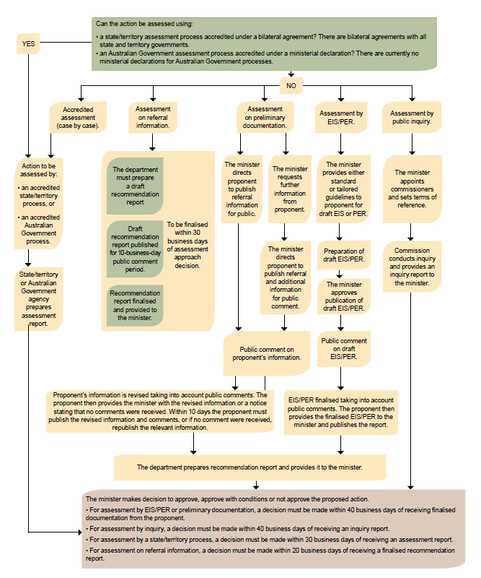Snapshot of the EPBC Act Environment Assessment Process

Assessment on Referral Information (ARI)
Before recommending this approach, discuss it with your director. This method is used in only limited circumstances.
The information provided by the person proposing to take the action in the referral is used to prepare a draft recommendation report. The public, relevant state/territory and Commonwealth ministers and the person proposing to take the action are given opportunity to comment.
The comments received are considered and addressed in the final Recommendation Report. A copy of the public comments and the final Recommendation Report are provided in the briefing package to the decision maker.
While the method of assessment is a matter of discretion for the decision maker, this method may be appropriate if, for example:
- no further information is needed to conduct an assessment, beyond the information provided at referral stage
- the potential scale and nature of the impacts can be predicted with a high degree of confidence
- the relevant impacts are expected to be short term, easily reversible or small in scale
- adequate information in regard to relevant impacts on matters protected is available
- only a small number of matters (including elements of each relevant protected matter) are likely to be significantly impacted by the action
- the person proposing to take the action has a satisfactory record of environmental management and compliance with environmental laws (if information is available)
- the degree of public concern associated with the action is relatively low or expected to be relatively low
If you need to seek any further information on the relevant impacts of the action to make a recommendation you are unable to use ARI and will need to recommend an alternative assessment approach. This does not prevent you from seeking clarification on other matters such as the details of the proposal or the practicality of proposed conditions.
See 3A Assessment on referral information for more information.

Assessment on Preliminary Documentation
If requested, the proponent will be required to provide additional information to specifically respond to gaps or issues identified by the department.
Once the decision maker has the information required to conduct the assessment the proponent is directed to publish the information for public comment, in accordance with the Regulations.
The public are given opportunity to comment and the proponent is then required to review the comments and consider revising the package of information in light of comments. The Assessment Officer considers the information and drafts a Recommendation Report to the decision maker.
While the method of assessment is a matter of discretion for the decision maker, this method may be appropriate if, for example:
- the number and complexity of relevant impacts is low and locally confined
- the relevant impacts of the action can be predicted with a high degree of confidence
- good quality information has been provided in the referral
- the relevant impacts have been or are being adequately assessed under Commonwealth or state legislation; that is, an environment report or similar exists or is being prepared
See 3B Assessment on preliminary documentation for more information.

Assessment by Public Environment Report (PER)
Tailored guidelines can be developed as required to investigate specific matters of concern. If guidelines are tailored it may be relevant to consider whether the proponent, public and other stakeholders should have the opportunity to comment on these at the draft stage.
The proponent prepares a draft PER addressing the guidelines. The public must be given opportunity to comment and the proponent may revise the PER. The Assessment Officer considers the document and drafts a Recommendation Report to the decision maker.
While the method of assessment is a matter of discretion for the decision maker, this method may be appropriate if, for example:
- an assessment of the relevant impacts is expected to focus on a relatively small number of key issues
- an adequate assessment of these issues will require the collection of new information or further analysis of existing information
- there is a moderate to high level of public interest
See 3C Assessment by public environment report/environmental impact statement for more information.

Assessment by Environmental Impact Statement (EIS)
Tailored guidelines can be developed as required to investigate specific matters of concern – wider and more encompassing than for a PER. If guidelines are tailored it may be relevant to consider whether the proponent/public and other stakeholders should have the opportunity to comment on these at the draft stage.
The proponent prepares a draft EIS addressing the guidelines. The public must be given opportunity to comment and the proponent may revise the EIS. The Assessment Officer considers the EIS and drafts a Recommendation Report.
While the method of assessment is a matter of discretion for the decision maker, this method may be appropriate if, for example:
- an assessment of the relevant impacts is expected to raise complex issues, or a large number of issues
- an adequate assessment of these issues will require the collection of new information or further analysis of existing information
- there is a high level of public interest or controversy
See 3C Assessment by public environment report/environmental impact statement for more information.

Assessment by an Accredited Process
The Commonwealth or a state government has a statutory process that allows for the effective investigation of the matters of concern under the EPBC Act. The decision maker agrees that this process will satisfactorily assess the matter.
While the method of assessment is a matter of discretion for the decision maker, this method may be appropriate if, for example:
- the state guidelines/terms of reference have not been finalised so there is still opportunity for the decision maker to engage
- the state government requests accreditation; and the action will not cross jurisdictions (linear projects, such as pipelines and railways, that cross state boundaries cannot be assessed by an accredited process)
- the state assessment approach is proposed to be accredited under a Bilateral Agreement
- the process will allow the matters of concern to the Commonwealth to be adequately addressed
See 3D Assessment by bilateral or accredited process for more information.

Assessment by Public Inquiry
The minister assigns a commissioner to investigate the matter. The commissioner determines the process they will use, usually inviting submissions from the public. They prepare a report to the minister.
While the method of assessment is a matter of discretion for the decision maker, this method may be appropriate if, for example:
- the relevant impacts are likely to be complex
- the relevant impacts, or the management of those impacts, are outside the control of a single proponent
- it is necessary or desirable to have public involvement in the assessment process
See 3E Assessment by public inquiry for more information.

Document your thinking
Summarise your considerations and justify the recommendation you make to the decision maker regarding the selection of assessment method in the Referral Decision Brief. Discuss each of the key matters considered
.
2I Finalise recommendation for decision maker
who | Assessment Officer
timing | within 20 days of receipt
refs | EPBC Act s75, s87  BRIEF 201 Referral Decision Brief  BRIEF ATT 201 - Table of impacts on listed threatened and migratory species  NOT 201 Notification – NCA  NOT 202 Notification – NCA Particular Manner  NOT 203 Notification – CA  NOT 301 Notification of assessment approach  LET 202 Notify decision on referral – NCA  LET 203 Notify decision on referral – NCA Particular Manner  LET 204 Notify decision on referral – CA  LET 301 Notify decision on assessment approach and direction to publish CA  EPBC Act Environment Assessment Process – Referral Flowchart  EPBC Act Decision on Referral Flowchart
The recommendation for the decision maker should contain an overview of the key matters considered, your conclusions and justifications.
Attach supporting detail for each relevant protected manner and assessment approach recommendation as appropriate.
If a decision on assessment approach is not possible at this stage (e.g. states have not responded) the assessment approach decision can be made later (you will need to ‘stop the clock’) and will be provided in a separate brief.
Complete the Referral Decision Brief template
The general structure of the Referral Decision Brief is:

The background to the proposal
- Description of the referral
- Description of the proposal, including location
- Description of the environment

The key issues considered
- Contentious issues about the project, including complexity/sensitivity issues associated with the environment or stakeholder engagement.

Recommended decision
Whether the referral is:
- not a controlled action
- not a controlled action if performed in a Particular Manner
- a controlled action that should be assessed by a particular method
- a controlled action decision with assessment approach decision pending
- a controlled action assessed under a bilateral agreement so no assessment approach decision is necessary
- clearly unacceptable
Include a discussion on impacts under a heading for each relevant protected matter. If more detailed analysis of a particular issue/protected matter is required, consider the need for the separate attachment (BRIEF ATT 201 – Table of impacts on listed threatened and migratory species.

Submissions
- Comments received from the public, Commonwealth ministers and/or State/Territory ministers.

Assessment Approach
- Recommend an approach for assessment in accordance with section 87 and give reasons for your recommendation.

Other Matters for Decision Maker
- Significant Impact guidelines
- Precautionary Principle

Attachments
- Attachment A
- Referral documentation and any supplementary information provided by the person intending the action
- Attachment B
- Other information used for recommendations (species table, more detailed analysis of complex issues, line area advice) if relevant. Number are B1, B2, B3 etc
- Attachment C
- Public comments
- Attachment D
- Ministerial comments
- Attachment E
- Decision notice; if this includes ‘Particular Manner’ the wording must be checked by the Monitoring & Audit Section. If the recommended decision is that the action will be assessed by Accredited Process the decision notice must specify which process, for example, if the action is to be assessed under a bilateral agreement, the notice must specify which agreement.
- Attachment F
- Letter(s) to the proponent and ministers (if relevant)
Prepare the documentation
Consult with your supervisor to determine who to address the brief to, that is who the decision maker will be for this proposed action.
Review before finalising. Consider having a colleague proof read before submitting it to your supervisor and then director, or leave the brief for a few hours and then re-read with fresh eyes.
Collate the Referral Decision Brief in hard copy and have it cleared by your director.
Ensure an electronic copy is on the T: drive in the ‘determination’ sub-folder.
Decision Point
The decision maker will review your brief, and may discuss the issues with you and your director or other stakeholders such as the proponent. They will then make one of the following determinations:
- the proposed action is not a controlled action
- the proposed action is not a controlled action as long as it is performed in a Particular Manner
- the proposed action is a controlled action that should be assessed by a particular method
- the proposed action is a controlled action with an assessment approach decision pending
- the proposed action is a controlled action to be assessed under a bilateral agreement
- the project is clearly unacceptable
For controlled actions, the decision maker will also:
- designate a proponent
- determine how the action will be assessed (section 87) – unless it will be assessed under a bilateral agreement

2J Communicate the decision and pass on information
who | Assessment Officer
timing | Notice to proponent - within 2 days of decision  Notice to 3rd parties – within 4 days of decision  Update EASy - within 4 days of decision
refs | EPBC Act s77(4)  LET 206 Thank public for comments - CA  LET 207 Thank public for comments - NCA  EPBC Act Environment Assessment Process – Referral Flowchart  EPBC Act Decision on Referral Flowchart
Following the decision, scan and save electronic copies of the signed brief, letters and notices in the T: drive. Add hard copies to the TRIM file.
Notify the proponent
The person proposing the action and the proponent (if not the same person) must be notified of the decision before it is publicly posted on the website (i.e. the person proposing to take the action and the proponent must be the first to know the decision).
Telephone and notify them of the decision on the referral and (if relevant) assessment approach.
Email a scanned copy of the signed decision notice and notification letters. Post a copy of the decision notice and the original notification letter.
If the decision is a controlled action, the notification letter should include details about the specific controlling provisions, key issues, and may indicate the nature of information that will form the basis of the assessment.
Notify internal advice areas, state and Commonwealth contacts
Once the decision on referral has been made:
- notify internal advice areas that provided advice of the outcome of the decision and proposed assessment approach by email
- notify state and territory contacts of the outcome of the decision by email and attach a copy of the letter and decision notice
Thank contributors of public comments
Depending on the circumstances, it may be appropriate to acknowledge receipt of public comments, however there is no legal requirement to do so.
Consider how much information to provide in the letter based on the level of public interest in the project.
Use the appropriate letter template (LET 206 Thank public for comments - CA, LET 207 Thanks public for comments - NCA) to thank contributors.
Notify local council
It is good practice to notify the local council, however there is no legal requirement to do so. Notify council by email or use the appropriate letter template (LET 204 Notify decision on referral – CA).
Update databases
The referral decision (CA, NCA, NCA-PM) is recorded in EASy within 4 days of the decision.
Record the assessment approach decision in EASy. See EASy user guides at http://intranet.environment.gov.au/About/divisions-and-agencies/heritage/bsgb/daims/Pages/EASy-EnvironmentalAssessmentsSystem.aspx.
Email the DaIMS helpdesk to publish the decision notice on the department’s website. For proposals proceeding under a Bilateral Agreement, no notice is required to be published. However, for completeness, you are required to email a request to DaIMS to publish notification. The default notice title unless otherwise requested will be ‘Assessment process notice: Not applicable, Bilateral Agreement’.
Pass on any useful information discovered on listed species or ecological communities to Species Information Section (managers of SPRAT) by emailing SPRAT@environment.gov.au
Check the website and print a copy of the notice web page
Go to the public EPBC website print a copy of the public notification and add to the TRIM file.
Record the matters of NES and protected items
Record the matters of national environmental significance which have been protected by a CA or NCA - Particular Manner decision in Chapter 4 Resources.
In the event of a request or variation, go to 2K-2P for more information.
If determined NCA-PM or NCA, go to 4A – Handover Monitoring and Audit Section
If determined CA, go to Section 3 – Assess and Recommend

2K Manage requests for ‘statement of reasons’
who | Assessment Officer/Monitoring and Audit Officer
timing | Within 28 calendar days of receiving request
refs | EPBC Act s77  ADJR Act, s13;EPBC Act s487  BRIEF ATT 602 SoR template CA, NCA and NCA-PM  BRIEF ATT 603 SoR template approval  LET 601 SoR covering letter to applicant  BRIEF 601 SOR Template Brief  EASy data entry
A request for a statement of reasons must be in writing (letter or email). The timing and content of a statement of reasons are identical no matter which legislation it is requested under (EPBC Act or ADJR Act).
A number of different parties are entitled to request and receive a statement of reasons. A statement of reasons can be requested for a number of decisions under the EPBC Act, including whether or not an action is a controlled action, the assessment approach or the approval decision.
If you receive a request for a statement of reasons you should speak to your director regarding the request. If you are in doubt as to whether or not a particular party is seeking or entitled to receive a statement of reasons contact the Legal Section.
A statement of reasons is also required as a matter of course where the decision maker has decided that the proposed action is clearly unacceptable.
See 2F Is the action clearly unacceptable for more information.
Check that the request is within the period allowed.
A request for a statement of reasons should normally be made within 28 calendar days of the date of notice that the decision has been made. If the request is made outside this timeframe, discuss the matter with your director and the Legal Section.
Record the request
Create a new “Statement of Reasons” folder on the T: drive, within the project folder.
Write these dates on the front of the request:
- date request received by the department
- date statement must be provided to requestor (28 calendar days from the date received)
Advise the Legal Section that you have received the request.
Prepare the statement
Identify the specific decision to which the request for statement of reasons pertains and prepare a draft response for consideration by the decision maker accordingly. The decision maker will review the draft and if it reflects the reasons for their decision, will sign it. It may be appropriate to discuss the project with the decision maker before/during the drafting so that a clear understanding of the reasons for decision is reached.
Write the draft clearly and simply so that the person seeking the statement can understand how the decision was reached. If in doubt about detail, check how it relates to the final decision and focus on being concise.
The reasons must be supportable and clearly derived from the information in front of the decision maker at the time of the decision. Statements of reasons cannot include evidence that was not available to the decision maker at the time the decision was made. The draft must demonstrate everything that the decision maker took into account, and nothing that the decision maker did not take into account.
The draft statement of reasons must be checked by the Legal Section.
When preparing the draft statement, refer to the Statement of Reasons template and:
- identify the person who made the decision and the delegation under which the decision was made
- specify the relevant legislation
- set out the decision - the issue required to be resolved or answered, as well as the decision reached
- list the critical information used in making the decision, this must include the proposed decision brief and may include records of relevant phone calls or conversations
- refer to the evidence for the findings – explain why material presented was accepted or rejected, and how judgements were made
- give the reasons for the decision – include the steps of reasoning, linking the facts to the decision
Send the draft statement to all internal advice areas that provided comment in relation to the decision in question. Ensure that your supervisor and your director clear the documents.
Send the following to the decision maker for their review and signing and/or discussion with you:
- statement of reasons brief (BRIEF 601 SoR Template Brief)
- the original decision package (Attachment A)
- the request (Attachment B)
- the draft statement (Attachment C – BRIEF ATT 601 SoR template CU, BRIEF ATT 602 SoR template CA, NCA and NCA-PM or BRIEF ATT 603 SoR template approval)
- letter to applicant (Attachment D – LET 601 SoR covering letter to applicant)
Finalise
Save a full set of documents, including signed and dated letter to the T:drive. Add hard copies to the TRIM file.

2L Manage requests for reconsideration of referral decision
who | Assessment Officer/Monitoring and Audit Officer
timing | Comment period – 10 business days  State/Territory reconsideration request – within 20 business days
refs | EPBC Act s78-79  Guidance Note 4 – Reconsideration: implementing the requirements of sections 78, 78A and 78C of the EPBC Act  DOC 101 Inviting comment – State Cwlth Contacts BRIEF 201 Referral Decision Brief  NOT 501 Notification - Reconsideration Decision NCA PM to NCA PM  NOT 502 Notification - Reconsideration Decision NCA PM to NCA  EASy data entry  Reconsideration of Decision on Referral Requested by Person other than State or Territory Flowchart  Reconsideration of Decision on Referral by State/Territory minister Flowchart
For further guidance about checking the validity of reconsideration requests and the reconsideration process, please refer to ‘Guidance Note 4 – Reconsideration: implementing the requirements of sections 78, 78A and 78C of the EPBC Act’. If you require further information, please contact the Legal Section.
Reconsiderations are processed in EASy. See user guides at http://intranet.environment.gov.au/About/divisions-and-agencies/awd/bsgb/daims/Pages/EASy-EnvironmentalAssessmentsSystem.aspx or contact the DaIMS helpdesk for assistance.

2M Manage variations to a referral
Referrals can be varied in a number of ways. Consideration needs to be given to specifics on a case by case basis, however in some cases the most efficient and transparent way to deal with a variation to a referral before the referral decision is made is to ask the proponent to withdraw the original proposal and resubmit a new one.
If you receive a request to vary a proposal that has been determined CA go to 3G Manage variations to a proposal.
If you receive a request to vary a proposal that has been determined NCA-PM go to 2L Manage requests for reconsideration of referral decision.
2N Manage changes of a person proposing to take the action
The process is identical in the referral stage to that in the assessment stage.
See 3H Manage changes of a person proposing to take the action for more information.

2O Manage lapsed proposals
Proposals cannot be lapsed during the referral stage. They can only be lapsed following a controlled action decision.
2P Manage withdrawn proposals
The process is identical in the referral stage to that in the assessment stage.
See 3J Manage withdrawn proposals for more information.

User’s notes page
This page is to record any additional notes, or processes to assist you. You may want to use these notes as a basis for providing feedback on the manual.
Feedback can be sent to the Branch Improvement and Coordination team.

3 Assess & Recommend
Assess the likely impact of the proposal. Find possible ways of mitigating and/or offsetting impact. | Given the likely impact, recommend whether the proposal should be approved, approved with conditions, or refused.

An overview of the assessment process
3(i) Understand the proposed action
3(ii) Investigate the likely impact to the environment
3(iii) Decide what impacts might be acceptable
3(iv) Consider options
3(v) Recommend conditions
3(vi) Finalise the recommendation
3(vii) How to check environmental history
3(viii) The ‘no’ case
3(ix) What to do if you do not have enough information
3A Assessment on referral information
3B Assessment on preliminary documentation
3C Assessment by Public Environment Report (PER) or Environmental Impact Statement (EIS)
3D Assessment by bilateral or accredited process
3E Assessment by Public Inquiry
3F Administrative procedures
3G Manage variations to a proposal
3H Manage changes of a person proposing to take the action
3I Manage lapsed proposals
3J Manage withdrawn proposals

Amendments to the Act came into effect in February 2007. Projects that were determined to be controlled actions before 19 February 2007 will be assessed under pre-amendment processes and legal requirements unless the minister has approved their transition.
On 25 November 2009, the Great Barrier Reef Marine Park became the eighth matter of national environmental significance under the EPBC Act. Any pproject that was the subject of an active referral before 25 November 2009 will be assessed under pre – amendment processes and legal requirements unless the person chooses to withdraw and resubmit their referral.

Assess & Recommend
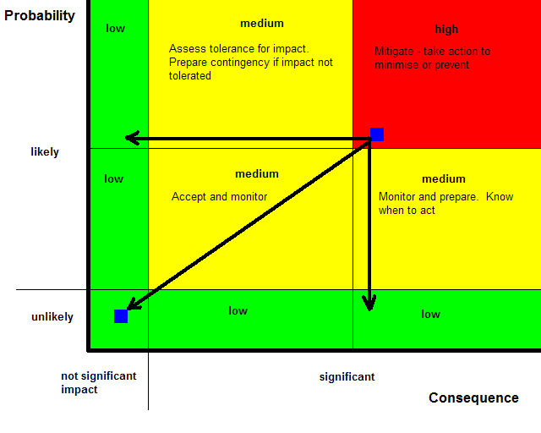Where the decision maker has made a decision that the proposed action is likely to have a significant impact on a protected matter, the referral process is also the stage where the decision maker determines the assessment method that will be used. Each method investigates the proposed action and the nature of the impacts.
The aim of the ‘assessment’ process is to:
- confirm the nature of the impacts
- confirm the effectiveness of the proposed mitigation and offset measures
- gather enough information to allow the decision maker to decide whether to approve with no conditions, approve with conditions; or not approve the action) in a manner that will prevent the action having an unacceptable level of impact on protected matters.
- achieve the best possible conservation outcome while taking into account economic and social costs and benefits
The output of the assessment process is a recommendation report (ARI, PD, PER, EIS), assessment report (assessment by an accredited process or under a bilateral agreement), or an inquiry report (Public Inquiry). This document summarises the findings and recommendations for a decision by the minister or their delegate.
Consider whether mitigation or offset
conditions can be applied to the
action to reduce the impacts

Principles of Ecologically Sustainable Development
The promotion of ecologically sustainable development (ESD) is a key objective of the Act. The principles of ESD must also be taken into account when deciding whether or not to approve actions under the Act. These principles set out a framework for thinking about, and balancing the interaction between protection of the environment and social and economic matters.
The principles of ESD are found in section 3A and are:
- decision-making processes should effectively integrate both long-term and short-term economic, environmental, social and equitable considerations;
- if there are threats of serious or irreversible environmental damage, lack of full scientific certainty should not be used as a reason for postponing measures to prevent environmental degradation;
- the principle of inter-generational equity – that the present generation should ensure that the health, diversity and productivity of the environment is maintained or enhanced for the benefit of future generations;
- the conservation of biological diversity and ecological integrity should be a fundamental consideration in decision-making;
- improved valuation, pricing and incentive mechanisms should be promoted.

Acceptable impact on the environment
Setting conditions on a controlled action should reduce the impact the action is likely to have on the environment. The idea of an ‘acceptable impact’ is a matter of judgement that cannot be calculated with precision.
The acceptability of the impact will depend on issues including:
- the nature and extent of impacts on MNES
- the social or economic benefits to be delivered by the action
- the capacity of the proponent to comply with conditions
- the views of the community
You will need to form a judgement on the acceptability of impact associated with each project.
Great Barrier Reef Marine Park considerations
Where EPBC Act assessment and approval is required in relation to an action in the Marine Park, the EPBC Act assessment will also support decision-making by GBRMPA (the Authority) on the granting of necessary permissions under the GBRMP Act – that is, a single integrated assessment will be employed. Under the integrated approach, the process established under the EPBC Act will provide the basis for public consultation / comment, and collecting information to inform decision making under both the EPBC Act and the GBRMP Act.
The Authority may not issue a GBRMP Act permission in relation to an activity that is a controlled action under the EPBC Act unless it has been approved under the EPBC Act.
Where the Marine Park matter of NES is the only controlling provision for a controlled action, the department and the Authority may agree that the Authority will lead administration of EPBC Act assessment and approval requirements. Any such agreement should be made at the time the action is determined to be a controlled action and an assessment approach determined. As part of the agreement, the department and Authority will identify the arrangements for consultation, record keeping and other administrative matters that will apply to the assessment and approval.
An overview of the assessment process
There are 6 basic steps in the assessment process, regardless of the assessment method. These steps are:
(i) Understand the proposed action
(ii) Investigate possible impacts to the environment
(iii) Consider what impact might be deemed acceptable by the decision maker
(iv) Consider options
(v) Recommend conditions
(vi) Finalise the recommendation
The various assessment methods work through these steps in different ways.
3(i) Understand the proposed action
What is the current situation at the controlled action location?
Developing a thorough understanding of the proposed project is key to the assessment process. This understanding will deepen as the process continues, but you should find out as much as you can at the beginning.
Depending on the assessment method that has been decided, developing an understanding of the project could include all or some of the following:
- reading the Referral Decision Brief
- reading all the material provided to date – by the proponent, by internal advice areas and comments made by the public and government agencies
- communicating with the proponent
- communicating with the state or local council officers
- developing some questions or matters for further investigation (these may be translated into formal guidelines)
- a possible site visit or meeting with proponent, state agency and other stakeholders
Seek to understand:
- the purpose of the action (and if relevant, motivation of the proponent – what do they want to achieve)
- where the project is up to, including the content and nature of any previous conversations with any part of the department and the status of state/territory approval processes (if any)
- the nature of the likely impact on the protected matters - conservation status, significance impact, assessment objective, key habitat requirements
- the current state of the environment
- the community’s view and how controversial the proposal is
Evaluate the information you have about the project. Who has provided it? Is it reliable? What is missing?
3(ii) Investigate the likely impact to the environment
What would be the situation if the controlled action went ahead in its current form?
For each matter and species potentially impacted, understand the nature of the impact.
Consider issues including:
- Is this a direct impact or a consequential or indirect impact (e.g. an impact on habitat)?
- When will the impact occur?
- Is this an impact on breeding cycle, feeding habits, etc?
- How will the protected matter respond to this impact?
- What is the duration of the impact – temporary or long term?
- Is the impact preventable or avoidable?
- Is the impact reversible?
- How certain is it that the impact will occur?
- Is the impact localised or broad scale?
3(iii) Consider what impacts might be viewed as acceptable by the decision maker
What environmental impacts are acceptable?
Once you understand the project and the impact it is likely to have on the protected matters, you can form a preliminary view on what environmental impacts may be acceptable. This preliminary view will guide your conversations with stakeholders and frame any conditions you recommend.
It’s important to form a preliminary view at the beginning of the assessment process, even though your view of what impacts may be acceptable will evolve as the process proceeds and more information becomes available.
The minister (delegate) will decide what environmental impacts are acceptable and, if required, what conditions to impose. It is important to not pre-empt this in discussions with stakeholders.
Two approaches to dealing with unacceptable environmental impacts are:
- actions that reduce or mitigate the impact of the project on identified matters of NES and/or the environment to an acceptable level (e.g. protect water quality in the GBRMP and GBRWHA. Restrict disturbance of marine species).
- actions that seek to offset the likely residual impact of the project (e.g. improve remnant woodland).
When developing possible mitigation or offsets, consider how they could be measured. What performance measures can be associated with it? How will you know the impact has been mitigated or offset?
3(iv) Consider options
How can the controlled action be performed in a manner that is acceptable?
Work with stakeholders to develop ways of meeting the objectives. Talk with the proponent to discuss the advantages and disadvantages of the various options (always document these conversations). Any negotiations at this stage are about the methods used to achieve acceptable impacts.
Options may be drawn from internal advice areas, public comment, state regulators, etc.
Depending on the assessment method being used, a PER or EIS will provide additional information and suggest options.
Research the mechanisms used in similar actions, or on other actions in the similar locality, or on the protected matter elsewhere.
Consider alternatives
It may be possible to avoid an impact completely with an alternate method. For example, changing a road alignment may move the impacts away from a threatened ecological community or habitat.
Seek to understand the proponent’s objectives. Help them better understand environmental impacts and, if possible, work to find an alternative approach that is not likely to have a significant impact on protected matters.
It is not always possible to find an arrangement that will meet the objectives of both the proponent and the requirements of the Act. The majority of proponents are open to alternatives to protect the environment as long as it aligns with their own objectives.
Consider mitigation measures
Remember that mitigation is preferable to offsetting and that offsets should only be considered where effective mitigation is not possible. Consider possible mitigation measures to either reduce the probability of impact, or to reduce the severity of impact, or both. Mitigation measures must be commensurate with the likely impacts of the action.
A risk matrix may guide you in your conversations with the proponent and other stakeholders to explain the need for mitigation measures.
Consider your confidence in potential conditions

What is the risk that the conditions will not be effective in achieving the outcomes?
Consider:
- likelihood – the possibility that the conditions will not work. For example, a 50% chance that drainage pipes will prevent run-off into the creek
- consequence – the impact of the conditions not working. For example, if there is run-off into the creek, the xyz frog will become extinct
How conclusive is the science behind the conditions? Are there case studies that support the effectiveness of the measure?

What is the risk that the conditions will not be complied with?
Consider:
- likelihood – the possibility that the proponent will not or cannot comply with the conditions (what is the ‘environmental history’ of the proponent? See ‘Guidance Note 14 Consideration of a person’s environmental history for decisions under the EPBC Act’ for more information.)
- consequence – the impact of the conditions not being complied with
Consider the monitoring requirements
To know whether conditions have been implemented, they must be monitored. Consider the monitoring resources required by the department to ensure that the conditions have been met.
Monitoring requires answering 2 questions:
- Have the conditions been complied with?
- Are the conditions achieving the intended objective?
Consider talking to Monitoring and Audit Section at this stage.
Consider offset actions
The draft Offsets Policy is available on the department’s website.
Consider economic & social matters
In deciding whether or not to approve the taking of an action, and what conditions to attach to an approval, the minister must consider economic and social matters. If you are considering recommending that an action be approved based on economic and social matters, discuss the situation with your supervisor.
If you are considering recommending a “no”
If you still do not believe that the residual impact on the environment is acceptable after having considered with the proponent suitable alternatives, mitigation and offset measures and the economic and social matters, discuss the situation with your supervisor.
See 3 (viii) The “no” case for more information.
3(v) Recommend conditions
Information about developing conditions is available at several Intranet sites, including
- http://intranet.environment.gov.au/Themes/epbc/assessments/approval-conditions/Pages/default.aspx
- http://intranet.environment.gov.au/POLICIESANDGUIDELINES/Pages/default.aspx; and
- http://intranet.environment.gov.au/About/divisions-and-agencies/awd/ceb/MAS/Pages/default.aspx
Conditions can reduce the impacts by either:
- lowering the probability of an impact occurring e.g. stormwater retention tanks may reduce the likelihood of stormwater entering a creek system
- reducing the severity of an impact e.g. stormwater filtering to improve water quality may reduce the impact of stormwater entering a creek
Good conditions:
- are Specific, Measurable, Achievable, Reasonable and Time Specific (SMART)
- are set within the legislative framework but usually don’t repeat what is already covered in the law
- make a difference in practice i.e. a better outcome for the environment
When setting draft conditions for the consideration of the decision maker to meet the desired environmental objectives, consider:
- the impact on controlling provisions
- the capacity of the proponent to implement the conditions and the impact they will have on the proponent, including the cost to the proponent
- the ongoing costs involved to the department (monitoring, compliance and enforcement)
- consistency with our policies and those of the states and territories
In developing draft offset approval conditions for the consideration of the decision maker, consider:
- the legal construct of the offset conditions to ensure that they can be adequately enforced
- the measures of success for the offsets
- the mechanisms for monitoring the offsets
- the processes for feeding the monitoring results back into the decision making process
For each condition ensure information is included in the Proposed Approval Decision Brief package about why the condition is needed and what it will achieve.
Activity based vs. outcome based
Activity based conditions require the proponent to undertake a specific activity. This type of condition may be appropriate when:
- the environmental outcome may be difficult to measure
- the proponent cannot demonstrate sound environmental management or their environmental history has not been established
- a particular mitigation method is known to be more effective than other methods
- there is a high degree of risk associated with various mitigation options
- the activity is already identified within a state/local approval process.
Outcome based conditions require the proponent to achieve a specified outcome using any activities that the proponent considers appropriate. This type of condition may be appropriate when:
- the proponent has a good environmental record and rigorous and reliable policies, processes and procedures to achieve the desired outcomes
- activity based conditions cannot adequately provide for changing circumstances or technology
- it is uncertain whether activity-based conditions will achieve the desired outcome.
Conditions should be S M A R T

Specific
A clear easy to understand statement of what:
- the proponent must do
- the proponent must not do
- outcome the proponent must achieve.

Measurable
Include a clear statement of the performance standards that must be met.

Achievable
The proponent can comply with the condition i.e. the activity or outcome is within the proponent’s control.

Reasonable
The condition is:
- fair and reasonable i.e. it is commensurate with the impact sustained as a result of the action
- legal
- cost-effective for both the proponent and the Commonwealth.

Time specific
Include a clear statement of the timeframe in which the condition must be met.
If we set conditions that are not SMART, we undermine the intent of the Act and increase the risk that the community will see the Act as:
- ineffective in protecting the environment (e.g. unenforceable conditions)
- a barrier to the efficient use of capital to promote economic growth (e.g. unreasonable or unachievable conditions)
In recommending conditions it is important to have regard to any conditions imposed or likely to be imposed under a state/territory approval, and the cost-effectiveness of the proposed conditions (section 134(4)(a) and (b) of the Act).
Internal Advice
You must consult with the Monitoring and Audit Section when drafting conditions of approval. In cases involving complex or sensitive matters, you may also need to consult LPS about any proposed conditions.
If relevant, you may also need to seek advice from internal advice areas.
Under the MOU between the department and the Great Barrier Reef Marine Park Authority, for all controlled actions where the Marine Park is a controlling provision, you will need to seek input from the Authority in relation to the recommendation report and any proposed conditions of approval.
Under the MOU between the department and the Great Barrier Reef Marine Park Authority, for controlled actions that are within, or partly within, the Marine Park, you will need to provide the Authority with a copy of the final approval decision, including the conditions of approval (where relevant) within one day of that decision being made.
3(vi) Finalise the recommendation
- Prepare a Proposed Approval Decision Brief. The Proposed Approval Decision Brief details the conditions you are recommending to protect or repair or mitigate damage to a MNES for which the approval has effect. There are templates available to assist you in doing this.
- The decision maker will consider your draft recommendation and draft conditions and make a decision regarding whether it reflects their proposed decision, and if yes will agree to consultation with the proponent.
- The proponent and all Commonwealth ministers who were invited to comment at the referral stage and public (if made publicly available) have 10 business days in which to respond.
- Finalise your Approval Decision Brief.
- If you do not believe you have enough information to make a final recommendation, see section 3(ix).

In making your recommendation, you will need to address the other matters that the decision maker must consider or take into account in making a decision. These include:
- economic and social matters (section 136(1b)
- principles of ecologically sustainable development (section 3)
- finalised assessment documentation from the proponent
- any other information on the relevant impacts of the action, including from strategic assessments
The decision maker must also not act inconsistently with:
- international agreements (where applicable) (section 137 – 140)
- National Heritage principles, agreements and plans (where applicable) (section 137)
- a recovery plan or threat abatement plan (where applicable)
- approved conservation advice (where applicable)
The decision maker may also take into account the environmental history of the person taking the action (section 136(4)). See 3 (vii) How to check environmental history for more information
Depending on the assessment method, you may also need to prepare a Recommendation report. This document summarises the department’s findings and conclusions and recommends a final decision to the minister (delegate). It presents a coherent argument about the likely impact of the proposed action and how the action can proceed (or not) in an acceptable manner. Once the Secretary’s delegate has signed off on the Recommendation Report, (prior to making the proposed decision) the Recommendation Report is finalised and cannot be changed. Changes that occur to the proposed decision during consultation need to be reflected in the covering brief to the final decision, not in the Recommendation Report.
If you do not have sufficient information to recommend an informed decision, you may recommend that the delegate stop the clock (section 132) to gather further information – but only after the recommendation report has been finalised. See Section 3 (ix) for more information.
In the case of Assessment on Referral Information, the Draft Recommendation Report must be published on the Internet for comment by the public or other stakeholders prior to finalisation, for a period of 10 days. If comment is made, the briefing documents must include a copy of the comments (or a statement that no comments were received), and account should be taken of any comments relevant to MNES in finalising the recommendation report.
See 3A Assessment on Referral Information for more information.
3(vii) How to check environmental history
The Act allows the decision maker to consider whether the person or company undertaking the action is suitable in light of their environmental record, and whether this would affect the conditions to an approval.
Searches can be undertaken on the person, company, parent companies and Executive Officers of the company undertaking the action. See ‘Guidance Note 14 – Consideration of a person’s environmental history for decision under the EPBC Act’ for more information.
Basic checks:
- review the information provided in the referral form
- request information from the person undertaking the action as to the status of their environmental record
- liaise with Compliance Sections on any relevant issues
- check Ch4 resources to determine if an audit has been undertaken and liaise with Monitoring and Audit section if required
- for older historic searches of referrals, contact the DaIMS helpdesk to search the old EPIP database
- search the Australasian Legal Information Institute online records of publicly-reported court cases for environmental-offence related convictions at a state level (http//www.austlii.edu.au) If any potentially relevant convictions are identified, you should consult with the Legal Section.
Consideration of environmental history
In evaluating the information, consideration should be given to:
- the risk of significant impact to a protected matter
- any documents which indicate the person has a questionable environmental record
- any compliance issues which indicate the person may have a poor environmental record
If, after undertaking an initial evaluation, you believe the environmental record of the person is an important consideration in the recommendation or framing of conditions, the following avenues could be followed up in consultation with your director:
- request company and director searches with the help of the Environment Investigations Unit to identify involvement in any previous breaches of the EPBC Act
- contact the relevant state environment and/or planning agencies and local councils to see if there are any historic or current compliance issues
- seek information through the AELERT Network (Australian Environmental Law Enforcement and Regulators network) in consultation with the Compliance Support Unit.
Procedural Fairness
To ensure procedural fairness it is important that the person undertaking the action has the opportunity to respond to any information that is to be considered in the decision making process, including any aspect of a person’s environmental record.
This should usually be done by writing to the proponent and clearly setting out (and as far as possible providing) the information concerned. Check with your supervisor/Legal Section to confirm approach.
3(viii) The ‘no’ case
In some cases the assessment process may demonstrate that the action will have an unacceptable impact. That is, the decision maker may be of the view that the action cannot be controlled, or positive actions implemented, in a way that will not result in an unacceptable impact to the environment having regard to the nature and scale of the impact and the economic and social matters to the community. In these cases, the assessment recommendation is ‘no’. The processes outlined in this manual apply equally when the recommended decision is to not approve the action.
Be sure about the decision
The Precautionary Principle has a very specific definition under the EPBC Act (see section 391). While the precautionary principle operates when assessing proposed actions, a ‘no’ decision should not necessarily result from a lack of suitable information. That is, if the assessment decision would be different if more information was available, and if it is reasonable to obtain the information, then the decision should be delayed using the provisions of the Act until further information is provided and considered.
If the report does not provide sufficient information to make an informed decision, you may stop the clock (section 132) to gather further information, but only after the recommendation report (or equivalent) is finalised.
Advise the proponent
The decision maker must sign-off your Proposed Approval Decision before you give the proposed approval and conditions to the proponent.
See 3F Administrative procedures for more information.
It is likely that during the assessment process you will have had conversations with the proponent about any concerns you have about the proposal. The decision maker deciding on a ‘no’ decision will not usually be a surprise to the proponent.
Before the decision maker makes a final decision the person proposing to take the action and the proponent (if different) must be informed of the intention not to approve the action (section 131AA(2)).
They must be provided with a copy of:
- any assessment or recommendation report
- information relating to social or economic matters considered
- information relating to the history of the person in environmental matters
- any other information about the impacts of the proposed action
You must not provide any document that is exempt under the Freedom of Information Act 1982, or that is commercial-in-confidence. You do not need to provide information that is in the public domain (section 131AA(3)(C)).
Invite the person proposing the action and the proponent to provide written comments on the proposed decision. They have 10 (Canberra) business days to do so.
Consider recommending that the decision maker invite public comment
Inviting public comment on the proposed decision is not mandatory. However, the decision maker may choose to do so.
If the decision maker decides to seek public comment, publish the material provided to the proponent on the department’s website and invite comment within 10 (Canberra) business days. You may choose to informally notify parties that have shown an interest in the proposal of the invitation.
Please note that when inviting public comment the approach in this manual must be used. If you are considering the need to depart from this approach you must first get advice from LPS before doing so.
Address comments
Summarise comments received from the person proposing the action, the proponent and the public, if any. Reference reports, advice or other information gathered during the assessment process as appropriate. Attach the comments to the briefing package that goes to the decision maker, so they can consider them.
Attach responses to comments in the final assessment or recommendation package.
Finalise the brief
Include all relevant material in the final brief.
Consider preparing a statement of reasons in readiness for a possible request.
See 2L Manage requests for statement of reasons for more information.
Consider the need to prepare a media release
If the proposal has generated significant public interest, consult with Public Affairs as they may wish to prepare a media brief for the minister.
Publish the decision
Publish the decision in the manner as described in the relevant assessment method.
3(ix) What to do if you do not have enough information
Under section 132 of the Act, there is a provision to stop the approvals clock, if the decision maker has been through the assessment information and does not feel they have enough information to recommend a decision.
If you are considering recommending this, talk to your supervisor.
Section 132 cannot be used until a recommendation report has been provided to the minister or delegate. In these circumstances, the Recommendation Report should be drafted to reflect that, that there is insufficient information to make an informed decision on approval. The covering brief should recommend that the delegate or minister stop the clock under section 132 to seek further information.
In this instance, the recommendation report and covering brief should be put to the delegate or minister as a prerequisite to a decision to stop the clock under section 132. A proposed decision should not be put to the delegate or minister until after sufficient information has been received and the clock has been restarted.

3A Assessment on referral information
who | Assessment Officer
timing | Prepare draft Recommendation Report – 10 days from Assessment Approach Decision (s87) (non-statutory timeframe);  Public comment on draft report – 10 days;  Final Recommendation Report – within 30 days of Assessment Approach Decision;  Decision maker’s decision – within 20 days of finalised Recommendation Report;
refs | EPBC Act s92-93  EPBC Regulations Division 5.1A  BRIEF 302 Proposed Draft Recommendation Report Brief  BRIEF 401 Proposed Approval Decision Brief (Recommendation report)  BRIEF 402 Approval Decision Brief (Recommendation report)  Assessment on Referral Information Flowchart  EASy Data Entry
The information provided by the proponent in the referral is used to prepare a recommendation report. The public, ministers and the proponent are given opportunity to comment.
If substantial further information is requested during the referral decision process, then an Assessment on referral information is not likely to be appropriate.
See 3F Administrative procedures for more information on administrative procedures relating to the compilation of briefs and to filing and publishing requirements after a brief has been signed.

Review the information provided by the proponent
Develop an understanding of the project.

Seek further information from internal advice areas if appropriate
Internal advice areas, e.g. GBRMPA, may provide more in depth information or have ideas about how to control the action.

Set objectives
Consider what may constitute acceptable environmental outcomes. See 3 An overview of the assessment process for more information on the thinking process.

Consider options to achieve the objectives
It is helpful to discuss options with both colleagues and the proponent.

If recommending approval - develop conditions
Discuss the proposed conditions with a colleague. Consult with Monitoring and Audit Section. In cases involving complex or sensitive matters, you may also need to consult the Legislation Policy Section about any proposed conditions.
For all controlled actions where the Great Barrier Reef Marine Park is a controlling provision, seek input from GBRMPA in relation to the recommendation report and any proposed conditions of approval.
See 3 (v) Recommend conditions for more information.

Prepare draft Recommendation Report and BRIEF 302 Proposed Draft Recommendation Report Brief and submit to Secretary (delegate)

(aim for 10 days from decision on assessment approach)

The Draft Recommendation Report should be accompanied by a brief to Secretary (delegate) seeking agreement to the draft Recommendation Report (section 93(2)) and to publish it on the internet (section 93(3)).

Publish draft Recommendation Report
Once the Secretary (delegate) has approved the draft Recommendation Report, update the status of your project in EASy and contact DaIMS to publish the draft Recommendation Report on the department’s website and invite comments.
You should also notify (via email) the person taking the action, the proponent, and (if required) Public Affairs that the draft Recommendation Report has been published.

Consider any comments
For controlled actions in, or partly within, the Great Barrier Reef Marine Park provide a copy of public comments to GBRMPA (as applicable).

Finalise Recommendation Report

Address any comments that have been raised which are relevant to controlling provisions.

Prepare BRIEF 401 Proposed Approval Decision Brief (Recommendation Report), submit to decision maker

(30 business days from decision on assessment approach)
Provide the finalised Recommendation Report to decision-maker.
Ensure comments are included with the brief, or a statement that no comments were received (section 93(5)(b)).
See 3F (i) Complete the proposed approval decision brief template for more information.

Invite comment on proposed decision and conditions
(10 day comment period)
Invite comment (within 10 business days) on proposed decision and conditions from:
- all Commonwealth ministers who have administrative responsibility relating to the action. Note that the ministers consulted would usually include all ministers who were invited to comment at the referral stage (section 131),
- the person taking the action and the proponent (section 131AA).

(optional) Publish proposed decision and conditions (s131A)
The public should be allowed opportunity to comment if the proposed action is controversial, may have a large impact or if there has already been significant public interest. Talk to your supervisor if unsure whether or not to recommend publication of the proposed decision.

Prepare BRIEF 402 Approval Decision Brief and submit to decision maker
Address any comments received from ministers, proponent or person taking the action.
Your director should review and approve the brief before it is submitted.
The Recommendation Report cannot be changed at this stage. Any changes to the proposed decision as a result of comments received need to be reflected in the covering brief and other briefing documentation.
See 3F (ii) Complete the approval decision brief template for more information.

Decision maker makes decision on whether to approve action

(20 business days from final Recommendation Report)

Publish the decision
For controlled actions in, or partly within, the Great Barrier Reef Marine Park, provide GBRMPA with a copy of the final approval decision, including any conditions of approval, within one day of that decision being made.
Update EASy and contact DaIMS to publish the decision on the public notices website.

3B Assessment on preliminary documentation
who | Assessment Officer
timing
refs | EPBC Act s94-95C, s130-140 A  EPBC Regulations 16.03-04  ATT 308 Publication of PD s95  ATT 309 Publication of PD s95A  BRIEF 401 Proposed Approval Decision Brief (Recommendation report)  BRIEF 402 Approval Decision Brief (Recommendation report)  EASy data entry  Assessment on Preliminary Documentation Flowchart
There are two ways that assessments can be done on preliminary documentation. The first is under section 95, where it has been decided at the time of making the assessment approach decision that no further information is required.
The second is under section 95A, where the proponent may be asked to provide more complete information than the information provided in the referral. The decision on Assessment Approach should outline whether further information is required under section 95A.
For both approaches, the public are given an opportunity to comment, and then the proponent is required to consider the comments and revise the package of information in response, if necessary. A recommendation is made to the decision maker about whether to approve the project or not, on the basis of the information provided and the comments received from the public and internal advice areas. The decision maker makes a proposed decision, consults with the proponent, ministers and the public (if necessary) and then makes a final decision.
See 3F Administrative procedures for information on administrative procedures relating to the compilation of briefs and to filing and publishing requirements after a brief has been signed.
Ensure you update the status of your project in EASy as you move through these steps.
See EASy user guides.

Initial Steps:
- Review the information provided by the proponent
Review the referral and the Referral Decision Brief. Identify why the action was determined to be a controlled action and the potential impacts on controlled matters and the broader environment.

Set objectives
Consider what the decision maker may believe are acceptable environmental outcomes. See 3 An overview of the assessment process for more information on the thinking process.

Determine what additional information is needed (s95A only)
If you have adequate information (section 95) go to step 7. The proponent is required to publish the preliminary specified information and invite public comment.
If you do not have adequate information, identify the gaps in information – those areas where there is a lack of certainty about the likelihood or significance of an impact. For example, if the issue is the potential impact of stormwater flows on a Ramsar wetland you should ask the proponent to provide further information on how that issue will be addressed.
For actions that are within, or partly within, the Great Barrier Reef Marine Park, you must seek advice from GBRMPA in relation to the nature of the additional information the proponent should be required to provide. You may also want to consult with other line areas that provided advice at the referral stage.

Request additional information
Within 10 business days of giving notice of Assessment Approach decision, the minister (delegate) must write to the proponent asking for the specific information you require (section 95A(2)).
Suggest a timeframe for this to be provided, however this is at the proponent’s discretion.

Proponent – prepares additional information as requested

Check the additional information
Check that the information is what was requested. Where the Great Barrier Reef Marine Park is a controlling provision, seek input from GBRMPA on whether the additional information provided is adequate for the purposes of assessing the action. If the assessment documentation is not adequate, ask the proponent to address remaining issues. You may be required to consult with the proponent on numerous occasions to ensure that the additional information is adequate.
Publication:
- Direct Proponent to publish all

preliminary documentation

(10-20 business day period for comment suggested)
Within 10 days of receiving all additional information requested, prepare a brief and letter for the decision maker to direct the proponent to publish all preliminary documentation for a specific period. Template letters are available on the Intranet.
The period directed for comment is discretionary but must be reasonable on business grounds. 10 – 20 days is most normally used for non-controversial projects, although recommending longer may be appropriate if the project is complex or controversial, has large impacts or has already been the subject of a high number of public comments.

Proponent – publishes specified information and invites public comment (s95(2) or s95A(3))
The proponent must provide a copy of the advertisement before publication to ensure it meets the requirements (see r16.03-04). File the final advertisement (see ATT 309 Publication of preliminary documentation s95A). The proponent is required to publish the documentation in several places, including at an appropriate location on the web. Normally this would mean the proponent’s own website or a host website. If the proponent has no access to a website, discuss the situation with your supervisor and DAIMS who may be able to offer assistance.

Publish public notice
Request a copy of the advertisement. Update EASy and ask DaIMS to publish a notice inviting comment and the advertisement on the website advising that the referral and further information is available for comment.

Proponent – receives comments and updates information (s95B)
The proponent must gather the comments and revise documents to address any issues raised (section 95B(1)).
For actions in, or partly within, the Great Barrier Reef Marine Park, provide a copy of any public comments to GBRMPA.
If comments are received, as soon as practicable after the end of the comment period, the proponent must provide the minister a copy of the comments received and a document that:
- Sets out information given previously to the minister in relation to the action, with any changes or additions needed to take account of the comments; and
- A summary of the comments received and a summary of how those comments have been addressed (section 94B(1)).
Go to Step 11: Review the revised documents.
If no comments are received, the proponent must notify the minister (section 95B(3)).
Go to Step 12: End of comment period.

Review the revised documents
Check that comments have been included and addressed. If so, the 40 business day Approval clock and the 40 business day Recommendation Report clock starts from the day you received this document.
You may need further advice from internal advice areas if the revised documents include new information.

End of comment period (s95B)
If comments have been received the proponent is required to publish the document referred to in Step 10 that was submitted to the minister (i.e. the amended documents and a summary of the comments and how they have been addressed) within 10 business days of the minister having received the documents referred to in Steps 10 and 11 (section 95B(2) & r16.04 and r.16.03).
If no comments were received, the proponent is required to republish the documents that were originally published under Step 8 and a statement stating that no comments were received during the public comment phase (section 95B(4) & r16.03 and r.16.04). This must be done within 10 business days of the minister having received the documents referred to in Steps 10 and 11 (section 95B(4)).
Consider contacting the proponent to remind them of their obligations in regard to publication/re-publication as outlined above.
There is no public comment process during this period, the publication is for public information only.
Confirm with the proponent that the department will be publishing the notice (and in some cases, the information), on the department’s website.
For actions in, or partly within, the Great Barrier Reef Marine Park, GBRMPA must be provided with a copy of the final amended documents and any public comments received.
Recommendation Report:

Consider options to achieve the objectives
It is helpful to discuss options with colleagues, your supervisor, the decision maker and the proponent.

If recommending approval - develop conditions
Discuss the proposed conditions with a colleague. Consult with Monitoring and Audit Section, GBRMPA (where the Great Barrier Reef Marine Park is a controlling provision) and relevant line areas. In cases involving complex or sensitive matters, you may also need to consult LPS about any proposed conditions.
See 3(v) Recommend conditions for more information.

Prepare BRIEF 401 Proposed Approval Decision Brief (Recommendation Report), submit to decision maker
(aim for 20 business days from receiving final documents from the proponent (non-statutory), to meet the 40 day statutory timeframe including the 10 business day mandatory consultation process)
Identify any public comments that have been raised and how the proponent addressed them. Ensure public comments are included in the report.
See 3F(i) Complete the proposed approval decision brief template for more information
Once the Recommendation Report is approved by the delegate, it is a final draft and cannot be changed.

Invite comment on draft decision and conditions
(10 business day comment period)
Invite comment (within 10 business days) on proposed decision and conditions from:
- All Commonwealth ministers who the minister believes have administrative responsibility relating to the action (section 131). Note that the ministers consulted would usually include all ministers who were invited to comment at the referral stage,
- The person taking the action (section 131AA) and
- The proponent (section 131AA).
The Recommendation Report must be given to the minister within 40 business days from when the documents referred to in Step 10 are received (section 95C (2)). However, as this is also the timeframe for the approval decision, it’s obviously desirable that the report be given to the decision maker earlier.

(optional) Publish proposed decision and conditions (s131A)
The minister may publish the proposed decision and any proposed conditions on the Internet and invite public comment (within 10 business days). However, this is not a mandatory step. As a matter of policy, the public should be allowed opportunity to comment if the proposed action is controversial, may have a large impact or if there has already been significant public interest. Talk to your supervisor if unsure whether or not to recommend to the decision maker that they seek public comment on the proposed decision.

Prepare BRIEF 402 Approval Decision Brief (Recommendation Report) and submit to decision maker
The Recommendation Report cannot be changed at this stage (i.e. it cannot be changed after it has been approved by the delegate). Any changes to recommendations as a result of comments received need to be reflected in the covering brief and other briefing documentation.
Note that under section 131AA the decision-maker must take any relevant comments provided by the person taking the action and the proponent into account when deciding whether or not to approve the action. The decision-maker must also take into account any comments from ministers received under section 131 and any public comments received under section 131A (if public comments were sought).
Your director should review and approve the brief before it is submitted to the decision maker.

Decision maker makes decision on whether to approve action
(40 days from receipt of final documentation in section 95B(1) or 95B(3))

Publish the decision
Update EASy and contact DaIMS to publish the decision on the public notices website. Notify the proponent and the person taking the action, and any line areas who were involved in the assessment.
For actions within, or partly within, the Great Barrier Reef Marine Park, provide GBRMPA with a copy of the final approval decision, including the conditions of approval (where relevant) within one day of the decision being made.
See 3F (ii) Complete the approval decision brief template for more information.

3C Assessment by Public Environment Report (PER) or Environmental Impact Statement (EIS)
who | Assessment Officer
timing | Approve guidelines – 20 days  Final Assessment Recommendation Report – 20 days of final PER, 30 days of final EIS
refs | EPBC Act s96-100 (PER)  EPBC Act s101-105 (EIS)  EPBC Regulations 16.03-04, Schedule 4  BRIEF 401 Proposed Approval Decision Brief (Recommendation report)  BRIEF 402 Approval Decision Brief (Recommendation report)  EASy data entry  Assessment by Public Environment Reports Flowchart  Assessment by Environment Impact Statements Flowchart
Tailored guidelines can be developed as required to investigate specific matters of concern. The scope for an EIS is generally wider and more encompassing than for a PER.
The proponent prepares an assessment document addressing the guidelines. The public are given opportunity to comment and the proponent revises the document.
The assessment officer considers the document and writes a Recommendation Report to the decision maker.
The decision maker makes a proposed decision, consults with the proponent, ministers and the public (if necessary) and then makes a final decision.
See 3F Administrative procedures for information on administrative procedures relating to the compilation of briefs and to filing and publishing requirements after a brief has been signed.
Ensure you update the status of your project in EASy as you move through these steps.
See EASy user guides.
- Review the information provided by the proponent.
Review the referral and the Referral Decision Brief. Identify why the action was determined to be a controlled action and the potential impacts on controlled matters
- Set objectives
Consider what the decision maker may believe constitutes acceptable environmental outcomes. See 3 An overview of the assessment process for more information on the thinking process.
- Develop guidelines
(20 days from the Assessment Approach Decision)
If public comments are not sought on the guidelines (see section 4 below), the guidelines must be provided to the proponent within 20 days of the assessment decision being made. The quality of the guidelines impacts the quality of the PER/EIS. The aim is to ensure the proponent prepares a PER/EIS that gives the decision maker enough information to make the approval decision.
See Schedule 4 to the EPBC Regulations for information that must be contained within tailored guidelines for the PER/EIS.
Guidelines are aimed at providing information on:
- the NES matters (controlling provisions) likely to be impacted
- the nature and extent of impacts, proposed mitigation and/or offset measures and their likely effectiveness
When writing guidelines:
- determine if standard guidelines exist and would be appropriate (section 96A(3) and section 96B) [Note: at time of writing, no standard guidelines exist]
- develop tailored guidelines (section 97) specific to the situation, if appropriate, for example, if there are gaps in the information
- include information requested by the relevant state/territory minister(s)
- request internal advice area comments as appropriate
- for actions within, or partly within, the Great Barrier Reef Marine Park, request advice from GBRMPA in relation to whether tailored guidelines are required, and if so, the scope of those guidelines, so as to ensure the assessment covers matters required by GBRMPA in considering the granting of necessary permissions under the GBRMP Act
- if you are updating TOR from a previous project, check to see that all relevant issues are still addressed.

If guidelines are tailored, invite comment (optional – s97(5) or 102(5))
(20 days for comment period suggested)
The period given for comment is discretionary but should be justifiable and reasonable on business grounds. You have 20 business days after the end of that comment period to provide the PER/EIS guidelines to the proponent. If public comments are not sought, the guidelines must be provided to the proponent within 20 days of the assessment decision being made. Guidelines need to be approved by the minister or delegate – check the templates Intranet page for a template brief.
Discuss with your director the need to seek external comment on the tailored guidelines.
It may be appropriate to seek input from external organisations or government agencies with specialised knowledge of the issues involved with the action, such as GBRMPA.
Public comment on the guidelines can be sought by asking DaIMS to publish a notice and the guidelines on the website.
You may decide to informally notify members of the public of the public comment period.
Remember that notice of the finalised guidelines must be published (section 170A).
In addition, the finalised guidelines themselves may also be published.

Proponent – prepares draft PER/EIS
Keep in touch with the proponent while they are preparing a draft PER/EIS. Where relevant, discuss drafts with the proponent. Give feedback – if there are inadequacies, discuss these with the proponent and ask them to resubmit.
- Approve the draft PER/EIS for publication (s98(2) or 103(2))

Check again that the report/statement adequately addresses the guidelines. For actions where the Great Barrier Reef Marine Park is a controlling provision, seek input from GBRMPA in relation to assessment reports and associated documentation. Prepare a brief and letter for the decision maker to direct the proponent to publish the draft report/statement for a specific period. Template letters are available on the Intranet.

The period directed for comment is discretionary but must be at least 20 days, and should be justifiable and reasonable on business grounds. Recommending longer may be appropriate if the draft PER/EIS is long, or the project is highly controversial, has large impacts or has already been the subject of a high number of public comments.

Proponent – publishes draft PER/EIS and invites public comment
(minimum 20 day comment period (statutory))
The proponent must provide a copy of the advertisement before publication to ensure it meets the requirements (r16.03-04, see PER/EIS publication advice sheet).
The proponent is required to publish the documentation in several places, including at an appropriate location on the web. Normally this would mean the proponent’s own website or a host website. If the proponent has no access to a website, discuss the situation with your supervisor and DAIMS who may be able to offer assistance.

Publish public notice
Request a copy of the advertisement. Update EASy and contact the DaIMS helpdesk to publish a notice inviting comment and the advertisement on the website advising that the draft PER/EIS is available for comment.

Proponent – receives any comments and finalises PER/EIS
After the end of the public comment period, the proponent must gather any comments received and finalize the draft PER/ EIS. The final document must take account of any comments received within the period for public comment, and must contain a summary of any comments, including how they have been addressed. As soon as practicable after finalising this, the proponent must give this document to the minister, and must also give the minister either a copy of any comments received, or a written statement that no comments were received. Public comments are also to be provided to GBRMPA in the case of actions in, or partly within, the Great Barrier Reef Marine Park.

Review the final PER/EIS document
Check that comments have been included and addressed (section 99(2) or 104(2)). If so, the 40 day Approval Decision Clock and the 40 day Recommendation Report clock commences from the day the department received the final PER/EIS.
You should seek further advice from internal advice areas e.g. GBRMPA, if the revised documents include new information.

Publication of finalised PER/EIS (s99(4) or 104(4))
Within 10 days after the minister has received these documents, the proponent must publish the final PER/EIS documents (r16.03-04).
Recommend that the documents be available for the same duration as the public comment phase.
For actions in, or partly within, the Great Barrier Reef Marine Park, provide GBRMPA with a copy of the final PER/EIS and any associated documentation.

Consider options to achieve the objectives.
It is helpful to discuss the options with colleagues, your supervisor, the decision maker and the proponent.

If recommending approval - develop conditions
Discuss the proposed conditions with a colleague. Consult with Monitoring and Audit Section, GBRMPA (for actions where the Great Barrier Reef Marine Park is a controlling provision) and other line areas. In cases involving complex or sensitive matters, you may also need to consult LPS about any proposed conditions.
See 3 (v) Recommend conditions for more information.

Prepare BRIEF 401 Proposed Approval Decision Brief (Recommendation Report), submit to decision maker and discuss option to publish Recommendation Report
(aim for 20 business days from receiving final documents from the proponent (non-statutory))
For actions where the Great Barrier Reef Marine Park is a controlling provision, seek input from GBRMPA in relation to the recommendation report.
Consider any public comments that have been raised and how the proponent addressed them. Ensure public comments are included in the report.
See 3F (i) Complete the proposed approval decision brief template for more information.

Invite comment on draft decision and conditions
(10 business day comment period)
Invite comment (within 10 business days) on proposed decision and conditions from:
- all Commonwealth ministers who have administrative responsibility relating to the action. Note that the ministers consulted would usually include all ministers who were invited to comment at the referral stage (section 131);
- the person taking the action (section 131AA); and the proponent (section 131AA).

(optional) Publish proposed decision and conditions (s131A)
(10 day comment period)
The decision maker may publish the proposed decision and any proposed conditions on the Internet and invite public comment (within 10 business days), or for public information. However, these are not mandatory steps. As a matter of policy, the public should be allowed opportunity to comment if the proposed action is controversial, may have a large impact or if there has already been significant public interest. Talk to your supervisor if unsure whether or not to make the proposed decision public.
Update EASy and contact DaIMS to publish a notice inviting comment on the department’s website.
See 3(ix) and 3(v) for further information.

Prepare BRIEF 402 Approval Decision Brief (Recommendation Report) and submit to decision maker
The Recommendation Report cannot be changed at this stage (i.e. it cannot be changed after it has been approved by the decision maker). Any changes to recommendations as a result of comments received need to be reflected in the covering brief and other briefing documentation.
Note that under section 131AA the decision-maker must take any relevant comments provided by the person taking the action and the proponent into account when deciding whether or not to approve the action. The decision-maker must also take into account any comments from ministers received under section 131 and any public comments received under section 131A (if public comments were sought).
Your director should review and approve the brief before it is submitted to the decision maker.
See 3F (ii) Complete the approval decision brief template for more information.

Decision maker makes decision on whether to approve action
(40 business days from when Final PER/EIS document accepted)

Publish the decision
Update EASy and contact DaIMS to publish the decision on the public notices website. Notify the proponent and the person taking the action, and any line areas who were involved in the assessment.
For actions within, or partly within, the Great Barrier Reef Marine Park, provide GBRMPA with a copy of the final approval decision, including the conditions of approval (where relevant) within one day of that decision being made.
A copy of the decision notice should also be emailed to relevant line areas.

3D Assessment by bilateral or accredited process
who | Assessment Officer
timing | 30 day approval following receipt of Assessment Report
refs | EPBC Act Chapter 3, s44-65A  Bilateral Agreement (w/ each State)  BRIEF 403 Proposed Approval Decision Brief (Assessment Report)  BRIEF ATT 401 Legal Considerations  BRIEF 404 Approval Decision Brief (Assessment Report)  EASy data entry  Assessment by Bilateral Flowchart  One off Accreditation Flowchart
One of the objectives of bilateral agreements is to reduce duplication of state/territory and Commonwealth requirements. This can only be achieved when the parties work closely, share information, and understand the objectives of each other.
The minister may adopt a state or territory statutory assessment process on a one off basis if he/she thinks that the requirements of the EPBC Act will be satisfied. In contrast, where an assessment Bilateral Agreement is in place with the relevant state or territory and applies to the class of actions being assessed, the project must be assessed using the Bilateral Agreement. The approval decision making power remains with the minister under both these processes.
In general, projects which have been identified as significant by the state/territory will be assessed under a bilateral agreement.
Keep your supervisor informed of progress throughout this process. They may be overseeing other projects with the same state/territory and need to have a comprehensive picture of how the bilateral agreement is operating “in the field”.
See 3F Administrative procedures for more information on administrative procedures relating to the compilation of briefs and to filing and publishing requirements after a brief has been signed.
Ensure you update the status of your project in EASy as you move through these steps.
See EASy user guides.
- Review the information provided by the proponent
Review the referral and the Referral Decision Brief. Identify why the action was determined to be a controlled action and the potential impacts on controlled matters
- Set objectives
Consider what the decision maker may believe constitutes acceptable environmental outcomes. See 3 An overview of the assessment process for more information on the thinking process.
- Contact the relevant state/territory agency
The relevant state/territory will confirm the action will be assessed under a bilateral agreement or accredited assessment process which can be accredited when responding to a request for comment (see referral process). If the state/territory informs the decision maker/department that the bilateral applies, this ‘switches off’ the need for any other assessment approach decision to be made, and automatically means the project will be assessed using the bilateral.
Liaise with the state/territory officer as soon as possible to get a good understanding of their intended process and timeframes. In particular, agree on the Commonwealth involvement in the process and timing. The department should be involved in all major steps of the state/territory assessment process, to ensure that the assessment adequately consider EPBC Act matters to allow the minister to make informed decision on whether or not to approve the project.
Further information will be available within the particular Bilateral Agreement the project is being assessed under, or within Administrative Procedures or Arrangements, if they have been prepared. Bilateral agreements place obligations on both the state/territories and the department to share information.
The Administrative Procedures or Arrangements detail how the Bilateral Agreements are to be administered to allow proponents to simultaneously satisfy both Commonwealth and state/territory requirements.
Communicate the department’s environmental concerns and objectives clearly to the state/territory so that they are aware of these as they progress through the assessment process.

Comment on the draft guidelines or terms of reference
The state/territory will prepare draft guidelines or terms of reference that must be addressed by the proponent in their impact statement (or equivalent). It is preferable that the guidelines developed address the department’s concerns and the minimum requirements in Schedule 4 of the EPBC Regulations before they’re published. If this is not possible then comments need to be provided on the guidelines once they have been made publicly available.
Ask internal advice areas (and GBRMPA if relevant) if the state/territory draft guidelines adequately cover the NES matters within their responsibility.
Provide feedback to the state/territory on the adequacy of the guidelines and any changes needed to meet the Commonwealth’s requirements.
Check final guidelines
Check that your comments have been incorporated into the final guidelines/terms of reference.
If they have not, discuss with your director and/or the decision maker. Further negotiation with the state/territory may be required.

State/Territory – runs assessment process
Seek to stay informed throughout the process and be actively involved so that the Commonwealth’s objectives are achieved.

Review draft assessment documentation
The proponent will prepare assessment documentation in accordance with the state/territory process.
Liaise with state/territory contacts to obtain a copy of the draft assessment documentation (often PER/EIS) preferably before it is released for public comment.
Request comments from relevant internal line advice areas and GBRMPA if relevant. Prepare comment on the adequacy of information for assessing impacts.
Provide preliminary comments (signed by your director) to the state/territory on any substantive issues you can readily identify and reserve the right of the department to comment during the public comment period. Under the bilateral agreements, the department reserves the right not to submit comments as ‘public comments’). Ensure that you clarify with the state/territory how departmental comments will be treated

Participate in public comment process
The state/territory process will include publishing the documents and inviting comment.
For controlled actions in, or partly within, the Great Barrier Reef Marine Park, provide a copy of public comments to GBRMPA.
Examine the documents and provide further feedback, if required.
Discuss with your director whether it is advisable to comment formally or submit informal guidance on the department’s outstanding concerns. Formal comments should only be made “without prejudice” to the department’s role as an approving agency.
Copies of all public submissions should be provided to the department as part of the Assessment Report in accordance with the relevant the Bilateral Agreement.

State/Territory – finalises assessment documentation
Review the state/territory’s finalised documentation to ensure the Commonwealth’s concerns have been addressed. If not, consult with your director.

State/Territory – produces assessment report or impact statement
Liaise with state/territory as they prepare their assessment report.
Discuss the conditions that may be set and how they relate to existing state or Commonwealth conditions on other projects.

Review the report or statement
(The 30 day approval clock commences upon receipt of the finalised assessment report)
The state/territory assessment report must summarise the action’s impact on protected NES matters, and describe any state/territory approval conditions.
Consider:
- Do we need expert/technical/peer review?
- Are there any gaps?
- Have public comments been adequately addressed?
- Is the information reliable/current?
- Does it deal with the matters of NES?
- Does it consider alternatives, impacts, mitigation measures & proposed offsets?
Update EASy when the department receives the report.
While the bilateral process is designed to improve efficiency and reduce duplication, it is still possible that, the Commonwealth may require further information for the purposes of an EPBC Act decision, even after the assessment report has been finalised. In this case, section 132 can be used to stop the clock to seek further information. (see Section 3(ix). (Alternatively, section 130(4) can be used to extend the period of time in which a decision must be made.)

If recommending approval - develop draft conditions
Discuss the proposed conditions with a colleague, your supervisor and the decision maker. Consult with Monitoring and Audit Section. In cases involving complex or sensitive matters, you may also need to consult LPS about any proposed conditions.
You may also want to consult on the adequacy of the proposed conditions with relevant line areas. For all controlled actions where the Great Barrier Reef Marine Park is a controlling provision, seek input from GBRMPA in relation to the assessment report and any proposed conditions of approval.
See 3 (v) Recommend conditions for more information

Prepare BRIEF 403 Proposed Approval Decision Brief (Assessment Report) and submit to decision maker
(aim for 10 business days from receiving final documents from the proponent (non-statutory))
Review the state/territory’s finalised documentation to ensure the proponent has adequately addressed all relevant issues raised in public comments.
For all controlled actions where the Great Barrier Reef Marine Park is a controlling provision, seek input from GBRMPA in relation to the recommendation report and any proposed conditions of approval.
See 3F (i) Complete the proposed approval decision brief template for more information.

Invite comment on draft decision and conditions
(10 day comment period)
Invite comment (within 10 business days) on proposed decision and conditions from all Commonwealth ministers who the decision maker believes have an administrative interest (this would usually include all ministers who were invited to comment at the referral stage (section 131)), the person taking the action and the proponent (section 131AA).

(optional) Publish proposed decision and conditions (s131A)
(10 day comment period)
The public may be allowed to make further comment.
For controlled actions in, or partly within, the Great Barrier Reef Marine Park, provide a copy of public comments to GBRMPA.

Prepare BRIEF 404 Approval Decision Brief (Assessment Report) and submit to decision maker
Address any issues that have not been adequately addressed by the state/territory process.
Your director should review and approve the brief before it is submitted.

Decision maker makes decision on whether to approve action
(30 days from receipt of final assessment report)

Publish the decision
For controlled actions in, or partly within, the Great Barrier Reef Marine Park, provide GBRMPA with a copy of the final approval decision, including any conditions of approval, within one day of that decision being made.
Update EASy and contact DaIMS to publish the decision on the public notices website. Notify the proponent and the person taking the action, and any line areas who were involved in the assessment.
See 3F (ii) Complete the approval decision brief template for more information.
Assessment under an accredited Commonwealth process will be included in a later version of this manual.

3E Assessment by Public Inquiry
who | commissioners appointed by the minister
timing | specified by the minister
refs | EPBC Act s106 - s129  EASy data entry
See 3F Administrative procedures for more information on administrative procedures relating to the compilation of briefs and to filing and publishing requirements after a brief has been signed.
Ensure you update the status of your project in EASy as you move through these steps.
See EASy user guides.
Appoint commissioners
The minister or decision maker appoints one or more commissioners to conduct the inquiry and report back on the proposed action.
Define terms of reference
The minister also specifies the commission's terms of reference and the period within which they must report. The minister may specify in the terms of reference the manner in which the commission is to carry out the inquiry.
For controlled actions within, or partly within, the Great Barrier Reef Marine Park, the department will seek advice from GBRMPA in relation to the scope of the terms of reference for the inquiry, so as to ensure the inquiry covers matters required by GBRMPA in considering the granting of necessary permissions under the GBRMP Act.
Commissioners determine the inquiry process
Within the limits set by the terms of reference, the commission is able to determine the procedure it wishes to follow.
Hearings held as part of the inquiry must be conducted in public unless the commission directs otherwise. Commissioners have the power to call witnesses, obtain documents and inspect places for the purpose of their inquiries.
Commissioners report to the minister
The commission must publish its report once it reports to the minister. The minister must then make a decision on whether to approve the proposed action within 40 business days of receiving the report (unless the clock is stopped under section 132).
The minister must seek comments on the draft decision from the proponent and other relevant parties and may seek public comments.
For controlled actions in, or partly within, the Great Barrier Reef Marine Park, the department will provide a copy of public comments to GBRMPA.

3F Administrative procedures
who | Assessment Officer
refs | BRIEF 401 Proposed Approval/Refusal Decision Brief (Recommendation Report)  BRIEF 402 Approval/Refusal Decision Brief (Recommendation Report)  BRIEF 403 Proposed Approval/Refusal Decision Brief (Assessment Report)  BRIEF ATT 401 Legal Considerations  BRIEF 404 Approval/Refusal Decision Brief (Assessment Report)  NOT 401 Approval/Refusal Notice  LET 401 Notify person taking action and proponent of proposed approval  LET 402 Notify person proposing to take action and proponent of proposed refusal decision  LET 403 Notify minister of proposed approval  LET 404 Notify minister of proposed refusal decision  LET 405 Notify person taking action of approval decision  LET 406 Notify person proposing to take action of refusal decision  LET 407 Notify other parties of approval decision  EASy data entry
Remember to save electronic copies of all relevant documents, and place copies on the paper file.
Finalising the recommendations of an Approval Decision is a two stage process. Firstly a Proposed Approval/Refusal Decision Brief is completed and supplied to the decision maker. Comment is sought from the proponent and other relevant parties on the Proposed Approval/Refusal Decision. If it is appropriate, public comment may also be sought. The second stage involves completing the Approval/Refusal Decision Brief which incorporates the comments from the previous stage. Once the brief has been signed off, check that all administrative tasks have been completed.
(i) Complete the Proposed Approval/Refusal Decision Brief Template
There are two sets of Decision Brief templates, one for use when the department has prepared a Recommendation Report, the other for use with an Assessment Report from a state or territory Agency.
The general structure of the Proposed Approval/Refusal Decision Brief is:

Recommendations
- Outline what the decision maker is to consider

Background
- List controlling provisions
- Provide a brief overview of the project
- Give the status of the state/territory and/or other major approvals
- Include outcomes on any relevant strategic assessments
- Provide information on any other Commonwealth involvement in the proposal

Issues/Sensitivities – the key points surrounding the Decision
- What are the main impacts?
- Are we satisfied that we can provide advice to the decision maker that the level of impact will be acceptable? Why? How are we ensuring that significant risks are adequately addressed? Are there environmental gains?
- Are the proposed conditions consistent with any relevant conditions that the state/territory is likely to impose? OR Do we agree with the conclusions and recommendations from the state/territory report that relate to the controlling provisions? If not, why?
- Does the environmental record of the person taking the action give confidence that they will fully implement all conditions? If not, how will this be addressed?
- Is the project controversial? If so, why? Who are the main opponents? If applicable, include reference to main issues raised in public submissions
- Is there anything else noteworthy about the project? What Commonwealth ministers need to be consulted on the draft conditions? All ministers who the decision maker believes have administrative responsibilities which relate to the action must be consulted. Will public comments be sought on the proposed decision?
- Record the number and distribution of public submissions received to date
- List any consulted internal advice areas and Government Agencies, e.g. GBRMPA

Attachments
Suggested order:
For a Recommendation Report
- Attachment A
- The Recommendation Report
- Attachment B
- Referral information/Finalised preliminary documentation/PER/EIS
- Attachment C
- Public Submissions
- Attachment D
- Draft Approval Decision Notice
- Attachment E
- Letters to proponent and other relevant persons
For an Assessment Report
- Attachment A
- The Assessment Report
- Attachment B
- Referral information/Finalised preliminary documentation/PER/EIS state or territory assessment documentation
- Attachment C
- Legal obligations for consideration by the decision maker
- Attachment D
- Draft Approval Notice
- Attachment E
- Letters to proponent and other relevant persons
Administrative tasks in this section
- Scan draft approval notice and signed letters into PDF documents and save to the T: Drive
- Photocopy signed letters and place in the TRIM file
- Notify proponent via phone (make a record of the conservation on file) and/or email (attaching the electronic copy of the Draft Approval Notice and printing email to file) of the proposed approval decision
- Post the original signed letter and Draft Approval Notice to proponent and relevant people
- Notify any consulted internal advice areas and Government Agencies, e.g. GBRMPA
If public comment is being sought on the Proposed Approval Decision you must also:
- Send an email to the DaIMS helpdesk attaching the Draft Approval Notice (scanned pdf document) asking them to load it onto the department’s website for a 10 business day public comment period
- Print the public notice webpage and place on file
Ensure you update the status of your project in EASy as you move through these steps.
See EASy user guides.
(ii) Complete the Approval/Refusal Decision Brief Template
Complete the Approval/Refusal Decision Brief once the Proposed Approval/Refusal Decision Brief has been approved and comments have been received.
The general structure of the Final Approval/Refusal Decision Brief is:

Recommendations
- Outline what the decision maker is to consider

Background
- List controlling provisions

Comments
- List the outcome of the consultation

Issues/Sensitivities
- What issues were raised in response to the consultation on the proposed decision? Does the decision need to be modified as a result?
- Have the proponent and Commonwealth ministers been informally consulted on any proposed changes? Have they raised any objections?
- Are there any other important issues the decision maker needs to be aware of that have arisen since the Proposed Approval/Refusal Decision Brief was submitted?

Attachments
For a Recommendation Report
- Attachment A
- The Recommendation Report
- Attachment B
- Responses to invitation for comment on proposed decision
- Attachment C
- Approval/Refusal Decision Notice
- Attachment D
- Letters to the proponent and other relevant parties
- Attachment E
- Proposed Approval/Refusal Decision Brief
For an Assessment Report
- Attachment A
- Responses to invitation for comment on proposed decision
- Attachment B
- Approval/Refusal Decision Notice
- Attachment C
- Letters to the proponent and other relevant parties
- Attachment D
- Proposed Approval/Refusal Decision brief

Administrative tasks in this section
- scan signed Approval/Refusal Notice and signed letters into PDF documents and save to the T: Drive
- photocopy signed letters and place in the TRIM file
- notify proponent via phone (make a record of the conservation on file) and/or email (attaching the electronic copy of the Approval/Refusal Notice and printed email to file) of the Final Approval/Refusal Decision
- post the original signed letter and Approval/Refusal Notice to proponent and relevant people
- for actions within, or partly within, the Great Barrier Reef Marine Park, provide GBRMPA with a copy of the approval/refusal decision, including any conditions of approval, within one day of that decision being made
- notify relevant line areas of the decision
- post the Approval/Refusal Decision Notice on the department’s website by emailing a scanned PDF document to the DaIMS helpdesk. Print a copy of the webpage for file
- Update EASy with conditions and approval decisions details. See EASy user guides.
Go to 4 Monitor.

3G Manage variations to a proposal
who | Assessment Officer
timing | Within 20 business days of receiving notice of variation
refs | EPBC Act s156A-s156E  EPBC Regulations 5.07-5.09
The proponent may request that the decision maker agree to accept a variation to the original proposal. The request must be made in writing (hard copy or email).
Record the variation request
Make a diary note of the due date for the decision on accepting the variation.
A request for variation “stops the clock”.
Check that the variation request can be considered
A variation cannot be considered if:
- the original referral was not accepted because it is part of a larger action
- the proposal has been determined to be NCA or NCA-PM (for requests to vary proposals where an NCA-PM decision has been made go to 2M Manage requests for reconsideration of referral decision)
- the referral has been withdrawn
- the proposal has been approved
- the approval of the proposal has been refused
The variation must contain:
- the details of the proposed variation
- the reasons for the variation
- a comparison of the impact on matters of environmental significance between the original proposal and the variation
- any impacts on matters of national environmental significance that were not included in the original proposal
- any alternatives, mitigation measures or offsets to compensate for additional impacts
If the variation cannot be accepted, advise the proponent of the reason.
Is the variation similar to the original proposal?
A variation can only be accepted if the character of the varied proposal is substantially the same as the character of the original proposal.
In making a recommendation to the decision maker, consider:
- Is the nature of the varied proposal similar to the original?
- Is the size of the varied proposal similar to the original?
- Are the impacts of the varied proposal similar to the original in nature and scale?
- Will the assessment process to date still be adequate to address the changed action?
- Would a different decision have been made at the referral stage if the variations were part of the original action?
If required, seek advice from internal advice areas. If you have referred the original proposal to an internal advice area, refer the varied proposal to them also.
See 2A Who should provide advice from within the department for more information.
If these questions cannot be satisfactorily answered, it may be appropriate to seek more information from the proponent. The clock stops while the proponent provides this additional information.
Prepare a brief for the decision maker recommending whether the variation should be accepted
Attach:
- the request for variation from the proponent
- your recommendation
- a summary of your analysis of the impact
- a draft notice of decision from the decision maker.

If the variation is accepted
When a variation is accepted it effectively replaces the original proposal. Anything that has already been done on the original proposal is taken to have been done on the variation.
Discuss with your supervisor and the proponent how the decision to accept the variation will impact the assessment process.
Record the decision and update EASy if the project is being varied during the referral phase or add a comment in EASy if the variation occurs during the assessment phase.
If the variation is not accepted
When a variation is not accepted the process on the original proposal continues.
Record the decision and update EASy if the project is in the referral phase or add a comment in EASy if in the assessment phase.

Give notice of the decision
Within 10 business days of the decision being made, a written notice of the decision must be provided to the person proposing to take the action and to the designated proponent (if different to the person taking the action).
Send standard letter to the proponent advising that the variation has or has not been accepted.
If the decision was to accept the variation you must also:
- give a written notice of the decision to the appropriate minister of the state or territory where the action is proposed (if any)
- contact the DaIMS helpdesk to publish on the department’s website:
- the request for variation from the proponent
- a notice of decision from the minister that the variation has been accepted, and the date of effect
- a description of the variation
- information identifying the original action, including the location and the person taking the action

3H Manage changes of a person proposing to take the action
who | Assessment Officer
timing | Within 10 days of receiving notice of variation
refs | EPBC Act s156F, s78(5) – (7)  EPBC Regulations 5.10-5.11  Guidance Note 6 - Change of person proposing to take an action; transfer of approvals: subsection 78(5) and sections 145B and 156F of the EPBC Act
The person originally proposing the action (the first person) and another person (the second person) may advise that there is a change in who proposes to perform the action. That is, the first person no longer proposes to take the action and the second person proposes to take the action instead.
A change of person can only take place if there has not been a decision made to approve or not approve the taking of the proposed action. If this decision has been made, a transfer of approval may be required.
See 4B Manage transfer of an approval for more information.
The second person effectively replaces the first person. Anything done by the first person in relation to the referral is taken to have been done by the second person.
Check that the change is valid
A change in the person proposing the action is not allowed if:
- the original referral was not accepted because it is part of a larger action
- the proposal has been determined to be NCA or NCA-PM
The change notification must contain:
- identifying information about the action – the EPBC project number, brief description and location
- the name of the person originally proposing the action
- the name of the person who will take the action instead
The change notification must be made (and signed) by both the first person and the second person.
If the change is not valid, send a letter detailing the invalidity.
Consider changing the designated proponent
If, in light of the changes to the person proposing to take the action, the person originally designated as the proponent is no longer appropriate, another person may be designated as the proponent.
This can only be done if the other person consents to being designated as the proponent or if the other person is the person proposing to take the action.
The effect of the change in proponent is that the first proponent is relieved of their obligations, and the later proponent takes on all obligations of the first proponent.
Record the change notification
Update the name of the person responsible for the action and the proponent if applicable, in the contacts page of EASy.
Give notice of the change
Contact the DaIMS helpdesk to publish a notice on the department’s website that identifies the original person proposing the action and the new person proposing the action. This must be done within 10 days of being notified of a valid change.
To confirm the change send a letter to both the person originally proposing to take the action (the first person), and to the person who now proposes to take the action (the second person). If applicable also send a letter to the original proponent and the new proponent.

3I Manage lapsed proposals
who | Assessment Officer
timing | At any time after a proponent does not meet a request within the specified time
refs | EPBC Act s155  EPBC Regulations 16.01-16.02  LET 302 Notify intention to lapse referral  LET 303 Notify referral has lapsed  NOT 302 Notify referral has lapsed - Declaration  EASy data entry
If a proponent of an action does not do something requested or required under Chapter 4 of the Act within a reasonable time period, then the proposal may be declared to be lapsed. This will usually be a failure to provide information that was required for the assessment and approval process. ‘Lapsed’ in this context means a declaration by the decision maker that Chapter 4 of the Act no longer applies. Before this declaration is made the decision maker must send a letter to the proponent.
Please note that a referral cannot be lapsed until a controlled action decision has been made.
Invite an explanation
Invite the proponent to explain;
- why the assessment process should continue or
- why the decision maker should go ahead and make a decision whether or not to approve the action.
Use standard letter (LET 302 Notify intention to lapse referral) to draft a notification for the decision maker to sign of an intention to lapse a proposal.
The letter should;
- set out the requirement or request that has not been met and the date by which it was meant to be done; and
- ask that the requirement or request be met or that an explanation be provided as to why it was not. The letter must include a new due date for either of these things to be done.
If the request or requirement is met
Continue the assessment process and update EASy.
See EASy user guides.
If a satisfactory explanation is provided
A satisfactory explanation should indicate when the outstanding request or requirements will be met (for example when the outstanding information will be provided).
If the decision maker accepts this, continue the assessment process once the information has been received.
If a satisfactory explanation is not provided
If the decision maker determines that a satisfactory explanation has not been provided, the person proposing the action, and the proponent (if different), must be advised in writing that the proposal has lapsed and a declaration published to advise that the provisions of Chapter 4 no longer apply to the proposal.
Use standard letter to draft a letter for the decision maker’s signature (LET 303 Notify referral has lapsed), notifying the person proposing the action and the proponent (if different) that the proposal has lapsed.
Click the lapse button in EASy and fill in the relevant dates.
See EASy user guides.
Contact the DaIMS helpdesk to publish the declaration (not the letter) in the Gazette and on the department’s website.

3J Manage withdrawn proposals
who | Assessment Officer
timing | As soon as practicable after receiving notice of withdrawal
refs | EPBC Act s170C  EPBC Regulations 6B.01  EASy data entry
The person proposing the action, or the person referring the action, may withdraw the referral and advise that the action is no longer proposed. The withdrawal must be in writing. Regulation 6B.01 (2) states that the withdrawal must include:
- the identification number for the action, allocated by the department;
- the name of the person originally proposing to take the action;
- a brief description or descriptive title for the action;
- the location of the action;
- notice that the referral of the action has been withdrawn; and
- the date on which the referral of the action was withdrawn.
Check that the withdrawal is valid
A referral cannot be withdrawn if a decision of whether or not to approve the action has been made.
An action which is the subject of a NCA decision cannot be withdrawn. If a proponent re-refers a project that has been determined NCA then it will need to be processed as a new referral.
See Section 1 Receive for next steps.
Record the withdrawal and give notice of the withdrawal
If it is a referral that has been withdrawn then update EASy and publish a notice on the department’s website.
If the project has been withdrawn during the assessment stage, update EASy and liaise with DaIMS to publish a notice of withdrawal on the department’s website that identifies the referral and the date the referral was withdrawn.
Include the notice of withdrawal in the TRIM file.

User’s notes page
This page is to record any additional notes, or processes to assist you. You may want to use these notes as a basis for providing feedback on the manual.

Feedback can be sent to the Branch Improvement and Coordination team.

4 Monitor

Monitor compliance with the particular manner requirements /conditions. Monitor predicted impact against actual impact.

4A Transfer to Monitoring and Audit Section
4B Manage transfer of an approval
4C Variations to conditions of approval
4D Suspend or revoke approval
4E Extending timeframe of approval for action

Post approval monitoring requires answering 3 questions:

Have the conditions or particular manner requirements been complied with?
- How do we know?
- When do we need to check?
- What should we do if they haven’t been complied with?

Are the conditions/particular manner requirements achieving the intended objective?
- How do we know?
- When do we need to check?
- Do we need to change the objectives?

What impact are the conditions/particular manner requirements having on the proponent?
- Is the proponent experiencing any difficulties in meeting conditions/particular manner requirements? If so, what action is required?
- Should we use the same or different conditions/particular manner requirements in the future?
For each condition/particular manner requirement attached to each project, set out how you will answer these questions.

Great Barrier Reef Marine Park considerations
Post-approval monitoring
Under the MOU between the department and the GBRMPA, actions occurring within, or partly within, the Marine Park, and subject to decision-making under the EPBC Act, will be subject to the EPBC monitoring and audit programs managed by the department. This will include routine monitoring of compliance with all conditions and particular manner requirements set out in decisions under the EPBC Act. Where GBRMPA has taken the lead for an assessment under the EPBC Act, the approved project and conditions will be handed over to the department for post-approval monitoring.
The GBRMPA will remain responsible for monitoring and enforcement of conditions and requirements imposed under permissions granted under the GBRMP Act. The department and the GBRMPA will consult in the event of non-compliance being detected by either party, for actions subject to both an EPBC Act approval / particular manner and GBRMP Act permission, to ensure the most efficient and effective response. A single party to take the lead in any investigation will be identified, with a relevant contact officer in the other agency also identified.
Compliance with the EPBC Act (Part 3 and approval conditions)
Under the MOU between the department and the GBRMPA, the department is responsible for the enforcement of the EPBC Act. GBRMPA is responsible for the enforcement of the GBRMP Act. Recognising the potential for overlap between the two Acts, for actions in, or partly within, the Marine Park:
- The department and the GBRMPA will notify each other of any potential contraventions of the EPBC Act and/or the GBRMP Act of which either party becomes aware, for actions within, or partly within, the Marine Park.
- The parties will decide which of them should lead compliance and investigation activities if a contravention under the EPBC Act is likely.
- The parties will consult in relation to investigation and enforcement activities as necessary.
Requests for reconsideration of EPBC Act decisions
Under the MOU between the department and the GBRMPA, the department will notify the GBRMPA of any requests for reconsideration of a decision under the EPBC Act.
- If the request is made prior to consideration of GBRMP Act permission application(s), the GBRMP Act permit assessment process will be suspended pending the outcome of the reconsideration request.
- If the request is made after the GBRMP Act permission(s) has/have been granted, the permission(s) will be suspended pending the outcome of the reconsideration request.

4A Transfer to Monitoring and Audit Section
who | Assessment Officer/Post Approvals Officer/GBRMPA
timing | As soon as practicable after NCA-PM or Approval decision
Not controlled action – particular manner and controlled action approved with condition(s) decisions
Referrals that have been determined as not a controlled action – particular manner (NCA-PM) and controlled actions that have been approved with conditions must be monitored and audited.
This activity is conducted by the Monitoring and Audit Section (MAS) and is aimed at ensuring that the action is performed consistent with the relevant particular manner requirements or conditions.
Where GBRMPA has taken the lead for an assessment under the EPBC Act, the approved project and conditions will be transferred to the MAS for post-approval monitoring.
Update EASy
Update EASy to indicate the project has been transferred to MAS.
Transfer the project to MAS
Transfer projects to MAS in accordance with the procedures outlined at http://intranet.environment.gov.au/About/divisions-and-agencies/eacd/ceb/MAS/Pages/TransferProcedures.aspx
Not a controlled action, controlled action – not approved and approved without condition decisions
No formal transfer to MAS is required for these decisions. Update EASy and transfer project file to the Records Management Unit.

4B Manage transfer of an approval
who | Assessment Officer/Post Approvals Officer
timing | As soon as practicable after receiving a request for transfer
refs | EPBC Act s145B  Guidance Note 6 - Change of person proposing to take an action; transfer of approvals: subsection 78(5) and sections 145B and 156F of the EPBC Act
The approval holder undertaking the action may transfer this approval to another person if and only if the decision maker consents to the transfer.
If an ACN is changed transfer of approval may also be required.
Receive the transfer request
The request should be received in writing and signed by the transferor (the person originally holding the approval) and the transferee (the person wishing to hold the approval).
The request should clearly reference the approval and the action being transferred.
Enter the transfer request in EASy.
Consider the request
Before granting approval of the transfer, the decision maker must be convinced that the transferee is a suitable person to hold the approval.
Consider the history of environmental performance of:
- the transferee
- the executive officers if the transferee is a body corporate
- the parent company or related body if the transferee is a subsidiary of another entity
Consider whether or not the transferee has the capacity and willingness to comply with the conditions attached to the approval.
If granting consent to transfer
Give a copy of consent to transfer to both the transferor and the transferee.
Contact the DaIMS helpdesk to publish a notice on the department’s website advising of the transfer.
Record the decision in EASy.
Advise MAS about the transfer of approval.
If not granting consent to transfer
Send a letter to both the transferor and the transferee notifying them of decision.
Consider preparing a statement of reasons in readiness for a possible request.
See 2L Manage request for statement of reasons for more information.
Make a note in the comments field of EASy if the SoR has been prepared.

4C Variations to conditions of approval
who | Assessment Officer/GBRMPA/Post Approvals Officer
timing | Nil
refs | EPBC Act s143
In certain cases the conditions of an approval may be varied by changing their content, adding conditions or revoking conditions. This can be initiated by the decision maker or at the request of the approval holder.
For actions in, or partly within, the Great Barrier Reef Marine Park approved under the EPBC Act, the department and GBRMPA will consult prior to:
- varying the approval / permission
- revoking the approval / permission
- reinstating a suspended or revoked approval / permission
and each will notify the other party of the final decision within one day.
If you receive a request for a change to NCA – PM go to ‘Reconsideration’.
See 2M Manage requests for reconsideration of referral decision for more information.
Approval conditions are developed in consultation with the proponent and are usually flexible enough to encompass any reasonably foreseeable events. In most cases, well crafted approval conditions should not need changing.
Approval holders should be advised when consulting on the proposed decision that varying the conditions of approval is not a common process. The decision maker is under no obligation to grant requests for variation, and under no obligation to consider the request within a defined timeframe.
Changes to conditions of approval cannot be made once the action has been completed.
Changes to conditions of approval made by the decision maker after approval, are likely to have some commercial impact on the person undertaking the action. These should be considered.
It is vital to involve your supervisor and LPS early in the process. Seek advice about the most appropriate section of the Act to invoke.
Grounds for varying conditions of approval (s143)
Whether a variation to a condition is on the initiative of the decision maker or at the request of the approval holder, conditions of approval may be varied, added or revoked in any of the circumstances set out in section 143.
Process to vary conditions of approval - initiated by the decision maker
A variation to a condition that is proposed by the decision maker will require you to investigate the matter to ensure that the variation is justified on one of the following grounds;
1. Conditions of approval not met
You will need to gather evidence that a condition has been contravened. This will need to have sufficient weight for the decision maker to believe on reasonable grounds that the condition has been contravened.
2. Impacts that were not identified
Review all information used to support decision making to check that the impact was not identified during the assessment process.
In some cases, it may be that a much larger impact than that originally identified is a different impact. That is, it is an impact that was not identified in assessing the action.
It must be shown that the impact has been, or is likely to be, significant.
If a condition has been attached to an approval for the purpose of mitigating a significant impact and the condition has been or is likely to be ineffective, it may be that the impact was not originally identified.
3. Inaccurate information
You will need to demonstrate that the information about impacts provided to the decision maker was inaccurate, misleading or incomplete.
If you think that misleading information has been provided, you should refer the matter to Compliance.
If a condition is to be changed on the initiative of the decision maker, the approval holder must as a matter of procedural fairness be given notice of any proposed decision to vary a condition of approval and be given a reasonable opportunity to respond to any material being relied on for that decision.
Depending on the circumstances, changes in the approval conditions may be a preferable option to suspension or revocation of the entire approval.
See 4D Suspend or revoke approval for more information.
If the approval holder agrees to the changed conditions, you will still need to demonstrate that the changes are necessary or convenient for either protecting, repairing or mitigating damage to a protected matter (actual or potential).
Consider environmental history
Past performance in environmental matters may be taken into account when considering whether or not to grant a request for change.
See 3 (vii) How to check environmental history for more detail.
Liaise with internal advice areas
If relevant seek comment from internal advice areas on any proposed changes to conditions.
If appropriate, ensure you refer the proposed conditions to MAS. In cases involving complex or sensitive matters you may consult with LPS about any proposed conditions.
Liaise with other authorities, if appropriate
Contact state or local authorities or GBRMPA (for actions within, or partly within, the Great Barrier Reef Marine Park) to discuss the impact of the changes to conditions if necessary. Consider their advice when formulating your decision.
Prepare brief and publish decision
Once this process has been followed, you will need to (a) prepare a brief for the decision maker; and, if necessary, (b) publish the decision. These steps are discussed below.
Process to vary conditions of approval - requested by approval holder
If a variation to a condition is requested by the approval holder then they must justify the proposed change on one of the available grounds.
The approval holder will need to demonstrate that a change to the condition is necessary or convenient for:
- protecting a protected matter
- repairing or mitigating actual or likely damage to a protected matter
It may be possible to negotiate other changes associated with the variation of the condition to achieve an overall improvement to the outcome.
Examine the original assessment
Re-examine the original proposal to thoroughly understand the nature of the impact on protected matters and the concerns at the time the approval decision was made. If appropriate, discuss with the assessment officers involved in recommending the original approval decision or with the original decision maker to provide additional information.
For each condition that the approval holder proposes to change, ensure the intent of the condition is well understood.
Examine the approval holder’s proposed changed conditions
Rigorously examine the proposed changes and how they differ from the original conditions. Assess the difference in impact on the protected matter between the original and changed condition.
Consult with the approval holder about the proposed change and seek to understand the motivation for the change request.
Seek advice from areas that provided advice in the original assessment, if required.
Ensure the wording of any new draft conditions, whether proposed by the approval holder or developed by you, meets the requirements of conditions attached to approvals.
See 3 (v) Recommend conditions for more detail.
Consider environmental history
Past performance in environmental matters may be taken into account when considering whether or not to grant a request for a variation to approval conditions.
See 3 (vii) How to check environmental history for more detail.
Liaise with internal advice areas
If relevant seek comment from internal advice areas on any proposed changes to conditions.
If appropriate, ensure you refer the proposed conditions to MAS. In cases involving complex or sensitive matters you may consult with LPS about any proposed conditions.
Liaise with other authorities, if appropriate
Contact state or local authorities or GBRMPA (for actions within, or partly within, the Great Barrier Reef Marine Park) to discuss the impact of the changes to conditions if necessary. Consider their advice when formulating the proposed decision.
Prepare a brief for the decision maker
Include:
- the reason/request for variation
- your recommendation
- a summary of your analysis of the impact
- a draft notice of decision from the decision maker
- a copy of the original assessment
- letters to approval holder
Publish the decision
As soon as possible after the decision to ‘vary’ or ‘not vary’ the conditions has been made, give a written notice to the approval holder. Record the variation in EASy. If the decision is to ‘vary’ the conditions, you will need to email the DaIMS helpdesk publish the variation decision on the website and arrange publication in the gazette.
If MAS are monitoring the project, MAS staff will enter the variation in EASy, and arrange publication on the website and in the gazette. However if the project is not being monitored by MAS staff, the Assessment Officer must complete the steps in EASy, including arranging publication on the website and in the gazette.

4D Suspend or revoke approval
who | Assessment /Compliance/Post Approval Officers/ Legal Section
timing | Reinstating an approval – 20 business days
refs | s144 - 145A EPBC Act
In addition to the ability to vary conditions of approval, the decision maker may unilaterally modify an approval in one of 2 ways:
- Suspend an approval. This prevents an action being taken for the time specified in the suspension.
- Revoke an approval. This prevents the action being taken – the effect is as if the proposal was not approved.
Either of these decisions, taken by the decision maker after approval has been given, may have commercial or other impacts on the person undertaking the action. These should be carefully considered.
For actions in, or partly within, the Great Barrier Reef Marine Park approved under the EPBC Act, the department and GBRMPA will consult prior to:
- Suspending the approval / permission
- Revoking the approval / permission
- Reinstating a suspended or revoked approval / permission
and each will notify the other party of the decision within one day.
Grounds for suspending an approval (s144)
An approval may be suspended in any of the circumstances set out in section 144.
Grounds for revoking an approval (s145)
An approval may be revoked in any of the circumstances set out in section 145.
Involve Legal Section
In deciding how to approach suspensions or revocations, it is vital to involve your supervisor and the Legal Section early in the process. Seek advice about the most appropriate section of the Act to invoke, and the nature of the evidence you will need to substantiate your action.
Process to suspend or revoke an approval
Inform the proponent
As a matter of procedural fairness, the approval holder must be given notice of any proposed decision to suspend or revoke an approval and given a reasonable opportunity to respond to any adverse material being relied on for that decision.
It may be appropriate to consider changes in the approval conditions rather than suspension or revocation of the entire approval.
See 4C Variations to conditions of approval for more information.
Conditions not met or contravened
To suspend or revoke an approval because a condition has not been met or has been contravened within the defined time evidence will need to show that either:
- the approval would not have been granted without the condition, (review the purpose of the condition in the original approval decision brief), or
- suspension or revocation is essential to protect the matter of NES.
Evidence that a condition has been contravened will be needed. This will need to have sufficient weight for the decision maker to believe on reasonable grounds that the condition has been contravened.
To suspend or revoke the approval, evidence will need to:
- establish a causal link between the contravention of the condition and the actual or anticipated impact on a protected matter
- show that this impact is ‘significant’.
Impacts that were not identified
If recommending suspension or revocation of an approval because the significant impact was not originally identified then evidence will need to show that the approval would not have been given if the impact was identified in the assessment process.
Review all information used to support decision making to check that the impact was not identified during the assessment process.
In some cases, it may be that a much larger impact than that originally identified is a different impact. That is, it is an impact that was not identified in assessing the action.
It must be shown that the impact has been, or is likely to be, significant.
Inaccurate information
Evidence will need to demonstrate that the information about impacts provided to the decision maker was deliberately inaccurate, misleading or incomplete.
If you think that misleading information has been provided, you should refer the matter to Compliance.
Decide modification approach
Review all matters that were considered in the original approval decision again, including any social and economic considerations and the past environmental history of the people involved.
See 3 (vii) How to check environmental history for more detail.
See 3 (vi) Finalise the recommendation for more detail.
You should also liaise with other sections as appropriate for example e.g. GBRMPA, the relevant Assessment Section, Compliance Section or MAS.
Prepare a brief for the decision maker.
Include:
- a statement of the facts of the case
- any response to the matter from the approval holder
- a summary of your analysis of the impact
- advice from the Legal Section
- your recommendation
- a draft notice of decision from the decision maker
- a letter to the proponent
Consider preparing a statement of reasons in readiness for a possible request.
Publish the decision
As soon as possible after the decision to suspend or revoke the approval has been made, give a written notice to the person holding the approval.
Contact DaIMS to publish a notice on the internet and in the Gazette.
Record the suspension or revocation in EASy.

Reinstating a suspended or revoked approval (s145A; s136)
The approval holder has two months after receiving the notice of suspension or revocation to ask the decision maker to reinstate the approval.
The decision maker has 20 business days to consider this request. ‘Stopping the clock’ is possible if either:
- the approval holder and the decision maker agree to extra time, or
- the decision maker asks the approval holder for additional information
For actions in, or partly within, the Great Barrier Reef Marine Park approved under the EPBC Act, the department and GBRMPA will consult prior to reinstating a suspended or revoked approval/permission. Each will notify the other party of the final decision within one day.
Consider the request
Review the decision to suspend or revoke the approval. Ensure that the grounds for this decision are solid. The considerations and matters to be taken into account in reinstating an approval are the same as those for an approval decision.
See 3 Assess & Recommend for next steps.
Consider the likely impact on the protected matter if the approval was reinstated.
‘Stop the clock’ is only available when specific information is requested from the approval holder.
Prepare a brief for the decision maker
Include:
- the information used to suspend or revoke the approval
- the request for reinstatement from the approval holder
- a summary of your analysis of the impact of reinstatement
- advice from Legal Section
- your recommendation
- a draft notice of decision from the decision maker
- a letter to the approval holder
Consider preparing a statement of reasons in readiness for a possible request.
Publish the decision
As soon as possible after the decision to reinstate the approval has been made, give a written notice to the approval holder.
If the approval is reinstated, contact the DaIMS helpdesk to publish a notice on the department’s website and in the Gazette.
Record the reinstatement in EASy.

4E Extending timeframe of approval for action
who | Assessment Officer / Post Approvals Officer
timing | 20 business days from receiving request
refs | s145C – 145E EPBC Act
The approval holder may request, in writing, an extension of the timeframe of an approval, unless:
- the approval is currently suspended or revoked, or
- the approval has ceased in some other way, or
- the approval is expired.
The decision maker is not under obligation to grant an extension of time.
However, the decision maker may grant an extension of time if the extension will not substantially increase or substantially change the adverse impacts of the action.
Consider the request
Examine the original assessment
Re-examine the original proposal to thoroughly understand the nature of the impact on protected matters and the concerns at the time the approval decision was made. If appropriate, discuss with the assessment officers involved in the original approval decision or the original decision maker to provide additional information.
Evaluate the impact of the extension of time on each of the protected matters. Seek advice from areas that provided advice in the original assessment, if required.
‘Stop the clock’ is available when specific information is requested from the approval holder.
Consider all matters
Consider any information relevant to the approval and the protected matters.
Consider economic and social matters relevant to the request.
Prepare a brief for the decision maker
Include:
- the request for extension
- your recommendation
- a summary of your analysis of the impact of the extension
- a draft notice of decision from the decision maker
- a copy of the original assessment decision
- a letter to the approval holder
Publish the decision
As soon as possible after the decision to accept or reject the request for extension has been made, give a written notice to the approval holder.
If the decision is to extend the approval period, contact the DaIMS helpdesk to publish a notice on the department’s website.
Record the suspension or revocation in EASy.

User’s notes page
This page is to record any additional notes, or processes to assist you. You may want to use these notes as a basis for providing feedback on the manual.

Feedback can be sent to the Branch Improvement and Coordination team.

5 Evaluate
Evaluate the effectiveness of conditions, approaches to mitigation and offset arrangements

Scoping for this section is underway and will be included in a later version of this manual.

6 Flowcharts
Environment Assessment Process – Referral
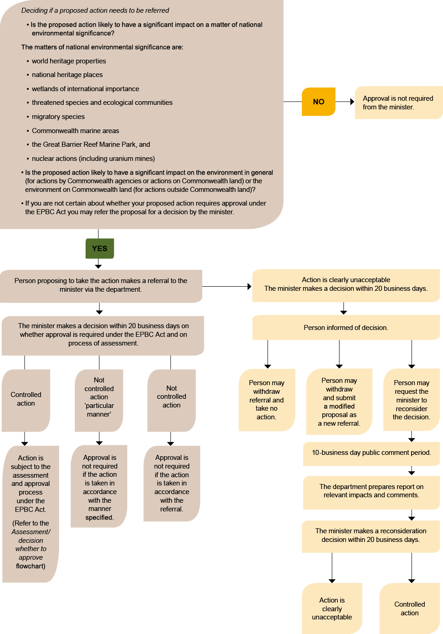
Decision on Referral
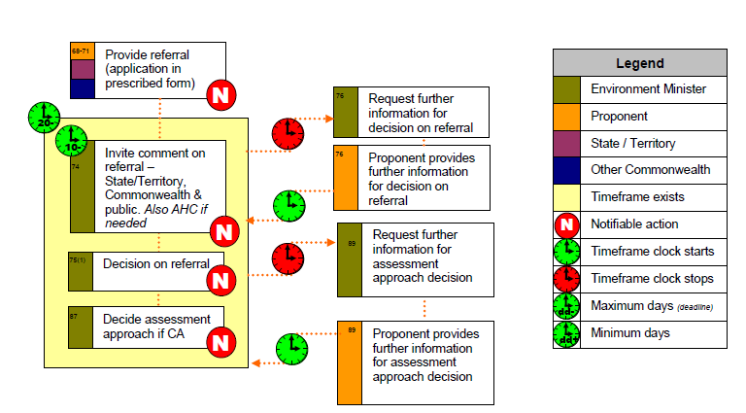
NOTE: The s.76 and s89 clocks can be stopped independently of each other
Environment Assessment Process – Assessment/Decision Whether to Approve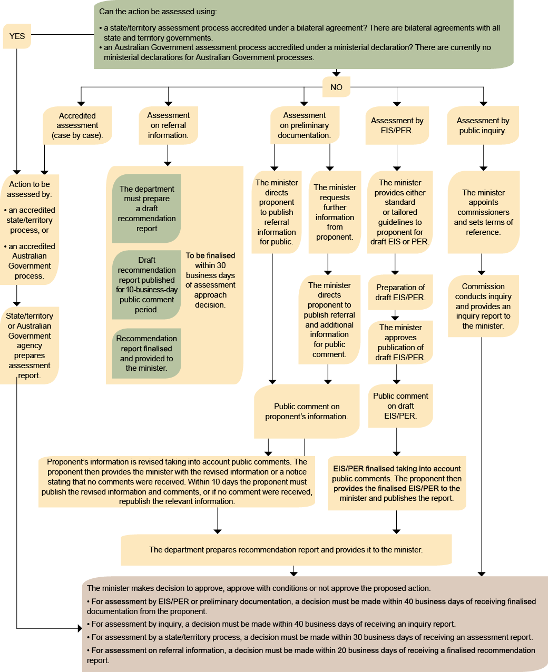
Minister’s Advice on Authorising Actions – Section160
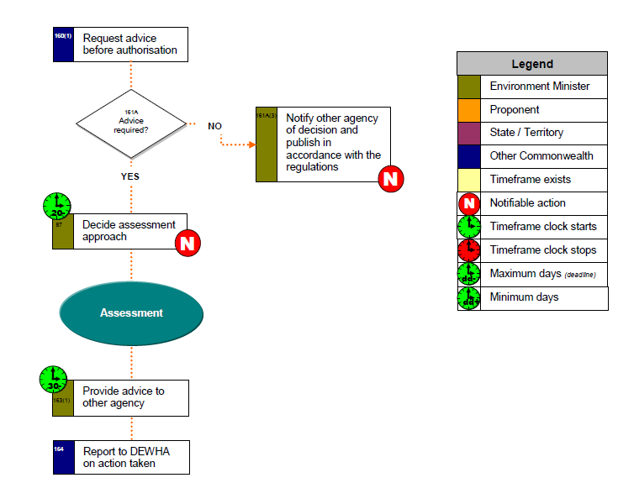
Decision that Action is Clearly Unacceptable
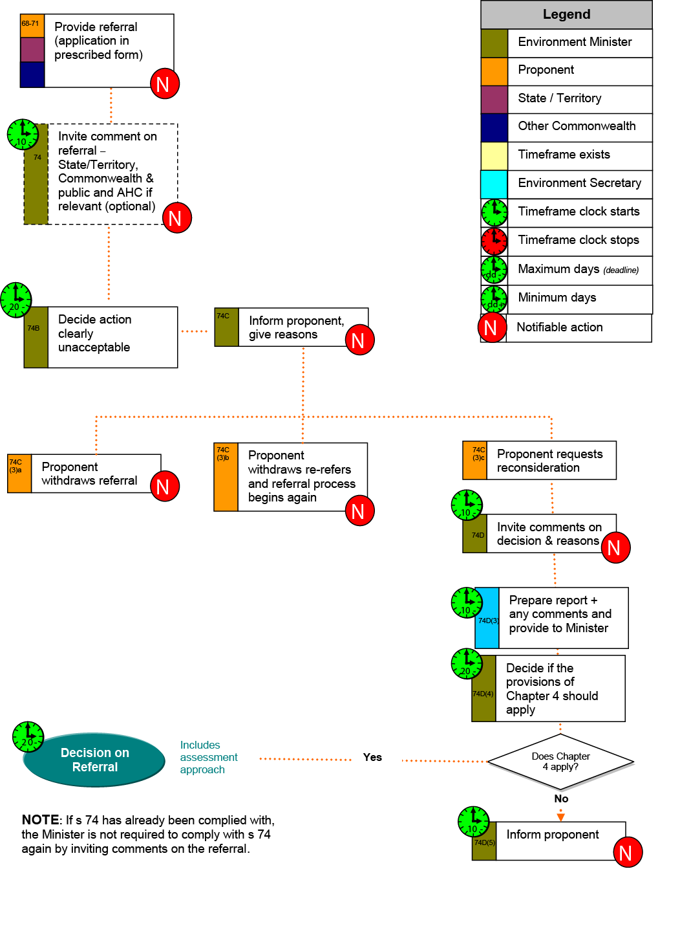
Assessment Methods
Assessment on Referral Information
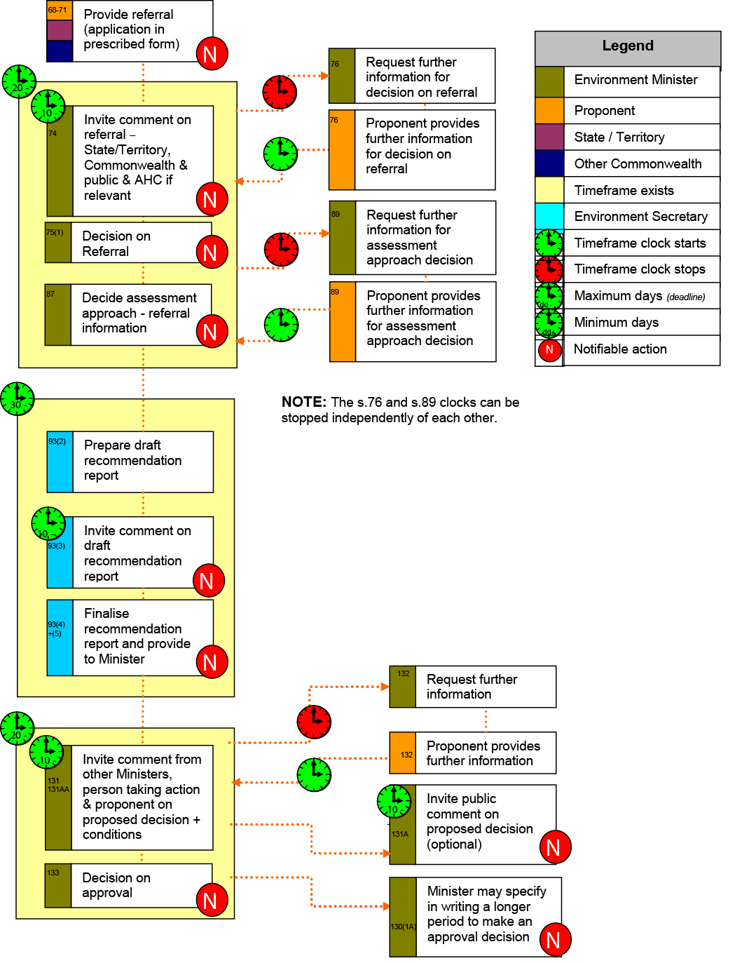
Preliminary Documentation – PD – Assessment
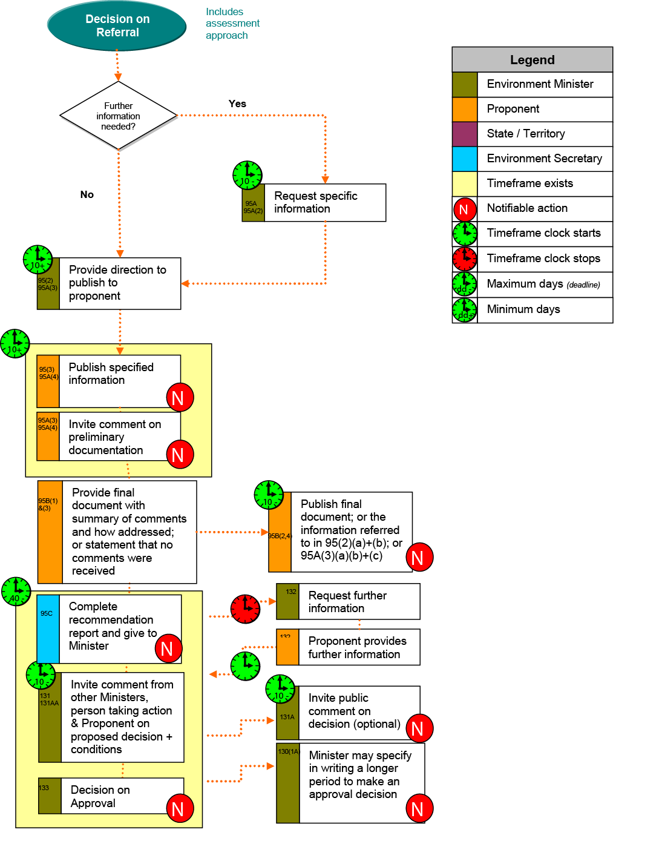
Public Environment Reports –PER – Assessment
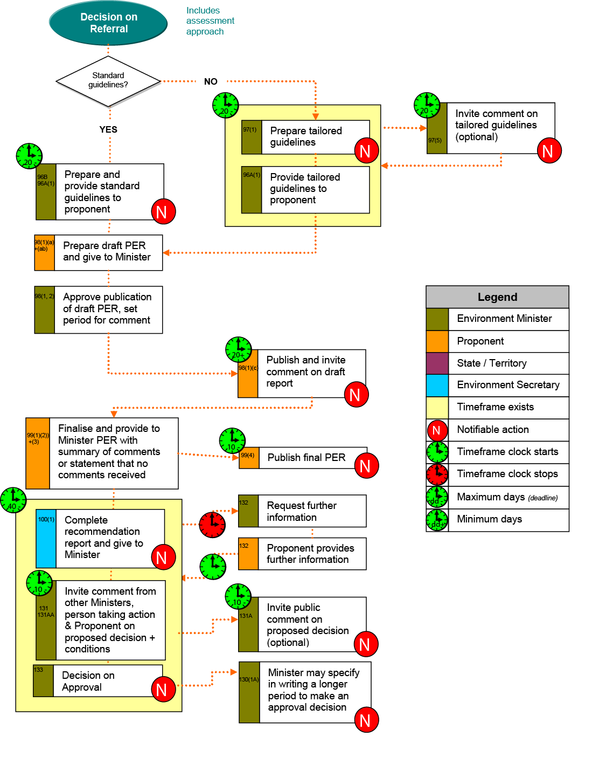
Environmental Impact Statements – EIS – Assessment
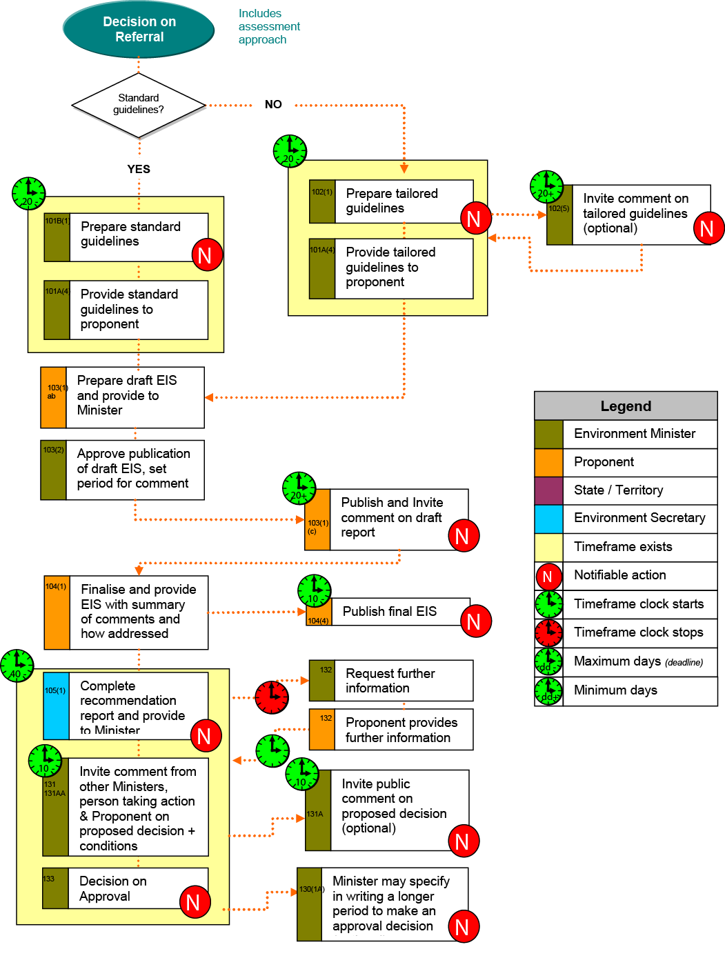
Bilateral Agreements
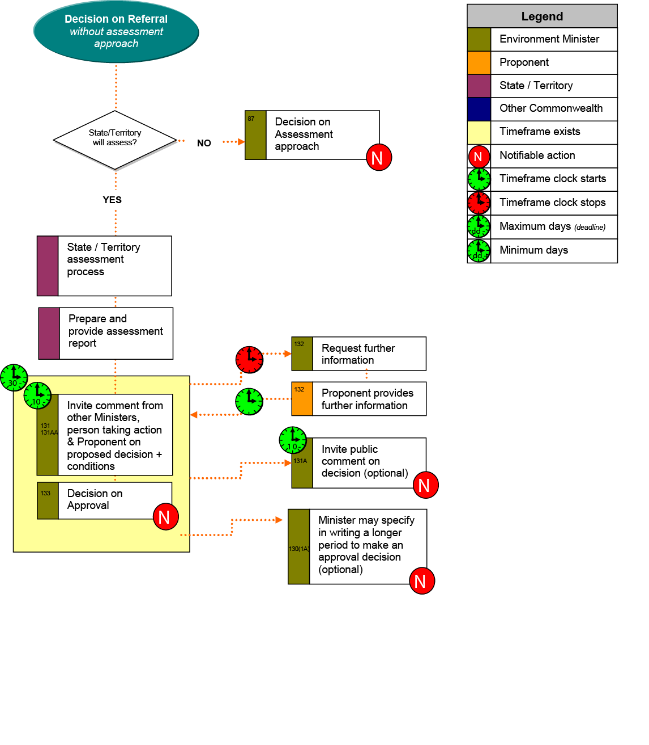
One off accreditation
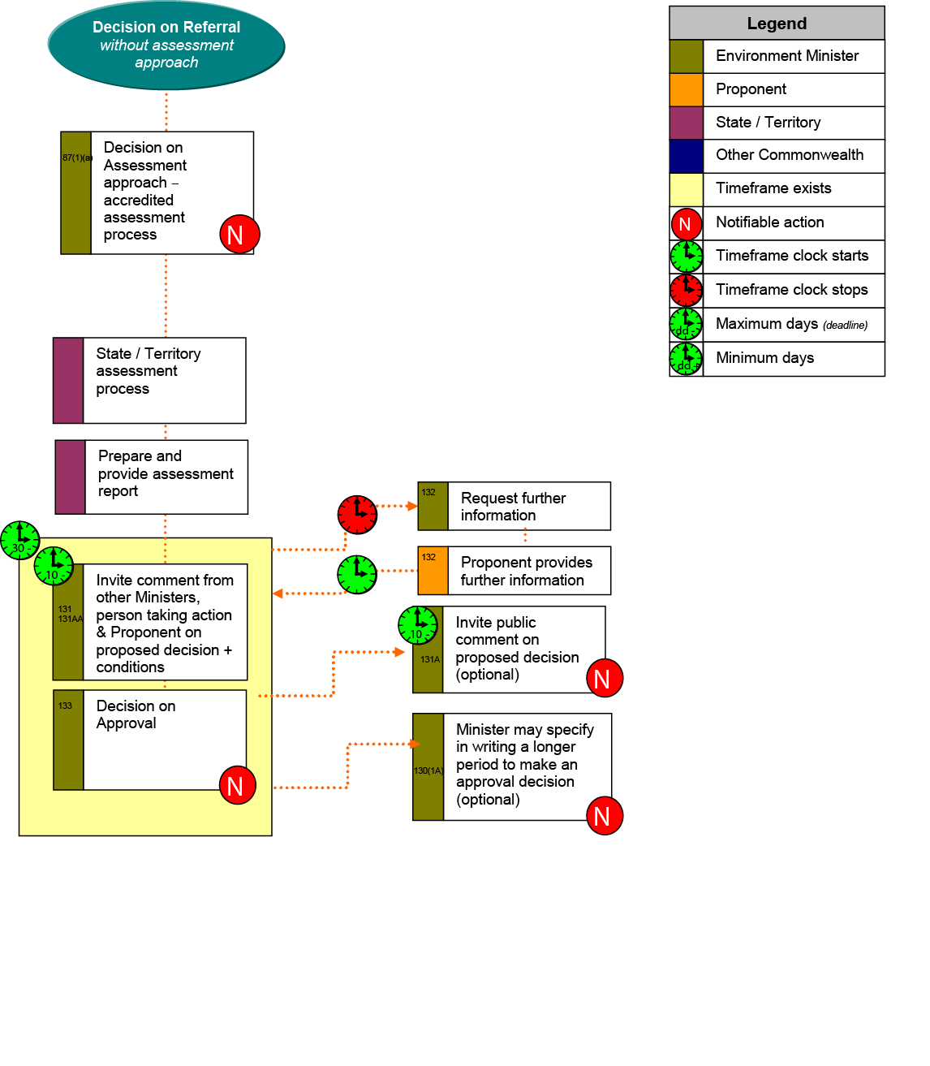
Reconsiderations
Reconsideration of Decision on Referral requested by person other than state or territory – Section 78
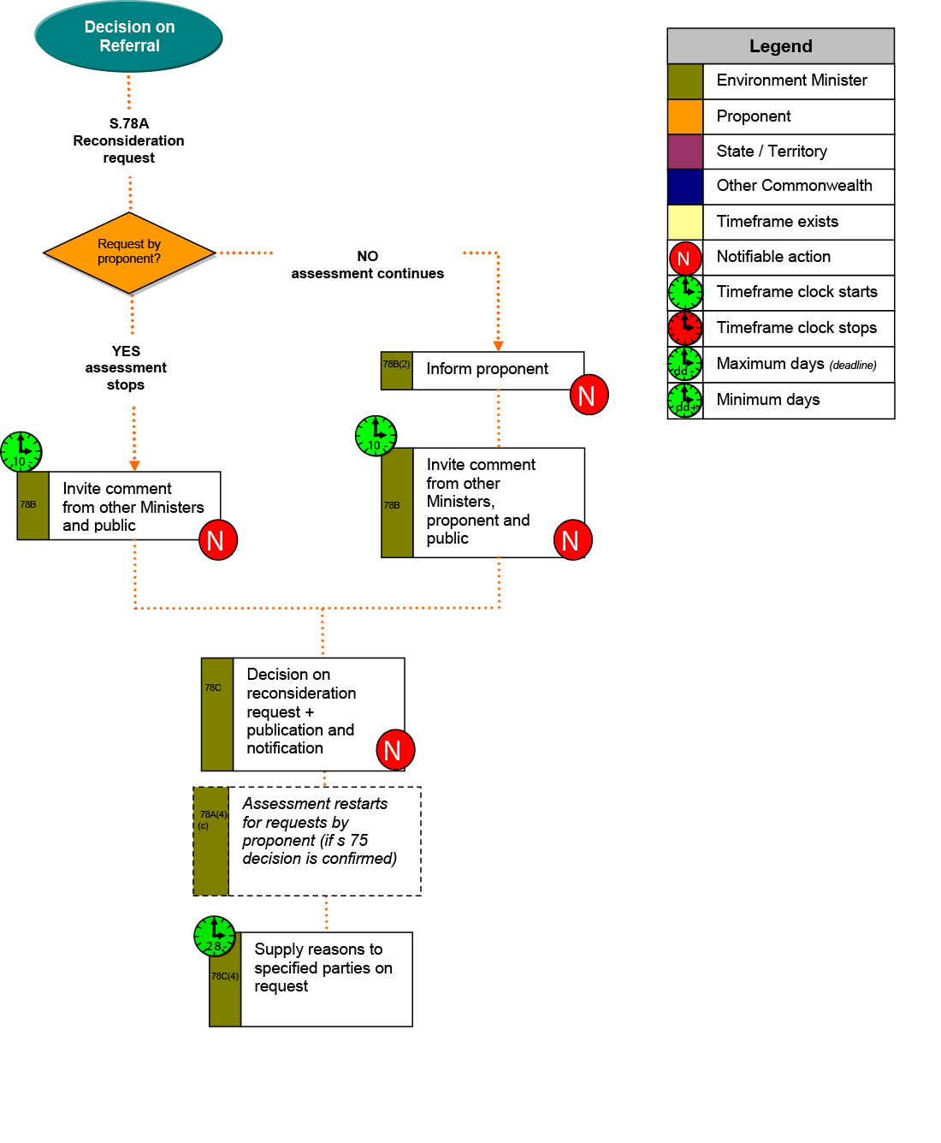
Reconsideration of Decision on Referral requested by state/territory minister – Section 79
