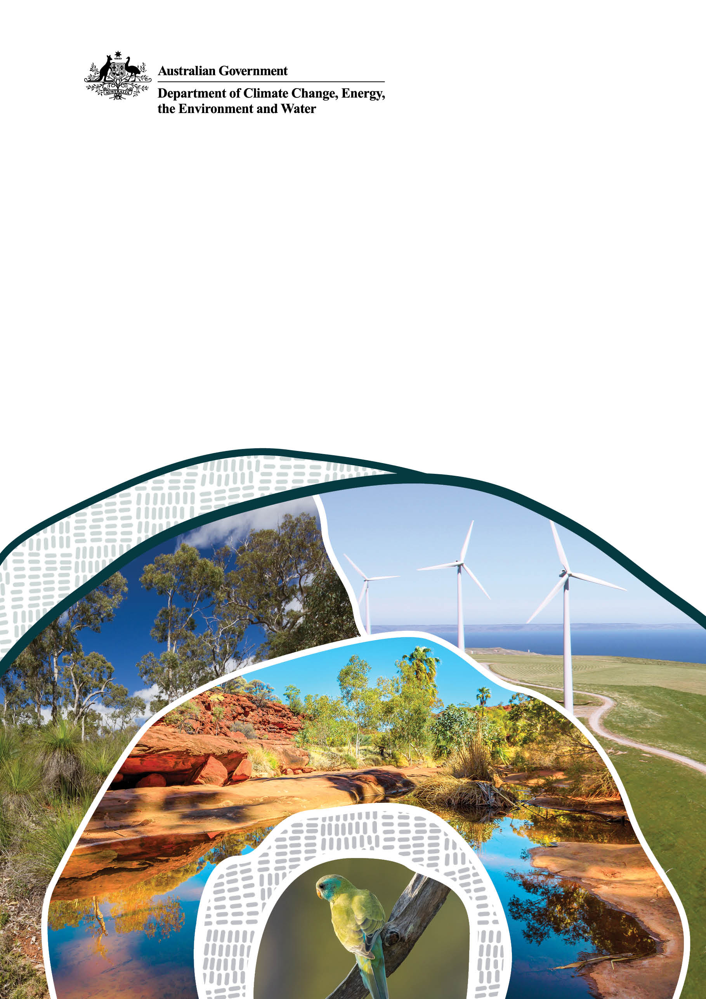

Environmental Offsets Audit
Department of Climate Change, Energy, the Environment and Water

© Commonwealth of Australia 2024
Ownership of intellectual property rights
Unless otherwise noted, copyright (and any other intellectual property rights) in this publication is owned by the Commonwealth of Australia (referred to as the Commonwealth).
Creative Commons licence
All material in this publication is licensed under a Creative Commons Attribution 4.0 International Licence except content supplied by third parties, logos and the Commonwealth Coat of Arms.
Inquiries about the licence and any use of this document should be emailed to copyright@dcceew.gov.au.

Cataloguing data
Department of Climate Change, Energy, the Environment and Water
GPO Box 3090 Canberra ACT 2601
Telephone 1800 920 528
Web dcceew.gov.au
Disclaimer
The Australian Government acting through the Department of Climate Change, Energy, the Environment and Water has exercised due care and skill in preparing and compiling the information and data in this publication. Notwithstanding, the Department of Climate Change, Energy, the Environment and Water, its employees and advisers disclaim all liability, including liability for negligence and for any loss, damage, injury, expense or cost incurred by any person as a result of accessing, using or relying on any of the information or data in this publication to the maximum extent permitted by law.
Acknowledgement of Country
We acknowledge the Traditional Owners of Country throughout Australia and recognise their continuing connection to land, waters and culture. We pay our respects to their Elders past and present.
Contents
1. Introduction 5
2. Approach 5
3. Review of Offsets Compliance 6
4. Desktop Audit 7
5. Conclusion and next steps 9
Executive Summary
On 29 June 2023 the Minister for the Environment and Water, the Hon Tanya Plibersek MP, announced an audit of environmental offsets approved under national environment law to review whether offset requirements have been met. Australia’s principal piece of environmental legislation is the Environment Protection and Biodiversity Conservation Act 1999 (EPBC Act).
In June 2023 the Department of Climate Change, Energy, the Environment and Water (the department) initiated an Offsets Audit Program (the program) to better understand offsets compliance and risks, as well as identify potential and actual instances of non-compliance.
Between June 2023 and March 2024, the program reviewed 222 EPBC Act approvals to determine compliance with the offset conditions of these approvals, of which:
- 32 (14% or 1 in 7) were non-compliant or potentially non-compliant with their approval conditions and required further investigation.
The program also performed a desktop audit of an additional 120 approvals with high environmental impact as well as a selection of others across risk profiles, sectors, and jurisdictions. Of these:
- 30 (25% or 1 in 4) approvals were found to have not, or potentially not, secured the necessary offsets and are subject to further information review, investigation, or audit.
The program has been successful in building a snapshot of compliance with conditions for approvals. The findings provide valuable information and insights on the current state of proponent offsets compliance that the department will use to:
- target activity in sectors and areas where non-compliance is likely to be occurring
- improve internal and external offset monitoring practices including informing Offset Management Plan guidance development
- provide approval holders with information to help take any corrective actions necessary to be consistent with their offset requirements, and
- take compliance action against approval holders non-compliant with their offset obligations.
The department will continue this work through its new standalone environmental audit function and dedicated offsets compliance capability, established as part of the program. Audit findings and compliance outcomes will be published on the department’s website.

Introduction
On 29 June 2023 the Minister for the Environment and Water, the Hon Tanya Plibersek MP, announced there would be an audit of environmental offsets approved under national environment law to review whether offset requirements have been met.
The EPBC Act is Australia’s principal piece of environmental legislation, designed to protect our national environmental assets including our unique plants, animals, habitats, and places. If a proposed development or other action is likely to have a significant impact on a protected matter, then it must be referred to the department for assessment under the EPBC Act. Proposed actions may range from a housing development, an offshore gas project, a mining project, to the construction of a road.
If a proposed development is approved under the EPBC Act, the approval may be subject to conditions or obligations proponents must meet as a requirement of approval. These may include the need to secure and manage environmental offsets to compensate for the residual significant impacts from actions that cause harm to protected matters, including nationally significant plants, animals, ecological communities, and places.
Approval holders’ compliance with environmental offset conditions is critical to compensating for the impact their developments have on the environment. If the Department identifies non-compliance, it can issue an infringement notice (a fine) and/or impose new conditions on a project to improve environmental and offset outcomes (a directed variation). If a court finds that a person or entity breached the EPBC Act they may face civil or criminal penalties.

Approach
To obtain an understanding of compliance with environmental offset conditions, and take appropriate compliance action, in June 2023 the Department of Climate Change, Energy, the Environment and Water (the department) initiated an Offsets Audit Program (the program).
A two-pronged approach was used, designed to better understand offsets compliance and risks, as well as identify potential and actual instances of non-compliance:
- development and implementation of an Offsets Compliance Strategy prioritising the review of high-risk EPBC Act approvals with offset obligations, including approvals that are due to expire or for which the department has received an allegation of non-compliance, and
- a desktop audit prioritising audits of EPBC Act approvals based on their overall compliance and environmental risk profile to identify potential instances of non-compliance and to inform future audit priorities and action.
Between June 2023 and March 2024, the program reviewed or audited 342 EPBC Act approvals. Key findings are summarised in the following sections.

Review of Offsets Compliance
An Offsets Compliance Strategy has been developed to provide a framework which focuses on the review of compliance with offset conditions. The Offsets Compliance Strategy prioritises approvals:
- approaching expiration, or
- approved prior to the EPBC Act Environmental Offsets Policy 2012 coming into force, or
- for which the department has received an allegation of non-compliance, or
- for which the department has detected non-compliance through audit or other programs.
Based on the priorities of the Offset Compliance Strategy, the department selected 222 valid approvals issues under Part 9—Approval of actions of the EPBC Act for review to determine compliance with the offset conditions of these approvals.
The review, undertaken between June 2023 and March 2024 in two separate tranches of work, found that of the 222 approvals 32 (14% or 1 in 7) were non-compliant or potentially non-compliant with their approval conditions and required further investigation.
In the first tranche of 104 approvals, 91 approvals were found to be compliant and 13 were found to be non-compliant with their offset obligations. As of 15 April 2024, and subject to any appeal:
- 5 approval holders have been issued a combined 6 infringement notices. Details of paid infringement notices are published on the department’s website, and
- 13 approvals are subject to a directed variation under section 143(1)(a) of the EPBC Act, of which 3 have been completed. Notices of directed variation are published on the department’s website.
The second tranche of 118 approvals are subject to ongoing review, with 19 being considered for compliance action (infringement notice(s) and/or a directed variation).
Non-compliance with offset-related approval conditions has been due to, for example:
- failure to submit offset management plans for approval in accordance with the approval
- failure to retire biodiversity credits in accordance with the approval
- failure to adequately implement offset management plans
- unauthorised clearing in an offset site.

Desktop Audit
A desktop audit was undertaken to help establish the leading indicators of non-compliance, as well as identify potential instances of non-compliance for further investigation. The desktop audit was informed by compliance records held by the department and publicly available records. The scope did not include requesting records from approval holders or undertaking site audits.
To provide visibility of offsets compliance of high-risk as well as other approvals, both those that have a high environmental impact (thematic and targeted) as well as a selection of others across risk profiles, sectors, and jurisdictions (representative and random) were selected for audit.
Thematic and targeted | 59 approvals were selected which impact both critically endangered Threatened Ecological Communities and critically endangered species.
Representative and random | 61 approvals were selected which included low, medium, and high-risk approvals, as well as approvals from different jurisdictions and across all sectors including mining, residential developments, transport.
Of the 120 approvals audited, 104 were found to have an offset requirement and conditions relating to securement and management. Of those, 86 had commenced activities on their approved projects; 54 of which had secured offsets, and 12 of which had not secured offsets. The remainder either could not be determined or are subject to information requests, investigation, or audit (Graph 1).
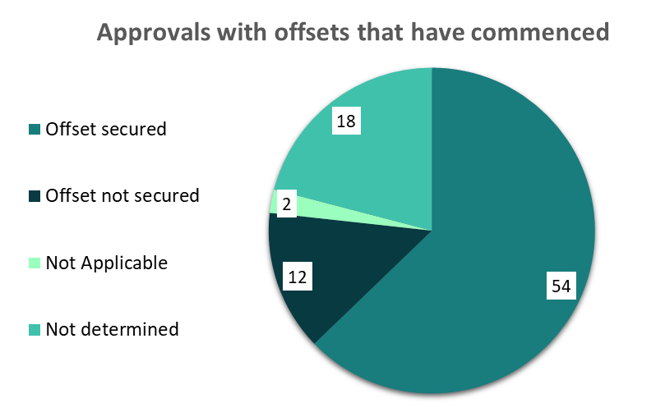
Graph 1. Number of approvals where the controlled action had commenced and the status of the related offset/s.

Across the 104 approvals with an offset requirement just under half were assessed as being compliant with both offsets’ securement and management obligations (Graph 2).
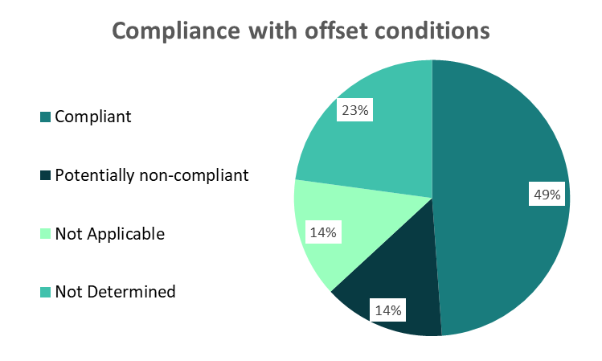

Graph 2. Outcomes by percentage for offset conditions audited under the Desktop Reference Audit project.
Potential non-compliance with offset conditions will require further information and investigation to appropriately assess compliance. Similarly, additional information is required to assess the almost a quarter of offset conditions that were unable to be determined based on available records.
Findings were further analysed to compare thematic and targeted and representative and random approvals. The key observations include:
- slightly more approvals in the thematic and targeted group (55 or 93 percent of those audited) compared with the representative and random group (49 or 80 percent of those audited) had offset conditions,
- the thematic and targeted group had a higher percentage of potential non-compliance with offset conditions, with 16 percent of offset conditions recording potential non-compliance compared to 7 percent of offset conditions in the representative and random group.

Conclusion and next steps
The program has been successful in building a snapshot of compliance with conditions for approvals dating back to 2001. The work to date has resulted in the department being able to:
- better understand the current state of compliance with offset conditions and initiate audit action on approvals identified as potential high risk for non-compliance
- take compliance action against those approval holders who are non-compliant with their offset obligations
- establish a robust, data informed, and risk prioritised compliance audit program including:
  - targeting activity in sectors and areas where non-compliance is likely to be occurring
  - improving internal and external offset monitoring practices including informing Offset Management Plan guidance development, and
  - providing approval holders with information to help take any corrective actions necessary to be consistent with their offset requirements.
The department’s recently established standalone environmental audit function and dedicated offsets compliance capability will continue the focus on the offsets work begun by the program. As the work progresses to the next stage the department has prioritised:
- audits of offset and land clearing related conditions for projects in residential and commercial development, mining, and energy sectors that meet specific risk and impact threshold
- audits of projects, including their offsets, that impact both critically endangered species and critically endangered Threatened Ecological Communities (TEC), and
- continued compliance engagement with approval holders who are non-compliant with offset conditions.
Audit findings and compliance outcomes will be published on the department’s website.

