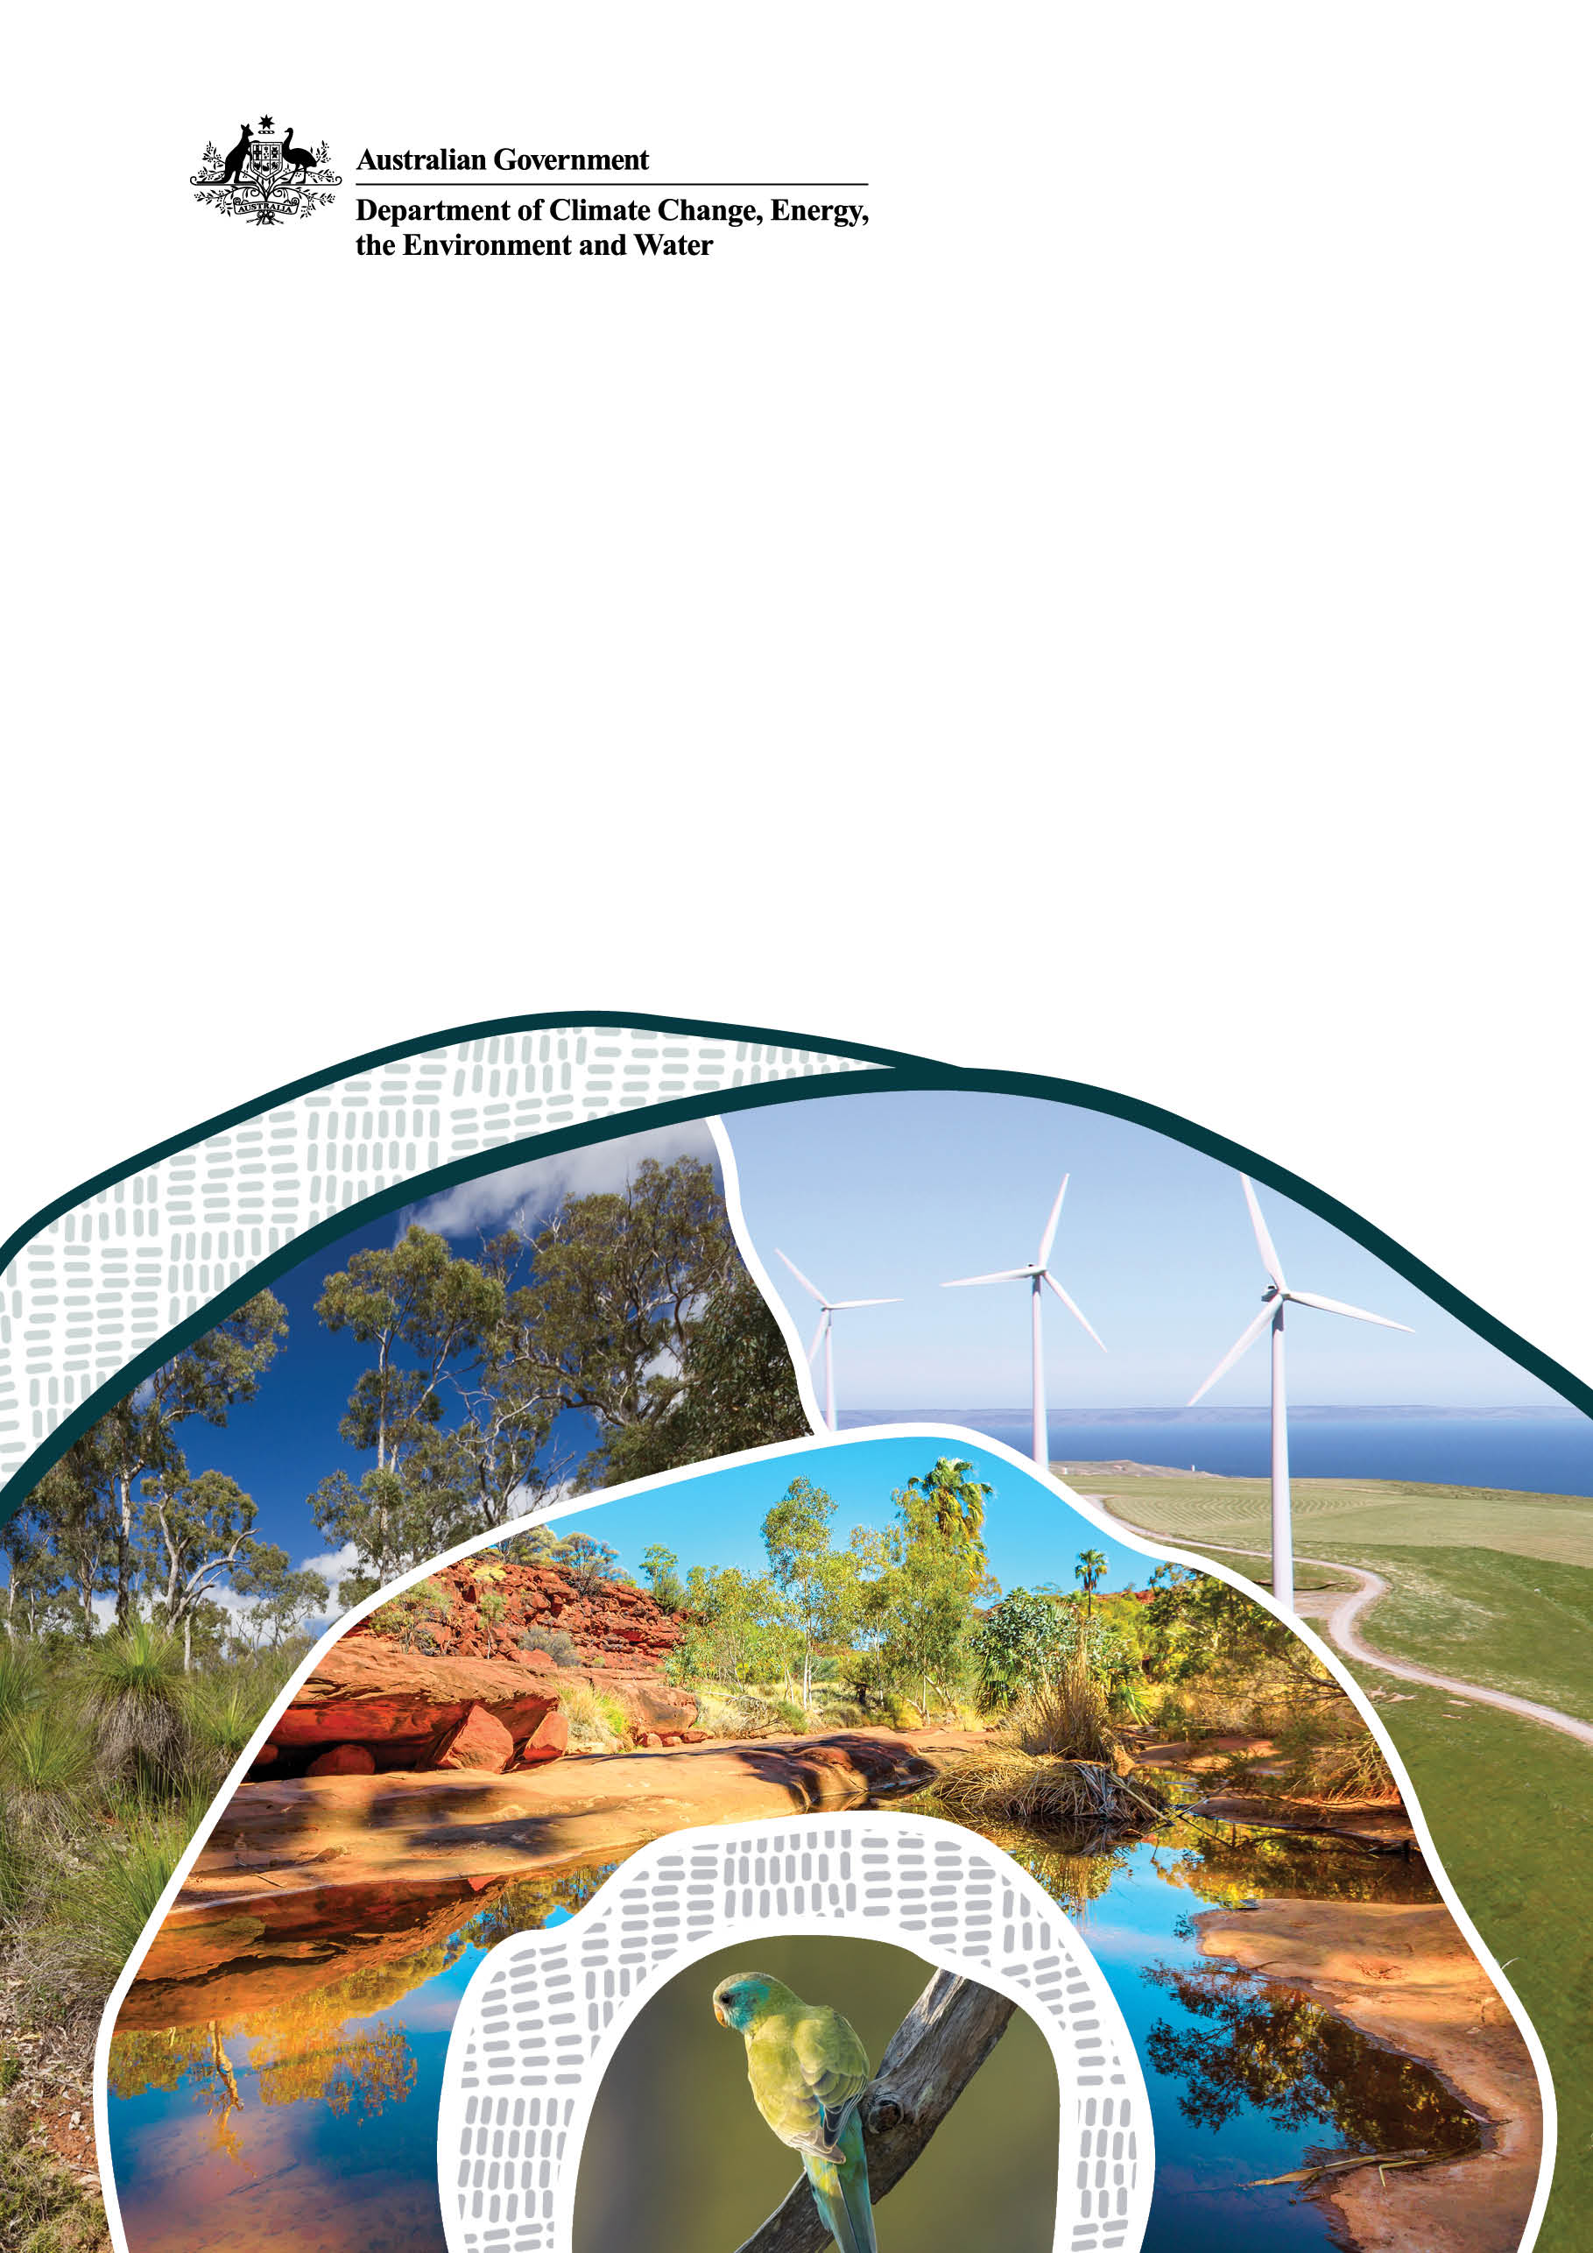
EPBC Act Self-Assessment Guidelines

World Heritage properties and National and Commonwealth Heritage places

© Commonwealth of Australia 2024
Ownership of intellectual property rights
Unless otherwise noted, copyright (and any other intellectual property rights) in this publication is owned by the Commonwealth of Australia (referred to as the Commonwealth).
Creative Commons licence
All material in this publication is licensed under a Creative Commons Attribution 4.0 International Licence except content supplied by third parties, logos and the Commonwealth Coat of Arms.
Inquiries about the licence and any use of this document should be emailed to copyright@dcceew.gov.au.

Cataloguing data
This publication (and any material sourced from it) should be attributed as: DCCEEW 2024, EPBC Act Self-Assessment Guidelines: World, National and Commonwealth Heritage, Department of Climate Change, Energy, the Environment and Water, Canberra, September CC BY 4.0.
This publication is available at dcceew.gov.au/publications.
Department of Climate Change, Energy, the Environment and Water
GPO Box 3090 Canberra ACT 2601
Telephone 1800 920 528
Web dcceew.gov.au
Disclaimer
The Australian Government acting through the Department of Climate Change, Energy, the Environment and Water has exercised due care and skill in preparing and compiling the information and data in this publication. Notwithstanding, the Department of Climate Change, Energy, the Environment and Water, its employees and advisers disclaim all liability, including liability for negligence and for any loss, damage, injury, expense or cost incurred by any person as a result of accessing, using or relying on any of the information or data in this publication to the maximum extent permitted by law.
Acknowledgement of Country
We acknowledge the Traditional Owners of Country throughout Australia and recognise their continuing connection to land, waters, and culture. We pay our respects to their Elders past and present.

Contents
Introduction 1
1.1 Heritage properties and places under the EPBC Act 1
1.2 Definition of an action 2
Self-Assessment 3
1.3 Understanding impacts from actions 3
1.4 Undertaking a self-assessment 3
1.5 Additional considerations 4
1.6 When to refer your action 5
Guidelines and Resources 5
1.7 Guidelines 5
1.8 Resources 5
Contact Us 6
Appendix A: Self-Assessment Template 6
Appendix B: Example Impact Assessment 10
Glossary 13

Introduction
These guidelines assist with the process of deciding whether to submit a referral to us where a proposed action may have a significant impact on a World Heritage property and National and Commonwealth Heritage places.
Undertaking a heritage self-assessment can help you to determine whether you may need to submit a referral under the Environment Protection and Biodiversity Conservation Act 1999 (EPBC Act).
This document aims to assist:
- with identifying whether significant impacts are likely or not
- with deciding whether to refer a proposed action to us for formal assessment
- with collating and providing adequate baseline information as a part of the referral process, if significant impacts are likely
- with collating adequate information that support a decision not to refer if significant impacts are not likely.

These guidelines should be read in conjunction with the Significant Impact Guidelines 1.1 self-assessment criteria and Significant Impact Guidelines 1.2 if your proposed action is on Commonwealth land.
Appendix A will assist you with the structure and factors to consider for your self-assessment.

Heritage properties and places under the EPBC Act

Heritage properties and places protected under the EPBC Act include places listed for their:
- connections with events and processes
- rarity
- research potential
- representativeness
- aesthetic characteristics
- creative or technical achievement
- social value
- associations with people and communities, and
- First Nations values

These places capture where we've come from, where we are now and gives context to where we are headed as a community.
Australia’s heritage gives us understanding and conveys the stories of our development as a nation. It also conveys our spirit and ingenuity, and our unique, living landscapes. Heritage is an inheritance that helps define our future.

World Heritage properties

World Heritage properties have been carefully assessed as representing the best examples of the world's cultural and natural heritage. Australia has 20 properties on the World Heritage List.
Australia's World Heritage properties are internationally recognised for their Outstanding Universal Value.

National Heritage places

The National Heritage List is Australia’s list of natural, historic, and Indigenous places of outstanding significance to the nation.

Commonwealth Heritage Places

The Commonwealth Heritage List is a list of Indigenous, historic, and natural heritage places owned or controlled by the Australian Government.
By identifying, protecting, and managing our heritage we are conserving a valuable asset. Conserving our heritage means those places will continue to be experienced and enjoyed by future generations.

Definition of an action

An ‘action’ is broadly defined in the EPBC Act. An action can be:
- a project
- a development
- an undertaking
- an activity
- a series of activities, or
- an alteration of any of these things
Actions include, but are not limited to:
- construction, expansion, alteration or demolition of buildings, structures, infrastructure, or facilities
- industrial processes
- mineral and petroleum resource exploration and extraction
- storage or transport of hazardous materials
- waste disposal
- earthworks
- impoundment, extraction, and diversion of water
- agricultural activities; aquaculture
- research activities
- vegetation clearance
- culling of animals, and
- dealings with land
Actions encompass various stages. These include:
- site preparation and construction
- operation and maintenance
- closure and completion of a project including any rehabilitation requirements, and
- alterations or modifications to existing infrastructure

Self-Assessment

Understanding impacts from actions

The EPBC Act protects the listed values of World Heritage properties and National Heritage places (section 34, items 1-1C, of the EPBC Act) and any heritage values on Commonwealth land.

When undertaking assessment of the significance of impacts, your assessment needs to address the impacts of the action on the listed values of the places. If the action is on Commonwealth land, your assessment needs to consider the impact on all heritage values, not just listed values.

For the purposes of this document, a self-assessment is required if, your action is:
- on, or with the potential to impact upon, the values of a place listed on the World, National or Commonwealth Heritage Lists, or
- an action undertaken on Commonwealth land or by a Commonwealth agency
Actions adjacent to or within the vicinity of a listed property may also have impacts on heritage values.
To view Australia’s listed heritage properties and places, refer to our webpages:
- World Heritage List
- National Heritage List
- Commonwealth Heritage List

Undertaking a self-assessment

A self-assessment should assess any potential impacts of your proposed action on relevant heritage values.
Your self-assessment must comprise of a Heritage Impact Assessment (HIA) - also known as a Statement of Heritage Impact (SoHI) or a Heritage Impact Statement (HIS) or an Environmental Impact Assessment.
A heritage specialist must prepare your self-assessment. They should understand the site, its heritage listings, and values, and your action.
Self-assessments should use evidence-based information. This demonstrates whether a significant impact is likely or not. If concerns with your proposed action and/or its potential impacts are raised, a robust self-assessment may mitigate potential legal risk to you.
The process will take some time. How much time depends on where and what your proposed action is, but we advise not rushing the self-assessment.
Our tools won't give you a definite answer, but you'll end up with a better idea of likely impacts.
Once you're done, keep a copy of your self-assessment. It's your record to show why you thought you did or didn't refer.
You must also undertake a separate self-assessment if your action is likely to impact other protected matters. For example, listed threatened species and communities in the Greater Blue Mountains Area World Heritage property.
You will need to also include these details within your self-assessment.
Refer to the Significant Impact Guidelines 1.1 for full self-assessment criteria or Significant Impact Guidelines 1.2 if your proposed action is on Commonwealth land.

Additional considerations

State and territory governments
State and territory governments also have heritage agencies. Many of these agencies maintain a list of local heritage and conservation specialists.
Engagement with First Nations peoples
You should undertake appropriate consultation with Traditional Owners and other First Nations peoples. They may have rights and interests in the place where you are proposing your action. You must document any consultation and include it in your self-assessment.
Other approvals
It is your responsibility to check what other approvals may be required. These include:
- Marine parks
- Great Barrier Reef Marine Park Authority (GBRMPA)
- Sea dumping
- Underwater cultural heritage (shipwrecks)
- State and territory

When to refer your action

If the self-assessment concludes that the proposed action is likely to have a significant impact, you must submit a referral.

You can contact us to schedule a pre-referral meeting to discuss the referral process.

If you decide a referral is not required, you must keep a record of your completed self-assessment on file.

Guidelines and Resources

Guidelines

There are several guides available to assist you throughout this process.
For actions on, or impacting upon:
National Heritage places and World Heritage properties, see:
Significant Impact Guidelines 1.1 - Matters of National Environmental Significance - DCCEEW
Commonwealth land and Actions by Commonwealth Agencies, including to Commonwealth Heritage places, see:
Significant impact guidelines 1.2 - Actions on, or impacting upon, Commonwealth land and Actions by Commonwealth Agencies - DCCEEW
World Heritage properties, see:
Guidance and Toolkit for Impact Assessments in a World Heritage Context - World Heritage Centre
First Nations communities, see:
The Interim Engaging with First Nations People and Communities on Assessments and Approvals under Environment Protection and Biodiversity Conservation Act 1999 (interim guidance) - DCCEEW

Resources

Refer to our web pages for more general information on self-assessments and the EPBC Act referral and assessment process.
- Self-assessment before making a referral under the EPBC Act - DCCEEW
- Engagement with First Nations People for referrals under the EPBC Act
- Step-by-step guide to the referral and assessment process - DCCEEW
- EPBC Act Policy Statement - Staged Developments - Split referrals: Section 74A of the EPBC Act - DCCEEW
- Offsets mitigation hierarchy - DCCEEW

Contact Us
For assistance or more information on self-assessments for heritage properties and places, contact us.
Email: Heritage@dcceew.gov.au

Appendix A: Self-Assessment Template
This section will assist you with the structure and factors that you should consider when preparing your self-assessment.
Section | Description and Contents
Introduction | - Background for the self-assessment and proposed action  - Author/s  - Summary of the site location/address and heritage listings  - Limitations of the document  - Methodology employed in the research, analysis, and assessment in the document
Heritage Listings | - Include all heritage listings and place identification numbers relating to the site. Include those also in the vicinity.  - Generate a report of all protected matters relevant to the site via the Protected Matters Search Tool. This includes World, National and Commonwealth Heritage listings.  - Include the listed heritage values and associated attributes.  - If it is included in the World Heritage List, find the listed Outstanding Universal Value (OUV) for the World Heritage property. This includes values and attributes, a statement of integrity/authenticity and a commitment of protection and management. Visit the UNESCO World Heritage Centre website and Australia's World Heritage on the DCCEEW website for information. Note that the OUV may differ from the values listed in the National Heritage List.  - Search the Australian Heritage Database for listed National and Commonwealth heritage values. Official gazette values can be found on the Federal Register of Legislation.  Note: if a place is located on Commonwealth Land, you must consider all heritage values. This is even if the values are not recognised in the Commonwealth Heritage List. A heritage analysis may need to be undertaken by a heritage specialist to understand any other heritage values present.
Statutory Context | - Relevant sections of the EPBC Act and Regulations  - Any statutory or non-statutory Heritage Management Plans  - The World Heritage Convention and The Operational Guidelines for the Implementation of the World Heritage Convention  - Any other relevant legislation e.g. state and territory planning legislation.
Site identification | - Physical Description – highlighting key features of heritage significance.  - Map(s) identifying the location of the place or property at different scales. This should include adequate detail to show the site in context. The map(s) should also include information relating to the boundary of the heritage place. See: Guide to providing maps and boundary data for EPBC Act projects - DCCEEW.  - Images of the proposed action site  - A brief site history (if relevant to the proposed works)  - Identify key stakeholders and users of the site.
Proposed Action | - Provide a detailed description of the proposed action:  - reference to any architectural, structural or landscape plans and surveys.  - life span of the project from planning to post completion. This includes decommissioning and removal, if applicable  - removal or disturbance of vegetation, soil, waterways, and/or geological features.  - timing of works (day/night, month). This can be an important consideration for potential impacts to breeding, roosting, and foraging of species recognised in listed heritage values, including listed threatened and migratory species.  - Map(s) showing where the proposed works are in the context of the boundary of the listed place. The footprint of the proposed action must be clearly defined. This includes demarcating areas within the map(s) according to the type of activities proposed.  - Stakeholder and Traditional Owner engagement and consultation. This includes documentation of their relationship with the place and their view of the potential action.
Impact Assessment | - Assess the direct, indirect, facilitated, and cumulative impacts of the proposed action. The impact assessment should focus on the heritage values and associated attributes. This includes official listed heritage values. This includes the Statement of Outstanding Universal Value for World Heritage Properties and the values included in the Gazette Notice for Commonwealth and National Heritage places. You must include any other heritage values identified during the heritage analysis if the place is on Commonwealth land.  Details of this may include:  - consideration of physical changes to fabric  - development in the vicinity  - demolition  - changes to the context  - change of use  - change of access  - impacts on sight lines  - impacts on archaeological deposits  - impacts on the ability for community to engage with the place  - waste and/or pollution increases.  Note: potential impacts to heritage values can be from activities occurring outside of the boundary of a listed place. You must also consider these impacts  - Assess the cumulative impacts of the proposed action. This should address the broader context of the development history of the place or property. It also includes any future and planned works.  - If there is a Heritage Management Plan for the place or property that is consistent with the EPBC Act, the action should also be assessed against the policies in the Plan. If the Heritage Management Plan is a Legislative Instrument, the proposed action must be consistent with the policies in the Plan.  - Refer to the Appendix B for an example Impact Assessment.
Measures to avoid or reduce impacts | - Provide detail of proposed measures to avoid or reduce impacts on the heritage values of the place or property.  Avoidance measures such as:  - changes to the design or proposal  - choosing a different location for the proposal  - limiting the size, scope, or scale of the proposal  - protection zones for significant elements on site and in the vicinity  - altering the timing of the action to avoid migratory periods.  Mitigation measures such as:  - conservation of specific heritage fabric identified in the values  - using appropriately skilled specialists and trades people  - sterilisation and sanitisation protocols for e.g. vehicles and personnel to prevent introduction of pests and weeds  - inducting those working on the project to understand heritage values and significance  - designing new built elements so they are sympathetic to the heritage values.  - photographic archival recordings  - interpretation plans for heritage values  - engagement of Traditional Owner heritage monitors to be present during groundbreaking works  - stop works procedures to be in place for unanticipated finds. This includes artefacts and ancestral remains  Note: offsets are usually not considered appropriate for heritage.  - The self-assessment should not conclude that a significant impact is not likely to occur because of management or mitigation measures. That is unless the effectiveness of those measures is well established and there is a high degree of certainty.  - The self-assessment should clearly state which measures and recommendations were accepted by you. It should also state how they have been incorporated in the proposed action, or if not, why not.  - Include a statement on all measures and recommendations that were considered, adopted and/or discounted and why. Include information on whether Traditional Owner groups endorsed or rejected any mitigation measures.  - Document consultation with Traditional Owner groups on listed First Nations cultural heritage values. This includes any potential cultural heritage values not listed. Obtain a letter of consent from the Traditional Owner representative bodies and First Nations Peoples with rights or interests in the place or property to support the action and any proposed mitigation measures.  - The Impact Assessment should utilise the relevant Significant Impact Guidelines. These guidelines are available in the resources and guidelines section above.
Conclusion | You must include a statement summarising:  - the potential impacts, proposed avoidance, and mitigation measures  - if the proposed action is likely to have a significant impact on the heritage values of the property or place This includes the authenticity or integrity for World Heritage properties  - clarity on commitment to the avoidance and mitigation measures outlined.
References | - A complete list of all references  - All figures, including illustrations, photographs, and plans, should have captions and be sourced  - The caption should be a description of the item and must be dated  - The source of information, including all quotations, must be referenced  - References should be consistent and include the following information:  - author’s name  - title of document  - publisher  - place published  - year of publication  - page number/s  - permalinks to website accessed or Digital Object Identifier, if applicable  - Identify if any of the material is sensitive.

Appendix B: Example Impact Assessment
Please note that these are examples only. Impact assessments will be different for each action due to the nature, scale, location, and severity of impacts of the action/heritage values to be impacted.
Action | Assessment | Unmitigated potential Impact on values | Mitigation Measures | Potential significant impact on values following mitigation measures
Proposed repainting of exterior | Previous works have obscured the original colour scheme of the building. The original colour scheme reflects the original design of the building as listed under criteria (b) and (d). It is proposed to reinstate the original colour scheme. Repainting will be according to archival photographic records, original plans, and paint scrapes. This would have a positive impact on the heritage significance of the building. | Not likely | - Repainting will reinstate the original colour scheme. Appropriate paint types will be used to ensure fabric is conserved.  - The works will be recorded to ensure records are maintained of any building and maintenance works.  - Repainting will be conducted by a qualified tradesperson with experience with heritage buildings | - Unlikely
Proposed demolition of interior walls | The layout and design of the building is recognised under criterion (a). The proposed demolition would alter the original design of the building. This will impact the integrity of criterion (a). The design will retain significant fabric and evidence of the original floor plan. This will manage the impact by retaining wall nibs and spandrels. Photographic archival recording will also be conducted prior, during, and after the works. This will be completed in accordance with HMP Policy 6.3, to capture an accurate historic record. Copies of the photographic archival recording will be retained on site. | Likely | - Undertake Photographic Archival Recording  - Retain significant fabric.  - Retain evidence of original floor plan | - Unlikely
Proposed expansion of property footprint for visitor carpark | The current footprint contains artefact scatters that include stone chips that indicate maintenance of stone tools. The artefacts do not appear to be from rocks in the region and may provide evidence of trade between groups. It is also not clear how many layers of artefacts may be present on the site. | Likely | - Option 1: Reduction in size and scope or relocation of carpark to less sensitive area  - Option 2: Record and salvage of artefacts agreed to by Traditional Owners  - Option 3: Record and salvage of artefacts not agreed to by Traditional Owners | - Option 1: Unlikely  - Option 2: Likely. Documentation of all options that TOs were consulted with supports record and salvage.  - Option 3: Highly likely – diminishing Indigenous heritage values - TOs do not support record and salvage.
Proposed undertaking of geotechnical investigations near/within a listed place | The place is listed for the concentrations of rock carvings and the range of images depicted, rarity, range, and density of images. These are listed under criterion a, b, c, d, and f. The geotechnical investigation areas were designed to avoid areas of cultural heritage significance. This includes the rock art and associated attributes. The geotechnical investigations are supported by Traditional Owners. They have approved a Cultural Heritage Management Plan specific to the work. A letter was also provided which details their consent to the works. | Not likely | - Design of the geotechnical investigations to avoid areas of cultural heritage significance.  - Measures detailed in Cultural Heritage Management Plan specific to the work being undertaken.  - The fieldwork component of the geotechnical investigations was designed to be undertaken in 8 days. This is to ensure there will be little to no impact on the surrounding area.  - Work will be undertaken in conjunction with Traditional Owner Rangers. This will be done on ground to monitor activities. | - Unlikely
Proposed construction of transmission lines across listed place | The place is listed for its biodiversity values under criteria a and b. The proposed clearing of land to build transmission infrastructure will impact on several endangered ecological communities and threatened species. Associated light and noise pollution could affect the migration patterns of threatened species. The place is also listed for aesthetic values under criterion e. The transmission structures may impact on its aesthetic beauty. This includes the remote and natural landscapes of the place. A visual impact assessment will be completed, and findings committed to. | Likely | - Relocation of transmission lines to outside the listed place or in areas of already cleared land.  - Timing of construction work to avoid migration period of threatened species.  - Regular monitoring of threatened species habitats  - Completion of and strict adherence to:  - Bushfire risk assessment  - Visual impact assessment  - Pest, weed and pathogen control protocols. | - Unlikely
Proposed expansion of existing fish farm operations within a listed place | The place is listed for its marine biodiversity and fossil sites along the coastline under criteria a, b, and e. The proposal will increase production of its fish farms and include new nursery sites. This development has potential to increase both road and boat traffic in the area. It will also increase nutrient enrichment and effluent pollution of the marine environment. You will carry out extensive monitoring of nutrient levels during construction. | Likely | - Number of new nurseries reduced.  - All construction and work activities will take place during daylight hours. This will avoid the need for significant lighting at night  - You will closely monitor nutrient levels and condition of sediments. Production will cease if data exceeds approved levels.  - Leases will be fallowed for a specified period. This will allow time for the sediment conditions to recover | - Unlikely

Glossary
Term | Definition
EPBC Act | Environment Protection and Biodiversity Conservation Act 1999
HIA | Heritage Impact Assessment
HIS | Heritage Impact Statement
SoHI | Statement of Heritage Impact
Regulations | Environment Protection and Biodiversity Conservation Act Regulations 2000

