Guide to providing maps and boundary data for EPBC Act projects
Geospatial and Information Analytics Branch

© Commonwealth of Australia 2021
Ownership of intellectual property rights
Unless otherwise noted, copyright (and any other intellectual property rights) in this publication is owned by the Commonwealth of Australia (referred to as the Commonwealth).
Creative Commons licence
All material in this publication is licensed under a Creative Commons Attribution 4.0 International Licence except content supplied by third parties, logos and the Commonwealth Coat of Arms.
Inquiries about the licence and any use of this document should be emailed to copyright@awe.gov.au.

Cataloguing data
This publication (and any material sourced from it) should be attributed as: DAWE 2021, Guide to providing maps and boundary data for EPBC Act projects, Department of Agriculture, Water and the Environment, Canberra, February. CC BY 4.0.
ISBN 978-1-76003-315-6
This publication is available at www.environment.gov.au/about-us/environmental-information-data/information-policy/maps-and-boundary-data-for-epbc-act-projects.
Department of Agriculture, Water and the Environment
GPO Box 858 Canberra ACT 2601
Telephone 1800 900 090
Web awe.gov.au
Disclaimer
The Australian Government acting through the Department of Agriculture, Water and the Environment has exercised due care and skill in preparing and compiling the information and data in this publication. Notwithstanding, the Department of Agriculture, Water and the Environment, its employees and advisers disclaim all liability, including liability for negligence and for any loss, damage, injury, expense or cost incurred by any person as a result of accessing, using or relying on any of the information or data in this publication to the maximum extent permitted by law.

Contents
Introduction 5
Purpose and structure of this document 6
Not covered by this document 6
1 Project boundary spatial information 7
1.1 How to create and provide good-quality maps 7
1.2 How to create and provide good-quality spatial data 14
2 Pre-referral stage 19
3 Referral stage 20
3.1 What to provide at the referral stage 20
3.2 How to provide maps and spatial data at the referral stage 21
3.3 Providing changes to referral boundaries after initial submission 24
4 Assessment, approval and post-approval stages 26
4.1 What to provide at assessment, approval and post-approval stages 26
4.2 How to provide maps and spatial data at assessment, approval and post-approval stages 29
5 Intellectual property rights and what happens to the data you provide 30
5.1 Sensitive data 30
6 Further information 31
Appendix A: Map checklist 32
At all times 32
Referral stage (via the online referral form) 33
Assessment, approval and post-approval stages 33
Appendix B: Spatial data checklist 34
At all times 34
Referral stage (via the online referral form) 34
Glossary 35
Other relevant policies and guidelines 39

Tables
Table 1 Spatial data creation methods 15
Table 2 Suggested scales for creating (digitising) data 16

Figures
Figure 1 Visual representation of spatial data 7
Figure 2 Two A4 maps – one at small scale, one at large scale 9
Figure 3 Two maps at same scale but different map sizes – one at A4 size, one at A3 size 9
Figure 4 Multiple A4-sized maps at same scale to represent entire area of interest 10
Figure 5 What is a polygon? 14
Figure 6 A shapefile is a collection of at least 4 files 17
Figure 7 Visual representation of boundary definitions 21
Figure 8 Example of output from the spatial capture tool within the online referral form 23
Figure 9 Example of how boundaries are drawn using the spatial capture tool 24

Maps
Map 1 Features of a good-quality map 13
Map 2 Example of map provided during assessment stage 27
Map 3 Example of map provided during post-approval stage 28

Boxes
Box 1 Map scale vs map size 9
Box 2 Polygon, polyline or point data? 14
Box 3 EPBC Act boundary area definitions 21

Introduction
Australia is home to many animals, plants, habitats and places that are found nowhere else on earth and it’s important to protect them. The Environment Protection and Biodiversity Conservation Act 1999 (EPBC Act) is Australia’s national environmental law. It ensures that nationally significant animals, plants, habitats and heritage places (‘protected matters’) are identified, and any potential negative impacts on them are carefully considered, before changes in land use or new developments are approved.
When a person decides to have a project assessed for environmental impacts under the EPBC Act, they must ‘refer’ the project to the Australian Government environment minister. The referral needs to contain accurate ‘project boundary’ information to understand the nature and extent of possible impacts on protected matters.
Good-quality information about the location of a project (‘spatial information’), including maps and data, is important throughout the environmental assessment process. Providing good-quality spatial information from the start helps streamline the process, saving time and money by reducing to-and-fro between you and the department. Providing good-quality spatial information throughout the environmental assessment process may help avoid variations or compliance issues.

Purpose and structure of this document
This document is a guide on how to prepare and provide spatial information (maps and data) for each stage of the EPBC Act environmental assessment process. This includes the pre-referral, referral, assessment, approval and post-approval stages.
This document is intended for people without any background in preparing maps or ‘spatial data’, as well as for experienced practitioners. The document includes many technical terms and concepts. Where a term first appears or where it is explained within the document, the term is presented in 'inverted commas'. Terms are also explained in the Glossary.
This document has been prepared in collaboration with the department's assessment officers and is intended to help you provide the information that they need to streamline your assessment. This document also includes checklists that outline everything that is required. Once you're familiar with the requirements in this document, use the checklists as a reminder. The checklists can be found at Appendix A and Appendix B.

Not covered by this document
This document relates to project boundary information only and does not apply to species observation information ('point data'). For guidance on providing species observation point data, see Guidelines for biological survey and mapped data (2018).
Detailed information on the EPBC Act environmental assessment process, including how to complete the ‘online referral form’, is not presented here. For information about the EPBC Act environmental assessment process, including the referral stage, see the Environment assessment and approval process website. For information about submitting a referral under the EPBC Act, including what information is required, see 'EPBC Act Referral' within Help in Online Services. See also 6. Further information and Other relevant policies and guidelines.

Project boundary spatial information
Spatial information can include written descriptions of locations, maps and spatial data. Spatial data means data defining the boundary shape and location of an area of interest for your EPBC Act project. Spatial data are normally stored in specialised spatial data files using specialised software (see 1.2.7 Types of spatial files you can provide).
Spatial data are used to create maps, which provide a visual representation of the underlying data (Figure 1). Maps and spatial data can be used to better understand the spatial aspects of your project, such as how large the overall area is or how close it lies to other areas.
Figure 1 Visual representation of spatial data
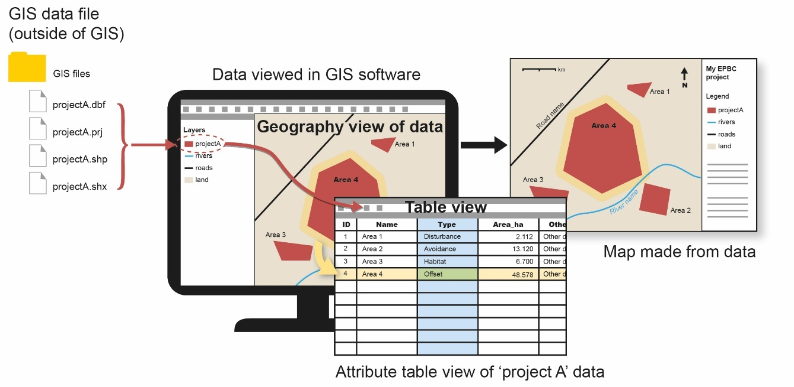
Note: Maps are created from spatial data. The spatial data that create a map can be viewed in a data attribution table. In the table, every record (represented by a single row) in the table correlates to a 'polygon' (area) in the map. You can store information for each record (polygon/area) in the table. The information is stored as values for each attribute (represented in columns, or 'fields') in the dataset. For example, you may have areas (rows) with values of 'Habitat' or 'Other' stored under the 'Type' attribute (column) and area values stored under the 'Area_ha' attribute. This sort of information must be entered manually or calculated by the creator. Other information, such as the geometry (shape) and coordinates, is automatically stored and not necessarily visible in the table. See also 1.2.5 Data table values.

How to create and provide good-quality maps
A good-quality map shows all of the relevant boundaries for a given stage of the EPBC Act environmental assessment process. A good-quality map includes enough information for others to understand the location, size and shape of the project, as well as the project's special on-ground features, landscape and context. Creating a good-quality map involves considering the nature of the project, the features represented and the purpose of the map. It also includes all necessary map elements, such as a scale bar and legend.
Different stages of the EPBC Act environmental assessment process have different map requirements (such as which features to be included or which file types are appropriate). For specific requirements for each stage, see sections 3. Referral stage and 4. Assessment, approval and post-approval stages.

What to show on your map

All relevant features and only relevant features
All relevant features should be included. Relevant features are those that are generally required to be shown at a given stage of the EPBC Act environmental assessment process as well as those that may be requested by an assessment officer. Requirements may vary depending on the stage of the process. For example, at the referral stage, the boundaries of your 'project area', your 'disturbance footprint' and your ‘avoidance area’ must be shown.
Relevant features also include those that provide necessary information about the location or context of the project, such as towns, roads, rivers, ‘cadastre’ boundaries, recognisable landmarks and overlapping or adjacent EPBC Act projects or ‘offset’ boundaries. Such features should be clearly labelled (see 1.1.4 Symbology and labelling). It may also be useful or necessary to provide coordinates – either in the form of standalone feature labels or by including a 'graticule' or 'grid' – to make the location of the project clear.
Make sure that only relevant features are included. Don't include features that don't add to the understanding of the spatial aspects of your project. This includes making sure you create maps at the right scale and don't show an area that is much larger than needed (see 1.1.2 Map scale to use).
All features should be clear, appropriately highlighted and displayed at the right scale.

Confidential locations
If your map shows the details of a location that may endanger a threatened species if made publicly available, you must request for the map to be kept confidential.

Appropriate amount of information and detail
Don't put too much information on any single map. For example, you may have a large or complex area that would end up being too small to be able to see the details of the boundaries or features if the whole area was presented in a single map. In such a case, use multiple maps to display separate portions of your project area or separate groups of information. The aim of any map you provide is to clearly show all of the required features with sufficient clarity to understand the details.
If you need to spread your information across multiple maps, make sure all maps are at the same scale (see Box 1 for more information).

Background maps
Use satellite imagery as a background map. Maps can be created with or without a background map (or 'basemap'). For example, a background map can be satellite or photographic imagery, a street map (showing roads or state boundaries) or a topographic map (showing natural and manmade features). In most cases, satellite (or photographic) imagery gives a better understanding of the on-ground features than other sorts of basemaps. Be sure to use recent and clear satellite imagery (that is, make sure there are no clouds covering the features of interest), and be sure to include the data source details on your map.

Map scale to use
'Map scale' refers to the relationship between the distance of features on the map and the corresponding distance of those features on the ground. For example, on a 1:100,000 scale map, 1 cm on the map equals 100,000 cm (1 km) on the ground.
The right scale will depend on the on-ground size of your project area, the particular features being shown and the page size of your map. The right scale is one where the area of interest on your map is not too large or too small. Maps at the right scale will show the area and features of interest in enough detail that they can be fully understood.
The right scale for your map may be different from the scale you used to create the data (see section 1.2.3 What scale to use when creating spatial data).
Maps at larger map scales (for example, 1:1,000) show more on-ground details (and have smaller numbers) than maps at smaller scales (for example, 1:1,000,000) (see Glossary and Box 1 for more explanation).
Box 1 Map scale vs map size
Maps using larger map scales show on-ground features and areas at a larger size on the page than maps using smaller map scales.
Figure 2 Two A4 maps – one at small scale, one at large scale
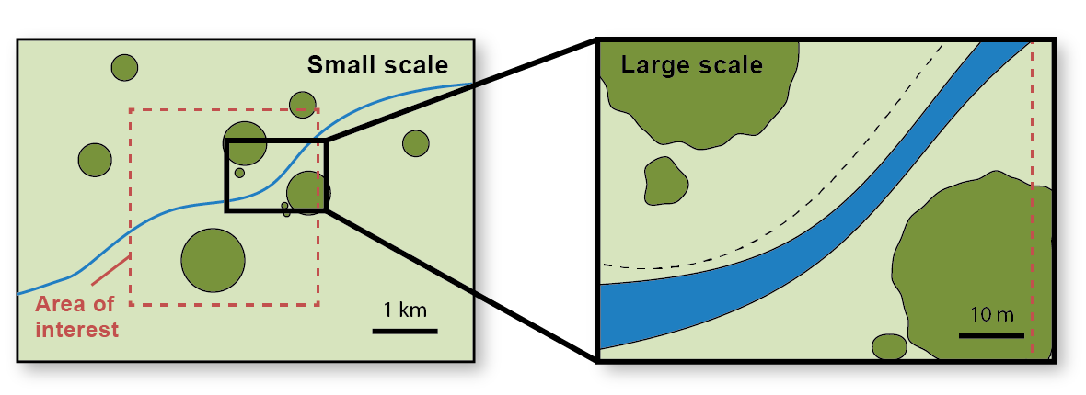
Note: You can see more detail in the large-scale map, but you cannot see the entire area of interest.
Figure 3 Two maps at same scale but different map sizes – one at A4 size, one at A3 size
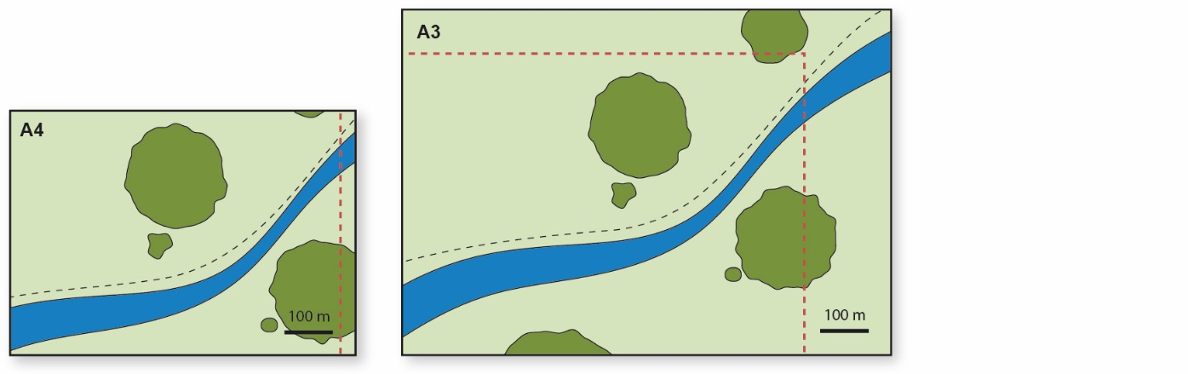
Note: You can see the same amount of detail in both maps, but you can see more area in the larger (A3-sized) map.
Depending on the map scale that you need to use to effectively show the features of interest, you may need to use more than one map to represent your entire area. Alternatively, you may be able to use a larger page size for your map.
Figure 4 Multiple A4-sized maps at same scale to represent entire area of interest
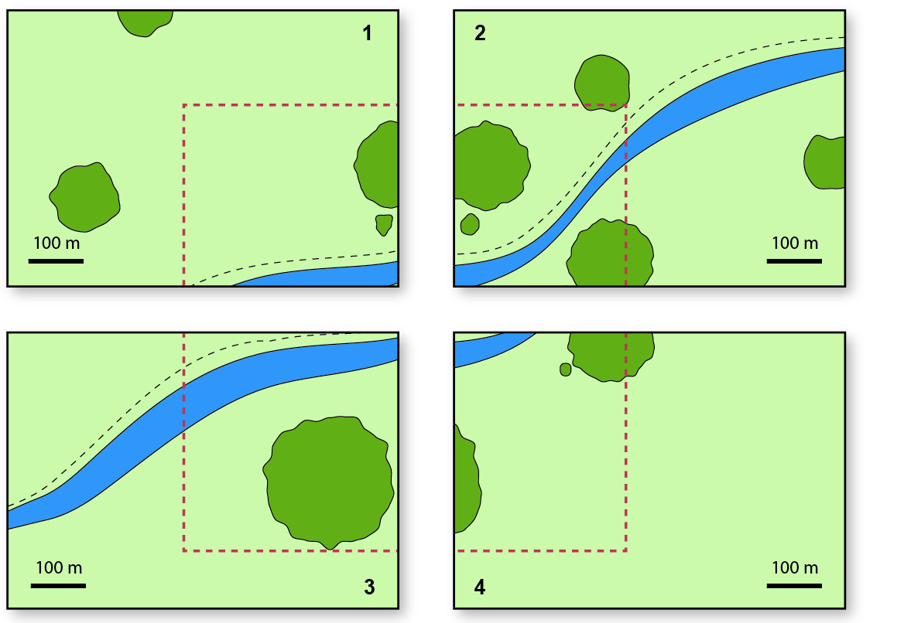
If you are not able to show the whole area of your project on your map at a scale that provides enough detail to fully understand the nature of the project, it will be necessary to use multiple maps. For example, you may wish to show a small area (less than 1 hectare) in enough detail to see individual trees. Or you may have a project with a complex boundary that covers a very large area or has separate areas that span a large overall area. Creating a map of such an area at a scale small enough to fit the entire project onto an A4-sized map may mean that the details of important information about the boundary would be lost. In this case, multiple maps should be used to show portions of the entire area at a large enough scale to allow the details to be seen and fully understood.
When deciding on the right map scale to use, ask yourself:
- What is the on-ground size of the area and features? For example, you may wish to show a feature with a diametre of 50 m surrounded by a no-go zone of 3 m.
- How big does the feature need to be on the map in order to see and understand its details? The difference between the size on the map and the on-ground size will dictate the necessary map scale. For example, the 3 m buffer zone may need to be at least 3 cm on your map. In this case, the scale would be 1:100 (1 cm on the map is 100 cm (1 m) on the ground).
- What map size (paper size) are you using? This will help determine whether you need to use multiple maps to show your entire area at the right scale. For example, to show 53 m x 53 m area at a scale of 1:100 would require six A4 maps.
When using multiple maps to show portions of an overall area, all maps should be at the same scale to allow them to be easily compared. Each of these maps should also include a 'locator map' with 'extent indicators' (see 1.1.3 Essentials for an explanation of these terms) so that the area shown can be seen in relation to the project as a whole. It is also useful to include a separate overview map that shows the entire project at a small enough scale to fit onto a single page, but this should not be the only map you provide.

Essentials
All maps must include (for an illustrated example of these items, see Map 1):
- Legend. All features shown on the map must be included in the legend. Make sure the legend is large enough and clear enough that it can be read easily.
- Title. The title must clearly describe the map and distinguish one map from another. It must identify the location and purpose of the map. For example, if the map is 'Attachment 1' to the referral, this should be stated. The title should not interfere with other elements of the map. It may be useful to place the title on a white background.
- Scale bar. A scale bar is vital in understanding the on-ground sizes of features on maps, particularly given the map may be printed at different page sizes.
- North arrow. A north arrow (which indicates the direction of north on the map) is particularly important for large-scale maps (that is, maps showing close-up views of on-ground areas). Including a north arrow ensures that the position, location and aspect of features is clear, which helps avoid possible misinterpretation of the map.
- Coordinate system. The coordinate system used to create the map must be specified somewhere on the map. Coordinate systems distort features in specific ways, so knowing which coordinate system has been used to create a map helps avoid misinterpretation or misunderstanding of map features. If your map uses a 'projected coordinate system' (such as Map Grid of Australia 2020 (MGA2020)), you must also specify the zone. See 1.2.4 Coordinate system and the Glossary for more information.
- Data sources. Include references for all data used to create the map so that the relevance and current nature of the map can be assessed and understood. This includes any satellite imagery used on the map. The reference should include the name of the dataset, the owner of the dataset and the year it was published. For example, 'Topographic 250K Transport Dataset. Geoscience Australia, 2016'. Wherever possible, the exact date that satellite imagery was captured should be noted. However, when unknown (such as when using imagery from Google Maps), include as much information as possible. For example, 'Satellite image of suburb of Parkes, ACT, Google, no date, retrieved September 2020'.
- Locator (context) map. A locator map (also referred to as a 'context map') is a smaller-scaled map included on the main map that shows where in the world, country or state an area is located. The locator map should include an extent indicator. An extent indicator is a box drawn on the locator map that shows the location and bounds of the main map (see Map 1). Where the area you are showing is extremely large (for example, an entire state or larger), a locator map may not be required.

Symbology and labelling
Symbology refers to the colours, patterns, line styles and line thicknesses used on your map.

Colours
Make sure you use colours that are easy to tell apart so no feature is confused with another. For example, if you use green to show one set of features (like conservation areas), use red to show a different set of features (like disturbance footprint areas). If you use similar colours, use versions that are very different from each other (for example, much darker or lighter versions) or use a pattern or outline to make sure features look obviously different from each other. The same applies to using patterns. If you use patterns, make sure that they are obviously different from each other so that features can be easily identified.

Lines
When using lines on a map, make sure they are precise and not too thick. Be aware that, depending on the scale of the map, the width of a thick line could cover an area of 50 m or more on the ground. To minimise possible uncertainty about the location of the boundary or feature, lines should be as thin as possible while remaining clearly visible.

Labels
Make sure that features such as the names of roads, rivers, lakes, towns and landmarks are labelled and that the labels are clear and unambiguous.

Text
Text, including captions and labels, should typically not be in white or use white borders or drop shadows because this can make them difficult to read. However, if you have a dark background, white text may be a better choice. The goal is to ensure that your text is clear and readable.

Terminology
Make sure that:
- the words you use to describe features on the map match the words you use to describe these features in your written documentation
- you use the same terminology for all maps
- all of your wording matches the wording specified in this document or by the department
- you define any abbreviations you use.
Terminology used in this document has been defined in the Glossary. Refer to the glossary if you are unsure of the meaning of a word or how to use it correctly on your maps and other documentation. See also Box 3.

Map file types
Depending on the stage of the EPBC Act environmental assessment process, you may be required to provide a PDF file (.pdf) (referral stage) or a JPEG file (.jpg or .jpeg) and a PDF file (other stages). The JPEG file must be at a resolution of 300 dpi.
At no stage should you provide your map solely within a Microsoft Word file.
See sections 3.Referral stage and 4. Assessment, approval and post-approval stages for more information about what to provide at each stage.
Map 1 is an example of an A4-sized map provided at the referral stage for a hypothetical project. It shows all the features of a good-quality map. The map shows the boundaries that must be shown on maps at this stage. These boundaries are: 1. project area, 2. disturbance footprint (in this case, this is a sub-section of the project boundary) and 3. habitat areas. This map also shows proposed avoidance areas.
Map 1 Features of a good-quality map
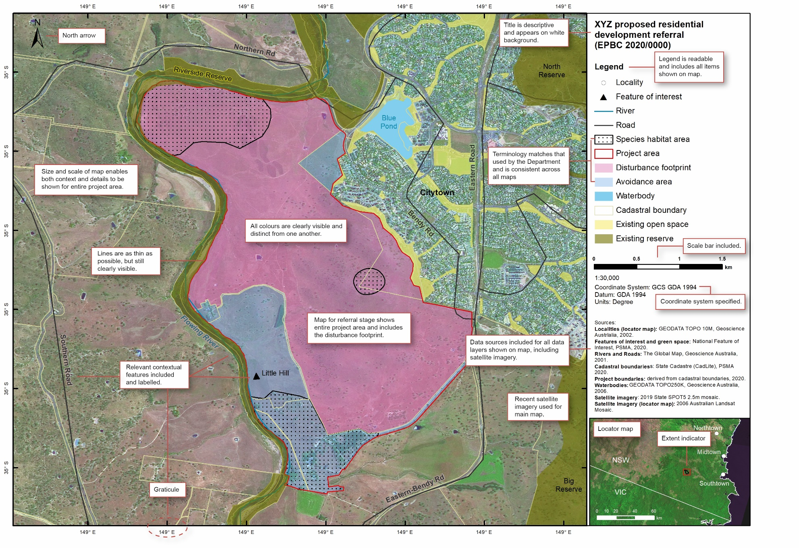

How to create and provide good-quality spatial data

Types of spatial data you should provide
Project boundary spatial data files must contain 'polygon' data only.
A polygon is an enclosed shape made up of at least 3 joined lines. A polygon defines an area on the ground. For example, a polygon may define your entire project area. A polygon spatial data file is different from a 'polyline' or 'point' data file (for more explanation, see Box 2).
Box 2 Polygon, polyline or point data?
A 'polyline' spatial data file contains lines that are created by joining at least 2 points. A line (in a spatial file) has a length but does not have any width. This means that it cannot have an associated area. Because all proposed ‘project boundaries’ exist somewhere in the real world, they all have area (length and width). Therefore, a polyline cannot adequately represent a project boundary. Even if a project is linear in nature (such as a road or a pipeline) and may look like a line on some maps, it still has width and area in reality. For this reason, all areas related to your project must be represented in the spatial data as 'polygons'. For more information, see 'feature types' in the Glossary.
Figure 5 What is a polygon?
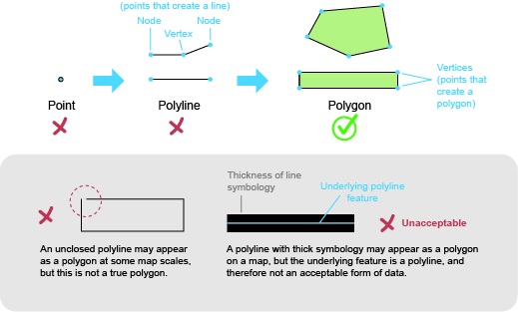

How to create spatial data
You (or your consultant) can create the spatial data that you intend to submit to the department in several ways. Some methods produce more accurate, precise and reliable results than others. Table 1 lists common methods, in order of reliability and preference from most to least preferred.
Table 1 Spatial data creation methods
Reliability | Method | Comments
1 (most reliable) | Use 'ground truthed' (on-site survey) data. | Requires collection of coordinate data with hand-held 'GPS' device and specialised 'geographic information system (GIS)' software.
2 | Use cadastre data and/or survey coordinates. | Requires specialised GIS software and data. Note that cadastre data can sometimes be incorrect and may change over time.
3 | Use other boundaries, for example, waterbodies, reserve boundaries. | Requires specialised GIS software and data.  May be necessary or useful if whole a cadastre parcel is not used or when referring to adjacent areas (such as conservation areas) when you do not have coordinate values.  Note that boundaries of natural features can change over time and/or season.
4 | Electronically hand-draw ('digitise') boundaries using satellite or other imagery as a reference. | The reliability of the specific method (4a, 4b or 4c) varies, as noted below, but in all cases this method relies on manually drawing the features using imagery as a guide. The quality of the end result is determined by the quality of the guide imagery as well as the scale at which the imagery is digitised. The scale at which the digitisation happens is therefore very important (see 1.2.3 What scale to use when creating spatial data).
4a | Digitise by using specialised GIS software. | Requires specialised GIS software and data.  Can switch between using satellite or topographic or other reference maps or add other image or 'vector' layers on which to base digitisation.
4b | Digitise by using the department's 'spatial capture tool'. | Does not require specialised GIS software, but is only available via the online referral form at the time of the referral application submission.  For more information on using the spatial capture tool to create spatial data and maps at the time of referral, refer to 3.2 How to provide maps and spatial data at the referral stage.
4c (least reliable) | Digitise in an online application (like Google Maps). | Does not require specialised GIS software.

What scale to use when creating spatial data
You must use a suitable scale when creating your data by hand-drawing ('digitising'). The right scale will depend on the on-ground size of the area and the features you wish to represent.
Table 2 provides estimations of suitable scales for creating (digitising) data for example features and approximate on-ground sizes.
Table 2 Suggested scales for creating (digitising) data
Example of features to be shown | On-ground area (hectares (ha)) | Appropriate scale | 1 cm on map = on-ground
Individual protected matters (for example, trees). | <1 | 1:100 – 1:500 (large scale) | 1 m – 5 m
Buildings, tracks, fences, sites within paddocks, individual trees, small dams, small gullies. | <2 | 1:1,000 | 10 m
 | 2–20 | 1:2,000 | 20 m
Paddocks, roads, creeks, rivers, large gullies. | 20–50 | 1:4,000 | 40 m
Paddocks, roads, creeks, rivers, large gullies. | 50–100 | 1:8,000 | 80 m
Paddocks, roads, creeks, rivers, large gullies. | 100–200 | 1:10,000 | 100 m
Paddocks, roads, creeks, rivers, large gullies. | 200–500 | 1:16,000 | 160 m
Urban areas, major roads and highways, large rivers, large geographic features (such as mountains, large lakes or large reserves) and planning zones. | 500–2000 | 1:32:000 | 320 m
 | 2000–20,000 | 1:100,000 | 1 km
 | >20,000 | 1:1,000,000 (small scale) | 10 km
As noted in 1.1.2 What map scale to use, map scale is also important when creating maps from your spatial data, but the right scale for a map can be affected by the physical (paper) size of the map (see Box 1). Therefore, the scale of a map may be different from the scale used to create the data for the map. The suggested scales for creating data in Table 2 may provide a useful starting point for determining the right map scale for your map.

Coordinate system
All spatial files submitted to the department must have a valid and appropriate coordinate system.
The coordinate system may be a 'geographic coordinate system' (with coordinate pairs in degrees) or a projected coordinate system (with coordinate pairs in metres). In most instances when capturing and displaying data for Australian locations, the geographic coordinate system Geocentric Datum of Australia 2020 (GDA2020 or GDA94), or the projected coordinate system Map Grid of Australia 2020 (MGA2020 or MGA94) will be suitable. In some instances (for example, when submitting a referral via the online referral form), it is preferable to use a geographic coordinate system (for example, GDA94) (see 3 Referral stage for more information).

Data table values
When providing spatial data to the department, you should ensure that the data in the 'data attribution table' are assigned meaningful and consistent values. You should include enough information for each polygon feature in the data attribution table to allow the feature to be identified and distinguished from others. For example, if your data include polygons for disturbance footprint and ‘retention area’ features, each should be assigned the appropriate value within the data table. Make sure that the terms you use match those provided in this document and that you use these terms consistently in the data, maps and written parts of your submission. For further explanation, see Figure 1, Box 3 and the Glossary.

Metadata
All spatial data provided to the department should include ‘metadata’. Metadata is documentation describing the data. Metadata typically includes information about the project, the creation and reliability of the dataset and data ownership. For further details about what should be included in the metadata, see the Glossary.

Types of spatial data files you can provide
Spatial data files can be provided to the department in the form of a 'shapefile', KML or KMZ file.

Shapefiles
A shapefile is a collection of at least 4 separate files with the extensions .dbf, .prj, .shp and .shx (see Figure 6).
Figure 6 A shapefile is a collection of at least 4 files
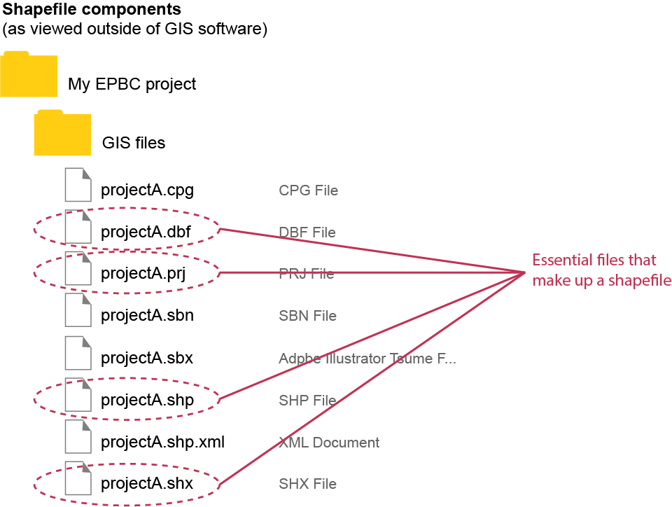
Figure 6 is an example of how a shapefile is viewed outside of GIS software. Any shapefile submitted to the department must consist of at least the essential 4 files, with the file extensions: .dbf, .prj, .shp and .shx. (Also see Figure 1 for an example of how a shapefile is viewed in GIS software.) At the referral stage of the environmental assessment process, you submit only the 4 essential shapefile components. At other stages, it is best to include all shapefile components, compressed within a Zip folder. Specific shapefile requirements for each stage are outlined in 3 Referral stage; 4 Assessment, approval and post-approval stages and the Spatial data checklist at Appendix B.
Shapefiles must be created using specialised 'geographic information systems (GIS)' software, such as 'Esri ArcGIS', or free GIS software, such as 'QGIS'. Shapefiles may also be generated at the referral stage using the department's 'spatial capture tool' within the online referral form (see 3. Referral stage, Glossary or Other relevant policies and guidelines).

KML files
A KML file (.kml) is a spatial file format commonly used for sharing and viewing spatial data without specialised geographic software. A KML can be created using specialised geographic software, as well as by using general, open-source applications such as Google Earth. A KMZ file (.kmz) is a compressed version of a KML file.
A shapefile can only contain one type of spatial data (for example, polygon data) but a KML (or KMZ) file can include different types of spatial data, such as polygons, polylines, points and 'raster' (image) data. If you provide your spatial data as a KML (or KMZ) file, make sure it contains only polygon data.

Pre-referral stage
At the pre-referral stage, you need to assess whether you think your project could have a ‘significant impact’ on protected matters. This will affect whether you need to refer your project to the department. Once you have a good understanding of the location of your project, use your information to run the 'Protected Matters Search Tool (PMST)', an interactive map tool provided by the department.
In the PMST, you can define your area of interest and then generate a report of the protected matters that are likely to occur in that area. Any information provided through this facility is indicative only, and local or expert knowledge and information should also be sought where possible.
Tools similar to the PMST are used by the department throughout the EPBC Act environmental assessment process and whenever changes are made to the proposed project.

Referral stage
This section provides specific guidance for providing maps and spatial data at the referral stage.
Providing maps and spatial data at the referral stage – and, in particular, at the initial time of submission – may be different from providing maps or spatial data at later stages of the EPBC Act environmental assessment process. When you first submit an EPBC Act referral to the department, you do so via the department's online referral form.
There are restrictions on the types of information and files that can be accepted by the online referral form. The maps are made publicly available on the EPBC Act public notices and invitation to comment website and must be in a particular format and meet particular standards. Following the advice and instructions in this document will help make sure your maps and spatial data meet the required format and standards. See 5. Intellectual property rights and what happens to the data you provide for more information.

What to provide at the referral stage
At this stage, you must provide a map (or maps) and spatial data showing the entire project area. This includes the location and full extent of the 'proposed action'. The project area encompasses the disturbance footprint (including temporary and permanent works) and, if relevant, avoidance areas and retention areas. See the Glossary, Figure 7 and Box 3 for project boundary definitions.
The map must show the disturbance footprint within the project area. The disturbance footprint may be the entire area. The map must also show other relevant project and environmental information, including areas of protected matters or habitat areas within or adjacent to the project area, and, where possible, the tenure of the land (for example, freehold).
The map may also show proposed avoidance areas or retention areas or proposed 'offset areas', if these are known or relevant. Including this sort of spatial information is optional at this stage, but is helpful to streamline the overall process.
Note that the spatial data provided will be stored and categorised by the department as the project area, even when separate polygons have been created and labelled as distinct elements, such as the disturbance footprint.
For more information about the referral requirements, see the Environmental Protection and Biodiversity Conservation Regulations 2000 (specifically, Regulation 4.03 and Schedule 2, items 5.01 to 5.07).
Box 3 EPBC Act boundary area definitions
‘Project area’: Total area that includes the direct and indirect disturbance footprint/s, as well as avoidance area/s and retention area/s. The project area includes areas of permanent works as well as temporary works. The project area may occur in one contiguous land area or be spread out over multiple, separated areas of land.
‘Disturbance footprint’: The areas within the project area that are directly or indirectly impacted by the 'proposed action'. These areas can include upstream and downstream areas and often extend beyond the physical or ownership boundary of the project.
Figure 7 Visual representation of boundary definitions
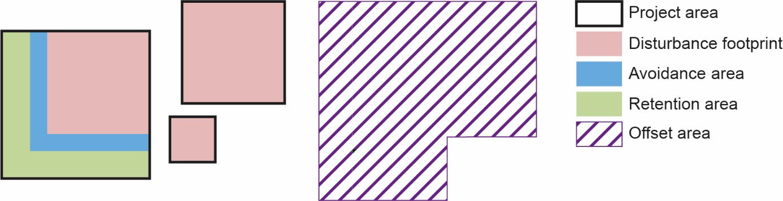
‘Avoidance area’: Any area or habitat within the project area that is intended not to be cleared or disturbed during the course of the project action. The avoidance area differs from the retention area in that the avoidance area may not be intended for conservation and protection under a conservation agreement.
‘Retention area’: Any area within the relevant project boundary which will be retained to provide current and future habitat for the specified protected matter/s. Retention areas may be protected with a conservation agreement.
‘Offset area’: The area of the proposed or secured offset. Offset areas can occur within or outside of the project area.

How to provide maps and spatial data at the referral stage
There are 2 ways to provide your maps and spatial data at this stage.
- Outside of the spatial capture tool. Create your spatial maps and/or spatial data by a method outside of the spatial capture tool and then upload the resulting files via the online referral form. This is the method most likely to produce the best quality maps and spatial data so is the preferred method (see 3.2.1 Uploading your maps and spatial data via the online referral form for detailed instruction).
When using this method, you first create your spatial data and then use the data to create your map. The spatial data and map are submitted as separate items.
When creating spatial data outside of the spatial capture tool, make sure you use appropriate procedures and digitise at the correct scale (see 1.2 How to create and provide good-quality spatial data and/or the Spatial data checklist at Appendix B).
- Spatial capture tool. Use the spatial capture tool within the online referral form to create your maps and/or your spatial data. Use this method if you are not able to create your maps or spatial data any other way (see 3.2.2 Using the spatial capture tool to create your maps and/or spatial data for detailed instruction).
When using the spatial capture tool to create you map and spatial data, both are created at the same time.
If you use the spatial capture tool to create your map, you will not be able to include the standard map elements noted in 1.1 How to create and provide good-quality maps. You will still be able (and are required) to show all of the project boundary areas noted in 3.1 What to provide at the referral stage.

Uploading your maps and spatial data via the online referral form
Uploading your map
- Upload your map as a PDF file (.pdf) file. (Only PDF file types are acceptable for maps at the referral stage.)
- You may upload multiple map documents.
When creating maps outside of the spatial capture tool, make sure you follow the instructions in 1.1 How to create and provide good-quality maps and/or the Map checklist at Appendix A.
Uploading your spatial data using the online referral form
- Make sure each spatial data file contains polygon data only and is in the form of:
  - The 4 essential files of a shapefile (.dbf, .prj, .shp and .shx). Each file is uploaded separately and only the 4 essential files of the shapefile can be included in the online referral form.
  - A KML (.kml) file. (You cannot upload a KMZ (.kmz) file via the online referral form.)
- You may upload multiple spatial files (up to a maximum of 5 MB).
- The combined total number of polygons (areas) for all spatial files must not exceed 50.
- The combined total number of 'vertices' for all spatial files must not exceed 25,000.
- It is preferable to use a geographic coordinate system (for example, GDA2020 or GDA94) at this stage.

Using the spatial capture tool to create your maps and/or spatial data
If necessary, you can use the spatial capture tool within the online referral form to draw your project boundary areas. This will create both the data and the map. You can also use it to create just the data or just the map.

Drawing areas (polygons)
When using the spatial capture tool, you can draw multiple areas (polygons). You can also draw areas that overlap.
When drawing separate areas using the spatial capture tool, each area will be automatically listed as 'Area 1', 'Area 2', 'Area 3', and so on. The numbering corresponds to the order in which features are drawn. You can later refer to these map labels in your written documentation where you can make the link between the automated map labels and the correct boundary area terms.
For example, you may draw your outer project boundary first (which would give it an automatic label of 'Area 1'), followed by your disturbance footprint areas within Area 1, including areas of temporary and permanent works (which would be automatically labelled 'Area 2', 'Area 3', and so on).
When discussing the disturbance footprint in your written documentation, you may note that the disturbance footprint is represented by areas 2, 3, or other on the map (see Figure 8). In the example in Figure 8, Area 1 represents both habitats areas and the avoidance area (that is, habitat areas within the project area that will not be disturbed or cleared).
By contrast, if you are creating your map and spatial data outside of the spatial capture tool, you can directly label your areas with the correct boundary terminology (see Box 3).

Using background maps
You can switch between using satellite imagery or topographic maps for the background map (basemap). If you zoom in close enough on the topographic basemap, you can see cadastral boundaries which you can use as a guide for drawing (digitising) your boundaries. Be sure to digitise your map at an appropriate scale (see 1.2.3 What scale to use when creating spatial data and Table 2 for suggestions.)
Detailed instructions on how to use the spatial capture tool and upload files are provided within the online referral form.
Figure 8 Example of output from the spatial capture tool within the online referral form
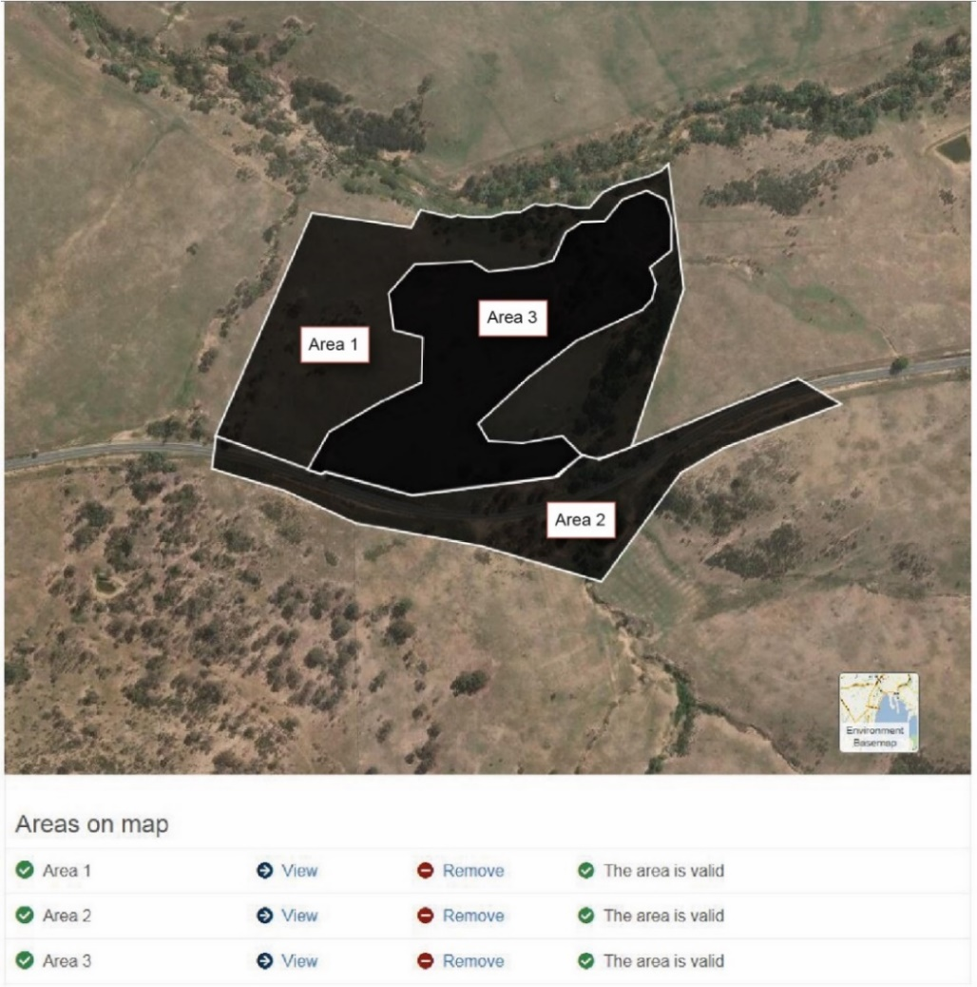
Note: Shows proposed project boundary areas as they appear and are listed within the spatial capture tool of the online referral form. The labels on the map itself do not appear within the tool.
Figure 9 Example of how boundaries are drawn using the spatial capture tool
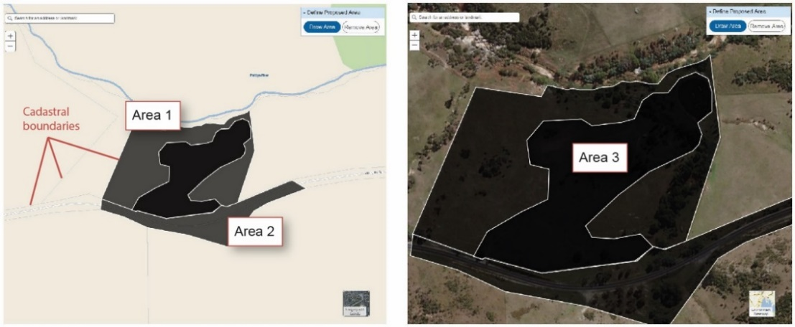
Note: Areas 1 and 2 were drawn using the cadastre boundaries with the 'Environment Basemap' as the background layer (basemap). The cadastre boundaries are only visible when zoomed in sufficiently. Area 3 was drawn at a larger scale (that is, more 'zoomed-in') using the 'Imagery with Labels' basemap.
Areas 1, 2 and 3, combined, represent the project area. 'Area 1' represents habitat areas and the avoidance area. 'Area 2' corresponds to an area of proposed temporary works, while 'Area 3' corresponds to an area of proposed permanent works. 'Area 2' and 'Area 3', combined, correspond to the disturbance footprint. The areas shown here are automatically labelled within the spatial capture tool at the time of creation, and the labelling corresponds to the order in which they were drawn. It is not possible to include the standard map elements on maps created using the spatial capture tool, but you can and should still show all the required project boundary areas noted in 3.1 What to provide at the referral stage.

Providing changes to referral boundaries after initial submission

What to provide
Once you have submitted your referral (and associated maps and spatial data) via the online referral form, you may find you need to provide additions or changes to the maps or data you provided. Such changes may be required because your project has changed slightly, you noticed an error, you would like to add new information or because an assessment officer has requested more information.

How to provide maps and spatial data following changes to referral boundaries
After your initial submission via the online referral form, the spatial capture tool is no longer available for that referral. From this point onwards, you will need to create all maps and spatial data outside of the spatial capture tool (see sections 1.1 How to create and provide good-quality maps and 1.2 How to create and provide good-quality spatial data). After initially submitting your application via the online referral form, you will submit all maps and spatial data by email to the assessment officer (or other method as directed, if necessary).

Maps
When you submit maps directly to assessment officers while still at the referral stage, the maps must be in the form of PDF (.pdf) files only.

Spatial data
When you submit spatial data directly to the assessment officer at this stage, the files may be provided in the form of a shapefile, a KML file or a KMZ file. It is a good idea to compress (or, 'zip') the shapefile components to reduce the file size and keep the components together. When creating and providing a Zip folder (.zip) of shapefile components, include all of the shapefile components in addition to the 4 essential components (that is, .dbf, .prj, .shp and .shx, and also .cpg, .sbn, .sbx and .shp.xml).

Assessment, approval and post-approval stages
Once you submit your referral, the Minister for the Environment (or the minister's delegate) will decide whether your project needs to be 'assessed' under the EPBC Act and, if so, how it should be assessed. If your project requires assessment, you will then enter the assessment stage after which the minister (or delegate) will determine whether to approve or refuse the project.
At any of these stages, you may be required to provide additional maps or spatial data for your project boundaries.

What to provide at assessment, approval and post-approval stages
At these later stages of the EPBC Act environmental assessment process, you may choose or be required to provide further maps or spatial data of project boundaries. Such maps and spatial data may include refinements, alterations, buffers, avoidance and retention areas, refined species habitat areas or proposed and/or secured offset areas.
For example, during the assessment stage, you are likely to be asked to provide detailed habitat area boundaries (see Map 2). At the approval and post-approval stages, you may be asked to provide proposed and secured offset site areas (see Map 3). If approval conditions require you to provide a map, you must show on the map all of the features referred to in the conditions.

Maps
In all cases, maps must be at a large enough scale to show all features in enough detail that they can be fully understood. See 1.1.2 Map scale to use and 1.2.3 What scale to use when creating spatial data for more detail.

Spatial data
It is a good idea to provide spatial data files whenever you submit spatial information or plans to the department, not just when required to do so by approval conditions. Doing so will reduce the time needed to review the plans. Providing spatial information in this way is also likely to increase confidence in decision-making, compliance and protection of protected matters.
Map 2 shows an overview of an amended project area boundary, disturbance footprint, avoidance areas, retention areas and refined known species habitat areas, as well as other project boundary areas. It is most important to ensure that species habitat areas are highlighted and shown at the correct scale. It may be necessary to provide more detailed maps of parts of the project area (including species habitat areas) if the current map size and scale are insufficient to show feature details adequately.
Map 2 Example of map provided during assessment stage
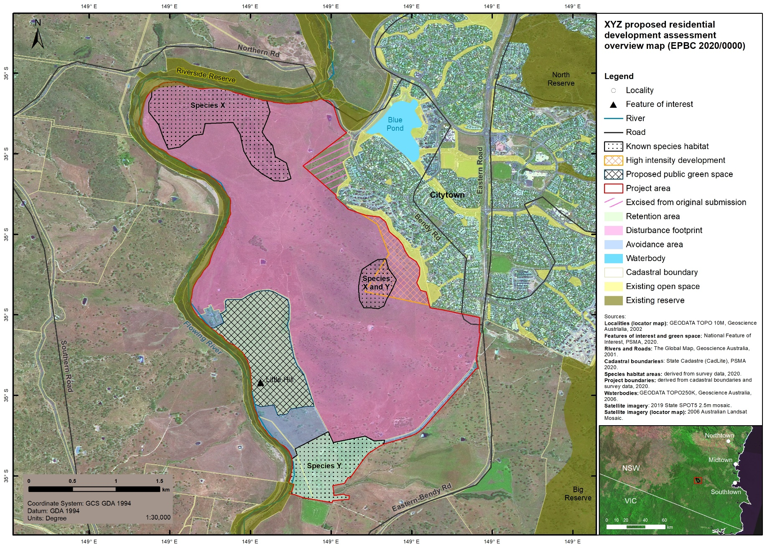
Map 3 Example of map provided during post-approval stage
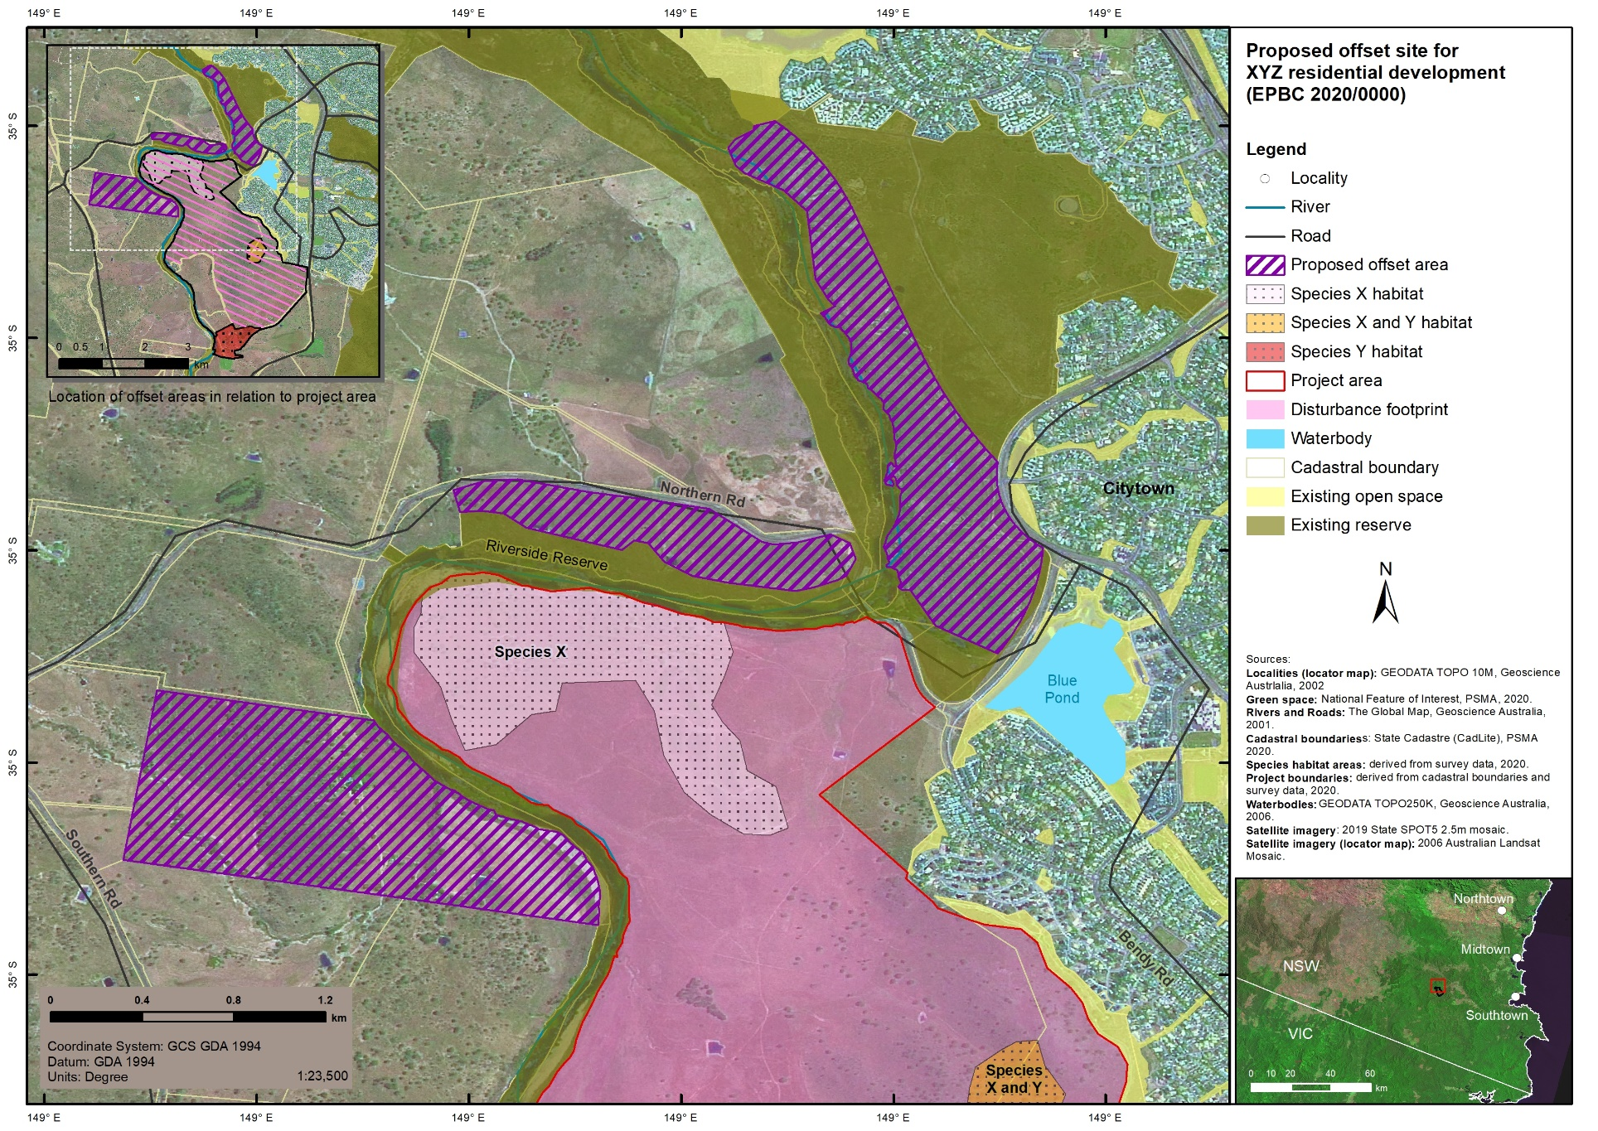
Note: It is important to distinguish proposed offsite offset areas from the project area or those that may be within the project area. In this example, 3 proposed offsite offset areas are shown. A small version of an overview map at a scale showing the entire project area in relation to the offset areas is also included in the top left corner of the map.

How to provide maps and spatial data at assessment, approval and post-approval stages
Maps and spatial data provided for EPBC Act assessment, approval or post-approval stages must be provided by email to the assessment or post-approvals officer (or other method as directed, if necessary). Because the spatial capture tool is not available after the initial referral submission, any maps and spatial data provided at these later stages must be created outside of the spatial capture tool (see 1.1 How to create and provide good-quality maps and 1.2 How to create and provide good-quality spatial data and/or Map checklist at Appendix A and Spatial data checklist at Appendix B).

Maps
It is best to provide maps at this stage as both PDF (.pdf) and JPEG (.jpg or .jpeg) files, but either is acceptable if you cannot provide both.

Spatial data
When you submit spatial data directly to the assessment officer at this stage, the files may be provided in the form of a shapefile, a KML file or a KMZ file. It is a good idea to compress (or, 'zip') the shapefile components to reduce the file size and keep the components together. When creating and providing a Zip folder (.zip) of shapefile components, include all of the shapefile components in addition to the 4 essential components (that is, .dbf, .prj, .shp and .shx, and also .cpg, .sbn, .sbx and .shp.xml).

Intellectual property rights and what happens to the data you provide
The department will process, store and share the data you provide in accordance with the Australian Government's Public Data Policy Statement (2015) and Data Integration Partnership for Australia initiative. Once submitted to the department, data, maps and information provided as a part of a referral submission belong to the department. You must ensure you have the intellectual property rights for any data provided to the department.
In line with the department's information strategy (Technology and Information Strategy 2019-23 (2019)), key data in relation to EPBC Act projects (such as referral boundaries) will be made publicly available under a Creative Commons Attribution license on the department's website, and via NationalMap and the Australian Government's data.gov.au site. Referral submissions appear (in their entirety) on the EPBC Act public notices and invitation to comment website.
Data provided to the department in relation to EPBC Act projects may be used to make decisions in relation to any stage of the current project or future projects. Data may also be used by the department for spatial analysis and reporting. For example, data may be used to assist in the protection and recovery of species and communities listed under the EPBC Act.

Sensitive data
If your map shows the details of a location that may endanger a threatened species if made publicly available, you must request that the map be kept confidential.
Any potentially sensitive data provided during the EPBC Act environmental assessment process will be assessed in line with the department's Sensitive Ecological Data – Access and Management Policy (2016). Spatial data or maps deemed as sensitive may be returned to you for adjustment, or undergo transformation and/or denaturing prior to public release.
While sensitive information may not be made publicly available, it should be provided to the department for assessment purposes.

Further information
For further information, please contact the Referrals Gateway by email on epbc.referrals@awe.gov.au or by telephone on 02 6274 2496 during business hours (AEST/AEDT). See also Other relevant policies and guidelines.

Appendix A: Map checklist
Before submitting your map/s to the department, check you have covered all requirements.

At all times

What to show on your map
All relevant features are shown.
Only relevant features are shown.
The purpose of the map is clear.
Features shown meet the requirements for the given stage of the project (or as requested by an assessment officer).
Features are clear, distinct and sufficiently highlighted.
Sufficient contextual features (such as towns, roads, rivers, cadastre, other EPBC Act project boundaries, graticule or grid) are shown and labelled.
Multiple maps have been used, where appropriate (that is, where a single map cannot adequately show all features in sufficient detail).
Recent satellite imagery has been used as a basemap.
If your map shows the details of a location that may endanger a threatened species if made publicly available, you have requested the map be kept confidential.

What map scale to use
Map shown at an appropriate scale (that is, details can be seen clearly). Ask yourself:
Can I work out what is where without having to enlarge the map?
Do I get enough context to be able to place the features in the environment and find them in the field?
Do I need 2 or more maps to achieve what a single map is trying to do?
If using multiple maps to represent the project area:
All map parts are at the same scale
An overview map has been included.

Essentials
Legend shows all map features and is readable.
Title is descriptive and unique.
Scale bar is included.
North arrow is included (especially for large-scale maps).
Coordinate system is specified.
Data sources are provided for all data used to create map (including satellite imagery).
Locator (context) map (unless area shown is for an entire state or larger) with extent indicator included.

Symbology and labelling
Colours and patterns are easy to tell apart. Each feature is easy to identify and is not easily confused with others.
Lines are as thin as possible but still clearly visible.
Features such as roads and landmarks are clearly labelled.

Terminology
Terminology is consistent within maps, between maps and between maps and other documentation provided during the EPBC Act environmental assessment process.
Terminology matches that used by the department.
Abbreviations are defined.

Map files
Map files are in PDF (.pdf) and/or JPEG (.jpg or .jpeg) format (see below for specific requirements at different stages of the environmental assessment process).

Referral stage (via the online referral form)
Map shows the entire project area, including area/s of proposed temporary and permanent works.
Map shows the disturbance footprint.
Map shows areas of protected matters or habitat areas within or adjacent to the project area.
Map shows the tenure of the land, when possible.
Map file is PDF (.pdf) format.

Assessment, approval and post-approval stages
Map file is in PDF (.pdf) and JPEG (.jpg or .jpeg) format.
JPEG file is at a resolution of 300 dpi.

Appendix B: Spatial data checklist
Before submitting your spatial data to the department, check you have covered all requirements.

At all times
Data are in polygon format.
Have used best method available to create spatial data (refer to Table 1).
Have used appropriate map scale to create spatial data (refer to Table 2).
Dataset has a valid coordinate system.
Data are attributed in a meaningful and consistent way.
Metadata has been included.
Polygon shapefile contains at least the 4 essential files (.dbf, .prj, .shp and .shx).
KML (or KMZ) file contains only polygon data.

Referral stage (via the online referral form)
Data describe the entire project area, encompassing disturbance footprint and area/s of proposed temporary and permanent works.
Data are provided as shapefile or KML file (but not KMZ file).
Data have been created outside of the online referral form, if possible.
Polygon dataset (or total for all datasets combined) does not contain more than 50 polygons.
Polygon dataset (or total for all datasets combined) consists of 25,000 vertices or fewer.
Dataset is not greater than 5 MB (applies to single or total of multiple datasets).
Note that only the 4 essential shapefile files (.dbf, .prj, .shp and .shx) are to be included within the online referral form.
OR, if good-quality spatial data are not able to be created outside of the spatial capture tool
Data are created within the online referral form using the spatial capture tool.

Glossary
Term | Definition
assessment | An environmental assessment of a controlled action under the EPBC Act. Assessing a controlled action includes assessing the impacts that the action has, will have, or is likely to have on the relevant protected matter.
action | An action is a project, development, undertaking, activity or series of activities that has the potential to impact on matters protected by the EPBC Act. Prior to approval under the EPBC Act, the action is known as the proposed action.
avoidance area | Any area or habitat within the project area that is intended not to be cleared or disturbed during the course of the action. The avoidance area differs from the retention area in that the avoidance area may not be intended for conservation and protection under a conservation agreement.
cadastre | A cadastre is a comprehensive recording of the real estate or property of a country. Cadastre parcels are used to define land parcels and property boundaries for all private and public land in Australia. Cadastral boundary spatial data may be used to define project boundaries.
controlled action | A proposed action that has been determined by the Australian Government Minister for the Environment (or the minister's delegate) to have, or be likely to have, a significant impact on a protected matter. Controlled actions require approval under the EPBC Act before they can commence. For further definition, see the About the EPBC Act Glossary.
data attribution table | The data attribution table is generated when spatial data are created. Spatial data files automatically include information about the shape and location of an area on the ground, and can also include other descriptive information. The descriptive information (or attributes), including text and number values, is manually entered into the data's attribution table. In this data attribution table, each row represents a single polygon feature. The columns (or fields) represent different attributes, such as the name of the features or the measured area of a feature. Therefore, a single feature can have many attributes.
disturbance footprint | The area/s within the project area that are directly or indirectly impacted by the proposed action. These areas can include upstream and downstream areas and often extend beyond the physical or ownership boundary of the project.
EPBC Act | Environment Protection and Biodiversity Conservation Act 1999 [Cwlth].
Esri ArcGIS | Esri ArcGIS is a set of geographic information system (GIS) software for creating and working with maps and spatial data developed by the Environmental Systems Research Institute (Esri).
feature types | Geographical features represented in a geographic information system (GIS). Points, lines (termed polylines when captured in a GIS) and polygons are ways of representing on-ground features in a digital form. Points are represented by one pair of x- and y-coordinates (generally latitude and longitude); polylines are represented by connected pairs of x- and y-coordinates; and, polygons are represented by the area of at least 3 enclosed lines.
geographic coordinate system | A geographic coordinate system (GCS) uses a three-dimensional spherical surface to define any locational point on Earth. Specific points are defined by a pair of numbers (coordinates). Coordinates consist of a latitude and longitude value. Lines of latitude run east-west, with zero degrees at the equator. Longitude lines run north-south, with zero degrees determined by the prime meridian (which is specific to a given GCS). Geographic coordinate systems use angular units of measurement (for example, degrees), and include a prime meridian and a datum (which relates to the position of the earth's centre). Geocentric Datum of Australia 2020 (GDA2020) and World Geodetic System 1984 (WGS84) are examples of geographic coordinate systems. See also: projected coordinate system.
geographic information system (GIS) | A geographic information system (GIS) is a framework for gathering, managing, analysing and visualising spatial data. This is typically realised with specialised GIS software, such as Esri ArcGIS.
GPS (Global Positioning System) | The Global Positioning System (GPS) is a satellite-based radionavigation system owned by the US Government. The GPS provides geolocation data to a GPS device, such as a hand-held one. A hand-held GPS device is used to collect coordinates (spatial data) in the field which can then be uploaded into geographic information system (GIS) software for processing or map-making.
graticule or grid | Graticules are lines on a map showing parallels of latitude and meridians of longitude for the Earth. Graticules can be used to show location in geographic coordinates (degrees of latitude and longitude).  In the current context, a grid displays measured locations using projected coordinates on the map.
ground truth | Ground truth refers to information gained through direct observation. In this case, ground truth refers to coordinate information collected on location using a hand-held GPS device. This is the most reliable way to collect accurate spatial data for your project boundaries.
map scale | Map scale refers to the relationship between the distance between features on a map and the corresponding distance between those features on the ground. For example, on a 1:100,000 scale map, 1 cm on the map equals 100,000 cm (1 km) on the ground. The smaller the map scale, the larger the reference number. For example, 1:100,000 is a smaller map scale than 1:1,000. For the same-sized map (for example, A4), a small-scale map will show more on-ground area (and usually less detail) than a large-scale map. A large-scale map provides a more 'close-up' (and, hence more detailed) view than a small-scale map.
metadata | Metadata is documentation describing a given dataset. In general, metadata should include enough information to allow the spatial data to be fully understood and/or re-created. Metadata may be included as a part of (or separate to) the spatial data shapefile or KML file. If included with the shapefile, the metadata will be contained with the shapefile's .xml file. When including shapefile metadata within the online referral form at the time of referral submission – while the data attachment section of the online referral form (section 1.3) does not accept the .xml file, it is possible to separately attach the shapefile .xml file at section 1.4 of the form.  The department uses metadata standard: ISO/TS 19139-1:2019 (SA/SNZ TS ISO 19139.1:2019).  Metadata for spatial data in relation to EPBC project boundaries should typically include:  - project information, such as the EPBC referral number and project title  - dataset information, including the title of the dataset; when, how and who created the data; the scale at which data were digitised (if applicable); what data sources were used (if applicable); and, estimations of the precision and accuracy of the data  - a description of the geographical extent of your data, including the general location, region and landscape  - a statement about the ownership (that is, who owns the intellectual property rights, if any) and custodianship (who has responsibility for maintenance, if required) of the data, and any conditions attached to use of the data. Please note that, in line with the department's information strategy, key data in relation to EPBC Act projects, including referral project boundaries, will be made publicly available (see 5. Intellectual property rights and what happens to the data you provide)  - contact details, including name, organisation, phone number, email and postal address.
offset | An environmental offset is a conservation action that is intended to compensate for residual negative environmental impacts of an action (after avoidance and mitigation measures are undertaken). Under the EPBC Act environmental offsets policy, offsets should directly correlate to the impacts of a proposed action. In practical terms, offsets can include protecting at-risk environmental assets, restoring or extending habitat for threatened species, or improving the values of a heritage place. The department captures spatial data for direct environmental offsets of land approved under Part 9 of the EPBC Act. The department captures both proposed offsets and offsets secured through a conservation agreement or similar mechanism (secured offsets).
offset area | The area of the proposed or secured offset that is captured and provided to the department in the form of maps and/or spatial data. Offset areas can occur within or outside of the project area.
online referral form | The online referral form is the method by which you submit an EPBC Act referral to the department. It is an electronic form available in Online Services. The online referral form allows you to start a new referral or continue with an existing draft referral. The online referral form contains the spatial capture tool.
point (point data) | Refer to: feature types.
polygon | A polygon is the area of an enclosed line defined by at least 3 points. See also: feature types.
polyline | Refer to: feature types.
project area | The total area that includes direct and indirect disturbance footprint/s, avoidance area/s and retention area/s. The project area includes areas of permanent works as well as temporary works. The project area may occur in one contiguous land area or be spread out over multiple, separated areas of land.
project boundary | The clearly-defined outer boundary of the project area. Project boundaries are often defined by cadastre land parcel boundaries.
projected coordinate system | A projected coordinate system uses a plane (that is, a spheroid projected onto a two-dimensional surface) and linear units (for example, metres) to define locations on Earth. In a projected coordinate system, locations are defined using x-coordinates (horizontal) and y-coordinates (vertical) on a grid. Unlike a geographic coordinate system, in a projected coordinate system units are consistent and equally spaced across all x- and y-values. A projected coordinate system is always based on a geographic coordinate system. Map Grid of Australia 2020 (MGA2020) is an example of a projected coordinate system. Projected coordinate systems such as MGA2020 uses the Universal Transverse Mercator (UTM) system to divide the Earth into 60 longitudinal zones. Coordinate pairs (as Easting and Northing values in metres) are projected onto the zones. When specifying a projected coordinate system on a map it vital to also specify the UTM zone. For example, Sydney and Brisbane are within MGA2020 Zone 56, while Canberra, Melbourne and Hobart are in MGA2020 Zone 55. See also: geographic coordinate system.
proposed action | A proposed action is a project, development, undertaking, activity or series of activities that has the potential to impact on matters protected by the EPBC Act. Once approved under the EPBC Act, the proposed action is known as the action.
protected matters | Protected matters under the EPBC Act include 9 matters of national environmental significance (MNES) (also referred to as matters of NES). Under the EPBC Act, actions that have, or are likely to have, a significant impact on a protected matter require approval from the Australian Government Minister for the Environment. The minister will decide whether assessment and approval is required under the EPBC Act.  The 9 MNES protected under the EPBC Act are: world heritage properties; national heritage places; wetlands of international importance (Ramsar wetlands); listed threatened species and ecological communities; migratory species; Commonwealth marine areas; the Great Barrier Reef Marine Park; nuclear actions; and, a water resource in relation to a coal seam gas development or large coal mining development.  Other protected matters include matters such as listed marine species.
Protected Matters Search Tool (PMST) | The Protected Matters Search Tool (PMST) is an interactive map tool provided by the department to help you determine whether or not your project area interacts with protected matters. Any information provided through this facility is indicative only, and local or expert knowledge and information should also be sought where possible. Tools similar to the PMST are also used by the department throughout the EPBC Act environmental assessment process and/or whenever changes are made to the proposed project.
raster data | Geographic information system (GIS) raster data files store images such as aerial photographs, satellite imagery, digital pictures or scanned maps. They also store data such as elevation and temperature. Raster files store data in cells (pixels) of equal size organised into rows and columns. The size of the cell determines the coarseness (or fineness) of the data. Raster data are different from vector data, such as polygons, polylines and points. Instead of storing data in cells, like raster data, vector data are stored using mathematical equations based on points (vertices).
referral | A referral is a submission to the Australian Government Minister for the Environment (via the department) for a proposal to take an action that has, will have or is likely to have a significant impact on a protected matter including a matter of national environmental significance (MNES). On receipt of a referral, the minister (or the minister's delegate) will determine whether or not further assessment and approval is required under the EPBC Act.
retention area | Any retained area within the relevant project boundary which will provide current and future habitat for the specified protected matter/s. Retention areas may be protected with a conservation agreement.
shapefile | A shapefile is an Esri GIS spatial data file, comprised of at least 4 files with the same file name and with the file extensions of .dbf, .prj, .shp and .shx. A shapefile may also include other files, such as the metadata component (.xml). (Refer to metadata for further information about providing metadata for your spatial data to the department, including at the time of referral.)
significant impact | A significant impact is an impact that is important, notable, or of consequence, having regard to its context or intensity. Whether or not an action is likely to have a significant impact depends upon the sensitivity, value, and quality of the environment which is impacted, and upon the intensity, duration, magnitude and geographic extent of the impacts.
spatial capture tool | The spatial capture tool is a component of the online referral form and is available to a person making a referral while using the form. The spatial capture tool allows you to create maps and spatial data required for your referral. The spatial capture tool is only available within the online referral form and is therefore not available after you have submitted your referral.
spatial data | In this document, spatial data means data defining the boundary shape and location of a project. Spatial data are included in specialised files (spatial data files). Spatial data are used to create maps. See also: shapefile, KML file and KMZ file.
spatial information | Information about the location of a project, including written descriptions, maps and spatial data.
vector data | Vector data, such as polygons, polylines and points, are stored using points (vertices) and paths. This is different from raster data, which are stored in cells of equal and defined size. Vector data are the type of spatial data provided to the department during the EPBC Act environmental assessment process. For example, a shapefile stores vector data.
vertex (vertices) | A vertex is the angular point of a polyline or polygon. A polygon is composed of multiple vertices. A polygon vertex is usually the point where the edge of the polygon changes direction. (Note that the end points of a polyline are termed nodes.)

Other relevant policies and guidelines
Other policies and guidelines relevant to providing data for EPBC Act projects that may be useful to you are:
- EPBC Act information pages, such as:
  - Environment and assessment process
  - EPBC Act publications and resources
  - EPBC Act policy statements
  - EPBC Act Protected Matters Search Tool
  - Environmental Protection and Biodiversity Conservation Regulations 2000 (specifically, Regulation 4.03 and Schedule 2, items 5.01 to 5.07).
- Guidelines for biological survey and mapped data (2018) – this document guides you on how to provide point-based fauna and flora survey and mapped data to support decision-making on referral applications, assessments and approvals under the EPBC Act, and to assist in the protection and recovery of species and communities.
- EPBC Act Online Referral Form via the Australian Government Department of Agriculture, Water and the Environment – Online Services. This is where you can complete and submit your online referral form, including accessing the spatial capture tool. You can use the spatial capture tool to create maps and spatial data as a part of your referral submission.
- EPBC Act public notices and invitation to comment. This is where your complete referral appears after successful submission. Other relevant documents in relation to your project (such as conditions of approval, should your project be assessed and approved) may also appear here.
- Australian Government Public Data Policy Statement (2015) – this document outlines the Australian Government's policy for making government data publicly available and accessible.
- Data Integration Partnership for Australia (DIPA) is a whole-of-government collaboration between over 20 Australian Government agencies. It aims to maximise the use and value of the government's data assets to create new insights into complex policy questions. DIPA guides the collection and use of data by the department.
- Technology and Information Strategy 2019-23 (2019) seeks to strengthen the department's ability to meet its objectives through the use of technology and information. The strategy guides the collection and use of data by the department.
- EPBC Act Referrals Spatial Database contains spatial data for the project area boundaries for all referrals submitted to the department under the EPBC Act. The data in this database can be viewed via National Map or data.gov.au.
- NationalMap is an online map-based tool that allows you to view and access spatial data from Australian Government agencies. EPBC Act referral boundary data (project areas boundaries) (from the EPBC Act Referrals Spatial Database) appear here.
- data.gov.au is the central source of Australian open government data. Anyone can access the anonymised public data published by federal, state and local government agencies. The data that you provide in relation to your referral will appear on this site.
- Sensitive Ecological Data – Access and Management Policy (2016) is the department's policy for identifying and managing sensitive ecological data, particularly data for EPBC Act listed and non-listed species and ecological communities.

