
Commonwealth of Australia
Exemption under section 158 of the
Environment Protection and Biodiversity Conservation Act 1999 (Cth)
I, Murray Watt, Minister for the Environment and Water, acting under section 158 of the Environment Protection and Biodiversity Conservation Act 1999 (Cth) (EPBC Act) and being satisfied that it is in the national interest to do so, exempt Alcoa, and any persons acting on behalf of Alcoa, from the application of all of the provisions of Part 3 of Chapter 2 and Parts 7 through 9 of Chapter 4 of the EPBC Act, in relation to the following action:
Clearance of up to 1200 hectares of vegetation associated with Alcoa's mining operations at Huntly and Willowdale within the areas marked blue at Attachment A on ML1SA to the extent necessary to maintain critical bauxite supply to Alcoa's two alumina refineries located in Pinjarra and Wagerup for a period of 18 months from the date of this notice.
In this notice:
Alcoa means the Australian public company Alcoa of Australia Limited (ABN: 93004879298)
Clearance means the killing, destruction or removal of vegetation
Critical bauxite supply means the minimum supply of bauxite needed to maintain refining operations
ML1SA means the area designated as ML1SA at Attachment A
This exemption takes effect from the date of this notice.

Minister for the Environment and Water
2026
Dated the |  | day of

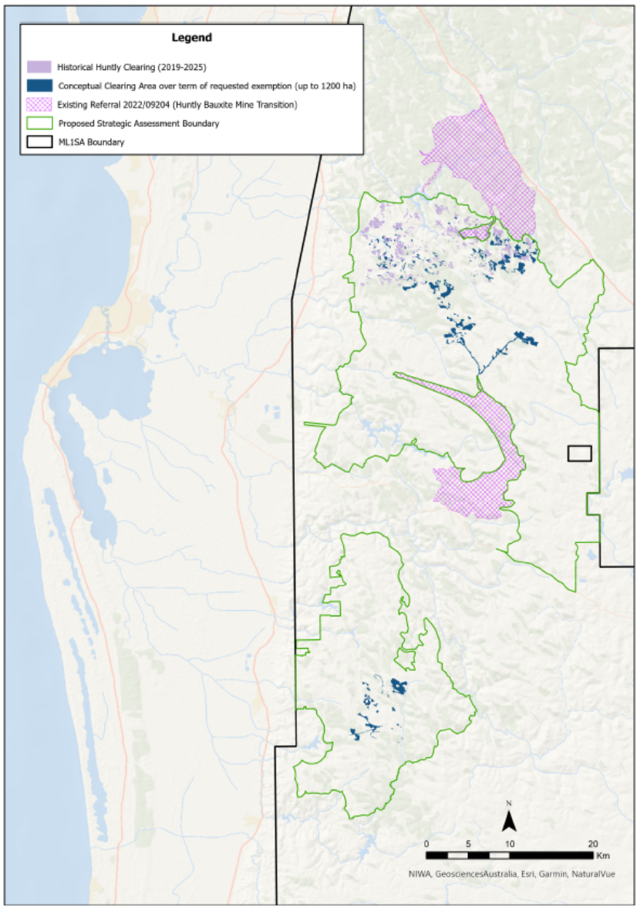
Attachment A: The location of Alcoa’s mineral lease ML1SA and geographic limit of clearing associated with the exemption.

