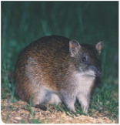

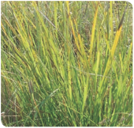

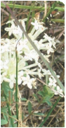

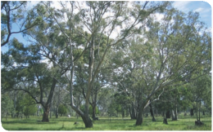





Gippsland Red Gum Grassy Woodland and Associated Native Grassland

A nationally threatened ecological community
Environment Protection and Biodiversity Conservation Act 1999
Policy Statement 3.22

This booklet is designed to assist land managers, owners and occupiers as well as environmental assessment officers and consultants to identify, assess and manage the Gippsland Red Gum (Eucalyptus tereticornis subsp. mediana) Grassy Woodland and Associated Native Grassland. This is a threatened ecological community listed under the Environment Protection and Biodiversity Conservation Act 1999 (EPBC Act)—Australia’s national environment law.

The booklet is a companion document for the listing advice, which can be found in the Australian Government’s species profile and threats database (SPRAT) at: www.environment.gov.au/cgi-bin/sprat/public/publiclookupcommunities.pl

At this website, click on the details link to download the documents and map for the ecological community.

© Commonwealth of Australia 2010
This work is copyright. You may download, display, print and reproduce this material in unalterated form only (retaining this notice) for your personal, non-commercialised use within your organisation. Apart from any use as permitted under the Copyright Act 1968, all other rights are reserved. Requests and inquiries concerning reproduction and rights should be addressed to the Commonwealth Copyright Administration, Attorney General’s Department, Robert Garran Offices, National Circuit, Barton ACT 2600 or posted at www.ag.gov.au/cca

Disclaimer
The contents of this document have been compiled using a range of source materials and is valid as at April 2010. The Australian Government is not liable for any loss or damage that may be occasioned directly or indirectly through the use of or reliance on the contents of the document.

CONTENTS

NATIONALLY THREATENED ECOLOGICAL COMMUNITIES | 2
What is a nationally threatened ecological community? | 2
Why does the Australian Government list threatened ecological communities? | 3
Why list the Gippsland Red Gum Grassy Woodland and Associated Native Grassland as critically endangered? | 3
THE GIPPSLAND RED GUM GRASSY WOODLAND AND ASSOCIATED NATIVE GRASSLAND | 5
What is the Gippsland Red Gum Grassy Woodland and Associated Native Grassland? | 5
Where is it found? | 7
Examples of key remnants | 9
How do I know if I am standing in a patch of the ecological community? | 10
Condition thresholds and decision flowchart | 11
Snapshot | 14
Other considerations to help with assessment | 16
How does the listed ecological community relate to other vegetation classification systems? | 17
Similar ecological communities | 19
KEY SPECIES 20
Species of special importance 24

OTHER IMPORTANT MATTERS IN THE REGION | 26
Ramsar wetlands | 26
Indigenous heritage | 26
WHAT DOES THE LISTING MEAN FOR LAND MANAGERS? | 27
GUIDE TO MANAGING THREATS AND SUGGESTED CONSERVATION ACTIONS | 29
Vegetation clearance, fragmentation and inappropriate management | 29
Exotic species | 32
Rural tree dieback | 34
Is funding available to protect the ecological community? | 35
WHERE CAN I GO FOR FURTHER INFORMATION? 36

GLOSSARY OF KEY TERMS AND ABBREVIATIONS 38

Native grassland at West Sale Aerodrome

NATIONALLY THREATENED ECOLOGICAL COMMUNITIES

What is a nationally threatened ecological community?

An ecological community* is a naturally occurring group of plants, animals and other organisms that interact in a unique habitat. Its structure, composition and distribution
are determined by environmental factors such as soil type, position in the landscape, climate and water availability. Species within ecological communities interact and depend on each other—for example, for food or shelter. Types of ecological communities listed under the national environment law include woodlands, grasslands, shrublands, forests, wetlands and cave communities.

Together with threatened species, threatened ecological communities listed under
the EPBC Act are protected as one of several matters of national environmental significance. Threatened ecological communities can be listed as vulnerable, endangered or critically endangered*— categories that represent their decline and potential for extinction across their national
extent. Protection through the EPBC Act complements other conservation measures and is vital for some ecological communities because many patches occur outside conservation reserves.

As well as being important because of their unique biodiversity and distinctive place within the Australian landscape, threatened ecological communities provide a range of ecosystem services. These can include the natural management of air, water and soil nutrients; the reduction or control of erosion and salinity; and carbon storage. In addition,
they are a form of landscape or systems level protection that provide vital wildlife corridors and habitat refuge for many plant and animal species, including some that are threatened and listed under national environment law.

Threatened ecological communities can also provide tourism and recreation benefits, and contribute to the productivity of farmlands. Protecting ecological communities can benefit farmers, as these communities help pollination of agricultural plants, maintain healthy soils leading to improved crop yields, support

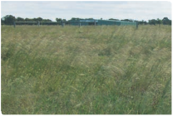

* An asterisk (*) identifies terms explained in the Glossary at page 39.

soil‑borne microbes that release nutrients for
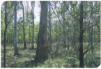

plant uptake, and manage water tables and run‑off. Woodlands, for example, also provide shelter and wind breaks, and native grassy ecological communities provide a degree of resilience and adaptability during periods of drought and longer‑term climate change.

More information on nationally threatened ecological communities can be found on the department’s website at: www.environment. gov.au/biodiversity/threatened/index.html

Why does the Australian Government list threatened ecological communities?

The Australian Government is responsible for identifying and protecting matters of national environmental significance. These include world heritage properties, national heritage places, internationally important wetlands (Ramsar wetlands), listed migratory species, Commonwealth marine areas, the Great Barrier Reef Marine Park, nuclear actions and nationally threatened species and ecological communities. All of these matters of national environmental significance are subject to Australia’s national environment law, the
EPBC Act.

The federal environment minister makes the decision to list an ecological community as nationally threatened. It follows a rigorous and transparent process of consultation
with stakeholders and the wider community, workshops and discussions with scientific experts, and advice from the Threatened Species Scientific Committee.
This committee is an independent scientific body that advises the minister on the conservation status of native species and ecological communities.

The listing of an ecological community under national environment law recognises that its long‑term survival is under threat. The aim
of listing is to prevent further decline and to promote and help recovery through landholder and community efforts. Listing may also lead
to funding opportunities, such as through the Australian Government’s Caring for
our Country initiative, to help with recovery and conservation efforts. See page 35 for information on funding opportunities or go to www.nrm.gov.au/funding/index.html for further details.

Why list the Gippsland Red Gum Grassy Woodland and Associated Native Grassland as critically endangered?

The federal environment minister listed the Gippsland Red Gum (Eucalyptus tereticornis subsp. mediana) Grassy Woodland and Associated Native Grassland as a critically endangered ecological community in
January 2009.

The Threatened Species Scientific Committee
found that this ecological community is critically endangered because it:
• has undergone a very severe decline in extent
• has a very restricted distribution
• faces continued threats, and
• has undergone a very severe reduction in its integrity.

Temperate grasslands and grassy woodlands are among the most under‑represented ecosystems in Australia’s conservation
estate, and are recognised nationally as among the most threatened vegetation types. The Gippsland ecological community
represents one of Victoria’s most threatened and fragmented endemic ecosystems.

The ecological community was formerly widespread across the central Gippsland plain, but now less than five per cent of
its original extent remains. Most known remnants are small—under 10 hectares— and comprise isolated fragments surrounded by a mostly cleared, agricultural landscape. Many patches of the ecological community require recovery efforts because they are
so degraded due to weed and feral animal invasion, loss of native biodiversity and rural tree dieback that their capacity to maintain ecosystem function is impaired. The protection, management and recovery of remnants on public and private land is crucial to the future survival of this unique ecological community.

The ecological community provides habitat to several nationally and state‑listed threatened plants and animals. Listing under the EPBC Act will help protect and recover the remaining patches of this
critically endangered ecological community, and preserve its value as vital habitat.

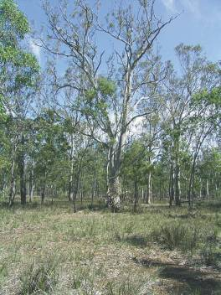
Grassy woodland at Stratford Highway Park

THE GIPPSLAND RED GUM GRASSY WOODLAND
AND ASSOCIATED NATIVE GRASSLAND

What is the Gippsland Red Gum Grassy Woodland and Associated Native Grassland?
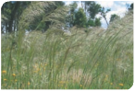

The Gippsland Red Gum (Eucalyptus tereticornis subsp. mediana) Grassy Woodland and Associated Native Grassland is a critically endangered ecological community listed under the national environment law.

Native grassy woodlands* and grasslands* are generally defined as areas of native vegetation in which the ground layer is dominated by native grasses*, but differ in
the degree to which a tree canopy is present. Despite the dominance of native grass species, grasslands and grassy woodlands can be extremely rich in other wildflowers
and plant species.
The Gippsland ecological community occurs in two forms:
• Grassy woodland
This is the most common form of the ecological community. The grassy woodland form has a tree canopy that has a projective foliage cover* of more than 5 percent
and is dominated by Gippsland red gum (Eucalyptus tereticornis subsp. mediana). The ground layer is covered by native perennial* tussock* grasses and grass‑like* plants with a variety of wildflowers such as daisies, lilies and orchids, occupying the spaces between tussocks.
• Grassland
Natural temperate grasslands formerly occurred on the Gippsland plains, but
they may have been entirely cleared since European settlement. In the grassland remnants of this ecological community, it
is likely that a tree canopy was formerly present, but it has been largely cleared and only the native ground layer remains. Many of these sites have been managed as native grasslands for decades.

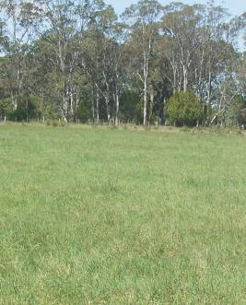

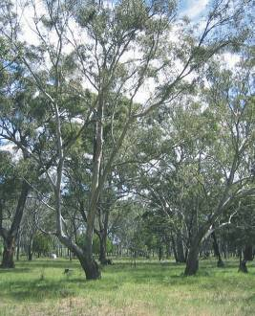
The grassland and grassy woodland forms of the ecological community at Fernbank Reserve, near Fernbank, Victoria

Shrubs are naturally sparse in both forms
of the ecological community, with a projective
foliage cover of less than 10 per cent. At some sites, however, disturbance may cause native shrubs to become invasive,
resulting in a denser shrub layer. Under these circumstances, the ecological community
may have a projective foliage cover for
shrubs of up to 50 per cent of the total area.

Both structural forms originate from the same woodland that formerly occupied
much of the Gippsland Plain. The ecological community typically occurs on undulating to flat plains less than 100 metres above sea level with some occurrences on low hills
up to 220 metres. The soils underlying the community are usually loamy topsoils over a clay or clay‑loam subsoil.

The woodland and grassland forms contain many similar plant species, but with some different species due to different historical management regimes. Both the woodland and the grassland forms support a variety of nationally threatened flora and fauna, as well as species that have a rare or threatened status in Victoria.

Where is it found?

The Gippsland Red Gum Grassy Woodland and Associated Native Grassland ecological community is endemic to Victoria. It is limited to the central Gippsland Plain, between Morwell and Swan Reach (see map on
page 8). It was formerly extensive in this area, but now occurs as mostly small remnants.

The general distribution of the ecological
community can be defined by the distribution of Gippsland red gum, the key tree species, which is bounded by the Strzelecki Ranges
to the west, the slopes of the Great Dividing Range to the north and the Tambo River valley to the east.

The bioregions, natural resource management (NRM) regions/catchment management authorities (CMA) and local government areas that correspond with the ecological community are listed in the table.
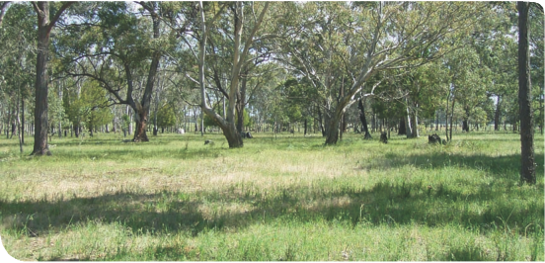

Fernbank Recreation Reserve

Further information on state equivalents to
Areas where the listed ecological community can be found
IBRA* bioregions/ subregions | South east coastal plain/ Gippsland plain (SCP1)  South east corner/East  Gippsland lowlands (SEC1)
Victorian bioregions | Gippsland plain (GipP)  East Gippsland lowlands (EGL)
NRM regions/ CMAs | West Gippsland  East Gippsland
Local government areas | East Gippsland Shire Council  Wellington Shire Council  La Trobe City Council

the listed ecological community can be found on page 17 of this booklet.

Area where the ecological community is likely to be found
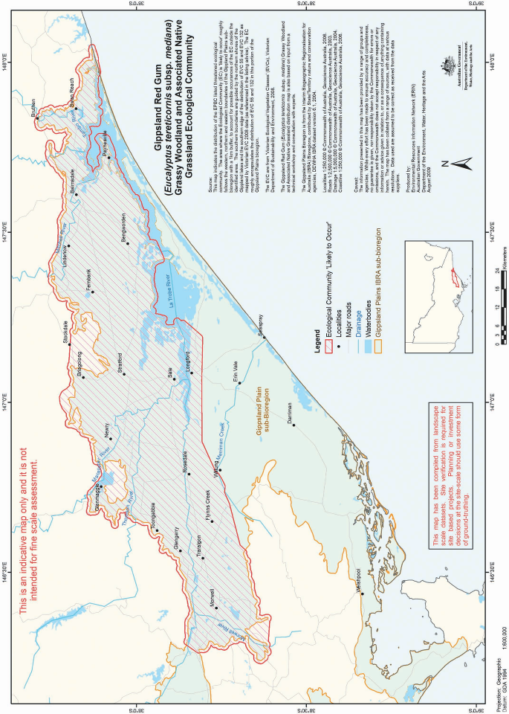

Examples of key remnants

Many areas of the Gippsland Red Gum Grassy Woodland and Associated Native Grassland ecological community are now disturbed and degraded. The ecological community mostly occurs as small, fragmented patches. Fortunately, good quality remnants of the ecological community can still be found on public lands, such as roadside or railway verges, cemeteries, and, to a lesser extent, in formal and informal conservation reserves.

Remnants may also be present on private tenure; for instance, paddocks that are uncleared or have been managed in a way that has maintained the ecological community. In these instances, supportive farming practices have helped to keep some patches of the ecological community in good condition.

Good quality examples of the ecological community can be found at the following sites:

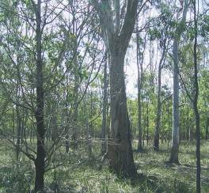
Stratford Highway Park

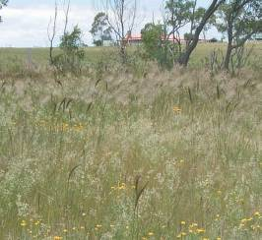
Maffra Cemetery

For grassy woodlands:
• Fernbank Recreation Reserve
• Stratford Highway Park
• Briagalong Forest Red Gum Reserve
• Moormurng Flora and Fauna Reserve
• Providence Ponds Flora and Fauna
Reserve, and
• Swallow Lagoon Nature Conservation
Reserve.

For native grasslands:
• Fernbank Recreation Reserve
• Maffra Cemetery
• West Sale Aerodrome
• Briagalong Cemetery
• Rosedale Cemetery, and
• Toongabbie Cemetery.

How do I know if I am standing in a patch of the ecological community?

This section is designed to help you determine if a native vegetation remnant could be part of the listed Gippsland Red Gum Grassy Woodland and Associated Native Grassland. The description and condition thresholds of the ecological community in the EPBC Act listing advice provide the definitive source of information for identifying the nationally threatened ecological community. The information from the listing advice is summarised and further explained in the following pages.

A patch of the listed ecological community is defined as a discrete and uniform area that comprises the ecological community.
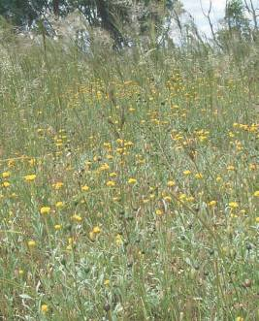
Grassland with common everlastings at Maffra Cemetery
It does not include substantial elements of other ecological communities, such as woodlands dominated by other tree species and other types of grasslands. However,
a patch of the listed ecological community may contain small, localised occurrences dominated by black sheoak (Allocasuarina littoralis) or drooping sheoak (Allocasuarina verticillata). A patch may also include small‑ scale disturbances, such as tracks or breaks, that do not alter its overall functionality— including the easy movement of wildlife or dispersal of plant spores and seeds—and may also include small‑scale variations in vegetation that are noted in the description.

If a native vegetation remnant meets the description of the listed ecological community, then you are likely to be standing in the listed ecological community. Help with identification of species may be obtained
from your local community Landcare groups or Conservation Management Network, catchment management authorities, other state agencies or local council.

It is important to remember that the ecological community occurs in two structural forms:
• Grassy woodland, and
• Grassland

Most large occurrences of the ecological community are grassy woodlands. At some smaller sites, the trees have been
cleared, leaving only the native ground layer vegetation in place. Most of these sites have been managed as native grasslands for some time.

Xerochrysum palustre (swamp everlasting)
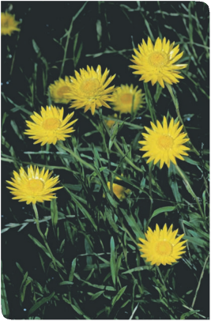

Condition thresholds and decision flowchart

Condition thresholds were established when the ecological community was listed to determine which patches are of particular conservation value and should
receive full protection as a matter of national environmental significance under the EPBC Act. The condition thresholds are intended
to focus national legal protection on native vegetation remnants that are relatively natural, functional and in relatively good condition. Some patches of the ecological community
are in such a heavily degraded state that they would not meet the condition thresholds.

The decision flowchart and snapshot that follow are intended to help determine if a patch of native vegetation is part of the listed ecological community.
The flowchart is in two steps:
• The first step asks if the nationally listed ecological community is likely to be present. If so, does the grassland or grassy woodland form occur? Note that
at some sites both forms of the ecological community may be present.
• The second step considers the quality of the patch of the ecological community. It indicates the minimum condition whereby patches of the ecological community triggers protection under the national environment law. This does not represent the ideal or undisturbed state of the ecological community, but does indicate when sufficient biodiversity values remain within a patch that its future protection should be taken into consideration.

Note that appropriate management of patches that do not meet the condition thresholds should continue, where possible, as they
may still play an important ecological role, especially where they are providing valuable habitat or connectivity functions. For example, patches that link native vegetation remnants
in the landscape are particularly important
as wildlife habitat and to the future viability of listed patches of the ecological community.

Both patches that meet the condition thresholds and those that do not should be considered in recovery and other
management actions, for instance through the Australian Government’s Caring for our Country initiative (see page 35). Patches that do not meet the condition thresholds may be eligible for funding to restore them to a better condition.

Notes for the flowchart:

The flowchart is intended to help identify if the Gippsland Red Gum Grassy Woodland and Associated Native Grassland ecological community is likely to be present. Other considerations to help with assessment of significant impact (see below) need to be taken into account when doing an on‑site inspection.
1. Where present, the scattered trees in the grassland form of the ecological community may comprise a range of eucalypt or Allocasuarina species that survive as remnant individuals.
2. Dominated by Gippsland red gum means that this species comprises 50 per cent or more of the tree canopy cover. Other eucalypt species may be present but are not dominant. However, small, localised patches of drooping sheoak (Allocasuarina verticillata) or black sheoak (Allocasuarina littoralis) may occur amongst the woodland patch. The woodland form varies in structure. At many sites the woodland comprises regrowth of closely spaced, thinner trees with occasional large trees. A mature open woodland of widely spaced, spreading trees is relatively uncommon.
3. Dominated here means 50 per cent of the vascular plant vegetation cover in the ground layer is made up of native grasses and grass‑like plants. This does not include mosses, lichens, litter or bare ground.
4. Note that a well‑developed shrub layer in the understorey is not a typical feature of the ecological community such that shrubs usually account for a projective foliage cover of less than 10 per cent. However, native shrubs may invade the ecological community due
to natural processes or disturbance. Under these circumstances, the projective foliage cover
of native shrubs in the ecological community may be up to 50 per cent of the total area.

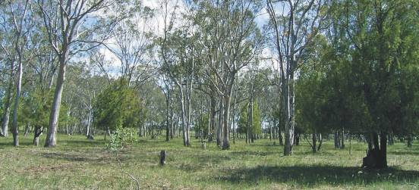
Fernbank Recreation Reserve

Flow chart to identify the Gippsland Red Gum Grassy Woodland and
Associated Native Grassland ecological community.

STEP 1: Is the national ecological community present?

Does the patch occur within the central Gippsland
Plain of Victoria (see indicative map at page 8)?

YES
Is the site a native remnant dominated by native species?

YES or NOT CERTAIN
NO. Outside the known, natural distribution of the national ecological community.

NO. Not the national ecological community – modified significantly by exotic pasture, plantings or weeds.

Are trees absent or sparse such that the projective foliage cover of native trees in the patch is 5 per cent or less? 1

YES
Is the ground vegetation layer dominated
by native grasses and grass‑like plants (for
example, sedges, lilies or Lomandra)? 3

NO Are trees present such that the projective foliage cover of native trees is more than 5 per cent?

YES

NO Is the tree canopy generally dominated by Gippsland red gum (Eucalyptus tereticornis subsp. mediana)? 2

YES. The grassland form of the ecological community is
present. Go to Step 2. Not the national
ecological community.

YES
Is the ground vegetation layer dominated
by native grasses and grass‑like plants (for
example, sedges, rushes, lilies or Lomandra)?3

YES. The grassy woodland form of the ecological community is present.
Go to Step 2.

STEP 2: Is the patch of sufficient quality to meet the condition thresholds for the nationally listed ecological community?

Is the patch bigger than or equal to
0.04 hectares (e.g. 20m x 20m)?

YES

Does 50% or more of the perennial ground layer vegetation, comprise native species? (Do not include mosses, lichens, litter and bare ground.) 4
NO. The patch is too small.

NO. The patch is
too weedy.
Is the patch bigger than or equal to
0.2 hectares (e.g. 100m x 20m)?

YES

Does 50% or more of the perennial ground layer vegetation, comprise native species? (Do not include mosses, lichens, litter and bare ground.) 4

YES

Does the patch have 7 or more native species present? (Do not include mosses, lichens or trees and tall shrubs over
5 metres tall.)

NO. The patch has too few native species
YES. The patch of the ecological
community is of sufficient quality to trigger
EPBC protection. See: What does the
listing mean for land managers on page 27.

1,2,3,4 see page 12 for notes

Snapshot: Gippsland Red Gum Grassy Woodland and
Associated Native Grassland
A critically endangered national ecological community.

What’s it look like?

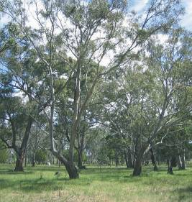
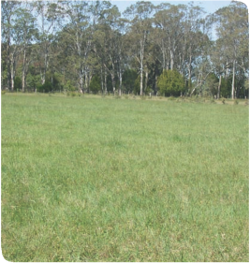

Mostly woodland with gum trees over grasses
and wildflowers.
Some smaller areas are grassland with wildflowers

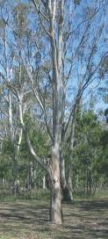
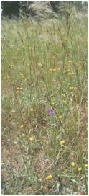

Tree canopy is dominated by Gippsland red gum (Eucalyptus tereticornis subsp, mediana).
Ground layer is dominated by a range
of tussock grasses and grass‑like plants. A
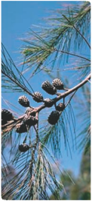

variety of wildflowers may be interspersed among the tussocks.
Small, localised pockets may occur within the woodland that are dominated by sheoak (Allocasuarina spp.)
Shrubs are typically sparse. Distrubance may cause native shrubs,
such as burgan (Kunzea ericoides) to spread into some sites.
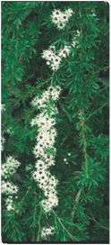

Where do I find it?
• Limited to the central Gippsland plain of Victoria, between Morwell and Swan Reach.
• On flat to undulating plains, usually low elevation up to 220 m altitude.
• Mostly along roadsides, rail reserves and cemeteries with some patches on private land.
• Good remnants are at Moormurng Flora and Fauna Reserve, Briagalong Forest Red
Gum Reserve and cemeteries at Maffra and Briagalong.

What else is it known as?

Corresponds to these Ecological Vegetation Classes in the Gippsland Plain and East Gippsland Lowland bioregions.
• 132_61 La Trobe Valley plains grassland
• 55‑03 Gippsland Plains grassy woodland
• Patches of mosaic units 259, 687, 897 and 927 may be included.

Corresponds to two threatened communities listed under Victoria’s FFG Act:
• Central Gippsland plains grassland community
• Forest red gum grassy woodland community.

Why it’s important to protect it….
• This ecological community was formerly widespread on the central Gippsland plain but is now reduced to mostly small fragments.
• Less than five per cent now remains.
• It continues to be threatened by clearing, inappropriate management, weeds and rural tree dieback.
• It’s essential to apply the right land use and management practices to maintain and restore this community.
• It provides habitat for threatened species, such as the swamp everlasting
(Xerochrysum palustre).
• Its future protection will provide vital support for native biodiversity and ecosystem services in the region.

Other considerations to help with assessment

The following issues should be considered when assessing a site containing the ecological community.

Variability in species composition

The native species composition of the ground layer may differ between grassland and
grassy woodland sites due to differences in past management history. For example, the management of many grassland remnants has involved periodic burning of sites.

The ecological community’s appearance can vary seasonally. This is because many native wildflowers are more visible when flowering during spring. Some wildflowers may not appear every year and may stay dormant, for instance during dry seasons. Some species are sensitive to particular disturbance regimes and may decline or disappear from disturbed sites. For example, highly palatable or grazing‑sensitive native species may disappear from sites that have been intensively or repeatedly grazed.

For these reasons, unless exceptional circumstances apply, native plant species diversity must be assessed during spring (September–November) and after the site has not been disturbed (for example, by fire, overgrazing, mowing) for at least two months before the springtime of sampling, to optimise the biodiversity assessment of
a site. However, features, such as vegetation structure, minimum patch size and perennial ground layer vegetation cover, can be assessed all year round.
Surrounding environmental and landscape context

It is important to consider the landscape context surrounding a patch of the ecological community. These landscape considerations help to determine if the patch has additional conservation value, and include:
• high diversity of native species within the patch
• evidence of recruitment of key native species, or the presence of a range of age classes. For instance, tree canopy species are present as saplings through to large hollow‑bearing trees
• good faunal habitat, as indicated
by patches containing mature trees (especially those with hollows), logs, natural rock outcrops, contribution to movement corridors
• areas of minimal weeds and feral animals, or where they can be easily managed
• presence of mosses, lichens, soil
crust and leaf litter on the soil surface, indicating low disturbance and potential for good functional attributes such as nutrient cycling
• connectivity to other native vegetation remnants or restoration works (for example, native plantings). In particular,
if a patch has an important position linking other patches in the landscape, and
• patches that contain listed threatened species (state or national).

How does the listed ecological community relate to other vegetation classification systems?

The nationally listed Gippsland Red Gum Grassy Woodland and Associated Native Grassland can be related to other vegetation classification systems used at both the national and state level.

The national vegetation information
system is a hierarchical national system for classifying vegetation across Australia. It ranges from broad major vegetation groups and subgroups to more fine-scale floristic associations and sub‑associations. The Gippsland ecological community falls within the following major vegetation subgroups:
• temperate tussock grasslands
(for the grassland form), and
• Eucalyptus woodlands with a grassy understorey (for the woodland form).

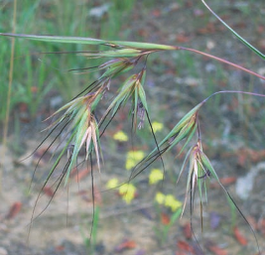
Themeda triandra (kangaroo grass)
For more information about the national vegetation information system go to the department’s website at: www.environment. gov.au/erin/nvis/index.html.

Victoria lists threatened communities through its Flora and Fauna Guarantee Act 1988.
The national ecological community covers
two threatened communities listed in Victoria.
These are the:
• Forest red gum grassy woodland community (which refers to the grassy woodland form of the national ecological community), and
• Central Gippsland Plains grassland community (which refers to the grassland form of the national ecological community).

Victoria classifies its vegetation using a system of Ecological Vegetation Classes (EVC*). An EVC may encompass one or more floristic communities. The system also takes account of mosaic vegetation units, where specific vegetation types cannot
be distinguished because the vegetation intergrades over a scale that is too fine for the vegetation mapping used. EVCs and floristic communities are defined on a bioregional basis and apply to specific Victorian bioregions.

The Gippsland Red Gum Grassy Woodland and Associated Native Grassland equates with
the following EVCs and mosaic units from the Gippsland plain and East Gippsland lowlands
Victorian bioregions.

EVC number and name  (as at the time of EPBC listing in January 2009) | Form of the listed ecological community
132_61 La Trobe Valley Plains Grassland | Grassland form
55‑03 Gippsland Plains Grassy Woodland | Grassy woodland form
259 Plains Grassy Woodland/Gilgai Wetland Mosaic  687 Swamp Scrub/Plains Grassland Mosaic  897 Plains Grassy Woodland/Plains Grassland Mosaic  927 Plains Grassy Woodland/Swamp Scrub/Plains Grassy  Wetland Mosaic | Mosaic units may apply to one or both forms

The national ecological community only
covers these EVCs where they meet the description in the flow chart on page 13 of this booklet, or in the listing advice available from the department’s website at: www.environment.gov.au/ biodiversity/threatened/communities/ pubs/73‑listing‑advice.pdf.
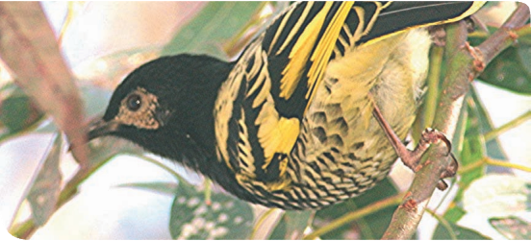

Further information on the implications of
the Victorian state listings or the Victorian Ecological Vegetation Classes can be sought from the Victorian Department
of Sustainability and Environment at www.dse.vic.gov.au or by calling 136 186.

Anthochaera phrygia. (regent honeyeater)

Similar ecological communities

Other ecological communities occur within the Gippsland plain that are near to or
may appear similar to the Gippsland Red Gum Grassy Woodlands and Associated Native Grasslands ecological community. These ecological communities are not part of the national ecological community. A brief outline with distinguishing features
and corresponding Victorian Ecological
Vegetation Class is presented below.
• South Gippsland Plains Grassland (EVC
132_62). This grassland occurs to the west and south of the central Gippsland plain, from Traralgon to coastal Gippsland. The sparse eucalypt canopy, when present, includes species other than Gippsland
red gum such as swamp gum (Eucalyptus ovata) and manna gum (Eucalyptus viminalis subsp. pryoriana). This grassland tends to occur on wetter sites with poorly draining soils subject to occasional waterlogging and, consequently, includes plant species associated with wetter
sites such as: smooth wallaby grass (Austrodanthonia laevis), mat grass (Hemarthria uncinata var. uncinata), blown‑grasses (Lachnagrostis spp.) and finger rush (Juncus subsecundus). It is listed separately as a threatened community in Victoria.
• Gippsland Lakes Damp Sands Herb‑rich Woodland (EVC 3‑01). This woodland occurs on relatively well drained, deep sandy or loamy topsoils and may be
near to, or intergrades with the national ecological community. The woodland
is typically dominated by manna gum and Gippsland red gum may be present but is not dominant. The presence of
a naturally well developed shrub layer and ground cover of austral bracken (Pteridium esculentum) also distinguishes this woodland from the national
ecological community.
• Other woodland and forest communities
in the region (for instance EVC 16 Lowland
Forest; EVC 61‑01 Gippsland Plains
Box Ironbark Forest; EVC 151‑01 South Gippsland Plains Grassy Forest). These communities are distinguished from the national ecological community by the dominance and presence of different species in the tree layer. Where Gippsland red gum may be present it is not dominant in the tree canopy. These communities
also differ in vegetation structure and landscape position. For instance, they may include a well developed natural shrub
layer with different species than may occur in the listed ecological community, or they occupy sites that are typically wetter, at a higher altitude or on stonier, rockier soils.

KEY SPECIES

The following photos show some of the key
flora species characteristic of the Gippsland Red Gum Grassy Woodland and Associated Native Grassland ecological community. Note that not all species shown may always be present, and other plant species not shown here may be present, at any given site.

An expanded list of key species characteristic of the ecological community can be found
in the listing advice on the department’s website at: www.environment.gov.au/ biodiversity/threatened/communities/pubs/
73‑listing‑advice.pdf.
Upper layer—dominant tree

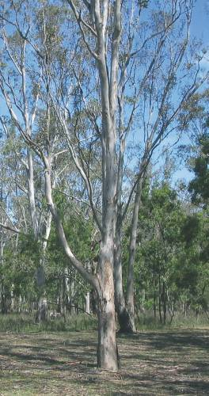
Eucalyptus tereticornis subsp. mediana
(Gippsland red gum)

Upper layer—other trees that may be present
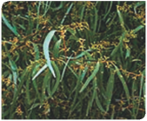

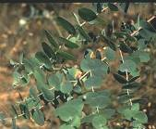

Eucalyptus bridgesiana
(but but)

Eucalyptus melliodora (yellow box)
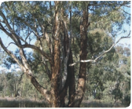

Eucalyptus camaldulensis
(river red gum)

Eucalyptus polyanthemos (red box)
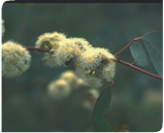

Eucalyptus globoidea
(white stringybark)
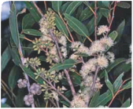

These are other tree species that may be present but are not pictured:
Eucalyptus angophoroides
(appled‑top box)
Eucalyptus bosistoana
(coast grey box)
Eucalyptus pauciflora
(snow gum)
Eucalyptus viminalis
(manna gum)

Mid layer—small trees and tall shrubs that may be present

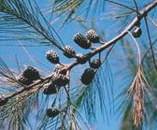

Allocasuarina littoralis
(black sheoak)

Acacia mearnsii (black wattle)
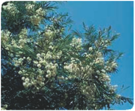

Allocasuarina verticillata
(drooping sheoak)
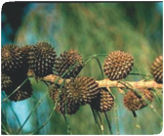

Kunzea ericoides complex (burgan)
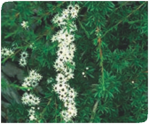

Acacia implexa (lightwood)

Please note: Burgan is typically sparse in the community, but can become invasive at some sites. Kunzea ericoides is a variable species and the name likely refers to a complex of taxonomic entities from south‑eastern Australia and New Zealand.
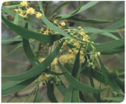

Ground layer—grasses and grass-like plants

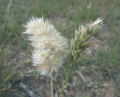
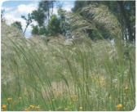

Austrodanthonia spp. (wallaby grasses)

Microlaena stipoides var. stipoides
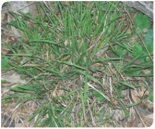

(weeping grass)
Austrostipa spp. (spear grasses)

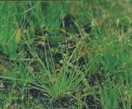
Schoenus apogon
(common bog sedge)
Lomandra filiformis
(wattle mat rush)
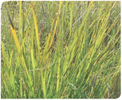

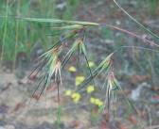
Themeda triandra
(kangaroo grass)

Ground layer—lilies and orchids

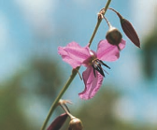

Arthropodium strictum
(chocolate lily)

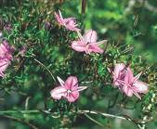
Thysanotus patersonii
(twining fringe lily)
Dianella revoluta
(flax-lily)
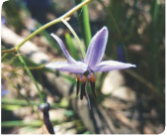

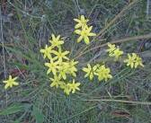
Tricoryne elatior
(yellow rush lily)
Diuris punctata
(purple donley orchid)
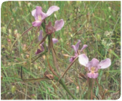

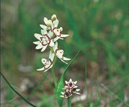
Wurmbea dioica
(early nancy)

Ground layer—other wildflowers

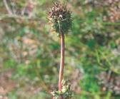
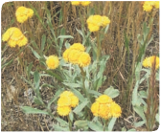

Acaena echinata
(sheep’s burr)

Drosera peltata subsp. peltata
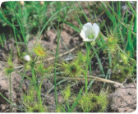

(pale sundew)

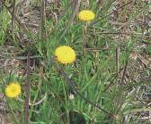
Leptorhynchos squamatus
(scaly buttons)

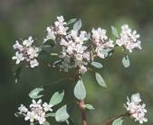
Poranthera microphylla
(small poranthera)
Chrysocephalum apiculatum
(common everlasting)

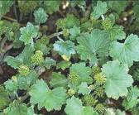
Hydrocotyle laxiflora
(stinking pennywort)

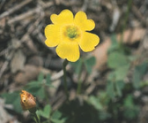
Oxalis perennans
(grassland wood sorrel)

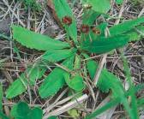
Solenogyne dominii
(smooth solenogyne)
Dichondra repens
(kidney weed)
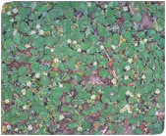

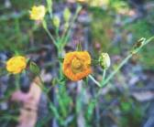
Hypericum gramineum
(small St John’s wort)

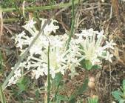
Pimelea humilis
(common rice flower)

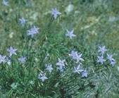
Wahlenbergia gracilis
(sprawling bluebell)

Species of special importance

The Gippsland Red Gum Grassy Woodland and Associated Native Grassland provides habitat for many native plants and animals. At the national level, at least 14 plant and animal species that may be found in or near the ecological community are listed as nationally threatened under the EPBC Act. Note that other species may be listed as rare or threatened under Victorian environmental laws.

Species listed under the EPBC Act, as of May 2010, found in or near the
Gippsland Red Gum Grassy Woodland and Associated Native Grassland.
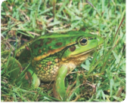

Animals

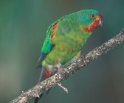
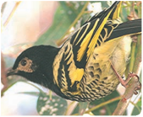

Lathamus discolor (swift parrot) Endangered

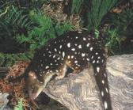

Dasyurus maculatus maculatus (south‑eastern mainland population) (spot‑tailed quoll)
Endangered
Anthochaera phrygia. (regent honeyeater) Endangered, migratory

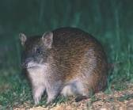

Isoodon obesulus obesulus (southern brown bandicoot ) Endangered

Litoria raniformis (growling grass frog) Vulnerable

Plants

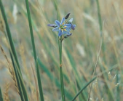

Dianella amoena
(matted flax-lily)
Endangered

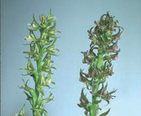

Prasophyllum frenchii (maroon leek‑orchid) Endangered
Glycine latrobeana
(purple glycine, clover glycine)
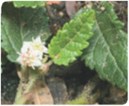

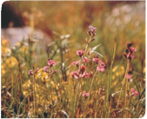

Vulnerable

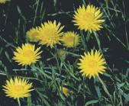

Xerochrysum palustre (swamp everlasting) Vulnerable
Rulingia prostrata (dwarf kerrawang) Endangered

Other species of special importance that may occur in the ecological community:
Amphibromus fluitans
(river swamp wallaby‑grass)
Vulnerable
Prasophyllum correctum
(gaping leek‑orchid) Endangered
Thelymitra epipactoides
(metallic sun‑orchid) Endangered
Thelymitra matthewsii
(spiral sun‑orchid) Vulnerable

More information on nationally listed species may be found on the species profile and threats
database (SPRAT) available at: www.environment.gov.au/cgi‑bin/sprat/public/sprat.pl

The Victorian Government also produces action statements for species listed in Victoria, which covers many of those identified here. They are found through the native plants and animals section of the Victorian Department of Sustainability and Environment website at: www.dse.vic.gov.au

Tricoryne elatior (yellow rush lily)

OTHER IMPORTANT MATTERS IN THE REGION

Ramsar wetlands
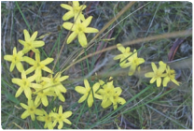

In addition to the threatened species identified
above, internationally important wetlands (also known as Ramsar wetlands) are also protected as matters of national environmental significance under the EPBC Act.

Patches of the ecological community may occur alongside or close to a Ramsar wetland site known as the Gippsland Lakes, Victoria. The Gippsland Lakes are a series of coastal lagoons that are separated from the sea by
a long strip of sand dunes known as Ninety Mile Beach. The Gippsland Lakes together form the largest navigable inland waterway in Australia. They are a distinctive regional
landscape of wetlands and flat coastal plains, which is of considerable environmental significance in terms of its landforms, vegetation and fauna. The wetlands provide habitat for many plant and animal species, including large numbers of waterfowl. Some
of these are listed threatened species or
listed migratory species under the EPBC Act. More information about Ramsar wetlands is available from the department’s website at: www.environment.gov.au/water/topics/ wetlands/database/ramsar.html
Indigenous heritage

The listed ecological community occurs across the lands of the Gunai/Kurnai people of Gippsland, who occupied the district from Foster in the west to the Snowy Mountains
in the east.

The Gunai/Kurnai people used the bark of both Eucalyptus tereticornis subsp.
mediana (Gippsland red gum) and Eucalyptus globoidea (white stringybark) to make canoes, and the products of other key species found
in the listed ecological community to produce shelters and other cultural objects vital for their daily lives. Scarred trees from some
of these processes can still be found at sites within the listed ecological community such as along the Bataluk cultural trail (www.maffra.net.au/bataluk/).

The Gunai/Kurnai people keep their culture and tradition alive today through diverse practices and cultural activities. Krowathunkooloong—the Keeping Place— located in Bairnsdale is a museum and cultural centre with a vast collection of arts, crafts and cultural material where people can learn about the history and heritage
of the Gunai/Kurnai people of Gippsland.

Litoria raniformis
(growling grass frog)

WHAT DOES THE LISTING MEAN FOR LAND MANAGERS?

If the listed ecological community is
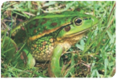

present at or near a particular site, adequate protection and appropriate land use practices are vitally important for the ecological community to persist for the benefit of future generations.

The listing of Gippsland Red Gum Grassy Woodland and Associated Native Grassland under the EPBC Act will not prevent land managers from continuing to use land in
the same way they were before the EPBC Act came into effect in July 2000. This is providing that they do not significantly change or intensify their activities, and that the
activity was lawful.

National protection means any new or intensified activities that may have a significant impact on one or more patches of the listed ecological community should be referred to the federal environment minister for assessment and approval.
Those activities likely to require approval
under the EPBC Act (if significant) include,
but are not restricted to:
• clearing remnants of native vegetation in
or near the listed community (for example, for new developments, roadworks, or
other changes in farming practice such as converting from grazing to cropping)
• significantly changing drainage and local
hydrology
• significant and adverse changes in
grazing or management regimes (such
as changing the fire regime or substantially
intensifying stocking rates on the ecological community)
• introducing potentially invasive exotic pasture species in or near to remnants, or broad‑scale applications of fertilisers,
herbicides or other chemicals to the listed ecological community.

Examples of activities unlikely to require
approval are:
• minor firebreaks and routine burn-offs
at appropriate times of year (for example,
avoid peak flowering season)
• maintaining existing fence lines, tracks,
internal access roads or firebreaks
• maintaining farm gardens and orchards
• replacing and maintaining sheds, yards and other farm buildings
• protecting and maintaining natural or lawfully established pastures
• running low intensity (sustainable) grazing, including rotation or strip grazing
• controlling weeds (hand and minor ground machinery), or
• moving farm vehicles and machinery (with minimised impact on native vegetation).

Land managers should also note that even
if the remnant vegetation does not meet the criteria for the listed ecological community, some plant or animal species that occur within the remnant may be otherwise protected under the EPBC Act. Land managers also should ensure that other
nationally protected matters, such as Ramsar wetlands or heritage‑listed sites, are not significantly affected.

The EPBC Act allows for some exemptions to the requirement for assessment and approval. This means some activities may not need to be referred for an assessment or approval under certain circumstances. However, failure to
refer an action that is likely to have a significant impact on the listed ecological community may have legal consequences such as financial penalties or remediation orders.
If you are considering an action that may have
an impact on the ecological community, you are encouraged to contact the department about your options. Further information is available from the department’s website on:

Exemptions www.environment.gov.au/epbc/publications/ exemptions.html

Referrals www.environment.gov.au/epbc/assessments/ referral‑form.html

Approvals
www.environment.gov.au/epbc/approval.html

Enquiries may also be directed to the department on 1800 803 772.

Farmers who have the listed ecological community on their properties are encouraged to seek assistance from the department’s outposted environment liaison officer at the National Farmers’
Federation. The environment liaison officer can be contacted by phone on 1800 704 520 or via email at: environment@nff.org.au

You should also check whether state or local government approvals are required in addition to EPBC Act requirements before starting an activity. As the national ecological community corresponds to two communities listed and protected under the Victorian Flora and Fauna Guarantee Act, all flora within the community
is protected on public land, and cannot be removed or damaged without a permit.

Cortaderia selloana
(pampas grass) – a weed

GUIDE TO MANAGING THREATS AND SUGGESTED CONSERVATION ACTIONS

This section identifies the key threats to the Gippsland Red Gum Grassy Woodland and Associated Native Grassland ecological community, and possible actions that land managers may take to conserve the listed community and their land. This guide is not exhaustive, but highlights conservation actions that are a high priority at the time of listing. Additional advice may be found as follows:
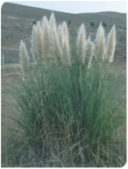

• On the department’s website, see the listing advice and conservation advice for the ecological community at: www.environment.gov.au/cgi‑bin/sprat/ public/publiclookupcommunities.pl
• When completed, a national recovery
plan will be available on the department’s website at: www.environment.gov.au/ biodiversity/threatened/recovery‑list‑ common.html
• Action statement 182 for five Victorian- listed grasslands and grassy woodlands is available on the Victorian Department of Sustainability and Environment website at: www.dse.vic.gov.au/dse/index.htm
Vegetation clearance, fragmentation and inappropriate management

Much of the Gippsland plain has been extensively cleared for agricultural use since European settlement. Clearing and changing land management practices continue to pose serious threats to the Gippsland Red Gum Grassy Woodland and Associated Native Grassland ecological community. More than
95 per cent of the ecological community has been cleared, and the patches that remain are mostly disturbed, fragmented and small—generally under 10 hectares in size.

Historically, management of the ecological community has involved grazing and/
or burning. Although the grassland and woodland forms have many species in common, different land use histories have resulted in some differences in plant species between the two forms of the ecological community. As a result, both grassland and grassy woodland remnants now require separate and specific management regimes to preserve the full remaining biodiversity of the ecological community.

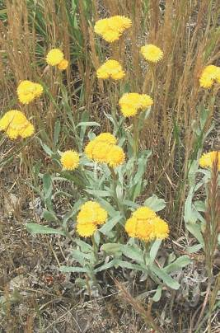
Chrysocephalum apiculatum (common everlasting)

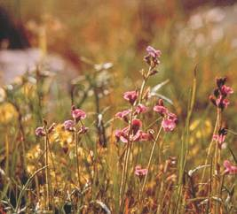
Glycine latrobeana (purple glycine, clover glycine)

Much of the ecological community occurs on public lands, often as linear patches
along roadside verges and railway corridors. The rest of the ecological community is likely to be on private lands used for agriculture.
In the case of grassland remnants on public lands, the regular burning previously used for biomass management (at appropriate intervals), and which promoted plant biodiversity, has been replaced by slashing or herbicide use. These changes in
management regime have contributed to the degradation of grassland remnants. At other sites, overgrazing by stock and/or feral animals, as well as road/railway maintenance works contribute to degradation of the ecological community. However, in other instances, sustainable farming practices have contributed to the survival of remnants.

There are many benefits to the long-term protection of Australia’s native biodiversity. Native vegetation remnants, such as the Gippsland Red Gum Grassy Woodland and Associated Native Grassland ecological community, provide a range of ecosystem services including management of water tables and flows, soil nutrient cycling, erosion and salinity reduction, carbon storage, and habitat for important functional species such as pollinators or predators of insect pests. They also provide wind breaks, shelter and food for stock, and exhibit some resilience
to drought.

Impacts of clearance, fragmentation and inappropriate management | Key management actions
• Direct loss of native species and decline in biodiversity (especially species least tolerant of disturbance).  • Loss of habitat for native plants and animals.  • Greater susceptibility to further disturbances and threats (as fragments become more isolated and the surrounding landscape  is modified).  • Impeded migration of native species among remnants (especially if remnants are isolated or widely separated).  • Loss of soil or soil quality (for example, erosion after vegetation loss, soil compaction by stock).  • Changes in water flows and quality  (for example, decreased water  infiltration, increased runoff).  • Inorganic fertilisers killing native species adapted to low nutrient environments.  • Weed invasion from poor management regimes. | • Identify the best quality remnants and key threats.  • Monitor their condition and the effectiveness of management actions, and adapt them, if necessary.  • Avoid or minimise any permanent damage to patches of the ecological community.  • Protect remnants through inclusion in formal conservation reserves, or through management agreements or conservation covenants.  • Protect native vegetation remnants that buffer or link remnants of the ecological community.  • Ensure road widening, maintenance activities and other infrastructure or development activities do not adversely affect known remnants.  • Retain any logs, fallen timber or standing dead trees to foster habitat diversity for native fauna and promote ecological functions like nutrient cycling.  • Raise awareness of the ecological community within the region.  • Develop and implement appropriate management regimes to maintain the distinctive biodiversity elements of the ecological community (for  example, strategic grazing regimes or appropriate fire regimes).  • Ensure that management regimes are also appropriate for any threatened species present.  • Encourage good management practices for remnants on all land  tenures, not just to remnants under conservation tenure.  • Avoid the use of fertilisers within native vegetation remnants and  ensure that fertiliser applications in adjoining pastures do not drift  into patches of the ecological community.

Exotic species

Some significant environmental and agricultural weeds occur in the Gippsland region that may affect the listed ecological community. Many of these species establish within native vegetation remnants through some form of soil disturbance (for example, maintenance works or stock movement). They may also be introduced by deliberate dumping of garden waste into or near remnants. Guidance about managing weeds is available from:
• Australian Government’s Weeds in Australia website at: www.weeds.gov.au/index.html
• Victorian Government’s Invasive plants website at: www.dpi.vic.gov.au/dpi/vro/vrosite.nsf/
pages/lwm_pest_plants

Weeds officers from a state agency, catchment management authority or local council
in your region can also help.

Notable pest animals that occur in the Gippsland plain region include predators such as the European fox, feral cats and feral dogs, as well as pest herbivores such as the European rabbit and brown hare. These species kill native wildlife or destroy native vegetation. The EPBC Act allows for the listing of key threatening processes, and preparation of threat abatement plans, such as those for predation by the European red fox and the feral cat, and for competition and
land degradation by rabbits. Approved threat abatement plans are available from the department’s website at: www.environment.gov.au/biodiversity/threatened/tap‑approved.html

Land managers should also be aware of, and comply with, any local or state laws that require them to manage noxious weeds or pest animals on their property.

Impacts of exotic species | Key management actions
• Direct loss of native species and decline in biodiversity.  • Weeds competing with native plants for space, water and nutrients. If left unmanaged, weeds will degrade and potentially dominate a site.  • Introduced predators, such as foxes and feral cats, competing with native predators and killing native animals.  • Introduced herbivores, such as rabbits, grazing, browsing and killing native plants. They can also disturb soil structure through extensive diggings or trampling. | • Identify the key weed and pest animals at a given site.  • Monitor and manage problem species following available best practice or management plans.  • Monitor and manage sites to prevent introduction or further spread of weed infestations.  • Ensure use of chemicals or other mechanisms to control weeds do not have  any significant adverse impact on native species (for example, avoid broad-cast  herbicide use such as aerial spraying).  • Monitor and manage the spread of invasive native shrubs into the ecological community.  • Minimise impacts to threatened species at known sites.  • Identify new and emerging weed and pest animal problems in the region. Act quickly to eradicate them before the problem becomes too impractical and  expensive to fix.  • Prevent or minimise the addition of nutrients, such as fertilisers. Nutrient enrichment promotes weed invasion.

Significant weeds that occur in the central Gippsland plain
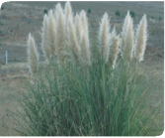

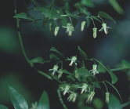
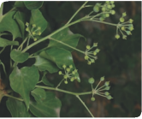

Asparagus asparagoides
(bridal creeper)

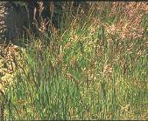
Holcus lanatus
(Yorkshire fog)

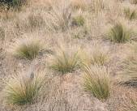
Nassella trichotoma
(serrated tussock grass)
Cortaderia selloana
(pampas grass)

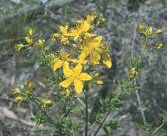
Hypericum perforatum
(St John’s wort)

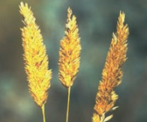
Phalaris spp. (phalaris)
Hedera helix
(English ivy)

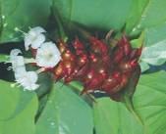
Leycesteria formosa
(Himalayan honeysuckle)

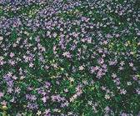
Vinca major
(periwinkle)

Other significant weeds that occur in the region include:
Anthoxanthum odoratum (sweet vernal grass) Eragrostis curvula (African lovegrass) Nassella neesiana (Chilean needle grass)

Rural tree dieback

Dieback is a progressive decline in the health and vigour of canopy trees. Affected trees show defoliation and death of twigs, branches and, ultimately, the entire tree. Rural tree dieback affects native eucalypts across much of the Gippsland plain, including Gippsland
red gum trees.

The underlying causes of dieback are complex. One immediate cause of dieback in Gippsland is repeated damage to shoots by beetles, lerps and caterpillars, sometimes in large numbers or over long periods.
However, the reasons why populations
of defoliating insects increase, and trees become more susceptible to damage may be due to wholesale changes in landscape, land use and longer‑term drought. For instance, the use of improved pastures and fertilisers also provides pest insects with a better food source. Clearing and thinning remnant native vegetation discourages the natural predators of insect herbivores, such as woodland birds and sugar gliders. And many trees now
exist as isolated paddock trees or in small fragments that leaves them susceptible to further disturbance.

Impacts of dieback | Management actions
• Progressive decline in the health and vigour of canopy trees.  • Loss of native trees or stands of woodland trees that provide habitat for native plants and animals.  • Loss of habitat for insectivores (woodland birds, mammals, spiders, wasps) that help to regulate insect pests, which may in turn contribute  to rural tree dieback. | • Monitor the extent and spread of rural tree dieback.  • Encourage natural regeneration or replant native canopy species at sites affected by rural tree dieback.  • Maintain whole native vegetation remnants (understorey and overstorey) to encourage habitat for natural predators of pest insects.  • Prevent or minimise the addition of nutrients, such as fertilisers, to sites. Nutrient enrichment can be a key factor that fosters outbreaks of pest insects.  • Minimise impacts from surrounding landscape stresses to reduce susceptibility of remnants to dieback; for example, provide buffers to agricultural impacts, such as fertiliser application.  • Undertake education programs about the complex land‑use factors that lead to rural tree dieback and the importance of trees in the landscape.

Is funding available to protect the ecological community?

Regardless of whether the ecological community exists on private property, council land or other public land, land managers or community groups may be eligible for funding to help preserve or restore remnants.

National

Funding through the Australian Government’s Caring for our Country initiative may be available for activities that have an environmental
benefit, such as improving land management practices, increasing native habitat and/or enhancing ecosystem services. For more details go to: www.nrm.gov.au/index.html

The national reserve system has an important role in protecting biodiversity values on private land in agricultural and pastoral regions. Building the national reserve system is one
of the priorities under Caring for our Country. Partners can apply for assistance from the Australian Government to purchase land to establish protected areas to be managed for nature conservation, as part of this system.

Funding is also available for landholders wanting to permanently protect their property’s biodiversity values. If a property’s values are a priority for addition as a national reserve, landholders can access support to establish protected areas on private lands. For more details go to: www.environment. gov.au/parks/nrs/index.html

You can also contact a Caring for our
Country facilitator based in Victoria for advice on natural resource management policies
and programs. For contact details go to:
State

As parts of the nationally listed ecological community are also listed as threatened communities under Victorian environmental laws, there may be state government initiatives to help protect it; for instance, through the Victorian Government’s BushTender and BushBroker programs.

Regional offices and websites of the Victorian Government agencies, catchment management authorities and local councils may contain information about current programs supporting conservation efforts. Contact details are shown in the table.
State and local authority contact details
Victorian Department of Sustainability and Environment
Website: www.dse.vic.gov.au
Phone: 136 186
Victorian Department of Primary Industry Website: www.new.dpi.vic.gov.au/home Phone: 136 186
West Gippsland Catchment Management Authority
Website: www.wgcma.vic.gov.au
Phone: 1300 094 262
East Gippsland Catchment Management Authority
Website: www.egcma.com.au
Phone: 03 5152 0600
East Gippsland Shire Council Website: www.egipps.vic.gov.au Phone: 03 5153 9500
Wellington Shire Council
Website: www.wellington.vic.gov.au
Phone: 1300 366 244
La Trobe Shire Council Website: www.latrobe.vic.gov.au Phone: 1300 367 700

WHERE CAN I GO FOR FURTHER INFORMATION?

The listing advice and conservation
advice for the Gippsland Red Gum Grassy Woodland and Associated Native Grassland are the definitive source of information on
the listing of this ecological community. These documents are available at: www.environment.gov.au/cgi‑bin/sprat/public/ publiclookupcommunities.pl

The Victorian Department of Sustainability and Environment has an action statement that includes useful management advice for this ecological community:
• Action statement no. 182. Central Gippsland plains grassland, Forest red gum grassy woodland, Northern plains grassland, South Gippsland plains grassland, Western (basalt) plains grassland. It is available at: www.dse.vic.gov.au/dse/index.htm

This website also contains action statements for many of the species of special importance.
Other guides with information that may help to identify and manage the ecological community include:

Barlow, T. (1999). Grassy guidelines. How to manage native grasslands and grassy woodlands on your property. Melbourne: Trust for Nature Victoria. Available at: www.environment.gov.au/land/publications/ grassguide/

Bramwell, M. (2004). Biodiversity action planning. Red gum plain landscape zone, Gippsland Plain bioregion. Bairnsdale: Department of Sustainability and Environment.

Dorrough, J., Stol, J. & McIntyre, S. (2008). Biodiversity in the paddock: a land managers’ guide. Canberra: Future Farm Industries
CRC. Available at: www.futurefarmcrc.com.au/documents/ Biodiversity_in_the_Paddock.pdf

Langford, C., Simpson, P., Garden, D., Eddy,
D., Keys, M., Rehwinkel, R. & Johnston, W. (2004). Managing native pastures for agriculture and conservation. Sydney: NSW Department of Primary Industries.

Lunt, I., Barlow, T. & Ross, J. (1998). Plains wandering: exploring the grassy plains of south‑eastern Australia. Victorian National Parks Association Inc. and Trust for Nature Victoria.

McIntyre, S., McIvor, J. & Heard, K. (eds) (2002). Managing and conserving grassy woodlands. Melbourne: CSIRO Publishing.

West Gippsland Catchment Management Authority (2003). West Gippsland native vegetation plan 2003. Traralgon: West Gippsland Catchment Management Authority.
Useful websites
• EPBC Act:
www.environment.gov.au/epbc
• EPBC Act Administrative guidelines on significance: www.environment.gov.au/epbc/ publications/nes‑guidelines.html
• Information about nationally threatened ecological communities and species: www.environment.gov.au/cgi‑bin/sprat/ public/sprat.pl
• Caring for our Country www.nrm.gov.au/index.html
• National Farmers’ Federation www.nff.org.au/

Additional copies

Enquiries and requests for further
copies of this booklet can be directed to the Community Information Unit of the Department of the Environment, Water, Heritage and the Arts on:

Freecall: 1800 803 772

Email: ciu@environment.gov.au

GLOSSARY OF KEY TERMS AND ABBREVIATIONS

ANBG: (In photograph credits) refers to the
Australian National Botanic Gardens.

Critically endangered: A category for listing threatened species and ecological communities under the EPBC Act. Items listed as critically endangered show an extremely high risk of extinction in the wild in the immediate future.

Ecological community: An assemblage of native species that inhabits a particular area in nature. In the context of the EPBC Act,
this only applies to nature in the Australian
jurisdiction.

Ecological Vegetation Class (EVC): A unit of vegetation classification used in Victoria. The EVC system includes information about vegetation floristics and structure, landscape context and ecological processes.

Grass(es): Any plant that is a member of the plant family Poaceae.
Grass-like: A plant that may superficially resemble a grass but is a member of a plant family other than Poaceae. Examples include sedges and rushes. The shoots of some
lilies, orchids and mat‑rushes (Lomandra spp.) may also appear grass‑like, especially when not in flower.

Grassland: A vegetation type characterised by the absence or scarcity of trees and large shrubs and where a ground layer of grasses is the dominant vegetation feature.

Herb, herbaceous: Any seed plant that never produces a woody stem.

Interim Biogeographical Regionalisation of Australia (IBRA): Under IBRA
version 6.1, Australia is classified into
85 bioregions, each of which is a large geographically distinct area of similar climate, geology, landform, vegetation and animal communities.

Perennial: A plant whose life span extends over more than two growing seasons.

Projective foliage cover: A measure of vegetative cover based on the percentage of a site occupied by the vertical projection of foliage only. In other words, if the sun were directly overhead, what proportion of the site would be shaded by the leaves.

Tussock: A plant growth form where the shoots form compact tufts. Common in many species of grasses, but also occurs in other grass‑like plant species.

Woodland: A vegetation type in which a tree canopy is present but does not form a dense or closed canopy, as in forest systems. In woodlands, the tree canopy typically has a projective foliage cover of up to 30 per cent, and individual trees are often more widely spaced, and shorter, with a spreading
canopy. Open woodlands have a tree foliage cover of less than 10 per cent. Grassy woodlands have an understorey dominated by grasses, interspersed with other herbs.

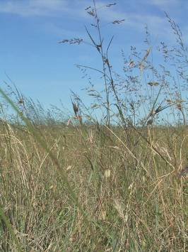
Grassland at West Sale Aerodrome

Photograph credits

Front Cover Images (left to right)
Pimelea humilis (common rice flower) © Ruth Crabb Lomandra filiformis (wattle mat rush) © Ruth Crabb Grassy woodland at Fernbank Reserve © Rosemary Purdie Isoodon obesulus obesulus (southern brown bandicoot)
© A. Tatnell

Internal Images (left to right, top to bottom)
2 Native grassland at West Sale Aerodrome
© Ruth Crabb
3 Grassy woodland at Stratford Highway Park
© Ruth Crabb
4 Grassy woodland at Stratford Highway Park
© Ruth Crabb
5 Austrostipa spp. (spear grasses) © Rosemary Purdie
6 Grassland form at Fernbank Reserve © Ruth Crabb
6 Grassy woodland form at Fernbank Reserve
© Rosemary Purdie
7 Fernbank Recreation Reserve
© Ruth Crabb
9 Stratford Highway Park © Ruth Crabb
9 Maffra Cemetery © Ruth Crabb
10 Grassland with common everlastings at Maffra
Cemetery © Ruth Crabb
11 Xerochrysum palustre (swamp everlasting)
© John Eichler
12 Fernbank Recreation Reserve © Ruth Crabb
14 Snapshot Grassy woodland, Fernbank Reserve
© Rosemary Purdie
Grassland, Fernbank Reserve © Ruth Crabb Gippsland red gum © Rosemary Purdie Grassland wildflowers © Ruth Crabb
Allocasuarina littoralis (sheoak) © M. Fagg, ANBG
Kunzea ericoides (burgan) D. Grieg, © ANBG
17 Themeda triandra (kangaroo grass) © Matthew White
18 Anthochaera phrygia (regent honeyeater) © G. Dabb
20 Eucalyptus tereticornis subsp. mediana
(Gippsland red gum) © Rosemary Purdie
21 Eucalyptus bridgesiana (but but) A. Cureton, © ANBG
21 E. camaldulensis (river red gum) C. Totterdell, © ANBG
21 E. globoidea (white stringybark) © M. Fagg, ANBG
21 E. melliodora (yellow box) © Colette Barton
21 E. polyanthemos (red box) G. Manley, © ANBG
21 Allocasuarina littoralis (black sheoak) © M. Fagg, ANBG
21 Allocasuarina verticillata (drooping sheoak)
R. Hill, © ANBG
21 Acacia implexa (lightwood) G. Manley, © ANBG
21 Acacia mearnsii (black wattle) © M. Fagg, ANBG
21 Kunzea ericoides (burgan) D. Grieg, © ANBG
22 Austrodanthonia spp. (wallaby grasses)
© Matthew White
22 Austrostipa spp. (spear grasses) © Rosemary Purdie
22 Lomandra filiformis (wattle mat rush) © Ruth Crabb
22 Microlaena stipoides var. stipoides (weeping grass)
© Colette Barton
22 Schoenus apogon (common bog sedge) R. Hill, © ANBG
22 Themeda triandra (kangaroo grass) © Matthew White
22 Arthropodium strictum (chocolate lily) © Ruth Crabb
22 Dianella revoluta (flax-lily) © Matthew White
22 Diuris punctata (purple donkey orchid)
© Rosemary Purdie
22 Thysanotus patersonii (twining fringe lily)
© M. Fagg, ANBG
22 Tricoryne elatior (yellow rush lily) © Matthew White
22 Wurmbea dioica (early nancy) © Matthew White
23 Acaena echinata (sheep’s burr) © Karen Wales
23 Chrysocephalum apiculatum (common everlasting)
© Ruth Crabb
23 Dichondra repens (kidney weed) © M. Fagg, ANBG
23 Drosera peltata subsp. peltata (pale sundew)
© Reto Zollinger
23 Hydrocotyle laxiflora (stinking pennywort)
© M. Fagg, ANBG
23 Hypericum gramineum (small St John’s Wort)
© Matthew White
23 Leptorhynchos squamatus (scaly buttons)
© Matthew White
23 Oxalis perennans (grassland wood sorrel)
© M. Fagg, ANBG
23 Pimelea humilis (common rice flower) © Ruth Crabb
23 Poranthera microphylla (small poranthera)
© M. Fagg, ANBG
23 Solenogyne dominii (smooth solenogyne)
© Reto Zollinger
23 Wahlenbergia gracilis (sprawling bluebell)
C. Totterdell, © ANBG
24 Lathamus discolor (swift parrot) © Dave Watts
24 Anthochaera phrygia (regent honeyeater) © G. Dabb
24 Litoria raniformis (growling grass frog) © A. Dudley
24 Dasyurus maculatus maculatus (spot‑tailed quoll)
© Dave Watts
24 Isoodon obesulus obesulus (southern brown
bandicoot) A. Tatnell
25 Dianella amoena (matted flax-lily) © Barbara Bell
25 Glycine latrobeana (purple glycine) © T. Barlow
25 Rulingia prostrata (dwarf kerrawang) © M. Fagg, ANBG
25 Prasophyllum frenchii (maroon leek‑orchid)
C. Totterdell, © ANBG
25 Xerochrysum palustre (swamp everlasting)
© John Eichler

26 Tricoryne elatior (yellow rush lily) © Matthew White
27 Litoria raniformis (growling grass frog) © A. Dudley
29 Cortaderia selloana (pampas grass) © Murray Fagg
30 Chrysocephalum apiculatum (common everlasting)
© Ruth Crabb
30 Glycine latrobeana (purple glycine) © T. Barlow
33 Asparagus asparagoides (bridal creeper)
© Murray Fagg, ANBG
33 Cortaderia selloana (pampas grass) © Murray Fagg
33 Hedera helix (English ivy) © Murray Fagg
33 Holcus lanatus (Yorkshire fog) P. Ormay, © ANBG
33 Hypericum perforatum (St John’s wort)
© Murray Fagg, ANBG
33 Leycesteria formosa (Himalayan honeysuckle)
© Murray Fagg
33 Nassella trichotoma (serrated tussock grass)
© John Baker
33 Phalaris spp. (phalaris) P. Ormay, © ANBG
33 Vinca major (periwinkle) K. O’Ryan, © ANBG
39 Grassland at West Sale Aerodrome,
© Ruth Crabb

Back Cover Images (left to right)
Anthochaera phrygia (regent honeyeater) © G. Dabb Eucalyptus melliodora (yellow box) © Colette Barton Pimelea humilis (common rice flower) © Ruth Crabb Glycine latrobeana (purple glycine) © T. Barlow

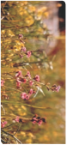

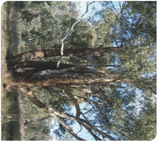

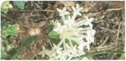

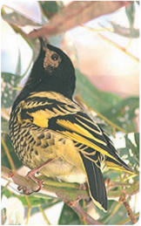

BIO074.1209

