

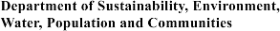

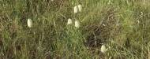
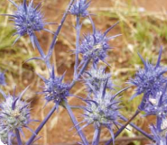

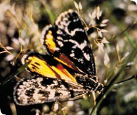

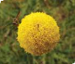

Nationally Threatened Ecological
Communities of the Victorian Volcanic Plain: Natural Temperate Grassland & Grassy Eucalypt Woodland

A guide to the identification, assessment and management of nationally threatened ecological communities
Environment Protection and Biodiversity Conservation Act 1999

Acknowledgement of Indigenous Heritage content

Information about Aboriginal language groups and permission to use names of language groups was provided by the South West Aboriginal Languages Committee and the Victorian Aboriginal Corporation for Languages www.vaclang.org.au/index.aspx

Glossary

An asterisk (*) against a term, on its first mention within the text, indicates that it is defined in the Glossary at the back of this publication.

© Commonwealth of Australia 2011

This work is copyright. Apart from any use as permitted under the Copyright Act 1968, no part may be reproduced by any process without prior written permission from the Commonwealth. Requests and inquiries concerning the reproduction and rights should be addressed to the Commonwealth Copyright Administration. Attorney-General’s Department, Robert Garran Offices, National Circuit, Barton ACT 2600 or posted at www.ag.gov.au/cca.

Disclaimer

The contents of this document have been compiled using a range of source materials and while reasonable care has been taken in its compilation,
the Australian Government does not accept responsibility for the accuracy or completeness of the contents of this document and shall not be liable for any loss or damage that may be occasioned directly or indirectly through the use of or reliance on the contents of the document.

Printed on recycled and FSC certified virgin pulp paper.

CONTENTS

WHAT IS THE PURPOSE OF THIS GUIDE? 3

NATIONALLY THREATENED ECOLOGICAL COMMUNITIES 4

What is a nationally threatened ecological community? 4

Why does the Australian Government list threatened ecological communities? 5

Why list the Natural Temperate Grassland and Grassy Eucalypt Woodland
of the Victorian Volcanic Plain as critically endangered? 5

THE NATURAL TEMPERATE GRASSLAND AND THE GRASSY EUCALYPT WOODLAND OF THE VICTORIAN VOLCANIC PLAIN ECOLOGICAL COMMUNITIES 7
What are native grasslands and grassy woodlands? 7

What are the Natural Temperate Grassland and the Grassy Eucalypt Woodland
of the Victorian Volcanic Plain? 7

Snapshots 10

WHERE ARE THESE ECOLOGICAL COMMUNITIES FOUND? 16

Examples of key remnants of the listed ecological communities 18

How do I know if I am standing in a patch of the listed ecological communities? 19

Condition thresholds 20

Other considerations to help with assessment 21

Flowchart 23

KEY SPECIES 25

Key plants and animals 25

Threatened Species 28

ARE THE LISTED COMMUNITIES KNOWN BY OTHER NAMES? 34

Similar ecological communities 36

INDIGENOUS HERITAGE 38

Aboriginal Language groups 38

Traditional Plant Use 38

Indigenous Protected and Heritage Areas 39

WHAT DOES THE LISTING MEAN FOR APPROVAL AUTHORITIES
OR LAND MANAGERS? 40

What does the EPBC Act listing of the ecological community mean for farmers,
land managers or developers? 40

Which activities might require consideration? 40

MANAGING THREATS AND PRIORITY CONSERVATION ACTIONS 42

Is funding available to protect listed grassland and grassy woodland communities? 45

National funds 45

State funds 45

WHERE CAN I GO FOR MORE INFORMATION? 46

The listing advice and conservation advice for the Natural Temperate Grasslands
and Grassy Eucalypt Woodlands of the VVP 46

Information about other matters of national environmental significance 46

Other useful resources 46

Other useful websites 48

GLOSSARY 49

Lathamus discolor (Swift Parrot)

WHAT IS THE PURPOSE OF THIS GUIDE?

This booklet is designed to assist land managers, owners and occupiers as well as environmental assessment officers,
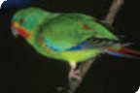

consultants and the general public to identify, assess and manage the Natural Temperate Grassland of the Victorian Volcanic Plain
and the Grassy Eucalypt Woodland of the Victorian Volcanic Plain (VVP). Both of these are nationally threatened ecological
communities listed under Australia’s national environment law, the Environment Protection and Biodiversity Conservation Act 1999 (EPBC Act).

This document accompanies the listing and conservation advice, which presents the definitive and detailed description of these two threatened ecological communities. The listing advice is a technical document
that explains what an ecological community is, where it is known to occur, why it
merits listing as nationally threatened and which conservation status applies to the ecological community. The conservation advice identifies priority management and conservation actions.
These documents can be found in the Australian Government’s species profile and threats database (SPRAT) at:
www.environment.gov.au/cgi-bin/sprat/public/
publiclookupcommunities.pl

At this website, click on the details link to download the documents for each ecological community.

This document does not provide specific advice on whether particular actions will trigger national environment law
by having a significant impact on the
ecological communities. This needs to
be considered on a case and site specific basis. However, a patch of either of the ecological communities must meet a number of minimum condition thresholds in order to be considered for national law protection. Additional environment assessment considerations are also covered on page 21.

General guidance on significant impacts is found separately at: www.environment.gov. au/epbc/publications/nes-guidelines.html

For what this listing means for approval authorities or land managers, please see page 40.

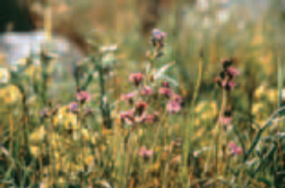

Glycine latrobeana
(Clover Glycine, purple clover)

NATIONALLY THREATENED ECOLOGICAL COMMUNITIES

What is a nationally threatened ecological community?

An ecological community is a naturally occurring group of plants, animals and
other organisms that are living together and interacting in a unique habitat. Its structure, composition and distribution are determined by environmental factors such as soil type, position in the landscape, climate and water availability. Species within such ecological communities interact and depend on each other – for example, for food or shelter. Types of ecological communities listed
under national environmental law include grasslands, woodlands, shrublands, forests, wetlands, ground springs and cave communities.

Together with threatened species, threatened ecological communities listed under the EPBC Act*1 are protected as one of several matters of national environmental significance. Threatened ecological communities can be listed as vulnerable,

1 * Words with an asterisk are defined in the
Glossary at the back of this publication.
endangered or critically endangered*, categories that represent their decline and potential for extinction across their national extent.

The decision to list an ecological community as nationally threatened is made by the federal environment minister. It follows
a rigorous and transparent process of consultation with stakeholders and the public, workshops and discussions with scientific experts, culminating in advice from the Threatened Species Scientific Committee. The committee is an independent scientific body that advises the minister on the conservation status of native species
and ecological communities.

Litoria raniformis (Growling grass frog)

Why does the Australian Government list threatened ecological communities?

The Australian Government is responsible for identifying and protecting matters
of national environmental significance. These include world heritage properties, national heritage places, Ramsar wetlands (internationally important wetlands), listed migratory species, Commonwealth marine areas, the Great Barrier Reef Marine Park, nuclear actions and nationally-listed threatened species and ecological communities. All of these matters of national environmental significance are subject to Australia’s national environment law, the EPBC Act.

Protection through the EPBC Act complements other conservation measures and is vital for some ecological communities because many patches* occur outside conservation reserves.

As well as being important because of their unique biodiversity and distinctive place within the Australian landscape, threatened ecological communities provide a range
of ecosystem services. These include the natural management of air, water and soil nutrients, the reduction or control of erosion and salinity, and carbon storage.

In addition, threatened ecological communities are a form of landscape or systems level protection. They provide vital wildlife corridors and habitat refuges for many plant and
animal species, including threatened species
and other Australian plants and animals that are in decline. Threatened ecological communities can also provide a focus
for tourism and recreation, have cultural significance, and contribute to the productivity of our farmlands. Benefits of protecting ecological communities can include facilitating pollination of agricultural plants, maintaining healthy soils leading to improved crop yields, and supporting soil-borne microbes that release nutrients for plant uptake, as well
as managing water tables and run-off. Woodlands, for example, also provide shelter and wind breaks, and native grassland ecological communities confer a degree
of resilience and adaptability during periods of drought and longer-term climate change.

The listing of an ecological community under national environment law recognises that its long-term survival is under threat. The aim of listing is to prevent further decline and to promote and assist recovery through landholder and community efforts. Listing increases public awareness and may also lead to funding opportunities,
such as through the Australian Government’s Caring for our Country initiative, to help with recovery and conservation efforts.

More information on nationally threatened ecological communities can be found at: www.environment.gov.au/biodiversity/ threatened/index.html

Why list the Natural Temperate Grassland and Grassy Eucalypt Woodland of the Victorian Volcanic Plain
as critically endangered?

The federal environment minister listed the Natural Temperate Grassland and the Grassy Eucalypt Woodland of the VVP as critically endangered ecological communities in June 2008 and June 2009, respectively,
on the advice of the Threatened Species
Scientific Committee.

The Threatened Species Scientific Committee found that these ecological communities were critically endangered because they both:
• had undergone a very severe decline in their extent
• had a very restricted distribution

• faced continued threats

• had undergone a very severe reduction in their integrity.

Temperate grasslands and grassy woodlands are among the most under-represented ecosystems in Australia’s conservation estate and are recognised nationally as among the most threatened vegetation types. The Natural Temperate Grassland and Grassy Eucalypt Woodland of the VVP represent some of Victoria’s most threatened and fragmented ecosystems. Both ecological communities were formerly extensive on the Victorian volcanic plain but now comprise
mostly small, highly fragmented remnants
in a landscape that has been largely cleared for agriculture.

Remnants also occur around Melbourne and other rmajor towns, so are subject to ongoing clearance and other threats from urbanisation.

Less than five per cent of the original extent of both communities remains, although patches in good condition are likely to constitute less than one per cent. Most known remnants
are small – under 10 hectares in size. Many patches of these ecological communities require recovery efforts because they are
so degraded, due to weed and feral animal invasion and loss of native biodiversity,
that their capacity to maintain ecosystem function is impaired.

These ecological communities provide habitat to several nationally and state-listed threatened species. Listing under the EPBC Act will help protect and recover the remaining patches of these critically endangered ecological communities and preserve their value as vital habitat for threatened species.

A range of wildflowers occurs amongst
the grass tussocks in spring.

THE NATURAL TEMPERATE GRASSLAND AND THE GRASSY EUCALYPT WOODLAND OF THE VICTORIAN VOLCANIC PLAIN ECOLOGICAL COMMUNITIES

What are native grasslands and grassy woodlands?
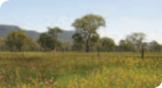

Grassy woodlands and natural grasslands are generally types of native vegetation where native grasses are a dominant* or common feature on the ground. They may be very rich in other herbs* that grow between the grass tussocks* and often appear as wildflowers in spring. The main difference between natural grasslands and grassy woodlands is the presence of a tree canopy. Trees are naturally absent or sparse in natural grasslands. A tree canopy, however, is typically evident in grassy woodlands.
At some woodland sites, the trees have been cleared but the native understorey* retained, giving the superficial appearance of a grassland. These sites are known as
‘derived’ or ‘secondary’ grasslands.
What are the Natural Temperate Grassland and the Grassy Eucalypt Woodland of the
Victorian Volcanic Plain?

The Natural Temperate Grassland and the
Grassy Eucalypt Woodland of the VVP are two critically endangered ecological communities listed separately under
the EPBC Act. Both of these ecological communities are associated with the Victorian Volcanic Plain (VVP) bioregion*, stretching from Melbourne to the Hamilton district. The boundary of the VVP bioregion is shown in the map on page 17 .

The Natural Temperate Grassland and Grassy Eucalypt Woodland were the most common vegetation types across the VVP. At many sites, the grassland and woodland intergraded to form a mosaic of open grassy vegetation with variable tree canopy cover.

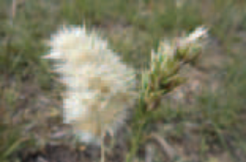

Austrodanthonia spp. (wallaby-grass)

The Natural Temperate Grassland is usually dominated by one or more of the following native tussock-forming grasses: kangaroo grass (Themeda triandra), wallaby grasses (Austrodanthonia spp.), spear grasses (Austrostipa spp.) and/or tussock grasses (Poa spp.). A variety of native herbs, including wildflowers, may be interspersed amongst the native grass
tussocks. In some circumstances, the native grasses may be sparse and the other native herbs are dominant, for instance after some fire regimes, and so these native herb fields are included as part of the national ecological community. As noted above, trees and large woody shrubs are absent to sparse.

The Grassy Eucalypt Woodland is an open eucalypt woodland with a tree canopy typically dominated by river red gum (Eucalyptus camaldulensis). In this ecological community, the river red gums occur outside of river or floodplain contexts where they are usually found. Other eucalypt species may become prominent on wetter or higher rainfall sites for instance swamp gum (E. ovata)
or manna gum (E. viminalis), or on drier sites in rain shadows, for instance grey box (E. microcarpa) or yellow box (E. melliodora). The understorey comprises a sparse shrub
layer and a ground layer similar to that found in the grassland. Additionally in the woodland, weeping grass (Microlaena stipoides)
may occur, and one or more of these wildflowers are usually present: sheep’s burrs (Acaena spp.), chocolate or vanilla lilies (Arthropodium spp.), beauty heads (Calocephalus spp.), common everlastings
(Chrysocephalum spp.), flax lilies (Dianella spp.),
kidney weeds (Dichondra spp.), crane’s bills (Geranium spp.), scaly buttons (Leptorhynchos spp.) or solenogynes (Solenogyne spp.).

The Grey Box (Eucalyptus microcarpa) Grassy Woodlands and Derived Native Grasslands of South-eastern Australia is also protected by national environmental law as an endangered ecological community. It is briefly covered here for comparison. It mostly occurs further north, from central NSW, through northern/central Victoria into eastern South Australia. Rare, small occurrences extend into the drier parts of the Victorian Volcanic Plain. The Grey Box Woodland is an open woodland with a tree canopy dominated or co-dominated by Grey Box (E. microcarpa) over an open to sparse ground layer of grasses and herbs. It can be distinguished from the Grassy Eucalypt Woodlands of the VVP by a combination of features:
• It occurs at drier sites.

• The understorey is more open to sparse.
Spear and wallaby grasses and chenopod shrubs and herbs are more evident than kangaroo, tussock or weeping grasses.
• The canopy often has Buloke
(Allocasuarina luehmannii) and Yellow Gum (Eucalyptus leucoxylon), in asociation with the dominant Grey Box. These tree species do not occur in Grassy Eucalypt Woodlands.

Snapshot summaries of these three ecological communities are presented on pages 10–15.

KEY POINTS

• The Natural Temperate Grassland and the Grassy Eucalypt Woodland of the VVP are endemic to south-western Victoria, primarily on the Victorian Volcanic Plain west of Melbourne.
• These ecological communities are closely related and often intergrade. They share a similar grass and herb ground vegetation but differ with respect to the presence
of woody vegetation. Trees are naturally absent to sparse in the grassland. A tree canopy is, or was formerly, evident in the woodland. The woodland ecological community includes a derived grassland form where the tree canopy has been removed but the native understorey remains.
• Grasslands and grassy woodlands were formerly extensive across the plain.
Less than five per cent now remains, mostly as small and highly fragmented remnants.

• Many patches are found on private land with some patches on public sites such as roadsides, rail reserves and cemeteries.
• Both the grassland and grassy woodland provide vital support to a diverse range of native plants and animals that are important for maintaining regional, state and national biodiversity.
• Putting in place favourable land use and management practices is essential at sites containing grasslands and grassy woodlands.

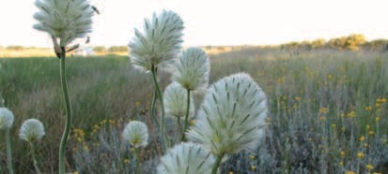

Ptilotus macrocephalus (feather heads)

Snapshot: Natural Temperate Grassland of the Victorian
Volcanic Plain

A critically endangered national ecological community.

What’s it look like?

10
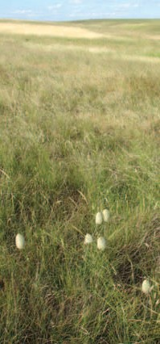

Typical natural grassland dominated by native perennial tussock grasses.

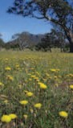

Trees and large shrubs are naturally absent
or sparse. They make up no more than 5% crown cover.

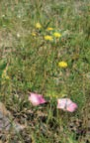

Many wildflowers may occur amongst the grass tussocks. They usually flower in spring and may become dominant under some management regimes.

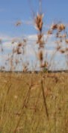

The grassland is usually dominated by one or more of these native grasses: kangaroo grass (Themeda), spear grasses (Austrostipa),
or wallaby grasses
(Austrodanthonia).

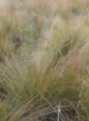

Some drainage lines may be dominated
by large tussocks of
Poa labillardierei.

Where do I find it?

• Restricted to south-western Victoria, between western Melbourne and the Hamilton region.

• Known from these Victorian bioregions: mostly the Victorian Volcanic Plain; pockets in
adjacent bioregions, e.g. Otway Plain, Dundas Tablelands and Central Victorian Uplands.
• Occupies flat to undulating plains with occasional stony rises. The soils are cracking clays
generally derived from Quaternary basalt.
• Some patches are found along roadsides, rail reserves and cemeteries. Patches also occur on private land.
• Good examples can be seen at Craigieburn Reserve, Laverton North Grassland Reserve and Mortlake Common Flora Reserve.

What else is it known as?

Corresponds closest to these Ecological Vegetation Classes (EVCs) in the Victorian bioregions noted:

• 132 Plains Grassland
• 654 Creekline Tussock Grassland
• 897 Plains Grassland/Plains Grassy Woodland Mosaic.
Corresponds to the threatened community listed under Victoria’s FFG Act as the
“Western (Basalt) Plains Grassland Community”.
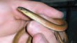

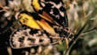

Why it’s important to protect it:

• The Victorian Volcanic Plain is one of Australia’s national biodiversity hotspots
• The grassland was formerly widespread across the plain but is now reduced to mostly small and degraded fragments
• Less than five per cent of the grassland remains
• It continues to be threatened by clearing, inappropriate management, and weeds
• It’s essential to apply the right land use and management practices to maintain and restore this community
• It provides habitat for many threatened species, such as the small golden moths orchid, and the striped legless lizard
• Its future protection will provide vital support for native biodiversity and ecosystem services in the region.

Delma impar
(striped legless lizard)

Synemon plana
(golden sun moth)

Snapshot: Grassy Eucalypt Woodland of the
Victorian Volcanic Plain

A critically endangered national ecological community.

What’s it look like?

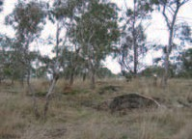

Typically an open woodland with gum trees over
grasses and wildflowers.

Typically has:

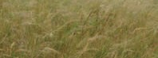

A native ground layer dominated by kangaroo grass (Themeda), spear grass (Austrostipa), wallaby grass (Austrodanthonia), poa tussock grass (Poa) or weeping grass (Microlaena).

These variations may occur:

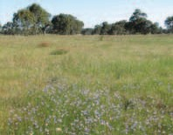

Patches of derived native grassland where woodland was once present but the trees were cleared.
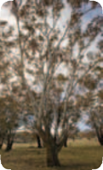

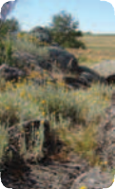

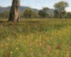

12

A range of wildflowers occurs amongst the grass tussocks in spring.

The tree canopy is typically dominated by river red gum (Eucalyptus camaldulensis).
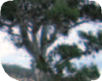

River red gum may be replaced by
swamp gum (E. ovata)
and manna gum
(E. viminalis) in wetter areas, or yellow box (E. melliodora) and
grey box (E. microcarpa)
in drier areas.
Stony knolls within the woodland may have localised pockets of shrubland or
non-eucalypt woodland.

Where do I find it?

• Restricted to south-western Victoria, between Melbourne and the Hamilton region
• Limited to the Victorian Volcanic Plain bioregion
• Occupies flat to undulating plains with occasional stony rises
• Limited to soils associated with Quaternary basalt
• Some patches are found along roadsides and rail reserves. Some patches occur on private land
• Good examples can be seen around the Darebin Creek, Epping and South Morang
regions north of Melbourne.

What else is it known as?

Corresponds closest to these EVCs in the VVP bioregion:

• 55 Plains Grassy Woodland
• 651 Plains Swampy Woodland
• 649 Stony Knoll Shrubland – pockets within or next to the woodland
• 897 Plains Grassland/Plains Grassy Woodland Mosaic.
Corresponds in part to the threatened community listed under Victoria’s FFG Act as “Floristic Community 55–04 Western Basalt Plains (River Red Gum) Grassy Woodland Community”. Also includes elements of the FFG-listed “Victorian temperate-woodland bird community”.

Why it’s important to protect it:

• The Victorian Volcanic Plain is one of Australia’s national biodiversity hotspots
• The woodland was formerly widespread across the plain but is now reduced to mostly small and degraded fragments
• Less than five per cent of the woodland remains
• It continues to be threatened by clearing, inappropriate management, and weeds
• It’s essential to apply the right land use and management practices to maintain and restore this community
• It provides habitat for many threatened species, such as the matted flax lily, and the
striped legless lizard
• Its future protection will provide vital support for native biodiversity and ecosystem services in the region.

Snapshot: Grey Box (Eucalyptus microcarpa) Grassy Woodlands and Derived Native Grasslands of South-eastern Australia

An endangered national ecological community.

What’s it look like?

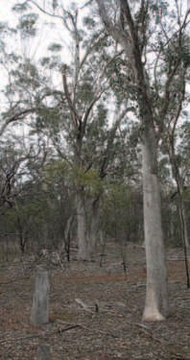

Typically an open woodland with grey box over a dry understorey, mostly of grasses and other herbs.

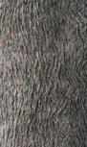

The tree canopy is dominated by grey box (Eucalyptus microcarpa).

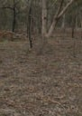

The native understorey is variable, ranging from almost bare to grassy to herb-rich. Taller shrubs may be present to 30% crown cover.

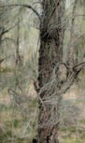

Other trees present may include buloke (Allocasuarina luehmanni) and yellow gum
(E. leucoxylon).

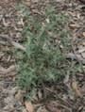

Chenopods
(e.g. saltbushes, bluebushes) are a characteristic feature of the ground layer.

14
Patches of derived native grassland, where woodland was once present but only the trees have been cleared, are included in the listed ecological community.

Where do I find it?

• This ecological community is widespread, from central NSW through Victoria, into eastern South Australia.
• Its occurrence in the Victorian Volcanic Plain bioregion represents a rare intrusion
of the ecological community south of the Great Dividing Range.
• Its presence in the VVP bioregion is restricted to the driest, rainshadow sites around western Melbourne to Melton and in the northern part of the bioregion.
• Examples can be found around Eynesbury and Tullamarine Airport, west of Melbourne.

What else is it known as?
Corresponds closest to this EVC in the VVP bioregion: 803 Plains Woodland. Corresponds in part to the threatened community listed under Victoria’s FFG Act as
“Grey Box–Buloke Grassy Woodland Community.”

Also includes elements of the FFG-listed “Victorian temperate-woodland bird community.”

Why it’s important to protect it:

• The Victorian Volcanic Plain is one of Australia’s national bodiversity hotspots
• This woodland has a very limited distribution within this bioregion
• It is threatened by clearing, inappropriate management, and weeds
• It’s essential to apply the right land use and management practices to maintain and restore this community
• It provides habitat for several threatened species
• Its future protection will provide vital support for native biodiversity and ecosystem services in the region
• Further details about this ecological ecommunity are available from the Department of
Sustainability, Environment, Water, Population and Communities.

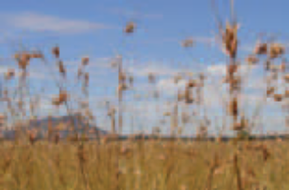

Kangaroo grass at Dunkeld.

WHERE ARE THESE ECOLOGICAL COMMUNITIES FOUND?

The map on page 17 indicates the area within which the Natural Temperate Grassland and Grassy Eucalypt Woodland ecological communities occur. However the distribution cannot be shown accurately
on a map of this scale, because the region has not been entirely surveyed in detail
and many remnants are now limited to very small, fragmented patches. To determine the presence of a patch of one of the listed ecological communities, please refer to
the decision flowchart on page 23 of this publication, and the listing advice for each of the ecological communities available at:
www.environment.gov.au/cgi-bin/sprat/public/
publiclookupcommunities.pl

The Victorian Volcanic Plain (VVP) is recognised as one of Australia’s 15 national biodiversity hotspots. It is a large, flat to undulating plain punctuated by scattered volcanic cones and stony rises. The soils are derived from Quaternary* basalt and
are highly fertile. It is also one of the most heavily cleared bioregions in Australia as the highly fertile basalt soils, and open nature of the vegetation, were favourable for intensive grazing and cropping.
The Grassy Eucalypt Woodland is limited to quaternary basalt substrates and therefore, its distribution is restricted to the Victorian Volcanic Plain bioregion. Rocky outcrops and stony rises within patches of woodland are included as part of the national ecological community.

The Natural Temperate Grassland occurs mostly within the VVP bioregion* but small occurrences extend into adjacent bioregions on the Otway Plain, Central Victorian Uplands and Dundas Tablelands. The grassland is typically found on cracking clays but is not limited to the Quaternary basalt soils which comprise much of the plain.

Both ecological communities occur within the catchment management authority or natural resource management (NRM) regions of:
Port Philip and Westernport, Corangamite, and Glenelg-Hopkins. Small areas may also be found in the Wimmera and North Central NRM regions.

142° E
143° E
144° E
145° E

Legend

Area of the Natural Temperate Grassland and Grassy
Eucalypt Woodland of the Victorian Volcanic Plain

Major roads
Natural Temperate Grassland and Grassy Eucalypt Woodland Ecological Community - May occur
IBRA Boundary
Victorian Volcanic Plain bioregion

ARCHDALE

EDDINGTON
37° S

BALMORAL

THE GRAMPIANS
STAWELL

GREAT WESTERN DUNNEWORTHY
MARYBOROUGH

CASTLEMAINE

BROADFORD

This is an indicative map only and it is not intended for fine scale assessment
37° S

ARARAT
KOOROOCHEANG DENVER
DAYLESFORD
LANCEFIELD
KILMORE

WANNON

BEAUFORT

MACEDON

UPPER PLENTY

CASTERTON

FERNBANK
38° S

WANNON

BRANXHOLME

CAVENDISH

HAMILTON

DUNKELD

PENSHURST

WILLAURA

LAKE BOLAC

MORTLAKE

DERRINALLUM
38° S

BALLARAT

BACCHUS MARSH

ROCKBANK
WHITTLESEA CRAIGIEBURN
DOREEN

FOOTSCRAY

Source:
The Natural Temperate Grassland 'May Occur' polygon loosely follows the Victorian Volcanic Plain bioregion and its associated soil types. The occurance also incorporates some of the adjacent sub-bioregions that are adjacent to the Victorian Volcanic Plain: SCP2 Otway Plain; VM2 Central Victorian Uplands; and VM4 Dundas Tablelands.
The Grassy Eucalypt Woodland of the Victorian Volcanic Plain
'May occur': the boundary is based on and follows a generalised boundary of the Victorian Volcanic Plain IBRA sub-bioregion and Quaternary basalt soil.
The 'Natural Temperate Grassland and Grassy Eucalypt Woodland Ecological Community - May occur' polygon resulted from merging Natural Temperate Grassland 'May Occur' polygon with the Grassy Eucalypt Woodland of the Victorian

HEYWOOD
MONTROSE
GEELONG
Volcanic Plain 'May occur' polygon to provide an outermost boundary representing both ecological communities.

PORTLAND

KIRKSTALL PORT FAIRY

CUDGEE WARRNAMBOOL

TERANG

CURDIE

CAMPERDOWN

BUNGADOR

COLAC

WINCHELSEA GHERANG

TORQUAY
The ecological communities distribution map is also based on input from an expert workshops and public consultation.
Interim Biogeographic Regionalisation for Australia (IBRA) Bioregions, contributed by State/Territory nature and conservation agencies, DEWHA IBRA dataset version 6.1,
2004.
Localities 1:250,000 © Commonwealth of Australia, Geoscience Australia, 2006.
Roads 1:5,000,000 © Commonwealth of Australia, Geoscience
Australia, 2004.
Coastline 1:250,000 © Commonwealth of Australia Geoscience
Australia, 2006.

This map has been compiled from landscape scale datasets. Site verification is required for site based projects. Planning or investment decisions at the site-scale should use some form of ground-truthing.
39° S

Each of these ecological communities is highly fragmented and estimated to have reducted by more than 95% of its pre-European extent.
Caveat:
The information presented in this map has been provided by a range of groups and agencies. While every effort has been made to ensure accuracy and completeness, no guarantee is given, nor responsibility taken by the Commonwealth for errors or omissions, and the Commonwealth does not accept responsibility in respect of any information or advice given in relation to, or as a consequence of,anything containing herein. The map has been collated from a range of sources, with data at various resolutions. Data used are assumed to be correct as received from the data suppliers.
39° S

142° E
143° E
144° E
145° E

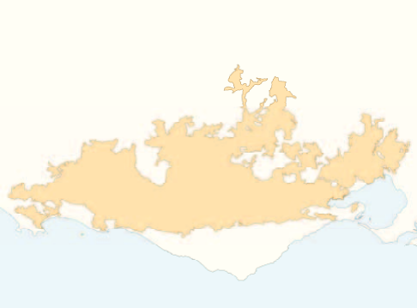

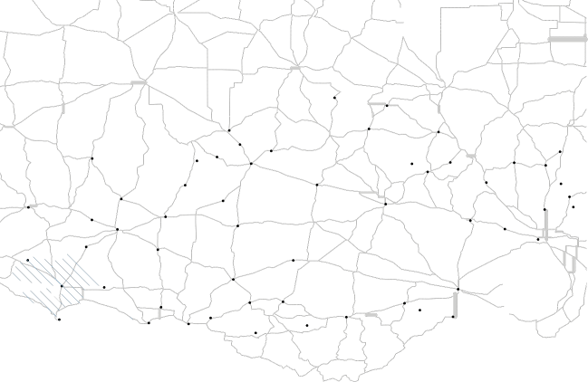

17
1:1,400,000
Projection: Geographic
Datum: GDA 1994

0 10

20 40 60 80
Kilometers
Produced by:
ERIN (Environmental Resource Information Network) Australian Government
Department of the Environment, Water, Heritage and the Arts
Oct 2009
COPYRIGHT Commonwealth of Australia, 2009

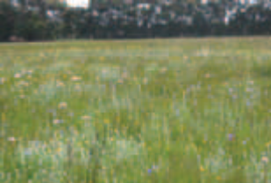
Woorndoo Common

Examples of key remnants of the listed ecological communities

Most areas of the Natural Temperate
Grassland and Grassy Eucalypt Woodland
of the VVP are now disturbed and degraded and generally restricted to small and fragmented remnants. Some better quality remnants of both ecological communities may persist along roadside verges, railway embankments and cemeteries. Very little is given long-term protection in conservation reserves. Remnants may also persist on private lands, for instance back paddocks that have not been cleared or are managed in a way that maintains these ecological communities. Supportive farming practices have allowed remnants of these ecological communities to persist in a reasonable condition.

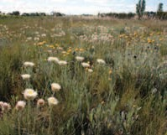

Glenelg Highway between Glenthompson and Wickliffe
Wildflowers in early spring.
Good quality examples of these ecological communities can be found at these sites.

For Natural Temperate Grassland of the VVP:
• Cairnlea Grasslands and associated grasslands along Kororoit Creek
• Cemeteries at: Rokewood, Truganina,
Bannockburn and Dowling Forest

• Cobra Killuc Wildlife Reserve – Blacks Creek Ridge Paddock
• Cooper St Grassland

• Craigieburn Grassland Reserve

• Cressy Flora Reserve

• Derrimut Grassland Reserve

• Evans St Grassland

• Hamilton Community Parklands

• Laverton North Grassland Reserve

• Mt Mercer Nature Conservation Reserve

• Mortlake Common Flora Reserve

• Rokewood Common

• Rail reserves, e.g. Bannockburn,
Middle Creek, Wingeel, Little River, Manor

• Roadside remnants, e.g. Cressy-Shelford
Road, Shelford-Mt Mercer Road,
Forrest Lane, Glenelg Highway between Glenthompson and Wickliffe, Chatsworth, Dundonnell, Woorndoo, Mt Mercer, Wickliffe-Ararat, Poorneit, McCorkells
• Skipton Common

• West Point Business Park
(former Laverton RAAF).

For Grassy Eucalypt Woodland of the VVP:
• Bald Hill (Merri Creek)

• Darebin Creek – Epping to Wollert

• Dunkeld Arboretum – Dunkeld

• Fenwick and Surrounds

• Silver Gum Park, Woodstock

• Summerhill Road, Wollert.

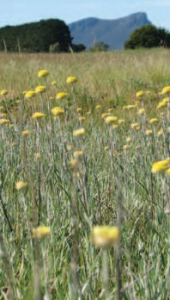

Dunkeld
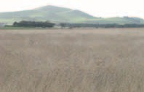

Mortlake Common

How do I know if I am standing on a patch of the listed ecological communities?

This section is designed to help you determine if a patch of native vegetation could be part of the listed Natural Temperate Grassland or Grassy Eucalypt Woodland
of the VVP. The Description and Condition thresholds of an ecological community in the EPBC Act listing advice provide the
definitive source of information for identifying nationally threatened ecological communities. Information from the listing advices (available at www.environment.gov.au/cgi-bin/sprat/public/ publiclookupcommunities.pl) is summarised and further explained in the following pages.

A patch* of a listed ecological community is defined as a discrete and uniform area that comprises the ecological community. It does not include substantial elements
of other ecological communities, such as woodlands dominated by other tree species

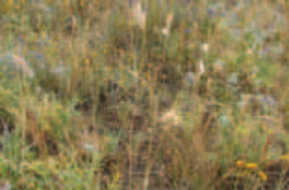
Grassland at Cressy Road.

and other types of grasslands. However, a patch of a listed ecological community may include small-scale disturbances, such as tracks or breaks, that do not alter
its overall functionality, for instance the easy movement of wildlife or dispersal of plant spores and seeds, and may also include small-scale variations in vegetation that
are noted in the description. The grassy woodland, for instance, includes small areas of non-eucalypt woodland associated with localised stony knolls and rocky outcrops.

How do I distinguish Natural Temperate Grassland of the VVP from Grassy Eucalypt Woodland of the VVP?

The Natural Temperate Grasslands and Grassy Eucalypt Woodland may intergrade with each other to form a mosaic of grassland and woodland across the landscape. The assemblage of species that characterises the grassland often occurs as an understorey component in adjacent
woodland. These intergradations can happen over relatively small distances and may be subject to site characteristics, for example drainage patterns of cold air or water.

Both of these ecological communities have
a ground layer dominated by native grasses, and/or native herbs and wildflowers. A key difference is that the grassland has few or
no trees, whereas the woodland has a tree canopy typically dominated by river red gums (Eucalyptus camaldulensis). The Key species
on page 25 illustrate commonly occurrring plant species in the grassland and woodland. The decision flowchart on pages 22–23 is designed to help identify whether a patch
of listed grassland or woodland is present on a property. Information in the flowchart is drawn from the description and condition thresholds found in the listing advice for each of the ecological communities.

Contra-indicative species for the
Grassy Eucalypt Woodland

Contra-indicative species are here defined as species that may be present in a locality but their dominant occurrence clearly indicates that the Grassy Eucalypt Woodland of the VVP ecological community is NOT present i.e. if the species below are dominant, you do not have the listed ecological community.

Contra-indicative species are:

• Allocasuarina luehmannii (buloke)

• Chenopod shrub layer

• Eragrostis infecunda (cane grass)

• Eucalyptus leucoxylon (yellow gum)

• Muehlenbeckia florulenta (lignum).

These species have affinities with wetland or more semi-arid vegetation communities than with temperate grassy woodlands.

Arthropodium sp. (chocolate lily)

Condition thresholds
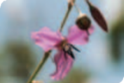

Condition thresholds were established when each ecological community was listed to determine which patches of grassland and woodland should receive full protection as a matter of national environmental significance under the EPBC Act. The decision flowchart on page 22 presents the description and condition thresholds in a way that can be used on site to assess a patch of native vegetation and determine if it is part of the listed grassland or woodland community.

The condition thresholds are intended to focus protection on vegetation remnants that are most functional and in relatively good to excellent condition.

For more information about management of patches and funding available to restore degraded patches please refer to the section Managing threats and priority conservation actions on page 42.

Other considerations to help with assessment

Variability in species composition

The ecological community’s appearance can vary seasonally. This is because many native wildflowers are more visible when flowering during spring. Some wildflowers may not appear every year and may stay dormant, for instance during dry seasons. Some species are sensitive to particular disturbance regimes and may decline or
disappear from disturbed sites. For example, highly palatable or grazing-sensitive native species may disappear from sites that have been intensively or repeatedly grazed.

For these reasons, unless exceptional circumstances apply, native plant species diversity must be assessed during spring (September to November) and after the site has not been disturbed (for example, by fire, overgrazing, mowing) for at least two months before the springtime of sampling, to optimise the biodiversity assessment of a site. However, most features, such as vegetation structure, minimum patch size and perennial* ground layer vegetation cover can be assessed all year round.

Derived grasslands

Derived, or secondary (human-induced), grasslands occur through the removal of woodland trees from grassy woodland communities. For this reason they can
be similar in vegetation composition and structure to natural grasslands, and it is difficult to distinguish the difference between natural grasslands and derived grasslands. Derived grasslands can be extremely rich
in native species and contain numerous threatened species, and are included in the listed grassy woodland ecological community where the description and condition thresholds are met. Information about how
to determine if a derived grassland may be present is given in footnote 1 on page 35.

Flow chart to identify the Grassy Eucalypt Woodland and/or Natural Temperate
Grassland ecological communities of the Victorian Volcanic Plain.

The considerations on pages 21 and 24 need to be taken into account when doing an on-site inspection.

STEP 1: Is the Natural Temperate Grassland or Grassy Eucalypt Woodland ecological community present at my site?

Does the patch occur within or near the Victorian
Volcanic Plain as shown on the map at page 17?1

YES

Is the site dominated by native vegetation i.e. a native vegetation remnant? IF uncertain proceed to YES

YES
NO. Outside the known, natural distribution of the national listed ecological community. Not the national ecological community

NO. Not the national ecological community – modified significantly by exotic pasture, plantings or weeds.

Are trees absent or sparse such that the projective
foliage cover of native trees in the patch is 5% or less?2

Are trees present such that the projective foliage
cover of native trees is more than 5%?
NO

YES YES

Is the ground vegetation layer dominated by native grasses and/or other native herbs?

Is the tree canopy generally dominated by River Red Gum (Eucalyptus camaldulensis) or associated eucalypts?3

YES

YES. The grassland ecological community is present. Go to Step 2.

NO. Not the national ecological community.

Is the ground vegetation layer dominated by native grasses, native forbs, other herbs, seasonal geophytes*

YES. The grassy woodland ecological community is present.5 Go to Step 2.
or small native shrubs?4

STEP 2: Is the patch of sufficient quality for national listing?

The grassland ecological community is present.
The grassy woodland EC is present.5

Is the patch bigger than or equal to
0.05 hectares (e.g. 10 x 50m OR 20 x 25m)?
NO. The patch is too small.
Is the patch bigger than or equal to
0.5 hectares (e.g. 100m x 50m)?

YES YES

The dominant4 native species represent at least 50% of
the native species and the perennial tussock cover; OR non-grass weeds comprise
less than 30% of ground cover;

NO. The patch has too few native species.

Does 50% or more of perennial ground layer vegetation comprise native species?4 OR are there more than ten native perennial species AND at least three big trees per hectare6?

OR native forbs (wildflowers)
comprise at least 50% of total vegetation cover during spring – summer.

YES. The patch of the ecological community is of sufficient quality to consider EPBC protection. See What does the listing mean for approval authorities or land managers? on page 40.

Notes for the flowchart:

1. Note that the although the Grassy Eucalypt Woodland is confined to the VVP bioregion only, the Natural Temperate Grasslands may also occur in areas adjacent to the VVP Bioregion (see map on page 17).

2. Where present, the scattered trees in the grassland form of the ecological community may include occasional occurrences of regenerating eucalypts. Note that a lower canopy cover limit of 0% applies for patches of derived grassland.

3. Dominated by river red gums means that
this species, including hybrids, comprises
50% or more of the canopy trees present. The tree canopy cover usually falls between
5–30% of the overall site, although a lower limit of 0% canopy cover applies for the derived grassland state.

The mid layer typically includes wattles, notably Acacia paradoxa (hedge wattle). On sites with higher rainfall, other eucalypt and wattle species may replace river red gum as the dominant species in the tree canopy. Higher rainfall (>700mm/year) species may
include E. ovata (swamp gum) or E. viminalis (manna gum), mid layer canopy occurrences of Leptospermum continentale (prickly tea-tree), Melaleuca gibbosa (slender honey myrtle)
or Ozothamnus ferrugineus (tree everlasting), and ground layer presence of sedges and other herbs. Lower rainfall (<600mm/year) eucalypts may include E. microcarpa
(grey box) and E. melliodora (yellow box).

4 Dominated means that a minimum of
50% of the ground layer cover comprising native grasses and/or other herbs.
The dominant grass genus is typically Themeda (kangaroo grass), but other genera may include Austrodanthonia (wallaby grass), Austrostipa (spear grass), Poa (tussock grass) and/or Microlaena (weeping grass). Herbs are typically
of the native daisy (Asteraceae), lily (Anthericaceae, Asphodelaceae, Phormiaceae) or orchid (Orchidaceae) families, and occupy spaces among native grass tussocks. See Key Species for examples of these plants. The ground layer cover excludes mosses, lichens,
litter or bare ground, but it may also include small shrubs in the woodland community.

Note that a well-developed shrub layer in the understorey is not a typical feature of either ecological community, and shrubs usually account for less than 10% of
the understorey vegetation. However, native shrubs may invade the ecological community due to natural processes or disturbance. Under these circumstances, the projective foliage cover* of native shrubs in the ecological community may be up to 50% of the total area. Note that the site may also contain up to 70% regenerating trees less than 5 metres tall and still constitute the grassy woodland ecological community.

5 Low stony or rocky rises, known as stony knolls, may be present in the grassy woodland and are included in this ecological community.

6 Big trees defined as having minimum 70cm diameter at breast height (dbh*) for eucalypts and minimum 40cm dbh for non-eucalypts.

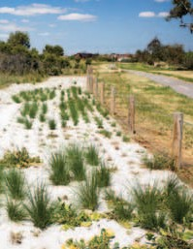

Native grasses being planted in Natural Temperate
Grassland.

Natural Regeneration and
Restoration Works

Areas that have been disturbed and are regenerating, or have been planted out using appropriate native species, but that still meet the key diagnostic characteristic and condition thresholds also qualify as the ecological communities protected under the EPBC Act. These sites are important for the recovery of the ecological communities.

Surrounding environmental and landscape context

It is important to consider the landscape context surrounding a patch of the ecological community. These landscape considerations
help to determine if the patch has additional conservation value, and include:
• Connectivity to other native vegetation remnants or restoration works (e.g. native plantings). In particular, if a patch has an important position between (or linking) other patches (or other native vegetation remnants) in the landscape.
• Patches that occur in those areas in which the ecological community has been most heavily cleared and degraded or are at the natural edge of its range.
• Large patch size and/or large area to boundary ratio. Such patches are less exposed and more resilient to edge effects disturbances such as weed invasion.
• Evidence that native species are recruiting or that a range of age cohorts are present. For instance, tree canopy species are present as saplings through to large old hollow-bearing trees.
• Good faunal habitat as indicated by the presence of trees with hollows, logs, natural rock outcrops, diversity of landscape.
• High diversity of native species within the patch.
• Areas of minimal weeds and feral animals, or where they can be easily managed
• Presence of mosses, lichens, soil
crust and leaf litter on the soil surface, indicating low disturbance and potential for good functional attributes such as nutrient cycling.

It is recommended a buffer zone is implemented to protect patches from edge effects and impacts from adjacent land uses such as herbicide spray drift.

KEY SPECIES

Key plants and animals

The following photos show some of the
key plant and animal species of the Natural Temperate Grassland and Grassy Eucalypt Woodland of the VVP. Many grassland plants and animals are likely to extend into at least some patches of grassy woodland
and vice-versa. The main difference between the natural grassland and grassy eucalypt woodland is a greater presence of trees. Consequently, the grassy woodland has an arboreal component of woodland mammals,
birds and other animals that is largely absent
in grassland. The grassy woodland is likely to support animals such as possums, bats, and parrots, which rely on trees and tree hollows for shelter and food.

A fuller discussion of key plants and animals, with longer species lists, can be found in the listing advice for each ecological community at: www.environment.gov.au/cgi-bin/sprat/ public/publiclookupcommunities.pl

Note that not all the native species mentioned will be present and other native species not mentioned may occur, at any given site.

Ground Layer Grasses

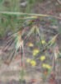

Themeda triandra
(kangaroo grass)

Austrodanthonia
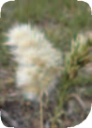

spp. (wallaby grass)

Austrostipa spp. (spear grass)
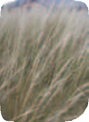

Poa labillardierei (river or common tussock grass)

Microlaena stipoides var. stipoides (weeping grass)
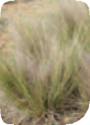

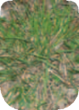

Ground Layer Wildflowers and Other herbs

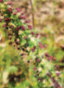

Acaena ovina
(Australian sheep’s burr)

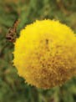

Craspedia glauca spp. agg. (common billy-buttons)

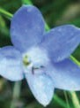

Wahlenbergia spp. (bluebell)

Acaena novae-zelandiae
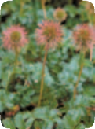

(bidgee widgee)

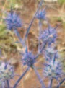

Eryngium ovinum
(blue devil)

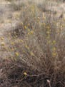

Calocephalus citreus
(lemon beauty heads)

Geranium spp. (crane’s bill)
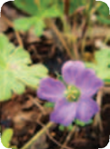

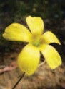

Oxalis perennans
(grassland wood-sorrel)

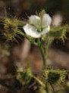

Drosera spp. (sundew)

Ptilotus macrocephalus
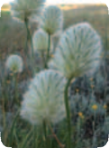

(feather heads)

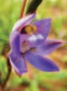

Thelymitra spp. (sun orchid)

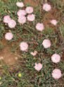

Convolvulus angustissimus (pink bindweed)

Shrub Layer

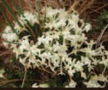

Pimelea humilis
(common rice flower)

Bursaria spinosa
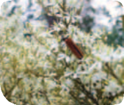

(sweet bursaria)

Leptospermum continentale
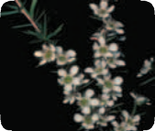

(prickly tea tree)

Tree Layer

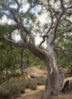

Eucalyptus camaldulensis
(river red gum)

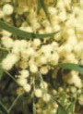

Acacia implexa
(lightwood)

Eucalyptus melliodora
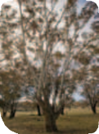

(yellow box)

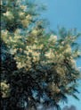

Acacia mearnsii
(black wattle)

Eucalyptus microcarpa
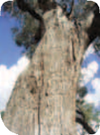

(grey box)

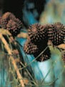

Allocasuarina verticillata
(drooping sheoak)

Eucalyptus ovata (swamp gum) – trunk and leaves.
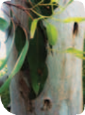

Threatened Species

Both the woodland and grassland ecological communities may provide habitat for at
least 12 animal species and more than 20 plant species that are listed as nationally
threatened under the EPBC Act.
The following pictures show some of the nationally threatened flora and fauna species of the Natural Temperate Grassland and Grassy Eucalypt Woodland. These species have been recorded in or near to the listed communities of the Victorian Volcanic Plain.

Mammals

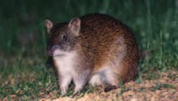

Isoodon obesulus obesulus (southern brown bandicoot) Endangered
Predominantly nocturnal. Once widespread throughout eastern Australia. Habitat fragmentation has reduced distribution. Relies on grassy areas for foraging and protection from predators.



Pteropus poliocephalus (grey-headed flying-fox)
Vulnerable
One of the world’s largest bats, identifiable by an orange/brown neck ‘collar’. Important in pollination and seed dispersal for various native trees.

Perameles gunnii subsp. unnamed (eastern barred bandicoot (mainland)) Endangered
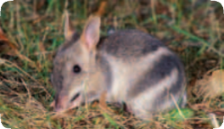

Once widespread in the VVP region, now known from only a few isolated sites due to habitat fragmentation and feral predators. Uses perennial tussock grasslands for foraging and nesting.

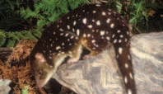

Dasyurus maculatus maculatus (SE mainland population) (spot-tailed quoll, spotted-tail quoll, tiger quoll) Endangered
A nocturnal, cat-sized, carnivorous marsupial with reddish-brown fur and distinctive white spots over its back and tail. Once widely distributed across eastern Australia, the mainland species range has reduced by up to 90%.

Birds

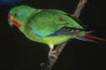

Pedionomus torquatus (plains-wanderer) Vulnerable
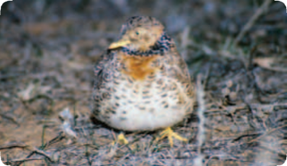

A nocturnal “quail like” bird found in grassy areas, it makes daytime resting spots in depressions in grasses. Grassland specialist using tussocks for
shelter. Known to eat grass seeds.

Lathamus discolor (swift parrot) Endangered
Mostly bright green, with dark-blue patches on the crown and a red face. It breeds only in Tasmania, and migrates to mainland Australia in autumn, undertaking the longest migration of any parrot species in the world.

Reptiles

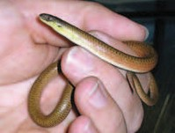

Delma impar
(striped legless lizard) Vulnerable
About 30cm total length. Grassland specialist, using tussocks and thick ground cover to shelter in.

Tympanocryptis pinguicolla (grassland earless dragon) Endangered
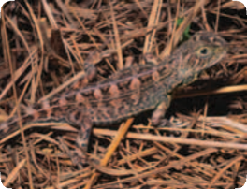

Up to 5cm long. Known from tussock grasslands on basalt soils, preferring sites with both taller tussock and shorter grasses.

Amphibians Insects

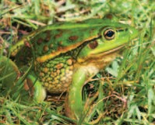

Litoria raniformis
(southern bell frog, growling grass frog, warty bell frog, green and golden frog)
Vulnerable
Large frog species (up to 104mm), known to use clay soil and grassland sites where dense emergent vegetation exists near permanent or ephemeral water sources.

Plants

Synemon plana (golden sun moth) Critically Endangered
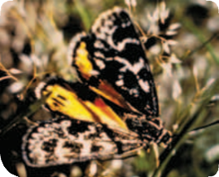

A day flying moth about 3cm wingspan. Once widespread through NSW, ACT, Vic and SA, now has a highly reduced and fragmented distribution and considered extinct in SA. Inhabits natural temperate grassland and grassy woodlands.

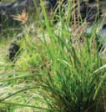

Carex tasmanica (curly sedge) Vulnerable
From Vic and Tas only. Usually associated with drainage lines or marshes.

Dianella amoena (matted flax-lily) Endangered
Mat-forming lily with flower spikes to 90cm tall. Some populations occur in urban areas.

Diuris basaltica
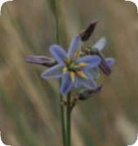

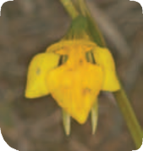

(small golden moths orchid; early golden moths) Endangered
Known only from Vic on basalt plains north and west of Melbourne. Flowering in September and October.

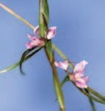

Diuris fragrantissima (sunshine diuris, white diuris, fragrant double-tails) Endangered
Only one known remaining population to the north of Melbourne. Flowering mid-October to early November. Pollination reliant on native bees.

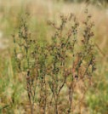

Lepidium aschersonii (spiny pepper-cress) Vulnerable
Thought to be extinct in NSW. Occurs in the south west of Vic but only a few known stands. Branched perennial herb to 30cm high.
Arises from underground rootstock and is only visible during the
spring – summer growth period.

Dodonaea procumbens (trailing hop-bush) Vulnerable
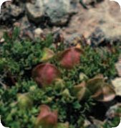

Known from southern NSW,
Vic and SA. Flowering November to
February and fruits may take up to
12 months to mature.

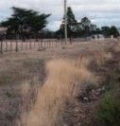

Lepidium hyssopifolium (basalt pepper-cress) Endangered
Vic distribution from only 3 areas in central Vic. Perennial herb to 50cm high flowering from December to February.

Glycine latrobeana
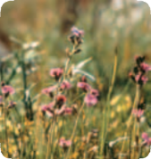

(clover glycine, purple clover) Vulnerable
Occurs in Tas, a single location in SA
and is spread throughout Vic but only
6 known viable populations. Grows mostly in grasslands and grassy woodlands, flowering in September to December.

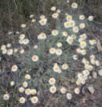

Leucochrysum albicans var. tricolor
(hoary sunray) Endangered
Known from NSW, ACT, Vic and Tas. Distribution for Vic is restricted to south-western Vic but was previously more widely spread. Mounding perennial straw daisy
to 30cm high, flowers in spring to
summer.

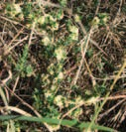

Pimelea spinescens subsp.
spinescens
(spiny rice-flower, plains rice-flower,
prickly pimelea) Critically Endangered
Endemic to south-western and north-central Vic. Stunted shrub
to 30cm, flowers in April to August. If present should be visible throughout the year.

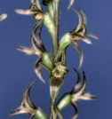

Prasophyllum suaveolens (fragrant leek-orchid) Endangered
Known only from western Vic. Slender orchid to 25cm,
flowering October and November.

Prasophyllum diversiflorum (gorae leek-orchid) Endangered
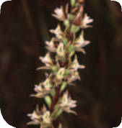

Endemic to south-western Vic, known from only a few sites. Orchid to 60cm high, flowering December to February.

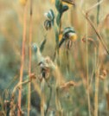

Pterostylis basaltica (basalt greenhood) Endangered
Endemic to central Vic from only a few populations. Flowering November to January.

Prasophyllum frenchii (maroon leek-orchid, slaty leek-orchid, stout leek-orchid, French’s leek-orchid) Endangered
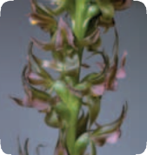

Distributed in Vic and far south-eastern SA. Seasonal perennial orchid to 60cm, flowering October to December.

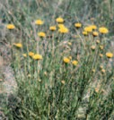

Rutidosis leptorrhynchoides (button wrinklewort) Endangered
Distributed in south-eastern NSW and ACT and south-western Vic, mostly in grasslands. Flowering October to January.

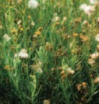

Senecio macrocarpus (large-fruit groundsel, large-fruit fireweed) Vulnerable
Occurs in south-eastern SA and south-western Vic. Shrub to 70cm,
flowering September to November.

Xerochrysum palustre (swamp everlasting) Vulnerable
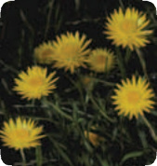

Occurs in southern Vic and a few sites in northern Tas. Perennial herb, flowering November to March
dying off in late summer.

Other nationally threatened species that may occur in the ecological community:

Eulamprus tympanum marnieae (Corangamite water skink)
Endangered
Up to 80mm length. Found in open grassy areas with basalt soils and rock mounds present; also found near water bodies.

Lachnagrostis adamsonii (Adamson’s blown grass) Endangered
Endemic to south-central and south-western Victoria. Tufted annual grass to 70cm high.

Poa sallacustris
(salt-lake tussock grass) Vulnerable
A grass endemic to south-western Victoria, where it occurs around the margins of salt lakes.

Senecio psilocarpus
(swamp fireweed,
smooth-fruited groundsel) Vulnerable
Occurs in south-eastern
SA and western Vic.

More information on these species may be found at the species profile and threats database
(SPRAT) available through the department’s website: www.environment.gov.au/biodiversity

The Victorian Government also produces Action Statements for species listed in Victoria, which covers many of the threatened species above. They are found through the Native Plants and Animals section of the Victorian Department of Sustainability and Environment (DSE)* website: www.dse.vic.gov.au. You should also refer to Action Statement 182, which covers
a number of grassland communities listed in Victoria, including the Western Basalt Plains
Basalt Grassland.

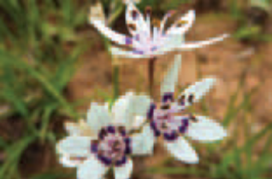

Wurmbea dioica (early nancy)

ARE THE LISTED COMMUNITIES KNOWN BY OTHER NAMES?

Vegetation may be identified in different ways among regions, states and territories, depending on the vegetation classification system and environmental legislation that are applied. The Natural Temperate Grassland and the Grassy Eucalypt Woodland of the VVP ecological communities relate to,
or may be known as other vegetation types.

The National Vegetation Information System (NVIS) is a hierarchical system for classifying vegetation across the Australian continent.
It ranges from broad Major Vegetation Groups and Subgroups to more fine-scale floristic sub-associations. The Natural Temperate Grassland and the Grassy Eucalypt Woodland of the VVP fall within two Major Vegetation Subgroups: temperate tussock grasslands and
Eucalyptus woodlands with a grassy understorey.

The Natural Temperate Grassland and Grassy Eucalypt Woodland correspond with two threatened communities listed under Victoria’s environmental legislation responsible for protecting threatened species and communities, the Flora and Fauna Guarantee Act 1988. All flora within a state-listed community is protected on public land and
cannot be removed or damaged without
a permit. Additional vegetation clearance controls apply under Victoria’s Native Vegetation Framework, which can extend a degree of protection to native vegetation remnants under private land tenure.

The threatened communities that correspond with the nationally-listed communities in Victoria are:
• Western (Basalt) Plains Grasslands Community which generally corresponds to the nationally-listed Natural Temperate Grassland
• Floristic Community 55–04 Western Basalt Plains (river red gum) Grassy Woodland, which corresponds, in part, to the nationally-listed Grassy Eucalypt Woodland. This state-listed community relates to a map unit limited to the Port Philip and Westernport region, in the immediate vicinity of Melbourne, and does not extend further across the rural part of the Victorian Volcanic Plain.

Victoria classifies its vegetation using a system of Ecological Vegetation Classes (EVCs). EVCs are broadly defined vegetation and landscape units that may encompass more than one floristic community. Victoria has established benchmarks for many EVCs to allow condition assessments to be made with respect to a reference patch of a particular vegetation type. Benchmarks are not a comprehensive description of an EVC but provide an accessible summary of its main features in each bioregion. The EVC system also includes complexes, mosaic and aggregate units for situations where specific EVCs cannot be identified at a site.

Table 1 Ecological Vegetation Classes that best correspond to the listed ecological communities. Relevant Victorian bioregions are noted under Where are these ecological communities found (page 16)

Natural Temperate Grassland | Grassy Eucalypt Woodland1
132 Plains Grassland | 55 Plains Grassy Woodland
654 Creekline Tussock Grassland | 649 Stony Knoll Shrubland2
 | 651 Plains Swampy Woodland
897 Plains Grassland/Plains Grassy Woodland2 | 897 Plains Grassland/Plains Grassy Woodland2

Note: The EVCs listed above correspond with the listing advice approved by the TSSC for the two ecological communities at the time of listing. Any reference to state units as equivalent to a national ecological community should be taken as indicative rather than definitive. A state unit that is generally equivalent may sometimes include elements that do not meet the description. Conversely, areas mapped or described as state units other than those referred to may sometimes meet the description. Judgement of whether an EPBC-protected ecological community is present at a particular site should focus on how an area meets the description and condition thresholds of the national ecological community.

1 Derived grasslands are only included in the Grassy Eucalypt Woodland where one or more of the main EVCs was confirmed to have been present on the site (e.g. by the presence of stumps, historical records and photos, the nature of surrounding native vegetation remnants, or from reliable modelling of pre-European vegetation) and has been cleared of trees and large shrubs.

2 Only part of the Ecological Vegetation Class that meets the description of the national ecological community is included in the listing. EVC 897 is a mosaic unit in which the precise vegetation type cannot be distinguished at the scale of mapping used. Ground-truthing is required to determine if a patch comprises grassland or grassy woodland. EVC 649 covers small and localised rocky outcrops and stony knolls within a patch of grassy
woodland where the typical eucalypt canopy may be replaced by a canopy of non-eucalypt species.

Similar ecological communities

The ground layer of the Grassy Eucalypt Woodland and the Natural Temperate Grassland are very similar in their native species composition, and can effectively be considered continuous in areas where the two ecological communities are adjacent or
intergrade. The derived grassland state of the Grassy Eucalypt Woodland of the Victorian Volcanic Plain, therefore, can resemble
the Natural Temperate Grassland of the Victorian Volcanic Plain. A distinction is only possible where there is clear evidence that indicates the original native vegetation at a site was temperate grassy woodland rather than treeless native grassland. The derived native grassland form of the Grassy Eucalypt Woodland is included as part of this
ecological community.
Other natural temperate grasslands also occur well outside the vicinity of the Victorian Volcanic Plain, for instance in the Victorian Riverina, Wimmera, Gippsland Plain and Monaro Tablelands (Victorian) bioregions. These are not included as part of the listed Natural Temperate Grassland of the Victorian Volcanic Plain ecological community as
they occur well outside the Quaternary basalt plain. Some of these other grasslands are listed in their own right as nationally threatened ecological communities and details of these are available from the SPRAT database on the department’s website.

Grassy woodlands with river red gum, yellow box or grey box extend onto the slopes and plains north of the Great Dividing Range.
The Grassy Eucalypt Woodland of the Victorian Volcanic Plain is distinguished from these occurrences by its limitation to soils

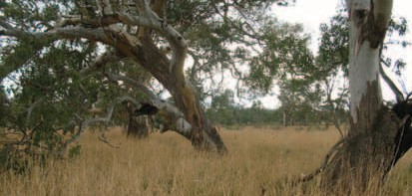

Grassy Woodland of the VVP.

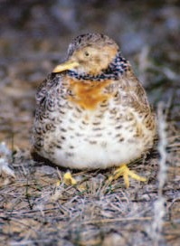

Pedionomus torquatus (plains wanderer)

derived from Quaternary basalt and to the plains and undulating slopes of the Victorian Volcanic Plain bioregion. The other woodlands in central and northern Victoria occur on a range of soil types but are not associated with a plain where soils are derived from Quaternary basalt. Some of these woodlands are threatened in their own right and are listed nationally as the White Box – Yellow Box – Blakely’s Red Gum Grassy Woodland and Derived Native Grassland, or the Grey Box (Eucalyptus microcarpa) Grassy Woodlands and Derived Native Grasslands
of South-eastern Australia.
Some other grassy woodlands and grassy communities occur on the
Victorian Volcanic Plain and may be similar to, intergrade with, or occur near to the nationally listed grassland and woodland ecological communities. These include:
• Grassy woodlands dominated by grey box with buloke or yellow gum occur on very dry sites in the north of the bioregion and as small patches north-west of Melbourne. These woodlands correlate with EVC
803 Plains Woodland and are not part of the listed Grassy Eucalypt Woodlands. They represent the southernmost intrusion of the grassy Grey Box woodlands that
are more typical and widely distributed inland of the Great Dividing Range and extend from central NSW through northern Victoria into South Australia. As noted above, this is listed as a separate national ecological community.
• Riparian systems and grassy wetlands characterised by ephemeral or permanent inundation of water are excluded from the listed ecological community. The flora
of these systems includes elements that are characteristic of inundated sites but absent from the Grassy Eucalypt Woodland of the Victorian Volcanic Plain, e.g. Amphibromus spp.
(Swamp Wallaby-grasses), Eleocharis spp. (Spike-sedges). They are classified as a series of separate EVCs (e.g. EVC 125, 292) to those that are associated with the ecological community.

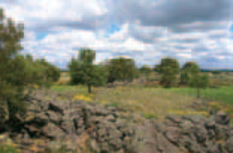

Tyrendarra Indigenous Protected Area.

INDIGENOUS HERITAGE

Aboriginal Language groups

Since long before European settlement, the Victorian Volcanic Plain was occupied by Aboriginal people from several language groups, including:
• Woiwurrung

• Boonwurrung

• Dja Dja Wurrung

• Gulidjan

• Djab Wurrung

• Djagurd Wurrung

• Keerraywoorroong

• Dhauwurd Wurrung

• Kee Woorroong

• Wirngilgnad dhalinanong

• Peek Woorroong

• Koornkopanoot

• Wooloo Woorroong

• Jardwadjali

Traditional Plant Use

Aboriginal people of the region used controlled burning methods to manage the ecology of grassy vegetation in the area.
Burning encouraged new vegetative growth that attracted kangaroos and wallabies to sites. Other traditional land management techniques were linked to harvesting of plants at different times of the year. Many plants were harvested and used by Aboriginal people for food, medicine and to make implements. Some plants were eaten raw, and others required cooking or special preparation before eating. Important plants that occur in the Victorian Volcanic Plain and an indication of traditional uses are noted in the table opposite.

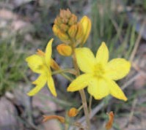

The Bulbine lily was another valuable food source and could be eaten year-round.

Dianella revoluta (flax lily)

Table 2 Plants traditionally used by local Aboriginal people of the
Victorian Volcanic Plain

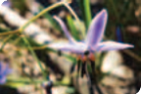

Indigenous Protected and
Heritage Areas

The Tyrendarra Indigenous Protected Area is located in the Victorian Volcanic Plain bioregion, on Darlot Creek, a tributary of Lake Condah near Portland. This 248 hectare area was declared in December 2003, and forms part of the Budj Bim National Heritage Landscape, which was one of the first places to be listed on Australia’s National Heritage List in July 2004. Recognised for its archaeological, cultural and environmental importance, the area is owned and managed by the Winda-Mara Aboriginal Corporation on behalf of the Gunditjmara people, for whom it holds particular significance. Please visit www.environment.gov.au/ indigenous/ipa/declared/tyrendarra.html

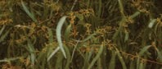
Species | Traditional Use
Yam daisy (Microseris spp.) | Tuber roots (food, seasonal)
Bulbine lily (Bulbine bulbosa) | Leaves (food, year round)
Black wattle (Acacia mearnsii) | Gum (drink & ‘cement’);  bark fibre (string, medicinal infusion)
Golden wattle (Acacia pycnantha) | Gum and bark as for Black Wattle
Manna gum (Eucalyptus viminalis) | Wood (spear-throwers and shields);  leaves (medicine for fever)
Blackwood (Acacia melanoxylon) | Wood (spear-throwers and shields); bark (medicine for rheumatism); bark fibres (string and fishing lines)
Spreading flax-lily (Dianella revoluta) | Leaves (string fibres)
Drooping sheoak (Allocasuarina verticillata) | Wood (boomerang); shoots and cones (food)
River red gum (Eucalyptus camaldulensis) | Wood (water containers); sap (medicine  for burns); leaves (medicine in steam baths)

Eucalyptus camaldulensis (river red gum) leaves were used medicinally in steam baths, and the sap was used to treat burns.

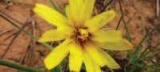

Once abundant throughout Victoria, the now scarce yam daisy was a valuable food source.

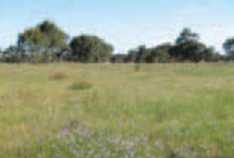
Grassland at Dunkeld.

WHAT DOES THE LISTING MEAN FOR APPROVAL AUTHORITIES OR LAND MANAGERS?

What does the EPBC Act listing of the ecological community mean for farmers, land managers or developers?

If you have a patch of Natural Temperate Grassland or Grassy Eucalypt Woodland on your property then adequate protection
and appropriate land management practices are vitally important if the listed ecological communities are to persist for the benefit
of future generations.

Appropriate management and restoration of patches that do not meet the condition thresholds (and thus do not qualify for
full protection under the EPBC Act)
is recommended, as these patches may still play an important ecological role, especially where they are providing valuable habitat or connectivity. For example: patches that link native vegetation remnants in the landscape are particularly important as wildlife habitat and to the viability of listed patches of the ecological communities.

The listing of Natural Temperate Grassland
and the Grassy Eucalypt Woodland under
the EPBC Act will not prevent land managers from continuing current land management practices or activities, providing that these practices or activities do not significantly change or intensify, or are unlawful.

Which activities might
require consideration?

National protection provided by the
EPBC Act means any new or intensified activities that may have a significant adverse impact on one or more of a listed ecological community should be referred
to the environment minister for assessment and approval.

Most day to day land use activities are not likely to have significant impacts or otherwise require consideration under the EPBC Act, however activities that are likely to require approval and should be referred include,
but are not restricted to:

• clearing patches of the ecological community (e.g. for new developments, roads or extensive fire breaks)
• development close to a particular site

• converting grazing land containing the ecological community to cropping

• heavy or blanket application of fertilisers or other chemicals
• significantly changing drainage and local
water patterns

• introducing potentially invasive exotic pasture species in or near to a patch of the ecological community
• significant and adverse changes in management regime (such as converting from mowing/slashing to herbicide use or substantially intensifying stocking rates).

On the other hand, activities that are unlikely to require approval include routine maintenance of buildings and properties, maintenance of existing firebreaks and routine weed management (with minimal or positive impacts on the ecological community).

Also note that even if a native vegetation remnant on your land does not meet the criteria for the listed ecological communities, there may be threatened plant or animal species within the remnant that are individually protected under the EPBC Act (see Threatened Species on page 28).

The process for making a referral under the EPBC Act can be done online. The EPBC Act allows for some exemptions to the requirement for assessment and approval. This means some activities may not need assessment or approval under certain situations. Generally, exemptions refer to existing permission to legally undertake an action or to routine actions that are carried out over a long time. However, failure to refer an action that is not exempt and likely to have
a significant impact on a listed ecological community may have legal consequences such as financial penalties or remediation orders.
If you are considering an activity that may have an impact on either of the ecological communities, you are encouraged to contact the department (1800 803 772) about your options. Further information is also available from the department’s website:

Exemptions: www.environment.gov.au/epbc/about/ exemptions.html

Referrals: www.environment.gov.au/epbc/assessments/ referral-form.html

Approvals:
www.environment.gov.au/epbc/approval.html

The department has also created a farmer fact sheet for the grasslands and woodlands of the Victorian Volcanic Plain to help landholders identify this community on their property, and decide whether any planned activity is likely to be significant and need a referral to the Minister. The fact sheet can be downloaded from www.environment.gov.au/ epbc/publications/pubs/grasslands-victoria- fact-sheet.pdf

You should also check with relevant authorities whether any state or local government approvals are required in addition to EPBC Act requirements. If you have a patch of either of the listed ecological communities on your property and would
like advice, then farmers can contact the department’s out posted Environment Liaison Officer at the National Farmers’ Federation (NFF) either by phone
(1800 704 520) or by email: environment@nff. org.au.

MANAGING THREATS AND PRIORITY CONSERVATION ACTIONS

The key threats faced by both the Natural Temperate Grassland and Grassland Eucalypt Woodland ecological communities are vegetation clearance, fragmentation of remnants, weed invasion, management actions that include the inappropriate use of fire, excessive mowing or grazing, and the broad-scale application of herbicides or fertilisers.

Survey work is encouraged to help identify more remnants of the grassland and woodland, to further assist in the protection of the listed communities. Monitoring to identify key threats as well as protecting known sites through the development of conservation agreements and covenants would also help to protect these communities.

Conservation advice has been prepared for both ecological communities, which is designed to provide management guidance for key threats and is available on SPRAT.
A number of additional publications offer more specific advice for the management of grasslands and woodlands on the Victorian Volcanic Plain. Both the SPRAT information and a range of additional publications
are listed in Where Can I Go For Further
Information? on page 46. The following table
summarises some of the key management issues associated with the Natural Temperate Grassland and Grassland Eucalypt
Woodland ecological communities. This list is not exhaustive. These suggestions are only a guide and some management actions may not necessarily apply to specific land management practices or sites.

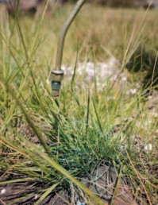

Spot spraying of Chilean needle grass.

Table 3 Key management issues associated with the Natural Temperate
Grassland and Grassy Eucalypt Woodland of the Victorian Volcanic Plain.

Action | Issues | Management
Survey & Monitoring | Understanding your site is essential to managing it. | Record what species occur in your patch. The best time to survey is spring or early summer – you can get help identifying species from your local NRM agency.  Use the information collected to develop a management plan for your site.  Keep records of actions taken and monitor regularly.
Grazing | Heavy grazing can remove palatable species reducing biodiversity, as well as compact the soil, decrease water uptake of plants and accelerate weed invasion. | Promoting native vegetation may lead to healthier soils and improved water retention in the long term. Prevent trampling and excessive grazing pressure at known sites. Develop strategic grazing regimes that minimise excess grazing to your site.
Fire | Fire is necessary for the maintenance of some grasslands and grassy woodlands especially those dominated  by kangaroo grass.  Dense grass can smother wildflowers, and result in  a loss of habitat for some native animals. | Get advice from your local NRM agency to develop strategic ecological fire regimes for your patch. Make sure any controlled burning is appropriately managed and undertake monitoring to ensure the burning program  has met management aims.
Soil  Disturbance | Soil disturbance can displace native animals and create opportunities for weeds to invade. It can also remove an important crust of algae, lichens or mosses that are important for soil health. | Avoid activities that result in excessive soil disturbance such as ploughing, earth works, vehicles and machinery, stockpiling,  rock removal etc in or near patches of the ecological communities.

Action | Issues | Management
Exotic plant invasion | Introduced plants compete with native plants for space, water and nutrients and may lead to pasture degradation. | Weed management is a priority to stopping degradation to remnant patches of the ecological communities. Weed cover can be variable according to the time of year, climate, recent and past management or disturbance history, and site conditions and weeds may require year-round attention. Some weeds have more impact on the health of grassy communities than others and should be prioritised for control (e.g. perennial weeds).
Herbicide application | Herbicides can kill native grassland plants and  can also injure grassland animals such as insects and frogs. | Take care that chemical applications don’t adversely affect the ecological communities. Use a combination of weed removal techniques, such as spot-spraying, hand removal and burning as designed in your management plan.
Fertiliser addition | Native grassland plants prefer low nutrient soils. The application of fertilisers can kill native plants and favour weed species. | Promoting native grassland on your property will save you applying fertiliser. When fertiliser use is required, ensure they are not used in or near the native grassland or grassy woodland.
Revegetation | Revegetation can include allowing natural regeneration of native species into new areas, planting of tube stock and sowing or direct seeding. | Revegetation may be appropriate to extend and buffer an ecological community on your site, or to manage any large weed patches that have been treated with herbicide.  Use only native local species appropriate to the ecological community at your site.

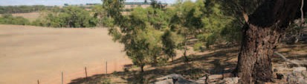

Edge of Grassy Woodland area showing protective fence from stock entry.

Is funding available to protect listed grassland and grassy woodland communities?

If you have either of the listed ecological communities on your property, you may be eligible for funding to help preserve
or restore remnants.

Patches that do not currently meet the condition thresholds may be eligible for funding to help restore them to good condition.

National funds

Funding through Caring for our Country may be available for activities that have environmental benefits. For more details visit www.nrm.gov.au or talk to a local Caring for our Country regional officer www.nrm.gov.au/contacts.

The National Reserve System (NRS) has an important role in protecting biodiversity values on private land in agricultural and pastoral regions. Building the NRS is one of the priorities under Caring for our Country. Interested organisations can apply for assistance from the Australian Government to help landholders voluntarily establish protected areas to be managed for nature conservation as part of the NRS. This allows landholders to permanently protect all or
part of their property’s biodiversity for future generations. The emphasis is on land with high biodiversity values and connectivity.
For more details visit www.environment.gov. au/parks/nrs/getting-involved/index.html.
State funds

Both the grassland and woodland (partially) are listed as threatened ecological communities under Victorian environmental laws, where they are known as the
Western Basalt Plains Grassland Community and the Western Basalt Plains (river red gum) Grassy Woodland respectively. There may
be state government initiatives such as BushTender and BushBroker programs to help protect the grassland. Regional offices and websites of the Victorian Department of Sustainability and Environment, Catchment Management Authorities and local councils can provide you with information about current programs in place to support conservation efforts in the region and on private property.

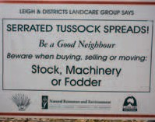

Victoria Landcare cautionary sign at Spring Creek.

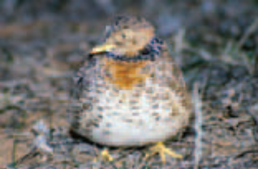

Pedionomus torquatus (plains wanderer)

WHERE CAN I GO FOR MORE INFORMATION?

The listing advice and conservation advice for the Natural Temperate Grasslands and Grassy Eucalypt Woodlands
of the VVP

These are the definitive sources of information about the nationally-listed ecological communities and can be down loaded from: www.environment.gov.au/cgi-bin/sprat/public/ publiclookupcommunities.pl

Click on the details link against the name of the ecological community then follow the link to the listing and conservation advice.

Information about other matters of national environmental significance
• Other EPBC-listed threatened ecological communities
• www.environment.gov.au/cgi-bin/sprat/
public/publiclookupcommunities.pl

• Individually-listed threatened species under the EPBC Act
• www.environment.gov.au/cgi-bin/sprat/
public/sprat.pl

• Internationally significant Ramsar wetlands

• www.environment.gov.au/water/topics/
wetlands/

• Australia’s heritage places

• www.environment.gov.au/heritage/index.html

Other useful resources

The Victorian Department of Sustainability
and Environment’s Action Statement
No. 182 (Central Gippsland Plains Grassland, Forest Red Gum Grassy Woodland, Northern Plains Grassland, South Gippsland Plains Grassland, Western (Basalt)
Plains Grassland) includes useful management advice for the grassland ecological community. Available at: www.dse.vic.gov.au

Barlow T (1999). Grassy Guidelines. How to Manage Native Grasslands and Grassy Woodlands on your Property. Trust for Nature, Victoria. Melbourne. Available at: www.environment.gov.au/land/publications/ grassguide.html

Department of Environment, Water, Heritage and Arts (2009) Farming and nationally protected grasslands and woodlands of the Victorian volcanic plain. Available at: www.environment.gov.au/epbc/publications/ grasslands-victoria-fact-sheet.html

Dorrough J, Stol J and McIntyre S
(2008). Biodiversity in the Paddock:
a Land Managers Guide. Future Farm Industries CRC, Canberra. Available at: www.futurefarmcrc.com.au/documents/ Biodiversity_in_the_Paddock.pdf

Department of Sustainability and Environment (undated). Victorian Volcanic Plains Native Vegetation Management Guide. Available at the Victorian Volcanic Plains Conservation Management Network Website (which also contains a lot of other really useful information on the VVP): www.vvpcmn.org/library-of- articles/vvp-grasslands/

Gott, B & Conran, J. (1991) Victorian Koorie Plants. Yangennanock Women’s Group, Aboriginal Keeping Place Hamilton, Victoria.

Kirkpatrick, J.B., McDougall, K. & Hyde, M. (1995) Australia’s most threatened ecosystem: the southeastern lowland native grasslands. World Wide Fund for Nature Australia. Surrey Beatty & Sons.
Langford C, Simpson P, Garden D, Eddy D, Keys M, Rehwinkel R and Johnston W (2004). Managing Native Pastures for Agriculture and Conservation. NSW Department of Primary Industries.

Lunt, I., Barlow, T. & Ross, J. (1998)
Plains Wandering: exploring the grassy plains of south-eastern Australia. Victorian National Parks Association Inc. and Trust for Nature (Victoria).

McIntyre S, McIvor JG and Heard KM (eds) (2002). Managing and Conserving Grassy Woodlands. CSIRO Publishing, Melbourne.

Victorian Volcanic Plains Native Vegetation Management Guide information kit produced by the Corangamite Catchment Management Authority (www.ccma.vic.gov.au)

A fold-out pictorial guide to some key grassland species has been produced: Grassland Species of the Victorian Volcanic Plain (2006) compiled by Yvonne Ingeme, Victorian Department of Sustainability and Environment. For a copy contact a local Catchment Management Authority in the Victorian Volcanic Plains region.

These references were current at the time of publishing; please refer to
the relevant agency’s website for any updated versions.

Other useful websites
• Relevant Catchment Management
Authorities:

- Corangamite CMA:
www.ccma.vic.gov.au/

- Port Philip & Westernport CMA:
www.ppwcma.vic.gov.au/

- Glenelg-Hopkins CMA:
www.ghcma.vic.gov.au/

• Caring for our Country – What can I do?:
www.nrm.gov.au/nrm/landholders/index.html

• Stipa Native Grasses Association:
www.stipa.com.au/

• South West Integrated Flora and Fauna Team (SWIFFT): bird.net.au/bird/index.php?title=SWIFFT
• Victorian Aboriginal Corporation
for Languages: www.vaclang.org.au

• Victorian Volcanic Plain Conservation
Management Network: www.vvpcmn.org/

Additional copies of this document

Enquiries and requests for further copies of this booklet can be directed to the department’s community information unit on:

Freecall: 1800 803 772

Email: ciu@environment.gov.au

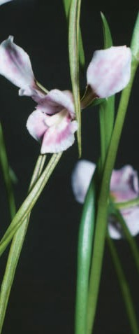

Diuris fragrantissima (sunshine diuris)

GLOSSARY

Bioregion: A unique area with characteristic soils, landforms, climates (environmental conditions), and flora and fauna, and which is bounded by natural rather than artificial borders. See also ‘IBRA’.

Critically endangered: A category of listing under the EPBC Act. It is applied to threatened species and ecological communities showing an extremely
high risk of extinction in the wild in the immediate future.

Dominant: A dominant species is one that is most prevalent in a given community
or area. Dominance usually relates to a specific measure such as vegetative cover or abundance.

DBH: Diameter at breast height
(measured 1.3 m above the base of the tree).

EPBC Act: The Environment Protection and Biodiversity Conservation Act 1999.
This is the Australian Government’s national environment law.

EVC: Ecological Vegetation Class. A unit
of vegetation classification used in Victoria. The EVC concept includes information about vegetation floristics and structure, landscape context and ecological processes.
Forb: A non-woody plant other than a grass, rush or sedge.

Geophyte: A perennial plant with an underground bulb, rhizome, corm or tuber which is generally evident during spring – summer.

Grass(es): Any plant that is a member of the plant family Poaceae.

Grass-like: A plant that may superficially resemble a grass but is a member of a plant family other than Poaceae. Examples include sedges and rushes. The shoots of some
lilies, orchids and mat-rushes (Lomandra spp.) may also appear grass-like, especially when not in flower.

Grassland: A vegetation type characterised by the absence or scarcity of trees and large shrubs and where a ground layer of grasses is the dominant vegetation feature.

Ground-truth (verb): To conduct an
on-site field check in order to determine details revealed by remote sensing or aerial photography.

Herb, herbaceous: Any seed plant that never produces a woody stem.

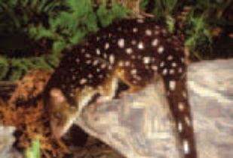

Dasyurus maculatus maculatus
(SE mainland population) (spot-tailed quoll)

IBRA: Interim Biogeographical Regionalisation of Australia. Under IBRA version 6.1, Australia is classified into
85 bioregions, each of which is a large geographically distinct area of similar climate, geology, landform, vegetation and animal communities.

Intergrade: To merge gradually, one into another, as when woodland grades into grassland.

Patch(es): A patch of the listed ecological community is a discrete and uniform area that comprises the ecological community. It does not include substantial elements of other ecological communities, such as woodlands dominated by other tree species and other types of grasslands. However, a patch
of the listed ecological community may include small-scale variations in vegetation, and small-scale disturbances, such as tracks or breaks, that do not alter its overall
functionality—including the easy movement of wildlife or dispersal of plant spores and seeds.

Perennial: A plant whose life span extends over more than two growing seasons.

Projective Foliage Cover: Is the percentage of area covered by the leaves, twigs and branches in the canopy, excluding any gaps between these. For example, projective foliage cover correlates to the amount of shadow that would be cast on the ground if
a light source was shining directly overhead.
Quaternary: Relating to the present period of earth history, forming the latter part of the Cenozoic Era, originating about
2 million years ago and including the
Recent and Pleistocene Epochs.

Remnant: Patch of native vegetation remaining after an area has been cleared or modified. For the purposes of this information brochure remnants also include naturally regenerating areas as well as areas that
have undergone revegetation.

Tussock: A plant growth form where the shoots form compact tufts. Common in many species of grasses, but also occurs in other grass-like plant species.

Understorey: Vegetation layers (e.g. grasses, herbs and shrubs) that occur below a tree canopy.

Woodland: A vegetation type in which a tree canopy is present but does not form a dense or closed canopy, as in forest systems. In woodlands, the tree canopy typically
has a foliage cover of 10 to 30 per cent, and individual trees are often more widely spaced, and shorter, with a spreading canopy. Open woodlands typically have a tree foliage cover of less than 10 per cent. Grassy woodlands have an understorey dominated by grasses, interspersed with other herbs.

Photograph credits
Internal (L to R, top to bottom)

Front cover (L to R, top to bottom) | 3 | Lathamus discolor (swift parrot) © T. Tonelli
Front cover (L to R, top to bottom) | 4 | Glycine latrobeana (clover glycine, purple clover)
• Synemon plana (golden sun moth) © E.D. Edwards |  | © T. Barlow
• Craspedia glauca spp. agg. (common billy-buttons)  © Matt White | 5 | Litoria raniformis (southern bell frog,  growling grass frog) © Alexander Dudley
• Kangaroo grass at Dunkeld © Reto Zollinger | 7 | A range of wildflowers © Reto Zollinger
• Natural temperate grassland © Tim Allen | 8 | Austrodanthonia spp. (wallaby-grass) © Matt White
• Eryngium ovinum (blue devil) © Matt White | 9 | Ptilotus macrocephalus (feather heads) © Tim Allen
 | 10 | Typical natural grassland © Tim Allen
Back cover (L to R, top to bottom) | 10 | Trees and large shrubs are naturally absent

• Stony knoll © Reto Zollinger
• Isoodon obesulus subsp. obesulus
(southern brown bandicoot) © Andrew Tatnell
• Delma impar (striped legless lizard) © Kate Ord,
DSEWPaC
• Oxalis perennans (grassland wood-sorrel)
© Matt White
• Grassy woodland at Morang South © John Vranjic

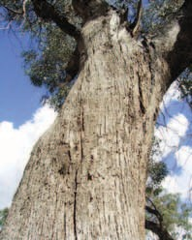

Eucalyptus microcarpa (grey box)
© Reto Zollinger
10 The grassland is usually dominated by one or more
native grasses © Reto Zollinger
10 Many herbs and wildflowers may occur © Heidi Zimmer
10 Some drainage lines may be dominated by large tussocks of Poa labillardierei © Anthony Hoffman
11 Delma impar (striped legless lizard)
© Kate Ord, DSEWPaC
11 Synemon plana (golden sun moth) © E.D. Edwards
12 Typically an open woodland © John Vranjic
12 Patches of derived native grassland © Tim Allen
12 A native ground layer © Tim Allen
12 River red gum may be replaced © DSEWPaC
12 Stony knolls within the woodland © Reto Zollinger
12 A range of wildflowers © Reto Zollinger
12 The tree canopy is dominated by river red gum
© P. Komidar
14 Typically an open woodland with grey box
© David Jackson
14 The tree canopy is dominated by grey box
© David Jackson
14 Other trees present may include © Emily Fearn
14 The native understorey is variable © David Jackson
14 Chenopods © Collette Barton
16 Kangaroo grass at Dunkeld © Reto Zollinger
18 Woorndoo Common © Karen Wales
18 Glenelg Highway © Stephen Platt, DSE Victoria
19 Mortlake Common © Heidi Zimmer
19 Dunkeld © Tim Allen
20 Grassland at Cressy Road © Tim Allen
21 Arthropodium sp. (chocolate lily) © John Vranjic

24 Native grasses being planted © John Baker
25 Themeda triandra (kangaroo grass) © Matt White
25 Austrodanthonia spp. (wallaby grass) © Matt White
25 Austrostipa spp. (spear grass) © Matt White
25 Poa labillardierei (river or common tussock grass) © Anthony Hoffman
25 Microlaena stipoides var. stipoides (weeping grass) © Collette Barton
26 Acaena ovina (Australian sheep’s burr) © Matt White
26 Acaena novae-zelandiae (bidgee widgee) © M. Fagg, Australian National Botanic Gardens
26 Geranium spp. (crane’s bill) © Matt White
26 Ptilotus macrocephalus (feather heads) © Tim Allen
26 Craspedia glauca spp. agg. (common billy-buttons)
© Matt White
26 Eryngium ovinum (blue devil) © Matt White
26 Oxalis perennans (grassland wood sorrel)
© Matt White
26 Thelymitra spp. (sun orchid) © Matt White
26 Wahlenbergia spp. (bluebell) © Matt White
26 Calocephalus citreus (lemon beauty heads)
© Emily Fearn, DENR SA
26 Drosera spp. (sundew) © Ross Rowe
26 Convolvulus angustissimus (pink bindweed)
© Anthony Hoffman
27 Pimelea humilis (common rice flower)
© Anthony Hoffman
27 Bursaria spinosa (sweet bursaria) © Matt White
27 Leptospermum continentale (prickly tea tree)
© M. Fagg, Australian National Botanic Gardens
27 Eucalyptus camaldulensis (river red gum) © DSEWPaC
27 Eucalyptus melliodora (yellow box) © Helena Mills
27 Eucalyptus microcarpa (grey box) © Matt White
27 Eucalyptus ovata (swamp gum) © Matt White
27 Acacia implexa (lightwood) © C. Green, Australian National Botanic Gardens
27 Acacia mearnsii (black wattle) © M. Fagg, Australian National Botanic Gardens
27 Allocasuarina verticillata (drooping sheoak)
© R. Hill, Australian National Botanic Gardens
28 Isoodon obesulus subsp. obesulus
(southern brown bandicoot) © Andrew Tatnell
28 Perameles gunnii subsp. unnamed
(eastern barred bandicoot (mainland)) © Dave Watts
28 Pteropus poliocephalus (grey-headed flying-fox)
© Viven Jones
28 Dasyurus maculatus maculatus
(SE mainland population) (spot-tailed quoll)
© Dave Watts
29 Pedionomus torquatus (plains-wanderer)
© Tom Wheller
29 Lathamus discolor (swift parrot) © T. Tonelli
29 Delma impar (striped legless lizard)
© Kate Ord, DSEWPaC
29 Tympanocryptis pinguicolla
(grassland earless dragon) © Steve Wilson
30 Litoria raniformis (southern bell frog,
growling grass frog) © Alexander Dudley
30 Synemon plana (golden sun moth) © E.D. Edwards
30 Carex tasmanica (curly sedge) © John Vranjic
30 Dianella amoena (matted flax-lily) © Barbara Bell
30 Diuris basaltica (small golden moths orchid;
early golden moths) © Len Carrigan
31 Diuris fragrantissima (sunshine diuris, white diuris)
© Mark Clements
31 Dodonaea procumbens (trailing hop-bush) © M. Fagg, Australian National Botanic Gardens
31 Glycine latrobeana (clover glycine, purple clover)
© T. Barlow
31 Lepidium aschersonii (spiny pepper-cress)
© Lynlee P. Smith
31 Lepidium hyssopifolium (basalt pepper-cress)
© J. Briggs
31 Leucochrysum albicans var. tricolor (hoary sunray)
© Matt White
32 Pimelea spinescens subsp. spinescens
(spiny rice flower, plains rice flower) © Michelle Storer
32 Prasophyllum diversiflorum (gorae leek-orchid)
© Mark Clements
32 Prasophyllum frenchii (maroon leek orchid, slaty leek-orchid) © C. Totterdell
32 Prasophyllum suaveolens (fragrant leek orchid)
© Mark Clements
32 Pterostylis basaltica (basalt greenhood) © T. Barlow
32 Rutidosis leptorrhynchoides (button wrinklewort)
© J.D. Briggs
33 Senecio macrocarpus (large-fruit groundsel,
large-fruit fireweed) © Keith McDougall
33 Xerochrysum palustre (swamp everlasting)
© John Eichler

34 Wurmbea dioica (early nancy) © Matt White
36 Grassy Woodland of the VVP © David Cheal
37 Pedionomus torquatus (plains-wanderer)
© Tom Wheller
38 Tyrendarra Indigenous Protected Area © Bruce Rose
38 The Bulbine lily © Matt White
39 Dianella revoluta (flax lily) © Matt White
39 Eucalyptus camaldulensis (river red gum) leaves
© C. Totterdell, Australian National Botanic Gardens
39 Yam daisy was a valuable food source © Matt White
40 Grassland at Dunkeld © Tim Allen
42 Spot spraying of Chilean needle grass © John Baker
44 Edge of Grassy Woodland area © John Baker
45 Victoria Landcare cautionary sign © John Baker
46 Pedionomus torquatus (plains-wanderer)
© Tom Wheller
48 Diuris fragrantissima (sunshine diuris) © Mark Clements
50 Dasyurus maculatus maculatus
(SE mainland population) (spot-tailed quoll)
© Dave Watts
51 Eucalyptus microcarpa (grey box) © Matt White
53 Eucalyptus melliodora (yellow box) © Helena Mills
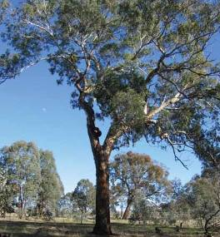

Eucalyptus melliodora (yellow box)

BIO128.0111

