Impacts on Birds and Bats from Onshore Wind Farms in Australia
An ecological risk assessment
  - Updated November 2025
Keith Reid¹ and G. Barry Baker²
¹Ross Analytics Pty Ltd
²Latitude 42 Environmental Consultants Pty Ltd
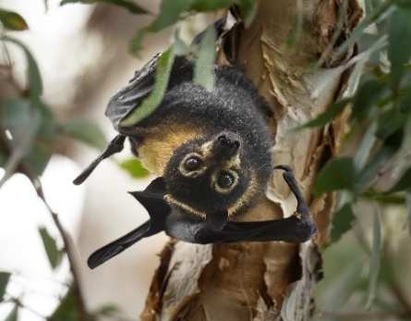
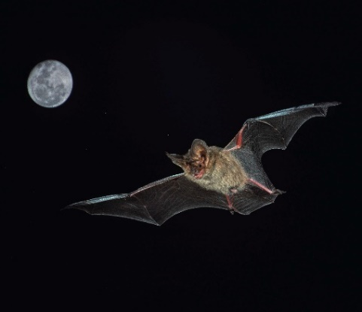
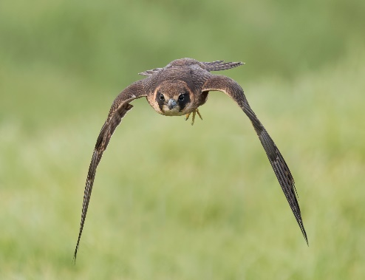
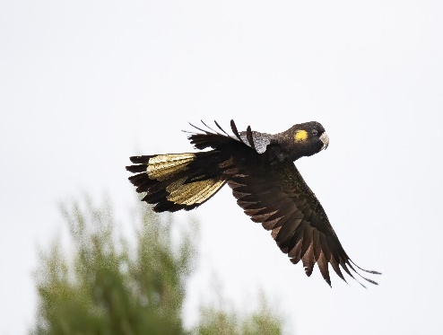
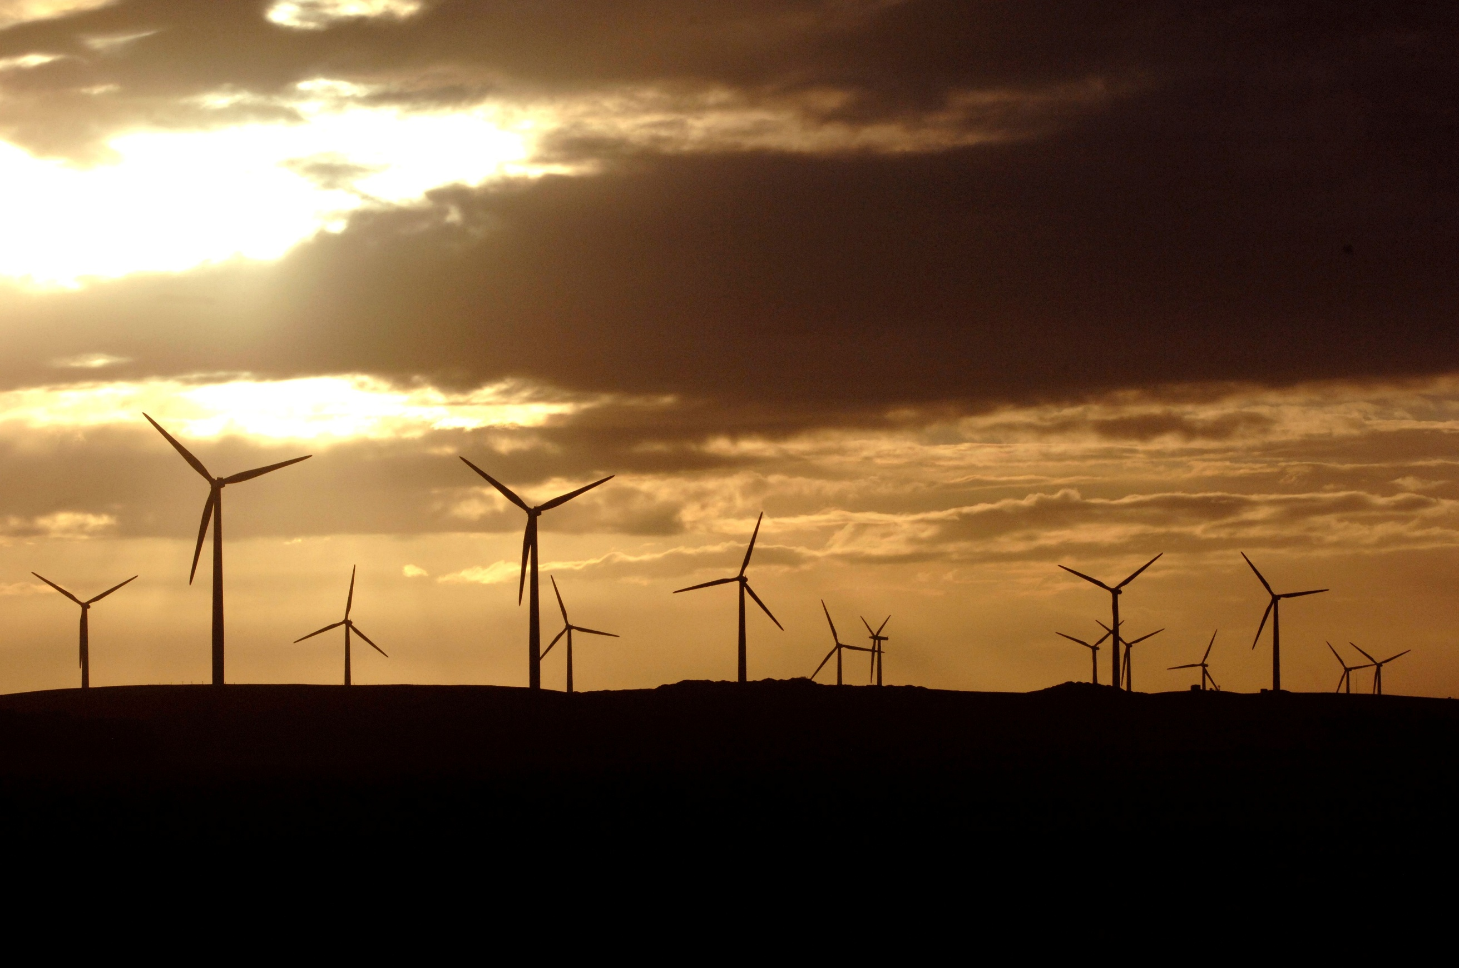
© Commonwealth of Australia 2025
Ownership of intellectual property rights
Unless otherwise noted, copyright (and any other intellectual property rights) in this publication is owned by the Commonwealth of Australia (referred to as the Commonwealth).
Creative Commons licence
All material in this publication is licensed under a Creative Commons Attribution 4.0 International Licence except content supplied by third parties, logos and the Commonwealth Coat of Arms.
Inquiries about the licence and any use of this document should be submitted via our online contact form.

Cataloguing data
This publication (and any material sourced from it) should be attributed as: Reid, K. and Baker, G.B (2025) Impacts on birds and bats from onshore wind farms in Australia: an ecological risk assessment, Department of Climate Change, Energy, the Environment and Water, Canberra. CC BY 4.0.
Department of Climate Change, Energy, the Environment and Water
GPO Box 3090 Canberra ACT 2601
Telephone 1800 920 528
Web dcceew.gov.au
Disclaimer
The views and opinions expressed in this publication do not necessarily represent the views of the Australian Government or the portfolio ministers for the Department of Climate Change, Energy, the Environment and Water (DCCEEW).
The Australian Government acting through DCCEEW and the authors have exercised due care and skill in preparing and compiling the information and data in this publication. Notwithstanding, DCCEEW, its employees and advisers disclaim all liability, including liability for negligence and for any loss, damage, injury, expense or cost incurred by any person as a result of accessing, using or relying on any of the information or data in this publication to the maximum extent permitted by law.
This document is designed to be an additional source of information. It is not a statutory document or policy statement. If information diverges, the information in the statutory document(s) and policy statement(s) take precedence over this document. This document should be used in parallel with the Significant Impact Guidelines 1.1 – Matters of National Environmental Significance, relevant conservation advices, recovery plans and/or referral guidelines and guidance.
Acknowledgements
The authors thank DCCEEW impact assessment staff and Lucy Porter and Kerri Woodcock, in particular, for valuable input during the development of the risk assessment process. The authors also thank Deya Andulo Chinas, Mandy Bamford, Mike Bamford, Jez Bird, Cathy Bulman, Rohan Clarke, Gus Daley, Mike Double, Will Dunlop, Greg Ford, Sheryl Hamilton, Pia Lentini, Lindy Lumsden, Golo Maurer, Peter Menkhorst, Arvid Pluschke, Elias Polymeropoulos, Justin Welbergen, Felicity Williams and Kerri Woodcock who participated in an expert workshop to identify key knowledge gaps and assess input parameters to the risk assessments. A peer review of an early version of the risk assessment undertaken by Jeremy Bird provided important input into the finalised report.
Cover photo of wind farm copyright shared DCCEEW and photographer Arthur Mostead. Photos of Yellow-tailed Black-cockatoo, Australian Hobby, Corben’s Long-eared Bat and Spectacled Flying-fox — Barry Baker.
Acknowledgement of Country
We acknowledge the Traditional Owners of Country throughout Australia and recognise their continuing connection to land, waters and culture. We pay our respects to their Elders past and present.

Executive summary
Project purpose
The construction and operation of onshore wind farms pose potential risks to birds and bat species. Risks may include direct collisions with turbines, displacement from preferred habitats, habitat destruction and barrier effects (the physical and visual obstruction of bird and bat flight paths) leading to altered movement patterns. This report collates information on the ecological attributes of all birds and bats in Australia to assess potential risks to them from wind farms. It presents the outcomes in a user-friendly format that can be used by proponents and regulators. A harmonised, consistent approach to identifying species at highest risk from onshore wind farm developments in Australia will help to streamline assessment processes and reduce impacts on birds and bats.
Categorising relative risk at a regional scale highlights those bird and bat taxa that are at highest risk from the potential impacts of wind farms. It indicates where more detailed, site-specific consideration is required for a proposed (or operational) development area. Importantly, the outcomes of the ecological risk assessment should guide survey design to ensure they are appropriate for the ecological characteristics of high-risk species. The risk assessment also provides regulators with relevant information when considering species of concern in an area during the assessment process. See Section 1 Introduction for further information.
Methods used
An ecological risk assessment was undertaken using the intrinsic ecological, morphological and life-history attributes of 1095 bird and 81 bat taxa (covering all bird and bat species in Australia). It provides a relative ranking of risk of negative interactions with onshore wind farms in Australia. Ecological attributes of these birds and bats indicate the likelihood of interactions with a wind farm and the population-level resilience to such impacts. The likelihood of interactions was scored based on attributes of flight activity (time spent flying and height relative to the height of turbines), flight characteristics (based on wing morphology and body weight), and habitat specialisation for each taxon. The estimated resilience of the current population to immediate impacts as well as the estimated duration of recovery from any potential impacts was scored based on a contemporary assessment of the population status and trends in combination with the generation time of each species. Each individual attribute was scored on scale of 1−5 and then combined to give an overall risk score for the taxon.
The limited availability of species-specific empirical data was addressed by using peer-reviewed, publicly available data, trait-based ecological groupings and testing with experts who reviewed input parameters and risk assessment methods. Acknowledging the limitations in data availability, experts reviewed and refined the details of the ecological traits used in parameterising the risk frameworks, in a workshop setting. See Section 2 Methods for further information.
Summary of the results
The thresholds between low-to-medium risk and medium-to-high risk were calibrated to the 25th and 75th percentiles of the overall risk scores. For birds, 238 taxa were classed as low risk, 583 as medium risk and 274 as high risk. For bats 17 taxa were classed as low risk, 44 as medium risk and 20 as high risk. The two highest risk bird species were Australian Palm Cockatoo (Probosciger aterrimus macgillivrayi) and Baudin's Black Cockatoo (Zanda baudinii) due to their particular flight attributes, conservation status and long generation times. The two highest risk bat species were Arnhem Leaf-nosed Bat (Hipposideros inornatus) and the Lesser Large-eared Horseshoe Bat (Rhinolophus intermediate). See Section 3 Results for more information.
Details of the individual attribute scores and the resulting overall risk categories are provided for birds and bats as separate appendices. The spreadsheets are filterable by state or territory. See Appendices 2−5 for more information.
Confidence, constraints and caveats
This is a general risk assessment and doesn’t account for site-specific characteristics that a proponent would need to consider when determining the potential environmental impact of a proposal. The limited availability of species-specific data means that the final risk assessment relies on generalised, trait-based data and expert opinion to estimate an overall score of relative risk. Importantly, the approach used here recognises the need to make progress using the best information currently available to undertake an ecological risk assessment, rather than being hindered by incomplete data. The inherent data limitations and contingent uncertainties underscore the need to employ methods that allow for risk scores to be updated as new information becomes available.
The information in this document is intended as an initial guide. The actual level of risk to which individual taxa are exposed cannot be fully known due to limitations of available data. Overall, the area of greatest uncertainty is the relative amount of time that different species spend at collision risk height over an annual cycle. This includes the dispersive or migratory behaviours of birds and bats, for which empirical data on nocturnal flights is particularly limited. The criteria applied to determine whether a taxon is included in a particular state or territory may mean that some species that either occur infrequently or are under-reported in a region may not be included in that state or territory’s list.
Sharing of data from bird and bat surveys, including those in association with wind farms, will help to improve and update our understanding of the behaviours and distribution of all taxa, especially for those that are at high risk from interactions with wind farms.
The ecological risk assessment provides a measure of potential risk; however, assessing realised risk is hampered by a lack of consistent data on actual or reported impacts of wind farms on birds and bats in Australia. Improving the understanding of potential and realised risk requires consistent methods and centralised reporting of the total numbers of bird and bat mortalities associated with wind farms. See Section 4 Discussion and risk assessment outcomes for more information.
How to use this report
This ecological risk assessment is a precursor to the development of baseline data required to assess, avoid, mitigate and manage impacts of onshore wind farms. It allows proponents and regulators to identify species that should be investigated further in relation to impacts from specific proposed developments. The approach provides a rigorous method to identify taxa that may be at high risk of negative impacts from onshore wind farms. Furthermore, the attribute score can be used to determine whether a taxon’s status as high risk is driven by wind farm-specific risks, low population resilience or a combination of both. In doing so, it provides proponents and regulators with an important tool for determining the most appropriate approaches for identifying and managing risks to birds and bats from onshore wind farms. See Section 5 Best and emerging practice to determine and mitigate impacts for more information.
Contents
Executive summary 3
1. Introduction 7
2. Methods 10
2.1. Species 10
2.2. Spatial distribution and zonation 11
2.2.1. Example of spatial distribution calculation for a species 12
2.3. Risk assessment approach 13
2.3.1. Productivity 13
2.3.2. Susceptibility 15
2.3.3. Overall risk 19
3. Results 20
3.1. Birds 20
3.2. Bats 22
4. Discussion and risk assessment outcomes 24
5. Best and emerging practice to determine and mitigate impacts 26
5.1. Scope and objectives 26
5.1.1. Data limitations 26
5.2. Types of impacts 28
5.2.1. Collisions 28
5.2.2. Displacement and barrier 29
5.2.3. Disturbance 29
5.2.4. Habitat 29
5.2.5. Indirect 29
5.3. Responses of birds and bats to onshore wind farms 30
5.4. Measuring impacts on birds and bats from onshore wind farms 31
5.4.1. Baseline data 31
5.4.2. Monitoring of impacts 33
5.5. Mitigation of the impacts on birds and bats of onshore wind farms 36
5.5.1. Infrastructure design: Number of turbines and technical specifications (including lighting) 37
5.5.2. Scheduling and curtailment 37
5.5.3. Acoustic and visual deterrents 38
5.6. Challenges to assessing best practice monitoring and mitigation in Australia 39
Appendix 1: Linking the taxonomy of the Working List of Australian Birds to the EPBC status from the SPRAT database 41
Data Preparation 41
Preparation of the WLAB 4.3 data. 43
Data linking 43
Appendix 2: Ecological Risk Assessment table for birds by State and Territory 48
Appendix 3: Ecological Risk Assessment table for bats by State and Territory 49
Appendix 4: Ecological Risk Assessment table for birds 50
Appendix 5: Ecological Risk Assessment table for bats 51
Glossary 52
References 53

Introduction
The construction and operation of wind farms, as part of the transition to renewable energy, poses a risk to birds and bat species. Impacts include:
- deaths as a result of direct collisions,
- displacement away from, or loss of, preferred habitats, caused by disturbance from operating turbines and associated construction and support traffic,
- barrier effects that impede preferred movement/migration routes, and
- destruction of habitat/land clearing.
The challenge for many regulators and proponents is how to identify, assess and manage this risk. This report sets out an approach for identifying at risk species based on species productivity and susceptibility, which require further consideration of impacts, avoidance and mitigation measures as part of an Environment Impact Statement. This is a preliminary risk assessment tool for use by proponents and assessment officers that provides a structured, consistent approach to identifying at risk species from onshore wind farm developments in Australia. It provides information to assist with the development of baseline data and mitigation strategies required to inform both regulatory decision-making and proponent proposals to ensure that the risks to birds and bats can be effectively and efficiently included in the planning and operation of wind farms in Australia. Typically, it is the likelihood of direct collisions with wind farms that attract the greatest attention; however, it is important to include those other factors that contribute to the overall impacts in any risk analysis to avoid an under-estimation of impacts where only the direct collision related risks are included. This document does not examine the impacts of habitat destruction/clearing for wind farm developments on birds and bats. Proponents and regulators have existing and adequate methods for assessing impacts of clearing on protected matters. There is a knowledge gap on the effects of collision, displacement and barriers created by wind turbines. This risk assessment should be used in conjunction with other information including site specific information.
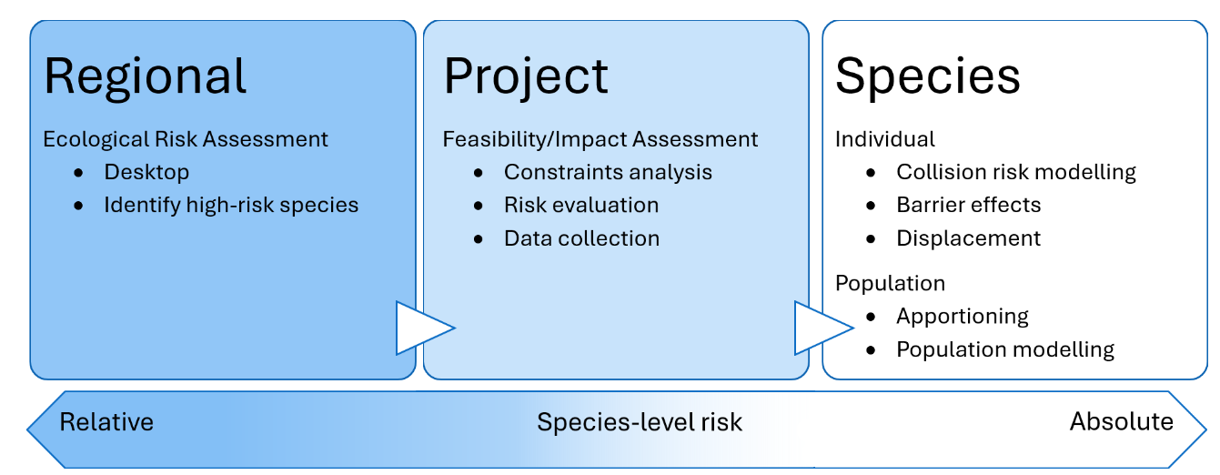
Figure 1. Conceptual structure of the process to assess the population-level risk to a bird species from a wind farm project.
Determining the potential impacts on birds and bats of wind farms in Australia requires a structured approach to determine those taxa that may be vulnerable to impacts at broad scales and those in need of detailed evaluation at specific sites at which wind farms are proposed. Confusion can arise when different descriptions of ‘risk’ are conflated, underlining the importance of clearly describing the level (either at an individual or population level) at which the risk is being assessed. The structured approach outlined in Figure 1 is intended as a schematic, rather than prescriptive, structure that also provides greater clarity of terminology and an understanding of the progression from qualitative to quantitative assessment of risk through the stages of the overall risk assessment process.
The initial part of the structured approach outlined in Figure 1 is the use of a regional scale ecological risk assessment to identify those species likely to be at the greatest risk from interactions with wind farms and this helps in identifying the appropriate level of risk assessment.
This is based on intrinsic ecological, morphological and life-history characteristics, as these determine the likelihood of an individual being impacted by a wind farm and their population-level resilience to an increased rate of mortality. This provides a relative index of risk across a wide range of species that might potentially be exposed to impacts from wind farms.
The intent of an ecological risk assessment (ERA) is not to provide a definitive assessment of the risk of an individual wind farm project. By categorising the relative risk to different species, it informs proponents and regulators about those taxa that are at highest risk from the impacts of wind farms at a regional scale. This does not mean that these taxa will necessarily be impacted by an individual development, but it provides a guide to ensure that those high-risk taxa are included in the review of impact pathways and constraints analysis in the initial stages of a development proposal in that region.
Assessing the risks associated with an individual wind farm requires site-specific data from surveys of the birds and bats present in the proposed (or operational) development area. Importantly the outcomes of the ecological risk assessment should guide the appropriate choice of survey to ensure that they are appropriate for the ecological characteristics of the high-risk species. It also provides regulators with supporting information to review the treatment of key species of concern in an area when evaluating project referrals.
Quantifying the risk to individual species requires an estimate of the number of birds expected to be involved in collisions and the impact that the removal of that number of individuals is expected to have on their population. Estimating the numbers of individuals of a given bird species that are expected to collide with wind turbines is assessed at a site-specific level using collision risk modelling (Masden and Cook 2016). There are a range of collision risk models that have been used to estimate the total number of birds exposed to risk of collision (see Cook et al. 2025). All of these models use some combination of the characteristics on the wind farm design/construction (i.e., the number of turbines, hub height, length and width of blades, rotation period) and the total number and characteristics of birds that may pass through the wind farm (i.e., flight speed, body length, wingspan, time at collision risk height). Thus, while collision risk models share some attributes of the ERA they are quite distinct and provide quite different levels of information, as reflected in their different positioning in Figure 1. An important parameter in collision risk models is the dispensation for birds taking action to avoid collisions, referred to as the avoidance rate, that is usually derived from the comparison of collision risk models results with no avoidance rate and the subsequent validation of those model outcomes through collision monitoring (Ferrer et al. 2012). There are currently no analogous collision risk models for bats.
Determining the potential for the effects of wind farms to have significant population level effects depends on the life-history/demographic characteristics of a species, including the spatial and habitat requirements. The potential impact of an increase in mortality rate on the population of a species can then be assessed using population models. Demographic parameters typically include population size and current growth rate, mortality/survival rates, and fecundity/ breeding output. Intrinsic rates can be measured and/or estimated or co-opted from closely related species. There are a range of modelling approaches that can be used to examine the population consequences of additional mortality (see May et al. 2019) all of which use some combination of these vital rates to project the population forward in time with different levels of mortality based on the estimated additional number of deaths from wind farm collisions.
A major challenge in quantifying the potential population-level impact is the definition on the population that is being impacted. In the context of assessing the impacts of wind farms on birds May et al. (2019) defined a population as “a group of individuals from the same species which live in the same space at the same time and reproduce”. Within the EPBC Act a ‘population of a species’ is defined as “an occurrence of the species in a particular area. In relation threatened species, occurrences include, but are not limited to:
- a geographically distinct regional population, or collection of local populations, or
- a population, or collection of local populations, that occurs within a particular bioregion.”
Therefore, while these definitions provide a framework for understanding the temporal and spatial scale of impacts it also highlights the need for a clear, shared definition of the impacted population to avoid misaligned objectives. For example, if a project proponent defines the ‘population’ of a species as the numbers occurring within the development site whereas a regulator’s view of that population is at a regional or national level then the interpretation of impacts on the ‘population’ is likely to be quite different. Allied to the definition of the population being impacted there is need to determine what proportion of the population is likely to interact with the wind farm, as with the definition of the population differences in the ‘apportioning’ of the population exposed to risk will result in different interpretations of the perceived risk.
Methods for conducting ecological risk assessments for a range of taxa are well developed and have been applied to assess the potential impacts of commercial activities, such as wind farms and fishing (Garthe and Hüppop 2004, Furness at al. 2013, Hobday et al. 2011, Richard et al. 2017). The specific data requirements and methods of implementation of ecological risk assessments will differ between different scenarios, however, the overarching principles are generally consistent with the tiered approach developed by CSIRO (Hobday et al. 2011), and in particular their Level 2 approach, a semi-quantitative ‘‘Productivity-Susceptibility’’ analysis.
As with any assessment of risk it is important to recognise that the risk is the combination of the likelihood of an event occurring and the potential impact should that event occur. The potential impact, referred to as the productivity of a species, is based on a contemporary assessment of the population status and trends in combination with the generation time of each species, reflecting the resilience of the current population to immediate impacts as well as the duration of recovery from any potential impacts. The likelihood of interactions, referred to as the susceptibility of a species, can be calculated based on indices of flight activity (time spent flying and height relative to the height of turbines), flight characteristics, based on wing morphology and body weight, and habitat specialisation for each taxa.
The outcomes of the ecological risk assessment are provided in a spreadsheet format that will assist in identifying which species require further assessment before a decision to approve or not can be made. Furthermore, highlighting those species at risk will also provide a trigger for research to gather more species-specific detail to refine the risk scores for those species and to ensure that survey and monitoring programmes are designed so that they can deliver the required data on high-risk bird and bat species.
The process of allocating species by states is designed to assist regulators, proponents and researchers in refining the list of species that they need to include in their considerations. However, we recognise that where other search tools are used to compile site-specific species lists these might use different species distribution data and inclusion criteria. For this reason, we have also included a single list of all species, without the regional filtering, to allow flexibility in how the data can be accessed by users. In this report we have sought to harmonise the species taxonomy and nomenclature across the different data repositories that we have used and note the need for caution when combining data from other sources and search engines.

Methods

Species
The methodology used in this assessment follows the approach taken by Reid et al. (2022) and subsequently modified by Reid and Baker (2025) which categorised the risk of negative interactions of birds and offshore wind farms. That analysis provided risk scores for 272 bird taxa according to their occurrence in eight marine zones divided by state/territory boundaries perpendicular to the coast that were each divided into sub regions.
Expanding this approach to include the suite of birds and bats that might interact with onshore wind farms in Australia involves a much greater number of taxa, reflecting the large spatial and biogeographic scales involved. In compiling the species list for birds, we have followed the taxonomy and nomenclature of the working list of Australian Birds (WLAB - BirdLife Australia WLAB 4.1., hereafter simply referred to as WLAB). In doing so we have adopted the ultrataxon approach to reflect genetically distinct regional populations (following Schodde and Mason 1999) and have included taxa as either subspecies or monotypic species. The taxa included in WLAB were filtered to remove taxa with a Population category of ‘Domestic’, ‘Extinct’, ‘Failed introduction’, ‘No confirmed records’ or taxa that are recognised hybrids and those records with the taxon level of ‘Group’ (i.e., groups of species or subspecies).
The EPBC Act and relevant state listings for each taxon were downloaded from the SPRAT database (download 1 April 2025) and then linked to the WLAB 4.1 using the scientific name as the linking field. Differences in the taxonomy used within SPRAT and between SPRAT and WLAB 4.1 required a process of alignments and refining to match records based on the scientific name. Data tidying in SPRAT and amendments to taxonomy/naming are described in Appendix 1. Implementing the changes in Appendix 1 resulted in 12 taxa that are listed in the SPRAT output that do not link to the WLAB. For 10 taxa there are no confirmed records of the species in Australia, and the listing of those species arises from their inclusion in international agreements/conventions to which Australia is a signatory. However, there are two subspecies that are listed under EPBC but not recognised as subspecies in WLAB:
- Fairy Prion (southern), Pachyptila turtur subantarctica, Vulnerable
- Western Beautiful Firetail, Beautiful Firetail (Mt Lofty Range and Kangaroo Island), Stagonopleura bella Samueli, Endangered
All subspecies inherit the status of the species for EPBC Threat Status, Migratory, Marine and all State Threat listings unless the subspecies has a listing in its own right.
For example, in the case of Bar-tailed Limosa lapponica and Black-tailed Limosa limosa Godwits:
- The Bar-tailed Godwit is listed as Migratory and Marine at the species level and two of the subspecies have an EPBC Threat status of Endangered.
- The Black-tailed Godwit is listed as Endangered and as Migratory and Marine (but the subspecies (Limosa limosa melanuroides) does not have any subspecies level listing.
In the final bird taxa list all subspecies of Bar-tailed godwit inherit the Migratory and Marine status from the species level listing but retain the subspecies level EPBC threat status (there is a third subspecies in the WLAB that inherits the Migratory and Marine status but does not have an EPBC threat status). For Black-tailed godwit the subspecies inherits the EPBC threat status as well as the Migratory and Marine status from the species level. Where there are differences in the taxonomy/nomenclature used in the EPBC Act and individual state/territory legislation (Table 1) and the latter have been aligned with the EPBC Act.
Table 1. Relevant State and Territory legislation that lists threatened species
State/Territory | Abbreviation | Legislation
Australian Capital Territory | NC Act | Nature Conservation Act 2014
New South Wales | NSW BC Act and FM Act | Biodiversity Conservation Act 2016, Fisheries Management Act 1994 (FM Act)
Northern Territory | TPWC Act | Territory Parks and Wildlife Conservation Act 1976
Queensland | NC Regulations | Nature Conservation (Animals) Regulation 2020
South Australia | NPW Act | National Parks and Wildlife Act 1972
Tasmania | TSP Act | Threatened Species Protection Act 1995
Victoria | FFG Act (Advisory Lists) | Flora and Fauna Guarantee Act 1988
Western Australia | WA BC Act | Biodiversity Conservation Act 2016
Seabird species that do not breed in Australia (other than in external territories) were excluded because they are unlikely to encounter onshore wind farms and the risks to these species of offshore wind farms are detailed in Reid et al. (2022); the only exceptions were seabird species that have been recorded from collision surveys with onshore wind farms in Australia (Hull et al. 2013).
In the case of bats, we included the 81 taxa listed by Armstrong et al. (2020) as occurring in Australia.

Spatial distribution and zonation
Each bird taxon was assigned to one or more of the states and territories list based on the extent of the overlap between the state/territory and the core range polygons for each taxon. The core range polygons for birds were based on those in Menkhorst et al. (2017) and were constructed using regionally subsetted Minimum Convex Polygons (MCPs). This approach intersects taxon records with a regionalisation (chosen based on the overall extent of the taxon) then constructs a single MCP per region (where >2 points exist). Following the intent of extent of occurrence metrics, i.e., a contiguous hull encompassing all the known occurrence of a taxon, excluding cases of vagrancy or extirpation (IUCN 2019), these polygons were then dissolved, and remnant gaps rationalised to ensure a continuous hull based on nearest neighbour with reference to known or suspected taxonomic boundaries (e.g., ultrataxon geographic boundaries – Schodde and Mason 1999) or habitat mapping. Vagrant zones were then subtracted from the main hulls based on low percentiles local reporting rates, commonly at least an order of magnitude less than the median. Finally, historic zones, i.e., areas from which taxa have been locally extirpated, were subtracted with reference to years since the last record (commonly 1990), weighed against search effort and expert review.
Each bat taxon was considered to occur in one or more of the state and territories based on the extent of overlap between the state/territory and the core range polygons and the known ‘Current Range’ provided by the Australasian Bat Society (2024) and the Batmap database (Milne et al. 2023).
A taxon was included in the state list where its range polygon covered >5% of the area of the state or where >10% of the total species range polygon occurred within that state. The latter criterion is to account for range-restricted/endemic species where the range might not cover > 5% of a state but more than 10 % of the total distribution is in that state (see Figure 2). Where the core range of distributions of subspecies are not well described, all subspecies were given the distribution of the parent species, noting that this could lead to apparent extra-limital occurrence of some subspecies in some states. Risk scores were not determined differently for different regions although we recognise that the risks to a migratory species may differ between states or territories in which it occurs at different stages of the annual cycle.

Example of spatial distribution calculation for a species
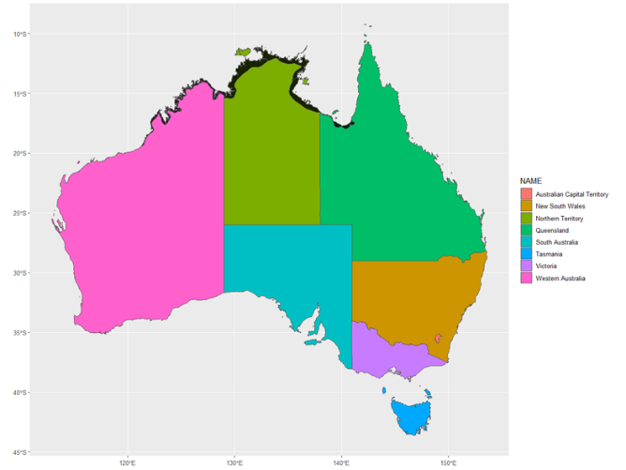
Figure 2. example of spatial distribution calculation for a species
The current range (black) of a species does not overlap with > 5% of any state, but it is included on the state lists for NT and WA, but not QLD.
Northern Territory: the area of overlap is 4.2 % of NT, but represents 65% of the total species range, so qualifies on the > 10% endemism criterion.
West Australia: the area of overlap is 1 % of WA, but represents 32% of the total species range, so qualifies on the > 10% endemism criterion.
Queensland: the area of overlap is 0.07% of QLD and this represents 1% of the total species range, so does not qualify for inclusion.

Risk assessment approach
Reid et al. (2022) expressed overall risk as a combination of productivity and susceptibility following the nomenclature of a semi-quantitative (level 2) ecological risk assessment (Hobday et al. 2011). Research on the interactions of bird and bats with wind farms is a relatively new field in Australia compared to Europe and North America and this is reflected in the very limited availability of empirical data on the key attributes that have been included in the risk assessment approaches used elsewhere. Where details of a particular attribute of a species (or subspecies) are not currently available, we have used the closest alternative at the species or family level. Given the data limitations we have sought to develop a consistent basis for attribute scoring using peer-reviewed, publicly available data combined with expert opinion.
To identify key knowledge gaps and assess input parameters to the risk assessment process two workshops were held in Hobart, Tasmania, on 19 March and 20 March 2025 (Baker and Reid 2025). The first workshop focussed on birds and the second on bats. Both workshops were attended by experts with detailed knowledge of bird and bat ecology and morphology, ecological risk assessment methodologies, and an understanding of the wind energy industry. Attendance at each workshop drew experience from the scientific, government and non-government sectors. Acknowledging the well-recognised limitations in data availability the workshops focused on the suitability of the use of the trait-based approach to parameterising the risk frameworks.
Notwithstanding differences in the number of species and the availability of data, the same overall approach was taken for the risk assessment for birds and bats, although there are differences in the calculation of attribute scoring that reflect the differences in number of species and data availability for birds and bats. The allocation of a species to high, medium or low risk group is made based on separate relative risk scores for birds and for bats. Therefore, while it is possible to make a comparison of actual risk scores between bird species, it is not appropriate to compare the risk score between a bird and bat species.

Productivity
A productivity risk score was calculated based on the following attributes that were scored on a 5 or a 3-point scale:
- Generation Time
- Population Status

Generation Time
The generation times (G) for each bird species were taken from Bird et al. (2020) and are based on age of first reproduction, maximum longevity and annual adult survival. The limitation in available data for bats meant that a family level mean generation time was used based on the data available in Pacifici et al. (2013). Increasing generation time provides a proxy for the life-history strategy of a species on a continuum from R-selected (fast) to K-selected (slow) species. Typically, life histories scale with increasing generation time following a logarithmic relationship (Sæther et al. 2005) and therefore the Generation Time was scored as in Table 2 for birds and Table 3 for bats.
Table 2. Allocation of Generation Time scores for birds
Generation time | Generation Time score
<2.6 years | 1
>=2.6 < 4.7 years | 2
>=4.7 <= 8.5 years | 3
> 8.5 <= 15.4 years | 4
>15.4 years | 5
Table 3. Allocation of Generation Time scores for bats
Generation time | Generation Time score
<2.9 years | 1
>=2.9 < 3.7 years | 2
>=3.7 <= 4.9 years | 3
> 4.9 <= 6.4 years | 4
>6.4 years | 5

Population Status
For birds we solely used the 2020 Action Plan for Australian Birds (APAB) status (Garnett and Baker 2021) and for bats we solely used the 2012 Action Plan for Australian Mammals (APAM) status (Woinarski 2014). These sources provide a national overview of the conservation status of birds and bats occurring in Australia, and incorporate population size and trends, and impending threats. The status was assessed in both the APAB and the APAM strictly following the IUCN Red List guidelines (IUCN Standards and Petitions Committee 2019). Although we have taken the APAB and APAM assessment as the most current and comprehensive review of the population status of Australian birds and bats we recognise the importance of the EPBC Act listing in a statutory context. Therefore, while the EPBC Act listing was not included in the actual risk scoring we have included the EPBC threat status and whether the taxon is listed as Migratory and/or Marine and the state/territory listings in the output files.
We recognise that generation time is used as a relative scalar for population trends in Garnett and Baker (2021) and Woinarski (2014) as part of the conservation status assessment. However, a long generation time does not automatically mean that a taxon will have an adverse conservation status. Therefore, in the context of the current assessment we have included the outcomes of the conservation assessment as it provides additional information about those species where other factors may be impacting the ability of the population of that taxon to withstand additional mortality impacts. Population Status was scored as in Table 4.
Table 4. Allocation of Population Status scores
Conservation Status | Population Status score
Least Concern | 1
Near Threatened | 2
Vulnerable | 3
Endangered | 4
Critically Endangered | 5
Where the status was not assessed in the APAB and the APAM the taxon was assumed to be equivalent to Least Concern and given a score of 1.

Productivity Risk Scoring
As the Population Status for each bird and bat taxa includes an assessment of population size, population trend and threats, it was given a higher weighting relative to the generation time, such that the overall Productivity score for each taxon was:
Productivity (P) = ((Population Status * 1.5) + Generation Time)/2

Susceptibility
A susceptibility risk score was calculated based on the following four attributes that were scored on 5-point scales:
- Flight Height
- Flight Manoeuvrability/Morphology
- Flight Time (birds only)
- Habitat Specialisation

Flight Height
The height at which birds and bats fly, relative to the swept area of wind turbine blades, is clearly one of the most important attributes that influences the risk of collision with wind farms. However, there is little empirical data for Australian birds and bats with which to estimate flight altitude. In order to develop an index for input into the ecological risk assessment the percentage of time that species would be expected to fly within the typical swept area of turbine blades was estimated using behavioural and ecological classifiers, following the approach of Hull et al. (2013) in describing the collision risks of birds with onshore wind farms.
Accordingly, each bird and bat taxa was assigned to a trait-based group based on an understanding gathered through expert opinion of their foraging and flight characteristics to provide an index of the relative amount of time that birds would be expected to fly below, inside and above the typical swept area of turbine blades (also known as collision risk height) (Figure 3 and Figure 4). The assignment to trait groups was initially made at the family level and any individual taxa where this was seen to be a poor description of their foraging ecology were allocated to a more appropriate group. The assignment to the trait/taxon grouping and any subsequent revisions was refined as part of the expert review process (Baker and Reid 2025). Flight height scores for birds were allocated as shown in Figure 3.
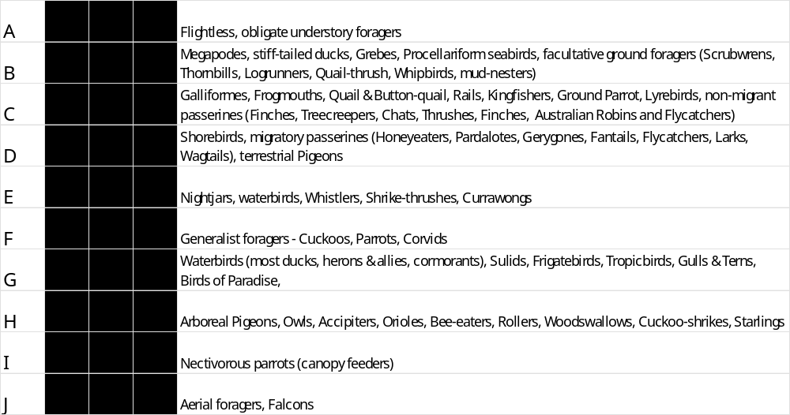
Figure 3. Flight height grouping for Australian birds. The relative height of the bars is illustrative of the relative amount of time that birds in this trait group are expected to fly below, within and above collision risk height (i.e., within the area encompassed by the rotating blades)
The foraging behaviour of Australian bat taxa was used to assign each species to one of three groups based on information on foraging ecology derived from Churchill (2008), Woinarski et al. (2014), Menkhorst (2001), Parnaby et al. (2021), Reardon et al. (2014), and unpublished field observations of one of the authors (GBB). Transit flight heights between roosts and foraging locations were taken into account during assignment of species to groups. As with birds, the assignment to the trait/taxon grouping and any subsequent revisions was refined as part of the expert review process (Baker and Reid 2025). Flight height scores for bats were allocated as shown in Figure 4.
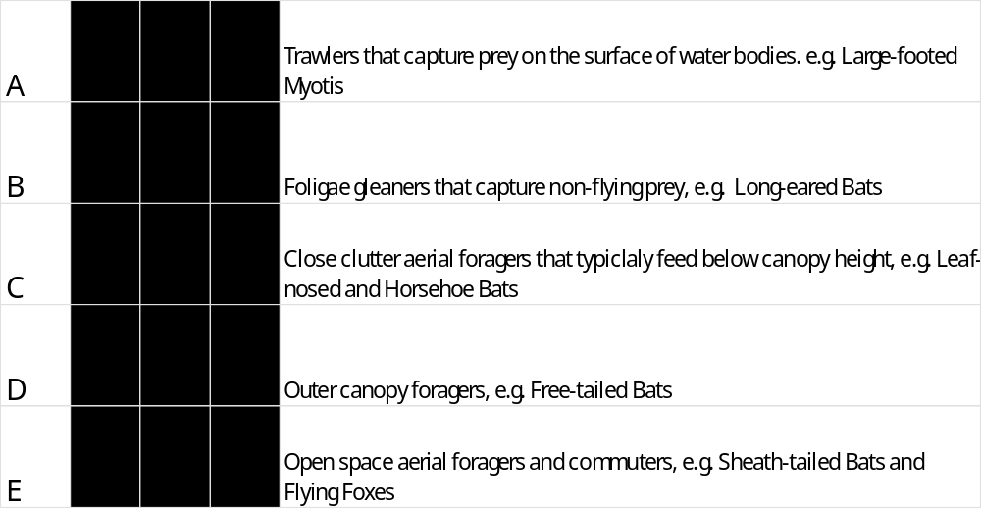
Figure 4. Flight height grouping for Australian bats. The relative height of the bars is illustrative of the relative amount of time that bats in this trait group are expected to fly below, within and above collision risk height (i.e., within the area encompassed by the rotating blades).
Based on the traits-based approach in Figure 3. and Figure 4. the final Flight Height attribute score was applied on a scale of 1 -5 as in Table 5.
Table 5. Allocation of Flight height scores
Trait groups for Birds | Trait groups for Bats | Flight Height score
A | A | 1
B, C, D | B | 2
E, F | C | 3
G, H, I | D | 4
J, | E | 5

Flight Manoeuvrability (birds)
The manoeuvrability of a bird in flight is assumed to be a consequence of morphology rather than behaviour and, therefore, we have used wing loading, which is the mass of a bird divided by the wing area, as a consistent metric of morphology that provides a proxy for flight manoeuvrability. The assumption underlying this approach follows Warham (1990) and Gauld et al. (2022), such that the taxa with a low wing loading are light and manoeuvrable (i.e., low risk), in contrast to taxa with a high wing loading that have relatively short-winged rapid flight and have lower manoeuvrability (i.e., high risk). Data from Tobias et al. (2022) on the wing length, wing width and body mass of all bird taxa were used to determine a wing loading index (FM^{birds}) where FM^{birds}= body mass / (wing length * wing width). Consistent with the logarithmic nature of allometric relationships the Flight Manoeuvrability attribute for birds was scored on a scale of 1-5 as in Table 6.
Table 6. Allocation of Flight Manoeuvrability scores for birds
Flight Manoeuvrability (FM) value | Flight Manoeuvrability score
< 0.002 | 1
>= 0.002 and < 0.004 | 2
>= 0.004 and < 0.080 | 3
>=-0.017 and <= 0.034 | 4
> 0.034 | 5
Although there was a positive relationship between the wing loading index and the flight time index in birds (F _{(1,1093)}=35.12 p< 0.001) both of these indices were retained in the assessment of susceptibility in birds given the wide range of morphologies, from passerines to seabirds.

Flight Manoeuvrability (bats)
In the case of bats there is little empirical evidence or expert opinion to support assumptions about the relationship between wing-loading and manoeuvrability being the same as it is for birds. Nevertheless, as Crane at al. (2024 and references therein) suggest, wing loading is linked to dispersal distance and flight patterns in bats (and therefore data from Thomson et al. (2024) were used to determine a Flight Morphology (wing loading) index (FM^{bats}) where FM^{bats} = body mass/forearm length. The assumption is that species with low relative wing loading ratio would have lower potential risk to direct wind turbine interactions because this characteristic predicts flight in cluttered habitats as opposed to species such as the flying foxes that have a higher wing loading and undertake longer flights in open areas.
Consistent with the logarithmic nature of allometric relationships the Flight Morphology for bats attribute was scored on a scale of 1-5 as in Table 7.
Table 7. Allocation of Flight Morphology scores for bats
Flight Manoeuvrability (FM) value | Flight Manoeuvrability score
< 0.23 | 1
>=0.23 and < 0.49 | 2
>= 0.49 and < 1.24 | 3
>= 1.24 and <= 2.37 | 4
> 2.37 | 5

Flight Time (birds only)
The Flight Time attribute applies only to the time when a bird is flying, however, there are substantial differences in the relative proportion of the overall time-budget of different species that they spend flying. To account for these differences in the amount of time spent flying, a similar, trait-based approach was taken to assign bird families to one of five trait-based groups based on an understanding of their foraging and movement characteristics to provide a relative index of the amount of time that birds would be expected spend flying over the course of a year (a timescale chosen to accommodate migratory/nomadic movements). The assignment to trait groups was initially made at the family level and then modified to account for the migratory/movement patterns of individual taxa (Table 8).
Table 8. Trait-based grouping for relative amount on time spent flying
Group | Trait group | Example
A | Flightless and resident obligate ground foraging | Rails and crakes (resident), Grassbirds, Chats
B | Arboreal foraging, resident, foliage gleaner, nectarivore, frugivore | Bowerbirds and Catbirds, Whistlers, Shrike-thrushes, Kingfishers (resident), Parrots, Lorikeets and Rosellas (resident)
C | Foraging traits as in A or B but are internal migrants/nomadic | Kingfishers (migratory), Parrots, Lorikeets and Rosellas (nomadic/migratory), Gerygones (internal migrants), Cuckoos, Monarchs
D | Aerial predator, long distance/external migrant | Birds of prey, Gulls, Terns and Noddies, shorebirds
E | Aerial insectivores  Marine surface feeders | Swifts, Swiftlets, Swallows and martins Albatrosses, Petrels and Shearwaters
Based on the traits-based approach to the time spent flying in Table 8 the final Flight Time attribute score was applied on a scale of 1 -5 as in Table 9.
Table 9. Allocation of Flight Time scores
Flight time group | Flight Time score
A | 1
B | 2
C | 3
D | 4
E | 5

Habitat Specialisation
A species-specific characterisation of the utilisation of discrete feeding habitat types for birds was taken from the analysis of Garnett et al. (2015). For bats the habitat utilisation was compiled from available information (Churchill 2008, Woinarski et al. 2014, Menkhorst 2001, Parnaby 2021, Reardon et al. 2014) and subsequent refinement in the expert workshops.
Each bird and bat taxon was given a Habitat Specialisation score to reflect its ability to switch to an alternative feeding habitat as a result of disturbance or displacement resulting from a wind farm. This was based on the number of the habitat types (HA) in which it occurred, such that a low HA value represents a habitat specialist (high score) and a high value reflects a habitat generalist (low score, see Table 10). Those bird taxa for which habitat data were not included in Garnett et al. (2015) were assigned the median HA value for all birds.
Table 10. Allocation of Habitat Specialisation scores
Habitat Specialisation (HA) value | Habitat Specialisation score
>=9 | 1
6, 7 or 8, | 2
4 or 5 | 3
2 or 3 | 4
1 | 5

Susceptibility Scoring
The relative importance of the component attributes of the susceptibility were reflected by giving a higher weighting to the flight profile and a lower weighting to habitat specialisation, such that the susceptibility score for each bird taxon was:
Susceptibility (S) = (Flight Height *2 + Flight Manoeuvrability + Flight Time + Habitat Specialisation *0.5)/4
For each bat taxon the susceptibility score was:
Susceptibility (S) = (Flight Height *2 + Flight Manoeuvrability + Habitat Specialisation *0.5)/3

Overall risk
The overall measures of relative overall risk (R) for each taxon were then estimated following the method of Williams et al. (2011) as the distance from the origin to the taxon on a two-dimensional productivity-susceptibility plot such that R = ((P -X₀)² + (S-Y₀)²)^{1/2} where X₀ and Y₀ are the x, y origin coordinates (in this case these are equal to zero).
All analyses were conducted in R (R Core Team 2023).

Results

Birds
Of the 2106 bird taxa in WLAB a total of 1095 met the pre-filtering and range-based criteria (see Figure 2) for inclusion in at least one of the state lists and were included in the ecological risk assessment. The median susceptibility score was 2.63 with an approximately symmetrical distribution around this value (Figure 5a left panel). The median productivity score was 1.75, and in contrast to the susceptibility score, the distribution of scores was skewed towards low scores (Figure 5b right panel) reflecting the high proportion of species with a conservation status of least concern.
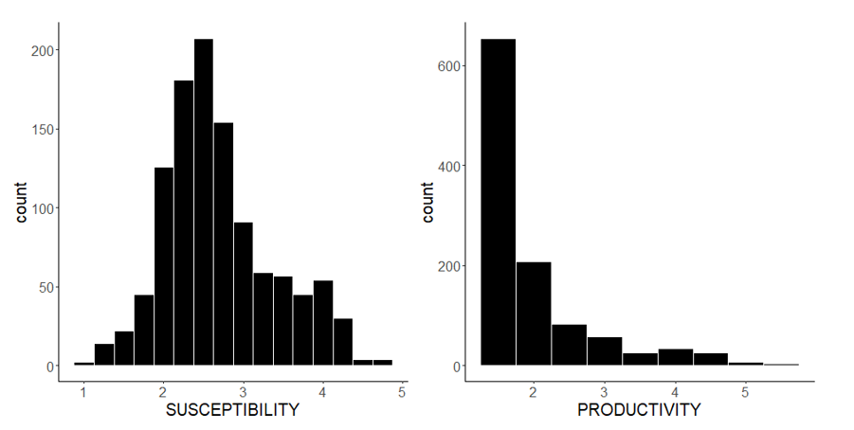
Figure 5. Distribution of a) susceptibility, and b) productivity scores for all bird taxa
For the overall risk scores for birds the thresholds between low -medium risk (2.85) and medium – high risk (3.54) were based on the 25th and 75th percentiles and resulted in 238 taxa classed as low risk, 583 medium risk and 274 in the high-risk category (Figure 6 and Figure 7).
Figure 6. The distribution of overall risk scores for birds with the transition between risk groups shown as stacked bars to show the number of species in each risk group. Green (diagonal stripe) indicates low risk; orange (cross-hatched) indicates medium risk and red (no line) indicates high risk.
Figure 7. The productivity-susceptibility plot for birds (the points have been jittered to avoid overprinting of multiple points with the same values). Green (diagonal stripe) indicates low risk; orange (cross-hatched) indicates medium risk and red (no line) indicates high risk.
Queensland contained the greatest number of taxa (n=722) and had 196 high risk species. Tasmania had the lowest number of taxa (n=179) but had the greatest proportion of high-risk species (Table 11).
Table 11. Number of bird taxa, and risk category for States and Territories
State/Territory | Taxa (n) | High-risk (n) | High-risk (prop) | Medium-risk (n) | Medium-risk (prop) | Low-risk (n) | Low-risk (prop)
Australian Capital Territory | 215 | 69 | 0.32 | 108 | 0.50 | 38 | 0.18
New South Wales | 493 | 156 | 0.32 | 248 | 0.50 | 89 | 0.18
Northern Territory | 416 | 123 | 0.30 | 209 | 0.50 | 84 | 0.20
Queensland | 722 | 196 | 0.27 | 382 | 0.53 | 144 | 0.20
South Australia | 455 | 144 | 0.32 | 225 | 0.49 | 86 | 0.19
Tasmania | 179 | 75 | 0.42 | 75 | 0.42 | 29 | 0.16
Victoria | 391 | 128 | 0.33 | 191 | 0.49 | 72 | 0.18
Western Australia | 506 | 158 | 0.31 | 239 | 0.47 | 109 | 0.22

Bats
All 81 bat taxa met the range-based criteria for inclusion in at least one of the state lists and were included in the ecological risk assessment. The median susceptibility score was 3.3 (Figure 8a) and the median productivity score was 2.8 (Figure 8b).
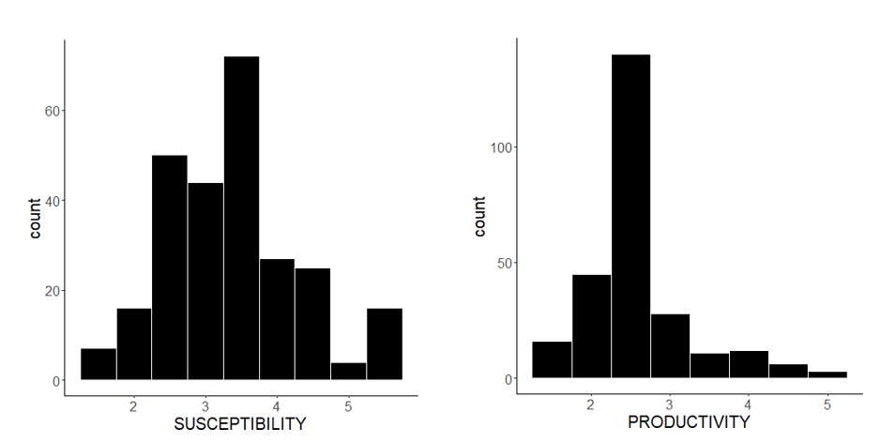
Figure 8. Distribution of a) susceptibility, and b) productivity scores for all bat taxa
Based on the overall risk scores the thresholds between low -medium (3.95) and medium – high risk (4.74), based on the 25th and 75th percentiles, resulted in 17 taxa of bat classed as low risk, 44 as medium risk and 20 in the high-risk category (Figure 9and Figure 10).
Figure 9. The distribution of overall risk scores for bats with the transition between risk groups shown as stacked bars to show the number of species in each risk group. Green (diagonal stripe) indicates low risk; orange (cross-hatched) indicates medium risk and red (no line) indicates high risk.
Figure 10. The productivity-susceptibility plot for bats (the points have been jittered to avoid overprinting of multiple points with the same values). Green (diagonal stripe) indicates low risk; orange (cross-hatched) indicates medium risk and red (no line) indicates high risk.
Table 12. Number of bat taxa, and risk category for States and Territories
State/Territory | Taxa (n) | High-risk (n) | High-risk (prop) | Medium-risk (n) | Medium-risk (prop) | Low-risk (n) | Low-risk (prop)
Australian Capital Territory | 17 | 3 | 0.18 | 11 | 0.65 | 3 | 0.18
New South Wales | 39 | 6 | 0.15 | 25 | 0.64 | 8 | 0.21
Northern Territory | 37 | 6 | 0.16 | 20 | 0.54 | 11 | 0.30
Queensland | 67 | 16 | 0.24 | 37 | 0.55 | 14 | 0.21
South Australia | 25 | 3 | 0.12 | 15 | 0.60 | 7 | 0.28
Tasmania | 8 | 1 | 0.13 | 7 | 0.88
Victoria | 26 | 5 | 0.19 | 15 | 0.58 | 6 | 0.23
Western Australia | 42 | 5 | 0.12 | 25 | 0.60 | 12 | 0.29

Queensland contained the greatest number of bat taxa (n=67) and had 16 high risk species. Tasmania had the lowest number of species (n=8) with no high-risk species, while Victoria has the highest proportion of high-risk species (Table 12). There were high-risk taxa in each of the nine bat families included in the ecological risk assessment.
Details of the overall risk, productivity and susceptibility scores along with the attribute scores are provided for each state in a spreadsheet format. In addition to the main output, which is filterable by states, we have included a separate list of all birds and bats with no separation by states. These are provided in Appendices 2-5.

Discussion and risk assessment outcomes
In taking a consistent approach to assigning risk scores to more than 1,000 bird taxa and 81 bat taxa there will inevitably be some anomalies, either through misspecification of parameters or the application of proxies where data is missing. By applying a consistent workflow, the process can be updated as new and improved data become available as well as through ongoing review by species and regional experts. The intent of this analysis is not that it be definitive but that it provides a basis for the ongoing refinement of species-specific risk scores and increased spatial granularity to ensure that the risks to birds and bats can be effectively and efficiently included in the planning and operation of wind farms in Australia.
Compared to birds there is a relative paucity of data on bats in Australia, as evidenced by the need to use family level proxies for attributes such as generation time. Direct comparison of the risks from wind farms between species of birds and bats is complicated by the biological and ecological differences between avian and chiropteran taxa. Birds are predominantly diurnal, visual foragers whereas bats are almost exclusively nocturnal, and many species use echolocation to locate flying insect prey.
The two highest risk bird species are in the family Cacatuidae (Australian Palm Cockatoo Probosciger aterrimus macgillivrayi and Baudin's Black-Cockatoo Zanda baudinii) and the risk level was particularly influenced by their adverse conservation status and long generation times.
The Swift parrot Lathamus discolor and Orange-bellied parrot Neophema chrysogaster are both migratory parrots that are critically endangered and so are of particular interest in consideration of risks associated with wind farms. While both species are categorised as high risk, the overall risk score for Swift Parrot (6.458) is higher than that for Orange-bellied parrot (5.618); the productivity scores are the same (4.75) but differences in susceptibility arising from the higher score for Swift Parrot (4.38) compared to Orange-bellied parrot (3.00) reflect differences in the habitat specialisation and the foraging trait-based flight profile.
The three highest risk bat species were the EPBC listed Arnhem Leaf-nosed Bat Hipposideros inornatus that occurs in Northern Territory, the Lesser Large-eared Horseshoe Bat (Rhinilophus philippinensis) that occurs in Queensland and the Ghost Bat Macroderma gigas that occurs in both Northern Territory and Queensland. The Critically Endangered Southern Bent-winged Bat Miniopterus orianae bassanii that occurs in Victoria and South Australia was also in the high-risk category.
There are broad similarities with the choice of parameters and general approach taken in this study and that of Lumsden et al. (2019) to identify bat species that might be at risk from wind farms in the state of Victoria. The highest risk species in Victoria in the current study, the Grey-headed Flying-fox (Pteropus poliocephalus) and Southern Bent-wing Bat, had the highest scores for ‘extreme concern’ in the risk matrices of Lumsden et al. (2019).
Including all species, rather than only those species that are of regulatory or statutory interest, necessitates the use of attributes from species analogues, however, it may be an important trade-off to recognise the broader ecological impacts of wind farms. In theory, it should be possible to validate the outcomes of an ‘all-species’ approach through the comparison of species composition in carcass surveys conducted as part of required post-construction monitoring and the susceptibility scores used in the risk assessment. We recognise that the inclusion criteria used in this analysis may mean that some species that occur infrequently, or are under-reported, in a region may not be included in individual state lists. For example, while the core range of the medium-risk White-striped Free-tailed Bat (Austronomus australis) does not extend into Tasmania there is anecdotal evidence that it may occur relatively regularly in the state. Sharing of data from bat surveys, including those in association with wind farms, will help to improve and update our understanding of the distribution of all bat species, especially for those species that are at high-risk from interactions with wind farms.
The combination of productivity and susceptibility provides an overall risk score that is based on a consistent, quantitative approach to scoring each attribute. Where possible this scoring should be based on peer-reviewed, publicly available data. However, the limitations on the availability of species-specific data means that the final risk assessment relies on the use of proxy data from sibling species or families, and from eliciting expert opinion, to estimate an overall measure of relative risk of encountering wind farms for each bird and bat taxon in Australia. This approach provides a mechanism to progress an ecological risk assessment that takes account of, but is not curtailed by incomplete data availability, as this does not impact the process of assembling the information needed to provide a semi-quantitative assessment (Hobday et al. 2011) to highlight high-risk species of concern. The inherent data limitations and contingent uncertainties underscore the need to employ methods that follow a consistent bird and bat taxonomy and nomenclature and allow for a structured updating process as new information becomes available.

Best and emerging practice to determine and mitigate impacts

Scope and objectives
The interaction between birds, and to lesser extent bats, and wind farms has been studied extensively, primarily in Europe (e.g., Marques et al. 2014, Peschko et al. 2020, Lloret et al. 2022, World Bank 2023) and the USA (Arnett et al. 2008, Baerwald et al. 2009, Smallwood and Karas 2010, Arnett et al. 2011, Adams et al. 2021; Whitby et al. 2021). Here we report on best and emerging practices and approaches to understand and mitigate the impacts on birds and bats during the pre-construction, construction, and operational phases of onshore wind farm developments, and provide advice on their applicability and implementation in Australia. The aim is to provide a synthesis of available information to support regulators and proponents in determining:
- the potential data collection methods to determine the potential responses to and impacts of a wind farm development on birds and bats; and
- mitigation measures that could be utilised to address any such impacts.
Earlier (Reid et al. 2022), we reported on best and emerging practice to mitigate impacts of offshore wind turbines on seabirds, reviewing the literature available for offshore developments. Much of that report is relevant to onshore wind developments in Australia and the impact on both landbirds and bats, and we have used that report as a basis for this analysis to ensure consistency with our recent advice.
Onshore wind farms have been in operation in Europe and North America since the 1980s and there is a large body of experience in the assessment and mitigation practices that provide a benchmark for the conduct of impact assessment elsewhere. The large scale roll out of onshore wind farms are a much more recent area of interest in Australia (see for example Laidlaw 2020, Briggs et al. 2021), and although there are differences in the species assemblages involved, the macro-ecological nature of the risk assessment processes for volant animals (birds and bats) and wind farms means that there is general applicability of the best-practice approaches developed in the Northern Hemisphere to location selection, mitigation strategies and monitoring of impacts in the Australian context.
Reviewing the data requirements of the methods and approaches outlined also provides an opportunity to highlight any knowledge/information gaps that should be addressed to support the Australian wind farm industry.

Data limitations
The information in this document is intended as an initial guide. We acknowledge that there are a range of data limitations that will modify the risks to species, including the dispersive or migratory behaviours of birds and bats. Addressing many of these data limitations will require surveys at local, regional and national scales to provide baseline information on populations to inform a biologically meaningful assessment of the potential effects of onshore wind farm projects.
In reviewing the data available to parameterise this ecological risk assessment for birds and bats respectively (Table 13 and Table 14) it is apparent that the key knowledge gap when evaluating the impact of offshore wind farms on birds is flight behaviour, particularly species-specific flight height distributions and flight morphology and avoidance behaviour at both macro and micros scales. Improved parameterisation of these attributes can be used to improve ecological risk assessments as well as providing key inputs into the assessment of collision risk. Many of these ‘gaps’ are frequently viewed in the context of assessing the risks from individual wind farm projects, but that they would also provide important opportunities to improve parameterisation of ecological risk assessments. Knowledge of population size for key species also restricts the use of models to assess the population level impacts of wind farms on high risk and other species and improving knowledge in this area should be a priority.
The area of greatest uncertainty is the relative amount of time that different species are likely to spend at collision risk height over an annual cycle. In the absence of empirical data, we have used a combination of ecological and morphological characteristics to provide a baseline understanding of relative risk, but this cannot be a substitute for the collection of empirical data of the type that is required to parameterise collision risk models. Dedicated research on the flight height and flight speeds of birds and bats will undoubtedly prove valuable to better inform both ecological risk assessments and collision risk models (Masden and Cook 2016).
An acknowledged limitation of our assessment of habitat specialisation is that there is no scaling for the spatial extent of each habitat type, thus a species may only occur in one habitat type, but this may cover many thousands of km², whereas another species may occur in multiple habitat types that sum to a much smaller overall area. Species distribution is also an attribute that should be regularly reviewed as the range of some species is not well defined and many species are likely to show climate-change induced changes in their distribution (Chen et al. 2011). A potentially valuable contribution to this process of addressing these data limitations would be for wind farm project proponents to submit any data relevant to the attribute scores for all high-risk species to a central repository in order that the data inputs for the ecological risk analyses can be continually improved.
Table 13. Review of the relative level of confidence in the attributes used in the ecological risk assessments and recommendations for prioritising future research on birds and bats to address knowledge gaps for birds
Attribute | Source | Confidence | Recommendation for research
Generation Time | Bird et al. (2020) | High: Peer-reviewed publication
Population Status | Garnett and Baker (2021) | High: Peer-reviewed publication
Flight Height | Trait-based - Expert elicitation | Medium | Collect empirical flight height data for species  - with high overall risk scores  - with high susceptibility scores.  - migrant passerines especially for nocturnal movements
Flight Manoeuvrability | Tobias et al. (2022) | High: Peer-reviewed publication
Flight Time | Trait-based- Expert elicitation | Medium | Collect empirical time budget data for species  - with high overall risk scores  - with high susceptibility scores.  - migrant passerines especially for nocturnal movements
Habitat Specialisation | Garnett et al. (2015) | High/Medium: Peer-reviewed publication | Refine habitat specialisation scoring using a measure of the spatial extent of available habitats

Table 14. Review of the relative level of confidence in the attributes used in the ecological risk assessments and recommendations for prioritising future research on birds and bats to address knowledge gaps for bats
Attribute | Source | Confidence | Recommendation for research
Generation Time | Pacifici et al. (2013) | High: Peer-reviewed publication
Population Status | Woinarski (2014)) | High: Peer-reviewed publication
Flight Height | Trait-based - Expert elicitation | Medium | Collect empirical flight height data for species  - with high overall risk scores  - with high susceptibility scores.
Flight Morphology | Thomson et al. (2024) | High/Medium: Peer-reviewed publication | Collect empirical data on flight movements and morphology
Habitat Specialisation | Churchill (2008), Woinarski et al. (2014) Menkhorst (2001), Parnaby (2021), Reardon et al. (2014) and Expert elicitation | High/Medium | Collect empirical data to refine habitat specialisation scoring

Types of impacts
The main types of impacts of birds and bats with wind farms are:
- Collisions
- Displacement and barrier
- Disturbance
- Habitat
- Indirect

Collisions
Collisions between birds and bats in flight and wind turbine structures are perhaps the highest profile of all impacts. The main factors that influence the risk of collision (Box 1.) is the heights the animals fly in relation to rotor swept area and the speed and direction of flight (relative to the wind farm configuration). The risk of fatal collisions will be modified by avoidance behaviour (resulting in decreased collision risk) and attraction behaviour (resulting in increased collision risk).
The consequences of barotrauma – injuries resulting from sudden changes in pressure associated with the movement of wind turbine blades – has been reported to be a significant cause of mortality to bats foraging in the vicinity of wind farms (Baerwald et al. 2008). However, a comprehensive review of the barometric changes created by wind turbines concluded that bats are unlikely to experience fatal barotraumatic conditions in other than exceptional circumstances and that collision-related trauma was likely to the be the major cause of fatalities in bats (Lawson et al. 2010). Whether the major cause of bat mortalities at wind farms is a result of barotrauma or direct collision would not influence the relative risk for different bat species and, as both hazards are associated with the same rotating blades, the same mitigation measures would be equally effective for both. If the effect of barotrauma is to cause fatalities from bats passing very close to, but not colliding with, a turbine blade, this effect may need to be included in the turbine dimension parameterisation of collision risk models (CRMs).
Estimating the potential numbers of collisions of birds and bats with wind farms is most commonly predicted using information on both animal and wind turbine characteristics to inform collision risk models. These models estimate the probability of a turbine blade and a bird or bat being in the same place at the same time and the probability of a collision occurring is then multiplied by the number of animals that pass through the airspace occupied by the wind turbines to estimate the total number of collisions.
There are a number of CRMs available that have different characteristics, for example the deterministic ‘Biosis’ model (Smales et al. 2013) is a proprietary model and is the most commonly applied CRM in Australia, whereas the ‘Band’ model (Band et al. 2007) is the most frequently used in the UK and is available as an open-source stochastic implementation (Humphreys et al. 2023). CRMs also vary in their statistical methods and whether they include behavioural factors such as avoidance, environmental factors such as wind speed and whether they determine the probability of an individual bird being involved in a collision or use a demographics model to determine the population level impact. Masden and Cook (2016) concluded that collision risk models are a valuable tool for the assessment of the impact of wind farms on birds but that the choice of the most appropriate model, from the suit of models available, will depend on the situations and circumstances in which is it being used.

Displacement and barrier
Displacement and barrier effects occur when birds and bats incur additional flight distances to circumnavigate a wind farm or avoid wind farms in preference to favoured habitats (McKay et al. 2023). In particular, repeated diversions around wind farms by non-migratory birds and bats moving between breeding or roosting sites and foraging areas may incur greater energetic costs compared to migratory birds.

Disturbance
Disturbance effects result in changes in the behaviour and/or reproductive success of birds in response to a wind farm. For example, Dahl et al. (2012) demonstrated a significant decrease in the proportion of successful breeding attempts of White-tailed Eagles (Haliaeetus albicilla) as a function of how close the breeding locations were to a wind farm.

Habitat
Habitat loss and degradation effects of a wind farm occur where the removal or damage to a habitat changes the behaviour of birds or bats that would otherwise use an area. For example, Marques et al. (2019) found changes in habitat use by Black Kites (Milvus migrans) in association with onshore wind farms. The impact of habitat loss and degradation will depend on the flexibility of a species and preferred prey items in its habitat use, and the extent it can respond to changes in habitat conditions. For example, the three most at-risk bird species (Section 1) depend on large hollow bearing trees which can take many years to form, and as such, are not flexible in their habitat requirements.

Indirect
Indirect effects of onshore wind farms on birds and bats may occur as a result of changes in the availability of particular habitats or changes in prey abundance, (Erickson et al. 2002, Drewitt and Langston 2006, Environment Canada 2007, McKay et al. 2023) that attract animals to a site and increase collision risk. There may also be local-scale impacts from additional noise or vibration effects during wind farm operations, although these might be expected to be relatively minor (and difficult to distinguish from other impacts).
Previous studies from overseas have indicated that micro bat-fatality rates are not affected by inclement weather (Johnson et al. 2003b, Young et al. 2003a), aviation warning lights (Johnson et al. 2003a), or ultraviolet paint (Young et al. 2003b). Bat-fatality rates are affected by turbine height (Barclay et al. 2007), geographic location (Arnett et al. 2008), and wind speed, with more bats killed on low-wind nights (Fiedler 2004, von Hensen 2004, Arnett 2005, Arnett et al. 2008, Horn et al. 2008, Bennett et al. 2022). More studies are required to determine if these findings extend to Australian bat species.

Responses of birds and bats to onshore wind farms
There is a range of behavioural responses shown by birds and bats to the presence of turbines and associated infrastructure. Within the spectrum of behavioural responses, the reviewed literature for birds places most of the emphasis on avoidance behaviour that occurs in both the horizontal (flying around a wind farm) and vertical (flying over or under a wind farm) planes (Masden et al. 2010). However, birds and bats can also be attracted to wind farm infrastructure as potential roosting sites or in response to a localised increase in food availability (Marques et al. 2021, NatureScot 2021).
Birds and bats may be displaced during specific migration periods or throughout some or all of the year while foraging. At its most extreme level, an adverse impact would see a wind farm acting as a barrier to migration of birds or excluding birds from a foraging area (Drewitt and Langston 2006, Masden et al. 2010).
The behavioural responses to offshore wind turbines have been loosely divided into three broad spatial scales: macro and micro, with an intermediate meso-response category proposed (Cook et al. 2014, see Box 1.) which may also be relevant for onshore wind farms too.
Box 1. Responses by birds to wind farms (from Cook et al. 2014).
Macro-response – The response of birds to the presence of the wind farm outside its perimeter, defined as a 500m buffer surrounding the outermost turbines. Responses may include attraction to the wind farm, displacement from preferred foraging habitat or an alteration to flight paths as a result of seeing the wind farm as a barrier. These may occur in either horizontal or vertical planes.
Meso-response – A redistribution of birds, or alteration of flightpaths within a wind farm perimeter in response to the presence of the turbines. This may encompass both horizontal and vertical responses. These responses are in contrast to micro-avoidance, see below.
Micro-response – Last-second action taken by birds flying at rotor height to avoid collision, encompassing both horizontal and vertical movements, within a 10m buffer surrounding turbine rotor-swept areas.
Identifying the potential impacts on birds and bats of a proposed wind farm, and designing mitigation approaches, begins with identifying the species that are likely to be present in the area of the proposed installation. This is because the biological characteristics and the regulatory status of the species involved will determine the mitigation approaches to be used.
The ecological risk assessment approach presented in this report provides a rigorous method to identify species that are potentially at high-risk of impact from collision/avoidance of turbines at onshore wind farms. The identification of those high-risk species in an ecological risk assessment means that appropriate survey designs, suitable for detecting those high-risk species, can be used. Furthermore, this information on high-risk species can be included with species composition data collected during pre-construction surveys, where there is the potential for high-risk species (particularly rare species, nocturnal birds and bats) to be under-reported or absent during such surveys. In this way the ecological risk assessment provides an essential precursor to the development of baseline data and mitigation information required to inform assessment decisions and proponent proposals in the overall management of risks associated with onshore wind farms.
The European Commission provides some of the most comprehensive and experienced-based guidance on best practices relevant to screening and assessment procedures for the establishment of a wind farm. Guided by the examples and case studies provided in European Commission (2020), Section 5.4 describes approaches for establishing baseline data series and the assessment of the likelihood of a plan or project having significant effects on birds and bats. Knowledge gaps, and potential means to address them in the context of the development of wind farms in Australia, are also highlighted.
To conduct the assessment and screening process there is a need to identify the type and extent of effects and the likely causal factors for those effects, as well as the area and timeframe of the assessment. Conducting assessments will require the collection of baseline data that is relevant and proportionate to the needs of the assessment of a particular plan or project. The baseline describes the ecological context of the plan or project location, important sites and/or species involved and the interactions between the plan or project and those attributes.

Measuring impacts on birds and bats from onshore wind farms

Baseline data
The creation of a relevant suite of baseline data to underpin the assessment process can be considered to comprise three major components:
- Desk-based review to identify protected habitats and species that are known to occur or are likely to occur in the study area. In the case of birds and bats, part 1 of this report provides an example of a risk-based process to identify species likely to be impacted by onshore wind farms.
- A reconnaissance site visit by a suitably qualified and experienced ecologist to determine if existing data remains appropriate (i.e., is it up to date (no more than 5 years old)), whether the proposed study area covers the entire area that could influence bird and bat responses and to provide context for survey design and methods.
- Undertake site utilisation surveys to collect the required data. The methods should specify the survey effort/duration and why these are justified and should sample over a sufficient period for each species of interest.
The method and design for these surveys should be applicable for collecting comparable data during all of the construction and operational stages of the wind farm to ensure consistent outcomes that can be used to inform the monitoring program and any potential adaptive measures for the wind farm operations.
The main information required from site utilisation surveys are:
- The species assemblage should be characterised using occurrence data and all animals should be identified to species, or where these cannot be separated with confidence, to species group. In some situations, it may be necessary to estimate the absolute abundance of a particular species, however, it is important to note that this would require a specific survey design and increased survey effort compared to determining presence/absence.
- The locations of important nesting sites and roosts (particularly maternity and hibernation sites for bats, and hollow bearing trees) and foraging sites in the project and surrounding area.
- The location and extent of commuting or foraging habitat used by birds and bats. This needs to include not only the site itself, but also:
- flight paths (e.g., seasonal, migratory and daily movements),
- habitats in the surrounding landscape that are likely to bring animals to the site (e.g., new urban developments, water sensitive landscaping, loss of habitat etc.), and
- potential impact sites.
- control sites that host similar bird and bat assemblage and are in a sufficiently close to the proposed wind farm site that they provide a means to distinguish regional changes and site-specific impacts.
- The information that may also be useful where habitat management is considered as a mitigation measure for predicted impacts on particular species.
- The amount of bird and bat activity on the site, and its spatial (3-dimensional) and temporal distribution.
Examples of survey methods relevant to the assessment of potential impacts on birds and bats of proposed onshore wind farms include:
- Visual surveys
- Vantage-point surveys if the terrain allows the airspace where turbines are proposed to be easily observed and for all birds and bats flying through that airspace to be counted.
- Time-area surveys to determine species occurrence, distribution, and potentially flight-heights.
- Activity surveys:
- Bat activity surveys deploying full spectrum automatic detectors wherever possible (NatureScot 2021). Placing detectors at a range of heights above ground level is necessary (e.g., on meteorological masts) to detect the full range of species at the site (noting the effective range of detectors is typically less than 30 m) and will assist determining flight heights. (NatureScot 2021, Mason and Ford 2024).
- Thermal imaging cameras, which will detect heat emitted from bats to monitor flight lines and foraging behaviour over greater distances than infrared cameras.
- Animal-borne tracking devices to understand behaviour and movements throughout the year to better understand the species movement preferences of favouring the use of geomorphic or topographical landmarks (e.g., riparian corridors, prominent mountain ranges).
- Roost site surveys for birds and bats, including identification of key features that could support bat maternity roosts and significant hibernation and/or swarming sites, both of which may attract bats from numerous colonies from a large catchment (NatureScot 2021). Infrared cameras and low light video can be used to help identify potential roost sites for bats.
- Radar-based estimation of bird and bat flux, densities, flight direction, and flight height, particularly where migratory birds and bats are likely to be present in large numbers (Jenkins et al. 2019, Werber et al. 2003). Radar data should be used in conjunction with visual observation to identify species and may be useful in circumstances where data cannot be obtained through direct visual observation or through animal borne tracking. As well as observations from radars used specifically for a project there is an increasing use of existing weather surveillance radars to examine large-scale bird movement. Australia's weather radar network is operated by the Bureau of Meteorology (BoM) and potentially provides a data resource to examine bird and bat movements in areas of interest for onshore wind farm developments (Rogers et al. 2020).
- Animal-borne tracking devices to understand behaviour and movements throughout the year, particularly movement preferences, e.g., favouring the use of geomorphic or topographical landmarks such as riparian corridors or prominent mountain ranges.
Where there are important bird breeding colonies, large hollow-bearing trees, bat roosting or breeding sites and or feeding areas within or adjacent to the proposed site of a wind farm and count data are not available, or where they are not reliable for the purposes of an impact assessment, census data should be collected using an accepted peer-reviewed methodology that is suitable for the species and habitat (e.g., NatureScot 2021).
Achieving the best overall picture of how birds and bats use the area of interest will likely involve using a range of available methods, recognising the strengths and limitations of each method. For example, visual surveys provide the best species-specific identification for birds but are limited in spatial and temporal coverage, whereas radar provides extensive temporal coverage, including at night, but with no resolution to species. For bats, combining acoustic surveys and trapping (Lumsden et al. 2022a, 2022b) may be necessary for cryptic and difficult to observe species. Relying on a single type of survey is unlikely to generate an overview of the use by birds and bats of areas at the scales required for the assessment of large wind farm projects. Using data from all available sources will pose analytical challenges, however, accessible statistical methods for combining data from different sources, to gain the maximum insights into distribution, have been developed by Matthiopoulos et al. (2022).

Monitoring of impacts

Collision Impacts
The collision impacts of onshore wind farm developments on birds and bats are typically assessed in a two-step process that involves:
- quantifying the magnitude of bird and bat mortality
- assessing the change in the population that this additional mortality would produce in the light of any conservation objectives of the species/site in question.
Blade borne devices such as cameras and microphones (Clocker et al. 2021) provide a quantitative approach to recording collisions that could be particularly suitable for wind farms where there are challenges in conducting direct observations, however these devices may not be suitable for detecting all species of bat. Blade borne collision detection devices also have the potential to help identify the height that collisions occur and further refine collision risk models (Box 2.).
Box 2. Measuring flight heights of birds and bats
The height at which birds and bats fly, relative to the swept area of turbine blades, is recognised as one of the most important attributes that influences the risk of collision with wind farms. A range of methods exist for either measuring or estimating the flight heights of birds and bats. Thaxter et al. (2015) considered that radar was the most commonly used method for measuring flight height in many surveys, however, as species identification is often not possible with this method, other methods of flight height data are also often collected simultaneously to allow cross-validation.
Recent advances in light detection and ranging (LiDAR; light radar) and digital aerial imaging make it possible to collect more accurate estimates of the flight heights of birds. LiDAR is a remote sensing technique that records the three-dimensional location of objects by emitting frequent, short-duration laser pulses. Cook et al. (2018) conducted a trial using LiDAR and digital aerial photography to measure the flight heights of seabirds. A validation of the flight height estimated from LiDAR showed that flight height could be measured to an accuracy of within 1 m. LiDAR might also provide the potential to estimate the general patterns of flight height of birds at night (albeit to a lower level of identification of species etc) including in combination with thermal imaging to determine the presence and identity of birds. The ability to collect flight height data at night is potentially important where there is evidence of considerable movement of landbirds at night and that flight heights may differ between day and night (e.g., Ross-Smith et al. 2016).
Cook et al. (2018) provide recommendations for approaches to studies of the use of LiDAR including minimum altitude and optimum flight speed for survey aircraft, camera repetition rate and ground sampling distance, mounting location of the camera and the LiDAR, and analytical approaches to using the data collected.
For bats, placing detectors at rotor swept height can provide additional information to detectors placed at ground level. It is particularly relevant because of the difficulty of inferring above-canopy level activity from ground-based detectors as the calls of some high-flying species are likely to be beyond the detection range (30 m) of ground-based equipment (NatureScot 2021).

Measuring collision impacts
The number of carcasses detected in surveys provides a minimum estimate of the actual number of birds and bats species that are killed. The extent to which this is an underestimate will depend on the search survey design, including how much and which area is searched and how often searches are conducted as well as the probability that any bird that has been killed in a collision is likely to be found. To estimate the total number of dead birds or bats the raw count data must be scaled by a detection probability. The two main factors influencing the detection probability are:
- Searcher efficiency – the probability that carcasses in the search area at the time of the search are detected. This is influenced by the search survey design, the individual searcher, the vegetation type being searches and the size and colour of carcasses.
- Carcass persistence -the probability that a carcass that falls within the search area will still be there at the time of the next search.
Specifically designed field trials can be conducted to estimate both searcher efficiency and carcass persistence. To measure searcher efficiency carcasses are placed randomly in the search area where the location and type of carcass is not revealed to the searchers.
Obtaining values for the searcher efficiency for different human searchers and for trained search dogs would allow cost-efficiency trade-offs between survey coverage and numerical precision to be evaluated. In essence, a lower searcher efficiency would not bias the estimation of total mortality but would likely result in larger confidence intervals around that estimate. An important design criterion could be the need to meet a minimum detection probability for the searched areas; there are statistical approaches to determine the optimum suite of search parameters to achieve this objective.
The mortality rates for the unsearched areas of wind farms would be assumed to not substantially differ from the searched segments. However, any scaling up to a total estimate should be based on the density weighted proportion (the fraction of carcasses expected to fall in the searched segments) rather than a simple scaling by the proportion of the area surveyed.
There are a range of non-proprietary analysis packages that can be used to estimate total mortality, the choice of which may be determined by the rates of detection of carcasses of the species of interest. Where carcass counts are relatively high ( > 10 per year) then the maximum likelihood Generalized Estimator (Simonis et al. 2018) provides reliable and unbiased estimates, however, when counts are low then the Bayesian Evidence of Absence (Dalthorp et al. 2017) approach is considered more appropriate. The same basic input parameters from survey data are required for both analysis methods therefore the selection of analysis method can be made on the basis of the available data (rather than needing to be made prior to the surveys commencing).
Differences in the apparent number of birds and bats reported killed at different wind farms cannot realistically be compared unless there is sufficient detail provided to determine whether the survey search techniques, area and frequency are consistent and whether comparable statistical procedures have been used to estimate the total, rather than the reported, number of birds and bats killed.

Displacement, disturbance and indirect impacts
In addition to direct estimates of collision-related mortality the displacement/barrier effects on birds and bats of wind farms are potentially important factors that impact flight distance and access to preferred feeding areas. Replicating the site utilisation (baseline) surveys, along with a relative control site, throughout the pre- and post-construction phases and during the life of a wind farm provides information on these impacts. These effects have also been studied by combining data from bird-borne tracking devices, radar and cameras to collect data on avoidance/displacement of the bird assemblage in the area around offshore wind farms; such studies have become widespread in wind farms in Europe.
Depending on existing infrastructure near a proposed wind farm, it is possible to locate radar installations to examine the use of a specific area by birds and bats as well as how use changes over time and with the scale of construction. Observations of avoidance behaviour, using a combination of radar and cameras, with consistent survey methods, can provide data to examine species specific changes at a site before and after construction as well as comparisons with unimpacted control sites (Skov et al. 2012).
Weather radars have been used to track the departure of migratory shorebirds and the migration routes of landbirds (e.g., Lane and Jessop 1985, Tulp et al. 1994, Walsh et al. 2017, Weisshaupt et al. 2018, Sivakumar et al. 2021). The existing network of these stations around Australia provides a potential resource for tracking movements of birds and bats around Australia.

Mitigation of the impacts on birds and bats of onshore wind farms
By far the most significant mitigation measure to avoid any negative impacts on wildlife is the appropriate siting of wind farms and associated infrastructure. It seems obvious that the greater the separation of the wind farm from areas of high numbers or importance for birds and bats will minimise impacts, and for that reason the availability of large-scale distribution data in areas of potential wind farm development is very valuable. The mitigation measures should be put in place as part of the project design, then adapted as the collision monitoring commences and informed by the extent of impacts on birds and bats.
Wildlife sensitivity maps use a sensitivity or risk score for each species, with the distribution of each species represented by whether it occurs in a grid cell and the risk scores then summed across all species that occur in each grid cell (Allinson et al 2020). This composite risk layer can then be overlayed on other geographical information, such as proposed wind farm locations, buffer zones and existing infrastructure to highlight areas of sensitivity to wind farm development (see Figure 11). Wildlife sensitivity maps are usually developed at a landscape scale and can be used to inform strategic planning decisions during the initial site selection phase (Allinson et al. 2020). Where there are gaps in the underlying data these can be addressed using modelling approaches that predict the values of empty regions based on the available data (see for example Vasilakis et al. 2017).
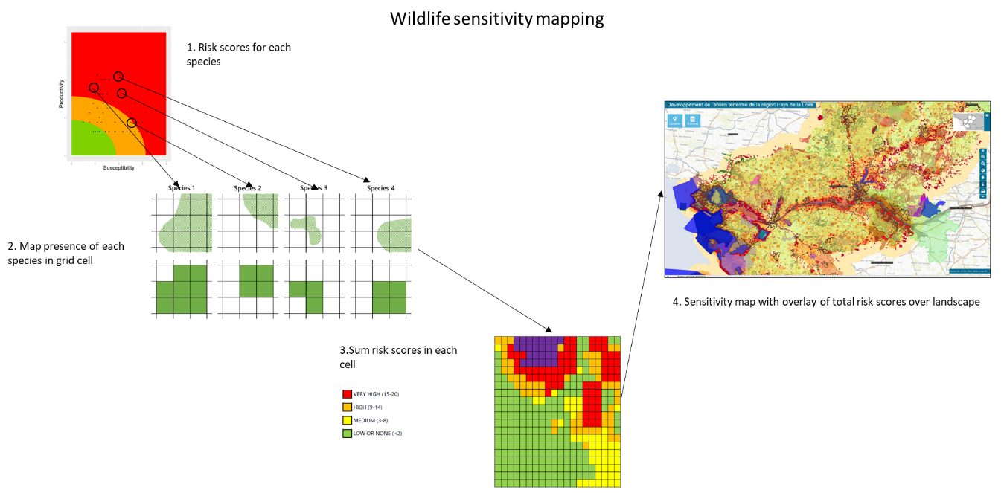
Figure 11. General approach to wildlife sensitivity mapping
Sensitivity maps represent a natural progression from the very large-scale regional approach taken with the ecological risk assessments to map much finer scale processes and risks. However, the data requirements, especially on the spatial distribution of species of interest, are considerably greater than the regional ecological risk assessments presented in this report. Compiling such sensitivity maps may also facilitate cross-sectoral collaboration by including Commonwealth priority species and priority locations as well as actions included in Threatened Species Action Plans.
Once a location has been identified that avoids the overlap of areas of high-risk to birds and the wind farm then the additional technical measures to mitigate impacts should be considered. These include:

Infrastructure design: Number of turbines and technical specifications (including lighting)
Using baseline field-survey data or operational monitoring data with predictive modelling (such as collision-risk models) makes it possible to explore the influence of turbine design and the number of turbines, to arrive at an optimal design of low ecological risk. For example, modelling by Johnston et al. (2014) demonstrated that raising hub height and using fewer, larger turbines are effective measures for reducing bird collision risk to seabirds. This approach increases the distance between the lowest point of the turbine and the ground/surface. This may be particularly relevant in areas used extensively by below canopy foraging birds and bats, meaning they are predominantly at heights less than 30 m above ground level. However, while this approach could also be an effective measure for birds and bats occurring near onshore wind farms experimental evidence is currently lacking.

Scheduling and curtailment
Scheduling, which involves avoiding, reducing or phasing activities during ecologically sensitive times of the year may be of most use during construction, repowering and decommissioning, rather than during operation. An example of mitigation through scheduling could include construction and operation activities being either suspended or reduced during migration and/or nesting periods.
Curtailment is defined (European Commission 2020) as:
- temporarily shutting down turbines during known migration times to reduce collision risk (especially in bad weather and visibility conditions) and,
- rotating the rotor plane out of the direction of migration.
Implementation of curtailment measures requires good prediction models for migration routes and timing; and surveys of migration intensity in the immediate surroundings of wind farms (European Commission 2020).
The timing of turbine operation can be effective in avoiding or reducing the risk of bird and bat collision at wind farms. Curtailment is one of the measures that can help reduce the risk of bird and bat collision (Brabant et al. 2021, Bennett et al. 2022). Large numbers of migratory shorebirds are known to fly to Australia from northern hemisphere breeding grounds in the spring and depart in the autumn, providing temporal windows of elevated potential collision risk (Howell et al. 2020). There are also regular spring and autumn movement between the Australian mainland and Tasmania, that involve species of high conservation status such as Orange-bellied and Swift Parrots (Menkhorst et al. 2021; Webb et al. 2021), and many Australian land birds exhibit regular spring and autumn movement between northern and southern parts of the continent, e.g., woodswallows, Rainbow bee-eater, cuckoos (Menkhorst et al. 2017). While not as predictable as movements of obligatory migrants, understanding the conditions that lead to these movements as well as evidence from regular surveys could be used as triggers for curtailment measures.
Automated curtailment systems have been developed for use in terrestrial wind farms and have been successful in detecting eagles approaching turbines. McLure et al. (2021) describe the use of IdentiFlight®, a camera system integrated with an artificial intelligence system, that detect objects, estimates the line-of-sight distance to the object and takes 10 photographs per second to track movement. The probability that the object will enter the rotor-swept zone is then used to trigger a curtailment.
For bats, operational or blanket curtailment is a mitigation approach that involves raising the threshold for ambient wind speed (“cut-in speed”) at which turbines begin generating electricity. Curtailment of turbine operations during low wind conditions, particularly in late summer and autumn when bat fatality rates are highest (Rodhouse et al. 2019; Adams et al. 2021; Whitby et al. 2021), is an operational minimisation tactic to reduce bat fatality at terrestrial wind facilities (Adams et al. 2021). Below the cut-in speed, turbine blades can spin with the wind but do so much more slowly, especially if blades are pitched to catch as little wind as possible. Because bats tend to be more active at lower wind speeds, increasing turbine cut-in speed (often lower than 6 ms−1) between dusk and dawn during periods of high bat activity can significantly reduce bat fatality (Baerwald et al. 2009, Arnett et al. 2011, Rodhouse et al. 2019; Adams et al. 2021; Whitby et al. 2021, Bennett et al. 2022). However, other factors such as time of year, weather, turbine dimensions, and landscape characteristics, also influence fatality risk and variability has been reported in the level of fatality reduction achieved by curtailment (Adams et al. 2021). Bennett et al. (2022) found curtailment (at a wind speed of 4.5 ms 1) significantly reduced mortality of bats by 54% and concluded that curtailment was a valid method for reducing bat turbine collision in south-eastern Australia. While Adams et al. (2021) considered curtailment to be an effective operational mitigation measure for microbats, they recommended additional curtailment studies to determine precisely the relationship between the magnitude of increased cut-in speed (e.g., the amount by which the cut-in speed of turbines is adjusted from the factory settings) and the degree of fatality reduction in bats.

Acoustic and visual deterrents
Deterrents typically involve the installation of devices that emit audible or visual stimuli constantly, intermittently or when triggered by a bird-detection system. Passive deterrents such as painting turbine towers and blades can also change the detectability of infrastructure. The effectiveness of particular deterrent techniques is inevitably site and species-specific, however, evidence of 70% reductions in fatality rates associated with turbines with one blade painted black, compared to unpainted turbines, have been reported in onshore wind farms (May et al 2020).
Increasing the visibility of structures may reduce collisions but may only be accepted by local residents if it does not create a visual disturbance. Baasch et al (2022) showed the potential for ultraviolet (UV) light, which is nearly imperceptible to humans, to mitigate avian collisions with anthropogenic structures. They tested the effectiveness of two UV (390–400 nm) Avian Collision Avoidance Systems (ACASs) at reducing collisions with power lines at an important migratory bird stopover location in Nebraska. They found the focal ACAS illumination reduced collisions by 88%, suggesting that illuminating power lines, guy wires, towers, wind turbines, and other anthropogenic structures with UV illumination will likely lower collision risks for birds while increasing human acceptance of mitigation measures in urban areas. Future applications of ACASs would benefit from additional study to check for potential negative effects on nocturnal foragers such as echolocating bats, non-echolocating bats or nocturnal birds drawn to insects.

Challenges to assessing best practice monitoring and mitigation in Australia
Evaluation of best-practice in the monitoring and mitigation of impacts from wind farms in Australia is hampered by a lack of consistent and comparable data on the potential and realised impact of wind farms on birds and bats. Mason and Ford (2023) outlined the need for national standards for bird utilisation surveys for wind farm proposals, and how the implementation of generic guidelines has led to a proliferation of site and proponent-specific methods that preclude meaningful comparison of the potential risks to birds and bats of different wind farm developments. There is also a very similar argument concerning the need for national standards for post-construction bird and bat fatality monitoring. Rigorous comparison of the numbers of birds and bats killed at wind farms is impossible due to the lack of transparency and/or consistency in the methods used to provide mortality data. In an analysis of post-construction mortality monitoring data from Victorian wind farms Moloney et al(2019) reported that, because of the way monitoring was designed or undertaken, a statistical analysis to estimate total mortalities could only be undertaken with data from two of 15 wind farms (and even for these wind farms the estimates had very large uncertainties). This clearly presents a challenge in determining the total mortality of threatened species arising from all wind farms in Australia.
Lack of accurate and precise post-construction mortality data also prevents the ability to develop and assess effective mitigation measures. In particular, without common standards for collection and analysis of mortality data, the opportunity to introduce effective, novel mitigation measures may be missed. For example, a trial of mitigation measures that includes rigorous carcass search and bias correction methods, and statistical procedures may appear to kill more birds than a wind farm that does not implement the same mitigation measure simply because of the differences in search and analysis methods. This means that the roll-out of positive mitigation measures will be missed, with contingent negative conservation outcomes.
Moloney et al (2019) provided potential options for assessing the impacts of wind farms on birds and bats. These ranged from discontinuing post-construction mortality monitoring (based on the assumption that risks have been adequately dealt with during pre-construction assessments) to taking a centrally designed, landscape-scale approach, using consistent methods across all wind farms in a region to assess population level impacts. There are clearly logistic and resource challenges in implementing the latter approach, however, the concerns raised by Mason and Ford (2023) would suggest that the assumption of risks being adequately addressed in the pre-construction phase may not be supported. In order to assess the regional-scale impacts of wind farms on populations of threatened species, and an ability to robustly evaluate effective mitigation of those impacts, changes to the current approach are required. A first step in this process would be to develop an inventory of the pre- and post-construction bird utilisation and carcass monitoring methods, analysis procedures and results from all onshore wind farms in Australia.
While the development of an agreed ‘standard method’ may be difficult there could be requirement for centralised reporting not just of results but also the metadata and data documentation required enable the ongoing management, context, discovery and potential reuse of data. The data documentation should also outline all data quality assurance processes that have been applied to the data. All data should be curated so that it is consistent and interoperable with other monitoring to inform a regional and national understanding of the impacts of wind farms of all species. To help develop this interoperability all data management systems should align with guiding principles of findability, accessibility, interoperability, and reusability (the FAIR principles, Wilkinson et al. 2016). Detailed documentation is required in order to provide regulators with confidence in the methods used and the results obtained when assessing the impacts of an individual wind farm. The methods used should be reviewed and agreed as part of the permitting process and any deviations from them should be agreed before they are used. Software that is used for the analysis should be non-proprietary and open-source to allow for appropriate validation processes. In the absence of coordination, estimates of the total numbers of animal mortalities associated with wind farms will be highly uncertain, but almost certainly substantial underestimates.

Appendix 1: Linking the taxonomy of the Working List of Australian Birds to the EPBC status from the SPRAT database
This describes the workflow to link records from the WLAB 4.3 to data from the SPRAT database using the scientific name as the linking field.

Data Preparation
SPRAT data – download 1 April 2025
The specification of the SPRAT output is to include all fields for Species names and Taxon Group for species and subspecies along with EPBC Threat Status, Migratory and Marine listings and the State Threat listed and IUCN Red List status.
This data was downloaded from SPRAT was filtered for those records where Taxon Group is ‘birds’; providing 661 records.
Records where the only non-empty field was for the IUCN Red List status of Least Concern were removed.
Records where the EPBC status is extinct, or the only non-empty field is a State/Territory status of extinct (this is only present in the NSW TSC Act and FM Act field) were deleted.
There are some species that are not true duplicates (i.e. where the species is the same, but the attributes are different) and these have been updated as follows:
- Herald Petrel appears is duplicated in the SPRAT as Pterodroma heraldica and ‘Pterodroma arminjoniana s. lat. (Herald Petrel (includes P. arminjoniana and P. heraldica))’. The latter is only included because it is listed as Marine. The record for Pterodroma heraldica was not listed as Marine.
Action: Pterodroma heraldica listed as Marine and ‘Pterodroma arminjoniana s. lat. (Herald Petrel (includes P. arminjoniana and P. heraldica))’ deleted.
- Tasmanian Masked Owl Tyto novaehollandiae castanops is duplicated as ‘Tyto novaehollandiae castanops (Tasmanian population)’ which is listed under EPBC Threat as Vulnerable, whereas Tyto novaehollandiae castanops is listed as Endangered in Tasmania.
Action: Tyto novaehollandiae castanops includes both the EPBC and State listings status and “Tyto novaehollandiae castanops (Tasmanian population)” is deleted.
- Elegant Parrot Neophema elegans (Vulnerable in Victoria) is duplicated as ‘Eastern Elegant Parrot Neophema elegans elegans’ (Rare in SA NPW Act). The latter is no longer recognised as a valid subspecies.
Action: Neophema elegans includes both the State and EPBC listings and ‘Eastern Elegant Parrot Neophema elegans elegans’ is deleted.
- Rock Parrot Neophema petrophila (EPBC Marine) is duplicated as ‘Neophema petrophila zietzi’ (Rare in SA NPW Act). The latter is no longer recognised as a valid subspecies.
Action: Neophema petrophila includes both the State and EPBC listings and ‘Neophema petrophila zietzi’ is deleted.
- Arctic Tern Sterna paradisaea (which is listed as Marine) is duplicated as ‘Sterna paradisaea (Atlantic populations)’ this is listed a as Migratory.
Action: Arctic Tern Sterna paradisaea is listed as Migratory and Marine and ‘Sterna paradisaea (Atlantic populations)’ is deleted.
- Royal Penguin is not recognised as a species in EPBC and is implicitly included as Eudyptes chrysolophus.
Action: The EPBC record for ‘Eudyptes chrysolophus sensu lato' becomes 'Eudyptes schlegeli', Royal Penguin and 'Eudyptes chrysolophus (sensu stricto)' becomes 'Eudyptes chrysolophus', Macaroni Penguin.
- Southern Cassowary is listed under EPBC as Endangered but is also included as a northern and southern population in the QLD NC Regulation. The solution used here is to follow EPBC and include Endangered in a single record, referring also the QLD NC Regulation for the species, and remove the records for the two regional populations.
- Ruff is duplicated as Philomachus pugnax (EPBC Migratory and Marine) and Calidris pugnax (Rare SA NPW Act). The WLAB only includes Calidris pugnax.
Action: Calidris pugnax includes both the EPBC and State listings (i.e it is listed as Migratory, Marine under EPBC and Rare under the SA NPW Act. Philomachus pugnax is deleted.
- Buff-breasted Sandpiper is duplicated because it has a different scientific name in the EPBC listing (Tryngites subruficollis, where it is listed as Marine) and the IUCN Redlist (Calidris subruficollis). The WLAB only includes Calidris subruficollis.
Action Calidris subruficollis is listed as Marine and Tryngites subruficollis is deleted.
- Broad-billed Sandpiper is duplicated because it has a different scientific name in the EPBC listing (Limicola falcinellus, where it is listed as Migratory and Marine under EPBC and Vulnerable under NSW BC Act and FM Act ) and the IUCN Redlist (Calidris falcinellus). The WLAB only includes Calidris falcinellus.
Action Calidris falcinellus includes both the EPBC and State listings and Limicola falcinellusis is deleted.
- The Little Egret is duplicated as Egretta garzetta nigripes in the SA NPW Act and Victoria. FFG Act (Advisory Lists) but as Egretta garzetta for EPBC listing. The subspecies Egretta garzetta nigripes is no longer recognised as a valid subspecies in WLAB.
Action Egretta garzetta includes both the State and EPBC listings and ‘Egretta garzetta nigripes’ is deleted.
This removal of duplicates gives a final list of 625 records from the original SPRAT output.

Preparation of the WLAB 4.3 data.
WLAB 4.3 was downloaded as a csv file from https://birdata.birdlife.org.au/whats-in-a-name. on 1 April 2025.
Each record has a Population field that reflects its status in Australia. All records where the Population status is not ‘Australian’, ‘Endemic’, ‘Endemic (breeding only)’, ‘Non-breeding’, ‘Vagrant’ or ‘Vagrant?’ were removed. This gets rid of Domestic, Introduced, Extinct, No confirmed record etc.
This reduces the original 2106 records to 1927 records

Data linking
Step 1
Link the SPRAT and WLAB data using a left join with the Scientific Name as the linking field results in 62 records in the 625 rows of data not linking.
Step 2
The majority of these non-linked records have differences in the scientific name that are the result of changes/updates to taxonomy. The nomenclature of the non-linked EPBC records has been reviewed and the corresponding name used in WLAB 4.3 (to allow the linking of records) is provided in Appendix 1.
Implementing the changes in Table 15 leaves 12 records in the SPRAT output that do not link to the WLAB. These are identified in the comments field of Appendix 1. In most cases there are no confirmed records of the species in Australia, however, there are two subspecies that are listed under EPBC but not recognised as subspecies in WLAB:
- Fairy Prion (southern), Pachyptila turtur subantarctica, Vulnerable
- Western Beautiful Firetail, Beautiful Firetail (Mt Lofty Range and Kangaroo Island), Stagonopleura bella Samueli, Endangered
Step 3
Following the logic s528 of the EPBC Act, in which a “species” is defined as including subspecies, all subspecies have inherited the status of the species for EPBC Threat Status, Migratory, Marine and all State Threat listings unless the subspecies has a listing in its own right.
For example, in the case of Bar-tailed and Black-tailed Godwits:
Bar-tailed Godwit is listed as Migratory and Marine at the species level and two of the subspecies have an EPBC Threat status of Endangered.
Black-tailed Godwit is listed as Endangered and also Migratory and Marine (but the subspecies Limosa limosa melanuroides does not have any listing (Table 16).
In the updated listing all subspecies of Bar-tailed godwit inherit the Migratory and Marine status from the species level listing but retain the subspecies level EPBC threat status (there is a third subspecies in the WLAB that inherits the Migratory and Marine status but does not have an EPBC threat status). For Black-tailed Godwit the subspecies inherits the EPBC threat status as well as the Migratory and Marine status from the species level (Table 17).
The taxonomy of the Shy Heathwren is complex. The nominate species Hylacola cauta has been renamed Calamanthus cautus in WLAB, with consequential renaming of subspecies. Hylacola cauta is listed as Vulnerable under the NSW BC Act and FM Act, however, based on subspecies distributions it seems likely that this is Riverina Shy Heathwren Calamanthus cautus macrorhynchus. However, the process by which subspecies inherit the listing status of the species means that all subspecies of Calamanthus cautus are included as Vulnerable under the NSW BC Act and FM Act.
Table 15 Changes to the EPBC listed name to allow linking to the WLAB 4.3 scientific name. Where the scientific name change filed is empty there is a corresponding explanatory comment
EPBC Scientific Name | EPBC Common Name | EPBC Threat Status | Scientific Name changed to link to WLAB | Comments
Ptiloris victoriae | Victoria's Riflebird |  | Lophorina paradisea
Motacilla flava | Yellow Wagtail |  | Motacilla tschutschensis
Pitta erythrogaster | Red-bellied Pitta |  | Erythropitta macklotii digglesi
Cuculus saturatus | Oriental Cuckoo, Himalayan Cuckoo |  |  | Not in WLAB
Ptilinopus magnificus | Wompoo Fruit-Dove |  | Megaloprepia magnifica
Stercorarius maccormicki | South Polar Skua |  | Catharacta maccormicki
Calidris mauri | Western Sandpiper |  |  | No confirmed records
Himantopus himantopus | Pied Stilt, Black-winged Stilt |  | Himantopus leucocephalus
Tadorna radjah | Radjah Shelduck |  | Radjah radjah
Puffinus lherminieri | Audubon's Shearwater |  |  | Not in WLAB
Apus affinis | House Swift |  | Apus nipalensis
Falcunculus frontatus whitei | Crested Shrike-tit (northern), Northern Shrike-tit | Vulnerable | Falcunculus whitei
Eclectus roratus macgillivrayi | Macgillivray's Eclectus Parrot, Eclectus Parrot (Cape York Peninsula) |  | Eclectus polychloros macgillivrayi
Phoenicopterus ruber | American Flamingo, Caribbean Flamingo |  | Phoenicopterus roseus
Hylacola cauta | Shy Heathwren |  | Calamanthus cautus
Melithreptus gularis laetior | Golden-backed Honeyeater |  | Melithreptus laetior
Lonchura oryzivora | Java Sparrow |  |  | Introduced
Hylacola pyrrhopygia | Chestnut-rumped Heathwren |  | Calamanthus pyrrhopygius
Phalaropus fulicaria | Grey Phalarope |  | Phalaropus fulicarius
Lugensa brevirostris | Kerguelen Petrel |  | Aphrodroma brevirostris
Ducula bicolor | Pied Imperial-Pigeon |  |  | No confirmed records
Cyclopsitta diophthalma coxeni | Coxen's Fig-Parrot | Critically Endangered | Cyclopsitta coxeni
Pachyptila turtur subantarctica | Fairy Prion (southern) | Vulnerable |  | Not in WLAB
Cyanoramphus cookii | Norfolk Island Green Parrot, Tasman Parakeet, Norfolk Island Parakeet | Endangered | Cyanoramphus novaezelandiae cookii
Hylacola pyrrhopygia parkeri | Chestnut-rumped Heathwren (Mt Lofty Ranges) | Endangered | Calamanthus pyrrhopygius parkeri
Hylacola pyrrhopygia pedleri | Flinders Chestnut-rumped Heathwren |  | Calamanthus pyrrhopygius pedleri
Melithreptus gularis gularis | Black-chinned Honeyeater (eastern) |  | Melithreptus gularis
Stagonopleura bella samueli | Western Beautiful Firetail, Beautiful Firetail (Mt Lofty Range and Kangaroo Island) | Endangered |  | Not in WLAB
Psophodes leucogaster lashmari | Kangaroo Island Whipbird | Endangered | Psophodes nigrogularis lashmari
Psophodes leucogaster leucogaster | Mallee Whipbird | Endangered | Psophodes nigrogularis leucogaster
Chroicocephalus novaehollandiae | Silver Gull |  | Larus novaehollandiae
Hylacola cauta halmaturina | Shy Heathwren (Kangaroo Island) | Vulnerable | Calamanthus cautus halmaturinus
Accipiter hiogaster natalis | Christmas Island Goshawk | Endangered | Accipiter fasciatus natalis
Lophochroa leadbeateri | Major Mitchell's Cockatoo, Pink Cockatoo |  | Cacatua leadbeateri
Lophochroa leadbeateri leadbeateri | Major Mitchell's Cockatoo (eastern), Eastern Major Mitchell's Cockatoo, Pink Cockatoo (eastern) | Endangered | Cacatua leadbeateri leadbeateri
Pezoporus flaviventris | Western Ground Parrot, Kyloring | Critically Endangered | Pezoporus wallicus flaviventris
Stercorarius antarcticus | Brown Skua |  | Catharacta antarctica
Stercorarius antarcticus lonnbergi | Brown Skua (Lonnberg's), Southern Great Skua |  | Catharacta antarctica lonnbergi
Leucophaeus atricilla | Laughing Gull |  | Larus atricilla
Leucophaeus pipixcan | Franklin's Gull |  | Larus pipixcan
Chroicocephalus ridibundus | Black-headed Gull |  | Larus ridibundus
Ptilonorhynchus guttatus guttatus |  |  | Chlamydera guttata guttata
Amblyornis newtonianus | Golden Bowerbird |  | Prionodura newtoniana
Procellaria conspicillata | Spectacled Petrel |  |  | Not in WLAB
Sterna hirundo hirundo (Western Palearctic populations) | Atlantic Common Tern, Common Tern (Western Palearctic populations) |  | Sterna hirundo hirundo
Antigone antigone | Sarus Crane |  | Grus antigone
Amytornis rowleyi | Opalton Grasswren, Rusty Grasswren |  | Amytornis striatus rowleyi
Falcunculus frontatus frontatus | Eastern Crested Shrike-tit |  | Falcunculus frontatus
Parvipsitta porphyrocephala | Purple-crowned Lorikeet |  | Glossopsitta porphyrocephala
Parvipsitta pusilla | Little Lorikeet |  | Glossopsitta pusilla
Sterna virgata | Kerguelen Tern |  |  | No confirmed records
Hylacola pyrrhopygia pyrrhopygia | Eastern Chestnut-rumped Heathwren |  | Calamanthus pyrrhopygius pyrrhopygius
Pseudobulweria becki | Beck's Petrel |  |  | No confirmed records
Anas eatoni | Eaton's Pintail, Southern Pintail, Kerguelen Pintail. |  |  | Not in WLAB
Ardea intermedia plumifera | Plumed Egret, Intermediate Egret (Plumed) |  | Ardea plumifera
Larus dominicanus dominicanus | Pacific Kelp Gull |  | Larus dominicanus antipodus
Northiella narethae | Naretha Bluebonnet, Naretha Parrot |  | Northiella haematogaster narethae
Gelochelidon nilotica macrotarsa | Australian Gull-billed Tern |  | Gelochelidon macrotarsa
Anous albivitta | Grey Noddy, Grey Ternlet |  | Anous albivittus
Antigone rubicunda | Brolga |  | Grus rubicunda
Calidris minutilla | Least Sandpiper |  |  | Not in WLAB

Table 16 SPRAT output for “Godwits”
Taxon Name | Scientific Name | EPBC Threat | Migratory | Marine
Bar-tailed Godwit | Limosa lapponica |  | Listed | Listed
Nunivak Bar-tailed Godwit, Western Alaskan Bar-tailed Godwit | Limosa lapponica baueri | Endangered
Northern Siberian Bar-tailed Godwit, Russkoye Bar-tailed Godwit | Limosa lapponica menzbieri | Endangered
Black-tailed Godwit | Limosa limosa | Endangered | Listed | Listed –overfly marine area
Black-tailed Godwit (Siberian), Black-tailed Godwit (eastern Siberia) | Limosa limosa melanuroides

Table 17 Inherited SPRAT status for “Godwits”
Taxon Name | Scientific Name | EPBC Threat | Migratory | Marine
Bar-tailed Godwit | Limosa lapponica |  | Listed | Listed
Alaskan Bar-tailed Godwit | Limosa lapponica baueri | Endangered | Listed | Listed
Yakutian Bar-tailed Godwit | Limosa lapponica menzbieri | Endangered | Listed | Listed
Anadyr Bar-tailed Godwit | Limosa lapponica anadyrensis |  | Listed | Listed
Black-tailed Godwit | Limosa limosa | Endangered | Listed | Listed –overfly marine area
Eastern Black-tailed Godwit | Limosa limosa melanuroides | Endangered | Listed | Listed –overfly marine area

Appendix 2: Ecological Risk Assessment table for birds by State and Territory
This is provided as an Excel spreadsheet to maximise search and filter functionality.

Appendix 3: Ecological Risk Assessment table for bats by State and Territory
This is provided as an Excel spreadsheet to maximise search and filter functionality.

Appendix 4: Ecological Risk Assessment table for birds
This is provided as an Excel spreadsheet to maximise search and filter functionality.

Appendix 5: Ecological Risk Assessment table for bats
This is provided as an Excel spreadsheet to maximise search and filter functionality.

Glossary
Term | Definition
APAB | Action Plan for Australian Birds
APAM | Action Plan for Australian Mammals
Barrier effects | Where a physical barrier impedes or blocks movement or interaction
BC Act | Biodiversity Conservation Act 2016 (WA)
BC Act | Biodiversity Conservation Act 2016 (NSW)
CRM | Collision risk modelling
EPBC | Environment Protection and Biodiversity Conservation Act 1999
ERA | Ecological Risk Assessment
FFG Act (Advisory Lists) | Flora and Fauna Guarantee Act 1988 (VIC)
FH | Flight height
FM Act | Fisheries Management Act 1994 (FM Act) (NSW)
HA | Habitat specialisation
FM | Flight manoeuvrability
LiDAR | A remote sensing technique that records the three-dimensional location of objects by emitting frequent, short-duration laser pulses
NC Act | Nature Conservation Act 2014 (ACT)
NC Regulations | Nature Conservation (Animals) Regulation 2020 (QLD)
NPW Act | National Parks and Wildlife Act 1972 (SA)
P | Productivity
TPWC Act | Territory Parks and Wildlife Conservation Act 1976 (NT)
TSP Act | Threatened Species Protection Act 1995 (TAS)

References
Adams EM, Gulka J, Williams KA 2021. A review of the effectiveness of operational curtailment for reducing bat fatalities at terrestrial wind farms in North America. PLoS ONE 16(11): e0256382.
Allinson T, Jobson B, Crowe O, Lammerant J, Van Den Bossche W Badoz L 2020. The Wildlife Sensitivity Mapping Manual: Practical guidance for renewable energy planning in the European Union. Final report for the European Commission (DG ENV) (Project 07.027733/2017/768654/SER/ENV.D.3).
Armstrong KN, Reardon TB, Jackson SM 2020. A current taxonomic list of Australian Chiroptera. Australasian Bat Society. Version 2020-06-09.
Arnett EB (Ed.) 2005. Relationships between bats and wind turbines in Pennsylvania and West Virginia: an assessment of bat fatality search protocols, patterns of fatality, and behavioral interactions with wind turbines. Final report submitted to the Bats and Wind Energy Cooperative. Bat Conservation International, Austin, Texas, USA.
Arnett EB, Huso MMP, Schirmacher MR, Hayes JP 2011. Altering turbine speed reduces bat mortality at wind-energy facilities. Frontiers Ecology and Environment 9, 209–214.
Arnett EB., Brown K, Erickson WP, Fiedler J, Henry TH, Johnson GD, Kerns J, Kolford RR, Nicholson CP, O’Connell T, Piorkowski M, Tankersly JR 2008. Patterns of fatality of bats at wind energy facilities in North America. Journal of Wildlife Management 72, 61–78.
Australasian Bat Society 2024. Batmap.
Baasch DM, Hegg AM, Dwyer JF, Caven AC, Taddicken WE, Worley CA, Medaries AH, Wagner CG, Dunbar PG, Mittman ND 2022. Mitigating avian collisions with power lines through illumination with ultraviolet light. Avian Conservation and Ecology 17 (2), 9.
Baerwald EF, D’Amours GH, Klug BJ, Barclay RMR 2009. Barotrauma is a significant cause of bat fatalities at wind turbines. Current Biology. 2008; 18(16), R695–R696.
Baerwald EF, Edworthy J, Holder M, Barclay RMR 2009. A large-scale mitigation experiment to reduce bat fatalities at wind energy facilities. Journal of Wildlife Management 73, 1077–1081.
Baker GB, Reid K 2025. Report on a review of existing risk assessment methods and model input parameters used to examine the impacts on birds from Offshore and Onshore Wind Farms. Report to Department of Climate Change, Energy, the Environment and Water. Latitude 42 Environmental Consultants, Kettering, Australia.
Band W, Madders M, Whitfield DP 2007. Developing field and analytical methods to assess avian collision risk at wind farms. In, De Lucas M, Janss GFE, Ferrer M. (Eds), Birds and wind farms: risk assessment and mitigation, pp. 259–275. Quercus, Madrid, Spain.
Barclay RMR, Baerwald EF, Gruver JC 2007. Variation in bat and bird fatalities at wind energy facilities: assessing the effects of rotor size and tower height. Canadian Journal of Zoology 85, 381–387.
Bennett EM, Florent SN, Venosta M, Gibson M, Jackson A, Stark E 2022. Curtailment as a successful method for reducing bat mortality at a southern Australian wind farm. Austral Ecology 47, 1329–1339.
Bird JP, Martin R, Akçakaya HR, Gilroy J, Burfield IJ, Garnett ST, Symes A, Taylor J, Şekercioğlu ÇH, Butchart SHM 2020. Generation lengths of the world's birds and their implications for extinction risk. Conservation Biology 34: 1252-1261.
Briggs C, Hemer M, Howard P, Langdon R, Marsh P, Teske S, Carrascosa D 2021. Offshore Wind Energy in Australia: Blue Economy Cooperative Research Centre, Launceston, TAS. 92p.
Chen IC, Hill JK, Ohlemüller R, Roy DB, Thomas CD 2011. Rapid range shifts of species associated with high levels of climate warming. Science 333,1024-1026 DOI:10.1126/science.1206432.
Churchill SK. 2008. Australian bats.2nd ed. Allen and Unwin, Crows Nest, NSW.
Clocker K, Hu C, Roadman J., Albertani R., Johnston M.L 2021. Autonomous Sensor System for Wind Turbine Blade Collision Detection. in IEEE Sensors Journal, doi: 10.1109/JSEN.2021.3081533
Cook ASCP, Humphreys EM, Masden EA, Burton NHK 2014. The avoidance rates of collision between birds and offshore turbines. BTO Research Report No. 656.
Cook ASCP, Salkanovic E, Masden E, Lee HE, Kiilerich AH 2025. A critical appraisal of 40 years of avian collision risk modelling: How have we got here and where do we go next? Environmental Impact Assessment Review 110, 107717.
Crane M, Silva I, Grainger MJ, Gale GA 2025. Predicting risk to bat species from wind turbine collision in Southeast Asia. Conservation Biology, 39, e14452.
Dahl EL, Bevanger K, Nygård T, Røskaft E, Stokke BG 2012. Reduced breeding success in white-tailed eagles at Smøla wind farm, western Norway, is caused by mortality and displacement. Biological Conservation 145, 79–85.
Dalthorp D, Huso M, Dail D 2017. Evidence of absence (v2.0) software user guide: U.S. Geological Survey Data Series 1055, 109 p.
Drewitt AL, Langston RHW 2006. Assessing the impacts of wind farms on birds. Ibis 148:29–42.
Environment Canada 2007. Wind turbines and birds: a guidance document for environmental assessment. Environment Canada and Canadian Wildlife Service, Gatineau, Quebec, Canada.
Erickson WP, Johnson GD, Young D, Strickland D, Good R, Bourassa M, Bay K, Sernka K 2002. Synthesis and comparison of baseline avian and bat use, raptor nesting and mortality information from proposed and existing wind developments. Bonneville Power Administration, Portland, Oregon, USA.
European Commission 2020. Commission notice. Guidance document on wind energy developments and EU nature legislation. Brussels 18.11.2020 C(2020) 7730 final, 182pp.
Ferrer M, de Lucas M, Janss GFE, Casado E, Munoz AR, Marc J. Bechard MJ, Cecilia P, Calabuig CP 2012. Weak relationship between risk assessment studies and recorded mortality in wind farms. Journal of Applied Ecology 49, 38-46.
Festa F, Ancillotto L, Santini L, Pacifici M, Rocha R, Toshkova N, Amorim F, Benítez-López A, Domer A, Hamidović D, Kramer-Schadt S, Mathews F, Radchuk V, Rebelo H, Ruczynski I, Solem E, Tsoar A, Russo D, Razgour O 2023. Bat responses to climate change: a systematic review. Biol Rev, 98: 19-33.
Fiedler JK 2004. Assessment of bat mortality and activity at Buffalo Mountain Wind farm, Eastern Tennessee. Thesis, University of Tennessee, Knoxville, USA.
Furness RW, Wade HM, Masden EA 2013. Assessing vulnerability of marine bird populations to offshore wind farms. Journal of Environmental Management 119, 56–66.
Garnett ST, Baker GB. (Eds) 2021. The Action Plan for Australian Birds 2020. CSIRO Publishing, Melbourne. Doi:10.1071/9781486311910
Garnett ST, Duursma DE, Ehmke G, Guay P-J, Stewart A, Szabo JK, Weston MA, Bennett S, Crowley GM, Drynan D, Dutson G, Fitzherbert K, Franklin DC 2015. Biological, ecological, conservation and legal information for all species and subspecies of Australian bird. Sci Data 2, 150061 (2015).
Garthe S, Hüppop O 2004. Scaling possible adverse effects of marine wind farms on seabirds — Developing and applying a vulnerability index: Journal of Applied Ecology, v. 41, no. 4, p. 724–734, doi:10.1111/j.021-8901.2004.0918.x.
Garvin JC, Jennelle CS, Drake D, Grodsky SM 2011. Response of raptors to a wind farm. Journal of Applied Ecology 48, 199-209.
Gauld JG, Silva JP, Atkinson PW, Record P, Acácio M, Arkumarev V, Blas J, Bouten W, Burton N, Catry I, Champagnon J, Clewley GD, Dagys M, Duriez O, Exo K-M, Fiedler W, Flack A, Friedemann G, Fritz J, Garcia-Ripolles C, Garthe S, Giunchi D, Grozdanov A, Harel R, Humphreys E M, Janssen R, Kölzsch A, Kulikova O, Lameris TK, López-López P, Masden EA, Monti F, Nathan R, Nikolov S, Oppel S, Peshev H, Phipps L, Pokrovsky I, Ross-Smith VH, Saravia V, Scragg ES, Sforzi A, Stoynov E, Thaxter C, Van Steelant W, van Toor M, Vorneweg B, Waldenström J, Wikelski M, Žydelis R, Franco AM 2022. Hotspots in the grid: Avian sensitivity and vulnerability to collision risk from energy infrastructure interactions in Europe and North Africa. Journal of Applied Ecology 59, 1496–1512.
Hobday AJ, Smith ADM, Stobutzki IC, Bulman C, Daleya R, Dambacher JM, Deng RA, Dowdney J, Fuller M, Furlani D, Griffith SP, Johnson D, Kenyon R, Knuckey IA, Linga SD, Pitcher R, Sainsbury KJ, Sporcic M, Smith T, Turnbull C, Walker TI, Wayte SE, Webb H, Williams A, Wise BS, Zhou S 2011. Ecological risk assessment for the effects of fishing. Fisheries Research 108:372–384.
Horn JW, Arnett EB, Kunz TH 2008. Behavioral responses of bats to operating wind turbines. Journal of Wildlife Management 72:123–132.
Hull CL, Stark EM, Peruzzo S, Sims CC 2013. Avian collisions at two wind farms in Tasmania, Australia: taxonomic and ecological characteristics of colliders versus non-colliders, New Zealand Journal of Zoology 40, 47-62.
Humphreys R, Caneco B, Cook A, Masden E 2022. stochLAB. Stochastic Collision Risk Model. R package version 1.1.2.
IUCN Standards and Petitions Committee 2019. Guidelines for Using the IUCN Red List Categories and Criteria. Version 14. Prepared by the Standards and Petitions Committee. IUCN.
Jenkins AR, Reid T, du Plessis J, Colyn R, Benn G, Millikin R 2018. Combining radar and direct observation to estimate pelican collision risk at a proposed wind farm on the Cape west coast, South Africa. PLoS ONE 13(2): e0192515.
Johnson GD, Erickson WP, Strickland MD, Shepherd MF, Shepherd DA, Sarappo SA 2003a. Mortality of bats at a large-scale wind power development at Buffalo Ridge, Minnesota. American Midland Naturalist 150:332–342.
Johnson GD, Erickson WP, White J, McKinney R 2003b. Avian and bat mortality during the first year of operation at the Klondike Phase I Wind Project, Sherman County, Oregon. Northwestern Wind Power, Goldendale, Washington, USA.
Johnston A, Cook AS, Wright LJ, Humphreys EM, Burton NH 2014. Modelling flight heights of marine birds to more accurately assess collision risk with offshore wind turbines. Journal of Applied Ecology 51 (1), 31-41.
Laidlaw H 2020. Australian electricity options: wind. Research Paper Series, 2020-21. Department of Parliamentary Services, Parliament of Australia.
Lane B, Jessop A 1985. Tracking of migrating waders in North-Western Australia using meteorological radar. Stilt 6, 17-29.
Lawson M, Jenne D, Thresher R, Houck D, Wimsatt J, Straw B 2010. An investigation into the potential for wind turbines to cause barotrauma in bats. PLoS ONE 15(12), e0242485.
Lloret RJ, Turiel A, Solé Ollé J, Berdalet E, Sabatés A, Olivares A, Gili JM, Vila Subirós J, Sardá Borroy R 2022. Unravelling the ecological impacts of large-scale offshore wind farms in the Mediterranean Sea. Science of The Total Environment, 2022, vol. 824, art. 153803.
Lumsden LF, Moloney P, Smales I 2019. Developing a science-based approach to defining key species of birds and bats of concern for wind farm developments in Victoria. Arthur Rylah Institute for Environmental Research Technical Report Series No. 301. Department of Environment, Land, Water and Planning, Heidelberg, Victoria.
Lumsden LF, Morrant DS, Broken-Brow J, Holz PH, McKeown A, Gill SJ, Vanderduys E 2022a. Bats. Ch.23 Bats, in, Smith BP, Waudby HP, Alberthsen C, Hampton JO (Eds), Wildlife Research in Australia, CSIRO Publishing.
Lumsden LF, Waudby HP, Meek PD, Crisp HA, Cripps JK, Cristescu R, Jamieson LT, Nelson JL, Teixeira D, Hodgens N, Rutter N, Morrant DS, Bower DS, Dickman CR, Soennichsen K 2022b. Chapter 5 Detecting and monitoring wildlife remotely, in, Smith BP, Waudby HP, Alberthsen C, Hampton JO (Eds), Wildlife Research in Australia, CSIRO Publishing.
Marques AT, Batalha H, Bernardino J 2021. Bird displacement by wind turbines: assessing current knowledge and recommendations for future studies. Birds 2, 460–475.
Marques AT, Batalha H, Rodrigues S, Costa H, Ramos Pereira MJ, Fonseca C, Mascarenhas M, Bernardino J 2014. Understanding bird collisions at wind farms: An updated review on the causes and possible mitigation strategies. Biological Conservation 179, 40–52.
Masden EA and Cook ASCP 2016. Avian collision risk models for wind energy impact assessments. Environmental Impact Assessment Review, 56, 43-49. 1.
Masden EA, Haydon DT, Fox AD, Furness RW 2010. Barriers to movement: modelling energetic costs of avoiding marine wind farms amongst breeding seabirds. Marine Pollution Bulletin 60 (7), 1085-1091.
Mason M, Ford G. 2023. Australia needs a national standard for baseline bird and bat utilisation studies for wind farm development. Ecological Society of Australia Blog.
Matthiopoulos J, Wakefield E, Jeglinski JW, Furness RW, Trinder M, Tyler G, Mccluskie A, Allen S, Braithwaite J, Evans T 2022. Integrated modelling of seabird-habitat associations from multi-platform data: A review. Journal of Applied Ecology 59, 909–920.
May R, Masden EA, Bennet F, Perron M 2019. Considerations for upscaling individual effects of wind energy development towards population-level impacts on wildlife. Journal of Environmental Management.230,84-93.
May R, Nygård T, Falkdalen U, Åström J, Hamre Ø, Stokke BG 2020. Paint it black: Efficacy of increased wind-turbine rotor blade visibility to reduce avian fatalities. Ecol Evol. 00:1–9.
McKay RA, Johns SE, Bischof R, Matthews F, van der Kooij J, Yoh N, Eldegard K. 2023. Wind energy development can lead to guild-specific habitat loss in boreal forest bats. Wildlife Biology e01168,
McLure CJW, Rolek BW, Braham MA, Miller TA, Duerr AE, McCabe JD, Dunn L, Katzner TE 2021. Eagles enter rotor-swept zones of wind turbines at rates that vary per turbine. Ecology and Evolution. 11,11267–11274.
Menkhorst P 2001. A field guide to the mammals of Australia. Oxford University Press, South Melbourne.
Menkhorst P, Magrath MJL, Stojanovic D, Garnett ST, Baker GB 2021. Orange-bellied Parrot Neophema chrysogaster. In The Action Plan for Australian Birds 2020. (Eds ST Garnett and GB Baker) pp. 450–454. CSIRO Publishing, Melbourne.
Menkhorst P, Rogers D, Clarke RH, Davies D, Marsack P, Franklin K 2017. The Australian Bird Guide. CSIRO Publishing, Melbourne.
Milne DJ, Reardon TB, Ford G 2023. BatMap – authoritative distribution maps for Australian bats. Australian Mammalogy 45, 350-355.
Moloney PD, Lumsden LF, Smales I 2019. Investigation of existing post-construction mortality monitoring at Victorian wind farms to assess its utility in estimating mortality rates. Arthur Rylah Institute for Environmental Research Technical Report Series No. 302. Department of Environment, Land, Water and Planning, Heidelberg, Victoria.
NatureScot 2021. Bats and onshore wind turbines: Survey, assessment and mitigation. Version August 2021.
Pacifici M, Santini L, Di Marco M, Baisero D, Francucci L, Grottolo Marasini G, Visconti P, Rondinini C 2013. Database on generation length of mammals. 5427 data records. Online at, version 1.0 (last updated on 2013-08-27).
Parnaby HE, King AG, Eldridge MDB 2021. A new bat species from Southwestern Western Australia, previously assigned to Gould’s Long-eared Bat Nyctophilus gouldi Tomes, 1858. Records of the Australian Museum 73, 53–66.
Pearce‐Higgins JW, Eglington SM, Martay B, Chamberlain DE 2015. Drivers of climate change impacts on bird communities. Journal of Animal Ecology 84, 943–954.
Peschko V, Mendel B, Müller S, Markones N, Mercker M, Garthe S 2020. Effects of offshore wind farms on seabird abundance: Strong effects in spring and in the breeding season. Marine Environmental Research 162, p.105157.
R Core Team 2023. R: A language and environment for statistical computing. R Foundation for Statistical Computing, Vienna, Austria.
Reardon TB, N. L. McKenzie NL, S. Cooper SJB, Appleton B, Carthew S, Adams M 2014. A molecular and morphological investigation of species boundaries and phylogenetic relationships in Australian free-tailed bats Mormopterus (Chiroptera : Molossidae). Australian Journal of Zoology, 2014, 62, 109–136.
Reid K, Baker GB. 2025. Impact on birds from offshore wind farms in Australia. Updated April 2025. Report to Department of Climate Change, Energy, the Environment and Water. Latitude 42 Environmental Consultants, Kettering, Australia.
Reid K, Baker GB, Woehler E 2022. Impact on birds from offshore wind farms in Australia. Department of Climate Change, Energy, the Environment and Water, Canberra.
Reid K, Baker GB, Woehler EJ 2023. An ecological risk assessment for the impacts of offshore wind farms on birds in Australia. Austral Ecology, 48, 418– 439.
Richard Y, Abraham E, Berkenbusch K 2017. Assessment of the risk of commercial fisheries to New Zealand seabirds, 2006–07 to 2014–15. New Zealand Aquatic Environment and Biodiversity Report 191.
Rodhouse TJ, Rodriguez RM, Banner KM, Ormsbee PC, Barnett J, Irvine KM 2019. Evidence of regionwide bat population decline from long-term monitoring and Bayesian occupancy models with empirically informed priors. Ecol. Evol. 9, 11078–88.
Rogers RM, Buler JJ, Wainwright CE, Campbell HA 2020. Opportunities and challenges in using weather radar for detecting and monitoring flying animals in the Southern Hemisphere. Austral Ecology 45: 127-136.
Ross-Smith VH, Thaxter CB, Masden EA, Shamoun-Baranes J, Burton NHK, Wright LJ, Rehfisch MM, Johnston A 2016. Modelling flight heights of lesser black-backed gulls and great skuas from GPS: a Bayesian approach. Journal of Applied Ecology 53 1676-1685.
Schodde R, Mason IJ 1999. The Directory of Australian Birds: Passerines. A taxonomic and zoogeographic atlas of the biodiversity of birds in Australia and its Territories. Collingwood, Australia, CSIRO Publishing 851 pp.
Simonis J, Dalthorp D, Huso M, Mintz J, Madsen L., Rabie P, Studyvin J 2018. GenEst user guide—Software for a generalized estimator of mortality: U.S. Geological Survey Techniques and Methods, Book 7, Chapter C19, 72 p.
Sivakumar AH, Sheldon D, Winner K, Burt CS, Horton KG 2021. A weather surveillance radar view of Alaskan avian migration. Proceedings of the Royal Society B, 288 (1950), 20210232.
Skov H, Leonhard SB, Heinänen S, Zydelis R, Jensen NE, Durinck J, Johansen W, Jensen BP, Hansen BL, PiperW, Grøn PN 2012. Horns Rev 2 Monitoring 2010-2012. Migrating Birds. Orbicon, DHI, Marine Observers and Biola. Report commissioned by DONG Energy.
Smales I, Muir S, Meredith C, Baird R 2013. A description of the Biosis model to assess risk of bird collisions with wind turbines. Wildlife Society Bulletin 37, 59–65.
Smallwood KS, Karas B 2010. Avian and Bat Fatality Rates at Old-Generation and Repowered Wind Turbines in California. Journal of Wildlife Management 73, 1062-1071.
Thaxter CB, Buchanan GM, Carr J, Butchart SHM, Newbold T, et al. 2017. Bird and bat species’ global vulnerability to collision mortality at wind farms revealed through a trait-based assessment. Proc. R. Soc.B.284:20170829.
Thaxter CB, Ross-Smith V-H, Cook ASCP 2015. How high do birds fly? A review of current datasets and an appraisal of current methodologies for collecting flight height data. BTO Research Report No. 666. Thetford, Norfolk, UK.
Thomson BG, Churchill S, LoCascio A 2024. Australian bats field guide. Mobile App. iOS and Android.
Tobias JA, Sheard C, Pigot AL, Devenish AJM, Yang J, Sayol F, Neate-Clegg MH C, and 108 others 2022. AVONET: morphological, ecological and geographical data for all birds. Ecology Letters 25, 581– 597.
Tulp I, McChesney S, De Goeij P 1994. Migratory departures of waders from north-western Australia: behaviour, timing and possible migration routes. Ardea vol 82, 201-201.
von Hensen F. 2004. Gedanken und arbeitshypothesen zur fledermausvertr glichkeit von windenergieanlagen. Nyctalus 9, 427–435.
Walsh SC, Ballard BM, Wester DB, Kuvlesky Jr WP, Brennan LA, Morrison ML, Boydston K 2017. High passage rates and different seasonal migration strategies of birds along the lower Texas coast. International Journal of Biodiversity and Conservation 9 (6), 183-199.
Warham J 1990. The Petrels: Their Ecology and Breeding Systems. Academic Press, London
Webb M, Stojanovic D, Roderick M, Saunders DL, Holdsworth M, Baker GB, Heinsohn R 2021, Swift Parrot Lathamus discolor. In The Action Plan for Australian Birds 2020. (Eds ST Garnett and GB Baker) pp. 427–431. CSIRO Publishing, Melbourne.
Weisshaupt N, Dokter AM, Arizaga J, Maruri M 2018. Effects of a sea barrier on large-scale migration patterns studied by a network of weather radars. Bird Study, 65 (2), 232-240.
Werber Y, Sextin H, Yovel Y, Sapir N 2023. BATScan: A radar classification tool reveals large-scale bat migration patterns. Methods in Ecology and Evolution 4, 1764–1779. DOI: 10.1111/2041-210X.14125.
Whitby MD, Schirmacher MR, Frick WF 2021. The state of the science on operational minimization to reduce bat fatality at wind energy facilities. A report submitted to the National Renewable Energy Laboratory. Bat Conservation International, Austin, Texas.
Wilkinson M, Dumontier M, Aalbersberg I, et al. 2016. The FAIR Guiding Principles for scientific data management and stewardship. Sci Data 3, 160018.
Woinarski JCZ, Burbidge AA, Harrison PL 2014. The Action Plan for Australian mammals 2012, CSIRO Publishing, Melbourne.
World Bank 2023. Post-construction Bird and Bat Fatality Monitoring for Onshore Wind Energy Projects in Emerging Market Countries. Good Practice Handbook and Decision Support Tool. World Bank Group, Washington, D.C. Available for download from:
Young DP, Erickson WP, Good RE, Strickland MD, Johnson GD 2003a. Final report avian and bat mortality associated with the initial phase of the Foote Creek Rim windpower project, Carbon County, Wyoming: November 1998–June 2002. Pacificorp, Portland, Oregon, USA, and SeaWest Windpower, San Diego, California, USA, and Bureau of Land Management, Rawlins District Office, Rawlins, Wyoming, USA.
Young DP, Erickson WP, Strickland MD, Good RE, Sernka KJ 2003b. Comparison of avian responses to UV-light-reflective paint on wind turbines. National Renewable Energy Laboratory, Golden, Colorado, USA.

