

Guidance:

Key environmental factors for offshore windfarm environmental impact assessment under the Environment Protection and Biodiversity Conservation Act 1999

July 2023

dcceew.gov.au

© Commonwealth of Australia 2023
Ownership of intellectual property rights
Unless otherwise noted, copyright (and any other intellectual property rights) in this publication is owned by the Commonwealth of Australia (referred to as the Commonwealth).

Creative Commons licence
All material in this publication is licensed under a Creative Commons Attribution 4.0 International Licence except content supplied by third parties, logos and the Commonwealth Coat of Arms.
Inquiries about the licence and any use of this document should be emailed to copyright@dcceew.gov.au.

Cataloguing data

This publication (and any material sourced from it) should be attributed as: DCCEEW 2023, GUIDANCE - KEY ENVIRONMENTAL FACTORS FOR OFFSHORE WINDFARM ENVIRONMENTAL IMPACT ASSESSMENT UNDER THE ENVIRONMENT PROTECTION AND BIODIVERSITY CONSERVATION ACT 1999, Department of Climate Change, Energy, the Environment and Water, Canberra, July. CC BY 4.0.
This publication is available at dcceew.gov.au/publications.
Department of Climate Change, Energy, the Environment and Water
GPO Box 3090 Canberra ACT 2601
Telephone 1800 900 090
dcceew.gov.au

Disclaimer
The Australian Government acting through the Department of Climate Change, Energy, the Environment and Water (DCCEEW) has exercised due care and skill in preparing and compiling the information and data in this publication. Notwithstanding, DCCEEW, the Environment and Water, its employees and advisers disclaim all liability, including liability for negligence and for any loss, damage, injury, expense or cost incurred by any person as a result of accessing, using or relying on any of the information or data in this publication to the maximum extent permitted by law.

Acknowledgements
The Department acknowledges the Offshore Infrastructure Regulator for providing specialist technical and regulatory advice to support the development of this guidance.
Thanks also to the officers within DCCEEW who provided feedback during the preparation of this guidance..
We acknowledge the Traditional Custodians of Australia and their continuing connection to land and sea, waters, environment and community. We pay our respects to the Traditional Custodians of the lands we live and work on, their culture, and their Elders past and present.



Contents
Introduction 1
Purpose 1
Environmental impact assessments of offshore wind farms 2
Statutory requirements 2
Cumulative impacts and regional planning approaches 3
The impact mitigation hierarchy 4
Collection and provision of environmental data 5
How to use the guidance 6
Table 1: Guidance materials, websites and tools 7
Guidance on key environmental factors for sources of impact 10
1. Underwater noise – mortality, injury and behavioural effects 11
2. Turbine interactions – injury and mortality to birds and bats 13
3. Electromagnetic fields 15
4. Seabed disturbance – loss of/harm to benthic habitats 17
5. Disturbance of underwater cultural heritage 19
6. Physical presence – effects on hydrodynamics and sediment transport processes 21
7. Physical presence – barrier effects and displacement of marine fauna 23
8. Light emissions 25
9. Vessel interactions – injury and mortality to marine fauna 27
10. Invasive marine species 29
11. Physical presence – socioeconomic: interference/displacement of existing uses 31
12 Physical presence – socioeconomic: seascapes and visual amenity 33
13. Multiple impact pathways – Australian marine parks and their values 35
GLOSSARY 37
Table 2: A matrix of key impact pathways (stressors)/sources of impact and receptor groups/specific protected matters 39

Introduction
Australia’s ocean economy is rapidly growing. The offshore renewable energy (ORE) sector offers huge potential to support Australia’s transition to renewable energy sources and achieve net-zero emissions by 2050.
Maintaining broad community support for the ORE sector is achieved by regulators and the sector delivering positive outcomes for our climate and for Australia’s unique natural environment.
ORE projects should reflect the Australian Government’s Nature Positive Plan by avoiding and minimising impacts to the environment of the Commonwealth marine area, protected birds and marine fauna and contribute to nature positive outcomes.
Currently, the leading ORE technology likely to be deployed at scale in Australia are offshore wind farms (OWF). For the purposes of this document, an OWF is an offshore wind farm and associated infrastructure in the Commonwealth marine area. Elements of an OWF that may be considered in an assessment under the Environment Protection and Biodiversity Conservation Act 1999 (EPBC Act) include construction, operation and decommissioning of wind turbines, cables, substations and associated infrastructure. This document does not address potential terrestrial impacts.

Purpose
This guidance has been prepared by Department of Climate Change, Energy, the Environment and Water (DCCEEW) to provide consolidated information to offshore renewable energy proponents on the key environmental factors for consideration when developing projects in the Australian marine environment under the EPBC Act. Information presented assists proponents to develop comprehensive referral and assessment documentation under the EPBC Act and supports timely assessment decisions.
The document first outlines EPBC Act statutory requirements and regulatory context. The second section contains information on the specific key environmental factors that may be considered pertinent to an OWF. The main impact pathways are outlined and should be read in conjunction with the key species information within the context of ecologically sustainable development.
For further information pertaining to the Offshore Electricity Infrastructure Act 2021 (OEI Act), licensing and sequencing of approvals to undertake an OWF project, please refer to the ‘Offshore renewables environmental approvals’ guidance. For further information specific to EPBC Act requirements refer to the EPBC Stakeholder Information Kit.
While this guidance focuses on key environmental factors to consider under the EPBC Act, additional legislative approvals may need to be granted under other legislation, such as, the Environment Protection (Sea Dumping) Act 1981 and the Underwater Cultural Heritage Act 2018 (UCH Act).
Further information on these acts can be found on the DCCEEW website.
It should also be noted that the Australian Government is in the process of reforming Australia’s national environmental laws to better protect, restore and manage Australia’s unique environment and heritage. The EPBC Act reform is being undertaken in response to an ‘Independent Review of the EPBC Act’ (Commonwealth of Australia, 2020). The ‘Nature Positive Plan: better for the environment, better for business’ (DCCEEW, 2022) outlines the Australian Government’s reform commitments and priorities, which includes the establishment of National Environmental Standards and an independent agency named Environmental Protection Australia (EPA). The EPBC Act reform will be guided by the following three principles:
1. delivering better environmental protection and laws that are nature positive;
2. speeding up decisions and making it easier for companies to do the right thing; and
3. restoring integrity and trust to systems and environmental laws.
Development and transition of new requirements from the EPBC Act reform will take some time. Importantly, this document provides guidance on how proponents can meet the current requirements of the EPBC Act.

Environmental impact assessments of offshore wind farms
Under the EPBC Act a person must not take an action that has, will have or is likely to have a significant impact on any of the matters of national environmental significance without approval from the Australian Government Minister for the Environment (the Minister). When deciding if your proposed action needs to be referred you need to consider:
- the scale of the action and its impacts
- the intensity of the action and its impacts
- the duration and frequency of the action and its impacts
- the environmental context, for example, the sensitivity, value, quality of the environment, the site’s connectivity to other habitats in the broader landscape and its importance in the conservation of the environment
- the nature of the impacts

The EPBC Act Significant Impact Guidelines 1.1 – Matters of National Environmental Significance explain how to take into account these considerations. Those guidelines, as well as Significant Impact Guidelines 1.2 - Actions on, or impacting upon, Commonwealth land and Actions by Commonwealth Agencies, outline what actions are likely to have a significant impact on protected matters and therefore require assessment and approval under the EPBC Act before they can go ahead. The Department’s website (dcceew.gov.au) also includes ecological survey guidelines.
To manage uncertainty in assessments proponents should apply a conservative approach to impact assessment and selection of management measures, and seek further information about the environment which will be impacted to increase their understanding of the likely impacts. For an explanation of these concepts and how they may apply to a proposed OWF, proponents should discuss their project with the Department at a pre-referral meeting with DCCEEW.

Statutory requirements
Key EPBC Act legislative and statutory requirements that may apply to an OWF are found in Table 1. This is not an exhaustive list of statutory obligations, but rather provides a starting point for proponents to consider which requirements may be relevant and require evaluation.
Proponents should identify the legislative requirements that apply to their circumstances and demonstrate in their referral and assessment documentation how those requirements will be met. Assessments under the EPBC Act must take the following into consideration:
- Australia’s obligations under the World Heritage Convention, or the Australian World Heritage management principles, or a management plan for a declared World Heritage property
- The National Heritage management principles, or an agreement to which the Commonwealth is party in relation to a National Heritage place, or a management plan for a National Heritage place
- Australia’s obligations under the Ramsar Convention
- Relevant biodiversity conventions (e.g. Biodiversity Convention, Convention on International Trade in Endangered Species of Wild Fauna and Flora (CITES))
- Requirements of a recovery plan, conservation advice or a threat abatement plan for a listed threatened species
- Australia’s obligations under migratory species conventions and treaties, including the Japan-Australia Migratory Bird Agreement (JAMBA), China-Australia Migratory Bird Agreement (CAMBA), Republic of Korea-Australia Migratory Bird Agreement (ROKAMBA), Bonn Convention and Agreement on the Conservation of Albatrosses and Petrels (ACAP)
- A management plan in force for an Australian Marine Park (AMP)
- Bioregional plans.

Part 16 of the EPBC Act requires that the Minister must take account of the precautionary principle in making a decision on whether an action is a controlled action (under section 7), and whether to approve an action (under Part 9). The precautionary principle is that lack of full scientific certainty should not be used as a reason for postponing a measure to prevent degradation of the environment where there are threats of serious or irreversible environmental damage.
In practice, this means that where there are threats of serious or irreversible damage to relevant protected matters and there is also a lack of full scientific certainty as to the nature or scope of the threat of this damage, the decision maker must apply the precautionary principle (and consider the need to take precautionary measures) in making their decision.

Cumulative impacts and regional planning approaches
The process of declaring areas suitable for offshore renewables under the OEI Act is likely to result in multiple large-scale offshore renewable energy projects being developed within each declared area.
When there are multiple proposals within a region, where possible, proponents should take into account the potential impacts of each project. This supports maximising the utility of a declared area for renewable generation while managing the cumulative environmental impacts of the individual and collective projects upon the region.
Appropriate consideration of cumulative effects by proponents will assist in project assessments and inform regional best practice approaches to monitoring and adaptive management.
It will also help to address residual uncertainty by demonstrating how cumulative and individual impacts may be managed to an acceptable level to ensure environmental objectives can be met.
The Department is considering a policy approach under the EPBC Act to support regional regulation to manage the potential cumulative impacts of this emerging industry. This would include applying regional planning approaches to inform effective management of cumulative impacts in the marine environment at appropriate regional scales (for example at individual project scale and the offshore renewable declaration area scale).
DCCEEW will continue to develop additional guidance and standards for the regulation of ORE under the EPBC Act, including policies on managing cumulative impacts and regional approaches to planning and regulation. DCCEEW is planning to engage with industry and co-regulators in the development of these products.



The impact mitigation hierarchy
The impact mitigation hierarchy is fundamental to best practice environmental management and is a key factor in EPBC Act referrals and assessments. The hierarchy is outlined in the EPBC Act Environmental Offsets Policy and is shown in Figure 1.
While areas declared under the OEI Act includes consideration for avoiding areas where significant environmental sensitivities are present, further avoidance measures may be required. The adoption of impact avoidance measures should always be explored first and early. Impact avoidance can be a very effective way for proponents to demonstrate impact acceptability. Measures to avoid impacts are often best incorporated into projects when considered at the early concept design stage of project planning.
The impact avoidance principle applies across all the impact pathways and, therefore, has not been repeated in each of the following sections. Impacts can be avoided through measures such as:
- Project siting to spatially separate the project and project activities from high value/use and environmentally important locations (e.g. biologically important areas for listed threatened or migratory species or key ecological features in the Commonwealth marine environment as identified in marine bioregional plans and marine region profiles). This may include areas used by marine fauna for important life history functions such as foraging, migrating, or breeding.
- Activity scheduling to exclude impactful work during biologically important times. For example, in locations known for seasonality of habitat utilisation, this may include commitments to limiting activities to times of year where they are unlikely to injure or disturb protected marine fauna. Proponents should undertake baseline studies suitable to inform project decision- making, particularly where seasonality of habitat use is not well understood but probable.
- Incorporating design features into projects that eliminate pressures or risks interacting with relevant protected matters. This may include considering the types of structures proposed as well as their orientation and layout within proposed OWF sites. Such measures can, for example, help to avoid impacts on benthic habitats and ecological services.
In all cases, it is the proponent’s responsibility to investigate the efficacy and effectiveness of impact avoidance, minimisation and mitigation measures, and to tailor such measures to be fit for purpose, in their specific circumstance and regional context.
In practice, a key mechanism for proponents to demonstrate application of the impact mitigation hierarchy and early adoption of avoidance and minimisation measures, particularly in project design, is through the identification and evaluation of alternatives and justification for approaches selected as part of the environmental impact assessment process under the EPBC Act.
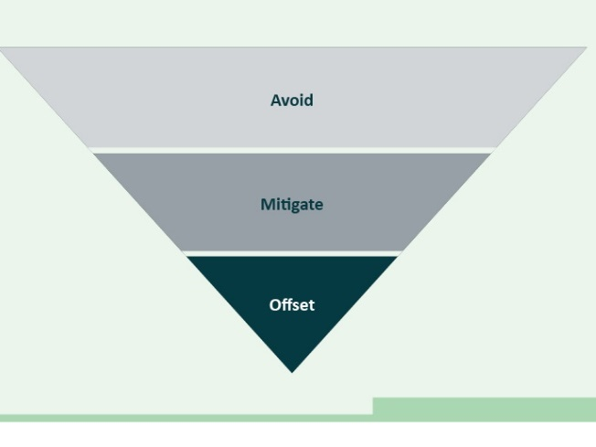
Figure 1: Mitigation Hierarchy
Avoid: Adopt measures that reduce extent, severity and/or persistence of impacts that cannot be completely avoided.
Mitigate: This is to enable monitoring during implementation of the Action to be used to inform decisions regarding whether action is needed to improve environmental performance and prevent unacceptable impacts from occurring.
Offset: Offset residual significant impacts only after making every attempt to avoid and minimise them*. More information on offsets can be found on the DCCEEW website at Environmental offsets under the EPBC Act - DCCEEW and in the ‘Environment Protection and Biodiversity Conservation Act 1999 Environmental Offsets Policy’
*Offsets in the marine context will often be impractical

Collection and provision of environmental data
Collaboration and data sharing with regulators and across industry will be important to inform an understanding of the environmental impacts of individual projects on protected matters. This information assists regulators’ understanding of a regional understanding the regional and cumulative effects of all projects proposed within a region.
DCCEEW is currently working to define appropriate survey protocols and data standards for offshore renewables projects and will consult with industry as required.

Provision of monitoring data to DCCEEW
The EPBC Act reform being undertaken by the Australian Government will include the establishment of Environment Information Australia (EIA) within DCCEEW to improve the availability, access and quality of environmental information. EIA will have a legislative mandate to provide environmental data to the independent EPA that will also be established as part of the reform process.
Access to quality data will underpin effective regulatory functions by the EPA. The success of regional planning and regional regulation, to enable environmentally sustainable development and environmental markets (including the OWF industry) will also depend on the collection of, and access to, environmental data.
Until the development and transition of new requirements from the reform process take place and become formalised by the Australian Government, OWF proponents are encouraged to voluntarily provide environmental data and study outcomes to DCCEEW. This will support a better understanding by government and industry of OWF impacts and their management at both the local and regional scales and support improvement over time. Proponents should also have regard to the Guidelines for biological survey and mapped data.

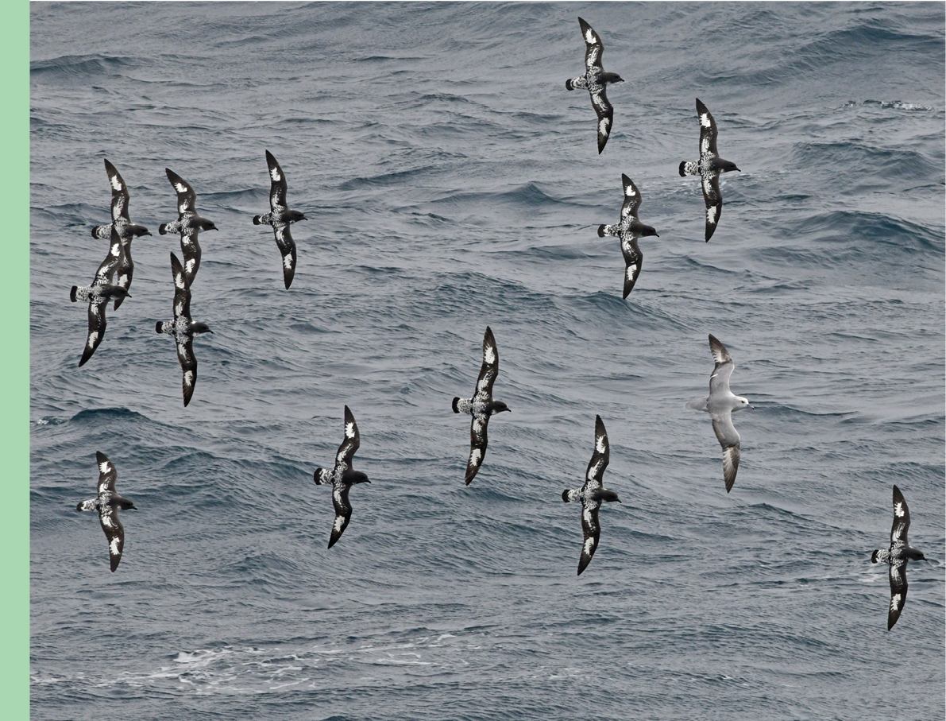

How to use the guidance
This guidance is a compilation of advice for general impact pathways typically associated with an OWF development and tailored to an Australian context. As the guidance is intended to apply nationally to the Commonwealth Marine Area (CMA), all impact pathways may not be relevant to all proposed developments or in all circumstances.
The conceptual model below includes links to each of the impact pathways addressed in this guidance.
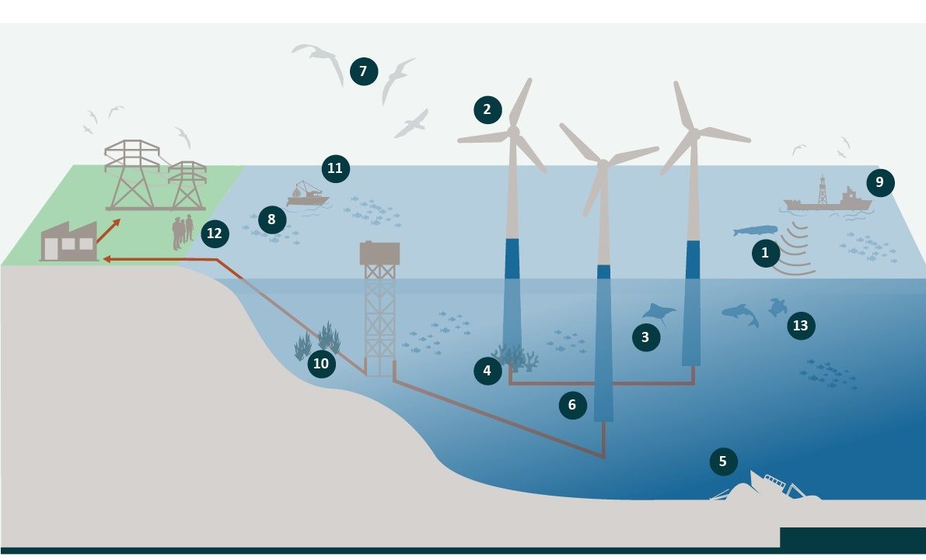

1. Underwater noise - Mortality, injury and behavioural effects
2. Turbine interactions – Injury and mortality to birds and bats
3. Electromagnetic fields
4. Seabed disturbance – Loss of/harm to benthic habitats
5. Disturbance of underwater cultural heritage
6. Physical presence – Effects on hydrodynamics and sediment transport processes
7. Physical presence – Barrier effects and displacement of marine fauna
8. Light emissions
9. Vessel interactions – Injury and mortality to marine fauna
10. Invasive marine species
11. Physical presence – Socioeconomic: interference/displacement of existing uses
12. Physical presence – Socioeconomic: seascapes and visual amenity
13. Multiple impact pathways – Australian marine parks and their values

Table 1: Guidance materials, websites and tools
Multiple sources of information are available to proponents. Icons used in this table relate to those found elsewhere in this guidance. Reference to materials should be used as a guide only and proponents are encouraged to actively seek out relevant and up-to-date resources.
Document type | Purpose | Examples of key considerations for environmental impact assessment
Protected Matters Search Tool (PMST)  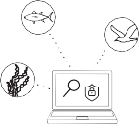 | The PMST allows proponents to search for what is protected under the Environment Protection and Biodiversity Conservation Act 1999 (EPBC Act) and therefore what will require assessment.  The PMST is available at: https://www.dcceew. gov.au/environment/epbc/protected-matters- search-tool | - Assessment of those protected matters relevant to the proposed action identified in the PMST
Conservation advice | Conservation advice guides recovery planning and identifies actions required for conservation and recovery of the threatened species  or ecological community. They inform the Australian Government in regulatory decision- making and investment for threatened species and ecological communities. Conservation advice can be supported by a Recovery Team or similar stakeholder group.  Conservation advices are available at: https://www.dcceew.gov.au/environment/ biodiversity/threatened/conservation-advices | - Overarching recovery objectives  - Content regarding threats  - Specific recovery actions relevant to the proposed action
Wildlife conservation plans   | A wildlife conservation plan sets out the research and management actions necessary to support survival of one or more migratory, marine, conservation dependent or cetacean  species listed under the EPBC Act, which are not considered endangered or vulnerable, but would benefit from a nationally coordinated approach to conservation.  Wildlife conservation plans are available at: https://www.dcceew.gov.au/environment/ biodiversity/publications | - Overarching vision for conservation  - Conservation objectives  - Content regarding threats  - Management actions relevant to the proposed action
Australian marine park (AMP) management plans  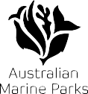 | AMP management plans set out the Australian Government approach to managing AMPs. There are six AMP management plans, one for each  of the five AMP networks (the North, North- west, South-west, South-east and Temperate East networks) and one for the Coral Sea Marine Park. Note that recently proclaimed Indian Ocean Territory Marine Parks are under transitional management arrangements while the management plan is drafted.  AMP management plans are available at: https://parksaustralia.gov.au/marine/ management/plans/ | - Values present, zoning allowability of activities, management plan prescriptions and rules pertinent to the relevant AMP  - Potential risk to natural, cultural and social environment and surrounding communities should be avoided or mitigated to acceptable levels that are  - consistent with AMP requirements  - Overarching AMP and zone objectives including levels of protection (IUCN categories)
Plans of management for World and National heritage properties and places   | A management plan for a World Heritage property or National Heritage place sets out how the area and its natural and/or cultural values will be managed, protected and conserved for over a specific duration (nominally 10 years). It enables the management of the place to proceed in an orderly manner, reconciles competing interests and identifies priorities for the allocation of available resources.  Plans of management for World Heritage property and National Heritage places are available at: https://www.dcceew.gov.au/parksheritage/  heritage/about/world/managementaustralias-world-heritage-listed/managingworld-heritage-australia | - Management objectives and other requirements  - Details about outstanding universal values of declared World Heritage properties  - Details for the values of listed National Heritage places
Plans of management for wetlands of international significance (Ramsar)   | The primary purpose of a management plan for a Ramsar wetland is to maintain ecological character and promote wise use of the site. Wise use is defined in the Ramsar Convention 2005 as “the maintenance of their ecological character, achieved through the implementation of ecosystem approaches, within the context of sustainable development”.  Plans of management for Ramsar wetlands are available at: https://www.dcceew.gov.au/water/wetlands/ramsar | - Management objectives and other requirements  - Details about threats to Ramsarwetlands  - Descriptions of the ecological character of Ramsar wetlands that may be affected
EPBC Act management principles | The EPBC Act management principles set out the statutory management principles for World Heritage properties and National Heritage places, Ramsar wetlands and Commonwealth marine reserves. For example, refer to the Australian IUCN Reserve Management Principles for Commonwealth Marine Protected Areas and Australian Ramsar management principles | - Demonstration that the impacts of the action will not be inconsistent with these management principles
Other relevant policy documents, bioregional plans, gazettal instruments and guidelines relevant to the environmental impacts and risks to matters protected under the EPBC Act found on DCCEEWs website   | Refer to DCCEEW’s website and EPBC Act Public Portal for further information.  Bilateral migratory bird agreements provide important mechanisms for pursuing conservation outcomes for migratory birds (e.g. Japan-Australia Migratory Bird Agreement (JAMBA), China-Australia Migratory Bird Agreement (CAMBA) and Republic of Korea-Australia Migratory Bird Agreement (ROKAMBA)).  DCCEEW has published guidance on Impacts on Birds from Offshore Wind Farms in Australia (Commonwealth of Australia, 2022) to assist the expanding offshore wind farm industry in Australia in the design and delivery of effective mitigation strategies for their potential impacts.  EPBC Act Policy Statement 2.3: Wind Farm Industry (Commonwealth of Australia, 2009) has been published by DCCEEW to assist operators in the wind farm industry to decide whether or not proposed actions require assessment and approval under the EPBC Act. While this policy statement was developed for the onshore wind farm industry, it includes information, guidance and principles that are generally applicable to OWF assessments and should therefore considered by OWF proponents.
Species Profile and Threats Database (SPRAT)  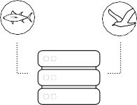 | SPRAT is a database designed to provide information about species and ecological communities listed under the EPBC Act. It provides information on what the species look like, their population and distribution, habitat, movements, feeding, reproduction and taxonomic comments. The information has been compiled by summarising information from a range of sources and contributors.  SPRAT also references out to other EPBC Act lists for matters such as critical habitats, key ecological features, threatening processes and ecological communities and contains web-links to relevant statutory documents.  SPRAT is available at: http://www.environment.gov.au/cgi-bin/sprat/public/sprat.pl | - Summaries of values, ecology, biology of matters protected  - References to relevant management documentation, policy and guidance
Marine bioregional plans  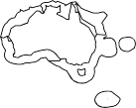 | Marine bioregional plans aim to strengthen the operation of the EPBC Act to help ensure that the marine environment remains healthy and resilient. They describe the marine environment and conservation values of each marine region, set out broad biodiversity objectives, identify regional priorities and outline strategies and actions to address these priorities.  Marine bioregional plans are available at: https://www.dcceew.gov.au/environment/ marine/marine-bioregional-plans | - Content of marine bioregional plans that describe the benthic environment of the Commonwealth marine area and any vulnerabilities/sensitivities that are relevant to impacts of OWFs
Threat abatement plans  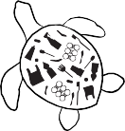 | Threat abatement plans provide for the research, management, and any other actions necessary to reduce the impact of a listed key threatening process on native species and ecological communities. Implementing the threat abatement plan should assist the long-term survival in the wild of affected native species or ecological communities.  Threat abatement plans are available at: https://www.dcceew.gov.au/environment/ biodiversity/threatened/threat-abatementplans | - Objectives and actions to address threatening processes that are relevant to the proposed action  - Content regarding sources of threatening processes relevant to the proposed action
National Conservation  Values Atlas (NCVA)   | The NCVA is an interactive web-based tool developed to support implementation of Marine Bioregional Plans. The NCVA incorporates a range of national data on Australia’s marine environment as well as specific information on the location and area of important marine habitats, ecological features, known breeding and feeding areas for protected species and other conservation values in the marine regions. The NCVA is available at: https://www.dcceew.gov.au/environment/marine/marinebioregional-plans/conservation-values-atlas | - Assessment of the conservation values for the Australian marine environment relevant to the proposed action identified in the NCVA

Guidance on key environmental factors for sources of impact
This page is intentionally blank

1. Underwater noise – mortality, injury and behavioural effects


Sources of impact
Underwater noise can cause behavioural changes, mask sounds used to communicate, locate prey or navigate and cause temporary or permanent hearing loss in marine fauna. Particularly intense impulsive noise characterised by very rapidly rising peak level can potentially cause injury or mortality if vulnerable fauna are exposed to the noise.
OWF activities can generate underwater noise with potential to impact marine fauna during all activity phases including geophysical and geotechnical investigations, construction and installation, operations, inspection, maintenance and repair and decommissioning. The most intense noise source associated with OWFs is likely to
be pile driving operations for turbine foundations,
where required.
Underwater noise associated with these activities is often characterised as impulsive or continuous. Examples of continuous noise sources include vessel operations, including use of dynamic positioning and operational
wind turbines.
It will be essential that a proponent’s assessment documentation has been informed by an understanding of the pre-development soundscape including existing anthropogenic noise sources.

Key receptors and protected matters:
- Baleen whales
- Seals/sea lions
- Turtles
- Toothed whales/porpoises
- Sharks/rays
- Benthic habitats
- Existing human uses
- Fish

Key statutory documents, management principles and other relevant EPBC Act information and resources:
- Protected matters search tool
- Conservation advice
- Wildlife conservation plans
- Australian marine park (AMP) management plans
- Plans of management for World and National heritage properties and places
- EPBC Act management principles
- Marine bioregional plans
- Threat abatement plans
- National Conservation Values Atlas (NCVA)
- Other relevant policy documents, bioregional plans, gazettal instruments and guidelines relevant to the environmental impacts and risks to matters protected under the EPBC Act found on DCCEEWs website.
- Species Profile and Threats Database (SPRAT)

Example using EPBC Act context to inform a defined acceptable level of impact
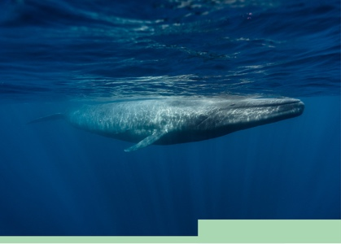
Where a proposed action has potential to result in underwater noise impacts on the blue whale, when defining an acceptable level of impact against which to evaluate predicted impacts, proponents will need to consider context from the Conservation Management Plan for the Blue Whale (Commonwealth of Australia, 2015). This plan includes an action area for assessing and addressing anthropogenic noise with an associated action of “Anthropogenic noise in biologically important areas will be managed such that any blue whale continues to utilise the area without injury and is not displaced from a foraging area.”

Good practice management
Minimise: Examples of underwater noise reduction/minimisation technologies may include:
- selection of foundation types that do not require pile driving for installation (e.g. gravity structures, caissons, floating) to improve environmental approval success in noise sensitive areas (e.g. biologically important areas for listed threatened whales). Note that alternative foundation types may generate a different suite of impacts that require consideration (e.g. benthic habitat disturbance);
- selection of vibratory pile driving over impact pile driving techniques to reduce the peak level of noise emissions; and
- if impact piling is selected, it is likely that underwater noise effect thresholds will need to be applied to determine effect ranges for noise sensitive receptors. The selection of appropriate thresholds will need to be informed by relevant guidance, recovery plans and peer reviewed literature. Where impact piling is proposed in biologically important areas and times, proponents will need to apply the best available technology for noise dampening (e.g. double bubble curtains and noise shielding), and demonstrate how impacts will be managed to acceptable levels over the construction period. This may require further innovation to find solutions that minimise low frequency underwater noise, which is most relevant to large baleen whales.
Monitor and mitigate: A marine fauna monitoring program will be required to reliably detect and monitor the presence, behaviour and response of sensitive fauna within relevant effect ranges and trigger mitigation measures such as shutdowns and restart procedures. More robust detection and mitigation measures will be required where there is potential for noise to affect listed threatened species and important life stages/behaviours. Pile driving operations in noise sensitive habitats are likely to require some level of in situ verification of received noise levels (adopting ISO18406:2017: Measurement of radiated underwater sound from percussive pile driving) to allow adaptive management, where necessary.

2. Turbine interactions – injury and mortality to birds and bats


Sources of impact
Birds and bats that fly in the OWF turbine swept zone are at risk of collision or barotrauma and in turn, injury or death.

Key receptors and protected matters:
- Seabirds
- Shorebirds
- Land birds

Key statutory documents, management principles and other relevant EPBC Act information and resources:
- Protected matters search tool (PMST)
- Conservation advice
- Wildlife conservation plans
- Australian Marine Park (AMP) Management Plans
- Plans of management for World and National heritage properties and places
- Plans of management for wetlands of international significance (RAMSAR)
- EPBC Act management principles
- Other relevant policy documents, bioregional plans, gazettal instruments and guidelines relevant to the environmental impacts and risks to matters protected under the EPBC Act found on DCCEEWs website
- Species Profile and Threats Database (SPRAT)
- Marine Bioregional Plans
- Threat Abatement plans
- National Conservation Values Atlas (NCVA)

Example using EPBC Act context to inform a defined acceptable level of impact

There is limited context in EPBC Act conservation management documents for seabirds and migratory shorebirds that is specific to collision or barotrauma risk associated with OWF.
Despite this, taking the National Recovery Plan for Albatrosses and Petrels (Commonwealth of Australia, 2022) as an example, when defining an acceptable level of impact against which to evaluate predicted impacts proponents will need to consider the recovery plan’s objective to improve the conservation status of albatrosses and petrels so that these species are on a trajectory towards no longer being threatened in Australia’s jurisdiction.

Good practice management
Minimise: Examples of collision risk reduction/minimisation technologies may include:
- blade design features and patterning found, based on credible scientific evidence, to reduce collision risk; and
- in field bird detection techniques coupled with near-real time turbine control and/or shut down.
When faced with uncertainty regarding impacts, implementing actions such as operational shutdowns during biologically important seasons/events and enhancing resilience and recovery of potentially affected colonies/populations may be effective in minimising impacts. It may also be possible to change such actions over time as more information becomes available through research and monitoring and uncertainties are reduced.
Monitor and mitigate: Early implementation of baseline monitoring programs at a range of scales appropriate to the species of interest (e.g. individuals, colonies, populations) to enhance understanding of flight activity and offshore movements for relevant species and using findings to inform predictions of collision/avoidance rates and impacts, may be helpful in reducing uncertainty in environmental assessments and assessment of management effectiveness.
Implementing monitoring programs to verify collision risk predictions made during assessments and define management triggers that will be used to trigger adaptive management measures, may be an effective means to control uncertainty and prevent unacceptable impacts.
Proponents are encouraged to review and apply guidance provided in DCCEEW’s report on Impacts on Birds from Offshore Wind Farms in Australia (Reid et al., 2022).

3. Electromagnetic fields


Sources of impact
Subsea inter array cables that carry electricity from each wind turbine to the export cables, which then carry that electricity to onshore distribution networks, generate electromagnetic fields (EMF). Taxa such as elasmobranchs (sharks and rays) are electrosensitive and able to detect low intensity electric fields and magnetic fields, using them to detect prey and others of the same species. Depending on field strength, elasmobranch species may be repelled or attracted by EMF, which may in turn create barriers to migration and behavioural changes. Other marine taxa such as fish (e.g. eels and salmon), marine mammals (e.g. cetaceans) and marine reptile (e.g. turtles) use geomagnetic fields to guide migrations. Subsea electricity infrastructure may therefore potentially interact with sensitive marine receptor species, potentially resulting in impacts including:
- disruption to species navigation/migration
- avoidance/attraction to the cable infrastructure
- negative physiological or developmental impacts.

Key receptors and protected matters:
- Sharks/rays
- Fish
- Turtles
- Benthic habitats
- Marine environment

Key statutory documents, management principles and other relevant EPBC Act information and resources:
- Protected matters search tool (PMST)
- Conservation advice
- Wildlife conservation plans
- Australian Marine Park Management Plans
- Plans of management for World and National heritage properties and places
- EPBC Act management principles
- Other relevant policy documents, bioregional plans, gazettal instruments and guidelines relevant to the environmental impacts and risks to matters protected under the EPBC Act found on DCCEEWs website
- Species Profile and Threats Database (SPRAT)
- Marine Bioregional Plans
- Threat Abatement plans
- National Conservation Values Atlas (NCVA)

Example using EPBC Act context to inform a defined acceptable level of impact
By way of example, an acceptable level of impact against which to evaluate predicted impacts may be defined as “the effects of EMF will not have an adverse effect on a population of a marine species such that biologically important life stages (breeding, feeding, migration) are disrupted and/or life expectancy or spatial distribution are reduced.”

Good practice management
Minimise: Examples of measures that may minimise EMF-related impacts include:
- engineering controls that reduce EMF emissions considering factors such as current flow, voltage, cable configuration and design, and sheath/armouring characteristics;
- adopting cable layouts to allow the field vectors from the cables to cancel each other out;
- sheathing cables and increasing the conductivity and permeability of the sheaths; and
- separating cables and sensitive receptors by burying the cables. However, burial may generate a number of other impacts to evaluate and manage (e.g. impacts to benthic habitats).
Monitor and mitigate: Monitoring the effectiveness of controls may include measuring EMF emitted from operational cables to validate predictions made during the assessment and enhance understanding of the effectiveness of controls. When considered in context with any biological effects studies, the data may also be used to trigger consideration/adoption of additional or different measures to mitigate impacts.
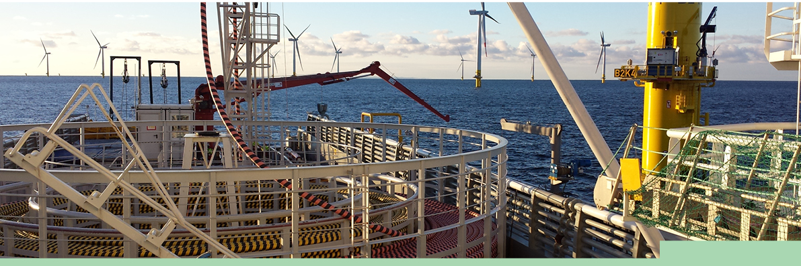

4. Seabed disturbance – loss of/harm to benthic habitats
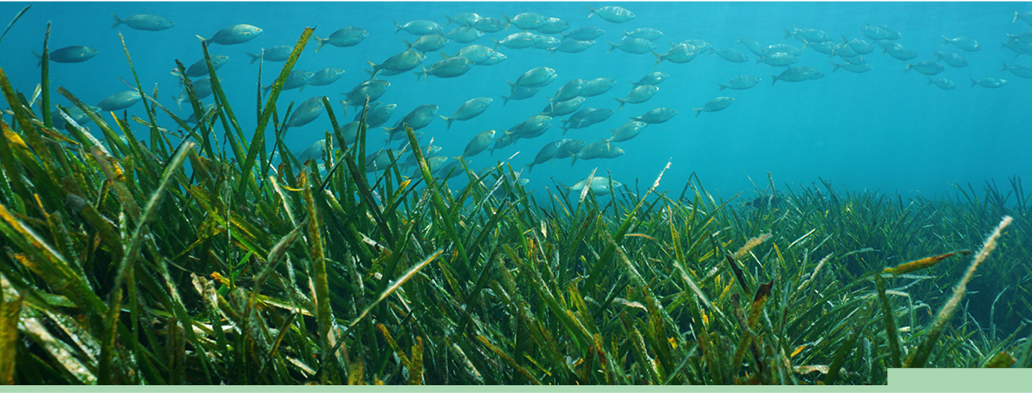

Sources of impact
Construction and operation of an OWF can result in loss, degradation, modification and fragmentation of benthic habitats in the CMA due to:
- excavation, burial/smothering or overtopping by infrastructure during construction;
- reduction in the quality and quantity of light reaching the seabed associated with increased water turbidity; and
- replacement of one benthic substrate type with another resulting in changes to benthic flora and fauna present.

Key receptors and protected matters
- Benthic habitats
- Marine environment
- Existing human uses

Key statutory documents, management principles and other relevant EPBC Act information and resources:
- Protected matters search tool (PMST)
- Other relevant policy documents, bioregional plans, gazettal instruments and guidelines relevant to the environmental impacts and risks to matters protected under the EPBC Act found on DCCEEWs website
- EPBC Act management principles
- National Conservation Values Atlas (NCVA)

Example using EPBC Act context to inform a defined acceptable level of impact
The setting of acceptable levels should consider recognised benthic habitat values of the CMA, including benthic habitat values of AMP and key ecological features (KEF), and important habitats utilised during important life history stages of commercially or ecologically important species.

Good practice management
Minimise: Examples of measures that may minimise impacts to benthic habitats include:
- site identification to consider the presence of KEFs and other unique or sensitive benthic communities including important habitats for threatened or ecologically important species so that these areas can be avoided at the outset;
- designing and configuring the OWF to limit the area of seabed required for installation and operation (e.g. considering floating turbines, turbine foundation configuration and subsea cable routes);
- selecting seabed intervention methods for cable installation that minimise turbidity;
- designing scour protection to minimise erosion;
- select mooring designs that minimise seabed interaction; and
- selecting horizontal directional drilling methods rather than trenching for nearshore elements and shore crossings for export cables.
Monitor and mitigate: Commit to monitoring programs designed to measure impacts and trigger adaptive management to prevent unacceptable impacts to benthic habitat and ensure loss/disturbance is no greater than predicted and approved.



5. Disturbance of underwater cultural heritage
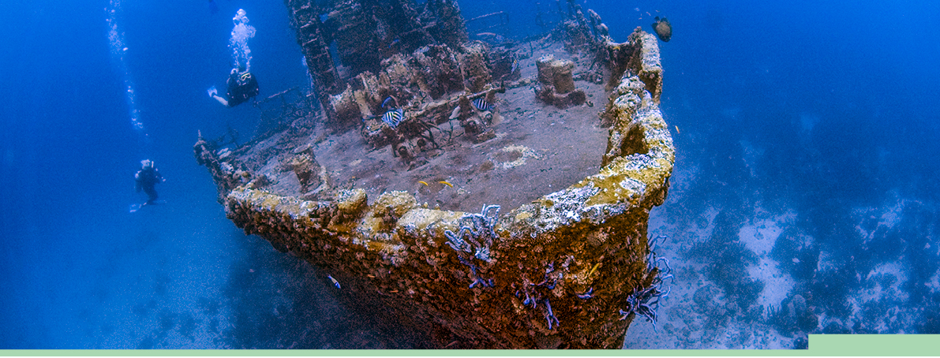

Sources of impact
Construction and operation of an OWF can result in the disturbance of cultural heritage including underwater cultural heritage (UCH). Identifying cultural heritage values that may be impacted should consider First Nations peoples’ beliefs, practices and connection to Sea Country, places of cultural significance and cultural heritage sites in the CMA.
Activities involving seabed intervention in particular (e.g. subsea cable burial, foundation installation) may adversely impact remains of shipwrecks and submerged aircraft and their associated articles which have been in Commonwealth waters for 75 years or more, and other sites/protected zones declared under the UCH Act which contain articles of heritage significance.
Key receptors and protected matters:
- Marine environment
- Viewshed/heritage values
- Cultural heritage

Key statutory documents, management principles and other relevant EPBC Act information and resources:
- Protected matters search tool (PMST)
- Plans of management for World and National heritage properties and places
- EPBC Act management principles
- Other relevant policy documents, bioregional plans, gazettal instruments and guidelines relevant to the environmental impacts and risks to matters protected under the EPBC Act found on DCCEEWs website
- EPBC Act management principles
- Marine Bioregional Plans
- National Conservation Values Atlas (NCVA)

The UCH Act applies to protection of UCH in the CMA. Certain UCH sites and associated artefacts are automatically protected for the purposes of the UCH Act and this protection is in effect whether these matters are located or unlocated.
The automatic protection under the UCH Act is extended to all remains of shipwrecks and submerged aircraft and their associated articles which have been in Commonwealth waters for 75 years or more.

Example using EPBC Act context to inform a defined acceptable level of impact
Proponents should have regard to and apply the relevant DCCEEW guidance and standards for engagement with First Nations people and communities – ‘Interim Engaging with First Nations People and Communities on Assessments and Approvals under the Environment Protection and Biodiversity Conservation Act 1999’ (DCCEEW, 2023). Proponents should also take into account requirements of legislation, statutory instruments and other management documentation which refers to cultural heritage values when defining what would constitute an acceptable level of impact to evaluate their predictions of impact and risk against.

Good practice management
Minimise: Examples of measures that may minimise impacts on UCH may include design features and construction methods that reduce the extent, severity and duration of potential impacts on parts of the CMA found to support heritage, including cultural heritage and values.
Monitor and mitigate: Both upfront studies and assessment as well as commitments to implement surveys to continually assess the potential presence of UCH during project implementation. Results of these surveys should inform adaptive management in the event previously unlocated UCH is discovered. Surveys must be designed and implemented by heritage experts in consultation with relevant First Nations people.

Potential critical issues
Proposed OWF within a protected zone declared under the UCH Act is a potential critical issue, particularly if there is uncertainty about whether a permit may be granted to enter the zone, or it would be possible to comply with any conditions of entry attached to a permit.
A lack of understanding of the cultural heritage values that may be at risk due to the proposed OWF is a potential critical issue, as this may prevent the proponent from identifying and evaluating relevant impacts.
A proposed OWF that may have an adverse impact on First Nations cultural heritage value may be a critical issue, particularly where consultation with appropriate stakeholders does not demonstrate those persons have been made aware of and understand the proposal and its impacts.

6. Physical presence – effects on hydrodynamics and sediment transport processes


Sources of impact
Physical presence of OWF infrastructure can change natural patterns of ocean water movement (e.g. currents, waves and mixing dynamics) and the transport of sediments in marine systems. The extent and severity of these effects will be influenced by the natural metocean conditions and how they interact with the scale, complexity, design and layout of proposed infrastructure.
Changes in ocean water movement have the potential to result in the alteration to the spatial distribution of biological productivity in the water column, which may have knock-on implications for marine fauna that feed on plankton or, the distribution and settlement of planktonic larvae of commercially and ecologically important species. This can result in cascading effects at an ecosystem level.
Change to patterns of marine sediment transport, deposition and resuspension may result in burial, erosion, modification, smothering and fragmentation of benthic habitats and communities. Presence of OWF infrastructure, particularly in nearshore areas, may also affect coastal processes that are fundamental to maintaining the ecological character of Ramsar wetlands (e.g. opening and closing of estuarine barrier systems).
Once infrastructure is installed, any alterations to hydrodynamics or sedimentation processes resulting from the OWF will be difficult to address and there is potential for irreversible environmental impacts. Given this, it is important that proponents consider site selection carefully and design OWFs in a manner that minimise modification to hydrodynamic processes and flow on ecological effects.
Key receptors and protected matters:
- Seabirds
- Shorebirds
- Turtles
- Fish
- Benthic habitats
- Marine environment
- Existing human uses

Key statutory documents, management principles and other relevant EPBC Act information and resources:
- Protected matters search tool (PMST)
- Conservation advice
- Wildlife conservation plans
- Australian marine park (AMP) management plans
- Plans of management for wetlands of international significance (RAMSAR)
- EPBC Act management principles
- Other relevant policy documents, bioregional plans, gazettal instruments and guidelines relevant to the environmental impacts and risks to matters protected under the EPBC Act found on DCCEEWs website.
- Species Profile and Threats Database (SPRAT)
- Marine bioregional plans
- Threat abatement plans
- National Conservation Values Atlas (NCVA)

Example using EPBC Act context to inform a defined acceptable level of impact
When defining an acceptable level of impact for the CMA and/or Ramsar wetlands, proponents may find it helpful to consider content from the Significant Impact Guidelines 1.1 - Matters of National Environmental Significance (Commonwealth of Australia, 2013). This is particularly relevant where changes in natural patterns of marine sediment transport, deposition and resuspension may result in benthic habitat impacts in the CMA, alteration in hydrology of a Ramsar wetland or modification of local hydrodynamic processes may result in changes in the distribution of plankton (e.g. larval stages of commercially and ecologically important species or food resources for marine mammals).
Content of the Significant Impact Guidelines 1.1 - Matters of National Environmental Significance (Commonwealth of Australia, 2013) that may be helpful for informing an acceptable level of impact includes reference to a real chance or possibility that an action may:
- modify, destroy, fragment, isolate or disturb an important or substantial area of habitat such that an adverse impact on marine ecosystem functioning or integrity in the CMA;
- result in a substantial and measurable change in the hydrological regime of a Ramsar wetland such as changing patterns of the opening and closing of a barrier estuary system to the ocean;
- have a substantial adverse effect on a population of a marine species or cetaceans including their life cycle (for example, breeding, feeding, migration behaviour, life expectancy) and spatial distribution; and
- modify, destroy, fragment, isolate or disturb an important or substantial area of habitat such that an adverse impact on marine ecosystem functioning or integrity in a CMA result.

Good practice management
Minimise: Examples of measures that may minimise impacts on hydrodynamics and sediment transport include modelling to inform site selection and the adoption of best practices in design of physical infrastructure and its layout configuration to reduce the effects of the OWF on natural ocean water currents, waves and sediment dynamics.
Monitor and mitigate: Commit to monitoring programs designed to measure the effects of infrastructure on biological productivity and sediment dynamics to
verify impact predictions and inform the need for
additional or different management, or in some cases rectification/remediation, and measures to prevent unacceptable impacts.

7. Physical presence – barrier effects and displacement of marine fauna



Sources of impact
Presence of OWF infrastructure can alter the natural movements and behaviours of marine fauna (e.g. create barrier effects along migration routes, or to and from areas that are important for breeding and foraging) or deter species from using areas of the marine environment that they currently use (e.g. for breeding, resting or foraging). Impacts of this nature may impede the recovery of threatened species such as blue whales and southern right whales.

Key receptors and protected matters:
- Baleen whales
- Toothed whales/porpoises
- Seals/sea lions
- Sharks/rays
- Turtles
- Seabirds
- Shorebirds
- Land birds
- Fish
- Benthic habitats

Key statutory documents, management principles and other relevant EPBC Act information and resources:
- Protected matters search tool (PMST)
- Conservation advice
- Wildlife conservation plans
- Australian marine park (AMP) management plans
- Plans of management for World and National heritage properties and places
- Plans of management for wetlands of international significance (RAMSAR)
- EPBC Act management principles
- Other relevant policy documents, bioregional plans, gazettal instruments and guidelines relevant to the environmental impacts and risks to matters protected under the EPBC Act found on DCCEEWs website.
- Species Profile and Threats Database (SPRAT)
- Marine bioregional plans
- Threat abatement plans
- National Conservation Values Atlas (NCVA)

Example using EPBC Act context to inform a defined acceptable level of impact
Where a proposed action has potential to impact the Orange-bellied parrot (Neophema chrysogaster), when defining an acceptable level of impact against which to evaluate predicted impacts, proponents may find it helpful to consider context from the National Recovery Plan for the Orange-bellied Parrot, Neophema chrysogaster (Department of Environment, Land, Water and Planning, 2016) which:
- identifies barriers to migration and movement, including those associated with wind energy turbines, as a key threat to recovery of the species;
- requires action to assess and manage the risks from development proposals that may represent a barrier to migration or movement; and
- requires information to be gathered to refine management of direct threats, including risk from barriers on the migration route. The plan establishes the expectations that management is in place for the threat if the risk warrants action.

Good practice management
Minimise: Examples of measures that may minimise potential barrier effects of an OWF include design considerations that minimise potential effects (e.g. configuration of turbines within the OWF area considering creation of corridors).
Monitor and mitigate: Implement monitoring studies that are informed by appropriate baselines and designed to verify predictions made during the assessment of any change in wildlife migration patterns and ensure these remain within the acceptable level of impact.
Consider a staged approach to OWF implementation with decisions regarding progress to subsequent stages informed by results of verification monitoring studies. Commit to adjusting design and management as needed in subsequent stages based on findings of monitoring studies.
Proponents should consider engaging a suitably qualified expert to review existing data, input on survey program design, predictive modelling, interpretation of data and modelling results and make recommendations about appropriate mitigation and management measures.


8. Light emissions


Sources of impact
Light is likely to be emitted around OWF development sites during pre-development surveys, construction, operations and decommissioning phases. Significant sources of light would include vessels that may operate during both day and night during some phases of the OWF development, particularly during construction and decommissioning and potentially during routine inspection, maintenance and repair operations. Turbine towers may require lighting to maintain safe navigation and aviation for the duration of the operational phase.
Artificial light can disrupt critical biological behaviours, cause physiological changes and potentially pose a barrier to the recovery of listed threatened species if not appropriately managed. In this context, impacts of artificial light are particularly relevant for birds and marine turtles, with the degree of management and mitigation required influenced by the proposed OWF location at its proximity in relation to biologically important habitat for light sensitive wildlife.

Key receptors and protected matters:
- Sharks/rays
- Turtles
- Seabirds
- Shorebirds
- Fish
- Marine environment
- Viewshed/heritage values
- Cultural heritage

Key statutory documents, management principles and other relevant EPBC Act information and resources:
- Protected matters search tool (PMST)
- Conservation advice
- Wildlife conservation plans
- Australian Marine Park Management Plans
- Plans of management for World and National heritage properties and places
- Plans of management for wetlands of international significance (RAMSAR)
- EPBC Act management principles
- Other relevant policy documents, bioregional plans, gazettal instruments and guidelines relevant to the environmental impacts and risks to matters protected under the EPBC Act found on DCCEEWs website
- Species Profile and Threats Database (SPRAT)
- Marine Bioregional Plans
- National Conservation Values Atlas (NCVA)

Example using EPBC Act context to inform a defined acceptable level of impact
Marine turtles are particularly sensitive to artificial light emissions. Where relevant, when defining an acceptable level of impact associated with light emissions, proponents may find it helpful to consider content in the Recovery plan for Marine Turtles in Australia (Commonwealth of Australia, 2017), which requires:
- management of anthropogenic activities to ensure marine turtles are not displaced from identified habitat critical to the survival defined in the recovery plan; and
- artificial light within or adjacent to habitat critical to the survival of marine turtles to be managed such that marine turtles are not displaced from these habitats.
- implementation of best practice light management guidelines for existing and future developments adjacent to marine turtle nesting beaches.
- Good practice management
- Minimise: Examples of measures that may minimise impacts of light emissions include:
- modelling light emissions and transmission to support the assessment, verification studies and management actions;
- reducing light emitted to the minimum required to meet standards for safety and navigation;
- careful lighting design that is tailored to manage spectral sensitivities of receptors, and considering factors such as wavelength, orientation/shielding, intensity and timing;
- limiting reflective surfaces in infrastructure design; and
- adopting good practice housekeeping for vessels operating offshore.
Monitor and mitigate: Monitoring wildlife interactions with activities and using results to inform ongoing management of lighting. Proponents are advised to review the National Light Pollution Guidelines for Wildlife (DCCEEW, 2023) for further guidance on lighting management.



9. Vessel interactions – injury and mortality to marine fauna


Sources of impact
Vessels used for pre-development surveys, construction, operations and decommissioning generate risk of collision with marine wildlife.
Key receptors and protected matters:
- Baleen whales
- Toothed whales/porpoises
- Seals/sea lions
- Sharks/rays
- Turtles

Key statutory documents, management principles and other relevant EPBC Act information and resources
- Protected matters search tool (PMST)
- Conservation advice
- Wildlife conservation plans
- Australian Marine Park Management Plans
- Plans of management for World and National heritage properties and places
- EPBC Act management principles
- Other relevant policy documents, bioregional plans, gazettal instruments and guidelines relevant to the environmental impacts and risks to matters protected under the EPBC Act found on DCCEEWs website
- Species Profile and Threats Database (SPRAT)
- Marine Bioregional Plans
- National Conservation Values Atlas (NCVA)

Example using EPBC Act context to inform a defined acceptable level of impact
An example of an acceptable level of impact may be no vessel collisions.

Good practice management
Minimise: Examples of measures that may minimise collision risk for cetaceans and marine wildlife include:
- adopting contract requirements and procedures for vessel operations that limit transit speeds such that likelihood of collisions with fauna are materially reduced (also has the benefit of reducing vessel noise in transit); and
- scheduling offshore works to limit the numbers of vessel movements to and from OWFs (e.g. rationalise inspections, maintenance and repair activities).
Monitor and mitigate: Proactively monitor compliance with procedures to limit vessel speed and implement actions to prevent any reoccurrence of non-compliance. Maintain watch and observation zones to enable vessel operations to be adaptively managed in real time to further reduce collision risk.
Proponents should review the National Strategy for Reducing Vessel Strike on Cetaceans and other Marine Megafauna (Commonwealth of Australia, 2017) and Environment Protection and Biodiversity Conservation Regulations 2000 (EPBC Regulations), Part 8, Division 8.1 – Interacting with cetaceans for further guidance on managing interactions, including collision risk, with cetaceans and other marine wildlife.



10. Invasive marine species


Sources of impact
Use of international vessels and equipment which makes direct contact with the seabed (e.g. pile driving equipment, dredges) are particularly high-risk vectors for the introduction of invasive marine species (IMS).
In addition, the introduction of new clean hard substrates, such as turbine foundations and scour protection, to the marine environment may influence the potential for establishment of IMS in the CMA.

Key receptors and protected matters:
- Marine environment
- Benthic habitats

Key statutory documents, management principles and other relevant EPBC Act information and resources:
- Protected matters search tool (PMST)
- Australian Marine Park Management Plans
- Other relevant policy documents, bioregional plans, gazettal instruments and guidelines relevant to the environmental impacts and risks to matters protected under the EPBC Act found on DCCEEWs website
- National Conservation Values Atlas (NCVA)
Australian ballast water management requirements (Commonwealth of Australia, 2020), Australian biofouling management requirements (Commonwealth of Australia, 2022) and Anti-fouling and in water cleaning guidelines (Department of the Environment and New Zealand Ministry for Primary industries, 2015) are particularly relevant to the effective control of
IMS risk.

Example using EPBC Act context to inform a defined acceptable level of impact
Where a proposed OWF has the potential to introduce IMS into a habitat, consider the following context taken from the Significant Impact Guidelines 1.1 - Matters of National Environmental Significance (Commonwealth of Australia, 2013). An action is likely to have a significant impact if there is a real chance or possibility that it will:
- result in invasive species that are harmful to critically endangered or endangered species, vulnerable species or migratory species becoming established in the endangered or critically endangered species habitat, vulnerable species habitat or habitat important for migratory species;
- cause a substantial reduction in the quality or integrity of an occurrence of an ecological community, including, but not limited to, assisting invasive species, that are harmful to the listed ecological community, to become established; and
- result in an invasive species that is harmful to the ecological character of the wetland being established (or an existing invasive species being spread) in the wetland.
An example of an acceptable level against which to evaluate predictions of impact and effectiveness of management may be ‘no introduction, establishment or spread of IMS.’

Good practice management
Minimise: Examples of measures that may minimise IMS risk include:
- compliance with location dependant biosecurity obligations to minimise translocation risk during construction, operation and decommissioning activities:
- international obligations (e.g. Guidelines for the Control and Management of Ships’ biofouling to Minimize the Transfer of Invasive Aquatic Species (International Maritime Organisation, 2011)); and
- Commonwealth, State or Territory legislation and guidelines (OWF proponents may find it helpful to refer to the following information paper on Reducing marine pest biosecurity risks through good practice biofouling management (NOPSEMA, 2022) that includes details of legislation and guidelines that applies to the management of marine biosecurity risk within Australian waters);
- use of best practice marine growth prevention measures to minimise colonisation and dispersal of IMS during operation and decommissioning; and
- timing maintenance and cleaning activities to occur during times when there is less opportunity for propagules to disperse, settle and survive.
Monitor and mitigate: Commitment to a monitoring program designed to identify and report any IMS found on infrastructure and surrounding benthos. Develop mitigation measures to manage IMS in line with relevant location dependent biosecurity obligations, legislation and guidelines. Implement reporting processes for IMS in accordance with any Commonwealth, State and Territory biosecurity agency requirements.

11. Physical presence – socioeconomic: interference/displacement of existing uses


Sources of impact
Presence of OWF infrastructure can result in interference with or displacement of existing uses of the CMA such as commercial and recreational fishing, tourism, recreational activities, commercial shipping and aviation activities. This can occur as a result of establishing restriction zones around infrastructure that may exclude existing marine uses either on a short term (during construction or maintenance activities) or longer-term basis.
Interference with, or displacement of marine uses may also occur due to the presence and layout of proposed infrastructure including wind turbine foundations, electrical cables and associated scour protection. For example, the use of rock dumping for scour protection may prevent trawling activities and the physical presence of large array of wind turbines may interfere with aviation radar.
Key receptors and protected matters:
- Marine environment
- Cultural heritage
- Existing human uses

This includes the air space above the CMA. Receptor groups potentially affected include fishers, tourism operators, shipping industry, defence and aviation sectors and members of the public.

Key statutory documents, management principles and other relevant EPBC Act information and resources:
- Protected matters search tool (PMST)
- Australian Marine Park Management Plans
- Other relevant policy documents, bioregional plans, gazettal instruments and guidelines relevant to the environmental impacts and risks to matters protected under the EPBC Act found on DCCEEWs website
- Marine Bioregional Plans
- National Conservation Values Atlas (NCVA)

Management plans and harvest strategies for commercial fisheries published by Commonwealth, State and Territory fisheries management agencies are also relevant.
Plans of management relating to the way that other marine industries utilise the marine environment (e.g. fisheries management plans).

Example using EPBC Act context to inform a defined acceptable level of impact
The relevant context for socio-economic values will include a combination of any relevant management plans and input from the marine users and their regulators during stakeholder consultation processes.
An example of an acceptable level against which to evaluate predictions of impact and effectiveness of management may be:
- commercially important activities can continue meeting objectives/targets set out in relevant management plans with no financial loss; and
- recreational users of the marine environment can continue utilising marine resources.

Good practice management
Avoid: Undertake desktop evaluation and targeted consultation to identify key areas of importance for marine uses and site the action in a location that avoids hot spots of activity (e.g. important commercial fishing grounds or shipping channels).
Minimise: Plan major construction and installation activities to avoid key times of importance for marine uses and/or design infrastructure in a way that minimises disturbance and allows for continued use of the area by relevant
marine users.
Monitor and mitigate: Develop detailed communication and simultaneous operations protocols to enable effective adaptive management to reduce impacts to marine users.
Where other users of a licence area are affected, under the EPBC Act actions should be undertaken to investigate and manage such conflicts. Furthermore, the OEI Act includes requirements for managing such conflicts when administering licences – see ‘Guideline: Offshore Electricity Infrastructure Licence Administration - Feasibility Licences’ for more information.

Key potential critical issues
Proposed actions within an important fishing ground for a fishery that deploys fishing methods that are not compatible with an OWF (e.g. trawling) resulting in significant long-term displacement may be a critical issue.
Proposed actions within a major shipping channel resulting in unacceptable disruption to shipping operations and navigation hazards may also be a critical issue.


12. Physical presence – socioeconomic: seascapes and visual amenity


Sources of impact
Presence of OWF infrastructure can change the viewsheds from land and sea. The materiality of the impacts on the visual amenity in the CMA can be subjective and a matter of personal opinion, with views on the impact garnered from consultation with stakeholders and the broader community.
Key receptors and protected matters:
- Marine environment
- Existing human uses
- Cultural heritage
- Viewshed/heritage values

This includes the air space above the CMA and receptor groups potentially affected include members of the public and any visual amenity values of protected areas/places (e.g. AMP, World or National Heritage areas/places), whether activities are proposed inside or outside the boundaries of those areas/places.

Key statutory documents, management principles and other relevant EPBC Act information and resources:
- Protected matters search tool (PMST)
- Plans of management for World and National heritage properties and places
- EPBC Act management principles
- Other relevant policy documents, bioregional plans, gazettal instruments and guidelines relevant to the environmental impacts and risks to matters protected under the EPBC Act found on DCCEEWs website
- Marine Bioregional Plans
- National Conservation Values Atlas (NCVA)

Example using EPBC Act context to inform a defined acceptable level of impact
Where a proposed OWF has potential to impact visual amenity, seascapes or wilderness qualities of a listed heritage place, when defining an acceptable level of impact against which to evaluate predicted impacts, proponents may find it helpful to consider context from the relevant management plan for AMPs, World Heritage properties or National Heritage places and the relevant management principles from the EPBC Act.

Good practice management
Minimise: Examples of measures that may minimise seascape and visual amenity impacts include adopting design features and configurations that reduce impact on existing visual amenity/sea scapes (e.g. using suitable colour schemes, limit lighting).
Monitor and mitigate: Consult stakeholders and the broader public transparently, evaluate merits of objections and claims about the impact of the proposal on visual amenity and sea scapes and adopt measures to further reduce impacts.


13. Multiple impact pathways – Australian marine parks and their values

Sources of impact
Depending on location, the construction and presence of OWF infrastructure can affect the values of AMPs.
Sources of impact may include underwater noise, light and EMF entering AMPs, disturbance to seabed features including benthic habitats and UCH, physical presence causing barriers and hydrodynamic effects, interference with social and commercial use and access, visual amenity, increased risk of the introduction of IMS, and additive effects to cumulative impacts from all pressures.
Key receptors and protected matters:
- Baleen whales
- Toothed whales/porpoises
- Seals/sea lions
- Sharks/rays
- Turtles
- Seabirds
- Shorebirds
- Fish
- Benthic habitats
- Marine environments
- Viewshed/heritage values
- Cultural heritage
- Existing human uses

- Values of AMPs include natural, cultural, heritage and socio-economic values.
- Natural values include habitats, species and communicates within marine parks and ecological processes.
- Cultural values include living and cultural heritage, beliefs, places, and sites of cultural significance.
- Heritage values include aesthetic, historic, scientific, and social significance.
- Socio-economic values include people, businesses, and the economy.

Key statutory documents, management principles and other relevant EPBC Act information and resources:
- Protected Matters search tool (PMST)
- Conservation advice
- Wildlife conservation plans
- Australian Marine Park Management Plans
- Plans of management for World and National heritage properties and places
- EPBC Act management principles
- Other relevant policy documents, bioregional plans, gazettal instruments and guidelines relevant to the environmental impacts and risks to matters protected under the EPBC Act found on DCCEEWs website
- Species Profile and Threats Database (SPRAT)
- Marine Bioregional Plans
- Threat abatement plans
- National Conservation Values Atlas (NCVA)

Example using EPBC Act context to inform a defined acceptable level of impact
The EPBC Act requires a Commonwealth reserve to be assigned to an IUCN category. Schedule 8 of the EPBC Regulations prescribes the Australian IUCN reserve management principles applicable to each IUCN category. The IUCN categories and associated management principles for each category broadly determine how areas will be managed and which activities covered by the EPBC Act and Regulations can and cannot be conducted in them. Each management plan for the AMP networks prescribes activities allowed in each zone. AMPs are generally designated as one of four IUCN categories for protection: IUCN Category Ia that are strictly protected for the purposes of preservation in a natural state and uses are limited to non-extractive research; IUCN Category II which are managed for ecosystem protection and passive recreation; IUCN Category IV that have allowable activities but that are managed to protect habitats or species; and IUCN Category VI whereby sustainable natural resources management is allowed provided there won’t be an unacceptable impact on values of the area. Examples of how to consider EPBC Act and other context to inform defined acceptable levels of impact are set out elsewhere in this guidance; however, consultation with the Director of National Parks (DNP) is strongly advised whether the OWF is proposed inside or outside of an AMP. Authorisation by the DNP will be required for any infrastructure proposed in an AMP.

Good practice management
Minimise: Design OWF to reduce impacts for all pathways to receptors that are values of AMPs considering guidance provided elsewhere in this document.
Monitor and mitigate: Apply mitigation factors for all impacts to receptors that are values of AMPs considering guidance provided elsewhere in this document.


GLOSSARY

Acronyms and abbreviations:
ACAP – Agreement on the Conservation of Albatrosses and Petrels
AMP – Australian Marine Park
CAMBA – China-Australia Migratory Bird Agreement
CITES – Convention on International Trade in Endangered Species of Wild Fauna and Flora
CMA – Commonwealth marine area
DCCEEW – Department of Climate Change, Energy, the Environment and Water
DNP – Director of National Parks
EIA – Environment Information Australia
EPA – Environmental Protection Australia
EPBC Act – Environment Protection and Biodiversity Conservation Act 1999
EPBC Regulations – Environment Protection and Biodiversity Conservation Regulations 2000
EMF – Electromagnetic fields
IUCN – International Union for Conservation of Nature
IMS – Invasive marine species
JAMBA – Japan-Australia Migratory Bird Agreement
KEF – Key ecological feature
NCVA – National Conservation Values Atlas
OEI Act – Offshore Electricity Infrastructure Act 2021
ORE – Offshore Renewable Energy
OWF – Offshore wind farm
PMST – Protected Matters Search Tool
ROKAMBA – Republic of Korea-Australia Migratory Bird Agreement
SPRAT – Species Profile and Threats Database
UCH – Underwater cultural heritage
UCH Act – Underwater Cultural Heritage Act 2018

Terms:
Impact pathways – “an anthropogenic force or object that can produce stress or injury on marine animals, habitats, or ecosystem processes (receptor). Marine renewable energy systems and subsystems can be stressors in the marine environment.” (based from the OES-Environmental 2020 State of the Science Report: Environmental Effects of Marine Renewable Energy Development Around the World (Copping and Hemery, 2020)).
Potential critical issues – A potential critical issue is one that may result in one or more of the following types of adverse assessment outcomes:
- protracted and costly assessments due to the need for additional environmental studies to inform EIA, management and the evidence-based demonstration of impact acceptability;
- particularly precautionary management and decision-making being required to address uncertainty; and/or
- a referral decision that a proposal is clearly unacceptable or at the final decision stage of the assessment process a decision to not approve the action.
Proponent – A person proposing to develop an offshore wind farm. For the purpose of this guidance this includes the proponent’s consultant/s.
Protected matters – Matters of national environmental significance and other matters protected under the Environment Protection and Biodiversity Conservation Act 1999.
Receptor groups – “Animal, habitat, or ecosystem processes susceptible to stress from an anthropogenic device or process (stressor) that may result in changes in behaviour, injury or death of an animal, or removal or deterioration of a habitat.” based from the OES-Environmental 2020 State of the Science Report: Environmental Effects of Marine Renewable Energy Development Around the World (Copping and Hemery, 2020)).
Sea country – Sea country refers to the areas of the sea that Aboriginal and Torres Strait Islander groups are particularly affiliated with through their traditional lore and customs (based from the Australian Marine Parks North Marine Parks Network Management Plan 2018 (Director of National Parks, 2018)).

Table 2: A matrix of key impact pathways (stressors)/sources of impact and receptor groups/specific protected matters
Receptor groups/specific protected matters susceptible to the effects of the introduction of an OWF and the key impact pathways (stressors)/sources of impact they are likely to encounter are identified below. An ‘x’ in the matrix signifies that there is likely to be a relationship between a key impact pathway (stressor)/source of impact and a receptor group/specific protected matter that will require consideration.
Reference to receptor groups/specific protected matters and key impact pathways (stressors)/sources of impact should be used as a guide only and proponents will need to actively seek out additional relevant and up-to-date resources. Documents identified with an ‘*’ are an example of relevant sources of information for receptor groups/specific protected matters. These documents do not form an exhaustive list of resources and proponents should seek further advice from Biodiversity publications and resources – DCCEEW or the relevant DCCEEW assessment team.
Key impact pathways (stressors)/sources of impact
Receptor groups/specific protected matters | Underwater noise – mortality, injury and behavioural effects | Turbine interactions – injury and mortality to birds and bats | Electro-  magnetic fields | Seabed disturbance – loss of/harm to benthic habitats | Disturbance of underwater cultural heritage | Physical presence –effects on hydro-dynamic and sediment transport processes | Physical presence – barrier effects and displace-  ment of marine fauna | Light emissions | Vessel interactions – injury and mortality to marine fauna | Invasive marine species | Physical presence –socioeconomic: interference/displacement of existing uses | Physical presence – socioeconomic: seascapes and visual amenity | Multiple impact pathways – Australian Marine Parks and their values | Cumulative impacts  Applies to all receptor groups/specific matters protected but should be considered only where these are relevant to a particular action in the context of existing and approved actions
Baleen whales (listed threatened, migratory and marine)  *Conservation Management Plan for the Blue Whale (Commonwealth of Australia, 2015)  *Conservation Management Plan for the Southern Right Whale (Commonwealth of Australia 2012)  *Conservation advices  (e.g. Sei and Fin whales) | x |  |  |  |  | x | x |  | x |  |  |  | x | x
Toothed whales and porpoises (listed threatened, migratory and marine) | x |  |  |  |  | x | x |  | x |  |  |  | x | x
Seals and sea lions (listed threatened, migratory and marine)  *Recovery Plan for the Australian Sea Lion (Commonwealth of Australia, 2013) | x |  |  |  |  | x | x |  | x |  |  |  | x | x
Sharks and rays (listed threatened, migratory and marine) | x |  | x | x |  |  |  |  |  |  |  |  | x | x
*Recovery Plan for the Grey Nurse Shark (Commonwealth of Australia, 2014) | x |  |  |  |  | x | x |  | x |  |  |  | x | x
*Recovery Plan for the White Shark (Commonwealth of Australia, 2013) | x |  | x | x |  |  |  |  |  |  |  |  | x | x
Turtles (listed threatened, migratory and marine)  *Recovery Plan for Marine Turtles in Australia (Commonwealth of Australia, 2017) | x |  | x | x |  |  |  | x |  |  |  |  | x | x
Seabirds (listed threatened, migratory and marine) | x | x |  |  |  |  | x | x |  | x |  |  | x | x
*Wildlife Conservation Plan for Seabirds  (Commonwealth of Australia, 2020)  *National Recovery Plan for Albatrosses and Petrels (Commonwealth of Australia, 2022) |  | x |  |  |  |  | x |  |  |  |  |  | x | x
Migratory shore birds  *International conventions (e.g. JAMBA, CAMBA, ROKAMBA, Bonn Convention, ACAP) | x | x |  | x |  | x |  | x |  | x |  |  | x | x
*Referral guideline for 14 birds listed as migratory species under the EPBC Act |  |  |  |  |  |  |  |  |  |  |  |  |  | x
Listed threatened birds  *Recovery plans and Conservation advices |  | x |  | x |  |  |  | x |  |  |  |  | x | x
Shorebirds (listed threatened, migratory and marine) |  | x |  |  |  |  | x | x |  |  |  |  | x | x
Land birds (listed threatened and migratory)  *Recovery plans and Conservation advices |  | x |  |  |  |  | x | x |  |  |  |  |  | x
Fish (listed threatened and marine) | x |  | x | x |  |  | x |  |  |  |  |  | x | x
*Sawfish and River Sharks Multispecies Recovery Plan (Commonwealth of Australia, 2015) |  |  | x |  |  |  | x |  |  |  |  |  | x | x

This publication is available at dcceew.gov.au/publications.
Department of Climate Change, Energy, the Environment and Water
GPO Box 3090 Canberra ACT 2601
Telephone 1800 900 090
dcceew.gov.au

Section 528 of the EPBC Act states ‘environment’ includes: a) ecosystems and their constituent parts, including people and communities; and b) natural and physical resources; and c) the qualities and characteristics of locations, places and areas; and d) heritage values of places; and e) the social, economic and cultural aspects of a thing mentioned in paragraph (a), (b), or (c).

