

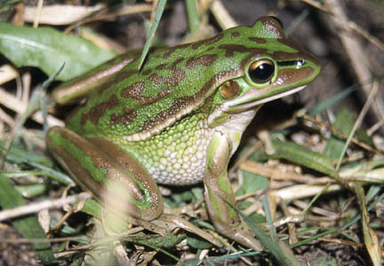

Significant Impact Guidelines for the vulnerable green and golden bell frog Litoria aurea
Nationally Threatened Species and Ecological Communities

EPBC Act Policy Statement 3.19

© Commonwealth of Australia 2009
This work is copyright. You may download, display, print and reproduce this material in unaltered form only (retaining this notice) for your personal, non-commercial use or use within your organisation. Apart from any use as permitted under the Copyright Act 1968, all other rights are reserved. Requests and inquiries concerning reproduction and rights should be addressed to Commonwealth Copyright Administration, Attorney General’s Department, Robert Garran Offices, National Circuit, Barton ACT 2600 or posted at www.ag.gov.au/cca.

Disclaimer
The contents of this document have been compiled using a range of source materials and is valid as at August 2009. The Australian Government is not liable for any loss or damage that may be occasioned directly or indirectly through the use of or reliance on the contents of the document.

Introduction
The green and golden bell frog, Litoria aurea, is listed as vulnerable under the Australian Government Environment Protection and Biodiversity Conservation Act 1999 (EPBC Act). Listed threatened species and ecological communities are a ‘matter of national environmental significance’. Under the EPBC Act an action will require approval from the federal environment minister if the action has, will have, or is likely to have a ‘significant impact’ on a matter of national environmental significance.
A ‘significant impact’ is an impact which is important, notable, or of consequence, having regard to its context or intensity. Whether or not an action is likely to have a significant impact depends upon the sensitivity, value, and quality of the environment which is impacted, and upon the intensity, duration, magnitude and geographic extent of the impacts. You should consider all of these factors when determining whether an action is likely to have a significant impact on matters of national environmental significance.
This policy statement is designed to help you to determine whether a proposed action is likely to have a significant impact on the green and golden bell frog. The policy statement applies to the current and historic range of the green and golden bell frog, in eastern New South Wales, the Australian Capital Territory and south-eastern Victoria.
This policy statement is based on the best available information, including:
- scientific literature
- consultation with species experts, and
- application of the EPBC Act.
This policy statement builds on the information and explanations in EPBC Act Policy Statement 1.1 Significant Impact Guidelines – Matters of National Environmental Significance.

How to interpret and apply these guidelines
The significance thresholds outlined in this policy statement are not designed to be prescriptive, but rather to clarify the level and types of impact likely to be significant at a national level, taking into account the biology, ecology and threats of the species. If you are planning to undertake an action—for example land clearing or development—in temperate habitat in New South Wales, the Australian Capital Territory or Victoria you should consider the following:
- Does my site support the green and golden bell frog (see section 4)?
- What impacts (direct and indirect) could result from my action (see sections 7 & 8)?
- Could any of these impacts exceed the impact thresholds (see section 8)?
- What measures could be taken to reduce the level of impact (see section 10)?
If you think that your action is likely to have a significant impact on a matter of national environmental significance, or if you are unsure, you should refer the action to the federal environment minister. The minister will make a decision within 20 business days on whether approval is required under the EPBC Act. Substantial penalties apply for taking an action that has, will have or is likely to have a significant impact without approval.

What other laws protect the green and golden bell frog?
The green and golden bell frog is also listed as endangered under the New South Wales Threatened Species Conservation Act 1995. There is no legislative protection for the green and golden bell frog in Victoria under the Flora and Fauna Guarantee Act 1988 or in the Australian Capital Territory under the Nature Conservation Act 1980.
The listing of a species, subspecies or ecological community on the EPBC Act threatened species and ecological communities list recognises the importance of the matter from a national perspective, and does not replace listing under state, regional or local legislation or regulations.
Judgements may differ between federal, state and local decision making processes, due to the different scales of consideration. If your activity could affect the species or individual animals, you should contact the relevant state and local authorities to find out your obligations.

Ecology of the green and golden bell frog
The species
The green and golden bell frog is a large dull olive to bright emerald-green frog reaching 85 millimetres in length. The frog has a number of distinguishable features that help identify it. The back of the frog has large irregular blotches ranging from brown to rich golden-bronze, and has a yellowish stripe running from behind the eye to the lower back. The yellowish stripe is bordered by a black stripe that can extend through the eye to the nostrils. The hind toes of the frog are almost fully webbed but fingers of the front feet lack webbing and the frog also has a distinct ear membrane.
Distribution
The green and golden bell frog now mostly occurs in coastal lowland areas in New South Wales and Victoria. The current species’ range is thought to extend from around Brunswick Heads in northern New South Wales (about 50 kilometres south of the Queensland border) to around Lake Wellington, just west of Lakes Entrance in south-eastern Victoria. The species occurs as far inland as Bungendore and Hoskinstown in the southern tablelands of New South Wales (see figure 1). The green and golden bell frog is historically known from the Australian Capital Territory and central slopes of Bathurst in New South Wales.

Figure 1 Green and golden bell frog distribution

Habitat
Green and golden bell frogs need various habitats for different aspects of their life cycle including foraging, breeding, over-wintering and dispersal. They will also use different habitats or habitat components on a temporal or seasonal basis. The habitat of the green and golden bell frog comprises one or more water bodies and associated terrestrial habitats (grassy areas and vegetation no higher than woodlands) within its known range.
Water bodies include but are not limited to ponds, wetlands, farm dams, creek lines and irrigation or drainage channels. Water bodies that only contain water periodically (that is, ephemeral water bodies) are important habitat for green and golden bell frog, as their flooding can trigger breeding or provide habitat ‘stepping-stones’ for dispersal between periodically disconnected water bodies. Ephemeral water bodies are also less likely to be inhabited by mosquito fish.

Reproduction
The green and golden bell frog is known to breed during late winter to early autumn, but generally between September and February with a peak around January-February after heavy rain/storm events. Males call mostly at night, but occasionally by day. Southern, higher altitude populations appear to have a narrower window of opportunity for breeding than populations in the north at lower altitudes. Populations in the north are more commonly known to begin breeding earlier and continue longer than southern populations, which appear to have a much shorter breeding period.
Dispersal (2nd level heading)
It is difficult to be definitive about movement patterns and other behaviours of the green and golden bell frog, as dispersal patterns can vary between populations. However, various studies have revealed that the species can move long distances in a single day/night of up to 1–1.5 kilometres, and mark and recapture studies recorded individuals moving up to 3 kilometres. Observations suggest movements of up to 5 kilometres may be common, and the frog may possibly disperse as far as 10 kilometres.
More information about the ecology and biology of the green and golden bell frog can be found in the background paper to this policy statement, located with the species profile on the department’s SPRAT database www.environment.gov.au/cgi-bin/sprat/public/sprat.pl
Please note that the scientific literature incorporated into this policy statement is expanded on and referenced in the background paper.

Survey guidelines for the green and golden bell frog
The decision-making process for determining significance under the EPBC Act considers the likelihood of the species occurring in the area that will be impacted. The effort and techniques applied in assessing the presence of the green and golden bell frog and/or the suitability of habitat for the species is taken into consideration in determining the likelihood.
Survey principles
Surveys for the green and golden bell frog should:
- be conducted by a suitably qualified person with experience in frog surveys
- maximise the chance of detecting the species
- determine the context of the site within the broader landscape, and
- account for uncertainty and error.

The survey methodology described below for the green and golden bell frog is considered best practice, and is aimed at minimising data gaps and accounting for the species cryptic behaviour. In the absence of adequate surveys (i.e. consistent with those described below) the precautionary principle should be applied where suitable habitat exists (the species assumed present).

Habitat assessment
A habitat assessment should be the first step in assessing green and golden bell frog habitat and/or presence. This should be followed up with targeted field survey for the species. The following questions should be asked during habitat assessment to determine and support whether a site contains or is likely to contain suitable habitat for the green and golden bell frog:

- Is the site within the expected range of the species?
- Are there records of the species within the local area/catchment?
- Does the site support potentially suitable habitat for the species?
- Are there other frog species on site? If so, what species?
- What vegetation occurs on and around the site?
- How close is the nearest water body?
- How many water bodies occur within 10 kilometres?
- Is there habitat connectivity (terrestrial or aquatic) between water bodies on site, and between on-site water bodies and those on neighbouring sites?
- Is there any evidence of disturbance on site?
- Has this habitat been modified as a result of previous development actions?
- Are water bodies infested with mosquito fish or other predatory species that prey on green and golden bell frogs?
- Are there other threats to green and golden bell frogs occurring on site (see section 7 below)?

During drought, the assessment of the importance of ephemeral water bodies (likely to be dry at the time) should not be underestimated.
Field survey (2nd level heading)
Field surveys for the green and golden bell frog should be done either in conjunction with or after a habitat assessment and should be done:

- over a minimum of four nights to increase the detection rate
- between September and March, at the time of peak activity for the species
- during warm and windless weather conditions following rainfall, and
- using a combination of diurnal surveys for basking frogs, nocturnal spotlight surveys, call detection, call playback and tadpole surveys.

Where possible, surveys should include use of a nearby reference site. This reference site should be a site where green and golden bell frogs are known to occur and should be visited before the survey of the site of interest to confirm that green and golden bell frogs are active and calling on that particular night. Use of a reference site will provide a measure of detectability. Where imperfect detectability is a reality of the field work, detection or occupancy modelling should be included in the assessment.

Small wetlands (less than 50 metres at greatest length) should be covered in a period of about one hour by searching banks and emergent vegetation. Larger wetlands (more than 50 metres) should be searched by sampling multiple units systematically. The multiple units should be stratified by some ecological feature, and sampling based on equitable sampling of each of the units. Green and golden bell frogs use a series of water bodies, not all of which will be permanently occupied. The presence of the species in neighbouring water bodies provides an indicator of the likely use of on-site water bodies. Surveys should therefore try to include connected and surrounding suitable habitats during field surveys.

Important populations
Because of the continued decline of the green and golden bell frog, the restricted nature of all known populations in New South Wales and the uncertainty about the current status of the Victorian populations, all current populations of green and golden bell frog are regarded as an ‘important population’. A current population is defined as a site where one or more green and golden bell frogs have been detected on at least one occasion since 1995, even if they have not recently been discovered at the site (due to the species tendency towards local extinction and recolonisation cycles).
At the time of writing, 54 populations of green and golden bell frog are known to occur in New South Wales since 1990. However the status of these populations have changed overtime, and some populations status are currently unknown or presumed extinct (refer to the background paper for a list of these populations). Information on the location of populations in Victoria is more limited.
It is important to note that a population is to be considered a separate population if it is located more than10 kilometres from a known or nearby population. Conversely any discovery of a new individual within 10 kilometres of a known site can be considered a member of a subpopulation of the known population. The 10-kilometre rule may not be relevant in all cases For example, it does not apply in built up areas where connectivity between populations does not exist, such as the Greenacre population, which is within 10 kilometres of the Sydney Olympic park population, but has no connectivity and is within different catchments.

Principal threats to the green and golden bell frog
Principal threats to the green and golden bell frog include:
- habitat removal
- habitat degradation (which includes siltation, changes to aquatic vegetation diversity or structure reducing shelter, increased light and noise, grazing, mowing, fire)
- habitat fragmentation
- reduction in water quality and hydrological changes (for example, pollution, siltation erosion and changes to timing, duration or frequency of flood events)
- disease (for example, infection of the frog with chytrid fungus (Batrachochytrium dendrobatidis) resulting in chytridiomycosis)
- predation (for example, by the introduced mosquito fish (Gambusia spp) and or cats and foxes), and
- introduction or intensification of public access to green and golden bell frog habitats.
Refer to the background paper for further discussion of these threats.

What sorts of actions may have a significant impact on the species?
Actions may have a significant impact on the green and golden bell frog if they directly or indirectly alter or interfere with the breeding or dispersal of the species (for example, occupied water bodies and associated terrestrial habitats).
Significant impact judgements must be made on a case-by-case basis and with consideration for the context of the action. The potential for a significant impact on a listed threatened species will depend on the:
- intensity, duration, magnitude and geographic extent of the impact
- sensitivity, value and quality of the environment on and around the site
- cumulative effect of on-site, off-site, direct and indirect impacts, and
- presence of this and other matters of national environmental significance.

Significant impact threshold for the green and golden bell frog

There is a possibility of a significant impact on the green and golden bell frog, and a referral under the EPBC Act should be considered, if the action results in:

- the removal or degradation of aquatic or ephemeral habitat either where the green and golden bell frog has been recorded since 1995 or habitat that has been assessed as being suitable according to these guidelines. This can include impacts from chytrid, Gambusia originating off-site

- the removal or degradation of terrestrial habitat within 200 metres of habitat identified in threshold 1

- breaking the continuity of vegetation fringing ephemeral or permanent waterways or other vegetated corridors linking habitats meeting the criteria in threshold 1.

Significant impacts on the green and golden bell frog are not only limited to development-type activities that cause long-term habitat change but can include event-type activities of short duration, intensification of existing activities, or experimental habitat management activities that will have or are likely to have serious or irreversible negative consequences for the green and golden bell frog.
The significant impact thresholds above give guidance to the level of impact that is likely to be significant for the species at a site. They are not intended to be exhaustive or prescriptive, but rather to highlight the need to maintain the ecological function of the habitat.

Figure 2 Significant impact thresholds
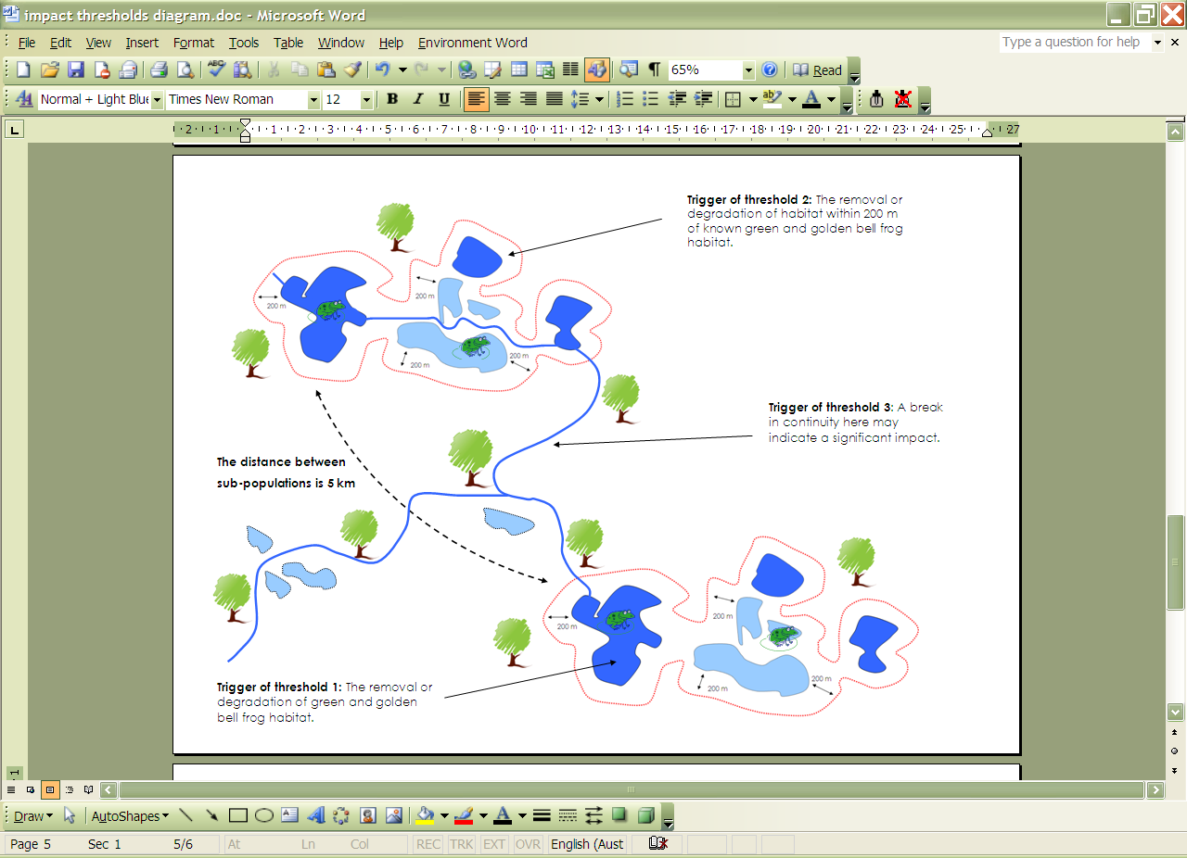
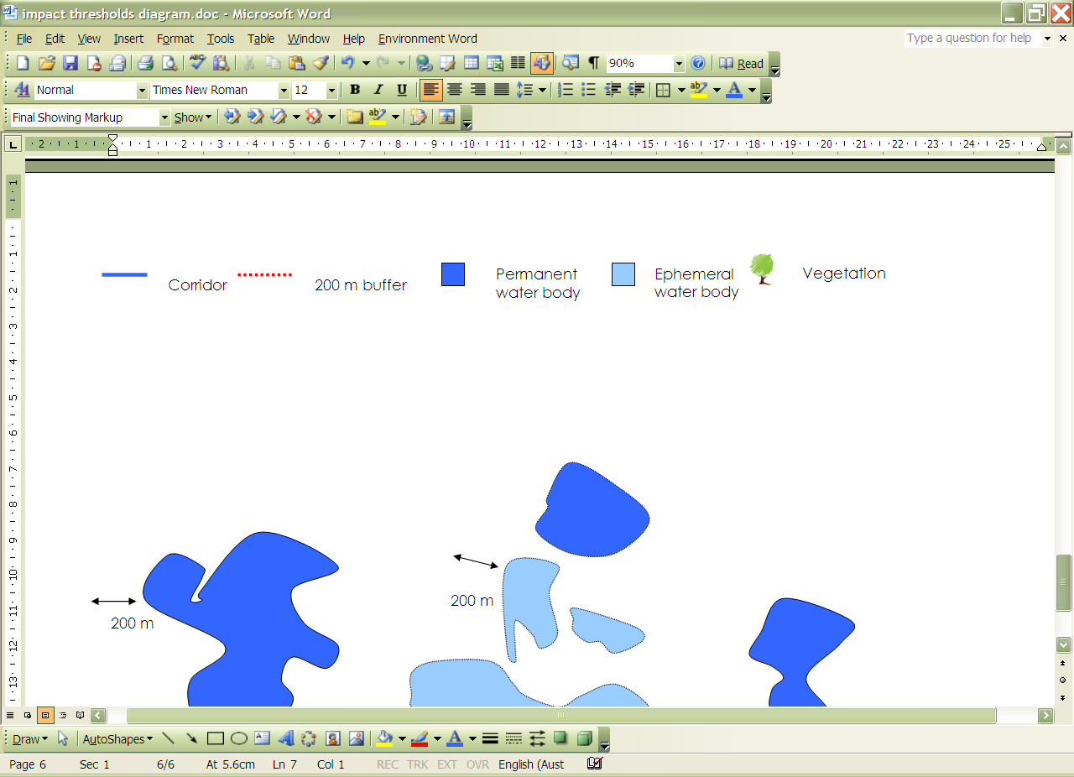

What does this mean for actions in green and golden bell frog habitat?
If you plan to undertake an action that may have a significant impact then you should refer the proposal to the minister before starting the action. The minister will decide, within 20 business days, whether assessment and approval is required under the EPBC Act. More information on referral and assessment is available at www.environment.gov.au/epbc/assessments/process.html
Exceptions to the EPBC Act
Note that an action does not require approval under the EPBC Act if it meets the criteria for the ‘prior authorisation’ or ‘continuing use’ exemptions. The EPBC Act allows for the continuation of activities that were fully approved by state and local governments before the EPBC Act came into force (16 July 2000), or unauthorised, but lawful, activities that began before the EPBC Act came into force, and that have continued without substantial interruption.
However, any enlargement, expansion or change in intensity of an existing action is not covered by the ‘prior authorisation’ or ‘continuing use’ exemptions, and, if the enlargement, expansion or change in intensity is likely to have a significant impact on the green and golden bell frog, referral to the minister is required.
Examples of activities that may be exempt under the ‘continuing use’ provision include:
- routine grazing activities
- continuing cropping and crop rotation
- slashing to maintain existing fire breaks
- maintaining existing dams, roads, fences, etc., and
- continuing an existing weed control program.

How can my action avoid having a significant impact on the green and golden bell frog?
Mitigation includes all measures undertaken on the site of the action to avoid or reduce the action’s impacts. Measures should be incorporated into the conceptual and planning stage(s) of the action to:
- avoid impacts in the first instance
- reduce the level of the impact below the significant impact thresholds outlined in this policy statement
- monitor the performance of the mitigation measures (specify the timeframe; for example, by using performance indicators measured at seasonally/annually nominated times), and
- provide feedback into an adaptive management plan, to quickly react to any changes in performance.
Mitigation and management actions must:
- prioritise impact avoidance over impact reduction measures
- avoid negative impacts on other matters of national environmental significance, and
- be consistent with relevant recovery, conservation, management or action plans; for example, New South Wales Department of Environment, Climate Change and Water key population management plans.
Measures that may avoid, mitigate or manage impacts on the green and golden bell frog are presented in Table 1.
Table 1 Mitigation of significant impacts on the green and golden bell frog
Principle | Measure | Comment
Avoid impacts | Avoid actions in known and/or potential habitat, and avoid impacts to important ecosystem functions and processes including habitat connectivity and the existing hydrology. | -Information from field surveys regarding habitat, existing threats and distribution of the green and golden bell frog should be incorporated into the early design phases of the project to ensure any impacts are avoided.  -Avoid creating barriers to movement or dispersal. Barriers are anything that prevents frogs from moving between local water bodies, and include hard structures that exclude frogs (for example, roads, fences, retaining walls, buildings) and/or introduction of a break of more than one kilometre between waterbodies.
Minimise impacts | Incorporate buffer zones into project design. | -Create buffer areas of at least 200 metres around water bodies (including aquatic corridors).  -Buffer terrestrial movement corridors by at least 100 metres. The width of the terrestrial movement corridor buffer necessary will depend on the length of the corridor and the surrounding land uses, with wider buffers necessary for longer corridors and/or those bounded by inhospitable land uses. These buffers should not include access ways, such as road or rail reserves, recreational trails or cycle paths.
Minimise impacts | Maintain existing hydrology. | -This should include any appropriate flood regime, and water flow and quality. Comprehensive modelling and/or pre-construction baseline monitoring, ongoing post-construction monitoring and adaptive management measures may be required to demonstrate that existing hydrology is maintained.
Minimise impacts | Enhance habitat quality. | -Actively maintain or enhance balance of submergent, floating and emergent vegetation in and around water bodies. For example, introduce indigenous submergent and emergent vegetation to water bodies; maintain open areas within water bodies; manage weeds manually and without chemicals, avoid trees and maximise dense grasses in terrestrial areas.  - Ensure aquatic sites do not become overgrown. That is, prevent overshadowing of ponds and maintain pond water temperatures to suit the green and golden bell frog. Water temperature should be about 25◦ Celsius or higher during the breeding season.  - Improve terrestrial habitat through provision of logs, rocks, etc. to provide a diversity of over-wintering habitat.
Minimise impacts | Avoid undertaking works during sensitive periods. | -Avoid works at aquatic sites during the breeding season (September to February). Frogs may also be sensitive during winter, when they are in torpor. While most green and golden bell frogs over-winter under rocks, logs, etc. on land, some over-winter in pond mud. Work should therefore be scheduled when frogs are alert, but not breeding, so they are able to move away from disturbances (That is, March and April).
Minimise impacts | Implement frog hygiene and pest control protocols. | -It is important to use strict hygiene protocols to prevent the spread of chytrid fungal disease. Environmental management plans must include a detailed frog hygiene protocol along with weed, predatory fish and feral animal management plans.
Manage  impacts | Provide sufficient ongoing monitoring of population and habitat. | -Monitoring should be undertaken and include factors such as recruitment, population numbers, survivorship, and, if appropriate, aim to evaluate success (or failure) of impact thresholds, for example buffers put in place, disturbance regimes or stock grazing. Project managers should also budget for ongoing monitoring and management costs.
Manage  impacts | Remove or manage exotic fish and implement control methods, such as draining or poisoning. | -This includes species such as the introduced mosquito fish or plague minnow, redfin and carp. If this is required, drainage of water bodies should occur when there are few, or no, tadpoles present.
Manage  impacts | Implement environmental management plans and construction management plans. | -Develop and implement environmental management plans to identify threats on site, and implement measures to address them, including control of chytrid fungal disease, weeds, predatory fish and feral animals.  -Develop and implement construction management plans to manage impacts such as frog mortality (may include pre-construction surveying, installation of frog exclusion fencing on construction sites etc.), measures to manage noise, vibration and light impacts on adjacent habitat, etc.  -Align management objectives with those identified in any New South Wales Department of Environment, Climate Change and Water key population management plans. Management plans exist for the following key populations: Coomonderry, Crookhaven River floodplain, Sussex Inlet-Swan Lake, Upper Hunter, Greenacre, Kurnell, Lower Hunter, Georges River, Lower Cookes River and Parramatta.

Experimental management
Several additional measures are being developed and tested to reduce the impacts of habitat loss on the green and golden bell frog. Such measures will not be considered mitigation until their effectiveness is well established (for example, through demonstrated application, studies or surveys), and there is a high degree of certainty about the avoidance of impacts or the extent to which impacts will be reduced. Until such information is available and accepted, such measures should be considered experimental and done only in conjunction with accepted mitigation such as those in Table 1. Experimental measures include:
- habitat creation—constructed water bodies may appear successful in the first year or two, but their occupancy and productivity often decline in subsequent years; the reasons for these declines are unclear
- frog fencing—used to guide frogs into suitable areas or keep them out of disturbed areas
- underpasses—used to overcome the need to cross roads and allow movement under roads; however, there is currently no empirical evidence indicating green and golden bell frogs use underpasses.
The application of experimental measures must be accompanied by a fully costed and funded adaptive management strategy which clearly specifies the criteria for identifying success, and identifies thresholds at which management intervention will occur. Ongoing monitoring and research should also investigate known threats to the species to inform any adaptive management done.
If these measures are proposed, they should use current best practice, and make the results of monitoring and management publicly available to further refine collective knowledge of the species. If creating habitat, it should be positioned to create new links between otherwise unconnected water bodies (due to distance or unsuitable corridors), and its creation timed so that it is suitable for occupation at the time individuals are dispersing. Sufficient time should be allowed for frogs to naturally colonise created habitat before any disturbance to the original habitat occurs. Further information can be found in the best practice guidelines for green and golden bell frog habitat (DECC 2008).

Translocation
Translocation is not a mitigation measure and does not reduce the impact of an action. Translocation of the green and golden bell frog is not considered to mitigate or offset the impact of an action. In limited circumstances translocations may be done for research purposes in accordance with a recovery program aimed at conserving the species. Such translocation may be tried as an experiment and must be done in association with a fully costed and funded monitoring program and adaptive management strategy, with clearly stated criteria for identifying success. Additional permits may be required to undertake salvage translocation. In New South Wales, translocations must be planned and done in accordance with the Department of Environment, Climate Change and Water translocation policy and procedures (currently being updated).

Where can I get more information?
The background paper for this policy statement provides a biological and ecological context for survey guidelines, significant impact thresholds, and mitigation measures.
Other EPBC Act policy statements are available to help you to understand the EPBC Act and your obligations. They are available from the department’s website at: www.environment.gov.au/epbc/guidelines-policies.html, or by contacting the Community Information Unit by email: ciu@environment.gov.au or by phone: 1800 803 772.
The Protected Matters Search Tool can provide a good starting point for determining the likelihood of having matters of national environmental significance in your area. State and territory government agencies may also hold relevant information including habitat and species distribution information.
Further information on this and other listed threatened species and ecological communities is at the department’s Species Profiles and Threats Database (SPRAT) at: www.environment.gov.au/cgi-bin/sprat/public/sprat.pl

Front cover: Green and golden bell frog Litoria aurea. Photograph taken by Frank Lemkert

BIO028.0809

