Littoral Rainforest and Coastal Vine Thickets of Eastern Australia
A nationally threatened ecological community

This brochure is designed to assist land managers, owners and occupiers to identify, assess and manage the Littoral Rainforest and Coastal Vine Thickets of Eastern Australia, an ecological community listed under the Commonwealth Environment Protection and Biodiversity Conservation Act 1999 (EPBC Act). The brochure is a companion document for the listing advice which can be found at the Australian Government’s species profile and threats database (SPRAT). Please go to the Littoral Rainforest and Coastal Vine Thickets of Eastern Australia profile in SPRAT: www.environment.gov.au/cgi-bin/sprat/public/publiclookupcommunities.pl

- What is an ecological community?

An ecological community is a unique and naturally occurring group of plants and animals. Its presence and distribution is determined by environmental factors such as soil type, position in the landscape, climate and water availability. Species within such communities interact and depend on each other - for example, for food or shelter. Examples of communities listed under the EPBC Act include woodlands, grasslands, shrublands, forests, wetlands, ground springs and cave communities

Together with threatened species, ecological communities are protected as one of several matters of National Environmental Significance under the EPBC Act. Threatened ecological communities can be listed as Critically Endangered, Endangered or Vulnerable, categories which reflect their decline and potential for extinction across their national extent. Protection through the EPBC Act is vital for some ecological communities because they often occur outside of conservation reserves.

Ecological communities provide a range of ecosystem services, including the natural management of water, air and soil nutrients, the reduction of erosion and salinity and the provision of carbon storage. In addition to providing vital connections for wildlife corridors and habitat refuge for many threatened plant and animal species, they also contribute to tourism, recreation and the productivity of our farmlands.

What is the Littoral Rainforest and Coastal Vine Thickets of Eastern Australia ecological community?

The Littoral Rainforest and Coastal Vine Thickets of Eastern Australia is a critically endangered ecological community listed under the Australian Government’s EPBC Act. The ecological community provides habitat for over 70 threatened plants and animals and it provides an important buffer to coastal erosion and wind damage.

Littoral Rainforest and Coastal Vine Thickets of Eastern Australia typically occurs close to the coast from northern Queensland southwards to eastern Victoria and on offshore islands. It occurs as a series of naturally disjunct and localised stands, on a range of landforms which have been influenced by coastal processes including dunes and flats, headlands and sea-cliffs.

The appearance of this ecological community and its plant species can vary greatly depending on location, but it appears as a complex of rainforest and vine thickets. The vegetation generally is structurally diverse, with native trees, shrubs, vines and ground layers all potentially being present. The vegetation typically has a closed canopy.

- The Littoral Rainforest and Coastal Vine Thickets of Eastern Australia is a highly fragmented, critically endangered ecological community.

- Littoral Rainforest and Coastal Vine Thickets of Eastern Australia is relatively resilient and is still functional even after some disturbances (such as storm events and weed invasion).

- Setting aside this ecological community for long-term protection is encouraged for future generations to experience.

- Implementing favourable land use and management practices is encouraged at sites containing this ecological community.

How do I know if I am standing in a patch of the Littoral Rainforest and Coastal Vine Thickets of Eastern Australia?

This guide is designed to help you determine if a native vegetation remnant could be part of the listed Littoral Rainforest and Coastal Vine Thickets of Eastern Australia ecological community. The description and condition thresholds of the ecological community in the listing advice are always the definitive source of information for identifying a nationally threatened ecological community and any mapped vegetation units should only be used as a guide. The description in the listing advice is summarised in the following pages.

A patch of the listed ecological community is defined as a discrete and continuous area that comprises the ecological community. It does not include substantial elements of other ecological communities, such as coastal scrublands and other drier types of forests. However, a patch of the listed ecological community may include small-scale disturbances, such as tracks or breaks that do not significantly alter its overall functionality, for instance the easy movement of wildlife or dispersal of plant spores and seeds.

If a native vegetation remnant meets ALL the criteria below, then you are likely to be standing in the nationally listed threatened ecological community.

Where should a rainforest patch be located?

- The ecological community occurs in the following bioregions identified in the Interim Biogeographic Regionalisation of Australia (IBRA): Cape York Peninsula (from Princess Charlotte Bay southwards), Wet Tropics, Central Mackay Coast, South Eastern Queensland, NSW North Coast, Sydney Basin and South East Corner. (See map on page 7).

- Patches of the ecological community typically occur within two kilometres of the east coast, or on offshore islands, or adjacent to a large body of salt water, such as an estuary, where they are subject to maritime influences.

- The ecological community occurs on coastal headlands, dunes, sea-cliffs or other places influenced by the sea.

What is the native vegetation like?

- The structure typically includes a closed canopy of trees, so when you are in the ecological community it often appears dark, but the canopy can be patchy when in exposed situations or after storm events. That is, at times the canopy may have temporary gaps, due to natural disturbance such as storm events or tree fall, allowing more light in the ecological community.

- Usually, several vegetation layers are present. The canopy protects less tolerant species underneath it from salt-laden winds. However, where there is extreme exposure to salt laden winds, these distinct layers demonstrate a height continuum. Moreover, wind sheared canopy can be present on the frontal section (closest to the sea).

- The Littoral Rainforest and Coastal Vine Thickets of Eastern Australia typically has tall trees as part of the canopy, but not always. The height of the canopy plants varies depending on the degree of exposure and can range from one to 25 metres. Emergent trees may be present above the canopy, for example species from the genera Araucaria (Bunya and Hoop pines in the northern bioregions only), Banksia or Eucalyptus. The ground layer of the vegetation typically is sparse.

- There are a range of plant life forms including trees, shrubs, vines, herbs, ferns and epiphytes (plants that are supported by or grow on other plants). To the north, most plant species diversity is in the tree and shrub layers rather than in the lower layer. The opposite, where the ground layer is typically more diverse, generally occurs from the Sydney Basin Bioregion southwards.

- Plants with drought tolerant and succulent features are generally more common in littoral rainforest than in more inland rainforest types. Trunks often host lichens (but rarely mosses) and canopy stem sizes tend to be smaller compared to that in more inland rainforest. Ground ferns and epiphytes are lower in diversity in littoral rainforests compared to many other rainforest types. Feather palms, fan palms and large leaved epiphytes are generally rare.

- Plant species are mainly rainforest species and can be regionally predictable. However there may be considerable variation in the composition of individual stands of the listed community within any given bioregion. The number of different species that can be found in the ecological community declines the further south the ecological community is located. There are more than 500 species of plants that could be part of the ecological community. A list of typical species for each bioregion can be found on the SPRAT database. Go to the Littoral Rainforest and Coastal Vine Thickets of Eastern Australia ‘Details’ link, then view ‘Further Information’:
www.environment.gov.au/cgibin/sprat/public/publiclookupcommunities.pl

What other condition criteria apply?

- The minimum patch size needs to be 0.1 hectares (1000 m2)

- The cover of transformer weed species is 70 per cent or less. Transformer weeds are highly invasive taxa with the potential to seriously alter the structure and function of the ecological community. This threshold recognises the relative resilience and recoverability of the ecological community to invasion by weed species. A list of the transformer weeds for each bioregion may be found on the indicative bioregional plant Species Lists (found on SPRAT)

- Of the native plant species present in the patch at least 25 per cent of these must occur on the indicative plant Species Lists for the associated bioregion of this ecological community (found on SPRAT)OR

OR
- At least 30 per cent of the canopy cover in the patch must be from one or more of the rainforest canopy species (either a tree or shrub) that are on the indicative bioregional plant Species Lists (found on SPRAT) excluding Banksia or Eucalyptus species.

If a patch is too degraded and does not meet the above criteria, then it will be excluded from the listed ecological community. However, managing areas to maintain and enhance remaining values is encouraged (please see the Threats, Impacts and Conservation Actions section on page 11 of this guide). If a patch is not listed because it’s too degraded, suitable management may improve it to the point that it can be regarded as part of the listed ecological community.

Some Key Species

The following photos show some of the key species of the Littoral Rainforest and Coastal Vine Thickets of Eastern Australia. The following abbreviations indicate the IBRA Bioregion in which each species may be found: Cape York Penninsula = CYP, Wet tropics = WT, Central Mackay Coast = CMC, South East Queensland = SEQ, NSW North Coast = NNC, Sydney Basin = SB, South East Corner = SEC. (See distribution map on page 7 for IBRA Bioregion boundaries).

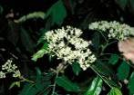  Micromelum minutum  CYP, WT, CMC, SEQ  © M. Fagg. ANBG | 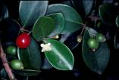  Eugenia reinwardtiana, beach cherry  CYP, WT, CMC  © M. Fagg. ANBG | 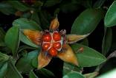  Hibbertia scandens, snake vine  WT, SEQ, NNC, SB, SEC  © M. Fagg. ANBG
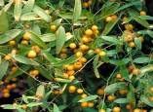  Eustrephus latifolius, wombat berry  CMC, SEQ, SB, SEC  © M. Fagg. ANBG | 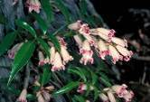  Pandorea pandorana, wonga wonga vine  SEQ, NNC, SEC  © M. Fagg. ANBG | 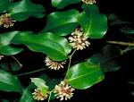  Smilax australis, barbed wire vine  WT, CMC, SEQ, SB, SEC  © M. Fagg. ANBG
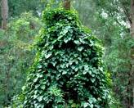  Stephania japonica, subsp. discolour  SEQ, SEC  © M. Fagg. ANBG | 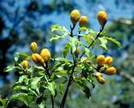  Pittosporum revolutum, rough-fruit pittosporum SEQ, NNC, SEC  © M. Fagg. ANBG | 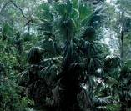  Livistona australis, cabbage tree palm  SB  © D. Greig. ANBG
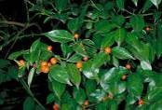  Morinda jasminoies, jasmine morinda  SEC  © M. Fagg. ANBG | 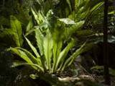  Asplenium australasicum, birds nest fern SEC  © M. Fagg. ANBG | 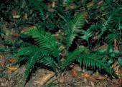  Doodia Aspera, prickly rasp fern  SEC  © M. Fagg. ANBG

Exception - Brigalow Belt North Bioregion

If the site is located in the Brigalow Belt North Bioregion and a patch of native vegetation fulfils the criteria above for Littoral Rainforest and Coastal Vine Thickets of Eastern Australia, then it is likely to be within the Queensland (QLD) Regional Ecosystem 11.2.3, Low notophyll to microphyll vine forest (“beach scrub”) on sandy beach ridges, which is a component of the Semi-evergreen Vine Thickets of the Brigalow Belt (North and South) and Nandewar Bioregions ecological community. This ecological community was listed under the EPBC Act in 2001 and includes coastal vine forests within the Brigalow Belt Bioregion.

Further information on the Semi-evergreen Vine Thickets of the Brigalow Belt (North and South) and Nandewar Bioregions ecological community can be found in the SPRAT profile of that ecological community:
www.environment.gov.au/cgi-bin/sprat/public/publiclookupcommunities.pl

The Environmental Protection Agency of Queensland has produced information on Regional Ecosystem 11.2.3 Low notophyll to microphyll vine forest (“beach scrub”) on sandy beach ridges. This can be found at:
www.epa.qld.gov.au/publications?id=2186

Where is the ecological community found?

The Littoral Rainforest and Coastal Vine Thickets of Eastern Australia ecological community is found on the east coast of Australia typically within two kilometres of the coast, or adjacent to a large body of salt water (such as an estuary), or on offshore islands. The ecological community is not associated with a particular soil type but is found on a variety of landforms, such as headlands and dunes.

The ecological community occurs from Princess Charlotte Bay, at the southern end of Cape York Peninsula in QLD to the Gippsland Lakes in Victoria as well as on offshore islands on the east coast. Warm temperate, sub-tropical and tropical climate zones may contain this ecological community. Other coastal rainforests occur further north but are not included in this ecological community.

The map on page 7 shows the areas along the east coast of Australia where the Littoral Rainforest and Coastal Vine Thickets of Eastern Australia is likely to occur. The description and condition thresholds of the ecological community in the listing advice are always the definitive source of information for identifying a nationally threatened ecological community and any mapped vegetation units should only be used as a guide. Coastal areas in the Brigalow Belt North Bioregion do not contain the listed community (see the exception - Brigalow Belt North Bioregion).

State equivalents to the listed community?

The three states in which the listed ecological community occurs, QLD, New South Wales (NSW) and Victoria, classify plant communities in different ways. NSW and QLD have equivalent vegetation types for Littoral Rainforest and Coastal Vine Thickets of Eastern Australia and these are listed below. This list may enable land managers who are familiar with their own state’s vegetation classification to identify whether the listed community is likely to occur at a particular site.

In QLD, the Regional Ecosystems that currently equate wholly to the ecological community are: 3.2.1a, 3.2.1b, 3.2.12, 3.2.13, 3.2.28, 3.2.29, 3.2.31, 3.2.11, 3.12.20, 7.2.1a-i, 7.2.2a-h, 7.2.5a, 7.2.6b, 7.11.3b, 7.12.11d, 8.2.2 and 12.2.2. A description for each of the Regional Ecosystems is found at:

www.epa.qld.gov.au/nature_conservation/biodiversity/regional_ecosystems

- In NSW, the ecological community is protected under the Threatened Species Conservation Act 1995 as “Littoral Rainforest in the South East Corner, Sydney Basin and NSW North Coast Bioregions”.

www.threatenedspecies.environment.nsw.gov.au/tsprofile/pas_profile.aspx?id=10867

- In Victoria, the ecological community is known as Littoral Rainforest but is not described under the Ecological Vegetation Class and is not protected as a threatened ecological community under state legislation (as at January 2009).

The listing of Littoral Rainforest and Coastal Vine Thickets of Eastern Australia under the EPBC Act protects the ecological community throughout its entire range including in Victoria.
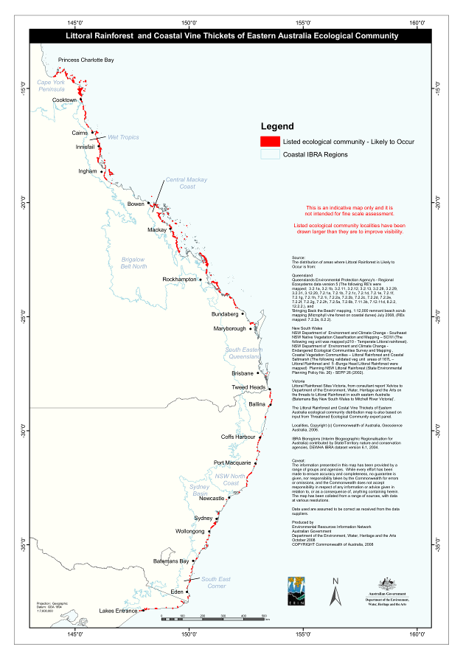

Some Examples of Littoral Rainforest and Coastal Vine Thickets of Eastern Australia

The listed ecological community varies greatly in appearance across its distributional range and from site to site; there may be differences in structure and plant species present. The following photos show some examples of this ecological community and some of the variations in appearance. The labels indicate the IBRA regions where the photo was taken (see distribution map on page 7 for IBRA boundaries).

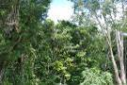  Palm Cove, North of Cairns, QLD  Wet Tropics  © G W. & R. F. Wilson | 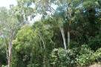  Palm Cove, North of Cairns, QLD  Wet Tropics  © G W. & R. F. Wilson | 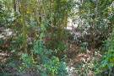  Ellis Beach, North of Cairns, QLD  Wet Tropics  © G W. & R. F. Wilson
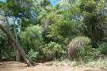  Ellis Beach, North of Cairns, QLD  Wet Tropics  © G W. & R. F. Wilson | 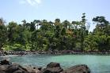  Mission Beach, South of Cairns, QLD  Wet Tropics  © Liz Gallie | 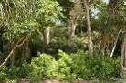  Mission Beach, South of Cairns, QLD  Wet Tropics  © Liz Gallie
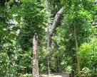  Mission Beach, South of Cairns, QLD  Wet Tropics  © Steve McDermott | 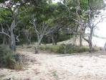  Wagnetti Beach, North of Cairns, QLD  Wet Tropics  © Steve McDermott | 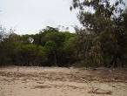  Central Mackay Coast  © Steve McDermott
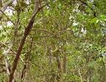  Central Mackay Coast  © Marie Cali | 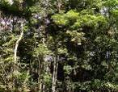  North of Cabarita Beach, Northern NSW South East Queensland  © Bill O’Donnell | 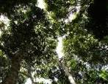  North of Cabarita Beach, Northern NSW South East Queensland  © Bill O’Donnell
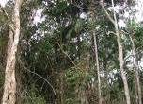  Wooyung Nature Reserve, North of Byron Bay, NSW. South East Queensland  © Bill O’Donnell | 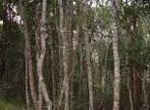  Wooyung Nature Reserve, North of Byron Bay, NSW. South East Queensland  © Bill O’Donnell | 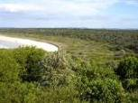  Iluka World Heritage Area, North of Yamba. NSW North Coast  © Bill O’Donnell
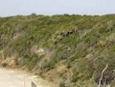  Sea Acres Nature Reserve, Port Macquarie. NSW North Coast  © F. Barzi | 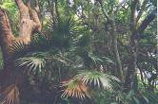  NSW North Coast  © Helena Mills | 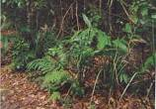  Booti Booti, National Park, South of Forest. NSW North Coast  © Helena Mills
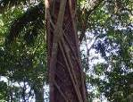  NSW North Coast  © F. Barzi | 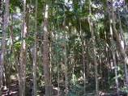  NSW North Coast  © F. Barzi | 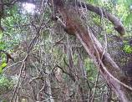  Bournda National Park, North of Merimbula, NSW. South East Corner  © T. Wright
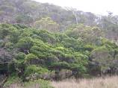  Bournda National Park, North of Merimbula, NSW. South East Corner  © T. Wright | 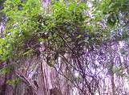  Bournda National Park, North of Merimbula, NSW. South East Corner  © T. Wright | 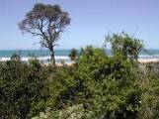  Ninety Mile Beach, near Lakes Entrance, VIC. South East Corner  © Bill Peel
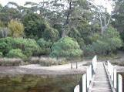  South East Corner  © Bill Peel | 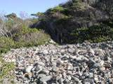  South East Corner  © Bill Peel | 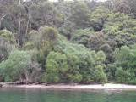  North Arm, near Lakes Entrance, VIC. South East Corner  © Bill Peel

- Species of Special Importance

Many threatened species that are listed under the EPBC Act have been either recorded in, or near to, known sites of the Littoral Rainforest and Coastal Vine Thickets of Eastern Australia ecological community. This includes more than 50 plants, as well as various birds, mammals, reptiles and frog species. Please refer to the listing advice for details:
www.environment.gov.au/cgi-bin/sprat/public/publiclookupcommunities.pl

Two species of particular note are the nationally-listed southern cassowary (Casuarius casuarius johnsonii) and grey-headed flying fox (Pteropus poliocephalus). These species are an integral part of the listed ecological community in some areas, relying on the fruits of the listed community plants for food and in return they disperse the seeds of these plants. The grey-headed flying fox has the potential for wide dispersal of seeds as it covers long distances in its foraging behaviour.

On pages 13-15 of this booklet there is a table of species which are associated with the Littoral Rainforest and Coastal Vine Thickets of Eastern Australia and are listed under the EPBC Act. There are also some photos of these listed species.
Why is the ecological community listed as critically endangered?

The decision to list the ecological community was made by the Minister for the Environment, Heritage and the Arts after a rigorous process that involved consultation with stakeholders and advice from the Threatened Species Scientific Committee (TSSC). The TSSC is an independent scientific body that advises the Minister on the conservation status of native species and ecological communities.

The Littoral Rainforest and Coastal Vine Thickets of Eastern Australia has been listed under the EPBC Act based on the TSSC finding that it is typically fragmented and small patch sizes coupled with demonstrable threats and the very severe reduction in the integrity of the ecological community, make it critically endangered.

National listing of an ecological community recognises that its long-term survival is under threat. The listing aims to prevent any further decline and to promote and assist recovery through government, landholder and community efforts.

What does the listing of the ecological community mean for land managers or developers?

If a patch of the listed ecological community is present, then continuation of supportive land use and practices is vitally important if it is to persist for the benefit of future generations.

The listing of the Littoral Rainforest and Coastal Vine Thickets of Eastern Australia under the EPBC Act will not prevent land managers from continuing to use land in the same way they were before, providing that they do not significantly change or intensify their activities (and the activity is lawful).

National protection means any new or intensified activities that may have a significant impact upon one or more patches of the listed ecological community should be referred to the Minister for the Environment, Heritage and the Arts for assessment and approval.

Such activities include clearing of the listed community and activities leading to or contributing to degradation of the community, such that its values or ecological viability are threatened. For example logging, clearing of understorey or ground layer, permanent changes in hydrology, introduction of invasive exotic species, fragmentation through construction of permanent access tracks. Also note that even if your remnant vegetation does not meet the criteria for the listed ecological community (on pages 2 to and 4) some plants or animal species that occur within the remnant may be individually protected under the EPBC Act.

The EPBC Act allows for some exemptions to the requirement for assessment and approval. This means that some activities may not need to be referred for an assessment or approval under certain conditions. However, failure to refer an action that has a significant impact on the listed ecological community may have legal consequences such as financial penalties or remediation orders.

Further information is available on:
Approvals: www.environment.gov.au/epbc/approval.html
Exemptions: www.environment.gov.au/epbc/about/exemptions.html
Referrals: www.environment.gov.au/epbc/assessments/referral-form.html
Enquiries may also be directed to 1800 803 772

You should also check with relevant authorities whether any state or Local Government approvals are required in addition to EPBC Act requirements.

If you have the listed ecological community on your property and intend to use that land for farming practices, then you are encouraged to seek advice from the Environmental Liaison Officer at the National Farmers’ Federation. The officer can be contacted by phone 1800 704 520 or email environment@nff.org.au

Threats, Impacts and Conservation Actions

What was once an almost continuous group of patches of the ecological community along the eastern coast of Australia has been and continues to be reduced and fragmented by land clearance, weed invasion, recreational disturbance, animal browsing/grazing, fire and natural disturbance.

There are many benefits to the long-term protection of native biodiversity. Native vegetation remnants, such as the listed Littoral Rainforest and Coastal Vine Thickets of Eastern Australia community, provide a range of ecosystem services along the east coast of Australia, like buffering salt laden winds and the prevention of erosion.

To assist in the protection of the listed community, survey work and mapping is encouraged to help identify more remnants of the listed rainforest. Monitoring to identify key threats as well as protecting known sites of the listed community through the development of conservation agreements and covenants with state conservation agencies, or re-zoning land would also help to protect the Littoral Rainforest and Coastal Vine Thickets of Eastern Australia.

Clearing and land development pose serious threats to the Littoral Rainforest and Coastal Vine Thickets of Eastern Australia. These activities remove vegetation and the seedbank, further fragmenting the listed community and having a significant negative impact on biodiversity. Developments that are near or are upstream of the listed community and that change drainage patterns can also have negative impacts on the community. Changes in water runoff and timing potentially threaten the community as they can alter the surrounding vegetation and impact on the listed ecological community.
Climate change may directly impact on the listed community by changes to rainfall and temperature regimes and by an increased intensity of coastal processes. This may include changes to inundation regimes and an increase in severity and frequency of storm events. Storm events may directly damage the forest canopy and increase the chances of weed invasion and establishment within the rainforest. Other indirect impacts may include changes to fire regimes and to species composition.

While the ecological community is relatively resilient to natural disturbances, weeds have the ability to structurally change and transform the Littoral Rainforest and Coastal Vine Thickets of Eastern Australia. Weeds of particular concern for the listed community are lantana, bitou bush, pond apple, asparagus species, rubber vine, cape ivy, madeira vine and Senna siamea (some of these are pictured below). For information on the management of some of these weeds, visit the Weeds of National Significance site: www.weeds.org.au/WoNS

Below is a table showing key potential threats to the Littoral Rainforest and Coastal Vine Thickets of Eastern Australia listed community as well as possible actions that land managers may take to benefit the conservation of the listed community and their land. This list is not exhaustive. A conservation advice for this ecological community has been prepared. It highlights conservation actions of high priority at the time of listing and provides additional guidance and is available on SPRAT: www.environment.gov.au/cgi-bin/sprat/public/publiclookupcommunities.pl

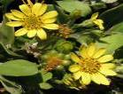  Chrysanthemoides monilifera  bitou bush  © H. Cherry | 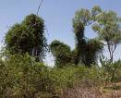  Crypostegia grandiflora  rubber vine  © D. Markovic | 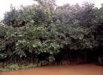  Annona glabara  pond apple  © C. G. Wilson | 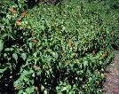  Lantana camara  lantana  © C. G. Wilson

Threat | Impact | Management Actions
Clearing, disturbance and modification | - Removal, damage, thinning or fragmentation of the community  - Increased edge effects including susceptibility to weed invasion  - Increased salt spray to plants | - Identify high conservation sites and implement conservation mechanisms  - Protect remnants  - Repair and expand and connect remnants  - Collect and store seeds for future plantings
Inappropriately placed paths/tracks including beach access and amenities | - Direct plant damage  - Patch fragmentation  - Increased salt spray to plants | - Ensure proper placement of paths/tracks, public amenities around the community
Invasive weeds | - Introduced plants compete with native plants for space, water and nutrients  - May lead to structural changes or smothering as some noxious weeds proliferate, especially after disturbances like storms | - Remove key problem species such as lantana and bitou bush from known littoral rainforest sites.  - Develop and use long-term management plans for controlling key exotic plant species in the region  - Replant with local native species
Inappropriate fire regimes | - Can open up forest to weeds, structural and species change  - Loss of habitat for native animals | - Implement hazard reduction zones in the vicinity of remnants
Trampling, browsing and grazing by feral animals and livestock | - Vegetation removal  - Soil compaction  - Decrease in water uptake  - Accelerated weed invasion | - Control feral animal and livestock impacts by appropriate means  - Manage known sites to exclude feral animals and livestock

Species listed under the Environment Protection and Biodiversity Conservaton Act, 1999

The following table shows species listed under the Environment Protection and Biodiversity Conservation Act 1999 as of February 2009 and associated with the Littoral Rainforest and Coastal Vine Thickets ecological community.

 | Species | Common name(s) | EPBC Status
Plants | Acacia caerulescens | buchan blue wattle | Vulnerable
 | Acronychia littoralis | scented acronychia | Endangered
 | Arenga australasica | Australian arenga palm | Vulnerable
 | Arthraxon hispidus | hairy jointgrass | Vulnerable
 | Asperula asthenes | trailing woodruff | Vulnerable
 | Asterolasia elegans |  | Endangered
 | Baloghia marmorata | jointed baloghia | Vulnerable
 | Boronia umbellata | orara boronia | Vulnerable
 | Bosistoa selwynii | heart-leaved bonewood | Vulnerable
 | Bosisoa transversa | yellow satinheart | Vulnerable
 | Bulbophyllum globuliforme | hoop pine orchid | Vulnerable
 | Clematis fawcettii | northern clematis | Vulnerable
 | Corchorus cunninghamii | native jute | Endangered
 | Corokia whiteana | corokia | Vulnerable
 | Cryptocarya foetida | stinking cryptocarya | Vulnerable
 | Cryptostlis hunteriana | leafless tongue orchid | Vulnerable
 | Cupaniopsis shirleyana | wedge-leaf tuckeroo | Vulnerable
 | Cynanchum elegans | white-flowered wax plant | Endangered
 | Davidsonia jerseyana | Davidson’s plum | Endangered
 | Davidsonia johnsonii | smooth Davidson’s plum | Endangered
 | Desmodium acanthocladum | thorny pea | Endangered
 | Diospyros mabacea | red-fruited ebony | Vulnerable
 | Diploglottis campbellii | small-leaved tamarind | Vulnerable
 | Durabaculum nindii |  | Endangered
 | Endiandra floydii | Floyd’s walnut | Endangered
 | Endiandra hayesii | rusty rose walnut | Endangered
 | Floydia praealta | ball nut | Vulnerable
 | Fontainea australis | southern fontainea | Vulnerable
 | Fontainea oraria | coastal fontainea | Vulnerable
 | Gossia fragrantissima | sweet myrtle | Endangered
 | Hicksbeachia pinnatifolia | red boppel nut | Endangered
 | Huperzia dalhousieana | blue tassel-fern | Vulnerable
 | Huperzia phlegmarioides | layered tassel-fern | Endangered
 | Macadamia tetraphylla | rough-shelled bush nut | Vulnerable
 | Medicosma obovata |  | Vulnerable
 | Muehlenbeckia australis | climbing lignum, native sarsparilla | Endangered
 | Neisosperma kilneri |  | Endangered
 | Ozothamnus eriocephalus |  | Vulnerable
 | Phaius australis | southern swamp orchid | Vulnerable
 | Phaius tankervilleae | Lady Tankerville’s swamp orchid | Endangered
 | Phalaenopsis rosenstromii |  | Endangered
 | Quassia bidwillii | quassia | Endangered
 | Randia moorei | spiny gardenia | Vulnerable
 | Rhizanthella slateri | eastern Australian underground orchid | Endangered
 | Sophora fraseri | brush sophora | Endangered
 | Syzygium hodgkinsoniae | red lilly pilly | Vulnerable
 | Syzygium moorei | rose apple | Vulnerable
 | Syzygium paniculatum | magenta lilly pilly | Vulnerable
 | Tinospora tinosoroides | arrow-head vine | Vulnerable
 | Vappaculum superbiens |  | Vulnerable
Birds | Amaurornis olivaceus | bush-hen | Listed Marine
 | Casuarius casuarius johnsonii | southern cassowary | Endangered
 | Cyclopsitta diophthalma coxeni | Coxen’s fig-parrot | Endangered, Listed Migratory
 | Ducula bicolor | pied imperial-pigeon | Listed Marine
 | Erythrotriorchis radiatus | red goshawk | Vulnerable
 | Hirundapus caudacutus | white-throated needletail | Listed Marine, Listed Migratory
 | Merops ornatus | rainbow bee-eater | Listed Marine, Listed Migratory
 | Monarcha melanopsis | black-face monarch | Listed Marine, Listed Migratory
 | Monarcha trivirgatus | spectacled monarch | Listed Marine, Listed Migratory
 | Pandion haliaetus | osprey | Listed Marine, Listed Migratory
 | Pterodroma leucoptera leucoptera | Gould’s petrel | Endangered, Listed Migratory
 | Ptilinopus superbus | superb fruit-dove | Listed Marine
 | Rhipidura rufifrons | rufous fantail | Listed Marine, Listed Migratory
 | Turnix melanogaster | black-breasted button-quail | Vulnerable
Mammals | Dasyurus hallucatus | northern quoll | Endangered
 | Dasyurus maculatus maculatus | spotted-tailed quoll | Endangered
 | Petrogale persephone | proserpine rock-wallaby | Endangered
 | Potorous tridactylus tridactylus | long-nosed potoroo | Vulnerable
 | Pteropus conspicillatus | spectacled flying-fox | Vulnerable
 | Pteropus poliocephalus | grey-headed flying-fox | Vulnerable
Frogs | Litoria aurea | green and golden bell frog | Vulnerable
 | Mixophyes balbus | stuttering barred frog | Vulnerable
 | Mixophyes iteratus | giant barred frog | Endangered

Some species listed under the Environment Protection and Biodiversity Conservaton Act 1999

Some species listed under the Environment Protection and Biodiversity Conservation Act 1999 as of February 2009 and associated with the Littoral Rainforest and Coastal Vine Thickets ecological community. [Vu: Vulnerable, En: Endangered; Ma: Listed Marine, Mi: Listed Migratory]

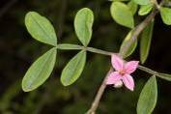  Boronia umbellata,  orara boronia Vu  © M. Fagg ANBG | 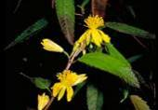  Corchorus cunninghamii,  native jute En  © M. Fagg ANBG | 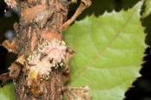  Davidsonia jerseyana,  Davidson’s plum En  © M. Fagg ANBG
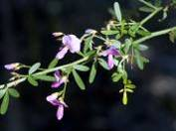  Desmodium acanthocladum,  thorny pea En  © M. Fagg ANBG | 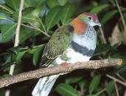  Ptilinopus superbus,  superb fruit dove Ma  © Wet Tropics Management Authority | 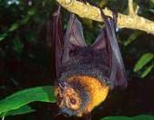  Pteropus conspicillatus,  spectacled flying-fox Vu  © Mike Trenerry
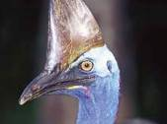  Casuarius casuarius johnsonii,  southern cassowary En  © Wet Tropics Management Authority | 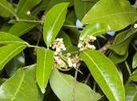  Diploglottis campbellii,  small leaved tamarind Vu  © M. Fagg ANBG | 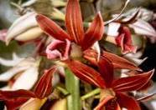  Phaius australis,  southern swamp orchid Vu  © Andrew Benwell
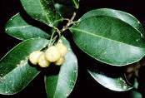  Acronychia littoralis,  scented acronychia En  © Hugh Nicholson | 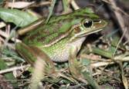  Littoria aurea,  green and golden bell frog Vu  © Frank Lemckert | 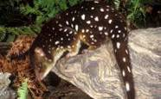  Dasyurus maculatus,  spotted-tailed quoll En  © Dave Watts
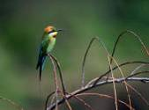  Merops ornatus,  rainbow bee-eater Ma, Mi  © Ester Beaton | 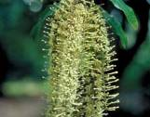  Floydia praealta,  ball nut Vu  © D. Greig ANBG | 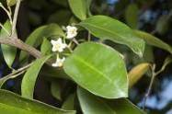  Fontainea oraria,  coastal fontainea Vu  © M. Fagg ANBG
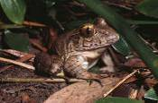  Misophyes balbus,  Stuttering barred frog Vu  © Frank Lemckert | 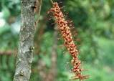  Hicksbeachia pinnatifolia,  Red boppel nut En  © M. Fagg ANBG | 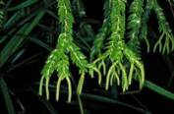  Huperzia phlegmarioides  layered tassel fern En  © M. Fagg ANBG
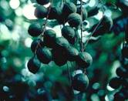  Macadamia tetraphylla  rough-shelled bush nut Vu  © D. Greig ANBG | 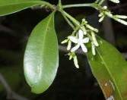  Neisosperma kilneri  En  © M. Fagg ANBG | 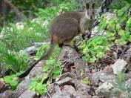  Petrogale persephone,  proserpine rock wallaby  En  © Barry Nolan
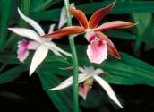  Phaius tankervilleae,  Lady tankerville’s swamp orchid En  © M. Fagg ANBG | 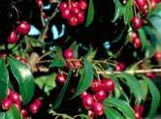  Syzygium paniculaturn,  Magenta lilly pilly Vu  © M. Fagg ANBG | 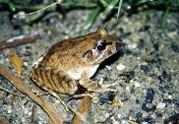  Mixophyes iteratus  Giant barred frog En  © Frank Lemckert

Can I get funding to protect the ecological community?

If the ecological community is on your property, council land or public land, you may be eligible for funding to help preserve or restore remnants.

Funding through Caring for our Country may be available for undertaking activities that are undertaken which have an environmental benefit. For more details:

www.nrm.gov.au/funding/future.html

The National Reserve System (NRS) has an important role in protecting biodiversity values. Building the NRS is one of the priorities under Caring for our Country. Funding is open to landholders who seek financial support to either purchase land or establish protected areas on private land for inclusion in the NRS. For more details:

www.nrm.gov.au/funding/2008/nrs.html

There may be state government initiatives to help protect the littoral rainforest, as it is also a state-listed threatened community in QLD and NSW. Regional offices of either the Environmental Protection Agency of QLD, or the Department of Environment and Climate Change of NSW, or your local Catchment Management Authority, Regional Natural Resource Management Group, or local council can provide you with information about any current programs in place to support conservation efforts on private property.

Where can I get further information?

Listing Advice and Conservation Advice for the Littoral Rainforest and Coastal Vine Thickets of Eastern Australia. Go to the ecological community and view the advices:
www.environment.gov.au/cgi-bin/sprat/public/publiclookupcommunities.pl

NSW Department of Environment and Climate Change (NSW listed ecological community). Littoral Rainforest ecological community profile: www.threatenedspecies.environment.nsw.gov.au

Peel, B. (not yet published). Rainforest Restoration Manual. Based on the Rainforests of South-eastern Australia. Bill Peel.CSIRO PUBLISHING (Due for release May 2009).

Murphy, H. (2008). Habitat management guide—Rainforests: Ecological principles for the strategic management of weeds in rainforest habitats. CRC for Australian Weed Management, Adelaide. www.weedscrc.org.au/documents/CRC_HMG_Rainforests_v6a.pdf

Useful websites
- EPBC Act web site: www.environment.gov.au/epbc

- EPBC Act Administrative Guidelines on Significance: www.environment.gov.au/epbc/assessmentsapprovals/guidelines/index.html

- Information about naturally-listed threatened ecological communities and species: www.environment.gov.au/cgi-bin/sprat/public/sprat.pl

- Caring for our Country – What can I do?: www.nrm.gov.au/do/landholders/index.html

- National Farmers’ Federation:
www.nff.org.au/

- Department of Climate Change www.climatechange.gov.au/publications/index.html#impacts

The views and opinions contained in this document are not necessarily those of the Commonwealth Government. The contents of this document have been compiled using a range of source materials and while reasonable care has been taken in its compilation, the Commonwealth Government does not accept responsibility for the accuracy or completeness of the contents of this document and shall not be liable for any loss or damage that may be occasioned directly or indirectly through the use of or reliance on the contents of the document.

Additional copies
If you would like extra copies of this brochure please contact the Community Information Unit of the Department of the Environment, Water, Heritage and the Arts.
Email ciu@environment.gov.au
Freecall 1800 803 772

© Department of the Environment, Water, Heritage and the Arts, 2009 EC001.0109

