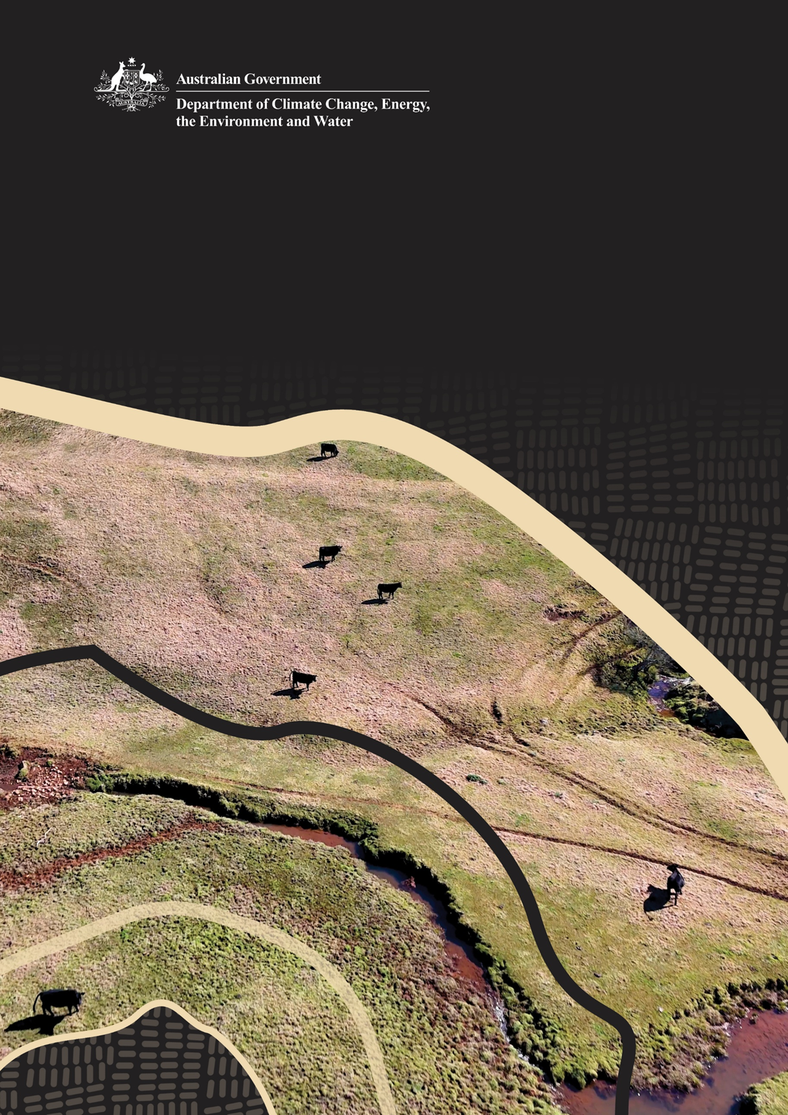
Mapping tools
Environment Protection and Biodiversity Conservation Act 1999 guidance material

Contents
Mapping tools 1
Introduction 3
Queensland Globe Instructions 4
Identifying whether vegetation clearance is exempt under national environmental law using Queensland Globe 4
Find your property 4
Add land parcel boundaries and labels to your map 5
Determining if vegetation is more than 15 years old 7
Determining if vegetation is within 50m of a watercourse, a wetland or drainage line in the Great Barrier Reef (GBR) catchments 10
Digital Earth Australia Instructions 12
Identifying whether vegetation clearance is exempt under national environment law using Digital Earth Australia 12
Find your property 12
Determining the age of vegetation on your property 15
Image quality 26

Introduction
On 28 November 2025, the Environment Protection Reform Bills were passed by the Australian Parliament. As part of the reform, changes were made to the continuations of use of land exemption (section 43B of the EPBC Act). From 1st December 2025, land managers can no longer claim a continuation of use exemption to clear vegetation that:
- Has not been cleared in the last 15 years (unless it is part of a forestry operation).
- Is within 50m of a watercourse, a wetland or a drainage line in the Great Barrier Reef (GBR) catchment areas.
The guidance has been collated to assist land managers to determine the age of vegetation and proximity to GBR catchment watercourses, wetlands and drainage lines.
Where historic information about the property you are looking to manage is limited, the Department of Climate Change, Energy, the Environment and Water (DCCEEW) recommends using the following publicly available tools:
- Queensland Globe – For land in Queensland
- Digital Earth Australia maps – For land outside of Queensland
The below chapters provide instructions for using each of these tools respectively, for the above purposes.
It should be noted that neither of the above two tools are owned by DCCEEW and as such DCCEEW cannot be held responsible for changes or disruptions to either of these two interactive websites. The instructions provided are based on our own worked examples only.

Queensland Globe Instructions

Identifying whether vegetation clearance is exempt under national environmental law using Queensland Globe
This chapter helps you to use the Queensland Globe website to determine whether your proposed land clearing is exempt from assessment and approval under national environmental law.
It provides guidance on how to use Queensland Globe to determine whether:
- Referenced land has been cleared in the last 15 years.
- Referenced land is within 50m of a watercourse, a wetland or drainage line in GBR catchments.
For more general/comprehensive information on how to use Queensland Globe, please see Tutorial Videos Library - Queensland Globe Help
Mapping under the Property Mapping of Assessable Vegetation (PMAV) system cannot be relied on to determine your exemption status under national environmental law.

Find your property
To get started, search for your property on the map.
Tip: To reset the map, press F5 to refresh the page.
- Open the Queensland Globe website (Figure 1).
- Read and acknowledge the terms and conditions.
- Select Get started.
- Open the Search option (usually located on the left side of the page).
- Search for your property using one of the following options:
- Lot on plan, e.g. 124DS183 (used in the below example)
- Town name
- Longitude and latitude.
- Once you find the property, use one or all the following processes to determine if your action is exempt.
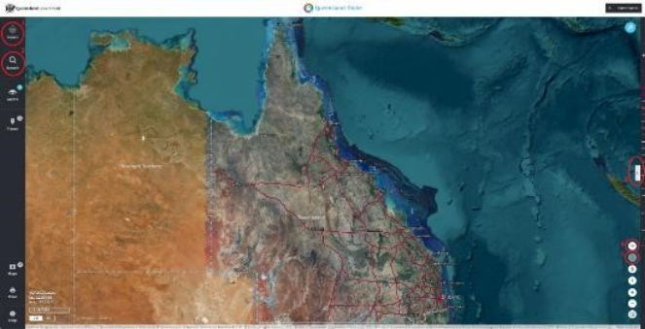
Figure 1 - Screenshot of the main page of Queensland Globe with relevant features, e.g. search, layers, and map controls.

Add land parcel boundaries and labels to your map
- Open Layers (usually located on the left side of the panel).
- Select Add layers at the top of layers panel (Figure 2).
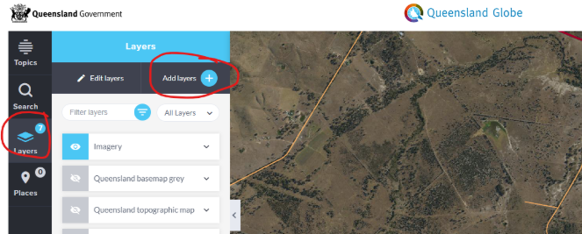
Figure 2 - Screenshot showing how to add layers
- Find Planning Cadastre in the list (Figure 3) and expand it using expand control (select the drop-down arrow not the checkbox). This will show more options.
- Find Land parcels from the list and expand it (use the drop-down arrow).
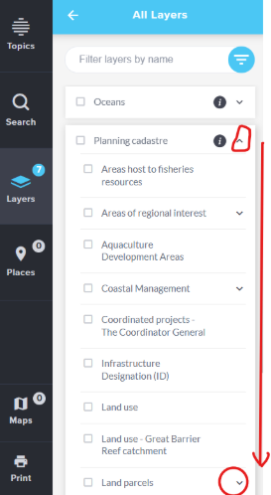
Figure 3 - Screenshot showing Planning cadastre expanded and Land parcels circled
- Select Land parcel label and Land parcel (Figure 4) to add these layers to your map.
- Use the return control (arrow) in the All Layers panel (on the top) to return to the Layers panel.
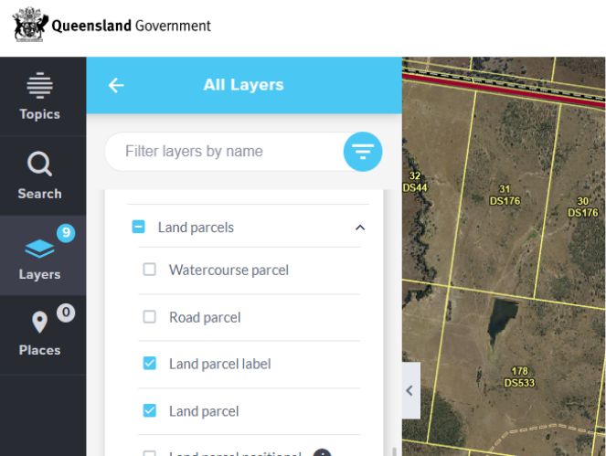
Figure 4 - Screenshot showing Land parcel label and Land parcel selected
- Close or minimise Layers panel (by using layers in the left-hand panel or the left arrow).
Add PMAV boundaries to your map
Adding PMAV boundaries to your map is optional, for information only. PMAV cannot be relied on to determine your exemption status under national environment law.
- Open Layers (usually located on the left side of the panel).
- Select Add layers at top of layers panel.
- Expand Biota (Flora & Fauna) using the expand control (use the drop-down arrow not the checkbox).
- Find Vegetation management information from the list and expand it (using drop down arrow).
- Find and expand the Property map of assessable vegetation (PMAV) from the list.
- Select the PMAV – all option. This will add the PMAV - all layer to your map (Figure 5).
- Use the return control (arrow) in the All Layers (top blue) panel to return to the Layers panel.
- Close or minimise the Layers panel using the layers in the left-hand panel or the left arrow.
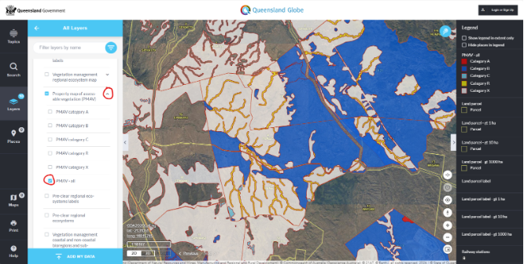
Figure 5 - Screenshot showing PMAV – all layers selected

Determining if vegetation is more than 15 years old
Find your property using the instructions above before proceeding to this step.
This option is for when you want to see how old specific vegetation on your property is to determine if it is 15 years old. Find your property using the instructions above before proceeding to this step.
- Click on Past Imagery, it looks like a clock and is located at the bottom right of the map. You will see a popup at the bottom of the screen.
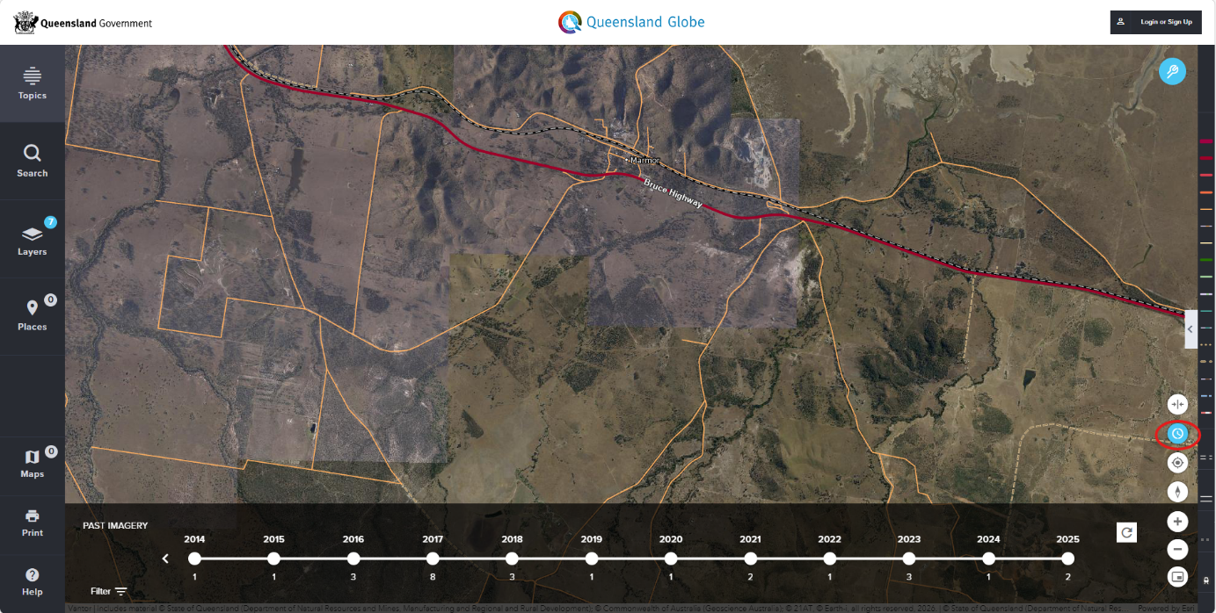
Figure 6 - Screenshot showing Past imagery selected (years showing)
- Use the arrow on the left of the timeline to go further back in time and select a year around the 15-year mark from now. Depending on your area there may not be data in every year so you may need to go further back/forward and extrapolate. Once you select the year, the timeline will update to show months, and you can click on a month with data available.
- The popup will then update to allow you to click on the eye icon or layer icon; click on the layer icon to add as a layer. You will see the map update with the older view, which is often a lower resolution than the current map.
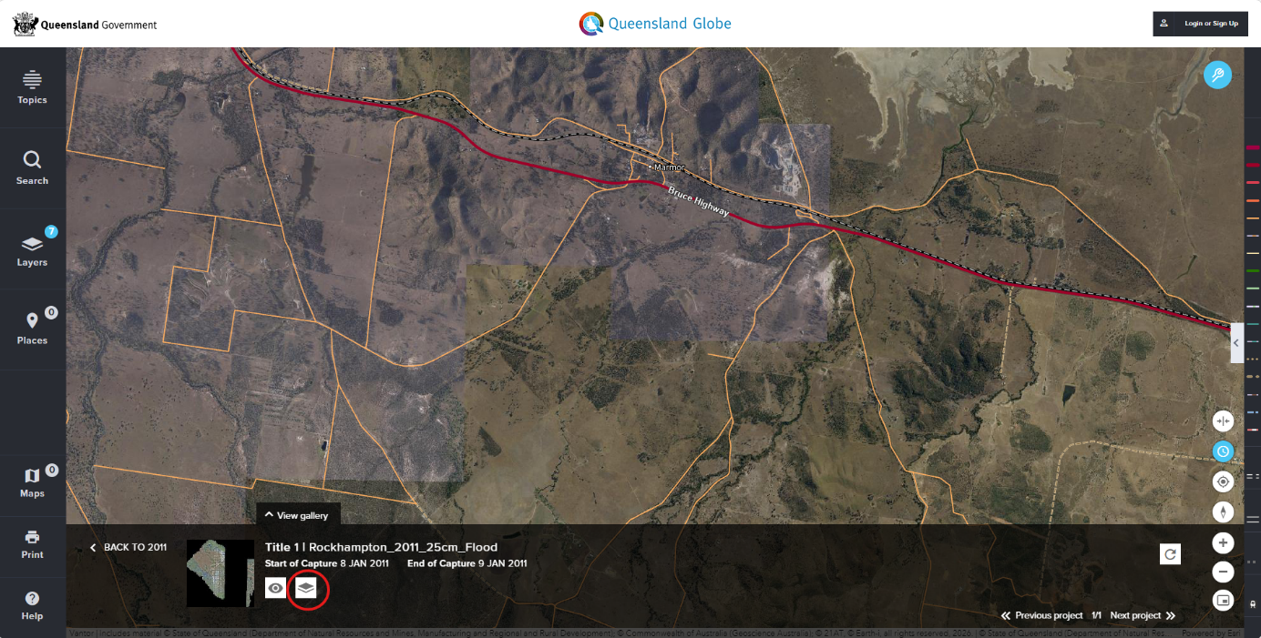
Figure 7 - Screenshot showing Past imagery with popup allowing you to select layer icon
- Click on the clock icon again to hide these popups.
- Click on Swipe tool, the one directly above the clock icon at the bottom right. This tool allows you to show different layers of information on the left and right side of the map, and sweep the central line left and right to see the difference between the layers.
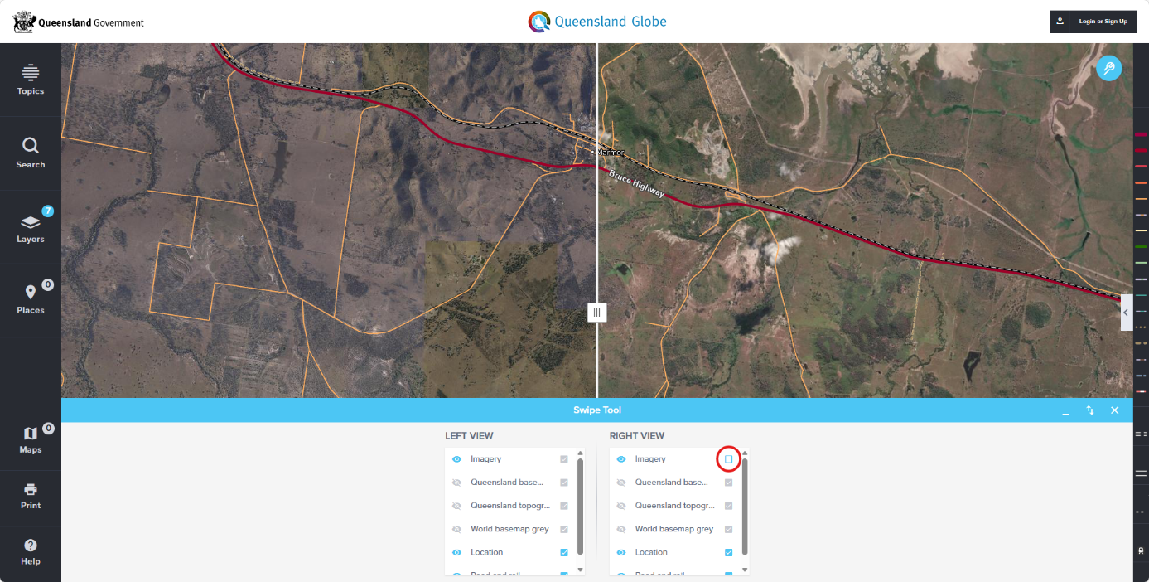
Figure 8 - Screenshot showing Swipe tool with right view unticked
- Disable the new 15-year-old data from showing on one side of the map so there is different information on each side. The name of the layer will be slightly different depending on what you selected in the previous step, but it should be the top tick box in the list. Untick the tick box for the new layer on the right. Once you have unticked it on the right, you can see each side of the central line is showing different map visuals.
- Minimise the popup using the “_” icon in the top right corner of the popup.
- You can now see the map images from two different years, the older image on the left and the newer image on the right. You can zoom in and out as needed and move around the map to look at the relevant part of your property, then use the Swipe tool to see the same area on the old and new images by dragging the centre line left and right.
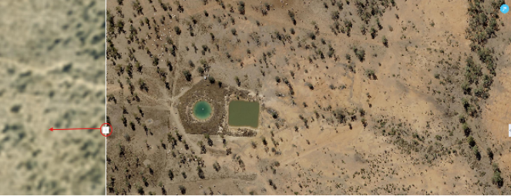
Figure 9 - Screenshot showing Swipe tool moved to the left
- If the vegetation appears in the older, 15-year-old image and in the current image, then the vegetation is typically at least 15 years old; and, if so, will not be exempt under s43B. For cases where regrowth occurs more rapidly than a 15-year-cycle, you can check intervening years using the approach described above, to confirm if clearing has occurred.
Tip: For some locations, the older maps may be too low resolution to determine this, if in doubt we recommend that you assume that exemptions do not apply.

Determining if vegetation is within 50m of a watercourse, a wetland or drainage line in the Great Barrier Reef (GBR) catchments
If the vegetation you plan to clear is within the GBR catchments, and within 50m of a watercourse, a wetland or drainage line, then it is not exempt.
This process is for when you want to view the GBR catchment overlays as they relate to your property and determine if the vegetation you plan to clear is in a GBR catchment and within 50 metres of a watercourse, a wetland or drainage line.
Find your property using the instructions above before proceeding to this step.
- Add the GBR catchment boundaries and determine if your property is within the GBR catchment.
- Click on Layers in left pane, click on add layers.
- Scroll down to inland waters and click the drop-down arrow on the right-hand side.
- Scroll down to drainage boundaries and click the drop-down arrow.
- Tick the check box next to GBR catchment boundaries.
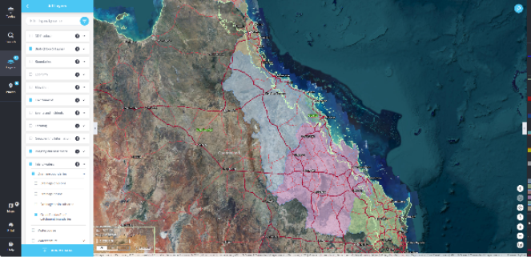
Figure 10 - Screenshot showing where the GBR catchment boundaries are across Queensland
- If your property is covered by the GBR catchment boundaries, then a coloured overlay will appear over your property on the map. These overlays may be one of several colours such as pale blue, pink or pale green. You can check the Legend on the right side of the map (expand by clicking the < in the middle) if you want more information. You may find it easier to tell if your property is within a GBR catchment if you zoom out and then back in. Click the back arrow at the top All Layers pane to take you back to the Layers pane.
If your property is within a GBR catchment, the next step is to determine if any vegetation you wish to clear is within 50 m of a watercourse, a wetland or drainage line. To do this, add the following layers to your map:
- From the Layers pane, click on add layers.
- Scroll up to Biota (Flora & Fauna) and click the drop-down arrow
- Scroll down and expand Vegetation management information
- Under Vegetation management information, select Vegetation management watercourse/drainage and Vegetation management wetlands map
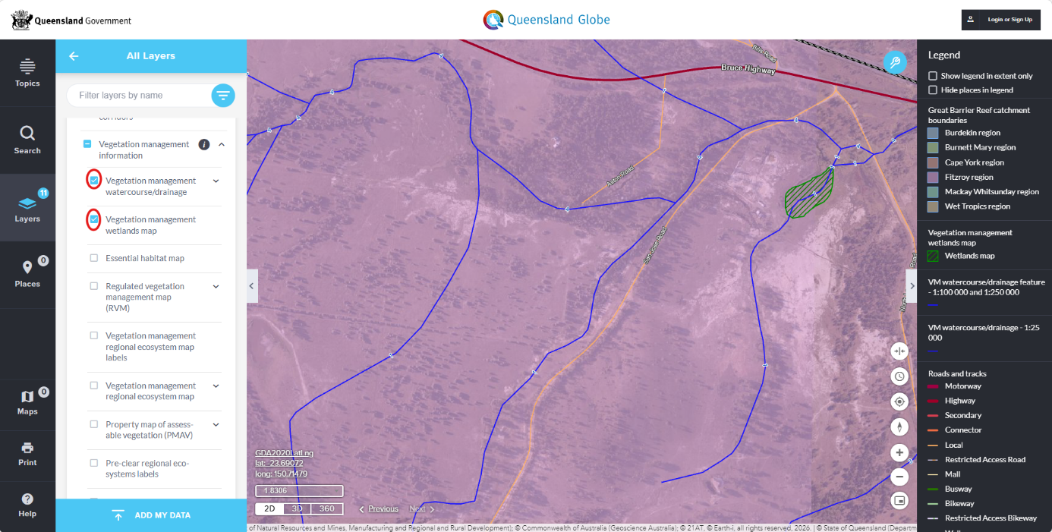
Figure 11 - Screenshot showing watercourse/drainage (blue lines) and wetlands (green area)
- Click on the left-hand arrow next to All Layers to return to the layers pane and click Layers or use the < in the middle right-hand side of the pane to hide the Layers pane.
- If the vegetation is within the GBR catchment boundary and within 50 metres of a wetland (green) or watercourse/drainage feature (blue), then clearing is not exempt under the EPBC reforms.
Tip: Some mapped drainage lines may not align exactly to the drainage on your property. Be guided by your knowledge of your property and where the water runs after heavy rain and where there is riparian vegetation (i.e. lines or corridors of trees, shrubs or sedges that run each side of the drainage line).

Digital Earth Australia Instructions

Identifying whether vegetation clearance is exempt under national environment law using Digital Earth Australia
This chapter will assist you to use the Digital Earth Australia (DEA) website to support you to determine if land has been cleared within the last 15 years, which goes towards informing whether clearing is exempt under s43B of the EPBC Act.
Please note: if your property is in Queensland, the website QLD Globe may be more suitable for your needs.
For more general/comprehensive information on DEA User Guides please see DEA User Guides - DEA Knowledge Hub

Find your property
Search for your property on the map to get started.
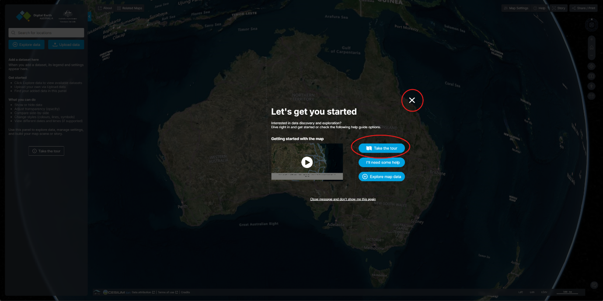
Figure 1 - Screenshot showing DEA Maps home page
- Go to the DEA website. An explanatory overlay appears on the page, which offers you various types of assistance. Select ‘Take the tour’ to learn about features or select the close (×) button at the top right corner of the overlay to close it down.
- On the left, select the ‘Search for locations’ field and find your property details. You can search using a street address, latitude and longitude, or name of a nearby town. You can then move the map to locate your property. In this example we searched for Mossy Point NSW to locate an inland area.
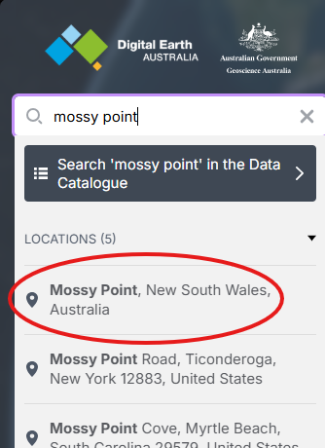
Figure 2 - Screenshot showing search function
- The map zooms to the selected location.
- Go to Map Settings on the top right hand of the screen and select Bing Aerial with Labels (if not already selected), this adds photographic imagery to the simplified Bing Roads map.
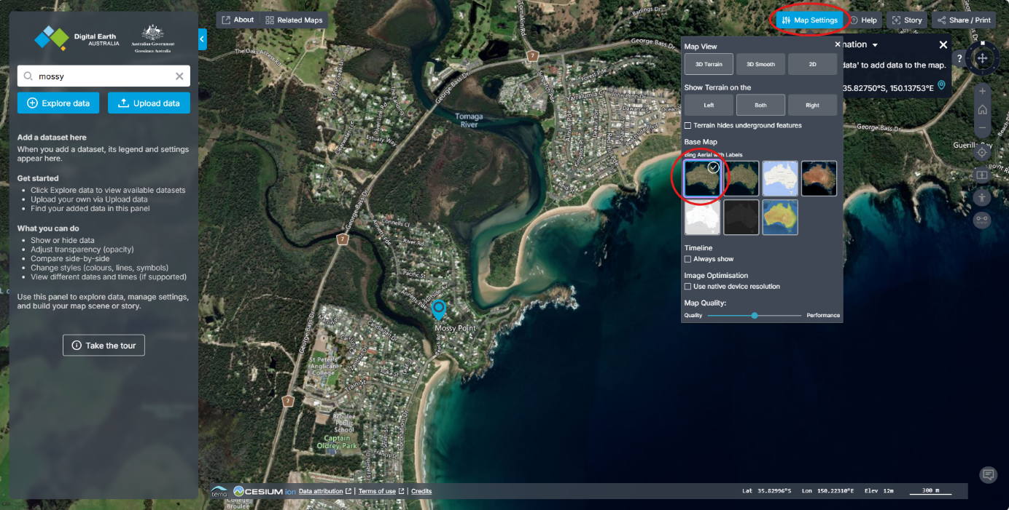
Figure 3 - Screenshot showing Map Settings expanded and Base Map Bing Aerial with Labels selected
- You may need to zoom out or move the map to find your property.
- The area we will focus on in this example has been circled in Figure 4 below, as this is an area where clearing has occurred that is easy to see. For reference, the centre of this is Latitude 35.81556 degrees South and Longitude 150.13984 degrees East.
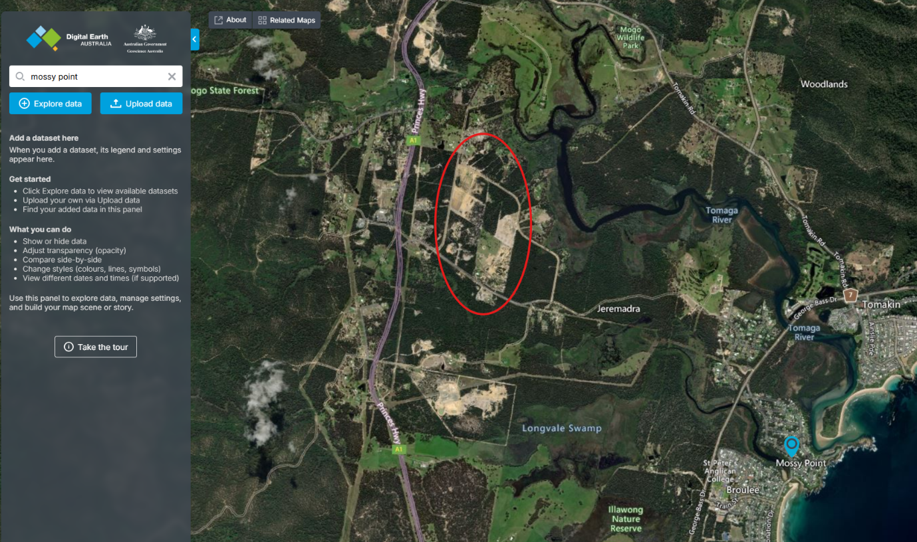
Figure 4 - Screenshot showing the area in Mossy Point we will focus on

Determining the age of vegetation on your property
- Once your property appears on the screen, you can add a dataset in the menu on the left by selecting ‘Explore data’. This allows you to compare satellite images from different points in time to see when past clearing has occurred on your property.
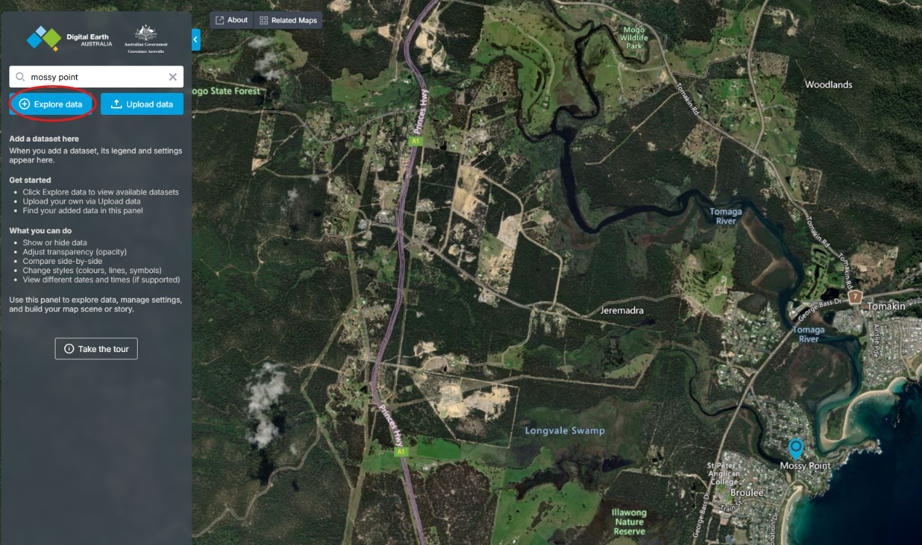
Figure 5 - Screenshot showing the Explore data option being selected
- A popup will appear on the screen. Select the arrow next to ‘Baseline satellite data’ option to expand the list. Then select the plus (+) button next to the ‘DEA Surface Reflectance (Landsat and Sentinel-2)’.
- The dataset will appear in the left menu as the popup disappears.
Note: This dataset includes satellite images from Landsat satellites and the Sentinel-2 satellite. These are commonly used for comparing changes over time as they both capture new images often.
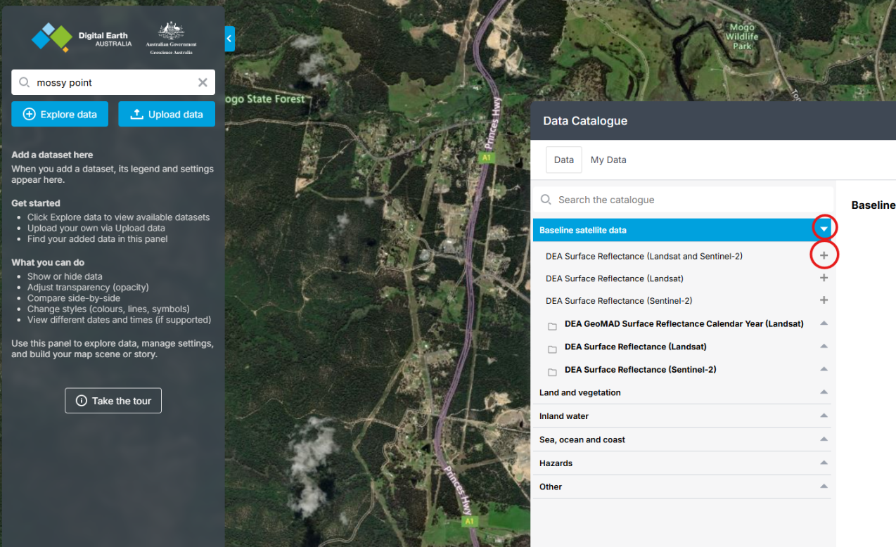
Figure 6 - Screenshot showing above-described dataset being selected
- A dataset will appear on the left menu. It appears as a new section (a dark box) with additional information. Note: You may need to click the Time arrows back or forward until a clear image is reached.
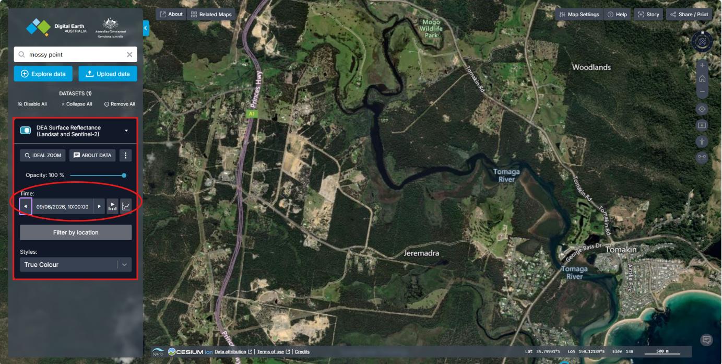
Figure 7 - Screenshot showing dataset (dark box) on left panel added
- Select ‘Filter by location’ and then click the approximate centre of your property. This filters the available images to just those capturing your property and reduces the number of images you have to click through. 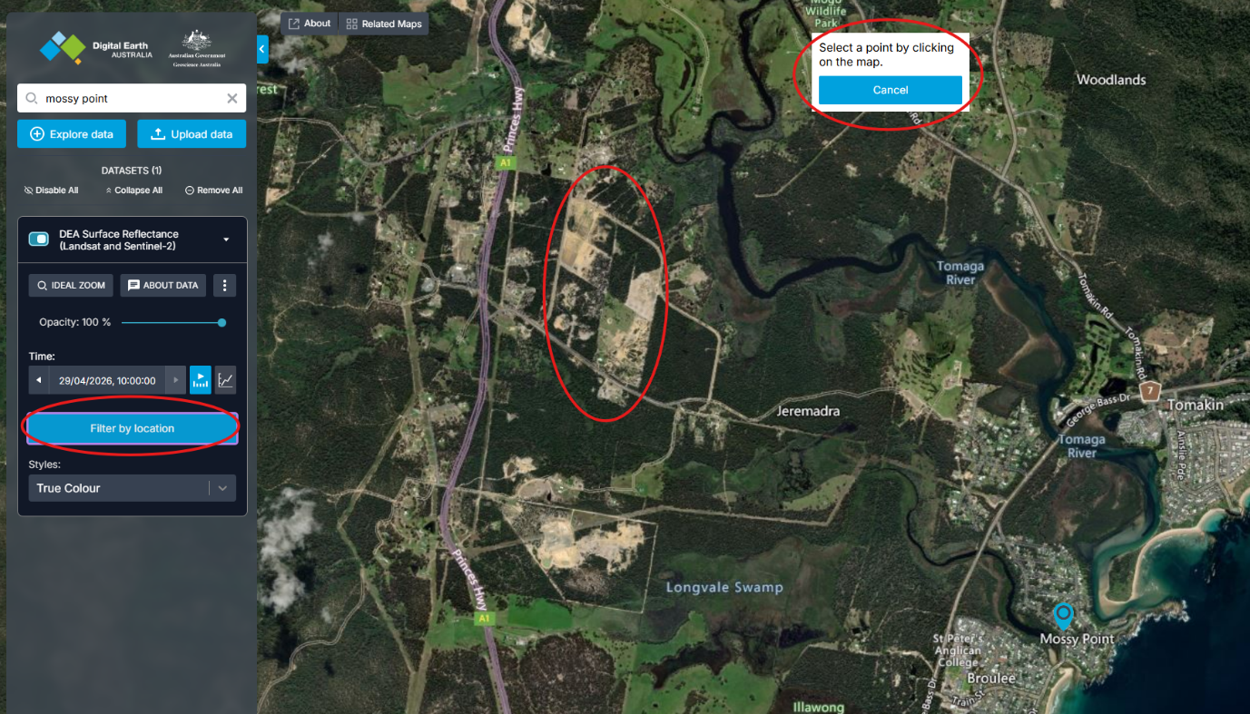
Figure 7 - Screenshot showing Filter by location being selected
- The system may take few seconds (or up to a minute) to process your request. The left menu will update to show latitude and longitude of the filter you selected (Figure 8). The map will also update to the most recent satellite image for your selected area. This image may appear lower in quality or include cloud cover. Again, click the Time arrow until you find a clear image. You can also zoom out a little if the best image is too pixelated. 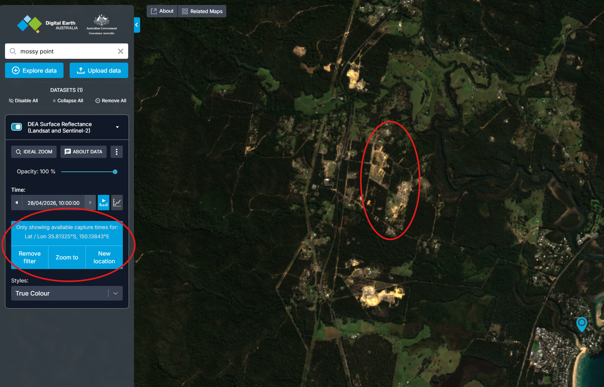
Figure 8 - Screenshot showing Filter applied
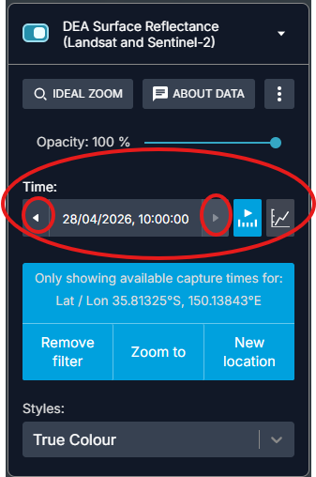
Figure 9 - Screenshot showing how to move between images taken at different times
On any given day, several factors may affect the quality of a satellite image. For example, cloud cover may obscure part of the land, or the satellite may capture a partial image. In some cases, this results in a banded or striped image, where sections of land remain missing for that day. Consider these limitations when deciding if an image is an accurate representation of your property at that time.
In the example below, images of the same property taken over different dates have been included to illustrate the variety of image quality/suitability you may encounter. The first image (top left) shows no cloud or stripes, and the whole property is visible. This is the best quality image for comparison. The other images on the left show striped images, with and without cloud. These should be excluded because they do not show the full property. The images on the right show different levels of cloud cover. The top 2 images on the right should be excluded as the cloud cover obscures most or all the property.
The last image (bottom right) shows a small, isolated area of cloud. If you come across a similar image, where the area of cloud or shadow is not obscuring your property, you can decide whether to use it for comparison based on your own assessment. Once you have decided on an image that provides an accurate view of your property, move to the next step.
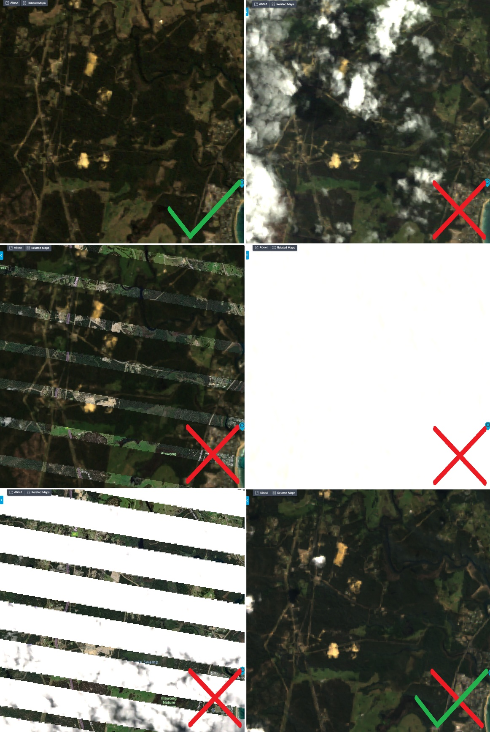
Figure 10 - Screenshot showing a range of different image qualities

- To enable the comparison tool (to compare past images with current image), select the 3 dots in the left menu. Then select the first option ’Compare’ (Figure 11). This will open a duplicate dataset in the left menu, allowing you to compare older and newer maps of your property.
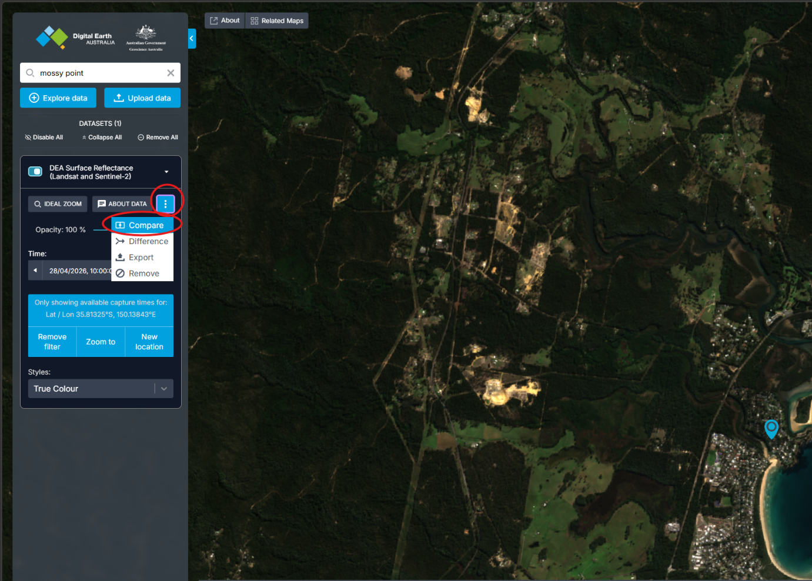
Figure 11 - Screenshot showing Compare being selected
- You can now access two datasets in left the menu. The dataset at the top is a duplicate of the bottom. Each datasets have indicators showing which side of the screen it appears on. In our example, the original dataset is showing on the right side of the screen. On the map, you can see a vertical divider with a circle button in the middle. You can click-and-hold it and drag your mouse left or right to see more or less of each side.
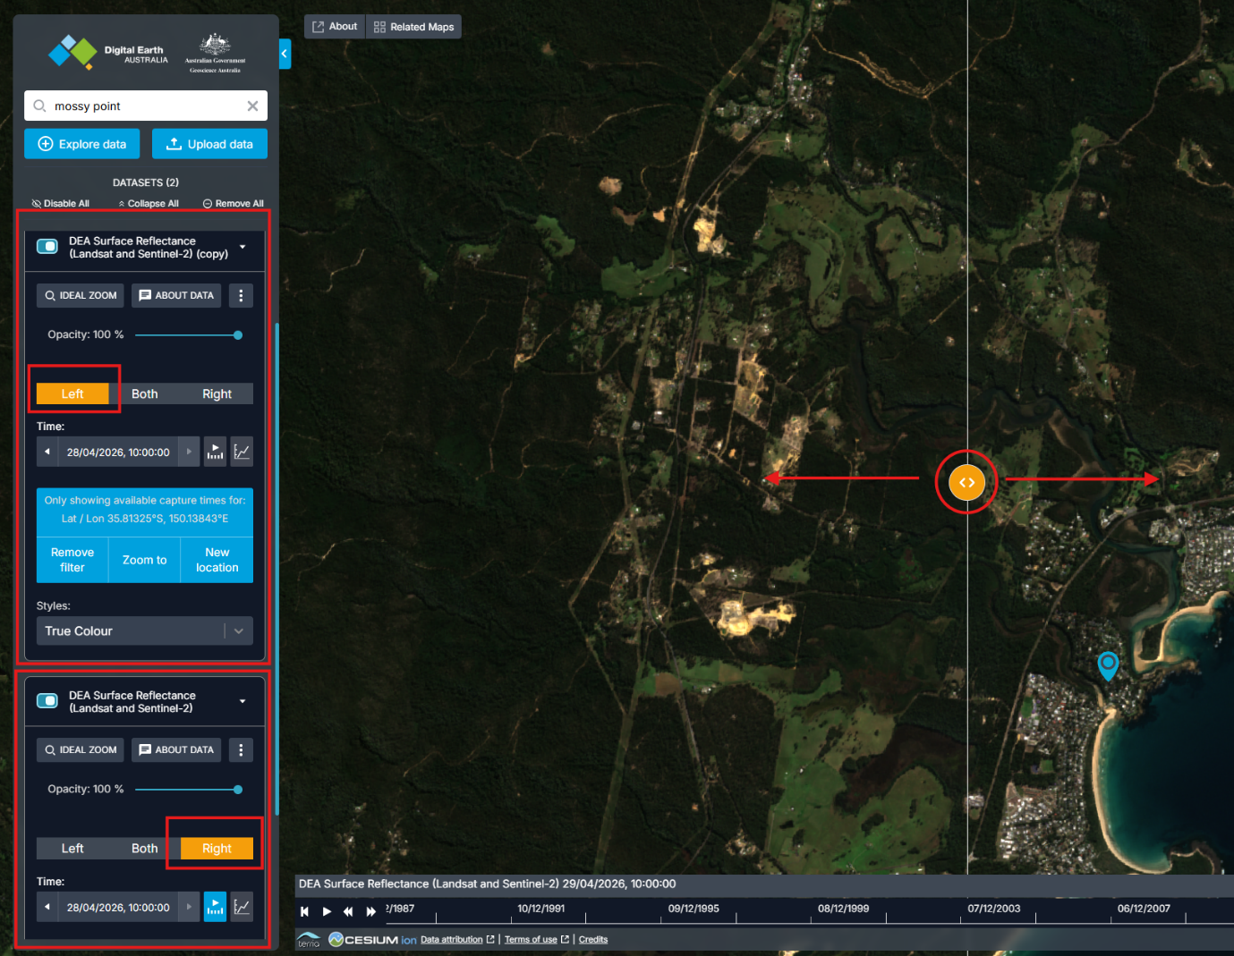
Figure 12 - Screenshot showing Comparison tool selected with top dataset showing on the left and bottom dataset showing on the right
- In the left menu, select the date/time in the ’Time’ field for the top dataset (relates to the left of the map). A popup will appear asking you to ‘Select a century’. Choose ‘2000’, then select the year you are interested in, e.g.15 years earlier than today. Then select the relevant month and a day.
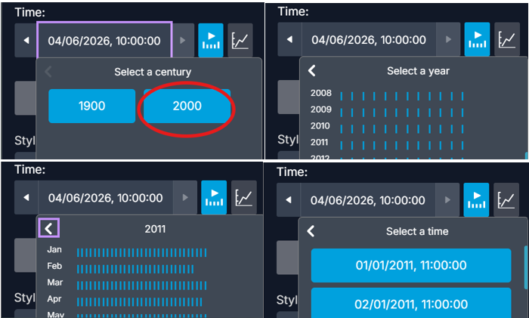
Figure 13 - Screenshot showing century, year, month and time selection
In the example, we selected a date in early 2011. In this example, the left side of screen shows a striped image of the land. The right side is still showing the image you selected in the previous step.

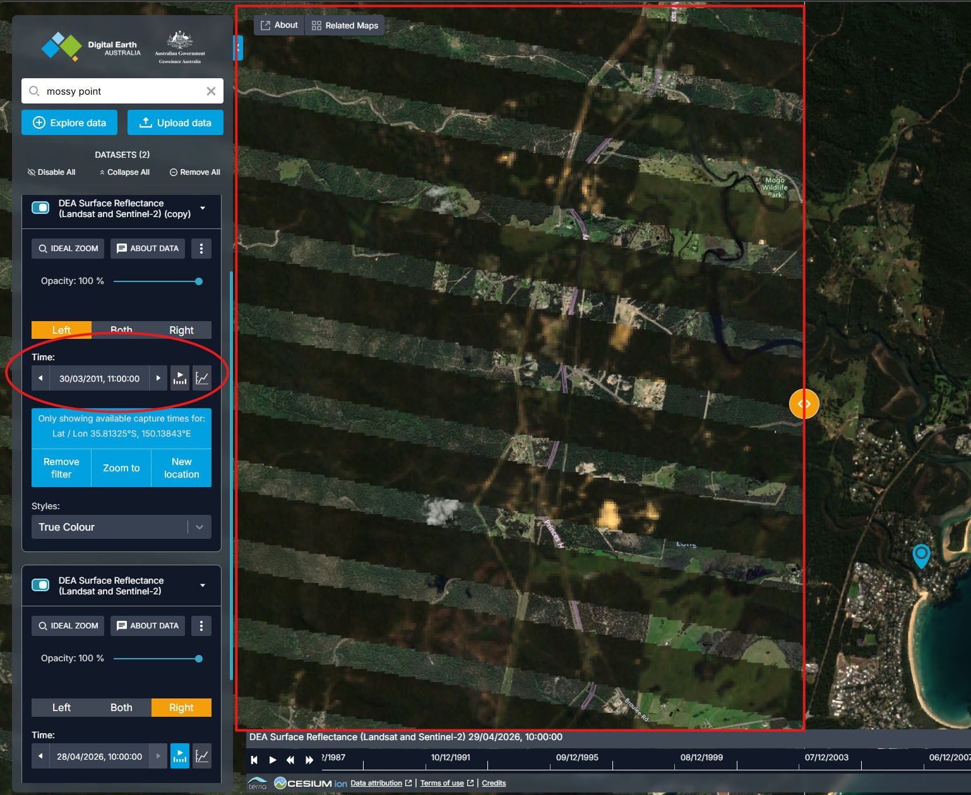
Figure 14 - Screenshot showing date/time on top dataset changed to 30/3/2011 11:00:00
- Click forwards or backwards through the dates to find an image that is clear and shows the full property. In the example shown, it took over 5 clicks forward to find a non-banded, clear image of the area. You may need to use the comparison tool to sweep back and forth on the map to ensure it is clear across all the relevant property. 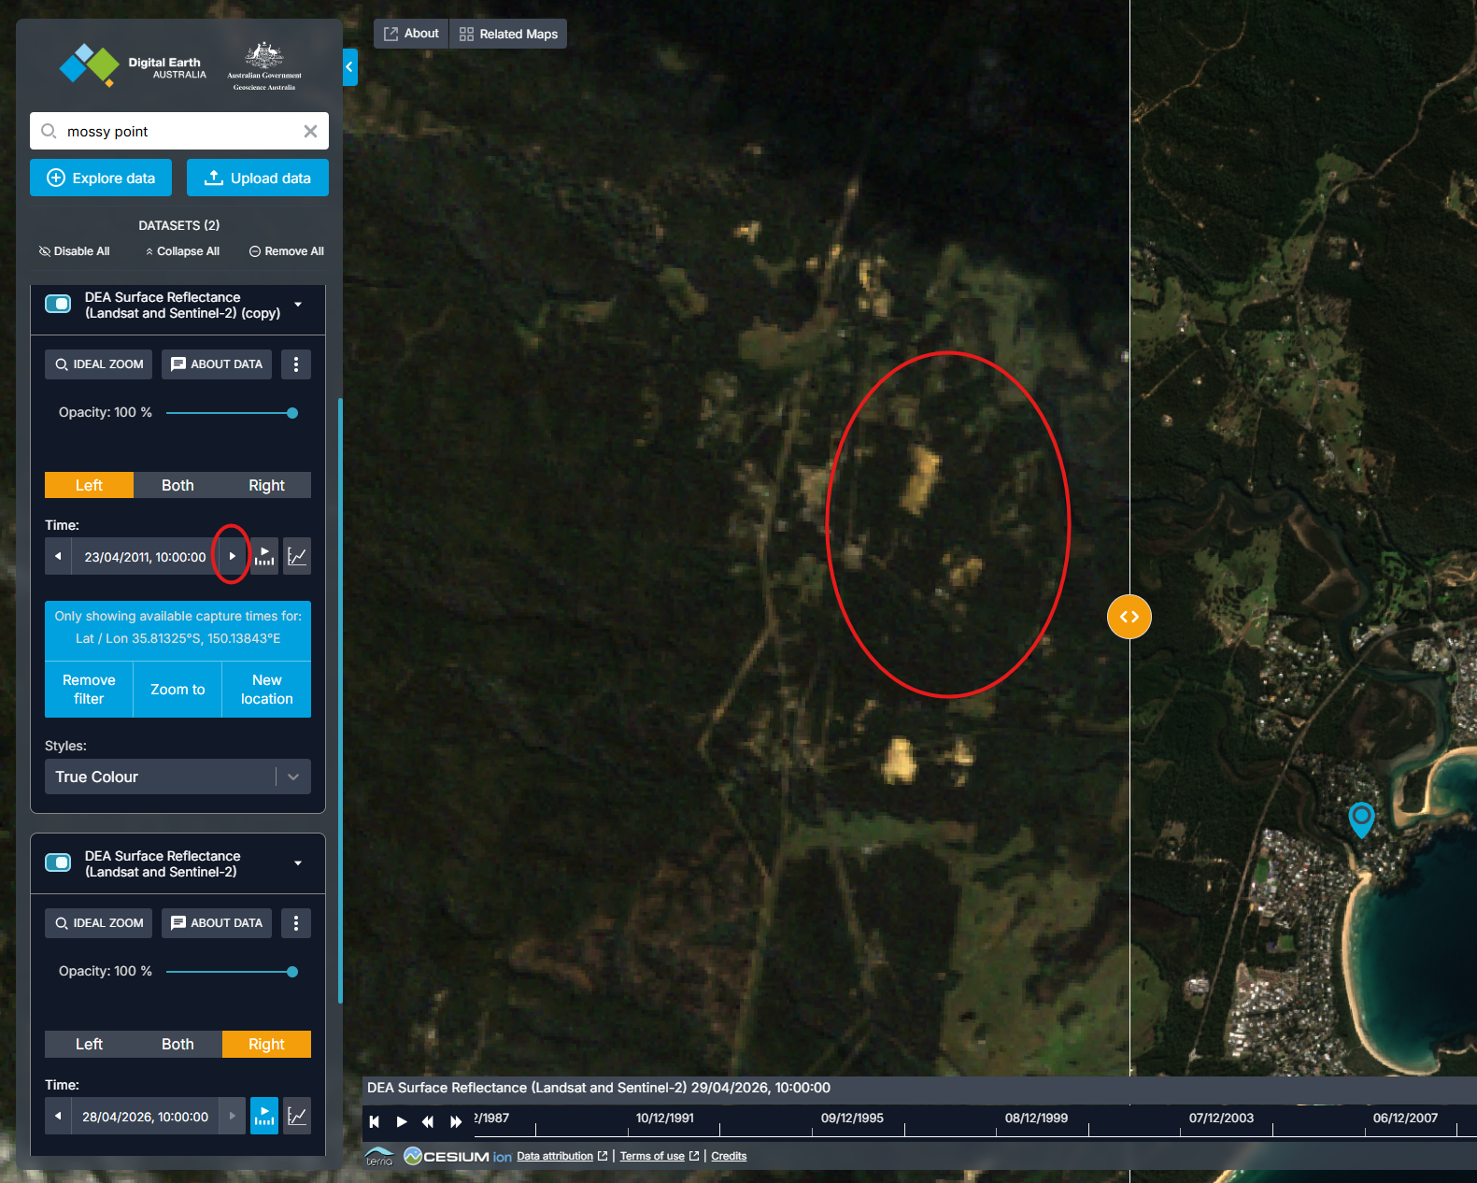
Figure 15 - Screenshot showing a 2011 image (left) and a 2026 image (right) with comparison tool
- Once you are happy with the selected image, use the comparison tool to sweep back and forth, comparing the footprint of cleared land in the current and older images. In the example below (Figure 16), you can see that significant clearing occurred in the lower right of the area. Roads were cleared and added between the two main cleared areas.
You can repeat the above using different points in time as needed. Once you have the required images, save these images, for example, for use as part of a self-assessment.

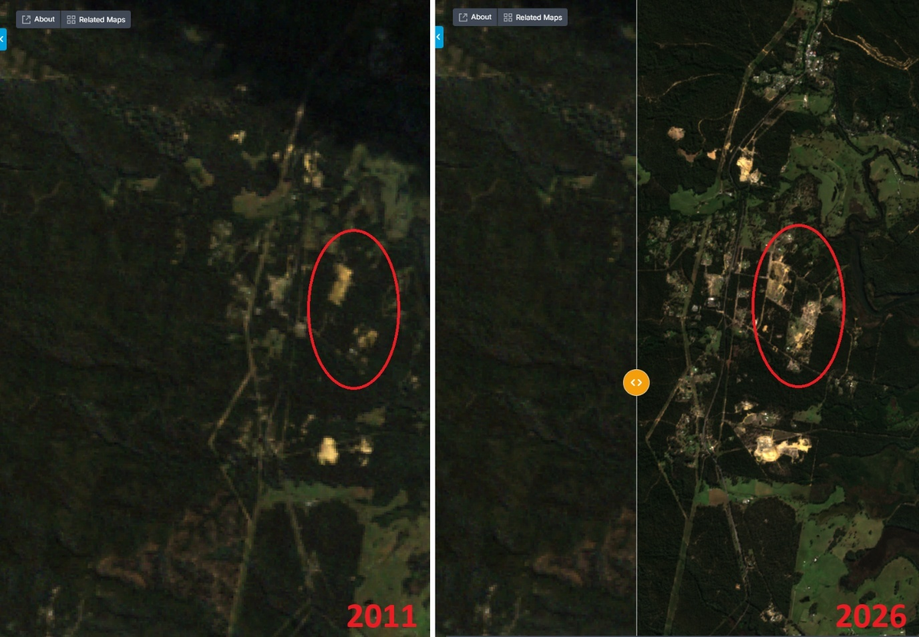
Figure 16 - Screenshot showing 2011 clearance footprint compared to 2026 clearance footprint

Image quality
In some parts of the country there may be less images taken, or less images available where your property is clearly visible. This is a limitation of the publicly available data. If you are unclear and need further assistance, please contact us on 1800 920 528.

