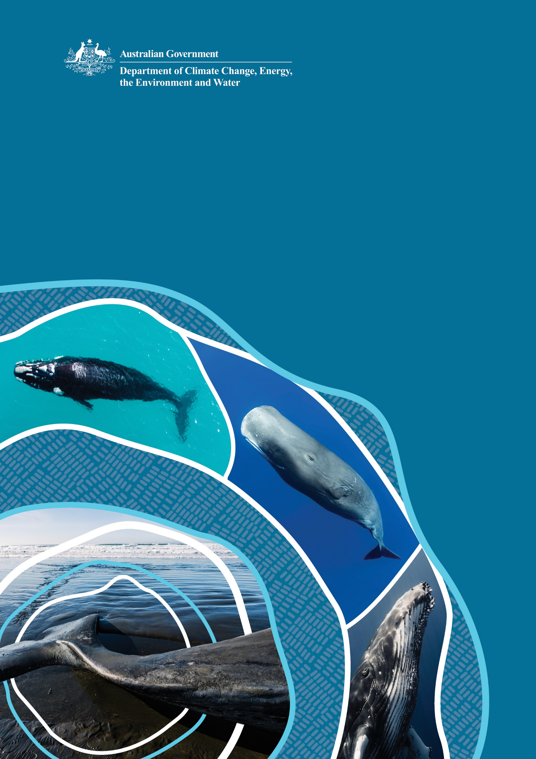

National Guidelines for Euthanasia of Stranded Large Whales
© Commonwealth of Australia 2024
Ownership of intellectual property rights
Unless otherwise noted, copyright (and any other intellectual property rights) in this publication is owned by the Commonwealth of Australia (referred to as the Commonwealth).
Creative Commons licence
All material in this publication is licensed under a Creative Commons Attribution 4.0 International Licence except content supplied by third parties, logos and the Commonwealth Coat of Arms.
Inquiries about the licence and any use of this document should be emailed to copyright@dcceew.gov.au.

Cataloguing data
This publication (and any material sourced from it) should be attributed as: DCCEEW 2024, The National Guidelines for Euthanasia of Stranded Large Whales, Department of Climate Change, Energy, the Environment and Water, Canberra. CC BY 4.0.
This publication is available at dcceew.gov.au/publications.
Department of Climate Change, Energy, the Environment and Water
GPO Box 3090 Canberra ACT 2601
Telephone 1800 920 528
Web dcceew.gov.au
Disclaimer
The Australian Government acting through the Department of Climate Change, Energy, the Environment and Water has exercised due care and skill in preparing and compiling the information and data in this publication. Notwithstanding, the Department of Climate Change, Energy, the Environment and Water, its employees and advisers disclaim all liability, including liability for negligence and for any loss, damage, injury, expense or cost incurred by any person as a result of accessing, using or relying on any of the information or data in this publication to the maximum extent permitted by law.
Acknowledgements
The Department of Climate Change, Energy, the Environment and Water would like to acknowledge those who contributed to the development of the National Guidelines for Euthanasia of Stranded Large Whales. We are grateful to technical experts Dr Duane March and Dr David Blyde (Wildlife Solutions) for developing the initial draft guideline, Dr Nick Gales, Dr Michael Lynch, the Australian Antarctic Division and State government agencies who provided expert knowledge and further technical reviews. Thank you also to Beth Croce and Uko Gorter for the anatomical illustrations.
Front cover images
Sperm whale (Physeter macrocephalus) © Shutterstock, southern right whales (Eubalaena australis) © Shutterstock, humpback whale (Megaptera novaeangliae) © Shutterstock and tail of a stranded sperm whale (Physeter macrocephalus) © Shutterstock.
Acknowledgement of Country
We acknowledge the Traditional Custodians of Australia and their continuing connection to land and sea, waters, environment and community. We pay our respects to the Traditional Custodians of the lands we live and work on, their culture, and their Elders past and present.

Contents
Contents 3
List of Figures 5
Glossary 6
Executive Summary 10
1 Introduction 11
1.1 Definitions 12
1.2 Purpose of the Guidelines 12
1.3 Key Recommendations 13
2 Incident Management 14
2.1 Incident Management 14
2.2 First Nations Cultural Protocols 14
2.3 Relevant Legislation 14
2.4 Human Safety 15
2.4.1 Training 15
2.4.2 Physical Risks 15
2.4.3 Environmental Risks 15
2.4.4 Biological Risks 16
2.4.5 Chemical Risks 17
2.4.6 Critical Incident Stress 17
2.4.7 Managing the Public 17
3 Stranding Assessment 19
3.1 Stranding Causes 19
3.2 Consequences of Stranding 19
3.3 Cetacean First Aid 20
3.4 Palliative Care 21
4 Euthanasia 23
4.1 Euthanasia Definition 23
4.2 Decision to Euthanise 23
4.3 Euthanasia Criteria 24
4.4 Euthanasia methods 24
4.4.1 Lethal Injection 25
4.4.2 Explosives 32
4.4.3 Ballistics 34
4.4.4 Other Techniques 35
4.4.5 Time to Death and Verification 35
5 Carcass Management Considerations 37
6 Death Investigation, Data Collection and Documentation 40
7 References 41
Appendix 1: National, State and Territory legislation relating to euthanasia of large whales 44
Appendix 2: Cetacean assessment and euthanasia data record 47
Appendix 3: Summary of drugs used and times to death using intracardiac injection in Australia 49
Appendix 4: Pre-euthanasia drugs used in large whales 50
Appendix 5: Euthanasia drugs used in large whales 51
Appendix 6: Carcass disposal options 52

List of Figures
Figure 1 External anatomical features for a) Humpback whale, (Megaptera novaeangliae) and b) Southern right whale (Eubalaena australis) 21
Figure 2 Internal anatomy of a Humpback whale 25
Figure 3 Sites for intramuscular injection are shown in the areas shaded blue and areas to avoid are shaded yellow in a stranded Humpback whale. 27
Figure 4 Intraveneous access via the periarterial venous rete in the tail fluke 28
Figure 5 Intraveneous access via the dorsal fin 28
Figure 6 Intraveneous access via the brachial vein in the pectoral flipper 29
Figure 7 IC needle placement with whale in ventral recumbency 30
Figure 8 IC needle placement with whale in lateral recumbency 30
Figure 9 Schematic diagram of cranial implosion technique 33
Figure 10 Post detonation effect of cranial implosion 34
Figure 11 Dilated pupil in a deceased Humpback whale 36
Figure 12 Transferring a Humpback whale carcass with a crane to a flat-bed truck for removal 38
Figure 13 Recovery straps attached to the tail stock of a Sperm whale carcass to facilitate dragging and lifting 38
Figure 14 Mechanical dissection of a Sperm whale carcass 39

Glossary
Asphyxiation  Aspiration  Axillary | The process of depriving oxygen to a person or animal; synonym of suffocation.  When something enters or is breathed into the lungs by accident.  Area located between the shoulder girdle and the thorax.
Australian Whale Sanctuary  Baleen | All Commonwealth (Australian) waters from the 3 nm State and Territory waters limit out to the boundary of the Exclusive Economic Zone (i.e. out to 200 nm and further in some places).  Plates of keratin hanging from the inside of the upper jaw of baleen whales, used instead of teeth to capture prey.
Baleen whale | Whales of the suborder Mysticeti, characterised by jaws with baleen plates instead of teeth.
Beach-washed | The process of coming ashore under abnormal circumstances; synonym of stranded.
Bilateral thoracotomy | The process of cutting through the thoracic wall on both sides leading to an inability of the thorax to provide negative pressure for the lungs to expand on breathing, essentially suffocating the animal.
Blow | Water vapour exhaled by cetaceans through the blowhole/s.
Blowhole | The single or double nostrils of a cetacean, located on top of the head. Baleen whales have two nostrils, while toothed whales have only one.
Blubber | The thick insulating layer of fat found beneath the skin of most marine mammals
Callosities | Areas of roughened skin on the heads of right whales, to which whale lice attach.
Cardiac | Relating to the heart.
Cardiac arrest | Cessation of the heart’s function.
Catecholamine | Substances released into the blood following emotional and physical stress.
Caudal | Towards the tail.
Cetacean | Marine mammals of the order Cetacea, comprising whales, dolphins, and porpoises.
Conspecific | Individuals of the same species.
Critical Incident Stress | A reaction to a sudden, overwhelming, threatening, or protracted event sufficient to overwhelm coping skills. Includes a desire to act urgently.
Cranial | Towards the head.
Cranial Implosion | The explosive charge placed above the cranium posterior to the blowholes and directed downwards to euthanise large whales.
Dorsal recumbency | Lying on the back.
Dorsal fin | The fin on the back of most cetaceans.
Dorsum | The upper side or back of an animal or structure.
Electrocution | The injury or killing a person or animal by electric shock.
Entanglement | Accidental confinement or encumbrance of a free-swimming cetacean in rope, netting, line or debris of human origin.
Entrapment | Accidental confinement of a free-swimming cetacean in situations from which the animal is unable to free itself and return to the open sea. (e.g. a land-locked inlet, upstream in an estuary, in a channel between sandbars or an artificial enclosure such as an aquaculture facility). These situations may occur where changing tide or weather conditions cause an obstruction between a waterway and access to the ocean. They may be temporary.
Euthanasia | The use of humane techniques to induce rapid, painless, and distress-free death.
Exsanguination | The action of draining a person, animal, or organ of blood.
Flukes | Horizontally flattened tail of cetaceans and sirenians.
Grounding  Hyperthermia  Hypothermia | Cetacean floundering in shallow water; generally refers to large cetaceans.  Abnormally high body temperature, overheating; above 37.5-38ºC in humans.  Abnormally low body temperature; below 35ºC in humans.
Iatrogenic | Illness caused by medical examination or treatment.
Incident Controller | Person responsible for the overall control of the response under the Australasian Inter-agency Incident Management System (AIIMS).
Intracardiac | Into the heart.
Intraglossal | Into the tongue.
Intramuscular | Into a muscle.
Intraperitoneal | Into the abdominal cavity.
Intrathoracic  Intravenous | Into the thorax.  Into a vein.
Jaw tone | Conscious muscular resistance to opening the mouth.
Lancing | Severing a large vessel or the heart through the thoracic wall using a large sharp weapon.
Large whale | A cetacean greater than 6 m in length.
Marine mammal  Mass stranding  Maxilla | A diverse group of over 120 species of mammals that have adapted to life in the marine environment and are primarily ocean dwelling or dependent on oceans for food. Includes, among others, cetaceans, pinnipeds (seals, sea lions and the walrus) and sirenians (the manatee and the dugong).  Stranding involving more than two individuals.  Upper jawbone.
Metabolic acidosis | Serious electrolyte disorder characterized by an imbalance in the body's acid-base balance, resulting in a build-up of acid in the body.
Misadventure | An unlucky event or occurrence.
Mass stranding | Two or more animals (excluding mother-calf pairs) stranding together, often in large numbers. May involve animals from one or several species at the same location.
Mysticetes | Any whale of the suborder Mysticete, such as the Humpback whale, characterised by a symmetrical skull, paired blowholes and rows of baleen plates used for feeding on plankton.
Necropsy | The examination of a body of an animal after death; autopsy.
Nystagmus | Congenital or acquired, persistent, rapid, involuntary and oscillatory movement of the eyeball, usually from side to side.
Oceanic | Ocean regions beyond the continental shelf (usually deeper than 200 m).
Odontocete | Any whale of the suborder Odontoceti, such as dolphins, killer whales, and Sperm whales, characterised by an asymmetrical skull, a single blowhole, and rows of teeth. They feed primarily on fish, squid, and crustaceans.
Palliative care | Care giving in the final stages of life, usually aimed at minimising suffering.
Palpebral  Parasternal | Relating to the eyelids.  Adjacent to the sternum.
Pathogens | Any disease-producing agents such as a bacteria and viruses.
Periarterial venous rete | Collection of arterioles and veins in the tail fluke.
Pod | A group of cetaceans.
Re-float  Reperfusion injury | The act of assisting a partially submerged cetacean into deeper water.  Tissue damage caused by restoration of blood flow after a period of lack of oxygen.
Retro-bulbar | Behind the eyeball.
Sedation | A state of calmness, relaxation or sleepiness induced by certain drugs.
Single stranding  Sloughing | Stranding involving only one or two animals, with the latter being a mother-calf pair.  Peeling, shedding or removal of skin.
State waters | State-controlled waters that extend to 3 nm from the shore.
Stranding | A situation where one or more cetaceans are ashore or close to shore and unable to return to sea without assistance. This includes animals that are washed ashore dead or immobilised alive above the wave zone or by grounding in shallow water.
Sublingual | Under the tongue.
Tail stock | Heavily muscled rear third of a cetacean’s body, which drives the flukes.
Take | To collect, as in to collect samples. Under the Environment Protection and Biodiversity Conservation Act 1999 ‘take’ is defined as harvest, catch, capture, trap (and kill if applied in relation to international movement of wildlife specimens).
Terminal fluking | Increased and sustained vertical movement of the tail as the animal dies, also referred to as ‘flurry’.
Thermo-regulation | The ability of an animal to maintain a constant body temperature to adapt to the surrounding environment.
Ventral recumbency | Lying on the sternum.
Whale lice | Parasitic crustaceans of the family Cyamidae which live on some species of whales. The presence of large numbers of whale lice on an animal can be an indicator of poor health.
Zoonosis | An infectious disease that is transferable from animals to humans, usually through a vector that is parasitic in the host animal.

Executive Summary
Cetacean (whales, dolphins and porpoises) stranding incidents present logistical and ethical challenges for incident managers. There are significant welfare concerns for live stranded large whales and euthanasia is often the most humane outcome for these animals. The National Guidelines for Euthanasia of Stranded Large Whales (the Guidelines) provide incident managers with a framework for the safe management and humane induction of death of stranded large whales.
For the purposes of the Guidelines, a “large whale” is defined as a whale that is 6 m or greater in length. Of the known 46 species of cetaceans that utilise Australian waters, there are 10 species for which adult and sub-adult animals fall into this category. These includes all of the Mysticete (baleen whales) species and one Odontocete (toothed whales) species, the Sperm whale.
The International Whaling Commission (IWC) has agreed upon the definition of euthanasia as ‘the use of humane techniques to induce the most rapid, painless, and distress-free death possible.’ The Guidelines reflect the current literature and describe best-practice national and international methodology for achieving this in large whales.
The Guidelines provide a suitable framework to assist incident managers in making appropriate decisions regarding the management and euthanasia of stranded large whales. These should be reflected in state and territory government plans, policies, and procedures relevant to each jurisdiction where appropriate. In developing the Guidelines, stranding incident managers, veterinarians and species specialists were consulted to contextualise the information with respect to field experience. Whilst it is acknowledged that the unique nature of each stranding event will influence the options available to incident managers, and each jurisdiction has its own policies, plans and procedures in place, it is important that jurisdictions around Australia deliver consistent best-practice in the decision process and conduct of euthanasia for stranded large whales.

1 Introduction
Commercial whaling in International and Australian waters in the 19th and 20th century resulted in many species being pushed to the brink of extinction. In 1946, the International Whaling Commission (IWC) was created, and the International Convention for the Regulation of Whaling was signed. A moratorium on commercial whaling was implemented by the IWC in 1986.
Australia has been at the forefront of whale protection and conservation internationally since it ceased whaling in 1978 and adopted a politically bipartisan position to oppose all forms of commercial whaling. Australia was one of the original 15 signatories to the International Convention for the Regulation of Whaling in 1946. Australia became party to the Convention on the Conservation of Migratory Species of Wild Animals in 1991 and has obligations under this convention to act to prevent significant impacts to listed migratory species, including whales.
The Australian Whale Sanctuary was established under the Environment Protection and Biodiversity Conservation Act 1999 (EPBC Act) to give formal recognition of the high level of protection and management afforded to cetaceans in Commonwealth waters (> 3 nm from the shoreline) and prescribed waters within State and Territory jurisdictions. All 46 species of cetaceans (whales, dolphins and porpoise) found within the Australian Whale Sanctuary are protected, and is an offence to kill, injure, take, trade, keep, move, or interfere with a cetacean within these waters. Four species of cetaceans are listed as a threatened species and a migratory species, Matters of National Environmental Significance, under the EPBC Act. These include the Southern right whale (Eubalaena australis), Blue whale (Balaenoptera musculus), Fin whale (Balaenoptera physalus) and Sei whale (Balaenoptera borealis)), and 14 species are listed as non-threatened and migratory.
Coastal State and Territory governments provide similar measures of protection for cetaceans, and it is the responsibility of each jurisdiction to protect cetaceans within 3 nm of the coastline. The management of whale stranding events, including euthanasia, is regulated under State and Territory legislation, including animal welfare legislation, and relevant State and Territory stranding policies and procedures.
The frequency of stranding events for large whales can vary considerably between years (Kemper et al. 2005, Groom & Coughran 2012, Foord et al. 2019) and may be influenced by seasonal weather events (Meager & Limpus 2014). Following global protection of Humpback whales (Megaptera novaeangliae) in 1965, significant population increases have been documented in Australian waters (Salgado Kent et al. 2012, Bejder et al. 2016, Noad, et al. 2019). As expected with growing populations and the increasing urbanisation of the Australian coastline, the reported frequency of stranding events is also increasing (Meager & Limpus 2014, Lloyd & Ross 2015, Meynecke & Meager 2016, Carlyon et al. 2021). Many stranding events occur on populated beaches, attracting significant media attention. There is significant public interest in whale strandings and an expectation that response measures will ensure the best possible animal welfare outcomes.
In 2015, the IWC held a workshop entitled Euthanasia Protocols to Optimise Welfare Concerns for Stranded Cetaceans (IWC 2015). The workshop made a number of recommendations to improve the management of cetacean stranding, including a recommendation that humaneness be the priority for any euthanasia decision and methodology, and that euthanasia shall only be conducted by trained personnel. Other recommendations outlined appropriate euthanasia methods for large whales, collection of scientific data and human safety. The Guidelines encompass and contextualise the findings of the IWC workshop to an Australian setting to ensure that incident managers are equipped with contemporary knowledge regarding global best-practice euthanasia methodologies for stranded large whales.

Definitions
For the purposes of the Guidelines, a “large whale” is defined as a whale that is 6 m or greater in length, measured in a straight line from the tip of the rostrum to the caudal notch of the tail fluke. Of the 46 species of cetaceans that use Australian waters, there are at least 10 species of which adult and subadult animals fall into this category. These include all 9 of the Mysticete (baleen whales) species and one Odontocete (toothed whale) species, the Sperm whale (Physeter macrocephalus). Although not considered large whales, adult Killer whales (Orcinus orca) and Pilot whales (Globicephala melas and Globicephala macrorhynchus) may exceed 6 m in length and the Guidelines may also be relevant for these animals.
Cetacean stranding is any situation where one or more cetaceans are located ashore or close to shore and unable to return to sea without assistance. This includes animals that are alive and immobilised by grounding or washed ashore dead.
The Guidelines follow the IWC agreed definition of euthanasia. The IWC has agreed upon the definition of euthanasia as ‘the use of humane techniques to induce the most rapid, painless, and distress-free death possible.’ To meet this definition, euthanasia techniques should aim to induce a rapid loss of consciousness followed by cardiac or respiratory arrest and the subsequent loss of brain function (Leary et al. 2013).

Purpose of the Guidelines
The purpose of the Guidelines is to provide recommendations for achieving safe management and humane destruction of live stranded large whales. The Guidelines have been developed based on internationally recognised best practice management and euthanasia procedures for large whales. The Guidelines carry no legal status and are intended to be used by incident managers around Australia to support consistent optimal human safety and animal welfare outcomes.
At all times during stranding response, the safety of responders and the public must be the highest priority. The Guidelines outline key safety hazards associated with large whale stranding and euthanasia and provide advice for managing the associated risks including management of public expectations.
The Guidelines encourage consistent and standardised data collection to facilitate information sharing and continual improvement of euthanasia techniques.
The Guidelines should be reflected in and implemented with existing State and Territory jurisdictional plans, policies and procedures including the National Guidelines on the Management of Whale and Dolphin Incidents in Australian Waters (DSEWPAC 2013).

Key Recommendations
The Guidelines contain recommendations about the management and euthanasia of stranded large whales. The key recommendations are listed below.
- Management and euthanasia of stranded large whales is conducted under the umbrella of formally established incident management structures by trained and experienced personnel.
- Animal welfare is given the highest priority, following human safety, in the management of stranded large whales.
- Large whale euthanasia decisions and actions involve veterinarians experienced in cetacean health assessment and euthanasia.
- Chemical euthanasia preceded by heavy sedation, with the aim of achieving loss of consciousness, is recommended for euthanising large whales in Australia.
- Cranial implosion is not recommended for euthanising large whales unless it can be carried out by personnel experienced in using the technique successfully on large whales.
- Where human safety or significant logistical issues preclude euthanasia, where possible, palliative care including heavy sedation, is provided and natural death is allowed to play out.
- Refloating of live stranded large whales is not attempted without full assessment of the health of the whale, human safety, and animal welfare implications. Towing or dragging of live large whales by the pectoral fins or tail is not recommended.
- Jurisdictional response plans consider local Traditional Owner cultural protocols whilst ensuring that the safety of humans and the welfare of the whale remain paramount.
- Opinions and actions of the public do not negatively impact animal welfare. The public is kept well informed and advised as soon as possible after a decision to euthanise is made.
- Every practicable effort is made to determine the cause of stranding. Each euthanasia case is documented and shared with other Australian practitioners, including the criteria used to make the euthanasia decision, the method of euthanasia used and the time to death.

2 Incident Management

Incident Management
The management of stranded large whales is complex and carries significant risks to humans. Stranding response should therefore be carried out under the umbrella of a formally established incident management structure utilising the Australian Inter-service Incident Management System (AIIMS). A senior agency representative or AIIMS Incident Controller should be responsible for all aspects of a stranding response operation.
The primary aim in stranding of large whales should be to facilitate safe and effective processes to optimise animal welfare outcomes. Considerations such as conservation status of the species involved, a desire to return the whale to sea, public amenity or public opinion should not over-ride human safety and animal welfare. Many State and Territory government agencies have their own jurisdictional stranding response policies, plans, protocols, and procedures. As far as possible, these should align with the recommendations set out in the Guidelines (Section 1.3).

First Nations Cultural Protocols
There are several hundred coastal and island First Nations groups around Australia. Estuaries, beaches, bays and oceans and the life forms contained therein, collectively known as “Sea Country” form an integral part of First Nations estates (Smyth 2001). Aboriginal and Torres Strait Islander peoples’ relationship to Sea Country brings a complexity of cultural rights and responsibilities (Smyth 2001), which are not always considered in legislative and policy settings surrounding marine mammals (Jackson 2005).
To improve cultural outcomes for First Nations people at stranding events, the specificity of the Indigenous experience for spiritual places and totemic species should be recognised (Yunupingu & Muller 2009). Consultation with relevant Traditional Owners is key to achieving this. Traditional Owner assertions for Sea Country and its associated bio-cultural values should be considered in jurisdictional response plans, and Traditional Owners should be included in stranding training and response. The safety of humans and the welfare of the whale must be the primary considerations. Where there is a preference for ante-mortem ceremonies to be performed prior to euthanasia, exposure of the animal to adverse stimuli such as physical contact with the whale and excessive noise and movement should be avoided.
Whale carcasses are protected under Commonwealth, State and Territory legislation, requiring permits for the collection of samples. However, exemptions may exist for First Nations people under Native Title or other State or Territory legislation. Arrangements regarding treatment of carcasses should be pre-identified in local response plans.

Relevant Legislation
Cetaceans are protected under Commonwealth, State and Territory regulatory frameworks. Cetacean animal welfare is the responsibility of States and Territories. Relevant legislative instruments are outlined in Appendix 1. Importantly, responders under the authorisation, direction or control of relevant government jurisdictions must obtain the necessary approvals to euthanise whales, and necessary notifications must be completed following the act.

Human Safety
Human safety is the highest priority during stranding response. There is a risk of death or injury to responders and onlookers from hazards associated with the whale, sea conditions, weather, terrain, machinery, chemicals, and equipment. All safety hazards, their likelihood and consequences must be carefully assessed and managed by appropriately qualified and experienced personnel as part of a safety plan developed under an incident management framework for each scenario.

Training
The use of trained and experienced response personnel, including qualified veterinarians and volunteers, is a critical safety measure. All response personnel should have appropriate training and accreditation, as well as be physically fit and competent operating in and around the water and large whales. Some States and Territories set minimum health and fitness requirements for participation in stranding responses. Consideration should be given to ensuring that real incidents be used as a training opportunity for inexperienced personnel under the supervision of more qualified and experienced personnel.
Competency based training for stranding response is available in Australia. The nationally accredited course ACMAIM308 Respond to Marine Wildlife Stranding covers key content for technical responders including content relevant to the management of large whales such as assessment of the scene, assessment of whales, provision of palliative care, euthanasia techniques and carcass management. It is recommended that all response personnel including veterinarians undertake competency-based stranding response training.

Physical Risks
There are inherent physical risks to responders dealing with stranded large whales, particularly in a dynamic beach environment with rough terrain. Euthanasia should not be attempted unless the physical hazards associated with the size, condition and location of the whale have been properly assessed and the risks mitigated.
Live or dead whales lying on unstable surfaces and within the surf zone can roll and trap people underneath. Responders should also be aware that wave action around large whales will erode sand and create uneven surfaces on the sea floor.
Responders must be aware that live whales can raise and lower their heads, tail flukes, and pectoral fins with great force. The risk of traumatic injuries in this scenario is high.

Environmental Risks
Environmental hazards surrounding stranded large whales include weather, sea state (swell and chop), tides, topographic features and the presence of marine predators such as sharks and crocodiles. Euthanasia should not be attempted unless hazards associated with the surrounding environment have been properly assessed and the risks mitigated. Deployment of drones and shore-based lookouts from an elevated position can assist assessing and monitoring the surrounding environment before and during response operations.
Cold weather will increase the risk of hypothermia to responders. Personal protective gear such as wet suits, booties, hoods, gloves and life jackets should be considered mandatory for personnel working in and on the water. Sunburn and hyperthermia can also be a serious risk. Sun protection including hats, sunglasses and sunscreen should be considered mandatory personal protective gear in most climates.
Swell and wave activity may increase the risk of drowning and injury. Additional personal protective gear such as helmets should be worn when working in the surf and/or around the whale. Planning for euthanasia should also consider local tide times and adequate exit times factored in for vessels, vehicles, and machinery.
Euthanasia of large whales should not be carried out within the surf zone or at night.

Biological Risks
Whilst the risk of zoonotic disease transmission from live cetaceans is low, good personal hygiene and common-sense precautions should be undertaken when working around stranded whales. Some pathogens of concern include Brucella ceti (Mackie et al. 2020), Streptococcus iniae (Souter et al. 2021), Paracoccidioidmycosis ceti (Waltzek et al. 2012, Vilela & Mendoza 2018), Leptospira spp. and Toxoplasma gondii (Obusan et al. 2019). Refer to Waltzek et al. 2012 for a comprehensive list of cetacean zoonoses. Responders should avoid inhaling the animal’s “blow” and avoid contact with open wounds or secretions. If responders experience illness following contact with a cetacean, medical advice should be sought immediately.
Live stranded whales are often severely debilitated and consequently carry a high lice burden. These can relocate to responders and although they do not cause major concern, they can bite and cause moderate irritation.
Whale carcasses can also present biological hazards. Infectious agents that may be transmissible to people cannot be excluded. Hands should be washed after any contact with stranded whales, particularly before eating and drinking. Personal protective equipment such as coveralls, mask, gloves, and goggles are recommended.
Large whale carcasses can rapidly develop significant amounts of internal pressure as bacteria proliferate within the gastrointestinal tract and produce gas. To reduce the risk of exposure to sudden expulsion of gases from a ruptured carcass, efforts should be made to vent the carcass in a controlled fashion as early as possible after washing ashore, particularly prior to removal and transport or burial. This should be conducted by persons familiar with whale anatomy and wearing full personal protective equipment. The assistance of machinery to stabilise or open the carcass is also recommended.

Chemical Risks
Drugs are often used in highly concentrated form for sedating and euthanising large whales. There is a risk of accidental exposure of responders to dangerous concentrations of drugs, particularly if working on a moving animal. Spray-back is also possible during the act of injecting. The use of luer-lock syringes should be considered to mitigate this risk. Drugs should be stored securely and transported by personnel authorised to carry them, e.g. veterinarians. Sharps containers should be available to dispose of needles, and drugs should be maintained in an exclusion zone with limited personnel access to ensure appropriate monitoring of drugs on site.
Where chemical euthanasia has been carried out on a large whale, there is the additional risk of chemical exposure to humans and animals from contaminated carcasses. Appropriate carcass disposal methods for contaminated carcasses are discussed in Section 5.

Critical Incident Stress
Critical incident stress is a normal reaction to an overwhelming, threatening or traumatic event sufficient to overcome the coping skills of an individual that may cause an adverse psychological and/or physiological reaction. Cetacean stranding and euthanasia can be a stressful and/or highly emotional experience for responders. It is recommended that critical incident stress awareness be included in stranding training and debriefs be conducted following incidents to identify the need for post event counselling.
When members of the public are in attendance and object and/or attempt to intervene in an action, this can exacerbate critical incident stress for responders. Management of public expectations is crucial to a successful stranding response (Section 2.4.7) and is an important health and safety measure for responders.

Managing the Public
Members of the public will often be in attendance and may be intervening in a stranding prior to authorities arriving on site. While this may be unavoidable, it poses safety risks to the public, can compromise the welfare of the stranded whale and create additional hazards for responders.
Taking control of the stranding site as early as possible and managing public expectations regarding the survival prognosis of the whale will reduce risks to people and the whale. Where possible, the beach should be closed to the public. At a minimum, a safety exclusion zone should be established around the whale to reduce stress to the whale and responders and ensure on-lookers are kept safe. The minimum recommended distances described within National Guidance for the Management of Whale and Dolphin Incidents in Australian Waters are 300 m for vessels in the water and 30 m for people ashore. Distances may vary under State and Territory legislation. These distances may need to be increased to suit the stranding scenario. A visual barrier should also be erected around the whale in case of a physical response from the animal to the injection of sedatives and euthanasia drugs.
The public should be warned early in the response operation that humane refloating of large whales is unlikely to be achieved and euthanasia is usually the most humane outcome. The public should also be:
- kept informed throughout the stranding response and be advised when a decision to euthanise is made
- made aware that a veterinarian is involved and an objective, robust and defendable set of criteria is used to guide the decision to euthanise and the method chosen
- advised that the euthanasia technique follows best practice protocols to ensure optimal animal welfare outcomes.

Where communication is optimal, the public can be an asset in the management of the event, however when communication is sub-optimal, disputes and conflict can arise leading to interference with euthanasia operations. Enlisting an experienced dedicated spokesperson early in the event is critical to effective communication with the public and the media.

Stranding Assessment

Stranding Causes
The reasons for stranding in cetaceans, particularly mass stranding (more than 2 individuals), are poorly understood. Whilst disease, mismothering, misadventure, trauma, pollutants, old age, weather or topography may be involved, there are many stranding events where the cause cannot be determined (Coombs et al. 2019).
Infectious diseases which may cause large whales to strand include cetacean Morbillivirus (Stone et al. 2011; Stone et al. 2012), cetacean Brucellosis (Mackie et al. 2020) and cetacean Herpesviruses (Blanchard et al. 2001). Other non-transmissible diseases have also been implicated, including Nocardiosis (Blyde 2019), Erysipelas and Toxoplasmosis (Bowater et al. 2003).
Healthy individuals or large pods may strand by becoming trapped in estuaries or by sand bars and changing tides. Mass stranding typically involves Odontocete species and, depending upon the circumstances, these animals can sometimes be refloated successfully. Strandings of compromised individuals typically involves Mysticete species. In most cases, these animals cannot be successfully returned to sea.
It is important to understand that the cause of stranding for large whales may not immediately be obvious. Whilst a stranded individual may outwardly appear healthy, consideration must be given to the high likelihood that the whale may have some underlying health issue which led to the stranding. Refloating of live stranded large whales should not be attempted without proper assessment of the health of the whale and management of the human safety and animal welfare. Towing or dragging by the tail or pectoral flippers carries significant animal welfare and human safety risks and is not recommended.

Consequences of Stranding
Regardless of the health status of a large whale at the time of stranding, its condition will significantly decline within 12 hours of stranding, particularly if it is out of the water, due to overheating and the physiological stress of supporting its own bodyweight (Daoust & Ortenburger 2015).
A stranded large whale is likely to be suffering from difficulty with breathing. Injuries may include muscle damage, bruising, broken bones, overheating, dehydration, skin blistering and cuts and abrasions from rolling in the waves. These injuries, combined with the high likelihood of stress being experienced by the whale, carry the potential for significant suffering. This suffering can become protracted as stranded whales can remain alive out of water for many days.
Likely physiological consequences of stranding in large whales include metabolic acidosis, exhibited by decreased pH, bicarbonate (HC03-), total venous carbon dioxide (TvCO2) and increased lactate. The weight of the animal out of water will damage muscle cells, which will release enzymes including creatine kinase (CK) and aspartate aminotransferase (AST) (Barnett et al. 2014). These parameters can only be determined by blood collection and examination. Where these levels are significantly elevated, the animal may be at risk of reperfusion injury if re-floated, which may compromise renal function (Blaisdell 2002). Other considerations include hyperthermia, dehydration, electrolyte imbalance, respiratory exhaustion, cardiovascular insufficiency, catecholamine and cortisol release.
The behaviour and demeanour of the whale should be serially monitored by a veterinarian to evaluate the stress response and psychological impairment. A decreasing response from the animal to consistent stressful stimuli is consistent with a poor survival prognosis. Health assessments of stranded cetaceans should be conducted by veterinarians experienced with cetaceans where possible. Clinical observations should be recorded as per Barco et al. (2016); see Appendix 2.
Health assessments should include:
- the history of the animal e.g. whether it has been re-floated previously and re-stranded, as well as recording the behaviour and swim ability prior to the stranding event
- the demeanour of the animal
- the body condition of the animal
- external parasite load
- heart rate
- respiratory rate and quality
- whether there are any obvious wounds on the exterior of the animal
- reflexes of the animal including palpebral reflex
- blood collection and assessment if safe and practicable.

Data should be interpreted with regard to the clinical appearance of the animal and responders can record physiological data in Appendix 2. In addition to patient-side diagnostics, additional blood should be collected for serological investigations to identify pathogens such as Morbillivirus, Toxoplasma, Brucella and Leptospira. Blood values and their corresponding physiological variables and the animal’s fate will provide information for responders for future events.

Cetacean First Aid
Welfare outcomes for stranded large whales can be improved through the provision of appropriate first aid carried out whilst waiting for a veterinary assessment.
Large, stranded whales are highly prone to overheating, blistering and sloughing of the skin. Every effort should be made to keep them cool, shaded and moist. Portable shade structures can be erected to protect animals from direct sunlight. Whales should be kept wet by pouring or spraying water over them, or by placing wet sheets or towels over the dorsum (Figure 1) whilst avoiding the blowhole. The extremities such as the dorsal and pectoral fins and tail flukes should be left uncovered as they assist the animal to thermoregulate. Where animals have stranded on sand, furrows can be dug underneath the pectoral flippers to allow them to sit in shallow water.
If possible, whales should be maintained upright in ventral recumbency (on the belly with the dorsal fin in a vertical position). Efforts should be made to keep the blowhole free from sand and water to limit the possibility of blowhole blockage or aspiration of water. This will also distribute the animal’s weight as evenly as possible and prevent crush injuries to the pectoral flippers.
Keeping the immediate surroundings as quiet as possible will decrease stress for stranded cetaceans. Domestic animals must be kept away, and appropriate approach distances must be enforced to limit the number of people around the stranded whale.
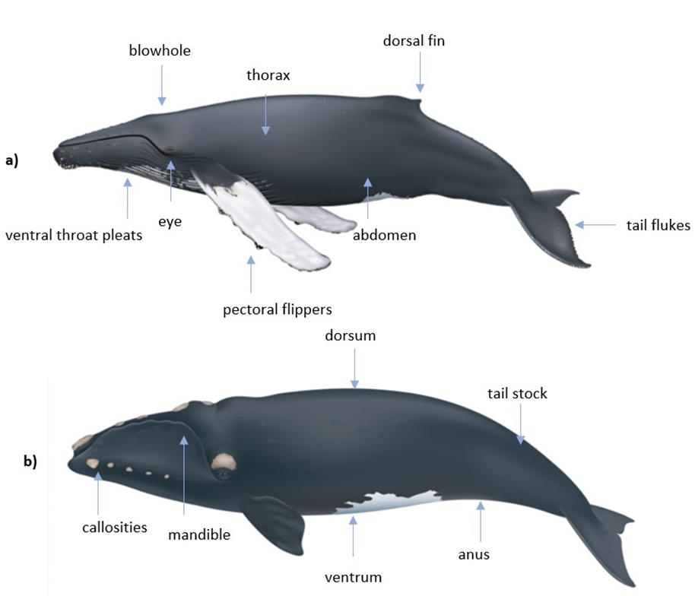
Figure 1 External anatomical features for a) Humpback whale, (Megaptera novaeangliae) and b) Southern right whale (Eubalaena australis) © Uko Gorter

Palliative Care
In some circumstances, human safety and logistical considerations may prevent euthanasia from being carried out. Where this is the case, a protected natural death with palliative care may be the only option (Daoust & Ortenburger 2015). Given the animal welfare implications of this approach, this decision must be made in consultation with a veterinarian.
Stranded large whales can survive for multiple days, particularly if they are otherwise healthy and have stranded by misadventure (Daoust & Ortenburger 2001). During this time, they can be exposed to terrestrial and marine predators and suffer the effects of crushing injuries, exposure to weather conditions and stress.
All attempts should be made to minimise suffering if euthanasia cannot be carried out, including heavy sedation, protection from predators, provision of shade, and limiting exposure to adverse stimuli such as loud noise and sudden movement. Recommended palliative care sedation medications include:
- sedation - Diazepam 0.05-0.1 mg/kg IM or Midazolam 0.025 – 0.05 mg/kg IM
- analgesia - Butorphanol 0.05-0.1 mg/kg IM.
To assist in weight estimation, the WhaleScale Application developed in the United States by Craig Harms, Kerry Wischusen and Leslie Hart is publicly available on Apple and includes algorithms for calculating body weight for a number of species where an accurate body length is available. This application should be used as a guide only. As a precaution, high drug doses should be used in case of under-estimation of weight by the WhaleScale Application.
Given the infrequent nature of incidents, the expiry date on all medications should be checked prior to use.
Recommended sedation routes of administration are provided in Section 4.4.1. Responders should be aware that the act of sedating a compromised cetacean can result in death of the animal. Whilst this is not an adverse outcome, this possibility should be communicated to those present prior to the administration of sedatives.

Euthanasia

Euthanasia Definition
The term euthanasia is derived from the Greek terms eu, meaning good, and thanatos, meaning death, and is usually used to describe the humane ending of a life via a method that minimises or eliminates distress and pain (Underwood & Anthony 2020). In a euthanasia workshop (Butterworth & Events 2017), the IWC agreed upon the definition of euthanasia used by the American Veterinary Medical Association which is ‘the use of humane techniques to induce the most rapid and painless and distress-free death possible’. To meet this definition, techniques employed should aim to induce a rapid loss of consciousness followed by cardiac or respiratory arrest and the subsequent loss of brain function (Leary et al. 2013).
For the purposes of this Guideline, euthanasia is defined using the American Veterinary Medical Association definition endorsed by IWC, therefore time to death, pain and distress associated with each method should be considered as part of decision-making regarding the most appropriate euthanasia method to use (Section 4.4).

Decision to Euthanise
The Guidelines recommend that, after human safety, animal welfare be given the greatest consideration when conducting a stranding options analysis. Euthanasia is usually the most humane option for stranded large whales, however, should be carefully considered before making a decision. A good incident management decision-making process involves an options analysis, which weighs up the costs and benefits of euthanasia associated with other factors.
In a formally declared emergency incident, the Incident Controller is ultimately responsible for a decision to euthanise, but the involvement of a veterinarian is recommended. According to the Australian Veterinary Association, triage of injured or diseased wild animals and their subsequent euthanasia should be performed by a veterinarian or, in the absence of a veterinarian, by someone with appropriate training and experience (AVA 2019). The Guidelines therefore recommend that a euthanasia decision should where possible involve, either directly or indirectly, a veterinarian experienced in cetacean health assessment and euthanasia.
A specific recommendation of the IWC workshop on euthanasia protocols for optimising welfare concerns for stranded cetaceans was that “humaneness should be the first criteria for any euthanasia method, rather than concerns over aesthetics or public acceptance” (Butterworth & Events 2017). The Guidelines strongly recommend that while the views of the public and the aesthetics of euthanising a large whale should be considered and handled appropriately, they should never override the welfare of the whale.
Before a decision to euthanise is made, management of public expectations is critical. Proactive communication regarding euthanasia should clearly articulate the poor survival prognosis of stranded large whales and the reasons that led to the euthanasia decision.
The ethical framework that guides the decision to euthanise a large whale is based on the premise that the whale is in, or soon will be, in an irreversible and drawn-out state of suffering; and that the act of euthanasia can be accomplished safely with a high likelihood of success (Daoust & Ortenburger 2015). Criteria to assist with decision-making about whether to euthanise or not are provided in Section 4.3. The Guidelines recommend that decisions to euthanise be carefully documented including listing the definitive, subjective and circumstantial criteria used (see Appendix 2).

Euthanasia Criteria
Definitive criteria for euthanasia of cetaceans have been described (DSEWPC 2013; Daoust & Ortenburger 2015) and include:
- disabling injuries - including wounds penetrating the thoracic or abdominal cavity
- dislocated or broken tail stock, broken pectoral fin or mandible
- copious haemorrhaging from the mouth, blowhole or anus
- severe blistering or sloughing of greater than 30 % of the skin
- loss of palpebral reflex
- loss of jaw tone
- protruding penis in male animals
- seizures.
Additional subjective criteria can be employed by an assessing veterinarian if there is evidence of increasing pre-existing disease or physiological impairment following stranding. Signs of pre-existing disease may include:
- emaciation
- heavy load of whale lice
- chronic skin lesions
- signs of severe systemic infection
- abnormal respiratory sounds and secretions.
Environmental and logistical constraints which may prevent return of apparently healthy large whales to sea include:
- rough seas
- remoteness/lack of access
- social and/or nutritional dependency e.g. juveniles unable to survive without maternal care
- unacceptable risk of stress and injury to the animal.

Euthanasia methods
In order to meet the IWC definition of euthanasia (Section 4.1), time to death is a key metric to consider. However, human safety, the limitations of human resources, the level of skill or experience of the responders and availability of equipment may also influence the choice of method. For example, cranial implosion provides the quickest time to death for large whales than any other method, however this method poses public safety challenges and there is limited expertise within Australia in the use of this technique.
The following sections provide detailed information on lethal injection, the primary euthanasia method recommended for euthanasia of stranded large whales within Australia. Other methods are briefly discussed. For small cetaceans, euthanasia by firearm may be the most humane method.

Lethal Injection
The use of chemical agents to euthanise animals is a widely accepted practice in domestic animal and research settings (Riley 2001) and can achieve effective and humane euthanasia in large whales. The most rapid method for achieving euthanasia using chemical agents on large whales is by intracardiac (IC) injection (lethal injection to the heart; Figure 2). Times to death recorded in Australia using IC injection are provided in Appendix 3.
Euthanasia via lethal injection is a two-step process beginning with heavy sedation followed by lethal injection. Since there are no drugs for sedation or anaesthesia that are labelled for use in marine mammals, drugs and dose rates selected by the veterinarian are used “off-label”.
Lethal injection can only be carried out by a registered veterinarian and IC lethal injection should only be carried out on a large whale by a registered veterinarian experienced with the technique. However, to date, IC injection has only been used on large whales a few times within Australia. If it is not possible to find a veterinarian experienced with IC lethal injection on large whales it is recommended that a responding veterinarian be supported by a veterinarian experienced with the technique via mobile telephone.
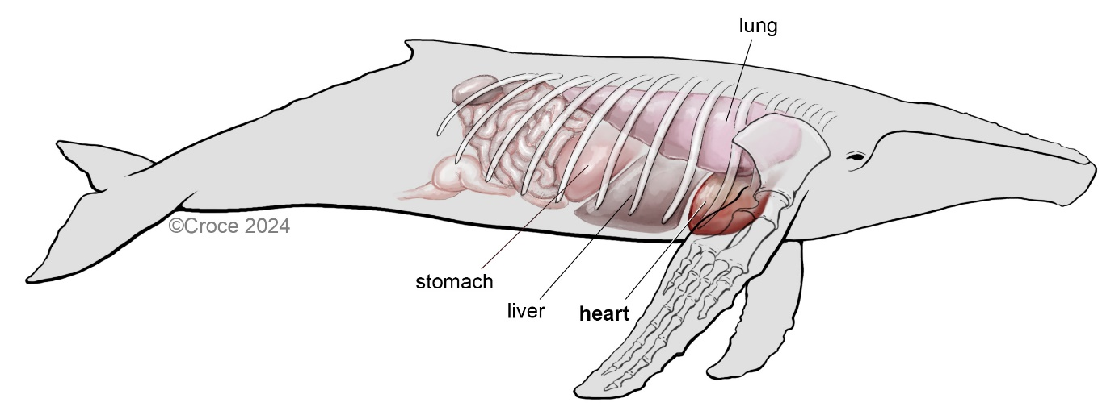
Figure 2 Internal anatomy of a Humpback whale

Pre-euthanasia sedation: Routes of administration
Intramuscular (into a muscle) and intravenous (into a vein) routes have been successfully used to sedate large whales (Harms et al. 2014). Intraglossal (into the tongue) and sublingual (under the tongue) routes have also be used (Barco et al. 2016) but these approaches place the operator in danger due to the potential lateral movement of the head and vertical movement of the maxilla. Intraperitoneal (into the abdominal cavity) administration of drugs in cetaceans should be conducted with caution, as the abdominal cavity is tightly packed with viscera, increasing the likelihood of iatrogenic damage to organs, or administering the agent into the gastrointestinal tract.
Intramuscular (IM) injections should be administered in the epaxial musculature, lateral to the midline and adjacent to the dorsal fin (Barco et al. 2016). The location of the injection should be ventral enough to avoid the thick connective tissue immediately adjacent to the dorsal fin and along the dorsal midline as shown by the areas shaded blue in the top image in Figure 3. The site of injection must also be dorsal enough to avoid the abdominal contents, as shown in the area shaded yellow in the bottom image of Figure 3. The administrator should use a needle that is capable of penetrating the blubber and accessing the muscle underneath, as administration of an agent into the poorly perfused blubber will delay absorption (Clifford 1984). The recommended needle size for an IM injection in a large whale is 16 – 20 gauge (ga) and greater than 20 cm long (Barco et al. 2016).
Administration of large volumes of drugs can be problematic in terms of drug absorption and pain. All routes of administration of large volumes of drugs are likely to cause pain and discomfort to the whale. These issues can be mitigated by the use of highly concentrated drugs and by limiting the volume administered to a single site.
The recommended maximum volume for epaxial muscles is 25 ml per site. For the intraperitoneal cavity the maximum recommended volume is 100 ml, provided that the preparation is of a pH between 6 – 8 (M. Lynch pers comm 11 January 2024).

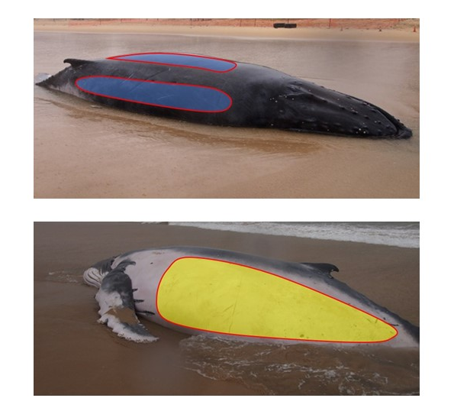

Figure 3 Sites for intramuscular injection are shown in the areas shaded blue and areas to avoid are shaded yellow in a stranded Humpback whale © Duane March.
IV administration can be achieved via the periarterial venous rete in the tail fluke (Figure 4), although this can present a hazard to the veterinarian, as the animal may thrash the tail fluke when stimulated. The tail fluke may be accessed with relative safety if approached from the head end of the animal. There are vessels in the dorsal fin (Figure 5) and pectoral flippers (brachial vein) (Figure 6) that can provide a safer route of administration, however delivery of large volumes by either of these routes can also be problematic due to the rigid nature of the surrounding tissues.

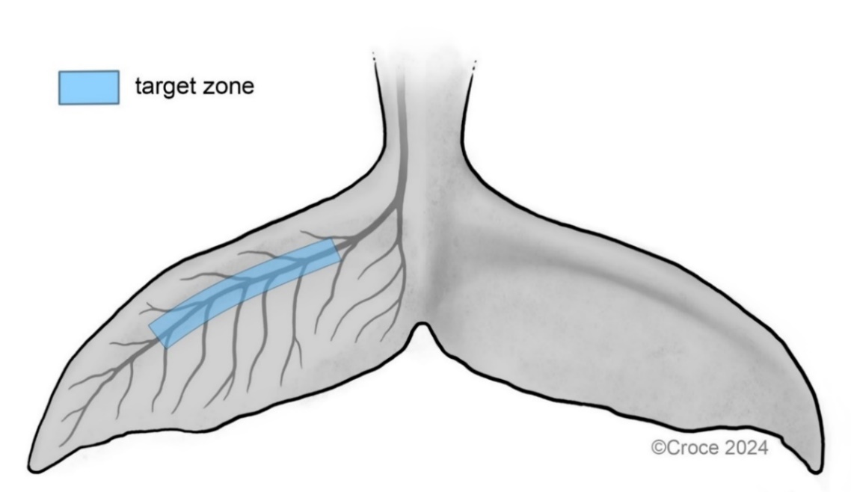
Figure 4 Intravenous access via the periarterial venous rete in the tail fluke

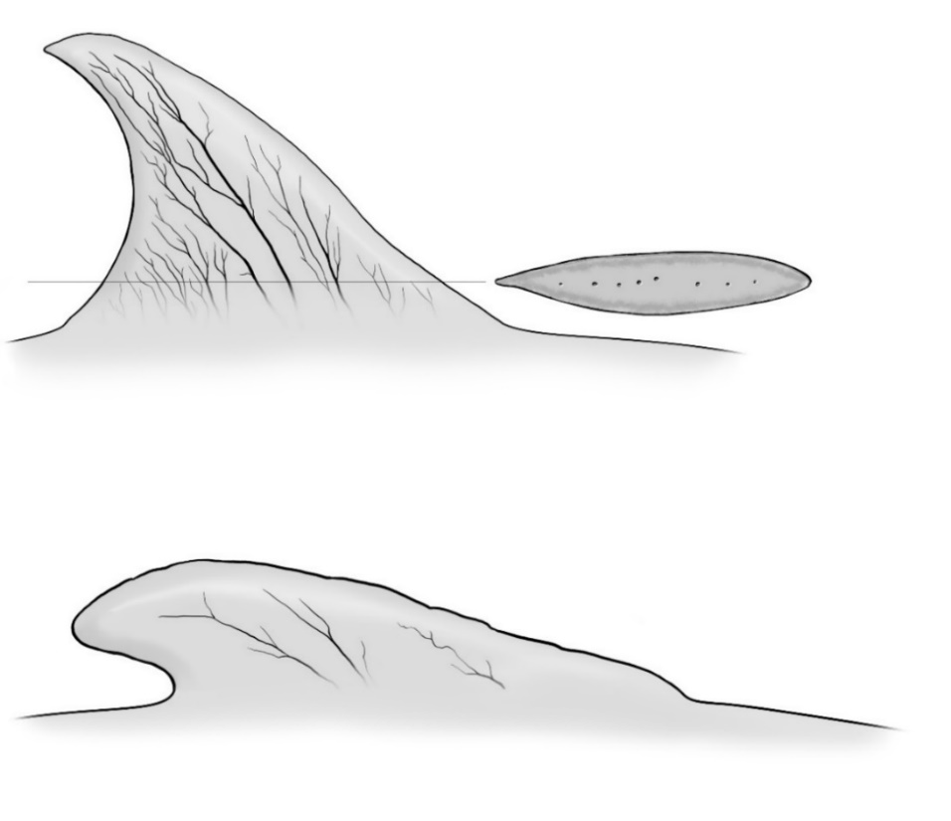
Figure 5 Intravenous access via the dorsal fin © Beth Croce

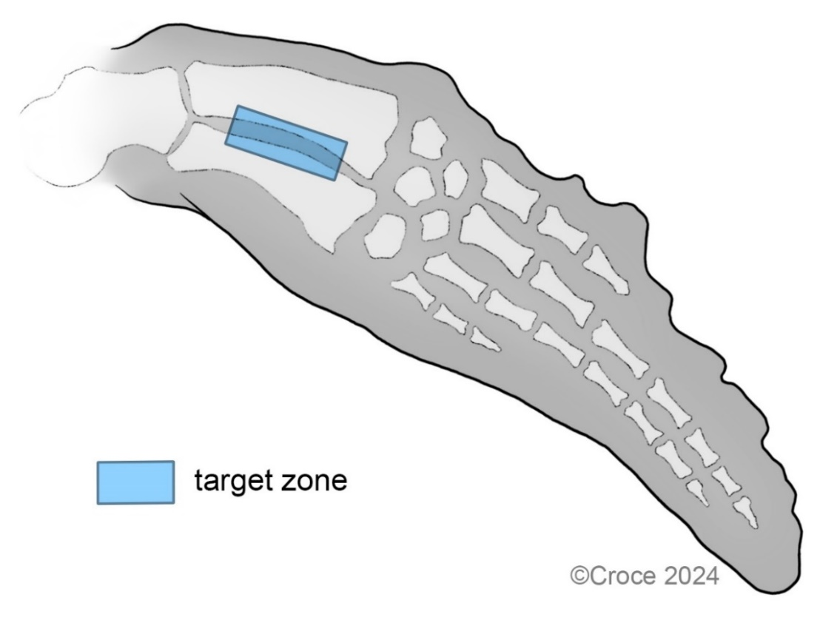
Figure 6 Intravenous access via the brachial vein in the pectoral flipper

Pre-euthanasia sedation: Drugs
The administration of pre-euthanasia drugs to sedate large whales is widely recommended (Baer 2006; Harms et al. 2014) and numerous agents have been used (Appendix 4). The successful administration of chemical agents to sedate and euthanise large whales requires the responder to accurately assess the animal’s weight. The WhaleScale App may be of assistance for estimation of weight.
The Guidelines recommend that large whales be provided with very heavy sedation prior to euthanasia. The preferred regime for pre-euthanasia sedation is 0.025 - 0.05 mg/kg midazolam and 0.02 – 0.04 mg/kg medetomidine delivered intravenously (D. March pers comm 24 November 2023, M. Lynch pers comm 4 December 2024). Lower doses if using intravenous delivery, higher doses if using intramuscular delivery.

Euthanasia: Routes of Administration
Once the animal is sedated, IC administration of drugs can be achieved through the right or left axillary space if the animal is in ventral recumbency (lying on its belly) or a parasternal approach if the animal is in lateral recumbency (lying on its side). IC administration can improve distribution of the drug relative to IV administration (Baer 2006) as the peripheral circulation can be compromised due to the weight of the animal when stranded. Administration of a local anaesthetic (e.g. lignocaine) at the site of approach is recommended prior to insertion of the needle.
The dimensions of the needle used for IC injection in large whales should be greater than 18 ga and longer than 50 cm (Barco et al. 2016). Purpose-built whale euthanasia kits consisting of three 8 mm diameter needles, ranging in length from 1 - 1.5 m with specialised pyramid tips and attachable handle have been developed in Australia and are commercially available. Most State and Territory jurisdictions now carry these kits.
The orientation of the animal should be considered when attempting the administration of drugs. Figure 7 shows placement of the needle parallel with the ground in an animal in ventral recumbency, whereas Figure 8 shows a more oblique angle as the animal had rolled towards lateral recumbency.
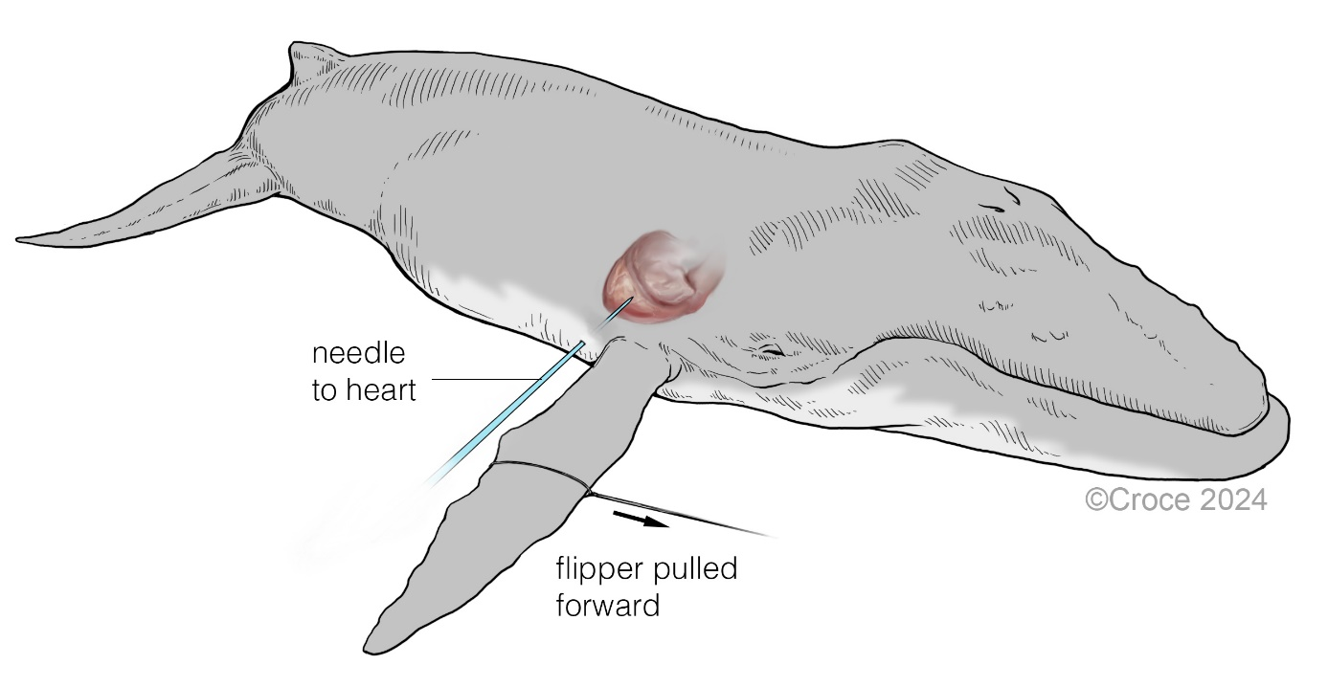
Figure 7 IC needle placement with whale in ventral recumbency

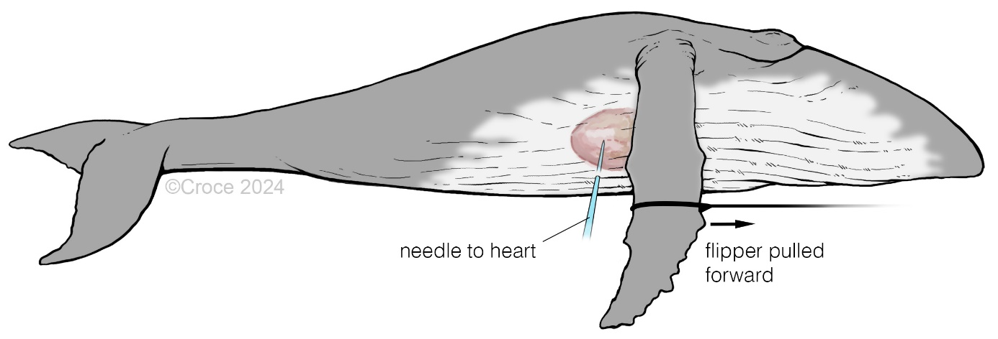
Figure 8 IC needle placement with whale in lateral recumbency

Euthanasia: Drugs
Numerous drugs have been used to chemically euthanise large cetaceans, including IC delivery of potassium chloride (Harms et al. 2014), pentobarbitone sodium (D. March pers comm 4 December 2023) and ultrapotent opioids such as etorphine and carfentanil (Kreeger & Arnemo 1996, Greer et al. 2001). Some euthanasia drugs and dose rates previously used on large whales are shown in Appendix 5.
Pentobarbitone sodium is the most widely utilised euthanasia solution and presents relatively little danger to operators (Underwood et al. 2013). Cetaceans are physiologically sensitive to anaesthetic agents and the dose of pentobarbitone sodium required to euthanise in these animals is lower than domestic animals, and can be further decreased through the use of alpha-2 agonists, such as xylazine and medotomidine, prior to administration (Barco et al. 2016). The use of pentobarbitone sodium without sedation can cause excitement (Watzman et al. 1968), which is undesirable and potentially dangerous to responders. Hence, where barbiturates are to be used, it is recommended that the animal is heavily sedated prior to administration (Baer 2006).
Given the challenges with disposal of large whale carcasses, where possible, low residue drugs are preferred to avoid creating a contaminated carcass. However, whilst administration of certain chemical agents including electrolytes such as potassium chloride and paralytics such as succinylcholine and pancuronium will result in death, the sole use of these agents is unacceptable for use on conscious animals due to the infliction of pain and stress (Gage 2006).
Potassium chloride is available as a powder that can be dissolved in tap water until saturation and presents no danger to operators. The temperature of the water will dictate the concentration of the saturated solution, with concentrations decreasing with decreasing temperature. Concentrations of 360 mg/ml can be achieved at 25°C (Lide 2004). Following dissolution in an aqueous solution, the electrolyte disassociates into ions and following administration, the potassium ion eliminates the potassium concentration gradient in cardiac muscle, preventing the muscle from repolarizing and resulting in cardiac arrest. Given the solution does not induce unconsciousness where intra-cardiac injection is being used, it is not considered humane to use potassium chloride as the sole euthanasia solution (Barco et al. 2016), hence prior heavy sedation is essential. Additionally, since potassium chloride stops the heart, the whale should be lightly anaesthetised so that it does not experience distress. The level of sedation can be hard to judge in stranded whales and the use of IC pentobarbitone sodium provides a welfare safety margin (M. Lynch pers comm 11 January 2024).
Whilst ultra-potent opioids can be effective in sedating and euthanising large whales (Kreeger & Arnemo 1996, Greer et al. 2001) they have a number of serious practical limitations. Firstly, the use of these drugs presents a significant safety risk to the operator, particularly if the animal is in an unstable environment. Secondly, the danger associated with the exposure to these drugs means that access can be difficult and specialised storage facilities are required to safely keep the drugs. The use of opioids can also result in a contaminated carcass. Based on the summation of these concerns, ultra-potent opioids are not recommended for routine use in the euthanasia of large whales where safer alternatives are available.
The recommended regime for chemical euthanasia of large whales is very heavy sedation (access via intramuscular and/or intravenous routes) followed by pentobarbitone sodium delivered IC to anaesthetise, and saturated potassium chloride delivered IC at 300 mls /1000 kg to induce cardiac arrest (D. March pers comm 23 November 2023, M. Lynch pers comm 11 January 2024). Because potassium chloride stops the heart, the use of this small amount of pentobarbitone sodium is recommended to add a welfare safety margin.

Ecotoxicological concerns
Some drugs routinely used in the sedation and euthanasia of animals including pentobarbitone sodium and ultra-potent opioids can persist in the environment for extended periods of time (O'Connor et al. 1985) and pose environmental and biological risks. A case of secondary toxicosis in dogs has been reported following the scavenging of a whale carcass that had been euthanised with pentobarbitone sodium (Bischoff et al. 2011) and similar dangers exist where ultra-potent opioids have been used during euthanasia (Greer et al. 2001).
This danger is mitigated if the entire carcass is removed from the beach following euthanasia and transported to a licenced waste facility. However, if the carcass is to be left in situ following euthanasia, attempts should be made to use low residue drugs such as potassium chloride and/or trim away the site of injection where IM sedatives were administered (Harms et al. 2014).

Explosives
The use of explosives to euthanise large whales has been implemented on stranded whales (Needham 1993) and whales at sea with explosive harpoons on terminally entangled animals (Knudsen & Øen 2003). An improved explosives methodology for stranded large whales, using a shaped charge to cause cranial implosion and instantaneous death (Coughran et al. 2012) has been developed and successfully used in large whales in Australia (Figures 9 and 10). This method has been recognised by the IWC as the method producing the quickest time to death for large whales (IWC 2011).
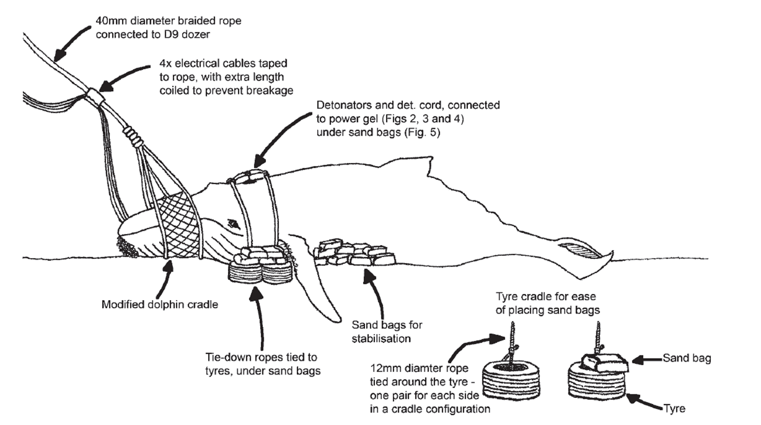
Figure 9 Schematic diagram of cranial implosion technique (Coughran et al. 2012)

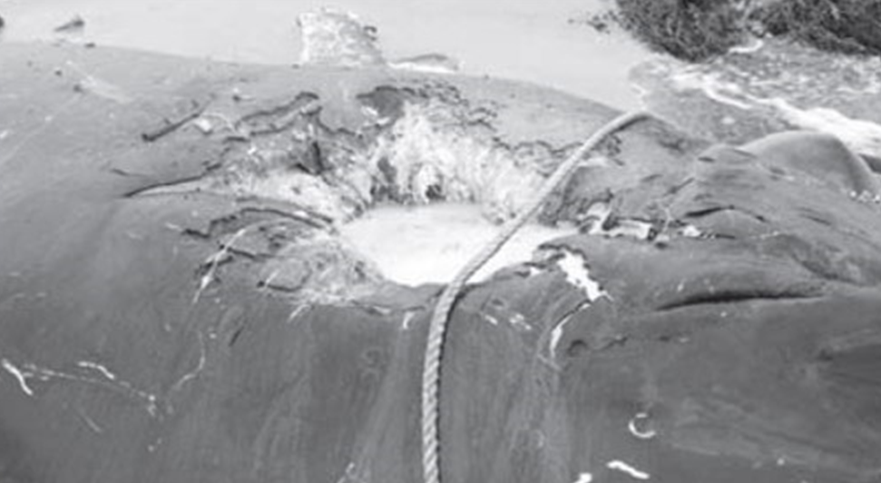
Figure 10 Post detonation effect of cranial implosion (Coughran et al. 2012)

The execution of cranial implosion requires the use of licensed shot firers. Safety and logistical constraints limit the application of this technique. Cranial implosion is not recommended unless it can be carried out by personnel experienced in using the technique successfully on large whales. In situations where whales strand in populated areas, chemical euthanasia is the preferred technique.
An explosives method using a hollow pointed needle with 30 gm of explosive in the tip, inserted into the thoracic cavity, aimed at the heart and large blood vessels has been developed for Sperm whales between 6 m and 15 m in the Netherlands (IWC 2018). Following sedation and analgesia, this method involves drilling a hole through the thoracic wall to provide access for the hollow needle containing the explosive. The explosion is controlled with a remote wired firing device. The use of a limited amount of explosive requires minimal safety perimeter and the procedure can be executed without large environmental impacts. This method is not tested nor recommended in Australia.

Ballistics
The use of ballistics for euthanasia of cetaceans has the advantage of producing rapid time to deaths. The use of ballistics does not require a veterinarian but does require trained and accredited firearms personnel. Where ballistics are to be employed, the use of pre-euthanasia sedation by a veterinarian may be appropriate.
While the use of firearms has been successfully documented in euthanising Humpback whales (Megaptera novaeangliae) up to 4.2 m in length with a cranial diameter of 0.6 m, it is not recommended for animals greater than 6 m (Hampton et al. 2014) and is not considered appropriate for species with larger cranial diameters or specialised cranial anatomy, such as Sperm whales (Physeter macrocephalus) or Southern Right whales (Eubalaena australis).
A specialised Sperm Whale Euthanasia Device developed in New Zealand (Marsh & Bramber 1999), was implemented with mixed results and is not recommended in Australia without further trials on cadavers to assess the efficacy of the device on large whales.

Other Techniques
Additional techniques have been used to induce death include exsanguination, asphyxiation, lancing, bilateral thoracotomy and electrocution. Exsanguination has been used on a right whale calf by cutting through the caudal tail stock (Harms et al. 2014), however time to death was protracted, with the animal expiring 64 min after the tail stock was severed. In the absence anaesthetics, these physical techniques will induce pain and suffering. These methods do not meet the definition of euthanasia required by the Guidelines and are not recommended. They are also specifically not recommended as techniques for euthanising large whales by the Australian Veterinary Association.

Time to Death and Verification
The preferred method for verification of death is the absence of a heart beat (Close et al. 1996, Underwood et al. 2013), which can be detected via a stethoscope or the use of a portable electrocardiogram. However, these techniques are not always practical where large whales are involved, and a combination of simpler criteria can be employed by responders.
The original criteria to determine death in cetaceans defined by the IWC was “the time taken for the mouth to slacken, the flipper to slacken and all movement to cease” (IWC 1980). However, criteria for verification of death have been reviewed (Knudsen 2005) and additional criteria added (Brakes et al. 2006, Barco et al. 2016) to include:
- loss of reflexes - tongue withdrawal, corneal/palpebral (blink), blowhole and anus
- loss of jaw tone - in large whales the maxilla will fall into the oral space
- loss of tail movement
- fixed and dilated pupils - cetaceans have a U-shaped pupil that will be constricted in normal amounts of ambient light. When this is the case, the majority of the eye visualised will be the brown iris. Following death, the pupil dilates and will become oval to circular in shape, as seen in Figure 11
- extended periods without breathing - although large whales can hold their breath for extended periods of time whilst diving, a period of greater than 10 min without respiration is abnormal for a large, stranded cetacean
- lack of response to a painful stimulus.
It is important to be aware that during euthanasia, at the point of death or just prior, the whale may exhibit tail thrashing known as terminal fluking or ‘flurry’. This behaviour does not necessarily indicate that the whale is experiencing pain or distress and heavy sedation prior to lethal injection may reduce the risk of this behaviour occurring (D. March pers comm 25 July 2024). However, it is recommended that this be explained to response personnel and the public.
Time to death is an important metric for assessment welfare implications of euthanasia and should be recorded after euthanasia is completed (see Appendix 2).
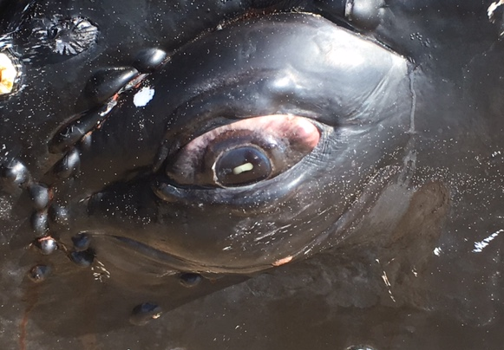
Figure 11 Dilated pupil in a deceased Humpback whale © Duane March

Carcass Management Considerations
Whales have been stranding and decomposing on beaches for thousands of years (Álvarez-Fernández et al. 2014), bringing a wealth of resources for humans and coastal ecosystems. Where possible, carcasses should be left in-situ to decompose naturally, provided there is no risk to humans or wildlife. However, there is increasing pressure on land managers, particularly in populated areas, to remove carcasses from beaches for reasons of public health and amenity.
Where chemical euthanasia has been performed, removal is normally required on health and safety grounds and may be a legal requirement under environmental protection laws. Some of the options for carcass management, including the associated advantages and disadvantages of each as outlined by Tucker et al. (2018) are listed in Appendix 6.
The potential for exposure of people to biological hazards is decreased if whale carcasses can be removed from the beach intact. This also ensures the integrity of the carcass is maintained for future examination and scientific research. To achieve this, the carcass needs to be accessible by a large crane and flat-bed truck (Figure 12). The carcass can be wrapped in cargo net lined with tarpaulins or lifted by the tail stock (Figure 13). A protective material, such as carpet wrapped around the tail stock, can reduce damage to the carcass.
The WhaleScale App can be used to estimate carcass weight, noting that machinery should have a combined operating weight of approximately double that of the carcass. When lifting, a spreader bar should be used to distribute weight. Operators should be warned that any pressure applied to the abdominal cavity may cause explosive oral evisceration, particularly where the carcass is several days old and gases have built up in the abdominal cavity.
The leakage of chemicals, organic fluids and solids pose a health and safety risk to operators and road users. Transport vehicles should be lined to prevent leakage or carcasses wrapped. A police escort and post-transport clean up may be required. The visual aesthetic of the transport process can also present a traffic hazard and, where possible, routes and times with dense traffic should be avoided. Humpback whales have long pectoral flippers and, in an adult animal, these will drag on the road when the animal is loaded onto a flat-bed truck. If the pectoral flippers are unable to be restrained against the side of the animal, they may need to be removed prior to transport.
Where removal of the entire carcass is not possible, the carcass can be dissected, manually or with the use of heavy machinery (Figure 14). In this case, it is strongly recommended that plastic and/or other forms of lining and organic material such as beach sand be added to be back of the transporting trucks to absorb any excessive liquid and prevent spillage on the road during transport.

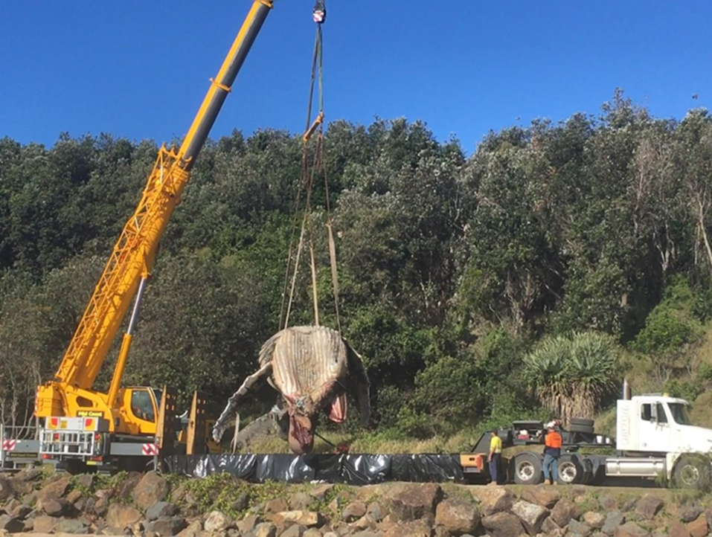
Figure 12 Transferring a Humpback whale carcass with a crane to a flat-bed truck for removal © Duane March

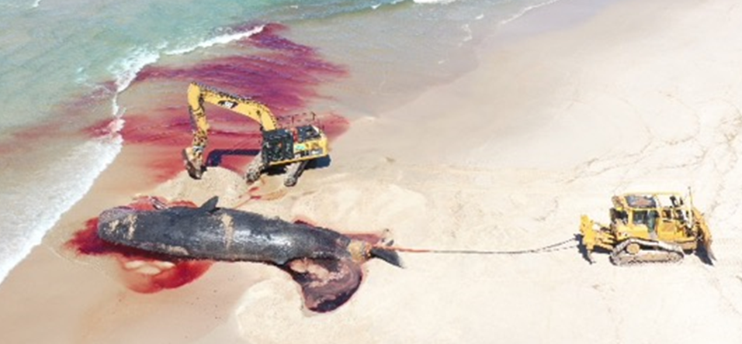
Figure 13 Recovery straps attached to the tail stock of a Sperm whale carcass to facilitate dragging and lifting © Duane March
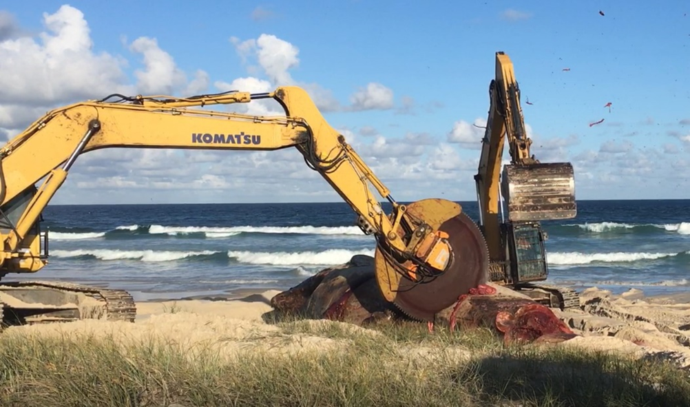

Figure 14 Mechanical dissection of a Sperm whale carcass © Duane March

Death Investigation, Data Collection and Documentation
A key recommendation of the IWC Workshop on Euthanasia Protocols for Optimising Welfare Concerns for Stranded Cetaceans (IWC 2015) was “the collection of appropriate data, full documentation of the event and the sharing of experiences/data to refine decisions and situation handling in the future.” The recommendation noted: “This process should include information on both successes and failures; the latter can be extremely informative in developing improvements and preventing mistakes being repeated.”
Understanding the efficacy and welfare implications of euthanasia is an important part of overall stranding incident assessment. Data on time to death is a key metric of the welfare implications. This data is generally lacking, particularly for large whales. Documentation of the circumstances of the stranding, the animal’s health status, criteria for euthanasia, methods and responses to sedation and euthanasia, including time to death, will improve animal welfare outcomes and assist with Australia’s obligations as a member of the IWC.
Investigation into stranding causative agent/s should be facilitated and it is recommended that full necropsy be performed wherever possible (Higgins & Noad 2006). If necropsy is not possible, rudimentary information should be collected. Tissue samples and basic information on the stranding should be stored at an appropriate State or Territory government facility such as a museum and made available for future studies. Minimal information to be collected includes:
- date
- circumstances of stranding
- photographs
- species
- sex
- length & estimated weight
- body condition including signs of injury/disease
- skin and blubber samples.

7 References
AVA (2019) Euthanasia of injured wildlife. Australian Veterinary Association. Accessed January 2024.
Álvarez-Fernández E, Carriol RP, Jordá JF, Aura JE, Avezuela B, Badal E, Carrión Y, García-Guinea J, Maestro A, Morales JV, Perez G, Perez-Ripoll M, Rodrigo MJ, Scarff JE, Paz Villalba M & Wood R (2014) Occurrence of whale barnacles in Nerja Cave (Málaga, southern Spain): Indirect evidence of whale consumption by humans in the Upper Magdalenian. Quaternary International, 337, 163-169.
Baer CK (2006) Guidelines for euthanasia of nondomestic animals.
Barco SG, Walton WJ, Harms CA, George RH, D'Eri LR & Swingle WM (2016) Collaborative development of recommendations for euthanasia of stranded cetaceans: US Department of Commerce, National Oceanic and Atmospheric Administration, National Marine Fisheries Service, Office of Protected Resources.
Barnett J, Dolman SJ, Simmonds MP & Wright AJ (2014) Best practice in rescue. ECS Special Publication Series(57).
Bejder M, Johnston DW, Smith J, Friedlaender A & Bejder L (2016) Embracing conservation success of recovering Humpback whale populations: Evaluating the case for downlisting their conservation status in Australia. Marine Policy, 66, 137-141.
Bischoff K, Jaeger R & Ebel JG (2011) An unusual case of relay pentobarbital toxicosis in a dog. Journal of Medical Toxicology, 7(3), 236-239.
Blaisdell FW (2002) The pathophysiology of skeletal muscle ischemia and the reperfusion syndrome: a review. Cardiovascular Surgery, 10(6), 620-630.
Blanchard TW, Santiago NT, Lipscomb TP, Garber RL, McFee WE & Knowles S (2001) Two novel alphaherpesviruses associated with fatal disseminated infections in Atlantic bottlenose dolphins. Journal of Wildlife Diseases, 37(2), 297-305.
Blyde D (2019) Cetaceans. In L. Vogelnest & T. Portas (Eds.), Current therapy in medicine of Australian mammals (pp. 593-604). Clayton South, Victoria: CSIRO PUBLISHING.
Bowater RO, Norton J, Johnson S, Hill B, O'donoghue P & Prior H (2003) Toxoplasmosis in Indo‐Pacific Humpbacked dolphins (Sousa chinensis), from Queensland. Australian Veterinary Journal, 81(10), 627-632.
Brakes P, Butterworth A & Donoghue M (2006) Investigating criteria for insensibility and death in stranded cetaceans in New Zealand. IWC/58/WKM&AWI, 9.
Butterworth A & Events I (2017) Report of an IWC Workshop Developing Practical Guidance for the Handling of Cetacean Stranding Events.
Carlyon K, Couchman N, Crocetti S, Hall J, Kemper C, Low Choy D & Andrews-Goff V (2021) Australia's Scientific Progress Reports submitted to the International Whaling Commission between 2012 and 2020.
Clifford DH (1984) Preanesthesia, anesthesia, analgesia and euthanasia. Laboratory animal medicine/edited by JG Fox, BJ Cohen, FM Loew.
Close B, Banister K, Baumans V, Bernoth EM, Bromage N, Bunyan J, Erhardt W, Flecknell P, Gregory N, Hackbarth H, Morton D & Warwick C (1996) Recommendations for euthanasia of experimental animals: Part 1. Laboratory Animals, 30(4), 293-316.
Coombs EJ, Deaville R, Sabin RC, Allan L, O'Connell M, Berrow S, Smith B, Brownlow A, Ten Doeschate M, Penrose R, Williams R, Perkins MW, Jepson PD & Cooper N (2019) What can cetacean stranding records tell us? A study of UK and Irish cetacean diversity over the past 100 years. Marine Mammal Science, 35(4), 1527-1555.
Coughran D, Stiles I & Fuller P (2012) Euthanasia of beached Humpback whales using explosives. J Cetacean Res Manag, 12, 137-144.
Daoust PY & Ortenburger A (2015) Advice on euthanasia techniques for small and large cetaceans: Fisheries and Oceans Canada, Science.
Daoust PY & Ortenburger AI (2001) Successful euthanasia of a juvenile fin whale. The Canadian Veterinary Journal, 42(2), 127.
DSEWPAC (2013) National Guidance on the management of whale and dolphin incidents in Australian waters. Department of Sustainability Environment Water Population and Communities. (2013).
Foord CS, Rowe KM & Robb K (2019) Cetacean biodiversity, spatial and temporal trends based on stranding records (1920-2016), Victoria, Australia. PloS one, 14(10), e0223712.
Gage L (2006) Interim polices and best practice marine mammal stranding response, rehabilitation and release standards for rehabilitation facilities. Silver Spring: MD.
Greer LL, Whaley J & Rowles TK (2001) Euthanasia. In L. Dierauf & F. M. Gulland (Eds.), Crc Handbook Of Marine Mammal Medicine: Health, Disease, And Rehabilitation (Vol. 2, pp. 729-738). Boca Raton, FL: CRC press.
Groom C & Coughran D (2012) Three decades of cetacean strandings in Western Australia: 1981 to 2010. Journal of the Royal Society of Western Australia, 95(1), 63.
Hampton J, Mawson PR, Coughran D & Vitali S (2014) Validation of the use of firearms for euthanising stranded cetaceans. Journal of Cetacean Research and Management, 14(1), 117-123.
Harms CA, McLellan WA, Moore MJ, Barco SG, Clarke III EO, Thayer V G & Rowles TK (2014) Low-residue euthanasia of stranded Mysticetes. Journal of Wildlife Diseases, 50(1), 63-73.
Higgins DP & Noad MJ (2006) Standardised protocols for the collection of biological samples from stranded cetaceans: Department of the Environment and Heritage.
IWC (1980) Report of the Workshop on Humane Killing Techniques for Whales.
IWC (2011) Report of the Second IWC Workshop on Welfare Issues Associated with the Entanglement of Large Whales with a Focus on Entanglement Response.
IWC (2015) Report of the IWC Workshop on Euthanasia Protocols to Optimize Welfare Concerns for Stranded Cetaceans.
IWC (2018) Summary of Activities Related to the Action Plan on Whale Killing Methods.
Jackson S (2005) Indigenous values and water resource management: a case study from the Northern Territory. Australasian Journal of Environmental Management, 12(3), 136-146.
Kemper C, Flaherty A, Gibbs S, Hill M, Long M & Byard R (2005) Cetacean captures, strandings and mortalities in South Australia 1881-2000, with special reference to human interactions. Australian Mammalogy, 27(1), 37-47.
Knudsen S (2005) A review of the criteria used to assess insensibility and death in hunted whales compared to other species. The Veterinary Journal, 169(1), 42-59.
Knudsen SK & Øen EO (2003) Blast-induced neurotrauma in whales. Neuroscience Research, 46(3), 377-386.
Kreeger TJ, Arnemo JM (1996) Handbook of wildlife chemical immobilization: International Wildlife Veterinary Services Laramie, Wyoming, USA.
Leary SL, Underwood W, Anthony R, Cartner S, Corey D, Grandin T, Greenacre C, Gwaltney-Brant S, McCrackin MA, Meyer R, Miller D, Shearer J & Yanong R (2013) AVMA guidelines for the euthanasia of animals: 2013 edition.
Lide DR (2004) CRC handbook of chemistry and physics (Vol. 85): CRC press.
Lloyd HB & Ross GA (2015) Long-term trends in cetacean incidents in New South Wales, Australia. Australian Zoologist, 37(4), 492-500.
Mackie J, Blyde D, Harris L, Roe W & Keyburn A (2020) Brucellosis associated with stillbirth in a bottlenose dolphin in Australia. Australian Veterinary Journal, 98(3), 92-95.
Marsh N & Bramber C (1999) Development of a specialised round and firearm for the humane euthanasia of stranded Sperm whales (Physeter macrocephalus) in New Zealand. Paper presented at the 51st meeting of the International Whaling Commission, St. George's, Grenada.
Meager JJ & Limpus C (2014) Mortality of inshore marine mammals in eastern Australia is predicted by freshwater discharge and air temperature. PloS one, 9(4), e94849.
Meynecke JO & Meager JJ (2016) Understanding strandings: 25 years of Humpback whale (Megaptera novaeangliae) strandings in Queensland, Australia. Journal of Coastal Research, 75(sp1), 897-901.
Needham D (1993) Cetacean strandings. Zoo and wild animal medicine: current therapy, 3, 415-425.
Noad MJ, Kniest E & Dunlop RA (2019) Boom to bust? Implications for the continued rapid growth of the eastern Australian Humpback whale population despite recovery. Population Ecology, 61(2), 198-209.
O'Connor J, Stowe C & Robinson R (1985) Fate of sodium pentobarbital in rendered products. American Journal of Veterinary Research, 46(8), 1721-1724.
Obusan MCM, Villanueva RMD, Siringan MAT, Rivera WL & Aragones LV (2019) Leptospira spp. and Toxoplasma gondii in stranded representatives of wild cetaceans in the Philippines. BMC veterinary research, 15(1), 1-14.
Riley JS (2001) Euthanasia Of Animals Used For Scientific Purposes. In J. S. Riley (Ed.), Australian and New Zealand Council for the Care of Animals in Research and Teaching. Adelaide, SA.
Salgado Kent C, Jenner C, Jenner M, Bouchet P Rexstad E (2012) Southern Hemisphere breeding stock'D'Humpback whale population estimates from North West Cape, Western Australia. Journal of Cetacean Research and Management, 12(1), 29-38.
Smyth D (2001) Management of sea country. Working on country: contemporary Indigenous management of Australia’s lands and coastal regions, Oxford University Press, Melbourne, 60-74.
Souter R, Chaber AL, Lee K, Machado A, Lam J & Woolford L (2021) Fatal Streptococcus iniae Infection in a Juvenile Free-Ranging Short-Beaked Common Dolphin (Delphinus delphis). Animals, 11(11), 3123.
Stone B, Blyde D, Saliki J, Blas‐Machado U, Bingham J, Hyatt A, Wang J, Payne J, Crameri S (2011) Fatal cetacean morbillivirus infection in an Australian offshore bottlenose dolphin (Tursiops truncatus). Australian Veterinary Journal, 89(11), 452-457.
Stone BM, Blyde DJ, Saliki JT & Morton JM (2012) Morbillivirus infection in live stranded, injured, trapped, and captive cetaceans in southeastern Queensland and northern New South Wales, Australia. Journal of Wildlife Diseases, 48(1), 47-55.
Tucker JP, Santos IR, Crocetti S & Butcher P (2018) Whale carcass strandings on beaches: Management challenges, research needs, and examples from Australia. Ocean & Coastal Management, 163, 323-338.
Tucker JP, Santos IR, Davis KL & Butcher PA (2019) Whale carcass leachate plumes in beach groundwater: A potential shark attractant to the surf? Marine Pollution Bulletin, 140, 219-226.
Underwood W & Anthony R (2020) AVMA guidelines for the euthanasia of animals: 2020 edition. Retrieved on March, 2013(30), 2020-2021.
Vilela R & Mendoza L (2018) Paracoccidioidomycosis ceti (lacaziosis/lobomycosis) in dolphins. In Emerging and epizootic fungal infections in animals (pp. 177-196): Springer.
Waltzek T, Cortés‐Hinojosa G, Wellehan Jr J & Gray GC (2012) Marine mammal zoonoses: a review of disease manifestations. Zoonoses and public health, 59(8), 521-535.
Watzman N, Barry III H, Kinnard Jr WJ & Buckley JP (1968) Some conditions under which pentobarbital stimulates spontaneous motor activity of mice. Journal of Pharmaceutical Sciences, 57(9), 1572-1576.
Yunupingu D & Muller S (2009) Cross-cultural challenges for Indigenous sea country management in Australia. Australasian Journal of Environmental Management, 16(3), 158-167.

Appendix 1: National, State and Territory legislation relating to euthanasia of large whales
Jurisdiction | Relevant Legislation
Commonwealth waters | Environment Protection and Biodiversity Conservation Act 1999  Section 231 states that it is not an offense to euthanise a cetacean in Commonwealth waters, if the action is taken in a humane manner and is reasonably necessary to relieve or prevent suffering of a cetacean or to prevent risk to human health.
Queensland | Nature Conservation Act 1992  Section 88 states that a person must not take a protected animal unless the person is an authorised person (Conservation Officer) or is authorised by the Act.  Animal Care and Protection Act 2001  Section 18 states that a person is in breach of the Act if they take an action which kills an animal in a way that is inhumane and causes it not to die quickly.  Nature Conservation (Animals) Regulation 2020  Division 2, Section 58 authorises a veterinary surgeon to euthanise a treated animal if the animal is unlikely to recover from sickness or survive in the wild.  Part 4, Section 316 of this Regulation prescribes for Section 154 (1)(e) of the Nature Conservation Act 1992 and authorises a Conservation Officer to direct the treatment, including euthanasia, of a marine mammal, where the Conservation Officer considers it necessary.
New South Wales | Biodiversity and Conservation Act 2016 (Biodiversity Conservation Regulations 2017)  Section 2.10 provides defence to prosecution of breaches to the act if actions are deemed part of an emergency response, including providing assistance to stranded marine mammals, acting under the authority of an Authorised Officer.  Prevention of Cruelty to Animals Act 1979  Section 24 allows humane destruction if required by an authorised officer.
Victoria | Wildlife Act 1975  Section 28 states that the Secretary may give written authorisation to a person to destroy wildlife for the purposes of care and treatment.  Section 76 (4) (aa) states that killing of a whale may be carried out by an authorised officer, or under the direction of an authorised officer, where reasonably necessary for the welfare of the whale.  Prevention of Cruelty to Animals Act 1986  Section 24 authorises euthanasia by a veterinarian where the practitioner reasonably believes that the animal’s condition is such that it would continue to suffer if it remained alive.
South Australia | National Parks and Wildlife Act 1972  Section 53 allows the Minister to grant a permit to any person to allow the take of protected animals for any other purpose (other than sale) that the Minister considers proper and not inconsistent with the Act.
Tasmania | Whales Protection Act 1988  Part 3 allows an authorized person to carry out such acts as he believes necessary including euthanasia. The authorised person can request another person help carry out the acts.  Animal Welfare Act 1993  Part 3, Section 24 allows an officer or veterinary surgeon to kill an animal if, in their opinion, the animal is injured or diseased or otherwise suffering and they reasonably believe that the injury, disease or other suffering will cause the animal continued and excessive pain and suffering.
Western Australia | The Biodiversity Conservation Act 2016  Section 165 states that an authorised Officer may destroy the fauna in a humane manner if they reasonably believe that any fauna is suffering so severely that destroying it would be a humane thing to do.
Northern Territory | Territory Parks and Wildlife Conservation Act 1976  Section 45 states that the Minister may declare that it is lawful to kill protected species.

Appendix 2: Cetacean assessment and euthanasia data record
Stranding Information
Date and time |  |  |  | Species
Incident Controller |  |  |  | Field ID
Veterinarian |  |  |  | Total length
Location (GPS) |  |  |  | Estimated weight
Stranding location | dry |  |  | intertidal zone | partially submerged still on low tide
Sea state | < 2 m | 2 - 4 m | < 4 m | Age class | calf | juvenile |  | adult
Weather | sun | rain | wind | Sex | male |  | female

Animal Assessment: Criteria for euthanasia
Position | left lateral recumbency |  | ventral recumbency | right lateral recumbency
Respiration Rate | _____ breaths / ____ min |  | Heart rate | _____ beats / ____ min
Respiration Character | strong and regular |  | weak and/or irregular | abnormal noise
Respiratory Exudate | clear / foam |  | blood | purulent
Movements | fluke movement |  | arching | trembling
Body Condition | robust |  | thin | emaciated
Haemorrhage | oral |  | anus | blowhole
Skin sloughing | nil |  | 0-30 % | < 30%
Palpebral Reflex | present | absent | Jaw tone | present | absent
Disabling Injuries
Decision | assist with re-float |  | euthanasia | palliative care
Selected method | cranial implosion |  | chemical euthanasia with barbiturates | chemical euthanasia with Potassium Chloride

Pre-euthanasia management: Sedation
Animal demeanour | alert |  | lethargic | non-responsive
Drug 1: |  |  | Time
Dose |  |  | Route | IM | IV | IP | other
Response to injection | nil | arching | increased fluke movement | vocalisation
Animal Assessment: Post sedation
Time post sedation | 0 -15 minutes |  | 15 – 30 minutes | < 30 minutes
Respiration Rate | _____ breaths / ____ min |  | Heart Rate | _____ beats / ____ min
Eyes | open | closed | Palpebral Reflex | present |  | absent
Respiration Character | strong and regular |  | weak and/or irregular | abnormal noise
Respiratory Exudate | clear / foam |  | blood | purulent
Movements | fluke movement |  | arching | trembling
Effect | nil |  | moderate sedation | profound sedation
Other

Pre-euthanasia management: Sedation
Animal demeanour | alert |  | lethargic | non-responsive
Drug 2: |  |  | Time
Dose |  |  | Route | IM | IV | IP | other
Response to injection | nil | arching | increased fluke movement | vocalisation
Animal Assessment: Post sedation
Time post sedation | 0 -15 minutes |  | 15 – 30 minutes | < 30 minutes
Respiration Rate | _____ breaths / ____ min |  | Heart Rate | _____ beats / ____ min
Eyes | open | closed | Palpebral Reflex | present |  | absent
Respiration Character | strong and regular |  | weak and/or irregular | abnormal noise
Respiratory Exudate | clear / foam |  | blood | purulent
Movements | fluke movement |  | arching | trembling
Effect | nil |  | moderate sedation | profound sedation
Other

Pre-euthanasia management: Sedation
Animal demeanour | alert |  | lethargic | non-responsive
Drug 3: |  |  | Time
Dose |  |  | Route | IM | IV | IP | other
Response to injection | nil | arching | increased fluke movement | vocalisation
Animal Assessment: Post sedation
Time post sedation | 0 -15 minutes |  | 15 – 30 minutes | < 30 minutes
Respiration Rate | _____ breaths / ____ min |  | Heart Rate | _____ beats / ____ min
Eyes | open | closed | Palpebral Reflex | present |  | absent
Respiration Character | strong and regular |  | weak and/or irregular | abnormal noise
Respiratory Exudate | clear / foam |  | blood | purulent
Movements | fluke movement |  | arching | trembling
Effect | nil |  | moderate sedation | profound sedation
Other

Euthanasia
Animal demeanour | alert |  | lethargic | non-responsive
Method |  |  | Time
Dose |  |  | Route | IM | IV | IP | other
Response to injection | nil | arching | increased fluke movement | vocalisation
Response to implosion | nil | arching | increased fluke movement | vocalisation
Animal Assessment: Confirmation of death
Pupil | fixed and dilated: yes/ no
Heart Rate | absent / present |  | Respiration | absent / present
Reflexes | palpebral reflex:  absent / present |  | blowhole reflex:  absent / present | anal tone:  absent/present
Movement | fluke movement:  absent / present |  | tongue withdrawal:  absent / present | response to painful stimuli:  absent / present
Time to death post commencement of euthanasia |  |  | Time post completion of euthanasia

Data record modified from Barco et al. 2016

Appendix 3: Summary of drugs used and times to death using intracardiac injection in Australia
 | Humpback whale (Megaptera novaeangliae) | Humpback whale (Megaptera novaeangliae) | Humpback whale (Megaptera novaeangliae)
Size | 10 m | 11 m | 12 m
Year | 2017 | 2021 | 2022
Location | Sawtell, NSW | Gippsland, Vic | Crescent Head, NSW
Sedation drugs used | Xylazine | Midazolam, Medetomidine | Midazolam, Xylazine
Euthanasia drugs used | Pentobarbitone sodium | Pentobarbitone sodium  Potassium chloride | Pentobarbitone sodium  Potassium chloride
Time to death | 20 min after first IC injection | 1 -2 min after first IC injection | 66 min after intra-thoracic injection
Comments | Single dose of sedation administered 90 min prior to IC injection of 2 doses of Pentobarbitone sodium | 3 doses of sedation administered over 30 – 45 min prior to IC injection of Pentobarbitone sodium followed by Potassium chloride | 4 doses of sedation administered over 37 min prior to intrathoracic injection of Potassium chloride, followed by IC injection of 6 doses of Pentobarbitone sodium
Reference | D. March pers comm 25 July 2024 | M. Lynch pers comm 24 November 2023 | D. March pers comm 25 July 2024

Appendix 4: Pre-euthanasia drugs used in large whales
 | Case 1 | Case 2 | Case 3 | Case 4 | Case 5
Species | Humpback whale (Megaptera novaeangliae) | Humpback whale (Megaptera novaeangliae) | Humpback whale (Megaptera novaeangliae) | Humpback whale (Megaptera novaeangliae) | Humpback whale (Megaptera novaeangliae)
Estimated weight (kg) | 9,500 | 8,000 | 13,000 | 15,000 | 14,000
Midazolam (mg/kg) | 0.04 | 0.05 | 0.025 | 0.0 | 0.0
Acepromazine (mg/kg) | 0.2 | 0.25 | 0.15 | 0.0 | 0.0
Xylazine (mg/kg) | 3.4 | 3.5 | 2.6 | 1.5 | 0.0
Zolazepam and Tiletamine (mg/kg) | 0.0 | 0.0 | 0.0 | 0.0 | 0.18
Medetomidine (mg/kg) | 0.0 | 0.0 | 0.0 | 0.0 | 0.002
Comment | Administered over 60 min and rendered the animal minimally responsive | Administered over 91 min and rendered the animal minimally responsive | Administered over 60 min and rendered the animal minimally responsive | Administered over 10 min and rendered the animal minimally responsive within 20 min | Administered over 10 min and had no observable effect on the animal
Reference | Harms et al. 2014 | Harms et al. 2014 | Harms et al. 2014 | D. March pers comm 18 July 2024 | D. March pers comm 18 July 2024

Appendix 5: Euthanasia drugs used in large whales
 | Case 1 | Case 2 | Case 3 | Case 4 | Case 5 | Case 6
Species | Humpback whale (Megaptera novaeangliae) | Humpback whale (Megaptera novaeangliae) | Humpback whale (Megaptera novaeangliae) | Humpback whale (Megaptera novaeangliae) | Humpback whale (Megaptera novaeangliae) | Humpback whale (Megaptera novaeangliae)
Estimated weight (kg) | 9,500 | 8,000 | 13,000 | 14,000 | 10,000 | 15,000
Pentobarbitone sodium | 0 mg/kg | 0 mg/kg | 0 mg/kg | 45 mg/kg | 20 mg/kg | 60 mg/kg
Potassium chloride | 100 mg /kg | 220 mg/kg | 150 mg/kg | 0 mg/kg | 10 mg/kg | 80 mg/kg
Comment | Administered IC or IV near the heart over 3 min. Death 4 min after the injection completed. | Administered IC or IV near the heart over 22 min. Death 8 min after the injection completed. | Administered IC or IV near the heart over 15 min. Death 10 min after the injection completed. | Administered IC over 12 minutes. Death 2 min after the injection was completed. | Administered IC. Death under 1 min after Potassium chloride injection completed. | No observable effect from IT Potassium chloride. Pentobarbitone sodium administered IC over 5 min. Death 4 min after injection completed.
Reference | Harms et al. 2014 | Harms et al. 2014 | Harms et al. 2014 | D. March pers comm 18 July 2024 | M. Lynch pers comm 24 November 2023 | D. March pers comm 18 July 2024

Appendix 6: Carcass disposal options
Disposal Method | Cost | Danger to beach users | Logistical Difficulty | Potential Risks | Benefits
Leave to decompose in situ | Low | Med- High (depending on euthanasia method and location of carcass) | Low | Potential biological hazard to the public.  Unsightly.  Predator attraction. | Carcass is available as a food source for marine and terrestrial animals.
Bury the animal on the beach or at alternative burial site away from beach | Medium | Unknown: Recent studies showed that leachate was unlikely to attract predators if it did not contact groundwater (Tucker et al. 2019). | Medium | Potential hazard if it is a vehicle access beach.  Predator attraction.  Interference with cultural sites: e.g. middens and burials. | Minimal adverse sights and smells.  Carcass is available as a food source for invertebrates.
Tow the animal out to sea | Medium | Medium: The carcass may return to shore in a less favourable condition and/or location. | Medium | Not endorsed in some jurisdictions. Carcass can pose boating and shipping hazard and liability would lie with the entity that disposed of the carcass. | Carcass is available as a food source for marine life.
Transport to a waste management facility | High | Low | High | Risk to operators and other road users during removal and disposal. | Controlled environment for decomposition.

Table modified from Tucker et al. 2018

