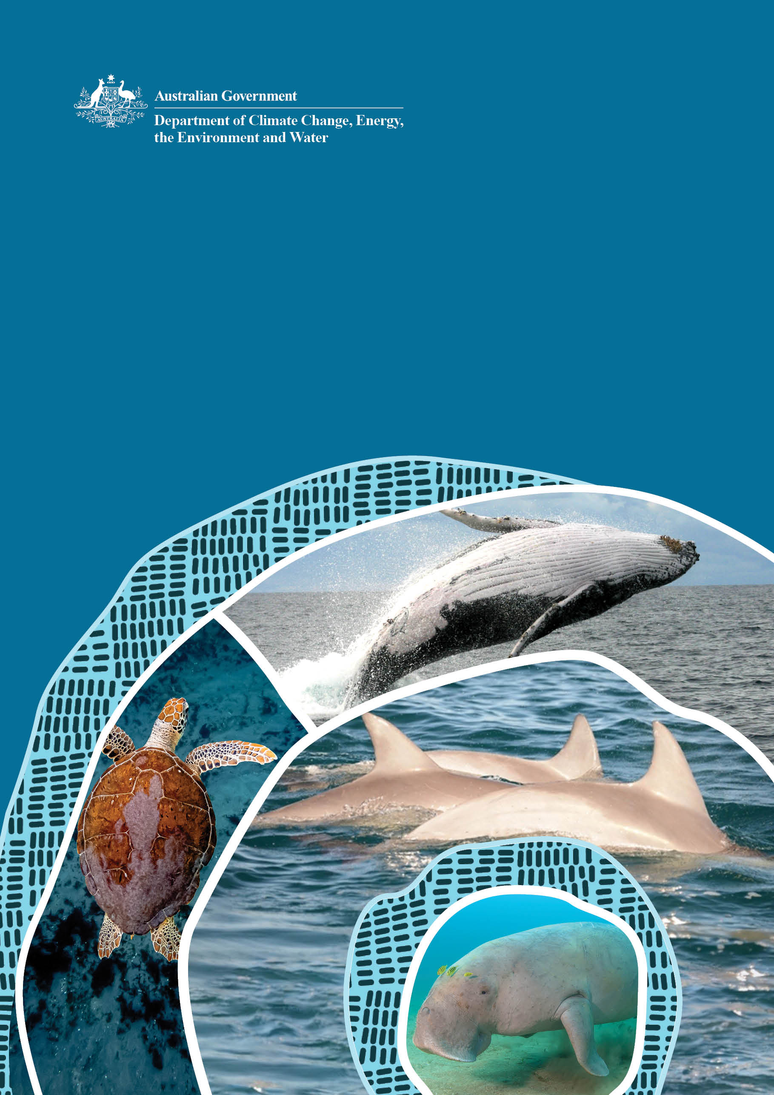

National Guidelines for
the Survey of Cetaceans,
Marine Turtles and the Dugong

February 2024
Version 1.0

© Commonwealth of Australia 2024
Ownership of intellectual property rights
Unless otherwise noted, copyright (and any other intellectual property rights) in this publication is owned by the Commonwealth of Australia (referred to as the Commonwealth).
Creative Commons licence
All material in this publication is licensed under a Creative Commons Attribution 4.0 International Licence except content supplied by third parties, logos and the Commonwealth Coat of Arms.
Inquiries about the licence and any use of this document should be emailed to copyright@dcceew.gov.au.

Cataloguing data
This publication (and any material sourced from it) should be attributed as: DCCEEW 2024, National Guidelines for the Survey of Cetaceans, Marine turtles and the Dugong, Department of Climate Change, Energy, the Environment and Water, Canberra. CC BY 4.0.
This publication is available at dcceew.gov.au/publications.
Department of Climate Change, Energy, the Environment and Water
GPO Box 3090 Canberra ACT 2601
Telephone 1800 900 090
Web dcceew.gov.au
Disclaimer
The Australian Government acting through the Department of Climate Change, Energy, the Environment and Water has exercised due care and skill in preparing and compiling the information and data in this publication. Notwithstanding, the Department of Climate Change, Energy, the Environment and Water, its employees and advisers disclaim all liability, including liability for negligence and for any loss, damage, injury, expense or cost incurred by any person as a result of accessing, using or relying on any of the information or data in this publication to the maximum extent permitted by law.
Acknowledgements
The Department of Climate Change, Energy, the Environment and Water would like to acknowledge those who contributed to the development of the National Guidelines for the Survey of Cetaceans, Marine Turtles and the Dugong. These guidelines are based on the draft written by Joshua Smith and Amanda Hodgson with the assistance of Krista Nicholson and Delphine Chabanne. Helene Marsh, Peter Gill, Natalie Kelly, Lyndon Brooks, Janet Lanyon, Holly Raudino, Christophe Cleguer, and Rachel Groom generously provided technical reviews of sections of this document. We are grateful to the large number of experts across industry, the scientific research community, Commonwealth, State and Territory government agencies who provided their knowledge and experience in development of the guidelines.
Front cover images
Green turtle (Chelonia mydas) © AdobeStock, humpback whale (Megaptera novaeangliae) breaching © Joshua Smith, bottlenose dolphin (Tursiops aduncus) fins © CEBEL Rebecca Haughey, and dugong (Dugong dugon) underwater © Matthieu Juncker.
Acknowledgement of Country
We acknowledge the Traditional Custodians of Australia and their continuing connection to land and sea, waters, environment and community. We pay our respects to the Traditional Custodians of the lands we live and work on, their culture, and their Elders past and present.

Contents
List of Tables v
List of Figures v
Glossary vi
1 How to use the Survey Guidelines 1
1.1 Objectives and scope 1
1.2 Legislative considerations 3
2 Background information to inform survey approach 6
2.1 Background search 7
2.2 Baseline surveys 10
3 Framing the question 12
4 Planning and design of surveys 16
4.1 Detecting change 17
4.2 Spatial considerations 18
4.3 Temporal considerations – multiple seasons and multiple years 19
4.4 Weather conditions and the quality of survey data 20
4.5 Effort, bias, precision, and uncertainty 20
4.6 Multiple survey methods and multi-species surveys 21
4.7 Permits and animal ethic approvals 22
4.8 Observer requirements and expertise 25
4.9 Independent review of survey plan 25
5 Survey techniques and methods 26
5.1 Aerial surveys 26
5.2 Vessel surveys 36
5.3 Land-based surveys 46
5.4 Passive acoustic monitoring (PAM) 51
5.5 Emerging techniques and technologies 59
5.6 Data analysis methods 63
5.7 Data availability 66
6 Taxa-specific considerations 67
6.1 Cetaceans 67
6.2 Marine turtles 68
6.3 Dugong 69
7 References 71
Appendix A: EPBC Act Significant Impact Guidelines 1.1 – Matters of National Environmental Significance 80

List of Tables
Table 1 Permit information for Commonwealth, State and Territory jurisdictions 24
Table 2 Expertise key outlining the level of knowledge and training required for the role the person will be fulfilling 26
Table 3 Resources that provide examples of how to apply corrections for imperfect detection (i.e. to account for detection probability) 64

List of Figures
Figure 1 Overview of the process to determine whether surveys are appropriate, frame an appropriate question (aims), and the appropriate survey methods to address the aims 13
Figure 2 Matrices outlining a two-step process to aid in determining appropriate survey methods according to the objectives. 15
Figure 3 Aerial photo of southern right whales (Eubalaena australis) and bottlenose dolphins (Tursiops sp.) 21
Figure 4 Manned aircraft with camera pods attached for aerial imagery 27
Figure 5 Transect marker attached to an aircraft for aerial surveys 32
Figure 6 Photo-identification of bottlenose dolphins (Tursiops aduncus) 38
Figure 7 Examples of dorsal fin images collected for a photo-identification capture-recapture study of bottlenose dolphins (Tursiops aduncus) 44
Figure 8 Land-based survey of humpback whales using a theodolite and binoculars 47
Figure 9 Passive acoustic monitoring of humpback whales using moored hydrophones 52
Figure 10 Dual camera payload in a ScanEagle drone operated by Insitu Pacific 59

Glossary
Term | Definition
Aberrant year | A deviation within a year by an individual, group and/or environmental condition from the expected or natural state (often informed by a time series of observations). This is typically an irregular occurrence, and the frequency will be dependent on the rate of change in biological and ecological conditions.
Abundance (Absolute) | The total number of individuals of a species, or population of a species, in a given area, ecosystem, or habitat. Absolute abundance could be a complete census of a population, or more commonly an estimate corrected for sampling biases.
Abundance (Relative) | Proxy that correlates to the absolute abundance of the species. It can provide a measure of how common or rare a species is relative to other species and trends in abundance in a defined location or community when uniform effort is applied.
Action | A project, a development, an undertaking, an activity or a series of activities, or an alteration of any of these as defined in the Environment Protection and Biodiversity Conservation Act 1999 (EPBC Act). An action may have both beneficial and adverse impacts on the environment, however only adverse impacts on Matters of National Environmental Significance (MNES) are relevant when determining whether an environmental approval is required under the EPBC Act. See controlled action.
Apparent survival | The probability that an individual that is in the population at time i is still alive and in the population at time i+1 and does not permanently emigrate. It is the product of the probabilities of true survival and study area fidelity. Estimates of apparent survival will be lower than true survival unless there is high study area fidelity.
Area of occupancy (AOO) | The area within the ‘extent of occurrence’ occupied by a taxon, excluding vagrant individuals.
Australian Whale Sanctuary (AWS) | All Commonwealth waters from the 3 nm state waters limit out to the boundary of the Exclusive Economic Zone (EEZ) (i.e. out to 200 nm and further in some places). Within the Australian Whale Sanctuary (AWS) it is an offence to kill, injure or interfere with a cetacean under the EPBC Act.
Australian Marine Park (AMP) | Australian Marine Parks (AMPs; Commonwealth reserves proclaimed under the EPBC Act) are located in Commonwealth waters that start at the outer edge of state and territory waters, generally 3 nm from the shore, and extend to the outer boundary of Australia’s EEZ, 200 nm from the shore.
Availability bias | Occurs when an animal cannot be seen (counted) by an observer because it is unavailable (i.e. animal is deeper than the visible layer of the water column and is out of sight).
Baseline survey | A survey that provides information on species composition, distribution, abundance, and habitat use from which comparisons can be made through repetition of surveys. These comparisons can be used to evaluate impacts and identify mitigation measures.
Beaufort Sea State (BSS) | An empirical measure that relates wind speed to observed sea conditions.
Biologically Important Area (BIA) | Spatially and temporarily defined areas of the marine environment used by protected marine species for carrying out critical life functions. These are areas (and times) known or likely to be regularly or repeatedly used by individuals or aggregations of a species for behaviours associated with reproduction, feeding, migration or resting.
Closing mode | Occurs during a survey when an individual/group of animals is detected and searching time/effort on the transect line is suspended to approach the animal/group by the ship or small vessel, or circle overhead by the aircraft, to facilitate species identification and group size estimation.
Common Assessment Method (CAM) | A common method for the assessment and listing of nationally threatened species in Australia agreed to by the Commonwealth and State and Territory governments.
Commonwealth Marine Area | Defined in Section 24 of the EPBC Act and simplified below (refer to the EPBC Act for the full definition).  - Any waters of the sea, the seabed or airspace inside the seaward boundary of the EEZ except waters within the limits of a state or the Northern Territory;  - Any waters, the seabed or airspace over the continental shelf except waters within the limits of a state or the Northern Territory; and  - Any other area of sea or seabed that is included in a Commonwealth reserve.
Control site | An unaffected (relative to the action being assessed) area which forms a standard against which comparisons can be made.
Controlled action | If significant impacts to MNES are considered likely, the action is deemed to be a controlled action, then the referral will proceed to the next stages of the process - environmental assessment and approval.
Core habitat | An area that is regularly used by a species that sustains either temporary (in the case of migratory species) or permanent populations.  For resident species, core habitat indicates sufficient suitable habitat area to maintain a viable breeding population. For migratory species, core habitat indicates sufficient suitable habitat area to support temporary populations.
Density | The number of individuals of a given species per unit area.
Distance sampling | Method for estimating animal density or abundance, where the detection probability is a function of the distance of the objects of interest (i.e. animals) from the survey (transect) line.
Distribution | The geographic area within which individuals of a species have been observed to occur.
Ecologically Sustainable Development (ESD) | Using, conserving, and enhancing the community’s resources so that ecological processes, on which life depends, are maintained, and the total quality of life, now and in the future, can be increased.
Environmental gradients | A change in abiotic (i.e. non-living) factors (e.g. altitude, depth, temperature) through space or time that may affect biotic (i.e. living) factors.
Environmental Impact Assessment (EIA) | A process of evaluating the likely environmental, social, and economic impacts of a proposed project or development.
Environmental stewardship | The responsible use and protection of the natural environment through active participation in conservation efforts and sustainable practices by individuals, small groups, non-profit organizations, government agencies and other collective networks.
Equal coverage probability | Occurs when all parts of a survey area are equally likely to be sampled during a survey.
Extent of occurrence (EOO) | The area contained within the shortest continuous imaginary boundary which can be drawn to encompass all the known, inferred, or projected sites or present occurrence of a species, excluding cases of vagrancy.
False negative (surveying) | A result which wrongly indicates that a particular condition or attribute is absent.
False positive (surveying) | A result which wrongly indicates that a particular condition or attribute is present.
Habitat critical to the survival (HCTS) of a species or ecological community | These are areas necessary for:  - activities such as foraging, breeding, roosting or dispersal  - long-term maintenance of the species or ecological community  - maintaining genetic diversity and long-term evolutionary development or  - reintroduction of populations or recovery of the species or ecological community.
Habitat use | Habitat features associated with the spatial and temporal use patterns of the animal/species of interest within a given area.
Heterogeneous habitat | Diversity or variety in habitat types.
Home range | An area over which an animal or group of animals regularly travels in search of food or mates (defined temporally), which may overlap with those of neighbouring animals or groups of the same species.
Important population | An important population is one that is necessary for a species long-term survival and recovery. This may include populations identified in recovery plans, and/or key source populations either for breeding or dispersal, populations that are necessary for maintaining genetic diversity and/or populations that are near the limit of the species range.  Refer EPBC Act Significant Impact Guidelines 1.1 - Matters of National Environmental Significance.
Important habitat | See core habitat and habitat critical to the survival.
Inter-annual variability | Variability in the element of interest (i.e. biological – number of individuals of a species; environmental – weather patterns) from year to year over two or more years.
Intra-annual variability | Variability in the element of interest (i.e. biological – number of individuals of a species; environmental – weather patterns) within a year.
Matters of National Environmental Significance (MNES) | MNES are world heritage properties, national heritage places, wetlands of international importance (often called Ramsar), nationally threatened species and ecological communities, migratory species, Commonwealth marine areas, the Great Barrier Reef Marine Park, nuclear actions and a water resource in relation to coal seam gas development and large coal mining development, as described in the EPBC Act.  Refer EPBC Act Significant Impact Guidelines 1.1 - Matters of National Environmental Significance.
Marine megafauna | Large-bodied organisms within the marine environment.
Migratory species | The entire population or any geographically separate part of the population of a species in which a significant proportion of members cyclically and predictably cross one or more national jurisdictional boundaries.
National Heritage | Places or groups of places with outstanding heritage value to Australia that are natural, Indigenous, historic or a combination of these.
National Reserve System | Australia’s network of protected areas that conserve examples of natural landscapes and native plants and animals.
Natural variation | The ecological and biological conditions, and spatial and temporal variation in these conditions, that are relatively unaffected by anthropogenic activities within a period of time and geographical area. Thus, variation attributable to natural processes.
Observer bias | Any kind of systematic discrepancy from the truth during the process of observing and recording information for a survey.
Passing mode | When there is no deviation of the survey platform (i.e. vessel, aircraft) from the transect line to investigate detected groups of animals. Surveys conducted in passing mode maximise searching time/effort, although may be subject to greater error in species identification and group size estimation than surveys conducted in closing mode.
Perception bias | Occurs when animals are ‘available’ to be detected (i.e. within the visible layer of the water column) but are missed by observers.
Population | A population of a species is defined under the EPBC Act as an occurrence of the species in a particular area.  In relation to threatened species, occurrences include but are not limited to:  - a geographically distinct regional population  - collection of local populations; or a population, or  - collection of local populations, that occurs within a particular bioregion.  In relation to a migratory species, population means the entire population or any geographically separate part of the population of any species or lower taxon of wild animals, a significant proportion of whose members cyclically and predictably cross one or more national jurisdictional boundaries including Australia.  Refer EPBC Act Significant Impact Guidelines 1.1 - Matters of National Environmental Significance.
Precautionary principle | As defined under the EPBC Act, the precautionary principle is that lack of full scientific certainty should not be used as a reason for postponing a measure to prevent degradation of the environment, where there are threats of serious or irreversible environmental damage (i.e. a lack of scientific certainty about the potential impacts of an action will not itself justify a decision that the action is not likely to have a significant impact on the environment). The Environment Minister must take account of the precautionary principle in making certain decisions, including a decision as to whether an action is a controlled action, to the extent he or she can do so consistently with the other provisions of the Act.
Protected matters | Nationally significant animals, plants, habitats or places protected under national environmental law.
Probability of detection | The chance of detecting animals within a survey area. Consists of three components: probability of presence during a survey, probability of availability given presence, and probability of detection given availability and presence.
Referral | A referral identifies the person proposing to take the action and includes a brief description of the proposal, the project location, the nature and extent of any potential impacts, and any proposed mitigation.
Reference site | See control site.
Sampling intensity | The spatial extent (proportionally) of the survey area that has been sampled.
Sampling occasion | The point in time that collection of a sample is undertaken in accordance with the sampling frequency specified.
Seasonal variability | A form of natural variation attributed to a time period (i.e. weeks to months) within a year which is assigned to the effect of seasons within the year.
Significant impact | An impact which is important, notable, or of consequence, having regard to its context or intensity. Refer EPBC Act Significant Impact Guidelines 1.1 - Matters of National Environmental Significance.
Subpopulation | A subset of a larger population.
Survey area | The area of land or waters that are the subject of a survey or proposed to be the subject of a survey.
Temporal | Relating to time.
Threatened species | A species listed under the EPBC Act as either critically endangered, endangered or vulnerable.

How to use the Survey Guidelines
The National Guidelines for the Survey of Cetaceans, Marine Turtles and the Dugong (Survey Guidelines) provide guidance and advice on best practice approaches and methods to conduct surveys of cetaceans, marine turtles (in-water) and the dugong, which are protected matters under the Environment Protection and Biodiversity Conservation Act 1999 (EPBC Act).
Appropriately designed surveys will establish the presence, distribution, abundance, and habitat use (including behaviour) of a species in a particular area. Survey data/information can be used to identify potential significant impacts, design management and mitigation of these impacts, and provide a reference point (i.e. a baseline) prior to development that informs any monitoring of impacts post approval. For the purposes of these guidelines, a ‘survey’ is the process of locating (georeferencing) and counting cetaceans, marine turtles, and dugongs, over a defined period using quantitative methods. Currently, the Survey Guidelines only applies to surveys of marine turtles ‘in-water’ and does not cover beach nesting survey methods. Survey methods and techniques currently outside the scope of the Survey Guidelines will be included as appendices to future versions of the Survey Guidelines.
The Survey Guidelines must be read in conjunction with other relevant EPBC Act publications and resources, including policy statements and guidelines, which provide guidance on the practical application of the EPBC Act. Specifically, the Survey Guidelines must be read in conjunction with the Significant Impact Guidelines 1.1 - Matters of National Environmental Significance (Significant Impact Guidelines 1.1).
The Survey Guidelines must also be considered in the context of available scientific knowledge, geospatial data and information tools such as the Protected Matters Search Tool and National Conservation Values Atlas, to assess existing knowledge about the presence, distribution and Biologically Important Areas (BIAs) of species relevant to monitoring programs and proposed actions requiring environmental assessment (Section 2).

Objectives and scope
The objective of the Survey Guidelines is to provide project proponents and regulatory decision-makers with national guidelines for surveying species of cetaceans, marine turtles and the dugong that are either listed as protected matters (i.e. Matters of National Environmental Significance (MNES) (such as threatened and/or migratory), listed as Marine, or afforded protection as a Cetacean under the EPBC Act.
The aim of the Survey Guidelines is to provide best practice survey methodologies (i.e. aerial, vessel or acoustic) to ensure adequate data of a high standard is obtained to answer specific questions on species biology and ecology. The Survey Guidelines summarises the best practice survey techniques (i.e. distance sampling, strip sampling, grid sampling and photo identification) for determining the presence (or likely absence), abundance (or density), distribution and habitat use (including behaviours) of cetaceans, marine turtles (in water), and the dugong.
The focus of the Survey Guidelines is on proponents conducting biological surveys to inform development of Environmental Impact Assessments (EIAs) and regulatory decision-makers assessing the EIA. However, the Survey Guidelines can also be used by broader stakeholder groups (e.g. researchers, citizen scientists, and community groups) to collect survey data that can be used to inform conservation planning and decision support tools (e.g. BIAs). Appropriately designed and implemented surveys using best-practice survey techniques can generate long-term standardised datasets when aggregated over long timeframes (e.g. 10 or more years). Long-term datasets inform decision-making and assist various regulatory considerations (e.g. EIAs, Policy Statements and guidelines, Conservation Advice, Recovery Plans, BIAs). Surveys must therefore be repeatable and standardised.
The Survey Guidelines are presented in a structure that will encourage the user to refine and state their ‘question’ and identify the most appropriate survey methods that can be used to answer the specified question.
Section 2 outlines the background information and resources available to inform current knowledge and identify key knowledge gaps on the species likely to be encountered within an area of activity or interest.
Section 3 outlines a process to assist with framing the appropriate questions to be addressed and survey methods to use. It is possible that undertaking surveys may not actually address these questions. The Survey Guidelines do not preclude the use of other methods such as tagging, behavioural observations, or body condition assessments, if these methods complement or better address the important questions to be asked.
Section 4 assists with planning and design of surveys. It outlines the major considerations for undertaking various surveys, including what data are required to address the questions, the spatial and temporal requirements, the constraints and limitations and expertise and resources required.
Section 5 describes international best practice survey and sampling methods, their advantages and limitations, the effort, level of precision and uncertainty involved.
Section 6 describes taxa specific considerations and includes an evaluation of the appropriateness of different survey methods for each taxon.
Note the intent of the Survey Guidelines is not to be a comprehensive list of all scientific publications relevant to the species and surveying. The most current understanding of the status of a species in an area of interest must be researched when planning and designing surveys. The Survey Guidelines are intended to be a dynamic resource with descriptions of the survey methods and techniques generic enough to allow for the incorporation of new methods and technologies to ensure relevance is retained. It is intended that original publication sources are consulted for greater detail in survey techniques. It is also recommended that the most current publications are consulted to ensure consideration of recent advances in survey techniques or newly emerging techniques.

Legislative considerations
The Environment Protection and Biodiversity Conservation Act 1999 (EPBC Act)
The EPBC Act is the Australian Government’s environmental legislation that provides a legal framework to protect and manage nationally and internationally important flora, fauna, ecological communities and heritage places - defined in the EPBC Act as Matters of National Environmental Significance (MNES) and referred to as ‘protected matters’. The EPBC Act regulates actions that are likely to have a significant impact on the environment in the Commonwealth marine area and state and territory waters. This includes regulating actions that will have, or are likely to have, a significant impact on nationally listed threatened species (e.g. critically endangered, endangered or vulnerable) and/or migratory species. Often these species are also listed as values of World Heritage Areas, National Heritage or Marine Parks.
Marine species are also protected under the EPBC Act and need to be considered when assessing impacts to the Commonwealth marine area, a MNES. All cetaceans are also afforded additional measures of protection under the EPBC Act including species that are not listed as threatened or migratory. Under Part 13 of the EPBC Act the Minister for the Environment and Water may issue cetacean permits for research activities or for activities that may incidentally interfere with cetaceans in Commonwealth waters (i.e. from the 3 nm state water limit) that include for example, vessel-based and drone surveys that require a closer approach to a cetacean than that specified under the EPBC Regulations. Separate regulatory obligations apply in each state and territory jurisdiction. Permits are discussed in more detail in Section 4.7.
The EPBC Act defines an action as ‘a project, development, undertaking, activity, or series of activities, or an alteration to any of those things’ that may have a direct or indirect impact to a protected matter. An action will require approval from the Australian Government Minister for the Environment and Water if the action has, will have, or is likely to have, a significant impact on a MNES. Therefore, projects do not have to occur within a Commonwealth marine area for there to be a potential significant impact on a protected matter in a Commonwealth marine area. For example, an action taken outside a Commonwealth marine area can still have a significant impact on the environment in a Commonwealth marine area.
The Survey Guidelines are also relevant for informing other Commonwealth and state and territory regulatory processes established under the EPBC Act and state and territory environmental legislation. Additionally, they may be relevant to regulatory processes that are in place for the environmental management of offshore projects and activities by the National Offshore Petroleum Safety and Environmental Management Authority. For example, the Survey Guidelines can be used to inform environmental assessments and decision making under the Offshore Petroleum and Greenhouse Gas Storage Act 2006, Offshore Petroleum and Greenhouse Gas Storage (Environment) Regulations 2009 (Environment Regulations) and Offshore Electricity Infrastructure Act 2021.

EPBC Act Significant Impact Guidelines 1.1 – Matters of National Environmental Significance
The Significant Impact Guidelines 1.1 provide guidance to determine whether a project is likely to have a significant impact on the environment. The significant impact criteria (Appendix A) are intended to guide determining whether an action is likely to have a significant impact on a matter protected under national environment law. These guidelines outline a ‘self-assessment’ process to assist persons in deciding whether or not a referral may be required. Consequently, the Significant Impact Guidelines 1.1 must be considered in conjunction with these Survey Guidelines.
The Significant Impact Guidelines 1.1 define a ‘significant impact' as an impact which is important, notable, or of consequence, having regard to its context or intensity. Whether or not an action is likely to have a significant impact depends upon the sensitivity, value, and quality of the environment, which is impacted, and upon the intensity, duration, magnitude and geographic extent of the impacts. In the context of the Survey Guidelines, for an action to be likely to have a significant impact, it is sufficient if the impact is a real or not remote chance or possibility. If there is scientific uncertainty about the impacts of an action and potential impacts are likely to be serious or irreversible, the precautionary principle is applied.

EPBC Act listing status for threatened and/or migratory species
There are at least 46 species of cetaceans known to occur in Australian waters. Under the EPBC Act four species of cetaceans are listed as threatened and migratory, and 14 species are listed as migratory. However, all cetaceans are protected under the EPBC Act within the Australian Whale Sanctuary (AWS), and the remaining 28 cetacean species may also require consideration in a survey program. Six threatened and migratory marine turtle species and the migratory dugong are also nationally protected. The scope of the Survey Guidelines extends to surveying these species. Information about the species listing status under the EPBC Act can be obtained from the Species Profile and Threats Database and Protected Matters Search Tool. It is important to always consult state and territory species listings given the conservation status may be different to that of the Commonwealth, and regulatory obligations for undertaking surveys may differ if being assessed under both state and/or territory requirements and the Australian Government.
The Australian Government and state and territory governments maintain threatened species lists under their respective biodiversity conservation legislation. The Common Assessment Method (CAM) has been implemented to enable efficient and consistent national protection across jurisdictions when assessing and listing threatened species. Species which are listed across different categories in range jurisdictions are being progressively reassessed to align their status in accordance with CAM requirements.

Australian Marine Parks
Australian Marine Parks (AMPs) are Commonwealth reserves proclaimed under the EPBC Act. AMPs are located in Commonwealth waters anywhere from 3 nm from the shore (approximately 5.5 km) and can extend to the outer boundary of Australia’s exclusive economic zone (EEZ), 200 nm from the shore (approximately 370 km). To protect Australia’s natural, cultural, socio-economic and heritage values, the Australian Government manages 62 AMPs within Commonwealth waters. Marine Parks have also been established by state and territory governments in their respective waters under the National Representative System of Marine Protected Areas.
AMPs are managed through region-specific management plans. The five marine park networks (North, North-west, South-west, South-east and Temperate East) and the Coral Sea Marine Park each have a management plan, that set out the values, rules and management of the parks. The management plan for the newly declared Indian Ocean Territories Marine Parks is being developed at the time of writing of the Survey Guidelines, and these parks are currently under transitional management arrangements. Certain activities require authorisation from the Director of National Parks (DNP). Authorisation can take the form of a licence, permit, class approval or lease. The assessment process for these authorisations is independent of other environmental regulators, except for specific activities which are covered by a class approval.
All proponents seeking Commonwealth environmental approval to undertake projects that may impact an AMP must also consult the DNP. Failure to obtain an authorisation from the DNP for certain activities is inconsistent with obligations under the EPBC Act and could lead to compliance action.

Background information to inform survey approach
Project planning schedules including preparation of EIAs, often operate to restricted and limited timeframes in order to meet project completion timelines. Consequently, the pre-referral (planning) stage should be used to gather as much information as possible about the species likely to be encountered in the area of interest (area within and surrounding the proposed development footprint).
The proponent is required to conduct a self-assessment process during the pre-referral stage to ascertain whether a proposed action may have a significant impact on MNES that occur within the area of interest. The self-assessment should include consideration of the nature, scale, intensity, duration and frequency of the proposed action. The proponent must identify the species that may occur in the proposed area of interest and obtain as much historical and contemporary information as possible about presence, distribution, abundance, and functional importance of the area (i.e. functional use of habitat and biological importance of the area) to each species. The self-assessment must also include the status of the species, current threats, potential impacts of the proposed action and mitigation measures to reduce the risk of impact to an acceptable level. This information may be collected via a background literature search and/or baseline surveys (Sections 2.1 and 2.2).
A well-designed survey will lead to a better-informed understanding of a species presence, distribution, abundance and habitat use of an area.
A detailed background search is essential to inform a baseline understanding of the species likely to be encountered. This can apprise the necessity of surveys and inform survey design, saving time and money.
It is recommended that baseline surveys are undertaken at the pre-referral stage to provide the most contemporary data and inform any referral. Baseline data may need to be obtained across multiple years prior to development (Section 2.2). However, alternatives to baseline surveys may also be appropriate, and, in some instances, baseline surveys might not be needed at all. This could occur when there is enough pre-existing data to confidently determine the likelihood of significant impacts with little-to-no uncertainty. Before undertaking a survey, proponents may wish to contact the relevant assessment section within the Australian Government Department of Climate Change, Energy, the Environment and Water (the Department) to discuss their project and seek specific advice.
In the absence of sufficient baseline data or adequate justification that a significant impact is unlikely, a precautionary approach may need to be applied in the assessment of projects. The precautionary approach should acknowledge knowledge gaps and scientific uncertainty in species information. Under the EPBC Act, a precautionary approach may include application of the precautionary principle, which is an element of Ecological Sustainable Development (ESD). The precautionary principle states ‘that lack of full scientific certainty should not be used as a reason for postponing a measure to prevent degradation of the environment, where there are threats of serious or irreversible environmental damage’. Consequently, a robust evaluation of species absence would need to be undertaken in accordance with the methodologies outlined in the Survey Guidelines to support a claim of species absence or unsuitable habitat.
Determination of species absence needs to be supported by robust evaluation and validation, which is informed by systematically derived data from a baseline survey.

Background search
The first step in understanding species in a given area of interest is to identify and utilise existing species data and information from Commonwealth, state and territory governments, industry, and the research community (including citizen science). This information should ideally be contemporary, within the previous 5 years. However, long-term datasets and historical baseline data are still valuable and when considered with contemporary data, historical baseline data can provide key insights to help inform an EIA.
Obtaining basic information about species’ biology, ecology, abundance, distribution, habitat use and population status, is an absolute minimum requirement. The ultimate aim is to obtain enough information to determine what significant impacts may occur.

Information sources to inform baseline knowledge on species
The following information sources and data repositories, where relevant, must be considered as a minimum, when undertaking a background search to obtain general information on protected species in the area of interest.
- Commonwealth geospatial decision support tools (e.g. BIAs and Key Ecological Features); see National Conservation Values Atlas and Protected Matters Search Tool)
- International decision support tools (e.g. Important Marine Mammal Areas)
- Australian Government conservation planning documents (e.g. species’ Recovery Plans, Conservation Advice, Threat Abatement Plans, Marine Park Management Plans, Marine Bioregional Plans)
- Species Profile and Threats Database, which includes links to statutory conservation planning documents
- State and territory government sighting databases (e.g. Victorian Biodiversity Atlas)
- State and territory government mapping tools (e.g. TurtleNet, CoastKit)
- Australasian Right Whale Photo Identification Catalogue (ARWPIC)
- Australian Ocean Data Network
- Atlas of Living Australia
- First Nations knowledge systems (Section 2.1.2)
- Citizen science databases (e.g. Happywhale, WhaleFace)
- Museum repositories
- Academic literature (e.g. published, peer-reviewed literature)
- Australian Government research programs (e.g. Commonwealth Scientific and Industrial Research Organisation (CSIRO), Australian Institute of Marine Science (AIMS)),
- Australian Government funded projects (e.g. National Environmental Science Program (NESP) and other research grants)
- Australian Government State of the Environment Report
- Australia’s scientific progress report to the International Whaling Commission (national stranding data).
Once relevant species are identified for the area of interest, it is important to review the key threats and knowledge gaps for each species occurring in the area. Understanding key threats may provide context for determining potential significant impacts. Conservation planning tools and documents (e.g. Recovery Plans, Conservation Advices) can be a valuable resource for acquiring such information. Understanding knowledge gaps will assist in determining what data needs to be collected in the pre-referral stage (e.g. during baseline surveys; Section 2.2), during the EIA stages or during monitoring for mitigation purposes.
Incidental and stranding data
In areas where little information exists about species presence and/or distribution, the collation of incidental sightings and/or stranding data from the area of interest and adjacent areas can provide an insight into species present and distribution depending on the quantity, quality, and reliability of the data collected. The use of incidental sightings data is not considered a survey technique, given that sightings provide no quantitative measure for assessing population change. Furthermore, sightings can be highly biased without information on effort and verification of the reliability of sightings (e.g. photos). Nevertheless, incidental sightings can provide indicative information about species presence that may inform the decision to use a more refined survey methodology and it may be useful for modelling purposes.
Biologically Important Areas (BIAs) for protected marine species
BIAs for protected marine species are spatially and temporally defined areas of the marine environment used by protected marine species for carrying out critical life functions. BIAs are designated by identifying areas and times known or likely to be regularly or repeatedly used by individuals or aggregations of a single species, stock, or population for either reproduction, feeding, migration or resting.

The designation of BIAs is informed by reliable behavioural data including Indigenous Ecological Knowledge. Data informing BIAs is quality rated, and BIAs are identified by applying minimum thresholds to filter the data, to ensure that the most important areas are captured. BIAs are not intended to represent species distribution or areas of high biodiversity, although some areas of the marine environment may support BIAs for multiple species. The absence of an identified BIA does not mean that an area does not qualify as important habitat, but rather that additional data may be required to designate an area as a BIA. Potential impacts to species that are likely to occur within the area, but for which BIAs do not exist or have not yet been defined, must also be considered. Data from surveys that indicate that an area may be of biological importance to cetaceans, marine turtles and the dugong can be used to nominate new BIAs or inform existing BIAs.

First Nations knowledge systems
For more than 65,000 years First Nations people have been the custodians of Australia’s native environment. Over this time through years of intergenerational transfer of knowledge, First Nation communities have and continue to develop intricate, detailed, and practical knowledge systems to care for their land, seas, and the environment.
Environmental stewardship is integral to the identity of First Nations people. With nearly 60 % of known threatened species occurring on land that is owned or managed by First Nations peoples, and with more than 82 mil ha (51 %) of the National Reserve System allocated to the Indigenous Protected Areas program. Sea Country is also an important part of First Nations culture and First Nations people have an important role to play in the management of Sea Country. Sea Country includes the sea and coastal environment as well as seagrass beds, dunes, estuaries, bays and coastal wetlands. Working in partnership and developing new and innovative ways of blending western science with Indigenous ecological knowledge is crucial in meeting the Australian Government’s objective to prevent new extinctions and conserve threatened species under the Threatened Species Action Plan.
The Australian Government recognises that First Nations people possess considerable knowledge in environmental management and conservation of wildlife and their habitat, and have an important role in ecologically sustainable use of Australia’s biodiversity. Indigenous ecological knowledge is often based on a longer temporal understanding of specific localities and can provide greater understanding of environmental conditions and wildlife compared to short-term surveys (MacKinnon et al. 2018).
Indigenous ecological knowledge systems must play a central role in management for Australia’s nature conservation efforts to be successful. The Department has issued guidance on expectations for applicants requiring EPBC Act approval in engaging and consulting First Nations people in Engage Early – Guidance for proponents on best practice Indigenous engagement for environmental assessments under the EPBC Act. This guidance should be read in conjunction with the Ask First: A guide to respecting Indigenous heritage places and values guidelines for proponents on consultation with First Nations communities. The Ask First guidelines emphasise early engagement at the pre-referral stage of a proposed activity and identify best practice consultation, including:
- identify and acknowledge all relevant affected First Nations peoples and communities
- commit to early engagement at the pre-referral stage
- build trust through early and ongoing communication for the duration of the project, including approvals, implementation and future management
- setting appropriate timeframes for consultation and
- demonstrating cultural awareness.
Recent efforts to enhance collaborations between First Nations peoples and non-Indigenous partners for the management and protection of wildlife and the environment have fostered the development of guidelines. Examples include:
- NESP Indigenous Engagement Protocols for Threatened Species Researchers
- CSIRO Reconciliation Action Plan
- AIMS Indigenous Partnerships Plan
- Western Australian Marine Science Institution (WAMSI): WAMSI Kimberley Indigenous Saltwater Science Project (KISSP).
The Western Australian Marine Science Institution (WAMSI) project provides a guide and the communication tools needed to build First Nation peoples engagement and participation. The principles applied in the NESP and WAMSI programs are based on the Australian Institute of Aboriginal and Torres Strait Islander Studies (AIATSIS) Code of Ethics for Aboriginal and Torres Strait Islander Research. The First Nations-led Our knowledge, Our Way Guidelines are also a recommended resource.
Further to early and appropriate engagement and consultation, a survey proposal should budget for funds and time for surveys in First Nations Land and Sea Country (including airspace). These surveys should have the free, prior, and informed consent of the relevant Traditional Owners and should consider:
  - paid employment and training opportunities for Traditional Owners including demonstrations of survey methodology
  - background briefings, including the qualification and attributes required for observers and other personnel
  - funds for Traditional Owners to attend meetings and provide expert advice
  - research Project Agreement(s) with Traditional Owners (depending on circumstances)
  - negotiations on how results will be communicated with Traditional Owners; this includes data access and sharing agreements in an accessible medium and format.

Baseline surveys
Baseline surveys provide information on species composition, abundance, distribution and habitat use for a particular area of interest. Baseline surveys also enable comparisons of these parameters via repeated surveying. These comparisons can be used to evaluate impacts and effectiveness of mitigation measures. Baseline surveys should be used to inform knowledge gaps, particularly when:
- there is little to no information on what species occur in the area
- protected species have been identified to occur in the area, but little knowledge exists about their use of the area, or
- existing information is out of date (typically greater than 5 years, particularly in areas of known changing environment).
A fundamental requirement of a survey is that it is standardised and repeatable. The type and design of the survey required depends on the survey question (Section 3 and Section 4).
If existing information is insufficient to predict possible adverse environmental impacts, baseline surveys that are repeatable and standardised should be conducted.
Baseline surveys must consider species biology and ecology and capture the inherent fluctuations in the species abundance, distribution and habitat use (Section 4.2). Where appropriate, baseline surveys should cover multiple seasons within a year and consecutive years (Section 4.3). A single survey cannot account for aberrant years (e.g. due to extreme climatic events) or cohort effects (e.g. related to breeding cycles) that may result in variations in use of an area across years. If natural variation is not adequately accounted for, it can result in an erroneous baseline understanding of species status against which environmental assessments are made.

Framing the question
The most important part of planning and designing surveys is understanding the question(s) the survey is proposing to address. An explicit statement of the objectives enables a clear understanding of the survey scope.
What question is being asked, and can surveys answer that question?
The process of framing an appropriate question and determining the type/s of survey required (if any) is outlined in Sections 3 and 4. In accordance with the scope of the Survey Guidelines, only methods to conduct surveys defined in Section 1 are considered. Depending on the potential impacts to MNES and other cetaceans for the proposed activities, alternative research may be required. Alternative research (e.g. body condition and health indicators) may provide a comprehensive understanding of potential impacts to MNES and other cetaceans.
The next step involves framing the question according to the Significant Impact Guidelines 1.1, for scenarios where the surveys are being considered as part of an EIA. This step can be skipped when considering surveys for purposes other than EIAs. If a survey is being conducted to inform an EIA, the question or aims of the survey must relate to the question of whether the proposed activities will have a significant impact on any MNES or other cetacean. Section 1.2 provides a brief overview of the significant impact criteria, which are outlined in Appendix A. The background search (Section 2.1) and/or baseline surveys (Section 2.2) should provide enough information on the species of interest to identify and determine the likelihood of occurrence of significant impacts.
Baseline surveys should be conducted in the pre-referral process (Section 2.2) if existing information is insufficient to identify potential significant impacts. In this situation, information about species presence and distribution would be a minimum requirement. Ideally, abundance and habitat use, including the presence of biologically important behaviour (e.g. reproduction, foraging, migrating, or resting), should also be obtained. The identified significant impacts will form the basis of the ‘question’ the surveys will address.
Determining which of the significant impact criteria is being tested will assist in:
- understanding why there is a need for a survey (the impact criteria will frame your question)
- what data are required to answer that question
- which techniques / methodologies are appropriate to obtain those data.

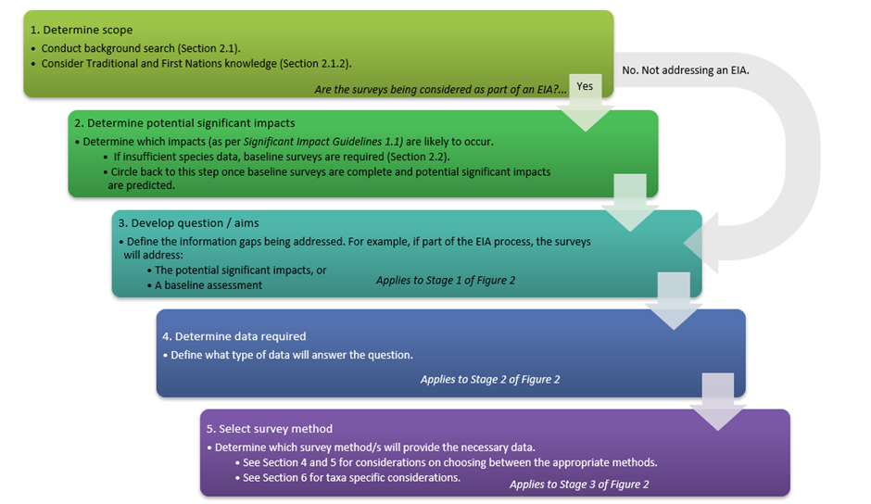
Figure 1 Overview of the process to determine whether surveys are appropriate, frame an appropriate question (aims), and the appropriate survey methods to address the aims
Once the relevant questions are identified, Figure 2 assists in identifying the most appropriate survey methods to use. This information is broken down into two matrices to reflect the different stages of the process. In the first matrix, Stage 1 is determining which significant impact is relevant (i.e. what aspect of the species population might the activity have an adverse effect on) which should inform the question(s) being asked. Stage 1 guides Stage 2 in the first matrix, which is determining the data required and the survey methods/techniques that can be used to obtain this data.
The second matrix starts from Stage 2 and guides Stage 3, which is determining the technique or method that can be used to collect the data required. In Stage 2, it should be noted that all techniques can provide data on abundance and presence, although those highlighted are the most appropriate techniques if abundance or presence are the only data required.
For example, in an EIA scenario where the proposed activities and information on marine species in the area determined by the background search indicate there is a risk of impact on the population size of a nationally listed marine mammal, ‘population size’ is listed in the Stage 1 section of Figure 2. Following along the ‘population size’ row, you will see that the only cell highlighted is under ‘abundance’ reflecting the data required (Stage 2) is abundance. In the second matrix, you will see ‘abundance’ listed under Stage 2 and following along that ‘abundance’ row you will see cells highlighted in every column. Therefore, the survey methods (Stage 3) that can provide abundance data are all types of aerial and vessel surveys, as well as land-based surveys and passive acoustic surveys.
In many cases, as in the example scenario, there is more than one type of survey that can provide the same data. Theoretical and pragmatic factors should be considered in determining which survey methods/techniques are the most appropriate for a particular scenario. Section 4 and Section 5 will further clarify which survey methods/techniques are likely to be the most appropriate and whether it is possible to obtain the data needed to answer the question by conducting those surveys. The descriptions of each survey method/technique include the advantages and disadvantages, appropriate spatial scale, expertise required and logistical and safety considerations for each survey type.
The most suitable method/technique for the target species will also need to be determined given not all methods are suitable for all taxa or species (Section 6). Multi-species surveys are discussed in Section 4.6. Considering the challenges in surveying each taxon, separate surveys for different taxa (e.g., cetaceans, marine turtles, and the dugong) may be needed to incorporate different methodologies for different species.
Conducting multiple survey methods will result in complementary data to determine the impact of an action; this approach is encouraged (for example, Marsh et al. 2015) (Section 4.6)
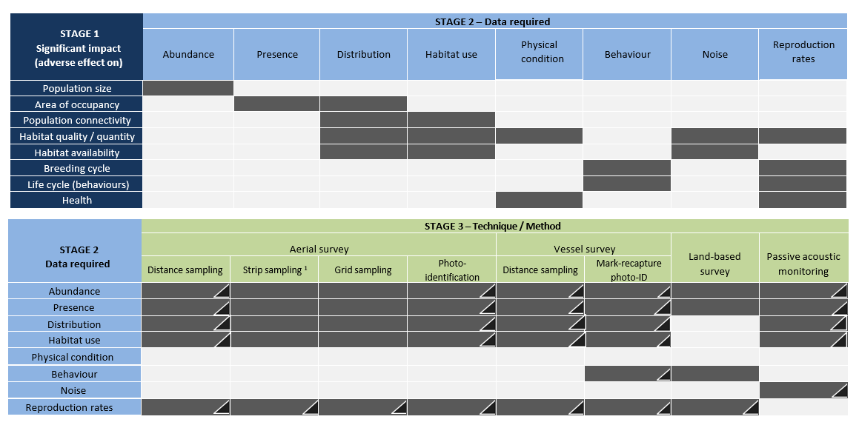
¹ Includes drone surveys.
Figure 2 Matrices outlining a two-step process to aid in determining appropriate survey methods according to the objectives.
The first matrix ascertains what data is needed to answer the question and the second matrix to ascertain what survey method/technique will provide those data. Black triangles indicate techniques least suitable for surveying turtles.

Planning and design of surveys
The objectives of the survey must be clearly stated and based on the questions that need to be answered. This process is outlined in Section 3. The following key points must be considered to choose the survey method(s) and plan and design the surveys. These considerations are discussed in the subsequent sections.
- Determine the most appropriate methods and survey design for maximising the probability of detecting the target species (Section 4.1). For example, consider:
  - What is the detectability of the species of interest?
  - Do the animals dive for long periods of time, or do they exhibit vessel attraction or avoidance?
  - What is known about area use of the target species for, e.g. reproduction, feeding, or migration?
  - Are the animals evenly clumped or patchily distributed throughout the area?
  - Will the survey design meet the assumptions of the survey method?
- Define the proposed survey area, species and population of interest for which parameters are to be estimated. The survey should not be restricted to the footprint of the project site. This should ensure the area represents the impact site (note this may be larger or smaller than the project site) and enough adjacent habitat appropriate to the species of interest to provide regional contextual information, which is particularly important for migratory species that have large-scale movements (Section 4.3).
- Account for seasonal variability and prevailing seasonal weather conditions by conducting surveys at different times of the year (Sections 4.3, 4.4).
- Consider the survey effort required to detect statistically significant change and the limitations in detecting changes in abundance (Sections 4.1, 4.2, 4.5).
- Account for detectability, uncertainty, and error (Sections 4.5, 5.1.2).
- Consider logistical and practical limitations associated with the survey methods and the resources (logistical and financial) required to collect and analyse the collected data. This includes meeting legislative requirements and any permit and animal ethics approvals (Section 4.7).
- Determine whether the survey is aimed at obtaining baseline data or is an adaptive monitoring program where the survey will be repeated during the construction / operational phases and who will conduct these ongoing surveys.
- Consider the design of the proposed project to ensure the methods can be repeated through time (e.g. wind turbine height and placement will need to be considered for aerial surveys and/or vessel-based transects for offshore renewable projects).
- Consider historical survey data and whether maintaining consistent methodology would be appropriate. If consistent methodology is not possible and/or appropriate, the alternate methodology must be justified.
- Have experienced subject matter experts conduct either the surveys or training of personnel and use experienced marine fauna observers that have been trained in the required survey technique (Section 4.8).
- Consult with a suitably qualified person(s) with demonstrated skill and experience in marine fauna surveys to design the surveys, or have survey designs independently reviewed by suitable subject matter experts (Section 4.9).

Detecting change
All species exhibit natural spatial and temporal variability in habitat use. In a biological and ecological context, natural variability is relatively unaffected by human activity, within a period of time and geographical area of interest (Landres et al. 1999). Consequently, there can be substantial variation in a species’ presence, abundance, distribution, and habitat use that occurs naturally within (intra-annual variation) and between (inter-annual variation) years.
This underlying natural variation may be a result of life cycle stage (e.g, adult, juvenile or calf/hatchling), biologically important behaviour (e.g. reproduction, migration, resting or foraging), social behaviour and structure, and/or changes to the animals’ environment, such as seasonal variation in resources or water temperatures. These variations can be further complicated by other environmental changes caused by extreme climate events, or the long-term impacts of climate change, that are unlikely to be detected over short time scales (e.g. with only one year of data). Consequently, cumulative natural influences will affect how, where, and when a species uses their environment which affects a species presence, distribution and abundance and can influence survey results.
A challenge of conducting surveys within the EIA process and monitoring for adaptive management purposes is the ability to accurately describe the species present and detecting impacts from a project while accounting for natural underlying variation (Groom et al. 2018). The ability to sample the ‘normal’ state of a species, which constitutes the baseline data, is diminished if surveys are conducted for only one year or one season. The baseline data may represent an ‘aberrant’ year/season that is not reflective of the normal state of the species or of the natural variation in habitat use throughout the year. For example, if the survey does not capture the time of year that animals are using an area, is conducted during/post an extreme weather event (e.g. marine heatwave or flooding), or only captures a subset of the cohort of animals using the area, such as migratory species with a breeding cycle that spans multiple years (e.g. southern right whales), the survey would not be representative of the normal state of a species in the area. If the baseline data do not capture natural variation, assessments about the baseline status of the population may be inaccurate. Once the planned activity starts, changes detected in the population may result in misleading conclusions regarding impacts.
Baseline surveys should be conducted across different natural cycles such as seasons, currents and tides, particularly for coastal species, and over multiple years to identify inter- and intra-annual variations in presence, abundance, distribution and habitat use. It is important to acknowledge that it is generally very difficult to detect change, particularly precipitous change, in marine mammal and marine turtle populations over relatively short periods of time (i.e. over a few years, as opposed to over decades) and without substantial survey effort (Taylor et al. 2007, Tyne et al. 2016, Symons et al. 2018). To determine long-term population trends, the statistical power needed to detect trends must be considered, and in many cases may require greater than ten years of monitoring (White 2019).
If the aim of the surveys is to detect change, then the survey program must provide data that will allow for a trend to be detected with sufficient statistical power. The survey intensity and frequency must also be adequate, including conducting the surveys over multiple years (Section 4.4). It should be acknowledged that for small, local populations, it may be impossible to achieve adequate statistical power to detect change.

Given that it is generally impossible to use survey methods to census entire populations of marine mammals (i.e. cetaceans and the dugong) and marine turtles, unbiased and representative ‘sampling’ surveys are undertaken to derive estimates of the parameter(s) of interest. The basic aim of the sampling design for any survey should be to obtain the data required to achieve statistically valid estimates.
Sampling intensity is related to survey effort, which is determined by survey design. For line transect surveys, for example, the sampling intensity is determined by the spacing between the transects and the strip width. The accuracy and precision of population estimates, and the ability to detect trends, is largely dependent on sample size and sampling intensity. Further components requiring consideration include the interval between surveys, the number of surveys included in the time series, the length of time series, and the magnitude of change to be detected (Ferreira and van Aarde 2009). Buckland et al. (2001) provide some guidance on survey design and the sample sizes required to provide robust population estimates.
If the expected animal densities within the survey area are heterogeneous (i.e. the density varies across the area of interest), it can be more statistically efficient to stratify the area (divide the area into smaller strata). This enables more effort (higher sampling intensity) to be invested into high-density areas or focal habitats, rather than low-density areas or less important habitat areas. If using design-based statistical analysis techniques rather than model-based (Section 5.6), it is important to ensure that the expected density of animals within your survey stratum are as homogeneous as possible (Caughley 1977). Each stratum then becomes a factor within a model to estimate population abundance, with effort as a variable.

Spatial considerations
Cetaceans, marine turtles, and the dugong are highly mobile marine species. Consequently, survey and monitoring programs need to consider the spatial and temporal scales that these species can range across. For example, some dolphin species may inhabit small areas and exhibit small home ranges (tens of kms), as do marine turtles during certain stages of their life cycle. Whales and marine turtles can be highly migratory (thousands of kms) and occur over large spatial scales and utilise different areas during different seasons or life stages.
The spatial extent of surveys should consider the predicted extent of impacts from a proposed action (impact site), which often extend beyond the construction and operational footprint of a specific project site (i.e. underwater anthropogenic noise). At a minimum, surveys must cover the predicted extent of the impact. Surveying beyond the impact site can provide contextual information and the potential to determine whether any detected changes in the species abundance, distribution, or habitat can be attributed to development activities, or whether they are consistent with natural variability in processes (e.g. immigration/emigration) and subsequent use of the area (Brooks et al. 2017).
When designating the survey area, the spatial scale of the movements of the species of interest should be considered. If Habitat Critical to the Survival (HCTS), BIAs and core habitat are adjacent to the impact area and there is a plausible link between the proposed action and impacts to species, these areas should be included in the overall survey area.
Proponents may choose to survey a reference or control site that is not affected by the activities such as a site that encompasses habitat that is not connected to the habitat within the impacted site. Any reference or control site surveyed needs to be at least equal to or greater in size to the impact site, and contain similar habitat, to ensure appropriate comparison of the species use of the areas. This approach may not be feasible where impacts occur over a large spatial extent.
Expert advice should be sought on the appropriate size and coverage of the survey area. Other spatial considerations in defining the study area include:
- biological relevance of the area for the population and species of interest (e.g. the interaction and intersection of the area with the migratory pathways)
- defining the ‘population’ to which abundance and/or other demographic and ecological factors are referred to (Thomas & Kunin 1999, Hammond et al. 2021b)
- whether the area can be adequately surveyed within the required time frame.

Temporal considerations – multiple seasons and multiple years
Many species exhibit seasonal changes in their distribution, abundance and habitat use. An example is the migratory behaviour of large whales such as the humpback whale and southern right whale that occur along the Australian coastline during the autumn, winter and spring months. Other species have smaller movement patterns. For example, the dugong in some parts of their range (particularly in the higher latitudes) utilise different areas of the same bay in summer versus winter. Reviewing historical knowledge and data may determine seasonal variability and ensure that surveys are conducted during seasons in which the species occur, particularly when there is a peak in abundance.
Baseline surveys should be conducted throughout all seasons if seasonal variation is suspected to influence a species distribution, abundance and/or habitat use. This will enable accounting for intra-annual or inter-seasonal variation.
The number of years of survey effort required depends on the scale of the project and species biology, habitat use and species distribution. For example, a project with small spatial scale and short-term impact (e.g. one year of construction and limited ongoing impact) will require a two-year survey program (minimum) to establish the status of populations at that point in time. However, a large spatial scale and/or long-term impact will require more than two years of baseline data to ensure that natural inter-annual variability is documented to better determine potential significant impacts and provide adequate data for monitoring programs to detect change (Sections 4.1, 4.2). Ensuring that a survey program covers multiple years is critical for establishing the baseline status of a species and to determine habitat use within an area.

Weather conditions and the quality of survey data
A constraint common to all visual survey methods regardless of the platform, and most other methods (e.g. passive acoustic monitoring (PAM)), is the need for surveys to be conducted in good weather conditions. What constitutes ‘good weather’ depends on the method, although low wind speeds, good visibility, low sea state, and minimal cloud cover would be desirable for most methods. The detection of animals is substantially affected by adverse weather conditions (e.g. high Beaufort Sea State (BSS) (Barlow 2015)) that can often obscure the most common cues (e.g. spray from exhalations such as blows, body breaking the surface of the water, or even vocalisations) and result in a decrease in the quality of the survey data. Some small species that have low surfacing profiles are particularly difficult to visually detect during adverse conditions, resulting in particularly restrictive weather constraints.
The quality of survey data should not be compromised by being undertaken in poor weather conditions. Surveys should be planned and undertaken in the best possible weather conditions to ensure high quality data.
It may be possible to plan for the survey to be conducted during the time of year where appropriate weather is likely. However, this time of year may not correspond to when the animals are present or in highest densities or answer any question(s) regarding seasonality. In any case, a survey plan must factor in a suitable proportion of adverse weather days (‘grounded’ days). A commonly used guide is to assume two grounded days for every field day required to complete a survey, but this will be dependent on location. The survey may subsequently be completed in less time, in the case of consistent good weather, but having grounded days factored into planning and budget is essential.

Effort, bias, precision, and uncertainty
To minimise the risk of false negatives (i.e. animals that are present but not detected) and underestimating the number of animals present in an area, surveys should be conducted at an adequate sampling intensity and be replicated within the area of interest. That is, a survey should be conducted multiple times in a row and/or at variable temporal scales (low/high tide, at different seasons). The frequency at which surveys are undertaken will also depend on the research question and the requirement of the analytical approach used.
Estimates of absolute abundance (or density) are extrapolated from counts of individuals using statistical models that incorporate correction factors to account for the portion of the population that is not detected during a survey (Hammond et al. 2021a). Inherent in these models are assumptions about the accuracy and representativeness of the sample data (raw counts), which if not met, can result in incorrect estimates. It is best practice to provide measure(s) of precision with estimates of abundance to enable an assessment of their validity, in addition to a comprehensive description of the assumptions/supporting data used at each analysis step (Hammond et al. 2021a).

Multiple survey methods and multi-species surveys
It may be appropriate to implement multiple survey methods during the one survey period. Using more than one complimentary survey method can increase the value and amount of data collected to provide the most comprehensive information. For example, visual vessel surveys and acoustic surveys are complimentary survey methods that can provide complementary data to address the same question. The two survey methods can be conducted from the same survey platform (e.g. a vessel with visual observer team and towed acoustic array) or can be implemented separate to each other (e.g. a vessel with visual observer team and hydrophones in fixed locations deployed throughout the study area).
Surveys can also be designed to detect multiple species, and this must be considered in the survey planning and design stages, given statistical methods often have inherent assumptions that are unlikely to be met when surveys have not been designed appropriately. Most commonly, surveys are designed for one priority species (the target species) and other species are recorded opportunistically. If the question requires surveys of multiple species the survey design should prioritise the species that is most difficult to detect (e.g. smallest morphologically, lowest density, most cryptic), which should ensure that the other species will also be detected. However, it is important to recognise that one survey method may not be suited to all target species (Section 6).
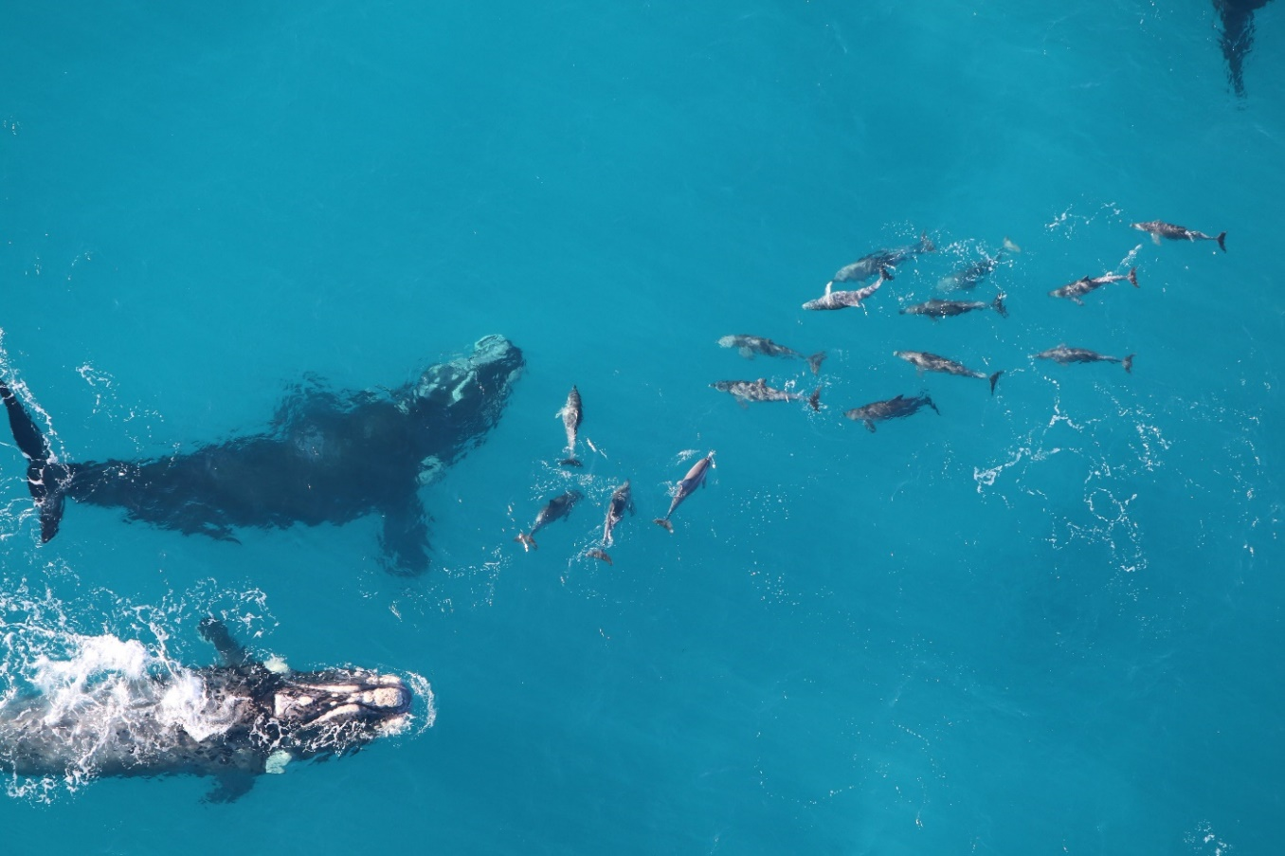
Figure 3 Aerial photo of southern right whales (Eubalaena australis) and bottlenose dolphins (Tursiops sp.)
© Joshua Smith

Generally, within a survey method (i.e. aerial surveys) only one sampling method (i.e. distance sampling) should be used during any one survey to ensure that the assumptions for that method are met and valid statistical analyses are possible. For example, if conducting aerial surveys, you should only do distance sampling or strip transect sampling and not both. It is not currently feasible to do one method for one species, and a second method for a second species, during one aerial survey using traditional survey methods.
The reliability of multi-species surveys can be improved by using high definition video/photographic records and/or digital recordings to provide a permanent record and verification of species sightings. This can include aerial photography on-board occupied aircraft (e.g. alongside observers) (Lamprey et al. 2020) or cameras mounted on drones or vessels (Section 5.5.1). Using photography can improve detection rates, but also the reliability of species identification, particularly where morphologically similar species are sympatric (Dunshea et al. 2020). However, the aerial imaging system specifications, coverage, aircraft flight protocols, likely detection probability, and image processing methods, should all be carefully considered prior to using this technique (Section 5.5.1).

Permits and animal ethic approvals
Throughout Commonwealth, state and territory waters a range of permits and authorisations are required to conduct surveys of cetaceans, marine turtles and the dugong. Under Part 13 of the EPBC Act the Minister for the Environment and Water may issue permits for research activities or activities that may incidentally interfere with cetaceans in Commonwealth waters (i.e. from the 3 nm state water limit) that include for example, vessel-based and drone surveys that require a closer approach to a cetacean than that specified under the EPBC Regulations. Separate regulatory obligations apply in each state and territory jurisdiction.
In the case of the Great Barrier Reef Marine Park, a joint permit can be issued if the proposed activities occur within both the Commonwealth Great Barrier Reef Marine Park and State of Queensland Great Barrier Reef Coast Marine Park. Queensland State Government will deal independently with any applications relating only to the Great Barrier Reef Coast Marine Park. In AMPs the DNP may issue permits for research and monitoring activities relating to cetaceans, marine turtles and dugongs under section 359B(2) of the EPBC Act.
For activities that involve the collection of biological resource samples for the purposes of genetic testing (including water samples), a biological resources permit under Part 8A of the EPBC Regulations is required.
A range of permits and authorisations may be required to conduct surveys and obtaining permits can take weeks to months, so adequate time is needed to allow for this process.
Permit applications must provide enough information about the proposed activity to allow regulatory agencies to assess potential impacts and determine the most appropriate risk management measures. All permit conditions must be adhered to by all personnel conducting the surveys, which may include specified approach distances to cetaceans, marine turtles and the dugong by vessels, aircraft (including drones). Table 1 provides an overview of where to find further information on government permitting and authorisation requirements.
There may also be other licencing requirements, such as vessel skipper tickets and drone pilot licences, and these additional regulatory requirements need to be considered when planning surveys.
In addition to government issued permits, surveys of cetaceans, marine turtles and the dugong may require an animal ethics approval under the relevant state or territory jurisdictional regulations. It is recommended that animal ethics approval is requested from an appropriate ethics committee (e.g. within a university, relevant state department or CSIRO), and note that the time required to obtain ethics permits depends on the timing of the relevant committee’s regular meeting schedule.
Table 1 Permit information for Commonwealth, State and Territory jurisdictions

Jurisdiction | Body | Contact
Commonwealth | Australian Antarctic Division | Contact  Antarctic Environmental Approvals
Commonwealth | Biological Resources | Contact the Biological Resources Team
Commonwealth | Department of Climate Change, Energy, the Environment and Water (DCCEEW) - Commonwealth waters | Contact the DCCEEW EPBC Permit Team for Part 13 permit applications and enquiries
Commonwealth | Great Barrier Reef Marine Park Authority (GBRMPA) | Contact the GBRMPA Assessments Team
Commonwealth | Parks Australia (PA) | Contact the PA Marine Parks Assessments and Authorisations Team
New South Wales | Department of Planning and Environment (DPE) | Contact the DPE Wildlife Team
Northern Territory | Department of Environment, Parks and Wildlife Security (DEPWS) | Contact the DEPWS Permit Team
Queensland | Department of Environment and Science (DES) | Contact the DES Permit and Licence Management Team
South Australia | Department for Environment and Water (DEW) | Contact the DEW Fauna Permit Unit
Tasmania | Department of Natural Resources and Environment (DNRE) | Contact the DNRE Wildlife Services Team
Victoria | Department of Energy, Environment and Climate Action (DEECA) | Contact the DEECA Conservation Regulator
Western Australia | Department of Biodiversity, Conservation and Attractions (DBCA) | Contact the DBCA Wildlife Licensing Section

Observer requirements and expertise
In all surveys, data quality is reliant on the experience and training of the observers. It is not possible to correct for systematic observer error, or false negatives (i.e. an observer fails to record an animal that is present), or in many cases false positives (i.e. where an observer records an animal that is not there or misidentifies an animal). Where possible, observers should have demonstrated prior experience in conducting the survey method being used and identifying the target species, and constitute the majority, if not all, of the survey team. If this is not possible, training should be conducted by personnel experienced in the survey methodology, including both theoretical (on the ground) and field (e.g. in the aircraft, on the vessel or from land) training. Experienced personnel must train any new observers in species identification and behaviour and ensure they are capable of making accurate identifications and observations of species in Australian waters.
Even when experienced observers are used, it is strongly recommended that prior to undertaking surveys, time is budgeted for initial training (e.g. training flights or time on a vessel) to enable ‘re-familiarisation’ of survey methods being used and species likely to be encountered. For example, training transects should be conducted at the start of the survey to allow observers to familiarise detection of species relative to the survey platform, test equipment and ensure that the survey protocol is well understood by all members of the team, including the pilot or vessel skipper. The data from the training transects would not be used as part of the actual survey effort.
There are also technical solutions to augment data collected by observers to enhance data quality. High-definition video/photography or digital acoustic recordings can provide a permanent record of the detection of sightings, cues, and/or vocalisations. These technical measures can be used to verify observer data or can be used to collect the observations in place of real-time observers. However, if used to replace observers it is critical to understand and demonstrate through justification of the survey approach the implications of collecting digital data on the probability of detecting the target species (Section 5.5.1).

Independent review of survey plan
It is highly recommended that once a survey has been designed, it is independently reviewed by a subject matter expert prior to the commencement of the surveys (Groom et al. 2018). The expert should be familiar with the species being surveyed and have a sound understanding of the Australian environmental regulatory frameworks, and potential limitations of conducting marine fauna surveys in Australian waters (e.g. the environmental conditions the species are likely to be surveyed in).
It is critical that when an independent review of a survey plan and design is undertaken, that the reviewer understands the objectives of the survey (the questions being asked) to assess whether the survey program will meet these objectives.
Obtaining an independent external peer review may save valuable time and money by ensuring that the survey program is robust, defendable, meets best practice standards, and will provide the desired outputs to inform an assessment of potential impacts to cetaceans, marine turtles and/or the dugong.

Survey techniques and methods
Outlined for each survey technique are the types of questions and data collection techniques that the method can address, a description of the method according to current best practice, the advantages and limitations, survey effort required, and level of precision and uncertainty involved.
The described techniques for monitoring cetaceans, marine turtles, and the dugong involve real-time visual observations either from aircraft, vessel, land, or via acoustic recording, to obtain both population (e.g. abundance estimates, distribution) and individual based (e.g. behaviour, habitat use) information. Further references are provided where appropriate for users to access more detailed information.
A guide to the different levels of expertise and training required for each survey method is given in Table 2. For each expertise level, an indication of required training and experience is provided, acknowledging that training and experience may be acquired in different ways.
Table 2 Expertise key outlining the level of knowledge and training required for the role the person will be fulfilling
Expertise level | Definition
Low | No formal educational background and little demonstrated understanding of marine ecology/biology necessary.  No prior experience but requires training in the targeted role.
Medium | Some educational science background (e.g. tertiary education in the field of science) or demonstrated understanding in marine ecology/biology usually required depending on experience.  Is trained and experienced in the targeted role.
High | Higher educational science background (e.g. postgraduate degree in the field of science) and demonstrated understanding in marine ecology/biology to inform survey design and statistical analyses of survey data.  Expert in the targeted field (e.g. has many years of experience and/or has published in the field).

Aerial surveys
Aerial surveys are commonly used to obtain information on distribution, abundance or density, and habitat use for cetaceans and the dugong and have been used to assess marine turtles. These are commonly conducted by sampling along defined transect lines and can use distance sampling (which includes line-transect sampling), strip sampling or less commonly grid sampling. Aerial surveys can provide information regarding:
- area of occupancy or distribution
- abundance within the survey area
- reproductive rates of mammals (calf counts)
- insights on large population (> 100 animals) trends over the long term (> a decade) if conducted frequently and over an appropriate spatial scale
- spatially explicit density within the survey area, including hotspots (areas where animals occur in high densities)
- ecology of target species, by enabling correlation of sightings data with prey data, physical oceanographic data, and remotely sensed environmental data.
This section includes the techniques and methods of ‘observer’ aerial surveys, i.e. aerial surveys conducted in an occupied (piloted) aircraft with observers onboard recording sightings (Figure 4). Methods for conducting ‘imagery’ aerial surveys, i.e. capturing aerial photography from either occupied aircraft or drones, are considered rapidly emerging and are discussed in Section 5.5.1. Aerial imagery surveys can be used to augment occupied aerial surveys to assess the application of imagery only aerial surveys as a standalone method, including necessary statistical considerations (e.g. correction factors).

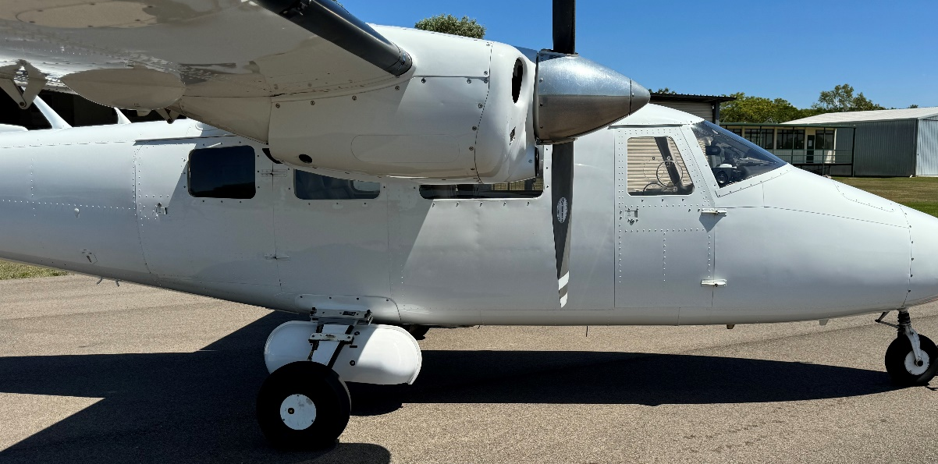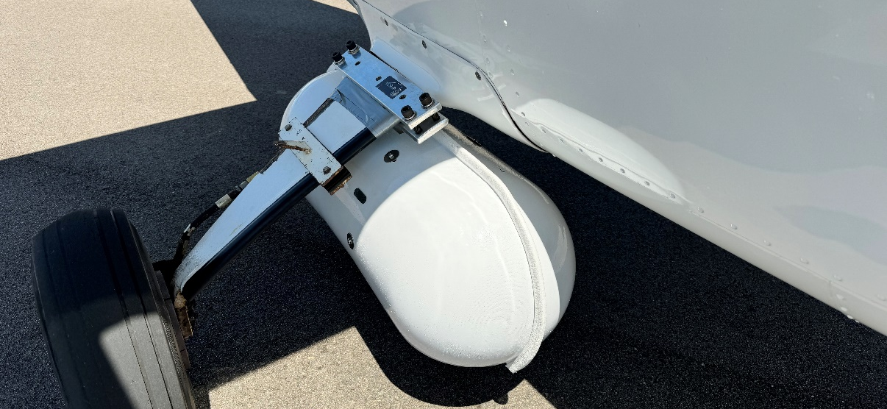
Figure 4 Manned aircraft with camera pods attached for aerial imagery
© AeroGlobe Spatial Science

Advantages and limitations
The main advantages of undertaking dedicated observer aerial surveys are:
- They are an economical approach to obtaining representative coverage of large spatial areas (> 100 km²) over relatively short time periods.
- They provide a ‘snapshot’ in time of the distribution and abundance of a species.
- The high vantage point (high altitude) can allow animals to be easily detected. This depends on the location and target species (e.g. depth of water, turbidity and nature of the species).
- They facilitate additional research such as photo identification (e.g. southern right whale).
The limitations of dedicated observer aerial surveys are:
- They may have limited capacity to detect changes in abundance and distribution with high precision.
Unless aerial surveys are replicated over long time scales, or changes in abundance are very large, abundance estimates may not provide enough precision to detect precipitous change. Even if changes in abundance are detected, they may be due to temporary movements/immigration or emigration movements, which may not be clearly understood unless the spatial coverage and frequency and time scale of the survey are appropriate to capture these changes. For example, dugong abundance and distribution are very sensitive to changes in their seagrass habitat, which tend to have multiple causes, and can cause dugong numbers to fluctuate in areas. Survey regimes need to be developed with an understanding of these limitations (Sections 4.2, 4.3).
- They have a lower probability of detection over smaller areas compared to other survey methods (e.g. vessel-based surveys).
The necessary high speed of the aircraft limits the amount of time a given area is within the observer’s view (known as the ‘observation window’), potentially reducing the precision in estimates. The high speed of the aircraft will result in a proportion of undetected animals, which will need to be addressed using correction factors (Section 5.1.2). It is particularly difficult to detect:
  - darker coloured species in deep water (e.g. southern right whale)
  - offshore/deep-diving cetacean species that have long dive times (e.g. sperm whales)
  - species occurring in low densities.
The probability of these species being detected at the surface is very low. Even though correction factors can be estimated and accounted for to some extent, relying on large corrections for animals with a low probability of detection can lead to (a) large errors in abundance estimates with larger confidence intervals (Hodgson et al. 2017), and (b) distribution being under-estimated or misrepresented. Alternatively, detection rates may be too low to obtain abundance estimates.
- They may incur a relatively high occupational, health and safety risk.
Flying a team of observers in a small aircraft at low altitude and low speed is relatively high risk and therefore occupational, health and safety is paramount (Section 5.1.5). Typically, the risk is higher when conducting offshore aerial surveys where access to landing areas is not possible, therefore twin-engine aircraft should be a minimum safety requirement. In some cases, the aerial surveys may be precluded by survey areas further offshore or a long distance from airports that push the aircraft’s endurance to near safety margins (i.e. fuel reserves).

Detection probability
Two main components that contribute to the detectability of animals are availability bias and perception bias (Marsh & Sinclair 1989, Pollock et al. 2006). Availability bias occurs when an animal has not been seen by an observer because it is unavailable (e.g. animal is deeper than the visible layer of the water column), and perception bias occurs when animals are available to be seen but are missed by an observer.

Availability bias
Availability bias has two components: the animal’s diving behaviour and the environmental conditions such as water turbidity (Pollock et al. 2006). Diving behaviour can be affected by numerous factors such as water depth (Hagihara et al. 2018), group composition (e.g. whether a calf is present) (Hodgson et al. 2017), and behavioural state (Dorsey et al. 1989). Various methods have been used, and experiments conducted, to estimate the availability of different marine mammal species in various environments and from different platforms (summarised in Hodgson et al. 2017, see also Laake et al. 1997, Slooten et al. 2002, Thomson et al. 2013, Hagihara et al. 2018, Sucunza et al. 2018, Parra et al. 2021 and Brown et al. 2022 for examples). Environmental data must be collected regularly during the survey and for each sighting to apply these corrections. These data include but are not limited to, BSS, glare (reflective and sun glitter), water visibility, air visibility (e.g. haze or smoke) and cloud cover.

Perception bias
Perception bias is estimated by comparing tandem observers or teams, each observing the same survey area, to measure relative success of sighting capture (dual platform surveys). An example is having two independent observers or teams (visually and acoustically isolated) either on the same side of an aircraft front and rear, or on adjacent headlands, and using a capture-recapture method (Pollock et al. 2006). The first observer/team ‘captures’ the animal as the initial detection, and detection by the second observer/team ‘recaptures’ the animal. This double-observer technique also maximises detection probability as the probability of the observer/team duo detecting an animal is greater than one. The double-observer technique is therefore recommended as best practice.

Detection probability ratios
Detection probability might be estimated using a census of a sub-set of the target population and extrapolating this estimate to the entire population. The following examples might be useful to understand the use of detection probability ratios:
- Land-based observations to census humpback whales migrating through a survey area can be combined with drone survey imagery to estimate detection probability, using the ratio of whales detected by the drone against the census count (Hodgson et al. 2017).
- Detection probability of marine turtles may be estimated by either marking turtles on land, for example on a beach adjacent to the survey area, or by marking captured turtles, prior to aerial (drone) surveys (Stokes et al. 2023). The detection probability would be the ratio of marked turtles sighted during a survey of in-water turtles, compared to unmarked turtles (Dunstan et al. 2020, Stokes et al. 2023). However, this method assumes that the detection of marked and unmarked turtles is equal, which may not be true (Stokes et al. 2023).
These methods assume that the population is ‘closed’ (no animals leave the survey area) between the first census or marking occasion and the subsequent census, and both are limited spatially to small-scale surveys. This assumption can be tested using techniques such as satellite tagging (Stokes et al. 2023).
The use of detection probability ratios should always consider the risk for environmental covariates to affect detection from different platforms (i.e. aerial, vessel and land) (Hodgson et al. 2017).

Spatial scale
Observer aerial surveys provide information over medium to large spatial scales (tens to hundreds km²). Observer aerial surveys are therefore appropriate for assessments along relatively large areas of coastline or offshore or across whole bays. Surveys at these scales are recommended for providing regional context to local surveys.

Expertise
A high level (Table 2) of expertise is required to undertake aerial survey design and oversee implementation. Aerial survey coordinators should demonstrate an understanding in aerial survey design, survey planning, observer and safety protocols, and data statistical analysis. Personnel with a medium level of expertise are required for leading field teams.
Experienced and/or trained personnel familiar with the species of interest and methodology should be employed as observers to maximise data accuracy (e.g. species identification and distance measurements to animals). It is highly recommended that inexperienced observers are provided with training and paired with experienced observers. An experienced data analyst should also be consulted or contracted.

Logistical, safety and scientific considerations
Proponents should consider the following list as a minimum to ensure safe, well organised surveys that provide robust, standardised, and unbiased data:
- Develop a standardised protocol prior to beginning the survey to reduce biases in the data. For example, clearly specify altitude, air speed, transect position and direction, timing, frequency of survey, weather conditions under which to fly or not, and survey team. Ensure these protocols are followed throughout the survey and are consistent with best-practice and peer-reviewed literature.
- Conduct the surveys when glare and wind are minimal to reduce the risk of missing a sighting. For example, surveys could be conducted during the mid-morning or mid-afternoon when the glare is low, and when the wind is less than 10 kts. Glare should also be minimised by flying the transect in an east-west direction where possible and by avoiding following environmental gradients.
- Reduce the risks of pilot and/or observer fatigue and heat stress/dehydration by not flying more than three consecutive hours at a time and by inserting breaks into long transects (e.g. transects that take more than 30 mins). Note that for local scale survey of coastal species, timing of tides should be considered. Should the whole survey not be able to be completed in one session the survey should be conducted across multiple days with tide height remaining as consistent as possible.
- Where possible, maintain the same survey team throughout the entire survey period (i.e. defined period over which consecutive surveys are undertaken to address the survey objective) to minimise variation in performance and perception bias.
- Use a reliable twin-engine, high-wing aircraft with bubble windows and seating that allows observers to be in close proximity to each other for calculating perception bias. Ensure access to a runway and aviation fuel (which may need to be sourced and shipped to remote locations). In particularly remote locations, it may be advisable to use a twin-turbine aircraft to reduce risk. If using twin-turbine aircraft, the most important requirement is that it is a high-wing aircraft which enables observers to have an unobstructed view to animals in the water.
- If wanting to conduct photo-identification, the aircraft should have at least one opening window.
- Ensure that all modifications to the aircraft (e.g. installation of transect markers (Figure 5) or cameras (Figure 4)), are conducted by a licensed engineer. Note that engineering orders are required for such modifications, which might be a lengthy process.
- Engage air charter companies well before starting the surveys, to plan and ensure aircraft availability. Aircraft charter companies will determine if the area is in controlled airspace or a recognised defence area and will ensure the aircraft is regularly maintained.
- Employ a pilot with a minimum of 500 hours flying experience. Where possible, pilots need to be experienced in flying straight line transects, flying at low altitude and conducting tight turns without losing altitude. Training is recommended for inexperienced pilots to ensure flight paths are accurate. Pilots also need to be aware of observer comfort (e.g. not changing heading (banking) too steeply or too fast).
- Use recommended safety equipment including life jackets and life rafts, Emergency Position Indicating Radio Beacons (EPIRBs), satellite phones and appropriate communications equipment. These may need to be hired separately if not provided by an air charter company.
- Have the survey team undertake a helicopter underwater escape training course (HUET).
- Ensure that the survey team is trained and familiar with emergency procedures.
The safety considerations listed above are a minimum requirement for conducting aerial observer surveys. Different charter companies and industry groups adhere to different standards. This safety list is not exhaustive and charter companies should be consulted well ahead of surveys to determine the appropriateness of the aircrafts, safety equipment, flight plans and protocols.
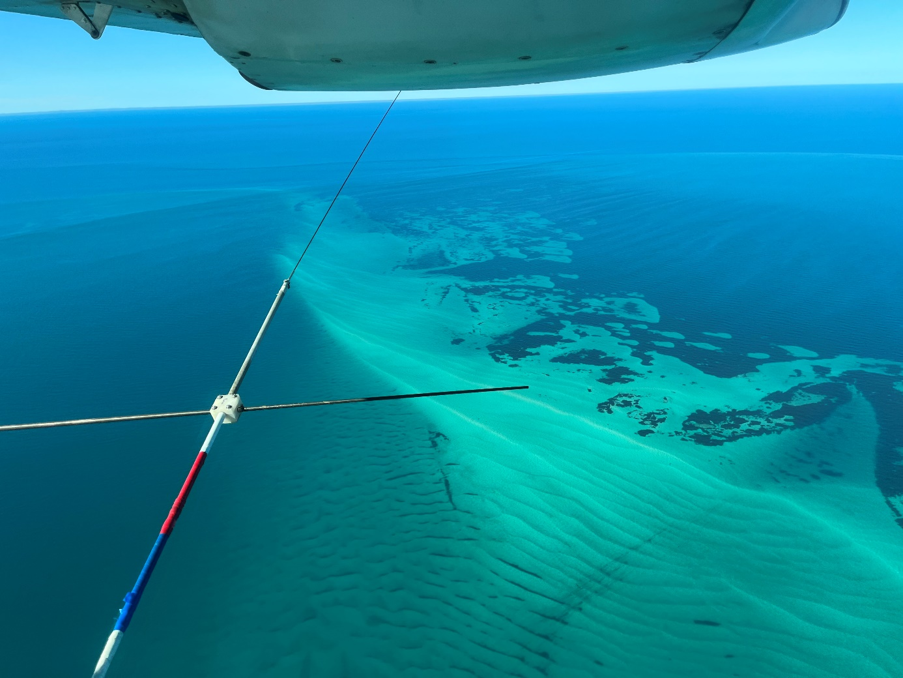
Figure 5 Transect marker attached to an aircraft for aerial surveys
© Holly Raudino

Sampling methods

Distance sampling (line-transect sampling)
Distance sampling (otherwise referred to here as line-transect sampling) is the most used aerial survey technique for estimating the abundance and density of species.
This technique is particularly appropriate for large species, such as whales, that can be seen at distance or for low density or rare species, as large areas can be covered.
The key data collected are the perpendicular distances of the animals or groups from the transect line out to the horizon, or to a distance that observers can reasonably observe (Buckland et al. 2015).
These distances are used to estimate a detection function, which is the probability of detecting an animal according to its distance from the transect line. The recorded distances of all the animals detected, along with the detection function, are used to estimate the density of the target animals in the survey area, and this density is then used to estimate abundance.

The four major assumptions made when undertaking distance sampling are:
- Animals are distributed independently of, and randomly relative to, the transect lines (also referred to as tracklines).
- All animals on the transect line are detected with certainty.
- Distance measurements are exact.
- Animals are detected at their initial location, i.e. do not react to the aircraft before observers have had time to detect them.
The first assumption (i.e. independent distribution to transect lines) relates to the survey design. To ensure that the survey design does not bias the data (either to areas of high or low abundance) you should:
- Place a series of systematically spaced parallel or zig-zag lines with a random start point (Thomas et al. 2010).
- Ensure that the direction of the lines is perpendicular to environmental gradients with which animal densities are potentially correlated (e.g. perpendicular to the coastline to ensure they do not follow along a particular bathymetry).
Surveys can be designed using the publicly available Distance software which allows the user to import their area of interest and specify their sampling intensity and other design parameters.
Observation technique
During distance sampling, observers are asked to record all focal animals visible from the transect line (straight down from the aircraft) out to a distance at which a species can be reliably identified. In most cases, observers tend to search too far out at the expense of seeing animals close to the line. Training must stress the importance of not missing animals.
The fundamental aim of distance sampling is to obtain accurate data, and protocols should prioritise effort closer to the transect line to ensure that animals on the line are not missed.
Distance sampling is applied with the acknowledgment that even with bubble windows, there will be a narrow strip directly beneath the aircraft that cannot be observed (unless floor windows are installed). Observers should be made aware that there is a narrower observation window (time available to sight an animal) for those animals occurring close to the transect line compared to those at distance because of the high observation angle (i.e. observing at steep angles straight down close to transect line. Hence, training on how to scan the survey area is important, and protocols should be employed that train observers to utilise search methods than ensure animals are not missed (e.g. figure eight eye scans).
Surveys may be conducted in “passing mode” or “closing mode”, which typically depend on whether group size and species can be accurately determined from the transect line. In passing mode, the aircraft does not divert from the transect line to investigate detected groups of animals; when animals are sighted a waypoint is recorded (via a timestamped audio recording that can be matched to the aircraft’s track). A vertical angle is then taken with a clinometer to enable post-calculation of the animals’ position (distance from transect line). In closing mode, when a group of animals is detected, searching effort is suspended and the group is circled overhead by the aircraft.
The additional time spent observing the animals provides more accurate species identification and group size estimation. Taking photographs while circling the animal(s) may help with this. Surveys conducted in passing mode maximise searching time, but may be subject to greater error in species identification and group size estimation than surveys conducted in closing mode. Alternatively, survey effort undertaken in closing mode can spend disproportionately more time in areas with higher densities of animals (due to time taken to break away from the transect to investigate detections), which may bias results. Therefore, the suitability of each technique depends on several factors:
- Passing mode – suitable for species that can be reliably identified and that occur in relatively small groups (< 10 animals). It is also recommended for species that surface cryptically or briefly, and therefore are unlikely to be re-sighted if circling.
- Closing mode – recommended for species that are difficult to discern, particularly where species with similar morphological characteristics occur in the same area (e.g. similar dolphin species or dolphins and the dugong). Suited to species occurring in large groups or aggregations to allow the best attempt to estimate group size. However, may be difficult in high density areas where the number of sightings becomes too high to feasibly keep track of each group sighted.

Strip sampling
Strip sampling follows the same principles as distance sampling, except observers are asked to record all sightings within a strip of defined width on each side of the transect line. It is then assumed that all animals are detected with equal probability across the survey strips. This method differs from distance sampling in that only sightings within the strip are recorded (rather than all sightings). It is important to be aware of, and make explicit, the assumptions of this survey technique. Violating these assumptions, by for example, having a poorly defined (marked) transect strip, or a strip that is too wide to assume constant detection probability, or having observers be distracted by recording animals a long way outside the strip, may mean that any resulting inferences from the data are misleading.
Strip sampling has been well developed for dugongs as described in Pollock et al. (2006) and Hagihara et al. (2014, 2018). It is an appropriate method for dugongs and marine turtles because they surface relatively cryptically, prohibiting reliable distance measurements, and are difficult to detect at distance. They spend very little time at the surface, and so getting reliable distance measurements of surfacing animals while in a passing plane is almost impossible.
Observation technique:
To meet the assumption of equal probability of detection of all animals within the survey strip, it is essential that observers are continuously looking at the survey strip, and that they continuously scan the entire width of the strip.
For dugong surveys in Australia, the strips commonly cover a ground distance of 200 m width either side of the plane (when flying at 500 ft, or 152 m) and are demarked using pseudo wing struts. It is important to note that even if using aircraft with bubble windows, there will be a strip of water directly below the aircraft that is not visible to the observers. The width of this ‘blind’ strip needs to be known to determine the total width of the area being covered by each transect (i.e. the blind strip plus the strips on either side of the aircraft), to then determine an appropriate transect spacing that avoids double-counting animals.
In some instances, the strips have been marked on the plane windows, however this relies on ensuring that observers have a constant eye height because with this method, minor changes in eye height project large differences in the area on water being observed. Maintaining constant eye height is challenging as observers often change the way they sit in the seat, and thus their projected strip constantly changes and will not necessarily match that of their tandem observer. Markers on the outside of the aircraft minimise the effect of this variation in eye height.

Grid sampling
A grid sampling approach is a relatively new application for surveying dugong and has been deployed on small (< 10s km²) spatial scales using drones (Cleguer et al. 2021) and medium sized (10s-100s km²) spatial scales using manned aircraft. The latter has been applied to Florida manatees using large scale observer aerial surveys (Martin et al. 2015). Grid sampling is conducted by overlaying a grid of identically shaped and sized cells on the survey area and randomly selecting cells to survey. The Cleguer et al. (2021) approach was to survey with complete coverage within each cell (i.e. the drone images covered the whole cell). The proportion of grid cells to sample ideally depends on the expected density of animals in the area: high densities would require a lower sampling intensity (less cells surveyed) than lower densities.
This approach is appropriate for stratifying the survey area and sampling at higher intensities in some areas and lower in others. Therefore, it is appropriate for species occurring in clumped distributions or in heterogeneous habitat types (i.e. varying seafloor substrate such as reef, sand and seagrass). It also works best in open areas rather than along coastlines as grid cells along the coast can end up being small and it can be impractical to survey these small grid segments. The ‘costs’ of commuting between survey cells also need to be considered during the design process.

Direct counts and photo-identification
The use of aerial surveys in conjunction with photo-identification techniques in Australia to estimate abundance and life history parameters has been limited in application to southern right whales. This technique fundamentally relies on identifying individually distinctive natural markings of the animals’ head callosity patterns from the air. It requires a high level of expertise from the pilot and observer/photographer to effectively survey for population abundance (relative abundance) and obtain high quality photo-identification images. Note that the use of aircraft with capability of opening windows for photography is a requirement of photo-identification during aerial surveys.
Aerial surveys should be undertaken following established protocols that enable comparisons of long-term population trend data (Bannister 2001). The aircraft does not follow usual line-transect sampling methodology as females and calves (used to derive population counts) predominantly occur within 1 nm of the coastline during breeding season. Direct counts of whales are recorded and no corrections are made for the detection probability of a sighting, resulting in relative abundance estimates of the population. A total population size estimate is obtained by multiplying the direct counts of cow/calf pairs with a single conversion factor over a three-year period (to account for a predicted three-year calving period) (IWC 2013).

A note on occupancy surveys and modelling
In 2013, the former Department of the Environment hosted an expert workshop that led to the development of a coordinated research framework to assess the national conservation status of Australian snubfin dolphins (Orcaella heinsohni) and other tropical inshore dolphins. A companion report, Methods for assessment of the conservation status of Australian inshore dolphins recommended occupancy modelling to address the main objective: to conduct a broad-scale assessment of the extent of occurrence and area of occupancy of snubfin dolphins. Although the expected home ranges, core habitats and mobility of the dolphins were addressed, it became clear soon after the report was written that knowledge of these factors was insufficient to provide assurance that the conditions under which occupancy models can be expected to produce reliable inference were met.
Efford & Dawson (2012) conducted simulations to assess the effects of varying plot size, home range size and animal density on expected occupancy. They conclude that occupancy is an inadequate metric for population monitoring for animals in continuous habitat when home range size is unknown. These are the conditions confronted by researchers of marine megafauna (such as cetaceans, marine turtles and the dugong) and, therefore occupancy is generally not suitable for monitoring marine megafauna populations. A variable abundance-occupancy relationship between cetacean species has also found in other studies (Hall et al. 2010).

Vessel surveys
Vessel surveys using predetermined systematic line-transect design together with either distance sampling or capture-recapture using photo-identification methods are well-established and widely used to estimate cetacean density and abundance (Burt et al. 2014, Hammond et al. 2021b). Both methods can also be used to assess temporal and spatial distribution, habitat use patterns and behaviour for species within defined study areas (e.g. Zanardo et al. 2017, Passadore et al. 2018, Sprogis et al. 2018, Hunt et al. 2020). Vessel-based line-transect design for distance sampling methods should ensure that animals are distributed independently of the transect line, while for capture-recapture methods, all individuals within the study area should have equal probability of being sampled. As such, study design for both methods should ensure a random placement of line-transects covering the study area. Considerations detailed in Section 4 of the Survey Guidelines apply for both methods.
The viability of capture-recapture methods depends on the biology of the species of interest and particularly whether individuals have distinctive natural marks. This could include callosities on southern right whales, skin pigmentation on blue whales, skin pigmentation patterns on the underside of humpback whale tail flukes and nicks and notches on dorsal fins of dolphins (Würsig & Würsig 1977, Wursig & Jefferson 1990). The feasibility of vessel surveys in general also depends on the density and distribution of the animals, and the potential for animals to move in response to a vessel (either towards or away).
The type of vessel survey conducted (e.g. line-distance sampling, capture-recapture) may vary with the research question, spatial scale, location, timing of the survey, and capacity of the observers.

Advantages and limitations
The main advantages of vessel surveys are:
- They can cover a range of spatial scales dependent on the type of vessel used. A wide variety of vessel platforms can be used, ranging from small vessels (~6 m) for surveys of nearshore, coastal species to large vessels (~100 m) for surveys of offshore species and waters.
- They can be used to undertake broad-scale surveys of offshore areas that may be unavailable to other survey techniques (e.g aerial surveys generally cannot cover areas a long way off the coast because of their limited fuel capacity).
- They provide a high detection rate compared to aerial surveys as the slower speed offers a longer ‘observational window’ within which to sight animals.
- They can be undertaken in conjunction with other survey techniques (e.g PAM) and auxiliary studies, including biopsy sampling, focal follows and behaviour of the target species, and prey sampling.
In addition to providing information on distribution, abundance and habitat use of animals, vessel surveys can be combined with other data collection methods, for example, observations of individual association patterns and behaviour, collection of tissue samples for genetic and stable isotope analyses, or collection of environmental and prey data. These additional data can provide useful information on population structure as well as residency, feeding ecology, health status and movement patterns of animals (e.g. Thiele et al. 2000, Chabanne et al. 2021, Nicholson et al. 2021). However, if multiple objectives are considered for a survey, it is important to ensure the study design is suitable for the primary objective(s) (e.g. abundance estimation) of the study and reliable estimates are not compromised by additional data collection. Generally speaking, for capture-recapture methods based on photo-identification (Section 5.2.2; Figure 6), if the study design and execution is suitable for abundance estimation, the data obtained will also be appropriate for other purposes like social structure analyses.
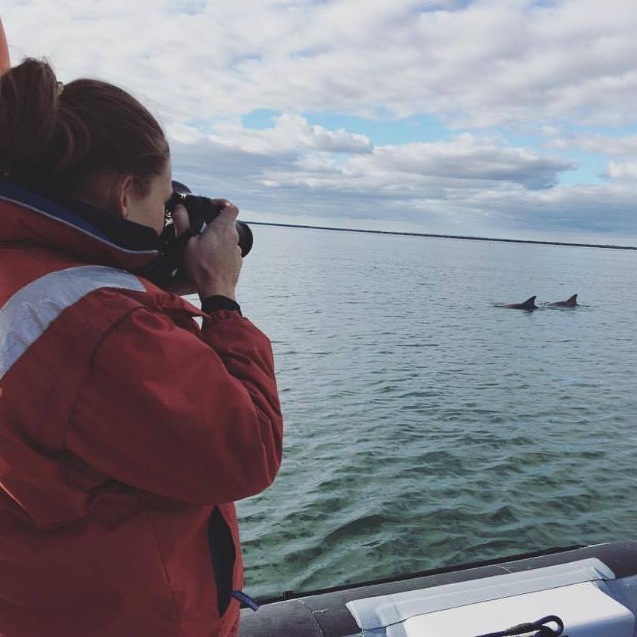
Figure 6 Photo-identification of bottlenose dolphins (Tursiops aduncus)
© Eleanor Pratt

The main disadvantages of vessel surveys are:
- They often require a large investment of time to complete surveys if covering large spatial scales (e.g. hundreds of km’s).
- They are dependent on sighting animals or animal cues on the surface of the water, and so may not be suitable for surveying species that have cryptic surfacing behaviour (e.g. species that do not bring much of their body out of the water so are difficult to spot across the water surface but may be easier to see from the air.
- Large vessels used to survey offshore areas are expensive to operate.

Detection and capture probability
The placement and design of the line-transects is critical to obtaining unbiased estimates of abundance. Transect lines should be placed within the study area in a way that gives each location (for distance sampling) or each individual (for capture-recapture) the same probability of being covered by the design (i.e. equal coverage and capture probability, respectively). Guidance for different designs that account for scenarios where animal density may differ between areas, where the defined area is stratified into blocks for logistical reasons or when surveys are conducted in challenging, confined areas, is provided in Thomas et al. (2007) and Dawson et al. (2008b).

Distance sampling
The assumption of distance sampling that all animals are detected on the transect line is rarely, if ever met (Section 5.1.2). To correct, or partially correct, for animals missed on the transect line, double-observer data can be collected and capture-recapture methods used to estimate perception bias (i.e. animals are present and available for detection but missed by an observer). Availability bias where animals are present but unavailable for detection (e.g. they are submerged at depth) is more difficult to quantify, although data on species’ diving behaviour may be used to correct an estimate of abundance (Section 5.1.2).

Capture-recapture
When using capture-recapture methods based on photo-identification, the assumption of individuals having equal probability of capture is difficult, or impossible, to fully satisfy. Heterogeneity in capture probabilities may be introduced due to some individuals being more distinctly marked (with more obvious natural markings) than others, which makes them easier to be identified. Heterogeneity in capture probability may also be associated with individuals’ sex, age or social status, ranging patterns in relation to the study area/transect design, and differences in individuals’ behaviour such as whether they approach vessels or show vessel avoidance behaviour. Unaccounted heterogeneity in capture probabilities may lead to biased abundance estimates. Therefore, it is important to take steps to minimise causes leading to heterogeneous capture probabilities by ensuring the sampling (transect) design allows equal probability of capture for individuals in the study area, for example:
- Ensure photographs are high quality – for capture-recapture methods, the best photograph of each encountered individual should be graded for quality. Only individual identifications made from good to excellent photographs (as per Rosel et al. 2011) should be included in analyses. ‘Captures’ from poor quality photographs should be excluded from analyses. As a rule of thumb, the least marked individual included in the dataset for analyses should be able to be identified from the poorest quality photograph included in the dataset.
As such, when planning a capture-recapture study, it is crucial to use a good quality camera fitted with a telephoto lens (200-400 mm recommended depending on species and platform) and ensure that personnel are sufficiently experienced and trained to photograph the target species from a moving vessel. Urian et al. (2015) and Rosel et al. (2011) provide a good general review of best practices for implementing photo-identification methods to generate data for estimating abundance using capture-recapture methods.
- Stratify the sample area (i.e. divide the area into blocks) – prior knowledge of animals inhabiting the area of interest may be used to inform the survey design.
As an example, study areas may be split into blocks based on broad-scale habitat types (e.g. estuarine and coastal) and abundance estimated separately for these blocks. Multi-state capture-recapture analyses can also be considered where prior knowledge allows for a study area to be split into blocks (Chabanne et al. 2017), and where estimated abundance can account for heterogeneity in capture probabilities between the different habitats. However, this approach may lead to data that is too sparse for reliable parameter estimates (i.e. low effective capture probability). It is generally more straightforward to fit a simpler capture-recapture model by pooling data collected with a more developed design (Brooks et al. 2017) than collecting data using simpler design that ignores potential heterogeneity in capture probabilities, thus leading to bias in the resulting estimates. It is important that the analytical approach is considered prior to commencement of any data collection to ensure that appropriate data is collected (Section 5.6 provides further information on data analysis).

Spatial scale
Vessel surveys are appropriate for small (tens of kms) and large spatial scales (hundreds and even thousands of kms). The feasibility and cost of vessel surveys depends on the detectability and/or distribution of the target species. For species with a low probability of detection and/or which occur at low densities over large spatial scales, a large survey effort would be required to ensure sufficient sightings to estimate abundance or density. In this case, aerial surveys may be more appropriate.
The appropriate spatial scale of vessel surveys is dependent on the sampling method used. Distance sampling is more suited to larger areas and multi-species surveys (Hammond et al. 2021b), whilst capture–recapture studies are more suited to quantify local populations on relatively small geographical scales (Smith et al. 2013, Chabanne et al. 2017, Haughey et al. 2020). Capture-recapture surveys can also be more efficient where prior knowledge, or acoustic detections, allows for higher encounter rates than line-transects (e.g. Miller et al. 2015, Peel et al. 2015).

Expertise
A statistician and/or a subject matter expert should be engaged prior to commencing data collection to ensure the proposed study design and analytical methods are appropriate.
The survey team should include a survey leader with high level of expertise for both distance sampling and capture-recapture methods (Table 2). If multiple vessels are used simultaneously, each vessel should have its own survey leader. In small vessels, the survey leader often doubles as a skipper. Observers in the survey team should preferably be of medium expertise level at a minimum.
Implementation of vessel surveys requires an appropriately qualified skipper (training level dependent on operational area and vessel) and, in most cases, a commercially registered vessel with appropriate certificate of survey (requirements can be found at the Australian Maritime Safety Authority).
For distance sampling surveys, given that these are likely conducted on a larger vessel and over a larger geographical area, it is likely that additional personnel, such as a navigator and deckhands, are required. Additionally, these surveys may run continuously over longer periods of time. This means that observers may need to work in shifts, leading to an increased number of observers required.
Given capture-recapture methods based on photo-identification rely on obtaining good quality photographs of individuals, it is crucial that the survey team has at least one sufficiently experienced photographer who is knowledgeable about the behaviour of the target species, as well as one team member who is experienced with photo-identification.

Logistical, safety and scientific considerations
The following considerations are important for conducting a safe, well organised survey that provides data that are as robust, standardised, and unbiased as possible:
- Use a raised sighting platform on a vessel when conducting distance sampling methods, which may involve retrofitting a vessel to ensure that the platform height is sufficient. Typical shipboard platform heights are 10 m but can be as low as 5 m with the angle of declination adjusted for each sighting distance (Lerczak & Hobbs 1998).
- Restrict surveys to good weather conditions to maximise detection probability. For dolphins, these conditions include low BSS (i.e. < 3), low sea swell, good air visibility and minimum sun glare to ensure that surfacing animals are detected. For large whales occurring offshore, large survey vessels are typically used and it may be possible to detect these species in higher BSSs (i.e. < 4).
- Consider seasonal, current and tidal regimes and range in the study area as this may affect access, survey coverage and behaviour of the target species. Visual surveys can also only be conducted during daylight hours, which further imposes time restrictions to the area that can be surveyed within a day.
- For capture-recapture methods it is important that the study area is covered in as short a time as possible to ensure an instantaneous sample. This means the survey (i.e. one sample of the survey area) should be aimed to be completed in a day, or in consecutive days. As such, care should be taken to allow sufficient time to complete surveys in appropriate weather windows.
- Ensure all relevant permits (i.e. Commonwealth, state and/or territory government scientific and/or approach permits, Animal Ethics approval) and that permissions to enter waters that may be restricted or requiring acknowledgment, (e.g. harbours, proximity to working jetties, recognised defence area), are obtained prior to commencement.
- Use recommended safety equipment and ensure the survey team is familiar with emergency procedures.

Sampling methods
A general overview of vessel surveys using distance sampling and capture-recapture methods based on photo-identification to estimate population demographic parameters specifically for cetaceans can be found in Hammond (2010) and Hammond et al. (2021b).

Distance sampling
Vessel surveys using distance sampling require a high vantage point to allow detection of animals at a relatively long distance and to ensure distances to detected animals are accurately estimated. The high vantage point can also allow groups to be observed for longer, which can provide greater opportunity to assess species and group size. Distance sampling methods are therefore usually applied when conducting line-transect surveys from larger vessels or ships over a larger spatial scale than what would be feasible with a smaller vessel suited to capture-recapture methods. Distance sampling methods allow for density and abundance to be estimated for species in the study area during the survey period (Buckland et al. 2001) as well as provide detailed distribution data.
This method, rather than capture-recapture based on photo-identification, is effective and should be used for surveys:
- in areas where using small vessels may not be logistically possible (e.g. offshore and/or remote areas)
- when species community structure and/or occurrence is unknown
- where a large number of migratory species are suspected to occupy the area during sampling
- targeted species are difficult to photograph or have insufficient natural markings that can be photographed to distinguish between individuals, thus rendering photo identification unsuitable.
The observational technique described for aerial surveys (section 5.1.6) also applies to vessel-based distance sampling methods.
Vessel surveys with distance sampling methods require observers (minimum of 3, although for estimating perception bias a minimum of 5) to be positioned at the highest possible point (important to know the observation height for distance calculations) on the vessel while searching for animals on either side of the vessel (i.e. 90° on either side of the vessel’s direction of travel). The vessel should follow pre-determined track lines (i.e. transects) at a speed of 8 to 10 kts.
As per aerial surveys, vessel surveys can be conducted either in “passing mode” or “closing mode”. In passing mode, the vessel does not deviate from transect when groups of animals are detected. For each sighting of animals, appropriate information (e.g. sighting cue and method, species, group size, calves present, behaviour) is recorded and measurements (e.g. heading of ship, horizontal angle to detected animal(s), reticules in the binocular view) taken to enable calculations of distance of the detected animal(s) to the transect line. In closing mode, transect effort is paused when animals are detected, and the vessel (or a second tender vessel or drone) approaches the group to gather further information. Observers may confirm species identification, better estimate group size and composition (i.e. age classes) and record behaviour. Once all desired information is recorded for the detected group, the vessel returns to the transect and search effort is resumed. Only group(s) detected during passing mode are used for density and abundance estimation. Time spent off transect should be minimised to ensure that the same animals are not recounted due to their movements while the vessel was off transect. Assumptions mentioned under Section 5.1.6 (aerial survey sampling methods – distance sampling) also apply to vessel-based distance sampling. Any violation of assumptions may result in biased estimates of density and abundance (Buckland et al. 2001).
Most common vessel-based line-transect designs for distance sampling involve sets of evenly spaced parallel or zig-zag lines with random starting points (Strindberg & Buckland 2004, Hammond 2010). The choice between designs depends on a number of factors. Equal coverage probability (i.e. the survey area has equal chance of being sampled throughout and the sampling design does not bias sampling particular areas according to the layout of the transects) can be reached with a parallel design rather than a zigzag one as apexes of a zigzag design may overlap, thus resulting in greater effort in these areas of the transects (Dawson et al. 2008b). However, zigzag designs are often more time and cost efficient as there is no travel between start and end points of transect segments. In relatively small areas, parallel line designs may be more appropriate given the reason above and to ensure the possibility of capturing any animal density gradient related to distance from the shore (Dawson et al. 2008b, Hammond 2010). Surveys of confined waters such as rivers or estuaries may require particular attention to coverage probability as a result of the complex shape of the survey area, and Dawson et al. (2008a) provide advice on how best to achieve equal coverage probability. More generally, the most appropriate design will depend on the shape of the study area, the resources available, logistical limitations, prior knowledge on the area and the species, as well as the desired precision of the abundance estimates. Common sense and balancing all of the above factors should justify the final design choice.

Capture-recapture based on photo-identification
Capture-recapture methods are more appropriate than distance sampling in situations where:
- individuals of the species and/or population(s) of interest are identifiable (Figure 7)
- pre-determined line-transects are surveyed on multiple occasions
- there is imperfect detection of individuals on transect
- life history / demographic information is required
- additional parameters such as apparent survival and temporary emigration are of interest.
Capture-recapture methods based on photo-identification are widely used in coastal and estuarine waters for species that are naturally marked (e.g. nicks and notches on dorsal fin of dolphins, callosities, natural pigmentation and/or scars or notches on the body or underside of whale flukes). These methods rely on resighting individuals on pre-determined line-transects to estimate:
- population abundance (defined as the number of animals using the study area during the sampling timeframe)
- apparent survival (i.e. permanent emigration is not able to be separated from death)
- temporary emigration, depending on the statistical modelling approach used.

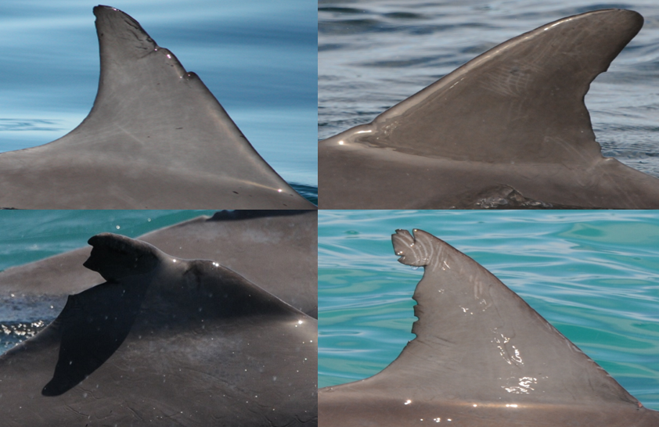
Figure 7 Examples of dorsal fin images collected for a photo-identification capture-recapture study of bottlenose dolphins (Tursiops aduncus)
© CEBEL

Capture–recapture methods based on photo-identification data do not require specific vessel structure (e.g. no need for a high sighting platform although this can be helpful for initial detection and photo-identification). Smaller vessels, that can be navigated easily around animals to obtain good quality photographs, are recommended. Photo-identification methods may also allow other population demographic parameters to be estimated, such as reproductive and age-class specific apparent survival rates, and may allow for population social structure to be investigated while also informing on individuals’ movements and site fidelity to the defined study area (Hammond et al. 1990). The survey should be designed primarily for abundance estimation, with photo-identification data being collected as a complementary method (Urian et al. 2015). Analytical requirements for abundance estimation are suitable for other analyses such as investigations of social structure, whilst data collected for social analyses may not meet the requirements and assumptions of models for abundance estimation.
Defining the survey area and developing an appropriate line-transect design for a capture-recapture study should follow the same rigorous planning as recommended for Distance sampling above, and in Section 4.1. Capture-recapture survey designs are generally species- and location-specific with the parameters of interest (e.g. abundance, apparent survival and/or temporary emigration rates) determining the most appropriate analytical and sampling approach.
The idea of capture-recapture based on photo-identification is to photograph the natural marks (e.g. dorsal fin shape, pigmentation patterns) of each encountered individual (consider them captured) during a defined sampling period, and then use the proportion of recaptured individuals in subsequent samples to estimate the proportion of individuals in the population at large. The five main assumptions for capture-recapture methods are that:
- All individuals have equal probability of being captured within a sampling occasion.
- Capture and recapture probabilities are equal.
- Marks are unique, permanent and identified correctly.
- Sampling is instantaneous.
- Each individual’s probability of capture is independent of all others.
If these assumptions are not met, an attempt should be made to either use a modelling approach allowing for relaxation of the assumption(s) or to quantify and discuss biases in estimated parameters and their direction (i.e. negative or positive).
The final estimated number of animals using a study area needs to be adjusted to incorporate the proportion of unmarked individuals (those without discernible natural markings) in the population (e.g. Nicholson et al. 2012, Brooks et al. 2017). A decision on how the proportion of unmarked individuals will be estimated should be made prior to collecting the data (Parra 2006, Nicholson et al. 2012, Eguchi 2014, Wickman et al. 2021).
To meet the fourth assumption, each sampling occasion (i.e. one complete line-transect survey of the area) should be completed in the shortest time frame possible to ensure that animals do not have sufficient time to travel to adjacent transects and are subsequently recaptured on the same survey. Generally, there should be a greater amount of time taken between sampling occasions than it takes to complete one sampling occasion, to ensure that each sampling occasion is independent (Chabanne et al. 2017). A minimum of three sampling occasions is required for most appropriate capture-recapture analyses.
During a survey, the research vessel should navigate the predetermined line-transect design at a maximum speed of 8 to 10 kts to maximise detectability of surfacing animals. When an individual or group is sighted, the vessel may break transect to photograph each individual in the group, to estimate group size and composition (e.g. age structure, as calves are dependent individuals and should be excluded from capture-recapture analyses) and, if applicable, to estimate the proportion of unmarked individuals in the group. Within reason, the sighting should not be considered complete prior to obtaining good quality photographs of each individual present.
The statistical modelling approach should be chosen prior to collecting data to ensure appropriate sampling frequency and intervals. The length of the study relative to the life-history characteristics of the study species usually determines whether the population can be considered ‘closed’ or ‘open’ to additions and deletions (animals permanently moving in or out of the study area) which is the basis for choosing what modelling approach to use for parameter estimation. The three methods commonly used are closed population, open population, and robust design models that combine closed and open population models (Otis et al. 1978, Pollock et al. 1990, Williams et al. 2002).
Some of the main advantages of the capture-recapture method based on photo-identification are that it is:
- a relatively non-invasive technique and can be used for abundance as well as estimating other life history parameters, e.g. survival, reproductive success, and behaviour
- able to simultaneously inform on ranging patterns and habitat utilization of individuals
- useful for long‐term (multi‐year) monitoring of animals (e.g. dolphins, whales) at key sites (e.g. proposed areas for development or important sites for monitoring for impacts on wildlife)
- suitable for estimating temporary emigration rates to inform on the probability of animals being in the study area. This may be very useful for informed planning of development activities around times that will have the least impact on species using the defined area.
A main disadvantage of capture-recapture methods is that it is relatively labour intensive and time consuming given that multiple sampling occasions that are temporally distinct (i.e. allowing individuals to move within their range between sampling occasions) are required to produce reliable population estimates and other demographic information.

Land-based surveys
Land-based surveys of animals at sea are usually aimed at obtaining a census of animals within the area of interest during the periods of observation, rather than sampling the population in the manner and for the purposes that most surveys are designed. Land-based surveys involve repeated scans of the same area from single, stationary platforms to survey populations (or parts of a populations) that are distributed nearshore and therefore have non-random distributions with respect to the coastline (Keen et al. 2021). Land-based surveys are most effective in areas where a large proportion of the population of interest is visible close to the coastline, and/or there is a highly elevated vantage point (i.e. clifftop, hill, building) can maximise the distance out to sea that animals can be detected as they transit the survey area (see 5.3.2).
This type of survey is most used for nearshore cetaceans, particularly coastal migrating whales (Figure 8), and to a lesser extent dugongs, dolphins and marine turtles. For most species it is difficult to determine whether multiple sightings reflect multiple individuals.
The kinds of outputs that land-based surveys can provide include (Piwetz et al. 2018):
- presence/occurrence
- relative abundance (except in unique circumstances where a high proportion of the population is visible from the survey point and absolute abundance can be estimated)
- movement patterns.
- habitat use
- behaviour.
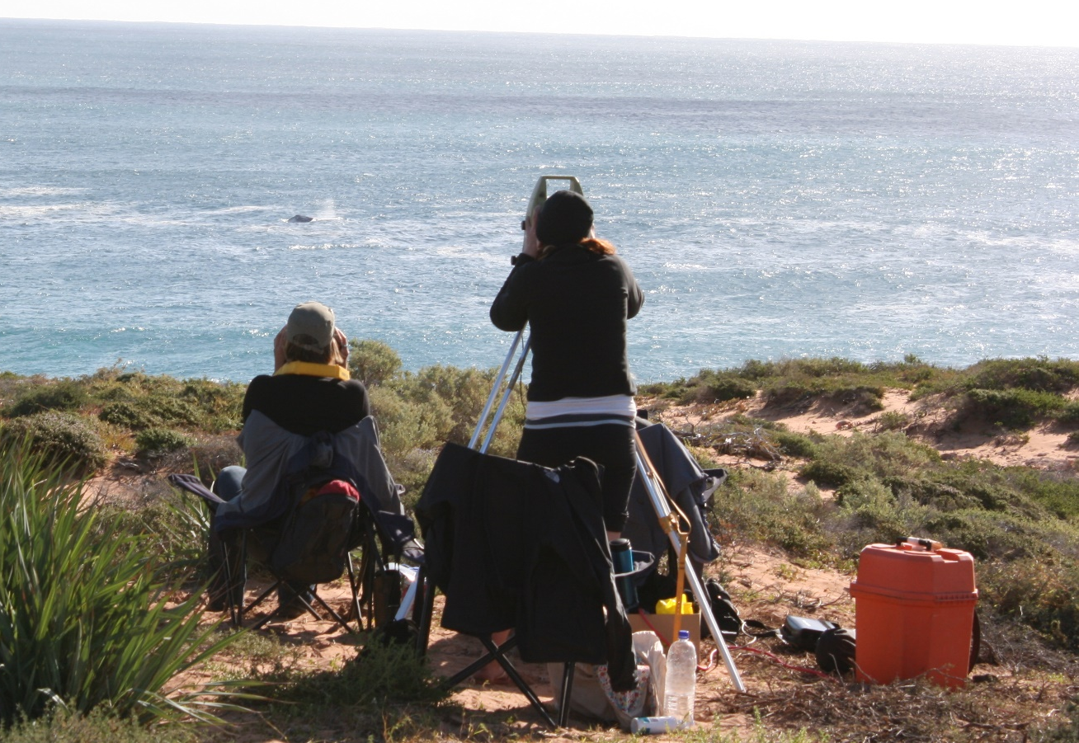
Figure 8 Land-based survey of humpback whales using a theodolite and binoculars
© Joshua Smith

Advantages and limitations
The main advantages of land-based surveys are:
- They are non-invasive and do not alter the natural behaviour of the animals.
- They are relatively simple logistically to conduct and inexpensive to undertake compared to aerial- or vessel-based surveys.
- They provide a high detection rate meaning limited corrections are needed for missed animals.
The limitations of land-based surveys are:
- The spatial extent of the survey area is typically small relative to the range of the species. Land-based surveys are therefore not generally suitable for baseline surveys to determine distribution and abundance.
- Detection is maximised for nearshore distributions of animals within populations and accuracy of the animal’s position at sea decreases with increasing distance from the land-based station. This may potentially create a bias in derived estimates of presence, density, movements, and behaviour of individuals closest to shore that might reflect only the portion of the population using this habitat.
- They are only practical in situations where there are suitable elevated survey locations in the areas where the species needs to be surveyed.

Offshore versus inshore environments
Land-based surveys are of limited value for the Commonwealth EIA process if the action is wholly occurring within Commonwealth waters (>3 nm). However, land-based surveys may be appropriate and efficient in State waters in very near-shore environments and activities (e.g. monitoring dolphins during port-construction/decommissioning, dredging of channels), depending on the objective for monitoring.

Influence of animal density and behaviour
The behaviour and density of animals within the area of interest will largely influence the application of land-based surveys. To obtain abundance estimates, individuals or groups need to be tracked or need to be identifiable to avoid double-counting. Both options are difficult when animals are in high density and are resident in the survey area. It is not usually possible to identify individual animals from a land-based station (i.e. using natural markings), however an example exception is southern right whales, which occur close to the coastline and are individually identified using callosity patterns on their head. Tracking the movements of individuals or groups is likely only feasible for situations where the animals are either conducting directional movement through the area (e.g. whales on migration, Section 5.3.6) or remain visible at the surface for large periods of time. Tracking may be aided by using a combination of land-based surveys and drones, although this would still typically require relatively low density. In most cases, it is easier to track groups rather than individuals.
Where movements of individuals or groups cannot be identified or tracked, it is not possible to obtain abundance estimates, however, land-based surveys can still be useful to obtain occupancy information.

Detection probability
Using land-based surveys to estimate abundance fundamentally relies on accurately recorded positions of animals at sea which are usually obtained using a survey station (theodolite; Section 5.3.6).
The accuracy of the animal’s position at sea and range from the land-based survey station decreases with increasing distance, which is a function of the elevation (height above sea level) of the survey station.
This means that for animals at distance, small changes in the measured vertical angle to the animal from the land-based station can equate to large distances on the water and therefore large errors in the position of the animal. Land-based stations at higher elevations can minimise this type of error for nearer distances and can increase the range out to sea that can be surveyed. In comparison to vertical angles, the accuracy of horizontal bearings to the animals will have less effect on the accuracy of the animals’ estimated positions (Sagnol et al. 2014). The accuracy of the estimated position will be affected, although small errors in the bearings will not greatly affect the range estimate which has a greater effect.
Generally, there is better detectability of larger animals (e.g. whales) at greater distance from a land-based site than smaller animals (e.g. dolphins, dugongs, marine turtles). This is due to a range of factors that affect an observer’s ability to detect small animals at distance, including smaller cues made by the animal (e.g. the blow or animal’s exhalation) and weather conditions (e.g. sea swell height or whitecaps) obscuring small animals more readily than larger whales.
Perception bias (animals available but missed) may be estimated when two independent observation teams (blind double count by teams visually and acoustically isolated from each other) are used at the land-based survey site (Noad et al. 2020).

Statistical consideration
As outlined in Sections 5.1 and 5.2, distance sampling is one of the most common statistical frameworks used for visual estimation of marine mammal abundance. However, one of the main assumptions of distance sampling is that animals, or animal groups, are distributed randomly relative to each other and independent of the observation point. This assumption is typically violated in land-based surveys due to the nearshore, non-random distributions of animals with respect to the coastline, and therefore distance sampling is not normally applied. Despite this, Keen et al. (2021) estimated a detection function for land-based survey data to determine density. It was suggested that this statistical approach has limited potential application to large, easily detectable whale species that exhibit slow moving behaviour, where there are small group sizes and under high sampling effort.
In the application of estimating absolute abundance from whale counts (e.g. east coast humpback whales), data analyses need to account for the daily variation in whale counts versus the variation in whale counts over the duration of the migration. A stratified random sampling approach and more complex Hermite polynomial approach can be undertaken to address the variation in whale count data, although the Hermite polynomial method is considered the better approach for modelling absolute abundance (Noad et al. 2020).

Spatial scale
Land-based surveys that operate from one land-based survey site are typically conducted over small spatial scales (< 10 km). However, in some areas, multiple sites have been used to increase the spatial scale of the survey (tens of km), noting this is different to having two land-based sites that are independent to each other to estimate independent estimates of animals or to derive correction factors. Where multiple sites are used to increase the spatial scale of the survey area it is critical to understand, or can record, the movements of individuals between sites to prevent double counting of animals that would result in biased estimates.

Expertise
A high level of expertise is required (Table 2) for survey design and planning, establishment of protocols, and data analysis. A medium level of expertise is required for training and leading field teams. The level of experience for observers may differ according to the role of the observer, with theodolite operators requiring a medium level of experience given the critical component of obtaining reliable and accurate animal location data using the theodolite. For surveys where observers utilise binoculars for distance estimation, species identification, or behavioural recordings, the level of experience required is low and it is recommended that training is provided to observers in the field on the identification and behaviour of the species of interest and on the general methodology.

Logistical and safety considerations
The following considerations are important when designing an effective land-based study that provides data that are as robust, standardised, and unbiased as possible:
- Knowledge of the relative importance of the site to the species (or proportion of the population), is necessary to provide context for the survey data. This includes an understanding of the types of behaviour the animals exhibit within the vicinity of survey area, which could inform why the animals use the area.
- Land-based surveys need to be conducted with as much shore-based elevation and be situated as close to the coastline as possible to maximise the distance surveyed offshore and minimise the possibility of animals passing unseen very close inshore.
- Accurate tidal height charts specific to the land-based site are required to calculate the geographic location of animals at sea.
- Sightings and observations from land-based stations can be significantly affected by environmental conditions including wind, heat or smoke haze, sun glare, sea swell, tidal range and atmospheric refraction. It is critical to frequently record the weather conditions (e.g. environmental variables such as BSS, wind speed) to standardise data for sampling conditions.
- Tracking animals from land-based platforms can result in errors in the position of animals due to the curvature of the Earth, predominantly for positions of animal’s at large distances (i.e. > 5-10 km). This effect is another reason for choosing suitably elevated survey platforms, and methods used to calculate positions need to take this curvature into consideration.

Sampling method

Observation technique
Land-based surveys require the use of a theodolite, which is a very precise surveying instrument that measures horizontal and vertical angles. When the exact theodolite position and referenced horizontal bearing (relative to a known geo-referenced object), height above mean sea level and tidal height over the period of observation are known, then the theodolite readings (horizontal and vertical angle) of an animal’s position can be geo-referenced (i.e. converted into latitude and longitude). In previous applications of theodolite tracking, station heights have been 20 – 45 m (e.g. dolphins up to 5 km from land) and 73 m (e.g. whales up to 10 km from land). Reticule binoculars can supplement the use of theodolites to estimate the distance of animals at sea from land. However, reticule binoculars provide relatively imprecise measurements of the position of the animal and should not be solely relied on for distance estimation.
Land-based survey methods have been augmented by other survey methods, including the use of vessels and PAM, to obtain relative abundance, movement and behavioural data (e.g. socialising, singing humpback whales), and habitat use. Theodolites have also been used with video footage to investigate spatial relationships and associations between individual cetaceans (DeNardo et al. 2001). These types of applications require the collection of detailed sighting location data which is best achieved using a digital theodolite (total station) that can be connected to a laptop computer. There is typically a team of at least 3 to 4 people, consisting of a theodolite operator, computer operator and two spotters with binoculars. Data is collected on the movements and behaviour of animals, environmental/weather conditions, and other data of interest (e.g. vessel movements). Observers identify animals to enable the theodolite operator to obtain an accurate positional fix of the animals and all positional, behavioural, weather, and incidental data can be recorded on the computer.
Land-based surveys only allow access to nearshore animals, and therefore there may be bias in the age, sex or behaviour of the animals that are reliably sampled closest to the land-based observation point. Furthermore, absolute population abundance and trend estimates have only been determined in rare occasions, when animals undertake unidirectional travel through the survey area, which minimises the probability of double counting individuals, and an understanding of the proportion of the population being sampled is known. An example where this has been achieved is for the Australian east coast humpback whale population on the migration path. In this example, the unique survey site characteristics provide access to most of the population (90% < 5 km from land) on their migration path, which enables this survey method to be used to estimate absolute abundance using correction factors for availability bias (Noad et al. 2019).

Passive acoustic monitoring (PAM)
Passive acoustic monitoring (PAM) relies on detecting vocalisations of marine species on an underwater microphone, called a hydrophone, and uses the sounds as cues for detection (Figure 9). Knowledge of how sound travels in the ocean (propagates) is essential when considering using PAM given sound propagation dictates how PAM is implemented and how effective it can be as a survey method. Another fundamental pre-requisite for implementing PAM is a good understanding of the different sounds that species make (i.e. their vocal repertoire) and the rate at which they produce those sounds (i.e. vocalization rate), including factors (e.g. environmental and biological factors) that may affect these.
PAM has almost exclusively been applied to cetaceans and is not a suitable survey method for marine turtles and has had limited application to dugongs, predominantly because they do not appear to vocalise reliably and there are significant knowledge gaps of their vocal behaviour (Tanaka et al. 2017).
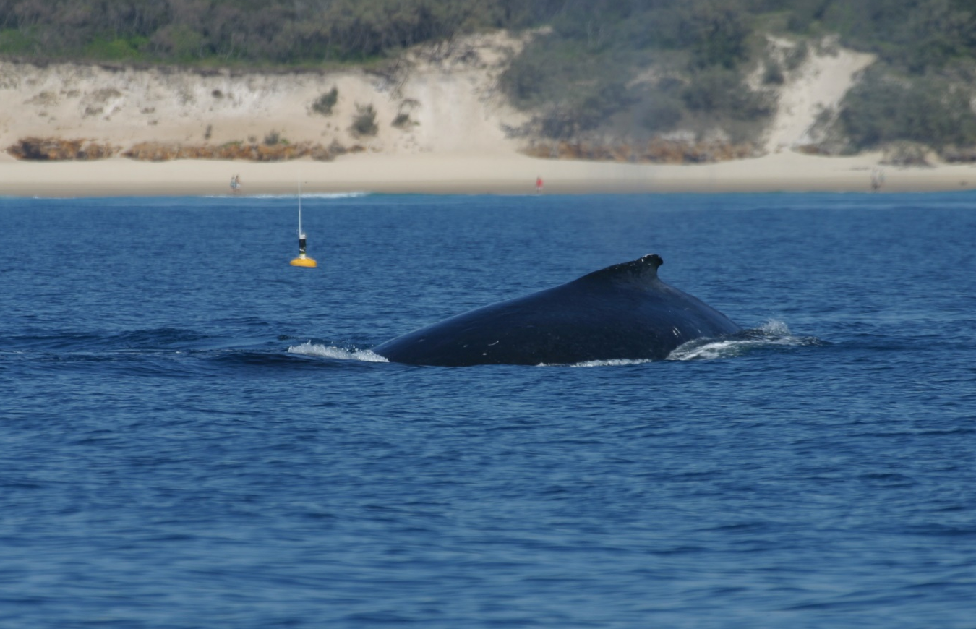
Figure 9 Passive acoustic monitoring of humpback whales using moored hydrophones
© UQ HARC

Advantages and limitations
PAM can be a good technique for surveying cetaceans because most species spend substantial amounts of time submerged underwater, and this approach confers a greater probability of being sampled. However, there are caveats and limitations to applying PAM to survey for cetaceans, and these need to be understood before making inferences from acoustic data.
The main advantages of PAM are that:
- It can be conducted over extended temporal periods of months (and potentially years). It can also be conducted continuously throughout daylight and night-time hours (effectively 24 hours a day) if the appropriate data hardware and storage capabilities are met.
- Data collection is less constrained by weather conditions than visual surveys and PAM can be conducted in higher BSSs with greater wind speeds and low visibility. However, an understanding of how sea state and wind speed can affect background noise levels is necessary.
- PAM can be used to monitor baseline and anthropogenic noise in addition to vocalisation of cetaceans.
- Data collection and data processing can be automated, enabling greater time efficiency and a more standardised and objective approach to analysing the data.
- It can be conducted at times and in places where it is often too expensive or dangerous to send human observers (e.g. Antarctica).
However, there are several factors that need to be met for PAM to be effective for surveys and monitoring. Some disadvantages and limitations of PAM include:
- They have limited capacity to detect changes in abundance (with high precision) and fine-scale distribution.
- Animals need to be vocalising to be detected and they must have reliable vocalisation rates to ensure adequate probability of being sampled. Some species and demographic groups vocalise less than others.
- Some species have sex-specific patterns of movement and habitat use, as well as vocalisation rates, which can create a bias toward sampling particular cohorts of a population (e.g. male humpback whales)
- Vocalisations need to be species specific to enable species identification and discrimination.
- Vocalisations need to be produced over a useful detection range such that the sound is not substantially degraded, and it is difficult to detect and extract measurements of the acoustic features (e.g. frequency range, duration, sound level). Consequently, background (or ambient) noise levels and the contribution of noise sources within the study area are an important consideration when assessing the feasibility of PAM.
- Acoustic equipment is relatively expensive and operating the acoustic hardware and software and analysing acoustic data typically requires a high level of expertise.

Detection probability
There are several factors that need to be considered when implementing PAM and evaluating animal presence through the detection of vocalisations.
When implementing PAM, it is essential to consider how environmental properties (e.g. bathymetry, sound speed profile), background noise and the animals’ vocal behaviour can influence the quality, and hence detection, of the sounds being measuring (Au & Hastings 2008).

Environmental and oceanographic conditions
An important consideration in applying PAM is how the environment (e.g. oceanographic conditions) influences detection of an animal’s vocalisations. PAM is affected by the way sound propagates underwater because sound loses energy as it travels through the environment from the source to the receiver, a phenomenon known as transmission loss (Zimmer 2011). Several factors affect the nature of sound propagation and the rate of transmission loss underwater, and these include characteristics of the sounds themselves (e.g. frequency, amplitude, duration), bathymetry and composition of the seafloor, properties of the water that affects the sound speed profile (e.g. water temperature, salinity), and the state of the water surface (e.g. calm or rough) (Richardson et al 1995).

Importantly, many of the factors that influence sound propagation are dynamic and change over time (e.g. during the day) with the tide, and seasonally. Consequently, site-specific sound propagation modelling is important to obtain an accurate understanding of the true detection rate of the species of interest.

Animal behaviour
Cetaceans often produce certain types of vocalisations based on behaviours. For example, odontocetes (e.g. dolphins, sperm whales) are well known for their use of echolocation for navigation and foraging, which is used in a highly repetitive and predictable manner. Consequently, the predictable use of a vocalisation type (i.e. echolocation) means acoustic surveys are highly suitable for odontocetes. However, identifying and discriminating between different species requires knowledge and understanding of each species’ acoustic repertoire (i.e. the acoustic characteristics of their echolocation). Our ability to identify echolocation click types to different genus and species, particularly from large PAM datasets, is improving through the application of machine learning methods which can facilitate analyses of spatiotemporal patterns of toothed whales (Ziegenhorn et al. 2022).
The factors influencing the timing, occurrence and rate of a species’ vocalisations (e.g. behaviour) need to be considered when designing a PAM survey, as these factors influence the detectability of the species.
There is also potential bias in the detection of animals if the behaviour of the species in the area is not understood. For example, the potential that southern right whale mother and calf pairs choose habitats where sound propagates the least to avoid predators and conspecifics, termed acoustic crypsis (Zeh et al. 2022), may bias detection rates of these animals in this habitat. Furthermore, certain vocalisations may only be produced by a subset of the population, for example the complex songs of humpback whales are only produced by males. In these examples, acoustic surveys could be biased towards subsets of the population (Noad et al. 2017).
Validation (ground-truthing) of acoustic datasets with visual observations is recommended wherever possible to validate species identification determine whether there are animals present that are not vocalising and to inform the detection rate of vocalising animals. Data collection should also consider baseline monitoring of the marine soundscape to provide an understanding of ambient noise conditions and the levels of anthropogenic noise, which can affect detectability of species vocalisations.

Spatial scale
The spatial scale over which PAM can be effective is fundamentally related to how sound travels in the ocean, but can also be dependent on several factors, including:
- oceanographic conditions of the study area (e.g. depth, salinity, substrate, and water temperature)
- acoustic frequency (i.e. frequency range) of the species’ vocalisations
- the species’ behavioural use of the area, e.g. breeding or foraging
- sensitivity and quantity of acoustic receivers used to detect and record acoustic signals.
Acoustic surveys and the collection of acoustic data over large spatial and temporal scales is becoming increasingly common. This has largely been due to improved technologies and technical capabilities of acoustic receivers which have decreased their costs, making it feasible to deploy larger numbers of acoustic recorders. A discussion on considerations of spatial and temporal scales of PAM is provided in Van Parijs et al. (2009).
PAM acoustic receivers can be fixed or mobile (Section 5.4.6) and surveys that use towed arrays of hydrophones have a greater spatial coverage compared to fixed hydrophone arrays. However, towed arrays may not reliably detect animals at depth as there can be issues with refraction of sound. The spatial coverage of fixed acoustic receivers can be increased by increasing the number of hydrophones at appropriately spaced locations within the study area.
The effective sampling area around a hydrophone will vary across space and time, amongst species and for different vocalisation types, all of which may ultimately result in detection biases. Detection of vocalisations can be limited to hundreds of metres for odontocetes and dugong (<300 m; Ichikawa et al. 2012) as they vocalise at high frequencies (> 5-10 kHz), and tens and sometimes hundreds of kilometres for whales that often vocalise at lower frequencies (< 1-5 kHz).

Expertise
Most aspects of conducting PAM surveys require a high level of expertise (see Table 2), as acoustic monitoring requires an understanding of the physics pertaining to sound propagation and attenuation through the ocean. Specifically, high levels of expertise are required for:
- Survey design – Establishment of a survey design requires an understanding of how an animal’s vocalisation will be detected by hydrophones (i.e. detection range) and how to determine the effective placement of acoustic receivers.
- Processing and analysis of acoustic data – PAM often generates large volumes of acoustic data, which can be costly and time-consuming to manually review and analyse. Automated or semi-automated methods are available to detect and classify marine mammal vocalisations recorded within the acoustic datasets. However, the use of detection algorithms to extract the desired vocalisations requires the user to apply appropriate parameters and filters, which requires an understanding of how this can affect the acoustic data and there can be variation in performance among algorithms.
The manual review and statistical analysis of PAM data may only require a medium level of experience. Specifically, medium levels of expertise are required for:
- Data collection and manual review of the data – Training in understanding the visual representation of acoustic data so animal vocalisations can be discriminated from non-target sounds is required. This also ensures that if PAM operators are monitoring real-time or near-real time acoustic data, they can potentially circumvent any computer or software problems that might arise by being familiar with acoustic data.
- Statistical analysis of acoustic data – Some understanding of general statistical analyses is required, as well as bioacoustics experience (e.g. an understanding of sound propagation). To determine appropriate biological inferences from the statistical analysis of the acoustic data, it is desirable that some biological understanding of the species exists, although this is not essential.

Logistical, safety and scientific considerations
PAM data collection methods are dependent on the objectives of the survey and the species sampled, which influence the survey design, data collection platform, and the number and location of acoustic receivers used.
Some practical considerations in relation to acoustic systems include:
- Frequency and bandwidth – the higher the recorded frequency, the shorter the deployment time if continuous sound recording is conducted. The range in frequency that is recorded is dependent on the objective of the study and whether a part, or all, of the species’ frequency range is required to be monitored. For monitoring at high frequencies (e.g. up to the 150 kHz produced by dolphin’s echolocation clicks), faster processors are required (with their associated power demands) and large amounts of data are generated, e.g. to record at 150 kHz, a sampling rate of at least 300 kHz is required.
- Memory size – the larger the memory capacity of the acoustic system, the more data it can store and the longer the acoustic systems (e.g. autonomous recorders) may be deployed.
- Battery size – the larger the battery capacity, the longer the deployment time; battery capacity is more limiting for autonomous detectors such as click detectors than continuous recorders, the latter which tend to be more memory limited.
- Duty cycle – the duty cycle is a method of prolonging deployment time by subsampling in time (e.g. only recording for 10 mins every hour) to extend deployment durations. Careful selection of the duty cycle is needed when used for monitoring due to the potential of missing animals as they pass through the area during the non-sampled period when the system is not recording.
The logistical and safety considerations for deployment of hydrophones to undertake PAM is dependent on the type of hydrophone system used. Fixed hydrophone systems are logistically simpler to use, although may potentially be difficult to deploy dependent on the size of the PAM system. Fixed hydrophone systems that must be deployed at depth (i.e. >500 m) require substantial infrastructure in the mooring system and on the vessels used to deploy them. This increases the occupational, health and safety considerations by increasing the level of risk. Towed arrays can be deployed from most vessels, although their use can be restricted by water depth, and influenced by the length of the array and speed of the vessel.

Sampling method
PAM is a non-invasive technique in which animal vocalisations are detected passively and no sound is produced by the equipment, as opposed to active acoustic methods that produces sound (e.g. echosounder) to detect an animal through target (the animal) reflection. PAM is particularly effective for cetaceans because most species spend substantial amounts of time underwater, thus are accessible for detection. For PAM to be effective, it is critical to understand the species’ vocalisation rates and the factors that potentially affect these, such as sex, group size, biology, behaviour, and season.
While visual surveys detect and monitor distinct individuals or groups, PAM systems generally detect acoustic signals (i.e. sounds, vocalisations) that may be being produced by one or more individuals of a species. Specific individuals of the same species may only be identified through their calls when using more complex methods of multi-path ranging or multiple hydrophones and localisation methods, e.g. triangulation in relation to multiple receivers (none of which are usually used during PAM surveys). Fundamentally, PAM relies on acoustic cue counting and is often augmented with visual surveys (Zimmer 2011).

Types of passive acoustic surveys
There are two types of passive acoustic surveys that would be appropriate:
- Fixed acoustic surveys where hydrophones are moored in a fixed location.
- Mobile acoustic surveys where hydrophone(s) are towed behind a vessel (i.e. towed array) or attached to a mobile platform (i.e. ocean glider).
The most common approach for undertaking PAM is to use a fixed-location method, or point sampling, whereas acoustic surveys from a moving platform to conduct line transects are less common (Mellinger et al. 2007).
The types of hydrophone systems that can be used include:
- autonomous recorders that typically acquire and store data internally with onboard storage
- fixed cabled hydrophone systems that are continuously powered by an external power supply, are directly connected to a receiver and can send acoustic data continuously
- radio-linked hydrophone systems that are moored in a fixed location and transmit acoustic signals via radio waves to a shore-based receiver station.
Best practice for collecting PAM data involves continuous collection of acoustic data or a high duty cycle sampling rate (i.e. a high proportion of time recording) throughout the period when any development activities are being undertaken. A high sampling rate also enables the collection of data within periods when species are likely present as well as absent from the study area. PAM surveys to determine impacts require at least two continuous years of baseline data, followed by data collection during construction and the first post-construction year.

Applications of PAM
PAM has been most applied to species of large whale (e.g. blue, humpback, fin, sperm, and southern right) and dolphin (e.g. bottlenose) species for which the acoustic repertoire is well established, to determine:
- presence
- distribution (including migratory) patterns
- abundance
- movement (if localisation of animals is possible)
- behaviour
- habitat use.
A limitation of PAM is that it is often difficult to account for spatial and temporal variation in the acoustic detectability of animals, and therefore the acoustic detections of animals may not reflect true patterns of density or abundance unless good knowledge of the species occurrence, acoustic repertoire, vocalization rates, and behaviour in the area of interest are known.
PAM might be used to determine relative abundance, although this is rarely achieved due to the high quality of information that is required to measure abundance. A very good understanding of the species acoustic repertoire and vocalization rates is required, including factors that affect vocalization rates (e.g. behaviour, individual or age/sex class variation). Typically, an abundance estimate relates to a subset of the population that consists of the vocalising animals, and it measures a vocalisation rate per unit time rather than actual numbers of individuals. To determine abundance of the total population, the relationship between vocalising and non-vocalising animals needs to be determined, which rarely occurs.
Density estimation of cetaceans is an emerging application of PAM that will become an important method for surveying these species. Acoustic-based density estimation is largely based on existing sampling methods applied to visual surveys, such as distance sampling and spatially explicit capture-recapture methods (Marques et al. 2013). For density estimation of cetaceans to be more routinely applied using PAM, further development needs to occur in:
- statistical approaches optimised for acoustic-based density estimation
- survey design using acoustic receivers
- research on the acoustic behaviour of target species.
The steps in undertaking passive acoustic surveys include:
- Survey design.
- Deployment and (often) recovery of recording instruments.
- Extraction of vocalisations of interest from recorded data.
- Statistical analysis of vocalisations.
- Interpretation of the results in a biologically meaningful way.
During the survey design stage, there needs to be careful consideration of the spacing between fixed hydrophones to account for the detection range of the species of interest dependent on the survey objective. Currently, the advantages and disadvantages of different acoustic survey designs are poorly understood.
The extraction of the animal’s vocalisations from the acoustic recordings involves three main steps:
- The detection of a potential sound of interest.
- The extraction of relevant features from potential sounds of interest.
- Classification of these sounds (based on the extracted features) to a particular marine mammal species or species group.
Common open-source software that is often used to visualise acoustic data and facilitate the process of detecting sounds of interest, extracting relevant acoustic features and classifying sounds is PAMGUARD.
Open-source options for acoustic monitoring hardware and software, sensors integrated with on-board detection and classification capabilities, and networked sensors connected wirelessly, will rapidly expand the field of acoustic monitoring (Zimmer 2011).

Emerging techniques and technologies

Drones / imagery surveys
Surveys conducted using either drones or aerial imagery from piloted aircraft (imagery surveys) may replace traditional real-time observations from occupied aircraft (observer surveys). Drones are rapidly emerging tools, and although studies have shown that aerial imagery captured from drones provides comparable data to observer surveys, there are many advantages in implementing drone surveys. These considerations also apply to aerial surveys using cameras fixed to piloted aircraft, although there are seemingly few studies that have assessed the application of this technique. As a result of this limited testing, it cannot be assumed that imagery survey data captured using drones is equivalent to those captured from piloted aircraft.

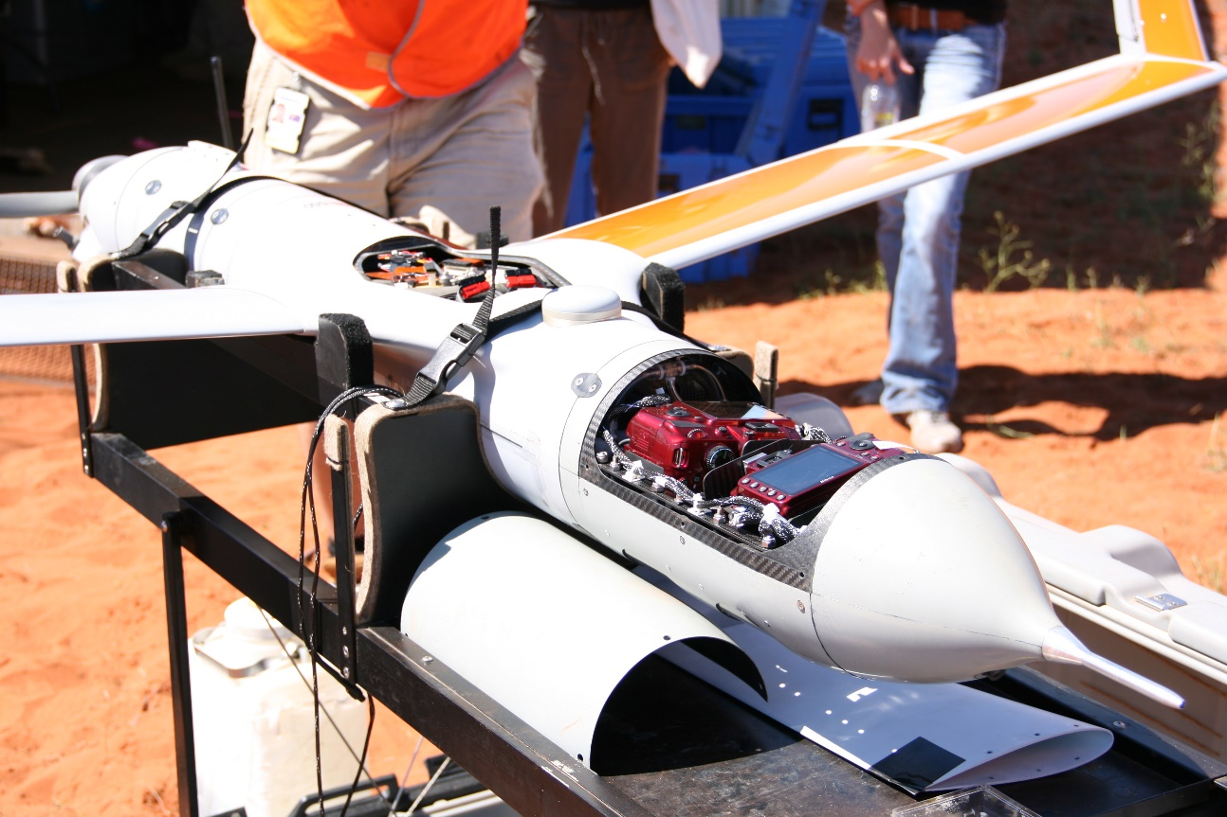
Figure 10 Dual camera payload in a ScanEagle drone operated by Insitu Pacific
© Amanda Hodgson

Integrating historical methods and data
If historical aerial survey data from observer surveys exists, it is important to consider how these data can be compared to contemporary data from aerial imagery. Studies aimed at understanding how detection probability differs between the two techniques are ongoing, and while some have shown no difference between these two platforms (Bröker et al. 2019, Garcia-Garin et al. 2020), higher numbers of dugongs have been detected in drone images when directly compared to observer survey data (Hodgson et al. 2023). Therefore, the integration of historical data with imagery survey data requires acknowledgement of, and ideally experiments to assess, these potential differences in detection probability. It is also important to acknowledge that not all aerial imagery is equal. The probability of detecting animals in images may be influenced by many factors, including ground sample distance, image capture settings, camera mounting, aircraft speed and stability, and the survey environment and conditions. These variations affect comparisons of survey results across surveys if the observation techniques and technologies differ.

Logistical considerations
The logistics of conducting drone and piloted aircraft imaging surveys are very similar to standard observer surveys (Section 5.1.5), apart from consideration of the image capture resolution, settings and quality required to achieve the objectives of a survey. Logistical considerations particular to drones include:
- The range and endurance capabilities of the drone, which determine whether it can cover the survey area within a reasonable time frame, while capturing the image quality and ground sample distance (GSD; the on-ground resolution) required to identify taxa.
- The potential locations for ground control stations, or operational bases, which will dictate the most appropriate launch and retrieval system / methods and the range and endurance needed.
- The speed of the drone – typically less than half the ground speed of piloted aircraft, and therefore a survey could take twice as long (though the drones may be able to be flown for longer periods of time). The slower speed of drones also means that if surveying migrating whales, it is important to account for movement bias (i.e. whales missed because of their systematic movement through the survey area) (Hodgson et al. 2017).
- The minimum GSD required for the smallest or most difficult species to detect should be the target GSD for multi-species surveys. There are some published data on the minimum GSD required for cetaceans (Hodgson et al. 2017, Bigal et al. 2022, Raudino et al. 2022) and dugongs (Hodgson et al. 2013).
The selection of the drone itself is an extremely important logistical consideration and the above points should be considered when deciding on an appropriate drone. It is essential to select an appropriate drone and imaging system (mounted payload) for the intended research question. It is also critical to ensure that the drone system selected has been rigorously field tested and that redundancies (spare drones) are factored into costings.

Image processing
A key advantage to using drones and of imagery surveys for marine megafauna monitoring in general, is the potential to standardise data collection. Also, by integrating the imagery and the telemetry data (flight characteristics such GPS tracks, altitude, and the rotations of the drone/aircraft in space), this technology can provide more accurate and higher resolution spatial data than observer surveys. It is important to understand the status of image processing options and the time required to extract data from aerial images. These data include:
- sightings (of multiple species, including identifying repeated detections of individual animals in overlapping images)
- environmental conditions (i.e. those that affect detection probability: sea state, glare, water visibility etc)
- spatial information (accounting for drone position, rotations, and camera lens distortions), including:
  - locations of individual animals, and
  - sampled area (merged coverage of image footprints).
Several automated systems have been developed for detecting marine fauna, typically using deep convoluted neural networks (machine learning) (e.g. Maire et al. 2015, Seymour et al. 2017, Gray et al. 2019). It is important to be able to quantify the performance of these models on each unique survey dataset, as this performance is a source of bias that needs to be corrected when estimating abundance (Section 5.1.2). Assessing this performance may require some manual review of images to allow comparisons between the output from automated models to manual detections.

Regulations
One of the greatest challenges in implementing drone surveys is in obtaining the appropriate permissions from the Civil Aviation Safety Authority (CASA). In order to achieve the coverage required for a large-scale aerial survey, the drones will need to be flown at relatively high altitude (e.g. Hodgson et al. (2017) flew at 732 m to survey humpback whales) and beyond visual line of sight (i.e. beyond the distance that the drone can be seen by the operator with the naked eye). In Australia, these two requirements mean that drones are being flown outside of the standard operating procedures. In addition to these operational limitations, the drone type (size/weight) determines permitting and licencing requirements. Operating a small drone (i.e. <2 kg) for research purposes under the standard operating conditions is defined by CASA as a low-risk procedure (termed “excluded RPA”, see CASA Regulation 101.237) and does not require a licence or operation certificate. However, larger drones may require a licence, an operation certificate, and specific permits to be granted (see CASA’s drone rules). Additionally, there are other jurisdictional requirements regarding the operation of drones which may limit their use e.g. height restrictions for flying above cetaceans and complete prohibition within national parks.

Satellite imagery
The application of Very High Resolution (VHR) satellite imagery to survey marine species uses aerial images of less than 1 m spatial resolution from orbiting satellites and is suggested as a complementary approach to traditional survey methods for monitoring whales. VHR satellite imagery has been used to investigate large whale presence/absence and abundance (density) adjusted for availability bias (Bamford et al. 2020) but has not yet been applied to the smaller dugong or marine turtles. Current image resolution (i.e. WorldView-3; 2016, 31 cm panchromatic and 1.24 m multispectral) enables the identification of characteristic whale features (e.g. flukes, flippers) in certain scenarios, which is critical for species identification (Cubaynes et al. 2019).

Advantages
- Potential for surveying remote or inaccessible marine areas (i.e. offshore waters) and migratory marine species over large spatial scales that currently incur large logistical and financial constraints.
- Rapid, repeatable and standardised measures to objectively survey populations, similar to drones.

Current limitations
- To date, feasibility studies using this approach have been undertaken in areas with known occurrence of a single whale species (e.g. Cubaynes et al. 2019). The satellite image resolution limits this approach as a survey method to differentiate whale species in areas where multiple species occur, and this remains the greatest challenge to the implementation of this technique.
- Poor weather conditions affect the detection of animals within images (similar to visual surveys), resulting in underestimates in presence and abundance, while extensive cloud cover can prevent effective use of this method.
- Corrections for availability bias have been relatively underexplored, although would apply similar approaches as for aerial surveys and use independent dive data from the same geographic region from visual observations or archival tag data (i.e. suction cup tags).
- High resolution image data can be costly to acquire.

Advancements as a survey technique
Development of this method currently focuses on image processing and analytical techniques given the use of aerial imagery requires new approaches for data analysis, similar to drone surveys. Automated image processing will improve efficiency, although currently will likely necessitate a semi-automated approach assisted by manual review, until large databases become available to train the automatic algorithms. To enable the use of VHR as a survey method, continued development needs to focus on the following areas, with further reference outlined in Höschle et al. (2021):
- Building large and complex datasets to train automated systems.
- Pre-processing workflows to identify a suitable standard method.
- Species identification to conduct density, abundance, and population trend assessments.
- Testing the ability of models to detect whales across different sea conditions to allow transferability.
- Understanding and accounting for factors limiting detectability and decreases in image quality, such as weather conditions (e.g. clouds, sea state).

Environmental DNA (eDNA)
eDNA collection involves obtaining DNA fragments from environmental sources (e.g. water samples) and using molecular genetic (DNA) markers to assess biodiversity. eDNA can currently be used to detect species presence and survey taxonomic biodiversity (Eble et al. 2020, Othman et al 2021). It can be applied using 1) q-PCR and taxon-specific genetic primers for single species identification or through 2) eDNA metabarcoding using general primers and high-throughput sequencing or next-generation sequencing for community biodiversity surveys.
The use of eDNA as a genetic monitoring technique has predominantly been applied in terrestrial or semi-aquatic systems, using hair or scat, to sample animals at low density. The few eDNA studies that have focussed on cetaceans and marine turtles have used a targeted species-specific assay approach or applied general fish specific primers as a proxy to assess total vertebrate biodiversity. In addition, PCR eDNA assays have been applied to manatee species (Hunter et al. 2018). New universal marine vertebrate eDNA primers have been developed that use eDNA metabarcoding capable of identifying both specific marine mammal taxa markers while also providing high taxonomic biodiversity across the range of marine vertebrates (Valsecchi et al. 2020).
Currently, there are limited studies that have evaluated the effectiveness of using eDNA to determine vertebrate biodiversity in the marine environment or to compare marine mammal and marine reptile data to traditional survey and monitoring methods. More research is needed on topics such as eDNA sampling in areas that have good baseline data using traditional survey methods to assess agreement among the methods. Greater understanding of the persistence of viable DNA for species identification across different marine environments, the rate at which DNA is shed by different species, and how environmental factors affect eDNA degradation is critical.

Data analysis methods

Abundance / density estimates

Strip sampling
If the survey sampling design assumes that all animals can be detected with equal probability throughout the sampled area (as opposed to the broader survey region), such as in strip transect sampling, then a simple density estimate can be derived as a rate of animals seen per area sampled. This density estimate can then be used as a multiplier to estimate the total abundance of animals throughout the survey area (i.e. the full area of interest), or strata if applicable (with care to appropriately estimate variance). This approach assumes that the animals are homogenously distributed (i.e. occur at a constant density) throughout the survey area. The validity of this assumption depends on the species, timing, size of the survey area and the variation in habitat features or prey distribution throughout that area. In the case of large survey areas, it may be necessary to divide the survey area into strata or blocks that delineate relatively similar habitats or environments (Marsh et al. 1994). The placement of transects (i.e. spacing and direction) can also aid in accounting for heterogeneity in distribution, for example, by placing transects perpendicular to any density (or habitat/environmental) gradients. If there are relatively large groups of animals (e.g. groups larger than 10 cetacean or dugong) these may need to be stratified out of the analysis and added at the end, in which case, the corrections to account for detection probability (Section 5.1.2) are not applied to these large groups.

Distance sampling
Where distance sampling methods are used (i.e. where measurements are recorded to determine the perpendicular distance of each sighting from the transect line) the surveyed area is dictated by the maximum distance from the transect line that sightings have been recorded (or a truncated distance beyond which few sightings have been recorded). These distances are used to fit a probability detection function – a model of the probability of detecting an animal, given its distance from the transect. Covariates, such as environmental conditions, may be included in the detection function to improve the fit, and to more fully account for the effects of those covariates on the probability of detection. This model is then used to estimate animal density and derive a population estimate. The software, tools and guides needed to conduct these analyses are available on the distancesampling.org website.

Corrections for imperfect detection
As outlined in Section 5.1.2, depending on which sampling method is being used, estimates of abundance must account for animals missed as a result of them being out of view (availability) or observer error (perception). Examples of how these corrections can be applied to surveys of each taxa are provided in Table 3.
Table 3 Resources that provide examples of how to apply corrections for imperfect detection (i.e. to account for detection probability)
Taxa | Resources | Note
Cetaceans | Moore, J. E. & J. P. Barlow (2013). Declining abundance of beaked whales (family Ziphiidae) in the California Current large marine ecosystem. PloS one 8(1): e52770-e52770. | Provides an example of correcting for perception bias in vessel surveys.
Cetaceans | Noad, M. J., E. Kniest & R. A. Dunlop (2019). Boom to bust? Implications for the continued rapid growth of the eastern Australian humpback whale population despite recovery. Population Ecology 61(2): 198-209. | Denotes methods to correct for availability to derive abundance from land-based surveys.
Cetaceans | Heide-Jorgensen, M. P. & K. L. Laidre (2015). Surfacing time, availability bias and abundance of humpback whales in West Greenland. Journal of Cetacean Research and Management 15: 1-8. | Describes an example of applying availability corrections to aerial survey data. But see Hodgson et al. (2017) for updated availability estimate methods.
Cetaceans | Barlow, J. (2015). Inferring trackline detection probabilities, g(0), for cetaceans from apparent densities in different survey conditions. Marine Mammal Science, 31(3): 923-943. | Outlines a method for assessing availability that accounts for BSS.
Cetaceans | Parra, G. J., K. Bilgmann, K. J. Peters & L. M. Möller (2021). Abundance and Potential Biological Removal of Common Dolphins Subject to Fishery Impacts in South Australian Waters. Frontiers in Marine Science 8. | Correcting aerial survey data.
Cetaceans | Slooten, E., S. Dawson & W. Rayment (2002). Quantifying abundance of Hector’s dolphins between Farewell Spit and Milford Sound. New Zealand Department of Conservation, DOC Science Internal Series 35. | Correcting aerial survey data.
Marine turtles | Thomson, J. A., A. B. Cooper, D. A. Burkholder, M. R. Heithaus & L. M. Dill (2013). Correcting for heterogeneous availability bias in surveys of long-diving marine turtles. Biological Conservation 165(0): 154-161. | Describes methods to apply availability corrections to vessel survey data.
Marine turtles | Fuentes, M. M. P. B., I. Bell, R. Hagihara, M. Hamann, J. Hazel, A. Huth, J. A. Seminoff, S. Sobtzick & H. Marsh (2015). Improving in-water estimates of marine turtle abundance by adjusting aerial survey counts for perception and availability biases. Journal of Experimental Marine Biology and Ecology 471: 77-83. | Describes methods to apply both availability and perception corrections to aerial survey data.
Dugongs | Pollock, K., H. Marsh, I. R. Lawler & M. W. Aldredge (2006). Estimating animal abundance in heterogeneous environments: an application to aerial surveys for dugongs. Journal of Wildlife Management 70: 255-262. | Denotes methods to apply corrections for availability (according to water visibility and sea state) and perception (based on double-observer capture-recapture techniques).
Dugongs | Hagihara, R., R. E. Jones, S. Sobtzick, C. Cleguer, C. Garrigue & H. Marsh (2018). Compensating for geographic variation in detection probability with water depth improves abundance estimates of coastal marine megafauna. PLOS ONE 13(1): e0191476. | Provides methods to apply availability corrections similar to above but incorporating water depth.

Capture-recapture based on photo-identification
Simple abundance estimates from capture-recapture data based on photo-identification provide an estimate of the number of individuals within the survey area during sampling periods where the animals are initially captured (photographed) and then a proportion of those animals are recaptured during subsequent sampling periods. The capture history of individuals can be used to estimate abundance according to the proportions of recaptures relative to the total number of individuals that have been identified across all sampling periods. This method assumes that all individuals are identifiable by natural markings, and if this assumption is not met within the sampled population, then an estimate of the ‘unmarked’ or unidentifiable portion of the population is needed to estimate abundance.
As outlined in Section 5.2.6, estimating abundance from capture-recapture methods involves a number of assumptions. In analysing capture-recapture data, it is important to understand whether the population being monitored can be considered ‘open’ (individuals moving in or out of the survey area) or ‘closed’ (individuals stay within the survey area and all individuals are assumed to have survived) between sampling periods. There are a number of different analysis methods that can be applied to closed or open populations, which are summarised and described in Hammond (2018) and Hammond et al. (2021a). Conventional capture-recapture models can be developed using the software MARK which is freely available and includes R packages. An alternative analysis technique that combines closed and open population models is called the ‘robust design’ model and is demonstrated in Smith et al. (2013).

Spatial modelling
The above data analysis methods are design-based approaches to estimating abundance and density. An alternative is to use model-based approaches, where observed density along the transect lines is modelled as a function of environmental covariate data, and this model is used to extrapolate the predicted density across the survey area and estimate abundance (Miller et al. 2013, Hammond et al. 2021a). There are two potential advantages to model-based approaches: (1) using covariate data that includes habitat or environmental features may increase the precision of the abundance estimates and add to ecological understanding of species and habitat, and (2) data collection method (survey design) does not necessarily need to meet the assumption of equal coverage probability throughout the survey area. As a result, increasingly, spatial modelling using General Linear Models and Generalized Additive Models are being used to develop species distribution models (SDMs) of animal abundance and distribution. The advantage of using SDMs in association with appropriate spatially explicit environmental data, is that they can provide a better understanding of the environmental (biotic and hydrographic) factors that can influence animal distribution, density, and habitat use (Evans & Hammond 2004, Redfern et al. 2006).
Density surface models can be developed in the open-source freeware statistical software R that incorporates animal sighting data with environmental covariates. There are online resources that provide best practice methods for undertaking species distribution modelling (e.g. Spatial Data Science, The Global Change Conservation Lab). Standard protocols for reporting SDMs have also been developed (Zurell et al. 2020), which highlight that best practice standards in modelling cannot be achieved unless standard procedures for reporting are met.
Important considerations in adopting spatial modelling methods, as outlined in Hammond et al. (2021a) include:
- The more covariates included in the model, the larger the number of animal sightings that are needed to support the model, and therefore, model-based approaches may not be appropriate where the sighting sample size is small.
- The range of values within each environmental covariate that can be found within the survey area needs to be sampled for the model to be robust. For example, the full range of water depths that occur with the survey area should be included within the sampled area in order for the model to accurately predict densities throughout all depth ranges.

Data availability
A key outcome from using standardised methodologies and best-practice methods for surveying cetaceans, marine turtles and the dugong is that it should generate comparable datasets, that when aggregated over long timespans can inform decision-making. Furthermore, it can provide more comprehensive and up-to-date species information to inform available to proponents.
Data must be made publicly available. Suggested repositories and/or metadata standards that could facilitate the standardisation and availability of data include:
- Australasian Right Whale Photo Identification Catalogue (ARWPIC)
  - Australian Petroleum and Production and Exploration Association (APPEA) – Industry guideline for the collection and submission of Marine Mammal Observer Data for Marine Seismic Surveys.
- General spatial data standards such as AS/NZS ISO 19115.1:2015, Geographic information – Metadata standard.
- States and Territories sightings databases (access permissions may be required).

Taxa-specific considerations
As outlined in Sections 3 and 4, the appropriate survey method depends on the objectives of the survey, or the question. However, there are some limitations to applying particular methods to some taxa or species, and some taxa or species have been traditionally surveyed using certain methods. This section outlines some of these considerations to further assist in determining the appropriate survey method for both the question and the target taxa / species.

Cetaceans
Cetacean species range in body size, ranging patterns, group sizes, and behaviours (diving, foraging, migration, and social), all of which can affect the efficacy of each survey method. For example:
- For survey methods that rely on photo-identification, it is important to understand the likelihood that a quantifiable proportion of the population has individually recognisable markings, and that the unmarked proportion of the population can be accounted for.
- If relying on PAM methods, it’s important to understand whether the species you are targeting have distinguishable vocalisations (particularly if more than one cetacean species occur in the area) and appropriate detection ranges under optimal conditions appropriate to the hydrophone sampling method.
- If conducting aerial surveys where multiple dolphin species co-occur, it can be difficult to reliably identify species. Where this is the case, it may be necessary to conduct surveys at the minimum safe altitude (normally 500 ft / 152 m) using ‘closing mode’ (see Distance sampling in Section 5.1.6). This advice also applies to cetacean species occurring in large groups or mixed species groups. Using aerial imagery can further inform species identification, although for small cetaceans, a very low GSD (high resolution imagery) is required (Raudino et al. 2022).

Deep diving species
While visual (aerial or vessel) surveys can provide high resolution data with high precision for most cetacean species, this generalisation does not apply to deep-diving cetacean species (e.g. sperm whales, beaked whales). For these species, visual surveys are not considered best practice as sighting data will likely be negatively biased because long dive times increase the likelihood that individuals will remain undetected as the survey platform passes through the survey area. Passive acoustic methods may be more appropriate in detecting presence or estimating abundance of deep-diving species (e.g. Barlow et al. 2013, Marques et al. 2013), and augmentation of PAM and visual surveys would be the most comprehensive.

Southern right whales
As discussed in Section 5.1.6, the most appropriate current survey method for southern right whales is photo-identification in conjunction with aerial surveys to investigate distribution and abundance. This approach can be applied to this species because it has individual callosity markings that are readily visible and identifiable from images captured from the air and the species high availability due to often occurring at the surface. Photo-identification is obtained from a dorsal perspective of the whale’s head therefore aerial surveys are most suitable for obtaining this data. Coastal aerial surveys during winter months are the most appropriate for southern right whales as they are difficult to detect in deep offshore waters.

Marine turtles
Most surveys of marine turtles in Australia have been conducted on nesting beaches, which is currently outside the scope of this document. Nesting beach surveys are often undertaken to provide population size estimates of the female breeding populations, and any relative changes in this subset of the population but exclude the large proportion of the population that are non-breeding, including males and juveniles. In-water surveys provide information about these components of the population (noting that post-hatchlings and small juveniles are difficult to locate).
Vessel-based surveys of marine turtles in-water are extremely useful to determine species presence in coastal waters (Whitt et al. 2023). Vessel-based surveys may provide additional details about turtle species and age/sex class. A good example of in-water surveys for marine turtles is the project conducted by the North Australian Indigenous Land and Sea Management Alliance (NAILSMA 2013). Vessel-based surveys are particularly suitable to identify marine turtle species that forage among mangroves (e.g. juvenile green turtles), on soft substrate (e.g. loggerhead turtles) and on rocky and coral reefs (e.g. hawksbill turtles). Vessel-based marine turtle survey strips may be limited to within 30 m of the vessel to maximise detection probability and species identification (Thomson et al. 2012 and Dunstan et al. 2020). Such a narrow survey strip necessitates a large number of transects to achieve a reasonable coverage of most survey areas (depending on the desired sampling intensity; Section 4.1.1). Should species identification from vessels not be possible under certain circumstances (e.g. turtle hiding under a coral), the animal may be identified via snorkelling.
Aerial surveys require less effort than vessel-based surveys but may not be able to identify marine turtles at the species level. Whilst the aerial perspective allows for larger portions of the sea surface to be searched and provides data on turtles that can be seen below the water column (like dugongs, Section 0), it is important to identify marine turtles to species level. Different species of marine turtle have different threatened species listings and therefore may respond differently to threats and impacts, with some species potentially more vulnerable to impact from certain projects. Several aerial surveys have recorded turtle sightings across multiple locations in Australia. However, these surveys have been limited in that turtles have not been recorded to species level as the standard aerial survey altitude of an observer survey is 500 ft (152 m), is almost always too high to discern species. Flying lower than 500 ft is not safe and not usually permitted by aircraft charter companies. Surveys with these limitations will hinder an adequate EIA.
Species-specific abundance can be estimated if the relative proportions of each species in the study area are known. For example, Fuentes et al. (2015) estimated large juvenile and adult green turtle abundance in the Torres Strait by assuming their relative proportion based on nesting turtles in the region and the ranging habits of the species known to occur in the study area.
The most practical sampling method for aerial surveys of turtles is strip transect sampling, as these taxa surface relatively cryptically and briefly. Distance sampling requires the observer to use equipment such as declinometers or reticule binoculars to measure the distance to the marine turtle/group, and there is usually insufficient time to do this for turtles. Aerial surveys will likely miss animals hiding among mangroves or under coral and rocky substrates. These cases may require vessel-based surveys and/or snorkelling for identification. In addition, marine turtles are unlikely to be sighted at any great distance from the transect line because of their small size and cryptic diving habits, meaning that determining a distance function for these species is likely to be problematic. Aerial imagery surveys may prove to be a useful alternative to observer surveys for marine turtles, though a low GSD (high resolution) is likely needed to identify species, and further research is needed to understand detection probability (Section 5.5.1).
Drone-based surveys might be a suitable alternative to aerial surveys, as drones can fly close to the surface and have a greater accuracy for species identification.
For surveys of well-defined areas adjacent to nesting beaches, detection probability can be assessed by marking nesting turtles, conducting vessel-based or aerial surveys and using the ratio of marked to unmarked turtle detections as the correction factor. This method is described in Section 5.1.2.

Sampling considerations
Surveys targeting marine turtles need to consider the habitat being surveyed (i.e. whether it is foraging or breeding habitat) and the timing of breeding. During breeding seasons, surveys of marine turtle foraging grounds may miss adult turtles that have migrated to breed, and surveys of breeding grounds during the peak of nesting will only include the portion of the population breeding that year and may miss males that have departed after mating, non-breeding females and juveniles (Yaney-Keller et al. 2021). Further, marine turtles do not breed every year. This means that interannual variability in nesting numbers can be high.
The habitats in which turtles forage depends on the species, as well as the age class. Some species prefer coral reef and others seagrass beds or open ocean. Juveniles are generally likely to occur in shallow waters or mangroves, while adults show site fidelity to coastal foraging areas. Additionally aerial surveys of marine turtles are likely only going to detect adults and large juveniles, and therefore conclusions drawn from these surveys need to include consideration of this.

Heterogeneity in availability
It is important that estimates of marine turtle density or abundance include corrections for availability, and the appropriate corrections likely depend on the site-specific factors such as water depth and temperature. However, further research is needed to determine the impact of site-specific factors on marine turtle distribution, density and abundance.

Dugong
There are relatively well-established procedures and protocols for conducting dugong surveys in Australia. The recommended techniques are observer aerial surveys (in occupied aircraft) or imagery surveys via drones or occupied aircraft using either the strip transect or grid sampling methods (from the former platform only). Methods to estimate abundance and estimates of availability corrections are described in Pollock et al. (2006), Hagihara et al. (2018) and Cleguer et al. (2021). Distance sampling methods are not recommended for dugongs for similar reasons as highlighted for marine turtles – they surface cryptically and momentarily and are difficult to observe at any great distance from the transect line, so that getting distance measurements is unlikely to be accurate or successful.
As discussed in Section 5.5.1 (Integrating historical methods and data) there is limited knowledge of the variation in detection probability between the two observation techniques of observer surveys versus imagery surveys, and not all imagery is equal. These variations in detection probability need to be considered if an objective of the survey is to compare with historical datasets.
Using vessel-based sampling methods can significantly underestimate dugong presence and abundance. The low vantage point of a vessel, together with dugong characteristics such as a lack of a dorsal fin and clearly observable natural marks for individual identification, and their skittish behaviour, mean that dugongs will be missed by observers even when they are surfacing. In addition, dugongs tend to flee in response to vessel noise (Hodgson & Marsh 2007), which violates the assumptions of line transect surveys and biases the density estimates downwards.
PAM has been trialled and used to a limited extent for dugongs, but this method is only suitable to obtain presence data for dugongs and is very limited. The detection range is usually only a few hundred meters (Ichikawa et al. 2012) meaning detection is limited to small local areas, and dugong vocalisations can vary spatially, seasonally, and according to age/sex class, meaning that PAM is not suitable for determining the relative importance of an area for dugongs (Tanaka et al. 2022).

Sampling considerations
Some sampling considerations that are specific to dugongs include:
- seasonal variation – in some areas, dugong distribution changes in response to water temperatures (Holley 2006, Sheppard et al. 2006)
- tidal variation – dugongs often forage on seagrass meadows that are intertidal or too shallow to be accessed during low tide and therefore their distribution changes according to the tides
- behavioural variation – when dugongs feed in deeper water areas (e.g. during low tide periods), they may remain submerged for longer periods, and therefore their detectability changes according to the tides (Hagihara et al. 2014)
- occurrence of species with similar morphology – dugongs can be mistaken for dolphins, particularly where they co-occur with Australian snubfin dolphins (Dunshea et al. 2020).

References
Au WWL & Hastings MC (2008) Principles of Marine Bioacoustics. Springer New York. DOI.
Bamford CCG, Kelly N, Dalla Rosa L, Cade DE, Fretwell PT, Trathan PN, Cubaynes HC, Mesquita AFC, Gerrish L, Friedlaender AS & Jackson JA (2020) A comparison of baleen whale density estimates derived from overlapping satellite imagery and a shipborne survey. Scientific Reports 10(1): 12985. DOI.
Bannister JL (2001) Status of southern right whales (Eubalaena australis) off Australia. Journal of Cetacean Research and Management Special Issue 2: 103-110. DOI.
Barlow J (2015) Inferring trackline detection probabilities, g(0), for cetaceans from apparent densities in different survey conditions. Marine Mammal Science 31(3): 923-943. DOI.
Barlow J, Tyack PL, Johnson MP, Baird RW, Schorr GS, Andrews RD & Aguilar de Soto N (2013) Trackline and point detection probabilities for acoustic surveys of Cuvier’s and Blainville’s beaked whales. The Journal of the Acoustical Society of America 134(3): 2486-2496. DOI.
Bigal E, Galili O, van Rijn I, Rosso M, Cleguer C, Hodgson A, Scheinin A & Tchernov D (2022) Reduction of Species Identification Errors in Surveys of Marine Wildlife Abundance Utilising Unoccupied Aerial Vehicles (UAVs). Remote Sensing 14(16). DOI.
Bröker KCA, Hansen RG, Leonard KE, Koski WR & Heide-Jørgensen MP (2019) A comparison of image and observer based aerial surveys of narwhal. Marine Mammal Science 35(4): 1253-1279. DOI.
Brooks L, Palmer C, Griffiths AD & Pollock KH (2017) Monitoring Variation in Small Coastal Dolphin Populations: An Example from Darwin, Northern Territory, Australia. Frontiers in Marine Science 4. DOI.
Brown AM, Allen SJ, Kelly N & Hodgson AJ (2022) Using unoccupied aerial vehicles to estimate availability and group size error for aerial surveys of coastal dolphins. Remote Sensing in Ecology and Conservation 9(3): 340-353. DOI.
Buckland ST, Anderson DR, Burnham KP, Laake JL, Borchers DL & Thomas L (2001) Introduction to distance sampling: estimating abundance of biological populations. Oxford, UK., Oxford University Press.
Buckland ST, Rexstad EA, Marques TA & Oedekoven CS (2015) Distance Sampling: Methods and Applications, Springer.
Burt ML, Borchers DL, Jenkins KJ & Marques TA (2014) Using mark-recapture distance sampling methods on line transect surveys. Methods in Ecology and Evolution 5(11): 1180-1191. DOI.
Caughley G (1977) Sampling in Aerial Survey. The Journal of Wildlife Management 41(4): 605-615. DOI.
Chabanne DBH, Allen SJ, Sherwin WB, Finn H & Krützen M (2021) Inconsistency Between Socio-Spatial and Genetic Structure in a Coastal Dolphin Population. Frontiers in Marine Science 7. DOI.
Chabanne DBH, Pollock KH, Finn H & Bejder L (2017) Applying the multistate capture-recapture robust design to characterize metapopulation structure. Methods in Ecology and Evolution 8(11): 1547-1557. DOI.
Cleguer C, Kelly N, Tyne J, Wieser M, Peel D & Hodgson A (2021) A Novel Method for Using Small Unoccupied Aerial Vehicles to Survey Wildlife Species and Model Their Density Distribution. Frontiers in Marine Science 8(462). DOI.
Cubaynes HC, Fretwell PT, Bamford C, Gerrish L & Jackson JA (2019) Whales from space: Four mysticete species described using new VHR satellite imagery. Marine Mammal Science 35(2): 466-491. DOI.
Dawson S, Wade P, Slooten E & Barlow JAY (2008a) Design and field methods for sighting surveys of cetaceans in coastal and riverine habitats. Mammal Review 38(1): 19-49. DOI.
DeNardo C, Dougherty M, Hastie G, Leaper R, Wilson B & Thompson PM (2001) A new technique to measure spatial relationships within groups of free-ranging coastal cetaceans. Journal of Applied Ecology 38: 888-895. DOI.
Dorsey EM, Richardson WJ & Würsig B (1989) Factors affecting surfacing, respiration, and dive behaviour of bowhead whales, Balaena mysticetus, summering in the Beaufort Sea. Canadian Journal of Zoology 67(7): 1801-1815. DOI.
Dunshea G, Groom R & Griffiths AD (2020) Observer performance and the effect of ambiguous taxon identification for fixed strip-width dugong aerial surveys. Journal of Experimental Marine Biology and Ecology 526: 151338. DOI.
Eble JA, Daly-Engel TS, DiBattista JD, Koziol A & Gaither MR (2020) Chapter Two – Marine environmental DNA: Approaches, applications, and opportunities. Advances in Marine Biology. Sheppard C, Academic Press. 86: 141-169. DOI.
Efford MG & Dawson DK (2012) Occupancy in continuous habitat. Ecosphere 3(4): art32. DOI.
Eguchi T (2014) Estimating the proportion of identifiable individuals and group sizes in photographic identification studies. Marine Mammal Science 30(3): 1122-1139. DOI.
Evans PGH & Hammond PS (2004) Monitoring cetaceans in European waters. Mammal Review 34(1-2): 131-156. DOI.
Ferreira SM & van Aarde RJ (2009) Aerial Survey Intensity as a Determinant of Estimates of African Elephant Population Sizes and Trends. South African Journal of Wildlife Research 39(2): 181-191, 111. DOI.
Fuentes MMPB, Bell I, Hagihara R, Hamann M, Hazel J, Huth A, Seminoff JA, Sobtzick S & Marsh H (2015) Improving in-water estimates of marine turtle abundance by adjusting aerial survey counts for perception and availability biases. Journal of Experimental Marine Biology and Ecology 471: 77-83. DOI.
Garcia-Garin O, Aguilar A, Borrell A, Gozalbes P, Lobo A, Penadés-Suay J, Raga JA, Revuelta O, Serrano M & Vighi M (2020) Who’s better at spotting? A comparison between aerial photography and observer-based methods to monitor floating marine litter and marine mega-fauna. Environmental Pollution 258: 113680. DOI.
Garcia-Rojas MI, Jenner KCS, Gill PC, Jenner MNM, Sutton AL & McCauley RD (2018) Environmental evidence for a pygmy blue whale aggregation area in the Subtropical Convergence Zone south of Australia. Marine Mammal Science 34(4): 901-923. DOI.
Gray PC, Bierlich KC, Mantell SA, Friedlaender AS, Goldbogen JA & Johnston DW (2019) Drones and convolutional neural networks facilitate automated and accurate cetacean species identification and photogrammetry. Methods in Ecology and Evolution 10(9): 1490-1500. DOI.
Groom R (2020) Re-thinking the assessment and monitoring of largescale coastal developments for improved marine megafauna outcomes. PhD, James Cook University. DOI.
Groom R, Neil K & Marsh HD (2018) Suggested improvements to the Australian Environmental Impact Assessment process to benefit marine megafauna. Environmental and Planning Law Journal 35(1): 46-59.
Hagihara R, Jones RE, Grech A, Lanyon JM, Sheppard JK & Marsh H (2014) Improving population estimates by quantifying diving and surfacing patterns: A dugong example. Marine Mammal Science 30(1): 348-366. DOI.
Hagihara R, Jones RE, Sobtzick S, Cleguer C, Garrigue C & Marsh H (2018) Compensating for geographic variation in detection probability with water depth improves abundance estimates of coastal marine megafauna. PLOS ONE 13(1): e0191476. DOI.
Hall K, Macleod CD, Mandleberg L, Schweder-Goad CM, Bannon SM, & Pierce GJ (2010) Do abundance-occupancy relationships exist in cetaceans? Journal of the Marine Biological Association of the United Kingdom, 90(8), 1571-1581. DOI.
Hammond PS (2010) Estimating the abundance of marine mammals. Marine mammal ecology and conservation: a handbook of techniques. Boyd IL, Dowen WD & Iverson SJ. Oxford, Oxford University Press.
Hammond PS (2018) Mark-Recapture. Encyclopedia of Marine Mammals (Third Edition). Würsig B, Thewissen JGM & Kovacs KM, Academic Press: 580-584. DOI.
Hammond PS, Francis TB, Heinemann D, Long KJ, Moore JE, Punt AE, Reeves RR, Sepúlveda M, Sigurðsson GM, Siple MC, Víkingsson G, Wade PR, Williams R & Zerbini AN (2021a) Estimating the Abundance of Marine Mammal Populations. Frontiers in Marine Science 8(1316). DOI.
Hammond PS, Mizroch SA & Donovan GP (1990) Individual recognition of cetaceans: use of photo-identification and other techniques to estimate population parameters. International Whaling Commission. Cambridge. 440.
Haughey R, Hunt T, Hanf D, Rankin RW & Parra GJ (2020) Photographic capture-recapture analysis reveals a large population of Indo-Pacific bottlenose dolphins (Tursiops aduncus) with low site fidelity off the North West Cape, Western Australia. Frontiers in Marine Science 6. DOI.
Hodgson A, Peel D & Kelly N (2017) Unmanned aerial vehicles for surveying marine fauna: assessing detection probability. Ecological Applications 27(4): 1253-1267. DOI.
Hodgson AJ, Kelly N & Peel D (2013) Unmanned Aerial Vehicles (UAVs) for surveying marine fauna: a dugong case study. PloS ONE 8(11): e79556. DOI.
Hodgson AJ & Marsh H (2007) Response of dugongs to boat traffic: the risk of disturbance and displacement. Journal of Experimental Marine Biology and Ecology 340: 50-61. DOI.
Holley DK (2006) Movement patterns and habitat usage of Shark Bay dugongs. Masters, Edith Cowan University.
Höschle C, Cubaynes HC, Clarke PJ, Humphries G & Borowicz A (2021) The Potential of Satellite Imagery for Surveying Whales. Sensors 21:963. DOI.
Hunt TN, Allen SJ, Bejder L & Parra GJ (2020) Identifying priority habitat for conservation and management of Australian humpback dolphins within a marine protected area. Scientific Reports 10(1): 14366. DOI.
Hunter ME, Meigs-Friend G, Ferrante JA, Takoukam Kamla A, Dorazio RM, Keith-Diagne L, Luna F, Lanyon JM & Reid JP (2018) Surveys of environmental DNA (eDNA): a new approach to estimate occurrence in Vulnerable manatee populations. Endangered Species Research 35: 101-111. DOI.
Ichikawa K, Akamatsu T, Shinke T, Arai N & Adulyanukosol K (2012) Clumped distribution of vocalising dugongs (Dugong dugon) monitored by passive acoustic and visual observations in Thai waters. Proceedings of Acoustics, Fremantle, Australia, 21-23 November 2012.
IWC (2013) Report of the workshop on the assessment of right whales. Journal of Cetacean Research and Management 14 (Suppl.): 437-462.
Keen EM, Wray J, Hendricks B, O’Mahony É, Picard CR & Alidina H (2021) Determining marine mammal detection functions for a stationary land-based survey site. Wildlife Research 48(2): 115-126. DOI.
Laake JL, Calambokidis J, Osmek SD & Rugh DJ (1997) Probability of detecting harbor porpoise from aerial surveys: Estimating g(0). Journal of Wildlife Management 61(1): 63-75. DOI.
Lamprey R, Pope F, Ngene S, Norton-Griffiths M, Frederick H, Okita-Ouma B & Douglas-Hamilton I (2020) Comparing an automated high-definition oblique camera system to rear-seat-observers in a wildlife survey in Tsavo, Kenya: Taking multi-species aerial counts to the next level. Biological Conservation 241: 108243. DOI.
Landres PB, Morgan P & Swanson FJ (1999) Overview of the Use of Natural Variability Concepts in Managing Ecological Systems. Ecological Applications 9, 4, 1179-1188. DOI.
Lerczak JA & Hobbs RC (1998) Calculating sighting distances from angular readings during shipboard, aerial, and shore-based marine mammal surveys. Marine Mammal Science 14(3): 590-598. DOI.
MacKinnon AJ, Duinker PN & Walker TR (2018) The Application of Science in Environmental Impact Assessment. London, Routledge.
Maire F, Mejias L & Hodgson A (2015) Automating Marine Mammal Detection in Aerial Images Captured During Wildlife Surveys: A Deep Learning Approach. AI 2015: Advances in Artificial Intelligence. Pfahringer B & Renz J, Springer International Publishing. 9457: 379-385. DOI.
Marques TA, Thomas L, Martin SW, Mellinger DK, Ward JA, Moretti DJ, Harris D & Tyack PL (2013) Estimating animal population density using passive acoustics. Biol Rev Camb Philos Soc 88(2): 287-309. DOI.
Marsh H, Grayson J, Grech A, Hagihara R & Sobtzick S (2015) Re-evaluation of the sustainability of a marine mammal harvest by indigenous people using several lines of evidence. Biological Conservation 192: 324-330. DOI.
Marsh H, Prince RIT, Saalfeld WK & Shepherd R (1994) The distribution and abundance of the dugong in Shark Bay, Western Australia. Wildlife Research 21: 149-161.
Marsh H & Sinclair DF (1989) Correcting for visibility bias in strip transect aerial surveys of aquatic fauna. Journal of Wildlife Management 53: 1017-1024. DOI.
Martin J, Edwards HH, Fonnesbeck CJ, Koslovsky SM, Harmak CW & Dane TM (2015) Combining information for monitoring at large spatial scales: First statewide abundance estimate of the Florida manatee. Biological Conservation 186(0): 44-51. DOI.
Miller DL, Burt ML, Rexstad EA & Thomas L (2013) Spatial models for distance sampling data: recent developments and future directions. Methods in Ecology and Evolution 4(11): 1001-1010. DOI.
Miller BS, Barlow J, Calderan S, Collins K, Leaper R, Olson P, Ensor P, Peel D, Donnelly D, Andrews-Goff V, Olavarria C, Owen K, Rekdahl M, Schmitt N, Wadley V, Gedamke J, Gales N & Double MC (2015) Validating the Reliability of Passive Acoustic Localisation: A Novel Method for Encountering Rare and Remote Antarctic Blue Whales. Endangered Species Research 26, 3, 257-269. DOI.
NAILSMA (2013) Developing boat-based survey methods for dugong and marine turtles: Field trials at Montgomery Reef, Western Australia, August 2012. Micha Jackson, Rod Kennett, Frank Weisenberger, Peter Bayliss and the Dambimangari Rangers. North Australian Indigenous Land and Sea Managment Alliance Ltd Darwin.
Nicholson K, Bejder L, Allen SJ, Krützen M & Pollock KH (2012) Abundance, survival and temporary emigration of bottlenose dolphins (Tursiops sp.) off Useless Loop in the western gulf of Shark Bay, Western Australia. Marine and Freshwater Research 63(11). DOI.
Noad MJ, Dunlop RA, Paton D & Cato DH (2020) Absolute and relative abundance estimates of Australian east coast humpback whales (Megaptera novaeangliae). Journal of Cetacean Research and Management (3): 243-252. DOI.
Noad MJ, Kniest E & Dunlop RA (2019) Boom to bust? Implications for the continued rapid growth of the eastern Australian humpback whale population despite recovery. Population Ecology 61(2): 198-209. DOI.
Othman N, Haris H, Fatin Z, Najmuddin MF, Sariyati NH, Md-Zain BM & Abdul-Latiff MAB (2021) A Review on Environmental DNA (eDNA) Metabarcoding Markers for Wildlife Monitoring Research. IOP Conference Series: Earth and Environmental Science 736(1): 012054. DOI.
Otis DL, Burnham KP, White GC & Anderson DR (1978) Statistical inference from capture data on closed animal populations. Wildlife Monographs 62: 3-135.
Parra GJ (2006) Resource partitioning in sympatric delphinids: Space use and habitat preferences of Australian snubfin and Indo-Pacific humpback dolphins. Journal of Animal Ecology 75(4): 862-874. DOI.
Parra GJ, Bilgmann K, Peters KJ & Möller LM (2021) Abundance and Potential Biological Removal of Common Dolphins Subject to Fishery Impacts in South Australian Waters. Frontiers in Marine Science 8. DOI.
Passadore C, Moller LM, Diaz-Aguirre F & Parra GJ (2018) Modelling dolphin distribution to inform future spatial conservation decisions in a marine protected area. Scientific Reports 8(1): 15659. DOI.
Peel D, Bravington M, Kelly N & Double MC (2015) Designing an Effective Mark–Recapture Study of Antarctic Blue Whales. Ecological Applications 25, 4, 1003-1015. DOI.
Piwetz S, Gailey G, Munger L, Lammers MO, Jefferson TA & Würsig B (2018) Theodolite tracking in marine mammal research: From Roger Payne to the present. Aquatic Mammals 44(6): 683-693. DOI.
Pollock K, Marsh H, Lawler IR & Aldredge MW (2006) Estimating animal abundance in heterogeneous environments: an application to aerial surveys for dugongs. Journal of Wildlife Management 70: 255-262. DOI.
Pollock KH, Nichols JD, Brownie C & Hines JE (1990) Statistical inference for capture-recapture experiments. Wildlife Monographs 107: 3-97.
Raudino HC, Cleguer C, Hamel MA, Swaine M & Waples KA (2022) Species identification of morphologically similar tropical dolphins and estimating group size using aerial imagery in coastal waters. Mammalian Biology. DOI.
Redfern JV, Ferguson MC, Becker EA, Hyrenbach KD, Good C, Barlow J, Kaschner K, Baumgartner MF, Forney KA, Balance LT, Fauchald P, Halpin P, Hamazaki T, Pershing AJ, Qian SS, Read A, Reilly SB, Torres L & Werner F (2006) Techniques for cetacean–habitat modeling. Marine Ecology Progress Series 310: 271-295. DOI.
Rosel PE, Hohn AA, Mullin K, Garrison LP, Schwacke LH, Adams J, Balmer BC, Conn PB, Conroy MJ, Eguchi T, Gorgone AM, Mazzoil M, Schwartz C, Sinclair C, Speakman T, Urian KW, Vollmer N, Wade PR, Wells RS & Zolman ES (2011) Photo-identification capture-mark-recapture techniques for estimating abundance of bay, sound and estuary populations of Bottlenose dolphins along the U.S. East Coast and Gulf of Mexico, a workshop report.
Sagnol O, Reitsma F, Richter C & Field LH (2014) Correcting Positional Errors in Shore-Based Theodolite Measurements of Animals at Sea. Journal of Marine Biology 2014: 267917. DOI.
Seymour AC, Dale J, Hammill M, Halpin PN & Johnston DW (2017) Automated detection and enumeration of marine wildlife using unmanned aircraft systems (UAS) and thermal imagery. Scientific Reports 7: 45127. DOI.
Sheppard JK, Preen AR, Marsh H, Lawler IR, Whiting SD & Jones RE (2006) Movement heterogeneity of dugongs, Dugong dugon (Muller), over large spatial scales. Journal of Experimental Marine Biology and Ecology 334(1): 64-83. DOI.
Slooten E, Dawson S & Rayment W (2002) Quantifying abundance of Hector’s dolphins between Farewell Spit and Milford Sound. DOC Science Internal Series 35. New Zealand Department of Conservation.
Smith HC, Pollock K, Waples K, Bradley S & Bejder L (2013) Use of the Robust Design to Estimate Seasonal Abundance and Demographic Parameters of a Coastal Bottlenose Dolphin (Tursiops aduncus) Population. PLOS ONE 8(10): e76574. DOI.
Strindberg S & Buckland ST (2004) Zigzag survey designs in line transect sampling. Journal of Agricultural Biological and Environmental Statistics 9(4): 443-461. DOI.
Sucunza F, Danilewicz D, Cremer M, Andriolo A & Zerbini AN (2018) Refining estimates of availability bias to improve assessments of the conservation status of an endangered dolphin. PLOS ONE 13(3): e0194213. DOI.
Symons J, Sprogis KR & Bejder L (2018) Implications of survey effort on estimating demographic parameters of a long-lived marine top predator. Ecology and Evolution 8(21): 10470-10481. DOI.
Tanaka K, Ichikawa K, Nishizawa H, Kittiwattanawong K, Arai N & Mitamura H (2017) Differences in Vocalisation Patterns of Dugongs between Fine-Scale Habitats around Talibong Island, Thailand. Acoustics Australia 45, 2, 243-251. DOI.
Tanaka K, Ichikawa K, Kittiwattanawong K, Arai N & Mitamura H (2022) Spatial variation of vocalising dugongs around Talibong Island, Thailand. Bioacoustics: 1-15. DOI.
Taylor BL, Martinez M, Gerrodette T, Barlow J & Hrovat YN (2007) Lessons from monitoring trends in abundance of marine mammals. Marine Mammal Science 23(1): 157-175. DOI.
Thomas CD & Kunin WE (1999) The spatial structure of populations. Journal of Animal Ecology 68(4): 647-657. DOI.
Thomas L, Buckland ST, Rexstad EA, Laake JL, Strindberg S, Hedley SL, Bishop JRB, Marques TA & Burnham KP (2010) Distance software: design and analysis of distance sampling surveys for estimating population size. Journal of Applied Ecology 47(1): 5-14. DOI.
Thomas L, Williams R & Sandilands D (2007) Designing line transect surveys for complex survey regions. Journal of Cetacean Research and Management 9(1): 1-13.
Thomson JA, Cooper AB, Burkholder DA, Heithaus MR & Dill LM (2012) Heterogeneous patterns of availability for detection during visual surveys: spatiotemporal variation in sea turtle dive–surfacing behaviour on a feeding ground. Methods in Ecology and Evolution 3(2): 378-387. DOI.
Thomson JA, Cooper AB, Burkholder DA, Heithaus MR & Dill LM (2013) Correcting for heterogeneous availability bias in surveys of long-diving marine turtles. Biological Conservation 165(0): 154-161. DOI.
Tyne JA, Loneragan NR, Johnston DW, Pollock KH, Williams R & Bejder L (2016) Evaluating monitoring methods for cetaceans. Biological Conservation 201: 252-260. DOI.
Urian K, Gorgone A, Read A, Balmer B, Wells RS, Berggren P, Durban J, Eguchi T, Rayment W & Hammond PS (2015) Recommendations for photo-identification methods used in capture-recapture models with cetaceans. Marine Mammal Science 31(1): 298–321. DOI.
Valsecchi E, Bylemans J, Goodman SJ, Lombardi R, Carr I, Castellano L, Galimberti A & Galli P (2020) Novel universal primers for metabarcoding environmental DNA surveys of marine mammals and other marine vertebrates. Environmental DNA 2(4): e72. DOI.
Van Parijs SM, Clark CW, Sousa-Lima RS, Parks SE, Rankin S, Risch D & Van Opzeeland IC (2009) Management and research applications of real-time and archival passive acoustic sensors over varying temporal and spatial scales. Marine Ecology Progress Series 395: 21-26. DOI.
White, E. R. (2019) Minimum Time Required to Detect Population Trends: The Need for Long-Term Monitoring Programs. BioScience 69(1): 40-46. DOI.
Wickman L, Rayment W, Slooten E & Dawson SM (2021) Recommendations for estimating mark rate of cetaceans in photo-ID research: A critique of field sampling protocols and variance estimation. Marine Mammal Science 37(1): 328-343. DOI.
Williams KB, Nichols DJ & Conroy JM (2002) Introduction to population ecology. San Diego, California, Academic Press: 3-9.
Wursig B & Jefferson TA (1990) Methods of photo-identification for small cetaceans. Individual Recognition of Cetaceans: Use of Photo-Identification and Other Techniques to Estimate Population Parameters. Hammond PS, Mizroch SA & Donovan GP. Cambridge, Special Issue 12. International Whaling Commission: 43-52.
Würsig B & Würsig M (1977) The Photographic Determination of Group Size, Composition, and Stability of Coastal Porpoises (Tursiops truncatus). Science 198(4318): 755-756. DOI.
Yaney-Keller A, San Martin R & Reina RD (2021) Comparison of UAV and Boat Surveys for Detecting Changes in Breeding Population Dynamics of Sea Turtles. Remote Sensing 13(15): 2857.
Zanardo N, Parra GJ, Passadore C & Möller LM (2017) Ensemble modelling of southern Australian bottlenose dolphin Tursiops sp. distribution reveals important habitats and their potential ecological function. Marine Ecology Progress Series 569: 253-266. DOI.
Ziegenhorn MA, Frasier KE, Hildebrand JA, Oleson EM, Baird RW, Wiggins SM & Baumann-Pickering S (2022) Discriminating and classifying odontocete echolocation clicks in the Hawaiian Islands using machine learning methods. PLOS ONE 17(4): e0266424. DOI.
Zurell D, Franklin J, König C, Bouchet PJ, Dormann CF, Elith J, Fandos G, Feng X, Guillera-Arroita G, Guisan A, Lahoz-Monfort JJ, Leitão PJ, Park DS, Peterson AT, Rapacciuolo G, Schmatz DR, Schröder B, Serra-Diaz JM, Thuiller W, Yates KL, Zimmermann NE & Merow C (2020) A standard protocol for reporting species distribution models. Ecography 43(9): 1261-1277. DOI.

Appendix A: EPBC Act Significant Impact Guidelines 1.1 – Matters of National Environmental Significance
The Significant Impact Guidelines 1.1 - Matters of National Environmental Significance provides important information and considerations on whether an action is likely to have a significant impact on a protected matter under the EPBC Act. A ‘significant impact’ is determined by whether an impact is ‘important, notable or of consequence, having regard to its context or intensity’. An action will require approval if the action:
- has, will have, or is likely to have, a significant impact on a listed threatened species
- has, will have, or is likely to have, a significant impact on a listed and migratory species
- if the action is taken in a Commonwealth marine area and the action has, will have or is likely to have a significant impact on the environment, or
- the action is taken outside a Commonwealth marine area and the action has, will have, or is likely to have a significant impact on the environment in a Commonwealth marine area
It should also be noted that there is a distinction in the significant impact criteria between the types of populations impacted for threatened species. For critically endangered and endangered species, a significant impact may occur to a ‘population’ of a species, whereas for vulnerable species it relates to an ‘important population’ of a species. As outlined in the Significant Impact Guidelines 1.1, the following relates to whether an action is likely to have a significant impact on any listed threatened or migratory species or on the environment within a Commonwealth Marine Area.
An action is likely to have a significant impact on a critically endangered or endangered species if there is a real chance or possibility that it will:
- lead to a long-term decrease in the size of a population
- reduce the area of occupancy of the species
- fragment an existing population into two or more populations
- adversely affect HCTS of a species
- disrupt the breeding cycle of a population
- modify, destroy, remove, isolate or decrease the availability or quality of habitat to the extent that the species is likely to decline
- result in invasive species that are harmful to a critically endangered or endangered species becoming established in the endangered or critically endangered species’ habitat
- introduce disease that may cause the species to decline, or
- interfere with the recovery of the species.
An action is likely to have a significant impact on a vulnerable species if there is a real chance or possibility that it will:
- lead to a long-term decrease in the size of an important population of a species
- reduce the area of occupancy of an important population
- fragment an existing important population into two or more populations
- adversely affect HCTS of a species
- disrupt the breeding cycle of an important population
- modify, destroy, remove or isolate or decrease the availability or quality of habitat to the extent that the species is likely to decline
- result in invasive species that are harmful to a vulnerable species becoming established in the vulnerable species’ habitat
- introduce disease that may cause the species to decline, or
- interfere substantially with the recovery of the species.
An action is likely to have a significant impact on a migratory species if there is a real chance or possibility that it will:
- substantially modify (including by fragmenting, altering fire regimes, altering nutrient cycles or altering hydrological cycles), destroy or isolate an area of important habitat for a migratory species
- result in an invasive species that is harmful to the migratory species becoming established in an area of important habitat for the migratory species, or
- seriously disrupt the lifecycle (breeding, feeding, migration or resting behaviour) of an ecologically significant proportion of the population of a migratory species.
An action is likely to have a significant impact on the environment in a Commonwealth marine area if there is a real chance or possibility that the action will:
- result in a known or potential pest species becoming established in the Commonwealth marine area
- modify, destroy, fragment, isolate or disturb an important or substantial area of habitat such that an adverse impact on marine ecosystem functioning or integrity in a Commonwealth marine area results
- have a substantial adverse effect on a population of a marine species or cetacean including its life cycle (for example, breeding, feeding, migration behaviour, life expectancy) and spatial distribution
- result in a substantial change in air quality or water quality (including temperature) which may adversely impact on biodiversity, ecological integrity, social amenity or human health
- result in persistent organic chemicals, heavy metals or other potentially harmful chemicals accumulating in the marine environment such that biodiversity, ecological integrity, social amenity or human health may be adversely affected, or
- have a substantial adverse impact on heritage values of the Commonwealth marine area, including damage or destruction of an historic shipwreck.

