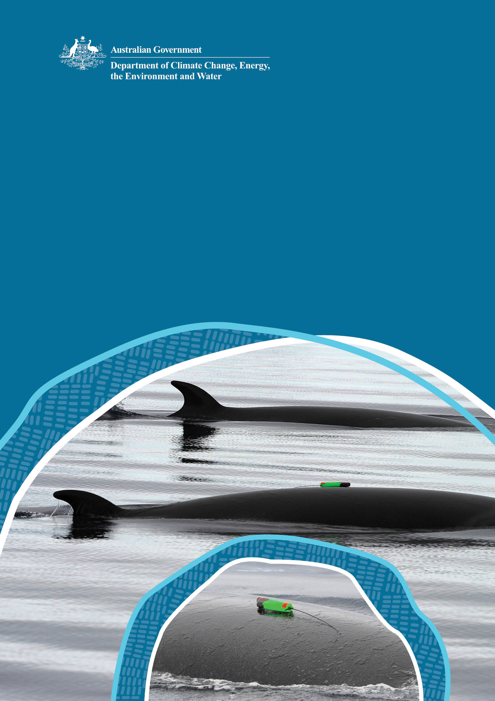

National Guidelines on the use of Tagging for Cetaceans

© Commonwealth of Australia 2025
Ownership of intellectual property rights
Unless otherwise noted, copyright (and any other intellectual property rights) in this publication is owned by the Commonwealth of Australia (referred to as the Commonwealth).
Creative Commons licence
All material in this publication is licensed under a Creative Commons Attribution 4.0 International Licence except content supplied by third parties, logos and the Commonwealth Coat of Arms.
Inquiries about the licence and any use of this document should be emailed to copyright@dcceew.gov.au.

Cataloguing data
This publication (and any material sourced from it) should be attributed as: DCCEEW 2025, National Guidelines on the use of Tagging for Cetaceans, Department of Climate Change, Energy, the Environment and Water, Canberra, CC BY 4.0.
This publication is available at dcceew.gov.au/publications.
Department of Climate Change, Energy, the Environment and Water
GPO Box 3090 Canberra ACT 2601
Telephone 1800 900 090
Web dcceew.gov.au
Disclaimer
The Australian Government acting through the Department of Climate Change, Energy, the Environment and Water has exercised due care and skill in preparing and compiling the information and data in this publication. Notwithstanding, the Department of Climate Change, Energy, the Environment and Water, its employees and advisers disclaim all liability, including liability for negligence and for any loss, damage, injury, expense or cost incurred by any person as a result of accessing, using or relying on any of the information or data in this publication to the maximum extent permitted by law.
Acknowledgements
The Department of Climate Change, Energy, the Environment and Water would like to acknowledge all those who contributed to the development of the National Guidelines on the use of Tagging for Cetaceans. We are grateful to Drs Nick Gales, Mike Double and Virginia Andrews-Goff for assistance in developing the draft guidelines and to State government agencies (Department of Natural Resources and Environment Tasmania and the Western Australian Department of Biodiversity, Conservation and Attractions), the Great Barrier Reef Marine Park Authority, Australian Antarctic Division, and technical experts Curt and Micheline Jenner, Michele Thums, Luciana Moller, Kate Sprogis and Olaf Meynecke for further technical reviews.
Front cover images
Attachment of a non-invasive suction cup tag on minke whales (Balaenoptera bonaerensis) © Ari Friedlaender/AAD.
Acknowledgement of Country
Our department recognises the First Peoples of this nation and their ongoing connection to culture and country. We acknowledge First Nations Peoples as the Traditional Owners, Custodians and Lore Keepers of the world's oldest living culture and pay respects to their Elders past and present.

Contents
1 Introduction 1
2 Purpose and scope 3
3 Tag types 4
3.1 Non-invasive tag 6
3.2 Invasive tag 7
3.2.1 Type A (anchored) tags 7
3.2.2 Type B (bolt-on) tags 8
3.2.3 Type C (consolidated) tags 9
4 Animal welfare and legal considerations 10
4.1 Potential impacts to cetaceans from tagging 10
4.2 National code of conduct and regulatory considerations 13
4.2.1 Australian code for the care and use of animals for scientific purposes 13
4.2.2 Animal Ethics Committee approval 13
4.2.3 Commonwealth and State government legislation and permit requirements 14
5 Best practice procedures for tagging 15
5.1 Initial planning 15
5.1.1 Explicit research objectives and management application 15
5.1.2 Appropriate planning and resourcing 15
5.1.3 Engagement on species cultural, social, and economic considerations 17
5.1.4 Established standard operating procedures 17
5.2 Operational needs and considerations 18
5.2.1 Experienced personnel 18
5.2.2 Focal species and animal demographic 19
5.2.3 Choice of tag type 20
5.2.4 Tagging platform 20
5.2.5 Tag sterilisation 21
5.2.6 Tag deployment 22
5.2.7 Tag placement 24
5.3 Post-tag monitoring and reporting 24
5.3.1 Post-tag monitoring and follow-up studies 24
5.3.2 Reporting on tagging studies 26
6 Tag development 27
6.1 Development and validation of new methods / attachments 27
References 29

Figures
Figure 1. Illustrations of the two main categories of tags: non-invasive (e.g. suction cup tag) and invasive (type A, B, C) tags ( 4
Figure 2. Tagging a minke whale using a non-invasive suction cup tag and the pole technique. 6
Figure 3. A minke whale tagged with an invasive Type A LIMPET tag, prior to the tag deployment cup and arrow (in orange) disengaging. 7
Figure 4. A stranded pilot whale prior to release with an attached invasive Type B fin mount tag (2008). © Marine Conservation Program, Department of Natural Resources and Environment Tasmania 8
Figure 5. Tagging a humpback whale using an invasive Type C tag. The tag is implanted in the whale whilst the tag carrier (orange component) has disengaged and will ultimately float in the water until retrieved. 9
Figure 6. A decision-making process when considering a cetacean tagging study. 16
Figure 7. Tracking a blue whale for tag deployment and biopsy sampling. 21
Figure 8. Approach of a blue whale for tag deployment. © CWR Grace Russell 23
Figure 9. Tag placement of a non-invasive suction cup tag on a minke whale (top), located high on the dorsum, forward of the dorsal fin and orientated lengthways along the body. 25
Figure 10. Tag placement of invasive type A tags on a blue whale, located high on the dorsum and well forward of the dorsal fin. 25
Figure 11. Tag placement location (red arrow) on a female southern right whale, with the tag located high on the dorsum and in the fat roll posterior to the blow hole. 25
Table
Table 1. Comparison of tag types and their applications 5
Abbreviations
AEC Animal Ethics Committee
AWS Australian Whale Sanctuary
DTAG Digital Acoustic Recording Tag
EPBC Act Environment Protection and Biodiversity Conservation Act 1999
LIMPET Low Impact Minimally Percutaneous Electronic Transmitter
NHMRC National Health and Medical Research Council
RPA Remotely Piloted Aircraft
SOP Standard Operating Procedure
UAV Unmanned Aerial Vehicle
VHA Visual Health Assessment

Introduction
A fundamental understanding of cetacean biology, ecology, movements, habitat use, behaviour, and health is challenged by the difficulty of accessing and observing these mobile animals in their marine environment. Cetaceans are inherently difficult to observe and study because they spend most of their time underwater, often at depth and/or in remote areas, and can range across large temporal (e.g. seasonal migrations) and spatial scales (e.g. tens to thousands of kilometres). This challenge can be partly overcome by using animal-borne monitoring instruments or bio-logging tags (herein referred to as ‘tags’) to track movements of individual animals. Tags are used globally to collect a range of data, including behavioural (e.g. dive depth and duration, acceleration, geographic position), physiological (e.g. heart rate, body temperature) and environmental (e.g. water temperature, salinity) data to help inform cetacean conservation and management (Andrews et al. 2019). In a management context, tagging can also be important in cases of cetacean strandings whereby tags attached to stranded cetaceans can be used to determine the fate of rescued individuals following a stranding event and assess the short- to medium-term success of stranding management techniques (Whaley & Borowski 2009, Gales et al. 2012, Wells et al. 2013).
The use of tags deployed on marine mammals has been increasing largely due to improved technologies that result in smaller devices, with improved sensors, data storage, and data transmission capabilities (McIntyre 2014, Andrews et al. 2019, Holton et al. 2021). Tags designed for cetaceans are commercially available or custom-designed and incorporate a range of designs for different species, applications and attachment mechanisms (e.g. Digital Acoustic Recording Tag (DTAG), Low Impact Minimally Percutaneous Electronic Transmitter (LIMPET) tag and implantable satellite tag). The attachment method for tags used on cetaceans includes suction-cup, bolting through body parts, and implantation (to varying depths) into the body (Weller 2008). The type of data generated is dependent on the tag used and deployments can range temporally from hours to over a year, and spatially from hundreds of metres to thousands of kilometres. There are a range of electronic instruments/packages integrated into tags to collect this information (e.g. time depth recorders, GPS receivers, accelerometers, acoustic, and video recorders). These instruments/packages are designed for short- to medium-term (hours, days and months) behavioural and ecological studies (e.g. Goldbogen et al. 2017) and for longer duration (months to a year) large-scale migration telemetry studies (e.g. Andrews-Goff et al. 2018, Ferreira et al. 2024).
Research on cetaceans (as with other vertebrate species) raises important issues of animal welfare and ethical considerations. This is due to legislative responsibilities for their protection and responsible care and because most cetaceans are considered to be sentient animals due to their high cognitive abilities, complex communication and social structures, strong social bonds, cultural learning, and that they can exhibit emotion (Frohoff & Bekoff 2018, Delfour & Charles 2021, South et al. 2023). Tagging has the potential to detrimentally affect the physiology, health, and behaviour of cetaceans because it involves attaching equipment to an animal. This can result in impacts that can include behavioural and physiological changes (e.g. stress), localised or systemic infection, pain, and potentially mortality (Weller 2008, Gulland et al. 2024). Furthermore, it will often involve approaches by humans (e.g. vessel approaches) into close proximity of cetaceans that can increase the risk of harm/disturbance. Consequently, it is imperative that the conservation value and management/scientific outcomes of tagging are clearly justified. In particular, the results must contribute in a demonstrable way to the conservation of the focal species. The justification for tagging methodologies must be evaluated against, and be proportional to, the ethical and animal welfare considerations. Additional care must be exercised when tagging threatened species.
Tag development is an ongoing area of research that largely focuses on tag design, sensors and attachment, and benefits from evolving technological developments and innovation. Recent focus has been on more benign approaches in tag attachment methods that utilise technological improvements (e.g. use of Unmanned Aerial Vehicles (UAVs) or Remotely Piloted Aircraft (RPAs), known as drones) to minimise close human/boat approaches to cetaceans (Wiley et al. 2023). Significant international efforts are invested in tag developments involving a diverse range of interest groups, including tag developers, researchers, government/conservation managers, veterinarians, and engineers. It is critical for continued tag development to focus on animal welfare and further inform our understanding of best practice cetacean tagging methods.

Purpose and scope
The National Guidelines on the use of Tagging for Cetaceans (Tagging Guidelines) provide guidance to researchers and regulatory decision-makers on existing best practice standards for tagging cetaceans in Australian waters. The Tagging Guidelines cover the use of invasive tags (i.e. percutaneous implants and bolt-on techniques) and non-invasive tags (i.e. tags attached to the skin/body surface) applied to the Australian context, with specific focus on the consideration of animal welfare and ethics, conservation outcomes and operational requirements. The objectives of the Tagging Guidelines are to ensure:
- Tagging is scientifically and ethically justified and is the most appropriate method to address research and management questions.
- Tagging operations follow best practice to minimise risks to both human and animal safety and welfare.
- Tag type selection accounts for species conservation status, life stage vulnerabilities, and the need to maximize data quality while minimizing risk of harm to tagged animals.
The Tagging Guidelines should be read in conjunction with the internationally adopted Best practice guidelines for cetacean tagging (Andrews et al. 2019) and Guidelines for the treatment of marine mammals in field research (Gales et al. 2009b). Andrews et al. (2019) provides comprehensive ‘best-practice’ recommendations for cetacean tag design, tag deployment, and post-tagging monitoring and Gales et al. (2009b) focuses on the principles of research design and the ethical treatment and handling of marine mammals in the field. The Tagging Guidelines have considered, and incorporated where appropriate, the relevant information from these two internationally developed and adopted guidelines, and the most contemporary scientific research findings relating to best practice for tagging cetaceans. The Tagging Guidelines should also be read in conjunction with the Australian Government National Health and Medical Research Council (NHMRC) Australian code for the care and use of animals for scientific purposes (NHMRC 2013) and Best practice methodology in the use of animals for scientific purposes (NHMRC 2017).
The Tagging Guidelines provide a logical framework to expand the scope of tag types and tagging techniques into the future as new technologies are developed and demonstrated to be scientifically and ethically appropriate.

Tag types
There are two main categories of cetacean tags that are defined according to the method of attachment to the animal: (1) non-invasive tags that do not penetrate the animals skin, and (2) invasive tags that do penetrate the skin (Figure 1) (Andrews et al. 2019). Tags are essentially comprised of mechanical and electrical systems containing sensors and data sampling electronics integrated into a protective housing and an attachment mechanism to the animal. The tags can be archival, telemetry-based, or both (e.g. archival pop-up tags). Archival tags record data that is stored in the tag and requires retrieval, whereas telemetry-based tags wirelessly transmit (telemeter) data to receiving equipment (e.g. satellite system).
Non-invasive archival tags generally contain high-rate sensors that use a wide data bandwidth (e.g. accelerometers, hydrophones, cameras) for short term durations due to limited recording capacity, storage capacity, and the need to recover the device to obtain the data. In contrast, invasive tags implant into the animals’ body and are therefore more reliable and suitable for longer-term deployments with lower data bandwidth recording requirements or onboard processing to transmit summarised data (Table 1).
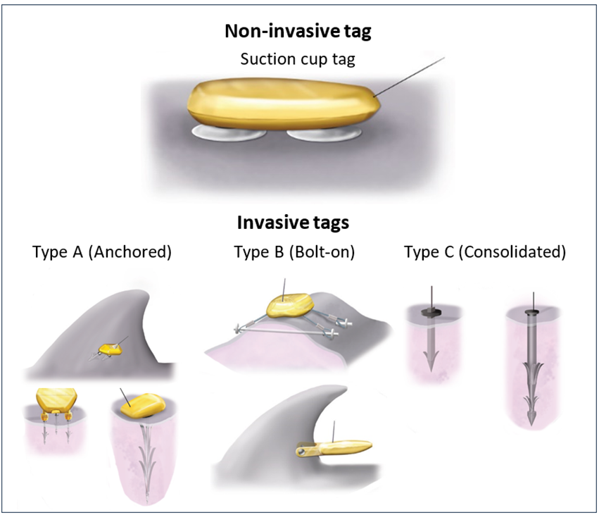
Figure 1. Illustrations of the two main categories of tags: non-invasive (e.g. suction cup tag) and invasive (type A, B, C) tags (
Andrews et al. 2019).

Table 1. Comparison of tag types and their applications
Tag type
 | Non-invasive | Invasive Type A | Invasive Type B | Invasive Type C
Tag examples | DTAG, CATS, Acusounde | LIMPET, MiniPAT | KiwiSat, Finmount |  | Transdermal, RDW
Attachment method | Suction cups, harnesses, peduncle belts attached to body without breaking skin. | Electronics package external to skin and attached by short barbs with petals that penetrate skin and blubber or tethered with blubber anchor. | Electronics package external to skin and attached using bolts mounted through tissue, e.g. fin. |  | Electronics and retention elements implanted into blubber and/or muscle.
Tag attachment duration | Short  Hours, occasionally days | Medium  Weeks, occasionally months | Medium  Months |  | Long  Months, occasionally > 1 year
Tag sensors | - GPS location  - Accelerometer  - Magnetometer  - Gyroscope  - Pressure transducer  - Light  - Temperature  - Hydrophone  - Video  - Electrocardiogram | - ARGOS/GPS location  - Depth  - Temperature  - Light | - ARGOS/GPS location  - Depth  - Temperature  - Light |  | - ARGOS location  - Depth  - Temperature  - Light
Tag application | - Fine-scale (3D) movement (short-term)  - Dive behaviour  - Feeding events  - Acoustics  - Physiology | - Movement data (medium-term)  - Time series and summarised dive behaviour | - Movement data (medium-term)  - Time series and summarised dive behaviour |  | - Movement data (long-term)  - Time series and summarised dive behaviour

Non-invasive tag
A non-invasive tag has an attachment that does not penetrate through the skin and includes attachments such as suction-cups (Figure 2), as well as harnesses, glue and peduncle belts which may be used on other marine mammals. Non-invasive tags are typically used to obtain high resolution, short-term data (hours to days) over localised spatial scales (metres to kilometres) to investigate animal movement, behaviour and physiology.
Despite these tags being classified as non-invasive, they can still cause adverse effects on cetaceans, particularly in terms of disturbance and/or tag-induced drag on the animal (dependant on the size of the tag and the animal) and stress or disturbance through the deployment process. While harnesses or a peduncle belt are often used on sirenians to obtain satellite tracking data (Marmontel et al. 2012), there can be an increased risk of entanglement and harnesses are not recommended with free-ranging cetaceans (Andrews et al. 2019). Suction cups are the most common non-invasive attachment that have been used on many species and present the least potential impact on the study animal compared to other non-invasive tags.

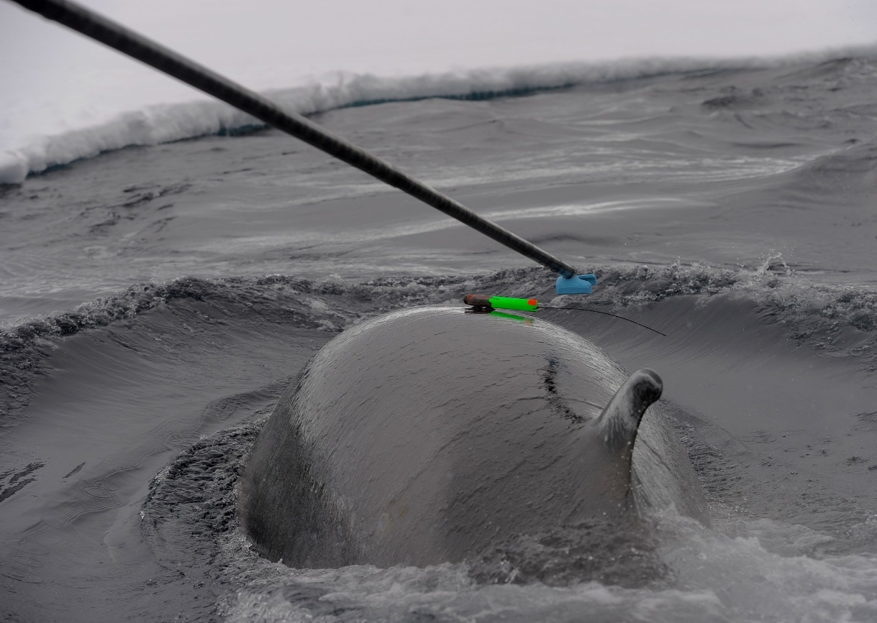
Figure 2. Tagging a minke whale using a non-invasive suction cup tag and the pole technique.
© Ari Friedlaender

Invasive tag
An invasive tag has an attachment designed to intentionally break the skin for the duration of the tag deployment, regardless of how large or deep the break in the skin. Invasive type A and C tags are usually deployed using pneumatic firearm, crossbow, or pole by teams of trained people from various sized boats, requiring approach ranges to animals of 10 m or less. In contrast, type B tags require capture and restraint of the animal to attach the tag. Based on Andrews et al. (2019), invasive tags can be divided into the following three categories.

Type A (anchored) tags
Type A tags are anchored into the dermal/hypodermal tissue of the dorsum of the body (Figure 3) or the central core tissue of the dorsal fin, typically with solid shafts of backward facing barbs as anchors. The electronics package is external to the skin and the anchoring system punctures and terminates below the skin (Figure 3). An example is the LIMPET that was designed for small-medium sized cetaceans, comprising species previously considered too large or difficult to manually capture, and too small for Type C invasive tags. These tags are generally deployed using remote attachment methods (e.g. firearm, crossbow, pole) with no need for restraint of the animal. The standard dart contains two rows of three petals (six petals total) and is 68 mm long. The short dart contains a single row of three petals (three petals total) and is 45 mm long. Due to the small barb sizes, these tags have the benefit of causing less deep tissue trauma relative to longer invasive tag types. However, when used on larger cetaceans with thick blubber layers, attachment times are likely to be shorter than deeper implant tags.

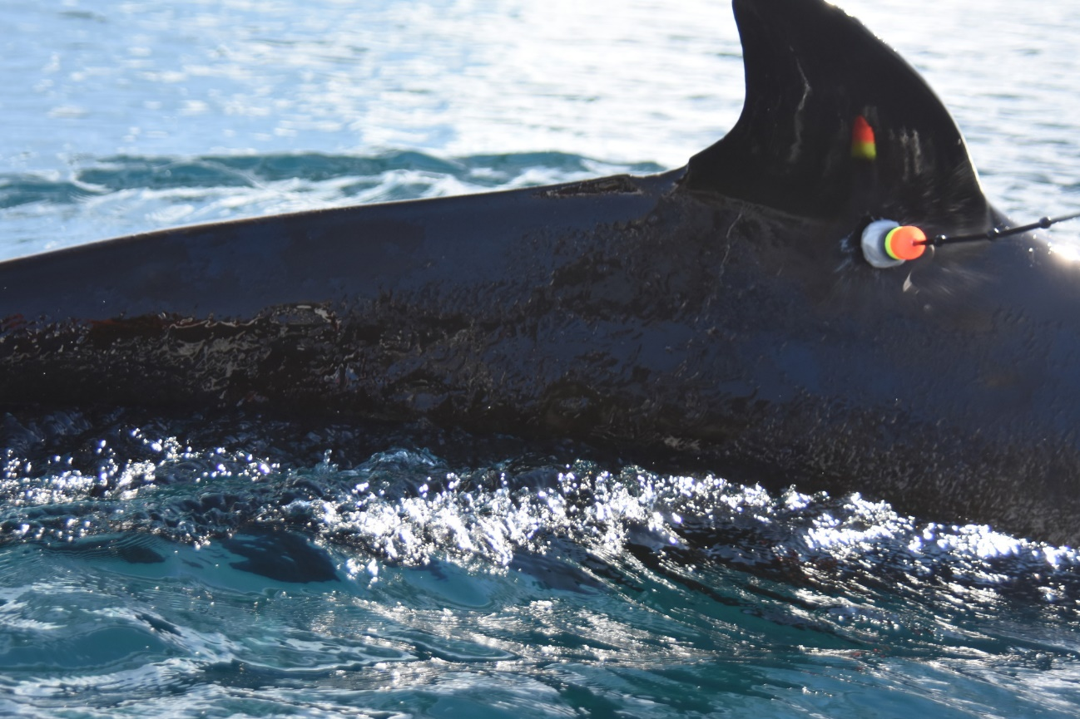
Figure 3. A minke whale tagged with an invasive Type A LIMPET tag, prior to the tag deployment cup and arrow (in orange) disengaging.
© Elanor Bell

Type B (bolt-on) tags
Type B tags have external electronics and one (i.e. single pin) or more (multiple pin) piercing anchor(s) that are typically attached through the dorsal fin, or dorsal ridge, of small to medium-size cetaceans and fixed with external bolts. These tags require capture and restraint of the animal to create the hole for the anchor and bolt to be attached, with new developments focussing on remote deployment (Balmer et al. 2023, Moore et al. 2024). Bolt-on tags have been attached using a single-pin anchor that bolts a v-shaped tag design trailing the dorsal fin (Figure 4), a three-pin design with the tag bolted on one side of the dorsal fin and a flat plate held on the opposite side, and a ‘spider-legs’ tag where the tag is situated over or near the dorsal ridge and connected via cables to piercing anchor pins, rods or bolts (Andrews et al. 2019). The safest way to attach long-term tags to small cetaceans is using a single-pin tag design given it has the least impact to the dorsal fin through drag effects and migration out of the dorsal fin (Balmer et al. 2014), and a core biopsy technique rather than a piercing method for a more sterile approach (Deegan et al. 2023).

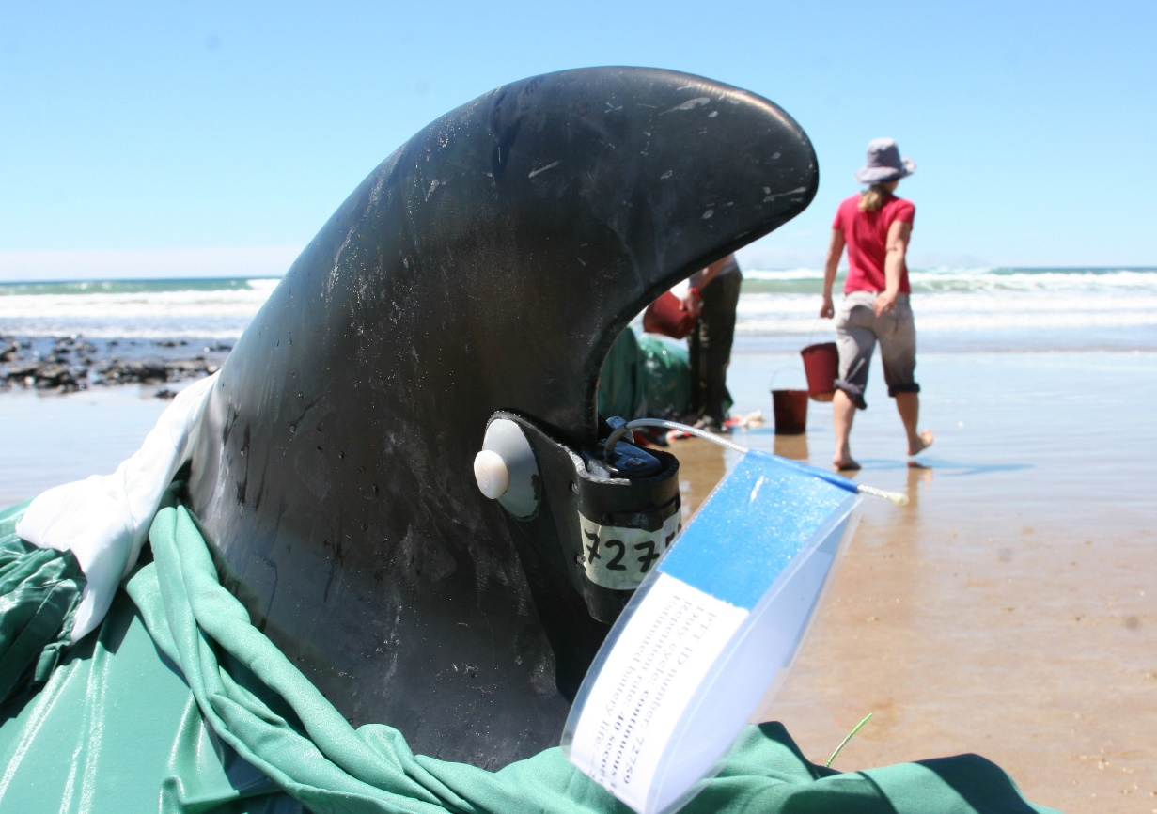
Figure 4. A stranded pilot whale prior to release with an attached invasive Type B fin mount tag (2008). © Marine Conservation Program, Department of Natural Resources and Environment Tasmania

Type C (consolidated) tags
Tag anchoring systems and electronics packages are consolidated and implanted in the body of the animal. Only a small part of the top of the tag, including relevant sensors and antenna, are external to the body and exposed for data transmission (Figure 5). These tags are typically used on large cetaceans and partially anchor below, or at, the fascia or blubber-muscle interface, depending on tag length and animal size. A newer ‘blubber’ tag design has also been developed to implant only in the blubber layer. These tags are deployed using remote attachment methods (e.g. firearm) with no need for restraint of the animal. The current Type C tag design fully integrates the electronics into a single tag, as opposed to older designs that included an anchor articulation and/or a tag–anchor interface. This newer design is recommended over previous articulated versions, given it provides better short-term health outcomes (e.g. less localised swelling) and is more robust to forces that have resulted in tag breakage or technical failure in previous designs (Zerbini et al. 2023).

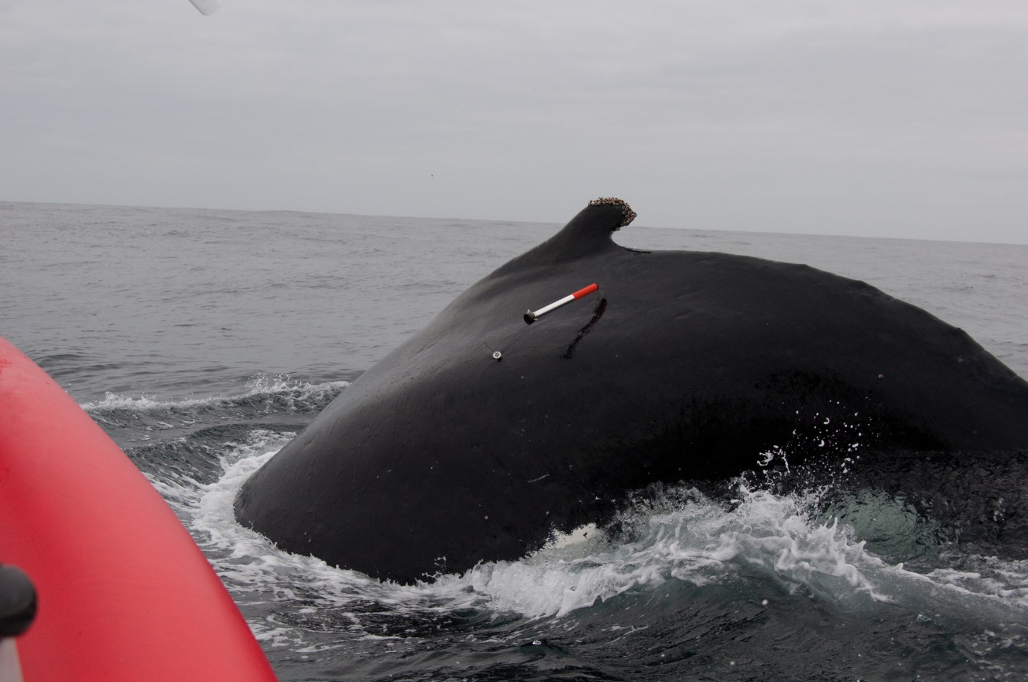
Figure 5. Tagging a humpback whale using an invasive Type C tag. The tag is implanted in the whale whilst the tag carrier (orange component) has disengaged and will ultimately float in the water until retrieved.
© Sarah Laverick

Animal welfare and legal considerations
Tagging cetaceans is a research method that can provide many benefits, yet there are also potential risks to both animal and human welfare and safety (Hassel et al. 2022). Tagging cetaceans has the potential to detrimentally affect the physiology, health, and behaviour of animals. These effects of the tagging process (i.e. close approaches to animals) and tag attachment can be short (minutes to days), medium (days to months), or long-term (months to years), and range from minor to lethal. Consequently, projects that tag cetaceans must adhere to high animal welfare requirements and should provide rigorous justification for the research under both Commonwealth and State legislation.
Animal ethics approvals are taken into consideration by the regulatory permitting agency assessing the tagging activity (i.e. Commonwealth or State Government), however, the final decision of whether to grant a permit or not is at the discretion of the relevant permitting agency. Factors influencing this decision include the conservation status of the target species, perceived and real levels of risk, and justification for the activity. Permitting agencies are encouraged to take a precautionary approach to tagging, particularly for threatened species, and to avoid risks to certain life stages (e.g. pregnant females or females with calves).

Potential impacts to cetaceans from tagging
The impacts to cetaceans from tagging may range from negligible to severe and have both acute and chronic effects that can result in behavioural and physiological responses, localised or systemic infection, pain, and sometimes mortality (Weller 2008, Robbins et al. 2013, Isojunno & Miller 2015, Williamson et al. 2016, Guzman & Capella 2017, Norman et al. 2018, Zerbini et al. 2023, Gulland et al. 2024). There has been limited studies, and currently little evidence, for longer-term, population level effects related to reductions in reproductive success and survivorship (Best & Mate 2007, Mizroch et al. 2011, Robbins et al. 2013, Gendron et al. 2015). There is relatively more information available on short-term compared to long-term impacts of tagging given immediate to short-term responses to tagging (e.g. surface behaviour, movement of travel) are documented at the time of tagging (Walker et al. 2012). The nature of an individual’s tagging response may depend on a range of factors including the species, age, sex, reproductive state and body condition, presence of dependents/offspring, tag type, tag application method, and the environmental and social context at the time of tagging (Weller 2008).
In the case of behavioural and physiological responses to tagging, the response may be significant enough to affect the interpretation of the data from tagged animals near the time of tagging given it may not be considered representative of normal behaviour (Mul et al. 2019, Warren et al. 2020, Shuert et al. 2021). In some cases, researchers may exclude data from subsequent data analyses at the time of tagging and immediately after, as a precautionary measure. Distinguishing between the response of animals to the disturbance associated with close approach by a vessel (that may be essential to tag deployment) from the response to tag deployment can be challenging (Williamson et al. 2016). Regardless, negative impacts from the procedure of tagging need to be minimised irrespective of whether it arises from the presence of the vessel or application of the tag.

The most common non-invasive tag uses a suction cup attachment, which presents the least potential impact on the study animal without direct injury or risk of infection. However, even though the tag does not penetrate the skin and represents a low level of risk to the animal, they can still cause short-term, adverse effects on cetaceans in terms of disturbance and/or tag-induced drag on the animal (dependant on the size of the tag and the animal), and stress or disturbance through the deployment process (Hanson & Baird 1998, Hooker & Baird 2001, Isojunno & Miller 2015). These responses can include changes to dive cycles, increased swim speed (Hanson & Baird 1998, Schneider et al. 1998, Hooker et al. 2001, Nowacek et al. 2004, Warren et al. 2020), and stronger responses of vessel avoidance over periods of days post tagging (Schneider et al. 1998). In most studies, the prior behavioural state of the animals appeared to influence their response to tagging.
Invasive tags are all designed for sub-dermal penetration whereby the tag penetrates the skin and anchor either in the blubber only or below/at the blubber-muscle interface (i.e. the fascia). Type A invasive tags are designed with retention barbs to anchor in the dorsal fin or blubber of a whale beneath the skin layer, and have been successfully applied to at least 22 cetacean species (IWC 2020). This tag is considered to have the lowest risk of the invasive tags due to the shorter barbs (~7 cm), although potential impacts to individuals can occur due to infection or breakage of the dart. Breakage of barbs, leading to retained fragments in cetaceans, can occur during the attachment or detachment process, and/or caused by animal-to-animal contact (e.g. right whales in contact with surface active groups or the seafloor). When the invasive dart or barbs of the tag breaks, chronic inflammation and possible infection or introduction of a pathogen can occur.
For invasive Type B tags, the time spent capturing and/or handling the animal for tag attachment can have a significant effect on the response of animals to tagging, and should be minimised to the least amount of time needed. For example, narwhals recover relatively quickly following capture, handling and tagging procedures, although extended handling times (i.e. > 40 minutes) have been demonstrated to elicit the greatest response in their activity levels and swimming behaviour (Shuert et al. 2021). Consequently, maximum handling time thresholds should be developed and not exceeded based on data of known effects from handling times and/or knowledge of species biology and behaviour. To remove the need for capturing cetaceans when attaching fin-mount tags, a remote attachment system using a pole has been developed (Tag Attachment Device; TADpole) for attaching single-pin fin tags to the dorsal fin of free-swimming dolphins (Moore et al. 2024). Follow-up studies to assess tag site tissue responses from fin tags, and health of the tagged dolphins, suggest no apparent long-term detrimental effects (e.g. Balmer et al. 2011). However, fin damage can result from migration of the pierced pin (anchor) through the fin and result in more severe immunological response (e.g. swelling) at the tag site, particularly when using multiple-pin tags (Sonne et al. 2012). Single pin tag attachment models have a smaller effect on the dorsal fin if tag migration occurs when compared to multi-pin tag attachment models, and are recognised as the safest design with the least immunological impact (Balmer et al. 2014).
Most studies that address the impacts of tagging on cetaceans have focused on Type C invasive tags that may be more prone to causing pain, discomfort and infection. Type C tags have typically been designed to anchor in the connective tissue and muscle underlying the blubber in order to achieve long tag deployment durations by preventing premature shedding of the tag (e.g. Mate et al. 1998, Mate et al. 2007). The immediate physical effects include responses to the impact and penetration of the tag at deployment (e.g. blood haemorrhage and cell damage), and physiological responses of blood clotting and swelling due to inflammation, which can be localised (e.g. < 30cm around the tag site) or regional (e.g. > 30cm around the tag site) (Weller 2008, Gendron et al. 2015, Norman et al. 2018). Chronic health effects may arise from complications of swelling and/or wound infection, as well as from any movement (horizontal or vertical) of the tag within the animal. A known impact and ongoing concern from any implantable tag designed to anchor at, or below, the fascia is shearing at the muscle blubber interface due to the muscle layer moving in different directions to the overlying blubber layer (Moore et al. 2013, Moore & Zerbini 2017, Zerbini et al. 2025). In early type C tag designs (i.e. known as Type I tag), there was a single articulation point connecting the anchor and transmitter designed to compensate for a degree of tag movement between the muscle and blubber layers (Gales et al. 2009a). Design flaws were found due to breakage and iterative tag design improvements have resulted in the tag anchor and electronics housing fabricated as a single body to prevent tag breakages inside the animal. Subsequent deployments of this tag design have indicated little to no detrimental health effects or tag breakage in re-sighted large whales, such as southern right whales and humpback whales (Zerbini et al. 2017, Zerbini et al. 2023, Gulland et al. 2024). The issue of muscle-blubber shearing from implantable tags is an ongoing concern and potentially it may only be multi-articulated or fully flexible anchoring systems that could best accommodate shearing forces and result in lower impacts to whales (Zerbini et al. 2025).
In rare cases, mortality of tagged individuals can occur which has been related to use of invasive tags, although it can be difficult to determine whether the tag had a direct or indirect cause in the mortality. An eastern gray whale was found dead on the beach during a tagging study (using Type C tags) in 2005 without its tag 18 days post-attachment, and while a necropsy 11 days post-mortem found no evidence of tag site infection, an evaluation and histological assessment of the tag-induced wound was not possible due to the pronounced state of decomposition and the tag was no longer implanted (WGWAP 2006, Weller 2008). There has been one reported case of mortality of a killer whale tagged with a Type A tag in 2016 that died from a lethal fungal infection approximately four weeks after tagging, with the proximate cause of death potentially attributed to the relatively deep tissue perforation from the tag deployment and the ultimate cause of mortality due to disseminated mucormycosis (IWC 2020). There have also been two recent (2022 and 2024) cases where southern right whales tagged using Type C tags were found dead when stranded onshore following being tagged approximately two weeks prior (Harcourt et al. 2025). Given only a very small number of whales were tagged and stranding events are rare in the area, there may be potential links to the tags. Despite no clear evidence of any such causal link between the tagging and the mortality events, the potential increased risk associated with using implantable tags cannot be excluded. Therefore, when developing a tagging project, our incomplete understanding of the risks associated with tagging cetaceans must be considered and a suitable precautionary approach taken. This is particularly important when tagging threatened cetaceans, such as southern right whales.

National code of conduct and regulatory considerations

Australian code for the care and use of animals for scientific purposes
In Australia, the State and Territory governments are responsible for the regulation of animal welfare, including the care and use of animals for scientific purposes through designated Animal Ethics Committees. All states and territories have incorporated into legislation the Australian code for the care and use of animals for scientific purposes (NHMRC 2013) (the Code), published by the Australian Government National Health and Medical Research Council. Research that involves the use of cetacean tagging must adhere to the Code and have consideration of the Australian Code for the Responsible Conduct of Research (NHMRC 2018) and Best practice methodology in the use of animals for scientific purposes (NHMRC 2017). The purpose of the Code is to promote the ethical, humane and responsible care and use of animals for scientific purposes in accordance with the obligation to respect the animals. The Code applies to live non-human vertebrates and encompasses all aspects of the care and use of animals, including the use of animals in research and environmental studies.
Determination within the Code on whether a proposed use of an animal is ethically acceptable is based on a set of governing principles including applying the Replacement, Reduction and Refinement principles (the 3Rs) at all stages of animal care and use. This determination must consider the balance between whether the potential effects on the wellbeing of the animals involved are justified by the potential benefits. Specifically, the determination must be based on information that demonstrates that respect for animals will underpin all decisions and actions involving the care and use of animals for scientific purposes. This includes supporting the wellbeing of the animals involved, and avoiding or minimising harm (including pain and distress) to those animals. Importantly, in accordance with the Code, the wellbeing of animals used for scientific purposes must be considered in terms of the cumulative effects over the animals’ lifetime. Wellbeing considerations have implications for the use of invasive tags on previously tagged animals, such that any known prior tagging history of an individual must be accounted for in proposed tagging studies.

Animal Ethics Committee approval
Any activity that is likely to be intrusive and have an impact on a cetacean, such as tagging or biopsy sampling, must be approved by an Animal Ethics Committee (AEC) prior to the activity taking place. It is a condition under Commonwealth and State and Territory permits that animal ethics must be approved by an AEC to be able to undertake tagging of a cetacean (which includes proof of competency to undertake activities), and it is recommended that ethics approval is sought before permits are applied for. Any permits issued for cetacean tagging are only valid when used in association with a current approval by an AEC and only for the species and number of animals covered by that AEC approval.
All relevant information on the potential impacts of tagging to the welfare of cetaceans should be provided in animal ethics applications to enable an informed assessment of the impact of the activity. For studies involving testing new tag designs/equipment, it is expected that a high-level of information on its testing and experimental process, in addition to the consideration of impacts to the welfare of cetaceans, is provided in animal ethics applications.

Commonwealth and State government legislation and permit requirements
Stakeholders involved in the care and use of animals for scientific purposes must be aware of the relevant Commonwealth, State and Territory legislation and their obligations under the legislation. All states and the Northern Territory protect cetaceans within their waters (within 3 nautical miles of the coastline) under their own environmental (e.g. Biodiversity Conservation Act) and animal welfare (i.e. Animal Welfare Act) legislation and provide similar protection for whales and dolphins to that provided by the Australian Government in the Australian Whale Sanctuary (AWS).
Under the Australian Government Environment Protection and Biodiversity Conservation Act 1999 (EPBC Act), all cetaceans (whales, dolphins and porpoises) are protected in Australian waters within the AWS. The AWS includes all Commonwealth waters from the 3 nautical mile state waters limit out to the boundary of the Exclusive Economic Zone (i.e. out to 200 nautical miles, and further in some places). Within the Sanctuary, it is an offence to kill, injure or interfere with a cetacean, and severe penalties apply to anyone convicted of an offence. Consequently, in the AWS it is a requirement to obtain a permit under the EPBC Act to take, keep, move or interfere with (harass, chase, herd, tag, mark, or brand) a cetacean, and to possess or treat (divide or cut up, or extract any product from) a cetacean, and thus includes tagging cetaceans. For Australian citizens, it is also a requirement to obtain a permit to carry out such activities in waters beyond the AWS, in international or foreign waters. Permits may be required by other Commonwealth agencies (e.g. Great Barrier Reef Marine Park Authority, Parks Australia) if tagging is undertaken in marine parks.
Under state and territory legislation there is also the requirement to obtain permits for activities that intend to take, interfere, or disturb cetaceans within state and territory waters, which includes tagging cetaceans. Permitting conditions among state and federal permitting agencies should be consistent, particularly where the species and research may cross jurisdictions. Irrespective of whether tagging occurs in Commonwealth and /or state and territory waters, tagging a cetacean should be conducted in accordance with best practice as outlined within these guidelines. Transparency among permitting agencies on permitting conditions could be achieved through increased awareness and communication when issuing permits for tagging cetaceans. During the permit application stage, permitting agencies are strongly encouraged to consult species experts and state and federal permitting agencies relevantly experienced with permitting tagging studies, to enable consistency in the advice provided regarding assessment of the project objectives, methodology, conservation outcomes, and any resulting permit conditions.

Best practice procedures for tagging
Tagging can generate data critical to addressing a range of key management and scientific questions (outlined in section 1). However, it is essential that tagging is scientifically and ethically justified. Any decision to tag cetaceans requires an evaluation of the positive and negative effects to those individual animals and the conservation value of the project (i.e. management/scientific outcomes) and should be evaluated against the ethical and welfare considerations for the animal. The Bateson Cube is one appropriate decision tool framework to assist this decision making process (McMahon et al. 2012). A transparent decision-making process should be undertaken when considering the use of tagging in cetacean research studies, particularly when using invasive tags, as outlined in Figure 6. Justification for a tagging study needs to explicitly address these considerations in project proposals, funding proposals, and ethics and permit applications.

Initial planning

Explicit research objectives and management application
The first requirement when planning a tagging study is to clearly identify, and explicitly state, the research questions, objectives, and management applications of the project. All methods and existing data (particularly tag data) that could address the identified research questions should be consulted and evaluated prior to the decision to use tags. This would ensure that alternative methods have been considered, and evaluate whether tagging is critical to address the study objectives, and the tags will provide the most appropriate data. These existing data considerations should be provided within a justification of the tagging study.
It is important to consult with the relevant policy officers and conservation managers to ensure the data collection is necessary and likely to inform conservation and management decisions. Given the mobile nature of cetaceans and their ability to cross multiple jurisdictions, it may be necessary to consult with many agencies, and where possible collaborations are encouraged.
Following identification of the research objectives/management needs and determination for the need to tag, a risk assessment should be undertaken on the proposed species and tagging method. The tag type and technique that presents the lowest risk should be used to address specific objectives. Therefore, if non-invasive tags and techniques can be used to achieve the project objectives, these should be prioritised. If tagging is justified, effects on the target animals should be minimised by following the best principles of research design outlined in Gales et al. (2009b) and summarised in section 5.2.

Appropriate planning and resourcing
The tagging study should have adequate time allocated to project and field planning and be appropriately financially resourced to ensure a safe and successful tagging operation can be achieved. Site selection and timing of research can affect the success of tagging studies and must be strongly linked to the management and/or research questions of the tagging study. These factors can affect the potential degree of disturbance to animals and should be considered to minimise the

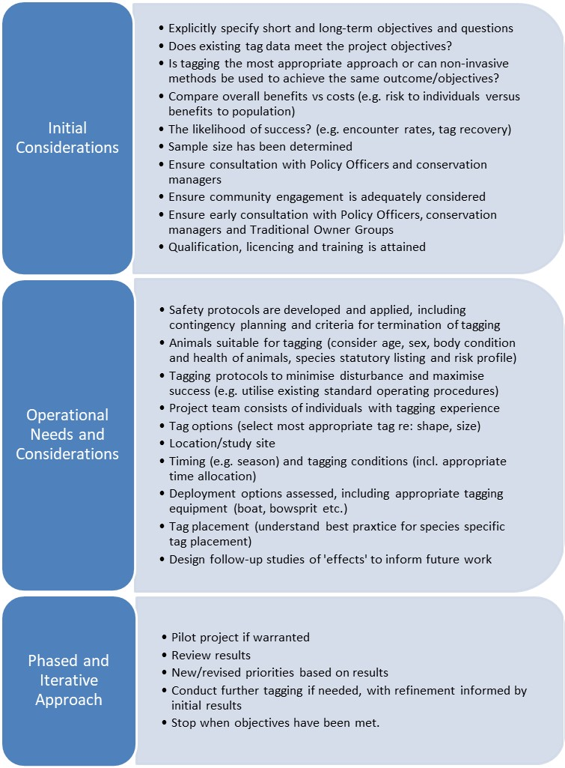
Figure 6. A decision-making process when considering a cetacean tagging study.
Adapted from Andrews et al. (2019)

disturbance. For example, animals may be more vulnerable to disturbance at a particular life-cycle stage (e.g. breeding season), behavioural state (e.g. calving, nursing), or habitat type (e.g. water depth). The prevailing weather conditions at the proposed time of tagging should be considered and accounted for in the planning and budget of the study. This will ensure tagging operations are conducted in optimal weather conditions and are not rushed or compromised due to weather constraints.
Tagging studies are typically expensive and need to be appropriately financially resourced, with the cost typically dependent on the tag type and potentially ranging from tens to hundreds of thousands of dollars. In general, the majority of costs in such a study are split between the purchase of the tag and satellite time (for satellite-linked tags, e.g. ARGOS) and the field research costs, including vessel time and personnel.

5.1.3 Engagement on species cultural, social, and economic considerations
It is necessary to consider and acknowledge the importance of cetaceans to various groups of people for cultural, social, and economic reasons, in addition to their scientific importance. These considerations should include engagement with First Nations Peoples, local community, and industry where tagging is intended to be undertaken.
Consultation with relevant Traditional Owner groups should occur in the initial planning stages of tagging studies, hereby recognising their management of Sea Country and the value of traditional knowledge. Consultation must occur when the species being tagged has cultural significance to First Nations Peoples, and Traditional Owner Groups should be provided opportunity for involvement in the planning and/or implementation stages of the tagging project. Early consultation will ensure that appropriate representative bodies are engaged and that any cultural sensitivities are identified.
There should also be consideration and engagement with the wider local community and relevant industries (e.g. whale-watching industry) that may live or operate where tagging studies are being undertaken. This is particularly important when industry is permitted for the same target species that tagging is being undertaken on. At a minimum, public engagement should be undertaken. Public consultation would consist of sharing research planning and objectives before the study commences and communicating results at the completion of the study. Engagement with local researchers, citizen groups, and local community will ensure appropriate communication of the tagging study is undertaken and potentially provide logistical support and knowledge that may ensure the success of the study.

5.1.4 Established standard operating procedures
The project team undertaking the tagging study should develop, and/or adopt a standard operating procedure (SOP) that comprises established protocols, levels of expertise required by personnel, a detailed procedure for tagging cetaceans and contingency planning. All personnel involved in the tagging should be familiar with the SOP and it should be disclosed in the permit and ethic approvals.
The SOP should address criteria on when a tagging program should be suspended/terminated due to unintended circumstances (e.g. a cetacean mortality event or an accident causing injury to humans and/or cetaceans). It should also include criteria addressing when to terminate tagging attempts, by specifying the duration or number of times a close approach of the tagging platform (i.e. vessel or UAV/drone) to an individual (or group) should not be exceeded. The termination criteria should include a response to signs of distress/disturbance and reflect any permitting conditions. SOPs should be progressively developed with respect to the incorporation of new knowledge and/or methodologies that can inform tagging protocols and have suitable contingencies that account for unexpected risks to the safety of animals and humans.

Operational needs and considerations

Experienced personnel
Successful tagging of cetaceans requires multiple skilled and qualified personnel (e.g. taggers and boat drivers) and it is essential that experienced and qualified personnel are involved with tag deployment in the field to ensure minimal risk to human and animal health and safety. Inexperience, or lack of familiarity with any aspects of the tagging procedure can present significant safety risks, and may compromise data quality. The roles of boat driver and tagger are critical given the success of the tagger is often directly related to the skill and experience of the boat driver. It is required that the boat driver is a qualified Coxswain skipper and the tagger is a licensed firearms holder that has undergone formal/accredited firearms training.
It is strongly recommended that taggers and boat drivers should:
- Have proven experience (acquired and demonstrated competency) in the tagging procedure or in similar biopsy sampling activities.
  - Boat drivers should have extensive experience and proficiency in the safe operation and handling of vessels near cetaceans, including experience with activities that require close approaches.
  - Taggers should be trained with the appropriate tags which should initially be undertaken under direct supervision of experienced personnel. It is recommended experience tagging common and more approachable species be undertaken prior to attempting to tag threatened species.
- Be familiar with the equipment used in tag deployment, including tag attachment and deployment devices, which can be achieved initially by undertaking training exercises in the absence of animals (land and sea), particularly when new tag designs and/or methods are being used.
- Have experience with the behaviour of the target species and/or similar species to minimise harassment of the animal and ensure human and animal safety.
There should be at least one team member on the vessel who has strong biological, ecological and/or behavioural knowledge of the focal species and can identify viable candidate individuals for tagging in the field. This includes the ability to undertake a visual behavioural and health assessment to ensure that the focal individuals are not injured or in a compromised state of health and do not exhibit abnormal behaviour.
Personnel can gain general experience and training by reviewing relevant literature for procedures, risks, and current best practice, through mentoring from experienced personnel, gaining familiarity with the species from field observations, and via direct experience and involvement in cetacean tagging studies undertaking roles other than boat driver and tagger (i.e. data recorder, photographer).

Focal species and animal demographic
The potential effects of tagging on animals may vary with intrinsic factors (e.g. animals’ age, sex, health, reproductive, and social status) and/or extrinsic factors (e.g. animals’ level of exposure to environmental and anthropogenic stressors) (Andrews et al. 2019). Justification in all documentation (e.g. ethic, permit and funding applications, publications) should therefore be provided for the selection of appropriate focal species, the animal demographic, tag type, and number of tag deployments, in accordance with the study objectives.
Tagging studies should first consider whether it is viable using focal species that are not a listed threatened species under the EPBC Act, while still addressing the study aims. This includes careful consideration of the species’ life history traits, and the appropriateness and potential impacts of the methods proposed. This is essential whenever there may be a higher risk of harm to the animal (e.g. using deep implantable tags), or where novel tag design and attachment are being developed and tested which may convey a perceived higher uncertainty in risk for the animal. For studies focussed on threatened species (particularly critically endangered, endangered), the aims of the study are often to address knowledge gaps to inform conservation management. The outcomes of the study should clearly demonstrate how the study will improve, or have the potential to improve, the conservation status of the species (Gales et al. 2009). Justifications for the use of the species must be explicitly stated against the management benefits.
Tagging studies should aim to select individuals that will be least affected by disturbance from the tagging process, while still satisfying the requirements of the research objectives. Specifically, tagging should not disrupt critical social bonds within groups of animals, particularly those of mothers and dependent young. Unless there is a stated high-level of justification for the study, tagging should be limited to cetaceans without dependent young (i.e. calves) and tagging calves (< 6 months) should not occur.
Individuals selected for tagging should be in apparent good health (e.g. body condition) which is undertaken via a visual health assessment (VHA), unless there is strong justification for using tags to monitor sick or injured animals (e.g. tagging entangled or stranded animals). A VHA before attempting to tag will assist in the identification of any pre-existing disease, predation, epizoites, and human-induced scarring or injury to individuals. VHAs using standardised protocols and a scoring system based on photographs have been developed for evaluating tag site wounds (Robbins et al. 2013, Andrews et al. 2019) and provide a valuable framework for identifying health indicators in the assessment of the health of an individual prior to tagging. In most cases, the use of aerial images from drones, in addition to lateral images, provide valuable information on the health of individuals due to accessing a greater portion of the animals’ body, and should be used whenever possible. VHAs have been applied to North Atlantic right whales (Pettis et al. 2004), southern right whales (Charlton et al. 2023), and humpback whales of the Arabian Sea (Minton et al. 2022) and Gulf of Maine (Gulland et al. 2024). Where protocols do not exist for a species targeted for tagging yet protocols exist for other related species, these assessments should be followed.

Choice of tag type
All tag design and deployment options should be explored when considering the appropriate tag type to use. Information should be obtained using peer-reviewed scientific articles, workshop/conference reports, and direct communication with researchers/management agencies with extensive tagging experience.
The main considerations when determining the type of tag used should include:
- Data needed/study objectives. The ability of the tag to provide the type, quantity, and resolution of data required to answer the objectives/questions of the research.
- Tag type. The tag is of appropriate size, weight, shape, and configuration for the species and sex/age class to be studied, and appropriate tag placement on the animal is undertaken for the species.
- Potential impacts. The selected tag type and tagging method have the least possible impact on the animals and will not significantly alter their behaviour, while still addressing the research objectives. The tag should result in minimal trauma to the animal and should not affect energetic costs, interference with body movements, predation risk, risk of entanglement, and social interactions.
In situations when multiple different tag types could be used to answer the specific management question(s), the tag type and deployment method considered to be the lowest risk should be used in alignment with animal ethics approvals. For example, the use of Type A tags should be considered if short-term datasets can address management/research questions as adequately as a Type C tag.

Tagging platform
Tagging is typically undertaken using small vessels (5-8 m length), that are often aluminium or rigid hull inflatable vessel types. However, the location for tagging and associated sea conditions may require the use of larger vessels (e.g. up to 28 m vessels have been used in Antarctica; Owen et al. 2019). Irrespective of the size of the vessel, there needs to be the ability for quick and clear communication among boat drivers and taggers and the primary requirement for taggers (and biopsy operators) is to have an unobstructed view and access to the animal at the bow of the vessel (Figure 7). For the purposes of satellite tagging, particularly when targeting large whales and using longer implantable tags, high elevation above the water line is required. Bowsprits should be used to facilitate this. The higher elevation will ensure greater downward orientation for tag placement (e.g. firing the tags) and potentially avoid traumatic impact by the tag impacting with the spine/vertebral column.
Non-invasive tags (e.g. suction cup tags) are often deployed using a carbon fibre pole, or an RPA (i.e. drone) (Wiley et al. 2023). Non-invasive tags may not necessarily require the use of a bowsprit, depending on the environmental conditions during the tagging procedure and the focal species. Where possible, the tag deployment should be conducted from platforms that will minimise stress or disturbance to individuals.
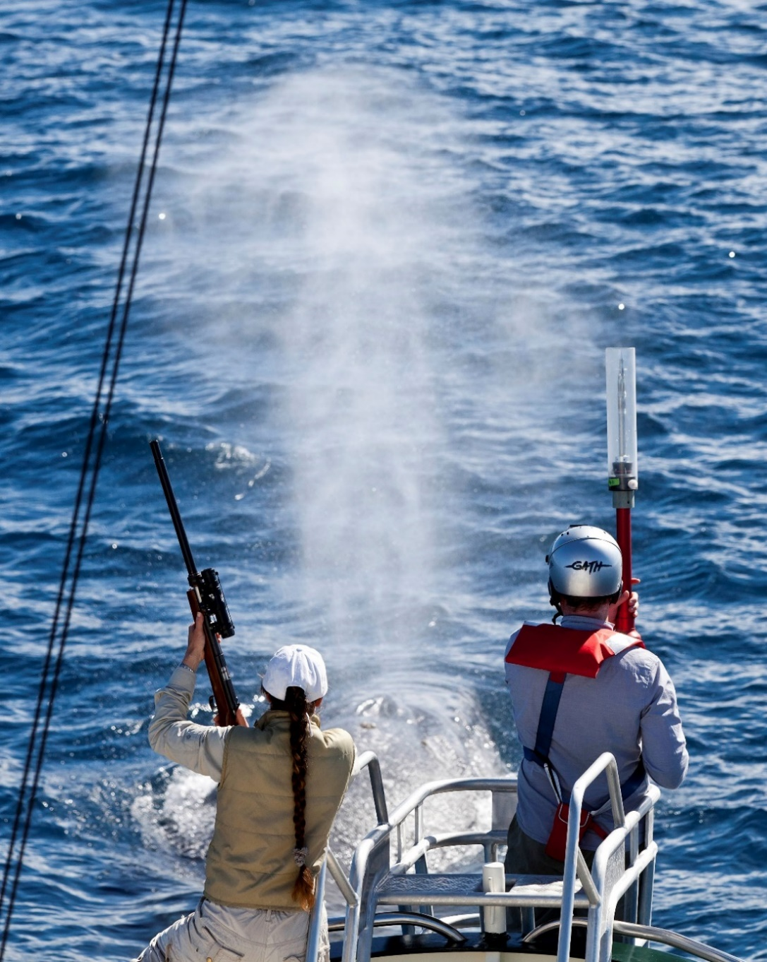
Figure 7. Tracking a blue whale for tag deployment and biopsy sampling.
© CWR Wayne Osborn

Tag sterilisation
Tags should be constructed of materials that are safe for skin contact. This applies to external parts in non-invasive tags, and to long-term implantation in mammalian tissue for implanted parts of invasive tags (regardless of the anticipated retention time). All tag components, especially implanted parts, must be disinfected through thorough washing and rinsing to clean any particles and chemical contaminants (e.g. machine oils). While the disinfection of implanted tags has always been common practice (Wells et al. 2013, Riekkola et al. 2018, Mackay et al. 2020) there are different levels of disinfection and even the highest level of disinfection does not kill or remove all microorganisms (Govindaraj & Muthuraman 2015). Few studies have looked at the biocompatibility of implanted tag materials and risks associated with wound infection (Smies et al. 2022) and there is a need for further research to guide the development of well-informed protocols on tag material choice and sterilisation techniques.
Following disinfection, researchers should adopt strict sterilisation protocols. Full sterilisation (i.e. killing or removal of all microorganisms, including viruses, fungi) to surgical-grade sterilisation standards is the recommended approach for implantable tags given improved understanding of the response of tissues to tag insertion and improved global animal welfare standards (Mate et al. 2015, Andrews-Goff et al. 2018, Andrews et al. 2019, Burek-Huntington et al. 2023). The full sterilisation process results in the killing or removal of all microorganisms, including viruses, bacteria, fungi, protozoa, and bacterial spores. Sterilisation of other pieces of the tag that are in contact with the implantable pieces, or with the whale, should be treated with high level disinfection (HLD), which can destroy all microbes except bacterial spores. A variety of sterilisation methods exist based on heat, radiation, or chemical exposure, although dry heat and steam sterilisation are not safe for most electronic devices.
Sterilisation techniques compatible with the tag electronics are often limited and difficult to access. Chemical gas sterilisation is highly recommended for tag sterilisation at a temperature tolerated by the tag electronics, and specifically the use of gas sterilisation with ethylene oxide. This method is widely employed in Australia in sterilisation/fumigation processes (ISO 11737-2:2019) and is preferred when using implantable invasive tags. After sterilisation, tags must be kept within sterilised packaging (e.g. sterile bags and tubing with end-covers for tags or implantable tag parts) and can be removed only when required for deployment. Even when tags are appropriately sterilised, tag handling prior to deployment is likely to contaminate the tag and should be minimised. If the penetrating elements of a tag become contaminated, they should be fully re-sterilised prior to use. Contamination could occur when implant parts come into direct contact with nonsterile surfaces, such as when handled by non-sterilised handlers or missing the target animal and landing in seawater.

Tag deployment
Adopted SOPs should be familiar to the tagging team and adhered to throughout the tagging process. Cetaceans that are targeted for tagging will have undergone a visual health assessment, and natural baseline behavioural data should be collected on the tagged individual and group members prior to tag deployment. Multiple sampling of tagged individuals should be avoided, given the consideration of cumulative tagging effects within an animal’s lifetime. However, tagging an individual with more than one tag and/or tag type may be done when using non-invasive and lowest risk tag types (e.g. Type A), which may differ in sensor setup and/or data transmission method (archive vs real time transmission). The ability to recognise individuals in the field is greatly enhanced when targeting species that have natural markings. Individual photo-identification should also be undertaken for all tagged animals. It is also recommended to obtain a genetic tissue sample using a biopsy probe to aid individual identification whenever photo-identification is not possible.
The tag deployment procedure should be documented through photographs and/or videos and tagged animals must be monitored immediately after tagging. This will aid in documenting the tag attachment site on the animal in sufficient resolution and enable subsequent evaluation of the condition and placement of the tag. If possible, an external part of the tag should be labelled with an identification number and contact information to facilitate identification of the research study whenever a tag, or a stranded cetacean with a tag, is found.
Collisions between vessels and cetaceans could occur if the vessel strikes the animal or if the animal strikes the vessel and may be related to intended close approaches. Close approaches by vessels for tagging purposes may result in elicit responses in cetaceans. For example, groups of humpback whales that are not travelling with calves may exhibit temporary changes in movement behaviours, whereas female-calf groups may exhibit longer-term changes in travel speed (Williamson et al. 2016). Close approaches by the vessel should be undertaken by experienced drivers in accordance with AEC and permit conditions and EPBC Act Regulations, in a way that minimises risk to personnel on the vessel and harassment and risk of injury to cetaceans being approached and/or tagged.
Close vessel approaches should be undertaken at the slowest feasible speed (e.g. < 6 knots) within 100 metres of animals and at angles that will minimise possible collisions with either target or non-target individuals (e.g. side-on; Figure 8). Frontal approaches from ahead of animals must be avoided, as well as positioning the vessel ahead of the cetacean at angles less than 30 degrees from its observed direction of travel which may restrict their path. Substantial changes in speed or gear changes during close approaches to tagged animals should be avoided, and the behaviour of the tagged animal should constantly be monitored. Close approaches should be kept to the shortest possible period, and multiple approach attempts (e.g. ≥3) should be avoided. If the cetacean demonstrates any strong reaction to the tagging procedure or close vessel approach, any further tagging attempts on the target individual must be suspended for the day. A strong reaction could be displayed as a succession of forceful activities or high energy behaviour (e.g. continuous surges, tail slaps and slashes, numerous trumpet blows; Weinrich et al. 1991) and/or sustained active avoidance of the vessel through speed/direction change.

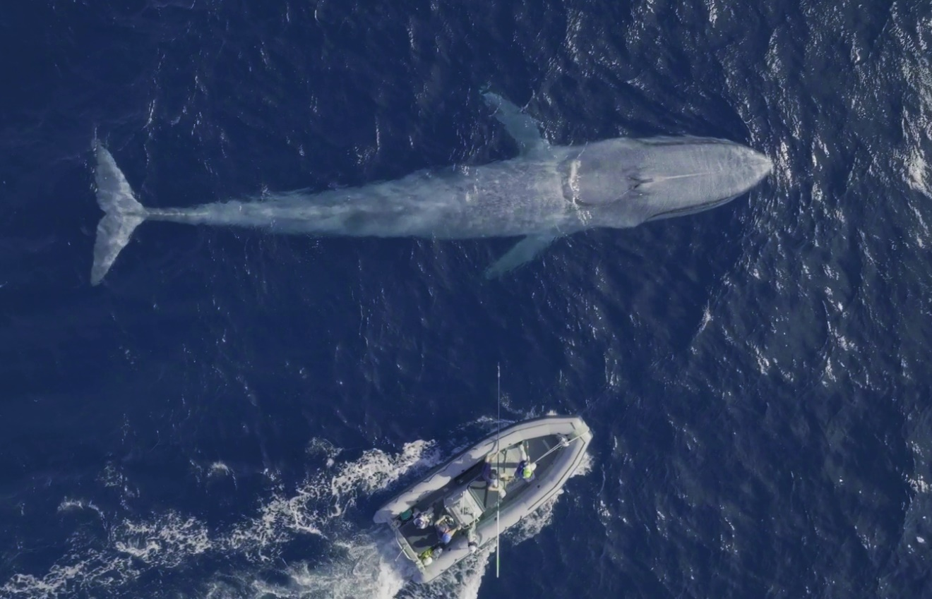
Figure 8. Approach of a blue whale for tag deployment. © CWR Grace Russell

Tag placement
The placement of the tag on the animal, including the angle of penetration for implantable tags, is critical to the welfare of the animal, the functioning of the tag, and for minimising tag-induced drag (Norman et al. 2018, Kay et al. 2019). The ideal position for tag placement on the animal will vary with species and tag type (Norman et al. 2018, Gulland et al. 2024). It is therefore essential that researchers involved in tagging understand species-specific best practice for tag placement, likely requiring consultation with the tagging research community. As a general rule for all whale species, the goal is to place the tag in a region of thick blubber, low muscle movement (the dorsum), and in an area where the tag is routinely out of the water and largely splash free to effectively transmit data.
For tag placement of non-invasive tags, the suction cups should be orientated parallel (i.e. lengthways along the body; Figure 9) to the animal for successful tag attachment (Wiley et al. 2023). For Type B (bolt-on) invasive tags, bolt through placement should follow existing SOPs for determining optimal bolt placement and minimising drag and animal welfare consideration. Where possible, an understanding of the bolt placement procedure and structural elements within the dorsal fin should be investigated using carcasses.
For Type A and C invasive tags, placement should be relatively high on the dorsum (Figure 10) to ensure greatest quality and quantity of location estimates (Mul et al. 2019), due to stiffer tissue in that region providing better anchoring and potential reducing tissue trauma due to muscle-blubber interface shearing compared to lower areas of the whales’ flanks (Moore et al. 2013, Moore & Zerbini 2017, Zerbini et al. 2025). However, tags that are aimed too high may not fully implant due to the curvature of the animal’s body, and this should be considered during the tagging procedure. On humpback whales specifically, the least amount of skin loss and swelling from tag implantation has been associated with deep implantation (i.e. shallower angle of insertion / penetration, facilitated through high elevation to ensure greater downward orientation) and placement of the tag anterior to the dorsal fin on the dorsum (Figure 5; Gulland et al. 2024). For blue whales, tags should be placed forward of/cranial to the dorsal fin. For southern right whales with no dorsal fin, the tag should be placed where the blubber is thickest, high on the body in the fat roll located posterior to the blow hole (e.g. Fernández et al. 2024) (Figure 11).

Post-tag monitoring and reporting

Post-tag monitoring and follow-up studies
The tagging process may result in short and long-term impacts to cetaceans, although adherence to best practice guidelines should minimise impacts. The monitoring of tagged animals post-tagging can be undertaken immediately after tag attachment and should be undertaken over a period of time (e.g. up to hours) that enables the ability to identify and report on any behavioural responses linked to close vessel approaches and tag attachment. However, monitoring individuals post-tagging may be challenging (e.g. animals may have travelled away from the tagging site and difficult to follow/locate) and assessments of the impacts of tagging on cetaceans may be limited (Andrews et al. 2019). Any inability to monitor these animals at sufficiently close ranges and over informative periods of time, may however result in tagging effects that remain unobserved.
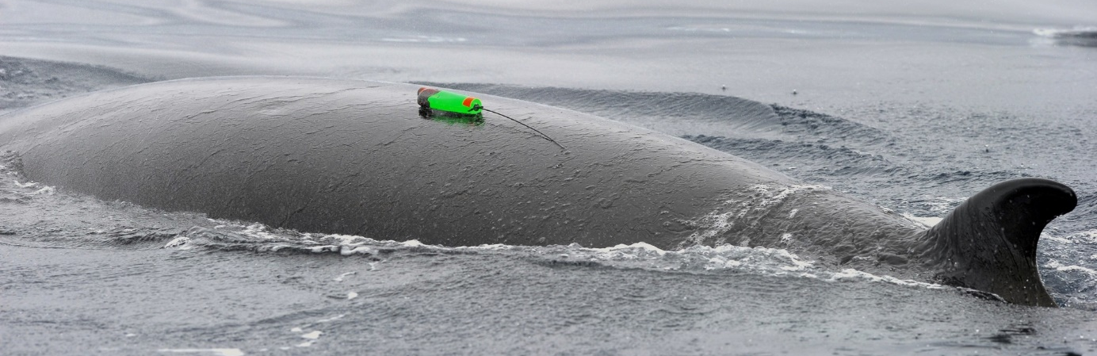
Figure 9. Tag placement of a non-invasive suction cup tag on a minke whale (top), located high on the dorsum, forward of the dorsal fin and orientated lengthways along the body.
© Ari Friedlaender
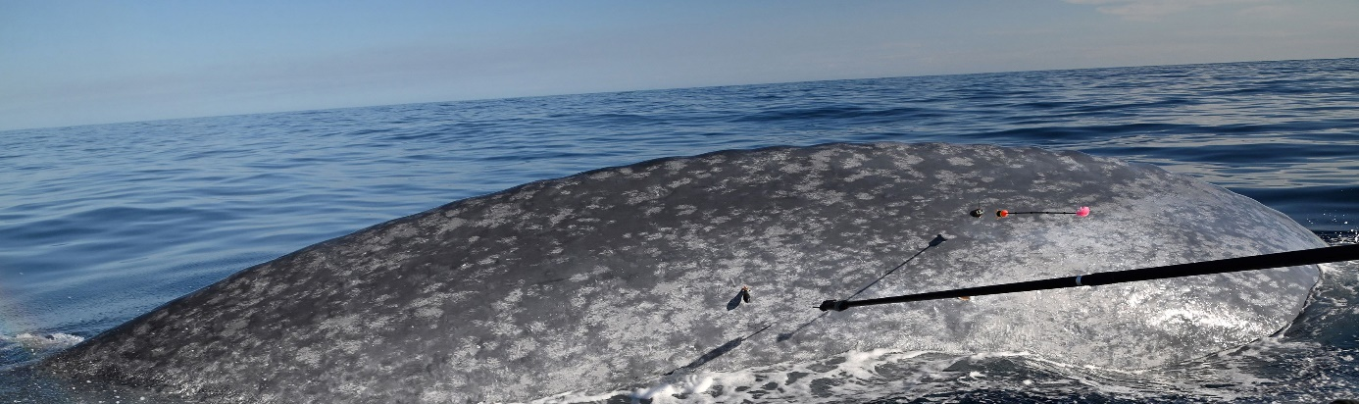
Figure 10. Tag placement of invasive type A tags on a blue whale, located high on the dorsum and well forward of the dorsal fin.
© CWR Micheline Jenner
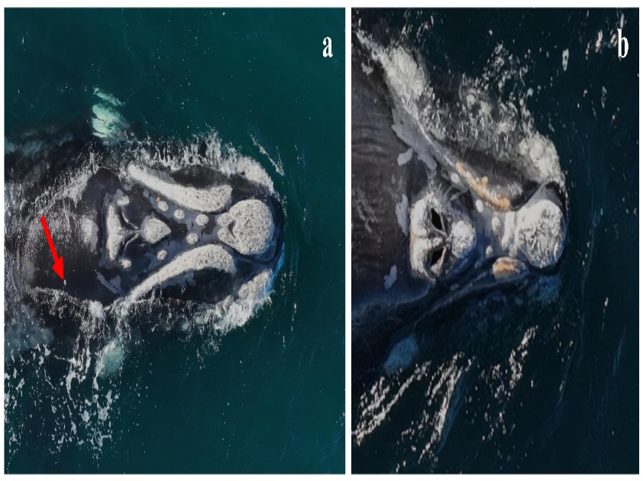
Figure 11. Tag placement location (red arrow) on a female southern right whale, with the tag located high on the dorsum and in the fat roll posterior to the blow hole.
Source Fernández et al. (2024)

Follow-up studies on tagged animals typically occur over a longer timeframe (i.e. months, years) than immediate post-tag monitoring, and are required to better understand the acute effects of tagging on cetaceans (e.g. disturbance, injury, pain) and any longer-term effects on health, reproduction, and survival particularly (Weller 2008, Walker et al. 2012, Andrews et al. 2019). These follow-up studies are particularly important for tagging studies using invasive tags, but also critical for small and/or endangered populations, and when new technology is developed. Cetacean species and populations that consistently return to the same feeding and/or reproductive areas may be particularly effective in the establishment of follow-up studies (Weller 2008). While effective follow-up studies may be challenging to implement for many species, such as wide-ranging species where resight probabilities are low and/or relocating animals at sea is difficult, they are essential to assess potential behavioural, physical/physiological, and demographic effects of tagged individuals.

Reporting on tagging studies
Publishing tagging studies and post-monitoring reporting on tagged cetaceans may inform our understanding of animal welfare impacts as well as improvements to tag deployment procedures and tag design. It would also result in a comprehensive understanding of the range of responses observed according to the range of different tag types. Tagging studies should be published as publicly available reports or (open access) peer-review literature to inform future studies. For effective and transparent reporting, tagging studies should provide information in accordance with the NHMRC Best practice methodology in the use of animals for scientific purposes (NHMRC 2017), with particular regard to the Publication and dissemination of research guide supporting the Australian Code for the responsible conduct of research. Studies that determine no or low impacts (i.e. best practice) on animals, and those that report on significant impacts (i.e. mortality), should both be published (Walker et al. 2012). Cases where accidents to animal and/or human safety occur (Hassel et al. 2022) may also be published to inform improvements in tagging procedures. Ultimately, these publications should be used to inform the design and methods of future tagging studies.
When reporting on tagging results, follow-up studies may fail to adequately characterise/quantify impacts given various challenges. These challenges include low resight rates of tagged animals, visual and superficial observations of potential impacts (e.g. photographs of skin surface), and intermittent post-tagging data on behaviour related to tag effects. Follow up studies should therefore be thoroughly designed, and conclusions related to effects of tagging should be qualified and consider the challenges experienced.
Researchers conducting tagging studies should standardise their reports by providing detail on methodology, monitoring, and sampling design. Examples of standard data fields to be used in reporting are provided in Andrews et al. (2019; section 2.8), and should at a minimum report on the tag(s) used, manufacturer, configuration, deployment method and configuration, performance, and any observed effects on the animal from tagging. The reports should explicitly address the potential tagging impacts on the animals and outline suitable impact minimisation practices (Walker et al. 2012). Research groups intending to tag cetaceans of the same population should share information on the individuals tagged to facilitate follow-up monitoring, prevent unintended repeat tagging, and reduce cumulative impact on individuals and their population. The use of public data repositories (e.g. Movebank) is recommended for the archival of tagging data and to promote data sharing among researchers.

Tag development
Improved tag design and attachment methods has directly contributed to the increasing use of biologging tags deployed on marine mammals (McIntyre 2014). The development of tags has been substantially aided by improved technologies that result in smaller devices, with improved sensors, data storage, and data transmission capabilities (Holton et al. 2021). The goal of tag development is to create or improve a tag’s ability to transmit the animals’ data (i.e. spatial, temporal, physiological, acoustic etc.) as long as possible without negatively impacting on the animals’ welfare, health, or behaviour. Tag deployment methods that minimise disturbance and/or injury to cetaceans are recommended, and as such any tag developments that aid this goal should be supported.
Testing and trialling different tag designs is critical to tag development, which can be undertaken by computer simulation (e.g. computational fluid dynamics; Pavlov et al. 2007), experimental approaches using in-situ modifications (e.g. wind or flume tunnels; Kay et al. 2019) and/or field testing (McKnight et al. 2024). While in-situ experiments are impractical for most cetaceans due to logistical constraints, computer modelling efficiently assesses the performance of different tag designs at initial stages of the process, particularly for smaller cetacean species (Pavlov et al. 2007, Balmer et al. 2014, Shorter et al. 2014, Kay et al. 2019).

Development and validation of new methods / attachments
Innovative approaches to development of new tag design and attachment methods and/or novel use of existing technology and tag attachment methods, are critical to improving the tag development process. However, the efficacy and effectiveness of new tag designs and innovative technology should be demonstrated before use on live animals. New tag designs and attachment methods may be substantially different from previous designs and their effects cannot be reliably predicted (Andrews et al. 2019). Detailed information on the testing of these tag designs and attachments, and the potential impacts to the welfare of cetaceans, should be provided in animal ethics and permit applications. This will ensure transparency and enable an informed assessment of the tagging methodology.
New tag designs and attachment methods should be tested in an environment that closely resembles the conditions during which the tag will operate in the field. These pilot studies should include consideration of the forces (i.e. rapid acceleration and/or deceleration) placed on the tag during deployment to ensure proper implantation, while minimising tissue damage and tag breakage (Andrews et al. 2019). For non-invasive tags, deployments testing tag attachment methods on cetaceans should occur within a controlled environment to enable detailed observations of tag performance and potential detrimental effects. For new tag attachment devices in invasive tags (i.e. Type A and C), testing should occur on tissue surrogates (e.g. ballistics gel, fibre-reinforced rubber, foam blocks) and and/or cetacean carcass tissue (e.g. Zerbini & Moore 2013). Equipment that will be deployed by projectile devices should be tested on whole cetacean carcasses, or using large tissue blocks with similar characteristics, to determine the appropriate projection velocity at a given distance to the animal (Andrews et al. 2019).

After thorough experimental testing, new tag design and attachment methods and/or novel use of existing technology and tag attachment methods applied to invasive tags must be demonstrated to be safe and effective on a similar non-threatened species/population before being applied to a threatened species (e.g. Baumgartner et al. 2015). Dedicated pilot studies limited to a small sample size of 2 to 5 individuals should be conducted by experienced professionals to demonstrate the efficacy of the methodology/equipment for proof of concept. Short-term resight observations should be undertaken to evaluate any potential impacts to the animals.
Recent developments in non-invasive and invasive tag attachments focus on the remote deployment of tags. Developments include the use of poles to attach single-pin satellite tags on small cetaceans (Balmer et al. 2023) and the use of drones for deploying non-invasive suction tags on large cetacean species (Wiley et al. 2023). In the case of using drones to deploy tags, disturbance impacts on the welfare of cetaceans may be minimised by avoiding close approaches and reducing the duration of the tagging attempt (Wiley et al. 2023). Drones also enable acquiring a larger random sample of animals, given that vessel-based tagging relies on individuals that are easier to approach. Non-random sampling introduces sampling bias and may prevent the collection of behavioural data of cryptic and evasive individuals. This may potentially result in inaccurate interpretation and conclusions at the population level. Tagging methods that minimise the interactions with cetaceans such as the use of drones, should be encouraged when appropriate. However, robust testing and evaluation of any associated innovative methods should be conducted if required.

References
Andrews, R. D., Baird, R. W., Calambokidis, J., Goertz, C. E. C., Gulland, F. M. D., Heide-Jorgensen, M. P., Hooker, S. K., Johnson, M., Mate, B., Mitani, Y., Nowacek, D. P., Owen, K., Quakenbush, L. T., Raverty, S., Robbins, J., Schorr, G. S., Shpak, O. V., Townsend Jr, F. I., Uhart, M.,…Zerbini, A. N. (2019). Best practice guidelines for cetacean tagging. Journal of Cetacean Research Management, 20(1), 27-66. https://doi.org/https://doi.org/10.47536/jcrm.v20i1.237
Andrews-Goff, V., Bestley, S., Gales, N. J., Laverick, S. M., Paton, D., Polanowski, A. M., Schmitt, N. T., & Double, M. C. (2018). Humpback whale migrations to Antarctic summer foraging grounds through the southwest Pacific Ocean. Scientific Reports, 8(1), 12333. https://doi.org/https://doi.org/10.1038/s41598-018-30748-4
Balmer, B. C., Wells, R. S., Schwacke, L. H., Rowles, T. K., Hunter, C., Zolman, E. S., Townsend, F. I., Danielson, B., Westgate, A. J., McLellan, W. A., & Pabst, D. A. (2011). Evaluation of a Single-Pin, Satellite-Linked Transmitter Deployed on Bottlenose Dolphins (Tursiops truncatus) Along the Coast of Georgia, USA. Aquatic Mammals, 37(2), 187-192. https://www.proquest.com/scholarly-journals/evaluation-single-pin-satellite-linked/docview/871224202/se-2?accountid=47381
Balmer, B. C., Wells, R. S., Howle, L. E., Barleycorn, A. A., McLellan, W. A., Ann Pabst, D., Rowles, T. K., Schwacke, L. H., Townsend, F. I., Westgate, A. J., & Zolman, E. S. (2014). Advances in cetacean telemetry: A review of single-pin transmitter attachment techniques on small cetaceans and development of a new satellite-linked transmitter design. Marine Mammal Science, 30(2), 656-673. https://doi.org/https://doi.org/10.1111/mms.12072
Balmer, B. C., Westgate, A. J., & McFee, W. E. (2023). Challenges in small cetacean telemetry: an attempt at developing a remotely deployed attachment device for single-pin dorsal fin satellite transmitters. Animal Biotelemetry, 11(1), 15. https://doi.org/https://doi.org/10.1186/s40317-023-00328-z
Baumgartner, M. F., Hammar, T., & Robbins, J. (2015). Development and assessment of a new dermal attachment for short-term tagging studies of baleen whales. Methods in Ecology and Evolution, 6(3), 289-297. https://doi.org/https://doi.org/10.1111/2041-210X.12325
Best, P., & Mate, B. (2007). Sighting history and observations of southern right whales following satellite tagging off South Africa. J. Cetacean Res. Manage., 9, 111-114. https://doi.org/https://doi.org/10.47536/jcrm.v9i2.677
Burek-Huntington, K. A., Shelden, K. E. W., Andrews, R. D., Goertz, C. E. C., McGuire, T. L., & Dennison, S. (2023). Postmortem pathology investigation of the wounds from invasive tagging in belugas (Delphinapterus leucas) from Cook Inlet and Bristol Bay, Alaska. Marine Mammal Science, 39(2), 492-514. https://doi.org/https://doi.org/10.1111/mms.12981
Charlton, C., Christiansen, F., Ward, R., Mackay, A. I., Andrews-Goff, V., Zerbini, A. N., Childerhouse, S., Guggenheimer, S., O’Shannessy, B., & Brownell Jr., R. L. (2023). Evaluating short to medium term effects of implantable satellite tags on southern right whales Eubalaena australis. Diseases of Aquatic Organisms. https://doi.org/https://doi.org/10.3354/dao03730
Deegan, T. C., Niemeyer, M., Colegrove, K. M., Rotstein, D. S., & Sharp, S. M. (2023). Pathology of short-term dorsal fin tag-attachments in tagged and re-stranded short-beaked common dolphins Delphinus delphis on Cape Cod, MA. Diseases of Aquatic Organisms, 156, 29-38. https://www.int-res.com/abstracts/dao/v156/p29-38/
Delfour, F., & Charles, A. (2021). Understanding and assessing emotions in marine mammals under professional care. International Journal of Comparative Psychology, 34. https://doi.org/https://doi.org/10.46867/ijcp.2021.34.00.01

Fernández, S. J., Uhart, M., Coscarella, M., Falabella, V., Heide-Jørgensen, P. M., Holland, M., Orce, A., Sironi, M., Sucunza, F., & Zerbini, A. N. (2024). Ocean to ocean: First documented migration of a Southern right whale from the southwest Atlantic to the southeast Pacific (Paper SC/69B/CMP/03 presented to the IWC Scientific Committee, April-May 2024, Bled, Slovenia (unpublished). 9pp., Issue. https://archive.iwc.int/?r=22046&k=8aec9a8f4f
Ferreira, L. C., Jenner, C., Jenner, M., Udyawer, V., Radford, B., Davenport, A., Moller, L., Andrews-Goff, V., Double, M., & Thums, M. (2024). Predicting suitable habitats for foraging and migration in Eastern Indian Ocean pygmy blue whales from satellite tracking data. Movement Ecology, 12(1), 42. https://doi.org/10.1186/s40462-024-00481-x
Frohoff, T., & Bekoff, M. (2018). Ethics. In B. Würsig, J. G. M. Thewissen, & K. M. Kovacs (Eds.), Encyclopedia of Marine Mammals (Third Edition) (pp. 338-344). Academic Press. https://doi.org/https://doi.org/10.1016/B978-0-12-804327-1.00122-9
Gales, N., Double, M. C., Robinson, S., Jenner, C., Jenner, M., King, E., Gedamke, J., Paton, D., & Raymond, D. (2009a). Satellite tracking of southbound East Australian humpback (Megaptera novaeangliae): challenging the feast or famine model for migrating whales.
Gales, N. J., Bowen, W. D., Johnston, D. W., Kovacs, K. M., Littnan, C. L., Perrin, W. F., Reynolds, J. E., & Thompson, P. M. (2009b). Guidelines for the treatment of marine mammals in field research. Marine Mammal Science, 25(3), 725-736. https://doi.org/https://doi.org/10.1111/j.1748-7692.2008.00279.x
Gales, R., Alderman, R., Thalmann, S., & Carlyon, K. (2012). Satellite tracking of long-finned pilot whales (Globicephala melas) following stranding and release in Tasmania, Australia. Wildlife Research, 39(6), 520-531. https://doi.org/10.1071/WR12023
Gendron, D., Martinez Serrano, I., Ugalde de la Cruz, A., Calambokidis, J., & Mate, B. (2015). Long-term individual sighting history database: an effective tool to monitor satellite tag effects on cetaceans. Endangered Species Research, 26(3), 235-241. https://www.int-res.com/abstracts/esr/v26/n3/p235-241/
Goldbogen, J. A., Cade, D. E., Boersma, A. T., Calambokidis, J., Kahane-Rapport, S. R., Segre, P. S., Stimpert, A. K., & Friedlaender, A. S. (2017). Using digital tags with integrated video and inertial sensors to study moving morphology and associated function in large aquatic vertebrates. The Anatomical Record, 300(11), 1935-1941. https://doi.org/https://doi.org/10.1002/ar.23650
Govindaraj, S., & Muthuraman, M. S. (2015). Systematic review on sterilization methods of implants and medical devices. International Journal of ChemTech Research 8(2), 897-911.
Gulland, F. M. D., Robbins, J., Zerbini, A. N. A.-G., Virginia, Bérubé, M., Clapham, P. J., Double, M., Gales, N., Kennedy, A. S., Landry, S., Mattila, D. H. K., Doug, S., Jennifer, E. T., Marcela, U., & Ralph, E. T. V. (2024). Effects of satellite-linked telemetry tags on humpback whales in the Gulf of Maine: photographic assessment of tag sites. bioRxiv, 2024.2002.2007.579298. https://doi.org/https://doi.org/10.1101/2024.02.07.579298
Guzman, H. M., & Capella, J. J. (2017). Short-term recovery of humpback whales after percutaneous satellite tagging. The Journal of Wildlife Management, 81(4), 728-733. https://doi.org/https://doi.org/10.1002/jwmg.21235
Hanson, M., & Baird, R. (1998). Dall's Porpoise Reactions to Tagging Attempts Using A Remotely-Deployed Suction-Cup Tag. Marine Technology Society Journal, 32, 18-23.
Harcourt, R., Sprogis, K., Gales, N. J., Andrews-Goff, V., Double, M., Besier, S., Riekkola, L., &

Carroll, E. L. (2025). Stranding of a satellite tagged southern right whale off southwest Australia. Journal of Cetacean Research and Management Special Issue 5. https://doi.org/10.47536/jcrm.v5i1.1072
Hassel, L. B., Zerbini, A. N., Andriolo, A., & Cabete, R. P. (2022). Example of applying a Health, Safety and Environment management system in cetacean research: Case study from a satellite tagging field accident. Journal of Cetacean Research Management, 23, 183-189.
Holton, M. D., Wilson, R. P., Teilmann, J., & Siebert, U. (2021). Animal tag technology keeps coming of age: an engineering perspective. Philosophical Transactions of the Royal Society B: Biological Sciences, 376(1831), 20200229. https://doi.org/https://doi.org/10.1098/rstb.2020.0229
Hooker, S., Baird, R., Al-Omari, S., Gowans, S., & Whitehead, H. (2001). Behavioral reactions of northern bottlenose whales (Hyperoodon ampullatus) to biopsy darting and tag attachment procedures. Fishery Bulletin, 99, 303-308.
Hooker, S. K., & Baird, R. W. (2001). Diving and ranging behaviour of odontocetes: a methodological review and critique. Mammal Review, 31(1), 81-105. https://doi.org/https://doi.org/10.1046/j.1365-2907.2001.00080.x
Isojunno, S., & Miller, P. J. O. (2015). Sperm whale response to tag boat presence: biologically informed hidden state models quantify lost feeding opportunities. Ecosphere, 6(1), art6. https://doi.org/https://doi.org/10.1890/ES14-00130.1
IWC. (2020). Report of the joint US Office of Naval Research, International Whaling Commission and US National Oceanic and Atmospheric Administration workshop on cetacean tag development, tag follow-up and tagging best practices. Journal of Cetacean Research and Management, 21 (Supplement), 349-372. https://doi.org/http://dx.doi.org/10.25607/OBP-858
Kay, W. P., Naumann, D. S., Bowen, H. J., Withers, S. J., Evans, B. J., Wilson, R. P., Stringell, T. B., Bull, J. C., Hopkins, P. W., & Börger, L. (2019). Minimizing the impact of biologging devices: Using computational fluid dynamics for optimizing tag design and positioning. Methods in Ecology and Evolution, 10(8), 1222-1233. https://doi.org/https://doi.org/10.1111/2041-210X.13216
Mackay, A. I., Bailleul, F., Carroll, E. L., Andrews-Goff, V., Baker, C. S., Bannister, J., Boren, L., Carlyon, K., Donnelly, D. M., Double, M., Goldsworthy, S. D., Harcourt, R., Holman, D., Lowther, A., Parra, G. J., & Childerhouse, S. J. (2020). Satellite derived offshore migratory movements of southern right whales (Eubalaena australis) from Australian and New Zealand wintering grounds. PLOS ONE, 15(5), e0231577. https://doi.org/https://doi.org/10.1371/journal.pone.0231577
Marmontel, M., Reid, J., Sheppard, J. K., & Morales-Vela, B. (2012). Tagging and movement of sirenians. In H. Ellen, E. R. John, III, A. Lemnuel, M.-G. Antonio, & M. Miriam (Eds.), Sirenian conservation: Issues and strategies in developing countries (pp. 116-125). University Press of Florida. https://pubs.usgs.gov/publication/70038541
Mate, B. R., Gisiner, R., & Mobley, J. (1998). Local and migratory movements of Hawaiian humpback whales tracked by satellite telemetry. Canadian Journal of Zoology, 76(5), 863-868. https://doi.org/https://doi.org/10.1139/z98-008
Mate, B., Mesecar, R., & Lagerquist, B. (2007). The evolution of satellite-monitored radio tags for large whales: One laboratory's experience. Deep Sea Research Part II: Topical Studies in Oceanography, 54(3), 224-247. https://doi.org/https://doi.org/10.1016/j.dsr2.2006.11.021
Mate, B. R., Ilyashenko, V. Y., Bradford, A. L., Vertyankin, V. V., Tsidulko, G. A., Rozhnov, V. V., & Irvine, L. M. (2015). Critically endangered western gray whales migrate to the eastern North Pacific. Biology Letters, 11(4), 20150071. https://doi.org/10.1098/rsbl.2015.0071
McIntyre, T. (2014). Trends in tagging of marine mammals: a review of marine mammal biologging studies. African Journal of Marine Science, 36(4), 409-422. https://doi.org/10.2989/1814232X.2014.976655
McKnight, J. C., Pass, C., Thompson, D., Balfour, S., Brasseur, S. M. J. M., Embling, C., Hastie, G., Milne, R., Kyte, A., Moss, S. E. W., Pemberton, R., & Russell, D. J. F. (2024). Quantifying and reducing the cost of tagging: combining computational fluid dynamics and diving experiments to reduce impact from animal-borne tags. Proceedings of the Royal Society B: Biological Sciences, 291(2034), 20241441. https://doi.org/10.1098/rspb.2024.1441
McMahon, C. R., Harcourt, R., Bateson, P., & Hindell, M. A. (2012). Animal welfare and decision making in wildlife research. Biological Conservation, 153, 254-256. https://doi.org/https://doi.org/10.1016/j.biocon.2012.05.004
Minton, G., Van Bressem, M. F., Willson, A., Collins, T., Harthis, A. L., Sarrouf, W. M., Baldwin, R., Leslie, M., & van Waerbeek, K. (2022). Visual health assessment and evaluation of anthropogenic threats to Arabian Sea humpback whales in Oman. Journal of Cetacean Research and Management, 23, 59-79. https://doi.org/https://doi.org/10.47536/jcrm.v23i1.336
Mizroch, S. A., Tillman, M. F., Jurasz, S., Straley, J. M., von Ziegesar, O., Herman, L. M., Pack, A. A., Baker, S., Darling, J., Glockner-Ferrari, D., Ferrari, M., Salden, D. R., & Clapham, P. J. (2011). Long-term survival of humpback whales radio-tagged in Alaska from 1976 through 1978. Marine Mammal Science, 27(1), 217-229. https://doi.org/10.1111/j.1748-7692.2010.00391.x
Moore, M., Andrews, R., Austin, T., Bailey, J., Costidis, A., George, C., Jackson, K., Pitchford, T., Landry, S., Ligon, A., McLellan, W., Morin, D., Smith, J., Rotstein, D., Rowles, T., Slay, C., & Walsh, M. (2013). Rope trauma, sedation, disentanglement, and monitoring-tag associated lesions in a terminally entangled North Atlantic right whale (Eubalaena glacialis). Marine Mammal Science, 29(2), E98-E113. https://doi.org/https://doi.org/10.1111/j.1748-7692.2012.00591.x
Moore, M. J., & Zerbini, A. N. (2017). Dolphin blubber/axial muscle shear: implications for rigid transdermal intramuscular tracking tag trauma in whales. Journal of Experimental Biology, 220(Pt 20), 3717-3723. https://doi.org/10.1242/jeb.165282
Moore, M. J., Lanagan, T. M., Wells, R. S., Kapit, J., Barleycorn, A. A., Allen, J. B., Baird, R. W., Braun, C. D., Skomal, G. B., & Thorrold, S. R. (2024). Development of single-pin, un-barbed, pole-tagging of free-swimming dolphins and sharks with satellite-linked transmitters. Animal Biotelemetry, 12(1), 6. https://doi.org/10.1186/s40317-024-00364-3
Mul, E., Blanchet, M.-A., Biuw, M., & Rikardsen, A. (2019). Implications of tag positioning and performance on the analysis of cetacean movement. Animal Biotelemetry, 7(1), 11. https://doi.org/10.1186/s40317-019-0173-7
NHMRC. (2013). Australian code for the care and use of animals for scientific purposes, 8th edition. https://www.nhmrc.gov.au/about-us/publications/australian-code-care-and-use-animals-scientific-purposes
NHMRC. (2018). Australian Code for the Responsible Conduct of Research. https://www.nhmrc.gov.au/about-us/publications/australian-code-responsible-conduct-research-2018#block-views-block-file-attachments-content-block-1
NHMRC. (2017). Best practice methodology in the use of animals for scientific purposes. (Updated 2018). www.nhmrc.gov.au/guidelines-publications/ea20
Norman, S. A., Flynn, K. R., Zerbini, A. N., Gulland, F. M. D., Moore, M. J., Raverty, S., Rotstein, D. S., Mate, B. R., Hayslip, C., Gendron, D., Sears, R., Douglas, A. B., & Calambokidis, J. (2018). Assessment of wound healing of tagged gray (Eschrichtius robustus) and blue (Balaenoptera musculus) whales in the eastern North Pacific using long-term series of photographs. Marine Mammal Science, 34(1), 27-53. https://doi.org/https://doi.org/10.1111/mms.12443
Nowacek, D. P., Johnson, M. P., & Tyack, P. L. (2004). North Atlantic right whales (Eubalaena glacialis) ignore ships but respond to alerting stimuli. Proceedings of the Royal Society of London. Series B: Biological Sciences, 271(1536), 227-231. https://doi.org/10.1098/rspb.2003.2570
Owen, K., Jenner, K. C. S., Jenner, M.-N. M., McCauley, R. D., & Andrews, R. D. (2019). Water temperature correlates with baleen whale foraging behaviour at multiple scales in the Antarctic. Marine and Freshwater Research, 70(1), 19-32. https://doi.org/10.1071/MF17288
Pavlov, V. V., Wilson, R. P., & Lucke, K. (2007). A new approach to tag design in dolphin telemetry: Computer simulations to minimise deleterious effects. Deep Sea Research Part II: Topical Studies in Oceanography, 54(3), 404-414. https://doi.org/https://doi.org/10.1016/j.dsr2.2006.11.010
Pettis, H. M., Rolland, R. M., Hamilton, P. K., Brault, S., Knowlton, A. R., & Kraus, S. D. (2004). Visual health assessment of North Atlantic right whales (Eubalaena glacialis) using photographs. Canadian Journal of Zoology, 82(1), 8-19. https://doi.org/10.1139/z03-207
Riekkola, L., Zerbini, A. N., Andrews, O., Andrews-Goff, V., Baker, C. S., Chandler, D., Childerhouse, S., Clapham, P., Dodémont, R., Donnelly, D., Friedlaender, A., Gallego, R., Garrigue, C., Ivashchenko, Y., Jarman, S., Lindsay, R., Pallin, L., Robbins, J., Steel, D., Constantine, R. (2018). Application of a multi-disciplinary approach to reveal population structure and Southern Ocean feeding grounds of humpback whales. Ecological Indicators, 89, 455-465. https://doi.org/https://doi.org/10.1016/j.ecolind.2018.02.030
Robbins, J., Zerbini, A. N., Gales, N. J., Gulland, F. M. D., Double, M. C., Clapham, P. J., Andrews-Goff, V., Kennedy, A. S., Landry, S., Mattila, D. E., & Tackaberry, J. (2013). Satellite tag effectiveness and impacts on large whales: preliminary results of a case study with Gulf of Maine humpback whales. Paper SC/65a/SH05 presented to the IWC Scientific Commitee, 100.
Schneider, K., Baird, R. W., Dawson, S., Visser, I., & Childerhouse, S. (1998). Reactions of bottlenose dolphins to tagging attempts using a remotely-deployed suction-cup tag. Marine Mammal Science, 14(2), 316-324. https://doi.org/https://doi.org/10.1111/j.1748-7692.1998.tb00720.x
Shorter, K. A., Murray, M. M., Johnson, M., Moore, M., & Howle, L. E. (2014). Drag of suction cup tags on swimming animals: Modeling and measurement. Marine Mammal Science, 30(2), 726-746. https://doi.org/https://doi.org/10.1111/mms.12083
Shuert, C. R., Marcoux, M., Hussey, N. E., Watt, C. A., & Auger-Méthé, M. (2021). Assessing the post-release effects of capture, handling and placement of satellite telemetry devices on narwhal (Monodon monoceros) movement behaviour. Conserv Physiol, 9(1), coaa128. https://doi.org/https://doi.org/10.1093/conphys/coaa128
Smies, A., Wales, J., Hennenfent, M., Lyons, L., Dunn, C., Robbins, J., Lee, B. P., Zerbini, A., & Rajachar, R. M. (2022). Non-antibiotic antimicrobial polydopamine surface coating to prevent stable biofilm formation on satellite telemetry tags used in cetacean conservation applications [Original Research]. Frontiers in Marine Science, 9. https://doi.org/10.3389/fmars.2022.989025
Sonne, C., Teilmann, J., Wright, A. J., Dietz, R., & Leifsson, P. S. (2012). Tissue healing in two harbor porpoises (Phocoena phocoena) following long-term satellite transmitter attachment. Marine Mammal Science, 28(3), E316-E324. https://doi.org/https://doi.org/10.1111/j.1748-7692.2011.00513.x
South, A., Garland, E. C., Rendell, L., d'Ettorre, P., Freeberg, T. M., & Ridley, A. R. (2023). Cultural Behaviour in Cetaceans. In (1 ed., pp. 227-239). Routledge. https://doi.org/10.4324/9781003091868-22
Walker, K. A., Trites, A. W., Haulena, M., & Weary, D. M. (2012). A review of the effects of different marking and tagging techniques on marine mammals. Wildlife Research, 39(1), 15-30. https://doi.org/10.1071/WR10177
Warren, V. E., Miller, P. J. O., & Tyack, P. L. (2020). Short-term responses of sperm whales Physeter macrocephalus to the attachment of suction cup tags. Marine Ecology Progress Series, 645, 219-234. https://doi.org/https://doi.org/10.3354/meps13344
Weinrich, M. T., Lambertsen, R. H., Baker, C. S., Schilling, M. R., & Belt, C. R. (1991). Behavioural responses of humpback whales (Megaptera novaeangliae ) in the southern Gulf of Maine to biopsy sampling. In A. R. Hoelzel (Ed.), Genetics ecology of whales and dolphins incorporating the proceedings of the workshop on the genetic analysis of cetacean populations: Report of the International Whaling Commission (Special Issue) (Vol. 13, pp. 91-97).
Weller, D. W. (2008). Report of the Large Whale Tagging Workshop: convened by the U.S. Marine Mammal Commission, U.S. National Marine Fisheries Service. Southwest Fisheries Science Center.
Wells, R., Fougeres, E., Cooper, A., Stevens, R., Brodsky, M., Lingenfelser, R., Dold, C., & Douglas, D. (2013). Movements and dive patterns of short-finned pilot whales (Globicephala macrorhynchus) released from a mass stranding in the Florida Keys. Aquatic Mammals, 39, 61-72. https://doi.org/http://dx.doi.org/10.1578/AM.39.1.2013.61
WGWAP. (2006). Report of the Western Gray Whale Advisory Panel at its first meeting (Unpublished report. WGWAP 1/Report 1st Meeting 9-11 November 2006 Prangins, Switzerland, Issue. https://iucn-csg.org/western-gray-whale-advisory-panel-wgwap-archive/
Whaley, J. E., & Borowski, R. (2009). Marine Mammal Response, Rehabilitation, and Release: standards for release (NOAA National Marine Fisheries Service Marine Mammal Health and Stranding Response Program, Issue.
Wiley, D. N., Zadra, C. J., Friedlaender, A. S., Parks, S. E., Pensarosa, A., Rogan, A., Alex Shorter, K., Urbán, J., & Kerr, I. (2023). Deployment of biologging tags on free swimming large whales using uncrewed aerial systems. Royal Society Open Science, 10(4), 221376. https://doi.org/https://doi.org/10.1098/rsos.221376
Williamson, M. J., Kavanagh, A. S., Noad, M. J., Kniest, E., & Dunlop, R. A. (2016). The effect of close approaches for tagging activities by small research vessels on the behavior of humpback whales (Megaptera novaeangliae). Marine Mammal Science, 32(4), 1234-1253. https://doi.org/https://doi.org/10.1111/mms.12324
Zerbini, A. N., & Moore, M. J. (2013). Improving large cetacean implantable satellite tag designs to maximize tag robustness and minimize health effects to individual animals. https://apps.dtic.mil/sti/pdfs/AD1014341.pdf
Zerbini, A., Robbins, J., Andrews, R., Andrews-Goff, V., Baumgartner, M., Clapham, P., Double, M., Kennedy, A., Leask, A., Schorr, G., & Wilton, S. (2017, October 22-27). Development of robust large whale satellite tags improves tag performance and reduces animal welfare problems 22nd Biennial on the Biology of Marine Mammals, Halifax, Nova Scotia.
Zerbini, A. N., Uhart, M., Fernandez, S., Kennedy, A. S., Sironi, M., Bedriñana, L., Clapham, P. J., Coscarella, M., Crespo, E. A., González, R., Harris, G., Hucke-Gaete, R., Mendez, M., Robbins, J., Rosenbaum, H. C., Sucunza, F., Vanstreels, R. E. T., & Viddi, F. (2023). Assessing the performance and effects of newly designed integrated implantable large whale satellite tags (Final Report presented to the Office of Naval Research. Grant number: N00014-18-1-2749, Issue.
Zerbini, A. N., Robbins, J., Andrews, R., Andrews-Goff, V., Baumgartner, M., Clapham, P. J., Double, M., Gales, N., Landry, S., Gulland, F. M. D., Hammar, T., Holland, M., Kennedy , A. S., Leask, A., Mattila, D. K., Sandiland, D., & Schorr, G. S. (2025). Developing robust large whale satellite tags through follow-up studies. Submitted to the Journal of Cetacean Research and Management Special Issue on Cetacean Tagging, 37.

