

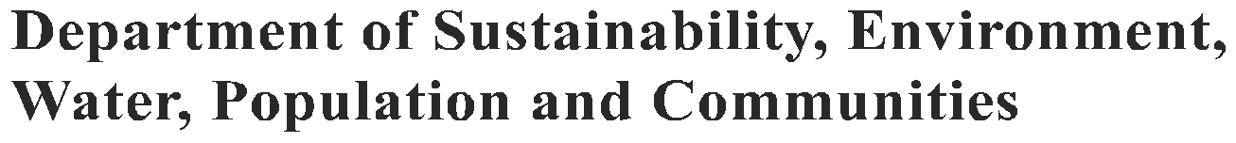

FARMING AND NATIONALLY PROTECTED NEW ENGLAND PEPPERMINT GRASSY WOODLANDS

Since European settlement, most of the New England Peppermint (Eucalyptus nova-anglica) Grassy Woodlands ecological community has been cleared or degraded by pasture improvement and heavy grazing. The small amount that remains in good condition is now protected under Australia’s national environment law, the Environment Protection and Biodiversity Conservation Act 1999 (EPBC Act), as a critically endangered ecological community.

What does national protection of New England Peppermint Grassy Woodlands mean farmers/graziers?

National environment law is not about stopping farm business; it protects Australia’s unique native plants and animals. In many cases, your supportive farming practices have helped retain remnant native grassy woodlands.

You may need Australian Government approval if:

- the protected grassy woodlands (or other protected matters) occur on your property, and
- a new, intensified or changed activity could have a significant detrimental impact on the ecological community.

If you are not sure whether your activity requires Australian Government approval, you can get free advice from the environment liaison officer at the National Farmers’ Federation on 1800 704 520
(or email: environment@nff.org.au).

What and where are New England Peppermint Grassy Woodlands?

This indicative map shows the outer boundary of the area in which the ecological community may occur. The community itself has been heavily cleared and is very fragmented
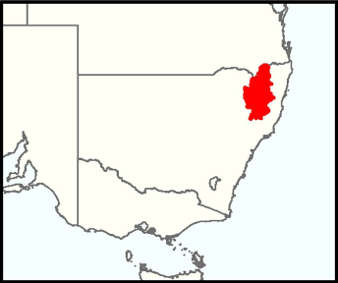

A more detailed map is available at www.environment.gov.au/cgi-bin/sprat/public/publicshowcommunity.pl?id=83

The New England Peppermint Grassy Woodlands ecological community mainly occurs on the Northern tablelands (also called the New England tablelands) and slopes in north-eastern New South Wales, and just across the border in Queensland. Most of its range is within the New England tablelands Bioregion, although it extends into adjacent areas of the NSW North Coast and Nandewar Bioregions.

The national ecological community is generally found in valley flats and lower slopes that are subject to cold air drainage. This grassy eucalypt woodland is found on both poorly drained fertile soils and on less fertile coarse sandy soils over granite.

The main tree species is New England peppermint (Eucalyptus nova-anglica). Other trees include: snow gum (E. pauciflora), black sallee (E. stellulata), mountain gum (E. dalrympleana subsp. heptantha), Blakely’s red gum (E. blakelyi) and fuzzy box (E. conica).

This woodland typically lacks a substantial shrub layer. If present, shrubs may include: blackthorn (Bursaria spinosa), native raspberry (Rubus parvifolius), peach heath (Lissanthe strigosa), sharp beard-heath (Leucopogon fraseri), urn heath (Melichrus urceolatus) and silver wattle (Acacia dealbata).

The often dense ground layer is mainly native grasses and other herbs. Cover varies depending on seasonal conditions and past management history. Typical grasses that may be present include tussock grasses, such as grey tussock grass (Poa sieberiana), and kangaroo grass (Themeda triandra); but there is wide variation in the individual native grass species found at different sites.

How do I know whether the New England Peppermint Grassy Woodland on my property is protected?

New England Peppermint Grassy Woodland is only protected under national environment law where it is in relatively good condition. The patch of the grassy woodland must be at least half a hectare (1.24 acres) in size, and at least half the perennial vegetation cover of the ground layer must be native plant species. The diagram below sets out the condition thresholds in more detail.

Is the patch of woodland or open forest at least 0.5 ha in size?

YES

Are 30% or more of the trees New England Peppermint
(Eucalyptus nova-anglica)?

YES

Not the New England
Peppermint Grassy
NO Woodlands ecological
NO
Are there at least 20 native tree seedlings per hectare (for example, 10 per 0.5ha)?
YES

community.

Is 50% or more of the perennial ground layer vegetation cover, native plant species?
YES

Are there at least 20 standing (live or dead) native
trees per hectare (for example 10 per 0.5ha)? OR

YES

The patch is likely to be part of the protected New England
Peppermint Grassy Woodlands ecological community.

Woodlands that do not meet these criteria are not protected by national environment law. But they may still
be protected under state regulations, such as the New South Wales Native Vegetation Act 2003, the New South
Wales Threatened Species Conservation Act 1995, or the Queensland Vegetation Management Act 1999.

How does protection of New England Peppermint Grassy Woodlands affect my farming activities?

This ecological community was officially protected under national environment law on 1 March 2011. Lawful activities that began before national environmental law came into effect on 16 July 2000 can continue without further Australian Government approval.

What routine farming activities do not need approval?

- maintaining existing fence lines, tracks, roads or fire breaks
- replacing or maintaining existing sheds, other farm buildings and yards
- maintaining existing grazing regimes (type of livestock, stocking rates and timing of grazing)
- controlling weeds (with minimal disturbance, or by selective spot spraying)

What farming activities might need approval?

Any activities that are likely to have a significant, irreversible or long-term detrimental impact on the ecological community may need Australian Government approval. These include:

- land clearing or substantial lopping of trees
- changing from grazing to cropping, or clearing understorey vegetation through cropping, excessive grazing or other methods
- substantially changing grazing management, weed control or fertiliser use
- new or altered burning regimes
- renovating or improving pasture by introducing exotic plant species, fertilisers, herbicides, mechanical disturbance or cultivation, addition of irrigation
- maintaining paddocks, lawfully cleared after 16 July 2000, where the community has regenerated, by excessive removal of native tree seedlings/saplings/suckers/regrowth.

If you are uncertain of your legal responsibility, you can contact the environment liaison officer at the National
Farmers’ Federation for help or go to: www.environment.gov.au/epbc

Can I get help to improve or restore New England Peppermint Grassy Woodland?

There may be natural resource management projects funded by the Australian Government’s Caring for our
Country initiative that can help you manage protected woodlands.

For more information on local projects go to www.nrm.gov.au or contact your:

- local NRM regional body—www.nrm.gov.au/nrm/region.html

- state facilitator—www.nrm.gov.au/contacts/ausgovt.html

BIO135.0211

Where can I get more information?

More information on this ecological community, its condition thresholds, threats and priority conservation actions is contained in the comprehensive listing advice and the shorter conservation advice for this ecological community, at: www.environment.gov.au/cgi-bin/sprat/public/publicshowcommunity.pl?id=83.

For free advice on whether or not an activity may need Australian Government approval contact the Australian
Government’s environment liaison officer at the National Farmers’ Federation (NFF).

Phone: 1800 704 520
Email: environment@nff.org.au
Web: www.environment.gov.au/farming

Disclaimer

The views and opinions contained in this document are not necessarily those of the Australian Government. The contents of this document have been compiled using a range of source materials and while reasonable care has been taken in its compilation, the Australian Government does not accept responsibility for the accuracy or completeness of the contents of this document and shall not be liable for any loss or damage that may be occasioned directly or indirectly through the use of or reliance on the contents of the document.

© Commonwealth of Australia 2011

This work is copyright. You may download, display, print and reproduce this material in unaltered form only (retaining this notice) for your personal, non-commercial use or use within your organisation. Apart from any use as permitted under the Copyright Act 1968, all other rights are reserved. Requests and inquiries concerning reproduction and rights should be addressed to Commonwealth Copyright Administration, Attorney General’s Department, Robert Garran Offices, National Circuit, Barton ACT 2600 or posted at www.ag.gov.au/cca.

