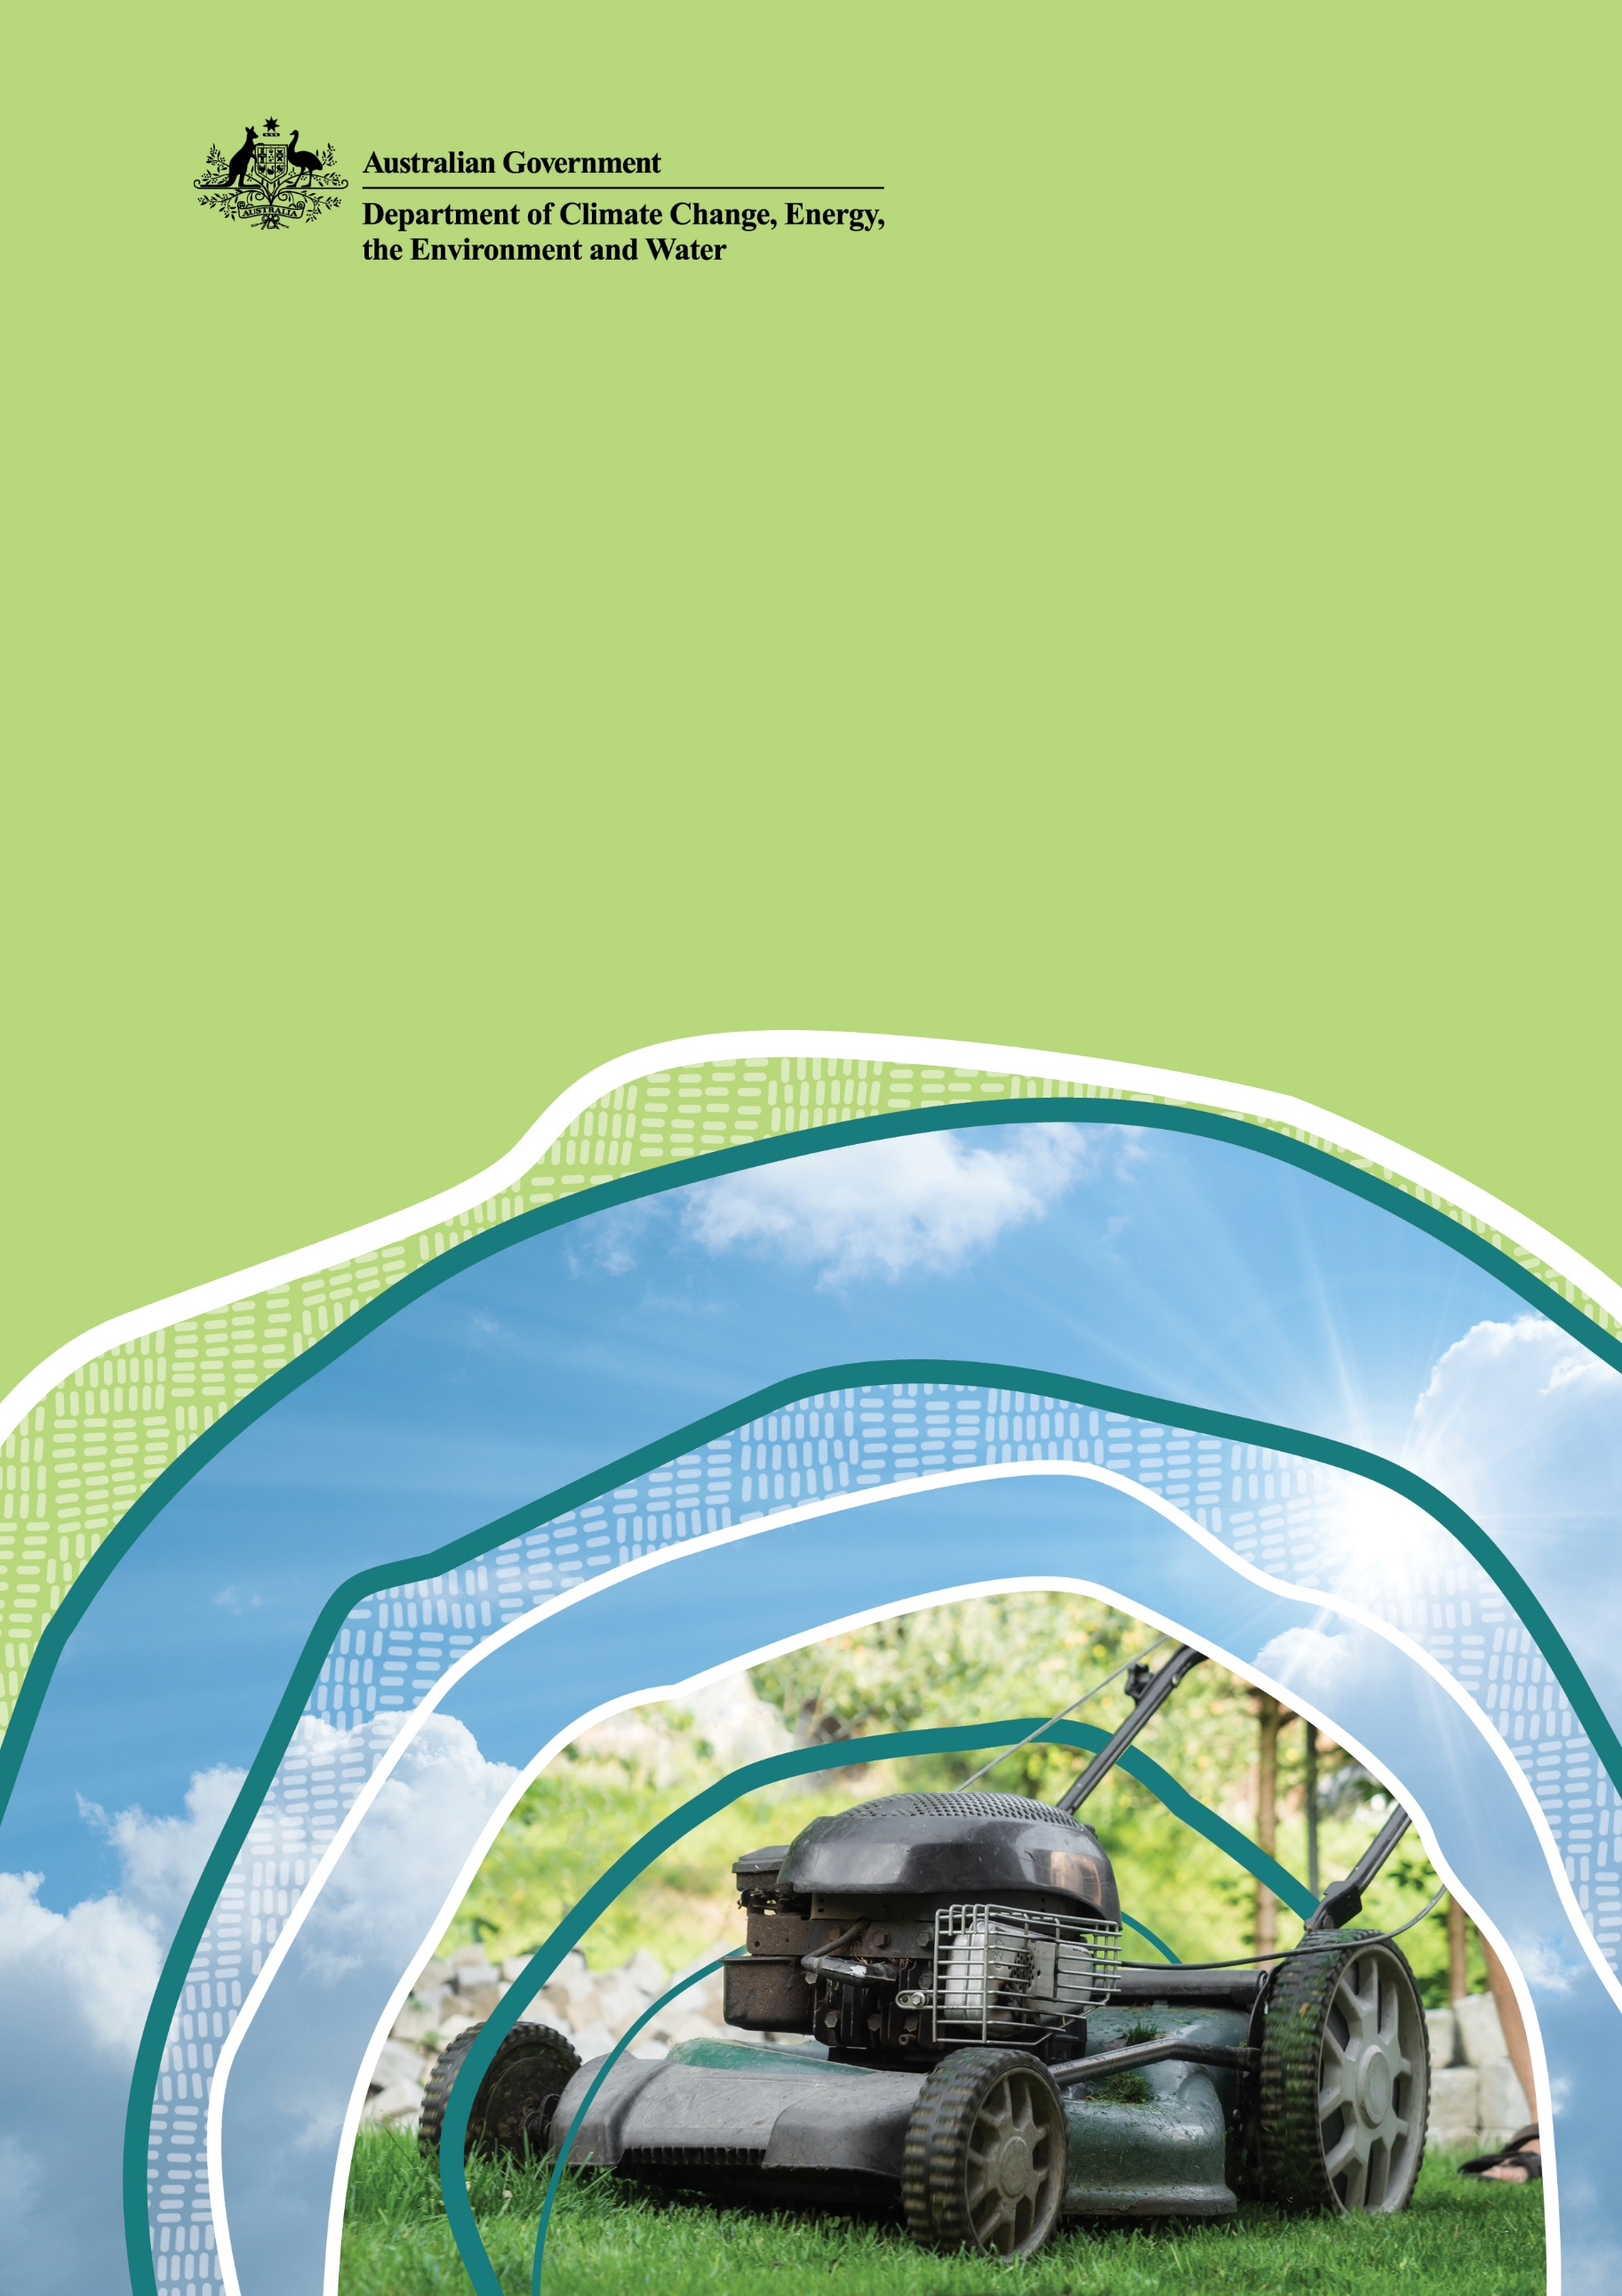
Guide to certification under the Product Emissions Standards Act 2017

© Commonwealth of Australia 2025
Ownership of intellectual property rights
Unless otherwise noted, copyright (and any other intellectual property rights) in this publication is owned by the Commonwealth of Australia (referred to as the Commonwealth).
Creative Commons licence
All material in this publication is licensed under a Creative Commons Attribution 4.0 International Licence except content supplied by third parties, logos and the Commonwealth Coat of Arms.
Inquiries about the licence and any use of this document should be emailed to copyright@dcceew.gov.au.

Cataloguing data
This publication (and any material sourced from it) should be attributed as: DCCEEW 2025, Guide to Australian certification under the Product Emissions Standards Act 2017, Department of Climate Change, Energy, the Environment and Water, Canberra, March, CC BY 4.0.
This publication is available at dcceew.gov.au/environment/protection/emissions-standards
Department of Climate Change, Energy, the Environment and Water
GPO Box 3090 Canberra ACT 2601
Telephone 1800 920 528
Web dcceew.gov.au
Disclaimer
The Australian Government acting through the Department of Climate Change, Energy, the Environment and Water has exercised due care and skill in preparing and compiling the information and data in this publication. Notwithstanding, the Department of Climate Change, Energy, the Environment and Water, its employees and advisers disclaim all liability, including liability for negligence and for any loss, damage, injury, expense or cost incurred by any person as a result of accessing, using or relying on any of the information or data in this publication to the maximum extent permitted by law.
Acknowledgement of Country
We acknowledge the Traditional Owners of Country throughout Australia and recognise their continuing connection to land, waters and culture. We pay our respects to their Elders past and present.

Contents
1. Introduction 4
1.1 Requirements for Australian certification 4
1.2 Application process 5
2. Making an application 6
2.1 Information required from the applicant 7
2.2 Application fees 7
2.3 Request to waive the application fee 7
2.4 Refunds 7
2.5 Submitting applications 7
3. If certification is granted 9
3.1 Varying, suspending or revoking an Australian certificate of conformity 9
4. If certification is not granted 10
4.1 Appeal a decision 10
5. Role of the department 10
6. More information 10

Figures
Figure 1 Link to application for Product Emissions Standards certification 6
Figure 2 Product Emissions Standards application home page portal 6

Table
Table 1 Application Fees 7

Introduction
All new spark-ignition non-road engines of 19 kilowatts or less in power and new spark-ignition propulsion marine engines imported into Australia—or domestically manufactured and supplied in Australia—must comply with the product emissions standards specified under the Product Emissions Standards Act 2017 (the Act). For the purposes of the Act, domestic manufacture does not include the mere assembly of imported engines into products.
Additionally, all products supplied to the Australian market must comply with the Act. European-certified non-road products that are imported into Australia must also meet Euro Stage V emissions standards.
This guide provides information to support anyone considering making an application to the Department of Climate Change, Energy, the Environment and Water (the department) for Australian certification. In certain circumstances, products may be eligible for exemptions from the standards under Part 5 of Product Emissions Standards Rules 2017 (the Rules). Refer to the separate guide on exemptions (‘Guide to exemptions under the Product Emissions Standards Act 2017’) under the Act.

Requirements for Australian certification
New spark-ignition non-road engines and propulsion marine engines imported, manufactured or supplied to the Australian market need to be certified unless they are exempted under the Product Emissions Standards Act (the Act) and the Product Emissions Standards Rules (the Rules). Products that have been certified as meeting emissions standards in their relevant jurisdictions by the United States Environmental Protection Agency, California Air Resources Board, Environment and Climate Change Canada, or an EU approval authority, are recognised as meeting the Australian standards.
Where a spark-ignition non-road engine or propulsion marine engine is not already certified in a recognised jurisdiction then an application may be made to the department for Australian certification.
Applications for Australian certification will have to submit laboratory emissions test results to the department for assessment.
Products which are certified, and correctly marked, can be imported or supplied Products that are not certified are banned from being imported or being manufactured and or supplied.
Products with Australian certification or certification from one of the recognised foreign regulatory authorities have an identifying certification number which will need to be provided when the products are imported.

Application process
Applications for Australian certification will be assessed through one of two streams. There is one stream for certification applications where testing has been conducted in a laboratory accredited by the International Laboratory Accreditation Cooperation (ILAC) and another stream where testing is conducted in a non-ILAC accredited laboratory.
Where a non-ILAC accredited laboratory is used for emissions testing, the applicant must be able to demonstrate the testing complies with the engine testing procedures specified in the Australian emissions standards. These are equivalent to the testing procedures specified in the United States Environmental Protection Agency Code of Federal Regulations Title 40 Part 1065.
Further information on ILAC accreditation is available at: ilac.org
Once the results of testing are assessed and verified by the department as meeting the Australian standard, the engine and any other engines within its designated engine family, are allocated an Australian certificate of conformity. The use of the engine family approach enables a manufacturer to test a specific engine for certification purposes, and have that certification apply to other similar engines without additional testing. This process is subject to strict rules around the selection of the test engine.

Making an application
Section 18 of the Rules sets out the process for applying for Australian certification. Applications are made through the department’s Product Emissions Standards applications portal. The application form can be accessed from the link ‘Apply for Australian certification’ on the department’s Product Emissions Standards Certification webpage, accessible at www.dcceew.gov.au/environment/protection/emissions-standards/certification.
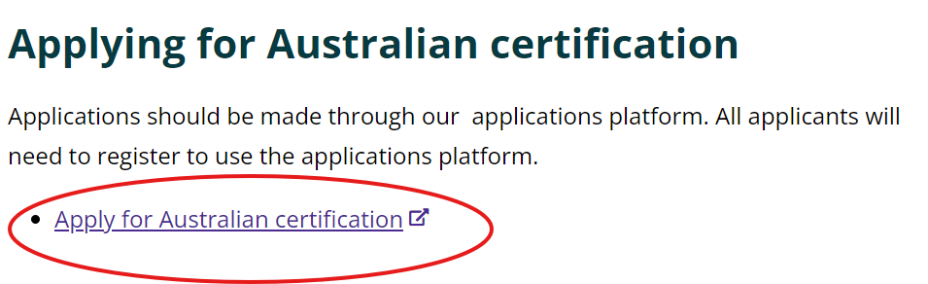
Figure 1: Link to application for Product Emissions Standards certification
All new applicants will need to create a new account to use the Product Emissions Standards applications portal. Existing users will be able to login using their existing account details and password. Once logged in, click on the applicable option to apply for an Emissions Controlled Product certification or exemption.
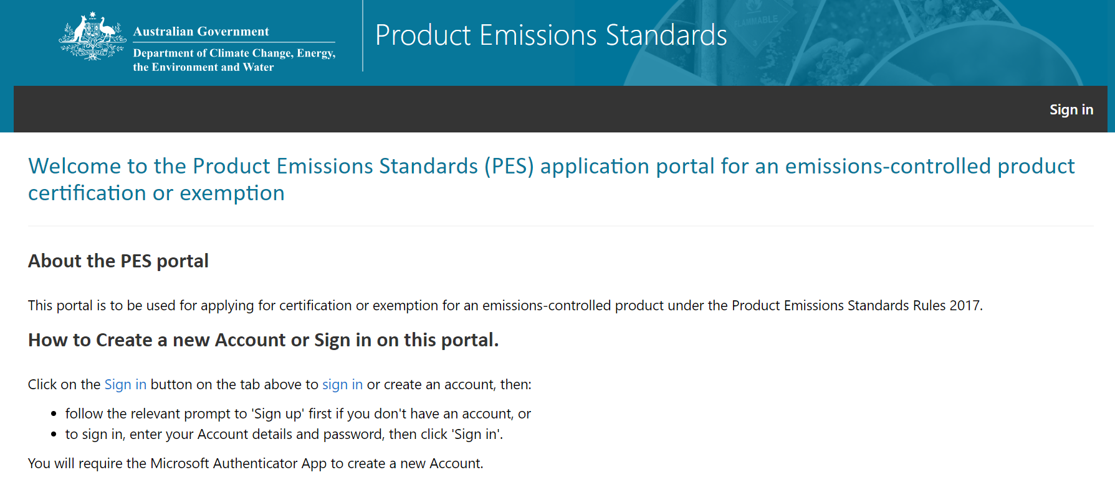
Figure 2: Product Emissions Standards application portal home page

Information required from the applicant
An application for Australian certification must be in writing and must include the following information, as specified in the Rules:
- name and contact details of the applicant
- the results of emissions testing, as required under the Rules
- supporting documentation, including evidence that the testing was conducted in accordance with the Rules
- a declaration that the information provided is correct.

The department may request further information from the contact person if the application does not include the information required.

Application fees
The fees payable for an application for Australian certification are specified in the Rules and set out in the table below.
The department will only begin to assess an application once the correct application fee has been paid.
Certification category | Fee per application*
Certification application (ILAC lab testing) | $1,330.00
Certification application (non-ILAC lab testing) | $2,850.00
Table 1 Application Fees
*GST does not apply to applications fees. Application fees are correct at time of publication.

Request to waive the application fee
Under section 44 of the Rules, the department may waive an application fee, if requested by the applicant, where it is satisfied that there are exceptional circumstances, such as financial hardship. Requests for fee waivers can be made through the department’s Product Emissions Standards applications portal, as part of the certification application process. The department will consider all requests and advise the applicant about the decision in writing.

Refunds
Applicants will only be eligible to receive a refund on the application fee if the application is withdrawn within 14 days of paying the fee and the department has not begun to assess the application. If the department considers an application but does not grant an Australian certificate of conformity, the fee will not be refunded.
Requests for refunds must be made in writing to the department at productemissions.environment@dcceew.gov.au

Submitting applications
Once an application is submitted, a confirmation will be sent to the contact person’s email. Applicants can check their application status at any time by logging onto the PES application portal.
Submitted applications cannot be edited by the applicant. Where an applicant identifies that they have incorrectly entered information, or details associated with the application have changed or are missing, they can provide the department with written notice of the information to be changed. Notices should be sent to productemissions.environment@dcceew.gov.au. The department will update the application and seek formal acknowledgement of changes from the applicant before they take effect.
Applications can be withdrawn at any time during the assessment process by notifying the department in writing at productemissions.environment@dcceew.gov.au. As noted above, the application fee will only be refunded if the application is withdrawn within 14 days of paying the fee and the department has not begun to assess the application.

Time period for assessing an application
Section 21 of the Rules provides that if products have not been certified or refused within 60 days of the department receiving all required information, including confirmation of fee payment or approval of a fee waiver, then the application is deemed to have been refused. It is anticipated that most applications will be finalised sooner than 60 days.

If certification is granted
Where the department is satisfied that an application has met the conditions for certification, an Australian certificate of conformity will be issued. The department will notify the applicant of the outcome in writing, and a notice will be published on the department’s website. An Australian certificate of conformity comes into force on the day specified in the certificate.

Varying, suspending or revoking an Australian certificate of conformity
In certain circumstances, the department may vary, suspend or revoke an Australian certificate of conformity.
Section 22 of the Rules allows the department to vary an Australian certificate of conformity. Variations are made by publishing a notice on the department’s website. The contact person for the Australian certificate of conformity will be notified in writing. A variation will take effect on the day specified in the notice. Variations are designed to correct errors and are not intended to allow additional products to be added to an engine family covered by the certificate. In this instance, a new application for Australian certification would be required.
Section 23 of the Rules allows the department to suspend an Australian certificate of conformity by publishing a notice on the website. The contact person for the certificate of conformity will be notified in writing. Suspensions of an Australian certificate of conformity may occur where the department reasonably suspects that any existing certified products do not comply with the relevant Australian emissions standard.
For example, this may occur where there is a mismatch between the information provided on the engine label and the types of engines covered by a particular Australian certificate of conformity. Suspending an Australian certificate of conformity allows the department time to investigate whether the conditions of certification are being complied with.
A suspension takes effect on the day specified in the notice. A suspension is ended by publishing a second notice on the department’s website and takes effect from the day specified in the second notice. While a suspension is in force, import manufacture and/or supply of products covered by the Australian certificate of conformity must stop. Continuing to import, manufacture and/or supply, whichever is subject to the notices, these products will be an offence under Part 3 (Enforcing product emission standards) or Part 4 (Record keeping) of the Act.
The suspension will only end if the department is satisfied that the products included in the suspension comply with the Australian emissions standard.
Section 24 of the Rules allows the department to revoke an Australian certificate of conformity by publishing a notice on the website. To revoke an Australian certificate of conformity, the department must be reasonably satisfied that any of the products covered by the Australian certificate of conformity do not meet the Australian emissions standards.

If certification is not granted
Where the department is not satisfied that an application has met the conditions for Australian certification, the application will be refused. The department will notify the applicant in writing.

Appeal a decision
Applicants who do not agree with a decision made by the department can seek review by the Administrative Review Tribunal. The following decisions related to Australian certification applications can be reviewed by the Administrative Review Tribunal:
- a decision to refuse a fee waiver request
- a decision to refuse an application for Australian certification
- a decision to vary, suspend, not end a suspension or revoke an Australian certificate of conformity.
Further information is available at www.art.gov.au.

Role of the department
The department administers the Act and any product emissions standards made under the Act. Section 10 of the Act allows the Minister to make Rules that provide for Australian certification. Part 4 of the Rules sets out the circumstances in which the department can grant Australian certification for products and/or persons under the Act.
The department is responsible for:
- responding to inquiries from applicants or potential applicants
- ensuring the correct fee has been paid by the applicant
- checking whether each application includes all the required information
- assessing and deciding whether an application should be granted an Australian certificate of conformity, within any applicable timeframes
- keeping the applicant informed about the progress of their application
- where an application is approved, issuing a certificate of conformity
- where the certification is refused, notifying the applicant and providing reasons
- ensuring compliance with the Act.

More information
If you have any questions about the product emissions standards, or applying for Australian certification, contact the department:
Email productemissions.environment@dcceew.gov.au
Phone 1800 920 528 (Customer Contact Centre)
Frequently asked questions are available on the department’s website Product Emissions Standards:
www.dcceew.gov.au/environment/protection/emissions-standards/faqs

