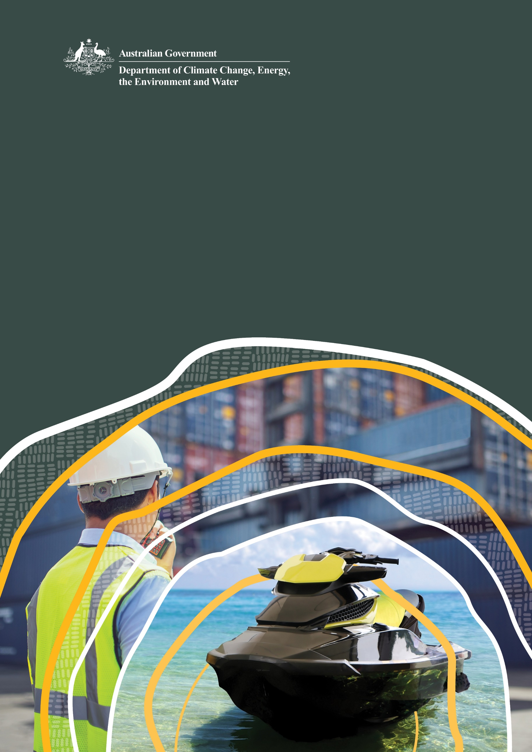
Guide to importing items regulated by the Product Emissions Standards Act 2017

© Commonwealth of Australia 2025
Ownership of intellectual property rights
Unless otherwise noted, copyright (and any other intellectual property rights) in this publication is owned by the Commonwealth of Australia (referred to as the Commonwealth).
Creative Commons licence
All material in this publication is licensed under a Creative Commons Attribution 4.0 International Licence except content supplied by third parties, logos and the Commonwealth Coat of Arms.
Inquiries about the licence and any use of this document should be emailed to copyright@dcceew.gov.au.

Cataloguing data
This publication (and any material sourced from it) should be attributed as: DCCEEW 2025, Guide to Importing items regulated by the Product Emissions Standards Act 2017, Department of Climate Change, Energy, the Environment and Water, Canberra, March 2025, CC BY 4.0.
This publication is available at dcceew.gov.au/publications.
Department of Climate Change, Energy, the Environment and Water
GPO Box 3090 Canberra ACT 2601
Telephone 1800 920 528
Web dcceew.gov.au
Disclaimer
The Australian Government acting through the Department of Climate Change, Energy, the Environment and Water has exercised due care and skill in preparing and compiling the information and data in this publication. Notwithstanding, the Department of Climate Change, Energy, the Environment and Water, its employees and advisers disclaim all liability, including liability for negligence and for any loss, damage, injury, expense or cost incurred by any person as a result of accessing, using or relying on any of the information or data in this publication to the maximum extent permitted by law.
Acknowledgement of Country
We acknowledge the Traditional Owners of Country throughout Australia and recognise their continuing connection to land, waters and culture. We pay our respects to their Elders past and present.

Contents
1. Introduction 3
1.1 Key points for customs brokers 3
2. About the legislative framework 4
3. Process for customs brokers to import products under the product emissions standards 5
4. Products covered by the standards 6
4.1 What products are not covered by the standards? 7
5. Certification and labelling/marking 8
5.1 About foreign-certified products 8
5.2 About foreign certification numbers 8
6. Exemptions 11
7. Community Protection Question 12
7.1 Answering the Community Protection Question 12
7.2 Special Case: Euro Stage V certification numbers 12
8. Tariff codes 13
9. Offences and penalties 14
10. Importation charges 15
11. More information 16

Tables
Table 1 Examples of typical products covered by the standards 6
Table 2 Exemption categories 13
Table 3 Tarriff codes linked to the Community Protection Question 14
Table 4 Penalties for import, supply and labelling contraventions ………………………………………………14

Figures
Figure 1 Process for importing emissions-controlled products for customs brokers 5
Figure 2 Format of Euro Stage V certification number 9
Boxes
Box 1 Community Protection Question 12
Box 2 Importation charge threshold examples ……………………………………………………………………………. 15

Introduction
The Product Emissions Standards regulate the import, supply and manufacture of non-road spark-ignition engines and equipment, through the Product Emissions Standards Act 2017 and the Product Emissions Standards Rules 2017. This guide provides information about importing products captured under the standards, including how to complete the import declaration.
Since 1 July 2018, all new spark ignition engines for outdoor power equipment that are below 19 kilowatts or 25.5 horsepower, and all marine propulsion spark ignition engines of any kilowatt or horsepower capacity, either domestically manufactured or imported into Australia, have been required to meet the emissions standards specified in the Rules. Products that must meet the emissions standards are referred to as ‘emissions-controlled products’. When importing these products, customs brokers need to be aware that a Community Protection Question (CPQ) is triggered when using certain tariff codes.
Since 1 July 2020, imports of European-certified outdoor power equipment must meet Euro Stage V standards. Also from this date, all new outdoor power equipment and marine engines supplied in Australia must meet the standards.
The Department of Climate Change, Energy, the Environment and Water (the department) undertakes post-border compliance activities on imports under the Act. If a breach occurs, importers and suppliers of emissions-controlled products may be liable for offences relating to import, supply, labelling and record-keeping. Emissions-controlled products imported without certification or an exemption number may be seized, and importers may be liable to penalties and prosecution.

Key points for customs brokers
Importers of emissions-controlled products must ensure their products carry either an Australian certification or a certification from a recognised international authority or have an exemption from the Australian Emissions Standards.
Recognised international authorities are the United States Environmental Protection Agency (US EPA), California Air Resources Board, member states of the European Union, and Environment and Climate Change Canada. Importers should check import requirements before importing goods and allow adequate time to apply for, and be granted, an Australian certification or an exemption if one is required.
In accordance with the Customs Act 1901, customs brokers must correctly answer the CPQ in the Integrated Cargo System (ICS) by entering the correct certification (foreign or Australian) or exemption number.
To do this, customs brokers should:
- enter one certificate number per line item on an import declaration
- ensure their import declaration does not group emissions-controlled products with products that are not captured under the standards

- follow the instructions provided in this guide under ‘About foreign certification numbers’ where a certification number exceeds the character limit available in the ICS.
Administration of the Emissions Standards is fully cost recovered. Import data collected through the ICS is used to calculate the importation charge. Fees are also charged for certification and exemption applications.

About the legislative framework
The Product Emissions Standards legislation consists of the:
- Product Emissions Standards Act 2017—which allows the minister to make Rules that set mandatory emissions standards for products and detail the administrative arrangements for regulating those products. It also establishes offences and civil penalties for the import and supply of non-compliant products and triggers compliance and enforcement provisions under the Regulatory Powers Act 2014
- Product Emissions Standards (Customs) Charges Act 2017 and the Product Emissions Standards (Excise) Charges Act 2017—which allows for a levy to be charged on products imported into or domestically manufactured in Australia
- Product Emissions Standards (Consequential Provisions) Act 2017—which allows for an amendment to be made to section 299 of the Customs Act 1901 in relation to the forfeiture of goods at the border
- Trans-Tasman Mutual Recognition Act 1997—which allows for the products captured by the emissions standards, to be exempt from the mutual recognition arrangements.
Subordinate legislation consists of the:
- Product Emissions Standards Rules 2017—which provide details of what products are regulated
- Product Emissions Standards (Customs) Charges Regulations 2018 and Product Emissions Standards (Excise) Charges Regulations 2018—which set the levies for imported and domestically manufactured products.

Process for customs brokers to import products under the product emissions standards
This flow chart has been developed to assist customs brokers to understand what information is needed from clients in order to import a product captured under the emissions standards.
Figure 1 Process for importing emissions-controlled products for customs brokers
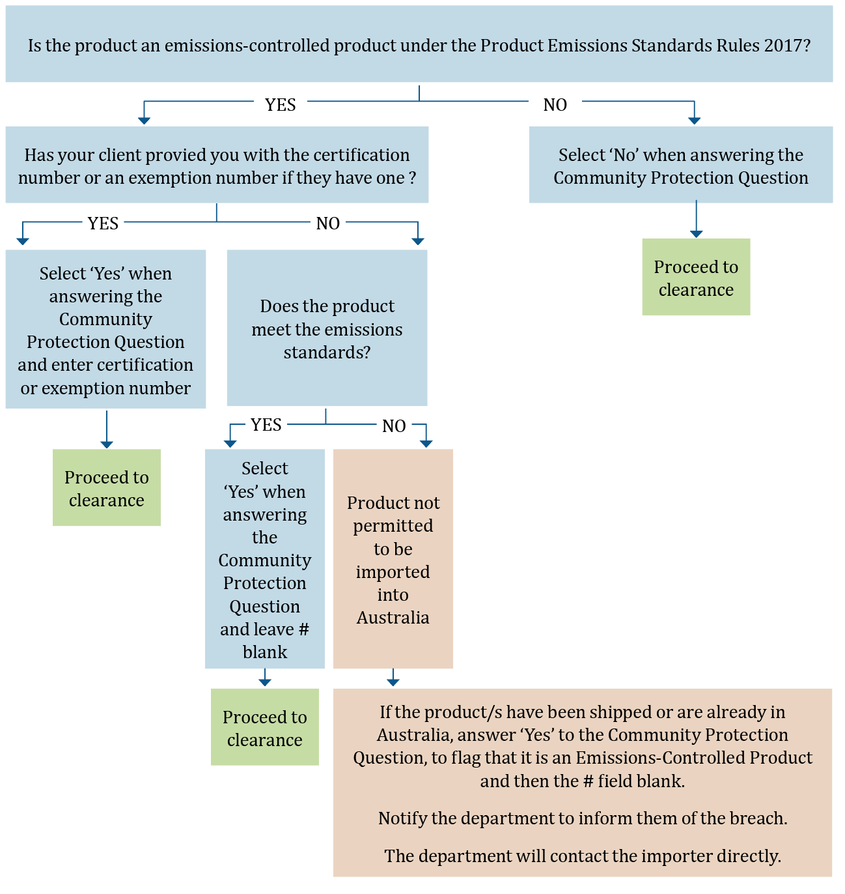
Please note that in instances where certification has not been provided in response to the Community Protection Question, you or your representative should contact the department and notify them. Further, all statements made in the ICS in, or in relation to, an import declaration—including in answer to a Community Protection Question and in the usual mandatory fields in an import declaration—are deemed to be statements made to a Customs Officer.

Products covered by the standards
Part 2 of the Rules details products captured by the standards, including:
- new, complete, non-road spark ignition engines with a maximum engine power at or below 19 kilowatts, or 25.5 horsepower; and
- new, complete, spark-ignition propulsion marine engines
- These products are predominantly petrol engines but also include a small number of gas-powered engines.

Table 1 Examples of typical products covered by the standards
Non-handheld | Handheld | Marine
Air compressor | Brick/concrete saw | Auxiliary marine engine
Brick elevator | Brushcutter | Inboard engine
Cherry picker/scissor lift | Concrete vibrator/rammer | Jet boat engine
Concrete cutter, concrete grinder | Chainsaw | Outboard engine
Concrete mixer | Engine for non-road equipment | Personal watercraft
Debris loader | Garden edger | Sterndrive engine
Engine for non-road equipment | Hammer drill | Water scooter
Firefighting/water pump | Hedge trimmer
Generator/inverter | Jackhammer
Go kart | Leaf vacuum/blower
Lawn aerator/corer | Mist blower
Leaf/garden vacuum (walk behind) | Pole pruner
Log splitter | Posthole borer/auger
Mini loader | Powered broom
Mulcher/chipper | Trowel machine (concrete)
Pitch roller | Whipper snipper/line trimmer
Plate compactor
Pressure cleaner/washer
Push mower
Ride-on mower
Rotary hoe
Slasher (ride-on)
Snow blower
Sod cutter
Stump grinder
Sweeper (non-handheld)
Note This list is not exhaustive and is for guidance only.
If a product your client is importing is not listed in the above table, but you think it might be an emissions-controlled product, please refer to the technical definition in Part 2 of the Rules. Alternatively, ask your client to contact the manufacturer for further information.

What products are not covered by the standards?
Products that are not captured by the Rules include:
  - second hand engines and equipment
  - outdoor power equipment at or above 19.1 kilowatts (or 25.5 horsepower)
  - all-terrain vehicles
  - hovercrafts
  - amphibious craft
  - compression engines and equipment (diesel).
The Australian product emissions standards align with the US EPA standards. However, the Rules do not set standards for evaporative emissions. Certificates detailing evaporative emissions are not acceptable under the Australian product emissions standards.

Certification and labelling/marking
Importers must ensure that emissions-controlled products imported into Australia, or supplied to the Australian market, carry either Australian certification or certification from a recognised foreign authority. Both importers and suppliers are liable for offences under the Act.

About foreign-certified products
The foreign authorities recognised in the Rules are:
- the United States Environmental Protection Agency (US EPA)
- the California Air Resources Board (CARB)
- European Union member states
- Environment and Climate Change Canada

About foreign certification numbers

United States Environmental Protection Agency certified products
For an engine certified to the US EPA standards (CFR 1054 or CFR 1045), the engine family name should be considered as the certification number and entered in response to the Community Protection Question. It would also be acceptable to enter the Certificate of Conformity certificate number, which is the engine family number with a 3-digit suffix allocated by the EPA.
Engine family names can be accessed from the US EPA certification database. An example of an engine family name for non-road engines would be ‘MHNXS.0995BA’. An example of a certificate number for marine engines would be ‘LM9XM04.62GW-026’.

California Air Resources Board certified products
CARB follows the same naming conventions for engine families as the US EPA. The engine family name is considered the certification number and should be entered in response to the Community Protection Question. It is also acceptable to enter the applicable Executive Order number (CARB calls their Certificates of Conformity ‘Executive Orders’).
Both the engine family names, and the Executive Order (EO) number, can be accessed from the CARB Off-Road Certification Database. In the database, the EO number is hyperlinked to the actual EO for the engine family. As an example, a non-road CARB certificate number will appear similar to ‘U-U-243-0070’ and for marine engines will appear as ‘U-W-067-0005’.

European Union authority certified products
For an engine certified to the EU standards for non-road engines (referred to as non-road mobile machinery or NRMM), the ‘type-approval number’ is the certification number, and should be entered in response to the Community Protection Question.

Transitional provisions for European Union certified products
European products must be certified to Euro Stage V standards and labelled correctly before they can be imported into Australia. ‘Supply’ includes supply as a giveaway, as part of a deal or as a special offer when supplying another product.
Euro Stage V certification numbers are located on the type-approval certificate and should be on the corresponding emissions label on the engine. This certificate is generally issued to the manufacturer after their products are certified as meeting the emissions standards.
The field available in the ICS has a limit of 35 characters. If a Euro Stage V certification number exceeds the character limit customs brokers should omit the asterisks and forward slashes in order to insert the complete number. If the product is certified to another recognised foreign standard, customs brokers may use this number rather than the EU certification number.
Euro Stage V certification numbers are explained below in Figure 2.
Figure 2 Format of Euro Stage V certification number
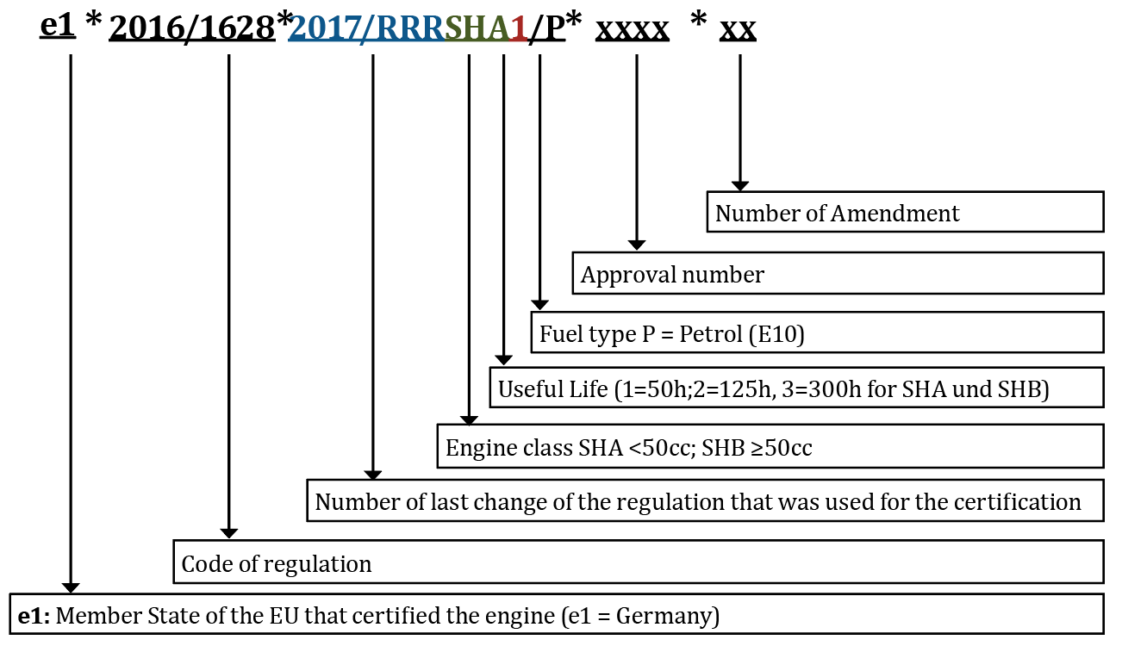
See Guidance note for importers and brokers regarding certification numbers for a detailed guide about foreign certification numbers. Further, see 7.1.1 of this document, detailing how to input certification numbers in instances of a character limit on the Integrated Cargo System.

Canadian certification
Certification from Environment and Climate Change Canada includes ‘ECA’, which stands for the Canadian Authority, IT is usually followed by a year of certification, and a certification number. An example of a Canadian certification for a non-road engine, recognised as meeting Australian certification requirements for emissions-controlled products is ‘ECA2023-507’.

Australian certification
Where a product is not already certified to a recognised international standard, a certification application may be made through the department’s Product Emissions Standards application portal. An application will typically be made by the manufacturer and will require laboratory emissions testing results to be submitted to the department for assessment. If Australian certification is granted, the applicant will be issued with a certification number. This unique number must be provided when answering the Community Protection Question in the ICS.
See Guide to Australian certification under the Product Emissions Standards Act 2017 for a detailed guide about Australian certification numbers.

Labelling and marking requirement
Any emissions-controlled product must have an emissions label fixed to the engine by the manufacturer in accordance with Part 6 of the Rules. The emissions label provides important information about the engine family, the model year, and date of manufacture. It further shows which foreign standard has been met.
A label or mark must be visible, legible and in English. Importers need to ensure that the products include the correct label before they import it into Australia. Retailers are also liable under the legislation, and must only supply emissions-controlled products that are labelled, and marked, in accordance with the Product Emissions Standards requirements.

Exemptions
The Department of Climate Change, Energy, the Environment and Water may grant an exemption to allow uncertified products to be imported or supplied to the Australian market under limited circumstances. Section 30 of the Rules specifies the six exemption categories under which an exemption application can be made (Table ).
Exemption applications are made through the department’s Product Emissions Standards application portal. If an exemption is granted, the applicant will be issued with an exemption number. This exemption number must be provided when answering the Community Protection Question in the ICS.
Table 2 Exemption categories
Exemption category (Rules reference) | Description of exemption category
Export (30(1)(a)) | Products will be exported from Australia but not used in Australia.
Testing evaluation and display (30(1)(b)) | Products will be tested, evaluated, displayed, advertised, offered for supply or pre-ordered but not used or supplied in Australia before the products are certified.
National security (30(1)(c)) | Products will be used by the Australian Defence Force or law enforcement or security agency for national security purposes.
Emergency services (30(1)(d)) | Products will be used by an emergency services organisation.
Competition (30(1)(e)) | Products will be used in organised competition.
Replacement engines (30(1)(f)) | Replacement engines for uncertified, unserviceable engines.

For national security, emergency services, organised competition and replacement engines exemption categories, the applicant must satisfy the criteria for the nominated category and be able to demonstrate that there are no other products available that meet the emissions standards that could be used instead.

Community Protection Question
Certain tariff codes are linked to the import of products regulated under the Rules. When a linked tariff code is entered into the Integrated Cargo System (ICS), the Community Protection Question (CPQ) will be triggered (Box 1).
Box 1 The Community Protection Question
‘Are these goods (or do these goods contain) new spark-ignition non-road engines or new spark- ignition propulsion marine engines as defined in the Product Emissions Standards Rules 2017 sections 7, 8 and 9?
If yes, please enter the relevant certification or exemption number for the product.’

The Department of Climate Change, Energy, the Environment and Water conducts compliance audits on the information provided in response to the CPQ, as well as for other monitored tariff codes, and will follow up with the importer.

Answering the Community Protection Question
The CPQ must be answered, and the certification or exemption number entered, when prompted. If your client has not provided a certification or exemption number, you should ask your client if the product is certified as meeting the emissions standards.
If your client informs you that the product is certified, but cannot provide you with the certification number, you can answer yes to the CPQ and leave the section for the certification or exemption number blank. However, you should notify the department and, additionally, advise your client that the Department of Climate Change, Energy, the Environment and Water will receive a notification that the product has been entered into the ICS without a certification or exemption number. The department will contact the importer to determine why this was not provided.
If your client informs you that the product is not certified, you can advise your client that it is illegal to import a product that is not certified as meeting the emissions standards. In this case, you or your client should contact the department immediately. Should your client inform you that the product is certified, and it is later identified to be an uncertified product, the importer will be liable for the offences under the Act.

Special Case: Euro Stage V certification numbers
The field available in the ICS has a limit of 35 characters. If a Euro Stage V certification number exceeds the character limit, customs brokers should omit the asterisks and forward-slashes in order to insert the complete number.

Tariff codes
The Department of Climate Change, Energy, the Environment and Water has identified a range of tariff codes that covers emissions-controlled products. Table 3 contains the tariff codes currently linked to the Community Protection Question. Please note that this is not an exhaustive list of the tariff codes monitored under our compliance program and other tariff codes may also be monitored.
Table 3 Tariff codes linked to the Community Protection Question
Tariff code | Statistical code
84072100 | 49, 50, 51, 52, 53, 54, 55, 56, 57, 58, 59, 61, 62, 63, 64, 65
84072900 | 25
84073100 | 26
84073200 | 11
84079030 | 30, 31
84137090 | 62
84148019 | 50
84244100 | 01
84243090 | 51
84304900 | 19, 44
84305000 | 45
84306100 | 23
84322900 | 47
84328000 | 14
84331100 | 48, 55, 56
84331900 | 62, 63
84368090 | 42
84641000 | 10
84659600 | 37
84678100 | 10
84678900 | 28, 60, 68
84743100 | 24
84791000 | 14
84798990 | 90
85022000 | 38, 39
89039210 | 15, 16
89039290 | 17
89039910 | 18
Please note that the above list is non-exhaustive and tariff codes monitored by the department may vary from time to time.

Offences and penalties
Importers and suppliers are liable for the offences under the Act, which relate to:
- import
- supply
- labelling
- record keeping.
Products imported without a certification or exemption number may be seized and importers may be liable to penalties and prosecution. Each import, supply and manufacturing contravention carries a maximum penalty (Table ).
Table 4 Penalties for import, supply and labelling contraventions
Type of contravention | Maximum penalty units per contravention  (1 penalty unit equals $330) | Maximum penalty per contravention
Strict liability offence (individual) | 60 penalty units | $19,800
Strict liability offence (body corporate) | 300 penalty units | $99,000
Civil penalty provision | 120 penalty units | $39,600

The penalty units expressed are correct as of 7 November 2024 and are reviewed by the Australian Government periodically.
All products must be labelled in accordance with Part 6 of the Rules, including:
- labelling in accordance with the relevant recognised foreign standards
- labelling in accordance with section 39 (2) of the Rules if the product has an Australian certification.
Records are required to be kept in accordance with Part 7 of the Rules. Records must be kept for 5 years after the end of each financial year.

Importation charges
The information entered into the ICS and the CPQ is used to calculate the charges importers are liable to pay at the end of each financial year, for the importation of emissions-controlled products.
The importation charge is charged at 0.33% of the value of products imported and is only payable if more than $44,000 worth of products are imported in a financial year. The charge is also subject to a high value threshold so that no more than $33 is payable for the import of any one item (Box 2).
Box 2 Importation charge threshold examples
Low importation charge threshold example
Threshold: $44,000 worth of products imported in one financial year.
- If an importer imports $50,000 worth of products over one financial year, the importer would be over the low importation charge threshold—bringing their import charge liability to $165, (0.33% of $50,000).
- If an importer imports $29,000 worth of products over one financial year, the importer would not be liable to pay the charge as it is below the low importation charge threshold of $44,000.
High value item threshold example
Threshold: $10,000 per item.
- If an importer imports one $50,000 boat (including the engine) over one financial year, only $10,000 of its value would go towards calculating the charge. The importer would not need to pay an importation charge, because $10,000 is under the low importation charge threshold of $44,000.
- If an importer imports 5 boats (including the engine) each worth $50,000, only $10,000 from the value for each boat would apply towards the calculation of the import charge so the charge will be $165, (0.33% of $50,000).

Following the end of the financial year, if an importer exceeds the import charge threshold, a notice of liability will be sent to the importer informing them of their liability and allowing 3 months for them to amend their import data if necessary. A final notice with the importation charge amount and invoice will be sent in October of that year.
The importation charges referred to in Box 2 are correct at the time of publication.

More information
If you have any questions about the Product Emissions Standards, please contact the department:
Email productemissions.environment@dcceew.gov.au
Phone 1800 920 528 (Customer Contact Centre)
Frequently asked questions are available on the department’s website Product Emissions Standards:
www.dcceew.gov.au/environment/protection/emissions-standards/faqs

www.epa.gov/compliance-and-fuel-economy-data/annual-certification-data-vehicles-engines-and-equipment

