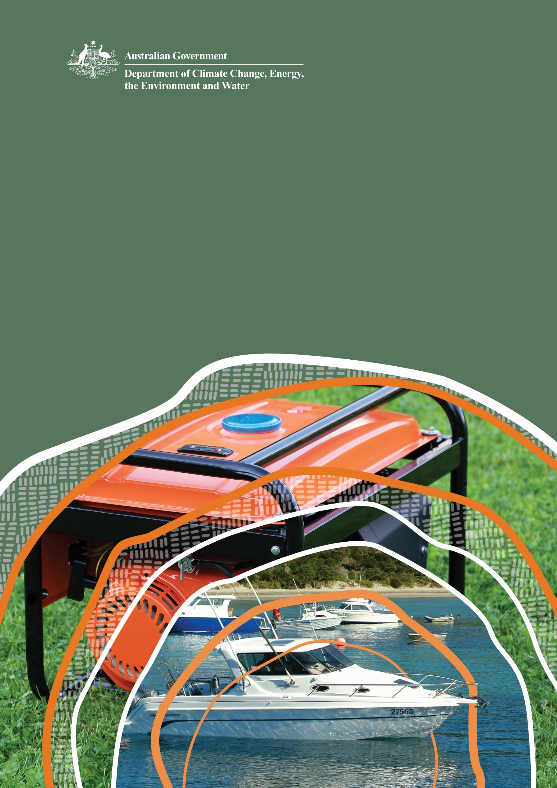
Guide to exemptions under the Product Emissions Standards Act 2017

© Commonwealth of Australia 2025
Ownership of intellectual property rights
Unless otherwise noted, copyright (and any other intellectual property rights) in this publication is owned by the Commonwealth of Australia (referred to as the Commonwealth).
Creative Commons licence
All material in this publication is licensed under a Creative Commons Attribution 4.0 International Licence except content supplied by third parties, logos and the Commonwealth Coat of Arms.
Inquiries about the licence and any use of this document should be emailed to copyright@dcceew.gov.au.

Cataloguing data
This publication (and any material sourced from it) should be attributed as: DCCEEW 2025 Guide to exemptions under the Product Emissions Standards Act 2017, Department of Climate Change, Energy, the Environment and Water, Canberra, March. CC BY 4.0.
This publication is available at www.dcceew.gov.au/environment/protection/publications.
Department of Climate Change, Energy, the Environment and Water
GPO Box 3090 Canberra ACT 2601
Telephone 1800 920 528
Web dcceew.gov.au
Disclaimer
The Australian Government acting through the Department of Climate Change, Energy, the Environment and Water has exercised due care and skill in preparing and compiling the information and data in this publication. Notwithstanding, the Department of Climate Change, Energy, the Environment and Water, its employees and advisers disclaim all liability, including liability for negligence and for any loss, damage, injury, expense or cost incurred by any person as a result of accessing, using or relying on any of the information or data in this publication to the maximum extent permitted by law.
Acknowledgement of Country
We acknowledge the Traditional Owners of Country throughout Australia and recognise their continuing connection to land, waters and culture. We pay our respects to their Elders past and present.

Contents
1 Introduction 4
2 Making an application 5
2.1 Exemption categories 6
2.2 Information required from the applicant 7
2.3 Application fees 7
2.4 Request to waive the application fee 8
2.5 Refunds 8
2.6 Submitting applications 8
2.7 Time period for assessing an application 9
3 If an exemption is granted 9
3.1 Conditions 9
3.2 Varying, suspending or revoking an exemption or its conditions 9
4 If an exemption is not granted 10
4.1 Appeal a decision 10
5 Role of the department 11
6 More information 11

Tables
Table 1 Application fees payable for Product Emissions Standards exemptions 8

Figures
Figure 1 Link to Product Emissions Standards applications portal 5
Figure 2 Access link to apply for certification or exemption under the Product Emissions Standards 5

Introduction
All new spark-ignition non-road engines of 19.1 kilowatts or less in power and new spark-ignition propulsion marine engines imported—or domestically manufactured and supplied in Australia—must comply with the product emissions standards specified under the Product Emissions Standards Act 2017 (the Act). Domestic manufacture does not include the assembly of imported engines into products.
All products, regardless of where they are manufactured must comply with the Act if supplied to the Australian market.
Under some specific circumstances, exemptions may be granted to allow products that do not meet the product emissions standards to be imported or sold in Australia. These circumstances relate to specific business requirements and cater for special circumstances where it is not possible to use a certified product.
It is expected that whilst a relatively low number of engines will continue to be imported or supplied in Australia under an exemption, the impact on total emissions will continue to be minimal.
When an exemption is granted, a unique identifying number is provided to the exemption holder. This number will need to be provided when the products are imported or supplied (including by way of sale or gifting).
This guide provides information to support anyone considering making an application to the Department of Climate Change, Energy, the Environment and Water (the department) for an exemption. Separately, the department has published ‘Guide to Australian certification under the Product Emissions Standards Act 2017’ detailing Australian certification requirements for products regulated under the Act.

Making an application
Section 29 of the Product Emissions Standards Rules 2017 (the Rules) sets out the process for applying for an exemption.
Exemptions can relate to a specified emissions-controlled product, or they can cover an applicant or a class of persons, including the applicant in relation to a specified product. Exemptions can relate to the provisions in Parts 3 or 4 of the Act which cover import, supply, marking requirements or record keeping requirements.
Applications are made through the department’s Product Emissions Standards applications portal, which can be accessed from the link ‘Apply for Australian Exemption’ on the department’s Product Emissions Standards Exemptions webpage, accessible at www.dcceew.gov.au/online-services, as shown in Figure 1.
Figure 1 Link to Product Emissions Standards applications portal
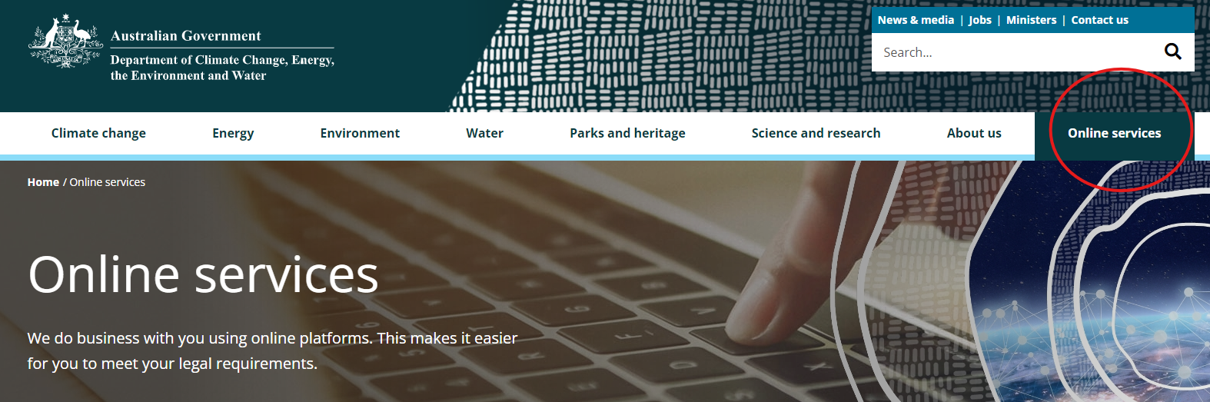
All new applicants will need to create a new account to use the Product Emissions Standards applications portal. Existing users will be able to Login using their existing account details and password. Once logged in, scroll down on the webpage and click on the applicable option to apply for an emissions-controlled product certification or exemption, as shown in Figure 2.
Figure 2 Access link to apply for certification or exemption under the Product Emissions Standards
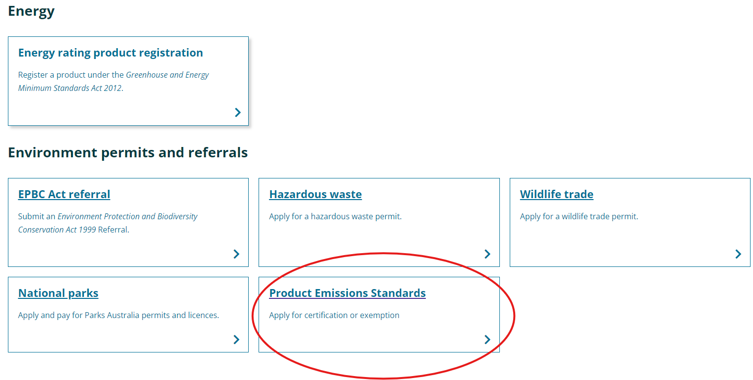

Exemption categories

Products imported for re-export (not to be sold or used in Australia)
This exemption category is available for the import of products that are not certified, which will then be re-exported from Australia and not used in Australia. Products that are granted an exemption under this category must comply with exemption conditions that include how products are managed while they are in Australia to ensure that they are not supplied domestically (including sale, exchange or offering the product). In addition, a report must be submitted to the department once the products have been exported.

Products tested, evaluated, displayed, advertised, offered for supply or pre-ordered
This exemption category is available for manufacturers or suppliers to test, evaluate, display and advertise products not yet certified but are expected to ultimately achieve certification.
This allows a person to place a pre-order based on a displayed or advertised engine, which is currently uncertified, recognising that ultimately any engine imported or supplied to the purchaser on the basis of that pre-order must be certified.

Products used by the Australian Defence Force or law enforcement or security agency
This exemption category is available for uncertified products used only by the Australian Defence Force, law enforcement or security agencies for national security purposes. A law enforcement or security agency is defined in the Independent National Security Legislation Monitor Act 2010.
This exemption is not available for products used in everyday non-security related activities by these agencies.

Products used by an emergency services organisation
This exemption category is available for uncertified products that will be used only by an emergency services organisation for rescue or emergency services purposes. This could include conducting training for those purposes.
This exemption is not available for products used in everyday, non-emergency or rescue-related activities. The Rules define emergency services organisations as including a police force or service, a fire service, an ambulance service, a coast guard service, rescue service, or a surf lifesaving organisation (subsection 30(4)).

Products used in organised competition
This exemption category is available for uncertified products that will only be used in organised competition. This ensures that the Rules will not inhibit legitimate organised racing competition activities.
An organised competition is defined in the Rules (subsection 30(5)) as one that consists of a race, or a series of races, that is managed and run by an organisation with restricted or licensed membership, and according to published competition rules and schedule. This definition does not include fishing competitions.

Replacement engines
This exemption category is available for uncertified engines that will only be used as new replacement engines for existing uncertified, unserviceable engines. This exemption allows for a ‘like for like’ replacement of an uncertified engine in a high value piece of equipment, where the equipment is still functional and only the engine has failed or become unserviceable. From 1 July 2020, all products supplied to the Australian market must be certified to the emissions standards in the Rules, so only those original engines supplied before this date are eligible for an exemption within this category.

Information required from the applicant
An application for an exemption must be in writing and must include the following information.
- name and contact details of the applicant
- the single exemption category applied for
- details of the product or products
  - the date on which, or the period in which, it is expected that the product or products will be imported or supplied under the exemption
  - the number of products expected to be imported or supplied under the exemption
  - a description of how the product or products are expected to be used or dealt with in Australia
- supporting documentation (this may include evidence of no available compliant alternatives)
- declaration that the information provided is correct.
The department may request further information from the contact person.
An application for an exemption of a product must be submitted, assessed and granted prior to the exemption coming into effect.

Application fees
The fees payable for an exemption application are specified in the Rules and are set out in the table below.
The department will only consider an application after the correct fee has been paid, or where the applicant has requested and received a fee waiver from the department.
Table 1 Application fees payable for Product Emissions Standards exemptions
Exemption category | Fee per application
Products exported from Australia but not used in Australia | $1,470
Products tested, evaluated, displayed, advertised, offered for supply or pre-ordered | $390
Products used by the Australian Defence Force or law enforcement or security agency | $550
Products used by an emergency services organisation | $1,470
Products used in organised competition | $1,470
Replacement engines | $1,470

Request to waive the application fee
Under section 44 of the Rules, the department may waive an application fee, if requested by the applicant, where it is satisfied that there are exceptional circumstances, such as financial hardship. Requests for fee waivers can be made through the department’s Product Emissions Standards applications portal as part of the exemption application process. The department will consider all requests and advise the applicant about the decision in writing.

Refunds
Applicants will only be eligible to receive a refund on an application fee if the application is withdrawn within 14 days of paying the fee and the department has not begun to assess the application. If the department has commenced assessment of the application, or where an exemption is assessed but not granted, the fee will not be refunded.
Requests for refunds must be made in writing to the department at mailto:productemissions@awe.gov.auproductemissions.environment@dcceew.gov.au

Submitting applications
Once an application is submitted, a confirmation will be sent to the contact person’s email. Applicants can check their application status at any time by logging onto the PES applications portal.
Submitted applications cannot be edited by the applicant. Where an applicant identifies that they have incorrectly entered information, or details associated with the application have changed or are missing, they can provide the department with written notice of the information to be changed. Notices should be sent to productemissions.environment@dcceew.gov.au . The department will update the application and seek formal acknowledgement of changes from the applicant before they take effect.
Applications can be withdrawn at any time during the assessment process by notifying the department in writing at productemissions.environment@dcceew.gov.au. As noted above, the application fee will only be refunded if the application is withdrawn within 14 days of paying the fee and the department has not begun to assess the application.

Time period for assessing an application
Section 33 of the Rules provides that if an exemption has not been granted or refused within 60 days of the department receiving all required information, including confirmation of fee payment or approval of a fee waiver, then the application is deemed to have been refused. It is anticipated that most applications will be finalised much sooner than 60 days.

If an exemption is granted
Where the department is satisfied that an application has met the conditions for a nominated exemption category, an exemption will be granted. The department will notify the applicant of the outcome in writing and an exemption notice will be published on the department’s website. The exemption will come into force on the day specified in the notice.

Conditions
All exemptions are subject to the conditions included under section 34 of the Rules.
The importer or supplier must reasonably expect that the product, or products, covered by the exemption will only be used or dealt with in accordance with the relevant category nominated in the application. A copy of the exemption, or information about how the exemption can be viewed on the department’s website, must be included with the product.
The department may include additional conditions in the exemption. Examples of additional conditions include a maximum number of exempted products, the period for the exemption, and limitations on the supply and use of the exempted products.
The department undertakes monitoring and enforcement activities to ensure compliance with exemption conditions. If a condition of an exemption is not complied with, the exemption will no longer apply, and the product or person will be subject to the full requirements in the Act, including any penalties and offences relating to import and supply of uncertified products.

Varying, suspending or revoking an exemption or its conditions
In certain circumstances the department may vary, suspend or revoke an exemption.
Section 35 of the Rules allows the department to vary an exemption. Variations are completed by publishing a notice on the department’s website, to either include an additional condition or amend or remove an existing condition. The contact person for the exemption will be notified in writing. A variation to an exemption will take effect on the day specified in the notice. An example of where the department may vary an exemption follows on the next page.
An exemption for an uncertified engine has been granted until December 2024 under the replacement engines category. A suitable alternative replacement engine becomes available and is certified under the Australian standard in August 2024. The department may vary the exemption so that no further uncertified replacement engines can be imported but continue to allow the supply of replacement engines already imported under the exemption until December 2024.

Section 36 of the Rules allows the department to suspend an exemption by publishing a notice on the website. The contact person for the exemption will be notified in writing. Suspensions of an exemption, in part or in whole, may occur where the department forms a reasonable suspicion that the conditions of the exemption have not been met. Suspending an exemption allows the department time to investigate whether exemption conditions are being complied with before more serious action is considered.
A suspension takes effect on the day specified in the notice. A suspension is ended by publishing a second notice on the department’s website and takes effect from the day specified in the second notice. While a suspension is in force, activity covered by the exemption must stop. The import and supply of products that are the subject of the exemption will be an offence under Part 3 (Enforcing product emission standards) or Part 4 (Record keeping), unless those products are certified.
Section 37 of the Rules allows the department to revoke an exemption by publishing a notice on the website. To revoke an exemption, the department must be reasonably satisfied that the conditions of the exemption have not been met, or that the product will not be used or otherwise dealt with in accordance with the nominated exemption category.

If an exemption is not granted
Where the department is not satisfied that an application has met the conditions for a nominated exemption category, an exemption will be refused. The department will notify the applicant in writing.

Appeal a decision
People who do not agree with a decision made by the department can seek review by the Administrative Review Tribunal. The following decisions related to exemption applications can be reviewed by the Administrative Review Tribunal:
- a decision to refuse a fee waiver request
- a decision to refuse to grant an exemption
- a decision to specify a condition in an exemption
- a decision to vary, suspend, not end a suspension or revoke an exemption.
Further information is available at http://www.art.gov.au.

Role of the department
The department administers the Act and product emissions standards made under the Act. Section 11 of the Act allows the Minister to make Rules that provide for exemptions. Part 5 of the Rules sets out the circumstances in which the department can grant exemptions for products and/or persons from the Act.
The department is responsible for:
- responding to inquiries from applicants or potential applicants
- ensuring the correct fee has been paid by the applicant
- checking whether each application includes all the required information
- assessing and deciding whether an exemption should be granted and any conditions that should apply
- keeping the applicant informed about the progress of their application
- where the exemption is granted, issuing a unique identifying exemption number with a set of conditions, and publishing a notice of the exemption on the department’s website
- where the exemption is refused, notifying the applicant and providing reasons ensuring compliance with the Act and exemption conditions.

More information
If you have any questions about the product emissions standards, or applying for an exemption, contact the department:
Email productemissions.environment@dcceew.gov.au
Phone 1800 920 528 (Customer Contact Centre)
Frequently asked questions are available on the department’s website Product Emissions Standards:
www.dcceew.gov.au/environment/protection/emissions-standards/faqs

GST does not apply to applications fees. Fees are correct at time of publication.

