
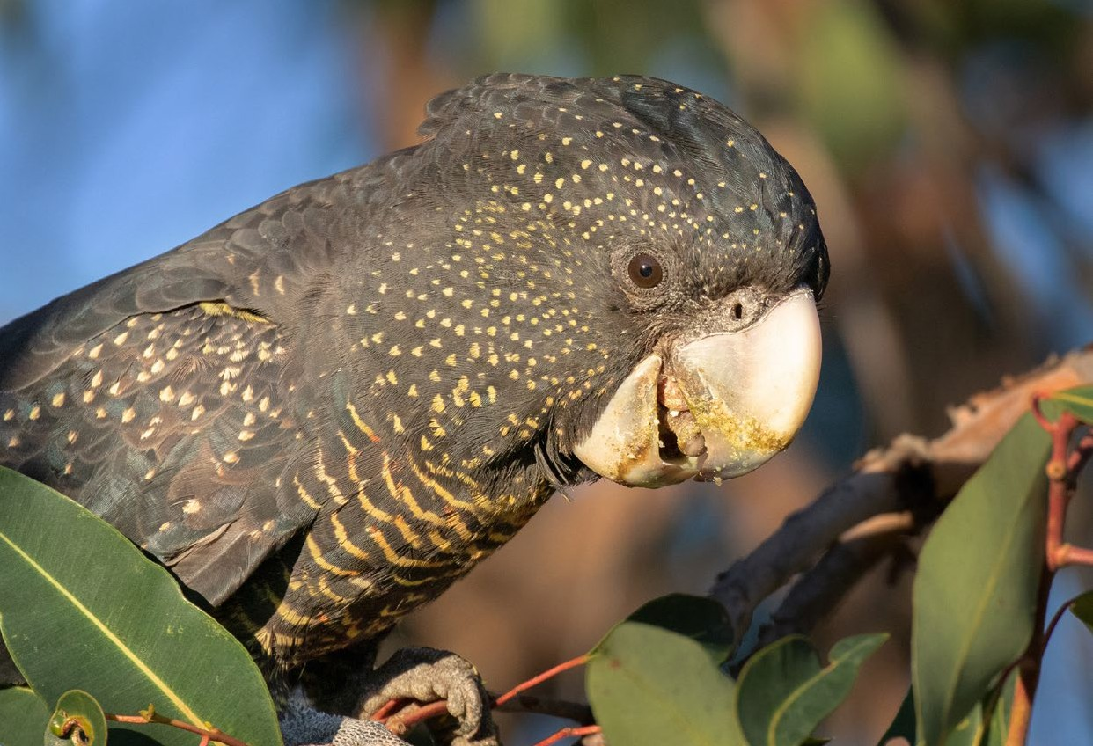

Referral guideline for 3 WA threatened black cockatoo species
Carnaby’s Cockatoo (Zanda latirostris),
Baudin’s Cockatoo (Zanda baudinii) and the
Forest Red-tailed Black-cockatoo (Calyptorhynchus banksii naso)

© Commonwealth of Australia 2022
Ownership of intellectual property rights
Unless otherwise noted, copyright (and any other intellectual property rights) in this publication is owned by the Commonwealth of Australia
(referred to as the Commonwealth).
Creative Commons licence
All material in this publication is licensed under a Creative Commons Attribution 4.0 International Licence except content supplied by third parties, logos and the Commonwealth Coat of Arms.
Inquiries about the licence and any use of this document should be emailed to copyright@awe.gov.au.


Cataloguing data
This publication (and any material sourced from it) should be attributed as: DAWE 2022, Referral guideline for 3 WA threatened black cockatoo species: Carnaby’s Cockatoo, Baudin’s Cockatoo and the Forest Red-tailed Black- cockatoo, Department of Agriculture, Water and the Environment, Canberra, February.
ISBN 978-1-76003-330-9
This publication is available at awe.gov.au/publications.
Department of Agriculture, Water and the Environment GPO Box 858 Canberra ACT 2601
Telephone 1800 900 090 Web awe.gov.au
Disclaimer
The Australian Government acting through the Department of Agriculture, Water and the Environment has exercised due care and skill in preparing and compiling the information and data in this publication. Notwithstanding, the Department of Agriculture, Water and the Environment, its employees and advisers disclaim all liability, including liability for negligence and for any loss, damage, injury, expense or cost
incurred by any person as a result of accessing, using or relying on any of the information or data in this publication to the maximum extent permitted
by law.
Acknowledgements
The Department of Agriculture, Water and the Environment would like to thank those people who participated in workshops and meetings or contributed valued advice and input into the revision of this guideline
Images credits (© Shutterstock.com unless otherwise noted)

Cover: Forest Red-tailed Black Cockatoo © Claire Greenwell
iv: Forest Red-tailed Black Cockatoo Family © Claire Greenwell
10: Western Australian woodlands © Copyright, Tony Kirkby, WA Museum 12: Black cockatoo in nesting hollow © Copyright, Tony Kirkby, WA Museum 16: Carnaby’s Cockatoo © Claire Greenwell
18: Carnaby’s Cockatoo © Claire Greenwell
21: Cockatoo drinking © Copyright, Tony Kirkby, WA Museum
25: Cockatoo © Copyright, Tony Kirkby, WA Museum
31: Cockatoo in flight © Copyright, Tony Kirkby, WA Museum

Contents
Summary 1
- Introduction 3
- What do black cockatoos need to survive and recover? 7
- Consider your action in the right context 9
- Have you surveyed for black cockatoo habitat? 12
- What actions are likely to require referral? 16
- Actions unlikely to require referral 18
- What mitigation measures may reduce the significance of
impacts of your action? 20
- Referring your action because of impacts to black cockatoos 22
Appendix A: Foraging quality scoring tool 24
Appendix B: Information that may become important during the assessment and approval process if you decide to refer 27
Appendix C: Distribution maps for the 3 black cockatoos 29
Glossary 34
References 36

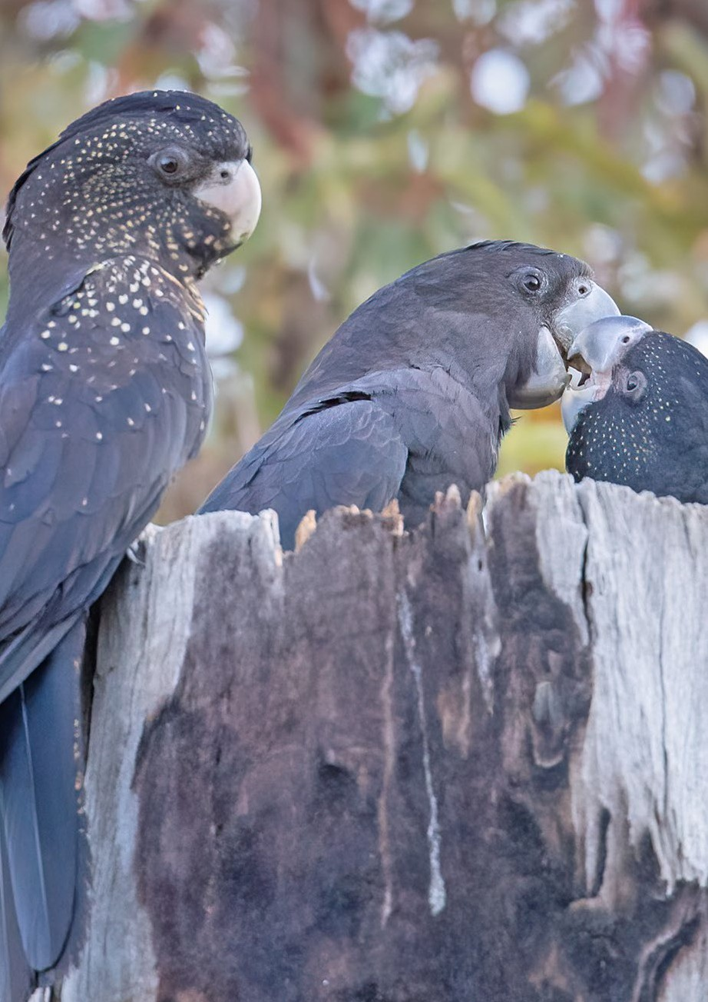
Contents

iv Referral guideline for 3 WA threatened black cockatoo species

Summary

This guideline applies to the 3 Western Australian (WA) black cockatoo species (known hereafter as black cockatoos) listed as threatened species under the Environment Protection and Biodiversity Conservation Act 1999 (EPBC Act):
- Carnaby’s Cockatoo (Zanda latirostris): Endangered
- Baudin’s Cockatoo (Zanda baudinii): Endangered
- Forest Red-tailed Black-cockatoo (Calyptorhynchus banksii naso): Vulnerable.
This document provides guidance on what actions are likely and unlikely to require referral to the Minister for the Environment because they could have a significant impact on black cockatoos. This guideline also provide details on the types of things that need to be considered when determining whether or not the proposal needs to be referred. This guideline also outlines information on habitat quality, survey expectations and standards for mitigating impacts, which could influence a decision on whether to refer an action. This advice is consistent with the current scientific literature and the conservation planning documents for these species. The following points and the diagram at Figure 1 summarise this guideline:
- Currently, the overall population trend for all 3 black cockatoo species is declining, and is expected to continue to decline (Garnett & Baker 2021).
- The loss of breeding habitat is likely to require a referral.
- The loss of one or more known or suitable nesting trees is likely to require a referral.
- The loss of a known night roosting site is likely to require a referral.
- The loss of equal to or greater than 1 hectare of high-quality foraging habitat is likely to require a referral (as determined using the foraging quality scoring tool in Appendix A).
- The loss of 1 or more hectare of predominantly exotic habitat (e.g. pines) known to be utilised by black cockatoos is likely to require a referral.
- The loss of under 10 hectares of low-quality foraging habitat is unlikely to require a referral (as determined using the foraging quality scoring tool in Appendix A).
- Light pruning or trimming of a night roosting site is unlikely to require a referral.

Summary

- Actions with indirect or facilitated impacts on black cockatoos, but where there are activities undertaken which align with mitigation objectives and priorities in this guideline, may not require a referral (see Section 6).
Avoiding impacts to breeding habitat and high-quality foraging habitat (see Appendix A) may remove the need to refer your action. Where indirect impacts are unavoidable, alignment with the mitigation objectives outlined in this guideline (see Section 6) may remove your need to refer.
If your action is likely to require referral, considering and conforming with this guideline should help to streamline the assessment of your action.

Figure 1 Summary of the referral guideline for black cockatoo species

Does your action involve loss of
any breeding habitat (i.e. known, suitable or potential nesting trees)
OR
part of a night roosting site
OR
>1 ha of high quality foraging habitat
OR
>10 ha of low quality foraging habitat
for one of the black cockatoo species (see Section 4 and Appendix A)

High risk of action resulting in a significant impact
Have you adopted the mitigation standards to remove the likelihood of significant impact?
(see Section 6)
No
Yes

Action is unlikely to require a referral
Low risk of action resulting in a significant impact
Whether the action will result in a significant impact will be determined in 20 business days after the referral is made along with an assessment pathway decision
(section 75 of the EPBC Act).
Yes
Yes
Action is likely to require a referral
No
No
No
Yes
Is there a high likelihood your action may interfere with the recovery of one or more of the black cockatoo species (see Section 6)?
OR
Will the action impact use of habitat or physically impact the species
(i.e. increased vehicle strike) (see Section 6)?
Yes
Yes

Will your action(s) directly or indirectly impact on black cockatoo habitat (see Section 3)?
Familiarise yourself with the EPBC Act assessment & approval process, Significant Impact Guidelines 1.1 and each of the black cockatoo species’ ecology and recovery needs (see Section 1).

Yes

Identify and familiarise yourself with the context (region) of your impact area (see Section 2).

Section 1

Introduction

This guideline does not remove your obligation to consider whether you need to make a referral to the minister under the EPBC Act. Although this guideline provides information to help you decide whether to refer your action, the possible impacts
of your proposed action will depend on the particular circumstances of that action. These circumstances may include the proximity of the action to foraging habitat or a nesting tree, indirect and facilitated effects, and avoidance and mitigation measures. This guideline does not attempt to pre-empt the decision that will be made by decision- makers in assessing the referral.
Although this guideline is developed based on the most current scientific information available at the time of writing, a referral will be assessed by the department based on the most up-to-date scientific information available at the time of referral, which may build on the information reflected in this guideline.

Relationship to local and state government frameworks
This document does not provide guidance on requirements under state and local government laws. Information on WA state and local government legislative requirements can be obtained from the WA Department of Water and Environmental Regulation and local government agencies.
Wherever possible, this guideline has been prepared in a manner that allows for alignment of definitions and assessment processes with those required under the relevant state and local government frameworks. This should allow the information gathered for local and state assessment purposes to be appropriate for decision-making under the EPBC Act, with little or no modification. Despite best efforts, the department recognises that some inconsistency may occur due to differences in jurisdictions’ statutory requirements and decision-making processes.

Introduction

Objectives of this guideline
The objectives of this guideline are to:
- assist proponents to decide whether an action is likely to require a referral
- promote avoidance and mitigation of impacts on black cockatoos
- promote a clear, consistent and transparent approach for making decisions on whether an action is likely to require referral for impacts on black cockatoos
- promote streamlined decision-making and approval processes
- promote proper application of the assessment and approval process under the EPBC Act to minimise interference with the recovery of black cockatoos.

How to use this guideline
This guideline is designed to be read from the perspective of a person proposing to take an action that may have an impact on black cockatoos, who needs to determine if a referral to the Minister for the Environment is necessary. Many parts of the guideline contain information that requires an understanding of the EPBC Act regulatory framework and the ecology of black cockatoos, as well as broader ecological concepts. Proponents are encouraged to seek assistance from suitably qualified or experienced people when applying this guideline to a particular action. There is an expectation that the self- assessment process would be carried out by (or be informed by) people with a reasonable level of knowledge and experience in these matters.
Prior to reading this guideline, you must be familiar with the Significant Impact Guidelines 1.1 – Matters of National Environmental Significance, which explain the concept of a ‘significant impact’.
The criteria used to judge significant impact for listed threatened species in the above guideline refer to ‘populations’ and ‘important populations’. These terms have not been defined for black cockatoos, due to the mobile and widely dispersed nature of these species, and the variation in flock compositions (for example, between breeding and non- breeding seasons). For black cockatoos, it is more appropriate to consider the likelihood of a significant impact from impacts on habitat and individuals rather than a population.
An action that will have or is likely to have a significant impact on black cockatoos must not commence until the minister makes an approval decision. Substantial penalties apply for undertaking such an action without Commonwealth approval (civil penalties up to
$8.5 million or criminal penalties, including up to 7 years imprisonment). Learn more about the referral, assessment and approval process and compliance and enforcement of the EPBC Act.
This guideline applies in areas where the threatened black cockatoos or their habitat occurs in Western Australia (see Appendix C for modelled distributions of the species). If you propose to undertake an action that could have a significant impact on black cockatoos, you should refer the proposed action to the minister prior to commencing the action. The minister will then decide within 20 business days whether a significant impact is likely and therefore whether an assessment is required under the EPBC Act. When deciding whether a proposed action requires assessment, the minister must consider all relevant information and act in a manner consistent with natural justice and procedural fairness obligations.

Introduction

If you are uncertain about the need to refer, you should refer your proposed action for legal certainty, or contact the department to discuss your proposed action at
epbc.referrals@environment.gov.au. The department cannot direct you to, or not to, refer an action.
Some black cockatoo habitat may also be part of an EPBC listed threatened ecological community or may also provide habitat for other EPBC listed threatened species (see Section 2 for examples) that are protected separately under the EPBC Act. Information on listed ecological communities is provided on the department’s website and in the Protected Matters Search Tool.
The decision tree in Figure 1 and the rest of this guideline are designed to assist you in determining whether your action should be referred to the department. It is not designed to assist you in determining whether your action will be a controlled action. This guideline does not attempt to pre-empt a decision on whether a proposed action will be determined to be a controlled action.

Possible exceptions to the need to refer
Certain actions are exempt from the requirement for assessment and approval under the EPBC Act. These include lawful continuations of land use that started before 16 July 2000 or actions that were legally authorised before 16 July 2000 (sections 43A and 43B of the EPBC Act). There are criteria that must be satisfied to rely on any such exemptions. More information on exemptions can be found on the department’s EPBC Act resources page.
Actions already underway at the time a species is listed may still require approval under the EPBC Act, depending on the circumstances. Advice is available on the department’s Environment assessment and approval process page.
Part 3 of the EPBC Act – ‘Requirements for environmental approvals’ – does not apply to forestry operations undertaken in a Regional Forestry Agreement (RFA) Region where an RFA is in place. Exceptions apply where the operation is being undertaken in a property on the World Heritage List, in a Ramsar wetland, or is incidental to another action whose primary purpose does not relate to forestry. There are clauses within RFAs regarding continuous improvement in threatened flora and fauna management, taking conservation planning documents into account and establishing a comprehensive, adequate and representative reserve system, which are intended to meet the objectives of the EPBC Act. Persons carrying out forestry operations outside of an RFA region must consider their obligations under the EPBC Act.
Bushfire hazard reduction techniques conducted in accordance with state law are typically exempt from EPBC Act approval requirements. National environmental law generally does not restrict responses required to manage bushfire emergencies, nor does it regulate measures taken to fight fires. However, any clearing required to create or maintain buffers as part of a proposed action must be included in an assessment of the impacts.
If you are uncertain about the need to refer, you should refer your proposed action for legal certainty, or contact the department to discuss your proposed action at
epbc.referrals@environment.gov.au. The department cannot direct you to, or not to, refer an action.

Introduction

Conservation planning documents
National recovery plans and approved Conservation Advices (hereafter referred to as conservation planning documents) are in place for the 3 black cockatoos. These plans provide more detailed information on ecology, threats, recovery objectives and actions.
Both recovery plans and conservation advices are taken into account under the EPBC Act in decision-making relating to project approvals. The minister must not make an approval decision that is inconsistent with a national recovery plan.
This guideline has been developed to be consistent with the conservation planning documents for these species and provides guidance to minimise interference with the recovery of black cockatoos.

More information
The species profiles for Baudin’s Cockatoo, Carnaby’s Cockatoo and the Forest Red- tailed Black-cockatoo in the department’s Species Profile and Threats (SPRAT) database provide additional information on these species.
Other EPBC Act policy statements and guidelines are available to help you understand the EPBC Act and your obligations. These are also available by contacting the community information unit at ciu@environment.gov.au or on 1800 803 772.
There may be other matters of national environmental significance to consider when assessing your proposed action, including, but not limited to, other threatened species, threatened ecological communities, Ramsar wetlands or heritage places. The Protected Matters Search Tool is a good starting point for determining the likelihood of other matters of national environmental significance occurring in the impact area. State government agencies may also hold relevant information, including species distribution and habitat information.
Although offsets are not a relevant consideration at the referral stage of an action, they may be relevant if a referral receives a ‘controlled action’ decision and moves into the assessment stage. The EPBC Act environmental offsets policy is the key document for guiding proponents and decision-makers on identifying suitable offsets.

Section 2

What do black cockatoos need to survive and recover?

Black cockatoos are long-lived, slow-breeding birds that display strong pair bonds and probably mate for life. All 3 species nest in tree hollows, with trees likely to take up to 200 years or longer to develop suitable nest hollows.
Black cockatoos forage over a large area, feeding on a variety of native and introduced (exotic and non-WA) vegetation species. Not all suitable native vegetation will produce good foraging resources each year, so black cockatoos will vary their foraging strategy depending upon availability. Black cockatoos rely upon the availability of foraging resources across their range, particularly when birds need to build condition after breeding and are teaching juveniles where foraging resources are located. Lack of foraging resources increases the likelihood that birds won’t regain condition after breeding, won’t breed again the following season, and that juveniles won’t survive to become part of the adult population.
Black cockatoos will mainly forage in areas up to 12 km from their nest, located in a known nesting tree during the breeding season. They rely on this proximity of foraging resources to known nesting trees to successfully raise chicks. During the non-breeding period, black cockatoos will mainly forage in areas up to 20 km from known night roosting habitat, though in some cases, foraging distances can be greater. Black cockatoos rely upon the availability of night roosting habitat in proximity to foraging resources, and rely on access to watering points in selecting night roost sites, with roost sites usually within 2 km of a watering point.
Connecting patches of vegetation between foraging resources, breeding habitat
and night roosting habitat are essential to enable black cockatoos to access resources across their range. Therefore remnant patches of vegetation are considered important in maintaining black cockatoo habitat connectivity across the landscape.
Currently, the overall population trend for all 3 black cockatoo species is declining. The decline of black cockatoos has been due primarily to the loss and fragmentation
of habitat as a result of clearing native vegetation. A major contributor to declines in populations of black cockatoos is the loss of nesting trees, loss of foraging habitat
(including non-native vegetation), fragmentation of breeding habitat from foraging resources and the mortality of individual birds, particularly from vehicle strike, intentional shooting or poaching. As slow-breeding birds, black cockatoos also have a relatively low ability to recover from population declines.

What do black cockatoos need to survive and recover?

The recovery actions in the conservation planning documents emphasise:
- protecting and maintaining nesting trees
- protecting and maintaining sufficient foraging resources, especially in proximity to
nesting trees
- protecting and maintaining night roosting habitat
- reducing the threats upon black cockatoos and their habitat, including threats from competitors for nesting hollows
- reducing threats from vehicle strike, shooting and poaching
- preventing habitat degradation from inappropriate fire regimes and hydrological
changes
- ensuring monitoring to inform management actions
- information sharing and communication with stakeholders to enable good decision- making.
For black cockatoos to survive and recover, impacts of the threats identified in the conservation planning documents must be addressed. Further loss, fragmentation and degradation of black cockatoo habitat must be avoided, and measures implemented to mitigate and manage impacts that are likely to interfere with the recovery of black cockatoos. These actions need to be complemented by best-practice planning for development proposals to improve the species’ chance of survival and recovery.
Further information on black cockatoo survival needs, recovery needs, and biology and ecology, is in the species’ profiles in the department’s SPRAT database, and the conservation planning documents for the three species.

Section 3

Consider your action in the right context
A ‘significant impact’ is an impact that is important, notable, or of consequence, having regard to its context or intensity. In relation to black cockatoos, the department considers ‘having regard to its context’ as being an important factor when considering whether or not to refer your action to the department.
Four regions (see Map 1) have been identified in this guideline to assist you in understanding how black cockatoos use the landscape (Section 3), the importance a region can have in referral decision-making (Section 4 & 5) and for identifying the best mitigation measures to meet recovery objectives (Section 6).
Each region has habitat that can be used by black cockatoos in a different way, providing a key function for the different species at different times of the year. Determining if your action is likely to require a referral, and/or what the best mitigation measures are, depends upon the key functions of each region for the relevant black cockatoo species.
For example, the Swan Coastal Plain is a critical foraging area for Carnaby’s Cockatoo during the non-breeding season. If your action is likely to impact foraging habitat on the Swan Coastal Plain, you would consider avoiding this habitat and/or adopting mitigation measures to reduce the impact on foraging habitat for that region.
Context (i.e. proximity to breeding, night roosting and foraging) is also very important when assessing habitat quality and is at the core of the foraging quality scoring tool provided for use in Appendix A. A high resolution map showing the different regions is also available in Appendix C and on the department’s webpage for this guideline.

Regions across the black cockatoo range

Swan Coastal Plain
The Swan Coastal Plain is used by black cockatoos primarily for foraging resources, with some small patches of breeding habitat. Vegetation used by black cockatoos is dominated by Banksia spp. and Tuart (Eucalyptus gomphocephala) woodlands, as well as Marri
(Corymbia calophylla), with Jarrah (E. marginata) in the east. A key focus for this region is the ongoing viability of foraging resources for black cockatoos, particularly Carnaby’s Cockatoo. Some parts of this region meet the definition for ecological communities in the EPBC Act list of threatened ecological communities, including Banksia Woodlands of the Swan Coastal Plain ecological community, which is listed as Endangered, and the Tuart Woodlands and Forests of the Swan Coastal Plain ecological community, which is listed as Critically Endangered. Vegetation in this region is fragmented and represented poorly in conservation reserves. The pine plantations north of the Perth metropolitan area and between Mandurah and Bunbury also provide foraging and night roosting habitat in this region.

Consider your action in the right context

Wheatbelt
The Wheatbelt contains open woodlands including York Gum (E. loxophleba), Wandoo (E. wandoo), Salmon Gum (E. salmonophloia) and Flooded Gum (E. rudis) used by Carnaby’s Cockatoo for breeding. This region extends north of the traditional Wheatbelt area, where York Gum and Kwongan heath foraging resources are accessed by Carnaby’s Cockatoo. Some parts of this region includes breeding habitat for Baudin’s Cockatoo
and the Forest Red-tailed Black-cockatoo on the eastern margins of the Jarrah forest, and some areas meet the definition for the Eucalypt Woodlands of the Western Australia Wheatbelt ecological community, which is listed as Critically Endangered in the EPBC Act list of threatened ecological communities. All areas of breeding habitat are critical to black cockatoos, as are the associated foraging areas that support breeding. Vegetation in this region is fragmented and represented poorly in reserves.

Jarrah Forest
This region is characterised by Jarrah and Marri forest, with Marri-Wandoo woodlands towards the eastern edge. All 3 black cockatoo species breed in this region and this is the main area used by Baudin’s Cockatoo and the Forest Red-tailed Black-cockatoo for breeding. Baudin’s Cockatoo has key foraging and wintering areas in this region. Marri is a primary foraging species for Baudin’s Cockatoo and the Forest Red-tailed Black- cockatoo. Foraging areas associated with breeding are critical for all species.

South Coast
The South Coast supports Jarrah-Marri forest, as well as Karri (E. diversicolor), and areas of low heath, including Banksia spp., and scrub. This region provides foraging resources for all black cockatoo species, as well as some critical breeding habitat for Carnaby’s Cockatoo and Baudin’s Cockatoo. Some foraging species are associated with the Eastern Stirling Range Montane Heath and Thicket ecological community and the Proteaceae Dominated Kwongkan Shrublands of the southeast coastal floristic province of Western Australia ecological community, both of which are listed as Endangered in the EPBC Act list of threatened ecological communities. Black cockatoos rely on this region to provide a range of foraging resources, including those in association with breeding habitat.
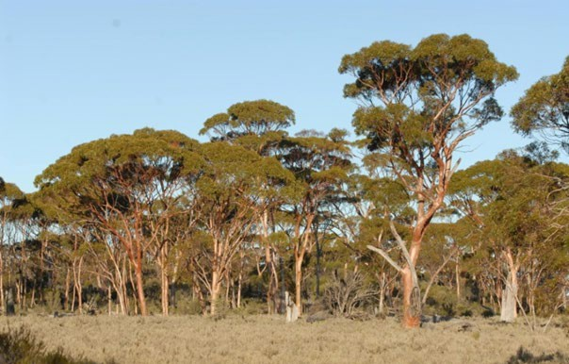

Consider your action in the right context

Map 1 Black cockatoos of southwest WA referral guideline regions

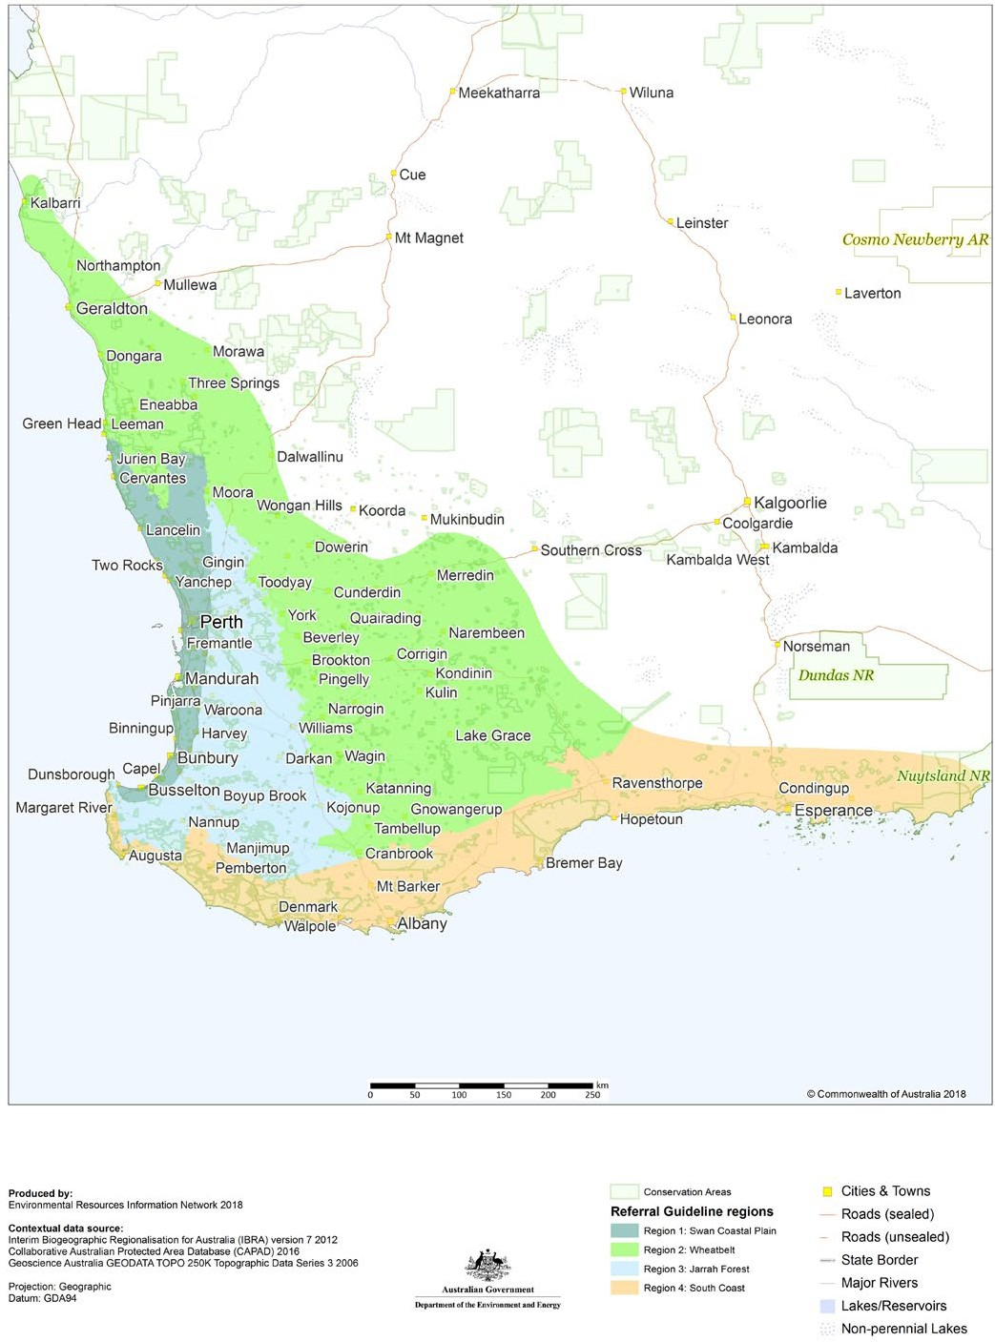

Section 4

Have you surveyed for black cockatoo habitat?

If your impact site is in the range of at least one black cockatoo species, it is recommended you undertake a habitat assessment to inform your decision about whether a referral to the minister is likely or unlikely to be required. This assessment will need to be informed by field observations on the presence of breeding habitat (known, suitable or potential nesting trees), foraging habitat or night roosting habitat.
Supporting field observations should be done by a suitably qualified person with experience in surveys of black cockatoo habitat, and account for uncertainty and error (false presence and absences). This is because the 3 species use different areas of habitat in different ways and at different times of the year. Details on the habitat types used by each species for breeding, foraging and night roosting are listed in Table 1, including common food items for each species. Details of when each type of habitat is used in each region is provided in Table 2.

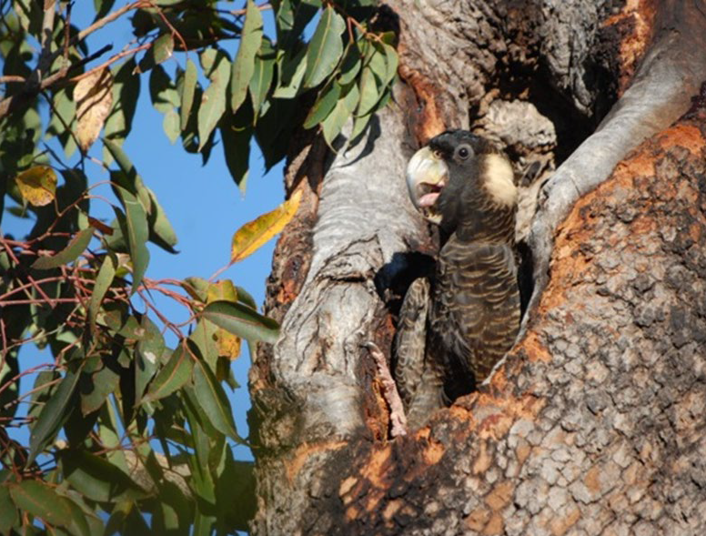

Have you surveyed for black cockatoo habitat?

Signs of use to look for during field observations include presence and size of hollows, chewing around hollow entrances, feeding signs or feeding debris, and sightings of the birds and observations of their behaviour. The presence of black cockatoo droppings and feathers, or ‘chewed’ Banksia or pine cones or Marri nuts, as well as broken or scattered flowers, can indicate feeding by black cockatoos (including, if possible, the identification of bite patterns to indicate which black cockatoo species fed there). Feeding debris can be assessed at any time of year, as cones can remain on the ground for up to two years.
Signs of use should be identified by a suitably qualified person.
A foraging quality scoring tool has been developed to guide you on what the department views as important determinants of high-quality foraging habitat. The scoring tool seeks to include consideration of the three components used in the EPBC Act Offsets Assessment Guide in the calculation of habitat quality (site condition, site context and species stocking rate), and aims to help support your decision on whether or not to refer your action to the department for impacts on foraging habitat (see Appendix A).
Habitat assessments and associated field observations of the impact area and in proximity to the impact area must be sufficient to complete the scoring tool, provide a solid justification for the score given to each attribute in the scoring tool and for supporting an overall appraisal of the foraging habitat quality on site. The attributes the department views as being important determinants of foraging habitat quality are:
  - Foraging potential
  - Connectivity
  - Proximity to breeding
  - Proximity to night roosting
  - Impact from significant plant disease.
Please note that the scoring tool does not include or require a consideration of vegetation quality based upon Keighery scale vegetation assessments or other similar methodologies. This kind of information may however (or may not) become important where an action requires assessment, or for complex proposals or offset discussions (see Appendix B).
To help with your habitat assessment and field observations, you can contact the WA Department of Biodiversity, Conservation and Attractions or the WA Museum for advice on existing records or the likelihood of breeding or night roosting habitat in proximity to your impact area. Modelled distribution maps for the 3 black cockatoos, based on the best available information, are also included in Appendix C and available on the department’s website.

Have you surveyed for black cockatoo habitat?

Table 1 Habitats used by black cockatoos

Habitat | Baudin’s Cockatoo | Carnaby’s Cockatoo | Forest Red-tailed Black Cockatoo
Breeding | Generally in woodland or forest, but may also breed in partially cleared woodland or forest, including isolated trees. Nest in hollows in live or dead trees (many eucalypt species may provide suitable hollows), particularly Karri (Eucalyptus diversicolor), Marri,  Jarrah, Wandoo, Bullich  (E. megacarpa) and Tuart. | Generally in woodland or forest, but also breeds in partially cleared woodland or forest, including isolated trees. Nest in hollows in live or dead trees (many eucalypt species may provide suitable hollows), particularly Salmon Gum, Wandoo, Tuart, Jarrah, Flooded Gum (E. rudis), York Gum, Powderbark (E. accedens), Karri and Marri. | Generally in woodland or forest, but may also breed in partially cleared woodland or forest, including isolated trees. Nest in hollows in live or dead trees (many eucalypt species may provide suitable hollows), particularly Marri, Karri, Wandoo, Bullich, Blackbutt (E. patens), Tuart and Jarrah.
Night roosting | Generally in or near riparian environments or other permanent water sources. Any tall trees may provide roosting habitat, but particularly Jarrah, Flooded Gum, Blackbutt, Tuart and introduced eucalypts (Blue Gum (E. globulus), Lemon Scented Gum (Corymbia citriodora). | Generally in or near riparian environments or natural and artificial permanent water sources. Any tall trees may provide roosting habitat, but particularly Flat-topped Yate (E. occidentalis), Salmon Gum, Wandoo, Marri, Karri, Blackbutt, Tuart, introduced eucalypts and introduced pines. | Any tall trees may provide roosting habitat, but particularly tall Jarrah, Marri, Blackbutt, Tuart and introduced eucalypt trees or large trees on the edges of forests.
Foraging and common food items | Primarily seeds of Marri, rarely Jarrah, in woodlands and forest, and seeds of native proteaceous plant species (for example, Banksia spp. (includes Dryandra spp.) and  Hakea spp.). During the breeding season feed primarily on native vegetation, particularly Marri (seeds, flowers, nectar and grubs).  Also insects and insect larvae; pith of Kangaroo Paw (Anigozanthos flavidus); tips of Pinus spp.; Macadamia spp., almonds and pecans; seeds of apples and pears; and persimmons. | Native shrubland, kwongan heathland and woodland on seeds, flowers and nectar of native proteaceous plant species (Banksia spp., Hakea spp. and Grevillea spp.), as well as Callistemon spp. and Marri.  Also seeds of introduced species including Pinus spp., Erodium spp., wild radish, canola, almonds, macadamia and pecan nuts; insects and insect larvae; occasionally apples and persimmons; and liquidambar. | Primarily seeds of Jarrah and Marri in woodlands and forest, and edges of Karri forests, including Wandoo and Blackbutt. Forages on Allocasuarina cones, fruits of Snottygobble (Persoonia longifolia) and Mountain Marri (C. haematoxylon). Other less  important foods include Blackbutt, Bullich, Allocasuarina fraseriana, Hakea spp., Tuart, Redheart Moit (E. decipiens) and Bushy Yate  (E. lehmanni).  Also some introduced eucalypts such as River Red Gum  (E. camaldulensis) and Rose Gum (E. grandis). On the Swan Coastal Plain, often feeds on introduced Cape Lilac (Melia azedarach),  E. caesia, E. erythrocorys, Lemon-scented Gum and Kaffir Plum (Harpephyllum caffrum).

Have you surveyed for black cockatoo habitat?

Table 2 Timing for surveys for black cockatoos

Regions | Baudin’s Cockatoo | Carnaby’s Cockatoo | Forest Red-tailed Black Cockatoo
Swan Coastal Plain | Unlikely to occur in much of the region, especially western and northern areas  Foraging habitat – March to September  Breeding habitat – may occur in southern Swan Coastal Plain | Foraging habitat and night roosts – any time of year (with the main period being from January to July); some individuals occur all year  Breeding habitat – localised breeding may occur from July to December (e.g. Lake Clifton) | Foraging habitat and night roosts – any time of the year  Breeding habitat – may occur in some locations containing suitable breeding tree species, including the Perth metropolitan area
Wheatbelt | Breeding habitat and foraging habitat in proximity – possible presence on western margins during breeding season (October to March) | Breeding habitat and foraging habitat in proximity - July to December; some individuals occur all year | Breeding habitat and foraging habitat in proximity – possible presence on margins, depending upon resource availability
Jarrah forest | Foraging habitat – February/ March to September  Breeding habitat and foraging habitat in proximity – August to January | Breeding habitat and foraging habitat in proximity – possible between July to December | Breeding habitat and foraging habitat in proximity – at any time of year, with peaks in April to June and August to October
South Coast | Foraging habitat – March to September  Breeding habitat and foraging habitat in proximity – August to January | Foraging habitat and night roosts  – January to July  Breeding habitat – breeding activity is July through December | Breeding habitat and foraging habitat in proximity – at any time of the year in the forested areas of the region, with peaks in April to June and August to October
Note: survey for feeding debris for all three species and in all regions can be done at any time of the year, as debris can persist for up to two years.

Section 5

What actions are likely to require referral?

An action that will have or is likely to have a significant impact on black cockatoos will require approval by the Minister for the Environment under the EPBC Act before commencing. The Significant Impact Guidelines 1.1—Matters of National Environmental Significance identifies factors that should be taken into consideration when deciding to refer an action. For the purpose of black cockatoos it is breeding habitat, night roosting habitat and foraging habitat that are the important considerations for determining whether an action is likely or unlikely to require a referral (see Table 3).

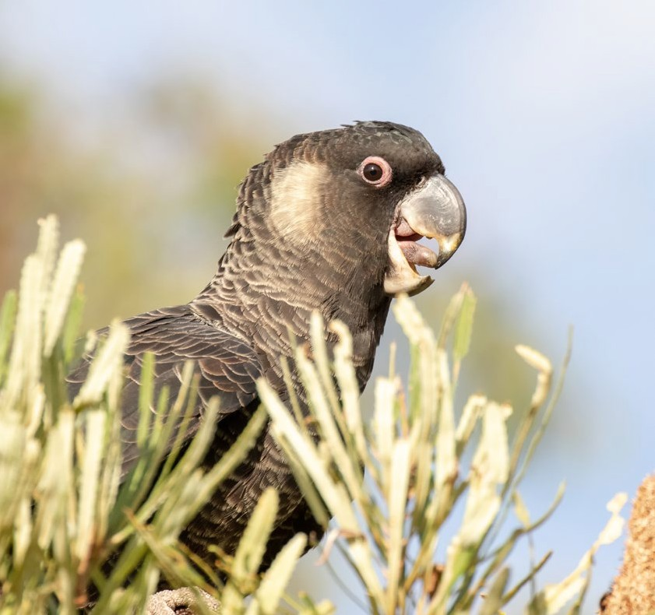

What actions are likely to require referral because they are likely to have a significant impact on black cockatoos?

Table 3 Referral thresholds for black cockatoos

Attribute | Referral threshold | Reasons
Breeding | Any loss of / impact upon known, suitable or potential nesting trees, and the habitat around these trees, is highly likely to require a referral to the minister.  Loss of any potential nesting habitat is likely to require a referral to the minister. | As identified in the conservation planning documents, clearing of breeding habitat is a known threat to the  3 speciesa as a lack of tree hollows is a limiting factor. Habitat loss, habitat degradation, lack of recruitment, fire and competition are causing the scarcity of nesting resourceb.
High-quality native foraging habitat | Loss of greater than or equal to 1 ha of foraging habitat scoring 5-10 using the foraging quality scoring tool is likely to require referral to the minister. Foraging habitat quality is determined using the foraging quality scoring tool (see Appendix A) and takes into account context i.e. proximity of the impact site to important attributes. | As identified in the conservation planning documents, clearing of foraging habitat is a known threat to the 3 species. Habitat loss, habitat modification, climate change and fire are increasingly causing the scarcity of foraging resourcesc. These resources are critical at all stages of life for the species.
Lower-quality native foraging habitat | Loss of greater than or equal to 10 ha of foraging habitat scoring 0-4 using the foraging quality scoring tool is likely to require referral to the minister.  Foraging habitat quality is determined using the foraging quality scoring tool (see Appendix A) and takes into account context i.e. proximity of the impact  site to important attributes. | As identified in the conservation planning documents, clearing of foraging habitat is a known threat to the 3 species. Habitat loss, habitat modification, climate change and fire are increasingly causing the scarcity of foraging resources. These resources are critical at all stages of life for the species.
Exotic foraging habitat | Loss of greater than or equal to 1 ha of predominantly exotic habitat (e.g. Cape Lilac trees and pine trees) known to be utilised by black cockatoos is likely to require a referral to the minister. | As identified in the conservation planning documents, clearing of exotic foraging habitat is a known threat to the 3 species, noting that its value in comparison to native habitat depends upon the context.
Night roosting habitat | Removal of any part of a known night roosting site is likely to require referral to the minister. | As identified in the conservation planning documents, clearing of night  roosting habitat is a known threat to the 3 species.
Note: Referral threshold described may be a result of direct loss, as well as loss from indirect and facilitated impacts.
a Chapman (2008); Department of Parks and Wildlife (2013)
b Johnstone & Kirkby (2008); Saunders et al. (2014)
c Saunders (1990); Johnstone et al. (2017)

Section 6

Actions unlikely to require referral

An action that is unlikely to result in a significant impact is unlikely to require referral to the Minister for the Environment. It is actions that may still involve some, but small, impacts to roosting habitat and lower quality foraging habitat that are unlikely to require a referral to the minister (see Table 4).

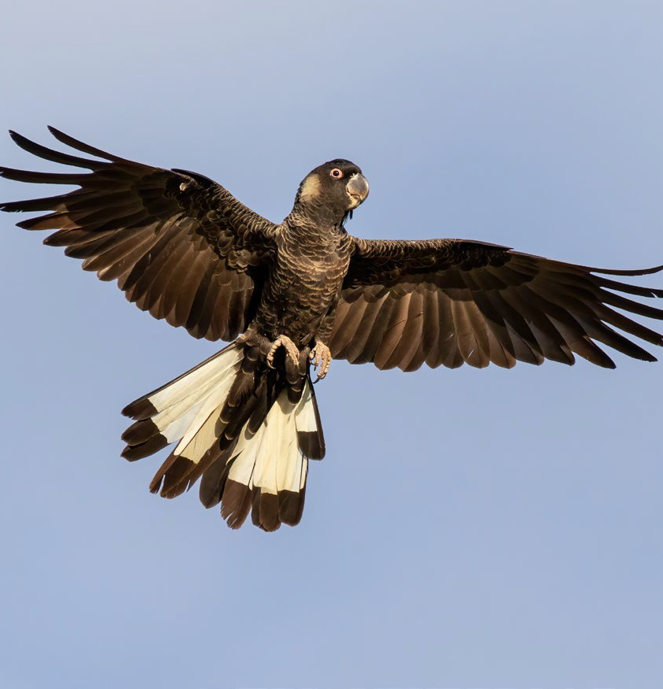

Actions unlikely to require referral because they are unlikely to have significant impact on black cockatoos

Table 4 Thresholds for when a referral is unlikely to be required

Attribute | Referral threshold | Reasons
Night roosting habitat | Limited pruning or trimming of trees within night roosting sites is unlikely to require a referral to the minister. | These types of impacts are considered low intensity, when black cockatoos are still be able to use the site for roosting.
Foraging habitat | Clearing of any quality of foraging habitat under 1 hectare is unlikely to require a referral to the minister. | This patch size is similar to minimum patch size for other EPBC Act listed entitiesa.
Foraging habitat | Clearing of low-quality foraging habitat (habitat scoring 1-4) that is less than 10 hectare is unlikely to require a referral to the minister. | Habitat on a site that scores 1-4 using the foraging quality scoring tool is not considered to provide significant foraging value or be critical to the survival of any of the species. This habitat will either not known to be used for foraging, be highly impacted by plant disease, highly isolated or considerable distance from known breeding or roosting areas.
Bushfire management | Responses to fire emergency management do not require a referral to the minister. | Refer to the Bushfire management and national environment law web page.
Forestry | Certain actions are exempt from the requirement for assessment and approval under the EPBC Act – see Page 5. | Sections 38-42, 43A and 43B of the EPBC Act.
Exotic foraging habitat | Removal of individual or multiple (up to 1 hectare) of predominantly exotic tree species (e.g. Cape Lilac trees, pine trees). | The importance of these trees is only considered significant when they are in native vegetation patches or forming patches greater than 1 hectare.
a Threatened Species Scientific Committee (2016)

Section 7

What mitigation measures may reduce the significance of impacts of your action?

In addition to consideration of direct impacts (e.g., habitat clearance), actions may still need to be referred if they result in significant indirect, offsite, or facilitated, impacts. This is where mitigation becomes an important part of your action as there are likely to be more options to successfully apply mitigation to indirect impacts than to direct impacts.
Examples of actions with indirect impacts that are likely to require referral include those that:
- adversely affect black cockatoo habitat quality and function through changes in hydrology, altered fire regimes, increased risk of deliberate fire, increase in weeds, increase in nest competitors or increased risk of diseases (habitat disease and cockatoo disease), or
- result in mortality of black cockatoo individual(s), for example, through vehicle strike, crop protection measures, including shooting, or poaching of eggs and birds.
Important information about measures proposed to
compensate for significant impacts on black cockatoos
At the referral stage, significance is based on the impact of the proposed action only. The EPBC Act does not allow for compensatory measures (such as rehabilitation of individuals) or positive impacts (including offsets) to be considered at the referral stage.
The first step should be to consider modifying the action to avoid or reduce direct and indirect impacts. The mitigation measures (examples) in this section could be applied, as appropriate, to minimise the above types of indirect impacts and be undertaken, and/ or managed and maintained, for the duration of the impact:
- For actions that will widen or create roads and so increase frequency of traffic, consider if a buffer to nearby foraging habitat is needed, or if signage and speed limits can be applied, to reduce the likelihood of vehicle strike. Where low speed limits apply (60 km/h or lower), additional plantings of foraging plants can provide food for black cockatoos in nearby areas away from roads, where vehicle strike is less likely.
- For actions that can spread pests, weeds or disease, ensure best practice hygiene protocols are followed during construction to protect black cockatoo habitat from degradation. Ongoing management of black cockatoo habitat to ensure pests, weeds and disease are not spread and/or are reduced can improve habitat quality.
- For areas where fire is possible, manage vegetation reduction burns to reduce the likelihood of frequent, hot fires that destroy breeding habitat, for example, cool burns that leave large trees intact. Controlled burns should not be detrimental to species that require long-unburnt habitat and, if considered necessary, should only be

What mitigation measures may reduce the likelihood of your action requiring a referral?

conducted by professionals and should take into account the needs of all threatened species on site. Maintain fire breaks and reduce the risk of human facilitated ignition by appropriate means.
  - For actions concerning seed, fruit or nut crops, ensure loads are covered, unwanted nuts or fruit are removed after harvesting (to discourage cockatoos from foraging) and, where appropriate, crop trees are protected with netting.
  - For actions that will degrade habitat through water drawdown (cone of depression is likely to be at least 2 km), including watering points used by black cockatoos, consider measures that concentrate drawdown in low quality habitat, rather than high quality habitat, as well as measures to reduce drawdown and/or top-up water availability for habitat.
  - For actions close to breeding areas, ensure the protection of nesting trees where black cockatoos, chicks and eggs can be at risk of poaching, by educating staff and visitors about cockatoos and appropriate activity/behaviour around breeding areas, and by installing fencing to deter illegal access.
  - For actions in breeding habitat, protect known and suitable nesting trees and trees in eucalypt forest, woodland and paddocks that have the potential to provide hollows into the future.
Commitment to avoiding significant impacts, in conjunction with well managed and maintained mitigation, will ensure your action is consistent with the recovery objectives for black cockatoos. Non-conformance with these objectives will increase the likelihood of your action requiring a referral to the minister.
If you wish to apply mitigation measures other than those identified in this guideline, evidence that they are effective in achieving the mitigation objectives should be provided in your referral. Measures should support the recovery planning process, including ongoing management of habitat areas, where appropriate.
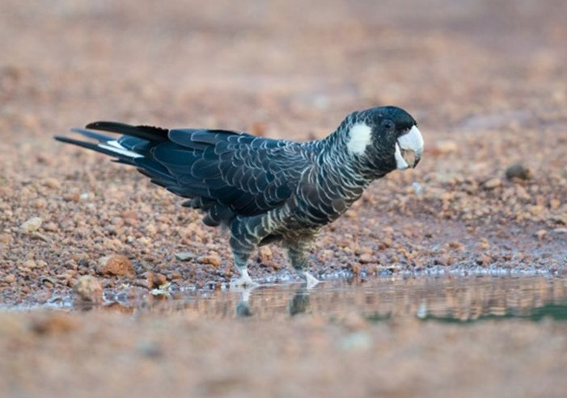

Section 8

Referring your action because of impacts to black cockatoos

As the person proposing to take an action, it is your responsibility to decide whether or not to refer your action. If your action will have or is likely to have a significant impact on black cockatoos, you are legally obliged to refer the action to the Minister for the Environment. If you remain uncertain as to whether your action will have a significant impact on black cockatoos, you can refer your action for legal certainty or contact the department to discuss your proposal.
Your decision on whether to refer will come down to 3 key considerations outlined in this guideline:
- Loss of breeding, nesting or night roosting habitat;
- Loss of high-quality foraging habitat, or substantial loss of low-quality foraging habitat; and
- Application of mitigation that avoids significant impacts.
Avoiding impacts and implementing mitigation to further reduce the overall impact will minimise your risk of a significant impact. Generally speaking, conformance with this guideline will ensure that you are best placed for a streamlined consideration of your referral, and for achieving the decision and outcomes you are seeking when you refer your action. Conformance with the principles within this guideline will also help minimise your offset obligations under the EPBC Act if assessment is required.
If you decide a referral is required, you should provide adequate information to the department so that a timely and well-informed decision can be made on the referral. Notwithstanding the requirement to adequately complete all questions on the department’s referral form, the following information is considered desirable in the initial referral package to the department:
- Detailed map/s defining the impact area (including any indirect, offsite and facilitated impacts) and any additional study area. These maps should indicate nesting trees, night roosting habitat and areas of foraging habitat within the impact area, and within a radius of at least 12 km from the impact area, including areas protected by conservation agreements/national parks/etc.
- Information from desktop and on-ground surveys, including the timing of on-ground surveys that were undertaken

Referring your action because of impacts to black cockatoos

- Calculations of total area of black cockatoo habitat in the impact area and study area in hectares
- An assessment of foraging habitat quality for the relevant black cockatoo species using the foraging quality scoring tool (i.e. include the filled out scoring tool template in the referral which includes an overall habitat appraisal requested at the bottom of template; See Appendix A)
- An analysis of the presence and extent of infestation by diseases caused by
Phytophthora and similar disease
- Detailed information on impact avoidance, as well as the design, management and monitoring of proposed mitigation measures
- An analysis and forecast of the magnitude and duration of impacts
- Detailed consideration of the significance of impacts on any other relevant matters of national environmental significance, such as other threatened species, ecological communities, Ramsar wetlands, heritage places, etc.

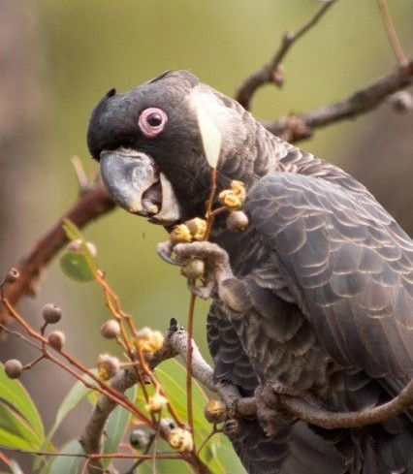

Appendix A: Foraging quality scoring tool

A foraging habitat quality scoring tool has been developed to guide you on what the department views as important for assessing quality of foraging habitat and which should influence your decision to refer your proposal to the Minister for the Environment for likely significant impacts on foraging habitat.
The scoring tool is designed to be simple, with a structure that allows for more detailed information to be taken into account, if needed. For actions that will clearly
require a referral, more detailed information relating to the key attributes in the scoring tool may be required, including on proposed avoidance and mitigation measures
(see Appendix B).

How the scoring tool works
If your impact site contains native vegetation used for foraging at any time by one or more of the black cockatoo species as described in the table below, and is larger
than 1 hectare in size, it is considered at face value to be of very high quality, important for recovery and therefore as having a score of 10. This is because black cockatoos rely on foraging resources to provide sufficient energy for breeding and to rebuild condition in the post-breeding period. The availability of foraging habitat, in close proximity to breeding and night roosting habitat, as well as watering sites, is also critical in ensuring that birds can successfully raise chicks.
The scoring tool includes consideration of the three components used in the EPBC Act Offsets Assessment Guide in the calculation of habitat quality (site condition, site context and species stocking rate) by taking into account contextual factors that may lessen the quality of that habitat, to give you a final habitat quality score, i.e., you use the context adjustors to subtract from your starting score.
To support your habitat score, you should provide an overall appraisal of the habitat to clearly explain and justify the score, and include it in your referral to the minister if you decide to refer.

Appendix A: Foraging quality scoring tool

Using the scoring tool
The scoring tool below is to be applied once to the entire impact area of your proposed action, even if there is more than one type of foraging habitat, for example, Banksia woodland and heath, introduced eucalyptus trees and planted pines (Pinus pinaster). You will always start with a score of 10.
You should complete the scoring tool for each black cockatoo species occurring within your impact area.
It is your responsibility to define the impact area and consider indirect, offsite or facilitated impacts on black cockatoos, and include these areas in the definition of your impact area (see Glossary).
If you have insufficient evidence to determine what score a particular habitat attribute meets, you should either:
- carry out additional targeted surveys (see Appendix B)
- apply the precautionary principle (i.e. assume the habitat is of sufficient quality to
warrant referral).
The scoring tool should not be used to calculate the value of an offset site.

Appendix A: Foraging quality scoring tool

Table A1 Foraging quality scoring tool template

Starting score |  | Baudin’s Cockatoo | Carnaby’s Cockatoo | Forest Red-tailed Black-Cockatoo
10 |  | Start at a score of 10 if your site is native eucalypt woodlands and forest, and proteaceous woodland and heath, particularly Marri, within the range of the species, including along roadsides and parkland cleared areas. Can include planted vegetation. This tool only applies to sites equal to or larger than 1 hectare in size. | Start at a score of 10 if your site is native shrubland, kwongan heathland or woodland, dominated by proteaceous plant species such as Banksia spp. (including Dryandra spp.), Hakea spp. and Grevillea spp., as well as native eucalypt woodland and forest that contains foraging species, within the range of the species, including along roadsides and parkland cleared areas. Also includes planted native vegetation.  This tool only applies to sites equal to or larger than 1 hectare in size. | Start at a score of 10 if your site is Jarrah or Marri woodland and/or forest, or if it is on the edge of Karri forest, or if Wandoo and Blackbutt occur on the site, within the range of the subspecies, including along roadsides and parkland cleared areas. This tool only applies to sites equal to or larger than 1 hectare in size.
Attribute | Sub- tractions | Context adjustor (attributes reducing functionality of foraging habitat)
Foraging potential | -2 | Subtract 2 from your score if there is no evidence of feeding debris on your site. | Subtract 2 from your score if there is no evidence of feeding debris on your site. | Subtract 2 from your score if there is no evidence of feeding debris on your site.
Connectivity | -2 | Subtract 2 from your score if you have evidence to conclude that there is no other foraging habitat within 12 km of your site. | Subtract 2 from your score if you have evidence to conclude that there is no other foraging habitat within 12 km of your site. | Subtract 2 from your score if you have evidence to conclude that there is no other foraging habitat within 12 km of your site.
Proximity to breeding | -2 | Subtract 2 if you have evidence to conclude that your site is more than 12 km from breeding habitat | Subtract 2 if you have evidence to conclude that your site is more than 12 km from breeding habitat. | Subtract 2 if you have evidence to conclude that your site is more than 12 km from breeding habitat.
Proximity to roosting | -1 | Subtract 1 if you have evidence to conclude that your site is more than 20 km from a known night roosting habitat. | Subtract 1 if you have evidence to conclude that your site is more than 20 km from a known night roosting habitat. | Subtract 1 if you have evidence to conclude that your site is more than 20 km from a known night roosting habitat.
Impact from significant plant disease | -1 | Subtract 1 if your site has disease present (e.g.  Phytophthora spp. or Marri canker) and the disease is affecting more than 50% of the preferred food plants present. | Subtract 1 if your site has disease present  (e.g. Phytophthora spp. or Marri canker) and the disease is affecting more than 50% of the preferred food plants present. | Subtract 1 if your site has disease present  (e.g. Phytophthora spp. or Marri canker) and the disease is affecting more than 50% of the preferred food plants present.
Total score |  | Enter score | Enter score | Enter score
Appraisal |  | To support your habitat score, you should provide an overall appraisal of the habitat on the impact site and within 20km of the impact area to clearly explain and justify the score. It should include discussion on the foraging habitat’s proximity to other resources (e.g. exact distance to proximate resources), frequency of use of proximate sites, the degree of evidence and description of vegetation type and condition.

Appendix B: Information that may become important during the assessment and approval process if you decide to refer

Section 3 of this guideline outlines what you are required to survey for to determine if your action requires referral to the Minister for the Environment. Where a referred action will have or is likely to have a significant impact and therefore is determined to be a controlled action under the EPBC Act, additional surveys could be required, particularly where high levels of uncertainty exist.
Additional survey effort is likely to be required if loss of breeding habitat (including known, suitable or potential nesting trees) is proposed, to establish the presence or absence of known nesting trees and/or breeding birds and to determine the importance of the site in the broader context. Where possible, undertaking additional surveys prior to referral may help to streamline the assessment of your action, including any compensatory measures or offset considerations. These surveys should be carried out during the preferred time periods outlined in Table 2 and if possible, the results submitted in the referral.
Surveys to determine presence or absence of breeding birds should always be undertaken by a suitably qualified person.

Appendix B: Information that may become important during the assessment and approval process if you decide to refer

Table A2 Types of additional information that might be considered during the assessment and approval stage

Type of habitat | Types of additional information
Breeding | - The number and location (e.g., in or adjacent to breeding habitat; in normal breeding range; away from breeding habitat; or outside of known breeding range.) of known nesting trees, i.e. trees of each species currently or recently used for breeding.  - The number and location of suitable nesting trees, i.e. trees of each species with suitable hollows.  - An estimated number and location of potential nesting trees. Potential nesting trees have a suitable diameter at breast height (DBH) to develop a nest hollow, but do not have hollows. For most species of trees, suitable nest hollows are only found in live trees with a DBH of at least 500 mm. Trees suitable to develop a nest hollow in the future are 300-500 mm DBH. Note that many species of eucalypt may develop suitable hollows for breeding.  - Landscape characteristics around the impact site, including details of foraging habitat in proximity (e.g. up to 12 km) to the breeding habitat and the location and details of watering points that could support the use of the breeding habitat.
Night roosting | - The number and location of trees of each species currently or recently used for night roosting (known  night roosting site).  - The frequency of use of the night roost site (daily, weekly, monthly or annually).  - The potential of the site to be used as night roosting despite no evidence of roosting (including the number and size of potential roosting trees).  - Landscape characteristics around the impact site, including details of foraging habitat in proximity (e.g. up to 20 km) to the night roosting habitat and the location and details of watering points that could support the use of the night roosting habitat.
Foraging | - The presence, extent and density (including foliage cover and flowering density) of all plant species that provide foraging, including non-native food sources used by black cockatoos.  - The distribution and size of foraging habitat in proximity (e.g. up to 12 km) to the impact site.  - Presence and prevalence of plant disease (such as dieback disease Phytophthora spp., Marri Canker (Quambalaria coyrecup) or any other plant diseases), or impact site degradation (such as cleared, disturbed or degraded areas).  - The fire history of the impact site.  - Landscape characteristics around the impact site, including details of roosting and breeding habitat in proximity (e.g. up to 20km for roosting and 12km for breeding) and the location and details of watering points that could support the use of the foraging habitat.

Appendix C: Distribution maps for the 3 black cockatoos

These maps are based on the best available information at the time of publication and remain a static product. Higher resolution versions of these maps are available from the website where this guideline was downloaded. For the most up-to-date
report of whether black cockatoos occur in your impact area, use the Protected Matters Search Tool.

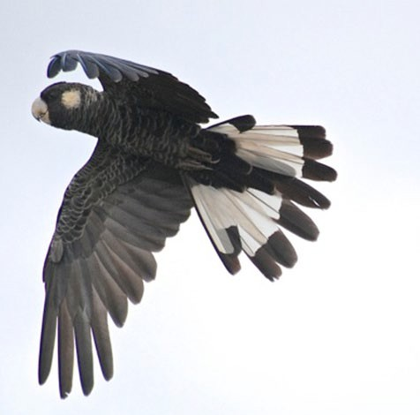

Appendix C: Distribution maps for the 3 black cockatoos

Map 2 Modelled distribution for Baudin’s Cockatoo (Zanda baudinii)

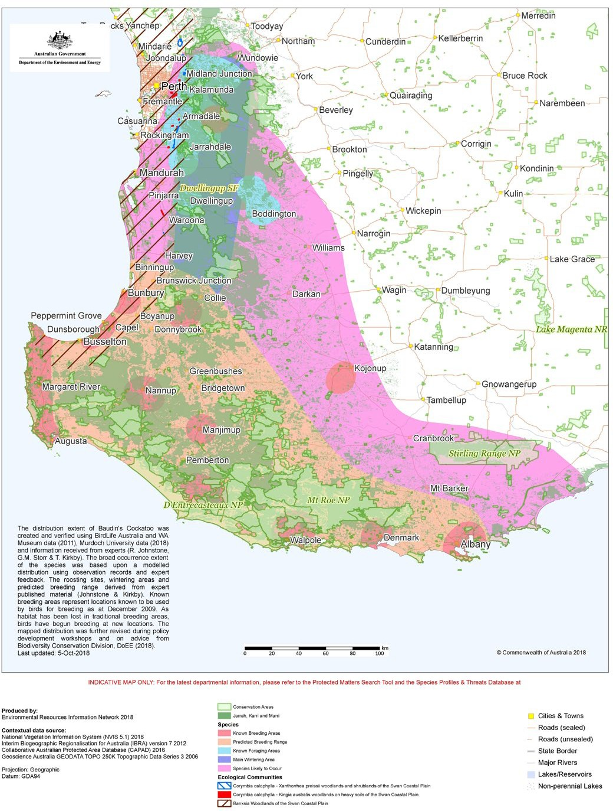

Appendix C: Distribution maps for the 3 black cockatoos

Map 3 Modelled distribution for Carnaby’s Cockatoo (Zanda latirostris)

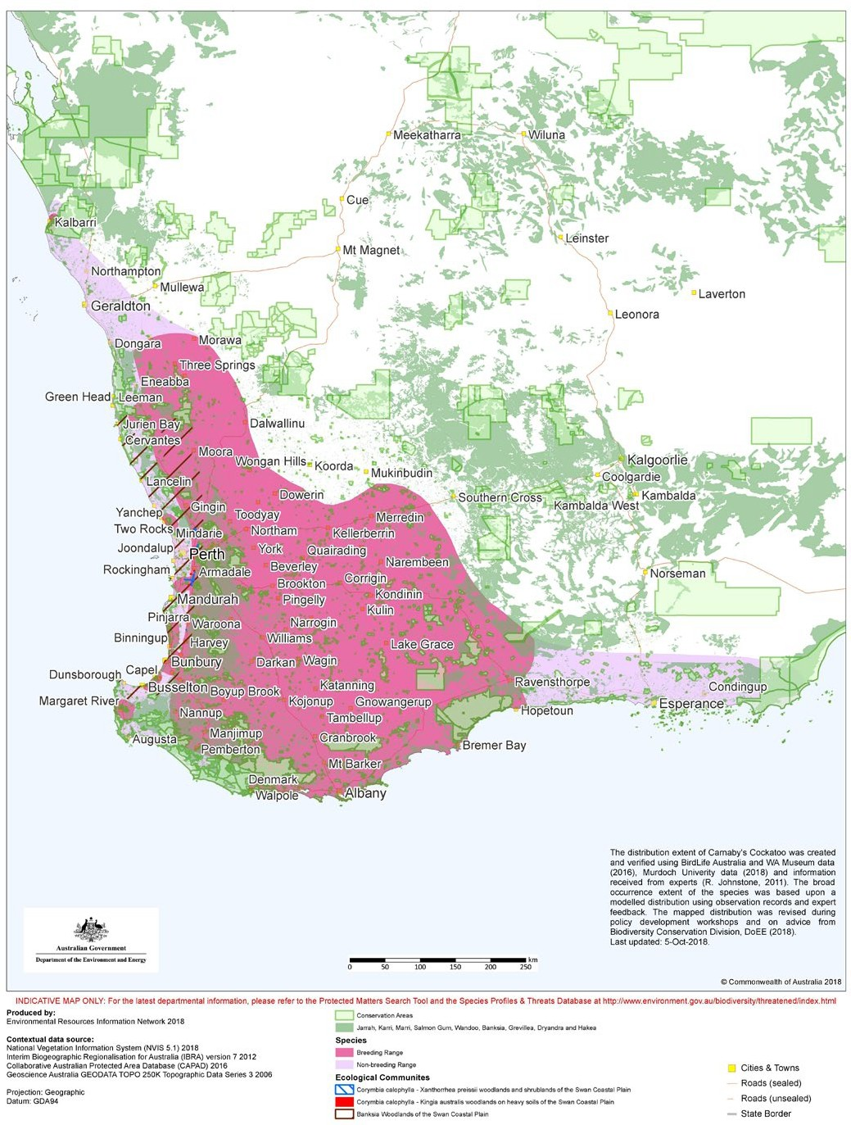

Appendix C: Distribution maps for the 3 black cockatoos

Map 4 Modelled distribution for Forest Red-tailed Black-Cockatoo (Calyptorhynchus banksii naso)

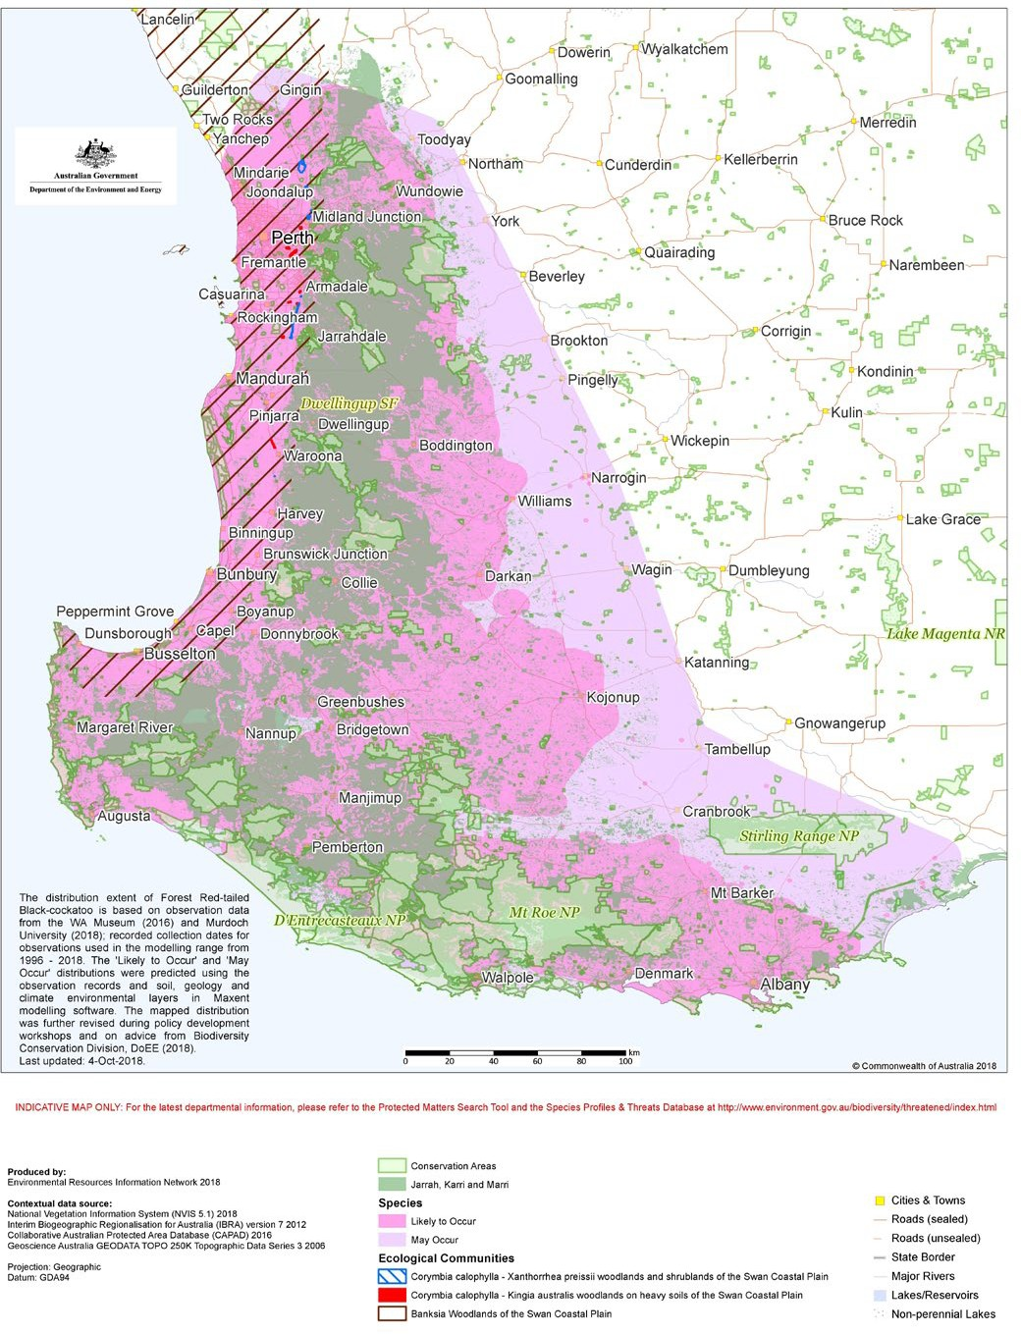

Appendix C: Distribution maps for the 3 black cockatoos

Map 5 Individual regions for black cockatoo referral guideline

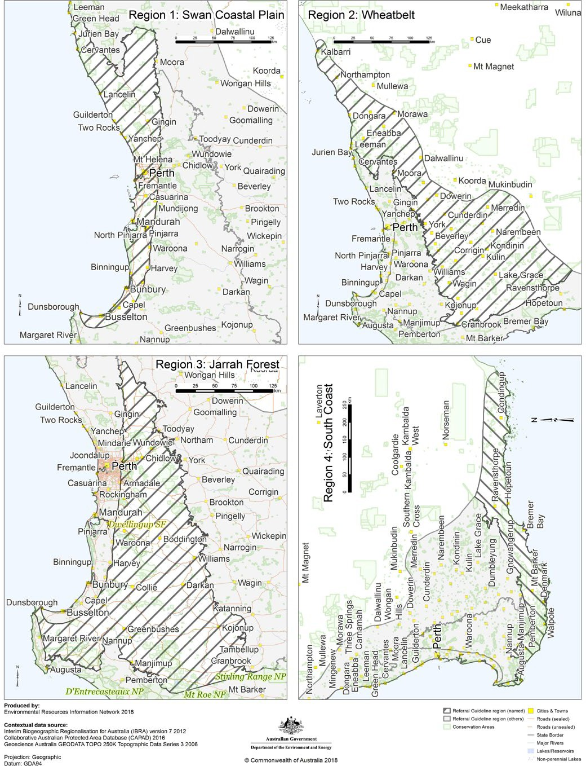

Glossary

Avoidance: Potential impacts of a proposed action removed by avoiding impacts on protected matters.
Breeding habitat: Habitat that contains known, suitable or potential nesting trees:
- Known nesting trees: Trees (live or dead but still standing) which contains a hollow where black cockatoo breeding has been recorded or which demonstrates evidence of breeding (i.e. showing evidence of use through scratches, chew marks or feathers). Note: some records of known nesting trees within or near the area of an action can be requested from the WA Department of Biodiversity, Conservation and Attractions and the WA Museum.
- Suitable nesting trees: Trees with suitable nesting hollows present, although no evidence of use. Note that any species of tree may develop suitable hollows for breeding.
- Suitable nest hollow: Any hollow with dimensions suitable for use for nesting by black cockatoos. Characteristics of hollows used by each species is available in the SPRAT database. Suitable nest hollows are only found in live trees with a DBH of at least 500 mm. Usually this will be a natural hollow, but artificial hollows may also be suitable in some circumstances (for example, where the artificial hollow has been specifically designed for use by black cockatoos). Note that artificial hollows have only been shown to have value for Carnaby’s Cockatoos to date.
- Potential nesting trees: Trees that have a suitable DBH to develop a nest hollow, but do not currently have hollows. Trees suitable to develop a nest hollow in the future are 300-500 mm DBH. Note that many species of eucalypt may develop suitable hollows for breeding.
Clearing: Cutting down, felling, thinning, logging, removing, killing, destroying, poisoning, ringbarking, uprooting, mulching or burning of native vegetation.
Department: Australian Government Department of Agriculture, Water and the Environment.
Impact area: The area likely to be affected by the action (in hectares). This includes the project site and any additional areas likely to be affected, either directly or indirectly.
That is, anywhere on or off site where the direct impacts (clearing of vegetation and construction) and indirect impacts (light, noise, dust etc.) of the proposed action would be felt. Habitat and/or populations may, and often will, extend beyond the development site boundaries. Therefore, the impact area should extend as far as necessary to take all potential impacts, including off site impacts, into account. This is the area that the person proposing an action must survey.

Glossary

Foraging habitat: Plant species known to support foraging (see Table 1) within the range of each of the species.
Maintain: Maintenance of habitat, including hollows, through ensuring regeneration of habitat and protection of hollows from feral competitors, for the duration of the impact, residual impacts and future secondary impacts.
Minister: Australian Government Minister for the Environment.
Mitigation: Scale and intensity of the potential impacts of a proposed action reduced by modifying impacts on protected matters.
Native vegetation: Shrubland, woodland, heathland or forest of species indigenous to Western Australia. Includes planted vegetation.
Night roosting habitat: Habitat that contains one, or a group of, known or potential roosting trees:
- Known roosting tree: A tree (generally the tallest), native or introduced know to be used for night roosting or which demonstrates evidence of roosting. Usually close to an important water source and within an area of high-quality foraging habitat (see Appendix A). During the breeding season, male black cockatoos roost in the vicinity of the nesting trees, therefore a breeding area may also be considered to be night roosting habitat. Roosting habitat is not always evident and can be discovered during surveys.
- Potential roosting tree: A tall tree of any species within close proximity to water.
Night roosting site: Night roosting habitat that contains one or more known night roosting tree and includes all vegetation within a 500 m radius of each known night roosting tree.
Offset: Compensation for any residual significant impact on protected matters.
Protection: Establishing an enduring legal mechanism to prevent clearing of habitat.
Quality: A measure of how functional and useful habitat is in providing what is needed to enable black cockatoos to recover and persist into the future, including proximity and availability of foraging, breeding, night roosting and water resources. Foraging habitat quality is determined using the foraging quality scoring tool (Appendix A).
Rehabilitation: Additional plantings, as well as weed and pest management, and fencing, to improve low quality habitat, so that it becomes higher quality habitat.
Residual impact(s): Unavoidable impact(s) that remain after avoidance and mitigation measures have been applied to an action.
Revegetation: Re-planting habitat in an area where no or limited habitat currently exists. In the Wheatbelt, this is known as restoration.
Suitably qualified: A person licensed or permitted by the state to carry out ecological surveys and who has previous experience undertaking black cockatoo habitat assessments, particularly in relation to nesting trees and foraging habitat.
Watering point: For the purpose of this guideline, refers to natural water bodies and artificial water sources such as artificial dams, lakes and ponds.

References

Chapman T (2008) Forest Black Cockatoo (Baudin’s cockatoo Calyptorhynchus baudinii and Forest Red-tailed black cockatoo Calyptorhynchus banksii naso) Recovery Plan. Department of Environment and Conservation, Western Australia.

Department of Parks and Wildlife (2013) Carnaby’s Cockatoo (Calyptorhynchus latirostris) Recovery Plan. Department of Parks and Wildlife, Perth, Western Australia.

Garnett ST & Baker GB (Eds) (2021) The Action Plan for Australian Birds 2020. CSIRO Publishing, Melbourne.

Johnstone RE & Kirkby T (2008) Distribution, status, social organisation, movements and conservation of Baudin's Cockatoo (Calyptorhynchus baudinii) in South-west Western Australia. Records of Western Australian Museum 25, 107-118.

Johnstone RE, Kirkby T & Sarti K (2017) The distribution, status movements and diet of the Forest Red-tailed Black Cockatoo in the south-west with emphasis on the greater Perth region, Western Australia. The Western Australian Naturalist 30, 4,
193-219.

Saunders DA (1990) Problems of survival in an extensively cultivated landscape: the case of the White-tailed Black Cockatoo Calyptorhynchus funereus latirostris.
Biological Conservation 54, 3, 277-290.

Saunders DA, Mawson PR & Dawson R (2014) Use of tree hollows by Carnaby's Cockatoo and the fate of large hollow-bearing trees at Coomallo Creek, Western Australia 1969-2013. Biological Conservation 177, 185-193.

Threatened Species Scientific Committee (2016). Approved Conservation Advice (incorporating listing advice) for the Banksia Woodlands of the Swan Coastal Plain Ecological Community. Department of the Environment and Energy, Canberra.

DA4766_0221

