South Australian Commercial Kangaroo Management Plan
2025-2029

Last updated: 5 December 2024
Contents

List of Figures iii

List of Tables iii

Definitions iv

Acronyms v

1 Introduction 1
1.1 The Plan 1
1.2 Why Manage Kangaroos? 1

2 Legislative Framework 3
2.1 Australian Government 3
2.2 South Australia 4

3 Goal and Aims 5
3.1 Goal 5
3.2 Aims 5

4 Management Actions and Performance Indicators 6
4.1 Aim 1: Ensure Humane Treatment of Kangaroos 6
4.2 Aim 2: Promote Community Awareness and Participation 7
4.3 Aim 3: Manage Impacts of Kangaroos 9
4.4 Aim 4: Monitor Kangaroo Populations and Set Quotas 10
4.5 Aim 5: Monitor Industry Compliance 18
4.6 Aim 6: Facilitate Adaptive Management and Research 20
4.7 Aim 7: Undertake Program Reporting and Review 21

References 38

Further Information 44

List of Figures
Figure 1: The 5 South Australian Commercial Kangaroo Harvest Regions, Western Pastoral, Eastern Pastoral, Western Agricultural, Eastern Agricultural and Southern Agricultural, which consist of 17 Harvest Sub-Regions. 11
Figure 2: Illustration on how the High Abundance Quota (HAQ) will be applied to kangaroo populations when the population estimate is above the population average. 15
Figure 3: Distribution of red kangaroo (Macropus rufus) determined from aerial survey (Pople and Grigg 1999). 24
Figure 4: Distribution of western grey kangaroo (Macropus fuliginosus) determined from aerial survey (Pople and Grigg 1999). 24
Figure 5: Distribution of euro (Macropus robustus) (Pople and Grigg 1999).. 25
Figure 6: Distribution of the eastern grey kangaroo (Macropus giganteus) (Van Dyck et al. 2013). 25
Figure 7: Distribution of the tammar wallaby (Macropus eugenii) (Van Dyck et al. 2013). 26
Figure 8: Histogram of a theoretical population of kangaroos. 33
Figure 9: A theoretical distribution after z-score transformation. 33
Figure 10: Example of setting harvest thresholds for red kangaroos in NSW’s Zone 2. 34
Figure 11: 10,000 simulations for a population fluctuating over 20 years. 35
Figure 12: Simulated population as described for Figure 8. 36

List of Tables
Table 1: Type of survey method and data driven model used in each harvest sub-region. 13
Table 2: Process for reducing or suspending quota based on most recent population estimate 16
Table 3: Biological threats that may regulate kangaroo populations. 27
Table 4: Anthropogenic threats that may regulate kangaroo populations. 28

List of Appendices

Appendix 1: Biology, Ecology, and Conservation of Kangaroos 22

Appendix 2: Threats to Kangaroos 27

Appendix 3: Setting and Applying Harvest Thresholds 32

Appendix 4. Summary of Quotas and Thresholds 37

Definitions
Carcass – the entire body (including the skin) of the kangaroo, field processed as per the National Parks and Wildlife (Kangaroo Harvesting) Regulations 2018.
Field processing/ processed – in relation to a kangaroo taken pursuant to a section 60J permit, means dressing the carcass into a form in which it is permitted to be sold as per regulation 42 of the National Parks and Wildlife (Kangaroo Harvesting) Regulations 2018.
Established harvest sub-regions – those established prior to 1 January 2020 and form part of the Eastern Agricultural, Western Agricultural, Eastern Pastoral and Western Pastoral Commercial Harvest Management Regions.
Field Chiller – an appliance or structure, whether mounted on or forming part of a vehicle or otherwise, providing refrigeration facilities for the storage of the carcass of a kangaroo during the period between field processing of the carcass and the transportation of the carcass to the premises at which it is to be processed by a kangaroo meat processor.
Kangaroo – means an animal of the genus Macropus (kangaroos and wallabies). The kangaroo species that can be utilised under this management plan are the red kangaroo (Macropus rufus), western grey kangaroo (M. fuliginosus), euro (M. robustus), eastern grey kangaroo (M. giganteus), tammar wallaby (M. eugenii) on Kangaroo Island and other islands, and other species as per relevant legislative amendment after the commencement of this plan. This document recognises that the genus of red kangaroo and euro has been changed from Macropus to Osphranter and the genus of the Tammar wallaby has changed from Macropus to Notamacropus, however, for consistency with the National Parks and Wildlife Act 1972, the genus Macropus has been retained.
Harvest region - A designated area of the State at which commercial quota is determined and commercial harvesting is permitted. At the time of writing, regions are defined by the former Soil Conservation Board boundaries (or amalgamation thereof), and consist of five harvest regions (Eastern Agricultural, Western Agricultural, Eastern Pastoral, Western Pastoral and Southern Agricultural), which are split into 17 harvest sub-regions. See Figure 1.
Landholder – owner or occupier of specified lands.
National Code of Practice for the Humane Shooting of Kangaroos and Wallabies for Commercial Purposes (Commercial Code)- jointly endorsed by the Commonwealth Minister for the Environment, and the Minister for Agriculture, Drought and Emergency Management in 2020, or any subsequently endorsed code. https://agrifutures.com.au/product/national-code-of-practice-for-the-humane-shooting-of-kangaroos-and-wallabies-for-commercial-purposes/
National Code of Practice for the Humane Shooting of Kangaroos and Wallabies for Non-Commercial Purposes (Non-Commercial Code) – endorsed by the Natural Resource Management Ministerial Council in 2008, or any subsequently endorsed code.
New harvest sub-regions – those established 1 January 2020 and form part of the Southern Agricultural Commercial Harvest Management Region.
Kangaroo field processor – a person, permitted under Section 60J of the National Parks and Wildlife Act 1972 to harvest and sell or use kangaroos for commercial purposes.
Kangaroo meat processor – a person, permitted under Section 58 of the National Parks and Wildlife Act 1972 to carry out the business of processing kangaroo carcasses for human or animal consumption and is permitted to keep and sell carcasses and parts of carcasses (e.g. skins) of kangaroos.
Kangaroo skin processor/tanner – a person, permitted under Section 58 of the National Parks and Wildlife Act 1972 to carry out the business of processing kangaroo skins and is permitted to keep and sell skins of kangaroos.
Note: All other terms are as defined in the National Parks and Wildlife Act 1972.

Acronyms
DEW – the South Australian Department for Environment and Water
DCCEW – the Commonwealth Department for Climate Change, the Environment and Water
EPBC Act – the Commonwealth Environment Protection and Biodiversity Conservation Act 1999
HAQ – High Abundance Quota
NPW Act – the South Australian National Parks and Wildlife Act 1972
PDW – Permit to Destroy Wildlife
SLMQ – Special Land Management Quota

Introduction

The Plan
The South Australian Commercial Kangaroo Management Plan 2025-2029 provides a framework to ensure the sustainable and humane use of commercially harvested kangaroos in South Australia. The plan satisfies the requirements of the Australian Government’s Environment Protection and Biodiversity Conservation Act 1999 (EPBC Act) as a Wildlife Trade Management Plan and the requirements of the South Australian Government as a management plan under the National Parks and Wildlife Act 1972 (NPW Act). The plan also aims to meet community expectations that kangaroo harvesting methods will not breach the Animal Welfare Act 1985. These goals will be achieved through the application of the best available scientific knowledge, best practice management and monitoring of outcomes to ensure that the viability of kangaroo populations is not compromised by any action carried out under this plan. This plan incorporates an adaptive approach to management, achieved by collecting and applying reliable information to improve management over time. This plan is current for a maximum five-year period from the date of approval as a Wildlife Trade Management Plan under the EPBC Act.
This plan relates to the following kangaroo species within South Australia:
- red kangaroo (Macropus rufus)
- western grey kangaroo (Macropus fuliginosus), including the Kangaroo Island subspecies (Macropus fuliginosus fuliginosus) and the mainland subspecies (Macropus fuliginosus melanops).
- euro (Macropus robustus)
- Tammar wallaby (Macropus eugenii)
- eastern grey kangaroo (Macropus giganteus)
- other species as per relevant legislative amendment subsequent to the commencement of this plan.

Why Manage Kangaroos?
Macropods, kangaroo and wallaby species within the Macropodidae family, are widespread and uniquely adapted to the Australian environment. South Australia has 11 species and subspecies of macropods, ranging from small wallabies up to the large red kangaroo. Two of these subspecies are listed as Vulnerable under the EPBC Act, the yellow-footed rock wallaby (Petrogale xanthopus xanthopus) and the Warru (Central Australian Rock-wallaby) (Petrogale lateralis centralis). Conservation management efforts have been successful in increasing the population sizes of these threatened species (Sharp et al. 2014, Read et al. 2018). However, other species of macropods have increased in number due to changes in land use designed to improve conditions for domestic livestock (e.g. sheep and cattle).
South of the dog fence, predation by dingos has been greatly reduced (Pople et al. 2000; Letnic et al. 2011), while the number of watering points (Fensham and Fairfax 2008) and palatable plants (Newsome 1975) have increased in areas where there was previously little water and feed. These changes have allowed macropod populations to increase in both number and distribution (Pople and Grigg 1999). The increase in herbivores has caused an increase in grazing pressure on the landscape, in both protected areas of native vegetation and agricultural land. The introduction of feral herbivores, such as rabbits, goats and deer, has also added to the grazing pressure. The presence of too many herbivores, native or feral, can have drastic negative effects on ecosystem resilience and biodiversity. The impacts of feral herbivores are generally well understood (e.g. Lange 1983), however control of only feral herbivores, without also managing populations of native herbivores, can result in over-grazing (e.g. Freeman and Pobke 2021).
Over-grazing by native herbivores can cause a decrease in plant regeneration (Morgan 2021, Freeman and Pobke 2021), changes to habitat structure used by other fauna species (Morgan 2021), changes to compositions of plant communities, reduction in food resources (e.g. seeds for birds by preventing grazed grasses from flowering, Shannon 2015, Rees et al. 2017) and soil erosion (Coulson et al. 2000). In fact, over-grazing by native herbivores can have such a negative impact that the Australian Government’s Species Profiles and Threats Database identifies grazing pressure from macropods as a threat for 152 threatened plants and 5 threatened animal taxa (Kearney et al. 2019). To prevent these negative outcomes, it is important to manage the total grazing pressure by controlling all herbivores, feral and native.
The control of herbivores can not only improve the resilience of ecosystems but also improve the animal welfare outcomes for the grazers themselves. Once grazers eat everything in the area, they are forced to move on or perish due to starvation (e.g. McMurtrie and Kerle 2021). Due to their adaptability to the Australian environment, kangaroos can quickly increase to high numbers during good rainfall years, and then decline during the next dry period. However, the changes made to landscapes south of the dog fence have intensified this natural ‘boom and bust’ pattern. Between 2012 and 2017 kangaroos reached a record high of 5 million within South Australia’s commercial harvest zone (DEW 2017), and during the next dry period thousands of kangaroos starved to death due to a lack of feed. To prevent this, and accompanying damage to ecosystems, it is important to proactively manage kangaroo numbers when conditions are good to prevent them from reaching extremely high numbers (e.g. Stephens 2021, Zanker 2021).
To help manage kangaroo impacts, the Department for Environment and Water (DEW) regulates the commercial harvest of kangaroos and non-commercial damage mitigation permits. The commercial harvest operates across most of the State and provides a landscape scale management tool that landholders can use to help reduce kangaroo numbers on their properties, while the damage mitigation permits are issued to individual properties. The commercial harvest also has the advantage of being undertaken by professional shooters and makes use of the carcasses for leather and meat production, rather than leaving carcasses on the property, as is the requirement of damage mitigation permits.

Legislative Framework

Australian Government
The EPBC Act requires the development and approval of Wildlife Trade Management Plans for permits to be issued for the commercial export of wildlife products. Wildlife Trade Management Plans are developed in line with the objects of part 13A which are detailed in section 303BA of the EPBC Act. The objects are as listed below:
(a) to ensure that Australia complies with its obligations under CITES and the Biodiversity Convention;
(b) to protect wildlife that may be adversely affected by trade;
(c) to promote the conservation of biodiversity in Australia and other countries;
(d) to ensure that any commercial utilisation of Australian native wildlife for the purposes of export is managed in an ecologically sustainable way;
(e) to promote the humane treatment of wildlife;
(f) to ensure ethical conduct during any research associated with the utilisation of wildlife;
(h) to ensure that the precautionary principle is taken into account in making decisions relating to the utilisation of wildlife.
This plan has been developed to meet the requirements of an approved Wildlife Trade Management Plan under the EPBC Act. If new legislation comes into action during the life of this plan that replaces the EPBC Act, an administrative update of the relevant sections of this plan may be required.
The EPBC Act states that the Australian Government Minister responsible for the EPBC Act may approve a Wildlife Trade Management Plan for a maximum of five years. Section 303FO of the EPBC Act specifies that such approval must only be given if the Minister is satisfied that:
- the plan is consistent with the objects of Part 13A of the EPBC Act
- an assessment of the environmental impacts of the activities in the plan has been undertaken
- the plan includes management controls directed towards ensuring the impacts of the activities covered by the plan are ecologically sustainable
- the activities in the plan are not detrimental to the species to which the plan relates or any relevant ecosystem
- the plan includes measures to mitigate, monitor and respond to the environmental impacts of the activity covered by the plan.
In deciding whether to declare this plan as a Wildlife Trade Management Plan, the Minister must also have regard to whether:
- legislation relating to the protection, conservation, or management of the species to which the plan relates is in force in the State or Territory concerned
- the legislation applies throughout the State or Territory concerned
- in the opinion of the Minister, the legislation is effective.
Finally, in deciding whether to declare this plan as a Wildlife Trade Management Plan, the Minister must also be satisfied that if an animal is killed, it is done in a way that is accepted to minimise pain and suffering. Animal welfare standards for the commercial harvesting and non-commercial destruction of kangaroos are detailed in the Commercial Code and the Non-Commercial Code, respectively. All kangaroos must be killed following these codes or any subsequent relevant endorsed code(s) that replace these documents.
In addition to the EPBC Act, this plan integrates with, and is informed by, the following pieces of legislation:
- Commonwealth Export Control Act 2020 and Export Control (Consequential Amendments and Transitional Provisions) Act 2020
- Commonwealth Native Title Act 1993

South Australia
All kangaroo species are protected animals in South Australia under the NPW Act. The NPW Act, the National Parks and Wildlife (Kangaroo Harvesting) Regulations 2018 (Kangaroo Harvesting Regulations), and the National Parks and Wildlife (Wildlife) Regulations 2019 (Wildlife Regulations), or any legislation that may replace these, make provisions for the permitting of a range of activities relating to the commercial harvesting of kangaroos in South Australia. If new legislation comes into action during the life of this plan that replaces the NPW Act, an administrative update of the relevant sections of the plan may be required.
Harvesting of kangaroos in South Australia requires a Management Plan approved under section 60I of the NPW Act, which states that the plan must:
- assess the likely impact of harvesting animals of that species:
  - on the species concerned
  - on the ecosystems which animals of that species form part
  - on the diversity of the species of animals and plants comprising those ecosystems
  - on the ability of the species to maintain natural genetic diversity throughout its population
- identify factors that are likely to reduce or increase the number of animals of the species to be harvested
- identify any other factors that will affect the species as a renewable resource for harvesting in the future
- assess whether there is a need to reduce the number of animals of the species to protect the environment, crops, stock, or other property
- specify humane methods and procedures for the killing, capturing and killing, and treatment after capture of animals under a permit under this Division (of the NPW Act)
- address any other matters that should, in the opinion of the Minister, be addressed.
This plan is designed to meet these requirements and is endorsed under the NPW Act. The Kangaroo Harvesting Regulations and the Wildlife Regulations manage the operations of the kangaroo industry through the issuing of permits, tags and record keeping. Permits are issued for harvesting kangaroos (Kangaroo Field Processor, section 60J NPW Act), processing and selling kangaroo products (Kangaroo Meat Processor, section 58 NPW Act) or processing and selling kangaroo skins (Kangaroo Skin Tanner, section 58 NPW Act). Tags are issued to kangaroo field processors under the Kangaroo Harvesting Regulations.
Kangaroos may only be harvested from land managed by DEW (e.g. national parks and conservation parks) where an approved park management plan is in place and in accordance with sections 38 and 60J of the NPW Act. Under current legislation, harvesting on DEW parks and reserves is limited to three kangaroo species: red kangaroo, mainland sub-species of western grey kangaroo and euro.
In addition to the NPW Act, this plan integrates with, and is informed by, the following pieces of legislation:
- Native Title (South Australia) Act 1994
- Landscape South Australia Act 2019
- Pastoral Land Management and Conservation Act 1989
- Animal Welfare Act 1985
- Primary Produce (Food Safety Schemes) Act 2004.

Goal and Aims

Goal
To provide for the sustainable and humane management of kangaroo species referred to in this plan
The goal of this plan is guided by the principles of ecologically sustainable development defined by the EPBC Act, which are that:
(a) decision-making processes should effectively integrate both long-term and short-term economic, environmental, social and equitable considerations
(b) if there are threats of serious or irreversible environmental damage, lack of full scientific certainty should not be used as a reason for postponing measures to prevent environmental degradation
(c) the principle of inter-generational equity - that the present generation should ensure that the health, diversity and productivity of the environment is maintained or enhanced for the benefit of future generations
(d) the conservation of biological diversity and ecological integrity should be a fundamental consideration in decision-making
(e) improved valuation, pricing and incentive mechanisms should be promoted.
To attain its overarching goal, this plan has 7 aims, each of which encompasses a particular facet of kangaroo management. When combined, these aims provide a strategic direction for ensuring an ecologically sustainable harvest of kangaroos and provide an alternative management option for reducing the impacts caused by kangaroos.
Under each aim sits one or more actions detailing both how the aim will be delivered and operational directions for kangaroo management. A range of performance indicators for each action have also been developed so that progress towards achieving the goal and aims of the plan can be measured.
Throughout the life of this plan, aims will be audited annually against performance indicators, with a major assessment and review to commence towards the end of the life of this plan.

Aims
The aims of this management plan are to:
- Ensure Humane Harvest of Kangaroos
Promote appropriate animal welfare outcomes and ensure that the commercial harvest of kangaroos under this plan is carried out in accordance with the Commercial Code.
- Promote Community Awareness and Participation
Promote greater understanding of kangaroo management and the benefits of the commercial kangaroo harvest through communication with the public.
- Manage Impacts of Kangaroos
Reduce impacts of kangaroos on the environmental, economic, and social objectives of stakeholders.
- Monitor Kangaroo Populations and Set Quotas
Monitor kangaroo populations to ensure harvesting is not negatively affecting kangaroo populations and to set commercial quotas based on population estimates that do not jeopardise the long-term conservation status of harvested species.
- Monitor Commercial Harvest
Manage the commercial utilisation of kangaroo species in accordance with the provisions of the NPW Act and Regulations, South Australian Government policies, and this plan to ensure the sustainable use of kangaroos.
- Facilitate Adaptive Management and Research
Promote adaptive management of new quota setting procedures set out in this plan using historical data from kangaroo industry returns and population data. Facilitate research into other aspects of kangaroo ecology and harvest management as required to fill knowledge gaps.
- Undertake Program Reporting and Review
Undertake regular reporting and a final review of this management plan in consultation with affected community members and stakeholders to ensure management is fully informed and to ensure outcomes remain consistent with the goal of this plan.

Management Actions and Performance Indicators

Aim 1: Ensure Humane Treatment of Kangaroos
Animal welfare is of prime concern to DEW. The Commercial Code is the current nationally-endorsed animal welfare standard for the commercial harvest of kangaroos. The Humaneness Model (Sharp and Saunders 2011) demonstrates that the ‘head shot’ required in the Commercial Code is humane, based on the premise that there is virtually no welfare impact prior to death, and mode of death is instant if undertaken by a competent shooter. Accordingly, the commercial kangaroo industry in South Australia is required (by the Kangaroo Harvesting Regulations and as a condition of the Kangaroo Field Processor permit) to comply with the Commercial Code. Any approved subsequent code(s) will similarly be adopted as the animal welfare standard for the commercial harvest of kangaroos in South Australia.
Kangaroo Field Processors are required to successfully complete a firearms proficiency course to ensure that they can harvest kangaroos according to the Commercial Code and provide a copy of this evidence to DEW (refer to Action 17). A copy of the Commercial Code is provided to all new kangaroo field processors to ensure that they are aware of their requirements.

Compliance with the Commercial Code by commercial kangaroo industry operators is monitored.
DEW staff will undertake both regular unannounced and opportunistic inspections of kangaroo carcasses stored for sale by kangaroo field processors and all premises registered to kangaroo meat processors. As per Action 18, all active chiller premises will be inspected at least once each year, and all meat processing works will be inspected at least twice per year. DEW has a zero tolerance to breaches of the Commercial Code, and where kangaroos have been found to be taken other than by the Commercial Code, DEW will instigate compliance action.
Performance indicators:

1.1 Compliance action is instigated for all identified breaches of the Commercial Code.

DEW will support research into improving the humaneness of the kangaroo harvest.
DEW will support research by other agencies or universities aiming to improve the humaneness of the kangaroo harvest. Contributions by DEW may include in-kind support, such as the provision of harvest data.
Performance indicators:

2.1 Research supported by DEW is reported in the annual Harvest Report.

Aim 2: Promote Community Awareness and Participation
Management strategies for kangaroos must meet detailed legislative requirements to ensure their sustainability, and stakeholders want to see their specific management objectives met. Community awareness of, and stakeholder participation in, kangaroo management is considered a key component in the success of the program.

Members of the Kangaroo Management Reference Group will be provided with information and afforded the opportunity to advise DEW on kangaroo management issues throughout the life of this plan.
The Kangaroo Management Reference Group (KMRG), which is convened by DEW, is the primary forum through which stakeholder group representatives can raise issues for discussion, as well as communicate their group's positions and interests to Government and other stakeholders on a regular basis. KMRG members are selected based on their skills and experience relevant to their nominated position. The current membership of KMRG includes representatives who speak on behalf of animal welfare, the kangaroo industry, landholder groups, Aboriginal communities, conservation organisations and government stakeholder groups (both Federal and State). A key function of KMRG is to advise the Chief Executive of DEW on the implementation and review of this plan, and kangaroo management more broadly.
Performance indicators:

3.1 KMRG members are provided with information relating to the implementation of this plan, such as Quota and Harvest Reports.
3.2 At least two KMRG meetings are held each year.

Public documents will be made available on the DEW website.
The provision of information to members of the public promotes understanding of the function of this plan and assists members of the community to develop informed opinions regarding kangaroo management issues.
Performance indicators:
4.1 The DEW web pages, currently entitled Commercial Kangaroo Harvesting and Kangaroo Industry Permits, are updated as required to ensure that the web pages and related links contain the following information:
- a statement of the reasons kangaroo management is undertaken in SA and how commercial harvesting can be used to assist in kangaroo management
- the current South Australian Commercial Kangaroo Management Plan
- review of the previous South Australian Kangaroo Management Plan
- relevant legislation and Commercial Code of Practice
- current and at least previous three annual Quota Reports
- current and at least previous three annual Harvest Reports
- contact information for the Kangaroo Management Program
- other information that may become relevant during the life of this plan.

Where appropriate, DEW staff will participate in media interviews and prepare media releases.
Participation in media interviews and preparation of media releases can be an efficient mechanism for communicating information regarding kangaroo management to a broad audience. Media releases also improve program transparency and accountability, and therefore public confidence.
Performance indicators:
5.1 Interviews are conducted on request from media agencies where appropriate.
5.2 Media releases are issued, when appropriate, for issues of interest to the community, such as population surveys.

An engagement strategy for the Kangaroo Management Program will be developed and utilised.
An engagement strategy will be developed for the Kangaroo Management Program to align all internal and external communication. The engagement strategy will establish the aim(s) of engagement with stakeholders; identify sectors / stakeholder groups that have an interest in kangaroo management; analyse stakeholder needs and challenges; and determine suitable communication and information management measures. The engagement strategy will specifically include engagement with representatives of First Nations communities to identify more effective ways of sharing information to support greater involvement in kangaroo management.
Performance indicators:
6.1 An engagement strategy for the Kangaroo Management Program is developed and utilised.

Aim 3: Manage Impacts of Kangaroos
This plan adopts the ethic that the mitigation of environmental, economic, and social impacts of kangaroos should be allowed through lethal management, provided it takes place in a manner that is humane and does not pose a risk to the long-term conservation status of harvested kangaroo species.
The NPW Act provides for the destruction of kangaroos for the purposes of mitigating or preventing damage to environmental values, pasture, crops and infrastructure. This process is managed outside of the commercial harvest through the Wildlife Permit System and DEW’s Permit to Destroy Wildlife Policy, which guides staff in the issuing of non-commercial destruction permits (Permits to Destroy Wildlife, PDW).

Educate DEW staff and land managers on best practice for combining the use of commercial and non-commercial options for kangaroo management.
Where a property is within the commercial harvest area, DEW will encourage the landholder to consider the commercial industry before applying for a PDW. However, where the commercial industry is unable to meet the landholder’s land management needs or the landholder does not wish to use the commercial industry, the landholder can apply for a PDW for a specified number of kangaroos when kangaroos are causing, or are likely to cause, detrimental impacts. Numbers of kangaroos approved for destruction are specific to each permit and are determined by the assessing officer in accordance with DEW Policy.
Kangaroos destroyed under a PDW must be killed in accordance with the Non-Commercial Code. In some instances, a combination of commercial and non-commercial options may be needed to achieve the management outcomes that landholders are seeking. During the life of this plan, alternative ways of integrating commercial and non-commercial kangaroo management options may be investigated and implemented.
Performance indicators:
7.1 Appropriate information on the commercial industry is available on the DEW website or regional offices for all landholders applying for a Permit to Destroy Wildlife (Kangaroos).

Aim 4: Monitor Kangaroo Populations and Set Quotas
The commercially used kangaroo and wallaby species are abundant within their current distributions in South Australia (Appendix 1- Conservation Status). A great deal is known about the biology of kangaroos including their habitats, distribution, diet, and reproduction (Appendix 1), and this knowledge is continually improving. In particular, the reproductive biology of kangaroos has been researched extensively. While there are variations between the kangaroo species (e.g. gestation period, lactation period and the interval between young), these are relatively well understood and accounted for in the various quotas set for each species.
A wide range of literature relating to kangaroos and their management is currently available (refer to the References and More Information sections of this plan). Monitoring of commercially harvested kangaroo populations ensures that potential negative consequences of harvesting (Appendix 2) are managed appropriately, and viable populations of kangaroos are maintained throughout their ranges. Results of aerial surveys since the late 1970s show that kangaroo populations fluctuate primarily in response to rainfall and other seasonal conditions. In South Australia the harvest has a negligible impact on kangaroo population dynamics, with 2-5% of the population being harvested annually over the last 10 years, well below the sustainable harvest level of 15-20% (Caughley 1987, Hacker et al. 2004). This trend and lack of significant impact on kangaroo population dynamics is consistent across other Australian States that commercially harvest kangaroos (Hacker and McLeod 2003, Prowse et al. 2015). Furthermore, following high rainfall years kangaroos can be at ecologically unsustainable levels in local areas and threaten biodiversity through damage to rehabilitation sites, protected areas and recreation parks (Read et al. 2021).
The results of surveys, both aerial and ground, and data-driven predictive models are used to set sustainable harvest quotas each year and monitor the kangaroo populations in each harvest area. This plan includes 3 types of quotas that can be used to manage kangaroos; Sustainable Use Quota, Special Land Management Quota and High Abundance Quota. In conjunction with the quotas, the plan uses Low Population Thresholds (Appendix 3) to prevent over-harvesting of the kangaroo species and Low Harvest Thresholds to ensure survey effort is distributed where harvest is the highest. Appendix 4 provides an overview of the different quotas and thresholds used in this plan.
The commercial harvesting area covers the entire State, excluding the Alinytjara Wiluṟara region and the Adelaide CBD and surrounding metropolitan area. The commercial harvest sub-regions are based on administrative boundaries for Soil Conservation Board districts established under now repealed soil conservation legislation (Soil Conservation and Land Care Act 1989). Some adjustments to the sub-region boundaries have been made for administrative efficiencies, such as amalgamations of Soil Conservation Board districts. The plan details 5 harvest regions; Western Pastoral, Eastern Pastoral, Western Agricultural, Eastern Agricultural and Southern Agricultural. Harvest Regions are divided into 17 harvest sub-regions (Figure 1). This management plan includes an expansion of the Hills and Fleurieu sub-region to include the Adelaide foothills and the DEW managed parks and reserves in this expanded area. However, kangaroo harvesting may only occur on parks and reserves where an approved park management plan is in place. The expansion aims to reduce confusion regarding where commercial harvesting is allowed and encourage consistent kangaroo management across the Adelaide Hills area.
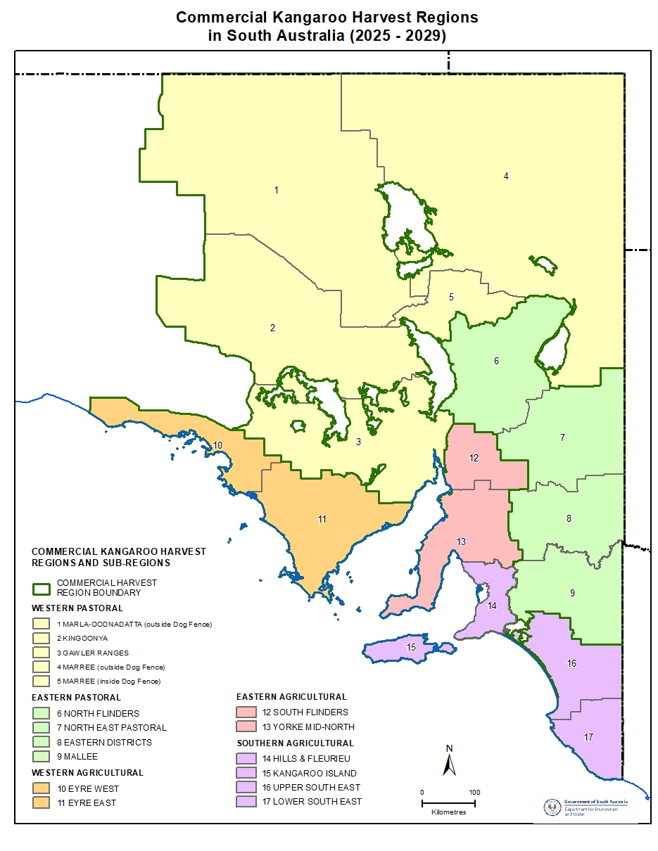
Figure 1: The 5 South Australian Commercial Kangaroo Harvest Regions, Western Pastoral, Eastern Pastoral, Western Agricultural, Eastern Agricultural and Southern Agricultural, which consist of 17 Harvest Sub-Regions.

Population estimates will be obtained using a combination of observational surveys and data-driven predictive models.
Kangaroo population estimates may be obtained directly from surveys or data-driven predictive models developed from long-term survey data. Data-driven predictive models will be used for the established harvest regions where data are available from at least 1996 (if not back to 1978). During the years between surveys, the models will be used to predict the population estimate based on previous surveys and rainfall, which will form the basis for setting the annual commercial quotas. During the life of this plan, models may be updated to ensure that the most accurate models are being applied to predict the kangaroo populations. Updates to current models or development of new models will be recorded in the Quota Reports.
At the time of writing, no predictive models are used for the Southern Agricultural Harvest Region due to the lack of long-term data in this area. However, data are being collected regularly with the aim to develop a predictive model for the area in the future.
A combination of aerial and ground surveys (walking and driving) will be used to survey kangaroo populations across South Australia (Table 1). Aerial survey lines for fixed-wing aircraft have been established at regular intervals across all sub-regions where fixed-wing is practical, and the same lines are surveyed at the same time every survey year (for details of survey methods, refer to Quota Reports). Ground surveys are employed in sub-regions where fixed-wing aerial survey is considered impractical. During 2020-2023 other aerial survey methods such as helicopters and drones with thermal cameras have been used in sub-regions of the Southern Agricultural Harvest Region. Survey methods may be updated during the life of this plan and changes will be recorded in annual Quota Reports.

Table 1: Type of survey method and data driven model used in each harvest sub-region. Note that no predictive models have been developed for the Southern Agricultural Harvest Region, due to the lack of long-term data in this area.
Harvest Region | Survey Method | Data-driven predictive models
Western Pastoral
Marla - Oodnadatta | Aerial
Kingoonya | Aerial
Gawler Ranges | Aerial
Marree (inside dog fence) | Aerial, walking
Marree (outside dog fence) | Aerial
Eastern Pastoral
North Flinders | Aerial, walking, driving
North-east Pastoral | Aerial, walking
Eastern Districts | Aerial, walking
Mallee | Aerial
Eastern Agricultural
South Flinders | Aerial, walking
Yorke Mid North | Aerial, walking
Western Agricultural
Eyre West | Aerial
Eyre East | Aerial
Southern Agricultural
Hills and Fleurieu | Aerial, driving
Upper South East | Aerial
Lower South East | Aerial, driving
Kangaroo Island | Aerial, driving

Performance indicators:
8.1 Population estimates are calculated, and quotas are set using a combination of data-driven predictive models and direct survey estimates and reported in the Quota Report.

Surveys will be stopped in harvest sub-regions with a consistently low harvest for the previous 3 or more years and will start again once the harvest has reached the Low Harvest Threshold.
This management plan uses a risk-based approach to surveying and quota setting, which will result in harvest sub-regions only being surveyed when the harvest is above a certain number of animals, referred to as the Low Harvest Threshold. This change will ensure that survey effort is targeted to areas with high harvest. Several harvest sub-regions consistently have very low or zero harvest for some or all harvested species. The risk posed to populations by very low harvest has been modelled using South Australian data and it is insignificant to regional kangaroo populations (Pople 2008), therefore reducing the survey frequency would not increase the risk of over-harvest. The Low Harvest Threshold is calculated as 1.5% of the average population estimate for each species in each harvest sub-region. The threshold of 1.5% of the average population estimate was chosen because in harvest sub-regions where surveys have occurred since at least 1996 (some since 1978), 1.5% of the population average falls below the sustainable quota that would be set when the population is at its lowest recorded estimate. In addition, 1.5% of the average population estimate across the established harvest sub-regions represents a very low number of animals (Low Harvest Threshold = range 46 to 4845 kangaroos as influenced by the size of each harvest sub-region and the proportion occupied by a species).
Low Harvest Thresholds will only be triggered within harvest sub-regions that experience harvests below the threshold for previous 3 consecutive years. Where the harvest falls below the threshold, the last proportional quota will either be re-issued annually until the next survey, or where a population model exists, annual proportional quotas will be calculated from predicted population estimates. No survey will occur until the harvest exceeds the harvest threshold, at which point a survey will be triggered for the following survey period to re-estimate the population and reset the now static proportional quota. However, sub-regions where surveys have stopped will be assessed during the risk assessment (Action 10) and additional surveys may be undertaken. For a harvest sub-region where multiple species are harvested, only one species is required to be harvested above threshold for surveys to resume. For example, in a sub-region where red kangaroos had a harvest rate below the Low Harvest Threshold, but western grey kangaroos did not, aerial surveys to count both species would continue. However, where multiple methods are used, surveys will not be continued for all species if a separate method is used for the species below the threshold. For example, euros are surveyed using walking surveys and usually have a low harvest, including in areas where the larger kangaroo species are harvested above their Low Harvest Threshold. In these instances, walking surveys for euros will stop in harvest sub-regions where euro harvesting is below the Low Harvest Threshold, but aerial surveys for the larger kangaroo species will continue.
Performance indicators:
9.1 Low Harvest Thresholds are set and implemented as per this plan.

A systematic risk-based assessment is used to prioritise harvest sub-regions for survey each year.
This management plan takes a risk-based approach to informing the annual survey program, with the goal of collecting data to make informed decisions regarding quota setting and to ensure that the harvest remains sustainable. Sub-regions where harvest is high will be prioritised for surveys over sub-regions where harvest is low. The risk assessment is conducted for each species in each sub-region and takes into consideration events of the previous 12 months.
Information taken into consideration will include, but is not limited to:
- climatic variables that affect kangaroo populations (e.g. rainfall, drought)
- harvest has fallen below the Low Harvest Threshold (Action 9)
- kangaroo population has fallen below a Low Population Threshold (Action 13)
- occurrence of an environmental emergency event (e.g. widespread bush fires) (Action 14)
- length of time since last survey
- data-driven predictive model estimate.
For each component of the risk assessment above, a risk level of low, medium or high is used to determine the overall risk of over-harvesting a sub-region if a survey is not conducted in a particular year. For example, a sub-region that had experienced high harvest in the previous calendar year, was last surveyed more than 3 years ago, and does not have a predictive model available for use would have a high-risk rating and be flagged for a survey that year. After the standard risk assessment, a manual process is conducted to allow changes to the sub-regions identified for survey based on other information, such as anecdotal reports of changes in kangaroo populations from kangaroo industry, land managers, regional DEW staff or researchers.
10.1 A risk-based assessment is conducted at the beginning of each calendar year to prioritise the harvest sub-regions for survey.

Sustainable Use commercial kangaroo harvest quotas are set annually for each harvest sub-region for each species.
South Australia uses a proportional harvesting strategy to account for the fluctuations in species abundance over time (Caughley 1987; Engen et al. 1997; McLeod and Pople 1998). Based on kangaroo population dynamics, quotas set at 15% to 20% are considered sustainable in the long-term (Caughley 1987, Hacker et al. 2004). Sustainable Use Quotas are set at a maximum of 20% of the estimated population size for red kangaroos, 15% for grey kangaroos (eastern and western) and euros, and 10% for Tammar wallabies within each harvest sub-region where each species occurs. A conservative quota is set for the Tammar wallaby as this species is restricted in its distribution (e.g. restricted to Kangaroo Island) compared to the large kangaroo species. A more conservative quota may be set for any species when coefficients of variation for population estimates exceed 25%.
Quotas calculated from population estimates developed in previous years may be carried over at the original species-specific quota for up to 3 years, before being reduced to 10% of the population estimate. This situation may occur when harvest rates are below the Low Harvest Threshold (Action 9) or in sub-regions where no population model is available, and quotas are derived directly from surveys are carried over (Action 10). Quotas will be reviewed annually for all sub-regions as part of the risk assessment conducted in Action 10, which includes assessing any significant changes in environmental conditions that are likely to have caused a large change in the population estimate since the last survey. In cases where a large change in population estimate is likely, a survey may be conducted before 3 years have passed.
Population estimates and Sustainable Use Quotas are derived and set at the level of each harvest region and sub-region. However, for the purposes of providing flexibility to manage quotas in response to spatial and temporal changes in kangaroo distribution, harvest sub-region quotas may be moved between other harvest sub-regions within the same harvest region. Sustainable Use Quotas cannot be moved between any of the 5 harvest regions. Quotas may be shifted between harvest sub-regions for damage mitigation reasons, and only where available quota in a harvest sub-region has been fully allocated. For species that do not have a quota in a particular harvest sub-region, but do within the larger harvest sub-region, quota may be moved into a harvest sub-region for damage mitigation purposes. Once all available quota for a species has been reached in a harvest region, no additional quota will be issued for that species in that harvest region until the following year (except for Special Land Management Quota, Action 13).
This management plan allows for the issuing of High Abundance Quota (HAQ) that may be applied to harvest sub-regions (Figure 2). The intent of the HAQ is to reduce the population peaks following periods of abundant resources, and therefore reduce the environmental damage caused by over-grazing and the number of kangaroos likely subject to death by deprivation that inevitably follows. Reduction in the population peaks may reduce the population average unless the reduced impact on resources is reflected in reductions in population troughs. The HAQ allows for all animals above the threshold (the average of the population estimate for each harvest sub-region) to be removed by harvest. The total quota is derived by adding the HAQ to the species-specific proportional quota (Figure 2). The trigger for activation of the HAQ is when a species’ population estimate exceeds the average population estimate by the proportional quota for that year within a harvest sub-region. When a species’ population estimate reaches the HAQ threshold, the Director of National Parks and Wildlife has the authority to release the HAQ, if required.
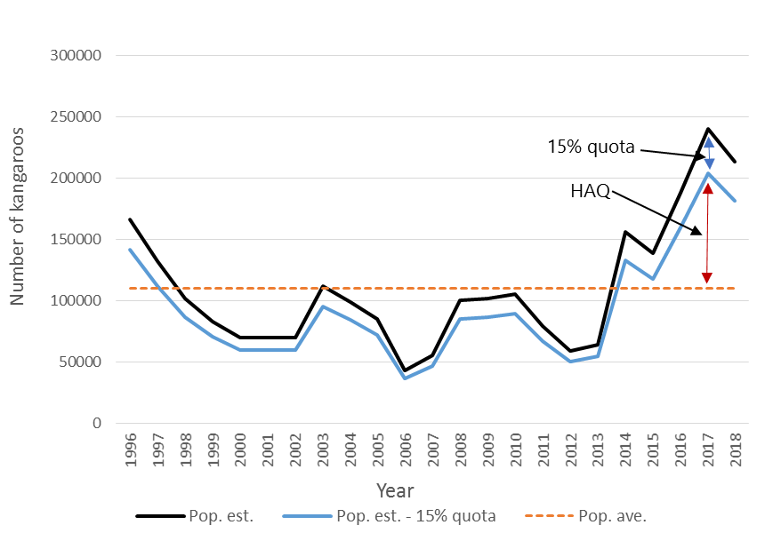

Figure 2: Illustration on how the High Abundance Quota (HAQ) will be applied to kangaroo populations when the population estimate is above the population average, using the western grey kangaroo data from Eastern Districts harvest sub-region as an example.
Performance indicators:
11.1 All commercial kangaroo harvest quotas are set in accordance with this plan.
11.2 HAQ method is reviewed at the end of the life of this management plan.

When kangaroo populations decline below Low Population Thresholds, the commercial harvest of these particular species in the affected harvest sub-region will be reduced or suspended.
This management plan aims to accommodate fluctuations in kangaroo populations that occur according to seasonal conditions. Calculating thresholds based on the long-term average population estimates or densities, and standard deviations (SDs) recognise these environmental differences (Appendix 3). Thresholds are calculated for each species in each harvest sub-region using the entire data set (1978 to present). The population density data are normalised using a log-transformation, and the thresholds are calculated as the long-term average minus either 1.5 times (Threshold 1) or 2 times (Threshold 2) the standard deviation of the transformed data. The lognormal thresholds are then back-transformed to allow comparison to the untransformed population densities reported in the Quota Report. If survey results indicate a population has fallen below either threshold for that species in that harvest sub-region, the commercial quota will be reduced or suspended in that harvest sub-region for the following calendar year (Table 2). The reduction or suspension will remain in place until population estimate, either from direct survey or modelled estimate, has increased above Threshold 1. Advice regarding issuing of non-commercial destruction permits is provided to regional DEW staff when quotas are reduced or suspended.
In established harvest sub-regions calculations already exist that represent the first and second thresholds. In the Southern Agricultural harvest region, thresholds will be created as data are gathered over time.
This management plan acknowledges that when kangaroo populations fall below one or both Low Population Thresholds across a harvest sub-region, there may still be local areas of high kangaroo abundance that need to be managed to mitigate damage. Therefore, Special Land Management Quota may still be issued when quotas have been reduced or suspended in a harvest sub-region.

Table 2: Process for reducing or suspending quota based on most recent population estimate.
Population density estimate | Status | Quota Setting (Maximum)
Population density estimate greater than 1.5 SD below average | Business as normal | Standard quota
Population density estimate less than 1.5 SD but greater than 2 SD below average | Threshold 1 reached | Quota reduced to 10% for that species in that harvest sub-region
Population density estimate less than 2 SD below average | Threshold 2 reached | Quota suspended for that species in that harvest sub-region

Performance indicators:
12.1 Low Population Thresholds are set and implemented as per this plan.

Special Land Management Quotas are set annually at 1.5% of the total population estimate for each species.
A Special Land Management Quota (SLMQ) will be set annually at a maximum of 1.5% of the total SA population estimate of each species and may be issued to any harvest sub-region as required.
SLMQ is a reserve quota for use when all commercial quota for a species has been exhausted (allocated) in a harvest sub-region to mitigate ongoing land condition damage caused by kangaroos. SLMQ may be issued if warranted by climatic trends, destocking orders, kangaroo population trends, or other extenuating circumstances. SLMQ will provide for commercial utilisation of kangaroos that would otherwise be shot and left in the field under the non-commercial permitting system.
Since the establishment of the Southern Agricultural harvest region, eastern grey kangaroos have been noted in small numbers in harvest sub-regions outside of the Lower South East sub-region. Currently the Lower South East is the only sub-region where Sustainable Use Quota is set for the species, and as such SLMQ is set based on this population estimate. To date, eastern grey kangaroos have been sighted in the following sub-regions; Upper South East, Hills and Fleurieu, Mallee and Yorke Mid-North. To facilitate the commercial utilisation of eastern grey kangaroos in other sub-regions, SLMQ may be issued outside of the Lower South East sub-region during the life of this plan.
Special Land Management Quota is issued to harvest sub-regions as needed, and the amount of quota released, the amount of harvest of the SLMQ and reasons for release are reported in the Harvest Report.
Performance indicator:
13.1 Special Land Management Quota is set and issued as per this plan.

Emergency management response may require harvest sub-regions to be closed to commercial harvesting or quotas amended.
Kangaroo populations may be negatively affected by environmental emergencies, such as wide-spread bushfires or floods. However, kangaroo numbers may also need to be managed post-emergency event as part of controlling total grazing pressure to allow regeneration of vegetation in the impacted area.
During an emergency event, targeted emergency interventions to assess and manage the welfare needs of impacted wildlife will be undertaken in accordance with legislative arrangements for a formally declared emergency. Where required based on animal welfare grounds, affected kangaroos will be euthanised as humanely as possible, having consideration to access to area, safety to humans, safety for animals and likelihood of success of the operation.
DEW may consider amending quotas or suspending commercial harvesting where a large-scale event is likely to significantly affect kangaroo populations within that sub-region. Any decision to reduce quota, suspend harvest, or subsequently reinstate harvesting in an affected harvest sub-region, will be informed by a range of factors including, but not limited to:
- the type of emergency event
- the scale of the impacted area by the emergency event, such as the percentage of the harvest sub-region effected.
- the impact on the local environment and kangaroo populations in the affected areas.
- the need for local land managers to maintain or increase kangaroo management in, or adjacent to, the affected area to assist in regeneration of native vegetation or agricultural land post-emergency event (e.g. fire)
- risk and safety factors for persons moving in and around the affected area.
Any changes to the quota, or to where harvest is permitted because of an emergency event, will be communicated to kangaroo industry permit holders by DEW in a timely fashion and reported in the annual Quota Report.
Performance indicator:
14.1 Emergency management actions are undertaken as per this plan when required.

Population estimates and quotas are reported annually in the Quota Report
The Quota Report is developed towards the end of each year to set harvest quotas for the following calendar year. The Quota Report is used to report on population estimates, quotas, and survey methods used in a particular year. DEW will advise the Australian Government of commercial harvest quotas through the Quota Report for the following calendar year.
The Quota Report will contain the following information:
- population estimates for each species in each harvest region and sub-region, and details of how estimates were developed (e.g. from model predictions, direct survey estimates or estimates from previous years)
- details of the survey methods used and any changes to the survey method or analysis
- details of new or changes to predictive models used to develop population estimates
- quotas calculated as per the approved Management Plan (including Sustainable Use Quota, SLMQ, HAQ)
- sub-regions where Low Harvest Thresholds have been triggered
- sub-regions where Low Population Thresholds have been triggered
- any proposed changes to quotas.

Performance indicator:
15.1 A Quota Report is developed and provided to the Australian Government.

Aim 5: Monitor Industry Compliance
To ensure that viable populations of kangaroos are maintained throughout their ranges, the commercial kangaroo industry in South Australia is closely regulated by a range of permitting and tag procedures provided for under the NPW Act, Kangaroo Harvesting Regulations, Wildlife Regulations, DEW policy, the Commercial Code and this plan. Permitting procedures are described in detail in Appendix 5. The compliance of the kangaroo industry with the above legislation and policy is essential for maintaining viable populations of kangaroos and ensuring public confidence in the management of kangaroos in South Australia.

All activities relating to kangaroo harvesting are carried out in accordance with South Australian legislation, DEW policy and this plan.
Kangaroo harvesting is regulated by the NPW Act, Kangaroo Harvesting Regulations, Wildlife Regulations, DEW policy and this plan. Therefore, all activities relating to kangaroo harvesting must be conducted in accordance with SA legislation and DEW policy and permits must accurately reflect current legislation and policy.
Permit conditions will be reviewed annually before permits are re-applied for, and, where necessary, conditions are amended before new permits are issued.
Permit holders will be notified in writing of changes to permit conditions that will be implemented, should they choose to re-apply for their permit, as soon as possible after changes are approved.
Performance indicator:
16.1 All permits are issued in accordance with South Australian legislation, DEW policy and this plan.
16.2 Permit conditions accurately reflect current SA legislation, DEW policy and this plan.

Kangaroo Field Processors are competent to achieve the standards set out in the Commercial Code, and other necessary requirements.
To ensure that the kangaroo harvest is humane, kangaroo field processors are required to demonstrate their competency with the Commercial Code by completing a Firearms Proficiency Course for Field Processors in South Australia (or another state’s approved equivalent course). The Commercial Code also requires that kangaroo field processors complete a firearms proficiency course every 5 years. DEW implemented the new Commercial Code (2020) on 1 July 2021 in line with permit re-applications. Ensuring that firearms proficiency accreditation is valid will be included as part of the permit application process.
Other accreditations kangaroo field processors are required to provide evidence of include the Wild Game Harvester Field Processing (Kangaroo) course endorsed by PIRSA Biosecurity SA (Food Safety) (or another approved course interstate), valid firearms licence (Category B7 or as directed by South Australian Police) and PIRSA Biosecurity SA (Food Safety) accreditation.
All new kangaroo field processors are provided with an information package to ensure permit holders are aware of their requirements and responsibilities.
Performance indicators:
17.1 All kangaroo field processor permit applicants are assessed at the time of permit application or re-application to ensure that they hold the following:
- Firearms Proficiency accreditation
- Wild Game Harvester Field Processing (Kangaroo) accreditation
- valid firearms licence
- other licence/s and/or accreditation/s as required (e.g. Food Safety accreditations).

Regular and opportunistic compliance of permit holders will be undertaken.
To assess industry compliance with South Australian legislation, permit conditions, the Commercial Code and DEW policy, regular and opportunistic inspections are conducted. DEW staff may inspect field chillers, where harvested kangaroos are stored by kangaroo field processors and all premises registered to kangaroo meat processors and skin tanners. Primary Industries and Regions South Australia (PIRSA) Biosecurity SA (Food Safety) also undertake inspections of field chillers and processing plants to ensure compliance with the Primary Produce (Food Safety Schemes) Act 2004. Audits of kangaroo field processor’s harvest records are also undertaken by DEW.
Performance indicators:
18.1 All active field chiller premises are inspected at least once a year.
18.2 All kangaroo processing works (meat and skin processing) are inspected at least twice a year.
18.3 A minimum of 30% of kangaroo field processors are audited each year, with individual permit holders audited at least once every three years.

Potential breaches of South Australian legislation relevant to kangaroo harvesting will be investigated and where an offence has been committed, appropriate compliance action will be taken.
Investigation and prosecution of activities in breach of South Australian legislation are essential for delivery of this plan. Good compliance also maintains public, industry and stakeholder confidence in the effectiveness of the plan as a mechanism for maintaining the viability of kangaroo populations, and thus the commercial kangaroo industry.
Performance indicator:
19.1 Where sufficient evidence is available, compliance action is instigated for all reports of unauthorised activities and activities in breaches of South Australian legislation.

The accuracy of permit holder returns will be monitored.
It is a permit condition, as set out in regulation, that both kangaroo field processors and meat processors submit regular harvest returns to DEW. Kangaroo field processor harvest returns contain information relating to the number, species, sex, weight and location of kangaroos harvested, as well as who bought the carcasses. Whereas the kangaroo meat processor returns include how many kangaroo carcasses they purchased, who they bought the carcasses from and when they were purchased. The data obtained from these returns are essential for monitoring whether the industry is harvesting kangaroos within approved quotas and for reporting to the Australian Government, industry, and the public.
Harvest return data provided by permit holders will be scrutinised as returns are provided each month, and any discrepancies between kangaroo field processor and meat processor returns will be investigated as appropriate. Some discrepancies may remain in data despite best efforts by permit holders and DEW staff, however, these discrepancies should be less than 1% of the total quota.
Performance indicator:
20.1 Discrepancies in permit holder return data are less than 1% of the total quota.

A compliance database will be maintained to manage investigations, inspections, and all compliance activity.
Accurate compliance information is recorded in a timely manner and maintained, including reports of alleged breaches of the NPW Act, Regulations and/or permit conditions, investigation activities undertaken and outcomes of investigations. The database facilitates compliance reporting to the Australian Government and other stakeholders.
Performance indicator:
21.1 All compliance records relating to the commercial kangaroo industry are maintained in a suitable database.

Improvements to the kangaroo management program will be considered when appropriate.
Technology and business practices are constantly improving and evolving. DEW will monitor potential new ways of conducting business that may increase efficiencies and streamline processes. Changes to business practices will be incorporated as appropriate.
Performance indicator:
22.1 Technological developments and innovations in business practices are monitored and incorporated as appropriate.

Aim 6: Facilitate Adaptive Management and Research
Adaptive management experiments and studies using historical data from kangaroo industry returns and population data are essential to improving our understanding of kangaroos and their interaction with environmental, social, and economic systems, and thereby effectively maintaining viable populations of kangaroos throughout their ranges. Research into aspects of kangaroo ecology or harvest management can also assist in ensuring that kangaroo populations are maintained at sustainable levels across their ranges in the long term. While there has been a large body of research on the ecology and management of kangaroos, there are information gaps which, when filled, may lead to more efficient management of the commercial harvest.

Investigate how climate change may affect kangaroo populations in the future.
The Kangaroo Management Program has obtained over 40 years of data on kangaroo populations and commercial harvesting in South Australia. Climate change is predicted to cause more variation in climatic patterns and an increase in extreme weather events, such as floods and droughts. Fluctuations in kangaroo populations are closely linked to rainfall and are likely to be affected by changes in rainfall patterns. The data-driven predictive models developed for, and used in, quota setting will be used to investigate changes in kangaroo populations under different climate change scenarios and what implications this may have for kangaroo management in the future.
Performance indicators:
23.1 A report is published detailing the improved understanding gained by modelling how kangaroo populations may respond under different climate change scenarios and a summary is included in the annual Harvest Report.

Where practicable, adaptive management experiments will be performed to test deliberate management interventions during the life of this plan.
Under active adaptive management, management activities are conducted as a deliberate experiment. Alternative strategies are viewed as treatments and are implemented through statistically valid experimental design; monitoring is the data-collection step of the experiment. Active adaptive management can establish cause-and-effect relationships between activities and changes in ecological conditions. Any research conducted as an active adaptive management experiment, which may include increasing quotas above the rates detailed in this plan will follow the principles of this plan and will obtain all necessary approvals – including animal ethics – before commencement of experiments. The Australian Government will be notified of any proposed adaptive management experiments prior to the experiment commencing.
As per the criteria outlined below, all active adaptive management experiment proposals must have monitoring programs incorporated. Monitoring programs must be maintained during the life of the experiment. All monitoring must be conducted following any conditions imposed with the approval.
All proposals for adaptive management must be approved by DEW following the provisions of this plan before implementation. Proposals to undertake adaptive management trials will be assessed by whether a proposal:
- is following the goal of this plan
- is consistent with legislation for kangaroo management (or whether legislation requires amendment for the trial to occur)
- is scientifically rigorous and statistically valid
- incorporates an adequate monitoring and review program
- addresses adaptive management or research areas for kangaroos
- would involve stakeholder input or feedback.
The results of the experiments will be made available to the Kangaroo Management Reference Group and a summary will be included in the Harvest Report.
Performance indicators:
24.1 A summary of any adaptive management experiments undertaken is recorded in the Harvest Report.

Support research into the biology and ecology of commercially harvested kangaroo species.
DEW will support research regarding issues relating to commercial harvest of kangaroos by external research organisations. Research may include aspects of the biology, ecology, disease, and genetics of kangaroos as they relate to the commercial harvest or survey techniques. Contributions by DEW may include in-kind support such as the provision of harvest data.
Performance indicator:
25.1 A summary of any research supported by DEW is recorded in the Harvest Report.

Aim 7: Undertake Program Reporting and Review
Regular program review and associated reporting ensure management outcomes remain consistent with the aims of the plan, and that management is fully informed.

An annual report on the implementation of this plan is prepared and submitted to the Australian Government.
An annual report (i.e. the annual Harvest Report) detailing the operation of this plan for the previous calendar year will be prepared and submitted to the Australian Government each year. This report will provide information on the previous year's quotas and harvest rates, adaptive management experiments undertaken, and compliance actions undertaken within the guidelines of this plan.
The Harvest Report will include the following information:
- harvest, by harvest region and species, compared to quotas
- Special Land Management Quota or High Abundance Quota released, and amount harvested
- sex bias and average weights of carcasses for each species in each harvest region
- number of Permits to Destroy Wildlife (kangaroos) and number of kangaroos issued on those permits within the harvest region
- number of kangaroos per species destroyed non-commercially from DEW parks and reserves
- compliance statistics:
  - number of meat processing premises inspected
  - number of field chiller premises inspected
  - number of kangaroo field processor audits conducted
  - number of cautions and penalty notices issued and the reason for the issue
  - number of prosecutions undertaken (offence and outcome)
  - number of kangaroo field processors that have had their firearms proficiency reaccredited
  - any other relevant compliance activities undertaken
- any emergency management actions taken
- any extraordinary situations that arose (e.g. flood/disease outbreak)
- any adaptive management experiments and research supported by DEW.
Performance indicators:
26.1 An annual report on the operation of this plan is prepared and provided to the Australian Government.

A review of this plan will commence 12 months before the expiry of this plan.
The review of this plan will commence no later than 12 months before the plan expires and will assess the success of the plan in achieving its goal and aims. The review will include an assessment of DEW’s performance against the performance indicators and provide recommendations for the development of the next plan. Once the review has been completed, DEW will submit the report on the results of the review to the Australian Government for their information and the document will be made available on the DEW web page.
Performance indicators:
27.1 A report is produced summarising the review of this plan and recommendations for the development of the next plan.

Appendix 1: Biology, Ecology, and Conservation of Kangaroos

Biology and ecology

Impacts of European settlement on kangaroo populations
The kangaroos that are the subject of this management plan have been influenced by European settlement. These kangaroo populations are considered secure within their current distributions in South Australia. Many changes have been brought about in the last 200-plus years of European settlement. These include widespread changes to the landscape, through replacement of native vegetation in many areas with agricultural and urban land uses. In places where native vegetation has not been widely cleared (e.g. pastoral rangelands), the landscape has still been modified by settlement, through measures such as the provision of watering points for stock, and construction of a dingo-proof fence across Australia to protect sheep in the southern rangelands from dingo predation.
These changes have altered the natural distribution and abundance of kangaroos. The species to which this plan relates have all been advantaged by these changes and in many places are present in higher abundances than they were prior to European settlement. Increased pasture, greater availability of water and reduced predator pressure have all contributed to an increased abundance of red kangaroo, eastern grey kangaroo, western grey kangaroo and euro (Pople and Grigg 1999). However, the introduction of foxes by Europeans led to the extinction of the tammar wallaby on mainland South Australia. Fortunately, no foxes were released on Kangaroo Island and the island population of Tammar wallabies has benefited from an absence of foxes and abundance of preferred habitat, including improved pastures where is it known to feed (TSSC 2019).
There are large populations of each of the harvested species in Australia. During 2023 the national kangaroo population within the harvest area of Queensland, New South Wales, Victoria, South Australia and Western Australia was over 35 million (source: DCCEW). Long-term surveys conducted in the commercially harvested parts of South Australia have shown that populations can range up to numbers exceeding three million red kangaroos and one-and-a-half million western grey kangaroos (Pople et al. 2010a). During 2023, the red kangaroo population was estimated at 2,019,168, the western grey kangaroo population was estimated at 643,427,and euro population was estimated at 430,872 in the commercially harvested area of South Australia (DEW 2023). The eastern grey kangaroo population was estimated at 121,539 during 2023 and the Tammar wallaby population was estimated at 384,671 during 2022 (DEW 2023). Long-term population data collected over 40 years for red kangaroo and western grey kangaroos and over 20 years of data for euros are available from the DEW website. Information of survey methods used is reported in the Quota Report each year.
Eastern grey kangaroos are widespread in eastern Australia and exhibit high levels of population connectivity (gene flow) across their range (Zenger et al. 2003). In recent years, eastern greys have expanded their distribution in south-eastern South Australia. The latest survey estimate using helicopters and thermal cameras in the Lower South East harvest sub-region only was 121,539 (DEW 2023). Sightings of eastern grey kangaroos have been seen outside of this area, so their state-wide population is higher than this estimate.
The Tammar wallaby is common on Kangaroo Island and previous studies have reported high levels of genetic diversity, which suggests a large, connected population (Taylor and Cooper 1999; MacDonald et al. 2013; Eldridge et al. 2017). Surveys conducted using a drone flown at night with thermal cameras produced a population estimate of 384,671 wallabies on Kangaroo Island (DEW 2022).

Systematics
A kangaroo is a marsupial from the Family Macropodidae. This family contains kangaroos, wallabies and tree kangaroos. At the time of writing, only six species of the genus Macropus are the subject of this plan:
- Macropus rufus (Desmarest, 1822), the red kangaroo – the largest of all kangaroos and the largest present era marsupial.
- Macropus fuliginosus (Desmarest, 1817), the western grey kangaroo – two subspecies: Macropus fuliginosus fuliginosus on Kangaroo Island and Macropus fuliginosus melanops on the mainland. Both subspecies are subject to this plan. The western grey kangaroo was identified as a separate species from the eastern grey kangaroo in 1972 (Kirsch and Poole 1972).
- Macropus robustus (Gould, 1841), the euro – a smaller kangaroo with four subspecies. The subspecies that is subject to this plan is Macropus robustus erubescens. In other parts of Australia, M. robustus is referred to as common wallaroo or hill kangaroo, however, in this plan, the name euro is used.
- Macropus eugenii eugenii (Desmarest, 1817), the Tammar wallaby (South Australia) – the smallest species of wallaby. In 2015, the genus of the tammar wallaby was reverted to Notamacropus from Macropus, however in keeping with South Australian naming, Macropus has been retained in this management plan. Recent genetic research determined that the Kangaroo Island and South Australian mainland subpopulations of tammar wallaby are the same subspecies, and Notamacropus eugenii eugenii has now been synonymised with Notamacropus eugenii decres (Eldridge et al. 2017). The other subspecies, Notamacropus eugenii derbianus (Western Australia) is not subject to this plan.
- Macropus giganteus (Shaw, 1790), the eastern grey kangaroo.

Conservation status
The commercially harvested kangaroo species that are the subject of this plan are widespread and secure.
This secure nature is reflected in the fact that they are:
- Not listed as threatened in South Australia (under Schedules 7, 8 and 9 of the NPW Act)
- Not listed as threatened in Australia (under the EPBC Act)
- Lower Risk – least concern with a stable population on an international scale (IUCN Red List 2024)
- Not listed under the Convention on International Trade in Endangered Species of Wild Fauna and Flora (CITES 2017)

Species Distribution
The red kangaroo is particularly well-adapted to the arid environment of central Australia and has a distribution covering most of the continent west of the Great Dividing Range, but excluding Cape York, Arnhem Land, the Kimberley region, the southwest corner and Tasmania (Pople and Grigg 1999) (Figure 3). Red kangaroos prefer more open habitats with scattered trees (Pople 1989), such as grassland, open scrub, mulga, low shrub lands and open woodlands.
Within South Australia, the highest densities of red kangaroo coincide with the more open areas of the sheep grazing rangelands (Cairns et al. 1991) inside the dingo exclusion fence. Over the time that aerial surveys have been flown in South Australia, the area of highest red kangaroo density has been just south of Lake Frome in the north-eastern section of the pastoral zone (Pople et al. 2006). The long-term monitoring data also suggest a westward shift in the range of the red kangaroo (Pople et al. 2010a) over the period that kangaroo surveys have been conducted.
The western grey kangaroo is found along the southern part of Australia, excluding Tasmania, and extending into New South Wales and Queensland at the eastern end of its distribution (Pople and Grigg 1999) (Figure 4). The western grey kangaroo is associated with less arid environments than the red kangaroo and is affiliated with semi-arid mallee scrub, shrub woodland, and forests (Pople and Grigg 1999). Western grey kangaroos mainly exploit mosaic environments with areas of shrub interspersed with open habitats and cleared areas.
Within South Australia, the western grey kangaroo is found in the southern half of the State and on Kangaroo Island. Aerial survey data have revealed that western grey kangaroo densities are consistently highest in the Gawler Ranges and the south-eastern section of the South Australian pastoral zone (Pople et al. 2006). This distribution is complementary to that of red kangaroos, with high western grey kangaroo densities occurring in woodland areas where red kangaroo numbers are lower. Over the last 20 years, the western grey kangaroo has had a northwards expansion in its distribution and has become more common in the northern parts of the South Australian pastoral zone (Pople et al. 2010a).
The euro has a widespread distribution covering most of mainland Australia (Pople and Grigg 1999) (Figure 5). However, within this wide distribution, the presence of euros is patchy and localised, reflecting their preferences for rocky and hilly habitat. Euros can be found in a wide range of habitats but prefer areas where steep escarpments, rocky hills or stony rises are available to them. The euro can build up to localised high densities when conditions are favourable.
The eastern grey kangaroo has been increasing its range in South Australia over recent decades and now inhabits the lower and upper South East, parts of the Murray-Darling Basin, the eastern and northern Mount Lofty Ranges and the north and south Olary Plains (north and south of the Barrier Highway) (Figure 6). Pastoral development has resulted in a marked increase in populations of the eastern grey (Pople and Grigg 1999). The species is associated with forest and woodland habitats with clearings and adjacent pastures.
In South Australia, the Tammar wallaby is found on Kangaroo Island where it is considered widespread and secure, and within Innes National Park at the tip of the Yorke Peninsula, where it was reintroduced and is now considered stable. It is also known to inhabit a number of offshore islands – Wardang, Boston and Greenly Islands (Figure 7).

Biology of the Red Kangaroo (Macropus rufus)
Red kangaroos are opportunistic breeders and will breed throughout the year except in periods of extreme drought. This species exhibits a reproductive technique called embryonic diapause, where a viable embryo can be carried in the uterus for many months with its development arrested at the stage of a blastocyst (e.g. 70-100 cells). A blastocyst will remain in diapause while there is another young in the pouch, or when environmental conditions are poor. This reproductive strategy reduces the time between breeding events. Largely a gregarious species, the red kangaroo has a polygamous mating system (i.e. one male, many females). The species exhibits sexual dimorphism, with males larger than females.
The red kangaroo grazes grasses and dicotyledonous plants and browses chenopods and shrubs when necessary (Tyndale-Biscoe 2005). The red kangaroo is dependent upon the presence of green herbage for breeding. As the supply of green pick dwindles, breeding is reduced.
Red kangaroos have sedentary populations that move within home ranges of variable size (typical weekly home range size may be up to 560 hectares or 5.6km² (Croft 1991). Red kangaroos range more widely in response to drought and can move a long way to access the better feed. Movements of up to 30km to obtain fresh pasture growth in response to rainfall have been recorded (Croft 1991). Occasional long-distance movements (i.e. >100km) of mature individuals of both sexes have been recorded (Bailey and Best 1992). Long-distance movements of red kangaroos to access better feed have also been found in the long-term aerial monitoring dataset for South Australia (Pople et al. 2006).
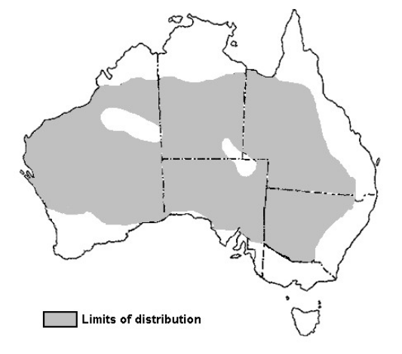
Figure 3: Distribution of red kangaroo (Macropus rufus) determined from aerial survey (Pople and Grigg 1999).

Biology of the Western Grey Kangaroo (Macropus fuliginosus)
Like the red kangaroo, the western grey kangaroo will breed year-round except in very poor seasons. Breeding peaks in spring and summer have been recorded (Hacker et al. 2004). However, unlike in red kangaroos, embryonic diapause is not found in this species, so the species is not as able to rapidly increase in response to favourable conditions. Western grey kangaroos are sexually dimorphic in body size, with males larger than females.
Western grey kangaroos feed mainly on grasses and also browse on some selected shrubs (Coulson and Norbury 1988). While red kangaroos will move a long way to access the better feed, western grey kangaroos do not do this and are more sedentary with small individual home ranges (Priddel 1987). Dispersing individuals tend to be young males.
The western grey kangaroo has higher water requirements than the red kangaroo (Dawson 1995), and so an expansion of available water in pastoral areas has enabled an expansion of this species into more arid areas.
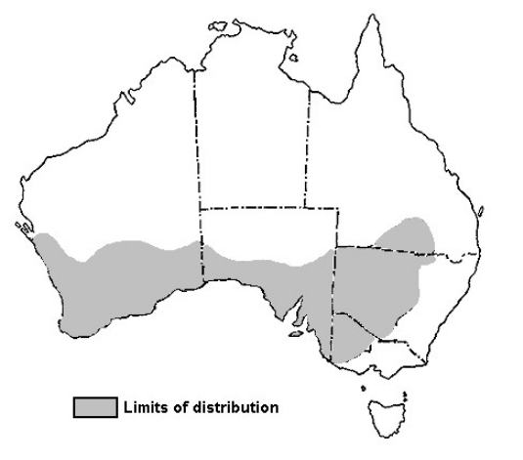
Figure 4: Distribution of western grey kangaroo (Macropus fuliginosus) determined from aerial survey (Pople and Grigg 1999).

Biology of the Euro (Macropus robustus)
Euros are opportunistic breeders, with continuous breeding possible throughout the year. Breeding is reduced during dry conditions and may cease during prolonged drought. Like red kangaroos, embryonic diapause occurs in this species. The euro exhibits marked sexual dimorphism, with mature males attaining twice the weight of mature females.
The euro feeds mainly on grasses and shrubs. The species is relatively sedentary, and individuals occupy small stable home ranges. The euro exhibits a less gregarious social structure than red and western grey kangaroos.
Euros are found in mountains and rocky hill habitat. Because this habitat type is not continuous across the landscape, the distribution of euro is likewise patchy (Dawson 1995). The steep escarpments, rocky hills and stony rises favoured by euro (Olsen and Braysher 2000) are less frequently cleared for agriculture, and thus this species is less affected by land-use changes.

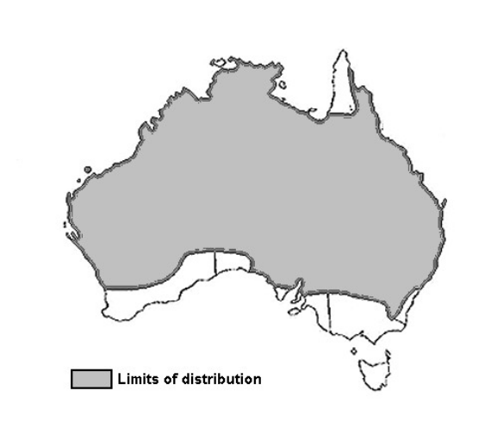
Figure 5: Distribution of euro (Macropus robustus) (Pople and Grigg 1999). Note that distribution is patchy within the range, based on the availability of suitable habitat.

Biology of the Eastern Grey Kangaroo (Macropus giganteus)
The eastern grey kangaroo is considered abundant on the Australian mainland and occurs extensively from north-eastern Queensland (Cape York Peninsula) to south-eastern South Australia. The eastern grey kangaroo is often confused with the western grey kangaroo and as a consequence it is considered that the species has been unreported or under-reported for many years and across much of its range. Since European settlement, the range of eastern grey kangaroos has been extending west, including into South Australia, due to an increase in semi-permanent stock watering points (Pople and Grigg 1999). Over recent decades the species has expanded into the lower and upper South East, parts of the Murray-Darling Basin, the eastern and northern Mount Lofty Ranges and the north and south Olary Plains (north and south of the Barrier Highway).
Eastern grey kangaroos are a gregarious species that often form large groups in the tens to over 100 individuals where food is abundant. These groups favour forest and woodland habitats with clearings and adjacent pastures. Breeding occurs throughout the year, however is known to peak in the summer months (Pople and Grigg 1999). Unlike western grey kangaroos, occasional observations of embryonic diapause have been recorded for this species (Pople and Grigg 1999).
Eastern grey kangaroos have been known to have similar habitat preferences to the western grey kangaroo (Pople and Grigg 1999). Recent studies in the Grampians of western Victoria by Garnick, et al. (2016a) found that eastern grey kangaroos occupied habitats with open grassy areas, but also occupied reasonably dense shrubby woodland. They less often occupied heathy habitats (heathy woodland, seasonally damp heath and sand heathland).
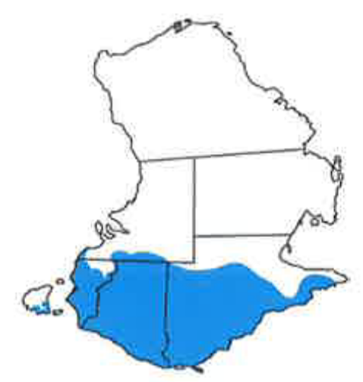

Figure 6: Distribution of the eastern grey kangaroo (Macropus giganteus) (Van Dyck et al. 2013).

Biology of the Tammar Wallaby (Macropus eugenii)
Tammar wallabies inhabit coastal scrub, heath, dry sclerophyll forest habitats and thickets in mallee and woodland (Hinds 2008). The subspecies prefers dense low vegetation for daytime shelter and more open grassy areas for feeding, preferentially eating grass, but will also eat other herbs, shrubs and small trees (DEH 2004). They also consume seedlings of a variety of perennial plant species and, are able to prevent the recruitment of many species when in high densities (DEH 2004).
The Kangaroo Island tammar wallaby population is considered abundant. The subspecies has benefited from both an absence of foxes and an abundance of their preferred habitat - dense bushland adjacent to pasture or cropland. On Kangaroo Island, impacts to newly emergent crops and pastures and native revegetation, due grazing pressure by tammar wallabies occurring at high densities, has been recorded.
Breeding cycles of the Kangaroo Island population of tammar wallaby have been well studied. The subspecies is a seasonal breeder, with a high rate of reproduction, generally birthing one joey between late January and early February (Hinds, 2008). Like euros and red kangaroos, tammar wallabies undergo embryonic diapause. It has been found that the Kangaroo Island population has the longest period of embryonic diapause recorded in mammals, with the blastocyst remaining dormant for nearly one year (Renfree and Shaw 2000, cited in Renfree et al. 2011). They exhibit sexual dimorphism, with males being larger than females and have defined home ranges that overlap the home ranges of several other individuals.

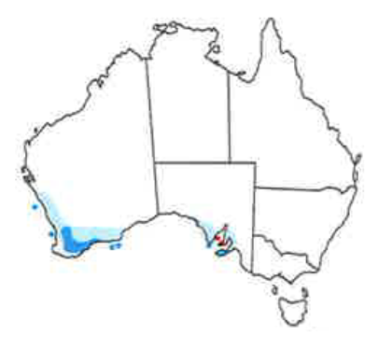

Figure 7: Distribution of the tammar wallaby (Macropus eugenii), light blue indicates former range and dark blue indicates current range (Van Dyck et al. 2013).

Appendix 2: Threats to Kangaroos

Threats to kangaroos
Detailed legislative requirements in the NPW Act and the EPBC Act require that threats which may impact negatively on kangaroo populations or the sustainability of harvest must be detailed and considered in this plan. This section provides a summary and assessment of such threats. Threats to kangaroos are either biological or anthropogenic. Possible current and future threats to kangaroos and their ability to be used as a sustainable resource are detailed below.

Biological threats
Biological threats are factors that have the potential to regulate kangaroo populations (Table 3).
Table 3: Biological threats that may regulate kangaroo populations.
Threat | Description | References
Climate change | The average global temperature is predicted to rise 2-3°C by the end of the century, placing approximately 20-30% of the world’s species at risk of extinction. The potential effects of climate change on kangaroos are not well documented, however potential effects may include changes in forage availability (due to potential changes in rainfall and wild fire frequency), fecundity, species distribution, movement patterns and an increase die-off of individuals due to extreme heat events, which may increase due to climate change. While climate change may be considered anthropogenic, the effects are biological, and so it is included here under biological threats to kangaroos, rather than in anthropogenic threats to kangaroos. | Goldie and van Wensveen 2003; Ritchie and Bolitho 2008; Dunlop and Brown 2008; Jonzen et al. 2010; IPCC 2007
Environmental Conditions – Drought | Rainfall distribution can determine kangaroo densities, as populations move in response to localised rainfall and subsequent new plant growth. Droughts limit the amount of food available and therefore the carrying capacity of the habitat. Kangaroo populations naturally decline in times of poor environmental conditions (or drought) due to starvation (biased towards mature males and juveniles) and suppressed reproductive activity. Droughts have negative animal welfare outcomes for the kangaroos themselves as individuals die of starvation, which can be increased when kangaroo populations are present in high abundance prior to the onset of the drought. The reproductive strategies of kangaroos allow for rapid recovery of populations following the end of drought conditions. | Caughley et al. 1985; Robertson 1986; Bayliss 1985; Bayliss 1987; Cairns and Grigg 1993; McCarthy 1996; Cairns et al. 2000; Pople 2003; Dawson et al. 2007; Pople et al. 2010b, McMurtrie and Kerle 2021
Environmental Conditions – Flood | Flooding events will limit the short-term movement of kangaroos. Where access to forage is cut off through flooding, starvation is a threat. When access to forage is still available, other biological needs may be somewhat limited (e.g., dispersal events such as those undertaken by young males moving or establishing territories, may be temporally limited during flooding events). Some kangaroo diseases are linked with flooding events | Hale 2004
Environmental Conditions - Bushfires | Bushfires are part of the Australian environment and the area affected can vary in size. Kangaroos are highly mobile and can flee from an approaching fire, however, like other species some kangaroos may perish in bushfires. The proportion of a harvest sub-region affected by bushfires in a given year is likely to be minimal. Given the widespread distribution of the harvested kangaroo species, a bushfire is very unlikely to significantly reduce the statewide population.
Disease | Disease by itself is not considered a significant mortality factor and tends to have a compensatory mortality effect in combination with conditions such as overcrowding, malnutrition, and flooding. Diseases can be linked to flooding events (e.g., when the resultant outbreak of biting insects can transmit arbovirus among kangaroo populations), although such infections are not necessarily terminal. The impact of kangaroo diseases tends to be localised. | Kirkpatrick 1985; Caughley 1987; Speare et al. 1989; Hopper et al. 1999; Pople and Grigg 1999; Roberts et al. 2010; Barnes et al. 2007; Parameswaran et al. 2009
Predation | Dingoes (Canis lupus dingo), wedge-tailed eagles (Aquila audax), and foxes (Vulpes vulpes) can predate on kangaroos, although only dingoes will predate upon large adult kangaroos. In South Australia, densities of red kangaroos differ on either side of the dingo-proof fence, in part due to the presence of dingoes. North of the dingo-proof fence kangaroo numbers are significantly lower than in the fenced sheep rangelands, suggesting that Dingo predation may play a role in regulating kangaroo populations. South of the dingo-proof fence predation is not a significant source of kangaroo mortality and is limited to fox and eagle predation on juvenile kangaroos. | Pople et al. 2000; Caughley et al. 1980; Corbett and Newsome 1987; Thompson 1992; Banks et al. 2000; Pople and Page 2001; Letnic and Crowther 2012; Fillios et al. 2010; Purcell 2010

Anthropogenic threats to kangaroos
Anthropogenic threats to kangaroos are those that result from human activities (Table 4).
Table 4: Anthropogenic threats that may regulate kangaroo populations.
Threat | Description | References
Habitat loss | Since European settlement, clearance of native habitat has occurred. Increased areas of land used for agriculture and pastoralism, combined with increased availability of water and control of predators, has benefited kangaroos. More intensive land use, such as intensive agriculture and urban development, can lead to contractions in the range of kangaroos. Intensive development is not a common land use within the commercial harvest zone and across the distributions of kangaroos in South Australia and is therefore considered to be a low threat to the harvested kangaroo species in South Australia. Furthermore, the common kangaroo and wallaby species described here have increased in number due to anthropogenic changes in land use to date. | Short and Grigg 1982; Calaby and Grigg 1989; Pople et al. 2010a
Human predation | Kangaroos may be taken via commercial harvest, non-commercial destruction for damage mitigation, traditional hunting by Aboriginal people and an unquantified amount of illegal shooting. The combined level of kangaroo take is considered sustainable for the populations (see Impacts of commercial harvest below).
Socio-economic changes | Changes in the relative value of meat products, or the extent to which kangaroos are considered as a valuable resource, may influence the extent to which the quota is taken. However, the maximum harvest defined by sustainable harvest quotas will ensure that harvest remains at sustainable levels.

Impacts of commercial harvest
Under South Australian and Australian Government environment legislation, commercial harvest of kangaroos can take place only where it is ecologically sustainable for kangaroos. At a broad level, this translates to ensuring that commercial harvest will not be detrimental to kangaroos. At a finer scale, this means knowing the potential impacts of harvest on kangaroos and developing and implementing management controls that prevent, mitigate and/or minimise these effects. In accordance with the requirements of the NPW Act and the EPBC Act, this section details the potential impacts of harvest on kangaroos, and on habitats and ecosystems of which kangaroos form part, and details the management controls that are in place to prevent and minimise these impacts and ensure the sustainability of commercial harvest.

Over-harvesting
Commercial harvesting has occurred for over 40 years, and it is clear from the extensive monitoring and research that has been conducted that the harvest is demonstrably sustainable (e.g. see Pople and Grigg 1999; Olsen and Low 2006). Kangaroo populations naturally increase and decrease as rainfall varies. During drought conditions, population numbers will stay low until conditions improve and the availability of food increases. The greatest threat to kangaroo populations from harvesting is over-harvesting of populations when populations are low due to other reasons, such as drought.
Potential of over-harvesting is mitigated by:
- Action 8: Regular monitoring of kangaroo populations.
- Action 10: Ensuring that survey effort is focused in harvest sub-regions where harvest is high.
- Action 11: Commercial harvest quotas are set at levels that are ecologically sustainable for kangaroo populations (Caughley 1987; Pople et al. 2010a), even when combined with other mortality factors (including predation).
- Action 11: A proportional harvest strategy is used that allows for fluctuating populations (Caughley 1977) and is robust to bias or uncertainty in population estimates (Milner-Gulland et al. 2001).
- Action 9 and 11: High Abundance Quota and Low Harvest Threshold are set at conservative levels.
- Commercial harvest is patchy within management regions and properties, leaving areas of unharvested refuge habitat.
- Action 12: If kangaroo populations fall below thresholds calculated from the long-term population data, such as during a drought, harvesting will be reduced or suspended as necessary.
- There is an economic threshold density below which it is not financially viable to harvest (see Hacker et al. 2004).
- The knowledge that harvesting mortality during drought is compensatory, not additive – harvesting removes animals that would die of natural causes during steep population declines, i.e. larger, older males (Pople and McLeod 2000).
- A process for developing management responses to evaluate and minimise risk to kangaroo populations in an adaptive approach to management.
- Action 14: Prioritising kangaroo conservation during emergency events, such as broad scale bush fires, by amending quotas or suspending harvesting in effected areas.
- Action 18, 19 and 20: Kangaroo industry permit holders are monitored to ensure harvesting is being carried out in accordance with South Australian legislation, DEW policy and this plan. Compliance action is taken when breaches of legislation are identified.

Population demographics
Commercial harvesting may affect the demography (e.g. size, growth, distribution and birth and death rates) of kangaroo populations as harvesters preferentially select older, larger kangaroos from the population (particularly large males) (Allendorf et al. 2008). Because older animals are more likely to be removed from the population, populations where commercial harvesting regularly occurs may have a lower average age compared to unharvested populations (Pople 1996).
The sex bias (i.e. the percentage of harvested kangaroos that are male) has fluctuated over the last decade. During 2012 the male bias of red and western grey kangaroos harvested ranged from 60-70% (DEWNR 2013). The male bias of red and western grey kangaroos harvested then increased to over 90% during 2016 (DEWNR 2017) because of the male-only policy that some meat processors adopted. The male-only policy stated that meat processors would only accept carcasses of male kangaroos from kangaroo field processors. The male-only policy has now been lifted by meat processors, and the male bias of the harvest has again declined. During 2023, the male bias in the harvest of large kangaroo species ranged from 55% in eastern grey kangaroos to 76% in red kangaroos. The sex bias of the euro harvest has historically been higher due to the small size of female euros, but the sex-bias has also increased from 75-95% male (DEWNR 2013) to 99% male (DEWNR 2017). An analysis of the size of skulls of the commercially harvested kangaroo species since the early 1800s did not produce any evidence to indicate that harvesting has reduced the average size of kangaroos at a species distribution scale (Prowse et al. 2015). Overall, the demographic impacts of harvest appear to be of little conservation concern (Pople and Grigg 1999), but further research may be required in the future.
Potential negative effect of significant change to population demographics mitigated by:
- Action 11: Sustainable harvest quotas are set.
- Environmental conditions tend to determine the structure of populations, suggesting that natural influences on population structure are stronger than the influences of harvesting. Both harvested and unharvested populations show unstable age distributions and a female sex bias (Newsome 1977; Pople 1996).
- Kangaroos have high fecundity and the ability to reproduce quickly following losses due to drought or harvesting (Appendix 1).
- Populations of kangaroos are not isolated in the landscape, and dispersing individuals can contribute to restocking a harvested population.
- The extent of harvesting is patchy, and refugia (e.g. areas that are not harvested) or areas that are lightly harvested occur across the harvested area.
- Action 25: DEW supports research into effects of harvesting on the population demographics of harvested kangaroo species.

Populations genetics
The genetic diversity and fitness of animal populations may be influenced by the selective removal of individuals that display a particular physical characteristic before they can contribute to the next generation (Allendorf et al. 2008; Coltman 2008). Consequently, there is the potential that the selective harvest of kangaroos (i.e. harvest efforts biased towards older, larger males) may lead to changes in the population genetic structure.
Potential negative effect of significant change to population genetics is mitigated by:
- Action 11: Sustainable quotas are set and harvesting at current rates has been assessed using genetic theory, empirical data and modelling, with the conclusion that it has negligible impacts on kangaroo genetics under present conditions (Hale 2001, 2004 Tenhumberg et al. 2004).
- Dispersal of individuals between populations (Clegg et al. 1998; Neaves et al. 2009) and patchiness of harvest allow for gene flow between populations, which helps to prevent genetic changes in a population.
- Species exhibit high levels of genetic diversity and limited genetic structure across their distributions (e.g. Neaves et al. 2009).
- Action 25: DEW supports research into effects of harvesting on the population demographics of harvested kangaroo species.

Inhumane harvesting
Commercial harvest involves the shooting of individual kangaroos and if dependent young are present (pouch young and young at foot) the destruction of pouch young. As such, harvest carries a risk of animals not being killed humanely.
Potential negative effect is mitigated by:
- Action 1: It is a requirement of the Kangaroo Field Processor Permit that all kangaroos harvested in South Australia must be killed according to the Commercial Code.
- Action 1: All kangaroo field processors are provided with a copy of the Commercial Code to ensure their awareness of the Commercial Code.
- Action 1, 18 and 19: Compliance with the Commercial Code is monitored routinely, and breaches are penalised. DEW has a zero tolerance to kangaroos not shot according to the Commercial Code.
- Action 17: Kangaroo field processors must pass mandatory firearms accuracy accreditation specific to kangaroo shooting to ensure that they can fulfil the requirements of the Commercial Code before receiving a permit. Kangaroo field processors must repeat the firearms accuracy accreditation every 5 years as per the Commercial Code.

Impact on habitats and ecosystems
Impacts of the commercial harvest on habitats and ecosystems may be positive or negative in nature. Impacts on habitats from the commercial harvest are more likely to be positive than negative, due to biodiversity benefits resulting from management of total grazing pressure. Over-grazing can cause a range problems such as a decrease in plant regeneration (Morgan 2021, Freeman and Pobke 2021), changes to habitat structure used by other fauna species (Morgan 2021), changes to compositions of plant communities, reduction in food resources (e.g. seeds for birds by preventing grazed grasses from flowering, Shannon 2015, Rees et al. 2017) and soil erosion (Coulson et al. 2000). Kangaroo harvest allows for kangaroo grazing pressure to be managed as a component of total grazing pressure (Grigg 1995). When managed in combination with sustainable stocking practices and management of feral herbivores, this is likely to reduce the effects of overgrazing.
Potential negative impacts of harvesting on habitats and ecosystems include potential damage to vegetation and soil structure through kangaroo field processors driving off-track and potential disease risk provided by offcuts of the commercial harvest. Kangaroo field processors generally use established tracks where possible, and limit damage to soils and vegetation by driving slowly off-track and not operating when the ground is very soft after recent rain.
Carrion is a natural part of the nutrient cycle and provides an important function in all terrestrial environments (Barton et al. 2013; Barton et al. 2019). Carcasses in the environment can become hotspots for animal activity as vertebrate scavengers, such as dingos, foxes and corvids, and insects are attracted to the carcass. A study monitoring the decomposition of kangaroo carcasses in three different environments showed that on average kangaroo carcasses persisted for just over 13 days in the environment (Newsome et al. 2024). During the commercial harvesting process, kangaroo field processors produce offcuts as part of the field dressing of the carcasses at the site of shooting. Several carcasses may be dressed at the one site, leaving small piles of offcuts called dumps (Wilson and Read 2003). These dumps can provide a food resource for predators such as foxes, birds of prey and insects and can quickly decompose in the environment (Read and Wilson 2004). For example, a study in arid South Australia found during summer kangaroo dumps decomposed to dry tissue and bone by day 5 (Read and Wilson 2004). Kangaroo dumps can also provide positive impacts such as improved soil nutrition, and a food resource for native scavengers.
Potential negative impacts of harvesting on habitats and ecosystems are minimised through:
- The presence of offcuts in ecosystems is minimised through full carcass only shooting in South Australia, therefore the size of offcuts left in the field is a lot smaller than leaving a full or part of a carcass in the environment.
- The impacts of offcuts tend to be localised in nature.

Appendix 3: Setting and Applying Harvest Thresholds
South Australia has adopted the harvest thresholds method used in New South Wales and described in the Wildlife Trade Management Plan for the Commercial Harvest of Kangaroos in New South Wales 2022–26. The following explanation on harvest threshold setting by SR McLeod and AR Pople (2011), is taken from the NSW Commercial Kangaroo Harvest Management Plan.

Setting thresholds for proportional threshold harvest strategies
When populations fluctuate widely, harvest strategies that track changes in population size have been found to reduce the likelihood of overharvest (Lande et al. 1995). A proportional harvest strategy is currently used to set quotas for the commercial harvest of kangaroos in Australia (Pople and Grigg 1999). This harvest strategy tracks fluctuations in population abundance and adjusts quotas accordingly, and has been found to have a low risk of overharvesting (Engen et. al. 1997). Proportional threshold harvesting is a modification of proportional harvesting and sets a threshold in population abundance, below which the proportion of the population that can be harvested is reduced eventually to zero. Harvest thresholds thus lower the risk of over-harvesting by reducing harvest mortality at times of low population size.
Harvest strategies that use thresholds will not necessarily result in substantially lower yields. Research on proportional threshold harvesting (Lande et al. 1997) indicated that average yield may even be increased if thresholds are set optimally. However, a drawback of threshold harvesting is that it may increase variance in annual yield since there may be some years when no harvesting is allowed if the population remains below the lowest threshold. Nevertheless, proportional threshold harvesting has been shown to be superior, in terms of reducing depletion and extinction while maintaining yield, to other harvesting strategies including proportional harvesting.
Threshold abundance levels can be set in a number of ways. Using a time series of abundance data, the threshold can be set at the minimum observed abundance (Deroba and Bence 2008). A potential disadvantage of this method is that the time series needs to be sufficiently long to be representative of the conditions (environmental and anthropogenic) that influence a population’s abundance, and so establish a reliable threshold.
Alternatively, the threshold can be based on statistical properties of a time series of the population’s abundance. For example, a time series of abundance estimates can be plotted as a histogram (Figure 8). In this example, the distribution of abundance follows an approximately lognormal distribution with a mean of 15.2 kangaroos per square kilometre and a standard deviation of 5.8 kangaroos per square kilometre. In the long term, kangaroo density is expected to follow a lognormal distribution. This distribution can also be represented using z-scores. The z-score transformation quantifies the variables in terms of standard deviations from the mean. The z-score transformation also standardises the variables so that the mean of the distribution is zero and the standard deviation is one. The area under the curve between two z-scores represents the probability that an element of the distribution is the specified number of standard deviations from the mean (Figure 9. In terms of setting harvesting thresholds, a threshold set at a z-score of -1.5 would represent the lowest 6.7 percent of the distribution, while a z-score of two represents the lowest 2.3 percent of the distribution.
The advantage of this method of setting the threshold over a more arbitrary method is that the threshold is unlikely to be biased by a single low abundance. Additionally, as more survey data are added to the time series of abundance for a population, the estimates of the population’s mean and standard deviation become more robust.
Applying this method of setting thresholds to red kangaroos in NSW's harvest zone 2 (Figure 10) indicates an initial threshold of 7.8 red kangaroos per square kilometre and a lower threshold of 6.4 red kangaroos per square kilometre. If the annual aerial survey indicates that the population of red kangaroos is below 7.8 kangaroos per square kilometre, the annual quota is reduced from 17 to 10 percent of the estimated population size. If the survey indicates that the population abundance of red kangaroos is below 6.4 kangaroos per square kilometre, then all harvesting in the zone will cease until at least the next survey when the annual harvest quota is reappraised. Thus, thresholds allow the population to fluctuate within its normal range in abundance, but prevent harvest mortality from depleting the population when it is at low abundance.
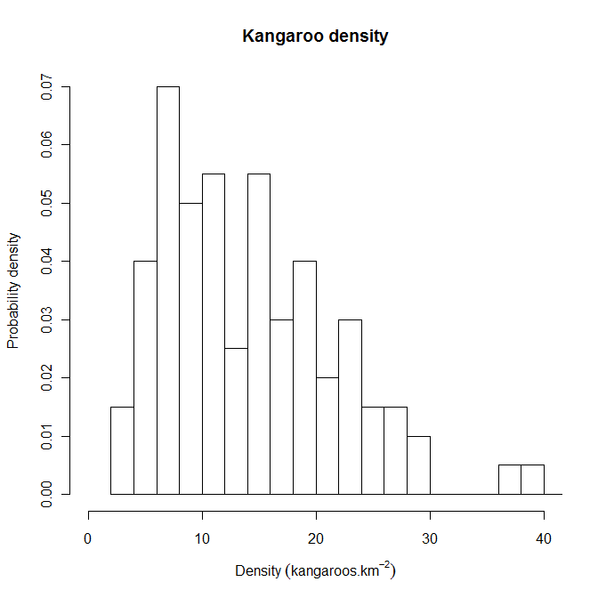 | Figure 8: Histogram of a theoretical population of kangaroos.  Density is estimated by aerial survey and the frequency of estimated densities is converted to probability densities. The distribution of kangaroo densities is approximately lognormal.

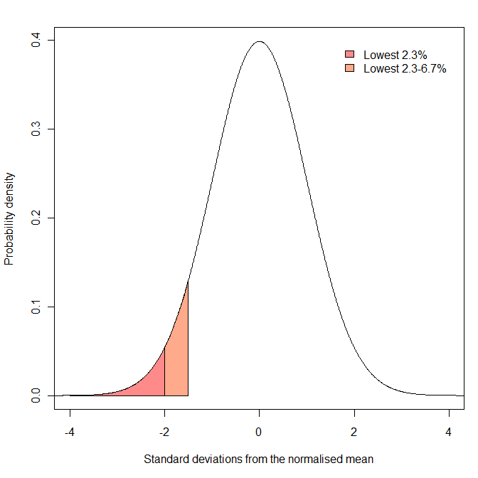 | Figure 9: A theoretical distribution after z-score transformation.  The mean of the distribution is zero and the standard deviation is one. Areas under the distribution represent probabilities. The orange shaded region represents the probability that a sample is between 1.5 and two standard deviations below the mean (and represents 4.4 percent of the area). The red-shaded region represents the probability that a sample is more than two standard deviations below the mean (and represents 2.3 percent of the area).

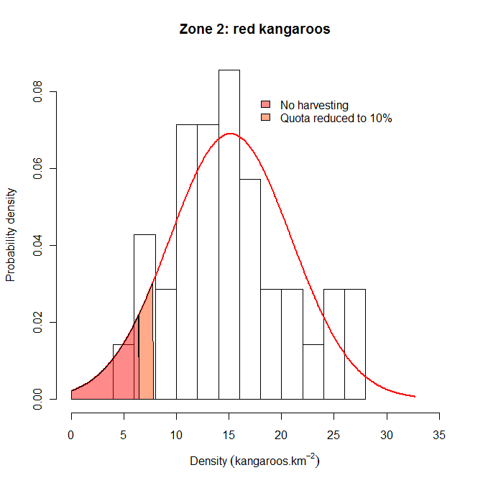 | Figure 10: Example of setting harvest thresholds for red kangaroos in NSW’s Zone 2.  The red line represents a normal probability distribution of the observed data with a mean of 15.2 kangaroos per square kilometre and a standard deviation of 5.8 kangaroos per square kilometre. The upper range of the orange region (7.8 kangaroos per square kilometre) represents the threshold within which harvest rate is reduced from 17 percent to 10 percent. This lower rate is maintained unless density falls below 6.4 kangaroos per square kilometre, at which point harvesting ceases (red region). The thresholds were calculated after log-transforming the data.
The following section shows how model simulations can be used to examine the relative effects of different thresholds applied to harvesting a theoretical population of red kangaroos.

Reducing the risk of overharvesting: an example using red kangaroos
The recommended strategy to minimise the risk of overharvesting is to reduce harvest rate as density declines, with changes in harvest rate triggered at predetermined density thresholds. Appropriate thresholds can be considered by harvesting a simulated population of kangaroos (e.g. Milner-Gulland et al. 2001). An appropriate population model for red kangaroos was developed by Caughley (1987) and various forms of the model have continued to be used for assessing strategies for managing the kangaroo harvest (e.g. Hacker et al. 2004; Pople 2003, 2008).
Briefly, changes in kangaroo numbers are modelled as a function of pasture biomass which, in turn, is determined by recent rainfall, past pasture biomass and the density of kangaroos (and livestock) consuming the pasture. Harvesting obviously reduces kangaroo numbers, but the reduced density results in higher pasture biomass and therefore higher rates of increase of kangaroos. This improvement in environmental conditions for a population, which without harvesting has no long-term trend, is a basic requirement for the sustainability of a harvest. The population can be simulated 10,000 times over a 20-year period. Each run is different as, every three months, rainfall is drawn from a probability distribution using the average and standard deviation for rainfall in western NSW and thus reflects the uncertain food supply in this arid environment. Population size is also estimated with uncertainty by aerial surveys, and so this too was drawn from a probability distribution using the average and standard deviation associated with aerial surveys (Pople 2008). The population was harvested at an annual rate of 15 percent or less if it was below a particular threshold.
Extinction is highly unlikely for this simulated population unless there is some combination of low numbers, catastrophic weather and unsustainable harvesting (i.e. much greater than 15 percent). A more useful measure of threshold performance is the probability of the population dropping to a relatively low density. This can be calculated as the proportion of the 10,000 simulation runs where the population falls below particular densities. Thresholds can be expressed in terms of standard deviations (SDs) below long-term average density for a kangaroo management zone. That way, the aim of the threshold harvest strategy is to keep the harvested population above historically low density.
The effect of reducing harvest rate at varying SDs below the long-term average density for the simulated kangaroo population is shown in Figure 11. Reducing the threshold not surprisingly reduces the probability of very low density, but the decline in probability from no threshold (15 percent harvest) to no harvest is smooth. There is, therefore, no obvious optimum with the choice being somewhat arbitrary. Notably, even an unharvested population has some chance of declining to very low density.

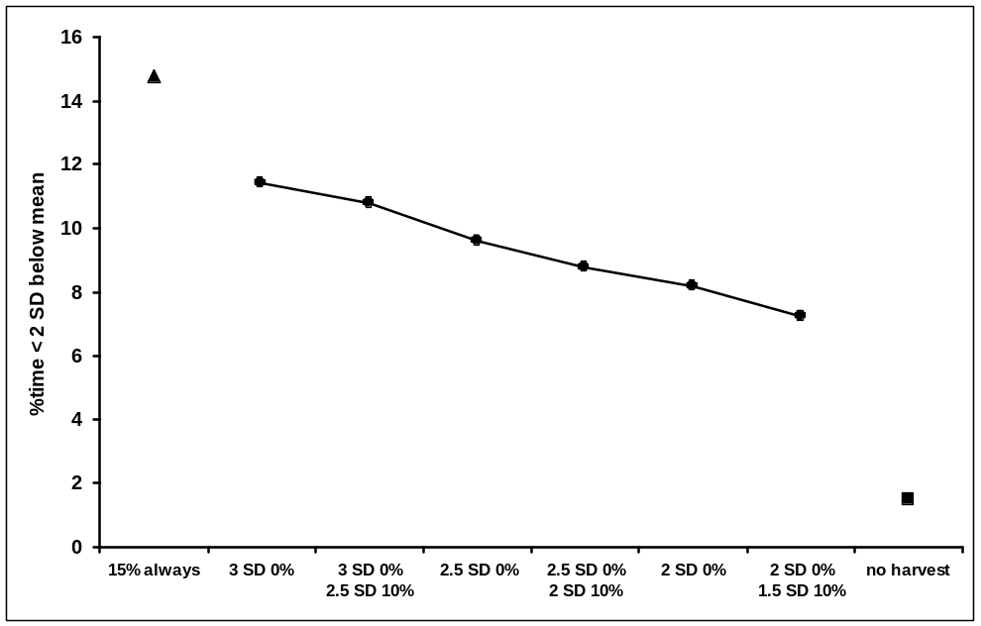
Figure 11: 10,000 simulations for a population fluctuating over 20 years.

Standard deviation (over time) was calculated from a lognormal distribution. Mean population size was about eight kangaroos per square kilometre. Density was about four kangaroos per square kilometre at two standard deviations below the mean.
Other factors that could be considered in setting thresholds is the time spent below some relatively low density (e.g. Figure 12), and the long-term average and variability in harvest offtake (including years with zero offtake) (Pople 2003). For these simulations, average harvest offtake was similar among the thresholds shown in Figures 11 and 12, but variability in the annual harvest increased slightly as the threshold was reduced.
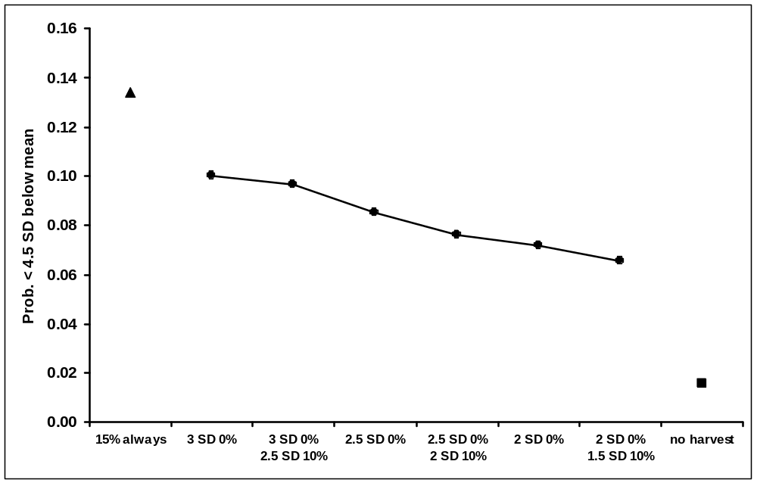
Figure 12: Simulated population as described for Figure 8.

Density was about two kangaroos per square kilometre at 4.5 standard deviations below the mean.

Appendix 4. Summary of Quotas and Thresholds
Quotas | Description | Management actions
Sustainable Use Quota (Action 11) | Sustainable Use Quota is set at a specific percentage of the population estimate for each species in each harvest sub-region. | Red kangaroo | 20% of population est.
Sustainable Use Quota (Action 11) |  | Western grey kangaroo | 15% of population est.
Sustainable Use Quota (Action 11) |  | Eastern grey kangaroo | 15% of population est.
Sustainable Use Quota (Action 11) |  | Euro | 15% of population est.
Sustainable Use Quota (Action 11) |  | Tammar wallaby | 10% of population est.
High Abundance Quota (HAQ) (Action 11) | HAQ is additional quota that can be issued in combination with the proportional quota when a population estimate in a harvest sub-region is above the long-term average. Quota is issued at the discretion of the Director of National Parks and Wildlife. | HAQ issued when population in a harvest sub-region is above the long-term average.
Special Land Management Quota (SLMQ) (Action 13) | Additional quota that can be released when all proportional quota has been allocated within a harvest sub-region to mitigate ongoing land condition damage. Quota is set at a maximum of 1.5% of the population estimate of each species in each harvest sub-region. | SLMQ is released when all proportional quota has been allocated and kangaroo populations are still causing or are likely to cause damage to land or infrastructure.
Thresholds | Description | Management actions
Low Harvest Threshold (Action 9) | Threshold based on harvest within each harvest sub-region. Threshold is set at 1.5% of the average population estimate. If harvest falls below threshold for three consecutive years, management actions are triggered. | If harvest is lower than threshold, stop surveys until harvest exceeds threshold.
Low Abundance Thresholds (Action 12) | Thresholds are based on population estimates to ensure that populations are not overharvested when at low densities. When population estimates fall below thresholds, management actions are triggered. | Threshold 1 | Quota is reduced to 10% of population estimate.
Low Abundance Thresholds (Action 12) |  | Threshold 2 | Harvest is suspended until population estimate increases above threshold.

References
Allendorf, FW England, PR Luikart, G Ritchie, PA and Ryman, N (2008) ‘Genetic effects of harvest on wild animal populations’ Trends in Ecology and Evolution. 23, pp. 327-337.
Bailey, P and Best, L (1992) ‘A red kangaroo, Macropus rufus, recovered 25 years after marking in north-western New South Wales’. Australian Mammalogy, 15, pp.141.
Banks, PB Newsome, AE and Dickman, CR (2000) ‘Predation by red foxes limits recruitment in populations of eastern grey kangaroos’. Austral Ecology. 25, pp 283-291.
Barnes, TS Morton, JM and Coleman, GT (2007) ‘Clustering of hydatid infection in macropodids’. International Journal for Parasitology. 37, pp. 943-952.
Barton, PS Cunningham, SA Lindenmayer, DB and Manning, AD (2013). The role of carrion in maintaining biodiversity and ecological processes in terrestrial ecosystems. Oecologia 171 pp. 761–772
Barton, PS, Evans, MJ, Foster, CN, Pechal, JL, Bump, JK Quaggiotto, M-M and Benbow, ME (2019). Towards quantifying carrion biomass in ecosystems. Trends in Ecology & Evolution 34(10) pp 950-961.
Bayliss P (1985) ‘The population dynamics of red and western grey kangaroos in arid New South Wales, Australia. 1: Population dynamics and rainfall’. Journal of Animal Ecology, 54, pp. 111-125.
Bayliss P (1987) ‘Kangaroo Dynamics’. In Kangaroos: their Ecology and Management in the Sheep Rangelands of Australia. (Eds G Caughley, N Shepherd and J Short) pp. 119-134. (Cambridge University Press, Cambridge).
Cairns SC, Pople, AR and Grigg, GC (1991) ‘Density distributions and habitat associations of Red Kangaroos (Macropus rufus) and Western grey kangaroos (Macropus fuliginosus) in the pastoral zone of South Australia’. Wildlife Research, 18, pp. 377-402.
Cairns, SC Grigg, GC Beard, LA Pople, AR and Alexander, P (2000) ‘Western grey kangaroos, Macropus fuliginosus, in the South Australian pastoral zone: populations at the edge of their range’. Wildlife Research. 27, pp. 309-318.
Cairns, SC and Grigg, GC (1993) ‘Population dynamics of red kangaroos (Macropus rufus) in relation to rainfall in the South Australian Pastoral Zone’. Journal of Applied Ecology. 30, pp. 444-458.
Calaby, JH and Grigg, GC (1989) ‘Changes in macropodid communities and populations in the past 200 years, and the future’, In Kangaroos, wallabies and rat-kangaroos, (Eds G Grigg, P Jarman and I Hume), Surrey Beatty and Sons, Sydney, pp. 813-820.
Caughley, G (1977). Analysis of Vertebrate Populations. (Wiley and Sons, London).
Caughley, G Grigg, GC Caughley, J and Hill, GJE (1980) ‘Does dingo predation control the densities of kangaroos and emus?’, Australian Wildlife Research 7, pp. 1-12.
Caughley, G Grigg, GC and Smith, L (1985) ‘The effect of drought on kangaroo populations’, Journal of Wildlife Management 49, pp. 679-685.
Caughley, G (1987) ‘Ecological relationships’. In Kangaroos: their Ecology and Management in the Sheep Rangelands of Australia'. (Eds G Caughley, N Shepherd and J Short) pp. 159-187. (Cambridge University Press, Cambridge).
Clegg, SM Hale, P Moritz, C (1998) ‘Molecular population genetics of the red kangaroo (Macropus rufus): mtDNA variation’ Molecular Ecology. 7, pp. 679-686
Coltman, DW (2008) ‘Molecular ecological approaches to studying the evolutionary impact of selective harvesting in wildlife’. Molecular Ecology. 17, pp.221-235
Convention on International Trade in Endangered Species (CITIES) of Wild Fauna and Flora 2017. The CITES Appendices I, II and III Valid from 4 April 2017. Available http://www.cites.org. Accessed on 8 June 2017.
Croft, DB (1991) ‘Home range of the Red kangaroo, Macropus rufus’. Journal of Arid Environments, 20, pp. 83-98.
Corbett, LK and Newsome, AE (1987) ‘The feeding ecology of the dingo’. Oecologia 74, pp. 215-227
Coulson, G and Norbury, G (1988) Ecology and Management of Western grey kangaroos (Macropus fuliginosus) at Hattah-Kulkyne National Park. Arthur Rylah Institute for Environmental Research, Technical Report Series No. 72. (Department of Conservation, Forests and Lands: Melbourne).
Coulson G., Alviano P., Ramp D., Way S., McLean N. and Yazgin V. (2000) The kangaroos of Yan Yean: issues for a forested water catchment in a semi-rural matrix. In:Nature Conservation 5: Nature Conservation in Production Environments: Managing the Matrix(eds J.L. Craig, N. Mitchell and D. A. Saunders),pp. 146–156. Surrey Beatty and Sons, Chip-ping Norton.
Dawson, TJ (1995) Kangaroos: Biology of the largest Marsupials. (University of NSW Press, Sydney).
Dawson, TJ Blaney, CE McCarron, HCK and Maloney, SK (2007) ‘Dehydration, with and without heat, in kangaroos from mesic and arid habitats: different thermal responses including varying patterns in heterothermy in the field and laboratory’. Journal of Comparative Physiology B Biochemical Systemic and Environmental Physiology 177, pp. 797‐807.
Department for Environment and Heritage (DEH) (2004) Translocation Proposal - Re-introduction of Mainland Tammar Wallaby to Innes National Park. Department for Environment and Heritage, Adelaide.
Department of Environment, Water and Natural Resources (DEWNR) (2013) South Australian Kangaroo Management Plan 2013-2017, Department of Environment, Water and Natural Resources, Adelaide.
Department of Environment, Water and Natural Resources (DEWNR) (2017) 2016 Commercial Kangaroo Harvest Report for South Australia, Department of Environment, Water and Natural Resources, Adelaide.
Department for Environment and Water (DEW) (2018) 2019 Quota Report for the Commercial Kangaroo Harvest in South Australia, Department for Environment and Water, Adelaide.
Department for Environment and Water (DEW) (2022) 2023 Quota Report for the Commercial Kangaroo Harvest in South Australia, Department for Environment and Water, Adelaide.
Department for Environment and Water (DEW) (2023) 2024 Quota Report for the Commercial Kangaroo Harvest in South Australia, Department for Environment and Water, Adelaide.
Department for Environment and Water (DEW) (2024) 2023 Harvest Report for the Commercial Kangaroo Harvest in South Australia, Department for Environment and Water, Adelaide.
Deroba, JJ and Bence, JR (2008) ‘A review of harvest policies: Understanding relative performance of control rules’. Fisheries Research 94, pp. 210-223.
Dunlop, M and Brown, PR (2008) Implications of Climate Change for Australia’s National Reserve System: A Preliminary Assessment. Report to the Department of Climate Change and the Department of Environment, Water, Heritage and the Arts. CSIRO Sustainable Ecosystems, Canberra.
Eldridge, MDB Miller, EJ Neaves, LE Zenger, KR and Herbert, CA (2017) ‘Extensive genetic differentiation detected within a model marsupial, the Tammar Wallaby (Notamacropus eugenii)’. PLoSONE 12, doi:10.1371/journal.pone.017277
Engen, S Lande, R and Saether, BE (1997) ‘Harvesting strategies for fluctuating populations based on uncertain population estimates’. Journal of Theoretical Biology, 186, pp. 201-212.
Freeman A. and Pobke, K (2021) Macropod management is critical for recovery of Sheoak Grassy Woodlands on Eyre Peninsula, South Australia. Ecological Management and Restoration, 22, pp. 44-49
Fensham, RJ and Fairfax, RJ (2008) ‘Water-remoteness for grazing relief in Australian arid-lands’ Biological Conservation, 141(6), pp.1447-1460
Fillios, M Gordon, G Koch, F and Letnic, M (2010) ‘The effect of top predator on kangaroo abundance in arid Australia and its implications for archaeological faunal assemblages’. Journal of Archaeological Science. 37, pp. 986-993.
Garnick, S DiStefano, J Elgar, MA and Coulson G (2016a) Do body size, diet type or residence time explain habitat use in a vertebrate herbivore community? Australian Journal of Zoology 64, pp. 91-99.
Goldie, N and van Wensveen, M (2003) ‘Agriculture: adapting to climate change’. ECOS, 115, pp.14-15.
Grigg, G (1995). Kangaroo Harvesting for Conservation of Rangelands, Kangaroos ... and Graziers. In Grigg, G. C., Hale, P. T. and Lunney, D. (Ed.), Conservation Through Sustainable Use of Wildlife (pp. 161-165): Centre for Conservation Biology.
Hacker, R and McLeod, S (2003) Living with kangaroos: a guide to kangaroos and their management in the Murray-Darling Basin, New South Wales Department of Agriculture, Orange.
Hacker, R McLeod, S Druhan, J Tenhumberg, B and Pradhan, U (2004) Kangaroo management options in the Murray-Darling Basin. (Murray-Darling Basin Commission, Canberra).
Hale, PT (2001) Kangaroo genetics: impacts of harvesting. Online: (http://www.environment.nsw.gov.au/resources/nature/genetics.pdf) Office of Environment and Heritage. Accessed 7 June 2017.
Hale, PT (2004) ‘Genetic effects of kangaroo harvesting’. Australian Mammalogy, 26: 75-86.
Hinds, LA (2008) Tammar wallaby, Macropus eugenii. In: S. Van Dyck and R. Strahan (eds) The Mammals of Australia. Third edition. Reed New Holland, Sydney, pp. 330−332.
Hooper, PT Lunt, RA Gould, AR Hyatt, AD Russell, GM Kattenbelt, JA Blacksell, SD Reddacliff, LA Kirkland, PD Davis, RJ Durham, PJK Bishop, AL and Waddington, J (1999) ‘Epidemic of blindness in kangaroos – evidence of a viral aetiology’. Australian Veterinary Journal. 77, pp. 529-536
Howland, B., Stojanovic, D., Gordon, I., Manning, A., Fletcher, D. and Lindenmayer, D. (2014) Eaten out of house and home: impacts of grazing on ground-dwelling reptiles in Australian grasslands and grassy woodlands. PLoS One 9, e105966.
IPCC (2007). IPCC Fourth Assessment Report. Intergovernmental Panel on Climate Change.
IUCN 2024. The IUCN Red List of Threatened Species. Version 2023-1. Online: www.iucnredlist.org Accessed: 10 April 2024.
Jonzen, N Pople, T Knape, J and Skold, M (2010) ‘Stochastic demography and population dynamics in NSW Commercial Kangaroo Harvest Management Plan 2017 – 2021 the red kangaroo Macropus rufus’. Journal of Animal, Ecology 79109‐116.
Kearney SG, Carwardine J, Reside AE, Fisher DO, Maron M, Doherty TS, Legge S, Silcock J, Woinarski JCZ, Garnett ST, Wintle BA & Watson JEM (2019). The threats to Australia’s imperilled species and implications for a national conservation response. Pacific Conservation Biology 25(3):231–244.
Kirkpatrick, TH (1985) ‘Biology for management’, in HJ Lavery (Ed), The kangaroo keepers, University of Queensland Press, St Lucia, pp. 135-160.
Kirsch, JAW and Poole, WE (1972) ‘Taxonomy and distribution of the Grey Kangaroos, Macropus giganteus (Shaw) and Macropus fuliginosus (Desmarest), and their subspecies (Marsupalia: Macropodidae)’. Australian Journal of Zoology, 20, pp. 315-339.
Lande, R Engen, S and Saether, B-E (1995) ‘Optimal harvesting of fluctuating populations with a risk of extinction’. American Naturalist 145, pp. 728-745.
Lande, R Saether, B-E and Engen, S (1997) ‘Threshold harvesting for sustainability of fluctuating resources’. Ecology 78, pp.1341-1350.
Lange R. T. and Graham C. R. (1983) Rabbits and the failure of regeneration in Australian arid zone Acacia. Australian Journal of Ecology 8, pp 377–381.
Letnic, M and Crowther, MS (2012) ‘Patterns in the abundance of kangaroo populations in arid Australia are consistent with the exploitation ecosystems hypothesis’. OIKOS, 122, pp. 761-769.
Letnic, M, Ritchie, EG Dickman, CR (2011). Top predators as biodiversity regulators: the dingo Canis lupus dingo as a case study. Biological Reviews. 87, pp. 390–413.
MacDonald, AJ Fitzsimmons, NN Chambers, B Renfree, MB and Sarre, SD (2013) Sex-linked and autosomal microsatellites provide new insights into island populations of the tammar wallaby, Heredity, 112, pp. 333-342
McCarthy, MA (1996) Red kangaroo (Macropus rufus) dynamics: effects of rainfall. Density dependence, harvesting and environmental stochasticity. Journal of Applied Ecology. 33, pp. 45-53.
McLeod, SR and Pople, AR (2011) New South Wales Commercial Harvest Management Plan 2012-2016. NSW Government.
McMurtrie A. and Kerle A. (2021) The dying has begun. It’s a pretty rough backdrop to a job. Ecological Management and Restoration, 22, pp. 64-65
Milner-Gulland, EJ Shea, K Possingham, H Coulson, T and Wilcox, C (2001) ‘Competing harvesting strategies in a simulated population under uncertainty’. Animal Conservation, 4, pp. 157-167.
Morgan JW (2021) Overabundant native herbivore impacts on native plant communities in south-eastern Australia. Ecological Management and Restoration, 22, pp. 9-15
National Code of Practice for the Humane Shooting of Kangaroos and Wallabies for Commercial Purposes (2020) Commonwealth of Australia.
National Code of Practice for the Humane Shooting of Kangaroos and Wallabies for Non-Commercial Purposes (2008) Commonwealth of Australia.
Neaves, LE Zenger, KR Prince, RIT Eldridge, MDB (2009) ‘Landscape discontinuities influence gene flow and genetic structure in a large, vagile Australian mammal, Macropus fuliginosus’. Molecular Ecology, 18, pp. 3363-3378
Newsome, AE (1975) An ecological comparison of the two arid zone kangaroos of Australia, and their anomalous prosperity since the introduction of ruminant stock to their environment. Quarterly Review of Biology. 50, pp. 389–424.
Newsome AE (1977) ‘Imbalance in the sex ratio and age structure of the Red Kangaroo, Macropus rufus, in central Australia’. In The Biology of Marsupials. (Ed D Gilmour) pp. 221-233. (Macmillan, London).
Newsome, T Spencer, E Cairncross, R Furst, C Vandersteen, J Barton, P (2024) A call to further understand the role of carrion in food webs: a case study of the Australian Alps. Australian Zoologist. 43(4) pp. 574-587.
Olsen, P and Braysher, M (2000) Situation Analysis Report: Current state of scientific knowledge on kangaroos in the environment, including ecological and economic impact and effect of culling. Report to the Kangaroo Management Advisory Committee, NSW.
Olsen, P and Low, T (2006) Situation Analysis Report: Update on current state of scientific knowledge on kangaroos in the environment, including ecological and economic impact and effect of culling. Report to the Kangaroo Management Advisory Committee, NSW.
Parameswaran, N O’Handley, RM Grigg, ME and Wayne, A (2009) Vertical transmission of Toxoplasma gondii in Australian Marsupials. Parasitology. 136, pp. 393-944
Pople, A (1989) ‘Habitat associations of Australian Macropodoidea’. In Kangaroos, Wallabies and Rat Kangaroos. (Eds G Grigg, P Jarman and I Hume) pp. 755-766. (Surrey Beatty and Sons, Sydney).
Pople, AR (1996) Effects of harvesting upon the demography of red kangaroos in western Queensland. PhD thesis, The University of Queensland.
Pople, A (2003) 'Harvest management of kangaroos during drought.' Online: http://www.environment.nsw.gov.au/resources/parks/NSWNPWSDroughtHarvestmanagementColour.pdf Report to the New South Wales National Parks and Wildlife Service. Accessed 7 June 2017.
Pople, AR. (2008) ‘Frequency and precision of aerial surveys for kangaroo management’. Wildlife Research 35: 340-348.
Pople, A and Grigg, G (1999) Commercial harvesting of kangaroos in Australia, Department of the Environment and Heritage. (http://www.environment.gov.au/biodiversity/trade-use/wild-harvest/kangaroo/harvesting/index.html).
Pople, AR Grigg, GC Cairns, SC Beard, LA and Alexander, P (2000) ‘Trends in the numbers of Red Kangaroos and Emus on either side of the South Australian dingo fence: evidence for predator regulation?’ Wildlife Research, 27, pp. 269-276.
Pople, AR and McLeod, SR (2000) ‘Kangaroo management and the sustainable use of rangelands’. In Management for Sustainable Ecosystems. (Eds PT Hale, A Petrie, D Moloney and P Sattler) pp. 78-86. (Centre for Conservation Biology, The University of Queensland, Brisbane).
Pople, AR, Evans, M, Farroway, L, Gilroy, J, Grigg, GC, Lundie-Jenkins, G and Payne, N. (2010a). ‘Using harvest statistics to monitor temporal variation in kangaroo density and harvest rate’ in Macropods: the Biology of Kangaroos, Wallabies and Rat-kangaroos. (Eds G Coulson and MDB Eldridge) pp. 371-397. (Melbourne: CSIRO Publishing).
Pople, AR Grigg, GC Phinn, SR Menke, N McAlpine, C and Possingham, HP (2010b) ‘Reassessing spatial and temporal dynamics of kangaroo populations’ in Macropods: the Biology of Kangaroos, Wallabies and Rat-kangaroos. (Eds G Coulson and MDB Eldridge) pp. 197-210. (Melbourne: CSIRO Publishing).
Pople, AR and Page, M (2001) Management of artificial watering points on National Parks in western Queensland, report for the Queensland National Parks and Wildlife Service.
Pople, AR Phinn, SR Grigg, GC Possingham, HP Menke, N and McAlpine, C (2006) Spatial patterns of kangaroo density across the South Australian pastoral zone over 26 years: aggregation during drought and suggestions of long-distance movement. In ‘Modelling the spatial and temporal dynamics of kangaroo populations for harvest management’. Final report to the Department for Environment and Heritage, Canberra. (The Ecology Centre, University of Qld).
Priddel, D (1987) ‘The mobility and habitat utilisation of kangaroos’. In Kangaroos: Their Ecology and Management in the Sheep Rangelands of Australia. (Eds G Caughley, N Shepherd, and J Short.) pp 100-118. (Cambridge University Press, Cambridge).
Prowse, TAA Correll, RA Johnson, CN Prideaux, GJ and Brook, BW (2015) ‘Empirical tests of harvesting-induced body-size evolution along a geographic gradient in Australian macropods’. Journal of Animal Ecology, 84, pp. 299-309
Purcell, BV (2010) Dingo (CSIRO Publishing, Collingwood).
Read, JL and Wilson, D (2004) ‘Scavengers and detritivores of kangaroo harvest off cuts in arid Australia’, Wildlife Research 31, pp. 51-56.
Read J., Zabek M., West R., and Olds L. (2018) Warru Recovery Team Progress Report 2016 – Recovery of Petrogale lateralis MacDonnell Ranges race in South Australia, An initiative of the Australian Government, Department of Environment, Water and Natural Resources, Alinytjara Wilurara Natural Resources Management Board, Anangu Pitjantjatjara Yankunytjatjara, Zoos SA and Ecological Horizons.
Read, JL., Wilson, GR., Coulson, G. and Radford, JQ. (2021) Introduction to the special edition on overabundant macropods. Special Issue: Optimum management of overabundant macropods, Ecological Management and Restoration, 22, pp 5-8
Rees J. D., Kingsford R. T. and Letnic M. (2017) In the absence of an apex predator, irruptive herbivores suppress grass seed production: implications for small granivores. Biological Conservation 213, pp.13–18
Ritchie, EG and Bolitho, EE (2008) ‘Australia’s Savanna herbivores: bioclimatic distributions and an assessment of the potential impact of regional climatic change’. Physiological and Biochemical Zoology. 81, pp.880-890
Roberts, MW Smythe, L Dohnt, M Symonds, M and Slack, A (2010) ‘Serologic-based investigation of Leptospirosis in a population of free-ranging eastern grey kangaroos (Macropus giganteus) indicating the presence of Leptospira weilii Serovar Topaz’. Journal of Wildlife Diseases. 46, pp. 564-579
Robertson, G (1986) ‘The mortality of kangaroos in drought’ Australian Wildlife Research 13, pp. 349-354 Short, J and Grigg, GC (1982) ‘The abundance of kangaroos in suboptimal habitats: wheat, intensive pastoral and mallee’, Australian Wildlife Research 9, pp. 221-228.
Shannon J. M. (2015) Assessing effects of grazing on the response of Coastal Grassy Wood-land vegetation to fire at Yanakie Isthmus, Wilsons Promontory National Park. Report to Parks Victoria. Department of Ecology, Environment and Evolution. La Trobe University, Bundoora, Victoria
Sharp, T and Saunders, G (2011) A model for assessing the relative humaneness of pest animal control methods (Second edition). Australian Government Department of Agriculture, Fisheries and Forestry, Canberra, ACT.
Sharp, A., Norton, M., Havelberg, C., Cliff, W., Burton, K., and Marks, A. (2014). Yellow-footed rock-wallaby population recovery following fox control, in New South Wales and South Australia. Wildlife Research. 41, 560–570
Speare, R Donovan, JA Thomas, AD and Speare PJ (1989) ‘Diseases of free-ranging Macropodoidea’. In Kangaroos, Wallabies and Rat Kangaroos. (Eds G Grigg, P Jarman and I Hume) pp. 705-734. (Surrey Beatty and Sons, Sydney).
Stephens T. (2021) Kangaroo management and animal welfare. Ecological Management and Restoration, 22, pp. 71-74
Taylor, AC and Cooper, DW “Microsatellites identify introduced New Zealand tammar wallabies (Macropus eugenii) as an ‘extinct’ taxon” Animal Conservation, 2, pp. 41-49
Tenhumberg, B Tyre, D Pople, A and Possingham, H (2004) ‘Evolutionary responses to selective harvesting in a stochastic environment’. Ecology, 85, pp. 2003-2017.
Thompson, PC (1992) ‘The behavioural ecology of dingoes in north-western Australia. III. Hunting and feeding behaviour, and diet’, Wildlife Research 19, pp. 531-541.
Threatened Species Scientific Committee (TSSC) (2019) Listing Advice Notamacropus eugenii eugenii Tammar Wallaby (South Australia). (Online: www.environment.gov.au/biodiversity/threatened/species/pubs/89257-listing-advice-22022019.pdf). Department of the Environment and Energy, Canberra.
Tyndale-Biscoe, H (2005). Life of marsupials. (CSIRO Publishing, Carlton).
Wilson, D and Read, JL (2003) ‘Kangaroo harvesters: fertilising the rangelands’. Rangelands Journal, 25, pp. 47-55.
Woinarski, J and Fisher, A (2003). Conservation and the maintenance of biodiversity in the rangelands. Rangelands Journal. 25, pp. 157–171.
Zanker L. (2021) Kangaroos, drought and a frustrated landowner. Ecological Management and Restoration, 22, pp. 66
Zenger, KR Eldridge, MDB and Cooper, DW (2003) Intraspecific variation, sex-biased dispersal and phylogeography of the eastern grey kangaroo (Macropus giganteus). Heredity, 91, pp. 153-162

Further Information
Department for Environment and Water – Kangaroo Conservation and Management web page
Department for Environment and Water – Kangaroo Industry Permits web page
Agrifutures Australia (2020) National Code of Practice for the Humane Shooting of Kangaroos and Wallabies for Commercial Purposes, second edition, Wagga Wagga, NSW.
Herbert, CA and Elzer, A (2011) Review of Scientific Literature Relevant to the Commercial Harvest Management of Kangaroos, Office of Environment and Heritage, Sydney, NSW. HVPC Working Group (2004) A national approach towards humane vertebrate pest control – Discussion Paper. RSPCA Australia.
McLeod, SR and Sharp TM (2014) Improving the humaneness of commercial kangaroo harvesting. Final report for RIRDC Project No PRJ-004103. Rural Industries Research and Development Corporation, Canberra ACT.
National Resource Management Ministerial Council (NRMMC) (2008) National Code of Practice for the Humane Shooting of Kangaroos and Wallabies for Non-Commercial Purposes, Department of the Environment, Water, Heritage and the Arts, Canberra, ACT.
Pople, T and Grigg, G (1999) Commercial Harvesting of Kangaroos in Australia. Department for Environment Australia, QLD.
Sharp, T and McLeod, S (2016) Kangaroo harvesters and the euthanasia of orphaned young-at-foot: applying the theory of planned behaviour to an animal welfare issue. Animal Welfare 25: 39-54.
Read, JL, Coulson, G, Radford JQ, and Wilson, GR (2021) ‘Special Issue: Optimum management of overabundant macropods’, Ecological Management & Restoration pp 1-192 https://onlinelibrary.wiley.com/toc/14428903/2021/22/S1

Published by the Department for Environment and Water.
Government of South Australia
November 2024
Telephone +61 (8) 8204 9000
Facsimile +61 (8) 8115 1256
ABN 36702093234
Report prepared by:
Department for Environment and Water
Conservation and Wildlife Branch
National Parks and Wildlife Service Division
www.environment.sa.gov.au


With the exception of the Piping Shrike emblem,
other material or devices protected by Aboriginal
rights or a trademark, and subject to review by the
Government of South Australia at all times, the content
of this document is licensed under the Creative Commons
Attribution 4.0 Licence. All other rights are reserved.
© Crown in right of the State of South Australia


