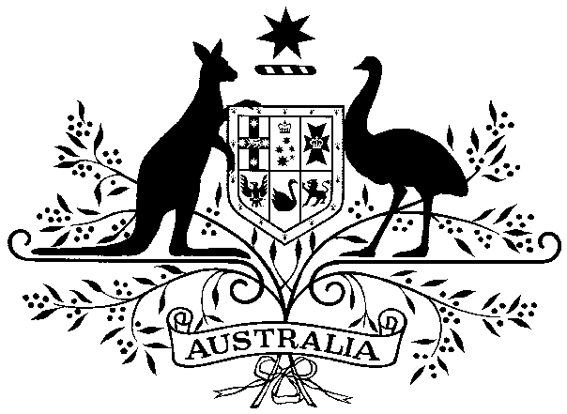

COMMONWEALTH OF AUSTRALIA

Intention to develop a draft bilateral agreement

with the State of South Australia under section 45 of the

Environment Protection and Biodiversity Conservation Act 1999 (Cth)

In accordance with subsection 45(3) of the Environment Protection and Biodiversity Conservation Act 1999 (Cth) (the EPBC Act), I, Tanya Plibersek, Minister for the Environment and Water, give notice of my intention to develop, on behalf of the Commonwealth, a draft bilateral agreement with the State of South Australia.

The draft bilateral agreement is intended to revoke and replace the current bilateral agreement of 25 September 2014 between the Commonwealth of Australia and the State of South Australia.

The draft bilateral agreement may update the classes of actions that are currently declared in Schedule 1 of the current bilateral agreement and make other miscellaneous updates to the current bilateral agreement.

Note: Subsection 47(1) of the EPBC Act provides that a bilateral agreement may declare that actions in a class of actions need not be assessed under Part 8 of the EPBC Act.

Dated this __ of ________ 20___

Minister for the Environment and Water

