

EPBC Act Policy Statement 3.14
Nationally Threatened Species and Ecological Communities

Significant impact guidelines for the vulnerable

growling grass frog (Litoria raniformis)
February 2009

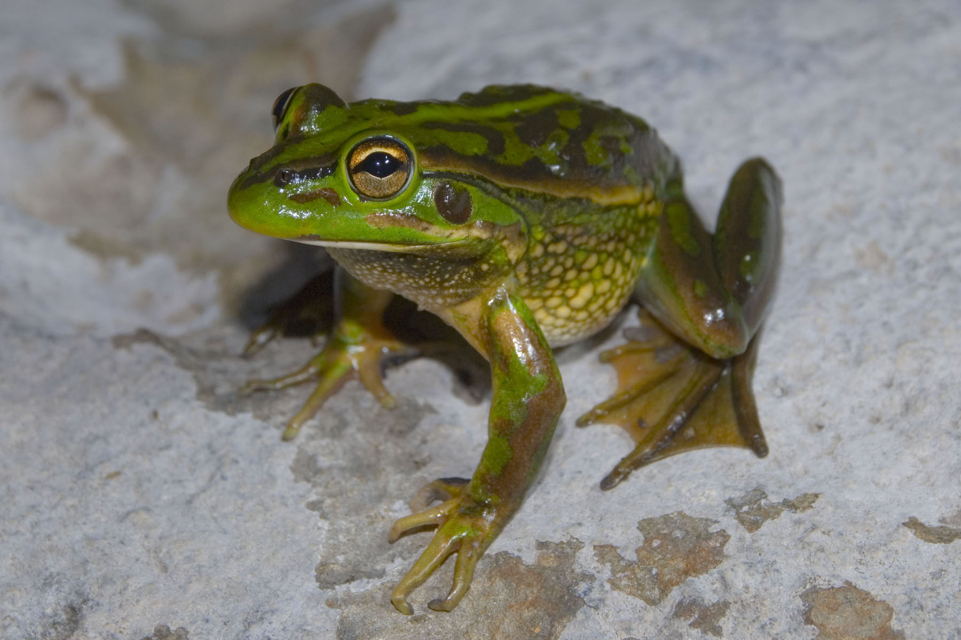

© Commonwealth of Australia 2009
This work is copyright. You may download, display, print and reproduce this material in unaltered form only (retaining this notice) for your personal, non-commercial use or use within your organisation. Apart from any use as permitted under the Copyright Act 1968, all other rights are reserved. Requests and inquiries concerning reproduction and rights should be addressed to Commonwealth Copyright Administration, Attorney General’s Department, Robert Garran Offices, National Circuit, Barton ACT 2600 or posted at www.ag.gov.au/cca.
Disclaimer
The contents of this document have been compiled using a range of source materials and is valid as at August 2009. The Australian Government is not liable for any loss or damage that may be occasioned directly or indirectly through the use of or reliance on the contents of the document.

Introduction
The growling grass frog (Litoria raniformis) is listed as vulnerable under the Australian Government Environment Protection and Biodiversity Conservation Act 1999 (EPBC Act). Listed threatened species and ecological communities are a matter of national environmental significance. Under the EPBC Act an action will require approval from the federal environment minister if the action has, will have, or is likely to have a ‘significant impact’ on a matter of national environmental significance.
A ‘significant impact’ is an impact which is important, notable, or of consequence, having regard to its context or intensity. Whether or not an action is likely to have a significant impact depends upon the sensitivity, value, and quality of the environment which is impacted, and upon the intensity, duration, magnitude and geographic extent of the impacts. You should consider all of these factors when determining whether an action is likely to have a significant impact on matters of national environmental significance.
This policy statement is designed to assist you to determine whether a proposed action is likely to have a significant impact on the growling grass frog (that is, whether or not the action is likely to be a ‘controlled action’ under the EPBC Act). The policy statement applies to temperate and semi-arid areas across the current and historic range of the growling grass frog, in western and southern New South Wales, the Australian Capital Territory, Victoria, South Australia and Tasmania (Figure 1).
This policy statement is based on the best available information, including:
- scientific literature
- draft National Recovery Plan for Litoria raniformis 2004 – 2008 (Clemann & Gillespie 2004)
- consultation with species experts, and
- application of the national environmental legislation (EPBC Act).
This policy statement builds on the information and explanations in EPBC Act Policy Statement 1.1 Significant Impact Guidelines – Matters of National Environmental Significance.

How to interpret and apply these guidelines
The thresholds outlined in this policy statement are not designed to be prescriptive, but rather to clarify the level and types of impact likely to be significant at a national level, having regard for the biology, ecology and threats of the species. If you are planning to undertake an action in temperate or semi-arid habitat (in New South Wales, the Australia Capital Territory, Victoria, South Australia or Tasmania) you should consider the following:
- Does my site support the growling grass frog?
  - Consider habitat, records and surveys on and near to the site (see section 6).
- What impacts, both direct and indirect, could result from my action?
- Could any of these impacts exceed the thresholds outlined in section 7?
- What measures could be taken to reduce the level of impact (see section 9)?
If you think that your action may have a significant impact on a matter of national environmental significance, or if you are unsure, you should refer the action to the federal environment minister. The minister will make a decision within 20 business days on whether approval is required under the EPBC Act. Substantial penalties apply for taking an action that has, will have or is likely to have a significant impact without approval.
Further information on the EPBC Act, including guidance on the referral, assessment and compliance processes is available at: www.environment.gov.au.

What other laws protect the growling grass frog?
The growling grass frog is also listed as threatened under the Victorian Flora and Fauna Guarantee Act 1988, vulnerable under the South Australian National Parks and Wildlife Act 1972 and the Tasmanian Threatened Species Protection Act 1995, and endangered under the New South Wales Threatened Species Conservation Act 1995.
The listing of a species, subspecies or ecological community on the EPBC Act threatened species and ecological communities list recognises the importance of the matter from a national perspective, and does not replace listing under state, regional or local legislation or regulations.
Judgements may differ between Commonwealth, state and local decision making processes, due to the different scales of consideration. In some cases, multiple approvals or permits will be necessary before the action can commence. If your activity could affect the species or individual animals you should also contact the relevant state and local authorities regarding your obligations.

Ecology of the growling grass frog

The species
The growling grass frog is a large frog (females may exceed 100 mm in length) that varies from dull olive to bright emerald-green on the back (dorsum), with large irregular blotches ranging from brown to rich golden-bronze.
The growling grass frog is also known as the southern bell frog, the green and golden frog, the warty frog, the warty bell frog and the green or warty swamp frog.
The species is dependent on a matrix of aquatic and terrestrial habitat for breeding, foraging, shelter and dispersal, and typically occurs in landscapes with both permanent and seasonally flooded water bodies.

Important populations
Much of the habitat for the growling grass frog has been isolated or fragmented, restricting the opportunity for important population processes such dispersal and colonisation. As such, any viable population is considered to be an important population for the persistence and recovery of the growling grass frog. For this species, a viable population is one which is not isolated from other populations or water bodies, such that it has the opportunity to interact with other nearby populations or has the ability to establish new populations when water bodies fill and become available. Interaction with nearby populations and colonisation of newly available water bodies occurs via the dispersal of individual frogs across suitable movement habitat (see ‘Key ecological requirements of the species’ below).
In addition, a population of growling grass frogs could be considered an important population if it is near the limit of the species range (for example small isolated populations in South Australia), is well-studied or has a history of monitoring, and hence provides opportunity for greater understanding of the species through the collection of long-term data.

Key ecological requirements of the species
Dependent on aquatic habitats, and appropriate hydrological regimes, for breeding and dispersal | - Permanent or seasonally flooded water bodies used for breeding. In semi-arid NSW, seasonal flooding of wetland systems necessary for breeding to occur.  - Breeding usually occurs in still or slow moving water.  - Tadpoles have an aquatic period which can vary between two and 15 months.  - Aquatic vegetation provides microhabitats for foraging and shelter for both frogs and tadpoles. Loss or degradation of aquatic habitat and/or disruption to hydrological regimes can lead to population declines and local extinctions.  - Aquatic eggs and larvae may also be vulnerable to fish predators, particularly mosquito fish, redfin and carp.  - Susceptible to the waterborne fungal pathogen Batrachochytrium dendrobatidis which causes the disease chytridiomycosis (chytrid fungus).  - Because of their semi-permeable skin, growling grass frogs may be susceptible to pollutants such as those found in biocides (that is, herbicides, pesticides etc.) or from surface runoff.
Dependent on terrestrial habitat for foraging, shelter and local movement. | - Adult frogs move across open ground (for example grasslands) to access local foraging resources and breeding sites.  - Terrestrial vegetation, fallen logs and ground debris surrounding water bodies provide essential shelter and hibernation (over-wintering) sites for adult frogs.  - Movement between breeding sites (water bodies) is crucial, allowing temporal variation in habitat use and/or recolonisation of sites following local extinction, and maintains genetic diversity.
More information about the growling grass frog can be found in the background paper to this policy statement, located with the species profile on the Department’s SPRAT database (http://www.environment.gov.au/cgi-bin/sprat/public/sprat.pl).

Principal threats to the growling grass frog
The principal threats most relevant to judgements on significance include:
Habitat loss, degradation and modification | - Draining, infilling or changes to flooding patterns of permanent and non-permanent water bodies, or their adjoining watercourses and surrounding vegetation.  - Alteration of wetland hydrology, diversity and structure.  - Removal of aquatic vegetation.  - Clearing of terrestrial vegetation, fallen logs and ground debris surrounding water bodies.  - Deterioration of water quality and any introduction of pollutants and biocides.  - Introduction of domestic stock or feral animals (for example rabbits, goats and pigs) causing damage to banks or terrestrial habitat.
Fragmentation and isolation of populations | - Construction of barriers that limit frog movements between waterbodies (for example buildings, fences, roads, industrial estates etc.).
Introduced predators and disease | - Introduction of exotic fish species.  - Introduction of feral predators such as foxes and cats.  - Introduction of the waterborne chytridiomycosis disease caused by the fungal pathogen Batrachochytrium dendrobatidis.

Survey guidelines for the growling grass frog
A guide to conducting surveys for the growling grass frog is outlined below. Surveys should:
- maximise the chance of detecting the species
- determine the context of the site within the broader landscape, and
- account for uncertainty and error.

Is the habitat suitable?
The following characteristics can be indicators of whether a site supports habitat that is suitable for the growling grass frog, and should be investigated prior to, or in conjunction with, surveys for the species:
- presence of water bodies, including slow flowing streams and rivers, or off-stream wetlands, which contain water at least periodically
- records of growling grass frogs in the local area/catchment, and
- presence of other frog species.

Survey recommendations

When conducting surveys consideration should be given to the timing, effort, methods and area to be covered in the context of the proposed action. If surveys are conducted outside recommended periods or conditions, survey methods and effort should be adjusted to compensate for the decreased likelihood of detecting the species.
Survey guidelines for detecting the growling grass frog
Aim | To maximise the chance of detecting the growling grass frog at the local site, and in the surrounding landscape.
Timing | At the time of peak activity for the species*:  Temperate southern regions: Between November - March (calling takes place primarily between November and December however the frogs may still be active until March).  Semi-arid regions: within one month of flooding (generally October-February).
Effort and methods | Over at least two nights, under suitable conditions:  - using a combination of call playback and night time visual encounter  - surveys (for example as per Heard et al. 2006)  - covering a range of stream structures, billabongs, farm ponds  and dams, swamps and irrigation channels  - accompanied by habitat assessment, and  - undertaken by appropriately experienced personnel.  Important: Chytrid fungus is readily transported between sites (for example on boots) and suitable precautionary measures must be taken whilst surveying. Please see the threat abatement plan for chytrid fungus and/or refer to relevant state publications.
Area to be covered  1) Study site, and  2) Local area | 1) Small water bodies (<50 metres at greatest length) should be covered in a period of about one hour, including searches of banks and emergent vegetation. Larger water bodies (>50 metres) should be searched by sampling subsets of the whole waterbody in a systematic manner.  2) Local area studies should include waterbodies surrounding the survey area to place observations at target site in context.
* As the timing of the peak activity and calling varies annually and geographically, the best indicator of key survey period is the presence of active growling grass frogs at known local sites. Such reference sites should be monitored during the expected seasonal period of high frog activity and used to guide survey timing at the study site.
Research from southern Victoria suggests that night time surveys are preferable to day time surveys and that ideal survey conditions include warm and windless nights in spring and summer (Heard et al. 20061):
- daytime air temperatures greater than 15ºC, with moderate to no wind, and
- night time air temperatures greater than 12ºC, with moderate to no wind.
See Heard et al. (2006) for further detail on survey techniques and detection probabilities for the growling grass frog. Note that Heard et al. (2006) have stressed that the detection probabilities reported are unlikely to apply over the entire growling grass frog range, and that differing survey methods and observer skill/experience could affect detection probabilities.
Where it is not possible to conduct surveys in the manner recommended the precautionary principle should be used, that is failure to detect the growling grass frog should not be considered indicative of its absence.

Habitat assessment
In addition to undertaking surveys for the growling grass frog, the following questions should be asked to determine the context of the site and quality of habitat:
- How close is the nearest water body?
  - In the semi-arid zone, individuals are unlikely to move further than five kilometres between water bodies in the absence of major flood events.
  - In temperate areas, individuals are unlikely to move further than one to two kilometres between water bodies.
- How many water bodies occur within 10 kilometres?
- Is there habitat connectivity (terrestrial or aquatic) between water bodies on site, and between water bodies on site and those on neighbouring sites?

What sorts of actions are likely to have a significant impact on the species?
Significant impact judgements must be made on a case by case basis and with consideration for the context of the action. The potential for a significant impact on a listed threatened species will depend on the:
- intensity, duration, magnitude and geographic extent of the impact
- sensitivity, value and suitability of the environment on and around the site
- cumulative effect of on-site, off-site, direct and indirect impacts, and
- presence of this and other matters of national environmental significance.
There is a real chance or possibility of a significant impact on the species if the action occurs in an area which supports an important population of the growling grass frog and results in any of the following:

Significant impact thresholds for the species: growling grass frog
Ecological element affected | Impact threshold | Comment
Habitat degradation in an area supporting an important population | - Permanent removal or degradation of terrestrial habitat (for example between ponds, drainage lines or other temporary/permanent habitat) within 200 metres of a water body in temperate regions, or 350 m of a water body in semi-arid regions, that results in the loss of dispersal or overwintering opportunities for an important population.  - Alteration of aquatic vegetation diversity or structure that leads to a decrease in habitat quality.  - Alteration to wetland hydrology, diversity and structure (for example any changes to timing, duration or frequency of flood events) that leads to a decrease in habitat quality.  - Introduction of predatory fish and/or disease agents. | Habitat is a connected area that supports one or more key ecological functions for this species. These functions may include, but are not limited to: foraging, breeding, dispersal, shelter.  Any action that results in the degradation of habitat such that the recruitment, survival or dispersal rates of an important population are lowered may have a significant impact on the species.  Habitat quality increases with:  - increasing wetland area,  - water permanence, and  - aquatic vegetation cover.  Habitat quality decreases with:  - the degree of development in the terrestrial zone (that is,. roads, buildings etc) and  - the presence of predatory fish.
Isolation and fragmentation of populations | - Net reduction in the number and/or diversity of water bodies available to an important population.  - Removal or alteration of available terrestrial or aquatic habitat corridors (including alteration of connectivity during flood events).  - Construction of physical barriers to movement between water bodies, such as roads or buildings. | Habitat connectivity could be provided by a linear water body (for example a creekline) or by suitable terrestrial habitat between waterbodies. Individuals may use a range of terrestrial and aquatic habitats as movement corridors between water bodies, including floodways or grassy fields.  Any creation of barriers or destruction of habitat that impedes movement between water bodies could have a significant impact on the species.
Notes:
The elements and thresholds in the table above give guidance to the level of impact that is likely to be significant for the species at a site. They are not intended to be exhaustive or prescriptive, but rather to highlight the need to maintain the ecological function of the habitat area (see Section 4 of this policy statement).
Habitat and/or populations may, and usually will, extend beyond the site boundaries. Consideration must be given to the context of the site in the broader landscape.

What does this mean for actions in growling grass frog habitat?
If you plan to undertake an action that may have a significant impact then you should refer the proposal to the Minister before commencing the action. The Minister will decide, within 20 business days, whether assessment and approval is required under the EPBC Act. More information on referral and assessment is available at http://www.environment.gov.au/epbc/assessments/process.html.

How can my action avoid having a significant impact on the growling grass frog?
Mitigation includes all measures undertaken on the site of the action to avoid or reduce its impacts. Measures should be incorporated into the design of the action at the conceptual and planning stage(s) to:
- reduce the level of the impact so that it is no longer significant
- monitor the performance of the mitigation measures within a specified timeframe.For example by using performance indicators measured at seasonally/annually nominated times, and
- feedback into an adaptive management plan, to quickly react to any changes in performance.
Mitigation and management actions must:
- make avoiding impacts the priority, followed by impact reduction
- avoid negative impacts on other matters of national environmental significance, and
- be consistent with relevant recovery, conservation or action plans.
The following examples may assist in minimising impacts on the growling grass frog:
Avoiding impacts
- Retain habitat known or likely to contain the growling grass frog, and manage for the species.
- Retain terrestrial habitat and dispersal corridors:
- Incorporate buffer zones of at least 200 m, and 350 m around water bodies in temperate and semi-arid zones respectively.
- Maintain dedicated terrestrial habitat corridors, of a minimum of 100 m in width.
- Maintain existing hydrological regimes.
Minimising impacts
- Maintain existing management regime if the site currently supports a breeding population of L. raniformis (for example current grazing intensity).
- Maintain existing water quality.
Managing habitat
- Enhance habitat quality
- Carefully remove weeds and replace with Indigenous submergent, floating and emergent vegetation in and around water bodies. In weedy areas that support growling grass frogs, weeds need to be gradually removed and replaced by natives. Any drastic and sudden removal of weeds in areas supporting growling grass frogs is likely to have a negative effect on the species.
- Maintain open (unvegetated) areas within water bodies, potentially by increasing water depth in some sections.
- Remove or manage exotic fish (for example mosquitofish, carp and redfin). If required, drainage of water bodies to eliminate fish should occur during times of the year when there are few or no tadpoles present.
- Improve terrestrial habitat through provision of logs, rocks and riparian vegetation etc., to provide a diversity of overwintering habitat.
- Manage terrestrial weeds (manually, and without chemicals).

Some experimental measures, such as habitat creation, frog fencing and construction of underpasses, have been proposed or tried in an attempt to mitigate the impacts of an action. As yet, these measures have not demonstrated substantial success and should be considered experimental.

Translocation
Translocation does not reduce the impact of an action below the significance threshold. Translocation of growling grass frogs is not considered to mitigate the impact of an action. However, salvage translocation may be considered as part of the conditions of approval.

Where can I get more information?
The background paper for this policy statement provides a biological and ecological context for survey guidelines, significant impact thresholds, and mitigation measures.
Other EPBC Act policy statements are available to help you to understand the EPBC Act and your obligations. They are available from the Department’s website at: http://www.environment.gov.au/epbc/guidelines-policies.html, or by contacting the Community Information Unit by email: ciu@environment.gov.au or by phone: 1800 803 772.
The threat abatement plan for infection of amphibians with chytrid fungus resulting in chytridiomycosis can be found at: http://www.environment.gov.au/biodiversity/threatened/publications/tap/chytrid.html
The draft New South Wales recovery plan for Litoria raniformis prepared by the Department of of Environment and Conservation (DEC) (NSW) can be found at: http://www.environment.nsw.gov.au/resources/nature/recoveryplanDraftSouthernBellFrog.pdf
The Protected Matters Search Tool can provide a good starting point for determining the likelihood of having matters of national environmental significance in your area. State and territory government agencies may also hold relevant information including habitat and species distribution information.
Further information including on this and other listed threatened species and ecological communities is at the Department’s Species Profiles and Threats Database (SPRAT) at: http://www.environment.gov.au/cgi-bin/sprat/public/sprat.pl.
SIS

Photo credit: page 1 © Daniel Gilmore

Heard, G.W, Robertson, P & M.P. Scroggie 2006. Assessing detection probabilities for the endangered growling grass frog (Litoria raniformis) in southern Victoria. Wildlife Research 33 (7).
1 Heard, G.W, Robertson, P & M.P. Scroggie 2006. Assessing detection probabilities for the endangered growling grass frog (Litoria raniformis) in southern Victoria. Wildlife Research 33 (7).

