

Environment Protection and Biodiversity Conservation Act 1999 draft referral guidelines for the endangered southern brown bandicoot (eastern), Isoodon obesulus obesulus

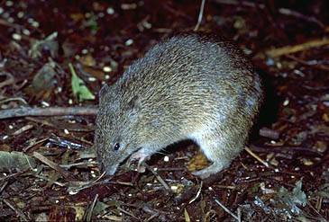

© Commonwealth of Australia 2011
This work is copyright. You may download, display, print and reproduce this material in unaltered form only (retaining this notice) for your personal, non-commercial use or use within your organisation. Apart from any use as permitted under the Copyright Act 1968, all other rights are reserved. Requests and inquiries concerning reproduction and rights should be addressed to Commonwealth Copyright Administration, Attorney General’s Department, Robert Garran Offices, National Circuit, Barton ACT 2600 or posted at www.ag.gov.au/cca.
Disclaimer
The contents of this document have been compiled using a range of source materials and is valid as at time of writing. The Australian Government is not liable for any loss or damage that may be occasioned directly or indirectly through the use of or reliance on the contents of the document.
Front page photograph: Corsi, Gerald and Buff. California Academy of Sciences.
Important notice
Please note that these guidelines are general in nature only and do not remove your obligation to consider whether you need to make a referral to the federal environment minister under the Environment Protection and Biodiversity Conservation Act 1999 (EPBC Act). While the guidelines provide information to help you decide whether to refer your action, the possible impacts of your proposal will depend on the particular circumstances of the action. These circumstances may include issues such as the precise location, mitigation measures and indirect impacts.
This guideline was developed on the basis of the best information available at the time of writing. However, impacts of proposals will be assessed by the department on the basis of the best information available at that point in time, which may differ from the information on which this guideline is based.

These guidelines do not provide guidance on requirements under state and local government laws. Information on New South Wales, Victorian, South Australian and local government council laws can be obtained from the New South Wales Department of Environment, Climate Change and Water; the Victorian Department of Sustainability and Environment; the South Australian Department of Environment and Natural Resources; and the local councils in or near the proposed project area.
How to use these guidelines
These guidelines are intended to assist you in determining whether your action needs to be referred to the Australian Government Department of Sustainability, Environment, Water, Population and Communities (the department). These guidelines should be read in conjunction with the EPBC Act Policy Statement 1.1 Significant Impact Guidelines – Matters of National Environmental Significance.
These guidelines apply to southern brown bandicoot (eastern), Isoodon obesulus obesulus, anywhere it may occur in south-eastern mainland Australia. The southern brown bandicoot is listed as endangered under the EPBC Act. Listed threatened species and ecological communities are matters of national environmental significance under the EPBC Act.
If you plan to undertake an action that has, will have or is likely to have a significant impact on the southern brown bandicoot you must refer the proposal to the minister before commencing. The minister will then decide, within 20 business days, whether assessment is required under the EPBC Act. The potential significance of each action is judged on a case-by-case basis. Substantial penalties apply for undertaking an action, to which the EPBC Act applies, without approval (civil penalties up to $5.5 million or criminal penalties including up to seven years imprisonment). More information on referral, assessment and compliance is available at www.environment.gov.au/epbc/.
The decision tree in Figure 1 and the rest of these guidelines are designed to assist you in determining whether your proposed action needs to be referred. You may also refer your proposed action if you are uncertain about the need to refer, or if you think the proposal would not have significant impacts on matters of national environmental significance, but would like legal certainty.

Possible exceptions to the need to refer
Certain actions are exempt from the requirement of assessment and approval under the EPBC Act. These include lawful continuations of land use that started before 16 July 2000, or actions that were legally authorised before 16 July 2000. There are a number of criteria that must be satisfied to rely on any such exemptions. More information on exemptions under the EPBC Act is available at http://www.environment.gov.au/epbc/publications/exemptions.html.

Figure 1: Decision making
YES
NO

YES or UNSURE
NO
Have you surveyed for southern brown bandicoot using the recommended methods (see Section 4)?
NO
or
UNSURE
REFERRAL RECOMMENDED
High risk of resulting in significant impact**
Assume your project may impact the southern brown bandicoot (see Section 5)
NO

Could your action impact the southern brown bandicoot (see Section 5)?
Is your impact mitigation best practice so that it may reduce the significance of your impacts on the southern brown bandicoot (see Section 6)?
Could the impacts of your action affect any southern brown bandicoot habitat (see Section 3) or individuals?
REFERRAL MAY NOT BE REQUIRED*
Low risk of resulting in significant impact**
Low risk that your action will result in a significant impact on southern brown bandicoot (see Section 7)**
Uncertainty whether your action will result in a significant impact on southern brown bandicoot (see Section 7)***
High risk that your action will result in a significant impact on southern brown bandicoot (see Section 7)**
REFERRAL RECOMMENDED
OR CONTACT THE DEPARTMENT
Uncertainty about a significant impact
REFERRAL RECOMMENDED
High risk of resulting in significant impact**
Could the impacts of your action occur within the modelled distribution of the southern brown bandicoot (see section 2)?
YES or UNSURE
REFERRAL MAY NOT BE REQUIRED*
Low risk of resulting in significant impact**
NO

REFERRAL MAY NOT BE REQUIRED*
Low risk of resulting in significant impact**
Could your action require a referral to the Commonwealth environment minister for significant impacts on southern brown bandicoot (see Section 7)?
REFERRAL MAY NOT BE REQUIRED*
Low risk of resulting in significant impact**
YES
YES or UNSURE
* Although it would appear a referral may not be required, you may still refer your proposed action if unsure, or if you think the proposal would not have significant impacts on matters of national environmental significance, but would like legal certainty. An example may be when other matters of national environmental significance, in addition to southern brown bandicoots, are potentially affected.
** Risk is the chance of something happening that will have an impact on objectives (Australian / New Zealand Risk Management Standard 4360: 2004).
*** If you are uncertain about the need to refer then you may also contact the department to discuss your action by emailing epbc.referrals@environment.gov.au

What is known about the southern brown bandicoot?
The southern brown bandicoot, Isoodon obesulus, Shaw 1797 (Peramelidae) is a medium-sized ground-dwelling marsupial found in New South Wales, Victoria, South Australia, Western Australia and Tasmania. Within their broad geographic distribution, five distinct subspecies of I. obesulus are recognised. This referral guideline refers specifically to the eastern subspecies, Isoodon obesulus obesulus, occurring in south-eastern mainland Australia.
Adult southern brown bandicoots weigh 400-1850 g, have long tapered snouts with a naked nose, a compact body and short, pointed tail. Their forelegs are short with curved claws on the digits used for digging, while the hind limbs are longer, resembling those of macropods with the second and third digits fused. The head and back of southern brown bandicoots appear brown in colour at a distance but grizzled with golden-brown flecks at close range due to the banded spiny guard hairs. The underside of their body and forefeet are creamy white or pale yellow, and their tail is brown above and creamy yellow below.
Relevant background information on the biology and ecology of southern brown bandicoots is provided in the department’s Species Profile and Threats (SPRAT) database.

Could the impacts of your action occur within the modelled distribution of the southern brown bandicoot?
Southern brown bandicoots were once widely distributed along a broad coastal band from Eyre Peninsula in South Australia, including Kangaroo Island, through southern Victoria and south-eastern New South Wales, to Ku-ring-gai Chase just north of Sydney. The current range of southern brown bandicoots has contracted considerably since European colonisation, and they are now very patchily distributed in isolated populations throughout their former range. Refer to Maps 1 to 6 as a guide to the subspecies’ predicted distribution.
The distribution maps presented in this document are based on the best available information at the time of publication and remain a static product. For the most up-to-date report of whether southern brown bandicoots may occur in your project area, always use the Protected Matters Search Tool. The distribution maps in this document indicate where southern brown bandicoot habitat may occur. They do not suggest that southern brown bandicoots occur throughout the entire modelled distribution. Distribution is based on observation data from Commonwealth and State environment agencies, herbaria and conservation agencies. The 'Known to occur' distribution consists of observation data buffered by 1 km, 2 km or 5 km, in accordance with expert advice. The 'Likely to occur' and 'May occur' distributions consist of predicted suitable habitat modelled using MaxEnt Version 3.3.2 software and a suite of 1 km resolution climate, plant, growth, terrain and substrate variables. The resulting distribution was modified in accordance with expert advice received from State and conservation agencies.
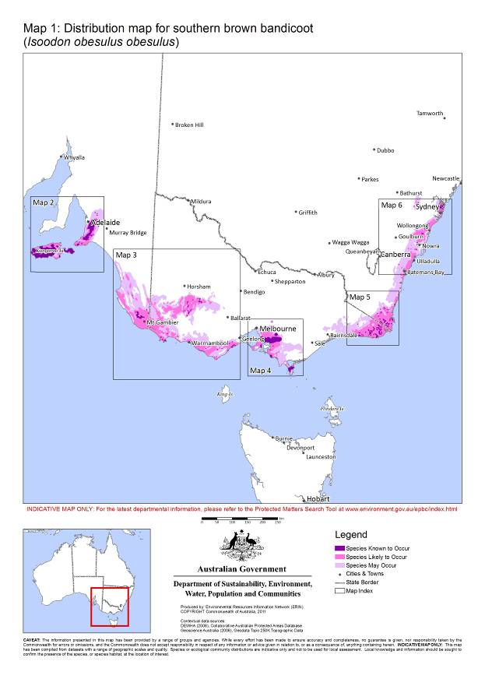

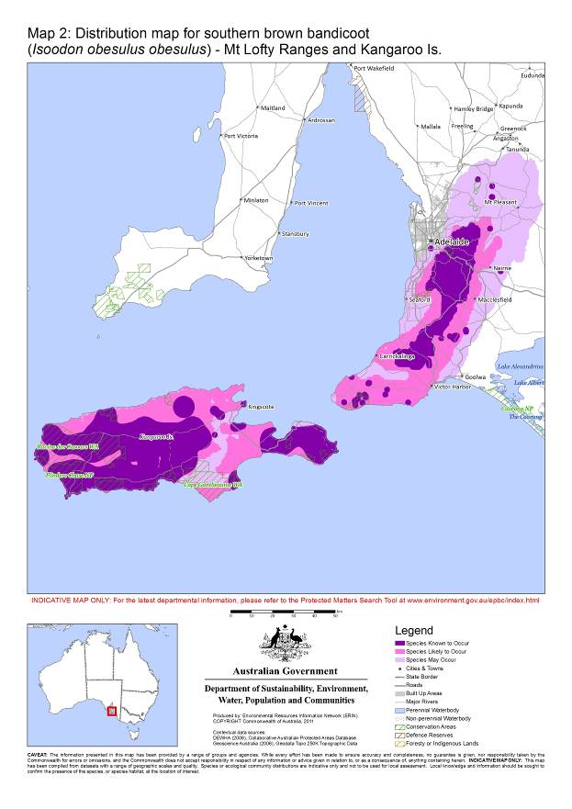

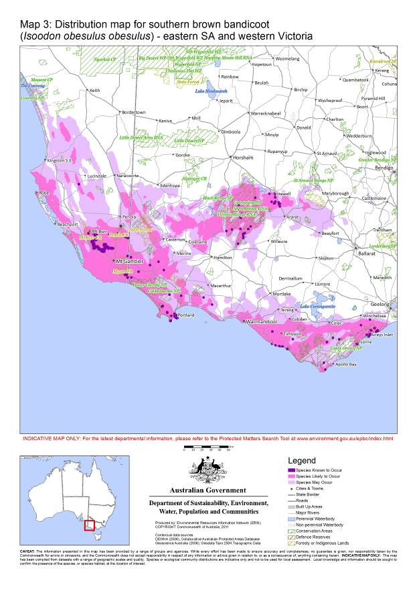

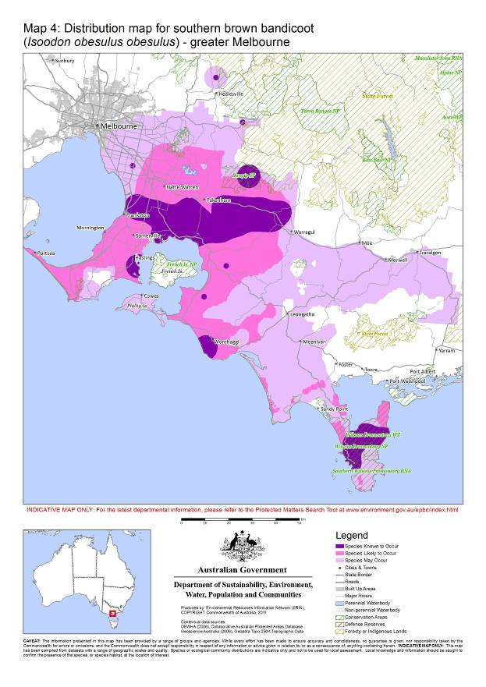

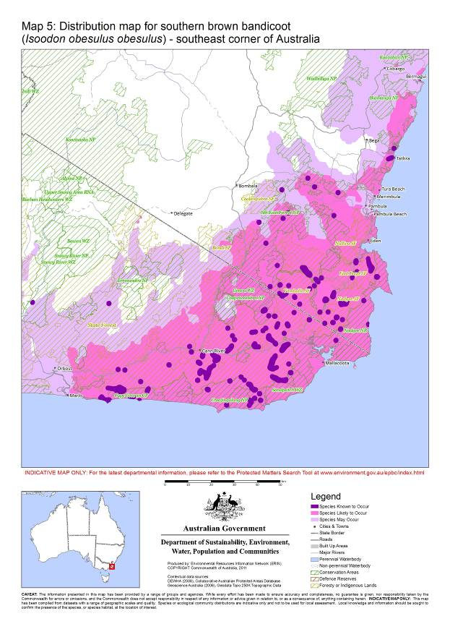

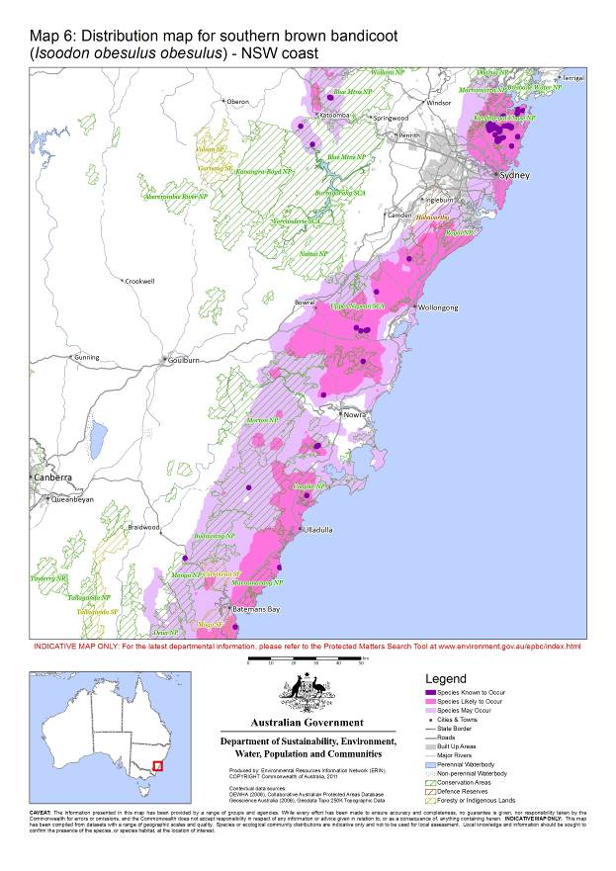

Could the impact of your actions affect habitat for southern brown bandicoots?
Southern brown bandicoots are known to inhabit a variety of habitats including heathland, shrubland, sedgeland, heathy open forest and woodland and are usually associated with infertile, sandy and well drained soils, but can be found in a range of soil types. Within these habitats, southern brown bandicoots prefer areas of dense ground cover of greater than 50% average foliage density within the 0.2-1 m height range. The dense understorey is important to support, disperse and provide predation protection for southern brown bandicoots. In areas where native habitats have been degraded or diminished, exotic vegetation, such as blackberry (Rubus fruticosus), can and often does, provide important habitat for southern brown bandicoots.

Have you surveyed for southern brown bandicoots using the recommended methods?
A guide to conducting surveys for southern brown bandicoots in areas of suitable habitat is outlined below. Surveys should:
  - be conducted by a suitably qualified person with demonstrated skill in fauna surveys
  - maximise the chance of detecting the subspecies
  - account for uncertainty and error (such as false presences and absences).
The following survey methods are recommended for presence/absence surveys. Where it is not possible to conduct surveys in this manner, failure to detect the subspecies should not be considered indicative of its absence.

Survey recommendations

Timing of surveys
The probability of detecting southern brown bandicoots is typically greatest in late summer to autumn coinciding with the peak in recruitment of juveniles into populations. Therefore surveys of the affected area (see Glossary) should preferably be conducted in autumn when the probability of detection is likely to be greatest. The subspecies’ broad distribution, however, means that occupancy and use of habitat may vary considerably over time with local climatic conditions, rainfall and/or temperature and surveying should extend across several months and preferably occur following a significant increase in soil moisture levels.

Survey methods
Affected areas should primarily be surveyed for the presence of southern brown bandicoots using a combination of active searches for diggings or other signs and the deployment of hair tunnels and remote infrared “game” cameras. Infrared cameras are the preferred method and should be used in addition to secondary survey techniques. Secondary survey techniques that may also be employed include predator scat analysis, raked soil plot analysis and anecdotal evidence from the community and surrounding landholders.
The recommended survey methods to determine the presence of southern brown bandicoots in an affected area are detailed in Table 1. Live trapping (using wire cage traps) is not recommended to determine presence due to its inefficiency (southern brown bandicoot are often considered to be "trap shy"), potential for injury and the tendency of females to eject pouch young when trapped.
Where it is not possible to conduct surveys in the manner recommended, failure to detect southern brown bandicoots should not be considered indicative of their absence. Primary surveys (using hair tunnels and remote infrared cameras) conducted outside of the preferred times indicated in Table 1 should be validated by supporting evidence.
Table 1: Survey guidelines for southern brown bandicoots
 | Method | Intensity | Effort | Timing
Primary Methods | Hair tunnel | Affected areas ≤ 4 ha:  - 20 hair tunnels per hectare  - set up in locations showing evidence of recent diggings or suitable habitat  Affected areas > 4 ha ≤ 10 ha:  - 10 hair tunnels per hectare  - set up in locations showing evidence of recent diggings or suitable habitat  Affected areas > 10 ha ≤ 30 ha:  - 10 hair tunnels per 2 hectares  - set up in locations showing evidence of recent diggings or suitable habitat  Affected areas > 30 ha:  - minimum of 5 hair tunnels per 2 hectares  - 10 hair tunnels per transect spaced 50 m apart  - minimum of 50% of affected area to be surveyed based on assessment of suitable habitat and recent diggings  Bait attractant: approx. 5:1:2 mixture of rolled oats, honey and peanut butter (optional to combine 20 ml/kg of truffle oil), secured in an inaccessible bait holder, to be set up with each hair tunnel.  Mammal hairs should be identified by trained or experienced persons. | Minimum of two surveys, each of 14 day duration, timed at least one month apart and at least one following significant rainfall  For affected areas greater than 10 ha, survey effort may be split over the two surveys to cover the whole area | Autumn  Not to be conducted during spring or summer due to the detrimental by-catch of amphibians and reptiles
Primary Methods | Remote infrared “game” camera | Affected areas ≤ 10 ha:  - 1 camera per hectare  - set up in locations showing evidence of recent diggings or suitable habitat  Affected areas > 10 ha ≤ 30 ha:  - 1 camera per 2 hectares  - set up in locations showing evidence of recent diggings or suitable habitat  Affected areas > 30 ha:  - minimum of 1 camera per 5 hectares  - set up in locations showing evidence of recent diggings or suitable habitat  - minimum of 50% of affected area to be surveyed based on assessment of suitable habitat and recent diggings  Bait attractant: approx. 5:1:2 mixture of rolled oats, honey and peanut butter (optional to combine 20 ml/kg of truffle oil), secured in an inaccessible bait holder.  Camera setup , : approx. 50 cm above ground level. Bait to be set up 1-3 m in front of each camera. If necessary, trim vegetation to ground level between the camera and bait and within a 1 m radius around the bait. | Minimum of two surveys, each of 14 day duration, timed at least one month apart and at least one following significant rainfall | Autumn preferred, but can be year round if validated with supporting evidence  Spring to Autumn within north-eastern distribution in NSW (region typically experiences moist summers)
Secondary Methods | Diggings & scats | Surveys of suitable habitat within the affected area can be conducted by suitably trained or experienced persons to search for diggings made by southern brown bandicoots when foraging.  However, southern brown bandicoot diggings may be confused with a range of other species and therefore the presence of southern brown bandicoots needs to be confirmed using more definitive survey techniques or supplemented by other evidence.  Southern brown bandicoot scats found during any of the above survey events should be identified by suitably trained or experienced persons. | As required | Preferred when soils are moist
Secondary Methods | Raked soil plots | Raked soil or sand plots can be set up along suspected southern brown bandicoot traversing paths such as along natural or vehicle tracks, walking tracks, and fauna trails/runways to detect foot prints  - 2 soil plots per hectare, each 1 m wide by width of track  However, tracks may be confused with a range of other species and therefore the presence of southern brown bandicoots needs to be confirmed using more definitive survey techniques. | Survey over three consecutive nights, frequency as required | Autumn preferred, but can be year round
Secondary Methods | Predator scats | Predator scats found during any of the above survey events should be analysed by suitably trained or experienced persons for the existence of southern brown bandicoot remains, especially hair. | Routinely during the course of field work | Year round
Secondary Methods | Other evidence | - Live trapping using wire mesh cage traps ,  - Review of the appropriate state agency wildlife sightings database for presence points within the affected area  - Anecdotal evidence of presence from local experts and landholders | - See footnote 5 and 6  - As required  - As required | - See footnote 5 and 6  - Year round  - Year round

Habitat assessment
In addition to undertaking surveys for southern brown bandicoots, the habitat characteristics listed below should be assessed by a suitably qualified or experienced person. Assessment of the habitat within the affected area may provide further indication of the likely presence (or absence) of the subspecies at a site and may also provide information to determine level of impacts (section 7):
- soil type
- landscape context i.e. connectivity and/or presence of suitable, nearby habitat
- vegetation type, structure and density
- botanical description (flora list) of the study area.

Could your action impact on the southern brown bandicoot?
The southern brown bandicoot is listed as endangered and all populations are therefore considered important. If surveys reveal the presence of southern brown bandicoots or suitable habitat likely to be occupied within the affected area, you must consider potential impacts through one or more of the criteria stated in significant impact guidelines 1.1 when determining whether to refer your action.
Section 7 provides guidance for when one or more of these criteria may trigger the need to refer your action.

Is your impact mitigation best practice so that it may reduce the significance of your impacts?
Mitigation has the principal aim of avoiding significant impacts and should be applied in a hierarchical order:
1. Avoid impacts – preserve populations and habitat to avoid further loss.
2. Mitigate impacts – prevent habitat degradation and retain habitat function.
3. Monitor effectiveness of mitigation – ensure mitigation is effective and feeds back into an adaptive management plan.
Table 2 outlines the main threats to southern brown bandicoots, their impacts and mitigation. It is not intended to be exhaustive or prescriptive. Direct and indirect impacts on southern brown bandicoots have been known to result from, but are not limited to, industrial and residential developments, pipelines, roads and bridge development and upgrades, dams and weirs, power stations and the associated infrastructure of such developments.

Table 2: Primary threats, impacts and mitigation
Threat | Impact | Mitigation
Predation by introduced predators such as the European red fox (Vulpes vulpes), feral and domestic cats (Felis catus), and feral and domestic dogs (Canis lupus familiaris) | - Reduced population size and viability | - Establish an integrated pest control program to reduce feral animals and invasive species on the project site:  - monitor and identify feral animal interactions so that control of these species can be integrated to minimise risks to native species  - consider the possible increase of weeds or undesirable plants after feral animal control  - refer to the department’s threat abatement plans at http://www.environment.gov.au/biodiversity/threatened/tap-approved.html.  - Erect predator exclusion fencing where appropriate (see fencing below).  - Do not allow dogs to be walked off-leash in bushland.  - Adopt domestic animal exclusion and nocturnal containment zones:  - minimum 1000 m width in urban-fringe areas and 2.4 km width from habitat in rural habitats.
Habitat loss, fragmentation and isolation | - Reduced population size and viability  - Direct loss and/or reduced suitability of habitat  - Loss of genetic variation  - Increased risk of localised stochastic impacts/extinctions  - Reduced opportunity for emigration, immigration and recolonisation | - Retain habitat patches known or likely to contain southern brown bandicoots in accordance with the guidance in section 7, and adaptively manage for the subspecies.  - Manage key threatening processes applicable to the site.  - Design the proposed development around site survey results such that:  - the development footprint avoids habitat disturbance  - asset protection zones (including wildfire protection, i.e. fuel management, zones) include roads, easements and services  - asset protection zones are constructed outside of buffer and/or corridor widths  - easements and services are integrated and co-located into a single corridor  - no services are built on conservation land.  - Avoid disturbance to understorey vegetation structure that results in a reduction below an average of 50% foliage density between 0.2-1 m in height.  - Ensure existing southern brown bandicoot movement corridors are maintained.  - Provide suitable buffer zones and corridors for dispersal and potential habitat:  - buffer zones between developments and known or likely suitable habitat should be greater than 30 m  - corridors should have a core greater than 50 m wide, for distances up to 1.1 km, and consist of native vegetation with an understorey vegetation structure with 50-80% average foliage density in the 0.2-1 m height range  - appropriate buffers and asset protection zones should be outside of the corridor core width  - wider corridor widths will be required for longer corridors  - erect fencing where appropriate (see fencing below).
Inappropriate fire regimes e.g. complete exclusion, very low or very high frequency of fires | - Simplification of the vegetation structure and particularly understorey density leading to a decline in habitat suitability | - Develop and implement an appropriate fire management regime:  - site specific fire management required based on the particular habitat type and connectivity  - at any given time, no more than 20% of suitable habitat should have reduced understorey vegetation structure below an average of 50% foliage density in the 0.2-1 m height range due to the effects of fire  - control burns should be undertaken in a “mosaic” pattern creating a mixed age of stands and vegetation foliage density that provides corridors and refuges.  - Develop strategies (such as maintaining fire breaks or fuel reduction zones) to reduce the risk of wild fires burning through an entire habitat patch.
Introduction of weeds and disease | - Competition for resources with native vegetation  - Reduced vegetation structure and density leading to a decline in habitat suitability.  - Prevents native vegetation regeneration. | - Avoid landscaping that would introduce weeds, Phytophthora cinnamomi or non-Indigenous plants into a site.  - Assess the site for the presence of Phytophthora cinnamomi and if present, undertake measures to prevent its spread and reduce its impact.  - Implement strict hygiene control procedures (on maintenance and construction vehicles, machinery, personnel and revegetation projects) to ensure weeds and Phytophthora cinnamomi are not spread.  - Avoid broad-scale chemical and pesticide use and avoid drift of herbicides onto native vegetation. For example through carefully applied and targeted spot-spraying or ‘wiping’  - Use sealed roads and footpaths outside the site boundary to limit the spread of weeds and help control fire.  - see also mitigation for important exotic vegetation.
Other forms of habitat degradation e.g. grazing by stock and rabbits, changes in urban or agricultural run-off and rubbish dumping | - Reduced vegetation structure and density leading to a decline in habitat suitability  - Prevents native vegetation regeneration  - Altered hydrological regimes, nutrient load and soil permeability  - Soil loss, disturbance and compaction,  - Pollution | - Prevent stock grazing and reduce rabbit numbers through the habitat.  - Control hydrological regimes including stormwater management:  - hydrological control mechanisms should be constructed within the development area to control altered water flow  - direct urban or agricultural drainage away from habitat.  - Avoid disturbance to understorey vegetation structure that results in a reduction below an average of 50% foliage density between 0.2-1 m in height.  - Improve degraded areas of habitat on the project site, and manage for southern brown bandicoot:  - regenerate (preferred) and/or revegetate dense native understorey vegetation structure on site with 50-80% average foliage density in the 0.2-1 m height range.
Broad scale removal of important exotic habitat (see Glossary) | - Reduced vegetation structure and density leading to a decline in habitat suitability | - Conduct staged removal of important exotic vegetation:  - prevent exotic vegetation spreading  - clear exotic vegetation in stages over several years  - provide suitable native habitat by regenerating (preferred) and/or revegetating native dense understorey species containing a vegetation structure with 50-80% average foliage density in the 0.2-1 m height range  - ensure suitable native vegetation structure is established before clearing.  - See also mitigation for weed control.
Other e.g. roadside mortality due to collisions with vehicle traffic, and potential non-target impacts of 1080 poison | - Reduced population size | - Prevent vehicle traffic through the habitat. If this is not possible then:  - reduce speed limits, install speed control measures (such as speed humps), and erect appropriate signage  - provide and monitor vegetated overpasses containing native vegetation with a vegetation structure with 50-80% average foliage density in the 0.2-1 m height range  - in consultation with species experts, provide suitable alternative crossing points such as underpasses, tunnels, pipes or culverts containing structural elements that provide refuge from predators  - erect appropriate fencing (see fencing below) to direct southern brown bandicoots to safe crossing points  - predator control must be undertaken at crossing points  - monitor and report the effectiveness of these measures and modify as necessary.  - Reduce non-target impacts of 1080 poison:  - seek alternative and complementary control options for vertebrate pest species including fencing, shooting and trapping, and the use of repellents or other poisons  - bury, and tether, baits to a depth of 8-10 cm  - conduct pre-baiting trials, with non-toxic baits buried at marked stations, and identify animals visiting the stations. Poison baits should be placed only in those stations not visited by non-target animals  - refer to the department’s threat abatement plans for best practice guidelines at http://www.environment.gov.au/biodiversity/threatened/tap-approved.html.
Fencing considerations | Fencing should be considered on a case by case basis. Appropriate fencing will depend on the situation, size, location and area where the activity will occur | - Restrict access by fencing populations to limit use as a thoroughfare, minimise risk of accidental damage, and destruction or degradation of habitat (e.g. from construction activities, recreational users, pest animals, rubbish dumping or unauthorised vehicle movement through an area).  - Erect predator exclusion fencing coupled with control of introduced predators.  - Fence habitat near roads to direct southern brown bandicoots to safe road crossing points. Note that southern brown bandicoots move freely through 40 – 50 mm diamond mesh fencing.  - Fence habitat where there is a major development that abuts but does not fragment habitat or a movement corridor.  - Incorporate bandicoot access holes in fences, where appropriate, to allow dispersal and movement through fences. A fence diamond mesh size of 40 – 50 mm will allow dispersal of southern brown bandicoots.  - Erect interpretive/educational signage to highlight conservation significance.  - Fencing will not be appropriate if it: fragments habitat; reduces connectivity; isolates southern brown bandicoots and their access to habitat; leads to entrapment (including on the outside of the fence); prevents movement during critical periods (such as extreme fire events); funnels southern brown bandicoots towards roads, leading to mortality; or blocks escape routes. In addition predator exclusion fencing will not be effective unless monitored, maintained and predator numbers reduced from within the fenced area.

Could your action require referral to the federal environment minister for significant impacts on the southern brown bandicoot?
As the person proposing the action it is your responsibility to decide whether or not to refer your action. If you believe your action is at high risk of having a significant impact on the southern brown bandicoot you should refer the action to the federal environment minister. If you are uncertain whether your action will have a significant impact on the southern brown bandicoot you may also refer your action or contact the department. Table 3 provides general guidance on what, in the department’s view, may be at high and low risk of requiring a referral to the department as well as providing some guidance on uncertainty.
Table 3: Referral guidelines
High risk of significant impacts: referral recommended
A high risk of a significant impact will occur if a proposed action will directly or indirectly affect southern brown bandicoots resulting in:
- loss or long term modification of suitable habitat (see Glossary) known or likely to support southern brown bandicoots, of:
  - greater than 1% in patches less than 100 ha; or
  - greater than 5% in patches greater than 100 ha; or
- reduced connectivity or fragmentation of suitable habitat known or likely to support southern brown bandicoots, that results in:
  - a distance greater than 50 m over natural surfaces; or
  - a distance greater than 10 m over artificial surfaces ; or
- reduction in suitable vegetation corridor core width to less than 50 m ; or
- any reduction in width of suitable vegetation corridors, which are less than 50 m in width and likely to be utilised by southern brown bandicoots; or
- as a result of fire management procedures, at any given time, greater than 20% of suitable habitat has a reduced understorey vegetation structure below an average of 50% foliage density.
Uncertainty: referral recommended or contact the department
- uncertainty about significant impacts on southern brown bandicoot may exist where actions, although not directly affecting southern brown bandicoots, may have the potential for indirect impacts such as, but not limited to: increasing introduced predators, altering long term vegetation structure (as a result of, but not limited to, clearing, slashing, rolling and/or fire regimes), altering hydrology, or introducing non-indigenous species or disease into suitable habitat; or
- degradation of suitable habitat within a 30 m buffer of the edge of known or likely habitat, surveyed in accordance with this document, which may lead to the long term modification of suitable habitat or reduce its suitability for southern brown bandicoots; or
- broad scale removal of important exotic habitat (see Glossary), not conducted in accordance with Table 2, which is likely to be utilised by southern brown bandicoots.
Low risk of significant impacts: referral may not be required but you may refer for legal certainty
- proposed actions that will not directly or indirectly affect southern brown bandicoot populations; or
- actions that are proposed outside the mapped distribution of the southern brown bandicoot and have no suitable habitat; or
- actions that retain greater than 30 m buffers to a population of southern brown bandicoot and adopt mitigation measures recommended in these guidelines (see section 6).

Where can I get more information?
The SPRAT profile for this subspecies provides the biological and ecological context for survey guidelines, significant impact thresholds and mitigation measures. It can be accessed at www.environment.gov.au/cgi-bin/sprat/public/sprat.pl.
Other EPBC Act policy statements are available to help you understand the EPBC Act and your obligations. They are available from the department’s website at www.environment.gov.au/epbc/guidelines-policies.html or by contacting the community information unit by email: ciu@environment.gov.au or by phone: 1800 803 772. The department can provide advice regarding the referral of proposals under the EPBC Act, especially when contacted early in the planning process.
The Protected Matters Search Tool can provide a good starting point for determining the likelihood of having matters of national environmental significance in your area. State and territory government agencies may also hold relevant information including habitat and species distribution information.

Glossary

Affected area: The area likely to be affected by the action. This includes the project area and any additional areas likely to be affected, either directly or indirectly. That is, anywhere on or off site where the effects, good or bad, of the proposed action would be felt. Habitat and/or populations may, and often will, extend beyond the development site boundaries. Therefore, the affected area should extend as far as necessary to take all potential impacts, including off site impacts, into account. This is the area that the proponent must survey.
Important exotic habitat: Any patches of exotic vegetation which may provide habitat or connectivity for southern brown bandicoots. Important exotic vegetation should be assessed on a case by case basis for use by southern brown bandicoots (see section 4) and typically has, but is not limited to, the following characteristics:
- an area covering greater than 25 m²
- occurs within 50 m proximity of suitable vegetation, which may be native or exotic
- contains understorey vegetation structure with 50-80% average foliage density in the 0.2-1 m height range.
“Known”, “likely” and “may” habitat distributions: Habitat modelling, accounting for vegetation class, climate, geology, topography, ecology, land use and other environmental factors has been conducted to predict suitable habitat for southern brown bandicoots. The predicted suitable habitat, in consultation with knowledge from species experts (such as known occurrences, population size, core habitat, remnant patch size, proximity to reserved areas and linkage/corridors to other large patches) have been used to define areas of “known”, “likely” and “may” habitat distributions. Refer to the Protected Matters Search Tool and Maps 1 to 6.
Long term modification: Reduction in understorey vegetation structure below an average 50% foliage density in the 0.2-1 m height range for longer than 5 years. Vegetation can be native or exotic which supports southern brown bandicoots. Long term modification can be as a result of, but not limited to, clearing, slashing, rolling and/or fire regimes.
Project area: The area where the action is proposed to take place and is to be directly affected by the proposed action. That is, the boundary of land directly affected including areas that would be retained, revegetated, cleared, developed and any associated infrastructure such as access roads, powerlines, easements etc.
Suitable habitat: Any patches of native or exotic vegetation, within the distribution of the southern brown bandicoot (Maps 1 to 6), which contains understorey vegetation structure with 50-80% average foliage density in the 0.2-1 m height range. See also Important exotic habitat.

When considering whether or not your action will have a significant impact on southern brown bandicoots, it is relevant to consider all adverse impacts from the action, including direct, indirect and offsite impacts such as downstream or downwind impacts, upstream impacts and facilitated impacts (impacts that result from further actions, which are made possible or facilitated by the action).all adverse impacts from the action, including direct, indirect and offsite impacts such as downstream or downwind impacts, upstream impacts and facilitated impacts (impacts that result from further actions which are made possible or facilitated by the action).
Permits may be required for some survey methods and should be sought from your state environment agency. Additionally, activities in commonwealth areas may require permits under Part 13 of the EPBC Act.
The terrain of the site, the camera being used and the vegetation at the site may require you to adjust these distances to maximise detection at the site in question.
Nelson, J. L. and Scroggie, M.P. (2009) Remote cameras as a mammal survey tool – survey design and practical considerations. Arthur Rylah Institute for Environmental Research Unpublished report number 2009/36. Department of Sustainability and Environment, Heidelberg, Victoria.
Not recommended by the department. If live trapping is to be conducted, consult your state environment agency for detailed approved survey methods, intensity, effort and timing.
Not recommended by the department. If live trapping is to be conducted, animal care and ethics considerations should follow the general recommendations for cage trapping in the department’s survey guidelines for non-flying mammals. Department of Sustainability, Environment, Water, Population and Communities (2011). Survey guidelines for Australia’s threatened non-flying mammals. Department of Sustainability, Environment, Water, Population and Communities. Canberra, ACT. Available at: www.environment.gov.au/
Artificial surfaces include, but are not limited to, roads, paths and pipelines
Corridor core widths of 50 m are effective for corridors less than 1.1 km in length. Wider corridors will be required for longer corridors. Appropriate buffers and asset protection zones should be outside of the core width.

