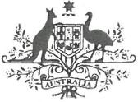
Commonwealth of Australia

Statement of reasons for granting an exemption under section 158 of the Environment protection and Biodiversity Conservation Act 1999 (Cth)
I, Murray Watt, Minister for the Environment and Water (the Minister), provide these reasons for my decision under section 158 of the Environment Protection and Biodiversity Conservation Act 1999 (Cth) (EPBC Act), to exempt Alcoa, and any persons acting on behalf of Alcoa, from the application of all of the provisions of Part 3 and Parts 7 through 9 of the EPBC Act, in relation to the following action:
Clearance of up to 1200 hectares of vegetation associated with Alcoa's mining operations at Huntly and Willowdale within the areas marked blue at Attachment A on ML1 SA to the extent necessary to maintain critical bauxite supply to Alcoa's two alumina refineries located in Pinjarra and Wagerup for a period of 18 months from the date of the exemption notice.

Definitions:
Alcoa means the Australian public company Alcoa of Australia Limited (ABN: 93004879298)
Clearance means the killing, destruction or removal of vegetation
Critical bauxite supply means the minimum supply of bauxite needed to maintain refining operations
MLISA means the area designated as MLISA at Attachment A

Background

The Huntly and Willowdale Mining Operations and the application of the EPBC Act
- Alcoa of Australia Limited (Alcoa) have been operating at the Huntly and Willowdale mining operations since 1963. Both mining operations relate to the mining of bauxite.
- Both mining operations are within the mining lease ML1SA, and are presently regulated through rolling five-year Mining Management Plans (MMPs), which are required under the Alumina Refinery Agreement Act 1961 (WA) (in relation to the Huntly mining operation) and the Alumina Refinery (Wagerup) Agreement Act 1978 (WA). The Western Australian Environmental Protection Authority are currently undertaking assessments and decision-making processes in relation to the operations,

and while this occurs a State Exemption Order is in place which permits Alcoa to continue the operations subject to an annual clearing limit of 800 ha and strict conditions relating to avoidance and mitigation measures with which Alcoa must comply.
3. As the Huntly and Willowdale mining operations commenced prior to the implementation of the EPBC Act, Alcoa has continued operations on the presumed basis that either s 43A or s 43B of the EPBC Act (as in force prior to 1 December 2025) (continuous use exemptions) applied, and therefore Alcoa did not need any approval under the EPBC Act to continue operations.
4. Since 2011, the department has taken the view that the continuous use exemptions did not apply to the Huntly and Willowdale mining operations, and has engaged with Alcoa regarding this. Alcoa took, and maintains, that the continuous use exemptions applied to the Huntly and Willowdale mining operations.
5. On 1 December 2025, amendments were made to the EPBC Act, including the continuous use provisions. In particular, s 43B now provides that the continuous use exemption does not apply to an action if:
- the action consists of or involves, clearing vegetation from land; and
- at the time the action is taken, the land has not been cleared of vegetation for a period of at least 15 years; and
- the action is not a forestry operation.
6. Alcoa now accepts that it requires EPBC Act approvals for the Huntly and Willowdale mining operations. Alcoa has submitted an application under Part 10 of the EPBC Act to undertake a strategic assessment of the impacts of actions or classes of actions to be taken to conduct mining operations and ancillary activities for the Huntly and Willowdale mines through to 2045. The Strategic Assessment includes the action subject of this request for an exemption but excludes the areas already contained within the existing referral EPBC 2022/09204, which is being assessed under an accredited assessment with the EPA Western Australia.
7. However, Alcoa states that, as a result of the amendments to the EPBC Act, it has not had an opportunity to assess its immediate clearing activities against Part 3 of the EPBC Act, and, critically, it is not possible to maintain ongoing supply of bauxite to its refineries at Pinjarra and Wagerup without clearing in advance of the mining.
Therefore, Alcoa is in the position of being unable to continue its operations.
8. It is against this context that, on 30 January 2026, Alcoa made an application for an exemption under s 158 of the EPBC Act. On 18 February 2026, I decided to grant the exemption for the reasons explained in this statement.

The Future Made in Australia National Interest Framework, Australia's Critical Mineral List and The Critical Minerals Framework Agreement

- On 14 May 2024, the Department of Treasury released the `Future Made in Australia: National Interest Framework' Discussion Paper. A part of the National Interest Framework referred to in the Discussion Paper was Critical Mineral Processing. The Paper explains that `A stable and diversified supply of critical minerals is critical to the smooth operation of global and domestic supply chains, including to support the net zero transformation, defence industries and a range of other applications.'
- Australia's Critical Mineral List is established to identify the importance of particular minerals to Australia's economy and national security. The Critical Minerals List states that it contains minerals that are:
- essential to our modern technologies, economies and national security, specifically the priority technologies set out in the Critical Minerals Strategy
- for which Australia has geological potential for resources
- , in demand from our strategic international partners
- that are vulnerable to supply chain disruption.
- Presently, there are 31 minerals identified on the Critical Mineral List.
- On 20 October 2025, the United States and Australian Governments signed a Critical Minerals Framework Agreement committing over $2 billion in joint investments to secure and diversify supplies of key minerals. The preamble to the Agreement notes that:
Whereas, rare earths and critical minerals are essential for the production of advanced technologies;
Whereas, the United States of America (the "United States" or "U.S.') and the Commonwealth of Australia ("Australia", and together, the "Participants') intend to support the supply of raw and processed critical minerals and rare earths crucial to the commercial and defence industries of the United States and Australia;
Whereas, the Participants plan to accomplish this through use of economic policy tools and coordinated investment to accelerate development of diversified, liquid, fair markets far critical minerals and rare earths;
Whereas, the Participants' objective is to assist both countries in achieving resilience and security of critical minerals and rare earths supply chains, including mining. separation, and processing;
Whereas, the Participants intend to capitalize on their respective existing domestic mining and processing operations in critical minerals and heavy and light rare earths as well as new capacity to be made available in 2026.
- Section 1 of the Agreement identifies the efforts of the participants to secure supply of critical minerals and rare earths and investing in mining and processing of those minerals.

14. Deputy Prime Minister and Minister for Defence Richard Mules and Minister for Foreign Affairs Penny Wong travelled to Washington DC for the Australia-United States Ministerial Consultations where they met with United States Secretary of War Pete Hegseth and United States Secretary of State Marco Rubio. A statement released after the consultations expressed that:
The Principals agreed on the importance of swift implementation of the Critical Minerals Framework. Following the announcement of joint investment with Japan in the project, they welcomed Alcoa's recent application for key Australian regulatory approvals needed to move expeditiously towards gallium production in 2026 to diversify a critical supply chain for the defense sector.

Bauxite and Gallium
15. Bauxite mining occurs across Australia, with the major mines located in Western Australia and Queensland. South 32 is a neighbouring bauxite mine to Alcoa in Western Australia, and the Weipa mine, operated by Rio Tinto, is located in Queensland. In relation to production:
- South 32 produced 16.81 million tonnes per annum (Mtpa) of bauxite in the 2025 financial year;
- Alcoa produced 27 Mtpa of bauxite in 2024; and
- Rio Tinto produces around 37 Mtpa of bauxite per year.
- Northern Territory produces 12.9 Mtpa from multiple mines.
16. Gallium is a byproduct from the processing of bauxite (aluminium ore) and zinc ores. It is one of the minerals identified on the Critical Mineral List. The Critical Mineral List records that Gallium is also identified as a critical mineral by other nations, including the United States, India, the European Union and the United Kingdom. Australia's geological potential for Gallium is rated as `high'.
17. A recent article' explains:
... gallium plays a critical role in key sectors such as electronics, clean energy, and communications. Its most notable uses include high-performance semiconductors, laser diodes, light-emitting diodes (LEDs), transistors, and solar photovoltaic (PV) cells. These applications are crucial to produce advanced electronic devices such as smart phones, computers, and high-efficiency renewable energy systems like solar panels and wind turbines.
18. Gallium is essential to advanced technology applications, including advanced semiconductor wafers essential to AI applications, LEDs, and high-performance magnets.
' Zuo, L. et al. (2025) Global and regional gallium recycling potential and opportunities: Based on historical material flow analysis, Sustainability 28(1):255, DO1:10.3390/su18010255

19. The demand for Gallium has increased, given the rapid shift towards clean energy, and is projected to increase by more than 200% compared to 2010 levels. Zuo et al state that (2026) ...global demand for gallium has grown exponentially, driven by electronic communication and emerging clean energy sectors, underscoring the urgency to address supply vulnerabilities.'
20: Although there are multiple bauxite mines in Australia, there is currently no operational gallium refinery. Rio Tinto have only just developed the technology to refine gallium at their Canadian site.
- Presently, bauxite is exported to either China or smaller refineries like those in Japan to refine into the gallium mineral. In 2023, 98% of global production of Gallium was produced by China. Alcoa currently export spent liquor as a raw material for gallium production but do not currently have a gallium refinery.
- Alcoa has entered a joint venture with the Japanese government and Sojitz corporation to develop a Gallium plant at the Wagerup refinery. This project, the `Western Australia Gallium Project' is proposed to produce 100 metric tonnes of Gallium per year, amounting to about 10% of the global supply.

National Interest Exemption
- On 30 January 2026, I received an application from Alcoa, which stated:
[Alcoa is] applying for an exemption under section 158(1) (Exemption) of the Environmental Protection and Biodiversity Conservation Act 1999 (Cth) (EPBC Act) from all of the provisions of Part 3 and all of Parts 7 through 9 of Chapter 4 of the EPBC Act in relation to the action as described in section 4, paragraph 22 of the attached submission (Submission). The 18-month Exemption requested will enable business continuity of [Alcoa 's] alumina refining operations, while the strategic assessment is undertaken and continued advancement of its nationally and internationally significant critical minerals gallium project.
- The exemption was articulated as follows:
Pursuant to section 158(1) of the EPBC, [Alcoa] is applying for an exemption from all of the provisions of Part 3 and all of Parts 7 through 9 of Chapter 4 of the EPBC Act in relation to the following action, to the extent the action is a controlled action for the purposes of section 67:
- Limited clearing on MLISA.
- Limited clearing on MLISA means clearing:
(I) Associated with Alcoa’s operations at the Huntly and Willowdale mining operations;
- of no more than 800 hectares per annum for a total of 1200 hectares of clearing, or the period of the exemption;
- undertaken in accordance with [Alcoa's]Mining Management Program as annually approved by the Western Australian Minister for State

Development, including any associated Ministerial approval conditions, and the Environmental Protection (Darling Range Bauxite Mining Proposals) Exemption Order 2023;
- that the residual adverse impacts of will be compensated by an offset in accordance with the EPBC Act Environmental Offsets Policy dated October 2012; and
- undertaken from the date the exemption takes effect until the date that is 18 months later.
- In short, Alcoa is seeking a national interest exemption under s 158 of the EPBC Act to clear up to 1,200 hectares of vegetation on ML I SA associated with the Huntly and Willowdale mining operation (action). The clearing (of up to 1,200 ha over the term of the proposed exemption) was to enable the Project to progress. That is, the action is required for the purposes of the Project remaining viable.
- I adopt the department's summary of the reasons Alcoa stated I should grant a national interest exemption, namely that the exemption is in the national interest and should be granted to:
- avoid unintended consequences of amendments to the EPBC Act — Alcoa cannot maintain ongoing supply of bauxite without clearing, and if ongoing supply cannot be maintained this will impact future production of Gallium. Due to the rapid introduction of the amendments, Alcoa has not been able to assess whether the action has, will have, or is likely to have, a significant impact on a protected matter;
- no impediment to the exercise of rights and discharge of obligations of the Australian government as contemplated in its agreement with Alcoa and the United States government in respect to the Project - Gallium production is critical to Australia's national security, and the continued development and viability of the Project is dependent on Alcoa's ability to provide spent liquor as a raw material for Gallium production. This depends on the financial sustainability of Alcoa's operations which will be materially impacted by the ceasing operations while the EPBC Act approval process is undertaken. This risks impeding the ability of the Australian Government to meet the expectations and obligations it has entered into with the United States and Japan, and impacting the bilateral relations between the governments;
- provide legal certainty for the ongoing conduct of Alcoa's operations which make a significant contribution to the Australian economy and the supply chain for strategically important materials for Australia — the Huntly and Willowdale operations employ 6,000 persons and Alcoa contributes a significant amount to the economy through its operations.

- In addition to the undertaking regarding the strategic assessment, Alcoa also stated that offsets for any operations covered by the exemption will be offset, and an amount of approximately $4.2 million has been `earmarked".

Materials Considered
- In making my decision, I have considered the information that was provided in my brief prepared by the department dated 12 February 2026, including each of its attachments.

Issue
- Under s 158(1), a person proposing to take a controlled action, or the designated proponent of an action, may apply in writing to the Minister for an exemption from a specified provision of Part 3 or of this Chapter. I accept that the application dated 30 January 2026 is an application for the purposes of s 158(1).
- The issue before me is whether I should exempt Alcoa from Part 3 and Parts 7-9 of the EPBC Act in relation to the action. I can only grant an exemption if I am satisfied that it is in the national interest to do so.
- The `national interest' is not defined in the EPBC Act. Sub-section 158(5) states that in determining the national interest, I may consider Australia's defence or security or a national emergency. The concept of the national interest is broad, though not unbounded, and largely a political question. Ultimately, I must be satisfied that some identified aspect of the national interest will be served, advanced or promoted by the granting of the exemption of the action from particular Part 3 and Parts 7-9 of the EPBC Act.

Findings and Reasons:
- I note that Gallium is identified on the Critical Mineral List, and that minerals on that list are included for the reasons set out at [10] above. The Future Made in Australia National Interest Framework also emphasises the importance of critical mineral processing, stating:
A stable and diversified supply of critical minerals is critical to the smooth operation of global and domestic supply chains, including to support the net zero transformation, defence industries and a range of other applications. However, currently:
- Global supply is highly concentrated and vulnerable to disruption;
- There is limited capacity for the industry to quickly adapt and respond to any shock; and
- The consequences of a serious supply disruption would be significant.
Critical minerals are important to the economic resilience and security of countries because they enable a range of technologies required for the basic functioning of a modern society, including defence and communications technologies. The global race to secure supplies of critical minerals is accelerating rapidly.

Critical mineral supply chains are also prone to disruption because mineral production and processing is heavily concentrated in particular locations, facilities or companies. Supply chains that are highly concentrated, are typically fragile, volatile and lack transparency...
33. Alcoa explains that the continued development and viability of the Project is dependent
on Alcoa's ability to provide spent liquor as a raw material for Gallium production. Alcoa's ability to provide spent liquor depends on the financial sustainability of Alcoa's operations in Australia, including the Huntly and Willowdale mining operations, both of which will be materially impacted without an exemption.
34. I accept that:
- the action is to enable a Project that has been endorsed by both the United States and Japanese governments, to enable processing of Gallium within Australia; and
- commitments have been made by the Australian and US Governments to the Project in terms of funding and equity, and an agreement reached between Alcoa and Sojitz.
35. I am satisfied that granting the exemption would be in the national interest because it
will enable mining operations to continue so as to preserve the viability of the Project which will enable the production and processing of Gallium. Gallium is used in defence and renewable energy sectors, and local production will enable diversification from the current concentrated nature of global supply, and will further the nation's interests, as reflected.in the Agreement and in the Future Made in Australia National Interest Framework.
36. As noted above, China accounts for 98% of Gallium production. The Project presently
represents the most viable path to the establishment of domestic Gallium processing in the near future, noting that there is presently no operational Gallium refinery in Australia and there is no indication that any other bauxite mining operators intend to establish such processing capability. Granting an exemption will serve and promote the national interest in establishing a stable and diversified supply of critical minerals to support the net zero transformation and defence industries. In this regard:
- as noted above, the United States and Australian governments recently endorsed the importance of progressing expeditiously towards gallium production in 2026 to diversify a critical supply chain for the defence sector; and
- Gallium is used in high-efficiency renewable energy systems like solar panels and wind turbines, with renewable energy a key part of the national priorities relating to net zero.
37. 1 note the commitment and support of both the United States Government and Japanese
Governments to the Project. The United States has committed equity to the Project, and the Japanese Government is funding Sojitz involvement. I accept if Alcoa is unable to

take the action its ability to undertake the Project may be significantly hampered. With this, there is some possibility that relations with the United States and Japanese governments may be impacted.
- While 1 accept that the Agreement and the investment of the Japanese Government do not override the processes or requirements of the EPBC Act, I am nevertheless satisfied that it is in the national interest to provide a time-limited exemption for the action from all of the provisions of Part 3 all of Parts 7 through 9 of the EPBC Act. An exemption will promote not only the national interest in developing an independent supply of a critical mineral, but reinforcing and giving confidence to both the United States and Japanese Governments as to Australia's commitment to the Framework. Providing a time-limited exemption to Alcoa would ensure that it can sustain its operations and its financial viability while the action is subject to assessment under the EPBC Act.
- Finally, Alcoa have agreed to voluntarily compensate for any residual significant impacts associated with the action (i.e. the clearing undertaken under the exemption), in accordance with the EPBC Act Environmental Offsets Policy dated 2012. An amount of $4.2 million has been reserved already by Alcoa. The voluntary offset will compensate for significant impacts (if any) as a result of the action and gives me assurance that Alcoa is committed to maintaining a positive environmental benefit. I agree with the department that, being satisfied that it is in the national interest to grant the exemption I should exercise my discretion to grant an exemption.
- Separately, I accept that the grant of an exemption (which is to allow continuity of operations both operationally and financially), will keep a workforce of approximately 6,000 persons employed. Based on the figures Alcoa have provided, just under 90% of those persons are employed in Western Australia. The geographical location of the employees reflects the fact that Alcoa's operations (and bauxite mining generally) are largely undertaken in Western Australia, with the exception of operation of alumina smelting in Portland, Victoria. The potential that such a significant number of persons may be immediately impacted over both WA and Victoria if an exemption is not granted highlights the importance of and national interest in maintaining operations while the assessment process under the EPBC Act is undertaken (such process estimated to be between 12-18 months in length).
- I note that the department has advised Alcoa since 2011 that Alcoa does not have exemptions under s 43A and s 43B of the EPBC Act and therefore I do not agree with Alcoa's reasoning that the amendments that came into effect on 1 December 2025 have the effect of removing an existing exemption, nor justifies the granting of the exemption.
As noted above, I have considered the period for which the exemption should be given. Alcoa has requested an exemption for 18 months though it has also said 24 months would provide the best opportunity to sustain operations. The department considers, and I agree, that an 18-month exemption would align with Alcoa undertaking a strategic assessment under Part 10 of the Act and me, or a delegate, considering and making a decision as to whether approve the taking of the proposed action the subject of the strategic assessment process. I am satisfied that an exemption for 18 months from the date of my decision to be reasonable and appropriate.

Decision
43. For the reasons given above, I have decided to grant a national interest exemption to Alcoa under s 158(3) of the EPBC Act, and the exemption is to be in effect for 18-months following the date of my decision. The terms of the exemption are as in the notice I signed on [date].

Minister for the Environment and Water
[Date]

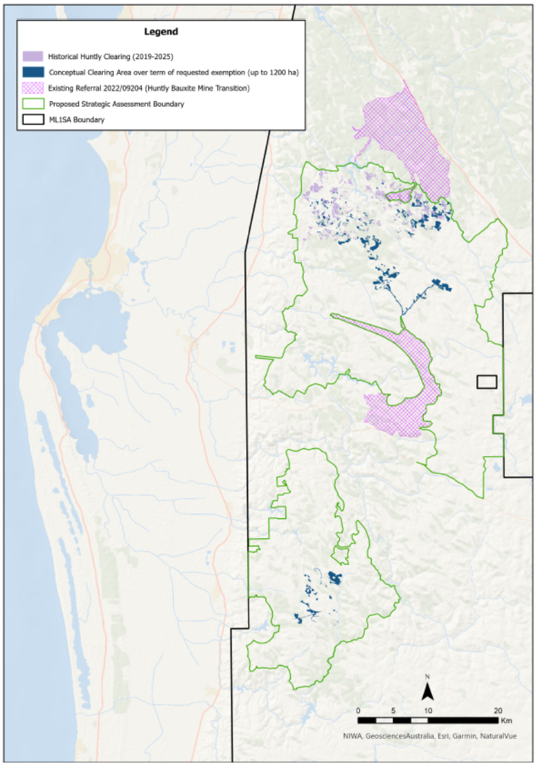
Attachment A: The location of Alcoa's mineral lease ML1SA and geographic limit of clearing associated with the exemption.

