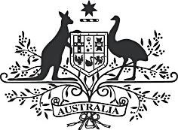

Commonwealth of Australia

Statement of reasons for granting an exemption under section 158 of the
Environment Protection and Biodiversity Conservation Act 1999 (Cth)
I, Tanya Plibersek, Minister for the Environment and Water, provide these reasons for my decision under section 158 of the Environment Protection and Biodiversity Conservation Act 1999 (Cth) (EPBC Act), to grant an exemption to the State of Victoria, the agencies of the State and those acting on behalf of the State of Victoria or the agencies of the State, from the application of all of the provisions of Part 3 (other than sections 21, 22A, 24B, 24C, 24D, 24E, 27B and 27C) of the EPBC Act, in relation to the following action:
The taking of firefighting activities, fire prevention activities and fire recovery activities in Victoria in response to bushfires during the 2024-2025 bushfire season.

Definitions:
Firefighting activities means emergency actions taken to prevent bushfires damaging life, property or matters of national environmental significance.

Fire prevention activities means urgent preventative actions taken to prevent the spread or reduce the severity of fires. This includes back burning, clearance of vegetation and building of fire breaks.

Fire recovery activities means urgent actions taken in the recovery from damage from bushfires. This includes clearance of vegetation that has been damaged as a result of bushfires, and urgent repair or replacement of essential infrastructure damaged by bushfire.

agencies of the State has the meaning given by section 528 of the EPBC Act.

Legislation
Section 158 of the EPBC Act provides:

158 Exemptions from Part 3 and this Chapter
- A person proposing to take a controlled action, or the designated proponent of an action, may apply in writing to the Minister for an exemption from a specified provision of Part 3 or of this Chapter.
- The Minister must decide within 20 business days of receiving the application

whether or not to grant the exemption.
- The Minister may, by written notice, exempt a specified person from the application of a specified provision of Part 3 or of this Chapter in relation to a specified action.
- The Minister may do so only if he or she is satisfied that it is in the national interest that the provision does not apply in relation to the person or the action.
- In determining the national interest, the Minister may consider Australia’s defence or security or a national emergency. This does not limit the matters the Minister may consider.
- A provision specified in the notice does not apply in relation to the specified person or action on or after the day specified in the notice. The Minister must not specify a day earlier than the day the notice is made.
- Within 10 business days after making the notice, the Minister must:
  - publish a copy of the notice and his or her reasons for granting the exemption in accordance with the regulations; and
  - give a copy of the notice to the person specified in the notice.

Background
- On 24 December 2024, the Hon. Ros Spencer MP, the acting Victorian Minister for Environment, made an application on behalf of the Victorian Government, to seek an exemption under section 158 of the EPBC Act to undertake emergency works and recovery actions associated with bushfires in Victoria for the 2024-2025 bushfire season.
- The Victorian Government sought an exemption for the State of Victoria and those acting on behalf of the State of Victoria from the application of relevant provisions of Part 3 of the EPBC Act.
- The action includes all activities being taken in response to current bushfires in Victoria, including clearance of vegetation, construction of fire breaks, planned burns, back burning, and ensuring the provision of essential services.

Evidence
- The evidence or other material on which my findings were based was a brief from my department dated 24 December 2024, including its attachments (the departmental brief).

Findings
- In their application for an exemption, the Victorian government noted that:
  - Victoria was currently experiencing severe bushfire activity in locations across the State following hot and dry conditions throughout December 2024.

  - As of 22 December 2024, there were multiple major fires across Victoria, including at the Grampians National Park, the Gurdies and Bullengarook.
  - The Grampians National Park fire was over 40,000 hectares in size, threatening local communities and critical infrastructure.
  - The area impacted by bushfires was predicted to increase, with greatly elevated fire weather conditions projected for 25-27 December 2024.
- In their application for an exemption, the Victorian government included:
  - A detailed summary which outlined the Victorian bushfire situation as at 22 December 2024.
  - A map showing the location of fires as at 22 December 2024.

Reasons
- Under subsection 158(4), I may grant an exemption if I am satisfied that it is in the national interest to do so. Subsection 158(5) states that in determining the national interest, I may consider Australia’s defence or security or a national emergency.
- I considered that there are some circumstances where emergency bushfire activities may have a significant impact on nationally protected matters and which would normally require approval under the EPBC Act. This could include, for example:
  - the clearing of new fire breaks through an area where nationally-protected threatened species are known to occur; or
  - fire prevention activities that affect migratory species, Ramsar wetlands or the environment on Commonwealth land.
- I was aware that I could grant the exemption if I was satisfied that it is in the national interest that the specified provisions do not apply in relation to the person or the action; and that granting an exemption would allow the person to take the action without it being assessed and approved under the EPBC Act.
- I understood that:
  - under subsection 158(5) of the EPBC Act, in determining the national interest, I may consider Australia’s defence or security or a national emergency; and
  - subsection 158(5) does not limit the matters I may consider in determining the national interest.
- I considered that the current bushfire in Victoria constituted a significant state emergency situation.
- I considered that the exemption would enable bushfire preparation, response and recovery activities to be undertaken by the State to respond in a timely way to the threat of bushfires for the 2024-25 bushfire season. The application of the normal assessment and approval requirements of Part 3 of the EPBC Act could hinder the

critical bushfire preparation, response and recovery actions due to the time it would take to undertake the normal EPBC assessments and approvals.
- I decided to grant the exemption under subsection 158(3) because I was satisfied that given the national emergency arising from the bushfires it was in the national interest that all of the provisions of Part 3 (other than sections 21, 22A, 24B, 24C, 24D, 24E, 27B and 27C) of the EPBC Act not apply in relation to the action described above.
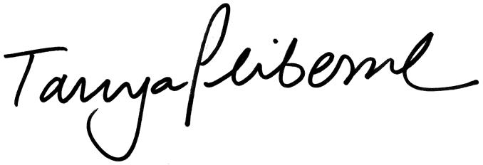

Minister for the Environment and Water
25 December 2024

