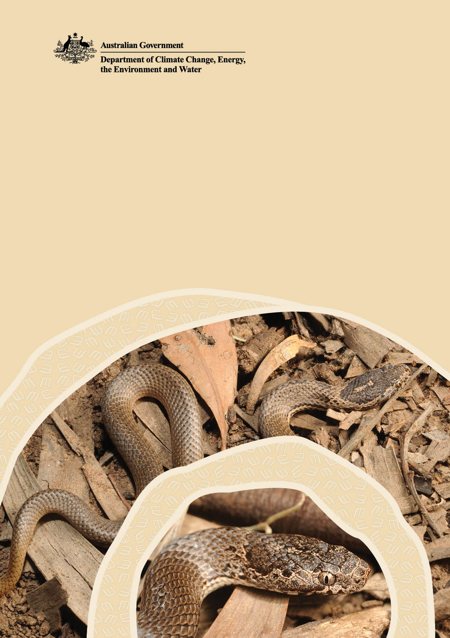

Survey guidelines for the ornamental snake (Denisonia maculata)

© Commonwealth of Australia 2025
Ownership of intellectual property rights
Unless otherwise noted, copyright (and any other intellectual property rights) in this publication is owned by the Commonwealth of Australia (referred to as the Commonwealth).
Creative Commons licence
All material in this publication is licensed under a Creative Commons Attribution 4.0 International Licence except content supplied by third parties, logos and the Commonwealth Coat of Arms.
Inquiries about the licence and any use of this document should be submitted via our online contact form.

Cataloguing data
This publication (and any material sourced from it) should be attributed as: DCCEEW 2025, Survey guidelines for the ornamental snake (Denisonia maculata), Department of Climate Change, Energy, the Environment and Water, Canberra.
CC BY 4.0.
This publication is available at dcceew.gov.au/publications
Department of Climate Change, Energy, the Environment and Water
GPO Box 3090 Canberra ACT 2601
Telephone 1800 920 528
Web dcceew.gov.au
Disclaimer
The Australian Government acting through the Department of Climate Change, Energy, the Environment and Water has exercised due care and skill in preparing and compiling the information and data in this publication. Notwithstanding, the Department of Climate Change, Energy, the Environment and Water, its employees and advisers disclaim all liability, including liability for negligence and for any loss, damage, injury, expense or cost incurred by any person as a result of accessing, using or relying on any of the information or data in this publication to the maximum extent permitted by law.
Acknowledgements
The Department of Climate Change, Energy, the Environment and Water would like to acknowledge those who contributed to the development of the Survey guidelines for the ornamental snake (Denisonia maculata). These guidelines are based on the draft written by Chris Pavey, Eric Vanderduys and Stewart Macdonald from the Commonwealth Scientific and Industrial Research Organisation (CSIRO). Damian Lettoof, Jordan de Jong, and Bruce Murray supported this work through participating in fieldwork. Craig Thornton and Amanda Elledge provided assistance and support while at the Brigalow Catchment Study area. We are grateful to the large number of experts across industry, the scientific research community, Commonwealth, State and Territory government agencies who provided their knowledge and experience in development of the guidelines.
Front cover images
Ornamental snake (Denisonia maculata) © Eric Vanderduys.
Acknowledgement of Country
We acknowledge the Traditional Owners of Country throughout Australia and recognise their continuing connection to land, waters and culture. We pay our respects to their Elders past and present.
Contents
Introduction 1
Species information 2
Diet 2
Habitat 4
Associated regional ecosystems 4
Survey guidelines 7
Seasonal and timing considerations 7
Survey approaches 7
Suitably qualified ecologist 8
Survey design 8
Calculating survey area 9
Survey effort 9
Collection of survey data 10
Glossary 12
References 12

List of Figures
Figure 1. Ornamental snake (Denisonia maculata) observed in Theodore, Queensland. 1
Figure 2. Ornamental snake (Denisonia maculata) observed in Charters Towers, Queensland. 1
Figure 3. Conceptual model of ornamental snake and gilgai interactions throughout a yearly cycle of seasons. 3

List of Tables
Table 1. Regional ecosystems (REs) where ornamental snakes have been recorded. 5
Table 2. Limitations of alternative survey approaches. 8
Table 3. Guide to search effort relative to habitat size within a site. 9
Table 4. Ornamental snake survey guidelines summary. 11

Introduction
This document provides best-practice methods for maximising the potential to detect the ornamental snake. Surveys help us learn more about the occurrence and ecology of the ornamental snake. Survey findings help inform land management, conservation and project planning. This survey method should be used for projects being referred to the Department of Climate Change, Energy, the Environment and Water, under the Environment Protection and Biodiversity Conservation Act 1999 (EPBC Act).
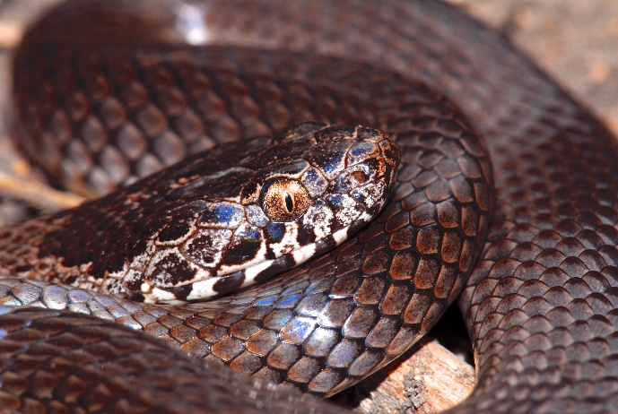
Figure 1. Ornamental snake (Denisonia maculata) observed in Theodore, Queensland. © Stewart Macdonald
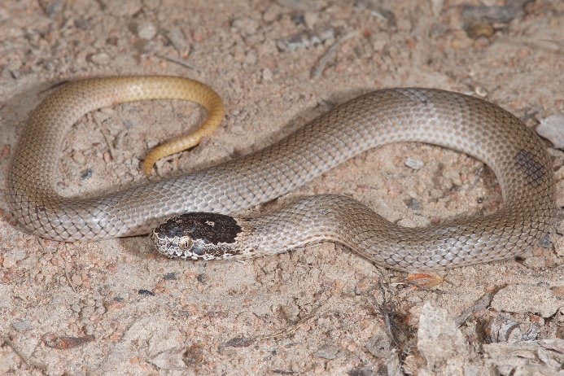
Figure 2. Ornamental snake (Denisonia maculata) observed in Charters Towers, Queensland. © Stewart Macdonald

Species information
The ornamental snake (Denisonia maculata) is a small, mildly venomous, nocturnal species of snake. The ornamental snake is found in central Queensland, from about Charters Towers in the north, to Theodore in the south. The ornamental snake is listed as Vulnerable under the Commonwealth Environment Protection and Biodiversity Conservation Act 1999 (EPBC Act) and the Queensland Nature Conservation Act 1992.
The ornamental snake grows to about 40cm in length and mainly eats frogs. They live in low-lying areas characterised by cracking clay soils.
The ornamental snake is adapted to cracking clay soils that shrink and swell each year, creating ephemeral wetlands. The soils where ornamental snakes are mostly found consist predominantly of vertosols with gilgai microrelief (shelter within cracked soil). These soils respond to the wet-dry cycle by shrinking when dry and swelling when wet.
The ornamental snake uses soil cracks for shelter during the cool, dry season and forages for frogs that breed in shallow, ponded water in gilgai depressions during the warm, wet season. This annual cycle of activity is visually described in Figure 3 below.

Diet
Ornamental snakes rely on frogs as the primary component of their diet. They eat various frog species, including:
- green tree frog (Litoria caerulea)
- eastern sedgefrog (Litoria fallax)
- broad-palmed frog (Litoria latopalmata)
- spotted marsh frog (Limnodynastes tasmaniensis)
- ornate burrowing frog (Platyplectrum ornatum)
- striped burrowing frog (Cyclorana alboguttata)
- short-footed frog (Cyclorana breviceps)
Other frog species present onsite may also be subject to predation by ornamental snakes.

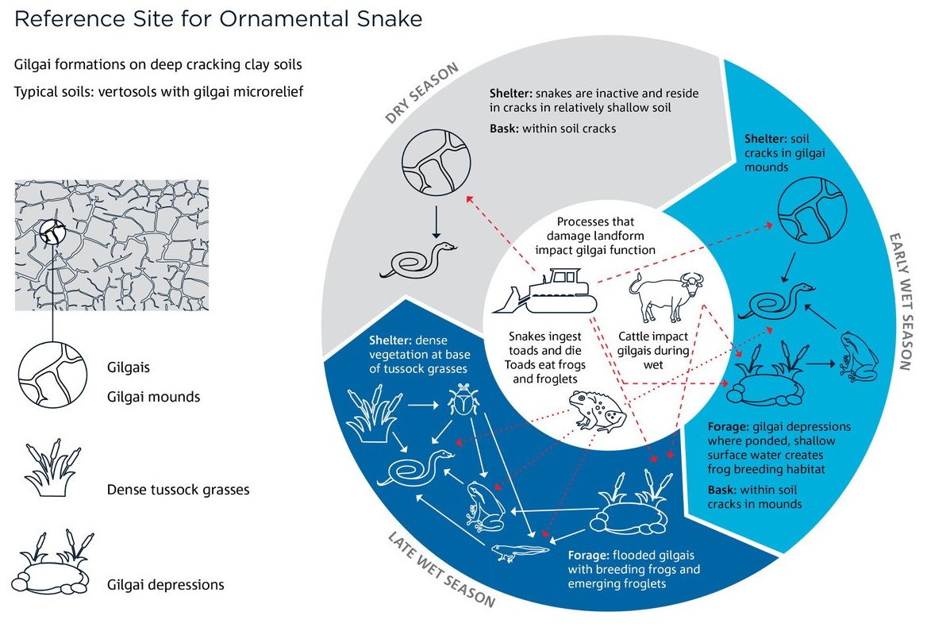

Figure 3. Conceptual model of ornamental snake and gilgai interactions throughout a yearly cycle of seasons.

In Figure 3, red dashed arrows represent threats to the ornamental snake and their interactions within the environment.

Habitat
Ornamental snakes are typically found in the Brigalow Belt bioregion, but they can also be found in the Desert Uplands bioregion. They are found in the Burdekin River and Fitzroy River drainage basins, along with some smaller basins on the coast, for example, the Styx River basin near Rockhampton. Ornamental snakes can be found in high numbers within their habitat (Swan and Wilson, 2012; Wilson and Swan, 2017).
Ornamental snakes typically live in gilgai formations on deep cracking clay soils and the intervening ground, including raised mounds. There is a strong association with clay soils, where the numbers of snakes observed were considerably less in different soil types (Wilson and Swan 2017).
Ornamental snakes have been recorded in woodlands and forests dominated by: brigalow (Acacia harpophylla), Dawson gum (Eucalyptus cambageana), forest red gum (E. tereticornis), bimble box (E. populnea), red gum (E. camaldulensis), silver-leaved ironbark (E. melanophloia), popular gum (E. platyphylla), carbeen (Corymbia tessellaris), long-fruited bloodwood (C. clarksoniana), and rough-barked apple (Angophora floribunda).
Ornamental snake habitat may include the grasses: forest bluegrass (Bothriochloa bladhii subsp. Bladhii), wind-grasses (Aristida spp.), black speargrass (Heteropogon contortus), bluegrasses (Dichanthium spp.), kangaroo grass (Themeda triandra), white speargrass (Aristida leptopoda), feathertop wiregrass (A. latifolia), Curly Mitchell grass (Astrebla lappacea), satintop grass (Bothriochloa erianthoides), cotton panic grass (Digitaria brownii), umbrella grass (D. divaricatissima), spring grass (Eriochloa crebra), stargrass (Panicum decompositum), yadbila grass (P. queenslandicum), and sago grass (Paspalidium globoideum).

Associated regional ecosystems
The Queensland regional ecosystem (RE) classification assigns a 3-part code to describe ecosystems. The 3 parts of this code reflect the:
- bioregion
- land zone
- vegetation community
Ornamental snakes are typically observed within the Brigalow Belt (11) and Desert Uplands (10) bioregions. Within these bioregions, the snakes mainly occur in the following land zones:
- land zone 3: alluvial river and creek flats
- land zone 4: clay plains
- land zone 5: old loamy and sandy plains
Records of ornamental snakes from other land zones have been very close (within 5 km) to one of these 3 land zones.
Ornamental snakes have been recorded from the regional ecosystems listed in Table 1, below. The majority of these records are from ecosystems on clay plains, specifically RE 11.4.9, 11.4.8, 11.5.3, 11.4.11, 11.3.2, and 11.3.1. These regional ecosystems are most likely to provide habitat for the ornamental snake.
Table 1. Regional ecosystems (REs) where ornamental snakes have been recorded.
RE | Description
10.3.4 | Acacia cambagei low open woodland to low woodland on alluvial plains
10.3.5 | Eucalyptus cambageana woodland to open woodland on broad stream beds
10.3.6 | Eucalyptus brownii woodland on alluvial plains
10.4.2 | Acacia harpophylla low woodland on Cainozoic lake beds (subregion 3)
10.4.5 | Acacia cambagei woodland on Cainozoic clay plains
10.5.5 | Eucalyptus melanophloia woodland to open woodland on sand plains
11.3.1 | Acacia harpophylla and/or Casuarina cristata open forest on alluvial plains
11.3.2 | Eucalyptus populnea woodland on alluvial plains
11.3.3 | Eucalyptus coolabah woodland on alluvial plains
11.3.4 | Eucalyptus tereticornis and/or Eucalyptus spp. woodland on alluvial plains
11.3.5 | Acacia cambagei low woodland on alluvial plains
11.3.7 | Corymbia spp. open woodland on alluvial plains
11.3.8 | Acacia argyrodendron woodland on alluvial plains
11.3.25 | Eucalyptus tereticornis or E. camaldulensis woodland fringing drainage lines
11.4.2 | Eucalyptus spp. and/or Corymbia spp. grassy or shrubby woodland on Cainozoic clay plains
11.4.4 | Dichanthium spp., Astrebla spp. grassland on Cainozoic clay plains
11.4.6 | Acacia cambagei woodland on Cainozoic clay plains
11.4.8 | Eucalyptus cambageana woodland to open forest with Acacia harpophylla or A. argyrodendron on Cainozoic clay plains
11.4.9 | Acacia harpophylla shrubby woodland with Terminalia oblongata on Cainozoic clay plains
11.4.11 | Dichanthium sericeum and Astrebla spp. grassland with patchy Acacia harpophylla or Eucalyptus coolabah on Cainozoic clay plains
11.5.2 | Eucalyptus crebra, Corymbia spp., with E. moluccana woodland on lower slopes of Cainozoic sand plains and/or remnant surfaces
11.5.3 | Eucalyptus populnea +/- E. melanophloia +/- Corymbia clarksoniana woodland on Cainozoic sand plains and/or remnant surfaces
11.5.15 | Semi-evergreen vine thicket on Cainozoic sand plains and/or remnant surfaces
11.7.2 | Acacia spp. woodland on Cainozoic lateritic duricrust. Scarp retreat zone
11.8.4 | Eucalyptus melanophloia woodland to open woodland on Cainozoic igneous rocks.
11.8.5 | Eucalyptus orgadophila open woodland on Cainozoic igneous rocks
11.8.11 | Dichanthium sericeum grassland on Cainozoic igneous rocks
11.9.1 | Acacia harpophylla-Eucalyptus cambageana woodland to open forest on fine-grained sedimentary rocks
11.9.2 | Eucalyptus melanophloia +/- E. orgadophila woodland to open woodland on fine-grained sedimentary rocks
11.9.5 | Acacia harpophylla and/or Casuarina cristata open forest to woodland on fine-grained sedimentary rocks
11.10.3 | Acacia shirleyi or A. catenulata open forest on coarse-grained sedimentary rocks. Crests and scarps
11.11.1 | Eucalyptus crebra +/- Acacia rhodoxylon woodland on old sedimentary rocks with varying degrees of metamorphism and folding
11.11.4 | Eucalyptus crebra woodland on old sedimentary rocks with varying degrees of metamorphism and folding. Coastal ranges
11.11.10 | Eucalyptus melanophloia woodland on deformed and metamorphosed sediments and interbedded volcanics
11.11.13 | Acacia harpophylla or A. argyrodendron low open forest with a secondary tree layer of Terminalia oblongata on deformed and metamorphosed sediments and interbedded volcanics
11.11.15 | Eucalyptus crebra woodland to open woodland on deformed and metamorphosed sediments and interbedded volcanics
11.12.1 | Eucalyptus crebra woodland on igneous rocks

See the Queensland Government’s website for more information on the RE classification system (https://www.qld.gov.au/environment/plants-animals/plants/ecosystems).

Survey guidelines

Seasonal and timing considerations
Ornamental snakes are largely inactive during the cool, dry season when their prey (frogs) is also inactive. They typically capture frogs at their breeding sites around the edge of ephemeral wetlands. Radio-tracking has demonstrated that individuals move only short distances from their daytime shelters when foraging at night.
Surveys should be undertaken within in the early to late wet season following wetland-filling rainfall, from the start of November to the end of March. This is the period that frogs are most active. Snake activity declines with temperature. This decline in activity reduces the detectability of the snakes.
Early in the wet season, the ideal survey timing is within 5 days of significant rainfall (>10 mm). Later in the wet season, frogs may not be as vocal but will be present with froglets emerging onto land.
Indicators of suitable survey conditions include the presence of:
- surface water
- frogs
- other snakes
- other reptiles

Survey approaches
Spotlight searches, on foot, are the best method for detecting ornamental snakes. These spotlight searches involve each observer walking throughout an area, passively searching for snakes that are active on the surface. This method targets the snakes when they are actively foraging in and around wetlands.
Spotlight surveys should begin shortly after last light and involve at least two observers. Each observer should use bright headtorches and walk slowly through areas that may provide habitat for the ornamental snake, carefully scanning the ground for snakes. All habitat components, including soil cracks, wetlands (especially with frogs present), grass tussocks and vegetation in and around water, should be thoroughly scanned. Shallow, ephemeral wetlands (primarily gilgai formations) and nearby surrounds should be the focus during the surveys.
Observers should not intentionally disturb habitat components, for example, by lifting logs or stripping bark.
The walking speed of the observer will depend on the environment. More time is required to complete a thorough search of structurally complex areas, for example, areas with dense grass and debris.
At sites with little cover, a thorough search of the area can be conducted at a faster walking speed. More time should be spent searching in areas with a high amount of cover (e.g. grass, debris) and therefore the walking speed will be slower.
Alternative survey approaches are not recommended for detecting the ornamental snake. Limitations of alternative survey approaches are discussed in Table 2, below.
Table 2. Limitations of alternative survey approaches.
Alternative survey approach | Limitation
active diurnal (daytime) searches | During the day, snakes are most likely to be in soil cracks that are not possible to target during active diurnal searches.
nocturnal vehicle drive transects | Drive transects will rarely encounter ornamental snakes. This is due to limited instances of wetland habitat intersecting with roads.
pitfall and funnel trapping with drift fences | Wetland habitat is very difficult to effectively trap and set drift fences in.

Suitably qualified ecologist
A person undertaking a search (an ‘observer’) should be a suitably qualified ecologist. This means that they can give an authoritative assessment and advice on the presence of ornamental snake.

Survey design
Searches should cover multiple 5-hectare (ha) plots. The number of plots should be relative to the extent of habitat within the target area.
To ensure searches are as effective as possible, two key factors should be used to inform the position and shape of plots within the survey area:
- the occurrence of water in ephemeral wetlands
- thorough coverage of habitat within the target area
The number of plots should be relative to the extent of habitat within the survey area. Table 3 suggests the minimum number of search areas relative to the extent of habitat within a target area.
Table 3. Guide to search effort relative to habitat size within a site.
Extent of habitat | Suggested minimum search effort
0-10 hectares (ha) | Search entire area.
10-20 | At least 2 x 5-ha plots.
20-50 ha | At least 3 x 5-ha plots.
50-100 ha | At least 4 x 5-ha plots.
100-500 ha | At least 6 x 5-ha plots.
500-1000 ha | At least 10 x 5-ha plots.
More than 1000 ha | At least 10 x 5-ha plots per 1000 ha.

Calculating survey area
For a pre-determined survey area, GIS software should be used to plan the location of search areas within the survey area.
For all searches, each observer should use a GPS device to record their search path. The record of each search path should be included in survey documentation.

Survey effort
Within habitat during ideal conditions, the minimum search effort recommended for night-time spotlight searches is 240 minutes per 5 ha. This means that the recommended time for each 5-ha plot is 240 minutes (4 hours).
These 240 minutes are person minutes. For example, two people can cover a search area for 120 minutes each to achieve the total of 240 minutes (2 x 120 minutes) so long as the two people don’t interact (i.e. overlap) with one another.
If no snakes are detected during the first evening of searching, the search should be repeated an additional time. Where conditions are ideal, this can be done in the following night/s. When the conditions are not ideal (lack of water and frogs), the additional survey should be delayed until conditions improve. All surveys should be completed during conditions that optimise the potential for detecting an ornamental snake, if present.
If spotlight surveys as outlined in these guidelines cannot be undertaken in areas of potential habitat, it should be assumed that the ornamental snake is present and abundant at the location.

Collection of survey data
All ornamental snakes observed should be identified, photographed and geo-located using a GPS system. This information, and the type of habitat where ornamental snakes were recorded, must be stored and provided on request to inform an environmental assessment under the EPBC Act.

Survey checklist
Table 4. Ornamental snake survey guidelines summary. Minimum survey effort per 5 ha of suitable habitat in the wet season
Survey components | Minimum effort
night-time spotlight searches in ornamental snake habitat | Searches should be undertaken:  - within 5 days of significant rainfall (>10 mm)  - in the wet season  - across multiple 5-ha plots  Observers should:  - be a suitably qualified ecologist  - use a bright headtorch  Searches should investigate all suitable habitat features, including:  - soil cracks  - wetlands (especially with frogs present)  - dense tussock grasses  - vegetation in and around water
record details | All ornamental snakes observed should be identified, photographed and geo-located using a GPS system.  Survey documentation should include:  - snake observation information  - a description of the type of habitat where the ornamental snakes were recorded (including RE type and microhabitat features).

Glossary
The following definitions are intended for interpretation of these survey guidelines.
Term | Definition
ephemeral wetland | A seasonally-inundated wetland that dries out during the dry season.
gilgai (or ‘gilgai microrelief’) | Repeated hummocky mounds and depressions associated with vertosols.
search area | The area within a survey area where ornamental snake detection surveys are undertaken. A search area is typically comprised of one or more 5-ha plots.
suitably qualified ecologist  (for the purpose of undertaking environmental surveys) | A person who has relevant professional qualifications and at least three years of work experience designing and implementing surveys for ornamental snake and can give an authoritative assessment and advice on the presence of ornamental snake using relevant protocols, standards, methods and/or literature.
target area | The area of land or waters that are the subject of a survey.
vertosols | Clay soils with shrink-swell properties that exhibit strong cracking when dry.

References
Swan, G and Wilson, S, 2012. The results of fauna recovery from a gas pipeline trench, and a comparison with previously published reports. Australian Zoologist, 36(2), 129-136.
Wilson, S and Swan, G, 2017. The ornamental snake (Denisonia maculata): notes on habitat and population density of a vulnerable elapid snake. Herpetofauna, 44, 8-14.

