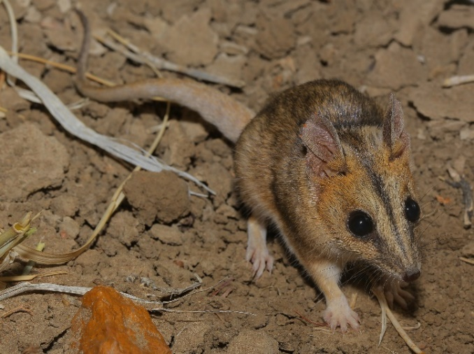
Julia Creek dunnart Sminthopsis douglasi
Targeted species survey guidelines
Photo by P.A. Woolley & D. Walsh
Vulnerable (Nature Conservation Act 1992) | Queensland Herbarium & Biodiversity Science

Identification
This cryptic dasyurid is the largest of the dunnarts (genus Sminthopsis) at 110-135 mm head-body length and up to 70 g in weight (males are larger than females). It has a conspicuous, dark facial stripe extending from between the ears down towards the tip of the pointed snout. The fur is brown peppered with grey above and buff-white on the belly, with rufous patches below the ears and on the cheeks, and buff-yellow fur on the fore and hindfeet. The thick, tapered tail is slightly shorter than or equal to the head-body length. The species is distinguished from the two other dunnarts in its range – the stripe-faced dunnart (S. macroura) and fat-tailed dunnart (S. crassicaudata) – by its generally larger size (hind feet usually >20 mm and body weight usually >26 g), dark hairs encircling the eyes, and dark hairs on the tail-tip and the tips of the ears (Appendix 1; Woolley 2023). However, juvenile S. douglasi and adult S. macroura may be difficult to distinguish (i.e., when hind foot length ≤20 mm and body weight is 26 g or less). In this case, observations or photographs of premolar teeth can be used to diagnose the individual as juvenile or adult (consult reference photos in Appendix 2 or Bakker et al. 2024). In juveniles, the 3rd premolar (P3) tooth is either a two-pointed ‘baby tooth’ or an adult tooth (with a single point) that has not fully descended. In contrast, adults have a fully descended P3 tooth, which is clearly the largest of the three premolar teeth (Appendix 2; Bakker et al. 2024).
Julia Creek dunnart (Sminthopsis douglasi) at Bladensburg National Park. Photo: John Augusteyn

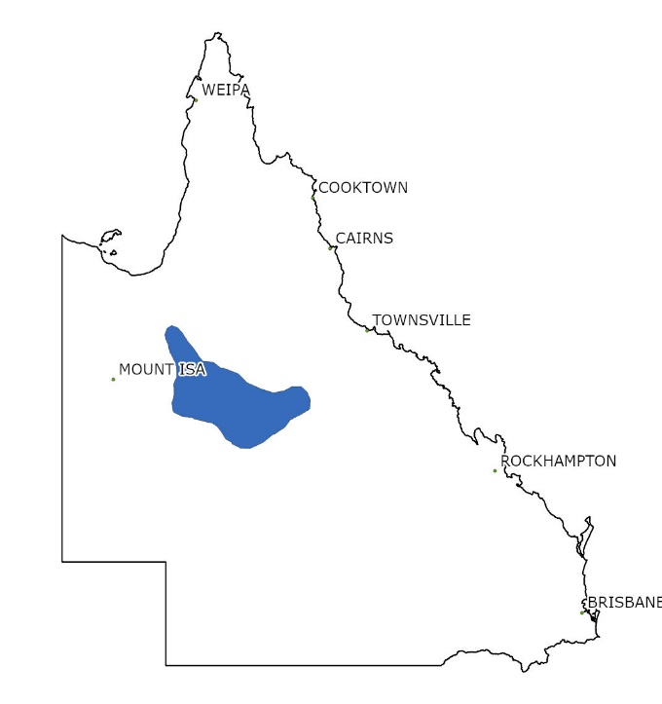
Distribution
Sminthopsis douglasi occurs across the grasslands of the Mitchell Grass Downs bioregion, in central and north-west Queensland, extending into the Gulf Plains to the north and the Desert Uplands to the east. Most records are in the Julia Creek, Richmond and Winton areas. The species has been considered rare and patchily distributed across its range; however, issues with detectability and fluctuating population size may influence their reputation as being generally scarce (Kutt 2003; Woinarski et al. 2014; Woolley 2023; Bakker et al. 2024).

Habitat
The species is probably largely restricted to tussock grasslands on ashy or stony cracking clay plains, dominated by Mitchell grass Astrebla spp., Flinders grass Iseilema spp., wire grass Aristida spp. and blue grass Dichanthium spp. Ground cover can be sparse to dense, but is preferably 40-50 cm high with 40-65% cover, and with or without evident soil cracks or holes in the ground (Mifsud 1999; Lundie-Jenkins & Payne 2002; Kutt 2003; Woolley 2016). Its distribution, as currently understood, does not cover the full extent of ‘Downs’ country (e.g., mapping of Broad Vegetation Groups 30a and 30b, Neldner et al. 2023), and Kutt (2003) has speculated that higher rainfall, limestone geology and the swampy nature of clay plains in the Barkly Tableland and Georgina Limestone areas (Sattler and Williams 1999) may affect soil structure and cracking behaviour of their favoured habitat. Habitat suitability may decrease with increasing density of exotic prickly acacia (Vachella nilotica) and close proximity to watering points (i.e., increased grazing pressure) (Smith et al. 2007).
Known distribution of the Julia Creek dunnart (Sminthopsis douglasi).
Underground cavities in the cracking clay soils are used for shelter and nesting, with animals seen sheltering in soil cracks during the day at depths between 10-50 cm (Woolley 2016). The species is assumed to use vegetation for cover when heavy rain causes the cracks to close up (Woolley 2023). Dunnarts have been reported perching in the tops of forbs during flooding rains on several occasions at Bladensburg National Park (D. Witten pers. comm. 2024).

Seasonal and timing considerations
To maximise detection success, trapping surveys should be undertaken during fine weather conditions and avoid inclement weather (i.e., rainfall periods, unseasonably hot or cold conditions). The breeding season occurs from September until mid-February, resulting in juvenile recruitment from December onwards, and in good seasons, females may breed twice (or in some cases in the season of their birth) (Mifsud 1999). Lactating females without attached young have been captured from November to April (Woolley 2015), so undertaking trapping between April–October will reduce the chance of mothers being separated from young in the nest for long periods. Over 23 years of periodic surveys at Bladensburg National Park (one of the few protected populations) trapping success was higher in April to July, although the species may be captured year-round (Mifsud 1999; Bakker et al. 2024). The species does undergo marked, climate-driven population increases and decreases (“boom and bust”), with some trapping efforts at known sites of occurrence capturing no S. douglasi (Bakker et al. 2024). Typically, a seasonal peak occurs in May–July, when the young have matured, and by July–August that season’s males will be actively looking for mates (Woolley 2015). Access to survey sites, after even light rain (5-10 mm) on dry soils, can be problematic, so avoid the wet season (December to February). Surveys are best planned for April–October.
Searches for sign and other inferential evidence (e.g., owl pellets) may be undertaken at any time of the year.

Recommended survey approach
The following survey techniques should be prioritised in order as per the headings below.

Habitat assessment
Undertake quantitative habitat assessments in areas where other S. douglasi survey techniques are deployed in order to better describe S. douglasi habitat (presence or absence). Suggested minimum effort: record cover (%) of dominant species, leaf litter, weed cover, score soil cracks and disturbance (weeds, grazing, fire, flooding) in quadrat plots (1 x 1 m).

Box or Elliott-type live trapping
Type ‘A’ Elliott trapping surveys have traditionally been the most utilised technique for detecting S. douglasi, and this is still one of the most effective methods if live captures are required (e.g., for life history information or biological samples). Most dunnart species avoid metal box traps, but once accustomed, S. douglasi may be captured (and recaptured) in them. However, capture success at the same site can vary markedly over time, as demonstrated by a monitoring grid at Bladensburg National Park where capture success ranged between 0–6.75% (Mifsud 2001; Rich unpubl. 2009; Baker 2013). Variable interannual climatic conditions (rainfall) and seasonal recruitment likely influenced trapping success (Bakker et al. 2024). Home ranges may be large (0.25–7.13 ha, Mifsud 1999), and population densities are relatively low (0.16–0.38 individuals ha⁻¹, Bakker et al. 2024), so trap spacing is wider than typically recommended for targeting small mammals. Trapping duration is also longer than generally recommended (7 nights, rather than 4) to allow individuals time to become accustomed to the presence of traps, as recommended by Mifsud (2001) and Bakker et al. (2024). Traps should be baited with bacon pieces added to universal bait (peanut butter and rolled oats), or just with peanut butter and bacon (ratio peanut butter to bacon 4:1). Check and replenish the bait on a daily basis due to ant depredation as needed, and re-bait completely after the 3rd day.
NOTE: Population booms of the long-haired rat (Rattus villosissimus) will likely reduce capture success of S. douglasi, and this may warrant the use of other survey techniques, such as camera trapping, when rodent irruptions are known to be in force.

Camera trapping
Camera trapping may be a good complement to live trapping, as cameras can be deployed for longer periods, have fewer ethical issues and may be effective at detecting animals at low densities (Vine et al. 2009). They are also a likely candidate to augment live trapping when rodent populations are high (in “boom” periods), as large numbers of R. villosissimus may overwhelm box trapping efforts. Camera trapping does require good image resolution at close range and the ability to determine animal size (i.e., with scale bars or bait cages of known size in the field of view) to help differentiate S. douglasi from the other two dunnart species (S. macroura and S. crassicaudata) occurring within its range. White-flash camera images taken from above (i.e., pointing directly down at the ground below) have the advantage of allowing relative body size and dimensions, as well as fur colour, to be compared (de Bondi et al. 2010, Thomas et al. 2020). White-flash camera traps, preferably with a reduced focal length (e.g., factory-adjusted to 70 cm or similar) set for a minimum of 28 days, on high-sensitivity motion sensor, no time delay and at least three photos per event, will be most likely to capture enough detail for a positive identification (Thomas et al. 2020) and distinguish adult S. douglasi from other dunnarts within its range. Obtaining a set of reference camera photos of focal species will assist with confident identification.
Cameras may be deployed on transects, preferably during the period of April–October when there are more adults or late-stage juveniles in the population. Position cameras using a bracket on a post (e.g., fence dropper or star picket) so the camera points directly down, with bait attractants (as per above) in secure housing (e.g., in a metal cage) attached firmly to the ground with tent pegs directly underneath the camera. Trim vegetation in the focal area to ground level to reduce false triggers. While cameras can be deployed and left unattended to gather data, the image processing step can be time-consuming, with potentially many thousands of images. As S. douglasi is nocturnal, a camera schedule set to operate from just before sunset to just after sunrise will help reduce records of non-target diurnal species.

Thermal Infrared imaging (Thermography)
Thermography is an increasingly utilised technique that detects infrared radiation (heat) emitted by objects in the field of view and does not require light sources. Vehicle-mounted thermal infrared cameras have been used successfully to detect S. douglasi on driving transects; with nearly double the detection success for S. douglasi compared to spotlighting alone on the same transects (Augusteyn et al. 2018). The technique was used in combination with a handheld thermal device, allowing the observer to advance on foot for closer inspection and wait in darkness for the animal to re-emerge from the burrow, and finally using a spotlight and/or hand-capturing to corroborate species identity (Augusteyn et al. 2018). The technique requires sufficient temperature contrast between the animal and the background to be effective (noting that cracks will also appear warmer than ground level), so researchers using units with less sensitive sensors may need to wait for soil surfaces to cool (e.g., >1.5 hrs after dusk) (Augusteyn et al. 2018). Best conditions for thermal imaging are during minimal wind, no rain and moderate nighttime temperatures (Augusteyn et al. 2018). Use with fixed-width strip transects, where the strip width is determined by the maximum detection distance for the current density of ground vegetation, and therefore visibility (e.g., 50 m either side of vehicle). Record details of individual sightings as well as total area surveyed (distance travelled and strip width).

Searching for remains (predator feeding remains, including owl pellets)
Numerous historical records of S. douglasi have been identified using predator feeding remains, including bone material in regurgitated owl pellets, dunnart carcasses found by local residents (sometimes from pet cats), or gut contents from feral cats and foxes sourced from professional kangaroo and pig shooters (Woolley 1992; Kutt 2003; J. Augusteyn pers. comm. 2024) – so these opportunistic sources may be important indicators of local S. douglasi populations. Dasyurid jaw bones (mandibles) at least 20 mm in maximum length will be of most use for further identification, as S. douglasi adults tend to be this size or larger. Targeted searches of potential eastern barn owl (Tyto javanica delicatula) roosts (e.g., large hollow-bearing trees, farm sheds) within several kilometres of survey areas may be included if the opportunity presents, and the results can be used to target further camera or live trapping efforts.

Wildlife detection dogs
Wildlife detection dogs have proven to be a highly effective survey tool for locating cryptic dasyurids at low population densities (Thomas et al. 2020). For example, new locations were identified for threatened Antechinus spp. using detection dogs (with target species presence subsequently corroborated by camera trapping), including some sites where substantial Elliott trapping efforts over many years had failed to detect the species (Thomas et al. 2020, Batista et al. 2019). The technique also has the advantage of being able to cover the same area as trapping grids in a period of several hours up to 2 days (depending on vegetation cover, environmental conditions and grid size) compared to ≥7 days for live or camera trapping. Thus, potentially much larger areas may be surveyed by detection dog teams. The technique requires access to, or the ability to obtain, a reference library of odour samples of both S. douglasi and non-target S. crassicaudata and S. macroura for dog training purposes. It also requires the dog and handler team to demonstrate successful location of test samples under field conditions. Ideally, dog indications should be subsequently corroborated by other techniques such as camera and/or live trapping.

Hair trapping and analysis
Hair sampling has previously been recommended as S. douglasi is distinguishable from hair samples, provided there is a sufficient sample (DSEWPaC 2011; G. Story pers. comm. 2024). However, the method has received criticism for an inability to distinguish other Sminthopsis spp. (Lobert et al. 2001). Hair funnels, which were formerly favoured over hair tubes for some species of dasyurid (Mills et al. 2002; Nelson 2006), now have reduced availability. Several commercial hair analysis services exist (e.g., scatsabout.com.au; hairidentification.com); however, ideally, any hair-based identifications would also be corroborated by other detection methods.

Survey effort guide
Detection rates for S. douglasi vary between studies, due to different seasonal, climatic and/or habitat conditions, fluctuating markedly even on the same trapping grid (e.g., 0–6.75% capture success at Bladensburg National Park, Bakker et al. 2024). However, capture rates are more typically <1% for areas where S. douglasi is known to be present. The greatest effort expended to detect S. douglasi was 17,300 trap nights to capture a single individual at Toorak, south of Julia Creek (Mifsud 1999). Detectability in ‘poor’ or extended drought conditions cannot be guaranteed with standard trapping techniques. The recommended level of effort outlined below may provide a reasonable opportunity to detect S. douglasi if present in the project area in suitable habitat under ‘normal’ to ‘good’ seasons. We recommend that a minimum of 10% of suitable habitat in a project area is assessed using fauna survey methods outlined below, and that at least 50% of that effort is in the form of Elliott-type live trapping.
Minimum effort per 100 ha of suitable habitat
Survey technique | Minimum effort
Habitat assessment | 10 quadrats (1 x 1 m) assessing dominant grass species, native grass ground cover, leaf litter cover, soil cracks (number, width) and disturbance factors (including weed cover %).
Elliott trapping | 20 Type ‘A’ Elliott-type traps, each spaced 50 m apart, set for 7 nights (= 140 trap nights). Bait with peanut butter and bacon mixture. This encompasses 5 ha.
Camera trapping | 5 cameras, each spaced 100 m apart, for a minimum of 28 nights (= 140 camera trap nights). Bait with peanut butter, rolled oats and bacon mixture. This encompasses 5 ha. Camera traps should only be armed and baited at the conclusion of Elliott trapping surveys. That is, surveys should not occur concurrently.
Recommended survey program per 100 ha suitable habitat: 10 quadrats of habitat assessment across trapping area, 20 Elliott-type traps for 7 nights (= 140 trap nights) and 5 camera traps for 28 nights (140 camera trap nights) covers a total of 10 ha (10% per 100h of suitable habitat).
Further targeted techniques to consider – no minimum effort recommended
Predator feeding remains/owl pellet searches | No fixed effort, but survey planning stages should include requests for knowledge of owl roosts or information about any feral predator control activities occurring locally. If possible, undertake searches for potential owl roosts (large, hollow-bearing trees; farm sheds) close to the survey area. Look for dasyurid jawbones >20 mm in total length.
Thermal Imaging | Vehicle-based thermal imaging may be undertaken on fixed-width strip transects of >2.5 km length in suitable habitat, travelling ~10 km hr⁻¹. Strip width will be determined by vegetation cover at the time of survey (i.e., maximum detection distance of small mammals, measured perpendicular to vehicle).
Wildlife detection dogs | Area searches for S. douglasi scent, undertaken by experienced dog and handler team, up to 5 hrs per survey day.
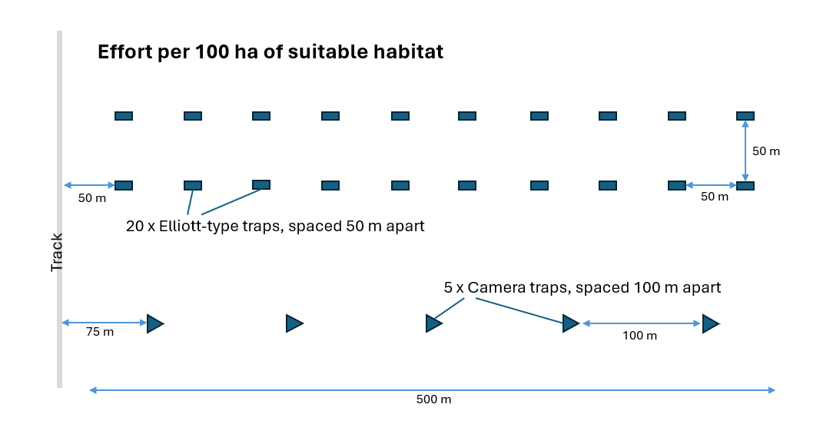
Suggested layout for S. douglasi survey effort (see Figure, below) per 100 ha of suitable habitat. We recommend a minimum of 10% of suitable habitat in a project area be assessed by methods outlined above, and that a minimum of 50% of effort is Elliott-type live trapping. For areas greater than 100 ha, a version of this layout should be scaled up accordingly. In the Figure (below), Elliott traps encompass 5 ha and camera traps encompass 5 ha, covering a total of 10 ha (10% of 100 ha suitable habitat). Traps are not to scale.

Ethical and handling considerations
- Check Elliott traps early in the morning before temperatures become too hot. Begin as soon as the sun fully crests the horizon. To protect released animals from aerial diurnal predators, consider holding animals (in a catch bag inside the Elliott trap, somewhere cool and dark) to release at dusk at the point of capture, particularly when soil cracks are not present and/or vegetation cover is sparse.
- Trapped animals should be protected from temperature extremes and exposure (heat, cold, dehydration). In cold conditions, provide a pad of bedding (e.g., sterile coconut coir fibre) in the rear of Elliott-type traps. Position traps under cover where possible (e.g., under a grass tussock) to provide shelter, and ensure traps are level and securely placed on soil substrate (dunnarts will not enter a trap that tilts even slightly under their feet).
- Check the weather forecast daily. If rain is possible overnight, decommission live traps (close and fold traps and remove bait) as site access becomes problematic after even light rain (5-10 mm), and it may take several days for the soil to dry out. Traps may need to be pegged down if high winds are forecast.
- Ensure that individual dunnarts are not live-trapped for more than three nights consecutively; fur-clip captures and close traps after three nights if recaptures of individuals occur. Consider a “rest’ night (traps collapsed and bait removed) if there are consecutive recaptures of ≥3 nights for any species.
- Close or move traps with lots of ants.
- Consider weed and pathogen spread when using equipment in multiple locations as these can be transported via dirty equipment.
- Gloves should be worn when handling material from feral or native predators to reduce exposure to zoonotic diseases, and consider whether vaccinations (e.g., QFever) are necessary for staff.
- Be aware of the possibility of 1080 poison baits if using a Wildlife Detection Dog and avoid working in hot periods.
- Be aware of venomous snakes, especially during the warmer months or hotter parts of the day.

Acknowledgements
These guidelines were prepared by Melanie Venz, Emma Gray and Andrew Baker in September 2024. Advice and comments on drafts were provided by Greg Mifsud and John Augusteyn.

Citation
Venz, M., Gray, E. and Baker, A.M. 2024. Julia Creek dunnart, Sminthopsis douglasi. Targeted species survey guidelines. Queensland Herbarium and Biodiversity Science, Department of Environment, Science and Innovation, Brisbane.

Key references
Augusteyn, J.D., Rich, M. and Hemson, G. (2018). ‘Using thermal image cameras to monitor the endangered Julia Creek Dunnart at Bladensburg National Park’. Rockhampton: Department of Environment and Science, Queensland Government.
Baker, T. (2013). An investigation into: The impacts of fire history and an insect-based bait on the trap success of the Julia Creek dunnart (Sminthopsis douglasi); the current diet of the feral cat (Felis cattus) within the Mitchell grasslands bioregion; and the Julia Creek dunnart population at Bladensburg National Park, Bachelor of Applied Science (Honours). University of Queensland, St Lucia.
Baker, A.M and Gynther, I.C. (eds) (2023). ‘Strahan’s Mammals of Australia’, 4th Edition. Reed New Holland Publishers, Sydney.
Bakker, A.H., Patterson, C.R., Mifsud, G., Reside, A.E., Fuller, S., and Baker, A.M. (2024). Density of a cryptic Australian small mammal: The threatened Julia Creek dunnart (Sminthopsis douglasi). Ecology and Evolution, 14(7), e11674. https://doi.org/10.1002/ece3.11674
Batista, S., Baker, A.M., Fisher, D., Baker, L. (2019). Detection dogs rapidly filling the gaps for rare antechinus species. In ‘Science for Saving Species’. Spring 2019 Issue 13. Accessed online 31 July 2024. www.nespthreatenedspecies.edu.au/media/hw3jhyu1/sfss-13-whole-mag_web.pdf
De Bondi, N., White, J. G., Stevens, M., & Cooke, R. (2010). A comparison of the effectiveness of camera trapping and live trapping for sampling terrestrial small-mammal communities. Wildlife research, 37(6), 456-465.
DSEWPaC (2011). ‘Survey Guidelines for Australia's Threatened Mammals’. (Department of Sustainability, Environment, Water, Population and Communities: Canberra, Australia).
Lundie-Jenkins, G. and Payne, A. (2002). ‘Recovery plan for the Julia Creek dunnart (Sminthopsis douglasi) 2000-2004’. Queensland Parks and Wildlife Service, Brisbane.
Kutt, A.S. (2003). New records of the Julia Creek Dunnart Sminthopsis douglasi in central-north Queensland. Australian Zoologist 32, 257-260.
Lobert, B., Lumsden, L., Brunner, H., and Triggs, B. (2001). An assessment of the accuracy and reliability of hair identification of south-east Australian mammals. Wildlife Research, 28(6), 637-641.
Mifsud, G. (1999). Ecology of the Julia Creek dunnart, Sminthopsis douglasi, (Marsupialia: Dasyuridae). Master of Science Thesis. La Trobe University.
Mifsud, G. (2001). Monitoring of Julia Creek dunnart populations at Bladensburg National Park. Report to Queensland Parks and Wildlife Service.
Nelson, J.L. (2006). A comparison of three hair-tube types for the detection of the spotted-tailed quoll Dasyurus maculatus in south-eastern New South Wales. Australian Mammalogy, 28(2), 229-233.
Neldner, V.J., Niehus, R.E., Wilson, B.A., McDonald, W.J.F., Ford, A.J. and Accad, A. (2023). ‘The Vegetation of Queensland. Descriptions of Broad Vegetation Groups’. Version 6.0. Queensland Herbarium and Biodiversity Science, Department of Environment, Science and Innovation.
Rich, M. (2009). ‘Julia Creek Dunnart survey at Bladensburg NP’, QPWS&P, Department of Environment & Science.
Smith, C.S., Howes, A.L., Price, B., and McAlpine, C.A. (2007). Using a Bayesian belief network to predict suitable habitat of an endangered mammal – The Julia Creek dunnart (Sminthopsis douglasi). Biological Conservation, 139(3-4), 333-347.
Thomas, M.L., Baker, L., Beattie, J.R., and Baker, A.M. (2020). Determining the efficacy of camera traps, live capture traps and detection dogs for locating cryptic small mammal species. Ecology and Evolution, 10(2), 1054-1068.
Van Dyck, S., Gynther, I., and Baker, A. (2013). ‘Field companion to the mammals of Australia’. New Holland Publishers.
Vine, S.J., Crowther, M.S., Lapidge, S.J., Dickman, C. R., Mooney, N., Piggott, M.P., and English, A.W. (2009). Comparison of methods to detect rare and cryptic species: a case study using the red fox (Vulpes vulpes). Wildlife Research, 36, 436-446.
Woinarski, J.C., Burbidge, A., and Harrison, P. (2014). ‘The action plan for Australian mammals 2012’. CSIRO Publishing.
Woolley, P.A. (1992). New records of the Julia Creek Dunnart, Sminthopsis douglasi (Marsupialia: Dasyuridae). Wildlife Research, 19(6), 779-783.
Woolley, P.A. (2015). The Julia Creek dunnart, Sminthopsis douglasi (Marsupialia: Dasyuridae): breeding of a threatened species in captivity and in wild populations. Australian Journal of Zoology, 63(6), 411-423.
Woolley, P.A. (2016). Diurnal resting sites of the nocturnal dasyurid marsupial Sminthopsis douglasi in Bladensburg National Park, Queensland. Australian Mammalogy, 39(1), 121-126.
Woolley, P.A. (2023). Julia Creek dunnart, Sminthopsis douglasi. In ‘Strahan’s Mammals of Australia’. 4th Edition. (Eds A. Baker and I. Gynther) pp. 131-132 (Reed New Holland: Sydney).

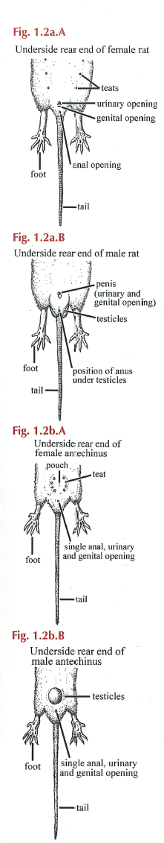
Appendix 1 – Identification of small mammals in grasslands of central and north-west Queensland
The following was prepared as a quick reference guide to assist with the identification of mammal fauna considered most likely to be encountered within the distributional range of the threatened Julia Creek dunnart (Sminthopsis douglasi) in western Queensland. Strahan’s Mammals of Australia, 4th Edition (Baker and Gynther 2023) and the Field Companion to the Mammals of Australia (Van Dyck et al. 2013) were consulted for probable distributional ranges and to adapt individual species identification keys.

Order Rodentia (rats and mice) versus family Dasyuridae (carnivorous marsupials)
Rodentia. Have a rounded snout and a single pair of incisor teeth in the upper and lower jaws and lack canines (Australian species also lack premolars). Rodents have two or three openings in front of the tail/between the legs (i.e., a penis and anus in males; and urinary, genital and anal openings in females) (see Figure, right, above).
Dasyuridae. Have a triangular, more pointed snout and dentition specialised for carnivory: four pairs of upper incisor teeth and three lower pairs of incisors; well-developed upper and lower canine teeth; two-three pairs of blade-like upper and lower premolars and four pairs of upper and lower molars. Dasyurids have only one apparent opening in front of tail/between legs for faeces, urine and reproduction (see Figure, right, below). Females have teats that are positioned in a circular pattern on the abdomen.

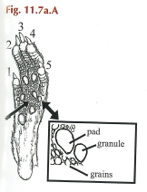
RODENTS

A1. Mouse-like = Mus, Pseudomys or Leggadina
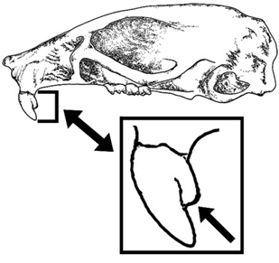
Mus musculus (house mouse). Pads at base of toes 1 and 5 each have an obvious large granule (1/3 to 2/3 area of pad) on outer side and the skin encircled by all footpads is usually pebbly/grainy (see Figure, left). Teeth: upper incisor usually has an r-shaped notch (see Figure, below left). Foot length: usually less than 20 mm. Tail: equal to or longer than head body (HB) length. Odour: distinctly ‘garlicky’. Females have 5 pairs of teats (total 10). Weight: up to 30 g.
Diagram showing the diagnostic granules under Mus musculus feet (Van Dyck et al. 2013, page 277).

NOTE: hindfoot measurement is taken from behind the heel, extending to the tip of the straightened longest toe (excluding the claws).

Underside of a female and male rodent (1.2a.A and 1.2a.B), compared to a female and male dasyurid (1.2b.A and 1.2b.B) (Van Dyck et al. 2013, page 241).

Diagram showing the distinctive r-shaped notch present in most Mus musculus upper incisors (Van Dyck et al. 2013, page 277).

Pseudomys and Leggadina should not have obviously large granules or pebbly/grainy skin around pads under the feet. They do not have an r-shaped notch in their incisor teeth and shouldn’t smell ‘garlicky’.

Pseudomys. Foot length: usually >20 mm. Tail: tapers to finer tip than Leggadina. Snout: not as broad and blunt as Leggadina.
Pseudomys desertor (desert mouse). Most likely species, which has a distinct, pale orange eye ring. Tail usually ≤ HB length. Weight: 11-35 g.
Leggadina forresti (Forrest’s mouse). Foot length: ≤20 mm. Tail appears abnormally short at <75% of HB length and with a blunt tip. Snout: markedly broad and blunt. Weight: 13-30 g.

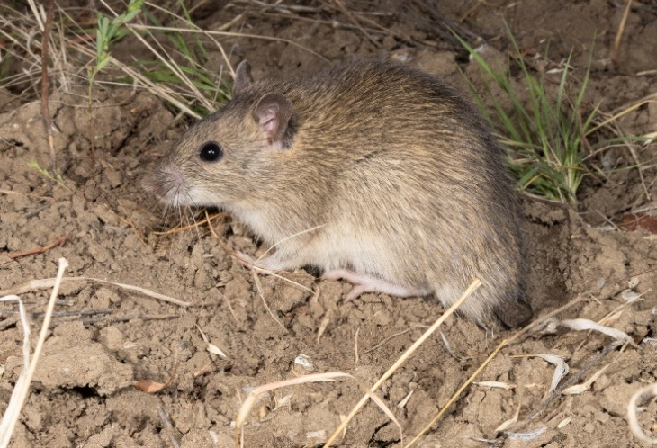
A2. Rat-like = Rattus or Zyzomys
Rattus villosissimus (long-haired rat). The most likely Rattus species to be encountered. Tail: usually the same length or slightly shorter than HB length. Scales form obvious rings around tail. Foot length: >20 mm. Females have 12 teats. Much bigger than Zyzomys or any of the mouse-like species and body hair appears long and shaggy (see Figure, right). Weight: males 65-280 g, females 54-200 g.
Long-haired rat (Rattus villosissimus) at Bladensburg National Park. Photo: Andrew Baker

Rattus rattus (black rat). Introduced Rattus species, often associated with human disturbance. Tail: unlike all native Rattus, the tail is notably longer than HB length (average 230mm, up to 1.5 x HB length). Ears: long, usually reaching up to or past the middle of the eyes when manually folded forward. Females usually have 10 teats. Weight: 95-340 g.

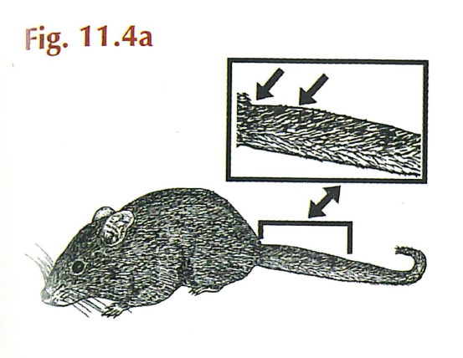
Zyzomys argurus (common rock-rat). Tail: distinctly fatter at base, tapering to a fine tip with longer hair forming a slight tuft (see Figure, right). Usually found near rocky outcrops, so less likely to be encountered within tussock grassland. However, the species is known to occur within Bladensburg National Park. Weight: 26-55 g.

Diagram showing the tapering tail of Zyzomys argurus (Van Dyck et al. 2013, page 277).

DASYURIDS

Planigale or Sminthopsis

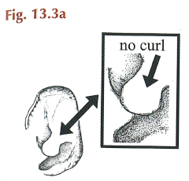
Planigale. Head: very flat. Tail: does not have black hairs on tip and is never ‘fat’ at tail base. Ear: skin fold (supratragus) above tragus does not have a curl (see Figure, right). Usually notably smaller in size than Sminthopsis spp.
Planigale ingrami (long-tailed planigale). Smallest planigale and one of the world’s smallest mammals. Weight: males 2.8-6.6 g, females 2.6-5.8 g. Eyebrow: pale cream or rufous. Ear: skin fold above tragus (flap in front of external ear hole) ≥ 2.6 mm wide at base. Tail: ≥ HB length.
Diagram showing the skin fold above the tragus in Planigale spp. (Van Dyck et al. 2013, page 289).
Planigale tenuirostris (narrow-nosed planigale). Weight: males 4.5-9 g, females 4-7 g. Eyebrow: rarely present. Ear: skin fold above tragus < 2.6 mm wide at base. Tail: almost as long as HB length.

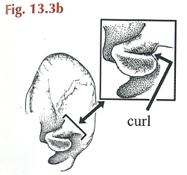
Sminthopsis. Skin fold (supratragus) above tragus has a curl (see Figure, right). Head not obviously flat. Tail typically fattened at base. Usually notably larger in size compared to Planigale spp.
Sminthopsis douglasi (Julia Creek dunnart). Largest Sminthopsis. Weight: Adults >26 g (and up to 70 g). Pes (hindfoot): length in adults >20 mm. Face: distinct dark facial stripe extending from between ears down to nose. Dark hairs in ring around eyes and outer edge of ears. Rufous hairs on cheeks and at base of ears. Tail: often has dark hairs at the tip and tail is about same length or slightly shorter than HB length.
Diagram showing the skin fold above the tragus in Sminthopsis spp. (Van Dyck et al. 2013, page 289).
Sminthopsis macroura (stripe-faced dunnart). Weight: adults 15-26 g. Pes: length in adults usually <20 mm. Face: distinct dark facial stripe extending from between ears down towards nose. Ears: shorter than S. crassicaudata – not extending as far as front of eye when manually folded forwards. Tail: usually without dark hairs at the tip, and tail is about same length or longer than HB length.
Sminthopsis crassicaudata (fat-tailed dunnart). Weight: adults 10-20 g. Pes: length in adults <20 mm. Face: no obvious facial stripe (although a dark patch may be present on head between ears). Ears: clearly extend further than front of eye when manually folded forwards. Tail: usually without dark hairs at the tip, and tail is usually slightly shorter than HB length.

NOTE: adult S. douglasi can be confidently distinguished from S. macroura and S. crassicaudata based on a combination of body weight and hindfoot length (see Figure, below). However, juvenile S. douglasi may overlap in body weight with adult S. macroura and have a hindfoot slightly <20 mm. Therefore, the teeth of smaller dunnarts (26 g or less) should be checked to verify juvenile/adult status and corroborate species identification (see Appendix 2 for a tooth aging guide and also Bakker et al. 2024). For example, a juvenile S. douglasi was caught in an Elliott trap, and the individual had a deciduous (baby, ‘milk’) premolar 3 tooth, a body weight of just 17 g, and a hindfoot length of less than 20 mm. Juvenile S. douglasi may be in the trappable population from about December – June.

Summary of key points for discriminating the three dunnarts:
- If adult and >26 g with hindfoot >20 mm = S. douglasi
- If juvenile and <26 g and hindfoot ≥20 mm or slightly under 20 mm = S. douglasi
- If adult and <26 g with hindfoot <20 mm = S. macroura (if it has obvious facial stripe and fits other characters specified above) or S. crassicaudata (if no obvious facial stripe and fits other characters specified above).
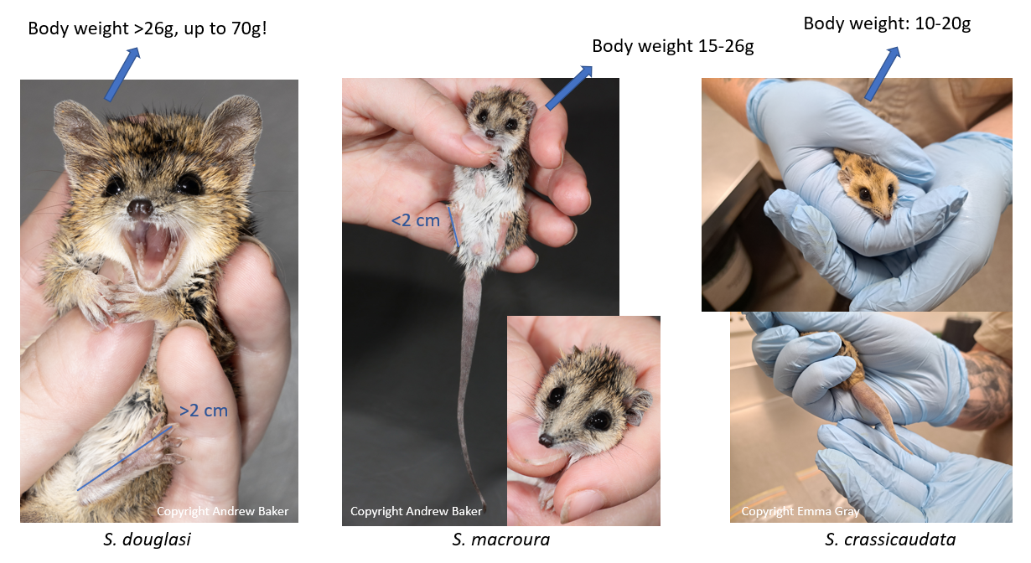
Diagram showing key differences between adult Sminthopsis species occurring in north-west Queensland.

Appendix 2 – Tooth ageing guide in Sminthopsis
Notes:
- P = Premolar tooth; Number 1, 2, 3 denotes position in the tooth row, moving from the front of the mouth backwards.
- Relative size of premolar teeth, the height of the tooth exposed above the gum line, can be adjudged by eye or a hand-eye lens (photos can also be taken); upper lip can gently be curled back with a cotton bud to expose teeth.
- Deciduous teeth have multi-cusped (peaked) appearance, whereas the adult premolars appear simple and curved with a single point.

- If P3 > P2 > P1 then adult
- If P3 ≤ P2 then juvenile
- If deciduous (i.e., ‘milk’ [baby]) P3 tooth is still present, then very young juvenile.
A deciduous tooth in P3 position will be small and the adult P3 will push it out, but until the adult P3 tooth has descended to the point that P3 > P2 in crown height, then it is still deemed a juvenile. Once P3 emerges far enough to appear obviously greater in height than P2, it is deemed adult.

Examples of determining dunnart age from relative size of premolar teeth

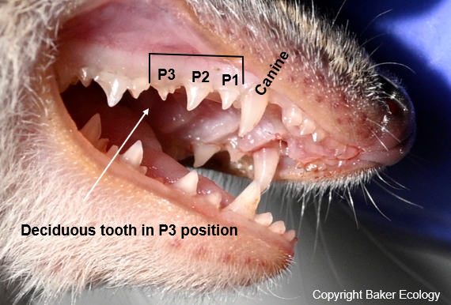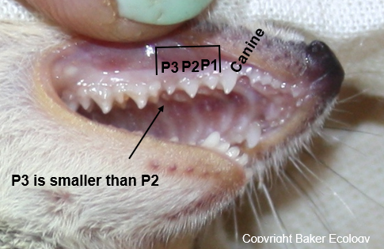
Juvenile: with premolar deciduous ‘milk (baby)’ tooth Juvenile: with adult P3 emerging (P3 < P2)

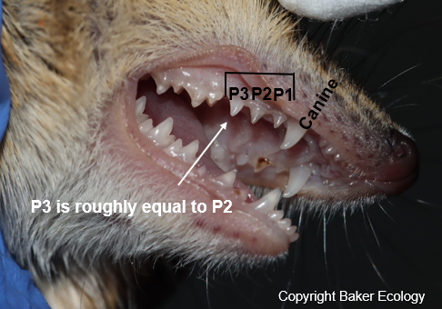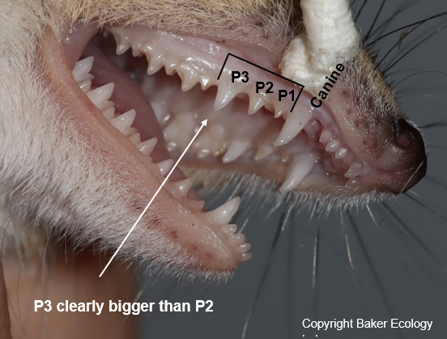
Juvenile: Adult P3 emerged and descending (P3 = P2) Adult: P3 fully descended (P3 > P2)

Acknowledgements
Research for the identification and tooth aging guide synthesised in Appendices 1 and 2 was conducted by members of the Baker Ecology Lab and principally funded by Multicom Resources as part of an Offset Management Plan conceptualised by Multicom Resources and Epic Environmental and approved under the Environment Protection and Biodiversity Conservation Act 1999 (EPBC Act) for the Saint Elmo Vanadium project (EPBC 2017/8007). Additional funding and resources were provided by QUT.

