Wildlife Trade Operation - Harvest of Tasmannia lanceolata (Tasmanian native pepper) from Tasmania

Introduction
This application relates to the species Tasmannia lanceolata variously known as Mountain pepper, native pepper or Tasmanian pepperberry.
The applicant  (t/a Diemen Pepper) has enquiry for dried leaf and berry from clients in several EU member states, the United States and Japan.
Harvest of leaf and berry will occur at a variety of sites around Tasmania, effectively spreading and reducing the impact, if any, on any particular stand or population.
Tasmannia lanceolata is not listed as threatened under the Commonwealth Environment Protection and Biodiversity Conservation Act 1999 (EPBC Act), nor does it appear in the Appendices to the Convention on International Trade in Endangered Species of Wild Fauna and Flora (CITES).
The species is widespread in the wetter parts of Tasmania, typically occurring naturally as an understory species in myrtle/sassafras rainforest, where it fulfils the role of a volunteer species after opening of the overstory canopy (eg treefall , landslide or similar disturbance) and tends to germinate in very large numbers in those circumstances. As a result, it is extremely common in areas where rainforest has been cleared for farming, forestry, mining, road and power infrastructure etc. often forming extensive communities of relatively uniform age.
The general goal of this application is to outline the harvesting strategy of Diemen Pepper, explaining how and where leaf and berry produce will be sourced and to detail Diemen Pepper's procedures for tracking and monitoring harvests from the various sites and through our drying and despatch system.
Diemen pepper's long term objective is to ensure sustainable use of the species and to establish protocols for harvesting which might be applicable for other future participants in the industry and
to foster the development of commercial orchards of the species for future managed production of berries and leaf.


Diemen Pepper intends to export a maximum of 15 tonnes of whole berries and a maximum of 15 tonnes of foliage per annum.

Harvest Sites
Currently Diemen Pepper has a variety of sites from which pepper berries and leaf are harvested with permission from landowners.

We DO NOT harvest from the following: any parks, reserves, conservation areas or covenanted land, private or public nature reserves, private property without landowner's permission, riparian zones, wetlands, mine sites, nor any other site where there has been no significant disturbance to cause regrowth of the plants ('old growth forest' for example).

Current sites of harvest for berries and foliage:
  - Leasehold sites: Diemen Pepper leases a 40ha 'old field' site from Sustainable Timber Tasmania, at Parrawe, in the Surrey Hills district, NW Tasmania (STT Lease No. 20319; attachment 1). This district was cleared of native vegetation in a post- war soldier-settlement scheme and after some time under grazing and cropping management, was abandoned and shortly thereafter granted to private forestry interests. The district was progressively swept clear of pepper regrowth and planted to trees (radiata pine and eucalypts.) The leased site was exempted from forestry due to the presence of an archaeological site in one corner, and consequently now supports a large stand of native pepper trees, up to 60 years old. See Attachment 3.

  - Licenced Areas: Diemen Pepper (as ) holds a licence to harvest pepper leaf and berry from a 150ha site in NE Tasmania on 'Dead Horse Hill', managed by the Crown (PIO 3340983; DPIPWE Ref: 246409-001, Attachment 4). This area was subject to intensive tin mining by Chinese miners in the late 1800's, and rough cleared for softwood forestry in the 1960's but never used. The site carries tens of thousands of pepper shrubs and trees, of mixed ages on undulating ground, is accessible via forestry roads and the licence includes a number of excluded areas (mostly riparian zones and some threatened

native vegetation communities, clearly identified in the map annexed to the licence, included in the attachment.
  - Private Land: Diemen Pepper maintains relationships with private landholders who have varying amounts of native pepper on their property - typically occurring as regrowth around the periphery of operating farmland, (eg grazing blocks in Takone and West Takone, dairy farms near South Riana and Lileah NW Tas, Forest Lodge near Pyengana and Weldborough NE Tas.) and widespread regrowth on cleared residential properties (eg around Waratah in NW Tas and Lottah in NE Tas).

  - Forestry Plantations: Through our collectors
, we also have permission to gather foliage from pepper
regrowth occurring as understory in timber plantations.(During the (typically) 25 year cycle of plantation production, regrowth of pepper can form a significant part of the understory community - most of which is destroyed during forest harvesting operations.) These agreements include strict details of harvest management, oversight by the company, fees to pay and maps of current and proposed timber harvesting sites as well as identified areas for pepper collection in the short term. Location maps (Attachments 5 and 6) have been taken from the agreements between  and

Harvest Management
Prior to commencement of harvest, Diemen Pepper provides a harvest guide to pickers of berry or leaf which outlines the expectation of good management by individual pickers (Attachment 7) and requires from them a signed undertaking to
follow this guidance as well as identifying the location and tenure of the site.

Berry harvest takes place from late March until June.
Leaf harvest can be conducted from March until bud swell begins - approximately beginning September. There are two strategies for harvest: the first (75% of the total harvest) being collection of foliage from young trees beneath forestry plantation before they are destroyed shortly afterwards during the tree harvest. Secondly we accept foliage from harvesters working on our leased/licenced areas (details above) or on their own properties where pepper trees have sprung up in previously cleared land. Foliage (no more than than 25% of above-ground biomass) would be gathered from
-
WTO Application Monday, 26 August 2024
these trees approximately once every 3 years at most. Where trees are beneath forestry plantations planned for harvesting in the near future and the bushes will be destroyed in the process we would expect a larger proportion of the total canopy would be collected - up to 90% of the foliage.

- Pepper berries: all berries are harvested by hand into baskets or onto tarpaulins between March and June each year. They are then stored in hessian bags for collection and delivery to the drying facility in the south of the state. Harvesting by even the most diligent pickers always leaves a significant portion of berries on the bush or on the ground beneath. Berries ripen unevenly and many drop from the tree before picking, or resist removal and hence remain on the tree, and furthermore the tops of the trees are inaccessible and seldom if ever harvested. Fresh pepperberries are dried using warm air, reducing them to about 20% of fresh weight, cleaned of debris (sticks, buds, leaves etc) and prepared for sale as either whole or ground product. End use for whole berries is almost entirely for domestic consumption as a novel alternative to conventional pepper. Small amounts of dried berries (about 10% of the harvest) are freezedried for specialist use in gourmet products for example pepper salt. Some dried berries (often in a milled format) are also used in commercial applications such as in the manufacture of distilled products, for food service manufacture and for value added products such as sauces relishes etc.

- Pepperleaf is collected using dedicated hedge trimmers to 'shave' a portion of the outer canopy onto a tarp or similar. This foliage is then gathered and delivered to the dryer, typically between February and September. The effect of repeated harvests of this kind over more than 30 years can be seen in Attachment 3 (Parrawe site) - trees which have been repeatedly hedged in this way continue to regenerate fresh foliage on the outer surface of the tree. Note the tops of the trees are not harvested for leaf.
Pepper foliage is dried to about 20% of the fresh weight, the leaves are stripped from the twigs and then milled or flaked.



Impact of Harvesting

The overarching point to make is that all of the populations listed in point 3 above from which Diemen Pepper gathers plant material, are essentially artifacts of human intervention, the species is extremely widespread and common and in their preferred landscape trees are quick to recover from harvest actions and seedling recruitment is continuous.

Acknowledging that regular harvest and removal of berries and leaf from volunteer populations of native pepper might have unplanned environmental consequences for example removal of resource from the habitat of browsing animals, insects and birds,
alteration of the balance of biomass in mixed species communities, incidental disturbance to the environment (tracking and soil compaction for example), Diemen Pepper is cognisant of these risks and manages harvesting to minimise risk in this area, but to address each of these concerns in turn however:
  - pepperberries are favoured by several native bird species - currawongs and rosellas being the most notable - in both cases eating, then regurgitating pellets of seeds and pulp (presumably having absorbed some nutrient in the process). Both species are generalist consumers, moving across fruit and seed throughout the seasons, including altitudinal migration between resources - pepperberries are only one of many berry and fruit resources in the wet schlerophyll and rainforest habitats they pass through.
  - Marsupial browsing does occur in a limited way around the base of the trees, probably opportunistic, and limited by the relatively unpalatable nature of the foliage and would be an important food source only in the absence of other browsing resources.
  - There are a variety of insect species found on aerial parts of the pepper including leaf rollers, leaf cutters and fruit and stem borers all of which seem able to inhabit the plant during and after harvest. Insect browsing is likely constrained by the presence of a potent natural compound - polygodial,- a volatile

sesquiterpene present in all parts of the plant and which has been shown in multiple studies to provide powerful deterrence to both insects and browsing animals as well as possessing anti-fungal and antibacterial properties.
  - The partial removal of foliage and berries of native pepper from plant communities where it occurs may have an effect on availability of other resources (light, water, nutrients) but this is likely to be minimal, though there are no published studies addressing this point. Again, the populations usually harvested are all artifacts and the disturbed communities of which they are part have many other ecological challenges besides partial removal of material from individuals of one species.
  - Lastly - the incidental damage caused by traffic within harvest areas is to be considered - this is addressed in Diemen Pepper's instructions to harvesters and the subject of regular discussion between us and the pickers. In the plantation situation of course, damage caused by pickers (foot traffic, light vehicle movements) is insignificant beside the impact of plantation harvesting which follows soon after.

Monitoring and record keeping
During the harvest season a chain of documentation provides traceability for both leaf and berry - commencing with harvest weight records - dockets which identify the individual harvester and therefore the site of collection. These weights are then consolidated into drier batch records after which the drying batch code remains with the product all the way to the customer.
Diemen Pepper maintains thorough records of harvests using batch numbers, and maintains spreadsheets recording the origins, amounts and collectors for all fresh products (foliage and fruit) delivered to the drier. This data is retained permanently and all dried leaf and berry sold can be traced (via the batch codes and spreadsheets) back to the harvester, the collection site and the time of harvest.

Attached is a report to Diemen Pepper by Enviro-Dynamics prepared in response to our brief - to identify sites of established stands and strategies for securing sustainable supplies of leaf
). The report provides advice as to the likely and known distribution, the ecological niche occupied by the species and some observations about sustainable harvesting of

the species. Among the recommendations to be adopted or continued are the guidelines for harvesting (autumn, trees in open areas, <25% of total biomass, spell between harvests of 3-4 years), and the suggestions for increasing available resource (support clonal selection and orchard planting, harvest beneath plantations due for harvest, augmenting existing private stands by reducing competition, interplanting productive clonal selections).


Long term observation (including photographs - eg Attachment 3) of the impact on sites where repeated harvests have occurred over almost 30 years show that trees harvested first in 1994, and since harvested at least 4 more times since have arrived at a 'topiarised' form, confirming that the response to pruning is robust and durable.

Social Context and Compliance

Collection of the leaf and berry produced during each harvest is a significant contributor to the economy of the local communities where it occurs. In a typical season, Diemen Pepper would collect berries from more than 40 individuals, families and community groups mostly participating in a 'hobby' context. The price paid for both berry and leaf, while reflecting relative scarcity of the former in some seasons, is always regarded as generous and encouraging to those taking part.
As the main, sometimes only buyer of fresh pepper produce Diemen Pepper is in the fortunate position of being able to refuse product if it is suspected of having been collected illegally or unsustainably. Personal relationships and regular visits to picking and collection sites help to ensure pickers exercise care and adhere to the guidance provided.

Domestication Strategy
Over the past 25-30 years much of the market development has occurred in tandem with progressive growth in access to unmanaged resource (forestry by-product, regrowth after clearing

etc), the long term approach should be towards managed production.
To this end there have been a number of attempts by this author and others to establish small commercial orchards of native pepper - mostly using clonally propagated material taken from existing fruitful or vigorous plants and multiplied in nursery areas in which clonal material can be assessed for useful or problematic characteristics.
At present there are 11 such plantings established using plants selected by Diemen Pepper, the size and status of which is shown in the table below:

Southern Tasmania:

Birchs Bay (on farm-Att 10.)" :
Dulcia Road, Gordon":
Uxbridge/Moogara":
-
Geeveston:
Campania:
Garden Island Creek: Northern Tasmania:

Elizabeth Town" Smithton (Lileah)" Smithton (nr Irish Town) Pyengana
Takone"

'These sites currently contribute small amounts to Diemen Pepper's commercial production.

References:
Himejima M and Kubo I (1993) Fungicidal activity of polygodial in combination with anethole and indole against Candida albicans. J. Agric. and Food Chem. 41 1776- 1779.
Caprioli-V; Cimino-G; Colle-R; Gavagnin-M; Sodano-G; Spinella-A (1987) Insect antifeedant activity and hot taste for humans of selected natural and synthetic 1,4- dialdehydes.: J-Nat-Prod. Mar-Apr; 50(2): 146-51

Attachment List:

Attachment 1:
Attachment 2:
Attachment 3:
Attachment 4:
Attachment 5:
Attachment 6:
Attachment 7:
Attachment 8:
Attachment 9: Attachment 1O:
Sustainable Timber Tasmania Lease Sustainable Timber Tasmania Lease Map
Sustainable Timber Tasmania Leased Site (image)
Dead Horse Hill License

harvest maps harvest map
Guide for Suppliers
Enviro-dynamic survey and report
Tasmanian Pepper Trees subject to pruning for 20 years (image)
Plantation (image)

Attachment 1


1

Lease No. 20319

THIS LEASE is made the 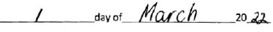

BETWEEN

FORESTRY TASMANIA (ABN 91 628 769 359) TRADING AS SUSTAINABLE TIMBER TASMANIA, a
statutory corporation pursuant to the provisions of the Forest Management Act 2013 (Tas) the registered office of which is Level 1, 99 Bathurst Street, Hobart in Tasmania, 7000.
(here referred to as "STT")

- and-
trading as DIEMEN PEPPER (ABN 88 956 346 927) of

(here together referred to as the "Lessee")

BACKGROUND

A. The Lessors wish to lease the Premises for the purpose of CULTIVATION AND COLLECTION OF NATIVE
PEPPER PRODUCTS INCLUDING LEAF AND BERRY.

B. In pursuance of the powers conferred by the Act, STT has agreed to lease the Premises to the Lessee in consideration of the payment of the Rental and otherwise upon the terms and conditions of this lease (the 'Lease').

DEFINITIONS
- In this Lease unless the contrary and otherwise requires:-
. "Act'' means the Forest Management Act 2013;
"Business Day" means any day on which trading banks are open for business in Hobart;
"Commencement Date" means the date specified in Clause 4;
"CPI" means the Consumer Price Index All Groups for Hobart published by the Australian Bureau of Statistics, or its successor;
"GST” means a Commonwealth goods and services tax introduced in the A New Tax System (Goods and
services Tax) Act 1999;
"Insurances" means all policies and contracts of insurance which are from time to time required to be or are taken out or entered into pursuant to the provisions of Clause 6(f);
"Party" means a party to this Lease;
"PTPZL" means permanent timber production zone land as is defined in section 3 of the Act;


2

"Premises" 44.3891Ha depicted in the colour purple on the plan attached;
"Rental" or "Rent" means the Rental referred to in Clause 5 as varied from time to time in accordance with the terms and conditions of this Lease;
"Writing'' and words of like import include typing, lithography, photography and other modes of representing or reproducing words in tangible and visible form and "Written" has a corresponding meaning.

GENERAL
- (a) In general:-
  - a reference to a clause or schedule is a reference to a clause of or schedule to this Lease and a reference to this Lease includes a recital or schedule;
  - a reference to this Lease or another instrument is a reference to this Lease or that other instrument;
  - a reference to a statute, ordinance, code or other law includes the regulations and other instruments under it;
  - a word importing the singular includes the plural and vice versa;
  - a word importing gender includes each other gender;
  - a reference to 'person' includes an individual, firm, body corporate, association (whether incorporated or not), government, semi-government or local authority or agency;
  - a reference to a person includes the person's executors, administrators, successors, substitutes (including persons taking by novation), transferees and assigns, and
  - a reference to an act, matter or thing includes the whole or any part of that act, matter or thing and a reference to a group of acts, matters, things or persons includes each act, matter, thing or person in that group;
- Where any act, matter or thing to be done under or pursuant to this Lease on or by a specified day which is not a Business Day, such an act, matter or thing will be done on the immediately following Business Day except in the case of the payment of Rental or any other money due in accordance with this Lease, payment of which will be made on the immediately preceding Business Day.
- Headings are inserted for convenience and do not affect the interpretation of this Lease.
- In the event that there is more than one Lessee then, unless this Lease expressly provides otherwise, all such Lessees are jointly and severally liable for discharging the Lessee's obligations under this Lease.

INTERPRETATION
- (a) If a provision of this Lease is void or voidable by the Lessee or unenforceable by STT, but would not be void or voidable or unenforceable if it were read down, it shall be read down accordingly.
- If notwithstanding sub-clause 3(a) a provision of this Lease is still void or voidable by the Lessee or unenforceable by STT:-


3

{i) if the provision would not be void or voidable or unenforceable if a word were severed, then that word will be severed; and
(ii) in any other case the whole provision will be severed, and the remainder of this Lease has full force and effect.

TERM OF LEASE
- STT hereby demise the Premises to the Lessee for a term of NINE (9) years from 1st day of January 2022 (the "Commencement Date") upon the terms and conditions appearing in this Lease.

RENTAL ANDREVIEW
- (a) The Lessee must pay a rental on the Premises in the amount of
per annum (the "Rental") to be paid annually in advance. The Rental does not include GST which will be invoiced and payment required at the same time as the Rental
payment.
- The Rental will be increased annually on the anniversary of the Commencement Date as follows:
  - The new Rental shall be the current Rental multiplied by the CPI of the current year and divided by the CPI of the previous year.
  - Notwithstanding sub-clause (b)(i), no increase will exceed twelve per cent (12%) in any one year.
- The Rental will be further reviewed every THREE (3) years on the anniversary of the Commencement Date as follows:
  - The Rental will be determined by STT and the Lessee will be notified in writing of the new Rental. If the Lessee does not agree to the new Rental thirty {30) days prior to the commencement of the new Rental term then the Rental shall be determined by a Certified Practising Valuer who is a member of the Australian Property Institute ("Valuer");
  - The Valuer will be appointed jointly by agreement between the Parties or, failing such agreement, by the President of the Tasmanian division of the Australian Property Institute;
  - The Valuer will in making their determination act as an expert and not as an arbitrator, and their determination will be final and binding on both parties;
  - Both Parties may provide the Valuer with a written submission supporting their respective cases provided such submissions are made within fourteen {14) days of the Valuer's written acceptance of the appointment;
  - The Valuer will, within thirty (30) days of their written acceptance of their appointment, determine the market Rental of the Premises for the subject term and advise each party in writing of their market Rental assessment;
(vi} In determining the market Rental, the Valuer will disregard any improvements undertaken by the Lessee on the Premises;


4

- The Valuer will apportion his or her costs to both Parties, taking into consideration the respective original positions of the Parties and Valuer's final Rental determination;
- The determined market Rental will in all cases, whether determined by agreement or by the Valuer, never be less than the previous year's Rental.
- If any moneys owing to STT in respect of this Lease are not paid on the due date then the amount so payable shall bear interest from the due date for payment until the actual date of payment at a rate of three per cent (3%) per annum such interest to accrue from day to day.

LESSEE OBLIGATIONS
- The Lessee hereby agrees to:-
- Use the Premises only for the purpose of CULTIVATION AND COLLECTION OF NATIVE PEPPER PRODUCTS INCLUDING LEAF AND BERRY
- Pay the Rental at the times and in the manner stated in clause 5;
- Pay:
  - all charges for all water, electricity, sewerage, and telephone costs and other like assessments charged and imposed upon the Premises and payable by the owner or occupier;
  - all stamp duty fees and legal costs associated with the preparation registration and enforcement of this Lease;
  - Any charges levied over the Premises by Local Government (inclusive of rates), State
Government (inclusive of land tax} or Federal Government (inclusive of taxation charges);
- Punctually comply with the requirements of all notices received from:
  - STT or STT's duly authorised agents;
  - any Health, Police, Municipal, Fire or other Authority with respect to the Premises;
(el Keep the Premises in good repair and condition (excepting fair wear tear and damage by fire storm and tempest);
- Take out and maintain with an insurance company:
  - public risk insurance to cover liability for personal injury or death or property damage arising from the Lessee's obligations under this Lease for an amount not less

than
arising out of one single occurrence; and
for any one claim or series of claims

  - worker's compensation insurance to meet the Lessee's statutory obligations (the
"Insurances");


5

- Ensure that:
  - STT are duly noted on any insurances required by sub-clause (f) and that STT are indemnified under these policies as a principal in relation to work the Lessee carries out under this Lease;
  - any act, matter or thing which may vitiate or render void or voidable any insurances or which may be liable to increase any rate or premium of any policy or which may put STT at risk is not to be done without STT's prior written consent;
  - upon request STT are provided with a copy of the insurances required by sub-clause (f);
- Permit STT or STT's agents, with our without workmen or other persons nominated by STT, to enter upon the Premises at all reasonable times in order to view the conditions and state of repair thereof, and upon notice being given by STT to repair all defects and conduct all maintenance for which the Lessee is responsible;
- Comply with the provisions of all laws, by-laws, regulations and other requirements of any Federal, State or Local Authority which may affect the Premises including but not limited to the Forest Practices Code, the land Use Planning and Approvals Act 1993 (Tas), the Water Management Act 1999 (Tas) and the Environmental Management and Pollution Control Act 1994 (Tas), and compliance with all Environmental Protection Notices issue on behalf of the Tasmanian Environmental Protection Authority;
0) Obtain and hold all necessary licences and approvals as may be required from time to time in
respect to any authorised activity undertake by the Lessee on the Premises;
- Keep the Premises in a clean and tidy condition in accordance with the Lessee's obligations and to maintain any essential health and safety features of any building or infrastructure within the Premises in accordance with the Building Act 2016;
  - Keep the Premises free from vermin and noxious weeds at the Lessee's cost, and to work jointly with STT to control the problem species in major infestations;
- Not assign, novate, sub-let or part with possession of the Premises (or any part) without STT's prior written consent;
- Not erect any building or structures without STT's prior written consent;
!o) Not do or permit to be done within the Premises anything which in STT's opinion may be or become a nuisance or annoyance to adjoining properties;
- Not permit on the Premises any activity not authorised under this Lease without STT's prior written consent;
- Not light any fires on the Premises nor allow any burning off without STT's prior written consent and to comply with all conditions imposed by STT if such consent is granted;
- Not:
  - interfere with native animals or plant life;
  - cut, harm, remove or destroy any standing trees, or
  - remove any gravel


6

without STT's prior written consent unless expressly permitted to do so under the terms of this Lease;
- Not keep any explosive or combustible substances in or about the Premises except for those normally used in accordance with the permitted use set out in sub-clause 6(a);
- Immediately give notice in writing to STT in the event of infection, disease or illness occurring in or about the Premises, and to make arrangements for the Premises to be thoroughly fumigated, disinfected or treated at the Lessee's cost to the satisfaction of the Department of Health or a person nominated by it for that purpose. If the Lessee fails to make such arrangements then STT may arrange for the Premises to be fumigated, disinfected or treated and the costs of doing say will be recovered from the lessee by STT as a debt;
- Not mortgage, charge or pledge the tenancy or obtain from any person any charges whatsoever against the Premises without STT's prior written consent;
- Deliver up the Premises in a condition consistent with the Lessee's obligations at or before the expiration of this Lease.
- Gain preapproval from STT for Herbicide and Pesticide usage and document after application;
- Gain preapproval for Fertiliser usage;
- high density planting is not permitted in locations clearly visual from the Murchison Highway;
- The central road alignment does not form part of the lease and must remain accessible to other PTPZL stakeholders;
(aa) Excavations on site should be carried out in adherence to the Aboriginal Heritage Act 1975;
(bb) STT without notice can inspect weed infestations and planting;

- The Lessee further agrees to comply with the prescriptions and conditions set out in the Forest Activity Assessment for the Premises.

- The Lessee acknowledges that:
- The Lessee has no right to compensation for any improvements made to the Premises by the Lessee however. prior to the expiration of the Lease the Lessee must remove any buildings or fences the Lessee may have erected, and if the Lessee does so the Lessee must make good any damage in a good and workmanlike manner. The Lessee may instead sell such improvements to any incoming tenant;
- Where the Lessee is obliged or required to do or effect any act then the doing of that act will, unless this Lease otherwise expressly provides, be at the Lessee's sole risk and expense;

STT OBLIGATIONS
- Provided that the Lessee renders payment of the Rental in the manner specified and observes and performs all covenants, stipulations, agreements and conditions contained in this Lease, STT agree that the Lessee may quietly hold and have exclusive use of the Premises during the term of the Lease without any disturbances by STT or any person claiming through or under STT except that STT and all persons authorised by STT will be entitled to reasonable access to the Premises for purposes under the Act at all reasonable times.


8
NO FURTHER LEASE
- Nothing in this Lease will be taken to grant or imply that the Lessee has a right for a further term or to continue in occupation of the Premises at the expiration of this Lease by whatever means.

NOTICES
- Any notice demanding consent in writing or other communication to be give or made pursuant to this Lease will be deemed to have been duly given or made when hand delivered in writing or sent by prepaid certificate or registered post or by e-mail (to the listed e-mail address) to the party to which such notices or demands or consent is required or permitted to be given or made under this Lease at the following address:-

STT Sustainable Timber Tasmania
Land Property Branch
G.P.O. Box 207
HOBART TAS 7001

LESSEE DIEMEN PEPPER


  - Any notice demanding consent in writing or other communication will be deemed to have been duly served:-
    - in the case of hand delivered when delivered;
    - if sent by prepaid certified or registered post on the third (3rd) Business Day after the date of posting;
    - if sent by e-mail when sender receives delivery notification if such sending is within ordinary business hours of the place in which the recipient is located but if not then at 9:00am on the following business day in such place;
(bl Any notice demanding consent in writing or other communication required to be given or made pursuant to this Lease will be sufficient if:-
- in the case of STT, if it is in the possession of STT or STT's solicitor;
- in the case of the Lessee, if it is in the possession of the Lessee or the Lessee's solicitor;
- A printed or copied signature shall be sufficient for the purpose of sending any notice, demand or consent in writing.

WHOLE OF LEASE
- The terms and conditions contained in this Lease and its schedules expressly or by statutory implication cover and comprise the whole of the Lease between the Parties.



10

NO SET OFF
- No set-off of any Rental due is permitted by the Lessee at any time under the terms of this Lease. STT are entitled to set-off at all times.

GOVERNING LAW
- This Lease shall be governed by and construed in accordance with the laws applicable in the state of Tasmania and the partieshereby submit to the exclusive jurisdiction of the courts in that state.

11


EXECUTED AS AN AGREEMENT on the date previously set OUT

THE COMMON SEAL of FORESTRY TASMANIA
(ABN 91 628 769 359I TRADING AS SUSTAINABLE
TIMBER TASMANIA was hereunto affixed in the presence of:


General Manager (Conservation and land Management)
Common Seal of Forestry Tasmania


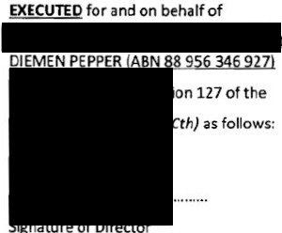
Name of Director
Trading as.



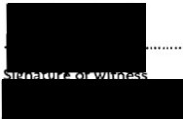

.. ... . . ..
I

Address of witness

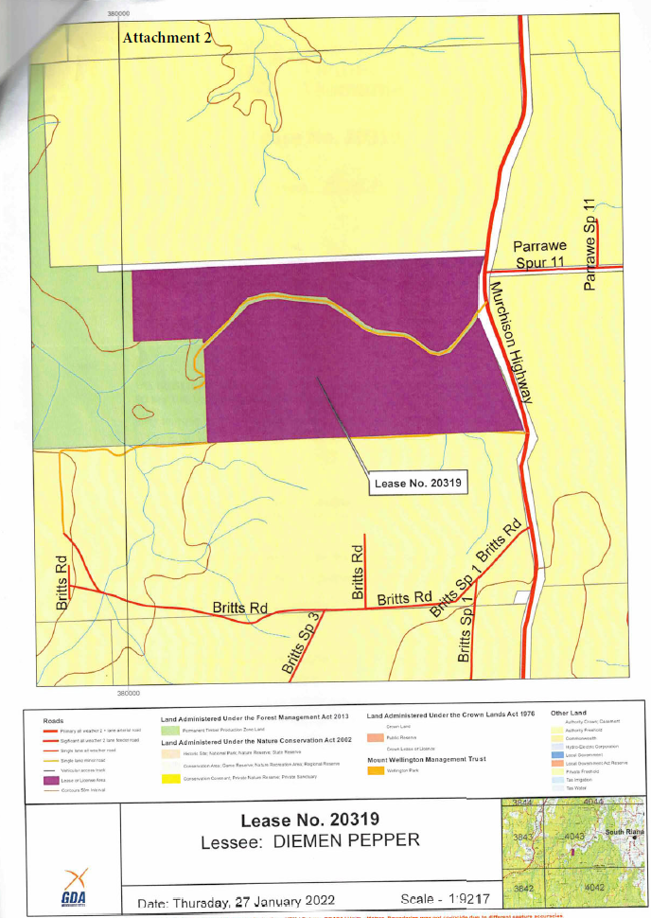

II] V 
View Zoom

c!J
Sham

Attachment 3
Fig 1 Parrawe NW Tas

@
Rotate Markup

Q Search

Search


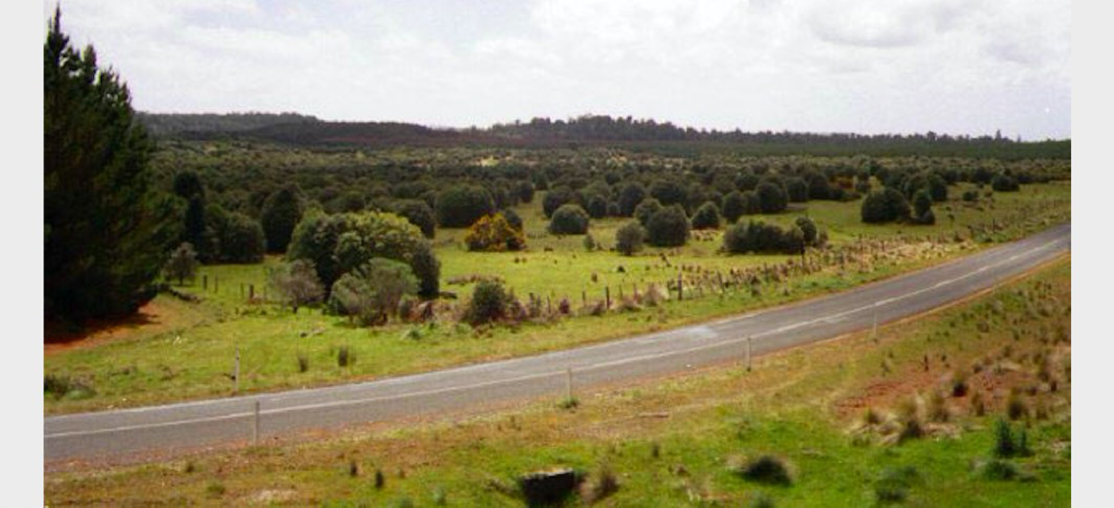

Attachment 4

•
••
•
II



Licence
[DPIPWE Ref: 246409-001]

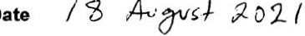

The Honourable Jacqueline Anne Petrusma MP
(being and as the Minister for the time being for the State of Tasmania administering the Crown Lands Act 1976 (Tas))
(licensor)

and

(Llcensee)

THE CROWN SOLICITOR OF TASMANIA
111 Macquarie Street Hobart Tasmania 7000
GPO Box 825 Hobart Tasmania 7001
Telephone: (03) 6165 3650
Facsimile: (03) 6173 0265
File Ref: 22843-21

Contents
Details and recitals 1
Information Table 2
- Definitions and interpretation 5
  - Definitions 5
  - Interpretation 7
  - Headings 8
  - No rule of construction applies to disadvantage party 8
  - Information Table 8
- Grant of Licence 9
  - Grant of Licence 9
  - No estate or interest 9
  - Licensor has access to the Licensed Area 9
- Option 9
  - Application 9
  - New Licence 9
  - Number of new terms 9
- Licence Fee 9
  - Fixed Licence Fee 9
  - Adjustment of Licence Fee 10
- Conditions of Licence 10
  - Conditions 10
  - Determination of Licence 13
  - Things remaining on the Licensed Area 14
  - Notice to repair 14
  - Licensor may recover costs 14
- Licensor's acknowledgements 14
  - Use of Licensed Area 14
  - Licensor not responsible 14
- Licensee's indemnities and waiver 15
  - Licensee indemnifies Licensor for risk 15
  - Licensee indemnifies Licensor against loss and damage 15
  - Licensee's risk 15
  - Licensee indemnifies Licensor against Contamination 15
  - Waiver of rights of recovery from the Licensor 15
  - Nature of indemnities and waiver 15
- Insurance 16
  - Licensee to insure 16
I
  - Crown to be insured 16
  - Licensee to notify Licensor 16
  - Evidence of insurance 17
  - Licensor may insure 17
I 8.6 Licensee not to prejudice insurance 17
i DPIPWE I Licence I 22843-21 page i

8.7 Licensor may waive obligation to insure 17
- Termination of Licence 17
  - Licensor's right to terminate 17
  - Antecedent breach 18
  - No compensation payable on termination 18
- Holding over 18
- Interest 19
- Licensee's risk 19
- No representation or warranty 19
  - No representation about suitability 19
  - No representation about zoning 19
- Guarantee and Indemnity 19
  - Application 19
  - Consideration for Guarantee 20
  - Guarantee and indemnity 20
  - Period of Guarantee 20
  - Extent of Guarantee 20
  - Guarantee in favour of owner 20
  - Guarantee is joint and several 20
  - Guarantee not discharged 21
- Special terms and conditions 21
- GST 22
- Dispute resolution 22
  - Application 22
  - Negotiation 22
  - Status of negotiations 22
  - Further action 23
  - Continuation of performance 23
  - Injunctive and other discretionary relief 23
- Notices 23
  - Notice requirements 23
  - Method and address for delivery 24
  - Time of receipt 24
  - Other modes or places of service 24
- Miscellaneous 24
  - Governing law 24
  - Dispute jurisdiction 25
  - Entire agreements clause 25
  - Liability 25
  - Benefit 25
  - Compliance with obligations 25
  - Severance 25
  - Counterparts 25

  - Execution of Licence 26
  - Further assurance 26
  - Business Days 26
  - No partnership or agency 26
  - Legal costs 26
  - Amendment 27
  - Waiver 27
  - Successors and assigns 27
  - Rights cumulative 27
  - Set-off 27
  - Disclosure 27
  - Consent and approvals 27
  - Doctrine of merger 28
  - Minister or State of Tasmania expressed to be party 28
  - No interference with executive duties or powers 28
  - Surviving provisions and termination 28
Signing 30
Attachment: Plan 32

Licence

Details and recitals
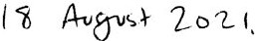
Date: Parties:

Name

Short form name Notice details

Name
ACN!ARBN/ABN
Short form name Notice details

Name
Short form name Notice details

The Honourable Jacqueline Anne Petrusma MP
(being and as the Minister for the time being for the State of Tasmania administering the Crown Lands Act 1976 (Tas))
Licensor
C/- Department of Primary Industries, Parks, Water and Environment, GPO Box 44, Hobart, Tasmania 7001
Telephone:(03) 6169 9015
Attention: Secretary, Department of Primary Industries, Parks, Water and Environment

Licensee


The person or entity (if any) named in Item 1 Guarantor
Refer Item 1

Recitals:
- Pursuant to the provisions of the Act, the Licensor as Minister may licence Crown land to any person on such terms as the Licensor thinks fit.
- The Licensor acting under the powers conferred by the Act (and in particular the Section of the Act) has agreed to grant the Licensee a licence of the Licensed Area in accordance with this Licence and the Act.
- The Licensee has agreed to accept a licence of the Licensed Area in accordance with this Licence and the Act.


I,
:I
I
The period of five years.

Information Table

Item 1· Page 1: Guarantor’s details ..
Name:  ACN/ARBN/ABN:  Notice details: | Not applicable.
Item 2 (clause 1.1): Licensed Area
All that area of Crown land situated at Dead Horse Hill Road, Ringarooma in Tasmania identified by Property Identification Number 3340983 being approximately 147.302ha shown outlined in red on the Plan.
IItem 3 (clause 1.1): Improvements
Nil.

Item 4' (clause 1.1): Commencement Pate
1 January 2021.
Item 5 (clause 1.1): Expiry Date
31 December 2025.
Item 6 (clause 1.1): Term

Item 7 (clause 3): Option
Application of clause 3 New Licence Term Number of New Terms | Applicable 5 years  1.
Item B (clause 4): Licence Fee
er annum as adjusted in accordance with clause 4.2(c).
Item 9 (clause 4.1): Fixed Licence Fee

Not applicable.

Item 10 (clause 4.2): Adjustment of Licence Fee
Applicable.
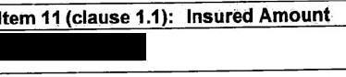
Item 12 (clause 1.1): Interest Rate

The rate prescribed by the Crown Lands Regulations 2011 (Tas) for the purposes of section 36(a)(ii) of the Act
Item 13 (clause 1.1): Section of Act
Section 40(1).
Item 14 (clause 1.1): Permitted Use
Carry out the collection of leaves and berries from the Tasmanian Native Pepper trees growing in the Licensed Area.

Item 15 (clause 15): Special tenns and conditions - [##]
The following Special terms and conditions apply to this Licence:
- Recording of harvesting
The Licensee must provide a report to the Licensor. in a fonn and substance satisfactory to the Licensor, by no later than 28 February each year of the Term, with such report to contain at a minimum the following:
(a) a comprehensive list of all species harvested during that year of the term;
(b) the amount and type of each plant material harvested;
(c) the number of plants the plant material was harvested from;
(d) the date of each harvest;
- the location of each harvest (map and//or GPS co-ordinates): and
- the names of the harvestors.
- Surrender of Existing Licence
  - The parties acknowledge that the Licensee is currently in occupation of the Licensed Area pursuant to the terms and conditions of the Existing Licence.
  - The Licensor and the Licensee will be taken to have surrendered the Existing Licence with effect at 11.59 pm on the day before the Commencement Date of this Licence (the Surrender Time).
  - Despite the surrender of the Existing Licence, the make good obligations of the Licensee under the Existing Licence continue under this Licence.

'/
'!
I

(d) The parties must perform all of their obligations under the Existing Licence up until the Surrender Time.
(e) With effect from the Surrender Time, but subject to subparagraph (c) each party releases the other and their respective employees and agents from all claims and actions arising under the Existing Licence which relate to any period after the Surrender Time.
Existing Licence for the purposes of this Item 15, means the licence between the Honourable Matthew Guy Groom as Minister for the time being of the Act as licensor and the Licensee dated 27 September 2017.

Grant of Licence
      - Grant of Licence
'
The Licensor grants to the Licensee, and the Licensee accepts, a non-exclusive licence under the Section of the Act, to use the Licensed Area for the Permitted Use from the Commencement Date for the Tenn in accordance with this Licence and subject to the Act.
      - No estate or interest
This Licence does not confer upon the Licensee any estate or interest in the Licensed Area.
      - Licensor has access to the Licensed Area
The Licensor retains the right to full and free access to the Licensed Area throughout the Term.

Option
      - Application
This clause 3 applies if Item 7 states that this clause is applicable. For the avoidance of doubt, this clause 3 is not applicable ifltem 7 states that clause 3 is not applicable.

I,
New Licence
The Licensor must grant the Licensee a new licence of the Licensed Area for such further term as set out in Item 7 to commence on the expiration of this Licence if the Licensee:


(a)

(b)
makes a written request no earlier than six months and at least three months prior to the expiration of this Licence; and
is not in breach of any of the terms of this Licence at the time of the request under clause 3.2(a) and at the expiration of the initial Term; and

(c) has not persistently been in breach of the Licence during the Term.
The new licence to be on the same terms and conditions contained in this Licence (with any necessary changes) with the commencing Licence Fee for the new licence to be the Licence Fee for the final year of the expired Term.
      - Number of new terms
The number of further terms that may be created under clause 3.2 is limited to the number specified in Item 7 and clause 3.2 must be excluded from the final licence entered into as a result of the application of that clause.

Licence Fee
      - Fixed Licence Fee
        - This clause 4.1 applies ifltem 9 states that this clause is applicable. For the avoidance of doubt, this clause 4.1 is not applicable if Item 9 states that this clause 4.1 is not applicable.
I
I DPIPWE I Licence I 22843 page 9

- do not extend to liability caused by the Licensor's wrongful (including negligent) act or omission.

Insurance
  - Licensee to insure
The Licensee must take out and keep current throughout the Term, and for as long as the Licensee uses the Licensed Area, contracts of insurance with a reputable insurer lawfully carrying on insurance business in Australia, indemnifying:
    - the Licensor's and the Licensee's liability for:
      - personal injury to, or death of, any person; and
      - either or both loss of, or damage to, property of any person,
for not less than the Insured Amount for each individual claim or series of claims arising out of a single occurrence, or for such other amount as the Licensor reasonably determines;
    - a comprehensive insurance policy:
      - for the full insurable and replacement value of the Improvements and any building, structure, fixture, fittings, plant and equipment and personal property on the Licensed Area;
      - against loss or damage by fire storm tempest earthquake lightning explosion burglary and other risks usually covered under a comprehensive insurance policy for fire and related risks; and
    - any other risks that the Licensor reasonably requires the Licensee to insure against, for the amount stipulated by the Licensor, to the extent that the claim for indemnity is not caused by the Licensor's wrongful (including negligent) act or omission.
The liability to be insured against under clause 8.l(a) is liability arising from, or attributable to, the Licensee's use or occupation of the Licensed Area to the extent that the injury, death, damage or loss is caused by a wrongful (including negligent) act or omission of the Licensee or the Licensee's employees, authorised contractors, sub­ contractors, agents, Licensees and invitees and any other person claiming through or under the Licensee.
  - Crown to be insured
Insurance taken out under:
    - clause8.l(a)and
    - clause 8.1(c), if the Licensor requires this clause to apply to it,
must cover "the Crown in Right of Tasmania" as principal under the insurance contract but only to the extent required under this Licence.
  - Licensee to notify Licensor
The Licensee must notify the Licensor in writing as soon as practicable:

Signing

Signed as a deed for The Crown in Right of Tasmania (acting through the Minister administering the Crown Lands Act 1976 (Tas)) by the person named below in the presence of the witness named below:

Signature:

*Print
name:

·Position
Acting pursuant to an Instrument of
Declaration

dated
and Position Number:

Please complete:

Witness' signature:



"Witness
I_
-- -
print name and position:


- use BLOCK LETTERS
*Witness print address:


in the presence of the witness named below:
Witness' signature:
•Witness
print
name:
*Use BLOCK LETTERS
*Witness
print address:

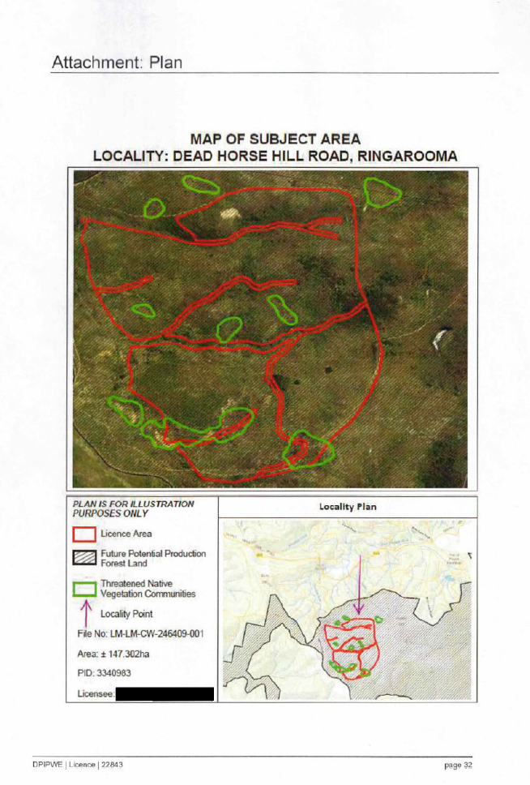
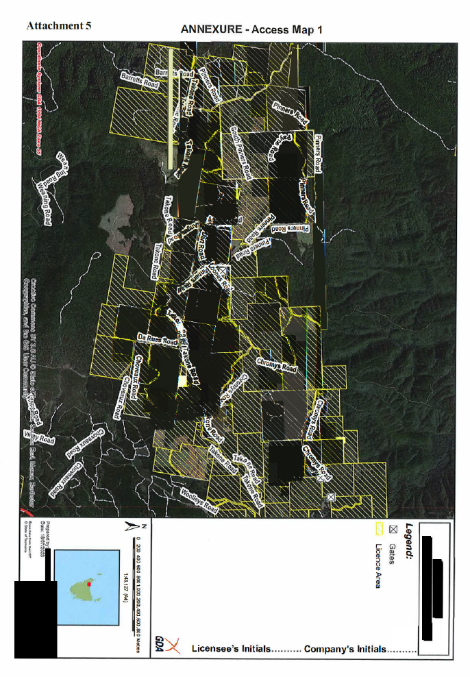
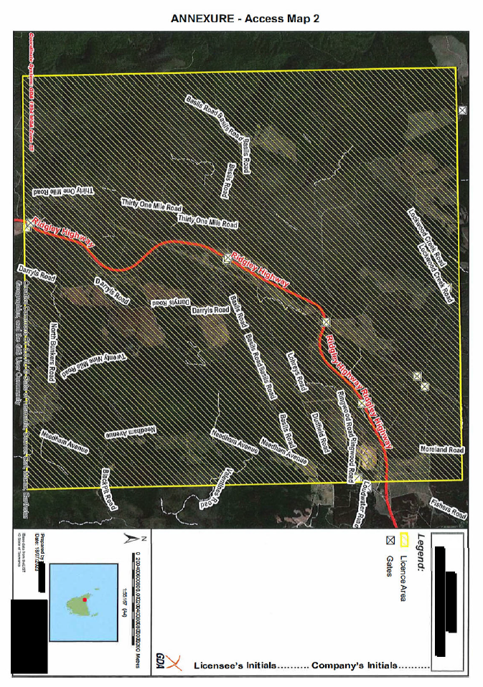
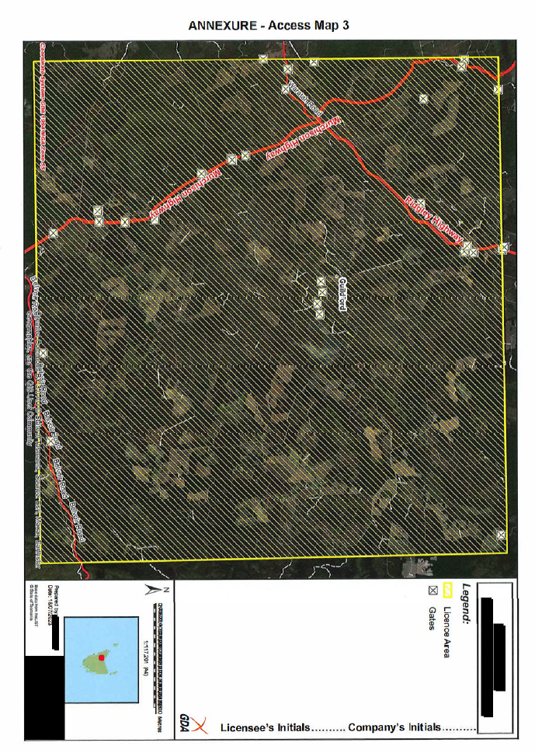
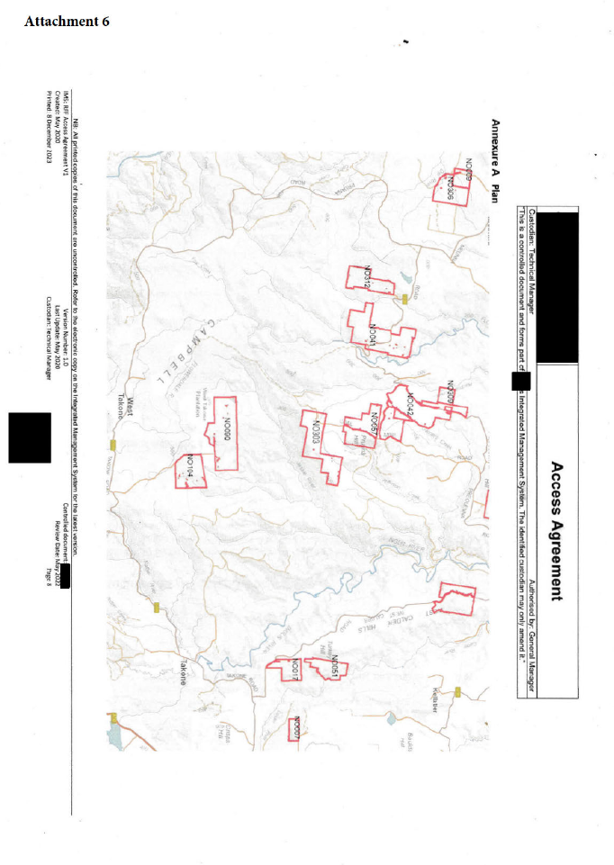

Attachment 7


•••

Guide for Suppliers of Pepperberries : 2023 Harvest
Our success depends on our quality product which we assure our customers is clean, safe, and fresh. If you would like to supply pepperberries to us this season, please note:
Cleanliness: A few leaves and bits of pepper bush in the berries are OK, and we can remove any bits of other kinds of plants and lichens, but no non-native plant material which might carry potential allergens or bacteria. This could happen if you use containers, bags, weighing gear etc which isn’t thoroughly cleaned beforehand. It’s safer to use dedicated equipment, storage containers, and either new bags, or the bags which we supply free of charge.
Berries must be stored in a cool, dry spot, away from risk of contact with animals (including pets and vermin!).
Sustainability: It is essential you consider the sustainability of your harvest – NO damage to large limbs or parts of the tree structure, use clean equipment, take care not to damage other vegetation as far as possible, and do not damage waterways or other habitat during access to the site or moving around it.
Safety: Although all fruit is cleaned and graded before sale, we rely on suppliers to make sure that there’s no chance of contamination by ANY foreign materials – metals, plastics, foodstuffs, domestic or agricultural chemicals, animal products, faecal matter or anything else which doesn’t belong.
Especially important: avoid any possible contamination by insect repellents or sunscreen – these are tested for in the finished product if it goes to Europe and the limits are low.
Freshness: Its helpful if you have access to cool storage for fruit at or close to 2°C until we collect. Otherwise, just make sure the berries are kept in a cool shady spot, and if they have been collected on a warm day, don’t make a big ‘pile’ – let the field heat out of the berries as quickly as possible. Until the fruit gets very ripe, its OK to store this way for up to a week – we’ll collect each week.
Identification: We supply tough plastic tags to tie to the bag – mark your name.
Collection: We weigh on collection and issue a delivery docket showing the number of bags and weight of fruit. We inspect bags at random, especially at the beginning of the season, to give you feedback on the condition of the fruit.

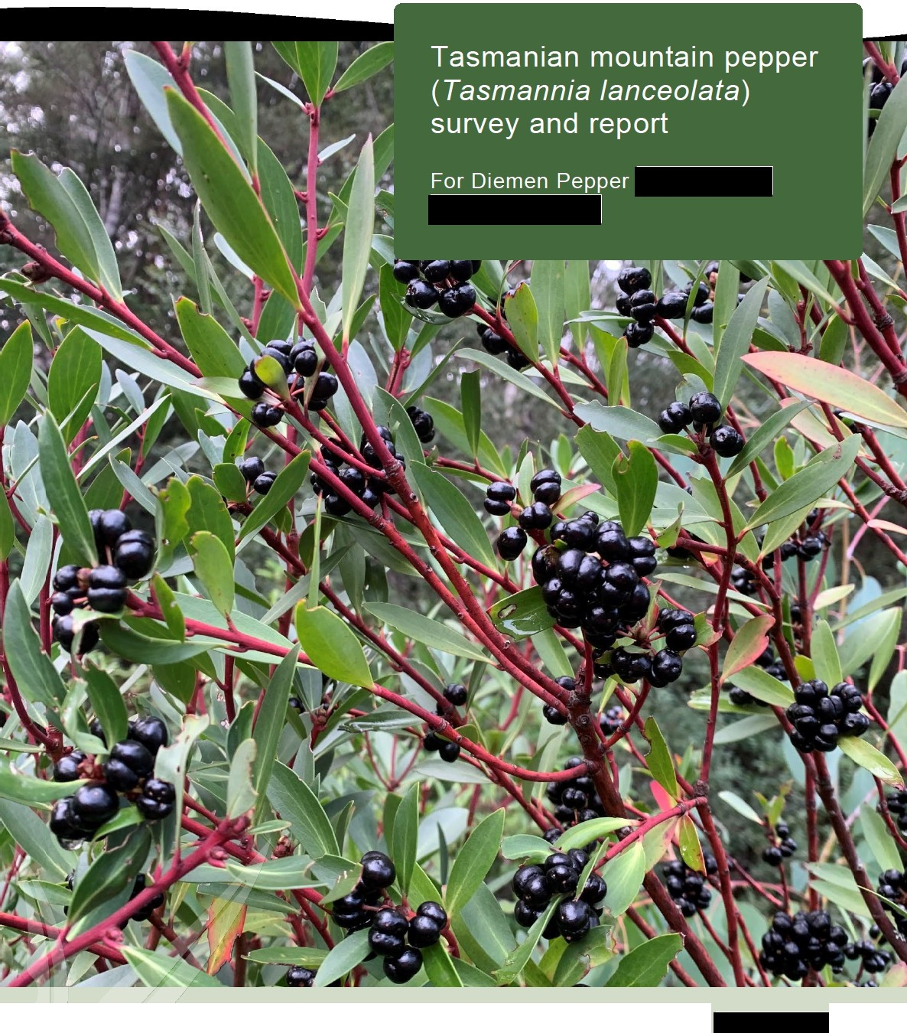
Attachment 8
enviro-dynamics
environmental solutions for a changing world

Prepared by:
-

JUNE 2022

Mountain pepper (Tasmannia lanceolata) survey report

Contents
- Introduction 1
- Methods 1
  - Desktop analysis 1
  - Field survey 2
- Results 4
- Conclusions and recommendations 15
References 18

Mountain pepper (Tasmannia lanceolata) survey report

Introduction
Diemen Pepper and are looking to increase the harvest of mountain pepper (Tasmannia lanceolata) in Tasmania in a sustainable way. Enviro- dynamics has been engaged to gain a better understanding of mountain pepper distribution, population dynamics and factors influencing site suitability for harvesting.
Mountain pepper fills a niche as a rainforest and wet eucalyptus forest early volunteer species. Following disturbance, either naturally or human induced, it will present in large numbers, often shaded by other species and emerging above other plants after a period of 5+ years. This survey aims to better understand factors that influence pepper berry distribution such as rainfall, elevation, aspect and forest type and what type of disturbance events favour the formation of dense stands of mountain pepper.

Methods
The initial work associated with the project gained an understanding of common site features of known populations around the State. The location of high value harvest sites was identified by  (Diemen Pepper) and  with additional potential sites identified through a desktop analysis.
A preliminary field survey was undertake to sites in the north east of the State around Weldborough. These visits were used to gather site characteristics to inform further desktop analysis.
  - Desktop analysis

The desktop analysis was completed for the northwest region of Tasmania using the location of known sites and additional analysis using parameters identified during the initial site visit. Whilst mountain pepper is known from a wide range of habitats across Tasmania it has only been observed growing in large stands in wetter and higher altitude areas of the state, typically associated with temperate rainforest or wet eucalypt forest.
Spatial data was analysed using QGIS to identify areas that are likely to support harvestable sites. Spatial layers were gathered from theLIST. Several attributes were selected and then

Mountain pepper (Tasmannia lanceolata) survey report

combined to represent the target area. Below is a list of datasets used and the features that were selected:
- 10m contours - 400 to 900m a.s.l.
- Land tenure northwest - forest production, future potential forest production or private freehold to allow collection
- TASVEG 4.0. - all associated vegetation communities including rainforest, wet forest, modified land for forest production and highland Poa grassland.
An intersection was performed with all the selected layers to identify potential mountain pepper harvest sites.
Within these areas, the aerial imagery was then analysed to determine the best sites to visit considering access, and mountain pepper ecology and proximity to known harvest locations.
  - Field survey

Two field surveys were undertaken by teams of two. The first in late March to the northeast surveying active collection sites to gain an understanding of ‘favourable’ factors for harvest. The second survey to the northwest was undertaken in late April surveying known sites and ground truthing sites highlighted as promising by the GIS analysis.
The survey in the northwest was concentrated around Waratah and Parrawe to target known sites and new areas. Opportunistic sites were visited as sighted throughout field surveys. At each site data on location, habitat and species was collected (Table 1).

Mountain pepper (Tasmannia Janceolata) survey report

Table 1- Data collected at each mountain pepper site.

Location Data | Habitat Data | Species Information
Date | Aspect | Forms
Location description | Slope | Abundance- locally
Landholder | Drainage | Population size estimate
Tenure | Geology | Population conditions score
Observer | Soil | Local area of occurrence
GPS location | Landform | Percent live mature individuals
Altitude | Disturbance | Percent fruiting
 | Overstorey canopy cover | Browsing damage
 | Vegetation community | Recruitment
 | Key associated species | Threats & threats to recruitment

3
Enviro-dynamics Pty Ltd - info@enviro-dynamics.com.au

Mountain pepper (Tasmannia lanceolata) survey report

Conclusions and recommendations
Mountain pepper is known from a wide range of locations and habitats around the state with significant harvestable populations in the North east around Weldborough, North west around Waratah, Parrawe and Daisy Dell, Central Highlands, Mount Hobbs and Mount Ponsonby in the Southern Midlands and in the Huon Valley. Through field surveys in the north east and north west we observed several conditions that contribute to large fruiting populations including:
  - Altitude between 600m and 800m a.s.l
  - High rainfall. Both Waratah and Weldborough have an annual rainfall over 1000mm
  - Open canopy with few overstorey trees shading mountain peppers
  - Presence of Myrtle beech (Nothofagus cunninghamii). Plants seen growing in fallen myrtle beech logs (Figure 3)
  - Some disturbance needed. Clearing event needs to be approx. 30 - 40 years ago.

Large and harvestable populations of mountain pepper like those seen at the current collection site south of Parrawe are uncommon. There are many areas with large stands of mountain pepper but access may be difficult or plants may be shaded and not fruiting to justify the area as a collection site.
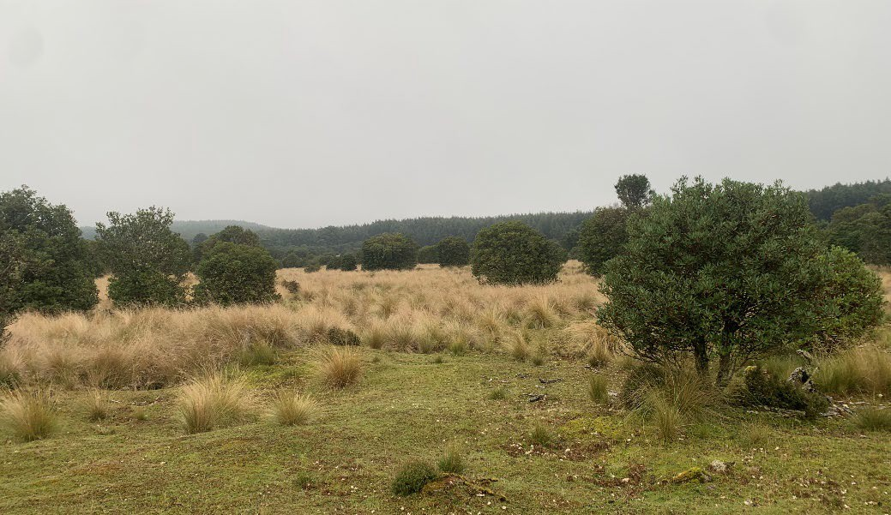
Figure 4 Collection site south of Parrawe

Mountain pepper (Tasmannia lanceolata) survey report

Recommendations

To ensure sustainable harvest of wild populations we would recommend commencing a survey to investigate harvest impacts on plant health and population dynamics that would run over 3 years to monitor change and optimal harvetign levels. Recommendations for wild harvesting of a similar plants in the Pyrenees (J. Recasens et al (2008)) have general guidelines for harvesting:
  - Harvest in autumn
  - Gather leaves in unshaded areas
  - Cut only partial portion of stem and leaves (≤ 25% of total biomass)
  - Repeat harvest from same population only after three to four years after previous harvest.
Further development of the work of this survey can incorporate further GIS modelling including historic aerial imagery analysis to look at clearing history, in particular land cleared of native forest approximately 40 years ago, rainfall above 1000mm per annum and mean summer and winter temperatures would further narrow down areas that have harvestable populations. This further work would provide targeted search areas to find additional populations.
To increase current harvestable areas of mountain pepper we suggest the following.

  - Approach plantation owners to discuss ways of harvesting mountain peppers beneath the plantations. There may be instances where they could harvest the timber in a way that would minimise damage to the mountain pepper removing the shade allowing plants to thrive. The plantation sites could be re-planted by hand allowing mountain pepper to continue to be harvestable. This could provide additional profit from the plantation and environmental benefits such as soil and water retention.
  - Another option to increase harvest more rapidly would be to approach landholders who have large populations in their paddocks and discuss ways to improve conditions for mountain pepper growth. At certain sites such as the paddocks alongside Waratah Road, close to Waratah and the site at west Parrawe removing

Mountain pepper (Tasmannia lanceolata) survey report

weeds, selectively removing shade trees and improving access could create some sites that produce well.
  - Establishing mountain pepper orchards could provide a situation for optimal harvesting. Land in the Waratah area would offer the best climatic conditions with high rainfall and low temperatures. The wild seedlings grew abundantly in decaying wood from myrtle beech and this interaction should be further investigated to improve germination and growth rates. Pepper berries appear to benefit from protection from the elements when they were small. It is recommended to replicate these conditions during establishment. It would take approximately 5-10 years to get the shrubs large enough to harvest fruit.

Mountain pepper (Tasmannia lanceolata) survey report

References
J.Recasens, P.Ninot, R. Cristobal, P.Aymerich (September 2008). Sustainable Wild Harvesting of Arctostaphylos uva-ursi in the Pyrenees as a Conservation Practice. Journal of Herbs Spices & Medicinal Plants.
Kitchener, A. and Harris, S. (2013) From Forest to Fjaeldmark: Descriptions of Tasmania’s Vegetation. Edition 2. Department of Primary Industries, Parks, Water and Environment, Tasmania. https://dpipwe.tas.gov.au/conservation/flora-of-tasmania/from-forest-to- fjaeldmark-descriptions-of-tasmanias-vegetation
TheList mapping layer. Home, https://www.thelist.tas.gov.au/.

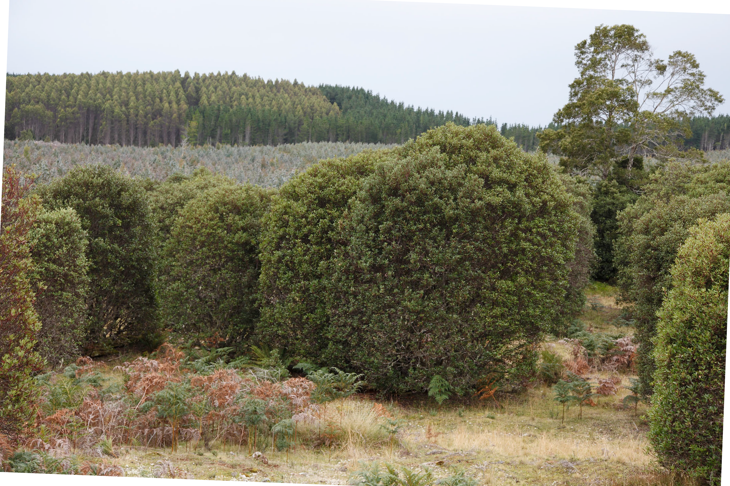
Attachment 9

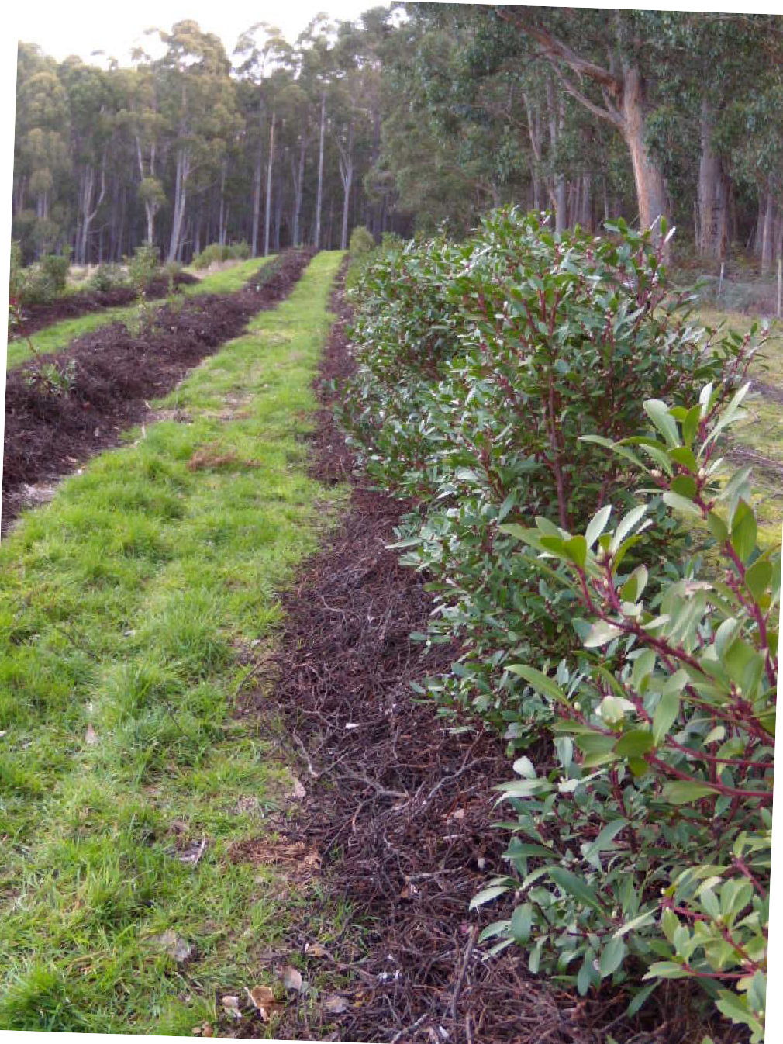
Attachment 10

